CUSTOMER RETENTION STRATEGIES IN PANDA RETAIL COMPANY AT SAUDI ARABIA

Research dissertation presented in partial fulfilment of the requirements for the degree of
MSc in International Business

GRIFFITH COLLEGE DUBLIN


Under the Guidance and Supervision of
Dr. Carla DeTona, PhD, MPhil and Research Supervisor

Student Name: Deepak Mysore Srinivasa
Date of Submission: 4 June 2021

DECLARATION

Candidate Name – Deepak Mysore Srinivasa
I declare that the dissertation entitled “CUSTOMER RETENTION STRATEGIES IN PANDA RETAIL COMPANY AT SAUDI ARABIA”, submitted by me for the degree of MSc in International Business, is the result of the my own work and that where reference is made to the work of others, during the period of March 2021 to June 2021 under the guidance of Dr. Carla DeTona, PhD, MPhil and Research Supervisor, Graduate Business School, Griffith College, South Circular Road, Dublin 8, Ireland.
This thesis was prepared according to the regulation for postgraduate study of Griffith College, Dublin.
The work presented in this thesis follows to the principle and standards of the college’s guideline for ethics in research.


Signature of the Student
Date: 04 June 2021

Supervisor Name: Dr. Carla DeTona

Supervisor Signature
Date:

ACKNOWLEDGEMENT

First, I am extremely grateful to my research supervisor Dr. Carla DeTona, PhD, MPhil and Research Supervisor, Graduate Business School, Griffith College, South Circular Road, Dublin 8, Ireland for her valuable guidance and moral support rendered at every phase of the research work. I acknowledge her constant motivation and dynamic approach, which helped me in completing the study in an effective manner.
I would like to thank Mr. Justin F.Keogan, Graduate Business School, Griffith College, South Circular Road, Dublin-8, Ireland for permitting me to carry out the research work and for the continuous encouragement.
I express my thanks to Ms. Mary Whitney, Programme Director of MSCIB, Pdip IBM and Dissertation coordinator, Graduate Business School, Griffith College, South Circular Road, Dublin 8, Ireland for her valuable suggestions and continued support from the beginning to the completion of the dissertation.
I wish to express my sincere gratitude to Dr. Garrett Ryan and Mr. Mark Campbell and all other faculty for their contribution during information session & ethical consideration at the beginning of research.
I am thankful to my ex-managers Mr. Raed Al Yomni and Mr. Mousa Qassem Ghazwani (Panda Retail Company) for their encouragement in this journey.
I would like to thank my friend Ranith Chakkoth who supported me and customers who were involved in the online survey task for this research. Without their time, effort and participation in survey and input, the data would not have been enough for the study and could not have been successfully completed my dissertation.
I would like to express my tender gratitude to my mother, wife, brother and brother in law for their moral support and assistance without them I could not have completed my study and I recognize their appreciation and sacrifices made by them in the successful completion of the research.
Table of Contents
DECLARATION II
ACKNOWLEDGEMENT III
LIST OF TABLES VI
LIST OF FIGURES VIII
LIST OF ABBREVIATION VIII
ABSTRACT IX
CHAPTER 1 - INTRODUCTION 1
1.1 BACKGROUND 1
1.1.1 Customer retention strategy trends in Saudi Arabia 2
1.1.2 Problem statement 3
1.1.3 Research Rationale 4
1.2 FOCUS AND PURPOSE 5
1.2.1 Aim 5
1.2.2 Objectives 6
1.2.3 Hypothesis 6
1.3 Summary 8
1.4 STRUCTURE OF THE REPORT 9
CHAPTER 2 - LITERATURE REVIEW 10
2.1 OVERVIEW 10
2.2 CUSTOMER PURCHASING BEHAVIOR 10
2.2.1 Theory of reasoned action 12
2.3 IMPORTANCE OF CONSUMER RETENTION 12
2.4 DISCUSSION OF CONSUMER RETENTION STRATEGIES 13
2.5 FACTORS INFLUENCING CONSUMER RETENTION STRATEGIES 15
2.6 APPLICATION OF CONSUMER RETENTION TO ELEVATE CUSTOMER SATISFACTION AND CUSTOMER PURCHASING BEHAVIOUR 18
2.7 CHALLENGES FACED BY COMPANIES TO INTEGRATE EFFICIENT CONSUMER RETENTION APPROACHES 19
2.7.1 Focusing on consumer acquisition rather than consumer retention 19
2.7.1 Lack of consumer differentiation 20
2.7.2 Neglecting customer service 20
2.7.3 Ignoring consumer feedback 20
2.8 IDENTIFICATION OF KEY AREAS TO BE MODIFIED TO BOOST CONSUMER SATISFACTION AND RETENTION 21
2.8.1 Consumer understanding 21
2.9 CRITICAL ANALYSIS OF CASE STUDY OF CUSTOMER RETENTION IN SAUDI ARABIA 23
2.10 CONCEPTUAL FRAMEWORK 23
2.11 LITERATURE GAP 25
2.12 SUMMARY 26
CHAPTER 3 - RESEARCH METHODOLOGY 27
3.1 OVERVIEW 27
3.2 RESEARCH PHILOSOPHY 27
3.3 RESEARCH APPROACH 29
3.4 RESEARCH TYPE 30
3.5 RESEARCH DESIGN 31
3.6 SAMPLING 31
3.7 DATA COLLECTION 32
3.8 DATA ANALYSIS 33
3.8.1 Statistical Package for Social Science (SPSS) 34
3.9 ETHICAL CONSIDERATION 34
3.10 RELIABILITY AND VALIDITY OF THE STUDY 35
3.11 SUMMARY 35
CHAPTER 4 - PRESENTATION AND ANALYSIS OF FINDINGS 37
4.1 OVERVIEW 37
4.2 DATA ANALYSIS AND INTERPRETATION 37
4.3 RELIABILITY ANALYSIS 57
4.4 STATISTICAL ANALYSIS 58
4.5 KEY FINDINGS 78
CHAPTER 5 - CONCLUSION AND SUGGESTIONS 80
5.1 CONCLUSION 80
5.2 SUGGESTIONS 82
5.3 SCOPE FOR FURTHER RESEARCH 84
REFERENCE 86
APPENDIX 93

LIST OF TABLES
table 4.1 Gender Analysis 37
Table 4.2 Age Analysis 38
Table 4.3 Nationality Analysis 40
Table 4.4 Communication Channel Analysis 41
Table 4.5 Other Source Of Information Analysis 42
Table 4.6 Time Spending Analysis 43
Table 4.7 Time Spending Analysis 44
Table 4.8 Regular Visit Analysis 45
Table 4.9 Festive Visit Analysis 46
Table 4.10 Factors Influencing Analysis 47
Table 4.11 Products Category Analysis 48
Table 4.12 Customer Service Satisfaction Analysis 49
Table 4.13 Recommend The Product/Service Analysis 50
Table 4.14 Customer Loyalty Analysis 51
Table 4.15 Panda Click Grocery App Analysis 52
Table 4.16 Customer Satisfaction Rate Of Panda Click App Analysis 53
Table 4.17 Recommend The Panda Click App Analysis 54
Table 4.18 Switched To Other Competitors Of Panda Retailer Analysis 55
Table 4.19 Reason For Switched To Other Competitors Of Panda Retailer Analysis 56
Table 4.20 Reliability Statistics 57
Table 4.21 Item Statistics 57
Table 4.22 Inter-Item Correlation Matrix 58
Table 4.23 Item-Total Statistics 58
Table 4.24 Scale Statistics 58
Table 4.25 Paired Samples Statistics 59
Table 4.26 Paried Samples Correlations 59
Table 4.27 Paried Samples Test 59
Table 4.28 Reliability Statistics 60
Table 4.29 Item Statistics 60
Table 4.30 Inter-Item Correlation Matrix 60
Table 4.31 Item-Total Statistics 61
Table 4.32 Scale Statistics 61
Table 4.33 Paired Samples Statistics 61
Table 4.34 Paried Samples Correlations 61
Table 4.35 Paried Samples Test 62
Table 4.36 Reliability Statistics 62
Table 4.37 Inter-Item Correlation Matrix 63
Table 4.38 Item-Total Statistics 63
Table 4.39 Scale Statistics 63
Table 4.40 Descriptive Statistics 64
Table 4.41 Correlations 64
Table 4.42 Model Summary 65
Table 4.43 Anova 65
Table 4.44 Coefficients 65
Table 4.45 Cross Tabulation 66
Table 4.46 Chi-Square Tests 67
Table 4.47 Cross Tabulation 67
Table 4.48 Chi-Square Tests 68
Table 4.49 Cross Tabulation 68
Table 4.50 Chi-Square Tests 69
Table 4.51 Cross Tabulation 69
Table 4.52 Chi-Square Tests 70
Table 4.53 Cross Tabulation 70
Table 4.54 Chi-Square Tests 71
Table 4.55 Cross Tabulation 71
Table 4.56 Chi-Square Tests 72
Table 4.57 One Sample Statistics 72
Table 4.58 One-Sample Test 73
Table 4.59 Descriptive 74
Table 4.60 Anova 75
Table 4.61 Cross Tabulation 76
Table 4.62 Chi-Square Tests 76
Table 4.63 Cross Tabulation 77
Table 4.64 Chi-Square Tests 77

LIST OF FIGURES
Figure 2.1: Conceptual framework 24
Figure 4.1: Gender Distribution 38
Figure 4.2: Age Distribution 39
Figure 4.3: Nationality Distribution 40
Figure 4.4: Communication Channel Distribution 41
Figure 4.5: Other Source of Information Distribution 42
Figure 4.6: Time spending Distribution 43
Figure 4.7: Time spending Distribution 44
Figure 4.8: Regular Visit Distribution 45
Figure 4.9: Festive Visit Distribution 46
Figure 4.10: Factors Influencings Distribution 47
Figure 4.11: Products Category Distribution 48
Figure 4.12: Customer Service Satisfaction Distribution 49
Figure 4.13: Recommend the product/service Distribution 50
Figure 4.14: Customer Loyalty Distribution 51
Figure 4.15: Panda Click Grocery App Distribution 52
Figure 4.16: Customer Satisfaction Rate of Panda Click Grocery App Distribution 53
Figure 4.17: Recommend Panda Click Grocery App Distribution 55
Figure 4.18: Switched to Other Competitors of Panda Retailer Distribution 55
Figure 4.19: Reason for Switched to Other Competitors of Panda Retailer Distribution 56

LIST OF ABBREVIATION
CLV - Customer Lifetime Value
N - Number of Responses
Std - Standard
Sig - Significant
t - Test
df - Degree of freedom
N of Items - Number of items
R - Multiple correlation coefficient

ABSTRACT
Retention strategies or loyalty program is defined as systematic marketing initiatives that rewards and encourages loyal purchasing behavior among the consumers. Such purchasing behavior of the consumer ultimately benefits the company in the end. The present work focuses on studying various customer retention strategies in Panda Retail Company at Saudi Arabia. The research tries to assess the impact of customer retention strategies of panda retail stores on the purchasing behavior of their consumers. The proposed work is descriptive approach and applies sampling technique for selecting a sample of valid 205 respondents. Data is collected from secondary sources, and paired t-test was applied for analyzing the data by using SPSS software. The paper concludes that retention strategies are a good option for retail stores for retaining and attracting consumers and they should practice it regularly.
Key Words: Customer Retention, Customer Retention Strategies, Retail Sector, Customer Satisfaction.

CHAPTER 1 - INTRODUCTION

1.1 BACKGROUND
Panda Retail Company is a distinguished Saudi Arabian Grocery Retail Store, which gives great quality products and service to its customers. Recently, this organization is function across various Middle East nations and notable in this region because of its well know customer retention strategy, which draw in people to buy its products. This company has positioned ninth position among top 100 organizations in the Saudi Arabia market and positioned as second after SABIC in the mechanical area, because of its successful key service related approaches(Panda, 2019).
Saudi Arabia retail sector is estimated to represent a growth rate of 6%, and it is calculated that this growth rate will be maintained until 2024. In 2018, the total revenue of this sector was $112.9 billion that will be converted into $159 billion in 2024(Reportlinker, 2019). Along with the growth, the consumer-shopping pattern will be also shifted from staple food to healthier food consumption, shifted from being dependent on fuel sectors to other sectors in terms of earning income. The Saudi Arabia retail market is categorized as per the product and offerings into footwear, food and beverages, jewelry, pharmacy, appliances and others(Reportlinker, 2019). Among these segments, food and beverages sector owns one third of the market revenue according to 2018 revenue. On the other hand, the total retail market of Saudi Arabia is segmented in Central, East, West South and North region. Among these segments, Central(Riyadh) region generates the largest retail demands due to the presence of key market rulers(Reportlinker, 2019). Some of the retail rivals include Lulu Group International, Panda Retail Company (Savola Group) Majid Al Futtaim Retail LLC, Fawaz Abdulaziz AlHokair Company, Abdullah Al Othaim Markets Company and others(Reportlinker, 2019). In Saudi Arabia retail sector, Panda Retail Company has been one of the popular brands in retaining customers. During Covid-19 the company has been started to use online retailing so that they can reach out to overall customers in Saudi Arabia. In recent time, the company has utilized oracle retailing, Oracle supply chain in order to boost their performance via online retailing(The Savola Group, 2020).
The revenue of Panda retail in 2017, Q2 was SAR3,229m (US$860m), in Q1 it was US$887m(IGD, 2018). Panda retail is the modern and largest grocery food chain rival in Saudi Arabia that serves 106 million customers and operates through 205 stores. Panda Retail earns 57% of the Savola Group’s total revenue. However, this organization has faced challenging conditions faced a net loss of SAR 520.4 million in 2018(The Savola Group, 2020). However, despite all the difficulties, Panda retail continues to show strong improvements through retaining obtaining new consumer segments.
It has been found that maintaining good communication with consumers is crucial for retaining customers. With the help of good communication, a company can focus on understanding needs and requirements of customers in order to satisfy them by delivering the needs. Customer satisfaction is directly linked to the service quality of business that brings customer retention and maintenance (Han et al., 2020). During the pandemic situation, it has been identified that companies in reputed service sector have turned to the internet to increase sales by making good engagement with customers (Dragnea and Mihaita, 2020). Therefore, Customers’ retention in the retail sector is obviously depended how the companies tend to communicate with customers.

1.1.1 Customer retention strategy trends in Saudi Arabia
The kingdom of Saudi Arabia is considered one of the most well established country in world with more eager customer base. According to CIA world factbook, over 34 million population with the global percentage of 0.45 and 30.8 years of median age people survive in the country years (Factbook, 2020). Another report says that more than 30% of the nation’s population are keen towards spending on shopping products and convenience (Moriarty, et al., 2013; Factbook, 2020). The growth of the population is tremendous every year and it is found that there is huge crowd inclined towards the retail market. Like the United Arab Emirates, Saudi Arabia is also been found established in the market and the growth is still evolving compared to the UAE.
The heart of retail marketing at Saudi is the convenience store, whereas the hypermarket has been established in a larger during the last decade. Sophisticated cities like Riyadh, Jeddah, Qassim and Dammam where hypermarkets are constructed in a large number but apparently, only on these cities the concertation of the hypermarkets is being focused. In addition, in the other hand, the population growth has also put a pressure on the growth of hypermarkets in these cities and the business have become competitive. To meet the customer’s demands, the retail owners have to focus on lot more stuff to retain their customers, moreover a long-term relationship is necessitated for the customer retention. The pressure is put on every retail business owner at Saudi because there are much more factors involved in retention strategy than compared to the quality of the service which is included in the customer satisfaction. The retail companies have to take high road in consoling the customers to stay back and attract new ones.
Consumer satisfaction is directly proportional to the service quality of the business, which thus brings about customer maintenance and retention. Thus, researching every one of these can help organizations not exclusively to meet or exceed their customers' desires, yet additionally to influence their behavior(Rizvi and Sabir, 2018).
Numerous examinations have been directed analyzing service quality, food quality and consumer loyalty builds in various settings in various nations, for instance the health care industry(Yeşilada and Direktouml, 2010),

1.1.2 Problem statement
The main problem that the company faces to target and retain customers in Panda Retail Company includes low revenue. This is because of huge competition with other retail companies in the country. The company fails to adopt a good customer retention strategy over its competitors. This is because employees of the company do not focus on making a good relation and communication with customers. Employees are known to be not satisfied with the policies and strategies of Panda Retail Company(Ramirez and Selsky, 2016). According to Das et al., (2018), Employees are the real estate of the company therefore if there are not satisfied then they do not pay attention on the requirements and demands of customers. This result in poor customer as well as employee satisfaction towards the panda retail company, during this covid-19 pandemic situation, customers require online ordering of food products and retail products. Customers also require online assistance from the company before purchasing a product online(Ascarza et al., 2018). In this respect, panda Retail Company fails to make a good communication with the customers, as employees are not cooperative with them. This not only hampers the reputation of the company but also lowers their revenue income in the retail sector.
The key research questions are addressed in this study.
- What are the strategies that developing Panda Retail Company should implement in order to retention their customers in Saudi Arabia?
- What are the influencing factor that contribute to the customer behavior?
- How customer-buying behavior is influenced by the promotional practices?
- Hence the topic of the research is “ Customer Retention Strategies in Panda Retail Company at Saudi Arabia”

1.1.3 Research Rationale
It has been found that Panda Retail Company faces challenges related to retaining customers in Saudi Arabia is main reason behind this lower footfall. On other hand, this was due to the closure of approx. seven supermarkets and two Hyper panda stores. In addition, shopping expectations of customers are continuously changing that makes difficult for panda Retail Company to identify and adopt.
Due to the reasons, the company has been facing decline in their revenue around 3.1% to SAR3, 229m from SAR3,331m in 2017. The performance of the retailer has declined to 6.6% to SAR5, 606m from SAR6, 006 in 2017(IGD, 2018).
It is also identified that there is an issues now as the company has been facing challenges to survive and get competitive advantages compared to its competitors in Saudi Arabia. If the company fails to become customers centric and meet needs of customers then they will be losing customers and will not maintain their business footprint. During this pandemic situation, where behavior of customers changes the company has not been able to address gap in their products range and create a compelling offering to evolve preferences of customers(IGD, 2018). One of the main gap in business is lack of online services facilities for customers that losses confidence of customers to shop from the retail company during pandemic situation.
That is why this research is focused on emphasizing customers retaining strategy of Panda Retail Company at Saudi Arabia so that it can get sustainable growth. If the company adopts customer-retaining strategy then helps them to retain loyal customer and meet expected annual revenue. In terms of customers retaining strategy, they might show appropriateness of discount rates, implementation of online retail services and others.

1.2 FOCUS AND PURPOSE

1.2.1 Aim
The main aim of this research is to analyze customer retention strategy of Panda Retail Company in Saudi Arabia.
This project focus around the key motive on enhancing the customer retention of Panda retail industry, and the reliability/rewards programs, brand/store network, personalization, customization, and their relationship with customer retention. Various strategies have been adapted in the project to add value and justification.
Consumer satisfaction as a term has been characterized as how much help service meets or exceeds the customers need(Kumar et al., 2008). Carman, (1990)has characterized satisfaction as an evaluative judgment of a particular exchange coming about because of apparent quality. On the other hand, Nasrin Danesh et al., (2012) has characterized customer retention as "the future inclination of a customer to remain with the company". As indicated by them, consumer satisfaction is not the main variable that affects the retention of customers. Ramachandran, (2006) has characterized customer retention as the marketing objective of keeping a customer from changing to another competitor. Edward and Sahadev, (2011) expressed that "Customer retention shows customer's goal to repurchase a product from the organization". They utilized customer retention as a proportion of the customer's aim to remain faithful to the company. For them, management quality and consumer satisfaction are significant forerunners of customer retention.
It is critical to comprehend what consumer satisfaction really implies. In business circles, the term refers to the sort of products and management an organization gives to meet and exceed its customers' desires. Company inside a similar market area must evaluate the nature of their management on the off chance that they are to pull in and hold customer. To add more essence to this term and following objectives are framed to fulfil the motive of the topic.

1.2.2 Objectives
- To study the profile of the respondents who shops at Panda retail stores.
- To determine which of the product category influence the customers to visit Panda retail stores frequently.
- To analyze dimension at Panda retail stores based on promotional benefits and consumer perception of service quality.
- To identify key areas that must be improved by the Panda Retail Company to enhance customer retention and satisfaction.
- To understand how the company attracts and retain customers in Saudi Arabia retail sector compared to other competitors.

1.2.3 Hypothesis
It is necessary for the researcher to test these theories in order to find at any genuine and true conclusions, since this aids in understanding the quantitative aspects of the work. In the proposed study, the study will test the following null hypotheses:
- H1 - Customer retention strategies do not have significant positive impact on sales.
- H2 - Customer retention strategies do not affect the buying behavior of customers in the retail sector.
- H3 - There is no significant difference in factors influencing in customer’s frequent visits.
- H4a - There is no significant difference in the customer preference for shopping in regular time at retailer with respect to gender.
- H4b - There is no significant difference in the customer preference for shopping in festival time at retailer with respect to gender.
- H4c - There is no significant difference in the customer preference for shopping during regular price at retailer with respect to gender.
- H4d - There is no significant difference in the customer preference for shopping during special offer at retailer with respect to gender.
- H4e - There is no significant difference in the customer preferences for shopping with respect to age.
- H4f - There is no significant effect of online shopping app on different age group of customers.
- H5 - There is no significant difference in frequent visit of customers for product category in the retailer.
- H6 - There is no significant difference in the influence on communication on customer preference for shopping at retailer with respect to ethnic.
- H7 - There is no significant difference in loyal customer of Panda retailer with respect to ethnic.
- H8 - There is no significant difference in customer satisfaction level of service/product and recommend it to their friends and family.
Every research has a goal in mind, whether it is to find solutions to real-world issues or to uncover statistics that the public is unaware of it. The aim of this research is to see how successful retention strategies are. Companies are also devoting significant resources to developing and applying multiple retention strategies in order to obtain a strategic edge and ensure long-term viability. This research aims to determine whether organizations will benefit from retention strategies. Whether or not the returns obtained by firms in comparison to the services used by retention measures are better. This study attempts to determine whether retention tactics are beneficial to Saudi Arabian retail industry, or whether retailers are simply spending their time developing creative strategies.

1.3 Summary
In Saudi Arabia, organized retailing is also in its infancy. However, the country's untapped retail market and large middle class are luring global retail giants to invest in this economy. This would increase the level of rivalry between the players. To address this issue, retailers have begun to place a greater emphasis on partnership marketing. Customer relationship marketing is a competitive and evolving strategy that helps marketers sustain their market share in today's extremely fragmented market. It is concerned with gaining a better understanding of the customer's mood, expectations and behavior in order to increase customer loyalty. Retention schemes play an important part in this respect. Retention schemes, also known as loyalty programs, are formal campaigns that compensate and inspire consumers to shop in a consistent and committed manner. Customers who purchase in this manner the company in the long run. The main goal of a customer engagement campaign is to create a stable customer base to keep them from switching to another company with the same goods or service.
The proposed research focuses on numerous company’s retention policies, with a special emphasis on the Saudi Arabian retail market. While several experiments have been undertaken in this field in the past, the bulk of the study has concentrated on discount stores that supply exclusively to high-end consumers and sell a single product. This thesis aims to examine different retention strategies used by Saudi Arabian retailer, as well as the effectiveness of these strategies in achieving the organization's objectives and goals.

1.4 STRUCTURE OF THE REPORT
Chapter 1 – Introduction: This study started with an introduction chapter giving an overview of Panda Retail Company, Customer retention strategy trends in Saudi Arabia and highlights the aim, objectives, hypothesis of the study.
Chapter 2 – Literature Review: In this chapter, study previous literature and outcomes of customer retention strategies and focuses on some of the research work conducted in a systematic method for achieving a deep understanding into the topic.
Chapter 3 – Research Methodology: is considered the heart of any researcher study that can adopt to gather the information and data to address to accurate and valid findings and conclusion. It also include research philosophy, design, type, data analysis, sampling and ethical consideration.
Chapter 4 - Presentation and Analysis of Findings: This chapter has paramount importance in this research. In this chapter, the researcher analyzed the data collected from survey by using SPSS statistic tool and findings are made from it.
Chapter 5 - Conclusions and Recommendations: This chapter of the research report and draws a conclusion of the entire work. In this chapter, make a certain suggestions and scope for further research.

CHAPTER 2 - LITERATURE REVIEW

2.1 OVERVIEW
The literature review of this study discussed in this chapter include the importance and explanation of customer retention strategies, Application of consumer retention to elevate customer satisfaction and customer purchasing behavior and Factors influencing consumer retention strategies. The theoretical frameworks incorporated in this chapter are Consumer behavior theory, Customer relationship management theory, and Theory of reasoned action.
In a thesis, the study of literature section is extremely important. The methodology portion, which is the third step of the study progression, is built on the foundation laid out in this chapter. Furthermore, a study may use this knowledge to determine the real void in the market, which supports in the formulation of data and information collection methodology. In conclusion, a literature review can be defined as a multipurpose guide to a specific subject. The theoretical aspect of the literature review is to deal with the study's specific subject. In order to verify different secondary sources, a study of literature is undertaken during the testing phase. Unlike surveys and data analysis, the review of literature does not deal with unique or new effort; instead, it relies on data gathering using previously available resources. This chapter has a well-defined structure that incorporates a variety of literature references as well as some personal experiences.

2.2 CUSTOMER PURCHASING BEHAVIOR
Stone et al. (2003) in their study, aims to assess consumer loyalty programs. Previously, the effectiveness of consumer retention programs was assessed based on their financial and marketing impact on customer growth, acquisition and retaining. However, according to the author, retention schemes must also be assessed in terms of how effectively they have assisted businesses in converting their marketing and industry. It was decided that reward programs are one of the competitive strategies employed by retailer to complement the standard brand, customer experience, price, product selection, product incentives, and location.
Bawa et al., (2019) studied changes in shopping behavior of today's supermarket consumers differ to those in the early 1990s. Despite the fact that the demographics of the respondents did not alter much between the earlier and later eras, they detected substantial variations in purchasing behavior and shopping patterns. When compared to consumers in the early 1990s, today's supermarket customers are more leisure-oriented, care more about product selection and visit the supermarket less often yet make more purchases each visit. The data also shows that situational circumstances have a greater influence on buyer’s purchasing decisions nowadays than they did before.
Fox et al., (2004) found that Families who spend more at grocery stores also prefer to spend more at retail stores such as supermarket & Hypermarket. Consumer spending is shown to be more responsive to variable amounts of selection (especially at grocery shops) and advertise than price.
Sreenivasulu, (2017) wanted to discover the important various factors are for consumers when selecting a product category. Customers found that availability of product range, second priority for service quality and third importance for convenience of location.
Kuruvilla et al., (2009) investigated whether there are gender variances in supermarket or hypermarket shopping attitudes and behaviors. According to the study, women have a more positive attitude toward shopping and purchase fashion-related, grocery categories more frequently than male purchase. On the other hand, visit more frequently and spend more time and money by male gender. While male and female spend more than 2 hours at the retailer store on average, male said they spend more time and visit frequently. When consider that shopping is usually a family affair, it is possible that male perceive himself as spending more time. However, this explanation appears improbable, as neither gender has demonstrated a significant difference in their recreational shopping approach. Retail stores appear to be popular places for male and female to shop for clothing, footwear, and accessories. Shoes and accessories appear to be popular purchases as well. On the other hand, female report making more purchases in all categories. However, male said to spend more money. One possible explanation is that men spend more than women on non-fashion items, but it is more likely that men spend more than women because they are the family's "purse bearers."
Rajagopal, (2011) investigated the effect of radio advertisements on urban customers' towards retail purchasing behavior. His findings show that physical, cognitive, and economic variables have a significant impact on urban consumers' purchasing behavior at retail outlets in reaction to radio marketing. Radio commercial listeners are drawn to fun ads and promotional messages on product sales, and they respond quickly to supermarkets and hypermarket.
According to Rita et al., (2019) service and consumer orientation behaviors are certainly related to service encounter quality and it is related to service quality and consumer satisfaction, value perceptions, customer satisfaction is positively related to retail customer’s purchasing intention, However, value is unrelated to consumer satisfaction.

2.2.1 Theory of reasoned action
The theory of reasoned action states that people possess total liberty to change their purchasing decision any time before purchasing the product. It renders an interrelation between the attitudes and behaviors and actions of humans related to buying a product. Hence, in case retaining the customers, marketers should represent the brands properly to the consumers integrated with customer satisfactory points to positively affect and encourage the purchasing decisions of buyers directed towards the products. The retailer should make sure that the product's beneficial features and satisfactory features are enough to generate the buying intention of the buyers(Han et al., 2020).

2.3 IMPORTANCE OF CONSUMER RETENTION
Customer retention aims to maintain or hold on to the customers for the long term and convert them into loyal customers. Consumer retention refers to a set of carried activities that focuses on turning first-time buyers into long-term, repeat customers to increase business profitability and customer lifetime value (Han et al., 2020). Customers do not approach companies or brands just to buy one product, but to buy for more in needs and come back repeatedly to buy the company offerings more. Customer retention guides company to form constructed and close relationships with the customers to turn them into loyal purchasers. In a way that customers influence their close circles about the benefits of choosing the brand and how brand has helped him/her (Dragnea and Mihaita, 2020).
It can be assumed that retaining customers is less expensive, less time taking and less hectic compared to acquiring them. Acquiring customers need to study, analyze, identify the market trends and their evolving tastes needs, collect tastes and their preferences, personalize the product and then launch them to gain customer use as well as the customer satisfaction (Bhat and Darzi, 2016).

2.4 DISCUSSION OF CONSUMER RETENTION STRATEGIES
The three most important business goals include leads, customers and sales. In case an organization is failing to hold on to its existing customer base, then it will lag behind its competitors. In case a business wants to have thriving profit and revenue status then the biggest asset of a company, which is customers, needs to be taken care of. New leads should be acquired continuously is required, but retaining the existing customers should be the fundamental goal. By reducing the risks of maintaining or creating a new purchase in a new provider, structural bonds help generate value for both consumers and the firm. Though it is seen in recent times that organizations are now recognizing the significance of loyal customers, and are including vast loyalty program. The aim of consumer retention is to maintain healthy relationships and constructed communication networks with value-adding customers. Hence, the strategies should be structured in a way that decreases consumer defection rate and increases the value of the customers through the incorporation of up selling and cross selling and inspiring them to influence others through mouth communication. Consumer retention strategies should be focused on identifying and encouraging profitable customers (Buttle, 2001; Magatef and Tomalieh, 2015; Fattahinejad and Gilaninia, 2018; Kim et al., 2020).
The approaches include surprises through customer services, setting customer expectations, building trust, application of automation or re-engaging customers, analyzing customer feedback surveys; over deliver the promises, measuring customer lifetime value. The other methods are evaluating the customer complaints, sending customers educational emails, integrating content marketing strategy, the formation of a customer advocacy program, personalizing communication, integration of loyalty programs(Hanaysha, 2017). Businesses must hold details for consumers in order to handle them differently. Therefore, providing a strong consumer history that documents all contacts and purchases are critical to establishing long-term client relationships.
Loyalty programs- The result of loyalty programs can generate data that can be researched by the market analytical group of the organizations, to extract the changing behavior of consumers, prepare their purchasing style changed. However, this information can help to retain old customers as well as the new customers. Sometimes organizations keep providing points to their customers; those customers who generated a high level of points cannot easily step out of the organizational buying facilities. These programs generally take the shape of loyalty card programs or membership in which the consumers are recognized or rewarded. The rewards can be based on the points the customers achieved, or how much money the customers have invested. Discounts, bonuses, membership cards, are generally provided to customers, privileged services can also be rewarded to the customers (Rao and Abegaz, 2017).
Application of automation to re-engage customers- This process called marketing automation, which helps the organization to manage some of its routines with innovation. Require to keep active and fresh in customer’s mind on an everyday basis so that customers can be attracted by the companies' flexibility and innovativeness. This approach monitors the customers and lists them according to their profitability value so that high-valued customers can be focused more efficiently. These re-engage prospects through automation possess four ways such as email marketing, event management, surveys and campaign automation. However, it is seen that this approach possesses a lot of challenges such as data quality and integration, organization culture, lack of skilled employees, IT support, funding, technological mind-set, poor marketing senses and others(Arbatani et al., 2019).
Analyzing customer feedback surveys- Surveys are powerful tools to give valuable insights regarding consumer trends, purchasing behavior, demands, expectation, needs, satisfaction and engagement. Surveys can help customers to state who they really feel about the product and services, how the products can be modified. It engages the existing customers and encourages them to expect back improved services or products or innovative offerings from the brands. Moreover, from the surveys, the satisfaction points need to be addressed and researchers should understand why the satisfaction points are satisfactory for the customers(Bahri-Ammari and Bilgihan, 2017).
Over delivering of the premises- Business should be focused on delivering the promised offerings to their customers. In case the promised products are not delivered at the correct time with accurate and efficient characteristics, the customer dissatisfaction rate becomes high. This phenomenon can accuse customers of exit from the loyalty list. Hence, to avoid the risk of late delivery or unfulfilled promises, organizations should integrate efficient planning and proper product monitoring phases to complete the production and delivery before the deadline, so that customers can achieve products with the expected quality before the exhaustion of promised time(Parawansa, 2018).
Measuring customer lifetime value- This technique shows the worth of the target customers and how profitable they are for the business. In case of acquiring customers, it takes a large volume of resources; hence, after investing so much to gain a customer, business people have a right to know how much value a customer is giving them, this is called customers' equity(Lim, 2005).
CLV is one of the biggest states likely to be tracked as part of a customer service campaign CLV is a metric that determines how important a customer is to the business over an indefinite period of time rather than just the first order(Sewell and Brown, 2002). Calculating CLV helps businesspersons to know the highly worthy customers so that they can be identified and can be especially retained through other approaches to induce their brand loyalty to the businesses. This VIP customer segment also increases the chance of accelerating the businesses through word of mouth (Rao and Abegaz, 2017).

2.5 FACTORS INFLUENCING CONSUMER RETENTION STRATEGIES
The factors that influence consumer retention include product quality, relationship quality, customer commitment, product engagement, branding, cost switching, price perception, service quality, consumer satisfaction, consumer loyalty, trust, responsiveness and others. These factors control, how consumer retention approaches are going to work out, in case these approaches are going to achieve expected customer retention goals and business value or not (Yadav and Sharma, 2018).
Product and service quality- It can be seen that people want to keep upgrading their products or keep coming back to the brand to upgrade their products or services. For example, most Netflix users want to stay subscribed for months as long as they feel that the quality of content provided by this app is good, high, and satisfactory. The time quality of the company offering is high, consumers want to come back to buy the services periodically. The factors that induce the quality of the product include reduction of friction, highly personalized quality, less service(Ascarza et al., 2018).
Reduction of friction means troubling the customers much less in case of payment, searching for target products, services, visual separation to brighten the crucial information and others. The more the steps required to get the targeted products or services, the lesser satisfaction of customers, the easier steps to reach out to the targeted offerings, the customers will be satisfied and impressed. On the other hand, highly personalized products are always appreciated (Datta et al., 2018).
For example in the case of Netflix, the contents they will show are highly personalized according to personality. The recommended products of Netflix are highly analyzed by the viewing history of the user, personality or preferences based contents and even device specified content sometimes. As people do not have to search for the things them like most of the time because it is in front of their eyes in the recommended sections, people keep subscribing to Netflix on a monthly or yearly basis.
Product engagement- The companies, which sell products that engage customers more likely to retain customers repeatedly for a long-term basis. The intensity and frequency of using the product should be high to retain customers and stay focused on it for a long time. For example, Facebook and WhatsApp, these types of applications have entertaining content and several engaging marketing ways that on a daily basis attract a wide range of customers(Bhat and Darzi, 2016).
Customer loyalty is concerned with gaining consumers' confidence and interest in long-term partnerships by having greater value than rivals. Social media's interactivity facilitates the mechanism of forming partnerships between sellers and customers(Sashi, 2012). From the perspective of the professionals, consumer experience is essential. Relation, contact, satisfaction, retention, loyalty, advocacy, and participation are the phases of customer engagement period(Sashi, 2012).
Customer's loyalty and high customer commitment- There is always high competition among renowned organizations, hence the ultimate goal of every company is to hold onto customers as much as possible so that probability can come up to the company's ultimate expected profitability can come to the companies. Building long-term relationships with the customers can cause robust customer commitment. Commitment comes from trust, long-term relationship, reciprocity, importance and stability of the relationship. In case there is a less amount of commitment, the relationship between customers and organizations is at an end. However, customers also have different motives to continue business with the organization. In case the company is able to fulfil the needs of the people, the customers will stay otherwise not. In the era of COVID 19 it is seen that most of the companies are seeing low demand from the customer. Hence, in such times to generate demands discounts, incentives and rewarding the highly valued purchasers are increasing the customer commitment(Dragnea and Mihaita, 2020).
Branding- Efficient branding approach can help the company to increase customer attention to certain products. Branding helps a brand to know its strengths and weaknesses and find out the unique points that distinguish them from other competitors. The brand separation helps brands to brighten their unique selling point that shares a level of awareness towards its customers and can make efficient and educated purchasing decisions. Staying transparent to the customers increases the brand integrity, the more integrity the more customer retention. On the other hand, exclusive gifts, offers, discounts are added to the product offering for loyal or highly valued customers to retain or attract customers to be encouraged to buy something(Han et al., 2020).
Time limited offers and discounts- Limited offers and discounts create an urgency sense among the customers. On the other hand, the advantage of limited discounts is that they clear up the regular targeted inventory and help the businesses keep track of regular activities and sales. Limited discounts boost the engagement of consumers, attract them, boost sales and increase everyday sales goals during the discount time (Stahl et al., 2012). Some corporations introduce daily discount deals on their website which are available for 24 hours only, which encourages its customers to stay waiting to grab the opportunity and induce sales resulting in the same group of customers coming back to the store again and again(Hanaysha, 2017).

2.6 APPLICATION OF CONSUMER RETENTION TO ELEVATE CUSTOMER SATISFACTION AND CUSTOMER PURCHASING BEHAVIOUR
As depicted before, online consumer retention strategies provide opportunities for businesses to analyze their product characteristics, benefits and weaknesses through collecting customer insights regarding the product. The customer reviews on online pages regarding the product shows the satisfaction points of the customers, the dissatisfaction points about the products that should be eliminated or resolved by the company. Moreover, customer trends from past days to current days should be evaluated to identify the changing buying pattern to estimate how it will be shaped in the coming days, so that companies can shift their tastes towards customer approximated and launch products as per customers' choices (Hanaysha, 2017). On the other hand, to retain customers or to maintain healthy relationships with the customers through online activities, continuous posts of innovative content sharing information, creativity, social values towards customers to impress and engage customers. In the sense of consumer satisfaction, confidence is a critical factor. It has a huge impact on customer satisfaction and repeat purchases(Alaaraj et al., 2017). The buying purpose is significantly influenced by online confidence in goods and web vendors(Pappas, 2016).
Previous studies observed the moderating role of online trust. The findings indicated that online trust moderated the effect of perceived desirability, organizational readiness, management support with intention to use business to business. In electronic finance (e-finance) online trust moderated the effect of customer satisfaction on continuous intention to use e-finance (Alaaraj et al., 2017; Rehman et al., 2019). Online confidence is supposed to have a moderating impact between the antecedent of online customer retention and the online customer retention, based on the discussion above. Online user satisfaction can improve if there is a high degree of online confidence, and vice versa.
Customer loyalty is critical for promoting services and the likelihood of repeat purchases. Consumer retention has a huge impact on customer engagement and purchasing intent. Previous research has shown that there is a good relationship between online customer loyalty and online customer retention in the field of online customer retention (El-Adly, 2018; Rehman et al., 2019). Therefore, Saudi customers' online consumer loyalty would lead them to repurchase from retailers, resulting in online customer retention. Moreover, to boost product sales the unique selling point of the offering should be brightened and can differentiate the product from other competitor products or offers. Even, a customer's need, attitude, trust and responsiveness.
The psychological factors such as motivation, perception, learning, attitude and beliefs can be well influenced by online and offline consumer retention approaches. On the other half, through evaluating customers' profiles, useful information can be collected regarding the social, cultural, demographic and economic factors that can be applied in case product designing, pricing, features and others. Thus, the consumer retention techniques can elevate consumer satisfaction and consumer purchasing behavior(Bahri-Ammari and Bilgihan, 2017).

2.7 CHALLENGES FACED BY COMPANIES TO INTEGRATE EFFICIENT CONSUMER RETENTION APPROACHES
The company have had to rethink their approach to consumer retention and acquisition because of the advent of technologies and the constantly developing business world. The complex market environment has resulted in many developments that have made customer satisfaction difficult. Companies should not only rely on improving consumer relationships, but also refine and revamp their customer retention plans on a regular basis if they want to survive. Our insights specialists have compiled a list of top consumer engagement tactics that have helped our clients increase their profit margins and make life simpler for companies like yours.

2.7.1 Focusing on consumer acquisition rather than consumer retention
Many companies conceptualize that getting new customers is the key to increased market share(Han et al., 2020). This concept restricts businesses to apply any retention approaches, but they get busy working on new product introductions to penetrate through the new consumer segment. Businesses only think of existing customers when they need to upsell to enhance the total revenue. It is researched that 44% of companies focus on consumer acquisition when only 18% think of consumer retention(Ascarza et al., 2018).

2.7.1 Lack of consumer differentiation
Lack of consumer differentiation does not give the marketers the opportunity to analyze the needs of different segments of customers. This results in a lack of studying of consumer purchasing patterns resulting in failing to meet the satisfactory points of every customer (Rao and Abegaz, 2017). Unclear ideas of different customer segments’ desires do not guide markets to send proper product recommendations to different customers. For example, the needs of an adult and a homemaker, mother of three children will not be the same. Buy one get one free offer can be justified for a better segment of customers and it will not satisfy the premium buyers (Bahri-Ammari and Bilgihan, 2017).

2.7.2 Neglecting customer service
As depicted before, building healthy relationships with customers increases consumer commitment and brand loyalty, resulting in succeeding in retaining the customers gaining and increasing the consumer lifetime value. This phenomenon will not exist in case any corporation chooses to neglect or does not know the value of entering customer service. Some companies even think that investing in customer service is unnecessary and a burden(Taufique and Vaithianathan, 2018). Hence, to cut costs instead of a customer service team, those companies hire representatives with no or little experience. This phenomenon leads to unsatisfied customers, instead of acquiring new customers they lose customers. The strong the customer service, the healthy the relationship between the customers and company, the more understanding the buyers, their buying points, leading to increased consumer loyalty, enhanced brand image and reputation(Jain et al., 2017).

2.7.3 Ignoring consumer feedback
This is one of the great faults of the businesses of not considering consumer feedbacks, their comments, reviews ratings and others in which customers depict their pain points and explain why they are unsatisfied. Customers taking time to give feedback, the company should take that whether it is good or bad(White et al., 2019). Not analyzing the consumer feedback results in the companies’ inability to track what are the customers’ actual needs and how their needs are constantly changing and what the mart threads will be in the near future. Companies unable to track the consumer needs fail to retain customers, do not appreciate the feedback, do not modify their products and services through applying changes that ultimately lead to customer loss (Taghikhah et al., 2021).

2.8 IDENTIFICATION OF KEY AREAS TO BE MODIFIED TO BOOST CONSUMER SATISFACTION AND RETENTION
The key areas that should be considered to induce consumer retention and satisfaction include technology, service, consumer trust, and commitment and consumer understanding.

2.8.1 Consumer understanding
Customers should know and believe that the chosen brands are not just generating value and profit from them but also care for them and provide essentials at the time of need through integrating the best quality services. Consumers prefer organizations that provide multiple choices, memorize the preferences and personalize the purchasing experience for them(Hawkins and Mothersbaugh, 2010).
Choices- Providing many options for products or services helps the customers to find one offering as per their current choices. Having a lot more options coming in different shapes, colors, flavors and other characteristics can attract the customers repeatedly to make purchases based on their current mood. The current studies of marketing and customer retention state that the more options that the customers have the more they feel like controlling the biltong procedure(Peterson and Umesh, 2017). Conversely, this possesses a disadvantage too. Too many options available can result in the choice overload that can ultimately result in no customer purchase. Hence, the right balance of providing offerings' options should be handled by the brands.
Preferences- Businesses that can form themselves according to consumers' preferences can build long-term valued relationships with the buyers. Preferences should not always be the products or offerings but the payment methods, communication methods, delivery services. Businesses that are capable of recalling and adapting consumer preferences earn a better understanding of the market and how to boost consumer buying attitudes to boost sales(Kim et al., 2017).
Service- Good services are often polite and friendly and providing good services is easy for the brands to provide to the buyers. However, maintaining good service is not easy as satisfying or retaining the customers. To retain the customers, efficient customer service through identifying the pain and satisfactory factors of consumer purchase experience as well as providing services through mending or implementing their needs are necessary(Hawkins and Mothersbaugh, 2010).
Convenient- Convenient is the first component to make a positive purchasing experience. Convenience comes through providing wide options of offerings, timely delivery, quality of the received products, and the price of the products. For example, Amazon, which is the world’s largest accelerating e-commerce organization, represents many options of products or services to the customer shows quick delivery manners through giving quality, low-priced products to the purchasers (Morales et al. 2017). Moreover, ease of use factors such as easy searching for the destined products, variety of options regarding the products, easy payment options, easy receive procedure, tracking procedure help the customers to retain highly convenient services from the brand that lead to enhanced customer retention and satisfaction(Huete-Alcocer, 2017).
Intuitive- When a bad purchasing experience occurs, consumers rarely think about product or service quality, but think about the loss of investment after a low-quality service from the brand. This is the reason purchasers want to choose a brand that provides proper customer service in case any issue or confusion happens, understand them, identify the requirements, and mitigates the issues. The customer service departments should be trained enough to serve proactively and anticipate the issues that can happen in the future regarding the services and ensure a safe and efficient purchasing experience(Fetscherin, 2019).
Delivery- Winning consumer trust is very hard but making small efforts to fulfil their expectations regarding their purchasing can help to gain trust or attract them to fulfil the next purchase with the same brand. Businesses should keep trying to make promises and fulfil them, overachieve them (Mooij, 2017).
Technology- Technology is the most necessary factor to operate modern businesses. Social media, websites, digital platforms, blogs, applications are present there to help consumers to access the services as soon as possible through incorporating high competition in the market. The company channels should be easily accessible, quickly load pages and easy to navigate(Khachatryan et al., 2018).

2.9 CRITICAL ANALYSIS OF CASE STUDY OF CUSTOMER RETENTION IN SAUDI ARABIA
Al-Tit (2015) conducted research on consumer satisfaction in developed countries such as Saudi Arabia in order to identify barriers to the retail industry's successful operation. As analysis methodologies, secondary research focused on academic sources as well as quantitative method was selected. The results indicated that government and non-government institutes, as well as certain communities of citizens who are more dependent on conventional retailers and have no understanding of the retail market, are the main impediments.
According to Al-Gharaibah (2020) Traditional problems such as a lack of postharvest infrastructure, as well as contemporary considerations such as a lack of technological expertise and initiative for developing suitable post-harvest technology, as impeding the growth of an efficient retail in Saudi Arabia.
Eid (2011) conducted research to determine the major challenges faced by retailers in Saudi Arabia in terms of consumer confidence, retention, and loyalty. The aim of the study was to see whether there were any mitigating methods that could be suggested to help solve the problems. For the purpose of the analysis, the researcher decided to conduct interpritivesum studies. A thorough analysis of the existing basic and current literature applicable to the thesis was also carried out. According to the results of the report, a major problem is the fragmentation of the Saudi Arabian retail market.

2.10 CONCEPTUAL FRAMEWORK
The goal of this division is to provide a conceptual framework that will lead us through my research. The framework is created on a few model and theory that were discussed on above on this chapter. Since the theory used are relevant to my research question, the conceptual framework often serves as a foundation for my data collection.
The conceptual framework would build the links between the different relationship market strategies and consumer retention. The paradigm incorporates concepts of trust, consumer engagement, customer satisfaction, and services in a relation-based framework to demonstrate the dynamics of loyalty. I have to be careful in determining which variable are most relevant, which relationship are most possible to be significant and as a result, what data should be gathered and evaluated.
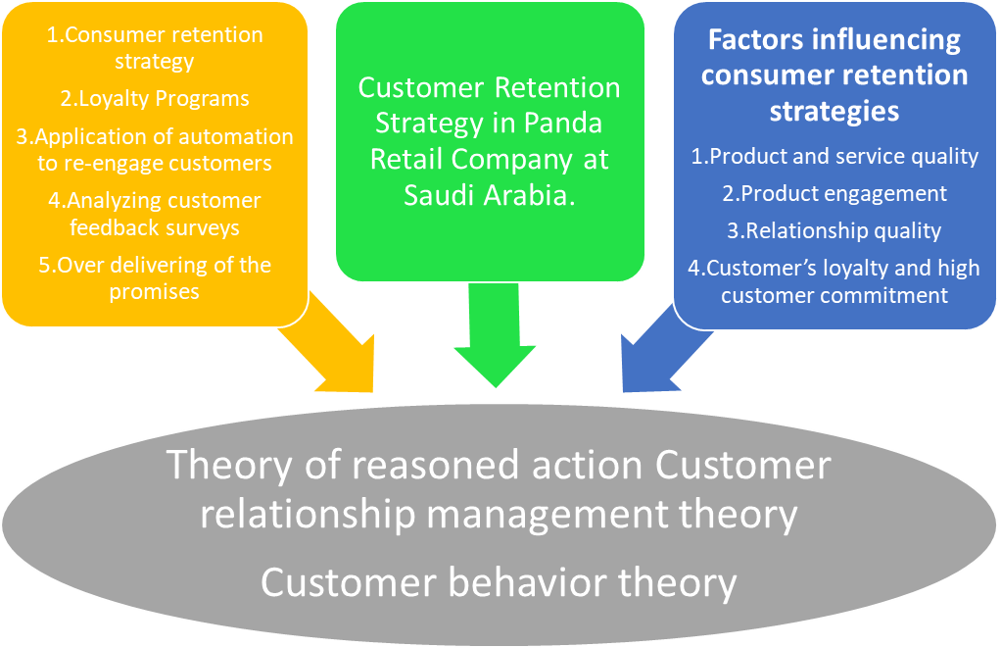
Figure 2.1: Conceptual framework
Source: (Dragnea and Mihaita, 2017)

2.11 LITERATURE GAP
Since analyzing a large amount of available literature, it was discovered that the majority of previous research on consumer satisfaction concentrated on convenience outlets that only compete with high-end consumers and sell a single product. The main motivation for this project is that, until recently, the idea of retail stores was not well known, and there were just a few stores scattered across the world. Furthermore, such shops sell items that are only accessible to those with a high salary. This has created a gap in the retail industry because none of the survey has taken into considered stores with a large and diverse product range that provide to the demands of various consumer groups, ranging from low-income to high-income consumers.
Various research conducted on the link between service quality, customer satisfaction and loyalty, as well as customer retention(Gustafsson et al., 2005). None of the reports has made on the link between promotional benefits, service quality, factors influencing for frequent visits, customer loyalty, which influence customer behavior and finally lead to customer retention. The connections between each dimension inside the two instruments have yet to be investigated. In order to retain a consumer, service providers must evaluate their customers' perceptions and expectations about the quality of their services. This study aims to address a knowledge gap in the field of service quality. In the context of the Panda retail company, it investigates the aspects of consumer retention, which are influenced by a variety of factors. The study chose Dammam - Saudi Arabia, which is one of Middle East’s booming country, which is classified as third richest country in Middle East. As a result, the proposed work fills the void by conducting research on retail competitors, which not only sell a diverse range of goods but also provide a diverse consumer base in terms of nationality. There is a scarcity of research on multi-product marketing. The proposed study assesses the effectiveness of these stores' retention strategies, which rely on multi-product marketing to draw and maintain a diverse range of buyers. Furthermore, since separate stores were chosen from Dammam, the buying habits of various consumers of various lifestyles.

2.12 SUMMARY
Consumer retention refers to a set of carried activities that focuses on turning first-time buyers into long-term, repeat customers to increase business profitability and customer lifetime value. The retention approaches include surprises through customer services, setting customer expectations, building trust, application of automation or re-engaging customers, analyzing customer feedback surveys; over deliver the promises, measuring customer lifetime value. The factors that influence consumer retention include product quality, relationship quality, customer commitment, product engagement, branding, cost switching, price perception, service quality, consumer satisfaction, consumer loyalty and trust and responsiveness, and others.

CHAPTER 3 - RESEARCH METHODOLOGY

3.1 OVERVIEW
Both the information increment method and research have related terminologies, and it may be argued that hard research will assist in growing an individual's knowledge of any subject or issue. New awareness is created by breaking down a topic into various layers in terms of different measurements, and the demand for analysis for this reason is enormous (Jonker and Pennink, 2009). Hence, it can become apparent that research and expertise have a beneficial relationship. Furthermore, research is a systematic and scientific approach to gathering knowledge on mentioned topics. This data is often associated with a set of parameters and precise goals.
Gathering facts is the baseline for research, and looking for anything different is an up to date equivalent. Because of this, further investigation, new attempts could be made to advance information, or assumptions could be drawn. Therefore, the results of analysis arise from different viewpoints. Discovery and innovation is most impactful when accompanied by strong evidence. It encourages society to have something different and fresh, thus empowering the researcher to have something unique(Neuman, 2017).
In the chapter on research methods, the development of hypotheses and the use of different available testing options are discussed. Here, I am represents my own thinking pattern as well as to the readers. With the support of study methods, the researcher's attitude toward the subject matter can be quickly established, and chosen research approaches can be justified with a study paper.

3.2 RESEARCH PHILOSOPHY
Various types of research philosophies have become apparent in a proper way with the support of Objectivism, realism, constructivism, interpretivism, and positivism stand key existing substitutes for the investigator to apply to the study to improve the material consistency. It is necessary to agree that the topic and research philosophy selections are inextricably linked. It can be categorically determined that obtaining the required results is difficult when the research philosophy is not in accordance with the topic chosen, and, more importantly, when the research resource is not properly used. The study's goal is to identify the most common consumer retention strategies in the Saudi Arabian retail market, as indicated by the subject. The study has also identified the retail industry and its category.
The whole research revolves around Saudi Arabia’s retail market. Therefore, the study's aim is to assess the effects of retail store’s customer retention strategies on consumer purchasing behavior and to investigate various variables that could effect on customer retention strategies of companies in the retail sector. Hence, the interpretive science theory is the most important research philosophy. The central tenet of interpretive philosophy is that it considers the reality in the context of the case and the surrounding environment. Interpretive theory is characterized by dynamism. Furthermore, the subject matter is highly competitive, since consumer retention tactics for businesses in different contexts can never be the same. It helps the investigator to focus on the interpretive research philosophy(Krishnaswamy et al., 2009).
The main argument for expending the interpretive analysis philosophy is that sometime a straightforward truth necessitates a thorough examination from various angles since it has too many secret meanings. Therefore, the study was able to work with a variety of thinking patterns as well as gaps in company strategy. It is obvious that no two firms will have the same consumer retention policy, but this assumption alone reinforces the interpretive analysis philosophy. The explanations for the selection of specific strategies were studied and critically analyzed using interpretive study philosophy. The theory of interpretive analysis is characterized by openness.
A number of other factors support the use of interpretive research theory in the present analysis. In the current situation, the scope of subject matter is also essential (Ragab and Arisha, 2018). However, the research is somewhat limited since it only covers one aspect of management Example: Customer retention strategy. However, the range of consumer experience and behavior is still very broad. It is something that makes companies to rethink their plans. Therefore, the researcher must first comprehend the customer's attitude before moving on to the subject of retention.
Companies would never be able to retain their customers if they do not deeply examine the host country's cultural traditions. Companies in the retail industry can have good retention plans, although it varies depending on the case. Therefore, interpretive analysis theory is well suited to the current research paper. Furthermore, it is necessary to recognize that the business in this case is not precise; it provides to a wide range of companies, including both Saudi Arabia and international companies operating in the Saudi Arabian retail industry (Khan, 2011). Hence, this component expands the reach of interpretive analysis philosophy's application. Customers are attracted to company based on their philosophies and strategies. Therefore, the general phenomenon could not be studied in this case.
The usage of interpretive research theory is supported by this study. The researcher's aim is not to discover any new theories, which is a key component of the interpretive philosophy. Moreover, it is seen in some fields of research methodology. Furthermore, the socioeconomic and culture of Saudi Arabia should be taken into account in order to comprehend retail sector strategies. The foundation or impact of Saudi Arabian culture on strategic decision-making has been established. It is simpler to create a connection between local cultural values and the cultural values of other countries with the aid of interpretive analysis theory. Via interpretive research theory, the disparity among the attitude of local companies and outside retail companies against the behavior of Arabian customers was also understood. The study was able to approach the subject from an open mind, seeing both details and facets from environmental standpoint instead of an over-all perspective. Generally, interpretive science theory has acquired prominence in order to obtain a broad range of insights and to shelter light on various scopes relevant to the present topic material.

3.3 RESEARCH APPROACH
The researcher's judgement about which study methodology to use is entirely based on how researcher approaches the subject matter. There are two types of research approaches: inductive and deductive testing. Both research methods are entirely different in terms of design and applicability(Taneja, 2007). The study has chosen the inductive method because it supports in justifying the study's subject matter and ultimate goal. The subject clearly refers to the detection of consumer retention techniques in the Saudi Arabian retail industry. Therefore, the researcher has the opportunity to investigate the Saudi Arabian retail market. Since the deductive method does not rely on the existing case, it is impossible to observe the specific argument or situation. On the other hand, the inductive approach enabled the researcher to concentrate on observing current consumer retention techniques in the Saudi Arabian retail market.
There are varieties of explanations that necessitate the usage of an inductive technique, and it encourages the researcher to adopt the aforementioned analysis method. Another explanation is that the market world and its different facets are derived from societal contexts while developing long-term consumer retention strategies. Hence, an inductive method should be used to research social perspectives and observe them closely. The finding could be as deep as the retail market, and its growth could be determined in part by consumer retention challenges.
The research becomes quite useful, and careful evaluation assisted in the discovery of certain very appealing and interesting information regarding company’s competitive positions and decisions. Furthermore, the pre and post-customer behavior observations by identify patterns and anomalies, offered a chance or incentive to identify the effect of different customer retention tactics. Therefore, the researcher had a broad reach to observe the elements with the aid of the inductive method, and validated the correct inference later (Zangirolami-Raimundo et al., 2018).
Since most companies have been part of the research because of the extensive industrial inquiry or discovery, there is a strong need for versatility, which can only be met using an inductive method. Furthermore, since the study's key goals is to learn about consumer engagement techniques developed by retail sector companies, there is no way to generalize the results to a specific segment of society because the research focused on the retail sector and one specific aspect of it.

3.4 RESEARCH TYPE
It requires the study's total scope. The study style is determined by the type of evidence and knowledge gathered and most specifically the research analysis methods used by the researcher. Since it is essential for the analysis method that data be obtained in a responsible manner, the research style plays an important role in ensuring the study's reliability. It is necessary to recognize that there are three forms of research: qualitative, quantitative, and a combination of both qualitative and quantitative. These three categories of study are distinct in nature, and their contributions are distinct. The qualitative method is used when a researcher wants to calculate feelings or other factors that cannot be calculated numerically. Quantitative attributes are those that can be calculated in terms of percentages(Rahi, 2017).
As previously said, both data collection and data analysis are inextricably linked to the report's qualitative or quantitative existence. Hence, I have used a quantitative method. Therefore, the data processing methods used here are more complex and reliable. Statistical instruments have been in conjunction with secondary data processing. Within this report, there is logical and numerical details included because of the quantitative aspects of the research, a wide range of data was collected.

3.5 RESEARCH DESIGN
The current study uses a descriptive research design and the researcher is able to thoroughly examine the characteristics and information, and more significantly, the researcher is able to gain a thorough understanding of consumer retention techniques and their effects. The researcher concentrated on the Saudi Arabian retail market and discovered fascinating data about consumer behavior using a descriptive analysis design. Therefore, it supports in determining positive or not retail companies' current consumer retention tactics are efficient. Hence, the descriptive analysis architecture included a wide range of measurements.

3.6 SAMPLING
The researcher uses participants' gender or age demographic. It is a very complicated aspect of the whole study phase because it has the potential to influence the findings and conclusions. If the researcher estimates the respondents incorrectly, the outcome would be an inaccurate inference, which may detract from the overall purpose of the study. Hence, it is true that sampling has a significant effect on maintaining the report's accuracy and authenticity(Etikan and Bala, 2017).
It is more convenient to reach ordinary citizens, and their answers are mostly focused on verifiable evidence and real incidents or occurrences. It may assist in the collection of various types of data. The same element will amplify the finding significantly. Hence, these are some of the major factors that affected the researcher's decision to use random sampling in the current sample.
As stores are located at different location in Dammam, I have concentrated on the areas surrounding the retail stores. Hence, the universe for this analysis is described as the population living near retail stores. The researcher targeted 20 questionnaires to consumers at the stores under research. There were 205 authentic and fully completed questionnaires received. There is a large range of respondents that will assist in gathering appropriate knowledge. The participants responded to questions about the company's plans and their relationships with customers.

3.7 DATA COLLECTION
The entire study phase is data processing or the collecting of valuable knowledge is the most important process of paperwork. It is to agree that, by data collection, the researcher will quickly arrive at his or her conclusions, and that the conclusion can be reached quickly. If the data collection process is not done correctly, it may have a negative effect on the report's accuracy and the job can never be finished with simplicity and perfection. The basis of the data collection method has been laid down by sampling. It is to recognize that sampling supports in the identification of the population group from which data must be obtained. It also helps with determining how many participants are expected to take part in the testing project. Therefore, sampling must be given a great deal of thought before moving on to the data collection phase(Shukla, 2018).
In this case, the conversations took place until the evidence was gathered. The researcher is aware of the sample size and target demographic in advance. It allows a researcher to step in the right direction while still ensuring that the path is visible. It is even possible to reduce the amount of uncertainty. These data collection approaches aid in the collection of data in a different ways (Singh and Mangat, 1996).
The test is well designed, and it has a number of questions on consumer satisfaction. The department stores and their different measurements have been thoroughly evaluated. The questionnaire contained queries that could be used to assess consumer perceptions of department stores and their buying habits. There were 19 questions were created to provide a connection between consumer satisfaction and the factors that influence it. Furthermore, questionnaires used a 10-point Likert Scale that closed-ended questions. Online methods were used to gather data. Participants in the online mode completed an online questionnaire that was delivered to them. Researcher conducted a comparative review by contrasting the analysis of secondary data using both primary and secondary sources of data collection. It supports in the collection of comprehensive and broad-spectrum information in a suitable manner (Peter et al., 1999).
In the current situation, the researcher has concentrated on indirect sources of data collection in order to gather data that has already been written or presented. Textbooks, newsletters, prior experiments, internet browsing, and academic papers were used as secondary references in this analysis. The systematic use of research trials and web publications has gotten a lot of attention as well. All of the secondary sources were genuine and credible, and they provided us with accurate facts. As a result, the latest research has centered on both main and secondary data sources(Brink et al., 2018).

3.8 DATA ANALYSIS
Another important segment that the researcher gained a lot of thought in this one. A portion justifies the whole analysis and provides a solid foundation for it. To come at a decision, it is critical to choose the right and most suitable data analysis process. Study can begin with a detailed logical approach that provides the researcher with a framework through which the person being studied can determine what should be considered and why. When playing out case studies, two traditional legitimate structures may be explicitly tended to by creating fanciful proposals and having a case image(Hollweck, 2016).The thesis could never be finished without the data review portion(Albers, 2017). Quantitative data processing method has been used to analyze the collected data. For quantitative analysis, numerous statistical tests have been used to analyze numeric results. Cronbach's alpha measures was used to determine the reliability of multiple-question Likert scale surveys. These questions assess implicit variables, hidden or unobservable, such as a person's conscientiousness, neurosis, or transparency. In actual life, these are very challenging to quantify. Cronbach's alpha determines how strongly collections of test objects are associated(Cronbach, 1951). To begin, the Cronbach Alpha test was performed on the collected data to determine its reliability. The quantitative data was then analyses using statistical tools SPSS using paired t-tests, multiple correlation and regression analysis.

3.8.1 Statistical Package for Social Science (SPSS)
The Statistical Package for Social Science (SPSS) is a statistical package that is used to analyze quantitative data statistically. SPSS Inc. was the company that first created the program. It was purchased by IBM in 2009 and it was renamed IBM SPSS Statistics in 2014. It was originally designed for social science research, but it has since acquired favor in other sectors such as marketing, health science, mining and market research.
This program is frequently used in social science for statistical analysis, notably in research and teaching. SPSS, on the other hand, has a lot of potential, which is why it is so popular among survey companies, health care researchers, market researchers, big data specialists, data miners, and the government. This program not only does statistical analysis but also data administration, making it easier for users to choose cases, produce derived data and reshape files. Furthermore, SPSS is great for data documentation, since it allows you to maintain a metadata dictionary with the data file.

3.9 ETHICAL CONSIDERATION
When undertaking the study, the researcher must consider a number of ethical considerations that will maximize the spectators' and other social participants' confidence in the research method and its outcomes. These legal considerations must be adhered to on a massive scale, since they support in the report's full validity. It is not an exaggeration to conclude that the content of the study and ethical issues are inextricably linked. However, in a general sense, ethical considerations are relevant to a researcher's work that is sincere and authentic while excluding unethical practices. The researcher can never achieve the desired outcomes and can never gain the confidence of academic fraternities if ethical considerations are not followed within the study(Sekaran, 2003).
Furthermore, secondary data ethics were specifically adhered. Finally, many of Griffith College's protocols were followed with honesty and confidence. The study has diligently maintained that the college reputation is not harmed at any circumstances at any point in time or place.

3.10 RELIABILITY AND VALIDITY OF THE STUDY
The research's credibility and feasibility are the most important aspects of the whole investigation. The researcher must ensure that the report is trustworthy and that the findings are accurate. Consequently, the results and knowledge must be reliable on a massive scale. The most significant move in ensuring the study's reliability, according to this paper was carefully determining the sample size and respondents. It is important to note that the people who took part in the study were knowledgeable about the sector and were frequent customers of the Saudi Arabian retail sector. Hence, it was easy to link consumer behavior to company retention tactics.
Furthermore, the information was gathered in a responsible way. Customers have put in a lot of time to fill out the answers in the most suitable and efficient way(Ciesielska, 2017). In addition, the data processing portion also received particular attention in order to ensure the authenticity of the findings. The methods for data collection must be relevant to the goals and objectives. Hence, the statistical methods and procedures used here were the most appropriate and in line with the study objectives. The study's validity was also assured by the specific uses of different research instruments. Specifically, the combination of the data collection, sampling, and data analysis sections enabled a researcher to concentrate on the report's reliability and validity. Hence, the study's reliability and feasibility have been preserved(Drumwright et al., 2015).

3.11 SUMMARY
The usage of interpretive research theory is supported by this study. The main argument for using the interpretive analysis philosophy is that sometimes a straightforward truth necessitates a thorough examination from various angles since it has too many secret meanings. Hence, the researcher was able to work with a variety of thinking patterns as well as gaps in company tactics. Furthermore, the writer has concentrated on the inductive method since it supports in justifying the study's subject matter and ultimate goal. In addition, the researcher used a quantitative methods approach, drawing on both quantitative dimensions of the sample. Furthermore, the analysis uses a descriptive analysis design. Hence, the researcher was able to thoroughly examine the characteristics and information, and most significantly and able to gain a thorough understanding of consumer retention techniques and their effects.
The random sampling technique has received a lot of attention from researchers as part of the probabilistic sampling methods in the present scenario. The key explanation for using the random sample method was that the researcher wanted to see how ordinary citizens reacted to company retention strategies. On this basis, 205 consumers were chosen to participate in the survey. Finally, quantitative data collection techniques are used to analyze the gathered data and the Statistical Package for Social Science to refine the raw data (SPSS).

CHAPTER 4 - PRESENTATION AND ANALYSIS OF FINDINGS

4.1 OVERVIEW
The researcher used survey questionnaires as a prominent data collection tool while engaging diversified study participants with multi-generational, multicultural and multisector attributes. The survey questionnaire consists of 19 distinct questions to gather adequate information from the engaged group with 205 respondents to understand customer satisfaction and retention attributes, popularity, branding efforts and bottom-line activities regarding Panda Retail's customer interaction and customization policies. The researcher has selected a random sampling method and primary data collection for quantitative data analysis while gaining consumer insights with open and close-ended questionnaires from the study participants. This data analysis section is significantly important to maximize research credibility and accountability by supporting and justifying research hypotheses with authentic opinions and preferences from a diversified consumer base.

4.2 DATA ANALYSIS AND INTERPRETATION
GENDER
Table 4.1 Gender Analysis

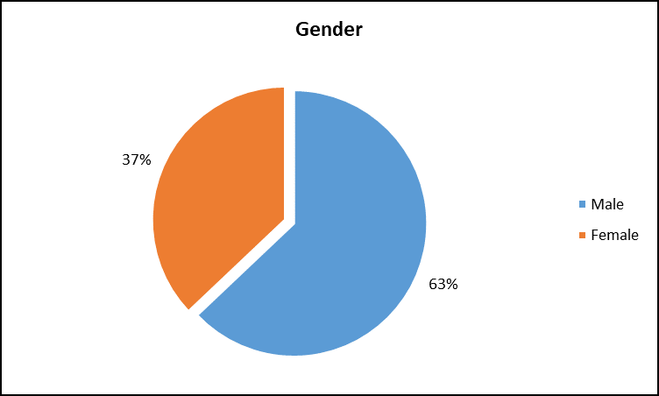
Figure 4.1: Gender Distribution
The gender breakdown of the responders are seen in Figure 4.1. From the above illustrate, it can be observed that out of 205 participants, 63% were male and the remaining 37% were female customers. The rationale for this distribution is because this retail stores provide a wide range of products, including groceries, fast moving consumer goods (FMCG) and perishable items like local produce items(Vegetables and Fruits) which are often bought by family persons. As a result, the proportion of male respondents are bigger than that of female respondents.
AGE
Table 4.2 Age Analysis

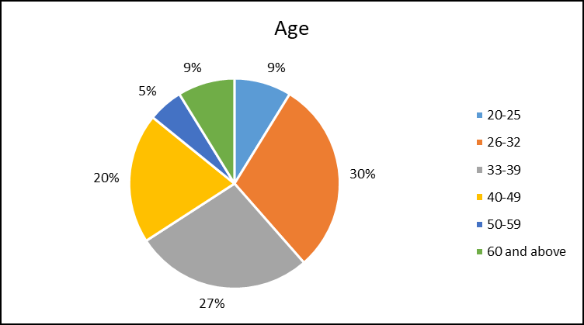
Figure 4.2: Age Distribution
The age distribution of the survey participants is shown in Figure 4.2. From the graph, it can be seen that 9% of the 205 participants are between the age of 20 to 25, 30% are between the age of 26 to 32, 27% are between the age of 33 to 39, 20% are between the age of 40 to 49, 5% are between the age of 50 to 59 and remaining 9% of the respondents are in between 60 and above. As a result, a higher percentage of middle-aged people are consumers of such retail shop. The explanation for this is the income level of adults in their youth and middle age. These individuals are self-dependent and have sufficient disposable income. The percentage of elderly people is quite low when compared to middle-aged (77% Cumulative of 26-49 age) people.
NATIONALITY

Table 4.3 Nationality Analysis
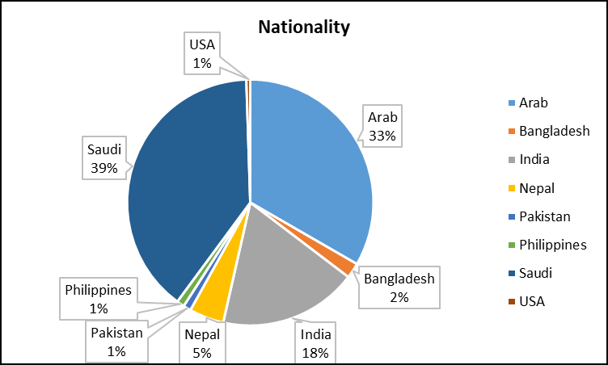
Figure 4.3: Nationality Distribution
The above Figure 4.3 shows that Participant’s nation wise Distribution, It can be seen that out of 198 participants, 39% were Saudi nationality customers while 33% were Arab nationality customer, 18% were Indian customers and remaining 8% were from different nationality customers. The reason for this distribution is most of Saudi and Arab nationality customers are adequate for local product range and traditional range of items. The percentage of other nationality customer is quite low due to lack of product range for other nationality customers.

COMMUNICATION CHANNEL
In today's business environment, most retail companies have created some kind of customer retention strategy to attract both new and existing consumers. However, just inventing new schemes would not help retailers; they must successfully market them to their consumers. Customers would not contact the retail shop if they are not aware of the various schemes and retention incentives and so the schemes will not fulfil their objective. So, in today’s business have a variety of opportunity to bring the awareness to consumers through social platforms, telemarketing, SMS, e-mail flyers, newspaper advertisements, television commercial.
Table 4.4 Communication Channel Analysis
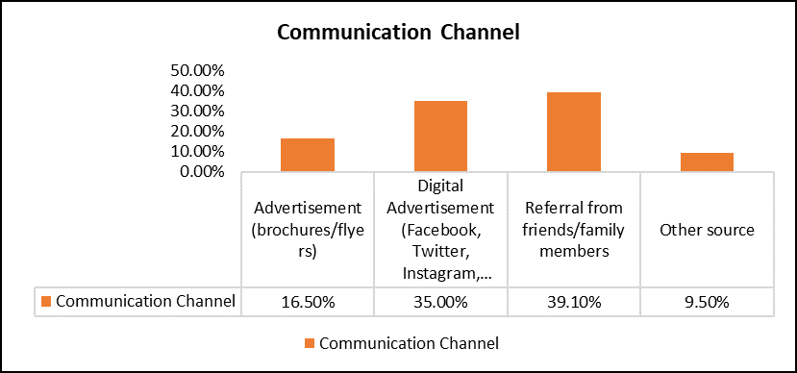
Figure 4.4: Communication Channel Distribution
If the offers are successfully advertised to customers on time, customers will be attracted to the retail shop. Furthermore, good communication will support the retail business in attracting consumers from other retailers, so gaining its consumer base(Rajagopal, 2011). Figure 4.4 demonstrates that 39% of respondents get referrals from friends and family members that their preferred retail outlets' schemes and offers are effectively conveyed to them on a regular basis. On the other hand, 35% of respondents came across about the retailer via digital advertisements (social media), 17% respondents known about schemes and offers thru advertisements (brochures/flyers) and the remaining 10% participants known by other sources of communication that will look at below table.
OTHER SOURCE OF INFORMATION
Table 4.5 Other Source of Information Analysis
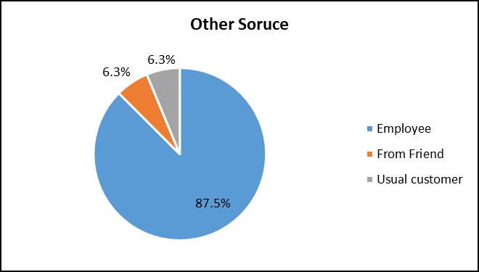
Figure 4.5: Other Source of Information Distribution
The above graph illustrates those other sources of information aware of retails. Out of 16 participants, 14 were employees of retailer, 1 from friend and remaining one is as usual customer.
SHOPPING DURING REGULAR PRICE
Customers that visit retail outlets regularly have greater knowledge about the shop than those who visit occasionally; therefore, the frequency of visit is also significant for the researcher to consider.
Table 4.6 Time spending Analysis
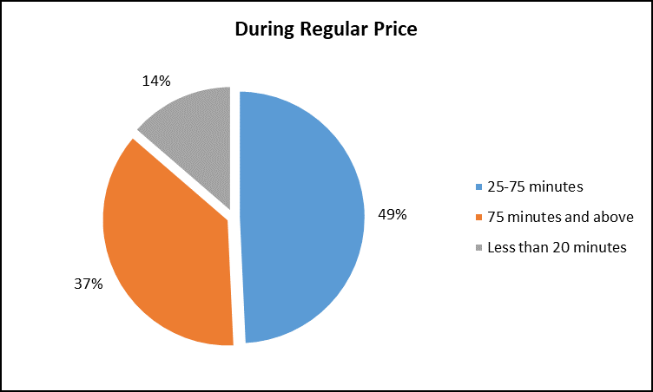
Figure 4.6: Time spending Distribution
If the customers are spending the time during regular price at retail store, they can provide accurate and reliable data about the retail store, as generally they are not worried about price. Figure 4.6 demonstrates that 14% of respondents spend less than 20 minutes at the shop, while 49% of respondents spend between 25 and 75 minutes and remaining 37% of participants spend more than 75 minutes in each visit in the retail shop, which shows that customer would not prefer to shop and spend more time during regular price.
SHOPPING DURING SPECIAL OFFER
Since the study wants to measure the success of the offers by studying consumers' buying patterns during special offers, it is critical to figure out how much time they spend on special offer. The researcher can be able to determine, if such offers are appealing enough to attract consumers to return to the retailer on a regular basis.
Table 4.7 Time spending Analysis
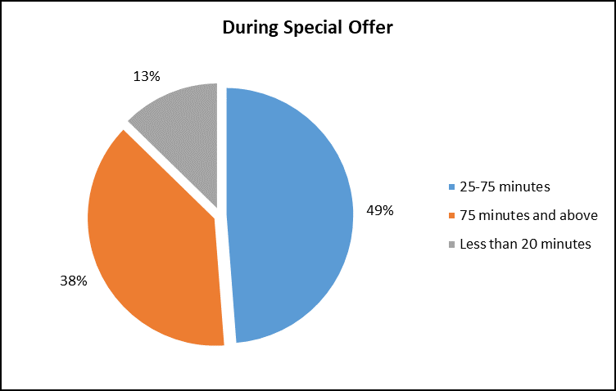
Figure 4.7: Time spending Distribution
It was chosen by the researcher to measure how much time customers spent during special offers. Figure 4.7 shows that 13% of consumer spend less than 20 minutes in retail shops, while 49% spend between 25-75 minutes and remaining 39% of shoppers spend more than 75 minutes at retail establishments. This demonstrates that retail establishments may attract consumers via retention schemes, the average time spent by a consumer at regular pricing 37%, but it has increased to 39% in 75 minutes and more during the special offer period, which would indicate that retailer still need to improve the customer retention schemes in effective way.
VISITS DURING REGULAR TIME
Customers that visit retail outlets often have better understanding about the shop than those who come less often, therefore the frequency of visit is also significant for the researcher to consider. The correlation this with other variables can be seen under statistical analysis section below.
Table 4.8 Regular Visit Analysis
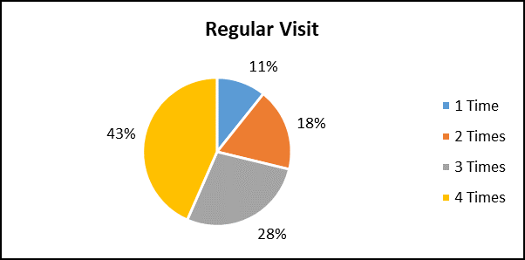
Figure 4.8: Regular Visit Distribution
Figure 4.8 illustrate that 43% of participants visit a retail outlet 4 times a month, whereas 28% of participants visit 3 times a month. Furthermore, 18% of respondents visit the retail shop twice a month and remaining 11% visit once a month.
VISITS DURING FESTIVAL OFFER
It is critical to estimate the number of visit during festival offer in a month (During Ramadan, Eid Al-Adha, Dates festival (heritage activity), etc.) because the researcher wants to analyze the purchasing patterns of consumers in order to estimate the efficacy of the offers that provide by retailers. The researcher can be able to determine whether such offers are appealing enough to attract consumers to visit to the retailer on occasionally.
Table 4.9 Festive Visit Analysis
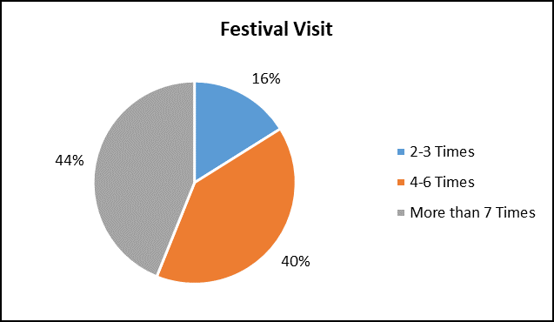
Figure 4.9: Festive Visit Distribution
This question was chosen by the researcher to determine the number of times consumers visited in a month during festival offer. According to figure 4.9, 16% of consumers visit retail outlets 2-3 times a month, while 40% visit participants visit 4-6 times a month. Moreover, 44% of consumers visit the retail shop more than 7 times in a month. This demonstrates that retail shops may attract consumers via festival offers and schemes, since the average number of visits per customer was 4 times during regular time, while it grew to more than 7 times during festival time in a month.
FACTORS INFLUENCING FOR FREQUENT VISIT
In Earlier, customers used to purchase the items from convenient store, which is handling all the service by single person. However, with the passing of time, there has been a significant change in purchasing patterns and consumer prefer retail stores that give shopping comfort. This is why the number of retail store is expanding with each passing day. Customers evaluate a variety of aspects while making purchases, including price, brand, quality, and service.
Table 4.10 Factors Influencing Analysis
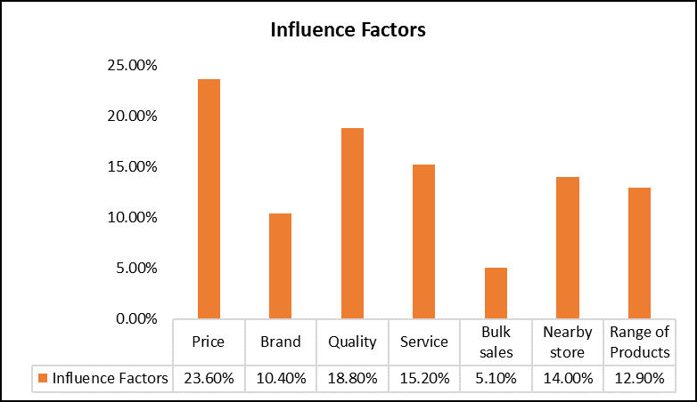
Figure 4.10: Factors Influencings Distribution
There are many factors playing a role in attracting consumers to retail stores. Table 4.10 reveals that, among all the elements that price, quality and service provided by retailers are the primary reasons for consumer visits to retail outlets. Figure 4.10 shows that 24% of 205 participants attracting for price, 19% of respondents influenced for quality, 15% of respondents were attracted for service category, 14% of participants visit the retail store because of store located near to their locality. 13% of participants were visiting the store for range of product they get under one roof, 10% of respondents were visited for brand conscious and remaining 5% of the respondents said that they prefer for bulk sales.

PREFERENCE OF PRODUCT CATEGORY
Retail stores used to be super and hypermarkets that influence the customers visit for their preferred product category. Some of these product categories are the Ethnic food, Meat, Fishery & poultry, Produce items and Grocery food and non-food items.
Table 4.11 Products Category Analysis
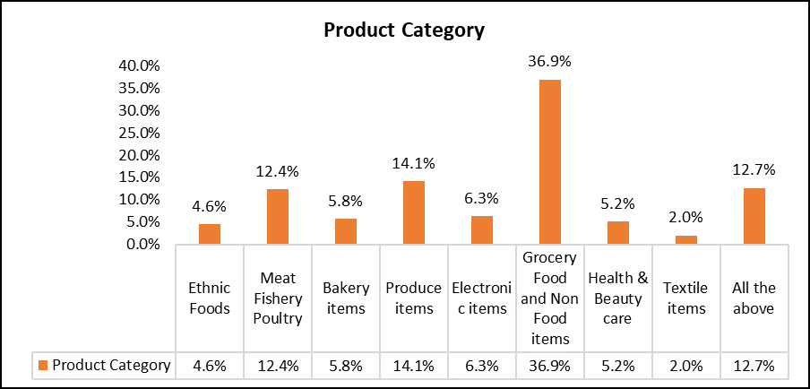
Figure 4.11: Products Category Distribution
Figure 4.11 shows that 37% of the customers were preferred to visit supermarket for Grocery food and Non-food category than any other category of product. 14% of respondents were prefer visit retailer to buy for produce items, 13% of participants were prefer to purchase all category of products at their visits in retail store and 12% of respondents were visit to buy Meat, fishery & Poultry category items. 6% of participants were visit for Bakery and Health & Electronics category respectively. 5% of respondents were visit for health & beauty care and Ethnic products. Remaining 2% of participants visit to buy for textile items.
CUSTOMER SERVICE SATISFACTION RATE
To provide high-quality items with exceptional service, it may need more time. In fact, providing consumers with the best service quality experience is one of the most important aspects in retrieve them. In this respect, retail store must have a trained team to provide outstanding service to all consumers and capable of managing any kind of customer query.
Table 4.12 Customer Service Satisfaction Analysis
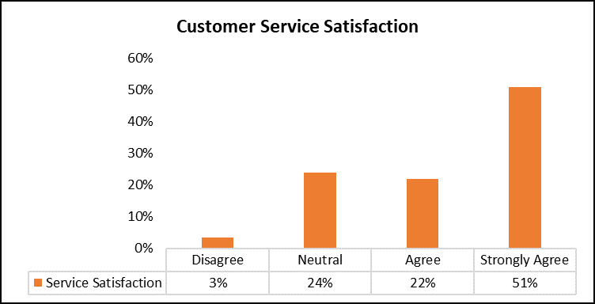
Figure 4.12: Customer Service Satisfaction Distribution
Figure 4.12 indicates that most of the retailer recognize that providing exceptional customer service will give them an advantage over their competitors. According to the results of the survey, 51% of respondents strongly agreed that their favorite retailer provides excellent service quality. None of the respondents believes that their favorite shops are lacking in strongly disagree area. Furthermore, 22% of participants agreed, 24% were neutral and 3% disagreed with the above-mentioned certainty. As a result, providing outstanding service is just as essential as providing quality service and retention programs to keep existing customers and generate new consumers.
RECOMMEND SERVICE/PRODUCTS OF PANDA TO FRIENDS AND FAMILY MEMBER
As human tendency when we find something and like, we prefer to share it with our friends and family. Retail stores can benefit from their loyal customers in this way. Retail stores can earn customer loyalty by offering regular schemes, and these loyal customers will refer their stores to their family and friends, this allowing them to benefit from referral business. Furthermore, it is the most cost-effective method of attracting customers because retail stores do not have to spend any additional money to attract and acquire potential customers.
Table 4.13 Recommend the product/service Analysis
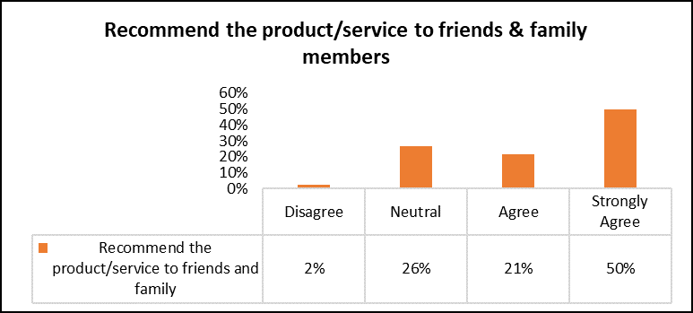
Figure 4.13: Recommend the product/service Distribution
Figure 4.13 shows that the majority of respondents agreed that customer would recommend their preferred retail shop to their friends and family because it gives retailers an added advantage without them having to pay any more money for advertisement. 50% of those polled said they would strongly agree to recommend their favorite shops to a friend or family member. 21% of participants were agreed, 26% of respondents were rated as neutral, 2% disagreed and no participants respond to strongly disagree the above fact.
CUSTOMER OF PANDA RETAILER
Table 4.14 Customer Loyalty Analysis
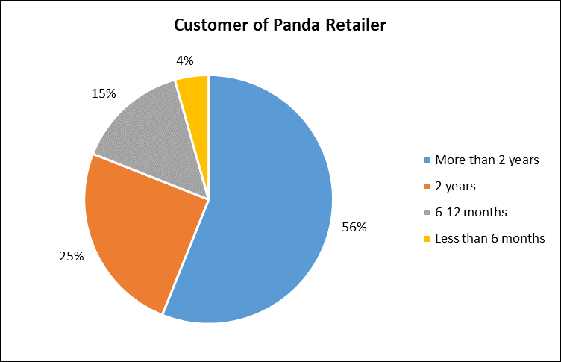
Figure 4.14: Customer Loyalty Distribution
It is critical to choose the right sources while gathering reliable information. If the data gathering sources are not appropriately chosen, the researcher will have incorrect or insufficient information, which will lead to bad conclusions. The researcher attempted to acquire data mainly from loyal consumers for this reason. According to Figure 4.14, 56% of the participants had connected in retail store for more than two years. This demonstrates that people are loyal to a one particular retailer and do not simply switch to another. From the remaining respondents, 25% had been shopping with the same retailer for at least 2 years, 15% were shopping with one retailer for 6-12 months and 4% had been shopping with the same store for less than 6 months.
PANDA CLICK GROCERY APP
New trend with latest technologies, new avenues are popping up that are changing buying habit and behaviors of the consumers. The Panda Click app is the most recent addition to this series. This platform has grown in popularity in recent days, attracting a large number of customers, particularly young and middle-aged people. Almost everything is now accessible online, so that do not have to leave the comfort of house or chair to purchase.

Table 4.15 Panda Click Grocery App Analysis
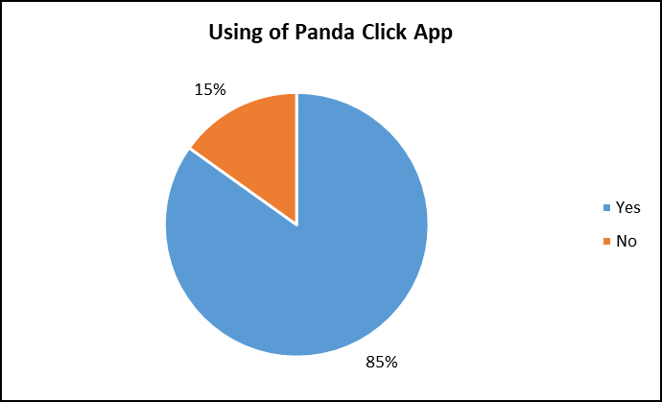
Figure 4.15: Panda Click Grocery App Distribution
The above Figure 4.15 illustrate that nowadays people have inclined towards the online shopping platform. Several online platforms have emerged in the market; as per the above graph, 85% of the respondents using Panda click app as online shopping platform has changed the way they shop and they are now inclining towards it and only 15% of respondents were not using of this app the reason due to data privacy or it contained unfriendly user.
CUSTOMER SATISFACTION RATE OF PANDA CLICK GROCERY APP
Once the online application launched, it is most important to know whether it is effectively using by customers and how satisfied with the application. In fact, providing consumers with the user-friendly application and excellent experience is one of the most important aspects in keeping them.
Table 4.16 Customer Satisfaction Rate of Panda Click App Analysis
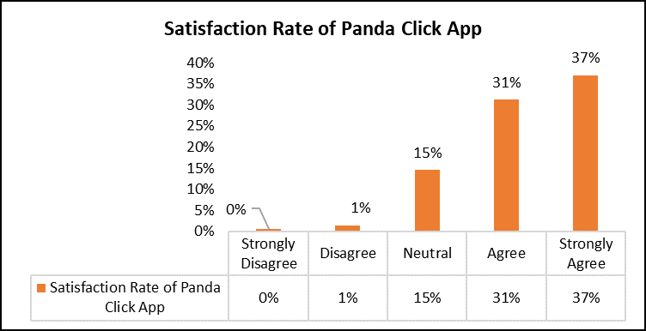
Figure 4.16: Customer Satisfaction Rate of Panda Click Grocery App Distribution
Figure 4.16 shows that most of the retailer recognize that providing exceptional online application will give them an added advantage over their competitors in this pandemic situation. According to the results of the survey, out of 174 participants, 37% of respondents strongly agreed that they are highly satisfied while less than 1% strongly disagree, 31% respondents were satisfied, 15% of participants were considered it neutral and remaining 1% of customers were unsatisfied with application the above-mentioned certainty.
RECOMMEND THE APP TO FRIENDS AND FAMILY MEMBERS
People are more likely to inform their friends and family about something they appreciate or find that is superior. Retail stores can benefit from their loyal customers to use such service provide by retailer. These loyal customers will refer online shopping to their family and friends, this allowing them to benefit from referral program. Furthermore, it is the most cost-effective method to attract and acquire potential customers.
Table 4.17 Recommend the Panda Click App Analysis
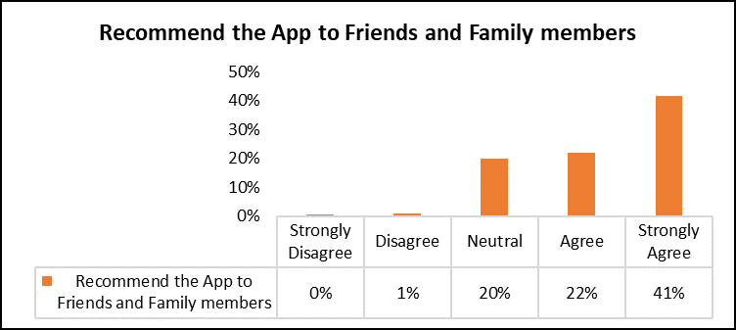
Figure 4.17: Recommend Panda Click Grocery App Distribution
Figure 4.16 shows that the majority of respondents strongly agreed that they would recommend Panda click app to their friends and family because it gives retailers an added advantages without them having to pay any more money for advertisement. 41% of those polled said they were strongly agree to recommend their favorite shops to a friend or family member. 22% of participants were agreed, 20% of respondents were rated as neutral, 1% disagreed and no participants respond to strongly disagree the above fact.
SWITCHED TO OTHER COMPETITORS OF PANDA RETAILER
Table 4.18 Switched to Other Competitors of Panda Retailer Analysis
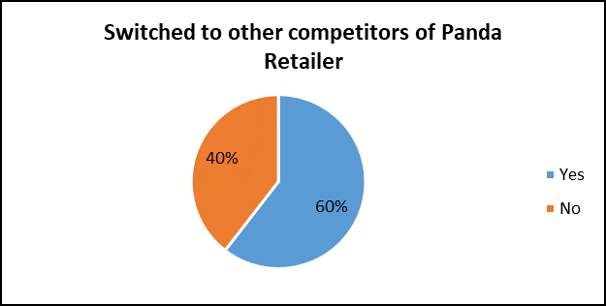
Figure 4.18: Switched to Other Competitors of Panda Retailer Distribution
The above chart illustrate that nowadays people have switched to other competitors due to some reasons. Out of 205 participants, 124(60%) of respondents were polled they switched to other competitors due to some certain reasons while remaining 81(40%) of participants were stick with Panda retailer. Therefore, it indicate that Panda retailer stores have to implement effective customer retention strategies to attract the customers towards to Panda retail stores.
REASON FOR SWITCHED TO OTHER COMPETITORS
Table 4.19 Reason for Switched to Other Competitors of Panda Retailer Analysis
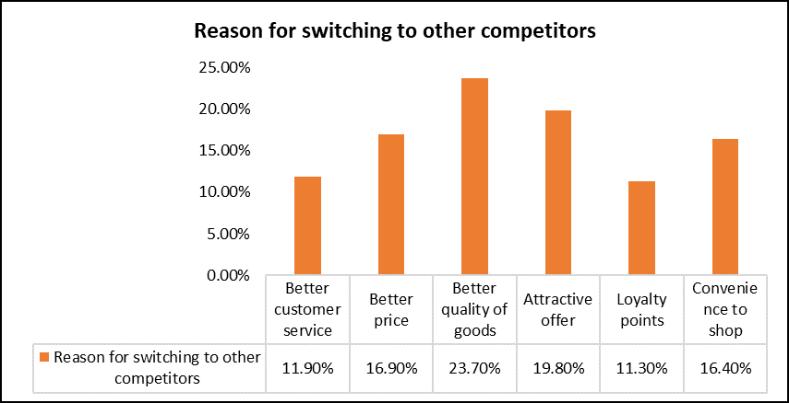
Figure 4.19: Reason for Switched to Other Competitors of Panda Retailer Distribution
Figure 4.19 illustrate that reason for switch from Panda retailer to other competitors. Out of 124 respondents, 24% of participants were finds better quality of goods in other competitors of Panda retailer. 20% of customers were influenced by attractive offer, 17% of participants were responded for better price, 16% were switched for convenience to shop at other retail outlets. 12% of respondents were said for better customer service and remaining 11% of customers were switched for loyalty points.

4.3 RELIABILITY ANALYSIS
Cronbach Alpha Reliability Analysis was used in SPSS to determine if the acquired data was trustworthy and appropriate for the research. Generally, if the Cronbach Alpha is more than 0.70, the data is adequate for research purposes and is regarded trustworthy. The Cronbach Alphas for various data acquired throughout the investigation are as follows:
Reliability analysis of data collected for Time Spending during Regular price and Special offer
Table 4.20
The Cronbach Alpha for spending time is 0.750, according to the data. It indicates that there is a high level of internal consistency and that the data for spending time is related. This demonstrates that the data is reliable.
Item Statistics for Time Spending
Table 4.21

Inter-Item Correlation Matrix for Time Spending
Table 4.22
Item-Total Statistics for Time Spending
Table 4.23
Scale Statistics for Time Spending
Table 4.24

4.4 STATISTICAL ANALYSIS
Following Hypotheses are tested.
Hypothesis 1: Customer retention strategies do not have significant positive impact on sales.
It is determined that more time spending by customer at the retail outlets generate more money by growing their sales thru retention strategy in this study. It will track consumer spending during regular price and special offer when retail shop introduce appealing retention schemes for this reason. The paired t-test was used in SPSS 19 to evaluate this hypothesis. The following are the outcomes of this test:

Paired Samples Statistics for Time Spending
Table 4.25
The descriptive statistics of the obtained data is shown in Table 4.25. Regular spending has a mean value of 1.87, while mean value of spending during special is also 1.87. This demonstrates that the values of the two means are no difference. Table 4.25 also illustrate the standard deviation and standard error mean of the two samples.

Paired samples correlations between Time Spending
Table 4.26
The correlation between the two samples is shown in Table 4.26. The correlation coefficient 'r' comes out to be 0.601, which indicating that the two samples have a positive and moderate relationship.
Paired Samples Test for Time Spending

Table 4.27
Table 4.27 is important in this stage. The mean difference between the two samples is .005, with a standard deviation of .751 and a t-value of .093, as shown. On the other hand, the significance values are the most significant factor to keep in mind. The significance value for this study is .926. As a rule of thumb, the null hypothesis is rejected when the significance value is less than 0.05, and the alternative hypothesis is accepted. This indicates that the difference between the mean values of the two samples is not significant. In this scenario, the null hypothesis is accepted since the significance value is greater than 0.05, indicating that customer retention schemes have no substantial beneficial influence on sales and profit. It implies that special offers must be introduced in a more efficient manner so that consumers spend more time and therefore there is no growth in sales and profit volumes of the retail shops. This demonstrates that there is no discernible difference between regular spending and spending on retention schemes.

Reliability analysis of data collected for Regular and Festival visits
Reliability Statistics for Regular and Festival visits
Table 4.28
The Cronbach Alpha for visits is 0.713, as seen in Table 4.28. It indicates that there is a satisfactory degree of internal consistency and that the data for visits is related. This demonstrates that the data is trustworthy.
Items Statistics for Regular and Festival visits
Table 4.29
Inter-item correlation matrix for Regular and Festival visits
Table 4.30
Item-Total Statistics for Regular and Festival visits
Table 4.31
Scale Statistics for Regular and Festival visits
Table 4.32
Hypothesis 2: Customer retention strategies do not affect the buying behavior of customers in the retail sector.
It is evaluated if introducing any offers results in an increase in customer visits and therefore an influence on their purchasing behavior. Using SPSS 19, a paired t-test was used to evaluate the hypothesis. The following are the outcomes of this test:
Table 4.33
The descriptive statistics of the obtained data are shown in Table 4.33. Regular visits have a mean value of 2.27, but visits during festivals have a mean value of 2.95. This demonstrates that the values of the two means are different. The standard deviation and standard error mean of the two samples are similarly shown in Table 4.33, with N being the total number of counts.
Table 4.34
The correlation between the two samples is shown in Table 4.34. The correlation coefficient 'r' comes out to be 0.590, indicating that the two samples have a positive relationship.

Table 4.35
Table 4.35 is important in this stage. The mean difference between the two samples is -0.678 with a standard deviation of 0.962 and a t-value of -10.093 as shown. On the other hand, the significance values are the most significant factor to keep in mind. The significance value for this study is 1*10-13. As a rule of thumb, the null hypothesis is rejected when the significance value is < 0.05 and the alternative hypothesis is accepted. This indicates that the difference between the mean values of the two samples is significant. In this study, the significance value is <0.05 and thus null hypothesis is rejected that indicating customer retention schemes have a substantial impact on consumer purchasing behavior in the retail sector. Customers are said to visit retail shops more often during festival season, implying that retention programs have an impact on their purchasing habits.

Reliability Analysis of Data Collected for Factor Influencing for Frequent visit
Reliability Statistics for Factor Influencing for Frequent visit
Table 4.36
The Cronbach Alpha for influencing factor is 0.664, as seen in Table 4.36. It indicates that there is a satisfactory degree of internal consistency and that the data for visits is related. This demonstrates that the data is trustworthy.

Inter-Item Correlation Matrix for Factor Influencing for Frequent visit
Table 4.37
Item-Total Statistics for Factor Influencing for Frequent visit
Table 4.38
Scale Statistics for Factor Influencing for Frequent visit
Table 4.39
FACTOR INFLUENCING FOR FREQUENT VISIT
Hypothesis 3: There is no significant difference in factors influencing in customer’s frequent visits.
The factors influencing for frequent visit to Panda retailer are price, brand, quality, service, bulk sales, nearby store & range of product. The subsequent analysis to determine whether or not the listed variables have a significant impact on consumer retention. In order to determine the influence of each component on customer retention, regression analysis was used.
Descriptive statistics for Factor Influencing for Frequent visit

Table 4.40
The descriptive statistics for the various factors evaluated are shown in Table 4.40. There were 205 valid responses for each component, according to it. The standard deviation for all of the variables is relatively low, indicating that the respondents' answers are quite consistent.
Table 4.41
The above table 4.41 shows that there is a positive association between all the variables
Table 4.42
Table 4.43
Table 4.44
The correlation and regression analysis between the Price and factors influencing frequent visits is shown in Table 4.42. The correlation coefficient 'r' is 0.441 as seen in the table. This demonstrates that there is a link between price and the factors that influence them for frequent visits. This implies that when these factors vary, there will be observed frequency of visits. Therefore, it can be concluded that if customers are satisfied, they will become loyal to the retailers, however if they are not, they will shop with other retailer. It is the case with Brand, Quality, Service, Bulk sales, nearby store and Range of Products.
Furthermore, the R square coefficient of regression between price and factors influencing frequent visit is 0.194. This indicates that price, brand, quality, service, bulk sales, nearby store and range of products obstacles have a positive and significant link. Therefore, it can be indicated that if a retail business has a stronger brand image, consumers are more likely to stay loyal to it and the same can be stated for other aspects. The ‘F’ value is 7.959, with a significance value or p-value of 0.000 as shown in Table 4.43. It represents statistical significance of the findings.
Individual variables have a considerable effect on the frequency of visits, as shown in Table 4.44. Table 4.44 shows that, with the exclusion of service, bulk sales and range of products are the significance value for all factors influencing frequent visits is less than 0.05. As a rule, a p-value of less than 0.05 indicates that the independent variable has a substantial impact on the dependent variable. Thus, in this case, all four (Highlighted) elements that is brand, quality, nearby stores and range of product contribute considerably to frequent visits.
CONSUMER PREFERENCE FOR SHOPPING
VISITS DURING REGULAR TIME
Hypothesis 4a: There is no significant difference in the customer preference for shopping in regular time at retailer with respect to gender.
It is evaluated, if customer preference results in an increase in visits during regular time and therefore an influence on their purchasing behavior. Using SPSS 19, a Chi-Square test was used to evaluate the hypothesis. The following are the outcomes of this test:
Table 4.45
Table 4.46
The cross tabulation between the gender and number of visits during regular time is shown in Table 4.46. The P value comes out to be 0.054, indicating that the null hypothesis is accepted. Thus, there is no significance difference in the customer preference for shopping in regular time at retailer with respect to gender.

VISITS DURING FESTIVAL TIME
Hypothesis 4b: There is no significant difference in the customer preference for shopping in festival time at retailer with respect to gender.
It is evaluated, if customer preference results in an increase in visits during festival time and therefore an influence on their purchasing behavior. Using SPSS 19, a Chi-Square test was used to evaluate the hypothesis. The following are the outcomes of this test:

Table 4.47
Table 4.48
The cross tabulation between the gender and number of visits during festival time is shown in Table 4.48. The P value comes out to be 0.142, indicating that the null hypothesis is accepted as it has been found that no significant difference in the customer preference for shopping in festival time at retailer with respect to gender.

TIME SPENDING DURING REGULAR PRICE
Hypothesis 4c: There is no significant difference in the customer preference for shopping during regular price at retailer with respect to gender.
It is evaluated, if customer preference results in time spending during regular price and therefore an influence on their purchasing behavior. Using SPSS 19, a Chi-Square test was used to evaluate the hypothesis. The following are the outcomes of this test:
Table 4.49
Table 4.50
The cross tabulation between the gender and customer’s time spending during regular price is shown in Table 4.50. The P value comes out to be 0.109, indicating that the null hypothesis is accepted. Thus, there is no significance difference in the customer preference for shopping in regular price at retailer with respect to gender.

TIME SPENDING DURING SPECIAL OFFER
Hypothesis 4d: There is no significant difference in the customer preference for shopping during special offer at retailer with respect to gender.
It is evaluated, if customer preference results in time spending during festival time and therefore an influence on their purchasing behavior. Using SPSS 19, a Chi-Square test was used to evaluate the hypothesis. The following are the outcomes of this test:
Table 4.51
Table 4.52
The cross tabulation between the gender and customer’s time spending during special offer is shown in Table 4.52. The P value comes out to be 0.021, indicating that the null hypothesis is rejected. Thus, there is significance difference in the customer preference for shopping during special offer at retailer with respect to gender.

AGE AND GENDER
Hypothesis 4e: There is no significant difference in the customer preferences for shopping with respect to age.
It is determined whether which gender and age group of customers visiting retail outlets make more money by growing their sales thru retention strategy in this study. It will track consumer’s gender and age visiting when retail shop introduce appealing retention schemes for this reason. The Chi-Square test was used in SPSS 19 to evaluate this hypothesis. The following are the outcomes of this test:
Table 4.53
Table 4.54
The cross tabulation between the gender and age group is shown in Table 4.54. The P value comes out to be 0.000, indicating that the null hypothesis is rejected as it has been found that there is significant difference in the customer preferences for shopping with respect to age.

PANDA CLICK GROCERY APP
Hypothesis 4f: There is no significant effect of online shopping app on different age group of customers.
It is determined whether which age group of people are using Panda Click grocery app in this study. It will track consumer’s usage of Panda click app and age group to appealing retention schemes for this reason. The Chi-Square test was used in SPSS 19 to evaluate this hypothesis. The following are the outcomes of this test:
Table 4.55
Table 4.56
The cross tabulation between the Panda Click app and age group is shown in Table 4.56. The P value comes out to be 0.000, indicating that the null hypothesis is rejected as there is significant effect of online shopping app on different age group of customers.
FREQUENT VISIT FOR PRODUCT CATEGORY
Hypothesis 5: There is no significant difference in frequent visit of customers for product category in the retailer.
To determine whether customers are frequently visiting retailer for particular product category in this study. It will track which product category influence the customers to visiting retailer frequently. The One-Sample test was used in SPSS 19 to evaluate this hypothesis. The following are the outcomes of this test:
Table 4.57
Table 4.58
Table 4.54 shows that P-value less than 0.05, indicating that the null hypothesis is rejected as there is significant difference in frequent visit of customers for product category in the retailer.
COMMUNICATION
Hypothesis 6: There is no significant difference in the influence on communication on customer preference for shopping at retailer with respect to ethnic.
To determine which ethnic customers are influenced by communication of schemes for shopping at retailer in this study. It will track which way has effective communication to reach the customers to shop at retailer. The One-way ANOVA test was used in SPSS 19 to evaluate this hypothesis. The following are the outcomes of this test:
Table 4.59

Table 4.60
Table 4.60 shows that P-value less than 0.05, indicating that the null hypothesis is rejected as there is significant difference in the influence on communication on customer preference for shopping at retailer with respect to ethnic.
CUSTOMER LOYALTY
Hypothesis 7: There is no significant difference in loyal customer of Panda retailer with respect to ethnic.
To determine which ethnic customers are loyal to the retailer in this study. It will track which nationality customers are loyal to the retailer. The Chi-Square test was used in SPSS 19 to evaluate this hypothesis. The following are the outcomes of this test:

Table 4.61
Table 4.62
The cross tabulation between the customer of Panda and ethnicity is shown in Table 4.62. The P value comes out to be 0.025, indicating that the null hypothesis is rejected as there is significant difference in loyal customer of retailer with respect to nationality of customers.
SERVICE/PRODUCT SATISFACTION & RECOMMENDATION

Hypothesis 8: There is no significant difference in customer satisfaction level of service/product and recommend it to their friends and family.
It is determined whether the customer are satisfy with their prefer retailer’s service/product and how much they will recommend the retailer’s product/service to their friends and family. It will track customer satisfaction and recommend level. The Chi-Square test was used in SPSS 19 to evaluate this hypothesis. The following are the outcomes of this test:
Table 4.63
Table 4.64
The cross tabulation between the service/product satisfaction level & recommendation to friends and family members is shown in Table 4.64. The P value comes out to be 0.000, indicating that the null hypothesis is rejected as there is significant difference in customer satisfaction level of service/product and recommend it to their friends and family.

4.5 KEY FINDINGS
- It is evident that between 26-49 years (middle age), which is around 77% of customers visited Panda retail stores.
- Gender-wise analysis indicated that 63 % respondents were males and 37 % are females. It is significant that majority of male gender were visited Panda retail stores based on the study.
- It is evident that out of 198 participants, 39% were Saudi nationality customers while 33% were Arab nationality customers, 18% of Indian customers and remaining 8% were from other nationality customers.
- There are various modes available with the retailers to communicate their schemes/offers to the customers such as social media, flyers, commercial ads and many others. Retailers are effectively using such modes to effectively communicate offers to the customers.
- Customer retention strategies have significant positive impact on sales. It indicates that when special offers are available at the store, customers spend more and thus there is an increase in sales volumes of the retail stores. This demonstrate that there is a significant difference in time spending during regular price and special offers.
- On an average, a customer visits the preferred retail stores 4 times a month on regular visits while more than 7 times a month during the festive offer. This shows that retail stores are able to attract the customers through its festive offers as in normal occasion the average visits per customer was coming out to be 4 times while it increased to more than 7 times during the festive offer.
- The four important factors, which influence customer preference shopping at retailer frequently. These factors are Price, Brand, Quality & Bulk sales.
- There are many product category that are attracting customers to visit retail store such as Grocery food and Non-food items(FMCG), Meat fishery & Poultry and produce items, its ambience service delivery.
- A retail store that delivers better customer service are highly liked by the customers in comparison to those, which provide average customer services. In this regards, retail stores need to have a team, which is trained in delivering excellent service to all the customers.
- It is evident that referral from friend and family members influence the consumers to shop in Panda retailer followed by social platforms and advertisement (brochures/flyers).
- The majority of the respondents were associated with the preferred retail store for more than 2 year. This shows that customers are loyal towards one particular retailer and does not drift towards other retailer easily.
- Online shopping has started affecting the customer retention strategies of retailers as online shopping app has started alluring customers towards retailers and as a result, customers have started attracting towards this new shopping app.
- Customer preference has no influence for shopping during regular time & festive time with respect to gender.
- Gender has influence on the consumer preference for shopping in hypermarket with respect to age.
- Online grocery app usage has significant effect on different age group.
- It is evident that customer strongly like and recommend to their friends and family members about service/product of Panda retailer.
- Most of Arab & Saudi nationality customers are loyal to Panda retailer.

CHAPTER 5 - CONCLUSION AND SUGGESTIONS

5.1 CONCLUSION
Various marketing theories addressed in this research study propose that by providing a wide range of items and increasing customer service, retail outlets may provide maximum satisfaction to their consumers. This will help them get an advantage over their industry competitors in today's highly competitive business world, as well as help them achieve long-term sustainability. Customer retention and satisfaction are the essential aspects of success in today’s business environment. Customers can be more satisfied, which may lead to an increase in consumer base. Customers that have been with the company for a long time have been proven less price sensitive. Attracting a new customer costs almost five times as much as keeping an existing customer. Previously, company managers concentrated on initiatives and strategies that would help them gain more customers, and the notion of customer retention was not well known. However, as time has passed, companies have realized that the key to their success is developing consumer loyalty and practicing customer retention.
Customer satisfaction is one way for businesses to gain customer loyalty. Increased repurchase rate, higher price willingness, larger cross-buying potential, lower switching tendencies, and positive referral behavior create the bulk of profit for a company with a large number of loyal customers. A devoted consumer will always offer a reference, both solicited and unsolicited and will always reject the inducement of a competition. Customer retention is particularly critical for retail businesses functioning in Saudi Arabia economy.
Customer retention also refers to the quantity of long-term connections that an organization can sustain. It is a pretty basic and basic notion that if customers are satisfied, delighted, and interacted with on a regular basis, they will coming back to the store. The major goal of a customer retention strategy is to establish a strong consumer base and prevent them from switching to another company for the same product or service.
The current research indicates the following sorts of retention strategies used by Panda Retail stores:
- Implementing a Customer Loyalty Program: Rewarding consumers for repeat purchases is a great strategy to keep them coming back. Discount coupons, reward points, vouchers, early access to the sale, and other types of benefits as possible. If a consumer is loyal to a shop, the company should reward and express gratitude for their decision to choose it over its competitors.
- Sales Promotion: A sales promotion plan is very effective for attracting new customers. Sales promotion techniques should be utilized to encourage customers to make repeat purchases. Rebates or cash back, rewards for repeat purchases, collection schemes, and so on.
- Employee training: Organizations conduct various training programs so that their staffs may easily learn about new products and services, team building skills, social skills, and so on. It will also aid in the reduction of staff turnover. The organization may simply develop an atmosphere of integrity that can be clearly noticed by both consumers and staffs by implementing these sorts of training programs.
- Customer Satisfaction Surveys: Customer satisfaction surveys are the most effective methods for discovering areas where a customer's experience might be improved, as well as determining the demands of consumers. Companies may use several survey methods for this purpose, such as feedback forms, suggestion drop boxes, and so on.
- Excellent Customer Service: In order to keep consumers happy and satisfied, businesses should provide them with exceptional services. It includes on-time delivery, the best after-sales services and touch with consumers and asking about their experience with the product and services, connecting with consumers through social networking sites & emails and providing frequent information on new product and services.
Thus, from the overall discussion it can be determined that customer retention strategy is critical to a retail store's success. In order to maintain and attract new consumers, retail store must use retention strategies. Furthermore, customer retention strategies provide retail outlets with an advantage over Panda retailer and competitors, as well as assisting them in attaining long-term viability in a dynamic business environment. In addition, by developing efficient customer retention strategies, businesses may influence their customers' purchasing behavior and thereby benefits from it.

5.2 SUGGESTIONS
Here are some of the suggestions that Panda retailers should consider while developing customer retention strategies:
- Retail stores should understand that Customer retention schemes are just tools for attracting and holding consumers. However, it is essential for the retailers to emphasis on their operations. Attractive customer retention schemes and loyalty programs will not fulfil their goal if retailers are unable to provide products and services. For example, if a retailer concentrates only on loyalty programs or retention schemes while ignoring the quality of goods and services, it would lose revenue since consumers would seek out other competitors in the absence of substandard goods and services. Customers have evolved into sophisticated customers in today's competitive business world. As a result, retailers should concentrate more on their company operations rather than only reward programs.
- It is not always required for customer retention strategies to be profitable. If such programs are not properly structured and all aspects are considered, providing rewards to consumers may result in a loss. As a result, retailers should create customer retention strategies that can be measured in statistics. Companies will be able to quantify loyalty programs and assess, if they are helpful to the firm or not. If not they can take appropriate steps. Therefore, it is advisable that loyalty and customer retention strategies should be measured.
- It is a technical era. As a result, organizations must adopt technology to develop new customer retention strategies. Companies can extend their global presence due to globalization and technological improvements. In such a business environment, Cloud-based customer retention strategies will show to be the most effective ways for businesses to keep existing consumers and attract new ones. Companies now have many retail stores across the country. Therefore, retention strategies should be founded on technology that allows a company's loyal customers to profit from it in any part of the country. For example, if a consumer is loyal to a shop with several branches throughout the nation, then the customer should be able to take advantage of the retention programs even if customer purchases from another shop of the same retailer in different part of the nation. Companies should employ cloud-based customer retention systems so that all customer information is saved in a distant cloud or cloud-like structure that can be accessible by the business and the customer at any time and from anywhere, allowing them to profit from it.
- Companies are coming up with a variety of inventive strategies to keep and attract customers these days. Designing a loyalty program that allows retail establishments to provide organizations a fundraising campaign utilizing their product, services is a bonus in this respect.
- It is the most effective technique to reduce downtime. Companies should automate time-consuming procedures that need manual involvement so that they can be standardized into repeatable processes. Companies can better fulfil their promises and maintain their customers' networks running at peak performance this way. Companies may boost client loyalty in this method, which will result in higher customer retention rates.
- The retail store's loyalty programs and customer retention strategies should be designed in such a way that they may be changed at any time. Because the business environment is so instable, all retailers must have a flexible business process and such programs.
- Demographic changes were discovered to be the most relevant factors in the changing patterns of consumption in Saudi Arabia throughout the course of this study. Customers gave more importance to availability and range of products.
- The most significant factor that customer looked for was the quality of service and ambience is a secondary consideration.
- It is one of the most effective ways to keep retaining customers. A proactive approach to customer service is known as anticipatory service. Instead of waiting for an issue to arise, businesses could offer anticipatory services. That is, such businesses remove the possibility of an issue arising for their customers. Therefore, businesses should be proactive in their search for methods to prevent issues from occurring.
- Panda Retail must implement proactive and customer-centric retail strategies including portfolio management practices, affordable pricing structure, eco-friendly products and sustainability-conscious operations to gain higher flexibility and consistency in managing fluctuating market demands and technological disruptions.

5.3 SCOPE FOR FURTHER RESEARCH
The current research examines the numerous customer retention tactics used by the Panda retail company to keep consumers. The study's main goal was to see whether the customer retention strategies used by Panda retailer is successful enough to keep their consumers, and whether such efforts have an impact on consumer purchasing behavior. Furthermore, the factors that affect consumer retentions are discussed in this study. In addition to this, the study describes several customer retention strategies used by Panda retailer, compares and contrasts them with those used by other competitors.
A closer analysis of the relationship between occasions or specific times of the year, different ethnic shoppers visiting the mall, and customer’s shopping duration, customer service satisfaction level can provide deeper insights into the reasons for visiting retailer and why malls are especially crowded during specific occasions such as Ramadan, Eid Al-Adan and Christmas, and thus lay the groundwork for future redevelopment.
Despite the fact that the researcher attempted to cover every part of the issue, a few areas were not covered, such as customer acquisition, several other economic sectors, and so on. As a result, other academics will be able to conduct a research in this field, and this work will serve as a springboard for them.
Firstly, this study only deals with the Panda retailer that are located in Dammam region. Thus, in future studies, an academic research can consider other regions and try to find out how other competitors can formulate their retention strategies for attracts the consumer. Furthermore, a relative research can be showed between the retention strategies practiced in Panda retailer and other competitors.
Another area where an academic study can do further research is comparing the consumer retention strategies used by other sectors or businesses, such as healthcare, banking, telecom, e-commerce and so on. The focus of this study is on consumer retention strategies used by Panda retailers. However, some research may be able to identify whether or not all sectors of the economy use comparable practices. On the other hand, why do various sectors use various consumer retention strategies and what are those strategies?

REFERENCE
Alaaraj, S., Mohamed, Z.A. and Ahmad Bustamam, U. (2017) ‘The Effect of Knowledge Management Capabilities on Performance of Companies: A Study of Service Sector’. International Journal of Economic Research, 14, pp. 457–470.
Albers, M.J. (2017) ‘Quantitative Data Analysis—In the Graduate Curriculum’. Journal of Technical Writing and Communication, 47(2), pp. 215–233. DOI: 10.1177/0047281617692067.
Al-Gharaibah, O. (2020) ‘ONLINE CONSUMER RETENTION IN SAUDI ARABIA DURING COVID 19: THE MODERATING ROLE OF ONLINE TRUST’. Journal of Critical Reviews, 7, pp. 2464–2472.
Al-Tit, A. (2015) ‘The Effect of Service and Food Quality on Customer Satisfaction and Hence Customer Retention’. Asian Social Science, 11, pp. 129–139. DOI: 10.5539/ass.v11n23p129.
Arbatani, T. et al. (2019) ‘Modelling Media Entrepreneurship in Social Media: SEM and MLP-ANN Approach’. Available at: https://www.researchgate.net/profile/Saeid-Ghanbary/publication/334231095_Modelling_Media_Entrepreneurship_in_Social_Media_SEM_and_MLP-ANN_Approach/links/5d7e7d69a6fdcc2f0f713450/Modelling-Media-Entrepreneurship-in-Social-Media-SEM-and-MLP-ANN-Approach.pdf.
Ascarza, E. et al. (2018) ‘In Pursuit of Enhanced Customer Retention Management: Review, Key Issues, and Future Directions’. Customer Needs and Solutions, 5(1–2), pp. 65–81. DOI: 10.1007/s40547-017-0080-0.
Bahri-Ammari, N. and Bilgihan, A. (2017) ‘The Effects of Distributive, Procedural, and Interactional Justice on Customer Retention: An Empirical Investigation in the Mobile Telecom Industry in Tunisia’. Journal of Retailing and Consumer Services, 37, pp. 89–100. DOI: 10.1016/j.jretconser.2017.02.012.
Bawa, R., Sinha, A. and Kant, R. (2019) ‘Emerging Mall Culture and Shopping Behavior of Young Consumers’. Advances in Anthropology, 09, pp. 125–150. DOI: 10.4236/aa.2019.93010.
Bhat, S. and Darzi, M. (2016) ‘Customer Relationship Management: An Approach to Competitive Advantage in the Banking Sector by Exploring the Mediational Role of Loyalty’. International Journal of Bank Marketing, 34, pp. 388–410. DOI: 10.1108/IJBM-11-2014-0160.
Brink, H., Van der Walt, C. and Van Rensburg, G.H. (2018) Fundamentals of Research Methodology for Health Care Professionals.
Buttle, F. (2001) ‘Customer Retention: A Potentially Potent Marketing Management Strategy’. Journal of Strategic Marketing. Available at: https://www.academia.edu/10719492/Customer_retention_a_potentially_potent_marketing_management_strategy (Accessed: 26 April 2021).
Carman, J.M. (1990) Consumer Perceptions Of Service Quality: An Assessment Of T - ProQuest. Available at: https://search.proquest.com/openview/9b58a6fed9a03970daaa0c1557ae7bb2/1?pq-origsite=gscholar&cbl=41988 (Accessed: 25 November 2020).
Ciesielska, M. (2017) Qualitative Methodologies in Organization Studies - Volume I: Theories and New Approaches. New York, NY: Springer Berlin Heidelberg.
Cronbach, L.J. (1951) ‘Coefficient Alpha and the Internal Structure of Tests’. Psychometrika, 16(3), pp. 297–334. DOI: 10.1007/BF02310555.
Das, S., Mishra, M. and Mohanty, P.K. (2018) ‘The Impact of Customer Relationship Management (CRM) Practices on Customer Retention and the Mediating Effect of Customer Satisfaction’. International Journal of Management Studies, 5(1(4)), p. 95. DOI: 10.18843/ijms/v5i1(4)/15.
Datta, P., Fraser, P. and Mohamed, L. (2018) ‘An Investigation into the Relationship between Customer Relationship Marketing and Customer Retention: Superstore Retailing Context in Bangladesh’. Journal of Business & Retail Management Research, 13. DOI: 10.24052/JBRMR/V13IS02/ART-03.
Dragnea, M. and Mihaita, N. (2017) Customer Retention, Behavior and Emotions. Available at: https://www.researchgate.net/publication/337274810_Customer_Retention_Behavior_and_Emotions.
Dragnea, M. and Mihaita, N. (2020) Digital Marketing: An Overview. ABMSACADEMY Available at: https://books.google.com.sg/books?id=2lf0DwAAQBAJ&pg=PA39&lpg=PA39&dq=Dragnea,+M.+and+Mih%C4%83i%C8%9B%C4%83,+N.V.,+2020.+Customer+Retention,+Behavior+and+Emotions.+VISION,+pp.1283-1290.&source=bl&ots=fTjUdVYt7v&sig=ACfU3U1Wvy9-vZiTTX2_ellaJXnRpq1GFw&hl=en&sa=X&ved=2ahUKEwim1erUl7TvAhVA73MBHYoeBfwQ6AEwAHoECAIQAw#v=onepage&q=Dragnea%2C%20M.%20and%20Mih%C4%83i%C8%9B%C4%83%2C%20N.V.%2C%202020.%20Customer%20Retention%2C%20Behavior%20and%20Emotions.%20VISION%2C%20pp.1283-1290.&f=false.
Drumwright, M., Prentice, R. and Biasucci, C. (2015) ‘Behavioral Ethics and Teaching Ethical Decision Making’. Decision Sciences Journal of Innovative Education, 13(3), pp. 431–458. DOI: 10.1111/dsji.12071.
Edward, M. and Sahadev, S. (2011) ‘Role of Switching Costs in the Service Quality, Perceived Value, Customer Satisfaction and Customer Retention Linkage’. Asia Pacific Journal of Marketing and Logistics, 23, pp. 327–345. DOI: 10.1108/13555851111143240.
Eid, M.I. (2011) ‘DETERMINANTS OF E-COMMERCE CUSTOMER SATISFACTION, TRUST, AND LOYALTY IN SAUDI ARABIA’. 12(1), p. 16.
El-Adly, M.I. (2018) ‘Modelling the Relationship between Hotel Perceived Value, Customer Satisfaction, and Customer Loyalty’. p. 11.
Etikan, I. and Bala, K. (2017) ‘Sampling and Sampling Methods’. Biometrics & Biostatistics International Journal, Volume 5(Issue 6). DOI: 10.15406/bbij.2017.05.00149.
Factbook, C.I.A. (2020) Middle East :: Saudi Arabia — The World Factbook - Central Intelligence Agency. Available at: https://www.cia.gov/library/publications/the-world-factbook/geos/sa.html (Accessed: 25 November 2020).
Fattahinejad, F. and Gilaninia, S. (2018) ‘Impact of Perceived Justice by Customer Satisfaction on Long-Term Customer Retention’. NG-Journal of Social Development, 7(1), pp. 133–137. DOI: 10.12816/0046780.
Fetscherin, M. (2019) ‘The Five Types of Brand Hate: How They Affect Consumer Behavior’. Journal of Business Research, 101, pp. 116–127. DOI: 10.1016/j.jbusres.2019.04.017.
Fox, E., Montgomery, A. and Lodish, L. (2004) ‘Consumer Shopping and Spending Across Retail Formats’. The Journal of Business, pp. S25–S60. DOI: 10.1086/381518.
Gustafsson, A., Johnson, M. and Roos, I. (2005) ‘The Effects of Customer Satisfaction, Relationship Commitment Dimensions, and Triggers on Customer Retention’. Journal of Marketing - J MARKETING, 69, pp. 210–218. DOI: 10.1509/jmkg.2005.69.4.210.
Han, H., Jongsik, Y. and Hyun, S.S. (2020) ‘Nature Based Solutions and Customer Retention Strategy: Eliciting Customer Well-Being Experiences and Self-Rated Mental Health’. International Journal of Hospitality Management, 86, p. 102446. DOI: 10.1016/j.ijhm.2019.102446.
Hanaysha, J.R. (2017) Journals-Paper Information - American Institute of Science. Jalal Rajeh Hanaysha, Faculty of Business and Management, DRB-HICOM University of Automotive Malaysia, Pahang, Malaysia. Available at: http://www.aiscience.org/journal/paperInfo/ajmr?paperId=3528 (Accessed: 15 March 2021).
Hawkins, D.I. and Mothersbaugh, D.L. (2010) Consumer Behavior: Building Marketing Strategy. 11th ed. Boston: McGraw-Hill Irwin.
Hollweck, T. (2016) ‘Robert K. Yin. (2014). Case Study Research Design and Methods (5th Ed.). Thousand Oaks, CA: Sage. 282 Pages.’ The Canadian Journal of Program Evaluation. DOI: 10.3138/cjpe.30.1.108.
Huete-Alcocer, N. (2017) ‘A Literature Review of Word of Mouth and Electronic Word of Mouth: Implications for Consumer Behavior’. Frontiers in Psychology, 8. DOI: 10.3389/fpsyg.2017.01256.
IGD, R. (2018) Panda Retail Company’s Challenging Q2. Available at: https://retailanalysis.igd.com/retailers/panda-retail-company/news-article/t/panda-retail-companys-challenging-q2/i/19967 (Accessed: 14 April 2021).
Jain, S., Khan, M.N. and Mishra, S. (2017) ‘Understanding Consumer Behavior Regarding Luxury Fashion Goods in India Based on the Theory of Planned Behavior’. Journal of Asia Business Studies, 11(1), pp. 4–21. DOI: 10.1108/JABS-08-2015-0118.
Jonker, J. and Pennink, B. (2009) The Essence of Research Methodology: A Concise Guide for Master and PhD Students in Management Science. Berlin, Heidelberg: Springer Berlin Heidelberg DOI: 10.1007/978-3-540-71659-4.
Khachatryan, H. et al. (2018) ‘Visual Attention, Buying Impulsiveness, and Consumer Behavior’. Marketing Letters, 29(1), pp. 23–35. DOI: 10.1007/s11002-018-9446-9.
Khan. (2011) Research Methodology. APH Publishing Available at: https://books.google.co.in/books?id=8FPMP7vIFtMC&pg=PR3&lpg=PR3&dq=Research+methodology.+New+Delhi:+APH+Publishing+Corporation&source=bl&ots=3j8mXLEefG&sig=3IkPKwi-P99Tp9IAKlRAwBVtnVY&hl=en&sa=X&ved=0ahUKEwik84i7naXPAhUG5GMKHd3EDjYQ6AEINzAG#v=onepage&q&f=false.
Kim, M.J., Lee, C.-K. and Jung, T. (2020) ‘Exploring Consumer Behavior in Virtual Reality Tourism Using an Extended Stimulus-Organism-Response Model’. Journal of Travel Research, 59, pp. 69–89. DOI: 10.1177/0047287518818915.
Kim, M.-K. et al. (2017) ‘Determinants of the Subscription to Bundled Services and Their Effect on Customer Retention in the Korean Communications Sector’. p. 19.
Krishnaswamy, K.N., Sivakumar, A.I. and Mathirajan, M. (2009) Management Research Methodology: Integration of Principles, Methods and Techniques. Pearson Education India.
Kumar, V. et al. (2008) ‘Alternative Perspectives on Service Quality and Customer Satisfaction: The Role of BPM’ Dickson, D. and Ford, R. (eds.). International Journal of Service Industry Management, 19(2), pp. 176–187. DOI: 10.1108/09564230810869720.
Kuruvilla, S.J., Joshi, N. and Shah, N. (2009) ‘Do Men and Women Really Shop Differently? An Exploration of Gender Differences in Mall Shopping in India’. International Journal of Consumer Studies, 33(6), pp. 715–723. DOI: 10.1111/j.1470-6431.2009.00794.x.
Lim, L. (2005) Customer Lifetime Value - The Key To Maximizing Your Profits!. EzineArticles. Available at: https://ezinearticles.com/?Customer-Lifetime-Value---The-Key-To-Maximizing-Your-Profits!&id=112 (Accessed: 26 April 2021).
Magatef, D.S.G. and Tomalieh, D.E.F. (2015) ‘The Impact of Customer Loyalty Programs on Customer Retention’. 6(8), p. 16.
Mooij, M. (2017) ‘Comparing Dimensions of National Culture for Secondary Analysis of Consumer Behavior Data of Different Countries’. International Marketing Review, 34. DOI: 10.1108/IMR-02-2016-0047.
Moriarty, M. et al. (2013) ‘The 2013 Global Retail Development IndexTM Global Retailers: Cautiously Aggressive or Aggressively Cautious?’ pp. 15–23.
Nasrin Danesh, S., Ahmadi Nasab, S. and Choon Ling, K. (2012) ‘The Study of Customer Satisfaction, Customer Trust and Switching Barriers on Customer Retention in Malaysia Hypermarkets’. International Journal of Business and Management, 7(7), p. p141. DOI: 10.5539/ijbm.v7n7p141.
Neuman, W.L. (2017) Understanding Research. second edition. New York, NY: Pearson.
Panda, R.C. (2019) Panda. Available at: http://www.panda.com.sa/stores/dammam/panda-overview?___store=dammam_en&___from_store=dammam_ar (Accessed: 26 November 2020).
Pappas, N. (2016) ‘Marketing Strategies, Perceived Risks, and Consumer Trust in Online Buying Behaviour’. Journal of Retailing and Consumer Services, 29, pp. 92–103. DOI: 10.1016/j.jretconser.2015.11.007.
Parawansa, D. (2018) ‘Effect of Commitment and Customers’ Satisfaction on Relationship between Service Quality to the Customer Retention in Rural Bank in Makassar, Indonesia’. Journal of Management Development, 37, pp. 00–00. DOI: 10.1108/JMD-12-2016-0303.
Peter, J.P., Olson, J.C. and Grunert, K.G. (1999) Consumer Behaviour and Marketing Strategy. McGraw-Hill London.
Peterson, R. and Umesh, U. (2017) ‘On the Significance of Statistically Insignificant Results in Consumer Behavior Experiments’. Journal of the Academy of Marketing Science, pp. 1–11. DOI: 10.1007/s11747-017-0528-7.
Ragab, M. and Arisha, A. (2018) ‘Research Methodology in Business: A Starter’s Guide’. Management and Organizational Studies, 5. DOI: 10.5430/mos.v5n1p1.
Rahi, S. (2017) ‘Research Design and Methods: A Systematic Review of Research Paradigms, Sampling Issues and Instruments Development’. Rahi S, 6(2), p. 5.
Rajagopal, R. (2011) ‘Impact of Radio Advertisements on Buying Behaviour of Urban Commuters’. International Journal of Retail & Distribution Management, 39, pp. 480–503. DOI: 10.1108/09590551111144888.
Ramachandran, R. (2006) Customer Lifetime Value. DOI: 10.13140/2.1.1787.1049.
Ramirez, R. and Selsky, J.W. (2016) Strategic Management : Panda Retail Company. Available at: https://www.studypurpose.com/assignment/710-strategic-management-panda-retail-company.html (Accessed: 4 June 2021).
Rao, G.S. and Abegaz, G.T. (2017) ‘THE ROLE OF RELATIONSHIP MARKETING ON EMPLOYEE JOB SATISFACTION: THE CASE OF ABAY BANK IN DESSIE REGION OF ETHIOPIA’. p. pp.97-111.
Rehman, S. et al. (2019) ‘The Moderating Role of Trust and Commitment between Consumer Purchase Intention and Online Shopping Behavior in the Context of Pakistan’. Journal of Global Entrepreneurship Research, 9. DOI: 10.1186/s40497-019-0166-2.
Reportlinker. (2019) Saudi Arabia Retail Market By Distribution Channel, By Product Category, Competition, Forecast & Opportunities, 2024. Available at: https://www.reportlinker.com/p05793308/Saudi-Arabia-Retail-Market-By-Distribution-Channel-By-Product-Category-Competition-Forecast-Opportunities.html?utm_source=GNW (Accessed: 14 April 2021).
Rita, P., Oliveira, T. and Farisa, A. (2019) ‘The Impact of E-Service Quality and Customer Satisfaction on Customer Behavior in Online Shopping’. Heliyon, 5(10). DOI: 10.1016/j.heliyon.2019.e02690.
Rizvi, D. and Sabir, A. (2018) ‘The Relationship between Customer Satisfaction and Service Quality with Special Reference to the Hypermarkets in Saudi Arabia’. Research in Economics and Management, 3, pp. 162–168. DOI: 10.22158/rem.v3n3p160.
Sashi, C.M. (2012) ‘Customer Engagement, Buyer‐seller Relationships, and Social Media’. Management Decision, 50(2), pp. 253–272. DOI: 10.1108/00251741211203551.
Sekaran, U. (2003) Research Methods for Business: A Skill-Building Approach. 4th ed. New York: John Wiley & Sons.
Sewell, C. and Brown, P.B. (2002) Customers for Life by Carl Sewell - ARBUKz. Available at: https://arekreatif.ga/book.php?id=5SiVOIfcEDgC (Accessed: 26 April 2021).
Shukla, S. (2018) Research Methodology and Statistics.
Singh, R. and Mangat, N.S. (1996) Elements of Survey Sampling. Dordrecht: Springer Netherlands DOI: 10.1007/978-94-017-1404-4.
Sreenivasulu, M. (2017) Trends in Retail Marketing in India. Diplom.De.
Stahl, F. et al. (2012) ‘The Impact of Brand Equity on Customer Acquisition, Retention, and Profit Margin’. Journal of Marketing, 76(4), pp. 44–63. DOI: 10.1509/jm.10.0522.
Stone, M. et al. (2003) ‘The Effect of Retail Customer Loyalty Schemes — Detailed Measurement or Transforming Marketing?’ Journal of Targeting, Measurement and Analysis for Marketing, 12(3), pp. 305–318. DOI: 10.1057/palgrave.jt.5740117.
Taghikhah, F. et al. (2021) ‘Shifts in Consumer Behavior towards Organic Products: Theory-Driven Data Analytics’. Journal of Retailing and Consumer Services, 61, p. 102516. DOI: 10.1016/j.jretconser.2021.102516.
Taneja, P.K. (2007) ‘Research Methodology: Methods & Techniques’. Journal of Services Research, 7(2), pp. 197–197.
Taufique, K.Md.R. and Vaithianathan, S. (2018) ‘A Fresh Look at Understanding Green Consumer Behavior among Young Urban Indian Consumers through the Lens of Theory of Planned Behavior’. Journal of Cleaner Production, 183, pp. 46–55. DOI: 10.1016/j.jclepro.2018.02.097.
The Savola Group. (2020) Savola. Available at: http://annual-report-2019.savola.com/ (Accessed: 14 April 2021).
White, K., Habib, R. and Hardisty, D.J. (2019) ‘How to SHIFT Consumer Behaviors to Be More Sustainable: A Literature Review and Guiding Framework’. Journal of Marketing, 83(3), pp. 22–49. DOI: 10.1177/0022242919825649.
Yadav, D.P. and Sharma, M. (2018) ‘Customer Retention and Customer Loyalty in Public Sector Banks’. 04(09), p. 7. DOI: http://ijream.org/papers/IJREAMV04I0945086.pdf.
Yeşilada, F. and Direktouml, E. (2010) ‘Health Care Service Quality: A Comparison of Public and Private Hospitals’. African Journal of Business Management, 4(6), pp. 962–971. DOI: 10.5897/AJBM.9000314.
Zangirolami-Raimundo, J., Echeimberg, J.D.O. and Leone, C. (2018) ‘Research Methodology Topics: Cross-Sectional Studies’. Journal of Human Growth and Development, 28(3), pp. 356–360. DOI: 10.7322/jhgd.152198.

APPENDIX

RESEARCH QUESTIONNAIRES
Q1.What is your gender?
- Male
- Female
- Prefer not to say
Q2.How old are you?
- 20-25
- 26-32
- 33-39
- 40-49
- 50-59
- 60 and above
Q3.Nationality?
- Saudi
- Arab
- Other
If other, please mention your nationality.
Q4.How long have you lived in the country?
- Less than 1 year
- 1-5 years
- 6-10 years
- More than 10 years
Q5.Which sources of information have the most impact on your shopping decisions at Panda retail outlets?
- Advertisement (brochures/flyers)
- Digital Advertisement (Facebook, Twitter, Instagram etc.)
- Referral from friends
- Other source
If other source, Please mention the name of source
Q6.How many minutes do you spend at the store during regular price (Approximate)?
- Less than 20mins
- 25-75mins
- 75mins and above
Q7.How many minutes do you spend at the store during special offers (Approximate)?
- Less than 20mins
- 25-75mins
- 75mins and above
Q8.How often do you shop at Panda retail shop in a month during regular time?
- 1 Time
- 2 Times
- 3 Times
- 4 Times
Q9.How often do you shop at Panda retail shop in a month during festival time?
- 2-3 Times
- 4-6 Times
- More than 7 Times
Q10.Which of the following would influence you to visit shop frequently?
- Price
- Brand
- Quality
- Service
- Bulk sales
- Nearby store
- Range of Products
Q11.Which of the following product category would you prefer to visit for Panda retail shop frequently?
- Ethnic Foods
- Meat, Fishery & Poultry
- Bakery items
- Produce items
- Electronics and Home Appliances items
- Grocery Food and Non-Food items
- Health & Beauty care
- Textile items
- All the above
Q12.How would you rate customer service of Panda Retail Company?
Not at all Extremely

Q13.How likely are you to recommend customer service of Panda Retail Company to friends/family?
Not at all Extremely
Q14.How long have you been a customer of Panda Retail Company?
- Less than 6 months
- 6-12 months
- 2 years
- More than 2 years
Q15.Are you using of ‘Panda Click’ grocery delivery app of Panda Retail Company?
- Yes
- No
Q16.How likely will you recommend the app to friends/family?
Not at all Extremely
Q17.If “yes", how satisfied are you with the delivery app?
Not at all Extremely

Q18.Have you ever switched to other competitors of Panda Retail Company?
- Yes
- No
Q19.If Yes, Reason for switching from Panda retail store to other competitors?
- Better customer service
- Better price
- Better quality of goods
- Attractive offer
- Loyalty points
- Convenience to shop

