Can research and development expenditures affect firm market value?
An empirical analysis of the ten most valuable companies in the Nasdaq exchange

Research dissertation presented in partial fulfilment of the requirements
for the degree of
MSc in Accounting and Finance Management
Griffith College Dublin

Dissertation Supervisor: George E. Iatridis

Student Name: João Maciel de Alencar
Date of submission 04/06/2021

Candidate Declaration

Candidate Name: João Maciel de Alencar

I certify that the dissertation entitled: CAN RESEARCH AND DEVELOPMENT EXPENDITURES AFFECT FIRM MARKET VALUE? AN EMPIRICAL ANALYSIS OF THE TEN MOST VALUABLES COMPANIES IN THE NASDAQ EXCHANGE, submitted for the degree of: MSc in Accounting and Finance Management is the result of my own work and that where reference is made to the work of others, due acknowledgment is given.

Candidate signature:



Date: 04/06/2021

Supervisor Name: George E. Iatridis
Supervisor signature:



Date: 04/06/2021

Acknowledgements
First and foremost, I would like to thank my mother Maria, my family, and my friends for all their support and love. I could not have done anything without you, thank you for supporting my decision of studying abroad and to give me comfort, always.
To my supervisor George E. Iatridis, my deepest gratitude for all the support and guidance. I have the feeling that George really whips the desire to invest all my life force in the process and embrace the challenge. The almost instant replies made me feel confident that I was not alone, and that I would benefit from the work.
To finalize, thank you to all Griffith College Dublin professors, and staff. Doing a master’s in a language that is not my native was a big challenge, and brought a lot of anxiety. I could not have gone through this without your patience and guidance.

Abstract

Can research and development expenditures affect firm market value?
An empirical analysis of the ten most valuables companies in the Nasdaq exchange
JOÃO MACIEL DE ALENCAR
This dissertation investigates the role of research and development in the financial market of firms. This study shows that the proportion of research and development expenditures is higher for companies high ranked in the stock exchange. The empirical analysis emphasized that innovation and technological changes are drivers for companies’ productivity and growth, and the market appears to rewards companies’ efforts to innovate. The role of research and development for the company changed over the years and the importance of this account for the company is positively associated with the capacity of the firm to grow. This research attempted to contextualize research and development as a fragment of how the firm visionary the future, been the financial market the scale of the innovative aspect of the firm. The sample analysed corroborates with prior studies finding positive relation between research and development, market value, financial market, and residual income, as well as highlighted the importance of governments take part in the development of a solid understanding of the role of research and development to the economy.

Keywords: Research and development, stock market, market value, globalization.

Table of Contents

Candidate Declaration ii
Acknowledgements iii
Abstract iv
Table of Contents v
List of Tables vii
List of Figures viii
1. Introduction 1
1.1 Overview 1
1.2 Research purpose 2
1.3 Significance of the study 3
1.4 Research objective 5
2. Literature Review 6
2.1 Introduction 6
2.2 Research and development an overview 6
2.3 The impact of research and development in the company 7
2.4 Stock exchange an overview 11
2.5 Nasdaq stock exchange 12
2.6 Research and development and stock exchange 13
2.7 Research and development and financial crisis 17
2.8 Conceptual Framework 20
2.9 Theoretical Framework 21
2.10 Research Methodology 21
2.11 Conclusion 27
3. Methodology and Research Design 28
3.1 Overview 28
3.2 Research Philosophy and Approach 28
3.3 Research Strategy 30
3.4 Collection of Data 31
3.4.1 Sources 32
3.4.2 Access and Ethical Issues 33
3.5 Approach to Data Analysis 34
3.6 Conclusion 34
4. Presentation and Discussion of Findings 35
4.1 Overview 35
4.2 Findings 36
4.2.1 Descriptive statistics 36
4.2.2 Research and Development and Residual Income 40
4.2.3 Research and Development vs. Market Value 42
4.2.4 Research and Development and Financial Market 49
4.2.5 Alternative Measures of Innovative Output 49
4.3 Conclusion 51
5. Concluding thoughts on the Contribution of this Research, its Limitations and Suggestions for Future Research 52
5.1 Contributions and Limitations of the Research 52
5.2 Recommendations for Practice 52
5.3 Recommendations for Future Research 53
5.4 Final Conclusion and Reflections 54
6. References 55

List of Tables
Table 1: Sub-Sample Characteristics (Market Value, Book Value, Research and Development and Residual Income. 33
Table 2: Descriptive Statistics for Key Variables in Each of the Sub-Samples. 35
Table 3: Research and Development Expenditures 38
Table 4: Regression analysis – Research and Development vs. MV/BV/Inventory/RI 44

List of Figures
Figure 1: The Research Onion 1 26
Figure 2: Apple - Market Value vs. Research and development Expenditures 38
Figure 3: Microsoft – Market Value vs. Research and Development Expenditures 39
Figure 4: Amazon – Market Value vs. Research and Development Expenditures 39
Figure 5: Alphabet – Market Value vs. Research and Development Expenditures 40
Figure 6: Tesla – Market Value vs. Research and Development Expenditures 40
Figure 7: Facebook – Market Value vs. Research and Development Expenditures 41
Figure 8: Nvidia – Market Value vs. Research and Development Expenditures 41
Figure 9: PayPal – Market Value vs. Research and Development Expenditures 42
Figure 10: Netflix – Market Value vs. Research and Development Expenditures 43

Introduction

Overview
Amid a globalized landscape, there seems to be, each time more an understanding of the importance of a company’s financial position and performance. Studies on the importance of how the firm perceives operates, and places itself in the marketplace have shown that even small changes in the financial reporting language have an impact on how the market responds to that information (Iatridis, 2016).
Although it is possible to state that each aspect of a company has a different impact in the industry of such organization, and in the economy as a whole, or the macroeconomy (Martin, 2020). There seems to be evidence that the market absorbs any particular movement that firms do in their connection to the world, been this financially, socially, in marketing, or in any aspect of an organization (Gilbert and Newbery, 1982). Naturally, if such is the case, the understanding and the treatment that organizations have towards its research and development, important to mention that not just but, as this account is in a sense a barometer to how long the company visionary, and invest in the future, brings to analysts a great tool to make predictions on the financial market of these organizations (James, 2019).
(Gilbert and Newbery, 1982) underline also the economic moment of the organization. From the economic perspective there are five cycles in a business; launch, growth, shake-out, maturity, and lastly decline (CFI, 2021). For each stage, a firm must adjust its financial, and other operations, in a way that such an organization will flourish in the best way possible in every stage. Consequently, firms that are already in a maturity stage will have or could use its research and development in a way that those in the launch stage are not imbedded to do so. In addition, the availability of internal sources of funding to finance the search for innovation, is much cheaper, than external sources of finance, and there is no need to share the information as to why the funding. External sources of finance typically mean that the firm is incorporated and has access to various forms of equity and debt capital via the financial environment that it faces (Deng et al., 1999).
(Junttila et al., 2006) the industry of the firm must be taken into consideration also. Firms with a high need for R&D, usually, bring with it the need for high investments in the launch phase, and a long time to mature and start having profit. And, although the market value of a firm is positive while this investment in knowledge, the correlation seems to be higher for firms already established in the market. The know-how, or experience that such a company carries, appears to be well received in the stock market.
All in all, research and development bring to business many risks and opportunities. This perhaps has not changed since the establishment of R&D in firms. However, what did change since firms adopted the search for knowledge, was the fact that the technological frame that the 21st century imposed in the world, made companies invest higher and higher amounts of money changing thus the role of this account. And, this tends to increase as the globe becomes a unified market as a result of the advancement of technology. Subjectively, there seems to be no turnback for companies while related to research and development. In order to be competitive, nowadays, companies must have a thorough perspective of research and development.

Research purpose
Research and development nowadays can be said to be in a unique moment. The innovative scope of a company has been studied, and its importance emphasized already since 1942. For (Schumpeter, 1942) the innovation from the organization's side of the equation means literally a means to grow. In today’s world, however, in which the competition is, because of the connectivity of the world, as never before, in the long-run literally means to the company a way to survive. (Mui, 2012) the need for innovation is true and should not be minimized. Companies in the 21st century are meant to have established research and development for the sake of maintaining their operations, those that do not as for example Kodak, will not see the changes in need of customers and the market, and thus are at a high risk of failure, even in the short/medium-run, as the macroeconomy is each time faster. That is to say, as the technological aspect advances rapidly, companies are bound to the number of investments that this makes in the research and development account. Higher investments in R&D, lessen the risk of fail (Eberhart et al., 2004).
Either the investments in research and development drive the market valuation, or a rational market valuation of research and development emphasizes the apports of the organization in R&D, can be discussed and bring a whole new variable to the study. Further, (Blundell et al., 1999a) another issue while analysing the discussed topic is; the correlation evidence of a causal effect of market structure on innovation or rather a statistical artifact? Despite it, the motivation of this study lies with the interpretation that the first influences the second, that is, apports in R&D impact the market valuation of the organization.
Moreover, at least from the corporate valuation, if the market appears to recognize research and development expenditures, in spite of this being the cause or the effect, this would do little or no harm on the impact of it in the stock exchange of firms. The important point, keeping in mind that this is based in the UK stock market, while this study is focused on the US sample, is that the market recognizes the expenditures in R&D (Green et al., 1996).
To resume, the aim of this research is to unfold the ramifications that apports in research and development may bring to organizations in the financial market. How organizations tackle this issue in a faster than ever environment in order to beat the competition and keep growing. This understanding is reached by analysing companies from different sectors on the basis of how apports in R&D affect the financial market of such a company.

Significance of the study
The present study seeks to give an additional point of view to the existing literature of the importance of research and development for the company, through an in-depth analysis of the most valuables companies in the Nasdaq exchange. In a sense, this research aims to give positive motivation to companies to establish and develop the practice of research and development. Through a demonstration of how each of those companies treats their R&D and how the market responds to such a perspective, willing to give a compass in terms of how to build a solid portfolio in the stock exchange.
It is possible to state that, even though the challenges that companies are facing nowadays make new perceptions such as climate change, CSR, social media, research, and development be a discussed topic in boarding meetings. The importance and the level of depth that each firm acknowledges from these topics differ greatly from case to case (Narayanan* and Thirunavukkarasu*, 2021). Important to mention also, and discussed in the literature, government plays a vital role in the establishment and development of research and development. Countries that have a grounded idea of the importance of R&D usually have better economic results, whether this is during an economic recession or economic growth. However, this understanding differs from country to country, and therefore businesses have growing opportunities as such are positioned where the action has to be taken.
From the company's point of view, research and development can be seen as a risk factor, as this usually, when it does, takes a long to give fruits. That risk, especially for companies that may not be in the position of apport investments in the search for knowledge, as discussed above, may be taken into consideration. But it is also wise to notice that, as studies have shown, the variable research and development is more than a one-way approach.
Investments made in this account ripple through many levels that such organization is related to, and the correlation between research and development and stock exchange seems to be positive (Duqi et al., 2011). Further, nowadays businesses are willing, and been push by society, towards sustainable innovation. Which will bring to such business a good perception from the outside world, and a more conscious profit in the long run (Hanelt et al., 2017). Moreover, as discussed in the literature review, many countries have incentives to encourage research and development. Companies performing R&D can benefit from a refund on their qualifying R&D expenditures (Deloitte, 2021).
The researchers hope is that through an empirical analysis of the ten most valuables companies in the Nasdaq exchange: Apple, Microsoft, Amazon, Alphabet, Tesla, Facebook, Nvidia, PayPal, Netflix, and Intel. Managers, regulators, shareholders, and the general public, can perceive the importance of this account to the evolution of the organization, how this connects to the environment around, and above all how these companies made their way to be the most valuables companies in the world.

Research objective
From the firm perspective, as competition becomes each time fiercer, a thorough understanding of the implications of every movement of the company has to be acknowledged. Not having a deep understanding of the effects that each action taken has, may bring in the long run, as already stated, a firm to go bankrupt. The connected world emphasizes aspects of fairness, social welfare, responsibility, aspects that in the past for instance could be left stray and its impacts would not be felt, especially from the financial point of view. Nowadays, every aspect of a company is been analysed by society.
Having said that, an important tool that not only will bring a competitive advantage to firms, but also will, as researches have shown, bring a good return in the stock exchange, is research and development. As already mentioned, this account is playing a big role, as first, the world each time more becomes an open economy, and second, the technological aspect of firms is underline and may bring abnormal profits.
This study aims in developing an understanding of how companies performing well in the stock exchange utilizes their R&D account. The main question to be pursued is; Can research and development expenditures affect firm market value? By analysing empirical data, the researcher aims in connecting the dots, find the way that those valuables companies followed to reach such place.
The remaining sections of this study are as follows. Section 2 presents the literature review of research and development. Section 3 the methodology and research design. Section 4 discusses the empirical findings, and section 5 presents the conclusions of the study.

Literature Review
  - Introduction
Nowadays with the globalization, and connectivity of the world, the necessity of a holistic economic view from the organization's point of view is more necessary than ever. As what happens in Bangladesh has an impact on the price of the share of a company in the stock exchange in London, companies are each time more aware of the importance of having a healthy view from the outside world.
This chapter will examine and critically assesses how the research and development of firms can impact the company in the financial market. Especially, this chapter reviews the literature on the importance of research and development from the company, and also from the macroeconomy point of view. The understanding of what is research and development, and how companies analyse this account, and also, an overview of the stock exchange. This chapter will unfold the research and development while the economy is passing through a time of economic restrain, or recession, as for example the crisis of 2008.
Furthermore, the relationship between the investments made in the research and development account and how a firm performs in the stock exchange can bring a new understanding of how factors by themselves have an important impact on the performance of an organization in the stock market, (Anwaar, 2016).

Research and development an overview
(Kenton, 2021) understands research and development as the activities that companies undertake to innovate and introduce new products and services. The term research and development, or simply R&D, is widely linked to innovation both in the corporate and government world, or public and private sectors. Another important factor about research and development is that companies rely on it to stay ahead of the competition, or in other words, companies aim to create new technology or information that can improve the effectiveness of products or make the production of products more efficient, (Shah et al., 2008).
For (Hill et al., 1998) the term research and development can be sometimes seen as a toll for usually companies in the pharmaceutical and technology sectors, but research and development can vary the perspective from firm to firm. (Tracy, 2021) goes on to say that while one is trying to understand the aspect of research and development in one company, one has to perceive that there are two forms of look at it.
First, some organizations have basic research and development, which means that this company will use the research and development to acquire new knowledge, even though this new understanding of the market or a certain product has not a specific use. It is basically the research for the sake of the research. Second, is the research and development for the sake of something, the research, and development with a goal in mind, which is the applied research. Also, it is important to mention that any project starts in the design and development phase. Which can be seen as the plan of the idea in the research and development of a product or service, (James, 2019).
In general, therefore, it seems that once analysing the research and development of a company, it is interesting to understand that organizations are after the positive aspect of the research and development. The future success of the investments that the firm made in this account. Success in this perspective meaning not just new ideas to the company. But, also, profit on the investment made, and moreover, a leading role in the market (Hall, 1998).

The impact of research and development in the company
(Schumpeter, 1942) highlighted the importance for organizations in order to survive, to innovate. Nowadays the importance of innovation for companies cannot be over-emphasized. In order to strive, or even survive with the economy as it is today, companies have to rely on aspects such as good customer service, in order to retain clients, and, the development of products that may lead such organization to a competitive advantage (Donelson and Resutek, 2012).
(Wang, 2011) explains that organizations have to work hard for their survival in a competitive environment, and to do this, it is needed an efficient allocation of assets. Another perspective is the importance of a strategy from the company in order to excel in the stock exchange. Although this strategy can vary, as each company has a different goal, a strategy will signify a better performance than those that do not have an explicit plan, (Lee and Choi, 2015).
A good example of the strategy aspect in the life of an organization is the payment or not of dividends. studies have shown a positive correlation the relationship between the payment of dividends and the impact it on the financial statements of a company. Although the relationship between payments of dividends, and the analysis of the research and development account are different aspects, both works try to make a connection between how an organization places itself in the market in order to gain market share, (Aboody and Lev, 2000).
Two understandings can derive from payments of dividends of an organization. First, researchers understand that the payment of dividends has no impact on the investment or not of investors in a company. On the other hand, there are those that establish a connection between the payment of dividends and decision-making. As a matter of fact, payment of dividends not only can make a decision-making process easier, the decision of someone investing or not in a company, as it is an important factor to one keep the share of such company, (Callen and Morel, 2005).
Although the study does not distinguish the many kinds of options of dividends that a company can make such as payments in cash, give away free stocks, repurchasing shares, and many others, (Franzen and Radhakrishnan, 2009). The idea that someone may invest in a company because this organization, pays dividends should be understood from the company perspective. The important fact for companies that are willing to perform well in the stock exchange is to understand the necessities and willingness of investors, (Beers, 2020).
Furthermore, the findings suggest that there is a correlation between firms that pay dividends and the profitability of these companies. It is apparent from this study that, keeping in mind that the studies were conducted in a small sector, and moreover analysing a unique aspect of the financial statement of a sector in the Nigerian economy, that the fact that a company pays a dividend, in the long run, tends to bring more profit for this organization. (McCombes, 2019a) another important finding was a positive correlation between dividend pay-out and size, supporting agency cost theory that size may act as a proxy for access to external capital markets. Putting in another way, the fact that companies pay dividends was an important fact to attract external capital for those companies studied, which means simply that companies that pay dividends not only make more profit but also have a better look from the outside world, (Nickolas, 2020).
Also, nowadays, with the advancement of technology and a bigger aspect of the integration of stakeholder, companies, and consumers, the last each time more interested in how the organization that he or she interacts with perform, it is necessary that while developing its R&D, organizations follow standards that are in accord with the social perception of fairness towards animals, and society. Corporate social responsibility or simply CSR has over the years become an important aspect for companies to demonstrate their point of view of the society, and implant their culture in the society that this organization is in (Edmans, 2015).
It is worth noticing as well that the challenges that organizations are facing nowadays it is so to speak related to where society has evolved so far. In the past for instance the idea of climate change had if so, a much smaller impact on the way organizations manages their interaction with the environment. Even though that, developed countries have more information of the matter, which in general may bring more clarity, and understanding of the topic. This does not mean that there is no space for a better allocation of resources, especially in countries such as the United States, for example, which has such a consuming mindset, and the need for novels. Companies have to take the carbon footprint into consideration while this is in the process of research and development of products, (Levine and Beck, 2002).
For (Bhagat and Welch, 1995) it is becoming increasingly difficult to ignore the relationship between the reduction of waste and the impact of such in the perception of the public, and more importantly in the environment. In this study, the connection sustainability vs. economic performance is established, and moreover, indicates that this should be the ground floor for companies to base on their studies, research, and development play a huge role on it. The already mentioned globalization brought new know-how to firms, and either this has more positive or negative aspects, is out of the question. But what each one is doing with all the data available is each time more what will make a prosperous prospect from the public decisions. The loyalty, so important and desired from companies from consumers, has its highest momentum once acknowledgment of the importance of every step of the way is shown from companies, (Eberhart et al., 2004).
Nonetheless, with resource-based theory, organizations that have valuable resources and capabilities, which further cannot be imitated, and non-substitutable will somehow have a better perspective once compared with other firms, and this, in turn, will bring an increased performance. Aspects such as research and development are each time playing a bigger role in the financial aspect of companies, and even when these investments are not fully or even part returned, the aspect of the internal capability of innovation from the perspective of the organization brings an enhanced performance. It is possible to state that the level of performance of a firm will be a function of its resources of R&D activities. That is to say that a firm with a higher investment in research and development will have higher returns, or are expected to earn more than those that do not, (Oriani and Sobrero, 2008).
It is said that the main idea of a firm should be to bring innovation in order to increase its profits. To do that, research and development have to be a toll that companies understand all the process of it, the planning, the execution, and the returns, being this positive or negative (Drucker, 2014). Lastly, any understanding of how research and development expenditures affect the market valuations of companies is value not only from the point of view of assessing how the capital market values research and development expenditures but also from the point of view of assessing the impact of the accounting treatment of research and development expenditures, (Green et al., 1996).

Stock exchange an overview
(Chen, 2021) the past decade has seen a rapid development of the number of people investing, and also the number of sources about the stock exchange. This tends to increase as the impact of technology is each time broader, and moreover, the understanding of the public in the stock exchange increases rapidly. Thus, the fact that in the long run, the prices of shares tend to increase, is simply an economic factor, demand vs offer.
(O’Shea and Voigt, 2021) since the first stock exchange in Amsterdam, in 1606 many things have changed and been professionalized. Many new understandings, sometimes because of the development of ideas, technology, new concepts, and sometimes because of the necessity because some wrong perspective that evolved into a crisis, such as the 2008 crisis. Truth to be told, the stock exchange is a market, even though very regulated, and each time with fewer flows, like any other in the economy, another way for a company to capitalize money.
(Bowman, 2020) in addition establish that an Initial Public Offering, well known as IPO, is one of the first movements that a company while in the stock exchange does. There are procedures that a company must comply with in order to be a public company, a company in the stock market. However, once such an organization has passed through the regulations that are necessary to be on the stock exchange, this company offers an IPO. From this perspective onwards there are many possible ways in which such an organization can flow.
For (Samiksha, 2020) there are nine important possible ramifications in which a company can utilize. Economic barometer, pricing of securities, the safety of transactions, contribute to economic growth, spreading of equity cult, providing scope for speculation, liquidity, better allocation of capital, promote the habits of savings and investments. These ramifications can be understood either from the investor, and the company in the stock exchange. Although every perspective can be seen in every company, each factor has a different weight in each company in the stock exchange. It is important to emphasize as well the importance of dividends from the public side of the coin. Many investors at first glance before deciding whether or not to invest in a company look if such pays or not dividends, which is a small piece of the company’s profit.
To resume, a stock exchange market is a place where it is trading financial securities, commodities, derivates, and other financial instruments. In order to be part of this market, it is essential that the company needs to be public and realize an initial offer in the stock exchange market. Furthermore, high-quality financial statements and reliable auditing are essential requirements of the stock exchanges to operate in it, (Callen and Morel, 2005).

Nasdaq stock exchange
Nasdaq was the world’s first fully electronic stock market in 1971, and it is the second-largest stock and securities exchange in the world. Another important point is that all of its trades take place electronically through dealers, rather than in physical location directly between traders, Nasdaq has no physical trading floor. Because of its perspectives, Nasdaq can be said to attract more tech-oriented business than other exchanges, as for example the New York Stock Exchange (NYSE), which is the first stock exchange in the world, (Kennon, 2021).
Many others important accomplishments have made Nasdaq outstand throughout the years. As already mentioned, Nasdaq was the first stock exchange in the world to offer electronic trading, further, it was the first exchange to launch a website, the first to store records in the cloud, and also the first to sell its technology to other exchanges. Another important accomplishment was the merger with OMX ABO, a Stockholm-based operator of Nordic and Baltic regional exchanges. Nasdaq OMX Group starts also to offer to trade in exchange-traded funds, debt, structured products, derivatives, and commodities. Nasdaq is short for the National Association of Securities Dealers Automated Quotations, (Nasdaq, 2021).

Research and development and stock exchange
It is important to notice that studies on the relationship between firm market value and the innovation aspect of such a company have to follow certain hypotheses while related to the financial market. (Fama, 1970) says that financial markets follow in certain levels all the information available about the company's financial perspective. In addition, theories about the financial market and its effects can bring to investors a compass towards first, how to analyse the market, and second, understand how, when, and in which way the market may flourish, (Ray, 2021).
(Pakes, 1985) however emphasizes, that although the financial aspect of a company can varies over the years and decrease or increase in values, investors will only take a decision of buying or selling once there is new information that may change the expectations about such organization. This is important to make sure that the factor in discussion is been analysed as a sole variable. A good point to analyse is the fact that the market value of a firm’s shares ultimately reflects the value of all its net assets. This can bring a proper perspective of the values, when most of the assets are physical, such as plant and equipment, inventories, or oil reserve underground, the link between asset value and stock prices are relatively apparent. Furthermore, the value of the firm physical assets is recorded on the firms’ financial statements, so one can have where to look up in any case.
On the other hand, (Chan et al., 1999) highlight the situation that the economic world has changed over the years and that globalization has brought aspects such as the intangibles of companies, which can make the evaluation of firms in the financial world a subjective matter. For example, a firm with negligible physical assets may rely on other aspects of the production such as skilled workforce, superior methods of production, assembly, or distribution. These kinds of situations may difficult the evaluation of the firm while this is related to the financial market, and the analysis, and valuation of the equity of the company.
Moreover, many organizations engage in research and development expecting that these products, and or services may bring benefits well enough to cover all the investment that was disposed to do such projects, even though that the globalized and fast world that we are living in now may be a huge challenge for a firm that is developing research and development in products, and services such as technological ones. The benefits, if any, are likely to materialize only much later, in contrast with the life cycles of these products that may be quite short (Megna and Klock, 1993).
Another important point while trying to understand the correlation between firms’ market price and innovation, is the fact that as the world each time is becoming an open market, to be specific, with the advancement of technology, and thus the globalization, the research and development aspect in companies in the technological area, for example, has to deal with the volatility of its products. The fleeting economic perception that the 21st century has brought to organizations, makes it a necessity to keep aspects such as research and development for the sake of not losing market share (Chauvin and Hirschey, 1993). From the same point of view, in today’s world, there is no certainty or established pattern that will persist despite anything else, as in the past may have happened. The passage from a solid to a liquid phase of modernity brought to individuals, and institutions a need to keep up to date with the new in order to strive, or even survive (Bauman, 2013).
It is possible to say that this idea of analysing a specific aspect in the account of a company and studying its impact on the life of such an organization in the financial world, is been studied since the 1940s. (Schumpeter, 1942) understands that investments in intangible are of vital importance for the organization creates relevant value in the financial market. Also, (Solow, 1956) goes on to say that the perspective of the organization creating value, and further the understanding of the importance of key accounts can signify for the organization an improvement of the company market value. For instance, the firms which allocate higher R&D expenditure are expected to have not just a higher impact in the market, but also have a higher value share in the financial market. (Wang, 2011) adds, the performance of a firm will invariable outweigh all the costs, or from an accounting perspective, the investments that such organization disposed of in the research and development of the product or service. However, one has to bring to attention that while analysing aspects such as innovation in a company, this can only be seen in organizations that already have established a perspective of research and development. That is to say that whether the innovative view from the firm has an impact or not on the market share of organizations, this in practice can only be evaluated by a small number of companies, as these organizations have already established research and development as a solid understanding of success (Pindado et al., 2010).
Furthermore, (Blundell et al., 1999b) emphasize that the relationship between innovation and market share could be superficial, or difficult to measure for at least three reasons. The perspective of the firm investing in its research and development, that is, companies that innovate will inevitably grow and therefore, have a higher market share. Another point to notice is that, would be wise to say that each situation should be analysed with extreme care, and to the fullest of its specificity. This means that, although companies may perform well in the stock exchange because of the investments of this company in the research and development, this fact in itself may be derived because of the moment of the macroeconomy and not on the fact of the investments, or even other aspects that may have led this organization to succeed. Lastly, it is important to notice that the quality and the quantity of data in the research may not exemplify what occurs in the economy as a whole, as many organizations may prefer to use, or label their disposals in research and development as expenses rather than investments in this account.
Nevertheless, this work will focus on the hypotheses that postulate that efficient financial markets, market value should be perceived as a connection of the apport that such organizations make in the account of research and development. In other words, the correlation of the firm performance with research and development investments, and the impact of the first on the second. (Tutticci et al., 2007) underline also the importance that the organization capitalize and amortize the costs of research and development, rather than utilize such as costs once this is incurred, which will bring a higher impact on market value.
For (Duqi and Torluccio, 2010) it is about research and development productivity, or research quotient. This not only analyses the return that the firm is getting from research and development, as demonstrates, or gives a better understanding of if the investments in research and development is been equal or balanced with other aspects such as marketing, and publicity of the company. As research and development take longer, usually than the impact of marketing on the profit of an organization, it tends to be the first to be cut out, or at least diminished once the organization is passing through a crisis.
In addition, (Connolly et al., 1986) deepen this view stating that to have a consistent understanding of how much correlation exists between market value and company investment, one has to bring to the equation aspects of advertising intensity, industry concentration, growth, and risk. Only with all these aspects on the equation would be possible to calculate the impact of research and development on the market value of a company.
(Penman and Sougiannis, 1998) on the other hand acknowledge that there is indeed a positive correlation of the fact that changes in investments in research and development can bring to the organization a return in marketing capital over the expected, strictly speaking, these investments bring abnormal returns. It is important to look at a specific firm from the perspective of tangible and intangible assets. There is to say that at the same time a firm is investing in its research and development, this innovative aspect of such company will be understood, or seen from the market as a stock of intangible assets that can bring to investors a perspective of where the firm stands at in the aspect of innovation, which in turns can bring clarity where investors are investing, (Griliches, 1981).
More recently, literature has emerged that offers contradictory findings of the link between R&D and the firm’s financial market. For (Zack, 2000) research and development should be understood as a factor of many while related to possible growth in the financial market of a company. It is important to follow certain perspectives in which would make this company develop a pattern of growth in the stock exchange. In other words, it is important for a company to take advantage of the uniqueness of its products and moreover, use the country and economic situation of that specific time in order to have a likely more grounded impact on the financial aspect of that organization. Nonetheless, it is important to bring to the discussion that investments in intangible have characteristics that may emphasize the research and development aspect on itself of such a company. It is interesting to see that these investments with the purpose of creating new products and services have high uncertainty of a final result.
To resume while analysing the impact that innovation has in the financial market of a company, one should acknowledge that there are theories and perceptions from either side, that first, research and development have an impact on the share prices of an organization, and, that research and development do not have an impact on it. Although studies have shown already a negative impact of the apports of innovation, this thesis has as a base for research the hypotheses that once established a pattern, and a positive view for research and development, this will indeed have a positive correlation in the share prices of this firm.

Research and development and financial crisis
Research and development can be said to be an important aspect of a company in order to survive in the challenging, and competitive world that organizations are immersed in. And, although most companies have in one way or another a perspective of research and development, and most of the time take advantage of this perspective, as this account can be a subjective matter for companies, bringing results not always so fast from the time of the investments, this tends to, in many cases, the first and easy way that organizations cease to spend in times of economic uncertainty, (Skinner, 2011).
Throughout the years, since capitalism was established as an economic model for most countries of the world, crisis of many magnitudes has been part of our lives. Even though that the connected world that we are living in now may emphasize the crisis aspect, since beginningless time economic crisis is something that can be taken as a fact, the only unknown aspect is time. Unfortunately, there is no way yet, to predict, 100%, that a crisis is on the way, or more precisely, when exactly on the way. If in a year time, five, ten, or wherever may be. Only after the crisis has happened is possible to have a fair understanding of why, and how it happened, (Białowolski and Weziak-Bialowolska, 2013).
The 2008 economic crisis brought to organizations around the world a perspective that many have never passed through. Even though crisis and economy are inseparable, and in a way or another for sure an economic downfall has visited the prospects of many firms. The 2008 crisis was a much deeper and wider crisis than the traditional world has ever seen, (Ali et al., 2012). Even that the crisis has hit each country, and firms’ sector in a different way, or that is to say, each firm has absorbed the impact of the crisis depending on how this company had their financial aspect in order or not.
In addition, (Baxamusa et al., 2015) emphasize the macroeconomy as a way to maintain the organization with a solid view towards its research and development. The economic crisis of 2008 rippled throughout the globe, and although some countries felt the impact more than others, every country shared a downturn in its economic growth. While analysing from the research and development perspective, the Nordic countries for example, because of the robust knowledge-intensive industrial structure, such countries and companies appeared to be less sensitive to the economic recession in which the world economy passed through.
Moreover, while studying all the situations, the other extreme of the balance also shows as true. Countries such as Greece and Romania for example, had an extremely difficult experience during, and to recover from the crisis. These countries, with rare exceptions, do not have any incentive so that organizations invest in their research and development. Furthermore, studies have shown that despite the fact that governments do not invest, or through taxes have incentives so that such companies can lead studies on innovation, this does not mean that the government is investing in other aspects, or that the decline in government R&D expenditures, not always is connected with a lower general expenditure from the government (Ghaffar and Khan, 2014).
The perspective of a country having a solid politic of incentive for companies to innovate can bring for organizations more partnerships, which in turn will develop the economy of that country in a way that an economic recession as 2008 will be felt in a different level, and also the recuperation of such economy will be much faster in comparison with countries that do not have politic of research and development (Rehm, 2018).
A good example of it can be seen in Ireland, which has changed over the years the understanding of how incentives in research and development impact the macroeconomic of a country. Ireland is one of the leading researches and development in the world, offering an ideal commercial, political and social environment for companies to carry out successful and profitable research, development, and innovation (RDI) activities. This has attracted global leaders in key high-tech industries to undertake RDI projects in areas such as pharmaceuticals, biotechnology, ICT, and financial services, transforming, therefore, the economic status of the Irish population, and been one of the best countries to recover from the 2008 crisis, (IDA Ireland, 2021).
To conclude, it is wise to say that the importance of research and development in the ongoing health crisis due to COVID-19 is vital, and cannot be overemphasized. Through research and development, in this case, in a record time, the pharmaceutical sector, has developed a vaccine against the Coronavirus and brought to the world aspects of hope and some economic stability (Mozumdar and Agca, 2021).
In addition, despite the fact that most sectors of the economy are doing poorly, or only well enough to maintain it open, there are sectors in the economy that should take advantage of the moment that the macroenvironment is availing these sectors and emphasize the R&D aspect in the industry. Sectors such as E-commerce, remote working, home health and fitness, game companies, tech companies, and the already mentioned pharmaceuticals. The economic crisis that the COVID-19 will bring to the world is likely to stay for some time, and most of the sectors will feel the hit. Those sectors not influenced by this situation should make the most of it to be ahead of the competition, plan, and establish a solid R&D (Sharma, 2021).

Conceptual Framework
The impact of the apports in research and development account in the stock exchange of companies have as already stated two possible ramifications. First, the idea that R&D intensity appears to be associated with the improvement of such organizations in the financial market (Anagnostopoulou and Levis, 2008). That is to say, it is possible to find a positive correlation between research and development expenditures, and the share prices of these firms.
Even though, it is important to keep in mind that, the firm size, is often used as a measure of the firm’s information environment. Large firms are widely investigated and followed by financial analysts, investors, and the media, whereas public interest in small firms is much more limited. Consequently, the information set regarding the future prospects of large firms is likely to be richer than that of small firms. That is to say, the effect of research and development spending is not always obvious from this figure alone, and there is the need for a wider perspective while analysing this ramification, or have an understanding that other aspects such as goodwill, advertising, etc. may if not brought to the equation, been understood (Collins and Kothari, 1989).
On the other hand, however, and important to mention, is the fact that studies have shown that the impact, solely, of the research and development in the stock market does not bring to companies a competitive advantage, or that this may result in a future benefit for the company, given the uncertainties surrounding the results of research and development (Levine and Beck, 2002). This view would be consistent with the functional fixation hypothesis, where the long-term benefits of research and development are left out of the equation.
Having said that the top of the framework consists in assessing how the research and development may affect the financial perspective of a company, and also how the market understands the research and development of such an organization. That is to say, how the innovation, and the investments in the knowledge of a firm impact the perception of the market.
The bottom of the framework consists of assessing the research and development. Understanding how the perspective of companies having an understanding of this account, or in other words, how the research and development work from the point of view of organizations that have this account developed and have a solid innovation aspect in the firm. The bottom part of the framework focuses on the perspective that the research and development have in the stock exchange of a company. The hypotheses that derive from the market understanding of firms that have a strong R&D. Moreover, the impact of the economic crisis in this account, or how companies manage R&D once the macroeconomy is in a recession, as for example the 2008 economic crisis.

Theoretical Framework
(Vinz, 2015) understand theoretical framework as a collection of interrelated concepts. A theoretical framework guides the research determining what things the research will measure, and what statistical relationship the study will analyse. (Arslan et al., 2006) add, theories are formulated to explain, predict, and understand phenomena and, in many cases, to challenge and extend existing knowledge within the limits of critical bounding assumptions. The theoretical framework is the structure that can hold or support a theory of a research study.
The theoretical framework introduces and describes the theory that explains why the research problem under study exists. (Labaree, 2008) once discussing the effects, or the importance of the theoretical framework in a research process, one can categorize it into four dimensions. First, a theoretical framework has the ability to organize and focus the study. Second, reveal and conceal meaning and understanding. Also, situate the research in the scholarly conversation, and lastly, reveal the researches’ strengths and weaknesses.

Research Methodology
(Goddard and Melville, 2004) state that research is more than the process of gathering, processing, mastering information, it is rather the process of analysing an aspect from a different angle. A way of bringing a new voice to the subject in discussion. It is about answering questions, creating new points of view, and or expanding the boundaries of the understanding of a specific matter, it is the systematic quest for undiscovered knowledge.
Research methodology is the specific procedures or techniques used to identify, select, process, and analyse information about a topic. For (McCombes, 2019b) a research methodology is the connection between the research and the methods used to do the work. Research methodology should bring aspects of what was done in the studies, and also how was done. Therefore, it is possible to perceive, first, the type of research, second, how was collected the data, third, how was analysed, lastly, the tools that were used in the development of the work. Another possible definition, research methodology simply means how. There is, how the researcher systematically designed the research in order to make sure all the important points of that specific study were assessed, and further, that the connection between such points was expressed in a clear and concise way, (Jansen, 2021).
The hypothesis and the model used are based on (Green et al., 1996) and are presented below.
H1 – The proportion of total research and development expenditure in a company’s annual report is likely to have a positive impact on its firm market value.
The importance of the hypothesis in this study is to verify whether research and development expenditure is also a relevant value if incurred in the year in progress. As a state, and discussed in depth below, the impact of the apports in research and development could have for the company an impact, or prove positive only after a period of time, and not immediately been felt in the market value of the company.
H2 – The proportion of research and development expenditures disclosed in a company’s annual report will be capitalized by the market despite their account treatment.
The importance of the accounting treatment of the company while related to research and development seems to have no impact on the market. That is, unless research and development expenditures capture some fundamental omitted variable, the market appears to make attempts to capitalize on research and development expenditures.

H3 – The proportion of research and development expenditures disclosed in a company’s annual report will be positively related to residual income.
It is important to notice that as an exploratory study, the results reported here should be taken as a way of developing a perception of how the market understands and absolve research and development expenditures. Therefore, the size of the coefficients should not be perceived as the most important measure, rather the relation to each other.

H4 – The proportion of stock returns for firms with high research and development expenditures will be higher than those with lower expenditures in R&D.
Therefore, following the work, and the model of (Green et al., 1996) the hypothesis derived from it follows the assets in place can be designed as the sum of book value plus discounted value of the future residual income stream. Thus, the valuation of the assets in place:

$MVi,t=BVi,t+ \sum_{m-1}^{∝}{E}(RIi,t+m)/ \prod_{n-1}^{m}{(}1+ Ki,t+n)$ (1)

Where:

$MVi,t$ is the market value of firm $i$ at time $t$.
$BVi,t$is the book value of firm $i$ at time $t$.
$RIi,t+m$ is the residual income of firm $i$ at time $t$ + $m$.
$Ki,t+n$ is the appropriated risk-adjusted cost of capital for firm $i$ at time $t$ $+n$.
$E$ is the expectations operator. Expectations are formed at time $t$.

Residual income is defined as:
$RIi,t$ = ($πi,t- Ki,tBVi,t-1)$ (2)

Where:

$πi,t$ is an appropriate measure of income.

Assuming residual income in a declining at rate $δ, δ >0,$ starting from the current realised value. Thus

$Ε\left(RIi,t+m\right)=\left(1- δ\right)\underset{→}{m} RIi,t, ∀ m >0.$ (3)

This modelling of future expected residual incomes is consistent with competitive advantage that allows the earning of superior accounting rates of return (i.e., in excess of the cost of capital, $κ$) being steadily eroded, as in competitive markets. It is possible to reduce equation (1) keeping risk-adjusted cost of capital treated as constant, $κ$, combined with equation (3) and well-known results about the sum of an infinite geometric series to:

$MVi,t-BVi,t= βRIi,t$ (4)

Where:

$β=\left(1-δ\right)/(κ+ δ)$ (5)
(Green et al., 1996) highlight the importance of if research and development are expressed as expense and $πi,t$ is measured before subtracting current research and development expenditures, there will be a match in the measurement of book value and residual income, as they do not account for research and development apports. Another point is that current residual income can be a measure of past apports in research and development, thus $βRIi,t$ can be thought of as capturing the value in excess of the book value of assets in place.
Also, market value can be a reflection of the expenditures that have not yet turned into projects. That is the assets in place are derived from past apports that the firm made in the research and development account, and not those investments that are been made at the present moment. Research and development expenditure should, therefore, be added separately on the right side of $Ε\left(RIi,t+m\right)=\left(1- δ\right)\underset{→}{m} RIi,t, ∀ m >0$. Thus, the reason to add residual income as an explanatory variable market value, and once this is done, research and development expenditure has no incremental information as to the market values, (Sougiannis, 1994).
(Green et al., 1996) the full understanding of the aspect of research and development through the equation may bring speculation of the theoretical size of the coefficient and also the factors affecting it. Analysing research and development expenditures as a process, being this either positive, that is, the investments produce a viable project resulting in an increase in market value, book value, and residual income. Or, the investments in research and development are valueless. In both cases the aspect of the project has a life cycle, $n$, and moreover, the expected growth in the rate of investment in research and development, $r$, grown at rate, $g$, have to be taken into the equation. Thus, current research and development expenditures at time $t$ as $RDt$, the past and current contribution of research and development expenditure to market value is:

$RDt.(1+[(1+r)/(1-g)]¹+…+[(1+r)/(1-g)]⁽n-¹⁾$ (6)

Equation (6) while analysed as a geometric series reduces to:

$RDt.([(1+r)/(1-g)]n -1)/([(1+r)/(1-g)]-1$ (7)

The multiplier of $RDt$ can be said to be equal future value of ordinary annuity of n payments of $1 at rate of interest ($r-$ $g)$. $RDt$will be equal to 6.74 when $g=0, r=15\% and n=5.$
Therefore, it is possible to adapt equation (4) to:
$MVi,t-BVi,t= βRIi,t+γRDi,t$ (8)
Where:

$γ=([(1+r)/(1-g)]\underset{→}{n}-1)/([(1+r)/(1-g)]-1)$ (9)

In this case γ is used to analyse the difference of research and development expenditures while this occurs, and the possible effects on profits. Further, as a way of controlling for size, equation (8) is divided by $BVi,t$ and thus reduced to:

$(MVi,t-BVi,t)/BVi,t= β(RIi,t/BVi,t)+γ(RDi,t/BVi,t)$ (10)

As a way of analysing the size of $β$ and $γ$, are added in the equation a few control variables. Moreover, coming down to a final equation model, it is necessary to include a risk factor. Apart from the risk on residual income, already included in equation (2), the risk factor in here is included as to prove that unexpired research and development expenditure are not in essence growth options on assets yet to be acquired, affecting therefore the value of options. In other words, the risk factor is needed, and included to ensure that a separate control factor is the variance of the firm’s stock market returns, (Green et al., 1996).
The final model to be estimated is:

$(MVi,t-BVi,t)/BVi,t=α0+α1(1/BVi,t)+ β(RIi,t/BVi,t)+γ(RDi,t/BVi,t)+\sum_{j=1}^{6}{λ}jΖij,t+ϵi,t$ (11)

Where:

$Ζi,1,t$ Market share for firm $i$ in year $t$;
$Ζi,2,t$ Concentration for firm $i$ in year $t$;
$Ζi,3,t$ Debt to equity ratio for firm $i$ in year $t$;
$Ζi,4,t$ The average debt to equity ration for firm $i$’s industry in year $t$;
$Ζi,5,t$ The square of difference between debt-to-equity ratio of firm $i$ and that of its industry in year $t$;
$Ζi,6,t$ The annual variability of stock market returns for firm $i$ in year $t$; and
$ϵi,t$ A random variable with mean zero.
Also, $α0$ is needed to capture the effect of deflated valuation relevant variables, that was not mentioned in the valuation model to be estimated.

Conclusion
This chapter has aimed to develop a broader understanding of research and development accounts and their impacts in first, the stability of the firm’s financials, that is, how the innovative aspect of the firm impacts the financial health of such. Second, how the research and development impact the stock exchange of this organization, or how the apports made in the research and development is perceived from the organization’s stock share price. Once companies invest in their R&D the market perceives these investments, and how much fluctuation this brings to the share of these companies.

Methodology and Research Design

3.1 Overview
This research primarily aims to understand how research and development account may help companies gain market share in the financial market, or, how those companies performing well in the stock exchange perceive their investments in research and development, and moreover how much of it is apport in this account. As some companies have a greater necessity, and performance in this account, the findings might be subjective to an individual’s perception, and therefore, an interpretivism philosophy is suitable for this project, which simply means that the results are in a sense study solely, and interpreted from a point of view, and therefore not the only true, which will be demonstrated and discussed over methodology and research design.

Research Philosophy and Approach
It is of vital importance in the process of developing research to consider the theoretical aspect of it, as this gives a background to what the research is trying to prove, and moreover a compass on which the studies will be settled. The research philosophy and approach for a dissertation follow in a way a path that step-by-step enhances the main idea that was established with the question to be answered, or a gap to be understood. The idea is to ground and design the research, keeping always in mind throughout the study the connection to what the work is trying to prove. Further, the collection of data can add another understanding of how the research will progress in terms of the different philosophies, approaches, strategies, choices, time horizons to use for such study, (Saunders et al., 2009).
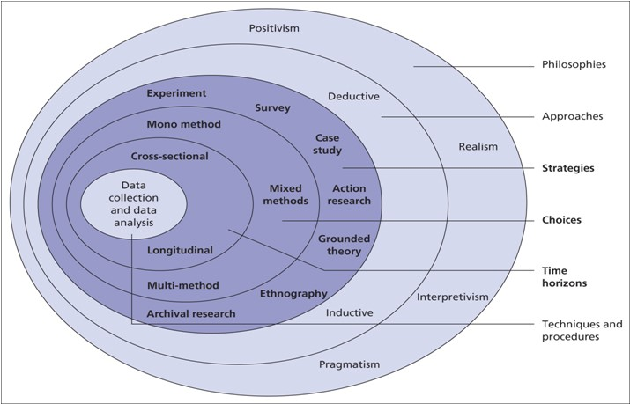
Figure 1: The Research Onion 1

Research philosophy can be seen as a sum of believes and assumptions that bring to the research an aspect of where the data is to be collected, and the development of such knowledge. The understanding of the philosophical position is vital to the connection of the work and to a full understanding of the study. Questions such as how what, and why to research have to be assessed in the research philosophy (Remenyi and Williams, 1996).
Having said that, in order to build up the knowledge, it is important an understanding the theories behind the research philosophy. In the process of building the research, before carrying out the empirical analysis, identification of the philosophical, and approach is necessary. In the process of developing the research through Saunders’ research onion, there are four ramifications from which research philosophy flow, that is positivism, realism, interpretivism, and pragmatism (Marabelli and Galliers, 2017). As already established Saunders’ research onion describes the different decisions the researcher needs to make in the process of developing a dissertation. The idea is to work from the outside of the onion inwards, and thus giving the necessary compass of the research, and therefore an easier understanding of the work. Philosophies are the first step while peeling the research onion.
The philosophy adopted by this study is interpretivism. Interpretivism relies on the idea that the researcher performs a specific role in observing the social world, also the interest of the research is taken into account in this philosophy. The main idea of this philosophy is to perceive the data from a particular point of view. (Willis, 2007) goes on to say that interpretivism does not specify a certain type of research method. However, it does take a very strong position on how the research should be understood. Interpretivism believes that reality and the individual who observes, that is the object and the subject, are inseparable (Stainton, 2020). On top of that, it is important to mention that there are two main ways to gather information for research, primary and secondary. This work is based on a secondary collection of data. Secondary data is information already collected and formatted (Oxford Dictionary, 2021). The primary collection of data is gathered by the researcher.
This study aims to explore research and development and how it affects the financial market. The secondary data used in the study aims to analyse trends, and therefore a deductive approach is selected for the study. (Streefkerk, 2019) states that whilst a deductive approach is aimed and testing theory, an inductive approach is concerned with the generation of new theory emerging from the data. While one starts from the theory trying to make the connection with the data, the other uses as starting point the information that was collected, and then draw to a possible theory. For that reason, the approach used in this study will be the deductive approach, as this starts from an already settled theory to design the hypothesis, thus a confirmation or rejection will be made after a test or observation. The deductive approach usually emphasizes causality. Through a series of causalities, a theory is then established or perceived, and hypotheses are made, hence the reason for the name deductive approach, (Gabriel, 2013).

3.3 Research Strategy
The research design is created to help the author plan how the collection of data will be done and therefore achieve the best result. Following the research onion, the strategies can vary from experiment, survey, case study, action research, grounded theory, ethnography, and archival research (Saunders et al., 2009). This study will be based on experimental research, which, refers to the strategy of creating a research process that examines the results of an experiment against the expected results. In other words, experimental research is a type of research method in which you manipulate one or more independent variables and measure their effect on one or more dependable variables. The experimental aspect in this method means simply creating a set of procedures to test a hypothesis (Bevans, 2019). While a conclusion is reached, the objective is then to propose recommendations based on the findings of the analysis of the data, emphasizing the main practices that those companies, in this case, studied follow.
The next layer of the research onion, so to speak, is about choices. As already mentioned briefly, this study will be quantitative research. As this study will be developed on the statistical analysis of numbers, collected from DataStream and or annual reports, of selected companies, quantitative research is the most suitable for the study. Further, following the next step in the research onion, monomethod will be the choice for this project. This type of method takes place when the researcher goes about collecting qualitative or quantitative data based on the decisions made in the previous stages of research onion. The most important point while conducting monomethod research is to recognize the research flow. If the researcher is trying to connect numbers or preferences will have an impact on the prospects of the research, as each perspective impact a specific kind of method. (Bell et al., 2018).

3.4 Collection of Data
As mentioned, this study utilizes quantitative research methods to access external information. The secondary data for the study was collected from DataStream, and/or the company’s annual report. Moreover, this study is based on a longitudinal time frame, which is the next layer in the research onion, this can vary from, cross-sectional or short-term study, involving the collection of data at a specific point of time, and longitudinal, collection of data repeatedly over a long period of time in order to compare data.
(Thomas, 2017) states that a longitudinal study researches that are carried over a period of time repeatedly in order to examine and detect changes that might have occurred. Usually, these kinds of researches are, most of the time, correlational studies, in which data are selected and observed with many different variables. The aim of a longitudinal study is that researchers through the observation of the data are able to detect developments or changes in characteristics, been these from individuals, populations, firms, or any level of society.

3.4.1 Sources
As evaluated earlier, the aim of this study is to analyse the importance of research and development accounts for a company. The secondary data were collected, around and focusing mainly in evaluate research and development, by the author and are all public information, available in DataStream websites, and the company’s annual reports. As the sample rely on public limited companies, all information needed in terms of analysis of data is available on the internet. Following the studies of (Green et al., 1996) the variables for the project are:
- Market Value ($MVi,t)$ is calculated for calendar year $t$ as the market value of the firm at the time of the research, therefore, May 2021.
- Book Value ($BVi,t)$ is calculated as the sum of shareholder equity.
- $πi,t$ is measured as earnings before exceptional and extraordinary plus research and development expenditures.
- The cost of capital, $Ki,t$, is measured through the systematic risk, beta$i,t$, is averaged for the year, to then calculate $Ki,t$ via CAPM as:
$Ki,t= rft+betai,t\left(E\left(rmt\right)-rft\right)$ (12)
- Research and development expenditures, $RDi,t$, are approximately by the use of research and development expense recognised in the income statement.
- An estimate of the firm’s market share in its main industry, $Ζi,1,t$, is prepared.
- An estimate of the industry concentration ration, $Ζi,2,t$, is prepared.
- An estimate of the total structure, $Ζi,3,t$ is derived by dividing the total of long and short-term debt by the sum of shareholder equity plus reserves.
- An estimate of the average value of the capital structure for the industry to which firm $i$ belongs, $Ζi,4,t$, is provided.
- The squared difference between the capital structure proxy for firm $i$ and value for the industry to which $i$ belongs, $Ζi,5,t$ is set equal to ($Ζi,3,t-Ζi,4,t)$².
- The annual variability of stock market returns, $Ζi,6,t$ is identified and averaged.
Another point worth mention is the selection of the companies for the study. To avoid any criticism as sometimes the justification of the selected data is not clear, and in consequence, this can bring an aspect of the author been bias, as underlined by (Chong and Yeo, 2015). The companies selected for the study are those that are the most valuable in the Nasdaq exchange at the time of the project: Apple, Microsoft, Amazon, Alphabet, Tesla, Facebook, Nvidia, PayPal, Netflix, and Intel. The main criteria apart of been the most valuables companies in the Nasdaq exchange is to have expenditure in the research and development account. To that end, all companies were approved.

3.4.2 Access and Ethical Issues
As already state earlier, as this study is based on an empirical analysis based on secondary data, all necessary information for the research is available online, therefore the need for an informed consent form was not necessary. In other words, as this study is based on information already available on DataStream websites, and the company’s annual reports, the author does not need to consider ethical issues that might arise in researches that need primary data, through surveys with personal information.

3.5 Approach to Data Analysis
As mentioned, this research is based on quantitative data analysis. (Dudovskiy, 2018) data analysis for quantitative studies involves critical analysis and interpretation of figures and numbers and attempts to find the rationale behind the emergence of main findings. The importance of selecting the right approach is that this influences the development of the study. The researcher must be mindful in order to merge the research question with the proper approach, in this way the study will emphasize the findings.
Also, descriptive statistics were used to show and summarize the main results originated by the test of the hypothesis. To explore the research question, this study was based on interpretivism, a deductive approach in order to express the results. And again, to not have any bias towards the companies selected, the ten most valuable in the Nasdaq exchange were the companies elected for the study.

Conclusion
In this chapter, the author aimed to ground the study in the different research philosophies and approaches. The study does not seek to have a correct or incorrect result. The main idea was to establish the research in the most suitable philosophies and approaches. Thus, an interpretivism philosophy is the chosen one, and quantitative research is appropriated.
Even though there are studies already analysing the connection research and development and stock exchange, or the impact of the first in the second, this study tries to understand how the ten most valuable companies in the Nasdaq exchange operate this account in order to make recommendations to other firms. A deductive approach, therefore, was taken to evaluate patterns and relationships.

- Presentation and Discussion of Findings

4.1 Overview
As already expressed in previous chapters, as competition, in the fast environment that the 21st century imposes on society increase, companies in order to excel and stay ahead of rivalry, need to have a broad perspective of each aspect that is related to a company such as social, marketing, responsibility towards environment and animal cruelty, and above all, the financial aspect. For (Handy, 1993) the organizations that play a big role in the market, and this tends to increase with the interaction consumers vs. companies each time more entangled, have to have a full understanding of the macro in order to act in the micro, and how the micro may impact in the macro. That is, a whole perspective of the actions and implications that this organization takes, and moreover, the organization's culture must be emphasized in every and each action taken.
Having said that, this chapter intends to first examine the data collected from the ten most valuables companies in the Nasdaq exchange in order to establish the importance of the research and development account to the financial market of such a company. As already stated, this research is conducted on the basis of an experimental study. This means that the data analysed, is researched and perceived from a standpoint, therefore, the work does not intend to give definite understandings or pledge that this is the only true. As highlighted by (Uchiyama, 2011) one needs to bring to the equation a subjective perspective to judge a subjective matter. In other words, while interpreting figures, one can look from many different angles, and one does not necessarily reject the other.
Also, in this chapter, all information used is available and collected from DataStream. The next section thus will present every theme identified from the analysis of the data collected and express the correlations, if there are such, and ramifications of the impact of research and development in the financial market of the firms studied. The aim is to perceive how the financial market weights the investments in intangibles of the sample firms, these having persistently expenditure in research and development from 2015-2019.
To resume the aim of this chapter is to present the relevant findings and present them in an orderly sequence in order to provide clarity to the reader and emphasize the results from the data gathered. As this research is based on a quantitative study, the finds will be present and discussed around the hypothesis placed in the research methodology. Moreover, to bring clarity to the points mentioned, this chapter will present charts and tables of the most important points of the data always trying to make a connection with the hypothesis and the research question.

4.2 Findings
In this chapter secondary data is collected in order to bring to the equation the discussion of the data. As highlighted by (Thomas, 2017) the findings should be expressed with appropriate words and phrases that presents the results to the reader. It is vital to connect the theoretical aspect of the work with the practical, to do that, the appropriated collection of data, and most importantly, the correct analysis of the data cannot be overemphasized. The purpose, therefore, is first, merge the theory aspect of the research with the correct statistical tests, and second, to explain the analysis and the steps taken to interpret the data.
Every important result has to be demonstrated in a clear and cohesive way. As already mentioned in the methodology chapter, the secondary data used in this study are available for researchers, and the flow of the discussion will be based on the equation established by (Green et al., 1996). Through this equation, this research has estimated a valuation model on five annual cross-sections for 2015, 2016, 2017, 2018, and 2019 for the most valuables companies in the Nasdaq exchange. Apart from that, this work will run a few correlations, and regressions on the data selected to emphasize the main points researched in this study.

4.2.1 Descriptive statistics
In accordance with the methodology used by (Green et al., 1996) table 1 analyses various samples statistics for market value ($MVi,t)$ book value ($BVi,t)$ residual income ($RIi,t$), and research and development expenditure ($RDi,t)$ in order to indicate salient features of the sub-samples employed, in terms of both size of firm and amount of research and development activity. It is possible to perceive a stream of increase of research and development expenditure, which is analysed in depth below in the topic related to research and development. The expenditures in research and development range from relatively minor to very substantial amounts. In order to highlight the important features in each sub-sample, table 1 will be split and expressed into years.
Table 1: Sub-Sample Characteristics (Market Value, Book Value, Research and Development and Residual Income.

Notes:
- $MVi,t$ is market value for firm $i$ of financial year $t;$
- $BVi,t$ is book value for firm $i$ of financial year $t$;
- $RDi,t$ is research and development expenditure for firm $i$ of financial in year $t.$
- $RIi,t$ is residual income for firm $i$ of financial year $t$.

It is possible to notice for the market value variable ($MVi,t)$, apart from the year 2018 where the median value decrease in comparison with 2017, and the minimum value does not increase as substantial as the rest of the years studied, that the sample appears to be concentrate in the middle part of the distribution for those variables. That is to say that, despite the companies studied belong to different sectors, and each sector should be seen with its specificity in terms of need of investments, e.g.: Apple a technological company vs. Netflix a production company, the firms of the sample share almost the same market value.
This would favour H1 and show that the proportion of total research and development expenditure in a company’s annual report is likely to have a positive impact on its firm market value, assuming that other conditions been equal. In order to bring robustness to this point, correlations for firm market value and research and development expenditure for every company analysed in this research is expressed below. Nevertheless, it reports a high correlation for the mean values of the samples, in which a suggestive evidence that research and development intensity correlated with a firm market value. Even though that the size component is not been taken into consideration for this study, given that the purpose is to analyse the behaviour of the variables studied, it is important to mention that larger firms streams of research and development expenditure usually follow different patterns (Blundell et al., 1999a).
Another point worth to mention even though, again, this research does not take into account, is the country origin of the firm. As mentioned in the literature review, each country has its understanding and may act, if so, in many different ways in order to help the firm acknowledge the importance of research and development for the company, and thus to the country. Countries such as Sweden and Denmark, and even Ireland lately, have a full understanding of the importance of research and development for the development of the country, on the other hand, countries such as Romania and Greece still in the process of establishing this importance (Anagnostopoulou and Levis, 2008). Despite it, all the sample selection derives from companies based in the USA.
For the book value variable ($BVi,t)$, it is possible to notice that the mean values are closer to the maximum, rather than the minimum, especially for the year 2018. (Seth, 2021) as book value literally means the value of business according to its books or accounts, as reflected in its financial statements, if the average figure is more concentrated at the top of the sample, and moreover, the difference of the mean market value and the mean book value stays consistent throughout the years studied, this would bring an understanding that the results are largely consistent with prior studies, and the findings would be consistent with H2 that the market capitalizes expenditures in research and development despite the treatment of this account, hence following the UK stock market and the studies of (Green et al., 1996).
Following the equation established by (Green et al., 1996) table 2 brings characteristics of key variables in the regression, $(MVi,t-BVi,t)/BVi,t$, $RIi,t/BVi,t$ and $RDi,t/BVi,t$. Again, in table 1, observing the difference between the minimum and maximum values and the median and mean values for each key variable suggests that their sub-sample distributions are skewed with a concentration of values at the middle.
Table 2: Descriptive Statistics for Key Variables in Each of the Sub-Samples.
Notes:
- $MVi,t$ is market value for firm $i$ of financial year $t;$
- $BVi,t$ is book value for firm $i$ of financial year $t$;
- $RDi,t$ is research and development expenditure for firm $i$ of financial in year $t.$
- $RIi,t$ is residual income for firm $i$ of financial year $t$.

Cross-sectional valuation models represented by equation (11) are first estimated on each annual sub-sample and the pooled sample. Important to mention that, although the equation established by (Green et al., 1996) first, remove the controls variables from equation (11), and the resulting reduced form equation estimated on each annual sub-sample and the pooled sample, and also, in their studies as the number of sub-sample are high and in some cases, this would bring abnormalities for the data, and consequently a clearly less satisfactory study, the equations are re-estimated on reduced samples and a reduced pooled sample in which all observations with market-to-book ratios $(MVi,t/BVi,t)$ in excess of ten and/or research and development expenditures-to-book ratios ($RDi,t/BVi,t)$ in excess of one are deleted, this research, as already state, does not have the same issues, as this study focus in a selected range of the sample, that is, the ten most valuables companies in Nasdaq exchange.

4.2.2 Research and Development and Residual Income
(Green et al., 1996) the valuation model is based upon the idea that the excess of market value over book value for assets in place is equal to the present value of future residual income, where residual income is defined as earnings less a capital charge. It is assumed that future residual incomes can be modelled as exponentially declining and, hence, the present value of future residual incomes can be captured by representing the excess of market value over book value as a linear function of current residual income. The mean for residual income over book value ($RIi,t/BVi,t$) for 2015 is 0.15 with stand deviation of 0.24, for 2016 is 0.14 and stand deviation of 0.19, 2017 is 0.13 stand deviation 0.16, for 2018 is 0.15 stand deviation of 0.18, and finally 2019 is 0.15 and stand deviation of 0.16. Also, the minimum and the maximum stay with no much change over the years, in either extreme.
Although the valuation model used in this study treats all firms as if they are subject to the same cross-sectional valuation equation. There seems to be evidence for the samples analysed that the residual income seems to be significant and positive throughout the years and the firms researched. For (Blundell et al., 1999a) this might be taken as further evidence that the market measures this position of the firm. The impact of residual income on market value seems to be strong.
Nonetheless, it is wise to say that, although the correlation research and development and residual income cannot be rejected, under the hypothesis that the proportion of research and development expenditures disclosed in a company annual report will be positively related to residual income (H3), there seems to be a lagged in terms of the valuation of these values, and therefore a proper valuation and correlation would be not accurate. (Green et al., 1996) highlight this perspective, and add that, given that there might well be differences between firms in different industries with respect to both the sustainability of excess profits and the type and time horizon of research and development activities engaged in, constraining the coefficients of residual income and research and development expenditure to be equal across firms is probably inappropriate.
In summary, although the empirical findings related to research and development expenditures with residual income, or at least it reports a correlation between these two variables. It is rather unsure if this happens derived from the correlation between these two variables, and subsequent analysis would be needed. As state by (Green et al., 1996) alternative estimation techniques are possible. The use of a truncated sample approach combined with maximum likelihood estimation techniques could be applied to the data in order to an in-depth analysis of the subject. Assumption that will not be fulfilled in the present study.

4.2.3 Research and Development vs. Market Value
As an alternative approach to dealing with how the market value of a firm absorbs the investments in research and development (H1), the findings reported in the correlation analysis of the market value and the research and development analysis, apart from Tesla, emphasizes the link between the investments in research and development and market value. The progressive correlation is followed throughout the years and, again, favour H1 showing that the proportion of total research and development expenditure in a company’s annual report is likely to have a positive impact on its firm market value. Another important stream is that on average the companies on the top of the sample seems to spend much more than the ones at the bottom, which can bring another factor to prove H1, even though worth mention that the size aspects are not been analysed in this study, this may emphasize the connection between the performance in the financial market and research and development expenditure, providing support therefore for H4.
Consistent with (Blundell et al., 1999a), analysing a small sample as this study intends, has costs and benefits. That is, although all these estimates suffer from a lack of precision due to a small sample size, they appear consistent with the tenor of the results reached by (Green et al., 1996). A positive aspect of analyses with such a spectrum is that each firm can be measured from different stand points, as expressed in the correlations below.
As state earlier, in order to deepen the perception of how research and development may interact with the market value of the firm, this section will bring different perspectives of these two variables. Table 3 reflects an in-depth analysis of the apports made by the sample selected for the years studied.
Research and development have its minimum in 2015 ($651,000.00) and its maximum in 2019 ($35,931,000.00), and a consistent increase of averaged 18% for the mean variable, 20% for the minimum, and 30% for the maximum variables expenditures for the years analysed. This can emphasize the aspect that the companies that usually invest more in research and development, in general, invest 12% more in their search for knowledge than the mean of those companies in the same search.
Table 3: Research and Development Expenditures
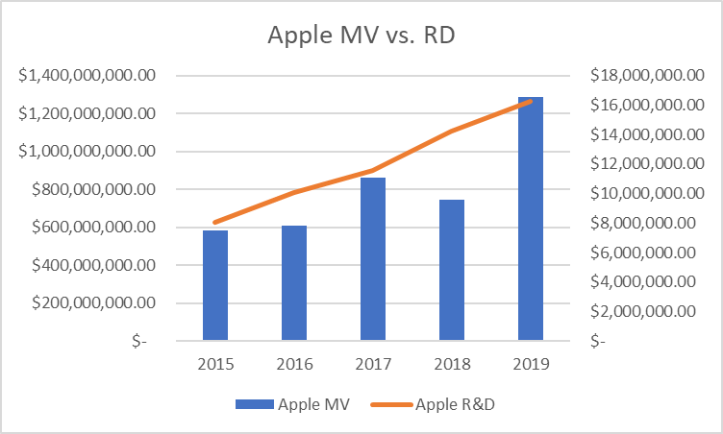
Another aspect that can be used to emphasize the aspect of how research and development expenditures may be linked with market value is the correlation between these two variables. In order to express this correlation, the charts below can bring a perspective of how these two variables are interconnected.
Figure 2: Apple - Market Value vs. Research and development Expenditures
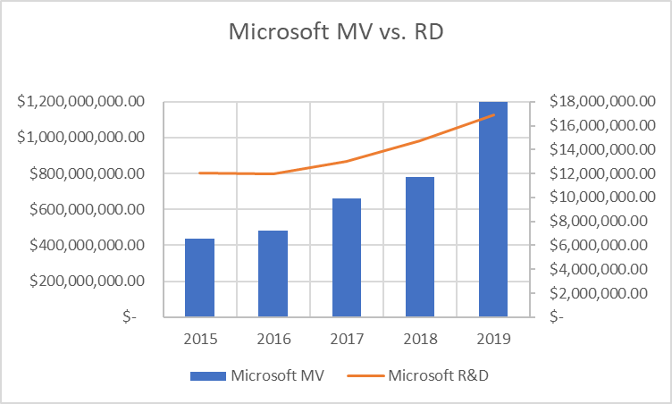
Apple is an American multinational technology company. The average of investments in its research and development for the years studied is over $12 million vs. $817 million averages for market value for the same period. The investments in research and development represent 1.5% of the market value of the company.
Figure 3: Microsoft – Market Value vs. Research and Development Expenditures
Microsoft Corporation is an American multinational technology company. The average of investments in its research and development for the years studied is over $13 million vs. $712 million averages for market value for the same period. The investments in research and development represent 1.9% of the market value of the company.
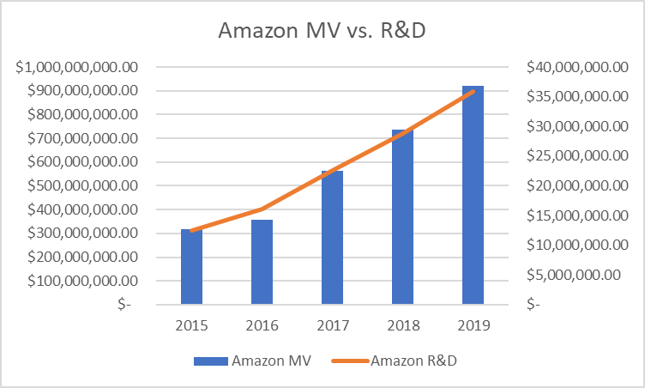
Figure 4: Amazon – Market Value vs. Research and Development Expenditures
Amazon is an American multinational technology company. The average of investments in its research and development for the years studied is over $23 million vs. $578 million averages for the market value for the same period. The investments in research and development represent 4.0% of the market value of the company.

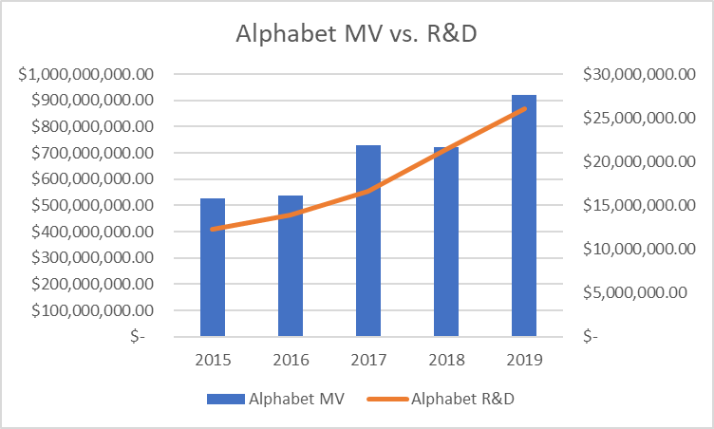
Figure 5: Alphabet – Market Value vs. Research and Development Expenditures
Alphabet is an American multinational conglomerate company. The average of investments in its research and development for the years studied is over $18 million vs. $688 million averages for the market value for the same period. The investments in research and development represent 2.6% of the market value of the company.

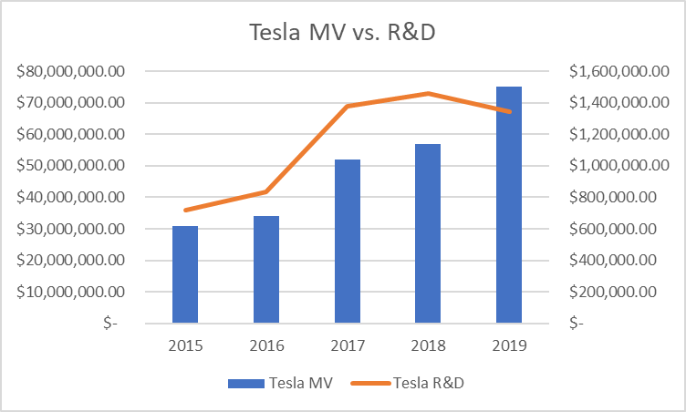
Figure 6: Tesla – Market Value vs. Research and Development Expenditures
Tesla is an American electric vehicle and clean energy company. The average of investments in its research and development for the years studied is over $1 million vs. $49 million averages for the market value for the same period. The investments in research and development represent 2.3% of the market value of the company.
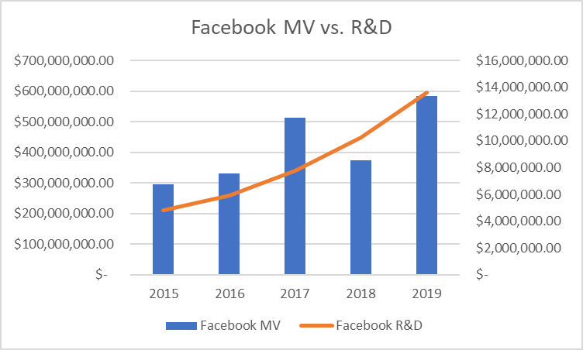
Figure 7: Facebook – Market Value vs. Research and Development Expenditures
Facebook is an American technology conglomerate company. The average of investments in its research and development for the years studied is over $8 million vs. 419 million averages for the market value for the same period. The investments in research and development represent 2.0% of the market value of the company.
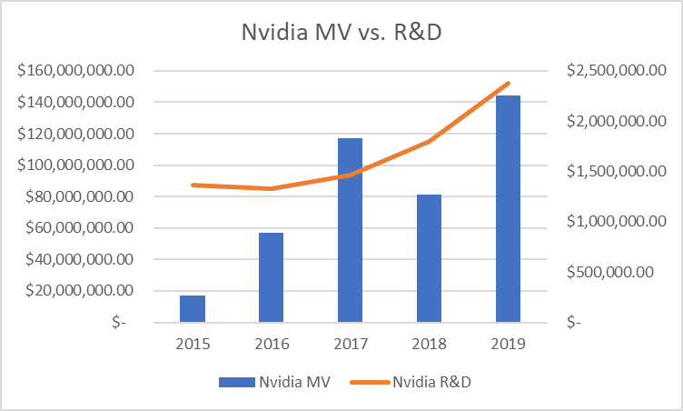
Figure 8: Nvidia – Market Value vs. Research and Development Expenditures
Nvidia is an American multinational technology company. The average of investments in its research and development for the years studied is over $1 million vs. $83 million averages for the market value for the same period. The investments in research and development represent 2.0% of the market value of the company.

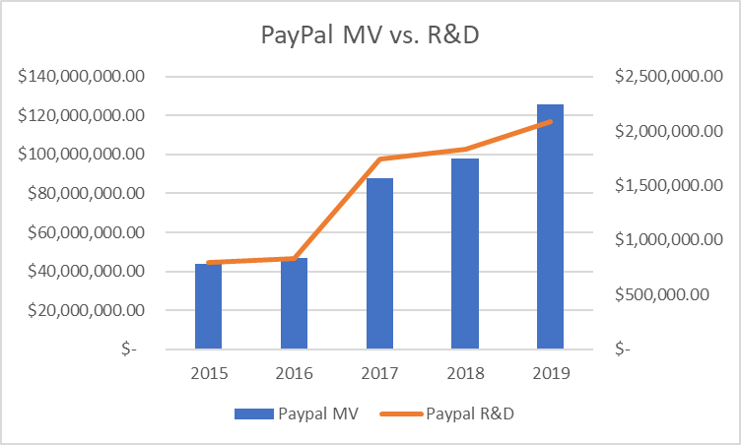
Figure 9: PayPal – Market Value vs. Research and Development Expenditures
PayPal is an American online payments system company. The average of investments in its research and development for the years studied is over $1 million vs. $80 million averages for the market value for the same period. The investments in research and development represent 1.8% of the market value of the company.

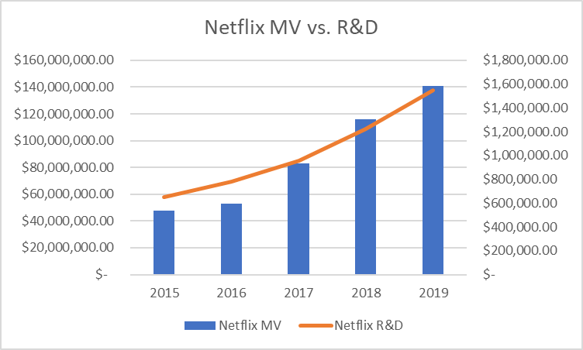
Figure 10: Netflix – Market Value vs. Research and Development Expenditures

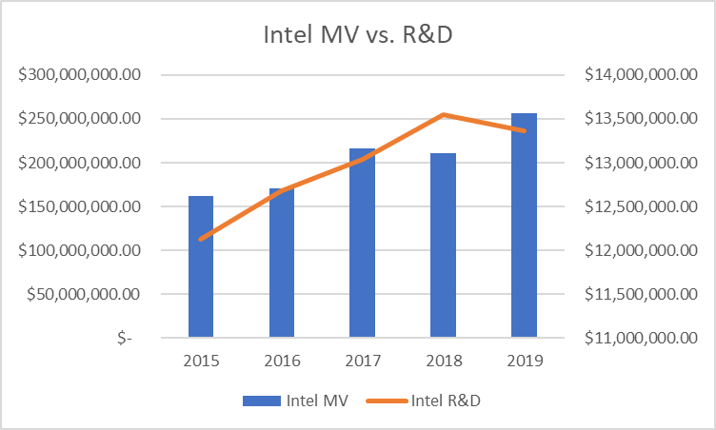
Netflix is an American production company. The average of investments in its research and development for the years studied is over $1 million vs. $88 million averages for the market value for the same period. The investments in research and development represent 1.1% of the market value of the company.
Figure 11: Intel – Market Value vs. Research and Development Expenditures
Intel is an American technology company. The average of investments in its research and development for the years studied is over $12 million vs $203 million averages for the market value for the same period. The investments in research and development represent 6.3% of the market value of the company.

4.2.4 Research and Development and Financial Market
As already discussed above, although this can be a subjective matter as analysed by (Donelson and Resutek, 2012), such as to analyse of patents, which the great majority are believed to be of effectively zero economic value. An important stream while analysing the data for the study, is that on average the companies on the top of the sample seems to spend much more than the ones at the bottom, which may emphasize the connection between the performance in the financial market and research and development expenditure, providing support therefore for H4, and proving that the studies of (Green et al., 1996; Stark and Thomas, 1998) remain strongly significant. For (Green et al., 1996) the UK stock market does not appear to be simply fixated on earnings, at least not in the case of research and development expenditures. It is important to mention, however, that the correlations with long-term investments in research and development seem stronger, and may bring a higher future return (Donelson and Resutek, 2012).

4.2.5 Alternative Measures of Innovative Output
Innovation headcounts are often criticized for being too subjective as a measure of innovation output (Blundell et al., 1999a). The need for robustness while analysing figures is a common, and useful practice that brings clarity for the reached results. (Beers and Anderson, 2021) highlight the importance of regression analysis as this study how one variable (the independent variable) describes another variable (the dependent variable). A regression will calculate the intercept and slope coefficients of a line that finds the minimal distance between the various observations of research and development expenditures in the scatter plot.
Table 4: Regression analysis – Research and Development vs. MV/BV/Inventory/RI

From table 4 it is possible to see that the correlation research and development, market value (R²=0.58), book value (R²=0.42), inventory (R²=0.60) is high, and not so high with residual income (R²=0.18), these may emphasize the rejection of H3, the proportion of research and development expenditures disclosed in a company’s annual report will be positively related to residual income, although the correlation (ρ=0.74) it is still significant. Another possible conclusion from table 4 providing support for H1 and H2 is the high correlation between research and development and market value (ρ=0.89), and book value (ρ=0.80).
Further, as the p-value for market value (0.010), book value (0.043), and inventory (0.009) are smaller than 0.05 this means that the variability in the conditions is not the same, that is to say, the scores in one condition vary much more than the scores in the second condition, or the impact of the independent variable in the dependent variable is stronger than the other way around proving the impact of research and development in the study of the variables. Also, the lower 95% of residual income (-0.124) and the upper 95% (0.454) emphasize the rejection of H3) the proportion of research and development expenditures disclosed in a company’s annual report will be positively related to residual income.

4.3 Conclusion
This chapter through an empirical analysis has assessed the hypothesis placed in the research methodology. It is possible to conclude that the figures study in this research favour H1) the proportion of total research and development expenditure in a company’s annual report is likely to have a positive impact on its firm market value. Also, favour H2) the proportion of research and development expenditures disclosed in a company’s annual report will be capitalized by the market despite their account treatment. As well as H4) the proportion of stock returns for firms with high research and development expenditures will be higher as to those with lower expenditures in research and development. However, the empirical data does not favour H3) the proportion of research and development expenditures disclosed in a company’s annual report will be positively related to residual income.

- Concluding thoughts on the Contribution of this Research, its Limitations and Suggestions for Future Research

5.1 Contributions and Limitations of the Research
This study examines the relationship between research and development, financial market, market value, and residual income. It investigates how the most valuables companies assess and utilizes their research and development. The results find positive relations with prior studies and emphasize the importance of a solid understanding of the firm towards research and development.
Nonetheless, it is important to mention that, there are a number of limitations that might have affected the outcome of this research, such as time constraint, sample size, the selected variables, and the current moment of the macroeconomy. Time constraint is the biggest issue related to this work as the research had to be conducted within a limited period, it affects also the sample size, and lastly the time frame of the study 2015-2019, those factors have to be taken into consideration while interpreting the results.

5.2 Recommendations for Practice
This study shows that companies that excel in the financial market have a thorough understanding of the importance of research and development. The research revealed that the top companies in the Nasdaq exchange, and the high top of the sample, spend on average 12% more in research and development than the median of the sample.
This finding is useful for business shareholders willing to have a greater impact in the financial market. This study is useful also for investors because a clear view and a deeper understanding of how successful companies treat their research and development can improve the effectiveness of decision-making. Lastly, the findings of this study are useful for governments that rely on the assumption that research and development are an aspect of and should be discussed by organizations only, rather it suggests that the efforts made by governs with the intention to develop acknowledgment of the importance of this process, ripple through many levels in the economy, and the forecasts for those that incorporate research and development are always positive.
Research and development have been evaluated to be successful in driving companies to place themselves in a favourable position in the financial market. With the intensity and fastness of technological advancement of the 21st century, this understanding more than bringing opportunities for companies and governments underline the importance of a solid market structure on innovation and its economic interpretation.

5.3 Recommendations for Future Research
Considering the concept, and the sample for the study, there are various aspects that can be further developed in order to bring different perspectives to future researches. The present study has focused on analysing the most valuables companies in the Nasdaq exchange as this may emphasize the objective of the study. However, future researches should examine the apports of research and development in other countries and other stock exchanges, as this can be seen as an issue in this study, especially in emerging markets, and undeveloped countries to bring the comparison factor with this research and U.S. Further, an in-depth analysis of a specific sector could be useful as well, as this would bring to the equation a contrast with firms in the same sector.
Future research could study different points of view about the sample, for example, analyse the companies that have grown faster in market share instead of the most valuables ones. Also, as a way of balancing out, how companies that do not invest in research and development perform in the stock exchange. Future research should examine how research and development expenditures have been affected by the COVID-19 crisis. As previously state, the impact of the COVID-19 crisis will be felt in a way or another by all sectors. As this study analysis research and development from 2015 to 2019, the crisis aspect will not be measured in this research, but certainly, this would bring a new perception for future studies.
As this research has selected some financial indicators such as stock exchange, market value, and residual income, future studies may decide to include other indicators as a way to emphasize the importance of research and development in a company, bankruptcy would be a good measure to highlight the importance of R&D. These indicators would improve the analysis and bring depth to the discussion.

5.4 Final Conclusion and Reflections
This paper has argued that the results presented are in line with models where high market share firms have greater incentives to pre-emptively innovate. There are alternative interpretative interpretations of the results, as state above, however, in line with prior studies, there seems to be a correlation between the expenditures in research and development and the financial market of the firms. Despite the size of the sample, the results reached in this study follow the same pattern of other studies, and highlight the importance for the company and for the economy the research and development aspect to the development of the macroeconomy, and the growth of the firm.
Lastly, as stated by (Blundell et al., 1999b) it is often asserted that the superior performance of large firms in innovating is because they have higher cash flows from which to finance investment in R&D. The findings of this study suggest that this is not the whole story, dominant firms innovate because they have relatively greater incentive to do so. Firms with high market shares who innovate get a higher valuation on the stock market than those who do not. Further, it seems related that the most developed countries have a thorough understanding of the importance of research and development, which could be understood as a compass to other nations and organizations.

6. References

Aboody, D. and Lev, B. (2000) ‘Information Asymmetry, R&D, and Insider Gains’. The Journal of Finance, 55(6), pp. 2747–2766. DOI: https://doi.org/10.1111/0022-1082.00305.
Ali, A., Ciftci, M. and Cready, W.M. (2012) ‘Market Underestimation of the Implications of R&D Increases for Future Earnings: The US Evidence’. Journal of Business Finance & Accounting, 39(3–4), pp. 289–314. DOI: https://doi.org/10.1111/j.1468-5957.2012.02282.x.
Anagnostopoulou, S. and Levis, M. (2008) ‘R&D and Performance Persistence: Evidence from the United Kingdom’. The International Journal of Accounting, 43(3), pp. 293–320.
Anwaar, M. (2016) ‘Impact of Firms’ Performance on Stock Returns (Evidence from Listed Companies of Ftse-100 Index London, UK)’. p. 10.
Arslan, O., Florackis, C. and Ozkan, A. (2006) (06/08) The Role of Cash Holdings in Reducing Investment-Cash Flow Sensitivity: Evidence from a Financial Crisis Period in an Emerging Market. Department of Economics, University of York Available at: https://ideas.repec.org/p/yor/yorken/06-08.html (Accessed: 16 May 2021).
Bauman, Z. (2013) Liquid Times: Living in an Age of Uncertainty. John Wiley & Sons.
Baxamusa, M., Mohanty, S. and Rao, R.P. (2015) ‘Information Asymmetry about Investment Risk and Financing Choice’. Journal of Business Finance & Accounting, 42(7–8), pp. 947–964. DOI: https://doi.org/10.1111/jbfa.12128.
Beers, B. (2020) Financial Characteristics of a Successful Company. Investopedia. Available at: https://www.investopedia.com/articles/stocks/08/successful-company-qualities.asp (Accessed: 12 May 2021).
Beers, B. and Anderson, S. (2021) What Regression Measures. Investopedia. Available at: https://www.investopedia.com/terms/r/regression.asp (Accessed: 2 June 2021).
Bell, E., Bryman, A. and Harley, B. (2018) Business Research Methods. Oxford University Press.
Bevans, R. (2019) A Quick Guide to Experimental Design | 4 Steps & Examples. Scribbr. Available at: https://www.scribbr.com/methodology/experimental-design/ (Accessed: 12 May 2021).
Bhagat, S. and Welch, I. (1995) ‘Corporate Research & Development Investments International Comparisons’. Journal of Accounting and Economics, 19(2), pp. 443–470. DOI: 10.1016/0165-4101(94)00391-H.
Białowolski, P. and Weziak-Bialowolska, D. (2013) ‘External Factors Affecting Investment Decisions of Companies’. Economics. The Open Access, Open Assessment E-Journal, 2013–44.
Blundell, R., Griffiths, R. and Van Reenen, J. (1999a) ‘Market Share, Market Value and Innovation in a Panel of British Manufacturing Firms’. Review of Economic Studies, 66(3), pp. 529–554. DOI: 10.1111/1467-937X.00097.
Blundell, R., Griffiths, R. and Van Reenen, J. (1999b) ‘Market Share, Market Value and Innovation in a Panel of British Manufacturing Firms’. Review of Economic Studies, 66(3), pp. 529–554. DOI: 10.1111/1467-937X.00097.
Bowman, J. (2020) What Is an IPO Company? | The Motley Fool. Available at: https://www.fool.com/investing/stock-market/types-of-stocks/ipo-stocks/what-is-an-ipo/ (Accessed: 14 May 2021).
Callen, J.L. and Morel, M. (2005) [PDF] The Valuation Relevance of R&D Expenditures: Time Series Evidence | Semantic Scholar. Available at: https://www.semanticscholar.org/paper/The-valuation-relevance-of-R%26D-expenditures%3A-Time-Callen-Morel/fde451acac74edbdf77ffda973cfa34cc1e208c3 (Accessed: 15 May 2021).
CFI. (2021) Business Life Cycle - Understanding the 5 Different Stages. Corporate Finance Institute. Available at: https://corporatefinanceinstitute.com/resources/knowledge/finance/business-life-cycle/ (Accessed: 17 May 2021).
Chan, L.K.C., Lakonishok, J. and Sougiannis, T. (1999) W7223.Pdf. Available at: https://www.nber.org/system/files/working_papers/w7223/w7223.pdf (Accessed: 12 May 2021).
Chauvin, K.W. and Hirschey, M. (1993) ‘Advertising, R&D Expenditures and the Market Value of the Firm’. Financial Management, 22(4), pp. 128–140. DOI: 10.2307/3665583.
Chen, J. (2021) Stock Market. Investopedia. Available at: https://www.investopedia.com/terms/s/stockmarket.asp (Accessed: 15 May 2021).
Chong, C.-H. and Yeo, K.-J. (2015) ‘An Overview of Grounded Theory Design in Educational Research’. Asian Social Science, 11(12), p. p258. DOI: 10.5539/ass.v11n12p258.
Collins, D.W. and Kothari, S.P. (1989) ‘An Analysis of Intertemporal and Cross-Sectional Determinants of Earnings Response Coefficients’. Journal of Accounting and Economics, 11(2–3), pp. 143–181.
Connolly, R.A., Hirsch, B.T. and Hirschey, M. (1986) ‘Union Rent Seeking, Intangible Capital, and Market Value of the Firm’. The Review of Economics and Statistics, 68(4), pp. 567–577. DOI: 10.2307/1924515.
Deloitte. (2021) R&D Tax Credit. Deloitte Ireland. Available at: https://www2.deloitte.com/ie/en/pages/tax/solutions/r-and-d-tax-credit.html (Accessed: 3 June 2021).
Deng, Z., Lev, B. and Narin, F. (1999) ‘Science and Technology as Predictors of Stock Performance’. Financial Analysts Journal, 55(3), pp. 20–32.
Donelson, D.C. and Resutek, R.J. (2012) ‘The Effect of R&D on Future Returns and Earnings Forecasts’. Review of Accounting Studies, 17(4), pp. 848–876. DOI: 10.1007/s11142-011-9179-y.
Drucker, P. (2014) Innovation and Entrepreneurship. Routledge.
Dudovskiy, J. (2018) Pragmatism Research Philosophy. Research-Methodology. Available at: https://research-methodology.net/research-philosophy/pragmatism-research-philosophy/ (Accessed: 12 May 2021).
Duqi, A., Mirti, R. and Torluccio, G. (2011) (ID 1971159) An Analysis of the R&D Effect on Stock Returns for European Listed Firms. Rochester, NY: Social Science Research Network Available at: https://papers.ssrn.com/abstract=1971159 (Accessed: 18 May 2021).
Duqi, A. and Torluccio, G. (2010) (ID 1609791) Can R&D Expenditures Affect Firm Market Value? An Empirical Analysis of a Panel of European Listed Firms. Rochester, NY: Social Science Research Network DOI: 10.2139/ssrn.1609791.
Eberhart, A.C., Maxwell, W.F. and Siddique, A.R. (2004) ‘An Examination of Long-Term Abnormal Stock Returns and Operating Performance Following R&D Increases’. The Journal of Finance, 59(2), pp. 623–650. DOI: https://doi.org/10.1111/j.1540-6261.2004.00644.x.
Edmans (2015) Directed by Edmans Available at: https://www.youtube.com/watch?v=Z5KZhm19EO0&t=88s (Accessed: 4 June 2021).
Fama, E.F. (1970) Fama1970.Pdf. Available at: http://gesd.free.fr/fama1970.pdf (Accessed: 12 May 2021).
Franzen, L. and Radhakrishnan, S. (2009) (1) The Value Relevance of R&D across Profit and Loss Firms | Request PDF. Available at: https://www.researchgate.net/publication/23776097_The_Value_Relevance_of_RD_across_Profit_and_Loss_Firms (Accessed: 15 May 2021).
Gabriel, D. (2013) Inductive and Deductive Approaches to Research | Dr Deborah Gabriel. Available at: https://deborahgabriel.com/2013/03/17/inductive-and-deductive-approaches-to-research/ (Accessed: 12 May 2021).
Ghaffar, A. and Khan, W. (2014) ‘Impact of Research and Development on Firm Performance’. International Journal of Accounting and Financial Reporting, 4. DOI: 10.5296/ijafr.v4i1.6087.
Gilbert, R.J. and Newbery, D.M.G. (1982) ‘Preemptive Patenting and the Persistence of Monopoly’. The American Economic Review, 72(3), pp. 514–526.
Goddard, W. and Melville, S. (2004) Research Methodology: An Introduction. Juta and Company Ltd.
Green, J.P., Stark, A.W. and Thomas, H.M. (1996) ‘Uk Evidence on the Market Valuation of Research and Development Expenditures’. Journal of Business Finance & Accounting, 23(2), pp. 191–216. DOI: https://doi.org/10.1111/j.1468-5957.1996.tb00906.x.
Griliches, Z. (1981) ‘Market Value, R&D, and Patents’. Economics Letters, 7(2), pp. 183–187. DOI: 10.1016/0165-1765(87)90114-5.
Hall, B.H. (1998) BHH98 NIESR.Pdf. Available at: https://eml.berkeley.edu//~bhhall/papers/BHH98%20NIESR.pdf (Accessed: 13 May 2021).
Handy, C. (1993) Understanding Organizations. Penguin Adult.
Hanelt, A., Busse, S. and Kolbe, L.M. (2017) ‘Driving Business Transformation toward Sustainability: Exploring the Impact of Supporting IS on the Performance Contribution of Eco-Innovations’. Information Systems Journal, 27(4), pp. 463–502. DOI: https://doi.org/10.1111/isj.12130.
Hill, E.J. et al. (1998) ‘Influences of the Virtual Office on Aspects of Work and Work/Life Balance’. Personnel Psychology, 51(3), pp. 667–683. DOI: https://doi.org/10.1111/j.1744-6570.1998.tb00256.x.
Iatridis, G.E. (2016) ‘Financial Reporting Language in Financial Statements: Does Pessimism Restrict the Potential for Managerial Opportunism?’ International Review of Financial Analysis, 45, pp. 1–17. DOI: 10.1016/j.irfa.2016.02.004.
IDA Ireland. (2021) Research and Development in Ireland. IDA Ireland. Available at: https://www.idaireland.com/doing-business-here/activities/research-development-and-innovation (Accessed: 12 May 2021).
James, S. (2019) What Is R&D? Research And Development In Business. ForrestBrown. Available at: https://forrestbrown.co.uk/news/what-is-r-and-d/ (Accessed: 12 May 2021).
Jansen, D. (2021) Saunders’ Research Onion: Explained Simply (+ Examples). Grad Coach. Available at: https://gradcoach.com/saunders-research-onion/ (Accessed: 12 May 2021).
Junttila, J. et al. (2006) ‘How Does the Financial Environment Affect the Stock Market Valuation of R&D Spending’. Journal of Financial Intermediation, 15, pp. 197–214. DOI: 10.1016/j.jfi.2005.03.003.
Kennon, J. (2021) What Is the Nasdaq?. The Balance. Available at: https://www.thebalance.com/what-is-the-nasdaq-356343 (Accessed: 12 May 2021).
Kenton, W. (2021) Why Research and Development (R&D) Matters. Investopedia. Available at: https://www.investopedia.com/terms/r/randd.asp (Accessed: 12 May 2021).
Labaree, R.V. (2008) Research Guides: Organizing Your Social Sciences Research Paper: Theoretical Framework. Available at: https://libguides.usc.edu/writingguide/theoreticalframework (Accessed: 12 May 2021).
Lee, M. and Choi, M. (2015) ‘The Determinants of Research and Development Investment in the Pharmaceutical Industry: Focus on Financial Structures’. Osong Public Health and Research Perspectives, 6(5), pp. 302–309. DOI: 10.1016/j.phrp.2015.10.013.
Levine, R. and Beck, T. (2002) ‘Industry Growth and Capital Allocation:*1: Does Having a Market- or Bank-Based System Matter?’ Journal of Financial Economics, 64, pp. 147–180.
Marabelli, M. and Galliers, R. (2017) ‘INFORMATION SYSTEMS SRATEGISING: THE ROLE OF AMBIDEXTROUS CAPABILITIES IN SHAPING POWER RELATIONS’.
Martin, P. (2020) 5 Factors That Will Determine the Economic Impact of Coronavirus. Available at: https://www.woodmac.com/news/opinion/5-factors-that-will-determine-the-economic-impact-of-coronavirus/ (Accessed: 3 June 2021).
McCombes, S. (2019a) Correlational Research | Definition, Methods and Examples. Scribbr. Available at: https://www.scribbr.com/methodology/correlational-research/ (Accessed: 12 May 2021).
McCombes, S. (2019b) Descriptive Research Design | Definition, Methods and Examples. Scribbr. Available at: https://www.scribbr.com/methodology/descriptive-research/ (Accessed: 12 May 2021).
Megna, P. and Klock, M. (1993) ‘The Impact on Intangible Capital on Tobin’s q in the Semiconductor Industry’. American Economic Review, 83(2), pp. 265–69.
Mozumdar, A. and Agca, S. (2021) [PDF] Investment Cash Flow Sensitivity: Fact or Fiction? | Semantic Scholar. Available at: https://www.semanticscholar.org/paper/Investment-Cash-Flow-Sensitivity%3A-Fact-or-Fiction-A%C4%9Fca-Mozumdar/32f294ed40cae72da9ba4320bc6d072d92084d24 (Accessed: 16 May 2021).
Mui, C. (2012) How Kodak Failed. Forbes. Available at: https://www.forbes.com/sites/chunkamui/2012/01/18/how-kodak-failed/ (Accessed: 17 May 2021).
Narayanan*, P.T.V. and Thirunavukkarasu*, R. (2021) (3) ‘Environmental Drivers on Green Supply Chain Practices’. INTERNATIONAL RESEARCH JOURNAL OF BUSINESS STUDIES, 13(3), pp. 269–283.
Nasdaq. (2021) About Nasdaq. Available at: https://www.nasdaq.com/about (Accessed: 12 May 2021).
Nickolas, S. (2020) Earnings Per Share vs. Dividends Per Share: What’s the Difference? Investopedia. Available at: https://www.investopedia.com/ask/answers/032515/what-difference-between-earnings-share-and-dividends-share.asp (Accessed: 12 May 2021).
Oriani, R. and Sobrero, M. (2008) (1) Uncertainty and the Market Valuation of R&D within a Real Options Logic | Request PDF. Available at: https://www.researchgate.net/publication/41210664_Uncertainty_and_the_Market_Valuation_of_RD_within_a_Real_Options_Logic (Accessed: 15 May 2021).
O’Shea, A. and Voigt, K. (2021) Stock Market Basics: What Beginner Investors Should Know - NerdWallet. Available at: https://www.nerdwallet.com/article/investing/stock-market-basics-everything-beginner-investors-know (Accessed: 15 May 2021).
Oxford Dictionary. (2021) Secondary Research. Oxford Reference. DOI: 10.1093/oi/authority.20110803100451291.
Pakes, A. (1985) ‘On Patents, R&D, and the Stock Market Rate of Return’. Journal of Political Economy, 93(2), pp. 390–409.
Penman, S.H. and Sougiannis, T. (1998) ‘A Comparison of Dividend, Cash Flow, and Earnings Approaches to Equity Valuation*’. Contemporary Accounting Research, 15(3), pp. 343–383. DOI: https://doi.org/10.1111/j.1911-3846.1998.tb00564.x.
Pindado, J., Queiroz, V. and La Torre, C. (2010) How Do Firm Characteristics Influence the Relationship between R&D and Firm Value? - Pindado - 2010 - Financial Management - Wiley Online Library. Available at: https://onlinelibrary.wiley.com/doi/abs/10.1111/j.1755-053X.2010.01091.x (Accessed: 15 May 2021).
Ray, L. (2021) Selection Criteria for Stocks. Finance - Zacks. Available at: https://finance.zacks.com/selection-criteria-stocks-6517.html (Accessed: 12 May 2021).
Rehm, J. (2018) ‘Ten Years after the Economic Crash, R&D Funding Is Better than Ever’. Nature. DOI: 10.1038/d41586-018-06634-4.
Remenyi, D. and Williams, B. (1996) ‘The Nature of Research: Qualitative or Quantitative, Narrative or Paradigmatic?’ Information Systems Journal, 6(2), pp. 131–146. DOI: https://doi.org/10.1111/j.1365-2575.1996.tb00009.x.
Samiksha, S. (2020) 9 Most Important Functions of Stock Exchange/Secondary Market. Available at: https://www.yourarticlelibrary.com/economics/market/9-most-important-functions-of-stock-exchangesecondary-market/8766 (Accessed: 14 May 2021).
Saunders, M., Lewis, P. and Thornhill, A. (2009) Research Methods for Business Students. Pearson Education.
Schumpeter, J.A. (1942) Capitalism, Socialism, and Democracy.
Seth, S. (2021) Book Value vs. Market Value: What’s the Difference? Investopedia. Available at: https://www.investopedia.com/articles/investing/110613/market-value-versus-book-value.asp (Accessed: 26 May 2021).
Sharma, S. (2021) Council Post: Industries Thriving During The Pandemic. Forbes. Available at: https://www.forbes.com/sites/forbestechcouncil/2020/12/18/industries-thriving-during-the-pandemic/ (Accessed: 12 May 2021).
Skinner, D.J. (2011) Accounting for Intangibles – a Critical Review of Policy Recommendations: Accounting and Business Research: Vol 38, No 3. Available at: https://www.tandfonline.com/doi/abs/10.1080/00014788.2008.9663332 (Accessed: 16 May 2021).
Solow, R.M. (1956) ‘A Contribution to the Theory of Economic Growth’. The Quarterly Journal of Economics, 70(1), p. 65. DOI: 10.2307/1884513.
Sougiannis, T. (1994) ‘The Accounting Based Valuation of Corporate R&D’. The Accounting Review, 69(1), pp. 44–68.
Stainton, H. (2020) Dr Hayley Stainton. Tourism Teacher. Available at: https://tourismteacher.com/hayley-stainton/ (Accessed: 16 May 2021).
Stark, A.W. and Thomas, H.M. (1998) ‘On the Empirical Relationship between Market Value and Residual Income in the U.K.’ Management Accounting Research, 9(4), pp. 445–460. DOI: 10.1006/mare.1998.0088.
Streefkerk, R. (2019) Inductive vs. Deductive Research Approach (with Examples). Scribbr. Available at: https://www.scribbr.com/methodology/inductive-deductive-reasoning/ (Accessed: 12 May 2021).
Thomas, F. (2017) How to Write the Findings of a Dissertation. Research Prospect. Available at: https://www.researchprospect.com/how-to-write-the-findings-of-a-dissertation/ (Accessed: 26 May 2021).
Tracy, P. (2021) Research and Development (R&D) Definition - What Is Research and Development (R&D). Available at: https://www.shopify.com/encyclopedia/research-and-development-r-d (Accessed: 12 May 2021).
Tutticci, I., Krishnan, G.V. and Percy, M. (2007) (1) (PDF) The Role of External Monitoring in Firm Valuation: The Case of R&D Capitalization. Available at: https://www.researchgate.net/publication/41116077_The_Role_of_External_Monitoring_in_Firm_Valuation_The_Case_of_RD_Capitalization (Accessed: 15 May 2021).
Uchiyama, K. (2011) Wholehearted Way: A Translation of Eihei Dagen’s Bendowa, With Commentary by Kosho Uchiyama Roshi. Tuttle Publishing.
Vinz, S. (2015) How to Build a Theoretical Framework for Your Research. Scribbr. Available at: https://www.scribbr.com/dissertation/theoretical-framework/ (Accessed: 12 May 2021).
Wang, C.-H. (2011) (1) (PDF) Clarifying the Effects of R&D on Performance: Evidence from the High Technology Industries. Available at: https://www.researchgate.net/publication/268050075_Clarifying_the_Effects_of_RD_on_Performance_Evidence_from_the_High_Technology_Industries (Accessed: 13 May 2021).
Willis, J.W. (2007) Foundations of Qualitative Research: Interpretive and Critical Approaches. SAGE.
Zack, M.H. (2000) (1) (PDF) Competing on Knowledge. Available at: https://www.researchgate.net/publication/242781214_Competing_on_Knowledge (Accessed: 16 May 2021).

