The aftereffects of the Covid-19 pandemic on news consumption habits and media trust on 3rd level students in Ireland

By
Laura-Marie Butenhoff

A thesis submitted in partial fulfilment of the requirements for MA in Journalism & Media Communications (QQI)

Faculty of Journalism & Media Communications
Griffith College

August 2023
Declaration

I hereby certify that this material, which I now submit for assessment on the programme of study to the award of the MA in Journalism and Media Communications, is my own; based on my personal study and/or research, and that I have acknowledged all material and sources used in its preparation. I also certify that I have not copied in part or otherwise plagiarised the work of anyone else, including other students.
Signed: Laura-Marie Butenhoff
Dated: 02.08.2023

Abstract

The public health crisis known as the Covid-19 pandemic was an unprecedented interruption of the world’s natural flow and people’s daily patterns. As a subject of frequent and sustained news coverage, the pandemic’s impact favoured the formation of alternative news & current affairs consumption habits among consumers. With the increasing and deliberate proliferation of erroneous information on social media platforms, the necessity to comprehend how and why people consume news as well as factors that influence those habits has grown significantly. Influential factors interrogated by this study incorporate media literacy and media trust. The aftereffects of the pandemic have provided a suitable environment and an opportune occasion to investigate this objective.
By employing an online survey that comprised both open-ended and closed questions, this objective was examined with data collected from 41 current and recent Irish students currently studying or with a media-related degree.
Through cross-tabulation and keyword extraction, this research identified that news consumption patterns as well as media trust in Irish news changed among the 41 questioned individuals. Additionally, it was found that there was active participation from the target audience in maintaining those patterns even after the pandemic. Lastly, the study was able to determine that media literacy has been a pivotal and influential factor in those changes.

Table of Contents

Content Page
2
3
6

7
10
11
11
13
16
20

21
21
25
30
35
39
42

44
44
45
46
47

Declaration
Abstract
Acknowledgements
Chapter One: Introduction
7
10
11
11
13
16
20
1.0 Introduction
1.1 Research questions and objectives
1.2 Hypothesis
1.3 Significance behind this research
1.4 What is news?
1.5 Disinformation and Misinformation
1.6 Structure of the Dissertation
Chapter Two: Literature Review
21
21
25
30
35
39
42
2.0 Introduction
2.1 The Formation of News Habits
2.2 News Consumption Patterns in Ireland
2.3 Media Trust
2.4 Fake News and the Fight against it
2.5 ‘Doomscrolling’
2.6 Communication Theories
Chapter Three: Methodology
44
44
45
46
47
3.0 Introduction
3.1 Research Design
3.2 Target Audience
3.3 Sampling
3.4 The Survey
3.5 Data Presentation and Analysis
49
51
52

3.6 Ethical Implications
3.7 Limitations
Chapter Four: Survey Findings
54
54
54
58
59
61
62
66

4.0 Introduction
4.1 Survey Findings
4.1.1 General participation data of the target audience
4.1.2 Reasons for news consumption
4.1.3 News consumption habits during the pandemic
4.1.4 News consumption habits after the pandemic
4.1.5 Changes in news consumption by an Irish media outlet
4.1.6 Media trust during and after the pandemic
Chapter Five: Data Analysis
73
74
75
79

5.0 Introduction
5.1 Research Questions and Objectives
5.2 News Consumption Habits
5.3 Media Trust
Chapter Six: Conclusion
86
89
6.0 Conclusion
6.1 Recommendations for future research
93

Bibliography
Appendices
104
106
116
117
Appendix 1: Survey Questions
Appendix 2: Quantitative data
Appendix 3: Information Sheet
Appendix 4: Consent Form

Acknowledgements
First and foremost, I would like to express my gratitude and appreciation to my supervisor, Ryan Brennan, for his unwavering support and guidance throughout the course of my master’s thesis. His expert knowledge and insights have helped me navigate through challenging and complex research topics, identify innovative solutions, and take my research to the next level. It has been an honour to benefit from your knowledge and expertise.
I would also like to thank the numerous lecturers in the Faculty of Journalism & Media Communications at Griffith College in Dublin for their teachings, which helped tremendously in the completion of this thesis.
To my family and Bärchen, who have supported me throughout this degree and my whole life – thank you for constantly and unconditionally believing in me.
Special thanks are also due to my dear friends Zoe, Eva, and Laura for lending me their ears and guiding me through times of self-doubt and procrastination.
Lastly, I would like to thank all the participants who have offered their valuable time to complete my survey. Your willingness to give up your time and answer my questions is greatly appreciated. Your valuable input has played a critical role in shaping the successful outcome of my research. Your participation has not only provided me with an opportunity to add depth to my research but has also contributed to the significant advancement of academic knowledge in this field.

Chapter One
- Introduction
The overarching purpose of this study is to examine the aftereffects that the Covid-19 pandemic had on news & current affairs consumption habits and media trust of current and recent Irish students in or with a media-related degree. Moreover, it investigates in what capacity those patterns have been retained after the official ending of the pandemic. Lastly, this study aims to ascertain how the parameters of media trust and media literacy have favoured or hindered the formation of altered news consumption patterns among the targeted audience. Consequently, the significance of media literacy and media trust within a society is investigated.
Understanding the shifting trends in news consumption habits among this particular subset of the population makes it possible to assess the ramifications for the media sector, public involvement, and the general democratic landscape.
A quantitative method in the form of an online survey was conducted. The primary intentions of this research design were to examine the objectives set out in this research and to gather both quantitative and qualitative data. This selected research design will offer a holistic understanding of the patterns, motivations, and factors influencing the changes in news & current affairs consumption habits and media trust among both current and recent third-level media students in Ireland as a direct consequence of the pandemic.
The survey data captured in this work displays the various individual answers of the participants within this target audience. The study's findings are anticipated to offer insightful information about both short-term and long-term changes in news consumption patterns and media trust. Ultimately, this will allow media practitioners and policymakers to effectively adapt to and address these unique circumstances and potentially develop an adequate crisis communication theory for future events on a similar scale.
With the advent of the Covid-19 pandemic in the early months of 2020, the repercussions have been embracing. Yoon et al. (2021) stated that uncertainty was a “defining feature of the Covid-19 pandemic.” Meanwhile, the following environment of physical and social distancing, isolation, and imposed restrictions on daily life, caused access to media channels for information gathering and exchange to grow at an incomparable rate. This can be justified by the abundance of additional free time people were having and, secondary, by their eagerness to understand “the coronavirus’ spread and risks as well as the preventative measures being pursued” (Nelson and Lewis, 2022).
In addition, it has been a prolific period for misinformation/disinformation that has allowed conspiracy theories to develop, particularly on topics related to the pandemic and its associated impacts. Many scholars have expressed that the growing circulation of fake news “poses a threat to the notions of truth and fact” (Muñiz-Velázquez et Paolucci, 2023; Lee, 2019; Burkhardt, 2017; Belova and Georgieva, 2018; Hollyer et al., 2019) and essentially undermines the principles of a well-functioning public sphere and, consequently, the principles of a well-functioning democracy.

The widespread use of smartphones among the younger generation is a direct effect of pandemic-induced disruptions, making them a particularly intriguing demographic to investigate the shifting patterns of news consumption habits during this time.
As a country that can already note a prominent level of media trust (The Irish Times, 2021) in comparison to the EU average, Ireland makes for an ideal and interesting focus country for this study. Moreover, the aftereffects of the pandemic have provided a suitable environment and an opportune occasion to investigate this objective.
Secondly, focusing the objectives of this study on current and recent third-level students with or in media-related degrees, creates unique conditions for this research. By looking at this particular population, this study aims to explore media students, who have a deeper comprehension of media dynamics and the news environment. Their insights and experiences of the public health crisis until today will bring exclusive data forward and can be used as a framework for future studies.
In order to achieve what this research is aiming for, the study is preceded by a series of research questions and objectives that are anticipated to be answered through a thorough investigation.

1.1 Research questions and objectives
This study seeks to answer the following research questions within the targeted audience:
- To what extent did the pandemic change the patterns of news consumption of third level media students and recent graduates?
- To what extent did their academic background in media influence changes?
- To what extent did the pandemic lead to changes in media trust towards news and current affairs?
- To what extent did the targeted audience engage to maintain their trust in the news?
- In what capacity have those patterns been retained after the official ending of the pandemic?
Research objectives
- Identifying the changes in news & current affairs consumption habits and media trust of third level media students in Ireland due to the consequences in direct relation to the pandemic.
- Assessing the impacts of media literacy on changes in news consumption habits and media trust.
- Evaluating the retention of news consumption patterns and the handling of media trust within the target audience after the pandemic.

1.2 Hypothesis
The direct consequences in relation to the Covid-19 pandemic have led to changes in the news & current affairs consumption habits of current and recent third-level media students from Ireland. Those changes have been greatly influenced by the existing academic media background of the audience.
1.3 Significance behind this research
Carrying out this study is of significance, as it provides a valuable and unique insight into the media environment and the consumption patterns of a niche target group. The key findings in relation to this study and this specific target group will therefore be beneficial to various parties.
Firstly, considering the fact that the demographic between the ages of 19-25 is more reliant on getting their news on social media (Eddy, 2022), and online-schooling is not a rare occurrence anymore, it can be assumed that those individuals spend more time online. Therefore, it remains crucial to comprehend how they get, select, and consume their news. Second, a significant portion of this group has grown up using social media, which makes them different from earlier generations in terms of how they get their news. Moreover, this demographic is the key target of many advertisers, making them a target of interest for many marketing researchers. Most importantly, this demographic is also at a crucial junction in their lives where they are establishing lifelong habits, making it even more crucial to understand their relationship with the media. As this research is primarily targeting people who are or were studying in media-related programmes, they both possess elevated levels of news consumption as well as strong media literacy.
Knowing how the public health crisis has affected the student’s perceptions of the news over time and especially afterwards is equally important. With a flood of false information, this pandemic has proven to be a testing ground for the credibility and reliability of news sources. It is important to comprehend how consumer trust in news sources has changed and how that can affect how they consume media in the future.
Given this, this research will be beneficial for media outlets, as they adapt to changing patterns of media consumption. It could additionally be advantageous for policymakers as they consider ideas for policing social media material and making sure that the public has access to reliable information.
Moreover, it is essential to comprehend how media news consumption trends are evolving, as this data may be used for developing effective communication strategies. Communication professionals may generate messages that successfully reach their target audience by analysing the variables that affect how news is consumed. It could also be of assistance with the development of communication messages that the audience is more inclined to absorb, share, and act upon. These insights can be used by each of these groups to enhance their communication tactics, whether they are aimed at growing audiences, spreading messages, or educating audiences.
Furthermore, knowing the degree of trust among students in higher education, or even students in general, could assist educational establishments in considering media literacy programmes for their students.

This could teach them to think critically about their media literacy abilities and to consider factors like the news source, fact-checking, the journalist covering the topic, the method used for selecting news, the importance of hyperlinks, and any potential biases that might be present. Media Literacy Ireland for example, have committed themselves to “promote all aspects of media literacy across Ireland” (Media Literacy Ireland, 2017). Research findings in relation to media literacy among the target group can aid them in adapting their goals.
To conclude, the research will offer unique data that will advance both the field of research as well as provide a framework that can be utilised to the benefit of policymakers, members of media organisations, communication professionals, and educational establishments.
1.4 What is news?
A central interrogative of this study is to determine a clear and unambiguous definition of what news is. Even though this seems like a deceivingly simple question to answer, a universal definition has proven difficult to research. In the centre of this discourse circulates the term journalistic “gut feeling” (Schultz, 2007). This term cited by Schulz suggests that determining what is news and what is not news, lies in the personal judgment of a media practitioner. In other words, this suggests that, for instance, a journalist has a stark ability to determine which topic is newsworthy and therefore should be reported on.

News is delivered to the consumer through a plethora of different channels – including TV, Radio, newspapers, and online platforms (O’Donnell, 2003). Its consumption is defined as the process by which individuals seek, obtain, interpret, and use news information from a variety of sources.
According to Eddy (2022), younger individuals distinguish between the news and news as two separate elements within the media environment.
Consequently, the news is defined as the traditional and thematic focus on topics surrounding politics and current affairs. News, on the other hand, comprises a greater variety of topics, for instance, sporting events, entertainment, celebrity gossip, cultural affairs, and science. The term ‘the news’ is characteristically linked with mainstream media brands, which are obligated to operate in an objective and unbiased manner. ‘News,’ conversely, exhibit more versatility as well as editorial freedom attributed to them and encompass a greater variety of topics that are eligible to be reported on (Eddy, 2022).
In aiming to define news and what makes a topic newsworthy, the so-called news values are a significant parameter to include. News values, primarily, are a journalistic directive of twelve different values that determine the specific threshold a story must pass in order for the story to be considered newsworthy.
Johan Galtung and Mari Holmboe Ruge first coined the term ‘news factors’ in the 1960s, when they jointly developed a list of 12 criteria that measured an event's potential for becoming newsworthy (Galtung and Ruge, 1965). In the decades since their publication, Harcup and O’Neill have revisited the original ‘news factors’ (Harcup and O’Neill, 2001), and have limited them to 10.
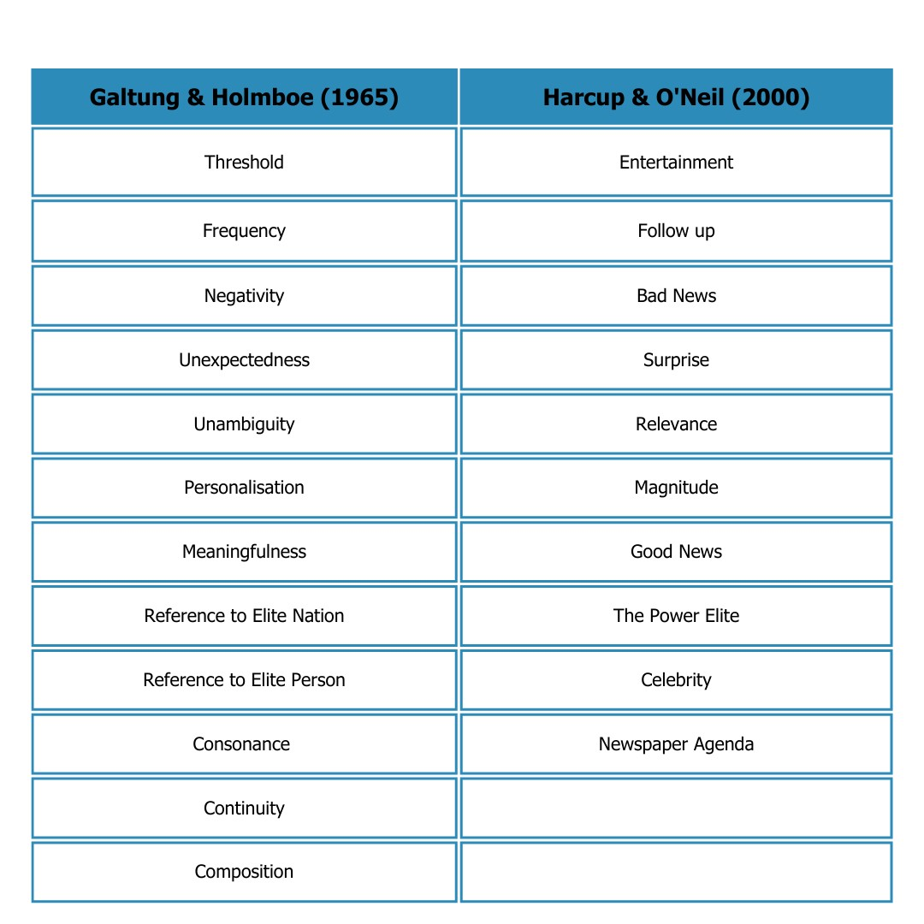
Table 1: List of News Values from 1965 and 2000

A news value that has dominated most of the news coverage throughout the course of the public health crisis has been Continuity. According to the revisited news values by Harcup and O’Neill, this can be equated with Follow up. As information about the pandemic was changing every day, it was crucial to keep reporting on news in relation to the pandemic.

1.5 Disinformation and Misinformation
A second, significant element of this study was to comprehend the distinction between ‘misinformation’ and ‘disinformation.’ Over time, meanings have been blended and have been equated with ‘fake news.’ According to Pérez-Escolar et al. (2023), ”fake news is a vague term that has been used to cover a wide variety of communication that is to some degree false” (2023, p. 76). The difference between misinformation and disinformation lies in the intention behind the dissemination of information.
Misinformation refers to information that is incorrect or inaccurate but is disseminated in good faith without the intention to mislead the consumer. It is not intentional or malicious and can occur in journalism due to a variety of reasons, such as misunderstanding, misinterpreting, or misreporting information (Feb. 15 and 2023, 2022).
On the other hand, disinformation refers to information that is deliberately falsified or manipulated with the intent to deceive or mislead (Fallis, 2014). Disinformation is often spread with a specific purpose, such as to influence public opinion or gain a political advantage (Deen and Wells, 2020). Disinformation can be propagated by individuals or groups with access to advanced information technologies or large resources, and it can be challenging to notice. (Deen and Wells, 2020).
While both possess the capacity to cause harm, disinformation is more pernicious since it is a conscious effort to influence or deceive the public.

Though created without malice, misinformation still occurs frequently and can be due to assorted reasons. This can be because not all facts are yet available or some unforeseeable factors change the direction of a story (Ecker, 2012), for instance, if there is a rush to publish or a source has intentionally misled the journalist. In that case, it remains the journalist’s duty to correct that misinformation. A majority of online news outlets are able to receive feedback via a comment function that is integrated into their websites. This is a useful tool for both the journalist and the reader. The reader can engage in a conversation with the journalist and point out a mistake, whether that be factual or grammatical. A good journalist will join the conversation, be open to receiving feedback, provide factual understanding of events, and, if within the editorial regulations of the news organisation, implement feedback.
The Covid-19 pandemic has been a prime example of how misinformation and disinformation can spread rapidly and affect people’s opinions. Social media sites have been platforms that frequently facilitate fake news (Xiao et al., 2021). Misinformation is often spread online due to the low level of media literacy among audiences, and their inability to discern between reliable and unreliable sources can be dangerous. As social media platforms do not have a moderator, erroneous information is more likely to circulate, be consumed, and be believed by the public.
An example of disinformation during the public health crisis has been the ongoing debate about vaccines against the Coronavirus. There have been numerous false and misleading assertions made in an effort to undermine the public's faith in the safety and adoption of COVID-19 vaccines, despite scientific evidence proving that these vaccines are a safe and effective way to prevent severe cases of corona infections.

Those false statement stated for example, that “people may decline immunizations due to false claims that vaccines contain infertility agents or can spread an infectious pathogen such as human immunodeficiency virus” (Islam et al., 2021).
However, an interesting detail, as mentioned by the Stanford News Service (Anon, 2022), states that falsified information about a vaccine against the virus has been circulating “long before a vaccine against COVID-19 had even been developed or approved.” Those rumours, however, have quickly gained momentum, especially online. BBC found that those rumours partially stem from people who pursue an anti-vaccine agenda and “have been misinterpreting figures.”
Though this false information originated due to misinterpretation, it was nevertheless perceived as factually true by a large group of people and has favoured vaccine hesitancy (Islam et al., 2021). Above that, groups with an anti-vaccine agenda have twisted the facts and used them as a means of expressing their personal convictions, therefore deliberately distributing disinformation.
An example of misinformation during the public health crisis was the spread of misleading facts regarding the efficacy of hydroxychloroquine as a medication for COVID-19. Hydroxychloroquine is originally known as an anti-malarial drug that gained widespread attention after studies suggested its potential effectiveness against the coronavirus (Krishna and Conversation, 2022). However, there was little solid scientific evidence to back up the claims and statistics that supported its use.

Considering there was no evidence of scientific agreement, misinformation began propagating on social media and additionally received encouragement from political officials. Donald Trump, former US president, has publicly backed hydroxychloroquine (ABC News, 2020). As a result, there was an increase in public interest as many people looked into the medicine as a possible cure.
Yet when additional research was undertaken and evaluated, it became apparent that hydroxychloroquine was not a viable COVID-19 treatment. Due to its conceivable negative effects and scarcity of scientific evidence, the World Health Organisation (WHO) (2023), the U.S. Food and Drug Administration (FDA) (Research, 2023), and the National Institutes of Health (NIH) (2020) have all released comments advocating against its use in relation to the Coronavirus.
Though the initial study that stated the possible effectiveness of hydroxychloroquine was criticised for, among other things, missing data, and ethical concerns, there was no proof that the study was published to intentionally deceive the public, therefore making it an instance of misinformation.
This illustration shows the perils of spreading false information when a public health emergency arises. It shows how misleading statements can spread, especially when they are supported by powerful people. It also underlines the crucial role that dependable sources and media literacy play in preventing misinformation and ensuring that the public receives accurate information, including healthcare professionals and public health organisations.

1.6 Structure of the Dissertation
This dissertation encompasses six distinct chapters that each comprise a specific function for this body of work. An introduction of the research issue, background, aims, objectives, research questions, and methods is given in Chapter 1 (Introduction). A critical evaluation of the literature is provided in Chapter 2 (Literature review), which addresses topics such as media consumption patterns, media trust, and fake news. The research design, sample selection, data collection techniques, and ethical issues are presented in Chapter 3 (Methodology). The results of the surveys will be presented in Chapter 4 (Findings), which will combine the quantitative and qualitative data for analysis. The final analysis of the data will be included in Chapter 5 (Analysis). Lastly, the main conclusion, their theoretical and practical ramifications, and recommendations for media educators, business professionals, and policymakers will all be summarised in Chapter 6 (Conclusion and Recommendations).

Chapter Two
Literature Review

2.0 Introduction
The overarching purpose of this chapter is to provide an overview of the empirical literature, framework of knowledge, and findings in connection with the news and current affairs consumption habits, and media trust of current and recent third level media students in Ireland. Additionally, it looks at connective themes that are contributory in answering the research questions that are guiding this study. This will provide an in-depth insight as well as a critical appraisal of the body of existing sources in this context to discover possible gaps in the existing knowledge, highlight the originality of the researcher’s contribution to this topic and identify opportunities for further exploration. Consequently, the consideration of sources will aid in the avoidance of duplications and ensure that the work builds upon previous findings that essentially enhance the validity and reliability of the study.
2.1 The Formation of news habits
The habit of consuming news is deeply imprinted in our minds. A habit is established by a frequently recurring stimulus, which generates repetitive behaviour, resulting in the formation of a routine (Groot Kormelink, 2023). According to The Habitual Consumer (Wood and Neal, 2009), roughly 45% of our everyday actions repeat themselves in the same environment every day. During the COVID-19 pandemic, a study by Broersma and Swart (2022) examined how and to what degree citizens developed new patterns of news consumption or modified old routines, as well as what factors promoted or inhibited habit formation.
According to their findings, typical behaviours such as checking your phone in the morning or turning on the radio while driving are performed automatically rather than as a result of "cognitive or deliberate motivation."
According to previous research, substantial changes in daily activities and ways of life may cause the establishment of new habits or the alteration of preexisting ones (Verplanken, Roy, and Whitmarsh 2018; Broersma and Swart, 2022; Ghersetti and Westlund, 2018). While some people's heightened perplexity, anxiety, and stress may have contributed to the development of news addictions, for some, the steady influx of confirmed incidents, daily mortality tolls, and new government laws may have had the opposite effect, causing consumers to lose interest in the news (Nielsen et al., 2020).
A recent study, conducted by Dutch scholars Marcel Broersma and Joëlle Swart (2022) provided context for this reasoning. They examined the question of whether newly adapted news consumption habits would ‘stick’ after the public health crisis. This question, which was intended to be answered through open-ended qualitative questionnaires, was conducted early in the pandemic. They found out that “for citizens who have not taken up news in their daily routines, the formation of novel patterns of news use is very rare” (Broersma and Swart, 2022).
Another study entitled Does a Crisis Change News Habits? (Van Aelst et al., 2021) adds that the growth is most visible among individuals who already have a more substantial amount of trust in 'legacy media' and are more worried about the pandemic.

Broersma’s and Swart’s study revealed that throughout the pandemic, people changed the way they consumed news, mostly as a result of a greater reliance on digital outlets (Eddy, 2022). This shift occurred as a result of factors such as increased access to news online, evolving media consumption patterns, and decreasing reliance on traditional sources such as newspapers and television. According to the survey, many people continued to follow certain old routines despite significant changes in news consumption.
Broersma and Swart's study (2022) also revealed that respondents retained pre-pandemic tendencies, particularly when it came to using traditional media sources or sticking with well-known news sources. The perceived utility of the habits, their fit with people's self-identities, and the social aspect of news consumption are three factors identified by the authors as determining the longevity of new routines. People were more likely to persist with new habits if they were positive, in keeping with their self-image, and allowed to create ties with others through the sharing of similar news experiences.
A study by Brita Ytre-Arne and Hallvard Moe (2021) corroborates those findings by additionally examining the theory of ‘habits of news avoidance’. Their qualitative questionnaire resulted in five major findings. It indicated that the pandemic increased news consumption significantly, with people spending more time reading news online or through traditional media sources. The study also discovered a phenomenon known as "Doomscrolling," in which people consume an overwhelming amount of negative news about the public health crisis.

This behaviour was driven by a desire to stay informed but also resulted in feelings of anxiety and stress. According to the findings, several participants adopted a monitoring attitude, continually checking news updates to stay up to date on current and quickly changing circumstances. This behaviour was motivated by a desire to exert control over the situation. The study also found that some people consciously tried to avoid news consumption in order to maintain their mental health. Participants in the study understood the harmful impact of excessive news exposure on their anxiety levels and intentionally reduced their news intake, according to the study.
Finally, Brita Ytre-Arne and Hallvard Moe (2021) discovered that participants preferred specific news themes such as health, government policies, and economic implications. They sought information from credible and trusted sources and depended on official sources for the latest developments.
Drawing attention back to the study conducted by Broersma and Swart (2022), they argue that habit formation has only ever been researched in experimental capacities and not in real-life scenarios as they are very complex. While their research considers a real-life scenario caused by the pandemic, they are focussing only on news consumption during the pandemic, while this research actively draws comparisons between news and current affairs consumption during the pandemic as opposed to after the pandemic.
Even though the examinination of a larger audience poses as a useful source for a general idea, this research, on the other hand, is narrowed down to examine those changes in the group of current and recent third-level Irish media students. In addition to this, the study by Groot Kormelink (2023) argues that habits can only be formed in a stable context.
However, having a three-week trial subscription, which included participants that might already have strong existing habits, makes this research fall into the category of ‘experimental.’
As this research is conducted after the pandemic, there has been a long enough and ‘stable context’ to research the formation of new habits and the extent of their retention after the pandemic with the consideration of any preexisting information from before and during the pandemic, which makes this research a continuation of any previously mentioned studies.
Moreover, most of the existing studies in this review focus on larger and arbitrary groups that consequently offer a general snapshot of the formation and changing of news habits during the pandemic. Focussing on a niche audience can aid in identifying more detailed insight and context in the field of news and current affairs consumption habits.
2.2 News consumption patterns in Ireland
News consumption has undergone significant transformation in recent years, influenced by technological advancements and changing societal dynamics (Anon, 2018). The period between 2019 and 2022 in particular provides valuable insight into factors for contributing to changes in news consumption habits and serves as a crucial basis for this research.
In a speech delivered by Rupert Murdoch in 2005, he references the study of Merrill Brown and quotes that “consumers between the ages of 18-34 are increasingly using the web as their medium of choice for news consumption” (Anon, 2005).
This prediction concludes that while local TV news will continue to be the most popular source of news, younger consumers are increasingly favouring the Internet and, more especially, news portals.
A decade later, a published report entitled Media Consumption Forecasts 2016 (Austin et al., 2016) looks at the changing patterns of media consumption in 71 countries and provides an estimate of how time spent on various media platforms will vary between 2016 and 2019 - the years preceding the pandemic.
The key findings taken from their survey suggest that the time spent on mobile devices will increase by 27.7% and all other media will experience a decline of 3.4% (Austin et al., 2016). In more detail, this further suggests that all traditional media will decline; cinema by 0.5%, outdoor by 0.8%, television by 1.5%, radio by 2.4%, newspapers by 5.6%, and magazines by 6.7%.
When people went into lockdown, however, daily patterns were disrupted. This unpredicted disruption has led to the formation of new news consumption habits that differentiate from pre-pandemic predictions and media studies (Coddington and Lewis, 2021).
A crucial source for assessing changes in news consumption habits are the annually published reports by the Reuters Institute. The annual Digital News Report compiles survey information from 93,432 online news consumers across 46 markets, or more than half of the global population – making their findings “revelatory, global and unique” (Reuters Digital News Report, 2022). Considering this source for the research for this study is of major significance, as comparing their reports from the period of 2020-2021 will not only offer the necessary data regarding news consumption habits but will also analyse them against the backdrop of the pandemic. Moreover, their annual reports list Ireland as a focus example through which an even more detailed analysis is possible. Essentially, this enables the formation of a strong framework for this research.
Looking at Ireland in pre-pandemic years, the Reuters Institute Digital News Report 2015: Tracking the Future of News (Newman et al., 2015) agrees to a “structural decline” of traditional media, though their 2020 report shows “television audiences increasing sharply during the COVID-19 lockdown” (Newman, 2020).
Though the pandemic hampered their research, literature in the peak years of the pandemic entitled Digital 2021: Ireland (Anon, n.d.) found 4.51 million Internet users in Ireland in 2021. This shows an increase of 242 thousand users in comparison to 2020.
By comparing the general findings of the reports from 2020 (Newman, 2020) and 2021 (Anon, 2021), there are several changes in consumption patterns that can be identified. Firstly, the reports recognise the pandemic’s impact on news consumption patterns. Online news consumption remained strong in 2021, but there was a minor decrease from the previous year as individuals began to obtain news more through TV and radio. Furthermore, in both years, there was an increase in concerns about the quality and dependability of news. In 2021, over 44% of global respondents said they were concerned about what is true and false on the internet, and approximately 55% were concerned about misleading information being constantly spread. Social media sites were seen as the most significant source of misinformation (Newman, 2020; Anon, 2021).
In The Impact of Covid-19 on Journalism: A Set of Transformations in Five Domains (Casero-Ripollés, 2021), those results were partially matched. According to Casero-Ripollés, a portion of the surge in digital news sources is attributed to various lockdown procedures that resulted in limited access to print newspapers and periodicals. According to the article, there has also been a shift and greater reliance on local news.
While the overall findings of Casero-Ripollés’ study concluded a decrease in trust in the news, Ireland has seen an increase in the confidence in news overall, with 53%, up from 48% in 2020. At the same time, the impact of the pandemic has increased general news consumption in Ireland, with 75% of respondents reporting that they used a greater variety of news sources throughout the crisis. This increase, however, was met with concern regarding Covid-19 disinformation.
A comparison of the results of the 2020 (Newman, 2020) and 2021 (Anon, 2021) puts ‘online’ at the top as a source of news both in 2020 (80%) and 2021 (81%). Though both reports show that traditional news appears to be in structural decline, “industry data show television audiences increasing sharply during the COVID-19 lockdown” (Newman, 2020). While in 2020 TV rates were at 64%, in 2021 this figure experienced a 4 percent increase. Newspaper consumption continues to fall, as print news has seen an “accelerated decline” (Anon, 2021) from 32% in 2020, down to 28% in 2021. This corroborates the findings of Casero-Ripollés (2021), which name the limited access as a cause.
For the first time in 2021, the report included data that looked the consumption of podcasts. The results show, that 41% of respondents listened to a podcast in the last month, though the reports did not provide any insight into the genres of podcasts.
Furthermore, it is of significance to include the Reuters Digital News Report from 2022 (Newman et al., 2022) as this became the year when regulations were dropping, and societies were returning to normality. Additionally, this study aims to examine the aftereffects of the pandemic on the news consumption habits of current and recent Irish 3rd level media students. Taking data from a broader period can aid in observing trends and patterns and any changes to them.
The 2022 report (Newman et al., 2022), with a focus on Ireland, reveals only slight adaptations in comparison to the data available from 2020 and 2021. The data highlights that the trust in news overall sites at 52%, which, according to the report, is “relatively well trusted by international standards”. Moreover, it matches the decline on print news (27%) and names tabloid news as the “least trusted” (Newman et al., 2022). The initial increase in TV from 2021, drops again from 68 percent (2021) to 63%, while online remains the highest source of news throughout during the pandemic period with 83 percent. Above that, Ireland has experienced an increase in podcast user from 41% in 2021 to 46% in 2022.
With this review, it becomes evident that there is a general lack of existing literature that considers the news and current affairs consumption habits of Irish 3rd level media students and recent graduates. With this study, however, and a unique approach, a more niche target audience will be observed and analysed, delivering novel data that is valuable both for this research and, at the same time, advances the field for future research.

2.3 Media Trust
In a democratic society, preserving the trust of consumers in the media remains paramount (Strömbäck et al., 2020). The maintaining of this position, however, is also in the interest of the media industry itself. Schranz et al. (2018, p.74) argue that “a product that is not trusted does not sell well.” To this statement, they add, that there is a prevailing environment of distrust. Particularly in recent years, trust in the media has experienced a shift that has caused issues. Not least because of the emergence of the Covid-19 pandemic, which has exacerbated those issues.
The Reuters Digital News Report 2020 compared to the 2021 report summarises those doubts about news quality and reliability that increased in both years. In 2021, around 44% of the respondents globally said they have concerns about what is real and fake on the internet, and about 55% worry about false information being repeatedly shared. Social media platforms were seen as the biggest source of misinformation.
By examining the relationship between trust in the media and patterns of media consumption, the study by Schranz et al. (2018) found that people's media usage behaviours are greatly influenced by how much faith they place in the media. According to the study, people who trust others more are more likely to read the news and rely on it for information. They also discovered that the rise of social media and other alternative media platforms has resulted in a more fragmented distribution of media consumption. People who have less trust in traditional media are more likely to use social media and alternative news and information sources (Schranz et al., 2018). The study also discovered a general reduction in traditional media confidence over time. Political polarisation and the growth of alternative media are just two of the factors contributing to this decline.
Furthermore, they discovered that media literacy influences trust in the media. More media-literate people are more likely to trust traditional media sources and are able to distinguish between trustworthy and untrustworthy sources (Schranz et al., 2018).
Those findings are a valuable basis for this research, as they function as a reference point for methodological approaches and data collection methods. The findings also correspond with the key questions this research has set out to answer.
Susan O’Donnell’s findings in her report entitled News Consumption in Ireland and the European Union: Traditional Media vs. the Internet (O’Donnell, 2003) developed an overview of news consumption trends and introduced the concept of trust in relation to media consumption. According to her, “seventy-eight percent tend to trust television media - making Irish people the most trusting of television in the EU, tied with Portugal. The EU average is 62 percent” (O’Donnell, 2003).
The findings of her Eurobarometer survey also conclude that their trust is highest in television, followed by their trust in radio, newspapers, and lastly, the Internet, at 9%. In the years following, the research outcome by the Reuters Institute (Newman, 2020) suggests, that between 2019-2020 universal trust in news remained level at 48%. Ireland’s trust in news has put RTÉ, the biggest national broadcaster, in first place with 76%, closely followed by the Irish Times and the Irish Independent. But even though news coverage on social media is increasing, trust in news provided on social network sites is at 18%. This overview of trust in media is crucial to consider for this research as it gives an incentive as to what the evolution of media trust was as well as factors that might influence this level of media trust.
By looking at possible factors that would cause a decrease in general trust in news, an article by the Columbia Journalism Review (Ingram, 2018) summarised the results of a Knight Foundation and Gallup poll. They found that 45 percent based their level of trust on inaccuracies, fake news, a lack of credibility and that “reports are based on opinions or emotions”.
Adding to that, in a study from 2019 (Strömbäck et al., 2020), Strömbäck et al. list other factors that mitigate people’s trust in the media inter alia that (1) traditional media faces competition from a plethora of other sources of information, (2) the emergence of so-called ‘alternative’ and ‘partisan’ media that label traditional news media as ‘untrustworthy or (3) that there is an increasing circulation of ‘fake news’, misinformation, and disinformation (Benkler et al., 2018).
A survey undertaken at the Queensland University of Technology and the University of Canberra (Fisher et al., 2020) was also conducted to determine what impacts trust in news. They found that “past history of inaccurate stories, opinionated journalists or presenters, a lack of transparency, sensationalism and excessive advocacy on behalf of particular points of view” were labelled as promoted factors of mistrust. On the other hand, “depth of coverage, the reputation of the news brand, the reputation of particular journalists or presenters, and openness to comments and feedback from audiences” promoted trust (Fisher et al., 2020).
The discovered factors that promote mistrust in news will serve as a valuable reference point for the methodological approach and data collection of this study.

In his paper, Casero-Ripollés (2021) added that the rapid spread of false information and conspiracy theories has resulted in a growing need for fact-checking and verification to ensure trustworthy news. With a second glance at the findings of the 2022 Reuters Digital Report (Anon, n.d.), there was mention of an increase in involvement by news organisations throughout the pandemic through the use of explainers or question-and-answer-formats, implying that news outlets were actively contributing to maintaining an elevated level of confidence across their channels. Their report emphasises its relevance while also emphasising the imperative of its continuation.
The rapid spread of the Covid-19 pandemic in the early months of 2020 has tested the media’s trust of consumers. As a result, an ‘infodemic’ has caused shifts in the judgment of the people (Patwa et al., 2021) The study How Media Exposure, Media Trust, and Media Bias Perception Influence Public Evaluation of the COVID-19 Pandemic in International Metropolises (Han et al., 2022) investigates the relationship between media exposure, media trust, media bias perception, and public judgement of the COVID-19 pandemic in international metropolises. Their primary findings indicated that media exposure and trust in the media have a beneficial impact on public perception of the COVID-19 pandemic. People who were exposed to a greater variety of media sources and had a higher level of trust in the media rated the news in connection with the pandemic more highly. The most important conclusions of this study were that different media sources have differing influences on public perception of the pandemic. According to the study, social media exposure has a greater favourable effect on public evaluation than traditional media sources.
A 2022 Eurobarometer survey (Anon, 2022) offers figures that put the current level of media trust in the European Union into perspective. The survey's results show that consumers have more faith in traditional print and broadcast media, including their online presence, than they do in social media and online news sources. The printed press, whether it comes through their "native channel" or their online presence, is expected to give consumers accurate news by 49% of respondents, followed by public TV and radio stations by 39%. On the other side, 27% of respondents cited private TV and radio stations as trustworthy media sources. Only in Poland are private TV and radio stations the most reliable news sources. Hungary's respondents cite "people, groups, or friends followed on social media" as their most reliable news sources, indicating an even more extreme shift away from conventional news sources. A significance of trust also emerged when respondents were questioned about what would make them most inclined to access an online news article. While 37% believe it is crucial to trust the news source giving the article, 54% are persuaded by the headline being pertinent to their interests (Anon, 2022).
Even though trust in the media has dropped throughout the EU, Ireland remained in an elevated position during the early months of the pandemic. A 2020 Eurostat survey published in the Irish Times (Horgan-Jones, 2020) showed that while Europe’s average trust in the media is at 4.6 (scale of 1-10), Ireland’s trust in the media is set at 5.5.
The empirical literature on media trust is broad and offers in-depth groundwork for this research. Considering the sources, it has revealed gaps, especially regarding the target audience. Most surveys conducted to establish a snapshot of Irish citizens’ trust during the pandemic are directed at the entire population.
This research fulfils the demands for more inclusive research, as it deliberately excludes demographics. This ensures that the unique challenges faced by the niche group, which was chosen, are adequately addressed.
2.4 Fake News and the fight against it
The emergence of the Covid-19 epidemic abruptly disrupted daily patterns resulting in economic adjustments, disturbances in education, and several laws governing “home confinement” (Munster et al., 2020). As a result of the increased ambiguity, more information regarding the virus and preventive measures was needed (Eysenbach, 2020). This increased need to be informed, however, simultaneously increased the circulation of false information and conspiracy theories, predominately on social media platforms. Burkhardt (2017) stated in his report that “the creation and spread of fake news is a problem that seems ingrained in human nature.” Rocha et al. (2023) additionally found that infodemic knowledge can cause psychological disorders, such as fear, depression, and fatigue. Additionally, Jin et al. (2020) state that crisis misinformation and fake news, “has become a fundamental threat to organizational wellbeing.” He empathises that there is a necessity for an effective crisis response to fight the rise of fake news. His study revealed that “The use of factual elaboration and the presence of employee backup increase crisis response effectiveness.”
As his study seeks to advance misinformation research in public relations, there is a thematic link that makes the study by Jin et al. (2020) valuable for this research.
Literature cited for this topic suggests that social media became a platform that more frequently facilitated misinformation and conspiracy theories, especially during the beginning of the Covid-19 pandemic (Xiao et al., 2021).
Introducing “horizontally integrated” media companies, that formed a “convergence has created a new phenomenon of multiplatform storytelling,” causing news coverage to be increasingly broadcasted on social media platforms (Austin et al., n.d.). Additional research by Al-Zaman (Al-Zaman, 2022) concludes that the main source of disinformation (84.94%) can be traced back to social media, and the largest source of misinformation for COVID-19 (90.5%) stems from the Internet as a whole. Moreover, out of all social media platforms, Facebook alone generates 66.87% of false information (Al-Zaman, 2022). Research undertaken by the HEC Paris (Anon, 2021) adds that this is due to the algorithmic design of social media platforms that prioritises engagement and reinforces existing beliefs.
A 2022 Eurobarometer survey (Anon, 2022) discovered that 37 % of Irish citizens “have encountered disinformation or fake news often in the past 7 days.” Taken from all the respondents, 12% feel ‘very confident’ while 52% feel ‘somewhat confident’ in identifying fake news. The study concluded this point by stating that age and level of education play a crucial role in distinguishing between true and false information. According to the study, “the level of confidence in distinguishing between real news and fake news decreases with age and increases with level of education” (Anon, 2022) indicating that a higher level in education equates to a higher level of media literacy.
The research by HEC Paris (Anon, 2021) focussed on finding out the root causes of information and misinformation and what the societal ramifications are. They urge consumers, to “crosscheck information that you get through social media with at least two other information sources such as government websites and high-quality news outlets” as people often rely on their gut feelings (Anon, 2021).
They concluded that governments should spend money on systems for more accurately spotting false content, which would boost online accountability. Due to the fact that the Internet is an unregulated, open public domain, we rely on platform owners to keep an eye on the material (Anon, 2021).
Though Burkhardt (2017) argues that both fake news and its source are complex to discern “and the means of making it stop are not yet known”, the pandemic revealed new ideas and approaches on how to tackle fake news.
How to Fight an Infodemic: The Four Pillars of Infodemic Management (Eysenbach, 2020) is a report that provides guidelines on managing the spread of misinformation during a public health crisis. They put forward the results that monitoring and detecting misinformation are crucial in combating an infodemic.
They contend that it is critical to set up methods for ongoing social media, news, and internet platform monitoring in order to spot fraudulent or misleading material. They also stress the value of efficient communication in combating an infodemic. In addition, they contend that interacting with communities and working with reliable influencers can assist in the establishment of trust and combat false information. Lastly, their report concluded that in order to counteract the proliferation of misinformation, a systematic and coordinated approach is required.
Conforming to Eysenbach (2020), that includes the fact that fact-checking organisations should be sponsored in order to quickly verify and refute misleading information. Additionally, to make sure the general public is informed accurately, information that is supported by evidence should be widely shared.
Further ideas on how to deal with fake news are explained in a report by Bajarin (2018). Though it was published prior to knowledge of the pandemic, it nevertheless offers an interesting viewpoint that is worth considering for the development of this research. Bajarin sparks interest with the Checkology virtual classroom, “where students learn how to navigate the challenging information landscape by mastering the skills of news literacy” (Checkology, 2023). According to their agenda, journalists as well as digital media experts, will provide students with the tools to analyse and comprehend news, as well as be taught how to select which news stories and additional data to trust and engage with (Checkology, 2023).
Tomczyk (Institute of Educational Science, Pedagogical University of Cracow (Poland) and Tomczyk, 2019), offers similar reasoning and states that “fluent use of digital media is one of the DL components – as much important as the ability to understand and anticipate online threats.”
The key findings of the study on the digital literacy of primary education teachers in the area of digital safety emphasize the importance of educating students on digital literacy.
From reviewing the existing literature concerning fake news and the fight against it, it becomes apparent that the existence and circulation of fake news are especially prominent and favoured on social media platforms. Simultaneously, social media is the primary source of information accessed by the targeted audience of this research. Consequently, it makes sense to assume that this audience would have come across an abundance of fake news.
With the data from past studies, it is therefore crucial to ascertain, whether the consumption of fake news has caused a change in their consumption habits or whether their media education has led to more awareness regarding the credibility of sources. Assessing this can aid in better understanding third level media students and recent graduates, as they have the potential to become future journalists, content creators, or media educators who can contribute to enhancing media literacy across society.
By understanding how the pandemic affected their news consumption and current affairs habits, future students can be more educated in producing content that is more trustworthy, engaging, and unbiased, thus contributing to the overall improvement of media literacy as well as trustworthy information for society.
2.5 ‘Doomscrolling’
The advent of the pandemic has led the act of doomscrolling to regain significance in order “to describe the phenomenon of elevated negative affect after viewing pandemic-related media” (Price et al., 2022). Doomscrolling, by definition, refers to the act of excessive consumption of negative news through online channels to the detriment of the consumer’s mental and physical health (Ytre-Arne and Moe, 2021). A link to its place of origin can be drawn back to the psychosocial phenomenon called Mean World Syndrome.
Kemp (2023) describes Mean World Syndrome is a ‘psychosocial phenomenon’ characterised by high levels of fear, anxiety, and pessimism. Above that it generates the impression that the world is "meaner" than it is. This is attributable to a high consumption of violence-related mass media.
A connection from the mean world syndrome can be drawn to the cultivation theory, which contends that media has a substantial influence on viewers' impressions of the world around them (Shrum, 2017).
According to a 2019 National Academy of Science study (Soroka et al., 2015), people exhibit larger physiological responses to bad news than good news, indicating that there is a negativity bias in how people react to news events.
According to the researcher, negative bias is a universal phenomenon because it is consistent across all ethnic and socioeconomic backgrounds. The study also discovered that the degree of negative news affected how strongly people reacted.
Far stronger physiological reactions were induced by far more severe, unfavourable experiences. The study also emphasises the role of the media in influencing public perception because negative news frequently attracts greater attention and participation, which may result in a distorted view of the world.
Overall, these results indicate that people naturally focus more on negative news, which affects their physiological reactions and can have an impact on their perceptions and behaviours.
The key findings of the research on Doomsurfing and doomscrolling mediating psychological distress in the COVID-19 lockdown: Implications for awareness of cognitive biases (Anand et al., 2022) have identified an extension to doomscrolling that became prevalent during the COVID-19 lockdown: doomsurfing.
Doomsurfing refers to seeking out negative news or information online, while doomscrolling refers to continuously scrolling through such content on social media platforms. The study also discovered a significant correlation between doomscrolling and doomsurfing habits and higher degrees of psychological discomfort during the lockdown. Increased worry, depression, and stress were indicated by those who exhibited these behaviours most frequently.
It was discovered that doomscrolling and doomsurfing serve as mediators between cognitive biases and psychological suffering. The likelihood of engaging in doomsurfing and doomscrolling was found to be influenced by cognitive biases such as availability bias and confirmation bias, thus influencing psychological well-being.
The results imply that it can be advantageous to be aware of cognitive biases and the possible drawbacks of doomscrolling and doomsurfing (Anand et al., 2022). Understanding these biases enables people to consciously choose to restrict their exposure to unfavourable news and information, thereby lowering their risk of experiencing psychological discomfort in emergency situations like the COVID-19 lockdown.
This study emphasises the significance of managing and monitoring one's online consumption habits since excessive exposure to unfavourable news and information can seriously exacerbate psychological distress, as stated in the NAS (2019) study.
As the addressed target audience that has been chosen for this research can be estimated to be between 19-25, they are also at the age of the so-called social-natives, who are defined as being more reliant on getting their news on social media (Eddy, 2022). There is an incentive to find out if an audience with a media academic background and an education in media literacy that predominately spends their time and gets their news from various digital platforms, leads to the same results as the general assumption of previous studies.
2.6 Communication Theories
Literature that has been published on this subject suggests that audiences display different behaviour when exposed to different forms of news through different platforms. The findings from Jin et al. (2020) have shown that reporting during a crisis has a major impact on ‘organisational well-being’. The research expounds that in order to combat the increasing dissemination of falsehoods and misinformation, crisis communication needs to be approached from a different angle. Personally reviewed sources have additionally provided insight into the plethora of theories (Anon, 2010) that are available when analysing audience and communication. According to the Cultivation Theory (Shrum, 2017), media influences how people see reality. Many people learn knowledge through mediated sources rather than through personal experience, hence, these sources have an impact on how they interpret the world. According to the framing theory (Chong and Druckman, 2007), "Frames" are the ways that we perceive the media that is offered to us. These frames serve to categorise social meanings. The media shapes what and how we see, thus having an impact on how we understand information as well. In a sense, they instruct us on both what and how to think. According to the Uses and Gratification Theory (Anon, 2010), viewers deliberately seek out media to meet their own wants. Using this premise, the Uses and Gratifications Theory seeks to address three issues: what do individuals do with the media, what drives them to use it, and what are the benefits and drawbacks of their media use?
Understanding these theories and applying them to this research can support the evaluation of the survey and establish a better understanding of the changes in the audience’s news consumption habits that were triggered during the pandemic. Consequently, it aids to understand any habits or long-term patterns that have been adapted as a result of the pandemic conditions. Understanding the psychology behind different communication theories also aids in better understanding the psychology of the targeted audience of this research. Lastly, in considering existing communication theories, the findings of this study might trigger an incentive for the formation of new theories. Ultimately, this advances the fields of communication and journalism.

Chapter Three
Methodology
3.0 Introduction
This chapter comprises the adopted methodology behind the investigation of this research. It aims to elaborate on the methods of primary and secondary data collection to answer the outlined research questions and justify them. Additionally, this chapter focuses on the research design and its sampling, the target audience that is addressed, the final data presentation, as well as its methods of analysis. Finally, it considers the ethical aspects of this research and any limitations that may hinder it.
3.1 Research Design
A quantitative method in the form of a survey was conducted with the primary objective of accumulating detailed insight into the media trust and the news & current affairs consumption habits of current and recent Irish 3rd level media students. The survey captures the various answers of participants within this target audience. Though often equated with a standardised questionnaire, both research designs are not identical (Slattery et al., 2011).
The survey used a plethora of predetermined questions to examine any changes in news consumption and media trust among this specific group. Additionally, it creates newfound data that is not available from other sources as the survey is tailored to the search questions (Fink, 2015). The term "quantitative research" refers to a variety of techniques employed to methodically examine social phenomena using statistical or numerical data. Qualitative research consequently involves measurement and presupposes that the event under investigation may be quantified. Essentially, the primary objectives of quantitative research are to collect data through measurement, look for patterns and relationships in the data, and verify the results. (Watson, 2015, p.1).
As surveys are of paramount significance for media researchers seeking information on their intended audiences (Bornman, 2009), this research design is well justified.
This approach will give a holistic understanding of the trends, driving forces, and underlying causes affecting the modifications in news consumption patterns and media trust among current and recent third-level media students in Ireland as a direct result of the pandemic.
In addition to the survey, a secondary method of data collection is directed at reading a plethora of peer-reviewed academic papers alongside statistics, magazines, as well as books. In addition, those sources will be analysed based on their contents and thematic significance to this study.
3.2 Target Audience
The targeted audience of this quantitative research are Irish 3rd level students as well as recent graduates in or with media-related degrees. According to the Education at a Glance 2022 report by the OECD, the 2020 EU average age of first-time upper-secondary graduates is between 19 and 20 years old (Markus, 2022). Considering that some students may take a break after a prior graduation, the target audience can be identified as 19- to 25-year-olds (Open Universities Australia, 2022). In addition, and within the defined target audience, the participants will have to be undergraduate students at the beginning of the pandemic and third-level students at the time of answering the survey. Additionally, the students must be enrolled in a media-related degree such as Journalism, Media Economics, or Communication.
Furthermore, the participants will have to be able to read and write in the English language and be subscribed to social media platforms. The mentioned parameters are ensured through the survey’s layout, which asks for name, age, and field of study.
3.3 Sampling
The technique of 'Sampling' refers to the technique of selecting a subset of individuals from a population in order to assess the characteristics of a population as a whole (Singh and Masuku, 2014, p. 3). In addition, it can be used to establish generalisations based on current theory as well as being (Taherdoost, 2016) fast and cost-effective (Groves, 2005). Specific methods of sampling are employed for specific research events in which sample size is a crucial component. (Singh and Masuku, 2014, p. 3). Sampling techniques are divided into two categories: 'Probability' samples and 'Non-probability' samples (Acharya et al., 2013), p.303).
In consideration of the various existing sampling techniques mentioned in Sampling Techniques & Determination of sample size in applied statistics research: An Overview (Singh and Masuku, 2014, p. 3), non-probability sampling was selected for this study.
Non-probability sampling is a type of sampling method where the selection of participants is not based on randomisation or equal chances of being selected. This sampling method allows for the intentional selection of participants who are relevant to the research question or objective under study. By narrowing the sample selection in this way, it decreases the likelihood of errors due to differences in age or experience, which could impact the results. Another key benefit of non-probability sampling in surveys is that it can be more efficient (Wolf et al., 2016). Rather than randomising participants from a large population, non-probability sampling allows the selection of participants based on specific criteria, such as demographics or interests. This aids in saving time and resources, as it filters for the most fitting candidates and allows the researcher to disregard the data collected from participants who do not meet the criteria for this study.
Non-probability sampling can, however, entail the risk of biases as the researcher determines the parameters and size of the sample “because sampling units are not independent and projecting data beyond sample is not justified” (Acharya et al., 2013). Though this is factually true, the quantitative research design is construed for a predetermined audience, as they are the central demographic that this study is investigating.
3.4 The Survey
The study’s selected instrument for data collection was a survey. The survey’s main channel of distribution was online. Surveys can be executed in a multitude of ways, including telephone interviews, meetings held in person, as well as most frequently, self-administered surveys (Slattery et al., 2011). Online surveys have been gathering value and are “used more frequently and better accepted by researchers” (Evans and Mathur, 2018). Conducted theories as well as metatheoretical research into surveys have led to the optimising of the credibility of surveys (Bornman, 2009, p. 425). To gather as much data as possible, the survey facilitates an alternation of thoughtfully determined measurement scales, multiple choice questions, ordinal scales, open-ended questions, and closed questions (Typeform, n.d.). Multiple choice questions are primarily efficient, easy to analyse and uniform in the data they provide, and therefore reliable (Fink, 2015).
This makes the data easily quantifiable, provides a clearer picture of overall trends, and allows for easy comparison between diverse groups of students. Moreover, online survey’s allow the researcher to reach a greater number of people and provide the option of drop-down menus and the creation of question groups for a more manageable structure (Fink, 2015).
The central theme of the survey aimed to explore and extract information from three different areas: the news consumption habits of the target audience, their attitude towards Irish news, and their changes in media trust. The survey provided information about the frequency of news consumption, the sources used, and the types of content being consumed. This can help identify patterns in student behaviour and provide insight into their attitudes towards news and media.
Finally, taking into account the sort of data the survey generates helps to develop a suitable approach for assessing and interpreting its findings in the end (Fink, 2015, p. 35).
Additionally, the survey has been peer reviewed in advance of its final distribution. Kelly et al. (2014) define the act of peer reviewing “as a process of subjecting an author’s scholarly work, research or ideas to the scrutiny of others who are experts in the same field.” Findings from Ware (2008) showed that 85 percent “agreed that peer review greatly helps scientific communication.” Additionally, he presents the types of peer-reviewing, mentioning single-blind review and double-blind review (Ware, 2008). However, single-blind reviewing has received criticism, as the author’s identities remain known to the reviewers, the reviewers’ identity on the other hand remains unknown to the author. This allows for biases that may hamper the authenticity of an academic paper.
Double-blind reviewing has been the preferred method of reviewing for this research. However, due to limited academic capacities, the survey was reviewed in an environment where both the author and the reviewers were aware of each other’s identities. In an effort to minimise subjective bias, a higher number of reviewers were chosen to review the survey. In total, four experts in the field reviewed the survey. The performance of a peer review on this survey will serve this research by delivering data of excellent quality that will advance this field of study.
3.5 Data Presentation and Analysis
An overview of the raw data is provided by Typeform, the programme that facilitates the survey and will serve as the basis for the final analysis. This will aid in better understanding the correlation and causation of the participants individual responses.
Considering the survey was hosted on the survey platform Typeform, their company’s analysis methods offer a suitable approach to how the gathered data can be evaluated. In advance of commencing any analytical evaluations, there is significant value in understanding the various ways that data can be measured (Pratt Lile, 2021). Comprehending the four measurement levels - nominal scales, ordinal scales, interval scales, and ratio scales - can assist in determining the appropriate statistical analysis to carry out on each data set (Pratt Lile ,2021).
As a first step, after the survey has come to an official end, any responses that are expressed in quantifiable figures will be evaluated. This allows for a broad sense of the trends and patterns in the data and reduces subjective biases and interpretation discrepancies. In a second step, any individualised responses will be transformed into aggregated numbers. The method of cross-tabulation is the chosen method for this step.
The method of cross tabulating will be a useful approach as it demonstrates how varied factors can affect a single outcome. Cross-tabulation allows one to classify survey responses and concentrate on those that are most pertinent to the study (Pratt Lile, 2021).
By exposing trends, establishing linkages, and promoting a deeper understanding of survey findings, cross-tabulating individual survey responses improves data analysis, interpretation, and decision-making. It enables comparisons between several entities or variables. It can also help validate the survey responses that have been gathered. Researchers can find abnormalities or inconsistencies in the data and ensure data quality by comparing the replies to various variables or queries. Additionally, cross-tabulation can be displayed using visual tools like charts, graphs, or tables, which makes it simpler for a broader audience to grasp and discuss the results. Enhancing clarity, comprehension, and engagement through visual representation.
Once all the data is analysed, it will be presented. To provide a manageable overview and a facile comprehension of the data, the findings will be presented through visual graphs and cross-tabulation, accompanied by a textual explanation of the findings. In addition to that, the findings will be presented from the most important findings to the least important findings.

3.6 Ethical Implications
It remains a crucial component of any academic work to identify any ethical implications. To guarantee that their study is carried out in an ethical and responsible manner, researchers take ethical issues and limits into consideration (Gates, 2022). This promotes the rights and welfare of study participants, reduces risk and harm, and ensures the legitimacy and integrity of the research. (Wagle, 2020). Furthermore, researchers need to consider the limitations of their study to ensure that the results are accurate, reliable, and generalisable. This requires ensuring sample size and validity and controlling for extraneous variables.
Taking these factors into consideration helps researchers maintain ethical standards and produce high-quality research that is scientifically sound and socially responsible.
The most often evaluated variety is an online or Web survey, which demonstrates the rising popularity of this approach to academic research. The most prevalent ethical issue stemming from this research strategy is informed consent. The online aspect of this survey data raises additional methodological problems, including data storage, sampling, and survey design, as well as classic research ethical considerations like permission, risk, privacy, anonymity, confidentiality, and autonomy (Buchanan and Hvizdak, 2009).
A survey entails a high degree of dependability on the voluntary participation of the target group that remains voluntarily and therefore offers no guarantee of the required number of participants to engage with the survey. Considering the general disadvantages, a surveys entails, there is the possibility of both acquiescence and social desirability bias being considered as “suppressor variables (Dicken, 1963).
Acquiescence refers to the general aggregation or disagreement with a set of questions regardless of their content. Social desirability bias, on the other hand, can mean that some respondents answers are related to their perception of the social desirability of those answers.
3.7 Limitations
A major obstacle that surfaced was reaching a sufficient number of participants that would provide information for this research. This was mainly due to the limited time available to carry out this survey. Though this did not hamper the quality of the gathered data, the survey does not compare size wise to other media surveys in this field.
As this research was highly dependent on the participation of the target group, estimates of the required number of participants were vague. The researcher also had to think about the possibility of both acquiescence and social desirability bias to being considered as ‘suppressor variables’ (Dicken, 1963). In connection with this, the survey included two rounds of participants that did not conform with the set-out targets of this survey. Though the deletion of those answers was possible, this has prolonged the analysis period as the results had to be adjusted by disregarding the responses of the mistaken participants.
Additionally, because of economic sanctions and certain journalistic guidelines, soft or hard paywalls and applied advertisements have led to restricted access and hindered the consumption of various sources of significance to this study.

Lastly, limited resources in the peer-reviewing process made double-blind reviewing impossible. As a result, the survey was reviewed by experts in the field. However, the researcher’s identity and the reviewer’s identify was known to both parties. This adds the risk of subjective bias to the reviewing process, however, but it did not interfere with the quality of the responses.

Chapter Four
Survey Findings
4.0 Introduction
This chapter offers a presentation of the accumulated raw data and individual responses from 41 participants that were gathered through the methodology of this research. The chapter carefully examines the survey results, uncovering patterns, trends, and correlations among variables. The findings will contribute to an improved understanding of the research topic and assist researchers, and practitioners in the field in making informed decisions. Overall, this chapter establishes an evidence-based foundation for further exploration and discourse in this field. To provide a manageable overview and a facile comprehension of the data, the findings will be presented through visual graphs and cross-tabulation, accompanied by a textual explanation of the findings. In the following, both the quantifiable and the individual open-ended responses will be exhibited.
4.1 Survey Findings
4.1.1 General participation data of the target audience
41 participants, all of whom matched the mandatory criteria, completed this survey. Those criteria, anchored in the survey information sheet, set out that any participant must be a recent graduate in a media-related course or a current third-level media student in Ireland. The survey concluded that 73% of participants were students, and 27% recently graduated with a media-related degree. Additionally, the survey was filled out by 23 female participants, 17 male participants, and one participant who identified as diverse. Moreover, with the survey, it was possible to ascertain the age division among the target audience.

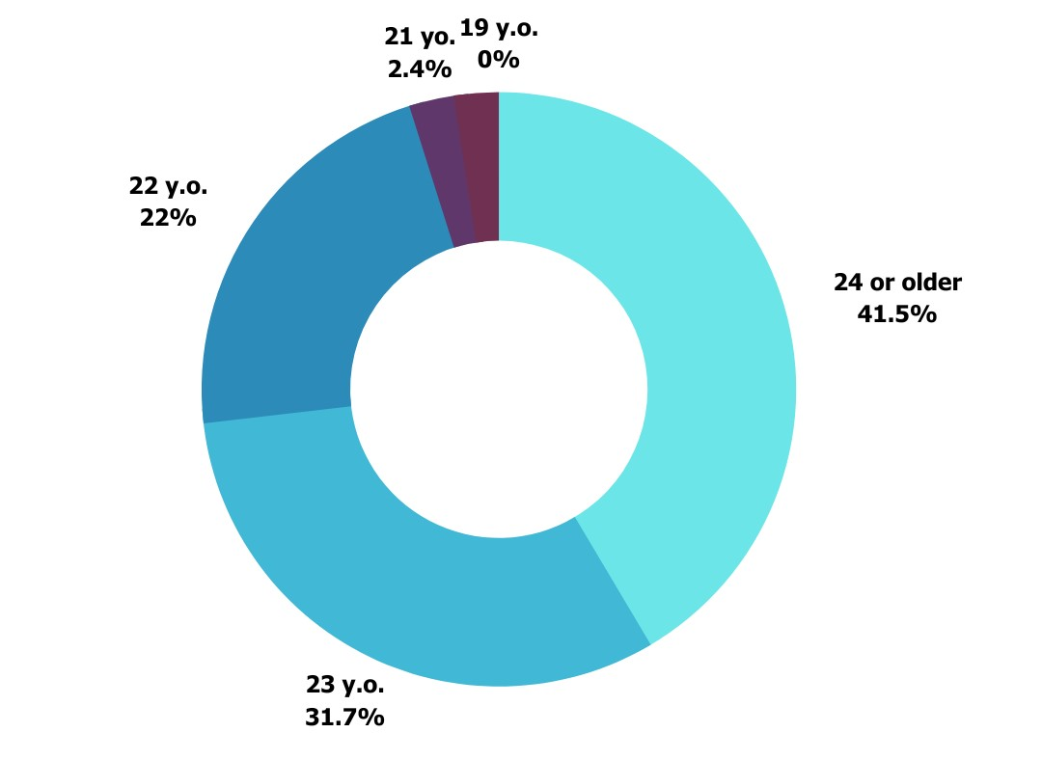

Figure 1: age of survey participants

The data highlighted that, with 42%, the age group in the category 24 or older dominated the survey participation. In addition, all 41 participants were requested to provide their current or recent field of study. Those findings have confirmed that data was gathered from students and recent graduates in 15 different academic areas, including Media Communication and Journalism and Public Relations as the field with the highest number of participants.

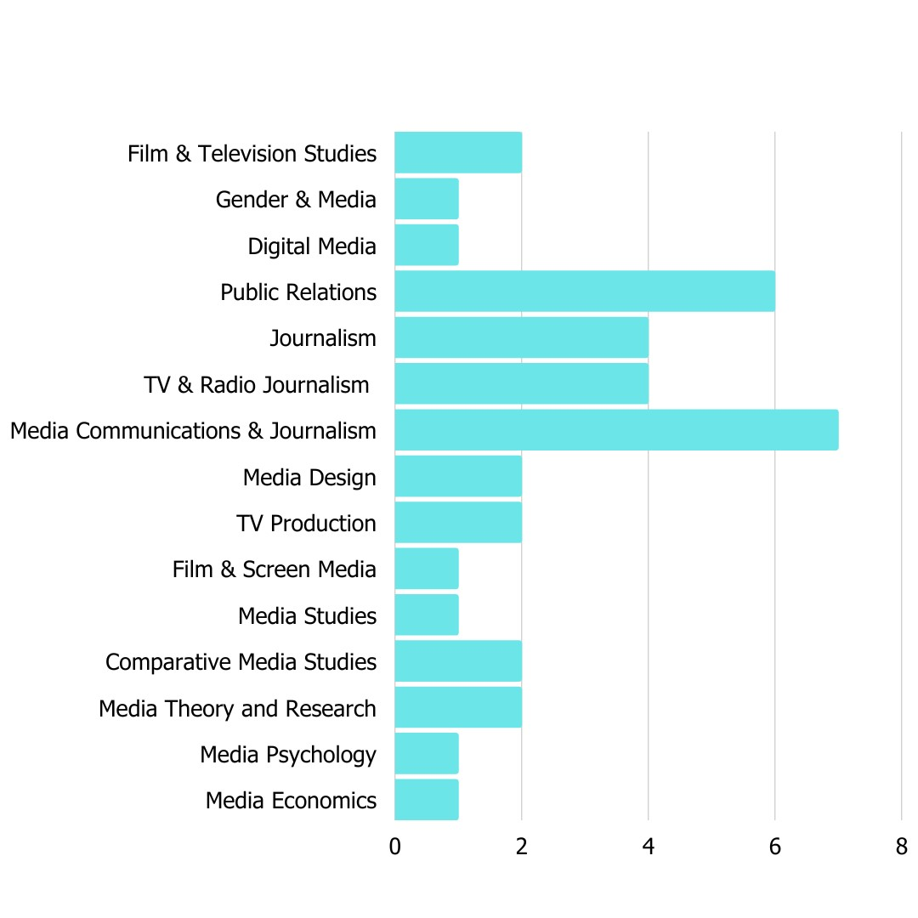
Figure 2: Current or previous field of study
To better determine and compare news consumption patterns among the participants, preferred journalistic genres were examined. When the respondents were asked to select from an array of journalistic genres they consume, 34 people chose Political Journalism, whereas Crime Journalism is labeleld the least-used genre of consumption in this group with eight votes in total.
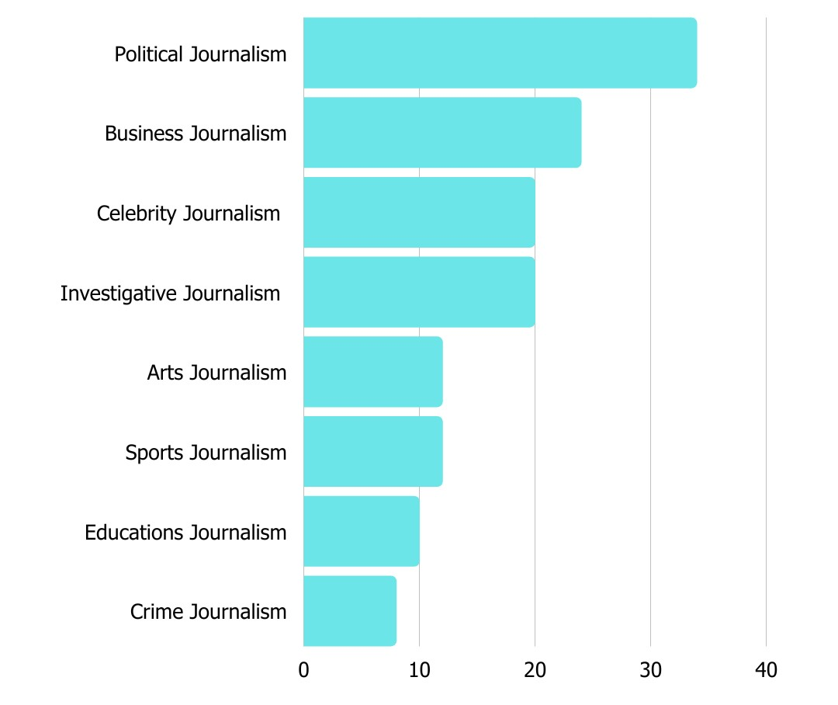
Figure 3: Genre of news consumption
In attempting to find out what the current preferred source for news was among the 41 participants, they were asked to rank Radio, TV, Word of mouth, Online/Print, and social media from most to least used. Regarding this question, (1) symbolises the sources that were collectively chosen as the most used source for news. Consequently, (5) indicates a news source that is used the least by the target audience. This ranking has clearly illustrated that social media is the preferred source, closely followed by print/online, TV, and radio. 85% of the participants have ranked ‘world of mouth’ as their least used source to obtain news.
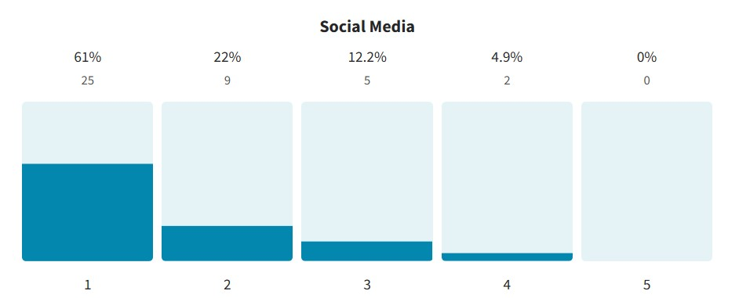
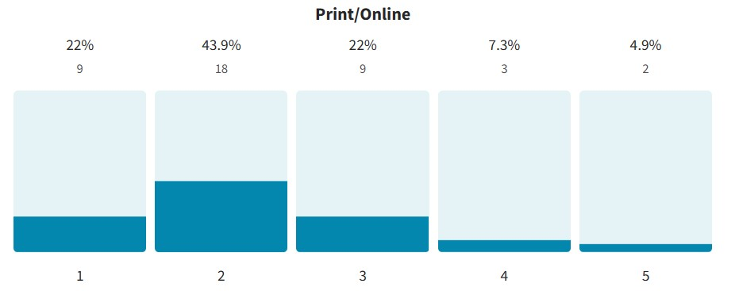
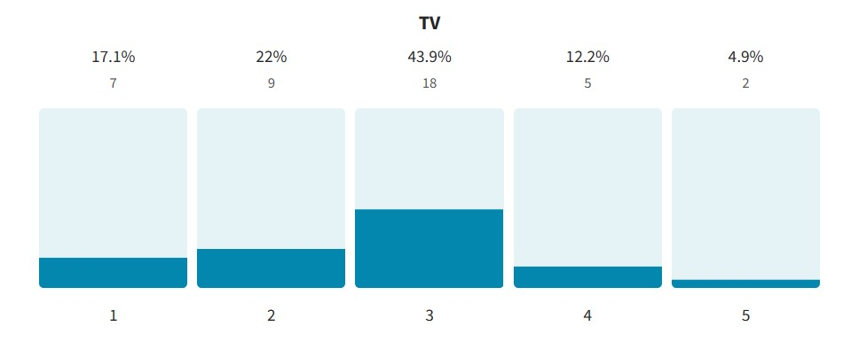
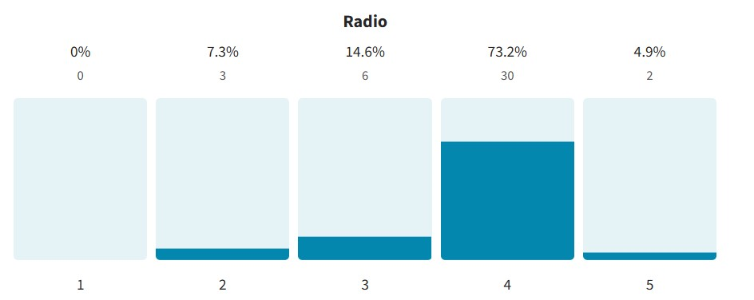
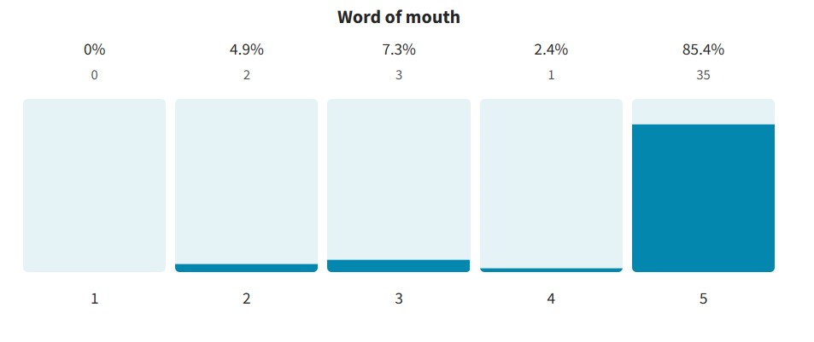
Figure 4: Ranking of most to least used source for news

4.1.2 Reasons for news consumption
A second objective of this survey was to investigate the assorted reasons why the targeted audience consumes news. As this objective was answered through an open-ended question and is therefore complex to generalise, the method of cross-tabulation in combination with keyword extraction was employed in order to examine patterns within those individual responses and summarise them in a comprehensive table. In scanning all responses in that category, 10 general keywords were established that highlight why the targeted group of his research consumes news. The most prominent findings show that about 68% of all respondents consume news for professional or academic reasons, 56% consume news to stay up to date and 19% of respondents deem news consumption important. Furthermore, 7% are currently consuming news for personal entertainment purposes.
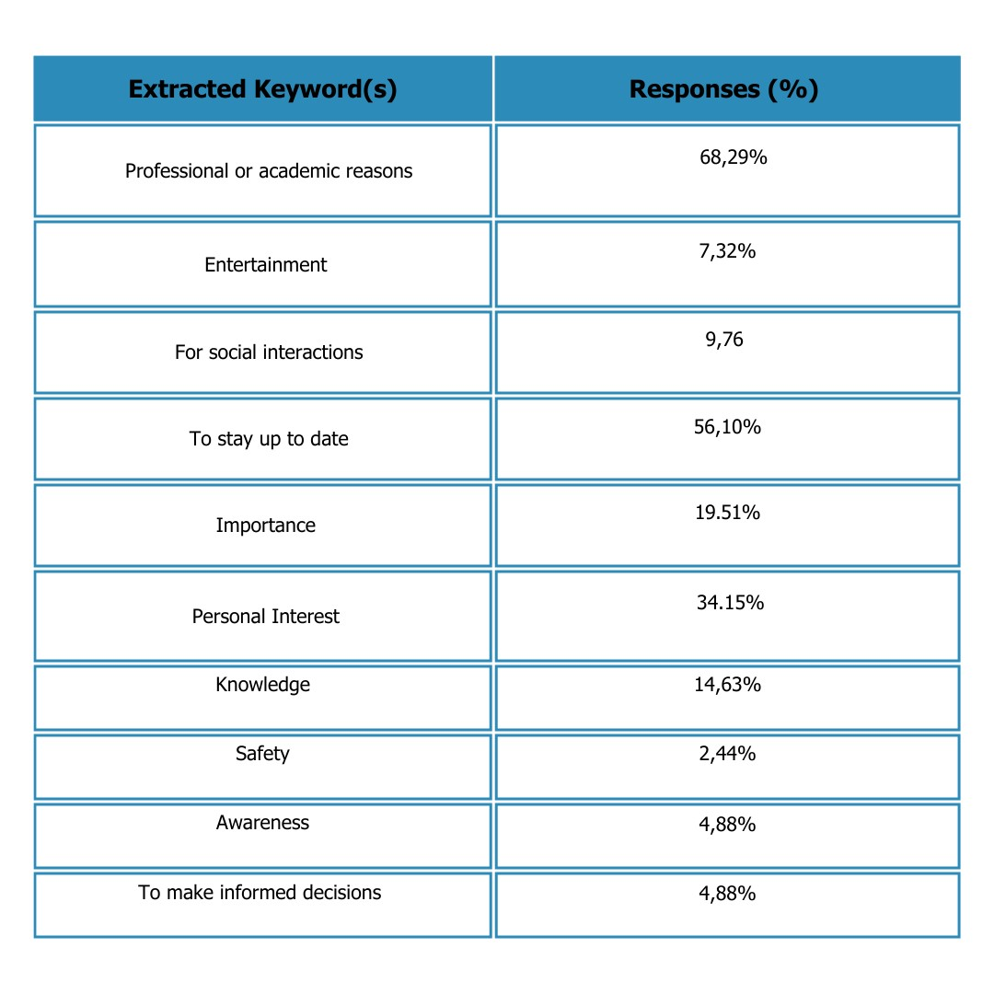
Table 2: Reasons for news consumption within the target audience
4.1.3 News consumptions Habits during the Pandemic
A set of questions have generated data regarding news consumption habits during the pandemic. When asked the question “Do you think the pandemic caused a shift in people’s news consumption habits”, 95% of the respondents answered yes, while 5% opted for no. A follow-up question that asked if the participant felt their news consumption has either increased or decreased during the pandemic has shown that 75% of respondents felt their news consumption increased, while 25% indicated that their news consumption decreased.
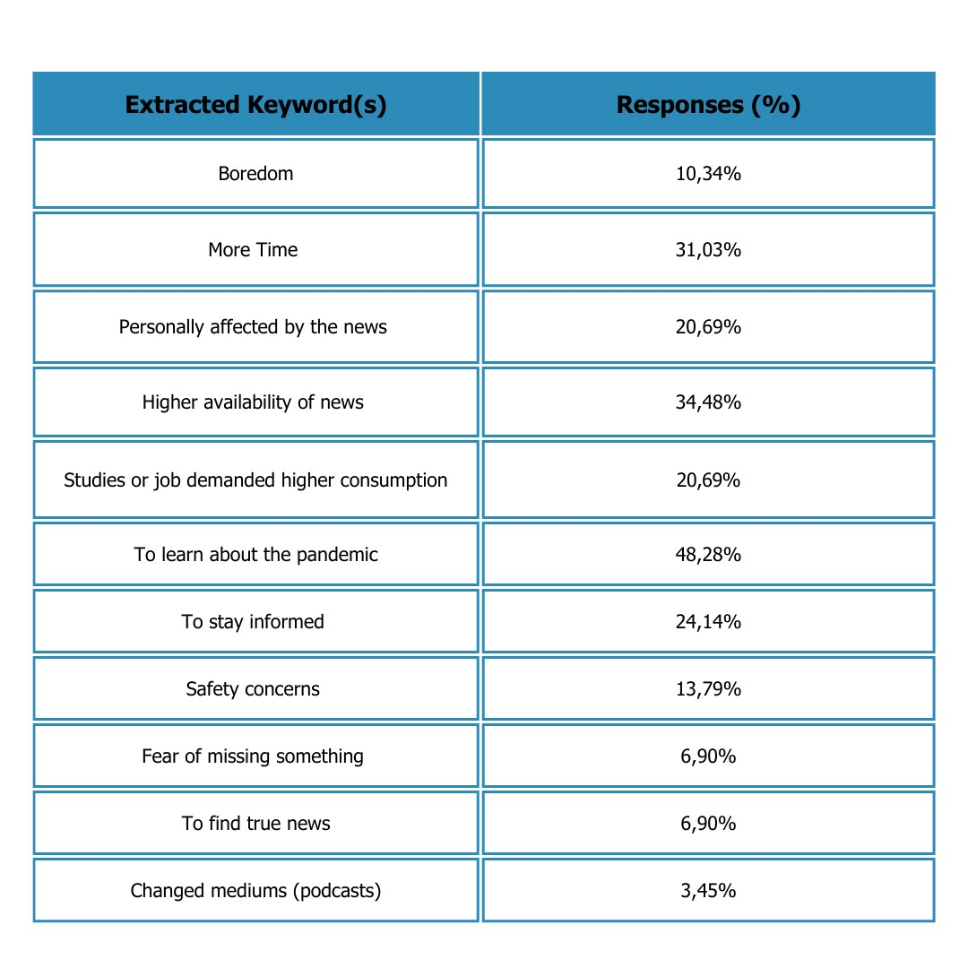
To further comprehend the motives behind those figures, the contestants were asked to provide reasons behind their selection. The findings extracted from this open-ended question have been summarised through the methods of cross-tabulation and keyword extraction and have provided a detailed insight into the causation behind the target audiences news consumption during the pandemic.
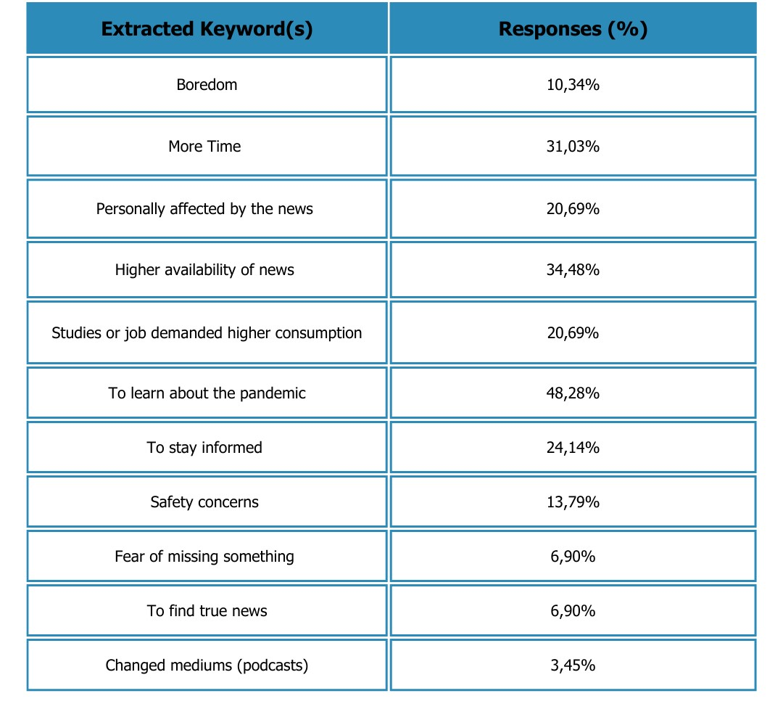
Table 3: Reasons for increased news consumption during the pandemic
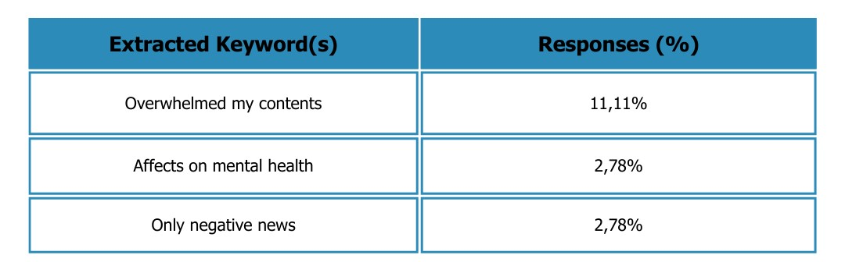
Table 4: Reasons for decreased news consumption during the pandemic
The findings show that the main reason news consumption has seen an increase during the pandemic was due to the motivation to learn about the pandemic (48%), higher availability of news (34%), and more time to consume (31%). A fall in news consumption during the pandemic, on the other hand can, be traced back to negative news and its effect on the respondent’s mental health.
As a means to gather data that would aid in answering this study’s research questions, this objective was concluded by finding out whether their level of news consumption during the pandemic has been retained in the same capacity after the pandemic. This answer helped uncover changing patterns. The results of the question showed the following:
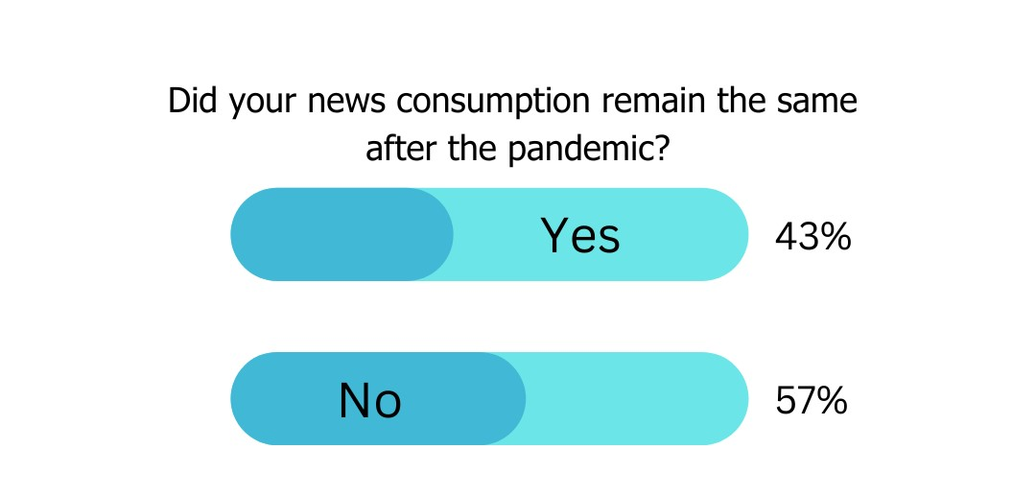

4.1.4 News consumption habits after the pandemic
A set of questions has generated data regarding news consumption habits after the pandemic. In acquiring a general idea of how high their consumption is, the participants were asked to select a box that corresponds best with their news consumption. The group had the possibility of choosing from six different options. The graph highlights that more than half of the participants consume news on a daily basis, while one respondent states that they only consume news every other week.
The choices of ‘once a week,’ and ‘I do not consume news ‘did not receive any votes from the study group.
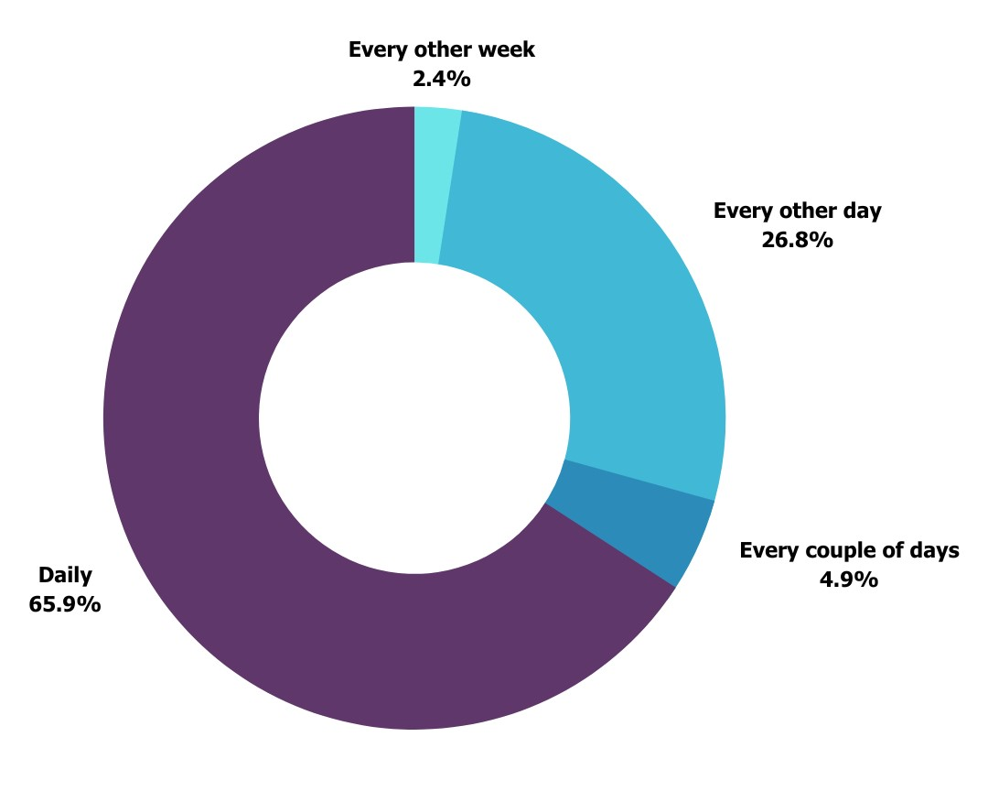
Figure 5: The amount of news consumption after the pandemic
4.1.5 Changes in news consumption by an Irish media outlet
An added parameter this survey examined was the investigation of preferred news publications and outlets over a specific period. This question was asked to assess if the aftereffects of the pandemic have led to significant changes. This instance has been examined by querying the target group to select three Irish media outlets they got their news from: (1) pre-pandemic, (2) during the pandemic, and (3) post-pandemic. In this instance, the participants were asked to choose three news outlets/publications based on their memory – no predefined options were provided by the survey. This ensures accurate results and does not limit the participant’s selection.

- Pre-Pandemic
The following bar graph summarises the key findings from pre-pandemic. It shows that participants were getting their news from 12 different news outlets/publications. While The Irish Times has garnered the most votes (23), closely followed by RTÉ (21), both The Irish Daily Mail and The Irish Daily Mirror were named once. In addition, 17% of respondents shared that they cannot recall any specific news outlets, or three in total.
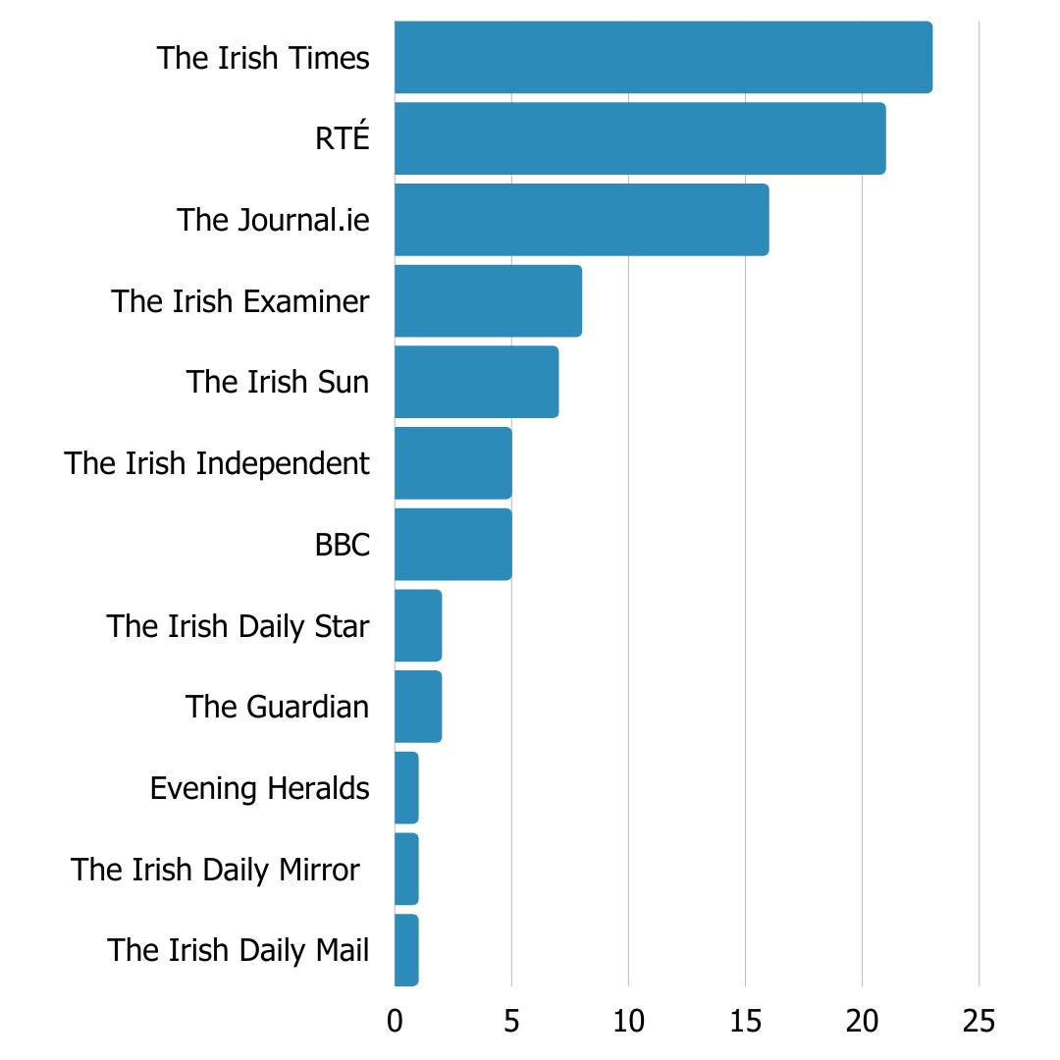
Figure 6: the three most used news outlets pre-pandemic

- During the Pandemic
The following bar graph summarises the key findings from during the pandemic. It shows that participants were getting their news from 8 different news outlets/publications. The Irish Times is still at the top with 33 votes, closely followed by RTÉ (26), publications that have both seen an increase. The Sunday Times and The Irish Sun were mentioned once. In addition, one participant shared that they could not remember any specific media outlets they consumed during the pandemic.
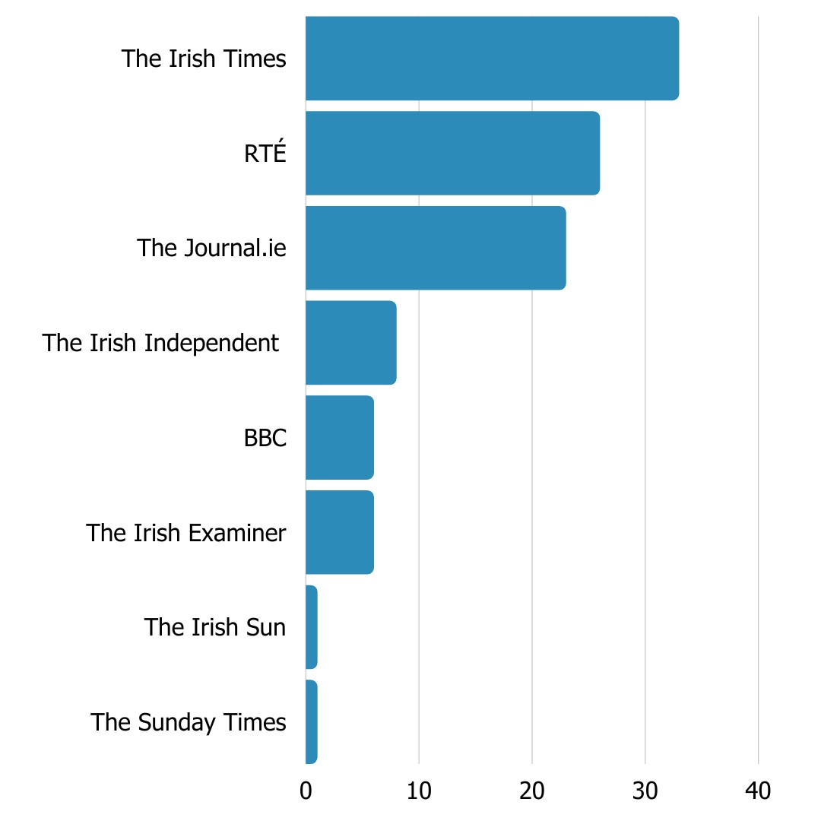
Figure 7: the three most used news outlets during the pandemic

- Post-Pandemic
Lastly, this bar graph looks at the period after the pandemic and summarises its findings. It shows that participants are currently getting their news from 8 different news outlets. After the pandemic, The Irish Times remained at the top (34) and The Guardian garnered one vote. News publications such as The Irish Daily Mirror, The Irish Daily Mail, and The Irish Sun were not named as sources for news consumption after the pandemic.
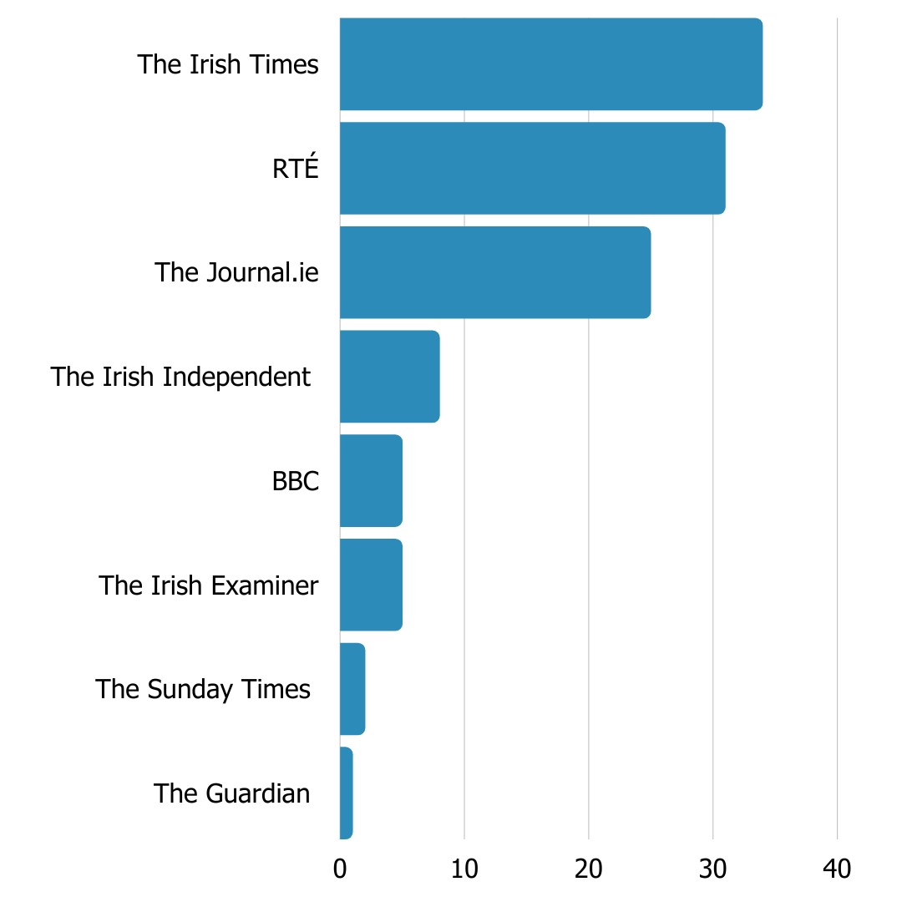
Figure 8: the three most used news outlets post-pandemic

4.1.6 Media trust during and after the pandemic
A third objective of this survey was to examine the level of media trust in Irish mainstream media during and after the pandemic and determine if there were any root causes for possible changes. The survey found that 55% of respondents answered that their level of media trust remained the same during the pandemic, 25% registered a decrease, and 20% stated that their trust in the news and the media during the pandemic had increased. When questioned again if those levels of trust remained the same after the pandemic, 70% answered that their trust remained the same, 20% detected an increase in media trust, and 10% felt a decrease in media trust since the pandemic.
To uncover the causation behind those figures, the target audience was asked to provide a brief explanation for their answers. For the group that mentioned an increase in media trust after the pandemic, six categories were detected.
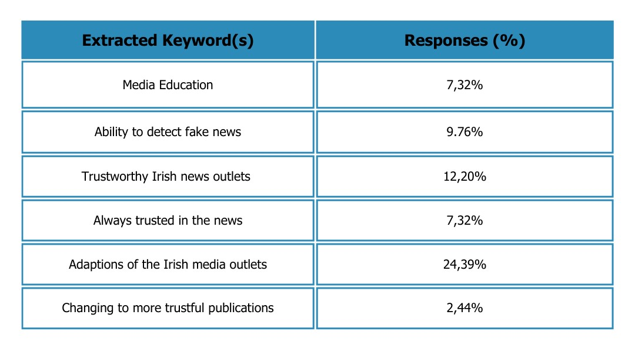Table 5: Reasons for increasing media trust after the pandemic
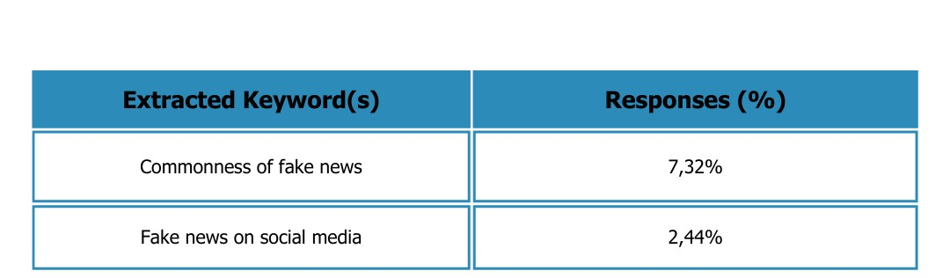
Table 6: Reasons for decreasing media trust after the pandemic
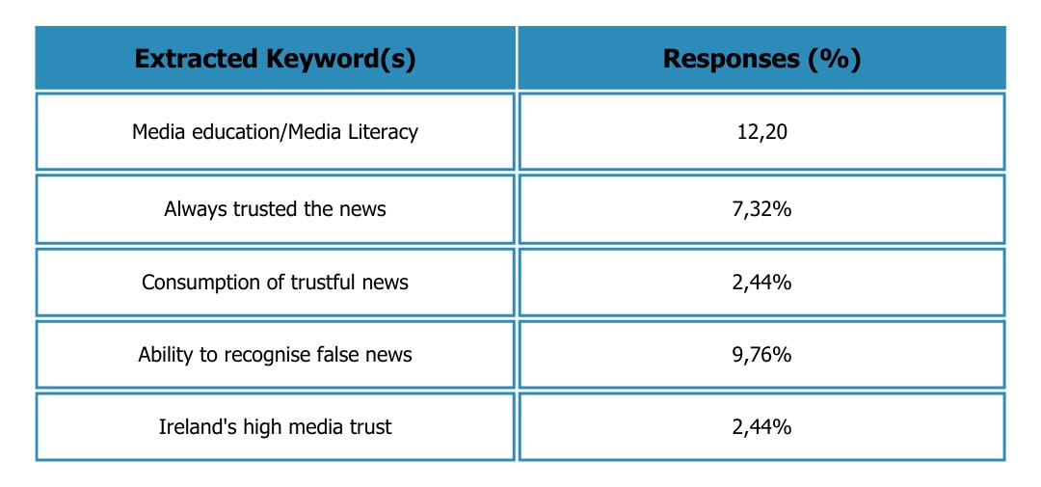Table 7: Reasons media trust remained the same after the pandemic
The key findings highlight that a majority of respondents named the adaptation of the Irish media to the pandemic as a reason for an increase in their media trust. 7% stated that they have always trusted the news. Looking at reasons that decreased media trust within the targeted audience, the abundance of fake news and the fake news on social media were mentioned. Reasons why media trust remained the same after the pandemic show that the respondents named their existing media education and their ability to detect false information as justifications.

Furthermore, the survey investigated if, within the targeted group, actions were considered or taken in an attempt to increase their media trust during the pandemic. 87 percent admitted to taking actions in order to increase media trust however, the open-ended answers also showed that a part of the group engages in those actions naturally and without the intent to minimise their mistrust. Screening the gathered insights from this question revealed that their media education has been a significant component. Through open-ended questions that looked at individual examples of those questions, multiple trends were found.
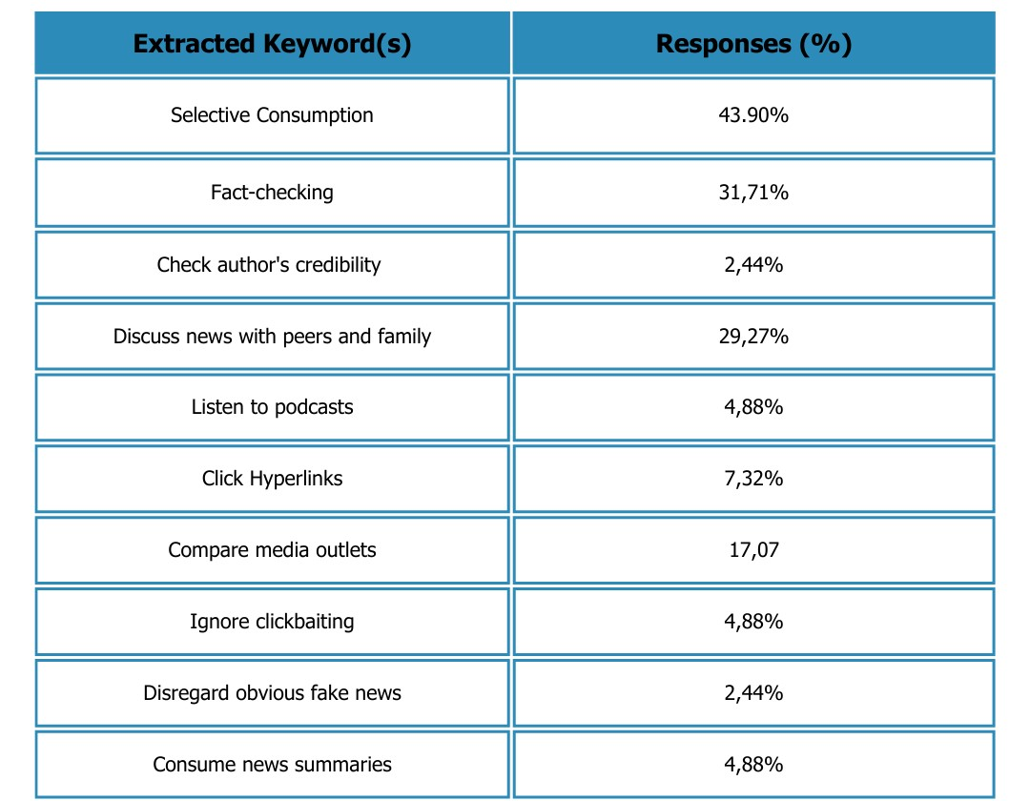
Table 8: Actions to increase media trust during the pandemic

The table shows that 44% of the questioned individuals have opted to consume news more selectively and engage in fact-checking (32%). Two respondents answered that they consume podcasts to get additional information from non-journalists, while 29% tackle false information by engaging in conversations with peers and family members.
In order to compare the data, the targeted group was asked whether they had retained those actions and whether they still used them after the pandemic. The results of the study have revealed that 85% of the participants have answered affirmatively, while 15% have shared that they do not perform those actions anymore.
In a multiple-choice question, the 41 participants were invited to select from a list of options. The bar graph shows that 90% still engage in fact-checking after the pandemic, and 66% consider the news organisation that published a story. Only 7% of people take into consideration the journalists who published or reported a news story.
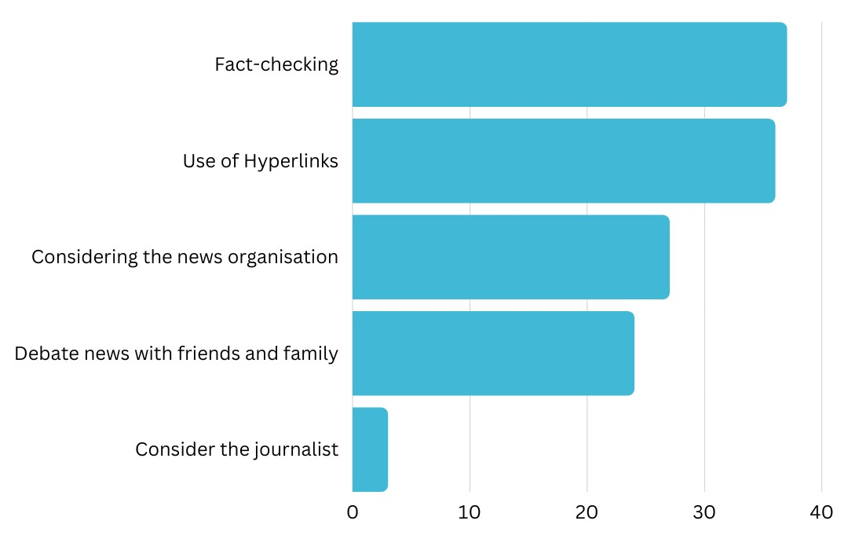
Figure 9: Actions to increase Media trust after the Pandemic
A question of assessment provided six statements that were made up by the researcher. Those six statements were set out to acquire additional insight into media trust among the target audience. As part of this inquiry, the participants were asked to carefully read the statements and select whether a statement would cause an increase or decrease in their trust in the mainstream media in general. The results of this process revealed that all six statements were answered almost unanimously.

Increases Trust Decreases Trust

Statement 1
„The Story does not use hyperlinks and does not have clearly identified sources.”
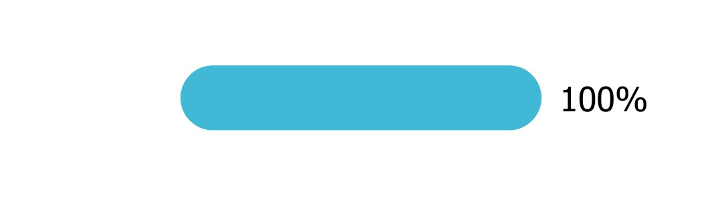
Statement 2
“The story contains an abundance of technical jargon that is not explained.”
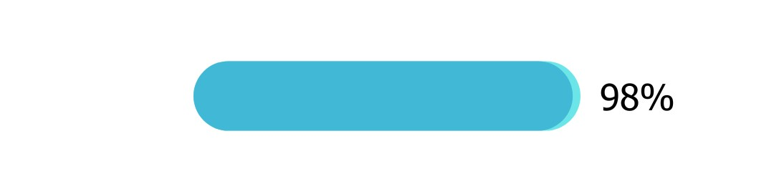

Statement 3
“A media outlet reports broadly about news and current affairs.”
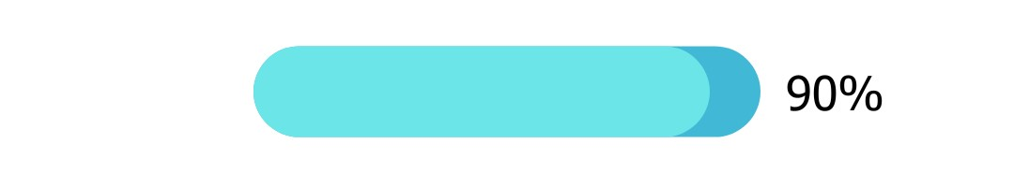

Statement 4
“News stories often face controversy for misinformation.”
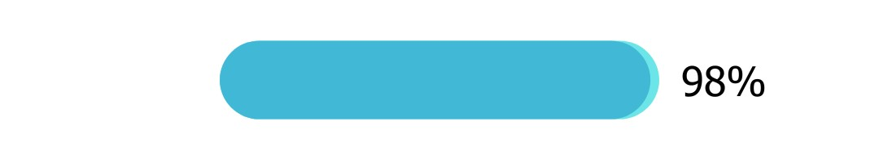
Statement 5
“Mainstream media allows comments and engages with their audience”
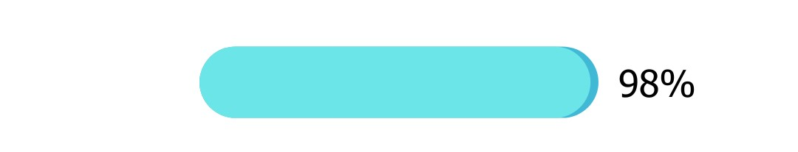
Statement 6
“The Mainstream media’s media coverage tends to be very narrow”
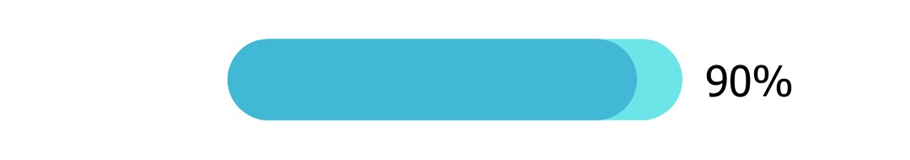

As a final objective of the survey, the targeted audience was asked to share what actions the mainstream media ought to consider in order to promote and maintain media trust among their consumers. The individual answers have been processed through the methods of cross-tabulation and keyword extraction. The results have revealed proposals that can be classified into 11 categories. 32% of respondents recommend the avoidance of biases in journalistic work. Credible and truthful reporting sites at 22% and 12% have shared that media organisations should make news consumption easier. They suggest explainers, simplified language, and the availability of hyperlinks. 10% expounded that false narratives need to be avoided. One respondent added, “Better monitor their social media channels as the comments are often full of misleading news.”
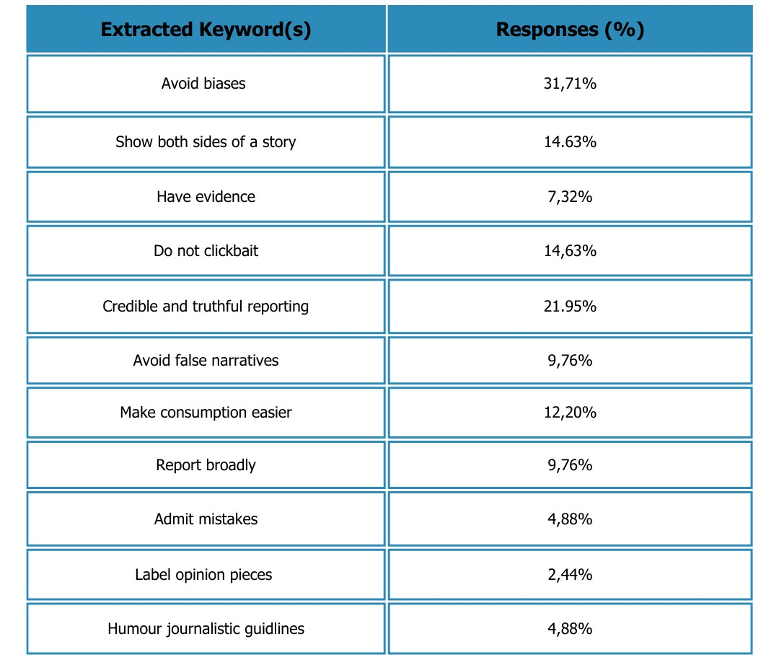
Table 9: actions proposed by respondents for the mainstream media to improve/maintain media trust

Chapter Five
Analysis
5.0 Introduction
This chapter aims to synthesise the cumulative knowledge and insights garnered throughout this research process and seeks to justify why the findings are significant in the broader context of this field of study. Having considered various theoretical frameworks and conducted exhaustive data collection, the obtained information and findings will now be rigorously analysed. Finally, this chapter will provide the answers to the research questions that guided this investigation and uncover possible recommendations for future studies.
Brown (2014) defines data analysis as the act of reviewing and displaying data with the purpose of identifying usable data, informing conclusions, and aiding decision-making. This will aid in “transforming unstructured data into useful information” (Brown, 2014). Data themes and patterns can be established throughout research analysis, thus rendering it simple to see how the data are interrelated. This can be achieved either top-down (from most important to least essential) or bottom-up (least important to most important). For the purpose of this study, however, the analysis will be executed in the order that the data appears in the survey. This ensures a cohesive analysis and minimises thematic confusion. A final summary of the analysis will nevertheless highlight the most important findings from the survey.

5.1 Research Questions and Objectives
This is a restatement of the research questions and objectives that guided this study. These questions and objectives are attempted to be answered by an in-depth data analysis.
- To what extent did the pandemic change the patterns of news consumption of third level media students and recent graduates?
- To what extent did their academic background in media influence changes?
- To what extent did the pandemic lead to changes in media trust towards news and current affairs?
- To what extent did the targeted audience engage to maintain their trust in the news?
- In what capacity have those patterns been retained after the official ending of the pandemic?
Research objectives
- Identifying the changes in news & current affairs consumption habits and media trust of third level media students in Ireland due to the consequences in direct relation to the pandemic.
- Assessing the impacts of media literacy on changes in news consumption habits and media trust.
- Evaluating the retention of news consumption patterns and the handling of media trust within the target audience after the pandemic.

5.2 News consumption habits
The research findings corroborate that the aftereffects of the Covid-19 pandemic led to a transformation in the news & current affairs consumption habits of current and recent Irish 3rd level media students. This conclusion was drawn as 95% of the survey participants answered affirmatively to the question of whether the pandemic caused a shift in their news consumption habits. Additional evidence has been collected and analysed to support this conclusion.
As many scholars have stated in chapter two, substantial changes in daily life can cause the establishment of new news consumption habits or the alteration of existing ones (Verplanken, Roy, and Whitmarsh 2018; Broersma and Swart, 2022; Ghersetti and Westlund, 2018). The prevailing conditions of the pandemic caused such substantial changes, as the results of open-ended questions revealed. Nielsen et al. (2020), highlighted that some people may experience an increase in news consumption while others may lose interest or simply consume less.
During the pandemic, the consumption of news increased by 75% within the target audience, corroborating the combined findings of the Reuters Digital News Report from 2020 (Newman, 2020), 2021 (Anon, 2021) and 2022 (Newman et al., 2022). After the pandemic, this initial increase turned into a 58% decrease, uncovering that those patterns had not been retained after the pandemic. The evidence shows that there are major differences in the reasoning behind news consumption during and after the pandemic.

The findings of the survey show a variety of reasons for the increase news consumption caused by the pandemic. The main reason was the motivation of the targeted group to learn about the pandemic (48%), the higher availability of news (34%), and due to more time to consume (31%). Participants also shared that “most of the news was concerning my life directly like lockdown and mask regulations” and that “I just got my started by degree and constant media monitoring was part of my daily life and I enjoyed it.” One respondent shared that they were “living in scary times and I wanted to feel as secure as possible by consuming as much as possible.”
Additionally, Brita Ytre-Anne and Hallvard Moe (2021) found that consumption during the pandemic increased because people were getting their news online. This suggestion is corroborated by the findings of the survey, which show that social media and online news platforms were and still are the preferred sources of news for this targeted audience.
A separate group that participated in the survey, however, was not affected by the conditions of the pandemic and was therefore not forming new consumption patterns. They stated that they “have always consumed a lot,” or they feel that they “consumed the same amount of news.” A result that, on the one side, contradicts and, on the other side, adds perspective to a statement made by Marcel Broersma and Joëlle Swart (2022) in chapter two. They found in their study, that “for citizens who have not taken up news in their daily routines, the formation of novel patterns of news use is very rare.” However, an already elevated level of news & current affairs consumption from part of the target group suggests that this group is also less likely to form novel patterns and consequently less likely to be influenced by its contents.
On the other side, the survey found that 25% of the targeted audience has experienced a decrease in news consumption. This fall can be traced back to negative news and its effect on the respondent’s mental health. They shared for, instance, that: “the news was mostly negative and at one point I just could not look at them anymore,” and that they “felt overwhelmed with all the new regulations, constant changes, growing numbers and my studies that I was not able to consume anymore,” and they found themselves “scrolling on my phone but the news were all the same everywhere, that was really depressing so I tried to not consume as much.”
The mentioned influences that caused news consumption to shrink, comprise characteristics that stem from the act of doomscrolling. As defined by Ytre-Arne and Moe (2021), doomscrolling is an act of excessive consumption of negative news through online channels to the detriment of the consumer’s mental and physical health. As the survey found that social media is the main source of news within the target group, it may well be assumed that doomscrolling was likely to affect the target audience.
Though doomscrolling is the continuous consumption of negative news without a stop, the respondents that experienced a decrease in their new consumption stopped according to their individual responses.
As explained by Anand et al. (2022) in chapter two, the likelihood of engaging in doomscrolling was found to be influenced by cognitive biases such as availability bias and confirmation bias, thus influencing psychological well-being. However, if an individual were to comprehend the biases, this would enable them to consciously choose to restrict their exposure to unfavourable news and information, thereby lowering their risk of experiencing psychological discomfort in emergency situations like the COVID-19 lockdown. Given this reasoning by Anand et al., it can be concluded that the 25% of participants that experienced a decrease in news consumption during the pandemic had knowledge about those biases, thereby leading to a reduction in their news consumption.
To investigate to what extent changes in news & current affairs consumption habits have been retained after the pandemic, it is of significance to analyse why the targeted audience is consuming news today. Though news consumption was proven to still be high after the pandemic, the motivations for consumption have changed.
The most prominent findings for this parameter show that currently, about 68% of all respondents consume news for professional or academic reasons, 56% consume news to stay up to date and 19% of respondents deem news consumption important. Furthermore, 7% are currently consuming news for personal entertainment purposes.
While 21% answered that their increase in news consumption during the pandemic was due to their media studies, now 68% of all respondents consume news for professional or academic reasons. This transformation offers an incentive to analyse to what extent the academic background in media of the target group influenced any changes in their news consumption habits.
The survey’s findings for this inquiry offer a wide range of data from which it can be concluded that the participants possess an elevated level of media literacy.
According to the Centre for Media Literacy (CML, 2023), media literacy “provides a framework to access, analyze, evaluate, create and participate with messages in a variety of forms – from print to video to the Internet.”
Media literacy additionally “builds an understanding of the role of media in society as well as essential skills of inquiry and self-expression necessary for citizens of a democracy.”
A Eurobarometer survey from 2022 (Anon, 2022) found that a higher level of education equates to higher media literacy. As the target audience consists of 73% of third-level media students and 27% of recent graduates with a media-related degree from 15 different areas, one can conclude that the 41 participants possess a high education and therefore strong media literacy. To investigate to what extent media education influenced the formation of novel consumption patterns and, consequently, the retention of those habits, the factor of trust is a crucial component of this analysis.
5.3 Media trust
The research findings corroborate that the aftereffects of the Covid-19 pandemic have caused a transformation in the level of media trust among current and recent Irish 3rd level media students. This conclusion was reached based on the collected survey data.
At the outset, the assumption that the target audience has higher media literacy can be further supported by looking at the parameter of trust within this study. Schranz et al. (2018) discovered that media literacy influences trust in the media, suggesting that more media-literate people are more likely to trust traditional media sources and can distinguish between trustworthy and untrustworthy sources.
Building on this assumption, one could assume that the target audiences’ trust must have either increased or remained the same from2020 to now.

When the participants were asked if their trust in the Irish news had increased, decreased, or remained the same, 20% said that their trust had increased, while 55% it had stayed the same. After the pandemic, 20% still felt that their trust had increased. Extracted data from open-ended answers revealed their existing media education and their ability to detect false information as a justification. One individual states that “being a media student during the pandemic helped me filter news.” Another respondent said that in her studies during the pandemic, “media literacy was highly prioritised.” Additionally, the survey found that 10% trace it back to their ability to detect fake news that they acquired through their media education, confirming the statement made by Schranz et al. (2018).
On top of their media education, 24% named the adaptations of the Irish media landscape to the pandemic as a factor that made their trust increase both during and after the pandemic. Additionally, 12% said that their trust remained the same or increased because Irish journalism is or has always been credible. The Reuters Digital News Report from 2022 (Newman et al., 2022) corroborates that Ireland has high levels of media trust and that “Irish media remain relatively well trusted by international standards and overall trust in news has remained stable at 52%” in 2022.
As Broersma and Swart's study (2022) revealed in chapter two, respondents retained pre-pandemic tendencies, particularly when it came to using traditional media sources or sticking with well-known news sources. The most trusted and well-known news publications in Ireland during the pandemic have been RTÉ, the biggest national broadcaster, with 76%, closely followed by the Irish Times and the Irish Independent (Newman, 2020, 2021).
In 2022, “Public broadcaster RTÉ remains the most trusted brand (74%), closely followed by the Irish Times (71%)” (Newman et al., 2022), while the least trustworthy newspapers are tabloids.
When comparing the three preferred Irish news outlets of the participants from the period before, during, and after the pandemic, the data showed that The Irish Times and RTÉ were among the top-used outlets for news consumption throughout the whole period. While entertainment publications like The Irish Sun were less used by the participants during the pandemic as compared to before, they were not mentioned as a source after the pandemic. While some individuals answered they consumed The Irish Sun because they “wanted some entertainment as a break from all the corona news,” the majority used the most trusted news publications, again supporting the conclusion that the targeted audience of this research possesses high media literacy and it able to consumes trustful sources.
This indicated that even though new habits of trust were formed, the existing academic background in media, supported their consumption and identification of trustful news outlets. This conclusion underlines the importance of media literacy, as this analysis has led to the discovery of a steady trust in news and disregard for fake news among the targeted audience.
Social media is a platform that predominately and frequently facilitates fake news (Al-Zaman, 2022) and is the preferred source for news consumption for younger demographics. A strong media literacy among consumers can therefore aid in better detecting and evaluating fake news on the Internet, as the results of the survey show. Bajarin’s study (2018) explained that media literacy should be taught in school.
He said in 2018 that the Checkology virtual classroom is “where students learn how to navigate the challenging information landscape by mastering the skills of news literacy” (Checkology, 2023).
To further analyse to what extent media trust changed, and to what extent the targeted audience engaged with their trust in the news, it is valuable to examine how the target audience engaged with fake news.
The research by HEC Paris (Anon, 2021) focused on finding out what the root causes of disinformation and misinformation were and what the potential societal ramifications would be. They urge consumers, to “crosscheck information that you get through social media with at least two other information sources such as government websites and high-quality news outlet” as people often rely on their gut feelings (Anon, 2021). Casero-Ripollés (2021) added that the rapid spread of false information and conspiracy theories has resulted in a growing need for fact-checking and verification to ensure trustworthy news.
By asking the study group if they engaged in actions such as “crosscheck information,” 87 percent admitted to taking actions in order to increase or preserve media trust however, the open-ended answers also showed that a part of the group engages in those actions naturally and without the intention to minimise their mistrust. Screening the answers to this question revealed that their media education has been a significant component. This shows that, on the one side, the target audience actively tried to maintain their trust but, also because their media education made it natural.
Looking at to what extent those actions have been retained after the pandemic, 85% stated that they still use those actions today, underscoring that those actions have in fact been retained by the targeted group of this study.
In analysing the proposals from the participants that aim to maintain trust as a media outlet, the act of click-baiting is mentioned. 7% of participants stated that they disregarded obvious click-baiting in order to maintain their trust.
This is an important finding, as a 2022 study (Anon, 2022) revealed that 54% of respondents were swayed by the headline being relevant to their interests. This emphasises how dangerous click-baiting is and how many people would be influenced by it.
Fisher et al. (2020) highlighted different influences that can result in a decrease or an increase in media trust. They found that “past history of inaccurate stories, opinionated journalists or presenters, a lack of transparency, sensationalism and excessive advocacy on behalf of particular points of view” were labelled as promoted factors of mistrust. On the other hand, “depth of coverage, the reputation of the news brand, the reputation of particular journalists or presenters, and openness to comments and feedback from audiences” promoted trust (Fisher et al., 2020).
To find out what actions the mainstream media ought to consider in order to promote and maintain media trust among their consumers, the participants were asked to provide their personal proposals. 32% of respondents recommend the avoidance of biases in journalistic work. One response states that the mainstream media should not “be biased and present both sides of the story.” Credible and truthful reporting sites at 22% indicate that the mainstream media ought to “be a space for credible journalism and don’t cherry pick topics that might drive the most audience.”
12% have shared that media organisations should make news consumption easier. They suggest explainers, simplified language, and the availability of hyperlinks. Furthermore, open-ended responses show that a “podcast for younger generations,” and “more comprehensive tools for all demographics to understand” can help mainstream media maintain consumer trust.
10% expounded that false narratives need to be avoided. One respondent added that mainstream media should “better monitor their social media channels as the comments are often full of misleading news.” As the HEC Paris (Anon, 2021) states in chapter two, this is due to the algorithmic design of social media platforms that prioritises engagement and also due to the fact that social media platforms do not have a moderator. Considering social media monitoring is a huge task, however, it can aid in mitigating the problems of fake news and ensuring a well-working public sphere and democracy.
One individual stated that the mainstream media ought to “adapt to their online presence and include explainers for more complicated topics.” This is a particularly interesting point as it corroborates a statement made by the 2022 Reuters Digital Report (Anon, 2022). The report mentions an increase in involvement by news organisations throughout the pandemic through the use of explainers or question-and- answer-formats and how it aided in maintaining an elevated level of confidence across their channels. Having participants articulate those proposals indicates a strong understanding of media dynamics and high media literacy. Their proposals are valuable in their content and will aid media practitioners, policymakers, future journalists, and most importantly, consumers, in obtaining and consuming credible news.

Chapter Six
Conclusion

6.0 Conclusion
A plethora of empirical research has proven that the direct consequences of the unprecedented and disruptive nature of the Covid-19 pandemic led to a shift in news & current affairs consumption habits and levels of media trust among Irish citizens (Ytre-Arne and Moe, 2021; Broersma and Swart, 2022). This study has collected and analysed a set of extensive data that partially coincides with previous findings. A focus on a new niche group, however, provided the opportunity for the collection of novel and unique data that expanded past studies and offered expertise for future ones.
Current third-level media students and recent media graduates from Ireland have not been spared the effects of the corona pandemic that has dominated the world from 2020 into the early months of 2022. Along with everyone else, they experienced significant impacts on their lifestyle, mobility, as well as a disruptive in their education. Information delivered by the government and health services about the public health crisis have been consumed by people through a variety of sources. News channels and publications, however, have been the primary source that provided details about the ongoing crisis for concerned citizens around the globe.
Yet, the targeted audience of this research possesses unique characteristics that have led to a set of interesting findings.
First and foremost, it can be asserted with certainty that news & current affairs consumption habits and levels of media trust have changed within the targeted audience of this research. While an extensive analysis corroborates the guiding hypothesis of this study, namely that those changes were caused by the direct consequences of the pandemic, other factors for transformation have surfaced.
73
74
75
79
The existing media education and the resulting media literacy of the target audience have proven to be a noteworthy influence that sets the survey findings of this target group apart from similar surveys, for instance, the Reuters Digital News Reports.
Analysing the consumption patterns of this specific demographic revealed that their deeper comprehension of media dynamics and the news environment has influenced their consumption of fake news, increased their ability to detect erroneous information, and made them maintain their trust in the Irish mainstream media. Though the target group acknowledged a general shift in news consumption patterns, they were less impacted by it because of the pandemic, than as a direct consequence of their academic studies and professional occupations. While some individuals admitted to consuming less and feeling the effects on their mental health, the study cannot precisely detect any cases of doomscrolling or doomsurfing – acts that were quite common among news consumers during the pandemic, as other research has highlighted (Ytre-Arne and Moe, 2021; Anand et al., 2022). This reveals an elevated awareness of the cognitive biases of doomscrolling and enabled the chosen study group to consciously choose to restrict their exposure to unfavourable news and information, thereby lowering their risk of experiencing psychological discomfort in emergency situations.
Moreover, this study reveals that the pandemic has influenced media trust among 3rd level students in Ireland. While previous studies concluded that the constant influx of information, rumours, and fake news related to the pandemic has made citizens less trusting in the media, Irish media users have continued to maintain a high level of trust in the media throughout the public health crisis.
Those results are mirrored in the findings of this study. The survey revealed that while media trust did change since the start of the pandemic, the survey participants actively sought to increase or maintain their trust. The study group gained knowledge on how to consume trustworthy news from their media education, as the analysis reveals. This again shows that even though changes in media trust occurred, the participants were able to manoeuvre through them. They often sought multiple sources, fact-checked, talked with peers and family, and verified before believing the information they came across. This reveals that media literacy and critical thinking skills have become increasingly crucial for students to discern reliable information from misinformation in an era of heightened uncertainty.
Lastly, newly developed patterns that have been obtained through either the direct consequences of the pandemic or their media education are highly likely still used today. Though the nature of the pandemic has been unprecedented, its ending did not lead to a stop to fake news or similar news content as during the pandemic. Therefore, it is highly likely that the habits that have been retained during the pandemic will still be used by the targeted audience in the future.
As for the limitations of this study, it is important to note that the findings are based on a specific sample of 3rd level students in Ireland and may not be fully generalisable to the broader population. Future research should incorporate longitudinal designs to explore the long-term effects of similar events to the pandemic on news consumption and media trust among students and other societal groups.
To draw a final conclusion, this dissertation has contributed to our understanding of the lasting effects of the Covid-19 pandemic on news consumption habits and media trust among 3rd level students in Ireland.
Additionally, there is a remaining vitality for researchers and media professionals to monitor news consumption trends and adapt to the constantly changing digital environments to ensure successful communication and an informed public sphere.
Above else, this survey showed the paramount importance of ensuring a stark media literacy among the younger generations to combat the effects of an increasing proliferation of false news, including deliberate disinformation and the spread of baseless conspiracy theories.
6.2 Recommendations for future research
This particular research has been unique in its objectives and methodological approach. In addition, it has provided novel data and insight into the causation of changes in news & current affairs consumption and media trust patterns among a specific target group. As a result, it has inspired a variety of recommendations for future studies.
Based on a research study on ‘the aftereffects of the Covid-19 pandemic on news consumption habits and media trust among third-level students in Ireland’, several recommendations for future studies are open for consideration. These recommendations are intended to fill in any gaps in the prior research and deepen awareness and comprehension of the subject of this study.

In addition to this study, the researcher recommended the conduct of possible longitudinal studies. Longitudinal studies would allow future researchers to examine changes in news consumption patterns and media trust over time, providing an even more comprehensive picture of the pandemic's long-term impacts in this area.
In addition, future scholars might want to consider expanding their methodological approach. Rather than collecting data from quantitative online surveys only, methods of qualitative research such as interviews or focus groups have the potential to acquire greater knowledge of students' opinions, motives, and experiences with news consumption and media trust.
As a third recommendation, the researcher proposes employing comparative analysis. Apart from Ireland, conducting comparative research across different nations or regions could provide useful insights into how the Covid-19 outbreak affected news consumption habits and media trust in diverse circumstances.
Comparing Irish students' experiences with their counterparts in other countries would aid in identifying country-specific elements impacting media consumption. In considering a new focus country while keeping the same target group, innovative data might be collected that can advance the whole realm of media research. Moreover, it may aid to uncover significant differences or matching factors that will be of significance for media practitioners and policymakers.
As a fifth suggestion, this researcher supports the concept of demographic analysis. Essentially, this would entail either breaking down the same target group as this research or creating a new one by highlighting specific demographic factors.
Examining how demographic factors such as age, gender, financial level, or educational background influence news consumption patterns and media trust would provide a more comprehensive picture of student population variances. Those insights can then be used as a means to compare them with other demographic factors, leading to the provision of an in-depth dataset.
Because this study discovered that online and social media platforms are becoming more prominent as news sources among this targeted group, future research could focus on understanding how the pandemic or other events with comparable impacts influenced the dependence of students on these platforms, their impressions of trustworthiness, and the impact on media trust.
In addition, future researchers might consider expanding their methodological approach. Rather than collecting data from quantitative online surveys, qualitative research methods such as interviews, focus groups, or ethnographic studies could be employed to gain a deeper understanding of students' perspectives, motivations, and experiences in relation to news consumption and media trust.
As this study emphasised importance of media literacy, another recommendation worth mentioning is the possibility of establishing media literacy interventions. Those interventions might comprise similar aims to the one Checkology (Checkology, 2023) follows, or the one Media Literacy Ireland (Media Literacy Ireland, 2017) has committed themselves to. Investigating the success rate of various media literacy initiatives, such as educational programmes or seminars targeted at improving critical thinking skills, evaluating news sources, and encouraging media literacy among students, could aid in the reduction of the spreading of misinformation and disinformation and the improvement of media trust.
Lastly, this research could inspire the development of strategies that can improve trust. It would be beneficial to investigate methods of trust-building to reform or reinforce media trust among students or other demographics in the post-pandemic age. Investigating the role of media organisations, the educational system, and legislative initiatives in creating trust and countering disinformation could be an essential part of those strategies.
Overall, these recommendations aim to expand knowledge on the aftereffects of the Covid-19 pandemic on news consumption habits and media trust among third-level students in Ireland, allowing for a deeper understanding of the topic and informing effective strategies for media literacy and trust-building initiatives.
However, those recommendations and the consequences of the public health crisis should not be mutually exclusive. Any framework that this study has provided can and should be applied against the backdrop of a variety of events that have happened in the past or might still be happening in the future. Irrespective of whether those events are events of crisis or peaceful events, this study’s findings are envisaged to be employed cross-thematically in order to investigate and deliver novel and special insights that will progress the field of academic research.

Bibliography

21131_IJECM-Libre.Pdf. Available at: https://d1wqtxts1xzle7.cloudfront.net/65225177/21131_IJECM-libre.pdf?1608404466=&response-content-disposition=inline%3B+filename%3DInternational_Journal_of_Economics_Comme.pdf&Expires=1686565544&Signature=YgEfPoBq3W2csnPra3x8QiK5Prx0ys-fTvoTiJP5S8ACzBelkWcTSkqfa8FUzW9x2ISECwhQGu~gdYnu6UKd1z4Baw1LxJIpIlAsrQgw96QBEhL4IQg~vWvR-ZsyazheOmZSIQ62gM2WOGG3xytdP02z67cqtz5IzpQ3jKu-jWFIP9EEJGLzBhJwp04O7xhXkf1JLaKKqf0cgAfJved0dv0OXcaeWF-qDRdMhyP37Lc0KTJIWD6lJ5YhPWHNLyAUV~OOw7fVRfCQ6mQo2nGyf~apC5QAfLdtfnuRcdE7bGtN9e5VTxkeAXNLD6e335cn8TvAIi19bmDYq6vp9CRcOQ__&Key-Pair-Id=APKAJLOHF5GGSLRBV4ZA (Accessed: 12 June 2023a).
20190314_MLI_InformationAboutTheNetwork_LBr.Pdf. Available at: https://www.bai.ie/en/media/sites/2/dlm_uploads/2017/12/20190314_MLI_InformationAboutTheNetwork_LBr.pdf (Accessed: 26 July 2023b).
A Novel Coronavirus Emerging in China — Key Questions for Impact Assessment | NEJM. Available at: https://www.nejm.org/doi/10.1056/NEJMp2000929 (Accessed: 7 July 2023c).
A Systematic Literature Review of the Phenomenon of Disinformation and Misinformation | Review | Media and Communication. Available at: https://www.cogitatiopress.com/mediaandcommunication/article/view/6453 (Accessed: 13 June 2023d).
Acharya, A. et al. (2013) ‘Sampling: Why and How of It? Anita S Acharya, Anupam Prakash, Pikee Saxena, Aruna Nigam’. Indian Journal of Medical Specilaities. DOI: 10.7713/ijms.2013.0032.
Al-Zaman, Md.S. (2022) ‘Prevalence and Source Analysis of COVID-19 Misinformation in 138 Countries’. IFLA Journal, 48(1), pp. 189–204. DOI: 10.1177/03400352211041135.
Analysis | Fake News Is Bad News for Democracy. (2019) Washington Post, 5 April. Available at: https://www.washingtonpost.com/politics/2019/04/05/fake-news-is-bad-news-democracy/ (Accessed: 27 July 2023).
Anand, N. et al. (2022) ‘Doomsurfing and Doomscrolling Mediate Psychological Distress in COVID-19 Lockdown: Implications for Awareness of Cognitive Biases’. Perspectives in Psychiatric Care, 58(1), pp. 170–172. DOI: 10.1111/ppc.12803.
Austin, A. et al. ‘Media Consumption Forecasts 2016’.
Belova, G. and Georgieva, G. (2018) ‘Fake News as a Threat to National Security’. International Conference KNOWLEDGE-BASED ORGANIZATION, 24(1), pp. 19–22. DOI: 10.1515/kbo-2018-0002.
Benkler, Y., Faris, R. and Roberts, H. (2018) Network Propaganda: Manipulation, Disinformation, and Radicalization in American Politics. Oxford University Press.
Bornman, E. ‘QUESTIONNAIRE SURVEYS IN MEDIA RESEARCH’. 3.
Broersma, M. and Swart, J. (2022) ‘Do Novel Routines Stick After the Pandemic? The Formation of News Habits During COVID-19’. Journalism Studies, 23(5–6), pp. 551–568. DOI: 10.1080/1461670X.2021.1932561.
Brown, M.S. (2014) ‘Transforming Unstructured Data into Useful Information’. In Big Data, Mining, and Analytics. Auerbach Publications.
Buchanan, E.A. and Hvizdak, E.E. (2009) ‘Online Survey Tools: Ethical and Methodological Concerns of Human Research Ethics Committees’. Journal of Empirical Research on Human Research Ethics: JERHRE, 4(2), pp. 37–48. DOI: 10.1525/jer.2009.4.2.37.
Burkhardt, J.M. ‘Library Technology Reports Vol. 53, No. 8, “Combating Fake News in the Digital Age”’.
Casero-Ripollés, A. (2021) (40) ‘The Impact of Covid-19 on Journalism: A Set of Transformations in Five Domains’. Comunicação e Sociedade, (40), pp. 53–69.
Checkology. Available at: https://dev.checkology.org/ (Accessed: 7 July 2023e).
Chong, D. and Druckman, J.N. (2007) ‘Framing Theory’. Annual Review of Political Science, 10(1), pp. 103–126. DOI: 10.1146/annurev.polisci.10.072805.103054.
Communication Theories. (2010) Communication Studies. Available at: https://www.communicationstudies.com/communication-theories (Accessed: 16 March 2023).
Coronavirus Disease (COVID-19): Hydroxychloroquine. Available at: https://www.who.int/news-room/questions-and-answers/item/coronavirus-disease-(covid-19)-hydroxychloroquine (Accessed: 27 July 2023f).
Dicken, C. (1963) ‘Good Impression, Social Desirability, and Acquiescence as Suppressor Variables’. Educational and Psychological Measurement, 23(4), pp. 699–720. DOI: 10.1177/001316446302300406.
Digital in Ireland: All the Statistics You Need in 2021. DataReportal – Global Digital Insights. Available at: https://datareportal.com/reports/digital-2021-ireland (Accessed: 6 January 2023g).
Digital News Report 2021. Reuters Institute for the Study of Journalism. Available at: https://reutersinstitute.politics.ox.ac.uk/digital-news-report/2021 (Accessed: 29 June 2023h).
Digital News Report 2022. Reuters News Agency. Available at: https://www.reutersagency.com/en/reuters-community/digital-news-report-2022/ (Accessed: 26 July 2023i).
Digital_News_Report_2021_FINAL.Pdf. Available at: https://reutersinstitute.politics.ox.ac.uk/sites/default/files/2021-06/Digital_News_Report_2021_FINAL.pdf (Accessed: 6 July 2023j).
Disinformation about the COVID-19 Vaccine Is a Problem. Stanford Researchers Are Trying to Solve It. (2022) Available at: https://news.stanford.edu/press-releases/2022/02/24/curbing-spread-cs-disinformation/ (Accessed: 26 July 2023).
Ecker, U. (2012) Where Does Misinformation Come from, and What Does It Do?. The Conversation. Available at: http://theconversation.com/where-does-misinformation-come-from-and-what-does-it-do-9885 (Accessed: 15 July 2023).
Eurobarometer Survey: 59 Percent of Irish People Trust Public TV and Radio the Most. Available at: http://www.europarl.europa.eu/ireland/en/news-press/eurobarometer-survey-59-percent-of-irish-people-trust-public-tv-and-radio-the-most (Accessed: 5 July 2023k).
Evans, J.R. and Mathur, A. (2018) ‘The Value of Online Surveys: A Look Back and a Look Ahead’. Internet Research, 28(4), pp. 854–887. DOI: 10.1108/IntR-03-2018-0089.
Eysenbach, G. (2020) ‘How to Fight an Infodemic: The Four Pillars of Infodemic Management’. Journal of Medical Internet Research, 22(6), p. e21820. DOI: 10.2196/21820.
Fakespotting: (Dis)Information Literacy as Key Tool to Defend Democracy. Available at: https://www.cogitatiopress.com/mediaandcommunication/issue/view/353 (Accessed: 2 August 2023l).
Fallis, D. (2014) ‘The Varieties of Disinformation’. In Floridi, L. and Illari, P. (eds.) The Philosophy of Information Quality. Synthese Library. Cham: Springer International Publishing, pp. 135–161. DOI: 10.1007/978-3-319-07121-3_8.
Feb. 15, L.B.U. and 2023 (2022) Misinformation vs. Disinformation: How to Tell the Difference. Reader’s Digest. Available at: https://www.rd.com/article/misinformation-vs-disinformation/ (Accessed: 13 June 2023).
Fink, A. (2015) How to Conduct Surveys: A Step-by-Step Guide. SAGE Publications.
Fisher, C., Park, S. and Flew, T. (2020) How Can We Restore Trust in Media? Fewer Biases and Conflicts of Interest, a New Study Shows. The Conversation. Available at: http://theconversation.com/how-can-we-restore-trust-in-media-fewer-biases-and-conflicts-of-interest-a-new-study-shows-135680 (Accessed: 6 July 2023).
Full Article: Disinformation as Political Communication. Available at: https://www.tandfonline.com/doi/full/10.1080/10584609.2020.1723755 (Accessed: 13 June 2023m).
Full Article: Doomscrolling, Monitoring and Avoiding: News Use in COVID-19 Pandemic Lockdown. Available at: https://www.tandfonline.com/doi/full/10.1080/1461670X.2021.1952475 (Accessed: 29 June 2023n).
Gates, E. (2022) What Is Ethics in Research, And Why Is It Important? Research Ethics Explained. American Judicial System. Available at: https://www.ajs.org/what-is-ethics-in-research/ (Accessed: 12 June 2023).
Ghersetti, M. and Westlund, O. (2018) ‘Habits and Generational Media Use’. Journalism Studies, 19(7), pp. 1039–1058. DOI: 10.1080/1461670X.2016.1254061.
Groot Kormelink, T. (2023) ‘How People Integrate News into Their Everyday Routines: A Context-Centered Approach to News Habits’. Digital Journalism, 11(1), pp. 19–38. DOI: 10.1080/21670811.2022.2112519.
Groves, R.M. (2005) Survey Errors and Survey Costs. John Wiley & Sons.
Han, R., Xu, J. and Pan, D. (2022) (7) ‘How Media Exposure, Media Trust, and Media Bias Perception Influence Public Evaluation of COVID-19 Pandemic in International Metropolises’. International Journal of Environmental Research and Public Health, 19(7), p. 3942. DOI: 10.3390/ijerph19073942.
Harcup, T. and O’Neill, D. (2001) ‘What Is News? Galtung and Ruge Revisited’. Journalism Studies - JOURNAL STUD, 2, pp. 261–280. DOI: 10.1080/14616700118449.
Here’s How Consumption Will Change over the next Decade. (2018) World Economic Forum. Available at: https://www.weforum.org/agenda/2018/01/how-consumption-will-change-over-next-decade/ (Accessed: 6 July 2023).
How the Pandemic (Sort of) Changed the Way We Consume News. Nieman Lab. Available at: https://www.niemanlab.org/2021/08/how-the-pandemic-sort-of-changed-the-way-we-consume-news/ (Accessed: 6 July 2023o).
How to Analyze Survey Data and Present Results | The Beautiful Blog. Available at: https://www.beautiful.ai/blog/how-to-analyze-survey-data-and-present-results (Accessed: 13 July 2023p).
How To Analyze Survey Data Without A PhD In Math. Typeform. Available at: https://www.typeform.com/surveys/survey-data-analysis/ (Accessed: 12 June 2023q).
Hydroxychloroquine Does Not Benefit Adults Hospitalized with COVID-19. (2020) National Institutes of Health (NIH). Available at: https://www.nih.gov/news-events/news-releases/hydroxychloroquine-does-not-benefit-adults-hospitalized-covid-19 (Accessed: 27 July 2023).
Ingram, M. Most Americans Say They Have Lost Trust in the Media. Columbia Journalism Review. Available at: https://www.cjr.org/the_media_today/trust-in-media-down.php (Accessed: 5 July 2023).
Institute of Educational Science, Pedagogical University of Cracow (Poland) and Tomczyk, Ł. (2019) ‘DIGITAL LITERACY OF PRIMARY EDUCATION TEACHERS IN THE AREA OF DIGITAL SAFETY’. In International Conference on Education and New Developments. pp. 39–43. DOI: 10.36315/2019v1end009.
Irish Public’s Trust in Institutions during Covid-19 above EU Average. The Irish Times. Available at: https://www.irishtimes.com/news/ireland/irish-news/irish-public-s-trust-in-institutions-during-covid-19-above-eu-average-1.4247273 (Accessed: 5 July 2023r).
Islam, M.S. et al. (2021) ‘COVID-19 Vaccine Rumors and Conspiracy Theories: The Need for Cognitive Inoculation against Misinformation to Improve Vaccine Adherence’. PLOS ONE, 16(5), p. e0251605. DOI: 10.1371/journal.pone.0251605.
Jin, Y. et al. (2020) ‘The Effects of Corrective Communication and Employee Backup on the Effectiveness of Fighting Crisis Misinformation’. Public Relations Review, 46(3), p. 101910. DOI: 10.1016/j.pubrev.2020.101910.
Kelly, J., Sadeghieh, T. and Adeli, K. (2014) ‘Peer Review in Scientific Publications: Benefits, Critiques, & A Survival Guide’. EJIFCC, 25(3), pp. 227–243.
Kemp, S. (2023) ‘It’s a Mean, Mean World: Social Media and Mean World Syndrome’. University Honors Theses. DOI: 10.15760/honors.1333.
Krishna, B. and Conversation, T. Does New Study Really Show That Hydroxychloroquine Might Be Effective against Omicron?. Available at: https://medicalxpress.com/news/2022-01-hydroxychloroquine-effective-omicron.html (Accessed: 27 July 2023).
Lee, T. (2019) ‘The Global Rise of “Fake News” and the Threat to Democratic Elections in the USA’. Public Administration and Policy, 22(1), pp. 15–24. DOI: 10.1108/PAP-04-2019-0008.
Markus, S. (2022) ‘Education at a Glance 2022’. EDUCATION AT A GLANCE.
Media Literacy: A Definition and More | Center for Media Literacy | Empowerment through Education | CML MediaLit Kit TM |. Available at: https://www.medialit.org/media-literacy-definition-and-more (Accessed: 21 July 2023s).
Murdoch’s Speech: Full Text. (2005) The Guardian, 14 April. Available at: https://www.theguardian.com/media/2005/apr/14/citynews.newmedia (Accessed: 8 January 2023).
Nelson, J.L. and Lewis, S.C. (2022) ‘The Structures That Shape News Consumption: Evidence from the Early Period of the COVID-19 Pandemic’. Journalism, 23(12), pp. 2495–2512. DOI: 10.1177/14648849221095335.
Newman, N. ‘Reuters Institute Digital News Report 2020’.
Newman, N. ‘Reuters Institute Digital News Report 2020’.
Newman, N. et al. (2022) ‘Reuters Institute Digital News Report 2022’.
Newman, N., Levy, D. and Nielsen, R. (2015) Reuters Institute Digital News Report 2015: Tracking the Future of News. Reuters Institute for the Study of Journalism.
News, A.B.C. Hydroxychloroquine Returns as Wedge between President Trump, Health Advisers. ABC News. Available at: https://abcnews.go.com/Politics/hydroxychloroquine-returns-wedge-president-trump-health-advisers/story?id=72036996 (Accessed: 27 July 2023).
Nielsen, R.K. et al. ‘Communications in the Coronavirus Crisis: Lessons for the Second Wave’.
O’Donnell, S. (2003) ‘News Consumption in Ireland and the European Union: Traditional Media vs the Internet’. 9.
Overview and Key Findings of the 2022 Digital News Report. Reuters Institute for the Study of Journalism. Available at: https://reutersinstitute.politics.ox.ac.uk/digital-news-report/2022/dnr-executive-summary (Accessed: 5 July 2023t).
Patwa, P. et al. (2021) ‘Fighting an Infodemic: COVID-19 Fake News Dataset’. In Chakraborty, T. et al. (eds.) Combating Online Hostile Posts in Regional Languages during Emergency Situation. Communications in Computer and Information Science. Cham: Springer International Publishing, pp. 21–29. DOI: 10.1007/978-3-030-73696-5_3.
[PDF] The Structure of Foreign News | Semantic Scholar. Available at: https://www.semanticscholar.org/paper/The-Structure-of-Foreign-News-Galtung-Ruge/b3b929df1fd2aa3ea6ddd7b44448fd409e48ea0a (Accessed: 15 July 2023u).
Price, M. et al. (2022) ‘Doomscrolling during COVID-19: The Negative Association between Daily Social and Traditional Media Consumption and Mental Health Symptoms during the COVID-19 Pandemic’. Psychological Trauma : Theory, Research, Practice and Policy, 14(8), pp. 1338–1346. DOI: 10.1037/tra0001202.
Research, C. for D.E. and. (2023) ‘FDA Cautions against Use of Hydroxychloroquine or Chloroquine for COVID-19 Outside of the Hospital Setting or a Clinical Trial Due to Risk of Heart Rhythm Problems’. FDA. Available at: https://www.fda.gov/drugs/drug-safety-and-availability/fda-cautions-against-use-hydroxychloroquine-or-chloroquine-covid-19-outside-hospital-setting-or (Accessed: 27 July 2023).
Research Ethics: Definition, Principles and Advantages - Public Health Notes. Available at: https://www.publichealthnotes.com/research-ethics-definition-principles-and-advantages/ (Accessed: 12 June 2023v).
Rocha, Y.M. et al. (2023) ‘The Impact of Fake News on Social Media and Its Influence on Health during the COVID-19 Pandemic: A Systematic Review’. Journal of Public Health, 31(7), pp. 1007–1016. DOI: 10.1007/s10389-021-01658-z.
Schranz, M., Schneider, J. and Eisenegger, M. (2018) ‘Media Trust and Media Use’. In Otto, K. and Köhler, A. (eds.) Trust in Media and Journalism: Empirical Perspectives on Ethics, Norms, Impacts and Populism in Europe. Wiesbaden: Springer Fachmedien, pp. 73–91. DOI: 10.1007/978-3-658-20765-6_5.
Schultz, I. (2007) ‘The Journalistic Gut Feeling’. Journalism Practice, 1(2), pp. 190–207. DOI: 10.1080/17512780701275507.
Shrum, L. (2017) ‘Cultivation Theory: Effects and Underlying Processes’. DOI: 10.1002/9781118783764.wbieme0040.
Slattery, E.L. et al. (2011) ‘A Practical Guide to Surveys and Questionnaires’. Otolaryngology - Head and Neck Surgery, 144(6), pp. 831–837. DOI: 10.1177/0194599811399724.
Soroka, S., Young, L. and Balmas, M. (2015) ‘Bad News or Mad News? Sentiment Scoring of Negativity, Fear, and Anger in News Content’. The ANNALS of the American Academy of Political and Social Science, 659(1), pp. 108–121. DOI: 10.1177/0002716215569217.
Strömbäck, J. et al. (2020) ‘News Media Trust and Its Impact on Media Use: Toward a Framework for Future Research’. Annals of the International Communication Association, 44(2), pp. 139–156. DOI: 10.1080/23808985.2020.1755338.
Taherdoost, H. (2016) ‘Sampling Methods in Research Methodology; How to Choose a Sampling Technique for Research’. SSRN Electronic Journal. DOI: 10.2139/ssrn.3205035.
The Changing News Habits and Attitudes of Younger Audiences. Reuters Institute for the Study of Journalism. Available at: https://reutersinstitute.politics.ox.ac.uk/digital-news-report/2022/young-audiences-news-media (Accessed: 1 July 2023w).
The Changing News Habits and Attitudes of Younger Audiences. Reuters Institute for the Study of Journalism. Available at: https://reutersinstitute.politics.ox.ac.uk/digital-news-report/2022/young-audiences-news-media (Accessed: 1 July 2023x).
The Kaleidoscope: Tracking Young People’s Relationships with News. Reuters Institute for the Study of Journalism. Available at: https://reutersinstitute.politics.ox.ac.uk/news/kaleidoscope-tracking-young-peoples-relationships-news (Accessed: 1 July 2023y).
Van Aelst, P. et al. (2021) ‘Does a Crisis Change News Habits? A Comparative Study of the Effects of COVID-19 on News Media Use in 17 European Countries’. Digital Journalism, 9(9), pp. 1208–1238. DOI: 10.1080/21670811.2021.1943481.
Ware, M. ‘Peer Review: Benefits, Perceptions and Alternatives’.
Watson, R. (2015) ‘Quantitative Research’. Nursing Standard, 29(31). DOI: 10.7748/ns.29.31.44.e8681.
What Is a Graduate Diploma? | Open Universities Australia. Available at: https://www.open.edu.au/advice/insights/what-is-a-graduate-diploma (Accessed: 13 July 2023z).
Why (Fake) News Spreads and How to Manage It. (2021) HEC Paris. Available at: https://www.hec.edu/en/knowledge/indepth/why-fake-news-spreads-and-how-manage-it (Accessed: 7 July 2023).
Wolf, C. et al. (2016) The SAGE Handbook of Survey Methodology. SAGE.
Wood, W. and Neal, D.T. (2009) ‘The Habitual Consumer’. Journal of Consumer Psychology, 19(4), pp. 579–592. DOI: 10.1016/j.jcps.2009.08.003.
Xiao, X., Borah, P. and Su, Y. (2021) ‘The Dangers of Blind Trust: Examining the Interplay among Social Media News Use, Misinformation Identification, and News Trust on Conspiracy Beliefs’. Public Understanding of Science, 30(8), pp. 977–992. DOI: 10.1177/0963662521998025.
Yoon, S. et al. (2021) ‘Working through an “Infodemic”: The Impact of COVID-19 News Consumption on Employee Uncertainty and Work Behaviors’. Journal of Applied Psychology, 106(4), pp. 501–517. DOI: 10.1037/apl0000913.
Ytre-Arne, B. and Moe, H. (2021) ‘Doomscrolling, Monitoring and Avoiding: News Use in COVID-19 Pandemic Lockdown’. Journalism Studies, 22(13), pp. 1739–1755. DOI: 10.1080/1461670X.2021.1952475.

Appendices
Appendix 1
Survey Questions

- I have read the information sheet
- I have read the survey consent form and consent
- After reading the survey brief, do you consent to taking part in this survey?
- What gender do you identify with?
- Hold old are your currently?
- Are you a student or recent graduate in/with a media related degree?
- Please share your current or previous field of study
- Do you think the pandemic caused a shift in people’s news consumption habits?
- How often do you consume news at the moment?
- What genre of journalism do you consume? Please choose as many as you like
- Can you provide reasons why you consume news? (open-ended question)
- Did your news consumption increase during the pandemic?
- If so, what were the primary reasons for those changes? (open-ended question)
- Did your news consumption remain the same after the pandemic?
- Please rank the following sources from most to least used for getting your news (TV; Radio; Word of mouth: Online/Print; social media)
- List three Irish media outlets where you got your news from pre-pandemic? (open-ended question)
- List three Irish media outlets where you got your news during the pandemic? (open-ended question)
- List three Irish media outlets where you got your news from after the pandemic? (open-ended question)
- Did your trust in the news increase, decrease, or remain the same during the pandemic?
- Did your trust in the news increase, decrease, or remain the same after the pandemic?
- Are you more or less trusted in the Irish media since the pandemic ended?
- If you are more trusted in the news after the pandemic, can you provide reasons as to why? (open-ended question)
- If you are less trusted in the news after the pandemic, can you provide reasons as to why? (open-ended question)
- Carefully read the following statements and selects if they would increase or decrease your level of trust in a media source.
- „The Story does not use hyperlinks and does not have clearly identified sources.”
- “The story contains an abundance of technical jargon that is not explained.”
- “A media outlet reports broadly about news and current affairs.”
- “News stories often face controversy for misinformation.”
- “Mainstream media allows comments and engages with their audience.”
- “The Mainstream media’s media coverage tends to be very narrow.”
- Did you take actions to increase your trust in the news during the pandemic?
- Can you provide examples of those actions? (open-ended question)
- Do you still use those actions today when consuming news?
- What actions do you take now when a story is making you sceptical? (Chose as many as you like)
- What actions should the mainstream media consider to increase consumer trust in the news? (open-ended question)

Appendix 2
Quantitative data
(in order of appearance)

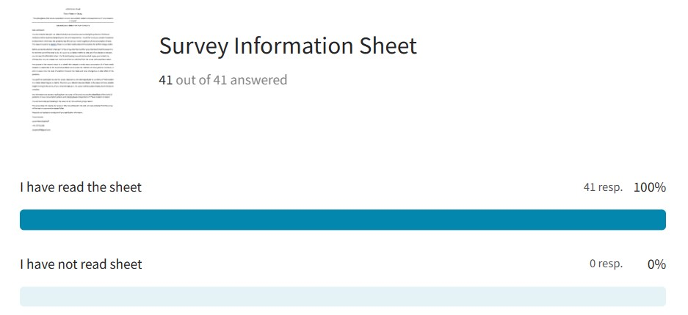
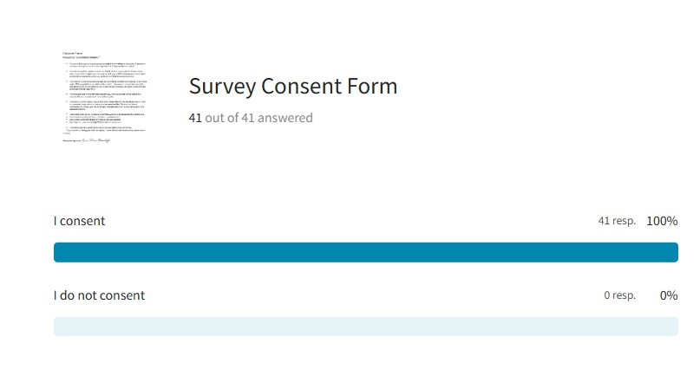
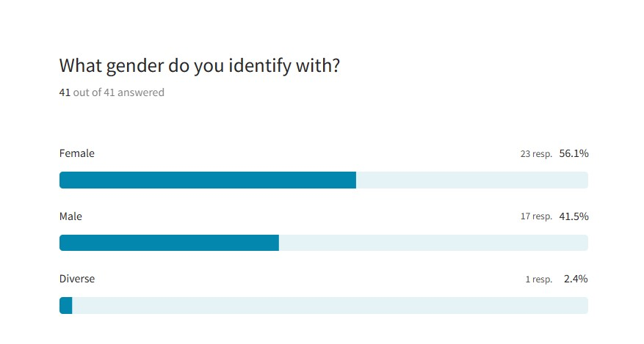
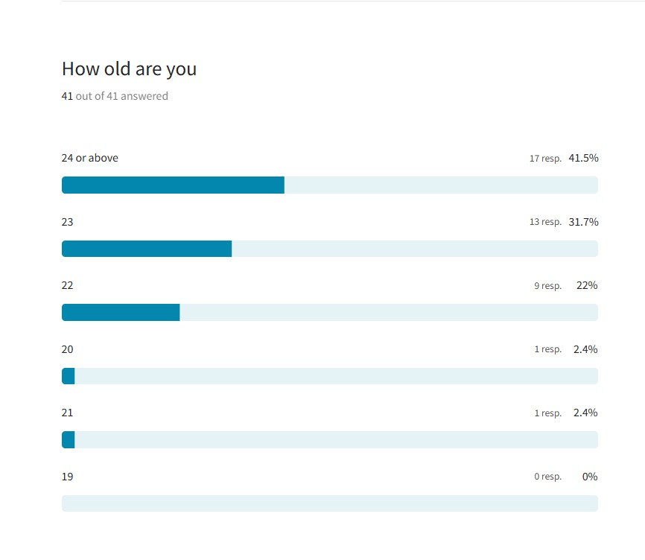

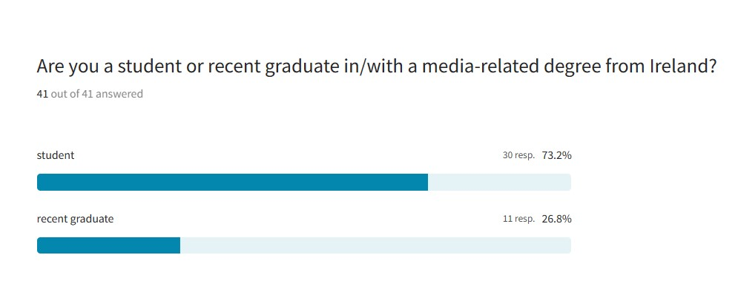
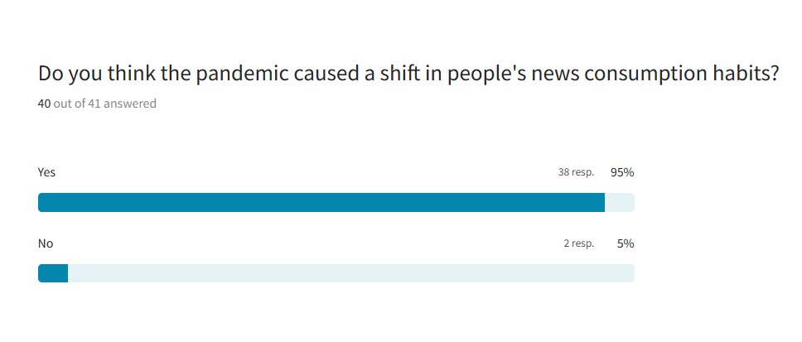
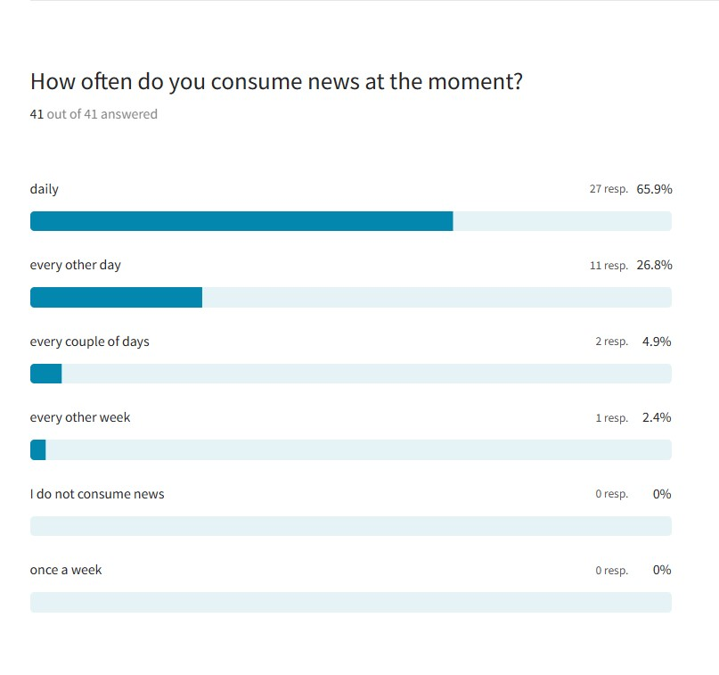
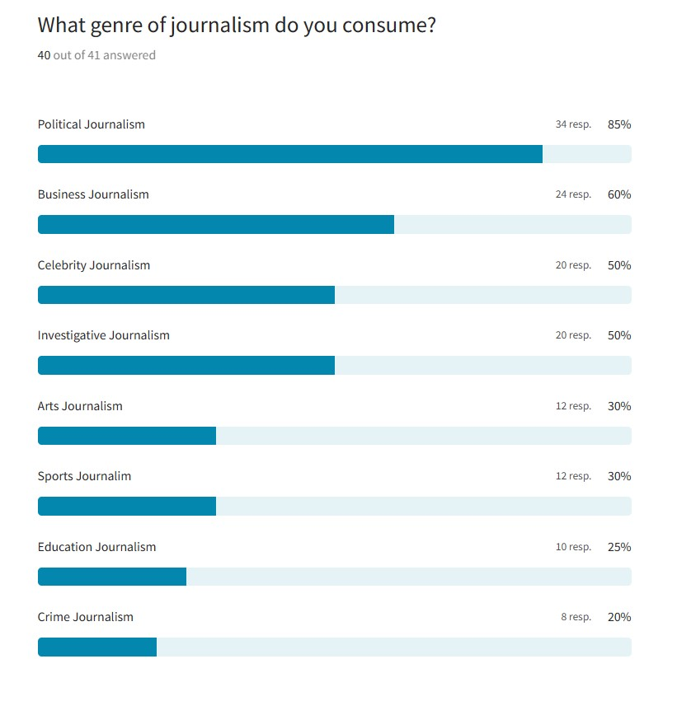

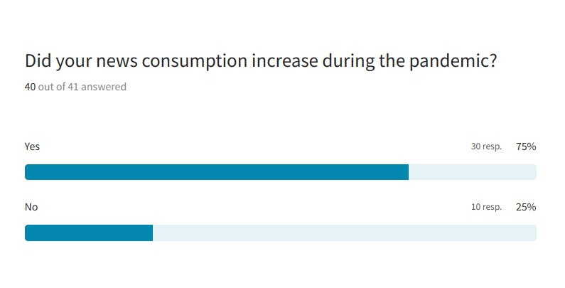

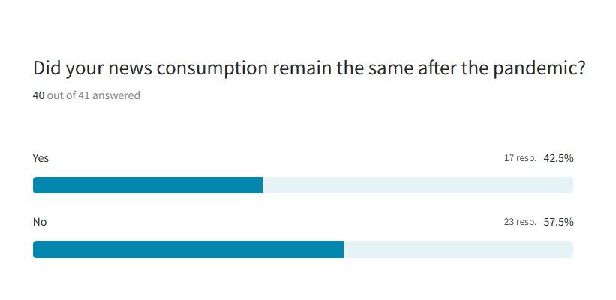

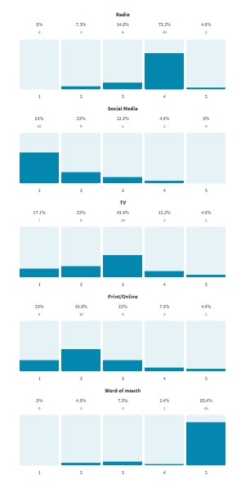

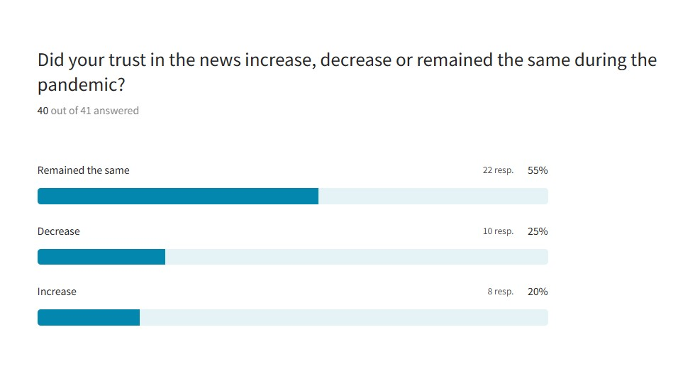
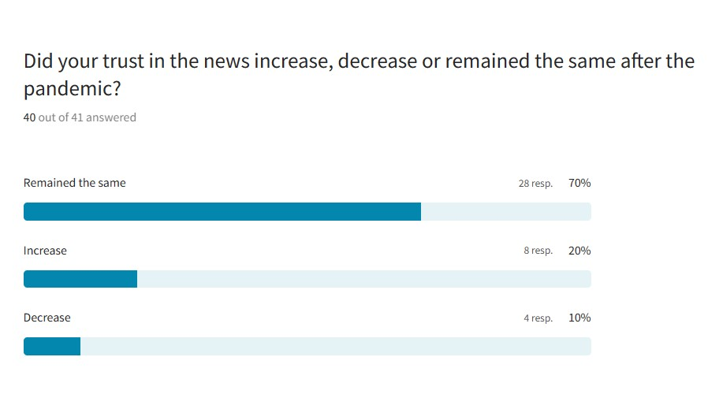

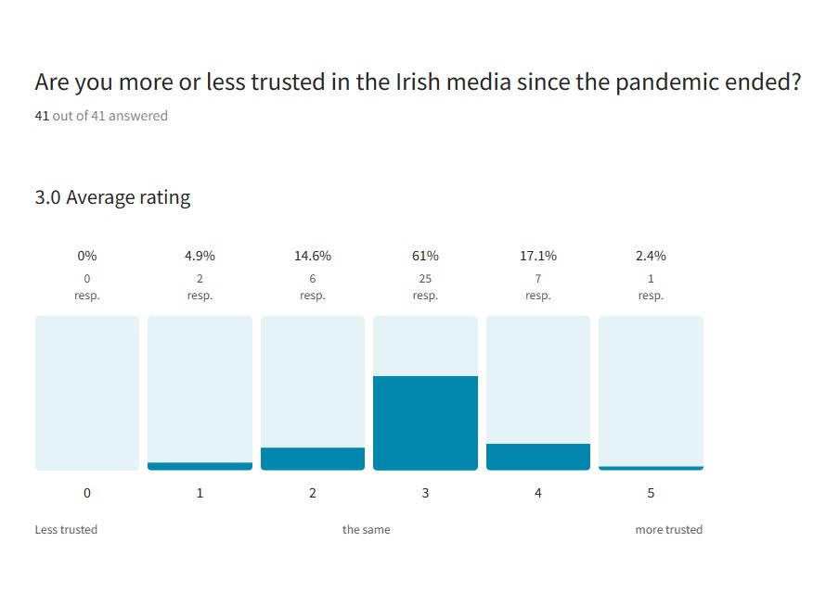

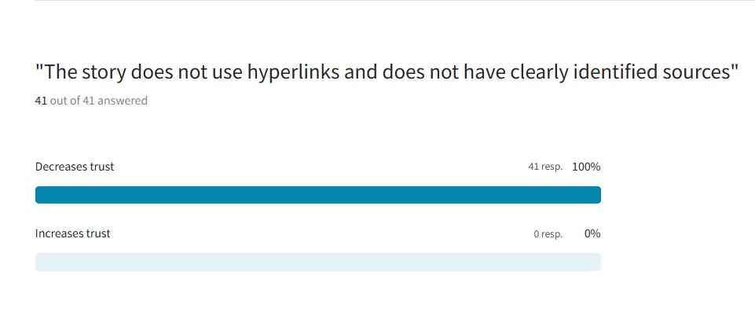
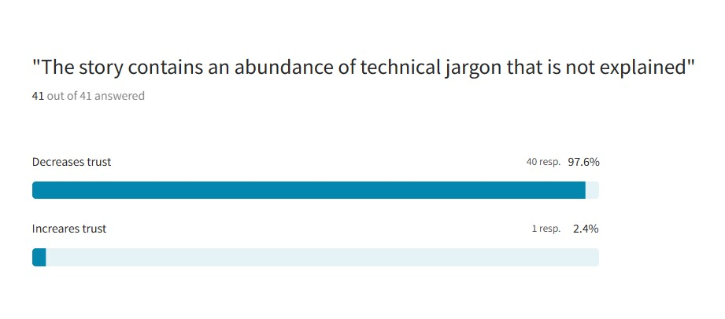
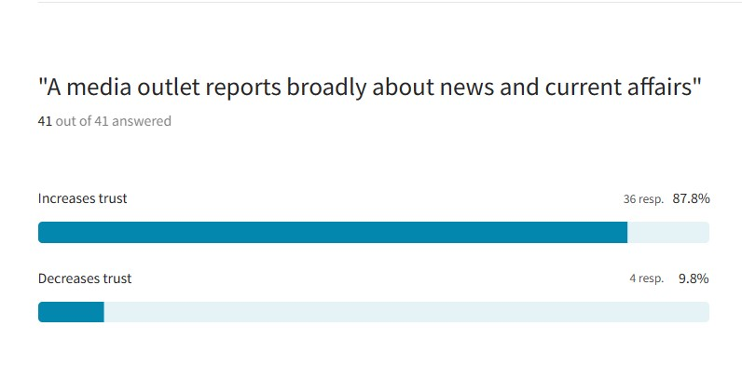
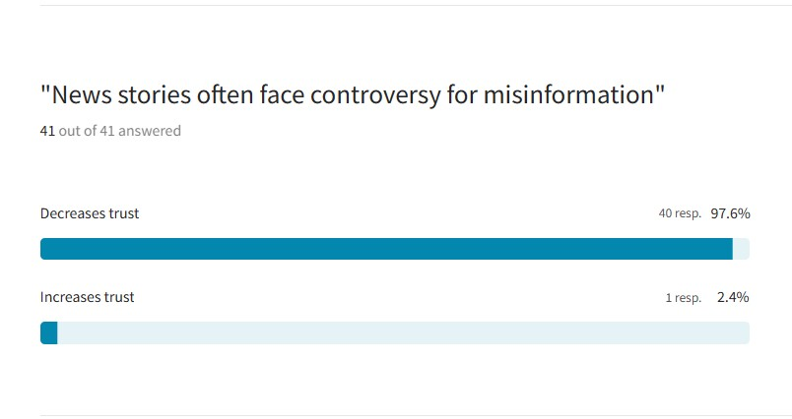

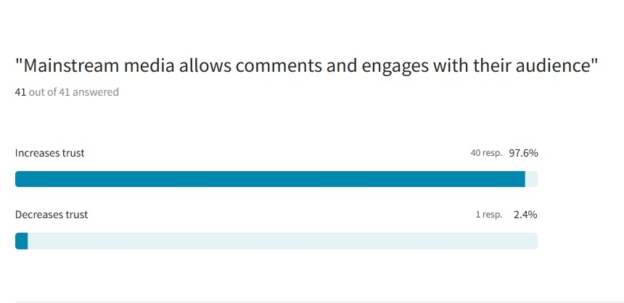

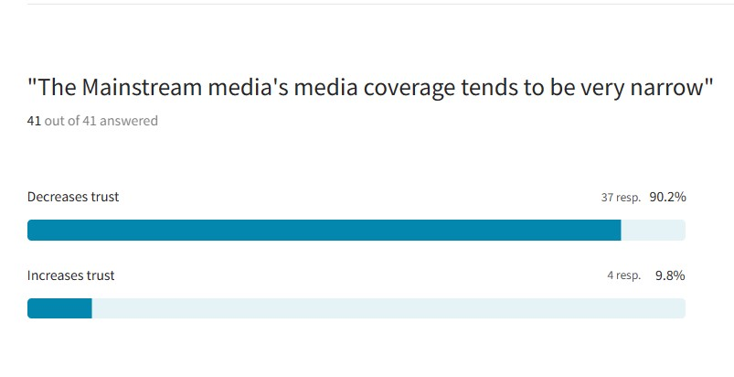

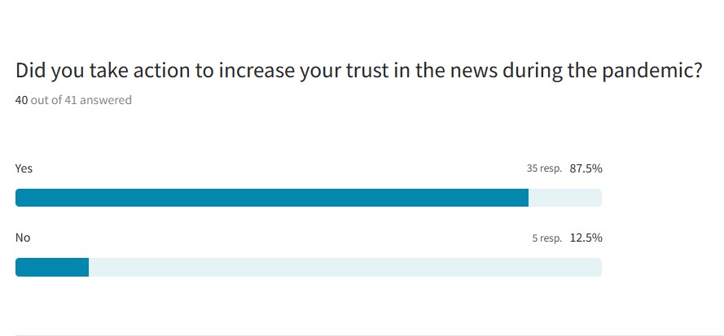
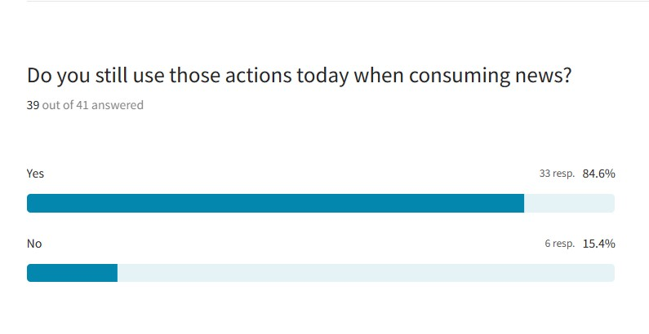

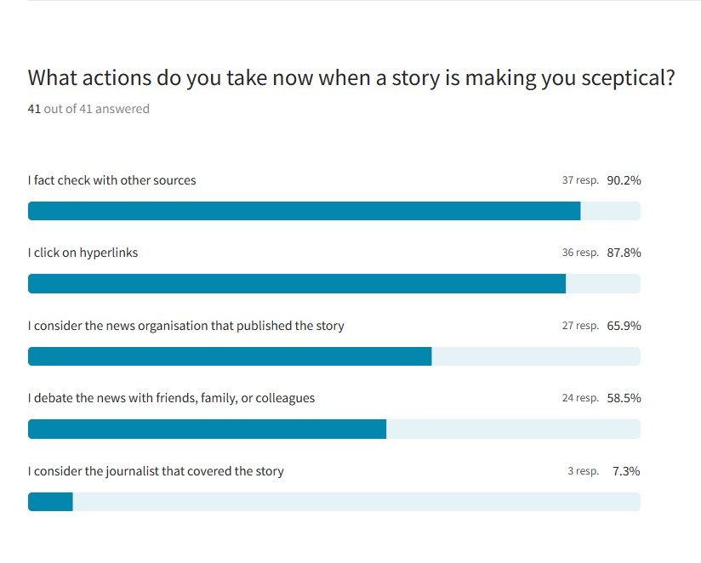

Appendix 3
Information Sheet
Title of Research Study:
“The aftereffects of the Covid-19 pandemic on news consumption patterns and media trust on 3rd level students in Ireland”
INFORMATION SHEET FOR PARTICIPANTS
Dear participant,
You are invited to take part in a research study to examine how news consumption patterns of third-level media/journalism students changed due to the Covid-19 pandemic. I would like to ask you sample of questions to determine in which ways the pandemic has affected your level of scepticism of and consumption of news. This research is part of a Master’s Thesis in Journalism and Media Communications for Griffith College, Dublin.
Before you decide whether to take part in the survey, it is important that you understand what the research is for and what you will be asked to do. It is up to you to decide whether to take part. If you decide to take part, you can save this information sheet. Prior to participating. You will also be asked to give your consent, by clicking a box. You can change your mind at any time and withdraw from the survey without giving a reason.
The purpose of the research study is to identify the changes in media news consumption of third level media students in Ireland due to the Covid-19 pandemic and evaluate the retention of those patterns. Moreover, it aims to assess how the level of scepticism towards the media and news changed as an after effect of the pandemic.
You qualify as a participant to take this survey, because you are a recent graduate or currently a third level student in a media related degree in Ireland. Therefore, you naturally have an interest in the news and have valuable insight to bring to the survey. If you consent to take part, this survey will take approximately 20-25 minutes to complete.
Any information and answers resulting from the survey will be used to assess the aftereffects of the Covid-19 pandemic on news consumption patterns and changing levels of scepticism of third level students in Ireland.
You are free to stop participating in the survey at any time without giving a reason.
This survey does not require any names or other data included in the GDP. Any data collected from the survey will be kept in a password-protected folder.
Please do not hesitate to contact me if you need further information.
Yours sincerely,
Laura-Marie Butenhoff
+49 1707312686
Lbutenhoff4@gmail.com
Appendix 4

Consent Form
Researcher: Laura-Marie Butenhoff

- The aim of this study is to examine and evaluate the aftereffects of the Covid-19 pandemic on news consumption patterns and media trust among third-level students and recent graduates with a media-related degree from Ireland.

- You will be asked thirty to thirty-five questions about your habits of news consumption in the last three years, if you have changed your consumption and why, and if you have grown more sceptic and selective towards news that you consume now that the pandemic is over.

- This research will be beneficial as it helps to understand the factors for changes in the media realm. With a special focus on Irish media students, this research concentrates on a vital demographic and its evaluation will be valuable to policymakers, education establishments, and media market researchers.

- The collected data will be provided anonymously, and any answers will be stored on a separate file and on a password protected computer.

- This survey will only require your gender, age, current degree, and educational level. There is no necessity to provide your name or other sensitive data. Personal participant information will not be used for any reason and participants will not be identifiable in any published material.

- Taking part in this survey is voluntary, and there will be no consequences for withdrawing.
- If you have any questions about this research, please contact:
- Laura-Marie Butenhoff: lbutenhoff4@gmail.com (researcher)
- Ryan Brennan: ryan.brennan@griffith.ie (research supervisor)

- This project has been approved by the Faculty Research Ethics Committee.

If you consent to taking part in this survey and the conditions mentioned above, please check the box.

Researcher Signature: Laura-Marie Butenhoff

