
Research dissertation presented in partial fulfilment of the requirements for the degree of MSc in Accounting and Finance Management.

JUNE 16, 2021.

TAÍS DE SOUZA BEZERRA

THE IMPACT OF COVID-19 ON SME'S AND THE BENEFIT OF AN AUDIT IN TRYING TO MITIGATE THE NEGATIVE CONSEQUENCES OF COVID-19.

2021

Candidate Declaration

Candidate Name: Taís de Souza Bezerra
I certify that the dissertation entitled: The impact of Covid-19 on SME’s and the benefit of an audit in trying to mitigate the negative consequences of Covid-19.
Submitted for the degree of: MSc in Accounting and Finance Management is the result of my own work and that where reference is made to the work of others, due acknowledgment is given.
Candidate signature:
Date:
Supervisor Name: Suzanne Burdis
Supervisor signature:
Date:

Acknowledgements
I would like to register how important is the role that Griffith College Dublin has played in my life. From the very first contact I felt welcomed by Jake Timmins who has an incredible talent with people. From classes to administrative issues, Eilis O'Leary and GBS faculty members, MSCAF Lectures, and Griffith Finance office have happily provided me a respectable experience within the possibilities of a pandemic. And for that I am obliged.
A special thank you to Professor Suzanne Burdis, who I have been admiring since first contact in classes and provided an exceptional guidance as my supervisor. For exploring my academic potential and encouraging me and other students to reach the highest achievements.
Thank you to Professor Paula Byrne who has encouraged and explored in her unique way how a student can accentuate talent.
Thank you to my classmates of MSCAF 2020 February intake, who have helped me going through this challenging course with happiness, discoveries, building good memories and a remarkable personal and professional growth.
I leave Griffith College Dublin with a feeling that I could not have chosen a better institution.

Thank you all.
Taís Bezerra

Dedication
I dedicate this victory to my parents, who have dedicated and sacrificed their lives in order to provide me opportunities to live a better future.
To Antonio Jose Ferreira Bezerra. Marine Sergeant, curious, fighter, strategist, problem solver and my Dad. And to Marcia D’ajuda de Souza Bezerra. Entrepreneur, saleswoman, crisis manager and my Mom.
Thank you for being my support. Thank you for investing your time, your life, and your resources on me with unconditional love.
To Beatriz de Souza Bezerra. My sweet little sister, my eternal child, who has never offered me nothing but love and admiration. To Pedro Filipe de Santana Leite. My partner, my sweetheart, climber, photographer, artist and dreamer. Thank you for holding my hand so that we could build our fortress. And to Talita Lorena Da Silva Do Nascimento. For being fearless and evolving with me.
I love you.
_________________________________________________________________________
Eu dedico essa vitória aos meus pais. Aqueles que dedicaram e sacrificaram suas vidas para proporcionar a mim oportunidades de alcançar um futuro melhor.
Para Antonio Jose Ferreira Bezerra. Segundo Sargento da Marinha do Brasil, curioso, batalhador, estrategista, solucionador de problemas e meu Pai. E para Marcia D’ajuda de Souza Bezerra. Empreendedora, vendedora, gerente de crises e minha Mãe.
Obrigada por serem meu suporte. Obrigada por investirem seu tempo, suas vidas e seus recursos em mim com amor incondicional.
Para Beatriz de Souza Bezerra. Minha doce irmã, minha eterna criança, quem nunca me ofereceu nada menos que amor e admiração. Para Pedro Filipe de Santana Leite. Meu parceiro, meu bem, escalador, fotógrafo, artista e sonhador. Obrigada por segurar minha mão para que construíssimos nossa fortaleza. Para Talita Lorena Da Silva Do Nascimento. Por ser destemida e evoluir comigo.
Eu amo vocês.

Table of Contents

Candidate Declaration 1
Acknowledgements 2
Dedication 3
Table of Contents 4
Lists of Tables 6
List of Figures 7
List of abbreviations 8
Abstract 9
I CHAPTER - Introduction & Objectives 10
1.1 The Purpose Of The Study 10
1.2 A Brief Overall Description Of The Study’s Context 10
1.3 The significance of and justification for the study 11
1.4 The research question or objective that guides the study 12
II CHAPTER - Literarure Review 15
2.1 Covid-19 15
2.1.1 Covid-19: Introduction 15
2.1.2 Covid-19 Impact on Global Economies: 15
2.1.3 Covid-19 Impact in Irish The Economy 17
2.2 Covid-19 Impact On Hospitality 18
2.2.1 Irish Restaurants and Covid-19 impact: 18
2.2.2 Difficulties Faced By Hospitality sector during covid: 21
2.3 Nature of SMEs and Impact of Covid-19 on SMEs in particular 22
2.3.1 SME definition: 22
2.3.2 Categories: 23
2.3.3 Irish SMEs and covid Crisis 23
2.4 Government Responses 27
2.4.1 Covid-19: International Government Responses for SMEs: 27
2.4.2 Covid-19: Irish Government Response for Small & Medium Enterprises (SMEs): 29
2.5 Nature Purpose and Scope of an Audit 30
2.5.1 Why Are Audits Performed? 30
2.5.2 Who Performs Audit? 32
2.5.3 Audit Process: 33
2.6 Advantages and Disadvantages of an Audit 35
2.6.1 Disadvantages of External Audit 35
2.7 Why Audits Would Benefit SMEs 36
2.7.1 Audit Process in SMEs: 36
2.7.2 How May Audit Help SMEs 37
2.7.3 Specialists Opinion Over covid challenges: 41
2.8 Why SMEs are not Required to Have Statutory Audit 42
2.9 Conceptual Framework 43
III CHAPTER - Research Methodology 46
3.1 Research Philosophy 46
3.2 Research Paradigms 48
3.3 Research Approach 49
3.4 Research Methods 50
3.5 Overall Approach 51
3.6 Research Limitations 52
3.7 Research Ethics 53
IV CHAPTER - Analysis of Findings 56
4.1 Overview 56
4.2 Interview process 56
4.3 Findinds 57
4.3.1: The Efforts of Irish SMEs To Remain Running: 57
4.3.2: Audits Benefiting SMEs to Utilise Wisely Government Assistance: 59
4.3.3: The Role of Audit in Improving Investment Options for SMEs: 60
4.3.4: Main internal controls Mistakes on SMES: 61
4.3.5: Overall Audit Relevance Over SMEs as per accountants and auditors: 62
4.3.5: Overall Audit Relevance Over SMEs as per Irish SMEs: 64
4.3.6: Findings summary: 66
V CHAPTER - Conclusions & Recomendations 68
References 72
Appendices 75
Appendice A: Plain language statement 75
Appendice B: Informed Consent: 77

Lists of Tables

Table 1: Philosophical assumptions as a multidimensional set of continua 45
Table 2: Participants Profile 56

List of Figures

Figure 1: IMF Projected Government Fiscal Deficits Relative to GDP (In percentage shares of Gross Domestic Product) 15
Figure 2: Unemployment rates among major OECD countries (in percentage terms) 15
Figure 3: GDP growth comparison between Ireland, Euro Zone and European Union. 16
Figure 4: Sectoral Analysis 18
Figure 5: Sectoral Distribution of Supports (PUP and TWSS) – W/E April 24th 2020 19
Figure 6: Proportion of business expenditure spent on measures to comply with COVID-19 requirements for trading from 27 Jul to 23 Aug 2020. 23
Figure 7 (Left): Estimated changes in personnel costs up to 23 Aug 2020 25
Figure 8 (Right): Estimated changes in non-personnel costs up to 23 Aug 2020 25
Figure 9: Turnover versus operation costs in the four weeks from 27 Jul to 23 Aug 2020. 26
Figure 10: The Research Onion 45

List of abbreviations

WHO | World Health Organization
OECD | Organisation for Economic Co-operation and Development
GDP | Gross Domestic Product
CRS | The Congressional Research Service
FAS | Federation of American Scientists
IMF | International Monetary Fund
CSO | Central Statistics office
PUP | Pandemic Unemployment Payment
TWISS | Temporary Wage Subsidy Scheme
SMEs | Small and Medium Enterprises
ITIC | Irish Tourism Industry Confederation
CRO | Irish Companies Registration Office
OAS | Overall Audit Strategy
OAP | Overall Audit Plan
ICQ | Internal controls questionnaires
IAASA | Irish Auditing and Accounting Supervisory Authority
ISA | International Standards on Auditing
IASB | International Accounting Standards Board
EFAA | European Federation of Accountants and Auditors for SMES
UNCTAD | United Nations Conference on Trade and Development

Abstract
The increase in going concern difficulties for small and medium business has reached a historical point in the last year due to the Covid-19 pandemic and one of the most affected sectors was hospitality sector. In the overall, Irish SMEs represents a significant contribution to Irish economy.
Given the above, and considering the specific challenges faced by the hospitality food sector in Ireland the objective of this research is to understand whether audit would be beneficial in mitigating risk to going concern resulting from the pandemic, from the point of view of the auditors and accountant professionals and SME management in the sector.
The study results indicate that there are different opinions on the value and efficiency of a statutory audit for SME businesses among audit and accountant professionals, nevertheless there is an unanimity result of that audit would not be recommended to SMEs and would be better replaced by consultancy since it would offer the same expected results for a SME business, with a considerable lower price, especially considering the pandemic period. This information goes against the findings of researches conducted in Sweden and Denmark 2018, that indicates better results among SMEs that were submitted to audit.

Keywords: Covid-19 Economic Impact, Covid-19 and Irish SMEs, Covid-19 and Audit, Hospitality Sector, Audit for SMEs. Audit Firms.

I CHAPTER - Introduction & Objectives

1.1 The Purpose Of The Study

The purpose of this research is to identify whether audit procedures applied over Irish SMEs that does not require statutory audit, could, in light of Covid-19 challenges help these businesses to overcome the losses, restructure and develop future strategies in order to maintain the ability to continue running the business.

1.2 A Brief Overall Description Of The Study’s Context
2019 was yet to surprise the world when in December 2019, a fast number of unknown pneumonia cases started to arise in Wuhan, China and call upon attention of the Chinese authorities. The kickoff of what all nations of the globe would know later as The Covid-19 Pandemic.
In an article published on the Journal of Medical Virology Lu et al. (2020), discuss “Outbreak of pneumonia of unknown etiology in Wuhan, China: The mystery and the miracle” among many other specifications and analysed facts, the authors explain that most of the patients had visited Wuhan’s fish and wild animal market the month before the symptoms start to upsurge. Still according to the journal article Lu et al. (2020), the fish and wild animal market also sold live animals such as poultry, bats, marmots, and snakes. All patients received prompt supportive treatment in quarantine. Among them, seven patients were in serious condition and one patient died. All of the 42 patients confirmed at that point were from China except one Thai patient who was a traveler to Wuhan.
From its website, the World Health Organization (WHO ([online] 2020)) disclosed details of how the organization had been informed by the China Authorities about the strangeness of this cases of pneumonia. On 31 December 2019, the WHO China Country Office was informed of cases of pneumonia of unknown etiology (unknown cause) detected in Wuhan City, Hubei Province of China. As of 3 January 2020, a total of 44 patients with pneumonia of unknown etiology have been reported to WHO by the national authorities in China. Of the 44 cases reported, 11 are severely ill, while the remaining 33 patients are in stable condition. According to media reports, the concerned market in Wuhan was closed on 1 January 2020 for environmental sanitation and disinfection.
When informed about the unusual cases of pneumonia detected in Wuhan City, China, the WHO released a communicate in its website affirming that further information was requested from China’s national authorities in order to initiate an investigation and evaluate the risk.
On 30 January 2020, Dr Tedros Adhanom Ghebreyesus, Director-General of the WHO, officially declared the epidemic a pandemic by issuing a public document detailing the current situation and providing a series of information on what has happened in China and how it is necessary to raise concerns for all nations (WHO ([online] 2020)).
Furthermore, as a consequence of the contemporary health crisis yet to come, from an economic perspective, Covid-19 has pessimistically bustling all economies around the world and countries started a new running movement in order to circumvent the adversities. Despite the measures taken by each country to mitigate the economic losses faced by business, especially in developed countries like Ireland, the Organisation for Economic Co-operation and Development (OECD) has published data of various researches analysing the effects of the pandemic in each sector globally. Among the affected sectors, smaller businesses were the most dependent on the daily activities of the society as we knew before Covid-19 and therefore were the ones in which the impact of closures and restrictions have been the most severely felt. Following the events, the author has narrowed down the research to understand the impact on the hospitality food sector in Ireland, which consists of a large proportion of Irish economy.

1.3 The significance of and justification for the study
Following the personal experience of the author working in the hospitality sector as a bartender, the author has just found natural to understand better the limitations of the sector and, throughout this paper inspect what has been done within the sector. As a Masters graduate, applying the knowledge acquired throughout the course into the current scenario of Irish SMEs of the food and hospitality sector aiming to minimize and or create an effective plan to overcome the issues raised from Covid-19 crisis.
Audit procedures can be highly effective in establishing methods of internal controls that are known as one of the best practices to mitigate major errors in the representation of financial statements on a yearly basis. Moreover, when a company is submitted to audit, it is more likely that it will be in accordance to the policies and regulations and therefore, operational inadequacies and surplus are more likely to be reduced. Implementation of new systems and technologies are also a big advantage of audit procedures in order to improve the daily activities. Furthermore, as a consequence of audit analysis, managements are more likely to wider their vision of future for the business and therefore create a more effective business plan.
Irish SMEs are not required to have statutory audit according to the Companies Act 2017, that establishes a minimum of criterion for a company to do so in Ireland. Audits are also expensive, which diminishes the likelihood of owners and managers to desire to have the business audited.
However, the author has found relevant to consider the exceptional circumstances and by witnessing the scenario in which Irish SMEs from hospitality sector are currently in, that audit, even though is an expensive resource, may improve the chances of reduce the risk of Irish SMEs from hospitality sector of being no longer considered a going concern in a long term-basis. In simple terms, considering the actual scenario, audit may help Irish SMEs to overcome the Covid-19 pandemic in a less stressful manner and reduce the chances of closures and losses in the future.

1.4 The research question or objective that guides the study
Are the Irish SMEs more likely to survive COVID-19 economic challenges if relying its performance on audit procedures well applied?
This research will in its conclusion, define whether SMEs companies are indeed facing strategic challenges due to the COVID-19 and if they are able to perform a concise risk analysis of the business and its future. The purpose of the research is to identify whether audit can help the Irish SMEs overcome business risks caused by the pandemic and therefore sustain themselves more easily in a long-term basis, avoiding going concern as stated in the topic above. For that, the author has investigated what has been the impact on the Irish SME hospitality sector, focusing in the food and beverage businesses, to determine how can audits help the sector to survive and build an effective business plan in order to increase growth in the future.
SME business from the hospitality sector are a large part of Irish economy, being responsible for 180,000 employments according to PWC (2020). The impact on the accommodation and food sector lead to a massive unemployment rate within the sector, causing almost 90% of the workforce to claim unemployment benefits from Irish government due to the closures caused by the restrictions over the sector according to the Irish Department of Employment Affairs and Social Protection’s (2021).
With the easy of restrictions occurring and the excitement of small and medium businesses to recover its profitability and maintain business running, the author believes that there is a risk of mistakes in the assessment of actions taken in order to improve business and make it more desirable for its potential customers and that audit would be helpful for those businesses to proceed with more accurate decisions to the foreseeable future.
Readers ought to expect see in the Chapter II – Literature Review a selected collection of books, articles, and peer viewed papers that investigates the origin of Covid-19, its impact on global economies and in Irish economy, the impact and difficulties faced by the hospitality sector mainly focused in Irish SMEs restaurant food sector and the Irish government responses to overcome Covid-19 economic impact over SMEs sector. Still in Chapter II the readers will find a literature review that presents the nature purpose and scope of an audit, the advantages and disadvantages of an audit, the reasons why audit would benefit SMEs, and why Irish SMEs are not required to have a statutory audit.
On Chapter III, readers should expect to see a brief introduction to research methods and understand the author’s method of research chosen as well as the limitations that had impacted over the research development.
On Chapter IV is presented the author’s findings and analysis resulted from the assessment of the data collected in the literature review, confronting with auditors and accountant professional opinions and finally an SME opinion over the efficiency of auditing in helping Irish SME businesses to survive to Covid-19 damages and incentivizes the Irish government onto an amplification of the audit benefits research over both small and medium businesses and audit companies, hoping that the interest over this subject helps the entities to prospect new points of view and investments, reducing going concern risk.

II CHAPTER - Literarure Review

2.1 Covid-19

2.1.1 Covid-19: Introduction
This chapter will focus on explaining the economic impact of the Covid-19 pandemic from a global perspective to the impact in Ireland. Looking into the GDP (Gross Domestic Product) variances before and after Covid-19, how governments have responded to the crisis and developed improvement plans in a long term, as well as short term actions as subsidy schemes launched in the early times when the pandemic hit. Furthermore, it will also look into the economic encounters faced by the Irish food hospitality sector, generally how are these businesses responding financially to the debts and liabilities acquired throughout the 2020 year and what steps those business may be able to take if they take into consideration an evaluation by a professional audit. Finally, from the analysis of the literature review, this chapter will be able to provide fundamental information to create relevant questions that will be directed to professional accountants and auditors to test if the proposed idea of audits helping Irish SMEs are in fact feasible.
This chapter will be looking into the extensive literature review used to improve and sustain the research question of this paper. The research question is: Is audit capable of improve Irish SMEs results, specially from the hospitality and food sector, considering Covid-19 challenges?

2.1.2 Covid-19 Impact on Global Economies:

The Congressional Research Service (CRS) and Federation of American Scientists (FAS) released an international report - (Jackson et al.,2021) from March, 10, 2021 - covering the Global Economics Effects of Covid-19 worldwide, where it is possible to see the following:

Figure 1: IMF Projected Government Fiscal Deficits Relative to GDP (In percentage shares of Gross Domestic Product) 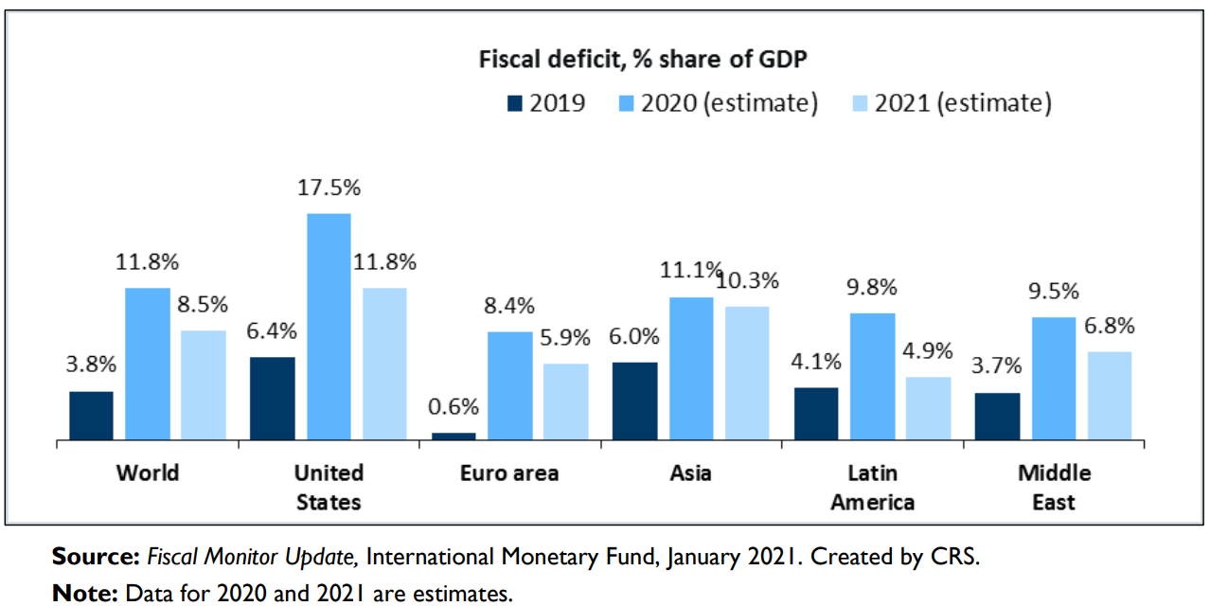

The graph above contains data from 2019 to January 2021. Despite the positive estimative for 2020, when looking at 2021 data, it projects a fiscal deficit for all continent's economies in 2021. Therefore, analyzing the estimate developed with data from the international monetary fund, it’s crucial that for the success of the estimate, despite low, that governments avoid the misapplication of the suggested measures. Otherwise, it can lead to a reduction in foreign investments, inflation, interest rates rising, unattended supply/ demand and depreciation of domestic currency.
Figure 2: Unemployment rates among major OECD countries (in percentage terms)
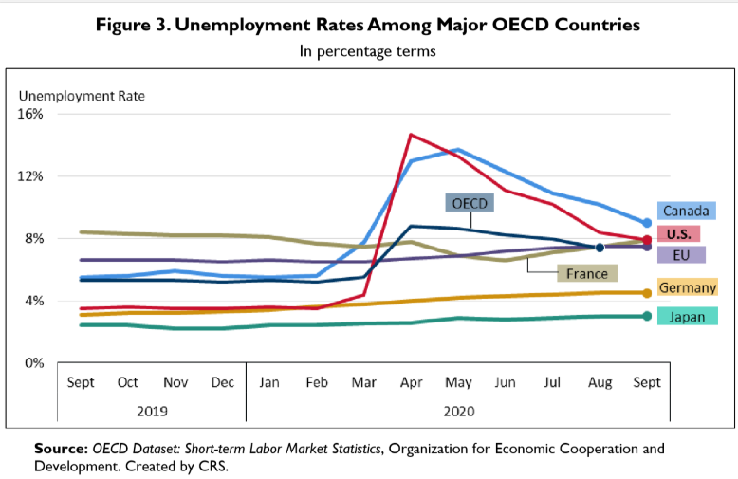
The chart above depicts the current unemployment rates among major OECD countries (OECD, 2020). Canada and US are above the OECD average rate, which is alarming. Nonetheless, a high unemployment figure raises concerns about the inhabitant's future as: housing crises, debts, violence increase, poverty, health issues, depression, social isolation and so on.

2.1.3 Covid-19 Impact in Irish The Economy

Although the rough scenario established above, when looking at Ireland, there is a positivist overview. The GDP projections for Ireland are, at a minimum, exciting. In the past decade, Irish economy has been positively highlighted among the European Union.
The graph below was constructed using the latest data revealed by the statistical office of the European Union (EUROSTAT, 2020), and it demonstrates a considerable improvement in Gross Domestic Product (GDP) that has been higher in Ireland than the European Union average since 2014. Besides, even with a rash decline from 2015 to 2016, Ireland continues to show a confident outcome of positive 3.4 for the year 2020 and when compared to both Eurozone and European Union, that presents a GDP of –6.6 and –6.2 respectively. The positive results, although in decline, is yet a very positive for a pandemic year.

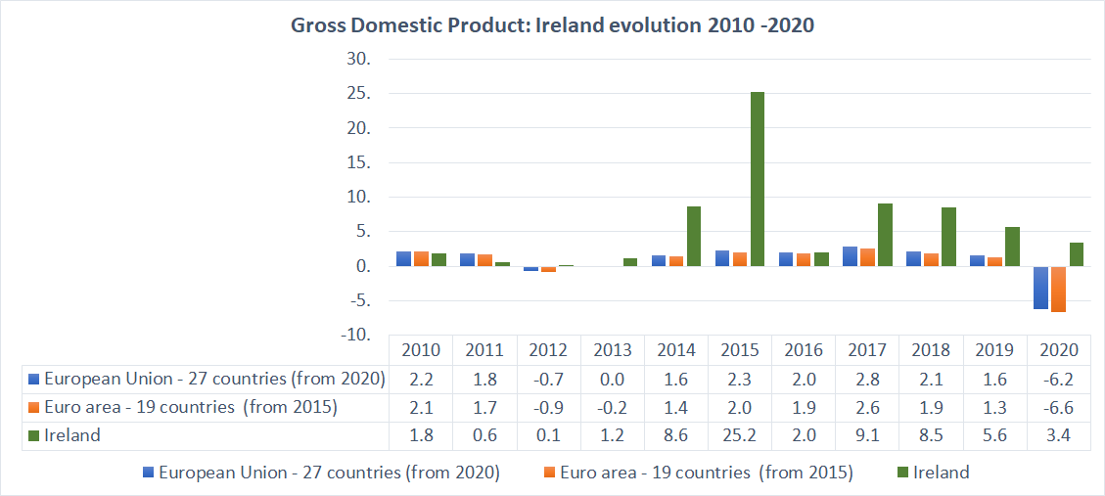
Figure 3: GDP growth comparison between Ireland, Euro Zone and European Union.
(Source: Authorship chart` made with data extracted on 21/03/2021 from [ESTAT])

Nevertheless, an optimistic optic is reinforced when analysing the results from 2019 and 2020, with the insertion of the pandemic factor.

GDP is essential because it offers details about the scale and performance of an economy. As affirmed by IMF (2020). The rate of growth in real GDP is often used as a measure of the overall performance of the economy. Speaking generally, an increase in real GDP is viewed as evidence that the economy is doing well. As real GDP grows rapidly, employment is expected to rise as businesses recruit more employees for their companies and people have more money in their pockets. As GDP falls, as it did in many countries during the recent global economic downturn, jobs usually fall. In certain cases, GDP could be will, but not quickly enough to produce an adequate amount of jobs for those who are looking for them.

2.2 Covid-19 Impact On Hospitality

2.2.1 Irish Restaurants and Covid-19 impact:
From the data exposed above, there are innumerous challenges arising from the impact of Covid-19 impacting Irish Businesses. For the purpose of this research the scope has been limited to SMEs in the hospitality sector, more specifically, restaurants and pubs. Most of those companies have totally ceased their business and a few have been able to adapt to online business in order to keep the business somehow running.
In a Sectoral analysis created by the Central Bank of Ireland, the data projected describes the most affected sectors in the Irish economy.

Figure 4: Sectoral Analysis.
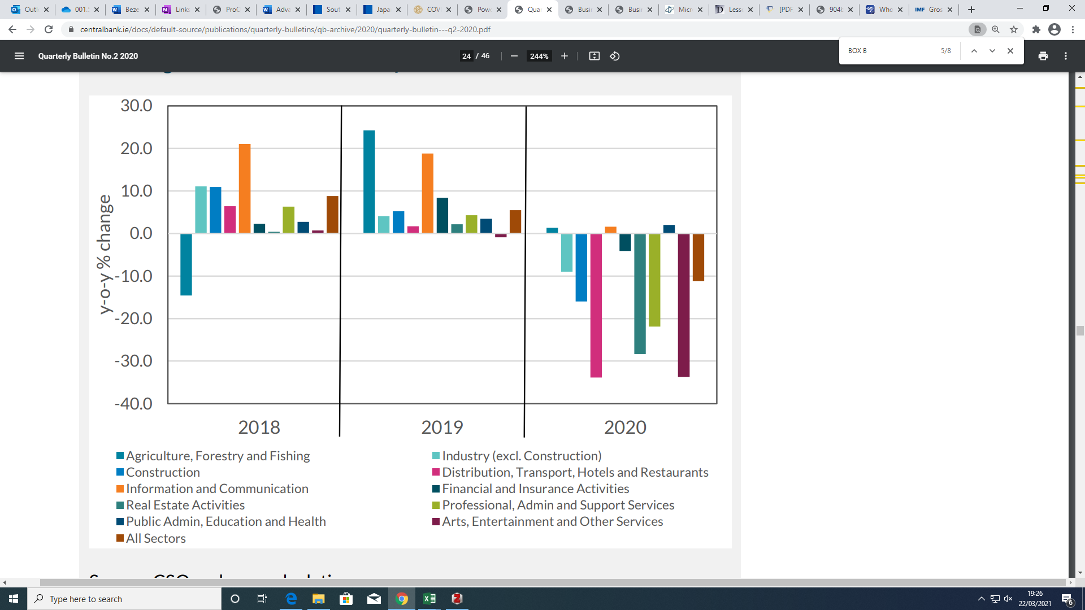
(Source: The macroeconomic effects of Covid-19 in Ireland, Central Bank of Ireland, 2020).

Ireland's hospitality industry is a vital part of the Irish economy. According to multiple sources, a (PWC, March 2020) study reveals that the sector's gross economic output ranges from €5 and €7.6 billion a year, or 1.5 to 2.3 percent of GDP. Whereas the sector's economic operation is supported by the success of tourism, Ireland's largest indigenous industry, the sector is tied closely to the general success and well-being of both the national and international economies. Access to disposable income, as well as corporate and commercial investment, are critical foundations of sectoral success (PWC, March 2020).
In terms of salary, the hospitality industry pays about €64m a week through its 180,000-strong employees. After taxes, savings, and a forecast for spending outside of Ireland, nearly €54.3 million is invested in the Irish economy. An example of the sector's gross payroll economic influence can be estimated by using multipliers and results. The payroll operation in the sector has an economic value of €82.6 million. With hospitality payroll taxes bringing in €5.14 million for the exchequer, hospitality payroll provides a net economic benefit to the Irish economy of €87.7 million. The sector is also a significant buyer from Irish producers, resulting in additional economic benefits. In 2016, supplier sales totaled €3.2 billion according to CSO data analysed by (PWC (March 2020).
From the statement above and by analysing the chart, it is noticeable that the distribution, transport, hotels and restaurants sectors, are by far the most concerning sectors for the Irish economy.
The unemployment rate in January 2020 was 5.1% according to CSO (2021). To support the seriousness of the impact on the sector, follow below a chart extracted from the Department of Employment Affairs and Social Protection (2018) article named “The Initial Impacts of the COVID-19 Pandemic on Ireland’s Labour Market” where it is possible to see that among the benefits, over 90% of accommodation and food sector workers have claimed either the Pandemic Unemployment Payment which has been made available for employees and self-employed who have been laid off due to the restrictions measures that forced hospitality business to close, or the Temporary Wage Subsidy Scheme, which is available for employers who suffered negative impact caused by Covid-19 crisis but were still keeping staff in the payroll. Therefore, only nearly 10% remains uninterruptedly employed within the sector.
Figure 5: Sectoral Distribution of Supports (PUP and TWSS) – W/E April 24th 2020
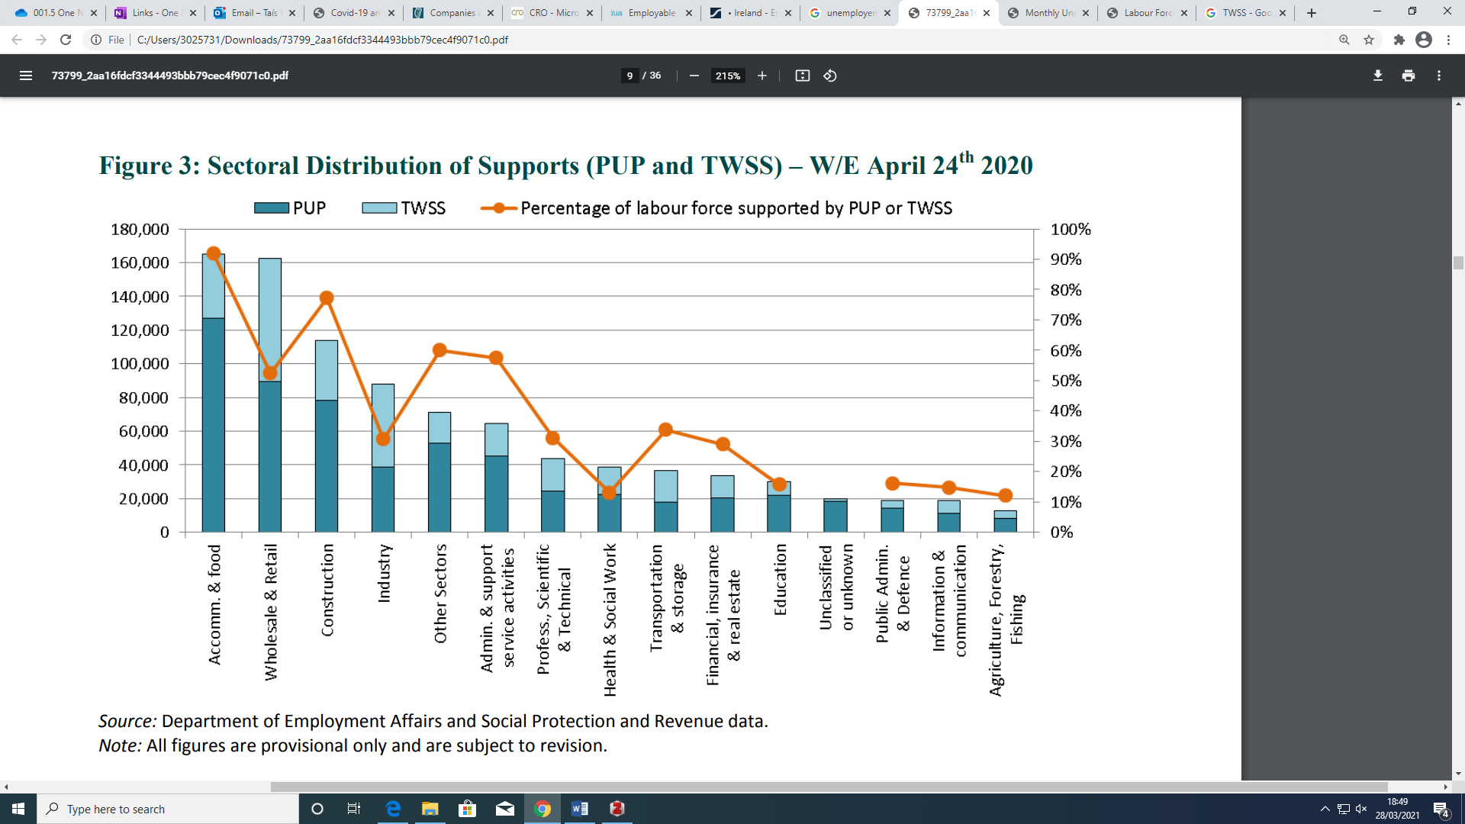
According to M. Martinez-Cillero et al. (2020) the proportion of viable SMEs is marginally smaller in the subsample of debt-ridden companies. The debt-to-turnover ratio is consistent in most industries, with the exception of hotels and restaurants, where the ratio is significantly higher than the average 42 percent. The proportion of firms that make a profit is lowest in this industry, at 58%, and the proportion of firms that have skipped a loan payment is highest in the SME hospitality sector. This is a major problem in the light of the hospitality sector's susceptibility to the COVID-19 shock, as it has been subjected to the most restrictive constraints and is expected to face operation limitations attributable to social distancing conditions for the longest time. On the demand side, households are expected to be more hesitant to participate in this sector as long as the possibility of contamination persists in the population

2.2.2 Difficulties Faced By Hospitality sector during covid:
Deloitte Ireland has released an article “Hospitality and Tourism Sector Domestic Market Review”, assessing the challenges emerged from the Covid-19 crisis in Ireland for the 2020 year. From the article, a number of consequences have been raised.
According to the mentioned article, Deloitte (2020) states that there is a major concern questioning the capability of the hospitality sector to raise new finance funds and/or the competence of the sector to access credit when able to fully reopen to public.
Moreover, Deloitte (2020) also affirms that liquidity issues and cash burn are listed as the top reasons for a business to confront. Therefore, it gives rise to defaults on medium and longer-term finance obligations and negatively operating credit concern since the closure of business for this considerable time must indicate that creditors are not fully receiving payment and unattended creditor payments.
Accumulated debt has also been included in list. Deloitte (2020) explains that debts brought forward may leave business in vulnerable positions when it is time to reopen, hence it may cause long term distress in the financial statements.
In addition, Deloitte (2020) article also mention price competition as an issue arising from Covid-19 for the hospitality industry in Ireland. The article affirms that as an effort to intensify sales quantity among the hospitality and tourism sector focused in gain market volume rather than profitability. Due to the retrocession felt in the past months, market review liquidity issues will be seen and will continue to challenge businesses as a result of cash flow drowning.
The Irish Tourism Industry Confederation (ITIC, 2021) has also pointed out in an article available in its website the struggle to sustain employment in the Irish tourism and hospitality sector. As mentioned in the topic above regarding benefits schemes, ITIC article reinforces the reality of the sector whereby accommodation and tourism employees are the most dependent on benefit schemes, such as PUP and TWISS, citing the Irish government initiative of The Tourism Recovery Taskforce, which has been appointed in May 2020 and that highlights the importance of employment retention, the dramatic economic slowdown on the sector and the impact on youth unemployment.

2.3 Nature of SMEs and Impact of Covid-19 on SMEs in particular

2.3.1 SME definition:

To this date, the author has not found in the course of this research a definition for Small and Medium Enterprises that can be applied globally. Therefore, the definition, classification and policies for small and medium enterprises may vary from country to country.
In Ireland, SMEs definitions are determined by the Companies Act 2017, that substitutes Companies Act 2014 due to an amendment where it includes Micro companies, besides the Small and Medium companies already covered by the Companies Act 2014.Both Companies Act are deemed to cover the accounting aspects of SMEs.
The OECD states in its webpage that they can help improve understanding about the conditions and drivers of SME and entrepreneurship performance. Moreover, it also informs that in collaboration with national and local governments, the OECD can undertake country- or place-specific analysis, and foster mutual learning on good policy practices that could unleash the potential of SMEs and start-ups to drive innovation, productivity, job creation and a more sustainable and inclusive growth.

2.3.2 Categories:
Since this paper is focused on Irish SME, the following the guidelines of the European Commission, are to be considered for this research. According to the European Commission User Guide for SME Definition, European Commission (2020), a SME company may interlock the following conditions:
To be considered medium-sized, an enterprise must have over 50 employees minimum and a maximum of 250, it must have an annual turnover up to EUR 50 million and/or an annual balance sheet up to EUR 43 million.
To be considered a small company, an enterprise must have between 10 and 50 employees and it must have an annual turnover up to EUR 10 million and/or an annual balance sheet up to EUR 10 million.
To be considered a micro company, an enterprise must have up to 10 employees and it must have an annual turnover of less than EUR 2 million and/or an annual balance sheet less total than EUR 2 million.
An important notion in the SME definition is the concept of control — both legal and de facto. European Commission (2020) declares that the controls determine whether or not an enterprise is considered a partner or a linked enterprise. It is not only the capital or shareholdings, but also the control that one enterprise has over another that needs to be assessed.

2.3.3 Irish SMEs and covid Crisis
From an article released by the Seanad Public Consultation Committee, named Report on Small and Medium Sized Businesses in Ireland (May 2019), 179,82725 persons were engaged in active enterprises in the accommodation and food service sector in 2016; 89% of these persons were in SMEs, Seanad Public Consultation Committee (2019).
The CSO (2020) research reveals that in 2017, there were 19,205 active enterprises in the Accommodation and Food Services sector. And according to Power (2020), this represents an increase of 10% on 2008. Hotels, restaurants and pubs are key components of the Irish tourism product and have been integral to the success of Irish tourism over the past decade. These sectors are now under significant pressure due to a variety of factors, but COVID-19 has presented a very real and potentially fatal threat to these sectors.

For the purpose of this research, an economic point of view is crucial to understand the scenario faced by SMEs in Ireland. Therefore, from “The Business Impact Survey of Covid-19 (BICS)” conducted by the Irish Central Statistics Office, where 3,000 enterprises in total were surveyed online and from those, 25.5% of the sample (765 companies) completed the survey by 24 of August 2020, CSO (2020) the following information has been taken as data for analysis:
Figure 6: Proportion of business expenditure spent on measures to comply with COVID-19 requirements for trading from 27 Jul to 23 Aug 2020. 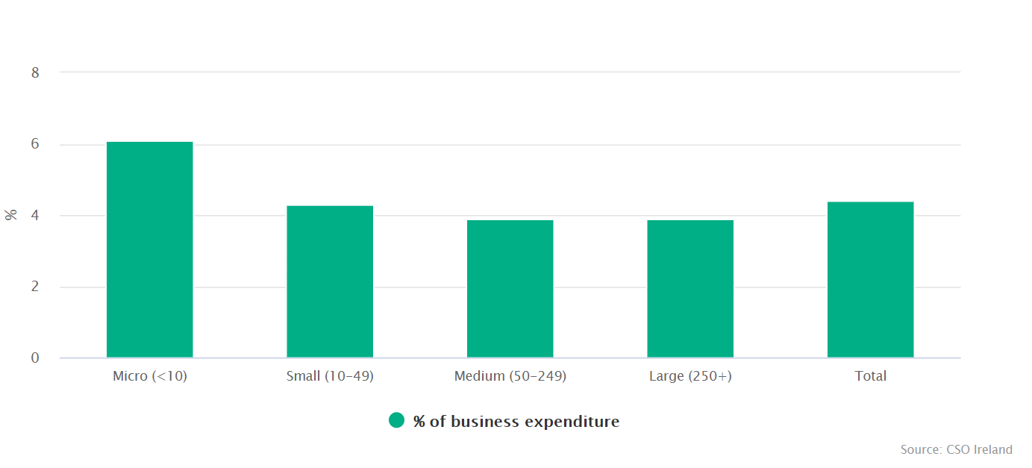(Source: CSO Ireland, 2020).
According to the CSO analysis CSO (2020) an average of 4.4% of total expenditure was spent on measures to comply with COVID-19 requirements for trading.
• Responding enterprises spent an average of 4.4% of total expenditure on measures to comply with COVID-19 requirements for trading during the four weeks 27 July to 23 August 2020 CSO (2020).
• Micro enterprises spent 6.1% of total expenditure during this period on measures to comply with COVID-19 restrictions, the highest among all size classes CSO (2020).
Moreover, analysing the chart above, it is also relevant to highlight that micro and small companies have the highest expenditure when compared to its revenues. For that reason, the author has found relevant to question how are those companies coping with financial obligations? and Does the management have enough knowledge of how to create a plan for the foreseeable future of the business?
Figure 7 (Left): Estimated changes in personnel costs up to 23 Aug 2020
Figure 8 (Right): Estimated changes in non-personnel costs up to 23 Aug 2020
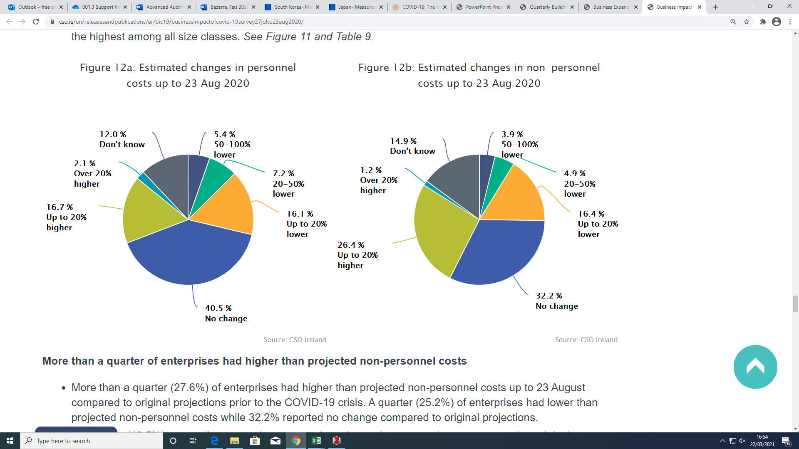
(Both Figures Source: CSO Ireland, 2020).

According to the Irish Central Statistics Office (CSO,2020) More than a quarter of enterprises had higher than projected non-personnel costs.
- More than a quarter (27.6%) of enterprises had higher than projected non-personnel costs up to 23 August compared to original projections prior to the COVID-19 crisis. A quarter (25.2%) of enterprises had lower than projected non-personnel costs while 32.2% reported no change compared to original projections (CSO,2020).
- Four in ten (40.5%) responding enterprises reported no change in personnel costs compared to original projections, 28.7% had lower than projected personnel costs while 18.8% reported higher than projected personnel costs (CSO,2020).

Figure 9: Turnover versus operation costs in the four weeks from 27 Jul to 23 Aug 2020.
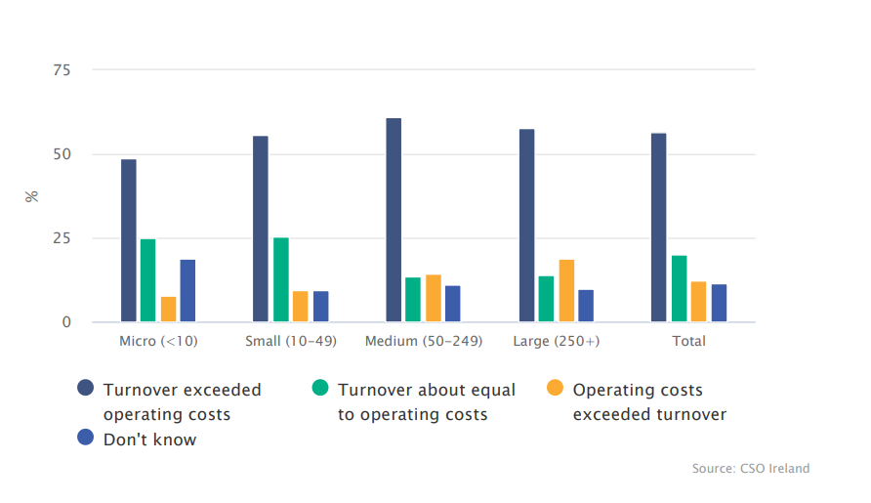
Source: (CSO Ireland, 2020)

According to PWC (March, 2020) the hospitality industry was the first to suffer significant employment cuts, and the effect was felt immediately. It is important to re-employ these people as Ireland recovers from the Covid-19 crisis. Nevertheless, there is a substantial danger that, once interventions are implemented, the companies that hire these people will no longer be competitive and will be unable to resume operations as normal. This is a business that often runs with limited cash flow capital, restricting its ability to rebound from a time of distress.
Reviewing the data above, the increase of ratio of debt-to-turnover among hotels and restaurants businesses and consequently the decrease of profitability caused by the Covid-19 crisis, resulted in the enlargement of the hospitality sector’s vulnerability. The sector has been under the most severe and extensive restrictions which largely prevented SMEs hospitality business owners to conduct commerce. Admittance to disposable income as well as corporate and business activity are crucial mainstay of sectoral operation.
As a consequence of the issues raised above, the author believes that auditors would be in a position to evaluate the risks of going concern in SMEs and implement measures to reduce the risk.

2.4 Government Responses

2.4.1 Covid-19: International Government Responses for SMEs:

Despite all data provided so far, it is important to say that the problems raised by Covid-19 are quite similar worldwide. However, depending on the measures taken by each country as well as its resources availability, the outcome will differ. There are several variables for this i.e.: Climate, Education, Laws, Announcements, Brexit, Government Image, Debts, Mental Health, Tax reform, Rate Exchange, Bankruptcy etc... That may interfere in the outcomes as well as how it is dealt with.
Many countries have launched stimulus packages that includes grants for business, subsidy wages schemes, and due to the lockdown in different areas in the world, many companies have decided to work remotely and close physical offices.
The OECD published an article last updated in 15 July 2020 compacting information from countries policies responses among its 60 participant countries, including Ireland. Across the information collected, they listed the overall measures that countries have implemented specifically to SMEs:
Several countries have introduced measures related to working time shortening, temporary lay-off and sick leave, some targeted directly at SMEs. Similarly, governments provide wage and income support for employees temporarily laid off, or for companies to safeguard employment. In many cases, countries have introduced measures specifically focused on the self-employed OECD (2020).
According to OECD (2020) many nations have implemented policies to delay revenue, social security, debt, and rent and service payments in order to alleviate liquidity constraints. In certain cases, tax relief or a moratorium on loan repayments have been put in place. In addition, several countries are taking steps to address public procurement processes and late payments.
Besides, OECD (2020) data have also informed that several countries have implemented, expanded, or streamlined loan guarantees in order to allow commercial banks to increase credit to SMEs. In some cases, governments have increased direct lending to SMEs through public institutions. Multiple nations around the world are providing grants and subsidies to SMEs and other businesses to help them bridge the revenue gap, affirms OECD (2020).
Countries are gradually incorporating non-banking financial intermediaries into their policy support mix, according to OECD (2020).
Countries are increasingly enforcing institutional policies to assist SMEs in adopting modern operating practices and (digital) technologies, declares OECD (2020), as well as in finding new markets and distribution platforms in order to sustain operations under current containment controls. These policies aim to resolve acute short-term problems, such as the implementation of teleworking, but they also lead to the systemic strengthening of SMEs and their future development. Some countries have implemented unique programs to track the effect of the crisis on SMEs and improve the governance of SME-related policy responses.
The document explains also that: Across countries, the most widely used instruments in response to the outbreak are income and profit tax deferrals, loan guarantees and direct lending to SMEs, and wage subsidies. This is in line with findings from the World Bank (2021) SME Support Measures dashboard, which suggests that out of 845 SME policy instruments used worldwide 328 relate to debt finance (loans and guarantees), 205 to employment support and 151 to tax. 67 structural policies have been used only modestly, with a focus on teleworking and digitalization, although over time the number of countries setting up such policies has increased. The use of grants, debt moratorium and specific measures for the self-employed provided is mixed, and highly differs across countries OECD (2020).
For the hospitality sector specifically, the United Kingdom had announced a 100% business rates tax holiday for 12 months. Scotland offered 75% rates relief for the sector from April 1st 2020, Turkey introduced a deferral of social security premiums by six months for hospitality sector, food and beverage businesses. Hungary introduced an exemption of social security contributions for sectors that were severely hit by the pandemic (tourism, film industry, restaurants, entertainment venues, gambling, sports, cultural services, passenger transportation) OECD (2020).

2.4.2 Covid-19: Irish Government Response for Small & Medium Enterprises (SMEs):

The Irish Government has been extremely supportive for Irish Business in the recent times and has launched along with the Organisation for Economic Co-operation and Development (OEDC) a plan called “SME Growth Taskforce” as seen below:
The OECD document “Review of SME and Entrepreneurship Policy in Ireland” was published in October 2019 following extensive engagement with Government Departments, agencies, academia, business representatives, and the small business sector. The OECD report identifies a number of challenges for SME policy in Ireland. These include the SMEs' productivity growth, increasing the pace of company start-ups and dynamism, encouraging entrepreneurship among women, youth, and migrants, scaling up micro-enterprises, creating more medium-sized businesses, and growing SME investment in international markets. Several proposals were made to assist with meeting these problems, declares OECD (2019).
With the arrival of COVID 19 and the risks for Irish Business, the Irish Government has also made available several financial supports that can easily be found in its website, such as: income supports, loans, grants, vouchers and schemes, rates waiver and tax measures, sector-specific supports and guidance, skills, and training support, Work Safely Protocol as well as a complete guideline called: “Supports for businesses impacted by COVID-19” (Government of Ireland, 2021).
Having said that, it is expected that those companies may be dealing with a volume of unknown situations and challenges and many changes to their business, and many companies may be approaching accounting records with erroneous figures that will impact on the overall aspect of the business furthermore.

2.5 Nature Purpose and Scope of an Audit

2.5.1 Why Are Audits Performed?
According to the Companies Act 2017 (CRO), a company must be audited if at any period throughout the year its financial statements have been: A Public Company (Offering shares of stock to the general public), A Subsidiary company (majority owned/controlled by a Parent) within a group which is not small, an authorised insurance company or carrying out insurance market activity and involved in banking activity or issuing e-money.
Small entities, however, are deemed to exceptions if meeting the following criterion according to the Irish Companies Registration Office (CRO):
Audit exemption applies to any group company if the group as a whole qualifies as a Small Group. The entire group and all its subsidiary undertakings must, taken as a whole, satisfy two of the following 3 conditions in order to claim a Group Company Audit Exemption (CRO):
• The balance sheet total of holding company and subsidiaries taken as a whole does not exceed €6m net (or €7.2m gross) (CRO).
• The amount of turnover of the holding company and subsidiaries taken as a whole does not exceed €12m net (or €14.4m gross) (CRO).
• The average number of persons employed by the holding company and its subsidiaries does not exceed 50 (CRO).

Generally speaking, a statutory audit must be conducted in public companies, any other company is subject to choose whether or not to have your businesses audited. In an audit, the objectives are to identify material misstatements through an investigation into the financial statements. Moreover, throughout the investigations it is also possible to mitigate future errors in the everyday procedures, as explained below from International Standard on Auditing framework: “ISA 315 Identifying and assessing the risks of material misstatement through understanding the entity and its environment”:
According to IAASA, ISA 315, (2016) the auditor's purpose is to recognize and evaluate the risks of material misstatement, whether due to fraud or mistake, at the financial statement and assertion levels by understanding the organization and its environment, including the entity's internal control, providing a foundation for planning and applying responses to the assessed risks of material misstatement.
For purposes of the ISAs (Ireland) framework, the following terms have the meanings attributed below in an audit:
(a) Assertions – Representations by management, explicit or otherwise, that are embodied in the financial statements, as used by the auditor to consider the different types of potential misstatements that may occur IAASA, ISA 315, (2016).
(b) Business risk – A risk resulting from significant conditions, events, circumstances, actions or inactions that could adversely affect an entity’s ability to achieve its objectives and execute its strategies, or from the setting of inappropriate objectives and strategies IAASA, ISA 315, (2016).
(c) Internal control – The process designed, implemented and maintained by those charged with governance, management and other personnel to provide reasonable assurance about the achievement of an entity’s objectives with regard to reliability of financial reporting, effectiveness and efficiency of operations, and compliance with applicable laws and regulations. The term “controls” refers to any aspects of one or more of the components of internal control IAASA, ISA 315, (2016).
(d) Risk assessment procedures – The audit procedures performed to obtain an understanding of the entity and its environment, including the entity’s internal control, to identify and assess the risks of material misstatement, whether due to fraud or error, at the financial statement and assertion levels IAASA, ISA 315, (2016).
(e) Significant risk – An identified and assessed risk of material misstatement that, in the auditor’s judgment, requires special audit consideration IAASA, ISA 315, (2016).
Massimo Laudato, who is a technical adviser at ACCA, discusses the essential elements of a time-saving risk-based approach on an article published in the ACCA website.
According to LAUDATO, Massimo (ACCA) when conducting an audit engagement, the auditor should bear in mind what the overall objectives of his/her work are, i.e., to obtain reasonable assurance as to whether the financial statements are free from material misstatement, which may arise from fraud or error, so that he/she can express an opinion on whether the financial statements are prepared in accordance with the adopted financial reporting framework and report accordingly.
Elliott et al (2019) affirms that management and audit committees since the creation of Sarbanes-Oxley Act (SOX), due to Arthurs Anderson scandal in 2002, are more focused on financial reporting, as an example of SOX Act 2002 that establishes stricter requirements regarding corporate governance and internal controls in relation to financial reporting for US-listed companies (Deloitte, 2020).
Still according to Elliott et al (2019), auditors have to confirm that companies have adequate systems and internal controls and are required to report to the audit committee rather than management.

2.5.2 Who Performs Audit?
To provide a general and simplified explanation, from Cambridge Dictionary, Cambridge Dictionary (2020): Auditor is someone whose job is to carry out an official examination of the accounts of a business and to produce a report.
As per the Chartered Accountants Ireland (2020), the regulation of the audit qualification is:
Under the provision of the Companies Acts (UK and Ireland) members are not entitled to work in audit practice, unless they have met the educational and training requirements set out in the Acts.
In the actual scenario for Ireland, accountant firms that are able to satisfy the Quality Assurance Committee that states specific regulatory process and obligations framework of audit are entitled to carry out audit and hence, its trained staff are also able to perform as auditors. The most well know firms are the group who composes the Big 4: EY, Deloitte, PWC and KPMG, in which the author has worked in two of the four. Big Four are the largest professional services firm in accounting and consulting in the world.
From Deloitte, (Deloitte, 2020) audit practitioners have a common view that, in addition to providing assurance over the financial statements, it is their role to:
- Understand the business models of the entities they audit;
- Understand the organization’s internal controls and provide challenge and insight to improve those controls;
- Provide expertise on financial reporting matters;
- Use technology to increase the assurance the auditor is providing; and
- Look to the future, understand the risks facing the business, and provide relevant insights.
However, the most straightforward definition assessed by the author came from a software company, SAP. For SAP (2020), audits can be internal or external. Internal audits can be a means for the board of the company to check that the organization is performing its tasks as expected. For that purpose, the board can use an internal auditing organization within the company or even hire a third-party. An external audit can be the result of checking for compliance with governmental regulations, accounting practices, or attempt by a customer to see that your company is servicing them as agreed.
The ISA 700 framework, (IAASA, ISA 700, 2016) which governs how an auditor must form an opinion and report on financial statements, specifies that the auditor must determine whether the financial statements are prepared in all material respects in complying with the requirements of the relevant financial reporting framework. This assessment would consider the qualitative dimensions of the entity's accounting policies, as well as measures of potential bias in management's decisions.

2.5.3 Audit Process:
Considering the complexity of an audit process due to its extensive framework, laws, regulations, international boards and regionalism already presented in the former paragraphs, the author has found to be more feasible for the process to be explained in a less chaotic and more simplistic vision to facilitate the understanding.
Step 1: Pre-Audit.
In the Pre-Audit stage, the auditor and/or the audit firm will be looking for reasons whether or not to initiate business with a client. At this point, the Know Your Costumer (KYC) procedures are applied in order to obtain relevant information that will be assessed by the auditor to identify relevant risks from interest conflict, laws and regulations, corporate governance and money laundry issues, to then consider follow through.
An auditor must obtain & document an understanding of the client’s accounting system & control environment, sufficient to determine an audit approach.
Step 2: Audit Plan
As commented by Burke-Kennedy on The Irish Times (2017), an audit plan helps the auditor obtain sufficient appropriate evidence for the circumstances, helps keep audit costs at a reasonable level, and helps avoid misunderstandings with the client. ISA 300 Planning an Audit of Financial Statements requires that the planning stage of the audit should be used to establish an overall strategy for the audit, develop an audit plan, and reduce audit risk to an acceptably low level.
Moreover, relying on the Overall Audit Strategy (OAS), it is also a procedure to construct an Overall Audit Plan (OAP) where a description of the risk assessment procedures and a description of the further planned audit procedures needs to be established and revised in the course of the audit.
Step 3: Controls assessment
The controls assessment is a crucial step in the course of the audit. At this point, the assessment of internal controls is processed throughout the Internal control questionnaires (ICQ) and Internal controls evaluation questionnaires, considering risks- walk-through tests, the client’s controls to prevent/detect error/fraud. In order to complete this step, assessing the adequacy and effectiveness of the controls.
Step 4: Fieldwork
According to ISA 500.4 “The objective of the auditor is to design & perform audit procedures in such a way as to enable the auditor to obtain sufficient appropriate audit evidence to be able to draw reasonable conclusions on which to base the auditor’s opinion”
Nevertheless, it is important to notice that the documentation acquired from the fieldwork step must be conceived by the management of the department/business in its better form in order to help the auditor the build a reverse path and confirm the data provided.
At the fieldwork stage, the evidences will help the auditor to better judge the materiality of item involved, results of risk assessment procedures, nature of accounting and internal control systems, previous audit experience with the client, auditor’s knowledge of the business and industry, general economic/other conditions, results of other audit procedures, source & reliability of information available.
Step 5: Review, Finalization & Report
At the final stage of an audit, auditors will be pointing areas according to the framework that states the evaluation of misstatements identified in the course of the audit, revising the analytical procedures, going concern of the business, subsequent events, revising also other information in documents that may be not part of the financial statements but are still deemed to impact on the main areas of the business.
The auditor must then, provide and collect written representations to support its findings and evidences, communicate effectively with those in charge and at last ensure that the quality control has been kept throughout the course of the audit over the financial statements.

2.6 Advantages and Disadvantages of an Audit

2.6.1 Disadvantages of External Audit
The main reason why an SME would not be interested in engage with an audit is the cost. Audits are quite expensive and it would take a large revenue proportion of SMEs to invest in an audit. So, it’s understandable the reduced interest in doing so, especially considering the pandemic period. Also, it’s important to consider that an auditor evaluation of evidence is not more than an auditor’s opinion over the data provided.
Employees may feel uncomfortable while being audited, and since this paper is focused in the SME food and hospitality sector, there is also the risk of that the business owner, which are the majority of the management in this kind of company may also feel the burden of someone else pointing out what to do with their businesses.
Business are deemed to follow rules and regulations, these sets of information may vary from time to time and the company’s policies may not have the same variance of those set of instructions. Therefore, it is important once submitted a business to an audit that the latter continue to occur periodically.
Finally, all the data needs to be provided by the audited company, therefore, there is a risk of, if the information provided is not true and fair, the auditor may be evaluating the company from an erroneous and fraudulent perspective, which is a higher risk for SMEs, considering it internal controls.

2.7 Why Audits Would Benefit SMEs

2.7.1 Audit Process in SMEs:
Despite the amount of information that need to be examined by an auditor when providing an audit service, SMEs may be an easier target if considering that SMEs financial statements are subject to the IFRS for SMEs framework, that was launched on July 9, 2009 by the IASB board.
Deloitte has published a list of main differences when comparing the full IFRS Standards (and many national GAAPs) and the IFRS for SMEs. According to Deloitte IAS PLUS, (2021), the standards for SMEs are less complex in a number of ways, as follows:
- Topics not relevant for SMEs are omitted; for example, earnings per share, interim financial reporting and segment reporting Deloitte IAS PLUS, (2021).
- Many principles for recognising and measuring assets, liabilities, income and expenses in full IFRS Standards are simplified. For example, amortising goodwill; recognising all borrowing and development costs as expenses; cost model for associates and jointly-controlled entities; and undue cost or effort exemptions for specific requirements Deloitte IAS PLUS, (2021).
- Significantly fewer disclosures are required (roughly a 90 per cent reduction) Deloitte IAS PLUS, (2021).
- The Standard has been written in clear, easily translatable language Deloitte IAS PLUS, (2021).
- To further reduce the burden for SMEs, revisions are expected to be limited to once every three years Deloitte IAS PLUS, (2021).
As pointed out in the topic “2.1 Irish Restaurants & Covid Impact”, according to M. Martinez-Cillero et al. (2020), the share of firms making a profit is lowest in this sector at 58 per cent and the share of firms that have missed a payment on debts is highest in the SME hospitality sector. Therefore, the assessment of those debts and the correct implementation of the standard may be able to reduce the impact of Covid-19 in a long-term basis.

2.7.2 How May Audit Help SMEs
As mentioned early in “2.5.2 Who performs audit” the ISA 700 framework that guides how an auditor must form an opinion and reporting on financial statements. Therefore, to better emphasize the possible benefits of an audit in a SME environment, the author has also found relevant to call attention to the following paragraphs of the cited framework:
According to ISA 700 Forming opinion and reporting on financial statements (IAS 700, IAASA, (2016), the auditor’s report shall include a section with a heading “Responsibilities of Management for the Financial Statements”. The auditor’s report shall use the term that is appropriate in the context of the legal framework in the particular jurisdiction and need not refer specifically to “management”. In some jurisdictions, the appropriate reference may be to those charged with governance.
According to the peer viewed paper used initially to develop this paper, “Rediscovering the value of SME audit” which took place in Switzerland and Denmark, in which SME companies were subjected to statutory audit and exempted after a few years. As a result, their research has found that when SME were required to have audit, they had a higher and faster growth in net sales and staff number. Also, while these companies were under audit the amount of savings annually were higher, there was also an increase of transparency and control in various areas, decreased risk of economic crime including tax evasion, and also a decrease in the financial statements errors (Accountancy Europe (2018).
Brendan Murtagh, IAASB member, stated that auditors in applying the ISAs to any sized audit engagement are expected to apply their professional judgement in several circumstances that are particularly relevant for SMEs and that this was achievable because:
1. Many of the ISAs are clearly not relevant when auditing an SME, such as ISA 610 Using the Work of Internal Auditors.
2. Many conditions do not exist in the audit of your average SME, allowing the auditor to scale down the ISAs application in those circumstances. An example might be the absence of any need for an auditor’s expert as the SME does not have specialist assets requiring complex or subjective valuations, and
3. Often transactions and balances in SMEs are not complex or less likely to be subject to fair value judgements than large listed audit clients, therefore the audit can often be considered lower risk. A lower risk of material misstatement again provides the auditor considerable ability to apply their own professional judgement with respect to the nature, timing and extent of the audit procedures conducted.
The importance of audit for Covid-19 recovery in SME business has also been brought to attention in China, where the virus began. From the Nanyang Technological University, Ravindran et al (2020) have developed a research group of five cases into three SME archetypes, based on the fundamental nature of the businesses as well as the unique challenges presented by COVID-19 and the strategies adopted to cope with them. The aim of the paper is to distill lessons from these cases to derive a conceptual framework that would guide SMEs in performing a pandemic readiness audit. The rationale is that a pandemic readiness audit check-list would enable SMEs to systematically asses the key business components that are impacted so as to identify the strengths and weaknesses of each. This would then enable them to better prepare themselves for the post COVID new normal, which as reported, could potentially last for some time to come Ravindran et al (2020) .
At the end of their research, some key factors were highlighted from the study, and the author has found relevant findings that are applicable to the hospitality food sector:
From Ravindran et al (2020) study it was found that for businesses that rely heavily on physical spaces, the places or spaces such as retail showrooms, warehouses and other facilities need to be assessed for pandemic preparedness. Heavy reliance on physical spaces could be a problem for most businesses during a pandemic due to the additional exposure and overheads involved in the maintenance as well compliance with the sanitization requirements.
The assessment suggested by the researchers is referring to audit assessments that could be able to improve the implementation of those measures with a reduced onerous result for the business.
The COVID 19 crisis has also shifted focus from physical spaces to virtual spaces whether it is home offices for the employees, or virtual platforms to interact with clients or digital content and training to engage stakeholders. For Ravindran et al (2020) it is important for firms to evaluate their readiness and capabilities in using such virtual spaces. Going forward, in the post COVID new normal, such virtual spaces will play a more predominant role; firms will therefore need to reassess the relative proportion of physical and virtual spaces they plan to use.
From the referenced paper, the author has understood that even business totally reliable on physical spaces will need to maintain a virtual contact with its stakeholders in order to keep presence on the market.
Considering all the exposed data, the author aims to create a result-oriented perspective from this research, therefore the main reason in the authors point of view to SMEs to engage with audit implementation is that it will be highly important when attracting investors, other than bank and government grants, since those are a crucial character in order to keep the food and hospitality sector running in Ireland.
Profitability is a main issue when looking for investment, and since the hospitality bar & food sector is not exactly generating profits throughout the pandemic, expanding their vision and searching for diversification in its income management is just a natural path to go.
The correct implementation, measurement, evaluation and presentation of SMEs financial statements may be the key to attract new investors as affirmed by the Angel Investment Network (2021), in its website:
The Angel Investment Network (2021) clarifies that private capital by angel investors is a form of funding that entrepreneurs may enjoy the benefits of by selling equity (or ownership) of their company to an outside investor. In exchange, they collect the funds they need to either launch and finance their business venture, or to grow their business.
The very first act an entrepreneur would do is to write a business strategy. This strategy would assist the owner in determining how the company will perform and what the expected operating costs (and income) will be. Without a strategic plan, Angel Investment Network (2021) proclaims that an entrepreneur would have no idea how well their business would actually do.
According to Angel Investment Network (2021), after developing a solid business strategy, small business owners may determine how much seed capital is required to start the business or how much venture capital is required to grow their current small business. Angel Investment Network (2021) insists that entrepreneurs are more positioned to locate the best private partner for their needs as a result of this.
To reveal a more experienced opinion that supports these thoughts the author has found relevant to mention Dr. Babafemi Oyewole. He is a consultant that in May 2018 published an article “Business Plan Guideline for Small and Medium Scales Enterprises” (2018) at the UNCTAD that concludes: Developing a business plan by Small and Medium Enterprises is very important because it serve two purposes. First and foremost, it will assist in running the organization with a clear vision, mission and objectives, thereby serving as the roadmap. It will enable the stakeholders, shareholders, management, staff and even customers to understand the business and serves as the instrument for performance evaluation of the various units of the business which will greatly enhance the chances of success. Secondly, financial institutions or other lenders will not be willing to invest in the organization without the ability to demonstrate a business plan that shows the pathway to successful operations. Banks look out for ways of mitigating their risks while equity investors want a realistic forecast on how they can achieve a reasonable return on their capital. Any SME that wants to attract financing for its operations must develop a credible and realistic business plan that will enable stakeholders make informed decision about the current and future direction of the organization. Dr. Babafemi Oyewole (2018)

2.7.3 Specialists Opinion Over covid challenges:
Discussing Deloitte’s article Deloitte (2020) there are a set of suggestions of how hospitality and tourism sector should lead their business in the following months/years. It’s suggests that the main messages for companies are to take action as soon as possible and to obtain expert advice from a trained practitioner. The expert would then perform a deep business analysis within internal and external assessment of the business in order to comprehend the economic and social atmosphere where the business is inserted. Besides, at this point it would be also an opportunity to the company to study opportunities that would allow a better outcome for the business toward its future.
In the article, Deloitte (2020) also explored that whereas utilization of cash reserves has been inevitable during the closing period faced by companies and reduction of costs is the first rule to any business. Extending the advice to warehousing of tax liabilities also.
As noted earlier in this research, there are a range of COVID-19 support measures available to businesses at present in the form of Government supports and grants and every business should ensure that they are availing of these.
Early engagement with key market partners such as trade vendors, employees, and funders are critical. Consensual mediation should be the primary starting point for distressed companies. Open discussion with stakeholders is also advised by Deloitte (2020). Given the current rate of distress in all sectors of the Irish economy, intervening early is likely to result in the best outcome for firms. This could reduce the risk of a stakeholder or secured creditor of the company being "required" to take a stance as a result of a default or inaction. To date, Deloitte (2020) affirms have knowledge of hosts of such positions in the industry where companies have negotiated direct deferrals of main payment dates, settled on restructured payment schedules, and obtained temporary restraint from their debt holders. Owners of businesses have no need to be reluctant to follow the advice of specialist advisors. Experienced consultants will frequently be able to include possible alternatives for the company to help in assessing the best approach to maintain the business's long-term value and overall financial strength. It should be remembered that, while consensual agreements will also provide immediate outcomes in the form of deferred compensation schedules and aspects of repayment, in most cases these steps are only transitional and may not succeed in a realistic long-term restructuring program.
Given the particular reason for the circumstances, Deloitte (2020) supports that such creditors can even fail to participate in a consensual procedure and may decline to consent to certain conditions before the result of mediation with other creditors is known. They might hold out for what they assume would be a better return for them, finding it harder to establish optimal performance. Considering the sector's already elevated liquidity risk, Deloitte (2020) states that imposing substantial costs in a non-binding system could increase a company's insolvency risk and cause an occurrence of default before all arrangements are in position.

2.8 Why SMEs are not Required to Have Statutory Audit
From a study conducted by the European Federation of Accountants and Auditors for SMES EFAA (2019) in which the author has understood as the most suitable elucidation to transport into this research paper, follows as follows:
EFFA (2019) supports their understanding of why SMEs are not required to have statutory audit based on the rules of Article 34 of the Directive 2013/34/EU of the European Parliament and of the Council of 26 June 2013 on the annual financial statements, consolidated financial statements and related reports of certain types of undertakings, amending Directive 2006/43/EC of the European Parliament and of the Council and repealing Council Directives 78/660/EEC and 83/349/EEC (here in after the Accounting Directive) in which explains that statutory audit are required for PLC companies and an audit for the following categories of companies:
• public-interest entities (broadly, those traded on a regulated market, credit and insurance institutions, and those specifically designated as such by Member States); and
• medium-sized and large undertakings.
In Ireland, as informed above in this paper on topic “2.1 SME definition”, the Companies Act 2017 is responsible for the regulation over Irish SMEs accounting standards and presentation requirements. The Companies Act 2017 transposes the EU Accounting Directive (2013/34/EU) and provides simplification on financial reporting for small companies. Besides, it’s also adds up reduced financial reporting obligation for a recently added category of micro company which is only valid for Irish business.
Moreover, the thresholds that classifies small companies are also higher in the Company Acts 2017, therefore more SMEs can be placed on this category and become eligible for cost saving such as the audit exemption, as per the Irish Department of Enterprise, Trade and Employment.
Considering all the above, in both Directive (2013/34/EU) and Companies Act 2017 policies, companies that are able to categorize as SME are not explicitly required to have an audit.
Notwithstanding, even though businesses categorized as SMEs in both policies are not required to be submitted to an audit, business management do have the option to submit the financial accounts under an auditor practice voluntarily.

2.9 Conceptual Framework

According to Miles et al (1994), a conceptual framework “lays out the key factors, constructs, or variables, and presumes relationships among them”. Therefore, a conceptual framework is more than just a list of concepts; it is a model in which each principle plays an essential part.
The projected conceptual framework, depicts the set of phases investigated over this research paper, in which the author up until this point has believed to delineate the reasons to explore the research theme of the impact of Covid-19 on SMEs and the benefits of an audit in trying to mitigate the negative consequences of Covid-19.
The conceptual framework has been inspired by the peer viewed paper, mentioned earlier in this paper, “Rediscovering the value of SME audit” (Accountancy Europe, 2018) developed over Sweden and Denmark, that resulted in a positive opinion over implementing audits in SMEs. From this article, SMEs were submitted to statutory audit for a year, and a year later the obligation to be evaluated by an audit had been excluded. As a consequence, several companies had their profit and liabilities impacted negatively and the study finished suggesting that audit are indeed beneficial to the foreseeable future of small and medium enterprises.
The article displays the risks of audit exemptions for SMEs such as the reduction of assurance in the accounting presentations, and the increase in the tax evasion for fraud or error, business insolvency which also impacts third party relationship such as suppliers, creditors, investors, employees and the state itself. As a result, it limits the access to credit/loans and financing as the demand for external financing has been increasing in Europe according to the European Central Bank Survey from 2017 used as database by the authors.
Nevertheless, as cited in the topic 4.6 “How May Audit Help SMEs”, in China a research has been conducted in the early times of the Covid-19 recovery plan, from the Nanyang Technological University by Ravindran et al (2020) in which they also reinforce the importance of audit procedures suggesting that a conceptual framework that would guide SMEs in performing a pandemic readiness audit.
Altogether, assessing the information discussed above and considering the literature review explored, the author has understood that there is a room for audit to be helping SMEs to improve their results in the following years. Therefore, the author aims to explore experts’ opinions over interviews seeking to validate the literature review reunited on this research paper.

III CHAPTER - Research Methodology
This chapter is concerned on the overall research methods used on this research based on Saunders, Lewis and Thornhill. For that, the author has chosen to illustrate the steps using the Research Onion developed by Saunders et al in 2007.
Figure 10: The Research Onion
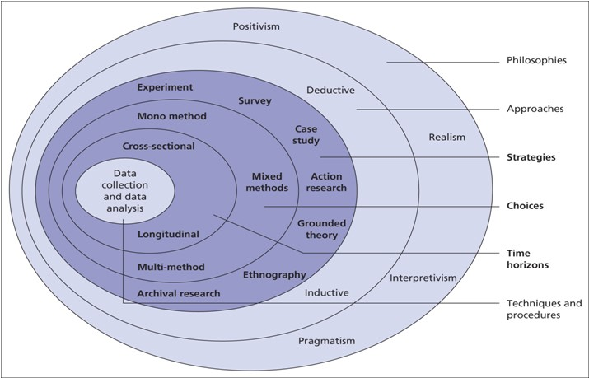
Source: 15 writers.

3.1 Research Philosophy
Saunders et al (2019) explains the relationship across beliefs and assumptions, research philosophies and research design. They affirm that this relationship is given even before the research starts, by the time the researcher is seeking a subject of matter to study in depth. At this point, Saunders et al (2019) there are three types of research assumptions to distinguish research philosophies: ontology, epistemology and axiology.
The term research philosophy refers to a system of beliefs and assumptions about the development of knowledge. Although this sounds rather profound, it is precisely what you are doing when embarking on research: developing knowledge in a particular field. The knowledge development you are embarking upon may not be as dramatic as a new theory of human motivation, but even addressing a specific problem in a particular organisation you are, nonetheless, developing new knowledge (Saunders et al, 2019).
Ontology refers to assumptions about the nature of reality (Saunders et al, 2019). Your ontological assumptions shape the way in which you see and study your research objects. In business and management these objects include organisations, management, individuals’ working lives and organisational events and artefacts. Your ontology therefore determines how you see the world of business and management and, therefore, your choice of what to research for your research project (Saunders et al, 2019).
Epistemology refers to assumptions about knowledge, what constitutes acceptable, valid and legitimate knowledge, and how we can communicate knowledge to others (Burrell and Morgan 1979). Whereas ontology may initially seem rather abstract, the relevance of epistemology is more obvious. The multidisciplinary context of business and management means that different types of knowledge – ranging from numerical data to textual and visual data, from facts to opinions, and including narratives and stories – can all be considered legitimate (Saunders et al, 2019).
Axiology refers to the role of values and ethics (Saunders et al, 2019). They also affirm that one of the key axiological choices that you will face as a researcher is the extent to which you wish to view the impact of your own values and beliefs on your research as a positive thing (Saunders et al, 2019). Saunders, Lewis and Thornhill (2019) also highlight that whatever your view, it is important, as Heron (1996) argues, to demonstrate your axiological skill by being able to articulate your values as a basis for making judgements about what research you are conducting and how you go about doing it.
To be able to apply those types of assumptions, it is crucial to distinguish between Objectivism and Subjectivism, and then correlate the research topic over it. The table below presents the comparison explained by Saunders, Lewis and Thornhill (2019).
Table 1: Philosophical assumptions as a multidimensional set of continua:
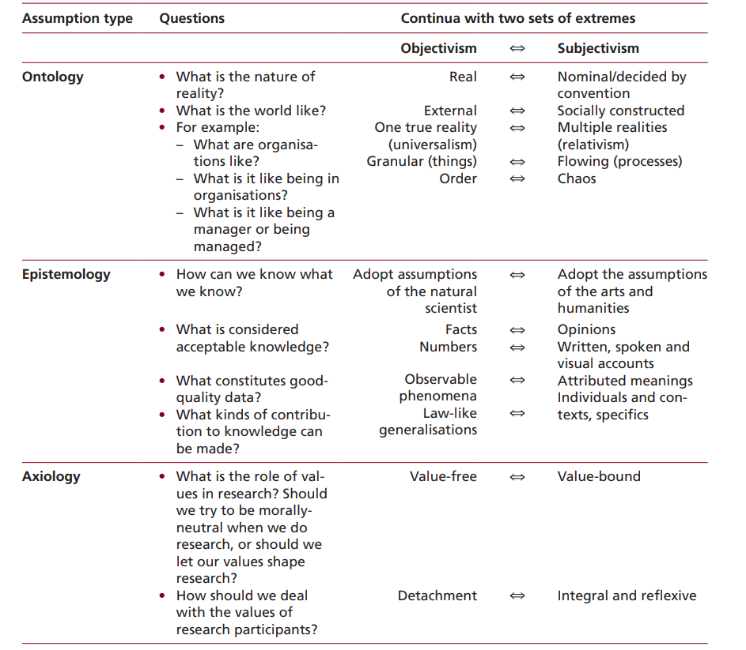
Source: Saunders, Lewis and Thornhill, Research Methods for Business Students, Eighth Edition, (2019).

3.2 Research Paradigms
There are good reasons to find the relationship between research paradigms and research philosophies confusing. In management research there tends to be little agreement about labels in general, and the labels ‘paradigms’ and ‘philosophies’ (and often others like ‘approaches’ and ‘schools of thought’) are sometimes used interchangeably to describe assumptions researchers make in their work Saunders et al.,(2019).
As outlined in the Figure 10: The Research Onion, on the topic above, the author has chosen to explore the perspective as follows:

Positivist: Research located in this paradigm relies on deductive logic, formulation of hypotheses, testing those hypotheses, offering operational definitions and mathematical equations, calculations, extrapolations and expressions, to derive conclusions. It aims to provide explanations and to make predictions based on measurable outcomes (Kivunja and Kuyini, 2017).
Interpretivist: For business and management research, the interpretivism perspective is very relevant, particularly in such fields as organizational behavior, marketing and human resource management. Not only are business situations complex, but they are also unique. They represent a particular set of circumstances and individuals coming together at a specific time to create a unique social phenomenon Saunders et al.,(2019).
Critical realism: Claims there are two steps to understanding the world. First, there are the sensations and events we experience. Second, there is the mental processing that goes on sometime after the experience, when we ‘reason backwards’ from our experiences to the underlying reality that might have caused them Saunders et al.,(2019).
Pragmatism: For a pragmatist, research starts with a problem, and aims to contribute practical solutions that inform future practice. Researcher values drive the reflexive process of inquiry, which is initiated by doubt and a sense that something is wrong or out of place, and which recreates belief when the problem has been resolved Elkjaer et al., (2011). As pragmatists are more interested in practical outcomes than abstract distinctions, their research may have considerable variation in terms of how ‘objectivist’ or ‘subjectivist’ it turns out to be Saunders et al.,(2019).

3.3 Research Approach
Following the third layer of the Research Onion, there are two types of research approach presented: Deductive and Inductive:
Deductive: Possesses several important characteristics. First, there is the search to explain causal relationships between concepts and variables. It may be that you wish, for example, to establish the reasons for high employee absenteeism in a retail store. After reading about absenteeism patterns in the academic literature you develop a theory that there is a relationship between absence, the age of workers and length of service. Consequently, you develop a number of hypotheses, including one which states that absenteeism is significantly more likely to be prevalent among younger workers and another which states that absenteeism is significantly more likely to be prevalent among workers who have been employed by the organization for a relatively short period of time. To test this proposition, you collect quantitative data Saunders et al.,(2019).
Inductive: The purpose here would be to get a feel of what is/was going on, so as to understand better the nature of the problem. Your task then would be to make sense of the interview data you collect through your analysis. The result of this analysis would be the formulation of a theory, often expressed as a conceptual framework Saunders et al.,(2019).

3.4 Research Methods
Regarding the available methods for conducting a research, the research onion displays on its inner layers the strategies, choices and time horizons of methods to be chosen when steering a research paper.
For the purpose of this research, the strategies are to rely on action research. Action research is characterized as a practical approach to a specific research problem within a community of practice (Bryman, 2012). It involves examining practice to establish that it corresponds to the best approach. It tends to involve reflective practice, which is a systematic process by which the professional practice and experience of the practitioner can be assessed. This form of research is common in professions such as teaching or nursing, where the practitioner can assess ways in which they can improve their professional approach and understanding (Wiles et al., 2011).
Regarding methods to be chosen, the author is focused on the mono method choice, for that reason qualitative research seems to be the better option. Qualitative research is often confirmatory according to Zefeiti et al.,(2015), they evaluate two authors in their article when presenting definitions for qualitative methods: According to Olds et al. (2005) qualitative research is used to collect and test textual data such as surveys, interviews, focus groups, conversational analysis, and observation. Likewise, Creswell (2003) states that a qualitative method is used to investigate an issue related to the work of interviewees by obtaining their views, attitudes and perceptions Zefeiti et al.,(2015).
For the most part, qualitative research methods help to gain insight into the processes involved in co- constructions of meaning, lived experiences, cultural rituals, and oppressive practices Atkinson (2017). Following this perception, the author has chosen to conduct a qualitative research that is to be concluded by interviewing professional accountants and auditors. The purpose is to understand their point of view in relation to the suggestions of improvements and benefits of audit for SMEs business to decrease the numbers of impacts on the businesses due to Covid-19.

3.5 Overall Approach
Considering the authors research over the research methodology presented along this section, the overall approach taken on its paper is presented as follows:
Research Philosophy:
Considering the explored research philosophy discussed above, this paper is exploring the proposed subject matter “The impact of Covid-19 on SMEs and the benefits of an audit in trying to mitigate the negative consequences of Covid-19” commencing from a epistemology assumption, based on objectivism since the identified need came from a peer viewed paper “Rediscovering the value of SME audit” Accountancy Europe, (2018) developed in Sweden and Denmark, that resulted in a positivist opinion over implementing audits in SMEs.
Research Paradigm:
This paper aims to utilize the interpretivist paradigm to conduct the research and collect the data, since as explained by Saunders, interpretivist paradigms are to represent a particular set of circumstances and individuals coming together at a specific time to create a unique social phenomenon Saunders et al, (2019). Covid-19 pandemic is undeniably a unique phenomenon.
Research Approach:
The author has chosen to apply the inductive approach, since it is relevant to the course of this paper that understanding the nature of the problems for SMEs, related to the Covid-19 pandemic was from the beginning the objective.
Research Methods:
Strategies:
Following the research onion approaches, the author has assessed that the most suitable strategy to be explored is to take a survey with accountants and audit professionals with professional experience in Ireland.
Choices:
Being a qualitative research, as explored, this paper is so then classified as mono method choice.
Time horizons:
Consequently, cross sectional is just a natural path to finalize this research, since the purpose of a cross sectional conducted research is to collect data at a specific point in time and create an analysis of the encountered data, without a need to re-intake another collection action later in the study. It is justified by the short period that dissertation paper is subjected to.
Techniques and Procedures:
As per reach now the nucleus of the research onion where the techniques used for data collection is what is so called data validation, where the author aims to present experts opinion from the literature review and then contrast it with the participants points of view based on practical experiences.

3.6 Research Limitations
As per the choice of the author to conduct a research relying on the inductive approach, several limitations may arise over the course of this research. Those limitations are as follows:
Participants prospective:
Since the author has never worked within an audit environment in Ireland, it may be difficult to reach specialists in the area due to the lack of connections in an Irish environment. To overcome this challenge, the author’s choice is to try and reach possible participants throughout professional social network such as LinkedIn. However, the participation is dependent on the willingness of the reached professionals to contribute to an academic research.
Also, the chosen method of data collected, being it open questionnaire and online interviews may not be as productive as thought initially, since questions initially thought by the author may not enlighten the matter precisely.
Lack of available information:
Since the author had to research an ongoing problem such as Covid-19, there is a gap of time for researches that assesses the impact of Covid-19 in business worldwide. Many of the problems are still happening and therefore, the author believes that there is a chance of more problems yet not discovered arising in the foreseeable future.
Nonetheless, as per the Irish SMEs facing difficulties due to the pandemic, and how audit may help those business to overcome problems that had arisen from the pandemic, is an innovative theme that may cause strangeness at a first sight. Therefore, limitations such as lack of trust on the researcher intention with the proposed study are a strong limitation. Consequently, it means that there is a high risk of lack of accuracy for the findings.
To overcome those limitations, the author intends to rely on the research over peer view papers that encourage the point of view that audits may be beneficial to small and medium business that had been conducted in European countries.
Finally,
Moreover, there was an enormous limitation of contacting possible participants that were linked to the matter, since the author has never worked within an audit environment in Ireland and for this reason the number of participants intended was not reached.

3.7 Research Ethics
To ensure that this research was conducted within consistent ethical conducts, the author has followed the Griffith College ethics committee guiding principles.
Having said that, this research has been carried out across an open questionnaire and online interview with accountant professionals based in Ireland and Northern Ireland, which increases the particularity aimed by the author including information and discussions about the Irish environment.
The author has made sure to communicate the participants in advance, providing awareness of the ethical standards that are in place on this paper in order to mitigate any chances of misconduct by the interviewees and specially by the author herself.
To achieve this, the researcher conducted all essential measures to establish that ethical standards were properly addressed at an early stage, as following: The online interview participants had been previously contacted by online professional social platform, known as LinkedIn, being told of the ethical issues and protected measures that the researcher have explored and once accepted to partake, the participants have been sent an email, in which they found attached the plain language statement together with the informed consent form and advised to read the attached information leaflet carefully.
Also, the researcher made sure to include the supervisor in any formal contact with potential interviewees, informing the extensive experience of the supervisor as well as her knowledge of each step that were being followed at that stage and therefore establishing a level of formality in order to avoid any misunderstanding and therefore reducing the risk of absence of confidence of the participants in contribute to this paper.
The email equally provided an overview of information about the course in which the researcher is engaged as well as the name of Griffith College Dublin and a brief explanation of the research objective. Finally, the author has also included in the email a disclosure informing that the participation right to be completely voluntary and that the participants remained unrestricted to refuse to carry on with the partaking at any moment, even when they have informed on the first contact that they confirmed contribution.
For the questionnaire participants, the first contact had been also made by online professional social media platform, LinkedIn, and for those who have accepted to contribute to this research, a similar email has been sent, with the same information’s provided on the online interview meeting, nevertheless the approach has been different in matter of time response. While the online interviewees had been made aware that the interview time would take up to an hour duration, the questionnaire respondents have been informed that answering time ought to take from ten to fifteen minutes in its total.
Moreover, in order to meet the compliance requirements of confidentiality, the two questionnaires used on this research have not approach any demographic data as age, gender, name, company in which they work. Establishing and securing a complete anonymity within the data collected, hence preserving the participants identify and any chance of identification for potential readers.

IV CHAPTER - Analysis of Findings

4.1 Overview
This section objective is to examine the data gathered in the course of this study, to assess and discuss the findings obtained from it, and consequently to compare the grounded information obtained on the interview process with the principal theories previously presented in the literature review chapter.
For the two first interviewees, the approach taken was to conduct an online debate where the participants could discuss the points outlined by the researcher and comment whether or not they found relevant the discoveries found by the author.
The interviewee responses to the questionnaires have addressed the questions relying on their experiences and perspectives about whether or not audit is capable of assisting Irish SME businesses, especially considering the hospitality sector, facing financial disruption reverberating from Covid-19 pandemic.

4.2 Interview process
The interview process has been conducted at first for audit and accountant professionals in Ireland within a cloud-based video conferencing tool known as Zoom, where two professionals joined the meeting together with the author and discussed about the first set of questions constructed at that point.
A power point presentation has been created by the author in order to provide a visual demonstration of what was to be explored in the meeting and attempt to increase the engagement of the participants. For the three remaining participants, the author has found it more efficient to create an open questionnaire where the participants would answer the same questions asked within the cloud-based video conference in less time and in a more precisely manner.
The participants profile are as follows:

Table 2: Participants Profile
Participant | Education | Experience
1 | • Bachelor’s Degree in Law  • Diploma Qualification of Accounting Technician Ireland  • The Chartered Institute of Management Accountants (CIMA) | • Accounting Practice Manager (13 years)
2 | • Bachelor’s Degree in Accounting  • Masters Degree in Advanced Accounting  • Fellow Chartered Accountant Ireland (FCA) | • Associate Director (9 years)
3 | • Bachelor’s Degree in Commerce.  • ACCA | • Assistant Manager, (8 years) of external audit
4 | • Business Technical Course | • 4 years of Subject Matter Expert  • Experience working in the hospitality sector
5 | • Bachelor of Business Studies  • Associate Chartered Accountant (ACA) | • Senior Lecturer (Accounting + Finance related modules)  • Experience in hospitality, sales and customer support.  • Experience working in the audit (5 years +)  • Experience in assisting management in hospitality sector
Source: Authorship based on interviews.
For the purpose of comparison and investigate what are the SMEs opinion over the matter of benefits of audit in overcome Covid-19, and then compare it to the auditors and accountant opinion, the author has reached out to an SME manager of business that operates in the heart of Dublin city, in a area famous for its high footfall index and tourist attraction.
The profile of the SME manager interviewed is 7 years of experience in management of a hospitality business, being 3 of them in the role of Assistant General Manager.

4.3 Findinds

4.3.1: The Efforts of Irish SMEs To Remain Running:
For the first analysis the author has taken into consideration the data provided in the literature review, extracted from CSO research and analysis CSO (2020) whereby it is affirmed that an average of 4.4% of total expenditure was spent on measures to comply with COVID-19 requirements for trading. Moreover, the responded enterprises spent an average of 4.4% of total expenditure on measures to comply with COVID-19 requirements for trading during the four weeks 27 July to 23 August 2020. Micro enterprises spent 6.1% of total expenditure during this period on measures to comply with COVID-19 restrictions, the highest among all size classes.
The main issue brought by the author is whether Irish SMEs are acting impulsively to remain open and how it may be a reason to increase the risk of bad investments and consequently, debt increase. Additionally, what issues could arise in a long-term perspective that may be likely to be avoided with an audit performance.

For participants 1 and 3, Irish business have faced recessions before as per the 2008 recession, therefore, despite the initial panic that affected all the market, Irish SMEs owners and managers tend to seek for professional advice as soon as a problem arises, avoiding the immediate action. Moreover, they also indicated that with the experience gained throughout the years spent running a business, it is unlikely that business owners and management do not have enough knowledge to act over desperate times.
Participants 3 and 4 have agreed that some of the business did exceptionally well, however, SMEs hospitality business specifically have limited resources comparatively and for that reason have struggled more. They also agreed that many businesses have faced challenges when creating future plans and that many small businesses have been seriously affected financially by applying wrong actions based on non-accurate information.
Participant 5 claims not have knowledge in whether or not business have committed mistakes, however affirms that these businesses would have spent a high amount preparing for reopening and that given the uncertainty times, it would be difficult for businesses to plan for the future. Such affirmation validates the literature review collected.
Given the information presented, the author has found that from the interviewees’ point of view, two out of the five participants disagree that SMEs business are acting spontaneously. For three of the five participants, SMEs are indeed incurring mistakes when spending grants and its cash reserves to prevent businesses from cease activities not due to hustle, but for the business risk itself. All of the participants have also outlined that SME business would be able to apply for Irish Government support’s throughout the pandemic. This information conveys with the literature review exposed in this research that shows efforts made by the Irish government to assist SMEs business.

4.3.2: Audits Benefiting SMEs to Utilise Wisely Government Assistance:
As shown in the literature review, the Irish Government has made available several financial supports, such as: income supports, loans, grants, vouchers and schemes, rates waiver and tax measures, sector-specific supports and guidance, skills, and training support, Work Safely Protocol as well as a complete guideline called: “Supports for businesses impacted by COVID-19” (Government of Ireland, 2021). Considering this information, the researcher has brought into the discussion, what are the professionals’ view on whether audit may be beneficial in helping SMEs to utilize wisely the government supports.
Participants 1, 2, 4 and 5 agreed that audit will be a costly resource to SME business and therefore would not be the best option. Also, agreed that audit would be helpful in terms of set red flags for possible errors in the treatment of the financial statements, however only this benefit would not be enough to affirm that SMEs would perform better when subjected to an audit.
Participant 3, believes that a structured deep analysis on the business would support a better understanding of its needs and limitations and that an audit should clarify the doubts and propose direction to the business regarding future plans.
Summing up, the main suggestions that the participants allocated were as follows:
• Creation of limited engagement review for SMEs which would provide similar comfort to audit procedures, but would not need as much audit evidence, not cost as much in time or disruption but provide a level of standards and credibility for SMEs.
• Considering the high cost, an audit would be beneficial for SMEs only if subsided by the government.
Although the majority of the participants refused the idea that SMEs would utilize wisely government financial supports when submitted to an audit. Participant 1, 2 and 5 highlighted that SMEs would benefit from consultancy works provided by audit firms rather than an audit itself.

4.3.3: The Role of Audit in Improving Investment Options for SMEs:
This topic analysis has emerged from the debt increase among Irish SMEs as indicated on the literature review, where a research conducted by M. Martinez-Cillero et al. (2020) informs that the ratio of debt-to-turnover is steady across most sectors with the exception of hotels and restaurants where the ratio is considerably higher than the average 42 per cent. The share of firms making a profit is lowest in this sector at 58 per cent and the share of firms that have missed a payment on debts is highest on the SME hospitality sector. Additionally, as per the literature review, a PWC (2020) study that reinforces the importance of the hospitality sector to the Irish GDP and the access to disposable income and corporate and business activity are key pillars of sectoral performance PWC (2020).
As an option to expand the investment options for SMEs considering the facts above, the author has brought into the literature review that according to Angel Investment Network (2021) private capital by angel investors is a form of funding that entrepreneurs may enjoy the benefits of by selling equity (or ownership) of their company to an outside investor. In exchange, they collect the funds they need to either launch and finance their business venture, or to grow their business.
When confronted against the affirmations above, the participants opinion where actually to refuse this type of investment for SME businesses. Participants 1 and 2 highly discouraged the participation of angel investments over SMEs business. These participants firmly pointed that angel investors could be in fact hazardous to the companies finance health due to the high percentage and business control that stakeholders may have over the invested businesses. Participant 5 disclosed that many businesses are more inclined to obtain supports that encourage them to survive alone rather than relying on investments from external institutions.
Nevertheless, as per the literature review, Dr. Babafemi Oyewole (2018) affirms that any SME that wants to attract financing for its operations must develop a credible and realistic business plan that will enable stakeholders make informed decision about the current and future direction of the organization Dr. Babafemi Oyewole (2018).
From the statement above, all the participants have agreed that in order to attract potential investors or lending institutions, those institutions would claim for a reviewed set of financial statements before investing in the business and audit would indeed provide this assurance, yet the high cost of an audit is an impairment and therefore would not be an option for SMEs. It was stated by the participants that SME businesses would welcome guidance and support but audit would not be a fundamental resource to acquire funds as this preparation over the financial statements could be provided by consultancy firms.

4.3.4: Main internal controls Mistakes on SMES:
For this analysis, the author has taken into consideration the literature review in which a research conducted in China, country where the virus has originated and also the first country to initiate a recovery procedures, where a recent research has been conducted seeking to validate the importance of audit for Covid-19 recovery in SME business. The aim of the paper was to derive a conceptual framework that would guide SMEs in performing a pandemic readiness audit. The rationale is that a pandemic readiness audit check-list would enable SMEs to systematically asses the key business components that are impacted so as to identify the strengths and weaknesses of each. This would then enable them to better prepare themselves for the post COVID new normal, which as reported, could potentially last for some time to come (Ravindran et al., (2020).
Also, as per the literature review, a study conducted in 2018 in Switzerland and Denmark by Accountancy Europe (2018) resulted in a paper named “Rediscovering the value of SME audit”, in which SME companies were subjected to statutory audit and exempted after a few years. As a result, their research has found that when SME were required to have audit, they had a higher and faster growth in net sales and staff number. Also, while these companies were under audit the amount of savings annually were higher, there was also an increase of transparency and control in various areas, decrease in the risk of economic crime including tax evasion, and also a decrease in the financial statement’s errors.
From the mentioned literature review, the author has found that all participants validate that audit would improve the regulator of internal controls within smaller businesses and that they face a reputation of not giving the sufficient attention to this matter. According to the discussion with Participants 1 and 2, there is a lack of clarity in terms of internal controls in terms of daily metrics, such as documentation of the daily procedures, untimely record maintenance which leads businesses management to not have the information they need in order to comply with decisions in relation to liquidity, borrowings, billings and credit control.
Moreover, Participant 3, 4 and 5 have reinforced the main mistakes pointed out by participants 1 and 2, and outlined the following mistakes when assessing SMEs financial account and internal controls:
- Failure in data management and consequently loss of important information.
- Accounting treatments are not updated as per the latest development in the local GAAP.
- Management commonly override controls
- There is no proper internal control system resulting in accounting errors
- Records are not properly maintained
- Discrepancies in regulatory filings, resulting in penalties.
- Lack of segregation of duties due to limited numbers of staffing in the SME
- Lack of controls due to a small size business, limiting procedures in place

4.3.5: Overall Audit Relevance Over SMEs as per accountants and auditors:
This topic concentrates in the overall analysis of the data collected with the audit and accountant professionals and the proposed idea of this research paper claiming the benefit of an audit in trying to mitigate the negative consequences of Covid-19.
In the course of the interviews, the data collected, although relevant does not sustain the initial thoughts of audit benefiting SMEs. The respondents enumerated several reasons for what causes to refuse the idea of SMEs being assisted by auditor would perform better over the Covid-19 implications.
From the data collected, it is unanimity among the respondents the cons that supports the refusal of audits being applied over SME business, even considering the exceptional circumstances of a pandemic, as follows:
Participants defend that audits are performed at a cost which would bring an extra cost burden on the SMEs. Moreover, audits would require compliance with other several other matters, additional staff time to facilitate the auditors in completing the audit work which would result in further costs. And finally, the business are normally owned by a few members who are often relatives. Public interest is not affected by these entities’ performance and the compliance with regulatory filings, the government departments can themselves take care of that.
The author has found out that the inquired professionals also sympathise with the reasons of refusal from a SME to undertake an audit voluntarily. Being as follows:
Participants 1 and 2 stated that the main reason probably arises from the additional costs associated with undertaking a voluntary audit, along with no real additional benefit. Most SMEs pay accountants to prepare their books and records, therefore there is probably no real additional gains from undertaking an audit, due to the less complex environment in which SME are subjected. Additionally, participant 3 informed that SMEs management are usually aware of the controls, so such exploration as audit is not needed.
Finally, Participant 5 claimed that audit firms would be able to help SMEs when properly informing these businesses of the benefits that an audit would have over it. By attempting to make them aware of the benefits of auditing; transparency, avoidance of legal fines, discovery of any abnormalities in corporate operations and accounts, and suggestion of proper accounting treatment, by offering lesser fees as the volume of work is low comparatively. Participant 4 added that audit would provide clarity on compliance, legal security agreements and expertise on the matter.
On the other hand, participant 5 acknowledged that that audit firms can encourage SMEs to understand the benefits from undertaking an audit. However, from the participant experience in the audit area, and being involved in an SME in the food and beverage sector, the participant reaffirms that due to the high costs of an audit, it is hard to believe that in times of recession, as of a pandemic, that SME businesses would incur additional costs to have the businesses audited. Participant 5 also claimed that other than assist with potential investors, audit would not be as beneficial for SMEs. Moreover, businesses would be now focused in reopen and restart to run the business in order to recover from the restrictions periods and therefore, increase profitability rates.

4.3.5: Overall Audit Relevance Over SMEs as per Irish SMEs:
From a SME point of view, in its turn, the researched has reached out to a SME that as mentioned acts in heart of the busiest areas in Dublin, Ireland. Around the temple bar are, famous for being a tourist attraction, audit could actually help with business management improvement, according to the interviewee.
The SME interviewee sustain the data collected in the literature review, where the CSO, 2020 published a unemployment rate in January 2020 of 5.1%, the Department of Employment Affairs and Social Protection’s informed over 90% of accommodation and food sector workers have claimed pandemic financial schemes, and finally, confirms the research of M. Martinez-Cillero et al. (2020) that exposed the debt ratio increase among SMEs for the first year of the pandemic. From the SME interviewee experience for the year 2020, only about 15% of pre Covid-19 budgeted revenue was achieved in 7 month of open business in 2020. To mitigate the risk of closure, the measures taken by these businesses were as follows:
Reduced menu size,
Reduced staff hiring,
Reduced in half the budget in A&P (advertising and promotional).
Also, a concern of the researcher was that SME businesses would not use wisely the government grants and would tend to commit mistakes when spending it due to a lack of knowledge about the business needs, and an audit might help business owners to understand those needs. Mostly of the audit and accountant professionals interviewed have disagreed with this line of inquires, however, from the SME participant point of view, many of its neighbor businesses investing the grant money into outside dining infrastructure in the meanwhile, as being a franchise and receiving advice from the IBEC (Irish Business and Employers Confederation) with their advice and interpretation on the Failte (National Tourism Development Authority) guidelines.
During the analysis the researcher comprehend that it is necessary to outline that the SME interviewed it is a franchise and by receiving support from its parent international group, the advice inputs occurred smoother rather than sole following the National Tourism Development Authority guidance since the guidelines seemed unreasonable and intransigent at some periods according to the SME participant, as per the quote below:
“I’m sure that many businesses did make mistakes when utilising the grants. Our business however was so severely affected that the grants were used in keeping our doors open. Ie, paying suppliers and other creditors rather than haphazardly investing the grants. We’ve seen some of our neighbours pouring money into outside dining infrastructure. We as a business didn’t see this as a wise investment. With limited outside space and the Irish weather the way it is, we believed the payoff wasn’t worth the investment.” (SME Interviewee).

Considering the influence from the parent business, the SME participant outlines that has had experience with audit as per the requirements of being a subsidiary and hence have to comply with company polices and be submitted to several kinds of regulatory audit as health & safety, financial, stock, insurance, fire etc. Adding that SME participant also mentioned that the IBEC support that is being received is adaptable to the evolving situation of Covid-19 and they benefitted from the service. Therefore, as per the author’s assessment, the sum of the different sources of advice received so far represents a privilege on the construction of an effect business recovery plan to the SME interviewed.
The audit and accountant participants and the SME interviewed for this research, agreed that audit would increase investors attraction. However the two parts presented a different point of view in the necessity of investors. While the audit and account professionals claimed that although audit would bring attraction of investors, SME businesses may not be inclined to require external investments and would be working towards revenue recovery relying on the reopening of business, the SME participant states that as per its observation, considering the impact that the hospitality sector suffered in consequence of Covid-19, now would be perhaps an appropriate time to invest.
As per the SME participant opinion over whether audit may be helpful in helping Irish SMEs to overcome Covid-19 challenges is positive. The SME participant believes that for independent restaurants, audit would be a wise long term investment, as per the quote below:
With the effects of the pandemic, an audit would be a worthwhile investment for businesses to start back on the right foot, identify ways to save costs & attract investment. Many businesses may not have the spend for an audit at this point so they may need some encouraging. Once SME’s realise that they will reduce costs going forward, it may be more attractive. (SME participant)

4.3.6: Findings summary:
A) The efforts of Irish SMEs to remain running:
The author has found that the accountant and audit professionals diverge in opinion when questioned about hustle on SMEs management when taking business actions for the pandemic period.
The SME participant, however, agrees that many businesses have been taking hustle actions in the period.
As per the literature review, SMEs have had a rate of expenditure
B) Audits benefiting SMEs to utilize wisely government assistance:
Overall audit would not be appropriate to Irish SMEs hospitality sector mostly due to its high cost in the majority of the accountant and auditors participants’ opinion and hence audit would only be useful to SMEs if the government subsidized it. Instead, it would be more appropriate for an audit to be replaced by consultancy services that could develop a limited engagement review for SMEs that would provide equivalent confidence to audit procedures, but would not demand as much audit evidence, would not take as long or cause as much disturbance, and would give a degree of standards and credibility for SMEs.
Participant 3 and SME participant interviewed agreed that audit would create a new guidance over SMEs from the hospitality sector into future spending towards business decisions improvement. SME participant outlined that government guidance have been sometimes confusing and restrictive.
C) The role of audit in improving investment options for SMEs:
Despite the agreement among the accountant and auditors professionals involved in that audit would help to attract investors to Irish SME hospitality businesses, the high cost of an audit would be a persuasive impediment. SME participant, instead, believes that SMEs from hospitality sector should be encouraged to invest in audits due to the likelihood of reducing costs going forward and attract investment.

V CHAPTER - Conclusions & Recomendations

This research aimed to identify whether audit procedures applied over Irish SMEs that does not require statutory audit, could, in light of Covid-19 challenges help these businesses to overcome the losses, restructure and develop future strategies in order to maintain the ability to continue running the business based on recent studies and on interviews with auditors and accountants professionals.
The first objective of the research was to understand the damaged caused by Covid-19 over global economies, over the Irish economy, especially food and hospitality SME businesses and what were the auditors’ opinions over the recovery capacity of the sector in Ireland. From the recent literature review, it was stated the massive increase of unemployment especially among the hospitality sector around the world. From that, it was also disclosure the impact on Irish economy. The results demonstrates that there was a massive disruption over economies worldwide, but Ireland would still present positives GDP rates if compared to other countries among European countries. Also, the number of Irish SME business has increase in 10 % since 2008. The auditors and accountant professionals confirmed that according to their experience, although the impact on the Irish economy was significant, Ireland had have experience with the 2008 crisis and therefore, would be in position to create solutions and overcome difficulties.
The second objective was to assess what were the solutions provided by government worldwide and in Ireland in order to help its businesses to remain in a going concern basis. The result demonstrates that several countries have introduced the measures in order to contain the effects of Covid-19 over its economies, as pointed below:
- Working time shortening,
- Temporary lay-off and sick leave,
- Policies to delay revenue, social security, debt, and rent and service payments in order to alleviate liquidity constraints.
- Incorporation of non-banking financial intermediaries into their policy support mix.
- Engaged on the research of new markets and distribution platforms in order to sustain operations under current containment controls
Besides the measures above, it was also found that governments worldwide are creating programs specifically to SME business, as follows:
- Enforcement of institutional policies to assist SMEs in adopting modern operating practices and (digital) technologies,
- Implementation of unique programs to track the effect of the crisis on SMEs and improve the governance of SME-related policy responses
- Implementation, expansion or streamlining loan guarantees in order to allow commercial banks to increase credit to SMEs.
- Direct lending to SMEs through public institutions.
The Irish Government has also made available several financial supports related to the above, such as: income supports, loans, grants, vouchers and schemes, rates waiver and tax measures, sector-specific supports and guidance, skills, and training support. It was also fund that Irish Government is in constant modernization of its guideline in order to assist SME business.
The auditors and accountant professionals confirmed that according to their experience, Irish Government is very active on the recovery measures provided and adding suggestion to the present measures, a benefit greater from financial supports in terms of regenerating business growth, and supports in terms of consultancy work would help SME institutions.
The third objective was to understand what were the pros and cons of having audit over a SME business.
As per a general agreement among the interviewees, due to its high cost, audit would not be a careful decision to SMEs since it could be replaced by consultancy services that would cost less and have a similar result. The literature review supports this point of view, with the following reasons:
- Audit process would be of much less complexity.
- Often transactions and balances in SMEs are not complex or less likely to be subject to fair value judgements than large listed audit client.
- Many conditions do not exist in the audit of your average SME, allowing the auditor to scale down the ISAs application in those circumstances.

Nevertheless, the findings are against the indicated on the peer viewed paper that demonstrates a higher and faster growth in net sales and staff number companies for SME companies that were subjected to statutory audit and exempted after a few years.

This paper has been explored from an epistemology assumption based on objectivism. It contains an interpretivist paradigm of the Covid-19 pandemic that as explained by Saunders et al, ( 2019), are to represent a particular set of circumstances and individuals coming together at a specific time to create a unique social phenomenon. Additionally, this paper relied on inductive approach seeking for understanding the nature of the problems for SMEs. The methods utilized were survey and open questionnaires as per qualitative method of validation or refusal of the data collected.

Research Questions:
“Are Irish SMEs more likely to survive COVID-19 economic challenges if relying its performance on audit procedures well applied?” The author’s conclusion is that it is highly unlikely that SMEs would fail if not receiving specific audit help. Therefore the research question is unconstructive.
Nevertheless, the research question answer is that Irish SMEs are unquestionably likely to survive without using audit services.
“Is advisable that SMEs invests in audit to overcome Covid-19 challenges?”. The author conclusion is negative, since this research has collected information that sustains the overwhelming complexity that audit would bring into small businesses.
Recommendations:
Based on the data collected and analysed, the researcher believes that there is a business opportunity for Irish Government and Audit firms to think of. Although the size of sample collected is not as big as is necessary to form an opinion over the matter with more assurance utilizing a quantitative research method.
Considering also that among the presented participants and its discordance onto the overall results of audit of SME businesses, the researcher believes that a more detailed research should be conducted in order to understand in depth what Irish hospitality SME business are desiring in terms of help after the chaotic period faced with the pandemic.
Adding that the as per the SME management point of view, although a unique opinion, many business around the same area were in fact wrongfully applying the financial help received without considering in depth the results of such action in a long term perspective. The author finds that maybe there is room for improvement and future research in the presented topic and suggests that more studies should be carried out on the matter in order to create businesses opportunities to audit firm that could, in the authors opinion, works alongside with the Irish Government aiming to develop new methods to deal with the economic impact suffered and attract a new force of investors for the sector.
Limitations:
This research has a major limitation for the validation of its findings that only 5 auditors/ accountant participants were involved. Therefore, there is a high risk of the data validated is not complying with the reality.
The topic chosen by the author was not as promising as expected in the beginning of this research, causing therefore several moments of stress to the author.
There were not as many researches available as necessary in terms of auditing results over SMEs, and the reasons to encourage smaller companies in Ireland to invest in an audit.
Moreover, time management was an issue to the author, which caused many sections and the questionnaires to not receive the proper attention.
Most and foremost, the author had also difficulties in terms of time management, which caused a considerable damage in the results and data analysis of this research.

References

Lu, H., Stratton, C.W. and Tang, Y.-W. (2020) ‘Outbreak of Pneumonia of Unknown Etiology in Wuhan, China: The Mystery and the Miracle’. Journal of Medical Virology, 92(4), pp. 401–402. DOI: https://doi.org/10.1002/jmv.25678.
WHO , 2020. Archived: WHO Timeline - COVID-19. Available at: https://www.who.int/news/item/27-04-2020-who-timeline---covid-19 (Accessed: 16 June 2021).
PWC, 2020. PricewaterhouseCoopers. What Is an Audit?. PwC. Available at: https://www.pwc.com/m1/en/services/assurance/what-is-an-audit.html (Accessed: 15 March 2021).
PWC, 2020. ‘Covid-19 and the Irish Hospitality Sector: Impact and Options’. p. 18.

Department of Employment Affairs and Social Protection , 2018. ‘The Initial Impacts of the COVID-19 Pandemic on Ireland’s Labour Market’ . p. 36.

Accountancy Europe, 2018. 180209-Rediscovering-the-Value-of-SME-Audit-Recent-Developments-in-Sweden-and-Denmark-1.Pdf. Available at: https://www.accountancyeurope.eu/wp-content/uploads/180209-Rediscovering-the-value-of-SME-audit-Recent-developments-in-Sweden-and-Denmark-1.pdf (Accessed: 10 December 2020b).
OECD, 2020. A-Road-Map-for-SME-and-Entrepreneurship-Policy-in-Ireland.Pdf. Available at: https://enterprise.gov.ie/en/Publications/Publication-files/A-Road-Map-for-SME-and-Entrepreneurship-Policy-in-Ireland.pdf (Accessed: 19 March 2021c).
OYEWOLE, Dr. Babafemi, 2018. UNCTAD Search | UNCTAD. Available at: https://unctad.org/search?keys=bUSINESS+PLAN (Accessed: 16 June 2021).
CSO, 2020. Business Impact of COVID-19 Survey 27 Jul to 23 Aug 2020 - CSO - Central Statistics Office. Available at: https://www.cso.ie/en/releasesandpublications/er/bic19/businessimpactofcovid-19survey27julto23aug2020/ (Accessed: 21 March 2021).
CSO (2020) Business Impact of COVID-19 - CSO - Central Statistics Office. Available at: https://www.cso.ie/en/methods/surveybackgroundnotes/businessimpactofcovid-19/ (Accessed: 16 June 2021).
Jackson, J.K. 2021. ‘Global Economic Growth Forecasts: Impact of COVID-19’. p. 4.
Jackson, J.K. 2021. ‘Global Economic Effects of COVID-19’. p. 129.
EUROSTAT , 2020. Available at: https://www.everycrsreport.com/files/2020-09-04_R46270_bf85dd38bb4cf565d90c71406951ff9274991796.html (Accessed: 25 November 2020).
IMF, 2020. Finance & Development. Finance & Development | F&D. Available at: https://www.imf.org/external/pubs/ft/fandd/basics/gdp.htm (Accessed: 16 June 2021).
M. Martinez-Cillero, M. Lawless and C. O'Toole, 2020. ‘COVID-19 Pandemic and SME Revenues in Ireland: What’s the Gap?’ p. 37.
OECD, 2019 ‘SME and Entrepreneurship Policy in Ireland’. OECD DOI: 10.1787/e726f46d-en.
Government of Ireland, 2021. ‘Supports for Businesses Impacted by COVID-19’ p.31
CRO . CRO - Audit Exemption Company. Available at: https://www.cro.ie/Annual-Return/Financial-Statements-Requirements/Audit-Exemption (Accessed: 16 June 2021).
CRO. Companies (Accounting) Act 2017. CRO - Companies Registration Office Ireland. Available at: https://www.cro.ie/en-ie/About-CRO/Latest-News/companies-accounting-act-2017-3 (Accessed: 16 June 2021).
IAASA, ISA 315, 2016. ‘International Standard on Auditing (Ireland) 315’. p. 49.
LAUDATO, Massimo, ACCA. Performing Effective (and Efficient) Audits - the Importance of Planning and Materiality | ACCA Global. Available at: https://www.accaglobal.com/ie/en/member/discover/cpd-articles/audit-assurance/effective-audits.html
Elliott, Barry, and Jamie Elliott, 2019. Financial Accounting and Reporting, Pearson Education, Limited, 2019. ProQuest Ebook Central, https://ebookcentral.proquest.com/lib/gcd/detail.action?docID=6398873.
Deloitte , 2020 Hospitality and Tourism Sector Domestic Market Review | Deloitte Ireland. Available at: https://www2.deloitte.com/ie/en/pages/finance/articles/hospitality-tourism-domestic-market-review.html (Accessed: 15 April 2021).
ITIC, 2021. g8k33per4rcvy225 Tourism Survival & Revival Report. ITIC - Industry Recovery Roadmap. Available at: https://www.itic.ie/RECOVERY/tourism-survival-revival-report/ (Accessed: 11 May 2021).
European Commission, 2020. User Guide to the SME Definition. LU: Publications Office of the European Union Available at: https://data.europa.eu/doi/10.2873/255862 (Accessed: 24 May 2021).
ISME, 2020. SME Facts & FAQs. ISME. Available at: https://isme.ie/sme-facts-and-faqs/ (Accessed: 16 June 2021).
Seanad Public Consultation Committee, 2019. ‘Report on Small and Medium Sized Businesses in Ireland’ p. 192.
Cambridge Dictionary, 2020. AUDIT | Meaning in the Cambridge English Dictionary. Available at: https://dictionary.cambridge.org/dictionary/english/audit (Accessed: 03 April 2021).
Chartered Accountants Ireland , 2020, Audit Qualification Requirements Regulations - ..Rteredaccountants.Ie. Available at: https://www.charteredaccountants.ie/Current-Student/Support-Services/Audit-Qualification-Requirements (Accessed: 03 April 2021).
SAP, 2020. Available at: https://help.sap.com/doc/saphelp_nw73ehp1/7.31.19/en-US/0e/268892e43d44ff9e05088f9415367b/frameset.htm (Accessed: 24 March 2021).
IAASA, ISA 700, 2016 ‘International Standard on Auditing (Ireland) 700’ p. 55.
Burke-Kennedy, 2017, E. Record 271,000 Businesses Operating in Irish Economy, New Figures Show. The Irish Times. Available at: https://www.irishtimes.com/business/economy/record-271-000-businesses-operating-in-irish-economy-new-figures-show-1.3945314 (Accessed: 25 January 2021).
Deloitte IAS PLUS, 2021. admin. IFRS for Small and Medium-Sized Entities (IFRS for SMEs). Available at: https://www.iasplus.com/en/standards/other/ifrs-for-smes (Accessed: 14 April 2021).
Ravindran, T., & Boh, W. F. 2020. Lessons from COVID-19 : toward a pandemic readiness audit checklist for small and medium-sized enterprises. IEEE Engineering Management Review, 48(3), 55-62. doi:10.1109/EMR.2020.3015488 (Accessed: 24 April 2021).
Angel Investment Network, 2021. Network, I.I. Small Business Entrepreneurs - Find Private Investment & Seed Capital From Private Investors. Available at: https://www.irishinvestmentnetwork.ie/small-businesses-ireland (Accessed: 10 April 2021).
European Federation of Accountants and Auditors for SMES , 2019. 20191903_EvidenceValueAuditSMEs-FINAL.Pdf. Available at: https://www.efaa.com/cms/upload/efaa_files/pdf/Publications/20191903_EvidenceValueAuditSMEs-FINAL.pdf (Accessed: 23 May 2021c).
Miles, M. B. , & Huberman, A. M. (1994). Qualitative data analysis: An expanded source book (2nd ed.). Newbury Park, CA: Sage.
Mark N.K. Saunders, Philip Lewis and Adrian Thornhill 2019. ‘RESEARCH METHODS EIGHTH EDITION RESEARCH METHODS EIGHTH EDITION FOR BUSINESS STUDENTS’. Available at: https://www.researchgate.net/publication/330760964_Research_Methods_for_Business_Students_Chapter_4_Understanding_research_philosophy_and_approaches_to_theory_development. (Accessed: 20 May 2021)
Burrell, G. and Morgan, G. (1979) Sociological Paradigms and Organisational Analysis, London,
Heinemann.
Kivunja, C. and Kuyini, A.B. (2017) ‘Understanding and Applying Research Paradigms in Educational Contexts’. International Journal of Higher Education, 6(5), p. 26. DOI: 10.5430/ijhe.v6n5p26.
Understanding the Research Onion | Writing Guides | 15 Writers. Available at: https://15writers.com/research-onion/ (Accessed: 16 June 2021).
Elkjaer, B. and Simpson, B. (2011) ‘Pragmatism: A lived and living philosophy. What can it offer to
contemporary organization theory?’ in H. Tsoukas and R. Chia (eds) Philosophy and Organization
Theory. Bradford: Emerald Publishing, pp. 55–84.
Bryman, A., 2012. Social Research Methods. 4th ed. New York: Oxford University Press.
Wiles, R., Crow, G., & Pain, H. (2011). Innovation in qualitative research methods: a narrative review. Qualitative Research, 11(5), pp.587-604.
Zefeiti, S.M.B.A. and Mohamad, N.A., 2015. Methodological considerations in studying transformational leadership and its outcomes. International Journal of Engineering Business Management, 7, p.10.
Power, J. 2020, ‘SIGNIFICANCE OF THE SME SECTOR IN THE IRISH ECONOMY’. p. 43.
World Bank SME Finance. World Bank. Available at: https://www.worldbank.org/en/topic/smefinance (Accessed: 19 March 2021n).

Appendices

Appendice A: Plain language statement
PLAIN LANGUAGE STATEMENT
Introduction to the Research Study
Research Study Title THE IMPACT OF COVID-19 ON SME'S AND THE BENEFIT OF AN AUDIT IN TRYING TO MITIGATE THE NEGATIVE CONSEQUENCES OF COVID-19
Principal Investigator: Dr Garrett Ryan.
Researcher Name: Tais De Souza Bezerrra
Email: taisbezerra@live.com
II. Details of what involvement in the Research Study will require

This project involves taking part in qualitative analysis of the the impacte suffered by SMEs, focusing in the hospitality and food sector in Ireland and pursue audit and accounting professionals opinion over the probability of audit help those SME business to overcome Covid-19 challenges.
The research aims to incentive these Irish small businesses to make use of the auditor professional services in order to avoid misstatements in their financial reports that can lead to risks such as: losses and bad investments, as well as incentive better practices within the course of the business that can help its owners to reach better financial decisions in lights of COVID-19 effects that requires semi-structured interviews and or completion of a survey. The interviews/survey responses will be recorded, and seek to gather information on your experience as of small and business enterprises. Questions are directed towards your thoughts on revenue income, liabilities, financial reports standards, internal control improvements. I estimate the interviews/survey will take no longer than 50 minutes to complete.
III. Potential risks to participants from involvement in the Research Study (if greater than that encountered in everyday life) I do not anticipate any risk to participants as a result of participation in this Research Study.
IV. Benefits (direct or indirect) to participants from involvement in the Research Study
The objective of this Research Study is to gain new knowledge that will enable (objective understanding the importance of professional qualified audit practice over companies which audit is non statutory, Small and Medium Enterprises, in Ireland. By the end of this research participants and readers may be able to identify what are the advantages of submitting their business under professional audit as a short term investment, resulting in saves on the business financial statements along the further years.) This study may, therefore, be of benefit to you by providing you with the opportunity to contribute to body of knowledge on non statutory audit practice so that you and or society may benefit.
V. Advice as to arrangements to be made to protect the confidentiality of data, including that confidentiality of information provided is subject to legal limitations
Every effort is made to ensure the confidentiality of the participant. Participant names will not be recorded, as all participants will be assigned a code. Where used,recorded interviews/survey data will be downloaded to a password-controlled computer, typed transcripts/survey resultsare held within password-controlled documents. Participant biographical details and or mention of other persons will be omitted in the final report.Confidentiality of information provided is subject to legal limitations.
VI. Advice as to whether or not data is to be destroyed after a minimum period
Audio tapes/Survey data will be destroyed on the successful completion of this master’s degree in full compliance with GDPR regulations.
VII. Statement that involvement in the Research Study is voluntary
Involvement in this Research Study is voluntary. Participants who decide to take part may withdraw from the Research Study at any point. There will be no penalty for withdrawing before all stages of the Research Study are complete..

If participants have concerns about this study and wish to contact an independent
person,please contact:

Dr. Garrett Ryan

MSCIB Programme director
Graduate Business School
Office: A109

Griffith College
South Circular Road, Dublin 8, Ireland

Phone: + 353 1 416 3324
Email: garrett.ryan@griffith.ie
Website: www.griffith.ie

Appendice B: Informed Consent:

INFORMED CONSENT FORM

Research Study Title THE IMPACT OF COVID-19 ON SME'S AND THE BENEFIT OF AN AUDIT IN TRYING TO MITIGATE THE NEGATIVE CONSEQUENCES OF COVID-19
University: Griffith College, Graduate Business School.
Principal Investigator: Dr Garrett Ryan.
Researcher Name: Tais De Souza Bezerrra
Email: taisbezerra@live.com
II. Clarification of the purpose of the research
The aim of this research is to understanding what are the benefits of an audit over small and medium enterprises in Ireland and how a good quality audit report and investigations can lead to an improvement on the financial statements results of the companies as well as the company’s performance, in the currently events of the COVID-19 Furthermore, through a combination your participation and the latest research into (Research Subject), this research will add to body of academic understanding of (Research Subject).
III. Confirmation of particular requirements as highlighted in the Plain Language Statement
This project involves taking part iin qualitative analysis of small and medium enterprises environment and the effects of COVID- 19 over their results for the pandemic year, as well as the new laws, grants and government packages offered during the pandemic for Irish Business. The research aims to incentive these Irish small businesses to make use of the auditor professional services in order to avoid misstatements in their financial reports that can lead to risks such as: losses, and bad investments, as well as incentive better practices within the course of the business that can help its owners to reach better financial decisions in lights of COVID-19 effects that requires semi-structured interviews and or completion of a survey. The interviews/survey responses will be recorded, and seek to gather information on your experience as of small and business enterprises. Questions are directed towards your thoughts on revenue income, liabilities, financial reports standards, internal control improvements. I estimate the interviews/survey will take no longer than 50 minutes to complete.
I do not anticipate any risk to participants as a result of participation in this Research Study.

Participant – please complete the following (Circle Yes or No for each question)

Have you read or had read to you the Plain Language Statement Yes/No
Do you understand the information provided? Yes/No
Have you had an opportunity to ask questions and discuss this study? Yes/No
Have you received satisfactory answers to all your questions? Yes/No
Are you aware that interviews will be audiotaped? Yes/No
IV. Confirmation that involvement in the Research Study is voluntary
Involvement in this Research Study is voluntary. Participants who decide to take part may withdraw from the Research Study at any point. There will be no penalty for withdrawing before all stages of the Research Study are complete..

V. Advice as to arrangements to be made to protect confidentiality of data, including that confidentiality of information provided is subject to legal limitations
Every effort is made to ensure the confidentiality of the participant. Participant names will not be recorded, as all participants will be assigned a code. Where used,recorded interviews/survey data will be downloaded to a password-controlled computer, typed transcripts/survey results are held within password-controlled documents. Participant biographical details and or mention of other persons will be omitted in the final report.Confidentiality of information provided is subject to legal limitations.

VI. Participant Signature:
I have read and understood the information in this form. My questions and concerns have been answered by the researcher, and I have a copy of this consent form. Therefore, I consent to take part in this research project
Participants Signature:
Name in Block Capitals:
Witness:
Date:

This SME User Guide serves as general guidelines for entrepreneurs and other stakeholders when applying the SME Definition. It does not have any legal force and does not bind the Commission in any way. Commission Recommendation 2003/361/ EC, as published in the Official Journal of the European Union L 124, p. 36 of 20 May 2003, is the sole authentic basis for determining the conditions regarding qualification as an SME. (European Commission, SME Definition Guide, 2020)
United Nations Conference on Trade and Development.
(Survey on the Access to Finance of Enterprises in the euro area October 2016 to March 2017) https://www.ecb.europa.eu/pub/pdf/other/ecb.accesstofinancesmallmediumsizedenterprises201705.en.pdf?17da4ff2a730b7ababea4037e4ce8cae

