THE AWARENESS OF SUSTAINABILITY PRACTICES AMONG SMALL-SCALE RESTAURANTS IN INDIA

A thesis submitted in partial fulfilment of the requirement for
MSc in International Business Management,
Griffith College

BY

ALENA BABU
(3011646)

April 2021

Declaration

I do hereby declare that the work that has been executed with the help of my supervisor who have helped me in very step. In addition to that, I would also like to declare that the research study has followed every single rule propagated by Griffith College. I also declared that I have not copied in part or whole or otherwise plagiarized the work of anyone else.

Signed: ALENA BABU
Dated: 30-04-2021
Acknowledgement

I ALENA BABU hereby shows my gratitude and thanks to my guide Mr.Vlasios Sarantinos Who have taken interest to complete my dissertation. He has supported and provided useful information throughout my project. Along with that I am grateful to him for providing valuable information and positive advice and suggestion more than that for the encouragement. He has taught me the correct way of approach by providing a plan to present the research works as clearly as possible.

I take this opportunity to owe my gratitude and thanks to the people in India who own small scale restaurant. As the spread of COVID -19 crisis effects the research some of the owners of small scale restaurant has come forward to provide me necessary information, I convey my sincere thanks to all of them. I give my heartfelt thanks to all non-teaching staff, my classmates and previous students for their immense support and consideration

I am extremely grateful to my parents for their love, prayers, caring and sacrifices for educating and preparing me for my future. I am very much thankful to my family for their love, understanding, prayers and continuing support to complete this research work.

Signed: ALENA BABU

Dated: 04-06-2021

Table of Contents
Chapter 1: INTRODUCTION 7
1.1 Introduction……………………………………………………………………. 7
1.2 Aims and Objectives:………………………………………………………….. 7
1.2.1 Aims………………………………………………………………………… 7
1.2.2 Objectives…………………………………………………………………. 7
1.3 Research Questions………………………………………………………….. 8
1.4 Identifying the Problems of the Research………………………………… 8
1.5 Justification of the Research………………………………………………… 11
Chapter 2: LITERATURE REVIEW………………………………………………. 12
2.1 Introduction…………………………………………………………………… 12
2.2 Sustainability practices……………………………………………………… 12
2.2.1 Three pillars of Sustainability………………………………………… 12
2.2.2 Awareness of sustainability practices among restaurants……….. 16
2.2.3 Sustainability and awareness among Indian restaurants…………. 17
2.3 Conceptual literature………………………………………………………… 17
2.3.1 National commitments towards sustainable practices…………….. 17
2.3.2 Issues faced by Indian restaurants……………………………………. 18
2.3.3 Benefits of sustainable practices in Indian restaurant…………….. 20
2.4 Empirical literature…………………………………………………………. 20
2.4.1 Corporate Sustainability……………………………………………….. 20
2.4.2 Five P’s of sustainability……………………………………………….. 21
2.4.3 Theme based restaurants……………………………………………… 23
2.5 Identification and review of the debates within the literature……….. 23
2.5.1 Need for Sustainability…………………………………………………. 23
2.5.2 Model of Sustainability…………………………………………………. 25
2.5.3 Environmental cost leadership strategy……………………………… 26
2.6 Commentary on nature of literature………………………………………. 28
2.6.1 Sustainability and Corporate Social Responsibility (CSR)…………... 28
2.6.2 Problems for implementing sustainable tools and mechanism in the work processes of Indian Businesses in Food Sector……………………………….. 29
2.6.3 Future scope of Sustainability…………………………………………….. 30
2.7.2 Favourable Sustainability Practices in Indian small-scale restaurants………… 31
2.7.3 Correlation between development of business with Sustainability…………….. 33
2.7.4 Factors behind the rising awareness for the development of Sustainable mechanism in Indian context……………………………………………………………….. 34
2.7.5 Evaluation of Sustainable Approaches……………………………………………… 34
2.7.6 Application of advanced technological tools for sustainable development in the Indian society…………………………………………………………………………………. 35
2.8 Literature Gap………………………………………………………………………………. 37
2.9 Chapter Summary…………………………………………………………………………… 37
Conceptual Framework………………………………………………………………………………………….. 37
Chapter 3: RESEARCH METHODOLOGY…………………………………………………….. 42
3.1 Introduction………………………………………………………………………………… 42
3.2 Research Philosophy……………………………………………………………………….. 42
3.3 Research Approach………………………………………………………………………… 43
3.4 Research Strategies……………………………………………………………………….. 44
3.5 Research Choice…………………………………………………………………………… 45
3.6 Research Design…………………………………………………………………………… 46
3.7 Data Collection Method………………………………………………………………………… 46
3.8 Sampling Technique……………………………………………………………………….. 46
3.9 Selection of the participants………………………………………………………………. 47
3.10 Time Horizon……………………………………………………………………………….. 47
3.11 Ethical Considerations…………………………………………………………………….. 48
3.12 Summary…………………………………………………………………………………….. 48
Chapter 4: DATA COLLECTION AND ANALYSIS OF FINDINGS……………………………. 50
4.1 Introduction……………………………………………………………………………………. 50
4.2 Data Collection and analysis………………………………………………………………… 50
Chapter 5: FINDINGS AND DISCUSSION……………………………………………………………….. 66
5.1 Findings………………………………………………………………………………………………………………… 66
5.2 Discussion……………………………………………………………………………………………………………… 67
Chapter 6: CONCLUSION AND RECOMMENDATION…………………………………………….. 69
6.1 Conclusion……………………………………………………………………………………………………………. 69
6.2 Recommendation…………………………………………………………………………………………………. 70
6.3 Limitations of the study……………………………………………………………………………………….. 70
6.4 Future of the study………………………………………………………………………………………………. 71
References………………………………………………………………………………………… 72
APPENDIX A……………………………………………………………………………………………………………………………… 80
APPENDIX B…………………………………………………………………………………………………………… ……. 82
Abstract
The aspect of sustainability among small-scale restaurants takes into consideration protection, preservation and restoration of the surrounding environment which tends to make enhancements in the social life, thereby promoting economic development. Food and beverages expenditure have been contributing significantly in the economic growth as well as in the growth of the hospitality sector of a country. Nutrition, undernourishment and micronutrient deficiency have become predominant in India on the other hand; the biggest challenge in agriculture sustainability is water as the country lacks recycling of water.

Underdeveloped infrastructure, resource constraints and lack of knowledge and awareness have caused issues in small and medium scale enterprises in adopting green practices and sustainable environmental practices. The aim of the business operating in the food sector of the Indian subcontinent is the need for meeting the demands of the population with judicious use of input goods. Majority of the organizations are practicing the phenomenon of Corporate Sustainability for designing their activities on sustainable lines for restoring the hazards caused to nature due to human activities.

Positivism research philosophy has provided an overall understanding of the perspective of the survey participants and it has also helped provide assistance to understand the current scenario of the small-scale Indian restaurants. With the help of survey and use of inductive approach, proper research outcome can be evaluated with the help of numeric data. The aspects of the survey include accurate characteristics of a large populace of participants and accurate sampling to meet the targeted results. The restaurant executives are chosen on the basis of operational experience within the restaurant industry of India.

In addition to that, operational experience has also been chosen as the exclusion criteria of the research. There are several challenges which need to be addressed by the restaurant management, otherwise it can impact the performance of the industry. The challenges are an unhealthy eating environment, huge population growth in smaller eating places making it difficult to maneuver the food supplies. The possible solutions for these problems require big and airy eating places and green management within the restaurant industry.

CHAPTER 1

INTRODUCTION

1.1 Introduction
The aspect of sustainability among small-scale restaurants takes into consideration protection, preservation and restoration of the surrounding environment which tends to make enhancements in the social life, thereby promoting economic development (Trafialek et al., 2019). The awareness of sustainability practices among small-scale Indian restaurants focuses on the reduction of waste and pollution, incorporation of recycle policies and utilization of energy and resources in a limited way. The purpose of this chapter is to develop the aims and objectives, form the research questions, identify the potential problems of the research study and make justifications pertaining to the creation of awareness of the suitable sustainable practices. The research study constitutes literature review which will focus on the national commitments for the effective implementation of the sustainable practices among the small-scale restaurants in India. The research study will further focus on the benefits of the small-scale Indian restaurants due to the application of the sustainability practices for overcoming the present issues and challenges. There will be provision of suitable business models regarding the creation of awareness of sustainability along with the issues of the implementation of sustainability practices and the future scope.

1.2 Aims and Objectives:

1.2.1 Aims
The aim of the research study is to investigate the awareness regarding sustainability practices and its implication in the Indian small-scale restaurant businesses.

1.2.2 Objectives
The objectives of the research study are-
- To identify the sustainable practices that will be suitable for the small-scale restaurants in India.
- To make the restaurant owners aware of the sustainability practices that will develop eco-friendliness in the restaurant business.
- To assist the small-scale restaurant owners of India, for implementing the sustainability practices to enhance eco-friendliness in business operations.

1.3 Research Questions
The research questions based on the objectives are-
- What are the sustainability practices that are considered to be suitable for the Indian small-scale restaurants?
- How will sustainable practices help restaurant owners to develop eco-friendliness in their small-scale businesses?

1.4 Identifying the Problems of the Research
Food and beverages expenditure have been contributing significantly in the economic growth as well as in the growth of the hospitality sector of a country (Lo et al., 2017). In order to gain competitive advantages in the market, operators of the restaurants should enhance customers’ experience and understand customers’ needs and expectations. According to the report of Nielsen (2015), personal health management has become a global concern and it is increasing day by day. Customers often seek out sustainable eco-friendly restaurants to dine out in order to maintain a healthy lifestyle. As mentioned by Tan and Yeap (2012), the unprecedented demand of customers for sustainable eco-friendly restaurants have triggered the practice of green supply chain management practice associated with reduction of solid waste, energy and water consumptions in the restaurant's business operation.

On the other hand, some restaurants have adapted an advanced business model to provide sustainable food and beverages and reduce air pollution in the business operation (Lo et al., 2017). The sustainable initiatives taken by the restaurants have increased their market reputation and provided structure to increase green practice in the supply chain management (Tan and Yeap, 2012).In 2016, India scored last in the survey conducted by The Food Sustainability Index among 25 countries and the country faced various challenges in food nutrition and sustainability in the agricultural sector (The Economist, 2021). Nutrition, undernourishment and micronutrients deficiency have become predominant in India.

(Lo et al., 2017). As stated by Raab et al. (2018), managers’ perception towards green practices as well as attitude and anticipated behavioral control also affects the adaptation of sustainable practices in the business operations. Goodman, (2000), have mentioned that restaurants that adopted sustainable practices have contributed towards environmental conservation and gained increased competitive advantages in the market. (Dewald et al. (2014), and Namkung and Jang (2017), have found out that customers pay more for the restaurants that have adopted green practices and sustainable practices in the market.

As mentioned by (Nulkar, 2014), reformation in environment laws, green financing and initiating efficiency in energy have taken place in India but the laws have not considered the concern and issues of small and medium scale enterprises of India. Underdeveloped infrastructure, resource constraints and lack of knowledge and awareness have caused issues in small and medium scale enterprises in adopting green practices and sustainable environmental practices (Nulkar, 2014). On the other hand, cost and low awareness from owners’ side are causing huge obstacles in the green practice of SMEs. Cost and voluntary practice in compliance does not benefit the business and revenue generation process directly therefore, SMEs tend to ignore the sustainable practices in their business operation (Hillary, 2017; Gadenne et al., 2009).

Indian small-scale restaurants are essential for the economic growth of India and have gained a market value of four trillion Indian rupees in the fiscal year 2019. The restaurants and the food service industry are divided into two parts first the organized segment that comprises large, medium scale restaurants and the unorganized segment comprises families and individuals selling foods through vendors, street stalls, food cart and others. Therefore, practicing environmental sustainability is important in Indian small-scale and large-scale restaurants as they emit a great amount of waste, usage of energy, and also use natural resources. On the other hand, the restaurant industry plays an important role in the growth of Tourism in India. As restaurants use a high level of resources from energy to food, the requirement of sensible practice for managing the waste created in the business operation. According to the article in India Today, India grows more and wastes more thus the country suffers from hunger. As mentioned in India Today between 2015 and 2016 3116 tons of grains were wasted, in between 2016 and 2017 the waste percentage was 0.0014 and in 2019-20, the government of India purchased 75.17 million food grains whereas 1930 tons were wasted (Shrivastava, 2021).
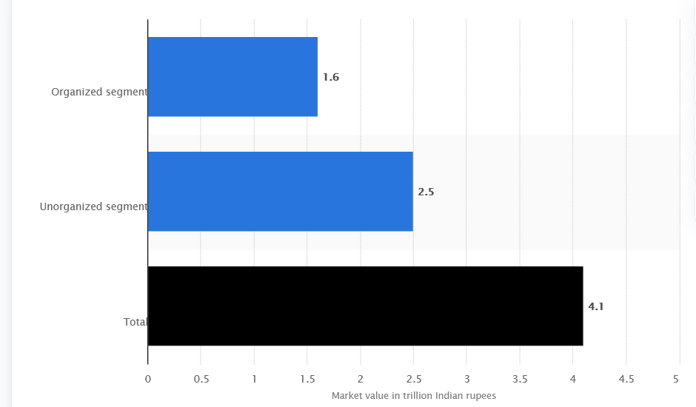

Figure 1: Represents the market value of Food Service Industry in India
(Source: Shrivastava, 2021)
According to Bhuyan, (2017), the movement of sustainable practice in Indian restaurants started a couple of years ago and the movement is gathering pace in the Indian restaurant sector. As mentioned in the website of Food and Agriculture Organization, the main sustainability focus of restaurants is food sovereignty, conservation of environment and fair pricing to establish healthy communities and sustainable agricultural economy in India (Hans, 2011).Improving sustainable practices in small scale restaurants not only differentiate them from others as well as it provides sustainability in the community.

The starting initial step towards sustainability comes from awareness and consciousness regarding green practices in the business operation. The process is challenging for small-scale restaurants as various factors of sustainable awareness are lacking in their business operation such as capital, infrastructure and green resources. The research has focused on the suitable sustainability practices for small-scale restaurants and aimed to assist small-scale restaurants owners in their sustainability practices in Indian market for gaining competitive advantages.

1.5 Justification of the Research
The study would focus on the awareness of sustainability practices among the small-scale restaurants in India. The reason behind selecting the specific topic of research is that previous researchers have not focused on the sustainability awareness among small-scale restaurants in India, therefore, the study has explained the issues in sustainability practices among small-scale restaurants in India and strategies that the Indian small-scale restaurants owners can implement in the business operations for gaining competitive advantages in the market.
The focus of the research study is to keep the small-scale restaurants in India in the centre and make determination regarding the sustainability practices and ensure the creation of awareness among the restaurant owners. The previous studies have focused on customers’ perception towards green practices and sustainable practices therefore lack of empirical evidence in the awareness of small-scale sustainability practices has caused obstacles which the research has focused to overcome. On the other hand, operational issues in the sustainable practices within small-scale restaurants in India have been focused by the research. Besides this, the aims, objectives and research questions have been decided on the basis of the research topic and thorough research about sustainability among the small-scale Indian restaurants. An in-depth analysis of competitive strategies implemented by the Food Service industry has been incorporated in the present study. Further the study would be beneficial for the small-scale restaurants and owners in the process of implementing sustainable practices in the Indian market.

CHAPTER 2

LITERATURE REVIEW

2.1 Introduction
The following section of the study consists of critical analysis of the existing literature from authentic sources to gain in-depth knowledge regarding the awareness of sustainability among small-scale restaurants in India. The gap that exists in the literature is also described in the literature review section. The literature review section further presents the overall concept and key variables of the research topic through a framework.

2.2 Sustainability practices
In order to resolve the obstacles faced by development and productivity such as global and economic collapse, sustainability is important and helps identify economic sustainability. Sustainable growth is often characterized as a holistic philosophy that represents all facets of society, environmental and economic aspects. Such three realms are regarded as sustainability dimensions that are committed to ensuring a sustainable standard of living for society and the inhabitants for population and resource growth (Talan et al., 2020). Sustainability is indeed an interdisciplinary approach that offers individual perspectives from industry and technologies to the planet and cultural sciences into many other facets of the human realm.

2.2.1 Three pillars of Sustainability
Three key fields that relate to the theory and cognitive science of environmental sustainability were established in the year 2005 at the World Summit on Social Development. In several national guidelines and qualification systems, these "pillars" shape the foundation of addressing the main aspects the world currently faces (Boyer et al., 2016). However, Turcu, (2013) considers an additional pillar of institutionalism and culture is considered to be one of the components of sustainability by Soini and Birkeland (2014). The figure below represents the three main pillars of sustainability determining its importance in development of stable business in any environment. In case of Indian small-scale restaurants, there are numerous limiting factors that are associated with the company's growth, diminish its development in early premature stage.
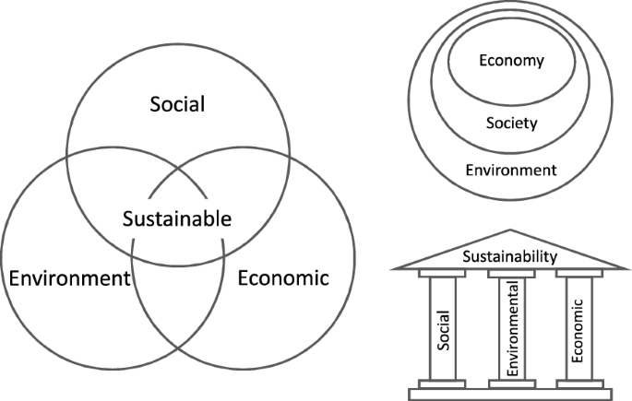
Figure 2: The three pillars of sustainability
(Source: Purvis et al., 2019)
Economic: Global organizations rely on decreasing the carbon footprints, pollution from manufacturing, the use of water as well as the total environmental effects. The above given image highlights the relation between economic, social as well as environmental factors for sustainable growth, where operational activity is influenced by economic stability of the company, which in-turn impact environmental aspects and thereby causing influencing social welfare. Corporations and business owners also discovered that an improved economic effect may also provide a favorable influence on the world (Barbier and Burgess, 2017). Usually, decreasing the quantity of products used in processing decreases the total cost on such items (Poveda, 2017).
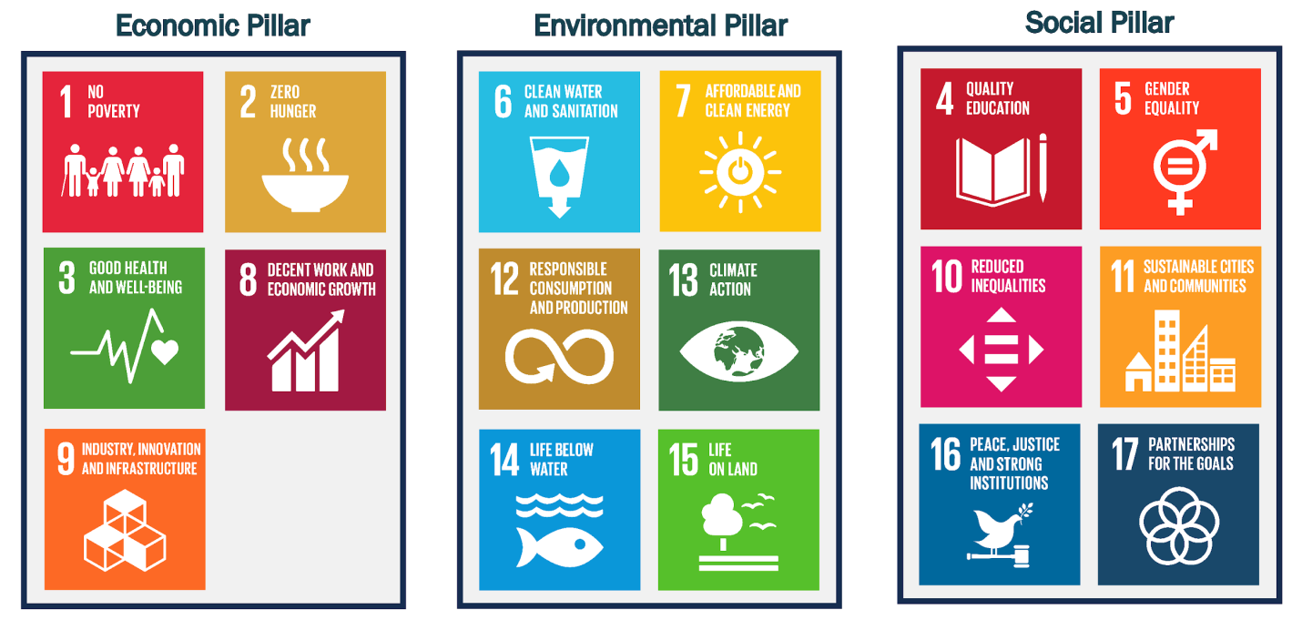
Figure 3: SDGs and pillars of sustainability
(Source: Kostoska and Kocarev, 2019)

In case of social aspect, services, facilities, socio cultural life, expression and leverage, and room for urbanization are influenced to sprout are influencing social sustainability. Urbanization is the driving force of social welfare, which directly facilitated environmental as well as economic aspects and thereby influences industrialization.

One of the important characteristics of social progress is the awareness of social inclusion and legislation to guarantee the protection and reliability of individuals, safeguarding them from natural hazards as well as other devastating actions of the business community and capitalization (Gaviglio et al., 2016). The figure below represents different dimensions of Social sustainability, highlighting social diversity as a maturity phase, which in turn indicates diversification in society as an important requirement, which drives the growth of organizations. On the other hand, quality of life as well as democracy of governance is the major areas of concern on sustainability practice, which directly or indirectly facilitates sustainability practices in nations like India, and thereby influencing its business growth.
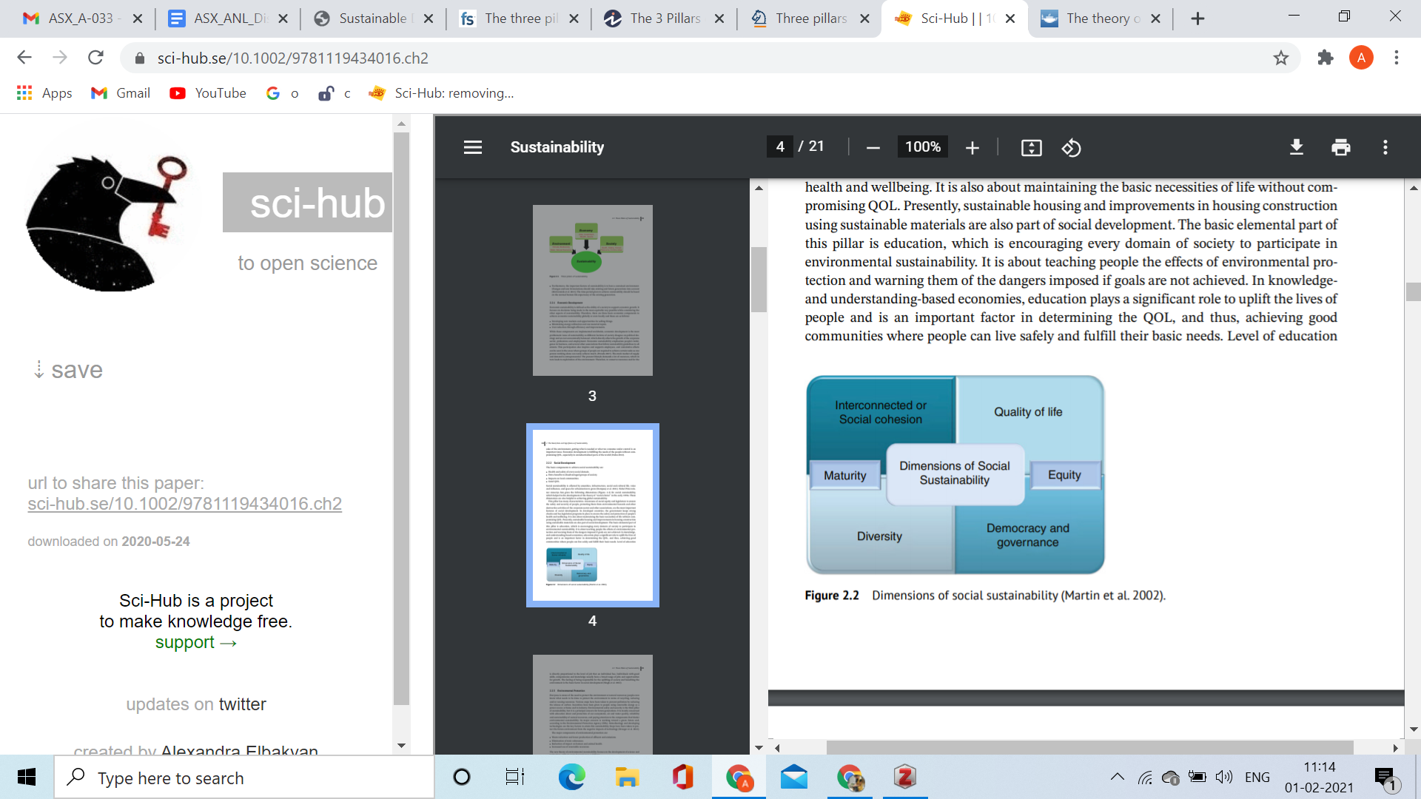
Figure 4: Dimensions of social sustainability
(Source: Talan et al., 2020)
Environmental management arises as the ecological investigation of the buildings, goods and operational activities of a business is minimized by procedures, structures and behaviors. Whilst reducing the emission of carbon, different measures have been undertaken to avoid emissions by nations that are signatories of Paris climate change agreement. Incentives need to be provided to individuals who use renewable resources at residence as well as in the business sector as a means of electricity (Patra et al., 2016). A stronger drive for environmental design concepts has been seen in recent developments in the corporate world and fit-out markets. Main market shifts include emphasizing on the use of green energies, like rainwater harvesting, solar power and recycling, increasing the use of natural and organic resources in the construction and manufacturing process, with the goal of being more environmentally friendly (Mensah, 2019). The figure below represents the environmental footprint with respect to sustainability.
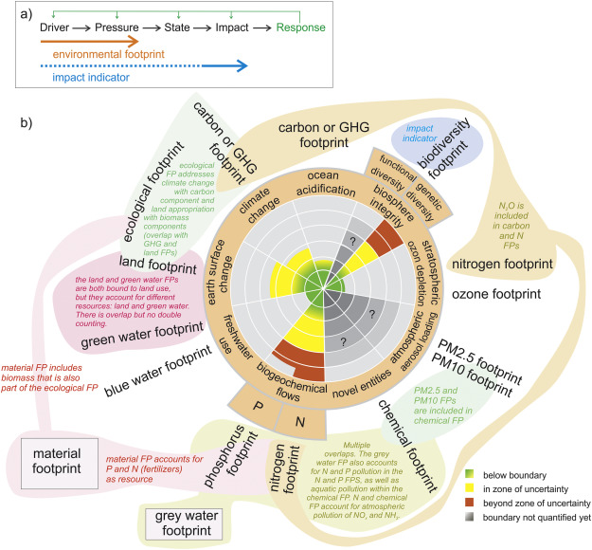
Figure 5: Environmental footprint
(Sorce: Vanham et al., 2019)

2.2.2 Awareness of sustainability practices among restaurants
Sustainable activities inside restaurants would help the profit margins of an organization by lowering operational costs. Lowering the environmental impact of a business implies recycling programs, and minimizes environmental degradation along with saving money (Kasim and Ismail, 2012). According to Kasim and Ismail (2012), throughout the restaurant market, the adoption of environmentally sustainable practices is low. Restaurants are hesitant to engage in environmental protection schemes, to reform policies, to market environmentally sustainable goods or to engage in the introduction of environmentally friendly strategies while top executives tend to be aware and knowledgeable about environmental concerns.

2.2.3 Sustainability and awareness among Indian restaurants
As per Bhuyan (2017), chefs as well as restaurateurs are now collaborating with environmentally friendly producers to support a trend that began a few years ago, however is steadily gaining momentum in India, so as to promote the goal of responsible dining. Based on the report of World Economic Forum (2020), India is moving towards a conscious consumerism, use and incorporation of green production and manufacturing has seen an increase in the country.

2.3 Conceptual literature

2.3.1 National commitments towards sustainable practices
India assumed a major role in forming the SDGs, the regional development objectives of the country are reflected in the SDGs. Since these, long before they emerged completely encapsulated, India was firmly determined to achieve the SDGs (Kumar. J and Majid, 2020). Although aimed at economic activity, the construction of facilities and rapid industrialization, the fight against deprivation in the world has been fundamentally based on social integration and inclusiveness of the people. India remains dedicated to, preserving the ecosystem while it battles poverty. The country has dedicated itself to reducing the emission rate of GDP, and also building an external carbon sink, underneath the Nationally Defined Contributions (Randhawa and Kumar, 2017).
The figure below represents the policy framework of the Government of India, for a sustainable marine ecosystem. A specific of marine policy of the government enables small scale restaurants specializing in seafood to implement green and sustainable measures in the eatery.
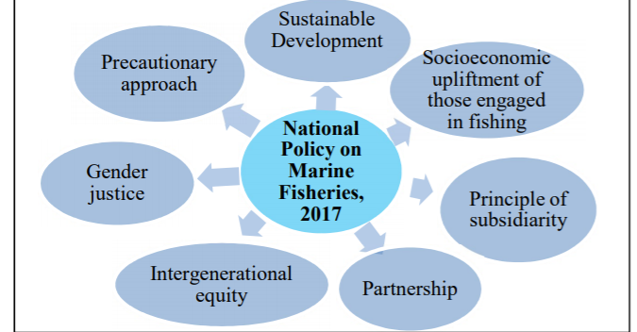
Figure 6: National policy on marine fisheries
(Source: UN SDG, 2018)
As a focus initiative the Namami Gange Mission, a core policy flagship for ensuring SDG 6, has been initiated. Sewage treatment project management, combating industrial waste, urban and rural hygiene, productivity and quality enhancement of water use, biodiversity protection and also the Clean Ganga Trust are main components, amongst others (Press India Bureau, 2019). Government schemes and policy interventions like Swachh Bharat for sewage treatment and enhancing the water quality is especially beneficial to small scale restaurants, given the fact that most of these restaurants will get government help to sustain themselves, and would be able to open branches in sub urbans of the country.

Facility on established policies to overcome various markets, a harmonized encompassing National Strategy on Resource Efficiency (RE) has been devised to incorporate the cost effectiveness approach into the path of development for accomplishing SDGs (Bardhan et al., 2019). RE is a significant instrument for fulfilling the national resource requirements at the lowest possible expense to the economy, thus, giving a push to SMSEs and entrepreneurs

2.3.2 Issues faced by Indian restaurants
The "predicament" of developing countries, like India, pursuing rapid economic growth to eradicate poverty, malnutrition, deprivation, unemployment as well as societal inequality without adversely disrupting the global climate is the greatest "hurdle" for environmental sustainability (Sudhir Sinha, 2017).
Water: In a country like India, where potable water itself remains a major concern, the procurement of water efficient technologies and systems remain a challenge for SMSEs and small-scale restaurants. The figure below represents just 42.49% of the rural population having access to safe drinking water in India.
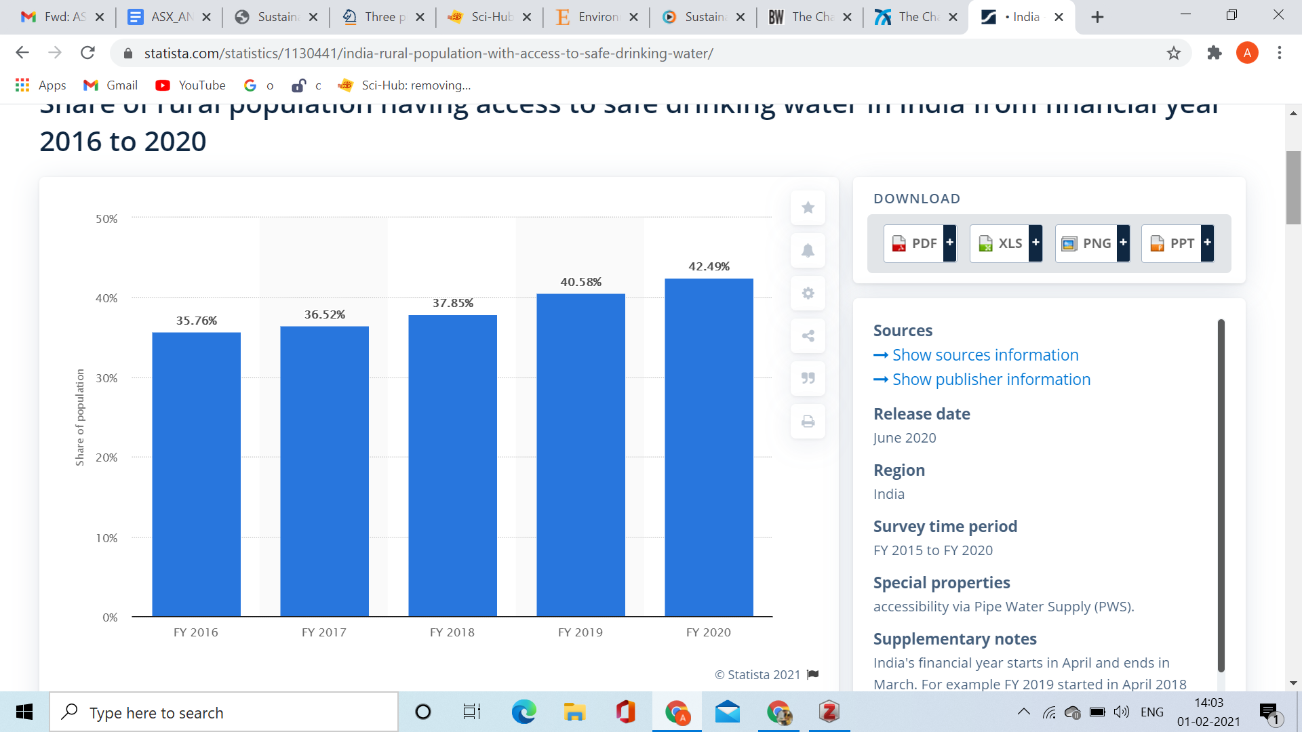
Figure 7: Rural Indian population having access to safe drinking water
(Source: Jaganmohan, 2020)
The energy usage focuses on the expensive non-conventional sources of energy coupled with Coal dominating the electricity supply in India by thermal power facilities with a presence from over 86%, makes it extremely difficult for small scale restaurant owners to turn to greener sources (Gulagi et al., 2017). The take away packaging constitutes the Food packaging, usually, is meant for sole usages and is therefore not recycled. Such packaging is highly unsustainable and affects the habitats of the planet, being inexpensive and durable are commonly used by restaurants in the country (Gallego-Schmid et al., 2019).

The food waste aspect in India considers the reasons of food wastage is primarily related to economical, administrative and technological shortcomings in processing methods, storage and conditioning facilities logistics, packaging as well as marketing processes in demanding climate conditions (Bharucha, 2018). The meat industry and carbon footprint take into consideration the meat industry, largely due to increased pollution and water use, is considered to have a comparatively high environmental effect (Tiseo, 2019) and the increasing demand upon the food industry for meat consumption. This is a concerning issue for small scale restaurants to be sustainable while meeting the consumer needs.

2.3.3 Benefits of sustainable practices in Indian restaurant
Employing sustainable practices in small scale Indian restaurants have multiple advantages, (Perramon et al., 2014), states that individuals want to invest their resources in sustainable methods, but they also want to gain in a sustainable manner. Getting a good social conscience will raise the productivity, enthusiasm, and longevity of workers dramatically, as investors and shareholders would feel proud that the job leads to a better cause. Communicating with the customer about the sustainability plan, people would feel increasingly motivated to visit the restaurant and turn regulars. Consumers nowadays are increasingly becoming aware and conscious about environmental sustainability and thus, will help increase the consumer base in small scale restaurants (Perramon et al., 2014).

2.4 Empirical literature

2.4.1 Corporate Sustainability
Small scale business owners require changing the business operation process in order to gain sustainability in the business process. The below points have described the sustainability challenges of small restaurant owners in the Indian market. According to Williams (2017), poor management skills of leaders and business owners lead to the failure of business. Lack of skills, knowledge regarding sustainable business operation often fails the business operation in the market despite having a unique vision for the business. Therefore, proper management practice is required to utilize the resources and achieve business goals in the market (Foxall, 2014). As stated by (Riahi et al., 2020), business plan should include business objectives, mission, vision, background and philosophy. Apart from that, business plans should include strength, weakness of the industry, and policies of marketing, price and operations as well as promotion strategies. The business plan sets goals for the business owners as well as for the employees and serves as a business tool for effective decision making (Halabí and N. Lussier, 2014). Well-developed business planning benefits small-scale business owners to gain opportunities in the market (Marom and N. Lussier, 2014) but often the small-scale business plan lacks vision and mission of the business as a result the employees and stakeholders lose focus on the goals in tough times (Nguyen et al., 2018). Creating an effective business plan and strategy helps the business owners to understand resources that the business requires for sustainability. As stated by (McKeever, 2017), a business plan should be created through team effort and the planning process should involve the perception of owners and managers to mitigate future issues and gain sustainability in the competitive market. As mentioned by, internal control prevents financial errors and helps to identify the issues in the business operation for sustainability. Therefore, it can be depicted that the challenges of poor management skills and poor business plans tend to create a gap in the maintenance of sustainability in the small-scale restaurants in India. The owners of such restaurants need to take initiative to adopt probable management skills along with developing business strategies that will help in boosting the restaurant business.

2.4.2 Five P’s of sustainability
The UN SDG states sustainable development to involve growth focused on 5 aspects of the planet, people, prosperity, peace and partnership. The figure below represents the interconnectivity among 5 P’s of sustainability.
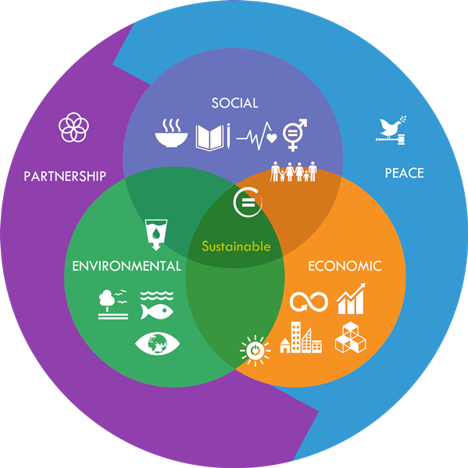
Figure 8: 5 P’s of sustainability
(Source: UNSSC, 2016)
The planet aspect focuses on the rising global temperature is of constant concern and the restaurant businesses, food processing industries and meat production adds to the woes of the planet earth and global warming (The World bank, 2018). The people aspect constitutes that Individuals are the main consumers of restaurants and the consumer awareness and demand can gretl influence the small-scale restaurants and what they serve. The prosperity aspect is a relatively recent notion for the presumption of sustainable, long-term business growth that translates towards needs of the population and consumer demands ensuring environmental sustainability (Moore, 2015).

2.4.3 Theme based restaurants
Themed restaurants based on sustainability, opportunity for greater income in a very short amount of duration is the value of operating a theme-based restaurant. Through these sales gets an opportunity to establish brand identity by transforming the small-scale restaurant to a particular style. The restaurants that are bamboo themed promote eco-friendliness and bamboo is inexpensive, adds to the ethnicity and architecture style of the small-scale Indian restaurants. Bamboo generates less waste as they are reusable and are biodegradable (Thi Bich Vân, 2018). Moreover, the traditional one-time straws are hazardous to marine life, whereas bamboo straws are much safer to the ecosystem.
Besides this, the zero waste restaurants have the concept of zero waste restaurants which are rising, where the decor is made using recycled and designed furniture or using crushed wine bottles as wall mounts and the use of eco bricks seems to be the new trend among the new generation. Small scale restaurants in the country may incorporate the concept, and make profits while saving money (TOI, 2017). Lastly, the utilization of solar appliances and rooftop farming: Rooftop planting is indeed a method to insulate houses, reduce the influx of stormwater, as well as eventually create habitat for birds, and humans to congregate (Whittinghill and Starry, 2016).

2.5 Identification and review of the debates within the literature

2.5.1 Need for Sustainability
As per the opinion of Chakrabarty and Wang (2012), the present needs of the environment and businesses are based on saving the resources and energy of the planet for ensuring future survival of the organization based on a sustainable line for managing its input materials. The aim of the business operating in the food sector of the Indian subcontinent is the need for meeting the demands of the population with judicious use of input goods. For the purpose of producing a high bulk of finished products of the organization it requires new strategic planning for redesigning the activities of the company on sustainable grounds (Kopnina, 2017). Sustainability helps in meeting the present need of the people as well as save resources for the future generation by recycling the used products which helps in reducing the production cost of the company (Mensah, 2019).

The image and reputation of the company such as a restaurant operating in India enhances its image by managing its work processes for producing, packaging and distributing goods based on sustainable lines in the market among its competitors (Rezaei et al., 2019). It helps in practicing a Unique Selling Point (USP) for the development of the business as well as of the planet as per the demand of the present situation persisting in the world. The following image depicts the Sustainable framework for managing the supply chain management of the food-based industry in India on sustainable grounds. The model clearly aligns the 3 pillars of sustainability practices, determining its strength in maintaining appropriate supply of products and associated customer satisfaction in the operating market.
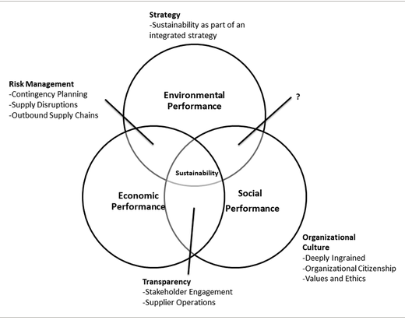

Figure 9: Supply Chain Management Framework based on Sustainability
(Source: Rezaei et al., 2019)

2.5.2 Model of Sustainability
The models of sustainability are based on 3 legged dimensions which are Social, Economic and Environmental in nature for the purpose of improving the present functioning and conditions of the business operating in a developing country like India as presented in the below image.
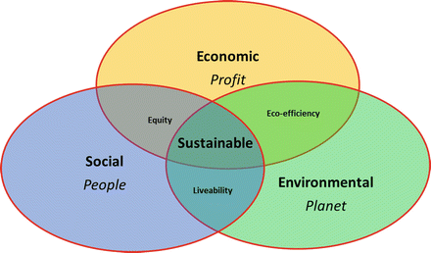

Figure 10: 3 Legged Dimensions of Sustainability
(Source: Sonnemann et al., 2015)
The economic model of sustainability as opined by Spangenberg (2005), constitutes the evolution of a suitable and reliable economy that tends to create sustainability in the small-scale Indian restaurants and create awareness among the restaurant owners. The model focuses on the utilization of resources in a limited manner for the enhancement of values in the creation of sustainability, which provides strength to businesses in execution of its operation (Vivien, 2008). Besides this, the environmental model of sustainability as opined by Jacobs and Klosse (2016), tends to make adoption of the sustainable strategies for making escalations in the natural belonging for promoting the non utilization of harmful chemicals.

This model focuses on the development of energy resources by the utilization of renewable energy resources and plants to keep a balance in the ecosystem of the restaurants (Jang, 2016). Moreover, the social model of sustainability as opined by Freeman (2011), determines the design of the restaurant infrastructure in context to the Indian norms and culture which will make increased customer engagement. Geissdoerfer et al. (2018), the business models based on innovation and circular approaches help in overcoming the challenges of wastage and barriers hindering sustainable development of the society as explained in the image below.

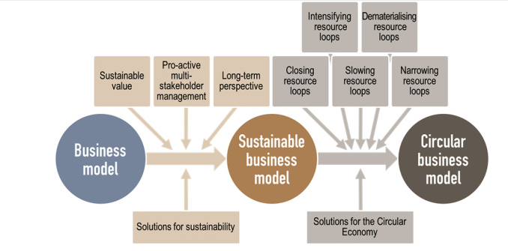
Figure 11: Need of Business model based on Innovation and Circular Approaches
(Source: Geissdoerfer et al., 2018)

The above given business model of sustainability has the ability to provide long-term sustainability to the organization, by giving focus on the surrounding market and economic state. As a result, the model not only has efficiency in managing its sustainable growth, but also ensures maintenance of market base. The models of sustainability helps in effective implementation and execution of sustainable plans in alignment with the work processes practiced in the brand for producing goods with high quality and quantity at reasonable cost for saving resources for the future (Nosratabadi et al., 2019).

2.5.3 Environmental cost leadership strategy
The production costs of the company are relatively in control with the application of sustainable approaches and mechanisms based on effective strategies of green methods which helps in bringing social, economic and environmental prosperity in the country as shown in the image below.
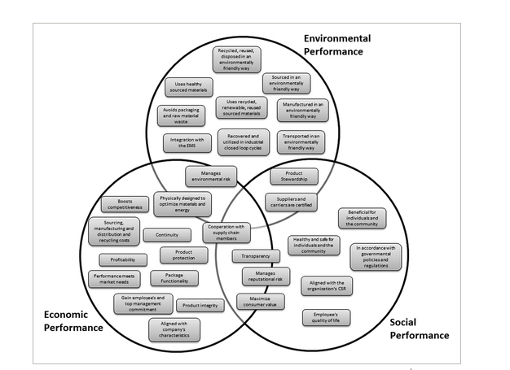
Figure 12: Social, Economic and Environmental prosperity by implementing sustainable strategies
(Source: Rezaei et al., 2019)
As per the information presented by the Xanthos and Walker (2017), the application of 4 R’s strategy which are Refuse, Reduce, Reuse and Recycle helps in regulating the activities of the company on sustainable grounds for managing the overall costs involved as well as the impact caused to the environment. The 4 R’s helps in reducing wastes generated by the brand during its production procedures as the strategy helps in recycling the used materials which helps to reduce the burden on the external resources of the environment as shown in the image below (Saini et al., 2020). The inclusion of both 4R practice and cost leadership strategy directly helps the company to align its business strategies as per the organizational requirement. The application of the strategies maintains the sustainability practice by proper resource utilization.
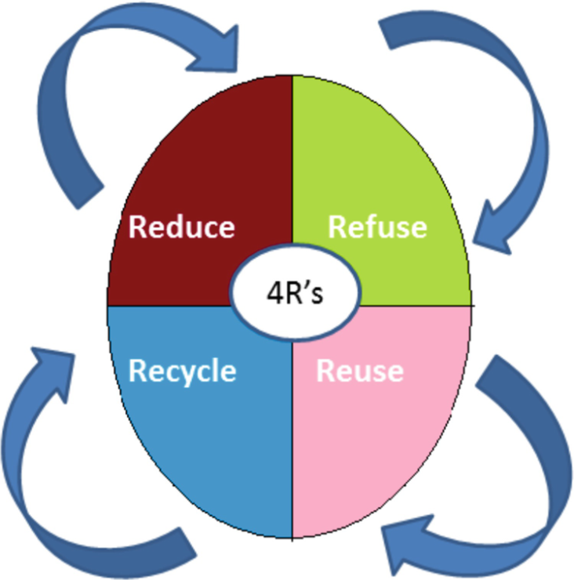
Figure 13: The strategy of 4R’s
(Source: Saini et al., 2020)

2.6 Commentary on nature of literature

2.6.1 Sustainability and Corporate Social Responsibility (CSR)
As per the opinion of Morsing and Spence (2019), Corporate Social Responsibility (CSR) are initiatives adopted by companies which manifest strong responsibilities towards the society and the environment for its welfare and conservation. Majority of the organizations are practicing the phenomenon of Corporate Sustainability for designing their activities on sustainable lines for restoring the hazards caused to nature due to human activities (Ashrafi et al., 2018). This in return helps the company for increasing its value in the market by associating the business with sustainable responsibility for enhancing the quality of the environment and fulfilling the needs of the society (Camilleri, 2017). Based on the below mentioned resources of sustainable line diagram, Indian small-scale restaurants can implement
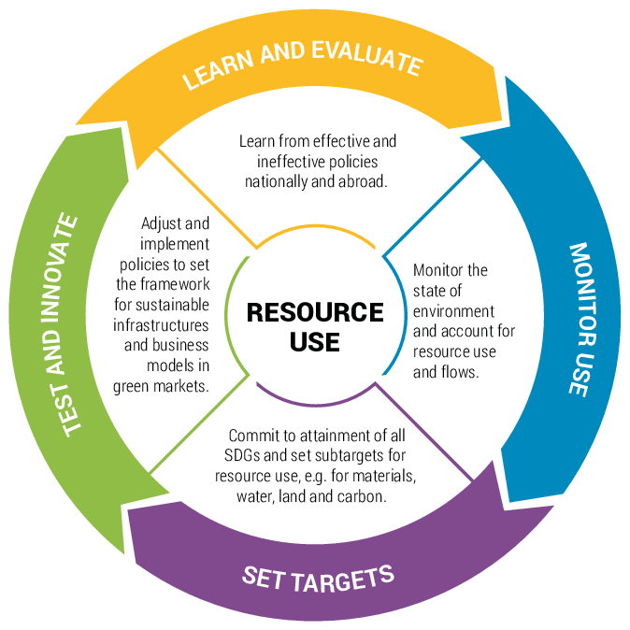
Figure 14: Uses of resources on Sustainable lines
(Source: Bringezu et al., 2017)

2.6.2 Problems for implementing sustainable tools and mechanism in the work processes of Indian Businesses in Food Sector
The approaches of sustainability are based on high tech technologies and green materials which help in recycling the used products that are relatively high in costs and are scarcely available in the developing markets (Iravani et al., 2017). The tools and mechanism of green approaches are exported from different parts of the world which often delays the supplies in the food-based industries operating in the developing nations of the world causing disturbances and unnecessary problems with the clients due to lack of appropriate technologies and equipment (Shenoy, 2016).

As per the reports of Barro et al. (2020), the supplies were further delayed due to the outbreak of the pandemic of Covid-19 which affected the production of goods globally. The small and medium enterprises are unable to bear the huge cost of sustainable practice which has further been detained in the present situation of Covid-19 (Shafi et al., 2020). Moreover, the present focus of the businesses operating worldwide tends to implement strategy for recovering the losses caused due to the pandemic than expanding the business on the foundation of sustainability for its survival in the market.

2.6.3 Future scope of Sustainability
Sustainable Development helps in yielding high income for the business by organizing the activities of the company on green approaches (Abdelkafi and Täuscher, 2016). In return the high productive activities of the organization help in increasing the income of the country which has prospects for enhancing the position of the developing nation like India in world politics. Sustainable approaches help in building strategic capacity of the businesses by utilizing and applying the tools and mechanism of green methods which regulates the activities of the brand for controlling the degradation caused to the environment for obtaining advanced development in the society (Dzhengiz and Niesten, 2020). Moreover, the businesses operating on sustainable strategies have the capabilities to capture the entire market of the country which helps in building a strong image and reputation of the brand for increasing the sales and profitability (Bansal and DesJardine, 2014). Designing the work processes and framework of the businesses on sustainable grounds helps in the survival of the human race on earth by regulating the activities of the company on the basis of renewable sources of energy and the recycling phenomenon.

2.7 Implications of the literature

2.7.1 Methods for bringing Sustainable Development in India
The methods of developing sustainability in the Indian small-scale restaurants based on the incorporation of the sustainability models are as follows-

Partnership with the right producers constitutes the creation of a sustainable supply chain system which will be beneficial for connecting with reliable suppliers and operators which will result in smooth running of the business by 90% due to the implementation of the sustainability practices (Sharma, 2009). Growth by Sourcing creates an effective opportunity for making professional connections like for example; making connections with popular chefs will be advantageous for the small-scale Indian restaurant owners to enhance their business. This is possible on the basis of the fact that popular chefs have great knowledge about cuisine which will help for attracting customers thereby, enhancing the overall business of the small-scale restaurants (Mensah, 2019).

Buy locally, in bulk focuses on the aspect of sourcing resources from local suppliers in a bulk amount along with purchasing materials especially when they are not expensive for avoiding extra expenses (RIS, 2016). Addition to this, there should be limitations in the utilization of these resources for mitigating the generation of wastes and carefully managing the available stock. For example, small-scale restaurant owners should contact local suppliers of materials from machines to the supply of foods in bulk and make limited utilization in order to avoid waste generation. Waste management in restaurants is considered to generate maximum general wastes in the form of food which needs to be composed or recycled to effectively manage wasteThe packaging system of the small-scale restaurants in India should focus on the utilization of renewable or recycled materials that can be reused in the future. The containers for the delivery system should comprise reusable containers instead of plastic for creating eco-friendliness for the surrounding environment (Bharucha, 2018).
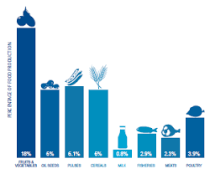
Figure 15: Sustainable Development in Indian Small-Scale Restaurants
(Source: FICCI, 2017)

2.7.2 Favourable Sustainability Practices in Indian small-scale restaurants
The favorable sustainable practices based on the sustainability models and methods in Indian small-scale restaurants are-
Sustainable Green Practices constitute the provision of organic foods that are sourced in the Indian small-scale restaurants by local suppliers along with limited food packaging facilities by making utilization of recycling packaging materials (B. DiPietro et al., 2013). Water Efficiency and Conservation is the Setting of sprinklers for timely watering of sidewalk along with utilization of water catchment in the form of rain barrel for reuse purpose, installation of touch less sensor faucets in kitchens and dishwashers for making less utilization of water (Kurunthachalam, 2014). Waste Reduction in restaurants can be reduced by distribution of excess food to the community, provision of online reservations, recycling of old items, utilization of proper towels instead of paper towels and refillable containers for soap.

The Indian small-scale restaurants should implement these sustainable practices which result in 26% of waste reduction every month (Dhir et al., 2020). Strict Recycling Policies constitutes recycling of items like plastic, glass, paper along with recycling of kitchen equipment and light bulbs in restaurants to overcome the generation of wastes. The recycling of these restaurant items results in the generation of reusable energy which creates sustainability in the operating process of the restaurants which results in 75% control of waste generation (Singh et al., 2014).
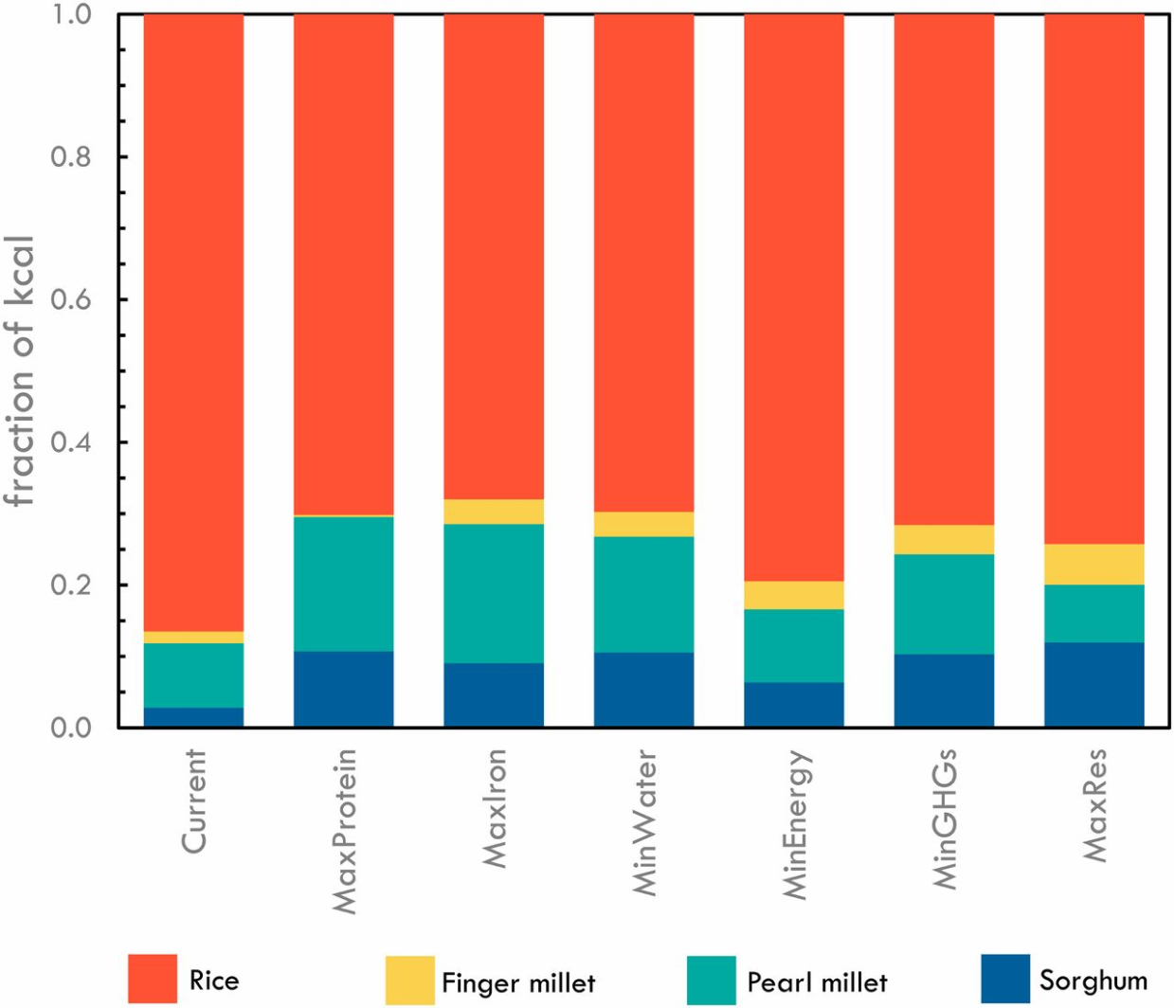
Figure 16: Sustainable Green Practices in India
(Source: Davis et al., 2019)

2.7.3 Correlation between development of business with Sustainability
As per the opinion of Wang et al. (2012), the business prosperity depends on the functional approaches of the company which should be based on sustainability as it has the capacity for producing bulk of goods in limited and judicious use of resources, energy, costs and time. This helps the companies for manifesting the use of high tech software’s and equipment for managing its activities efficiently. With the application of green strategies to reuse and recycle the used input goods for again producing the desired outcome for the brand.

2.7.4 Factors behind the rising awareness for the development of Sustainable mechanism in Indian context
The following factors which have been listed below are the key variables which have been identified for generating awareness for the application of Sustainable Approaches for effective development of the business (Scharlemann et al., 2020). The factors are- saving nonrenewable resources of energy, meeting the demands of the future generation, reducing the production cost of the business, controlling pollution, reducing the generation of wastage and toxins, regulating the emission of carbon, holistic development of the society, rescuing the used materials by recycling for reducing the burden on the input sources, ensuring future survival of the human on the planet, securing the business of the brand in the future global market context, eradicating the use of chemicals for manufacturing goods and application of renewable sources of energy such as solar, hydro and wind.

2.7.5 Evaluation of Sustainable Approaches
According to the findings of the report presented by Kwon (2017), over 190 countries of the world committed towards the agenda of Sustainable Development for bringing global development throughout the world by 2030. For the purpose of achieving such targets, there is a clear need for planning an effective strategy and model for meeting the objectives in the given time. Therefore, one such systematic approach has been explained in the below image which has high potential for raising the standards of the business for enhancing its sales and profits (Pedercini et al., 2019).
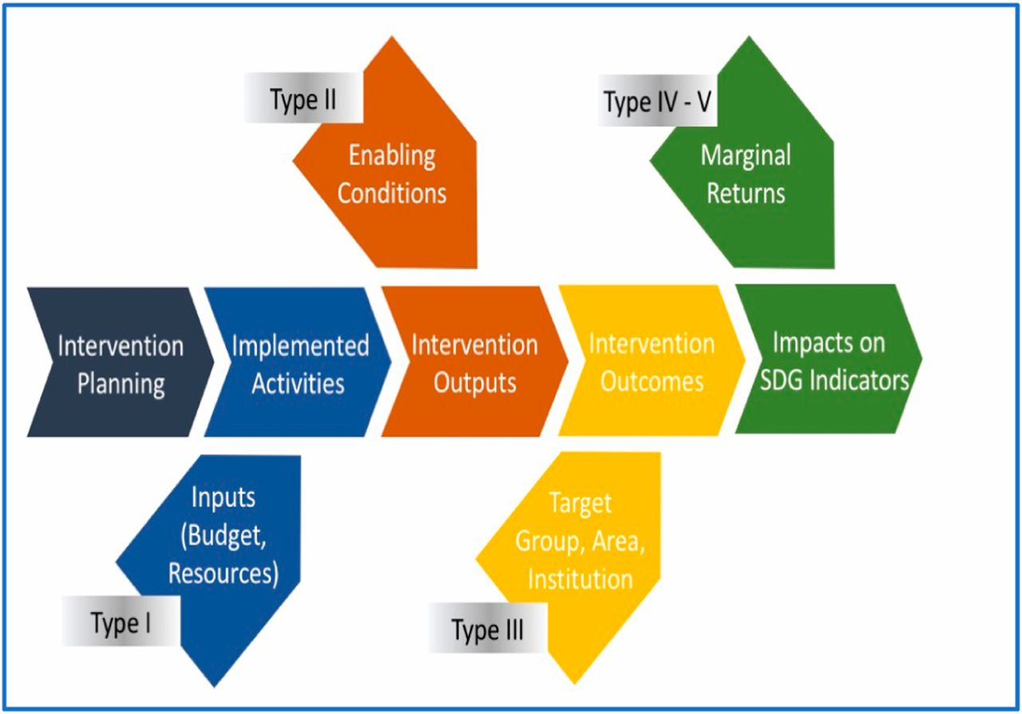
Figure 17: Conceptual model for achieving Sustainable Development Goals
(Source: Pedercini et al., 2019)
This approach of sustainable development helps in effective planning of the actions with continuous evaluation of its probable outcomes by adequate management of the resources purchased by the company for mitigating its responsibility towards the society and the environment. These approaches produced key indicators which help in elaborating the benefits and returns that the company receives by emphasizing the application of sustainable development goals and agenda throughout their work processes operating worldwide.

2.7.6 Application of advanced technological tools for sustainable development in the Indian society
There are certain technological tools for the creation of sustainable development in the Indian small-scale restaurants which are as follows-
Guest Facing Point of Scale focuses on the aspect of non utilization of paper in the form of table registrations, bill receipts and menu cards and instead usage of technology like online reservations and payment of bills and accessing of menu cards digitally. This helps in the reduction of waste generation by 93% with further reduction in paper materials thereby, creating sustainability in the restaurant environments (Kamath, 2019).

Displacement of Kitchen Screens will be useful in overcoming the utilization of paper tickets when restaurants face a huge queue of guests with increase in ordering of menu (Ivkov et al., 2016). The displacement of kitchen screens for example, will help in the effective communication between the waiters and the chefs pertaining to taking orders of menu from the guests (G. R. et al., 2019). Digitalization of Guest Feedback in the Indian small-scale restaurants should make provision of online feedback of guests by the creation of restaurant websites where the guests can share their experience regarding the restaurant and the food menu. For example, the restaurant owners can utilize tabs and online links where guests can immediately provide feedback after making bill payments (Cavusoglu, 2015). Inventory Tracking Solution helps in the management of purchase decisions, analysis of the best food menu and making wise selection of ingredients which result in 85% of cost savings (Martin, 2019).
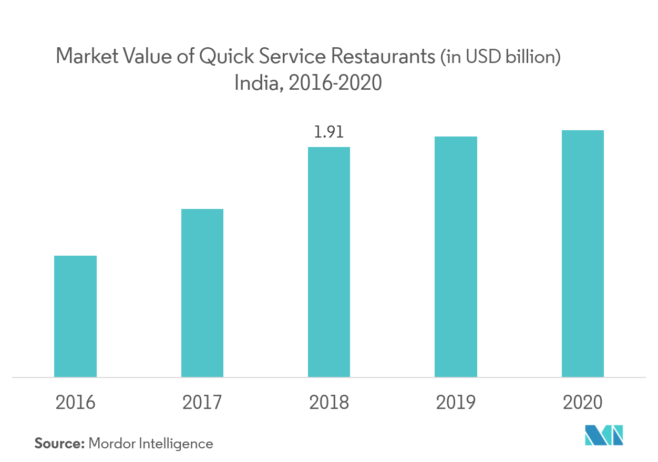
Figure 18: Market Value of India Small-Scale Restaurants
(Source: Dewan, 2019)

2.8 Literature Gap
The present research study is based on the analysis of the sustainability practices for small-scale restaurants in India which is helpful for the restaurant owners to implement thereby, creating a sustainable environment to meet requirements of customers. However, despite making provision of detailed discussion on the research topic and making critical evaluation of the issues and benefits of the sustainability practices for small-scale restaurants, the study comprises certain gaps in the section of literature review. There is absence of adequate information about culture and institutional pillars of sustainability along with the three major pillars. There is no alignment with the research topic due to the restriction in word count which creates an effective gap in the research study. Addition to this, the research study lacks the provision of suitable evidence that is pertaining to the creation of awareness of the sustainability practices that will benefit the Indian small-scale restaurants for gaining productivity.

2.9 Chapter Summary
The above section of the literature review discusses the need and the concept of sustainability on the present conditions of the food-based industries of a developing nation like India. Along with that, a thorough evaluation on the principles, characteristics, pillars and dimensions of sustainability for producing desirable outcomes for the business have been critically evaluated based on the existing academic journals. Moreover, the role of Corporate Social Responsibility (CSR), technological advancement and the models as well as the theories of sustainable development has been discussed. In addition to that, the implications and the obstacles faced by the business for executing the work process on sustainable lines have been analyzed which have further been deeply impacted due to the present pandemic situation of Covid-19. Lastly, the future scope and the literature gap for the research study have been identified for elaborating and channelizing the course of this dissertation.

Conceptual Framework

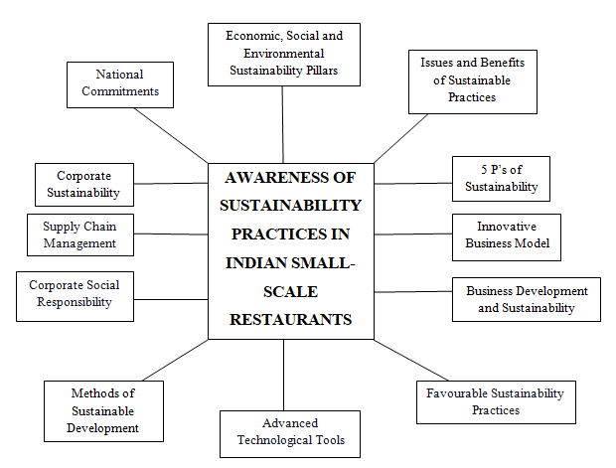

Figure 19: Conceptual Framework
The above figure constitutes the conceptual framework for the creation of awareness among the restaurant owners of the small-scale restaurants in India which is regarded to be the independent variable. There are certain dependent variables like the sustainability pillars, national commitments, corporate sustainability, supply chain management, corporate social responsibility, methods of sustainable development, advanced technological tools, sustainable practices, business development and sustainability, innovative business model, 5 P’s of sustainability and the issues and benefits for the sustainability practices implementation. Based on the aforementioned models are taken as important variables, which would be justified as the influencing factors for sustainability awareness generation in Indian small-scale restaurants.

The aspect of sustainability constitutes an economic pillar pertaining to the reduction of carbon emissions for overcoming excessive pollution in the environment; social pillar is the provision of restaurant services and legislations for the protection from natural hazards and environmental pillar for the management of the operational processes for attaining sustainability (Chattopadhyay and Shah, 2014). These three pillars of sustainability are the inflow of money, reliability of business community and capitalism and provision of environmental design for increasing natural sources for implementation of sustainable practices. The aspect of national commitments focus on the formation of SDGs for constructing facilities to make preservations of the ecosystem by making reduction in the utilization of carbon footprints. Therefore, national commitment is considered as a broad independent variable, the impact of which would be investigated through the adoption of sustainable practice of organization.
Moreover, national commitments constitute treatment of sewage for decreasing the waste generation and making a balanced utilization of water for enhancing the productivity of small-scale restaurants. The policy framework by the Government assists small-scale restaurants to make implementation of green and sustainable measures for combating waste generation (Kumar and Narain, 2014). The aspect of corporate sustainability is regarded to create value for a long term with the stakeholders of small-scale restaurants by incorporating ethical, social, environmental, cultural and economic business strategies. This is important for the restaurant owners to become aware of the sustainability practices that help in the performance enhancements which results in the brand name of the restaurants in market competition. This paves the way for making reduction in costs and maintaining relationships with stakeholders thereby, increasing productivity.
The aspect of supply chain management helps the small-scale restaurant owners to make effective and professional connections with the stakeholders especially the local suppliers in terms of supplying food items and kitchen equipment. Such professional connections help the restaurant owners to achieve customer satisfaction which results in the attainment of market competitiveness. The supply chain management aspect helps in making improvements in the quality of the restaurant environment and controls the utilization of non-recyclable materials for mitigating the issue of waste generation. As a result, the variable has been taken as an independent variable, to directly investigate its impact on the growth of small scale business in Indian restaurants.

The aspect of corporate social responsibility takes into account the emergence of suitable relationships that are to be maintained for the welfare of the society and the surrounding environment. This promotes corporate sustainability for making designs pertaining to the sustainable lines for restoring hazards that are caused by human population creating a misbalance in the ecosystem. This results in the increased valuation of small-scale restaurants in India by which the restaurant owners create a link between their business and sustainable responsibility for fulfilling the needs of society and making enhancements in the environment.

The aspect of innovative business model depends upon three factors of social, economic and environmental for the objective of attainment of sustainability in small-scale restaurants in India on the basis of innovation. These factors help in the smooth operating of the business in a developed country like India by effectively managing resources which are produced due to the social, economic and environmental factors. The aspect of 5P’s of sustainability makes inclusion of planet, people, prosperity, peace and partnership with the aim of having sustainable development in small-scale restaurants of India. This can be achieved by making stabilization and omitting the utilization of carbon footprints thereby, creating a sustainable environment. The aspect of the issues and benefits of sustainable practices help the restaurant owners to make identification of the challenges of water wastage, increased energy utilization and food wastes.

CHAPTER 3

RESEARCH METHODOLOGY

3.1 Introduction
The Methodology chapter within the research study provides appropriate methods along with a systematic plan to complete the study in a proper manner. The following research on the basis of sustainability awareness practice among the small-scale restaurants in India. In addition to that, the research is going to discuss research philosophy, approach, design and strategies which is based on the awareness practice within small-scale restaurants in India. The research methodology chapter shall also focus on the aspects of data collection method, sampling technique, time horizon and ethical considerations which will help to generate accurate research outcomes for the selected research topic.

3.2 Research Philosophy
In order to formulate proper research outcomes, positivism research philosophy has been chosen to conduct the research. Positivism philosophy uses the approaches of presenting and analyzing the results in a quantitative design which empowers the credibility of the research finding. Positivism philosophy will enhance the credibility and authenticity of the research findings as it will enable the study to present factual results based on numeric and statistical evidence. As opined by Ryan (2018), positivism research philosophy provides an understanding which is based on primary quantitative research methods, that is, the survey.

Moreover, factual knowledge has been gained with the help of surveys based on the sustainability awareness practice among small-scale restaurants in India. Furthermore, a positivism philosophy has been chosen as it helps to analyze the research data with quantitative measurements. Likewise, positivism research philosophy has provided an overall understanding of the perspective of the survey participants and it has also helped provide assistance to understand the current scenario of the small-scale Indian restaurants. Additionally, it has also provided assistance to integrate sustainability awareness practice within the study with the help of the survey. In order to understand the contribution of research philosophy, the image below shows the actual usage of research philosophy. The image explains the usefulness of research philosophy with the help of research purpose, research question, theoretical perspective of the research and the research design. As per the image shown below, it helps to understand the research purpose as it explains individual perspectives that are required to generate proper research outcomes. Henceforth, the research philosophy has helped to understand the current perspective of Indian small-scale restaurants on the basis of sustainability awareness.
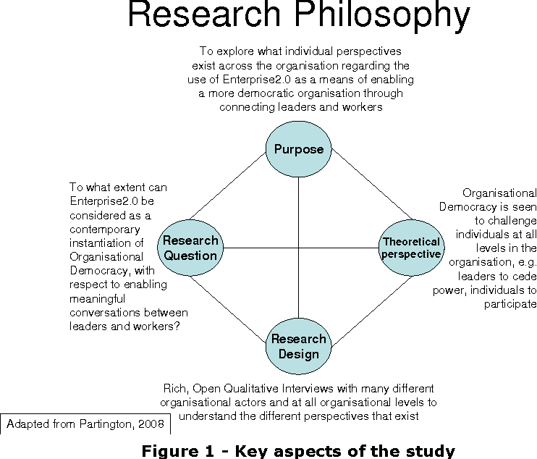
Figure 20: Importance of Research philosophy
(Source: Flowers, 2020)

3.3 Research Approach
Inductive research approach has been selected in order to conduct the research due to the fact that the research aim indicates a new perspective which has not been discussed in any previous work. With the help of Inductive approach, research data has been transcribed into new theories about the sustainability awareness practice among small-scale restaurants in India. This will enable the research study to enhance its validity and authenticity by mitigating all its research objectives as the inductive approach formulates effective strategies which aids in the process of testifying the identified research problems by collecting data from credible sources. In addition to that, an inductive research approach provides assistance in order to carve a path for a new research topic which has been chosen in this work (Azungah, 2018). Likewise, with the help of survey and use of inductive approach, proper research outcome can be evaluated with the help of numeric data (Woiceshyn and Daellenbach, 2018). The image below has been provided with a detailed evaluation of the importance of an inductive research approach. The image has observed the significance of inductive research approach as it shows that on the basis of the social phenomenon, data is collected and examined with the help of theories (Azungah, 2018).

According to the figure given below, it provides an understanding about inductive approach and its actual usage in research methodology. As per the image, a social phenomenon has been observed and then data is collected on the possible reasons. In the next step, the data has been examined and a theory has been developed in order to explain the social phenomenon. Thus, the cycle of a social phenomenon with the inductive approach has been explained in the image below. It has provided assistance to understand the social phenomena of the restaurant industry with the help of restaurant executives.
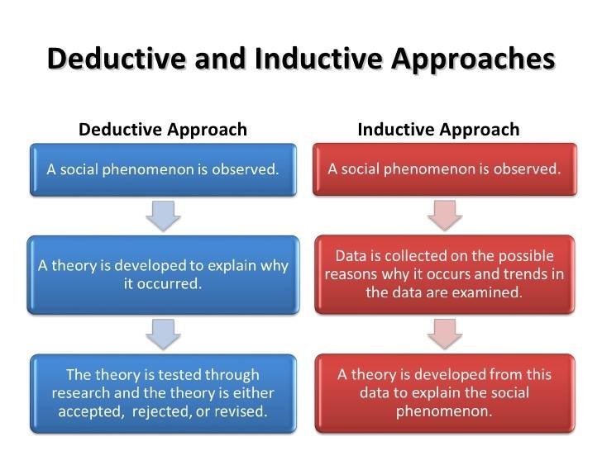
Figure 21: Importance of Inductive research approach
(Source: Azungah, 2018)

3.4 Research Strategies
Primary quantitative data collection methods have been chosen in order to gain a research outcome. The primary data collection approach will enable the research study to work on the present parameters and dynamic of the market for producing relevant and critical research outcomes of the study. It will also help in enhancing the overall reliability of the study by reporting the facts objectively gathered from the participants without any occurrence of subjective interpretation, influence, pressure, manipulation or external force on the respondents while providing their responses. In addition to that, a primary quantitative data collection method has been chosen in order to gain an adequate research outcome. 80 small scale restaurant executives of India have been chosen in order to collect numerical data.

As explained by Paradis et al. (2016), numeric data can help to ease the research process to generate proper research outcomes. Sustainability awareness among the small-scale restaurants in India can be improved with the survey questionnaire. Furthermore, the primary quantitative data collection method also provides an overall understanding about the current strategic position of small-scale Indian restaurants. In order to understand the impact of research strategies better, the image below shows its exact usages in a correct manner. The image represents that the importance of research problems shall be evaluated first. After that, critical barriers have been evaluated in order to generate the concepts and methods related to the research.
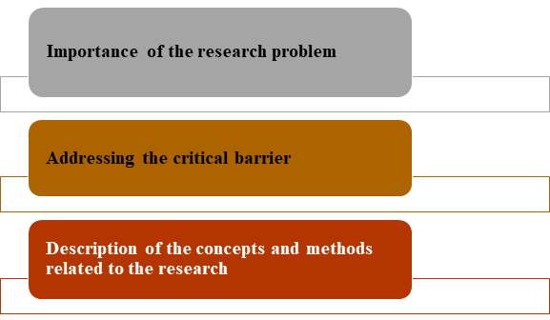
Figure 22: Importance of research strategy
(Source: Tajvidi and Karami, 2015)

3.5 Research Choice
Mono quantitative research choice has been considered as the study comprises a survey which is a numerical data collection method (Timans et al., 2019). Collecting data based on quantitative approaches enhances the overall productivity of the research study as the findings of the data are supported by authentic evidence which are presented using statistical methods which facilitates the data interpretation procedures by the audience. Moreover, quantitative data can be presented using graphical representation which helps in the easy and convenient data analysis process. 80 small scale restaurant executives of India have been chosen in order to collect numerical data. Survey was chosen due to the fact that it helped to understand the sustainability awareness practice among small-scale restaurants in India. Survey has been chosen as it ensures a more accurate sample to gather targeted results in which to draw conclusions and make important decisions (Kotzab, 2005).

In addition to that, mono quantitative research choice has been considered as it helps to understand the current path of choice which provides an overall understanding about the current strategic position of small-scale Indian restaurants. The survey will be conducted on an online mode through utilizing the offerings of Goggle platform due to the present pandemic situation of Covid-19. The survey will consist of a questionnaire along with a 5-pointing scale based on Liker scale which will be sent to all the participants through their Emails after receiving the consent forms from all the interested respondents.

3.6 Research Design
In order to generate adequate research outcomes, Descriptive quantitative research design has been chosen for the research study as the research consists of a survey with 80 small scale restaurant executives of India. Descriptive quantitative research design helps to gather quantifiable information for statistical analysis (Nassaji, 2015). The quantitative research methods help in increasing the credibility of the research study in comparison to other approaches due to the provision of objective reporting of the facts gathered through the collected data which are in the form of numbers.

The statistical presentation of the research outcomes developed through the collected data acts as an evidence for supporting the reporting given in the dissertation which increases its overall credibility and authenticity. In addition to that, it also provides assistance to collect and describe every single aspect of the survey with accurate analysis. The aspects of the survey include accurate characteristics of a large populace of participants and accurate sampling to meet the targeted results (Kotzab, 2005). Furthermore, Descriptive quantitative research design provides assistance regarding the insight of the sustainability awareness practice among small-scale restaurants in India.

3.7 Data Collection Method
In order to gain an accurate research outcome, a survey with 80 small scale restaurant executives of India has been conducted. On the basis of inclusion and exclusion criteria, the survey has been conducted. The restaurant executives have been approached through the personal Twitter handle as well as Face book profiles as the topic of the research has been posted about the survey and has asked for interested participants. Interested participants have been supplied with consent form and information sheet stating the purpose of the research and harmlessness of the same. After getting appropriate responses from the interested participants with a signed consent form and information sheet, the survey has been conducted through the usage of Google Form with help of 12 close-ended questions.

3.8 Sampling Technique
A purposive sampling technique has been considered for quantitative data collection methods. The purposive sampling technique has been chosen due to the fact that the current research has a particular purpose which can be executed with this sampling technique. Likewise, the selection of this technique is also helpful as the study consists of both inclusion and exclusion criteria. The executives are chosen on the basis of operational experience within the restaurant industry of India. In addition to that, operational experience has also been chosen as the exclusion criteria of the research. Moreover, a purposive sampling technique has been selected due to the fact that only restaurant executives can provide useful insights about sustainability awareness within the restaurant industry.

3.9 Selection of the participants
In addition to that, the selection of the survey participants have been considered on the basis of exclusion and inclusion criteria. In case of the survey, more than 3 years of operational experience has been selected as the inclusion criteria. Operational experience has been selected due to the fact that it provides assistance to understand the sustainability awareness within the small-scale restaurant industry of India. Comparatively, less than 3 years of operational experience has been chosen as the exclusion criteria as restaurant executives with lower experience cannot provide useful data on the basis of sustainability within the restaurant industry of India.

3.10 Time Horizon
Cross-sectional method has been considered for the current study as it helps to conclude the research study within a short period of time (Setia, 2016). The present study, which is based on sustainability awareness within the small scale Indian restaurants, utilized the cross-sectional method due to the fact that it focused on the present scenario. Moreover, the present study has rejected longitudinal methods as it is a time consuming method (Anastassiou-Hadjicharalambous and Stylianou, 2011). Hence, the Cross-sectional method has also been used to capture a specific set of time in which the research has been conducted which implies that it is not a tedious method (Setia, 2016). The image below shows the importance of the cross-sectional method and the reasons behind why it is one of the most efficient time-horizon methods. The image evaluates that used to assess the burden of a particular research study in a defined population. In addition to that, it also provides assistance in understanding the prevalence of attitudes and knowledge among selected research approaches and design in validation with other research studies comparing, for example, different measurement instruments (Rindfleisch et al., 2008).
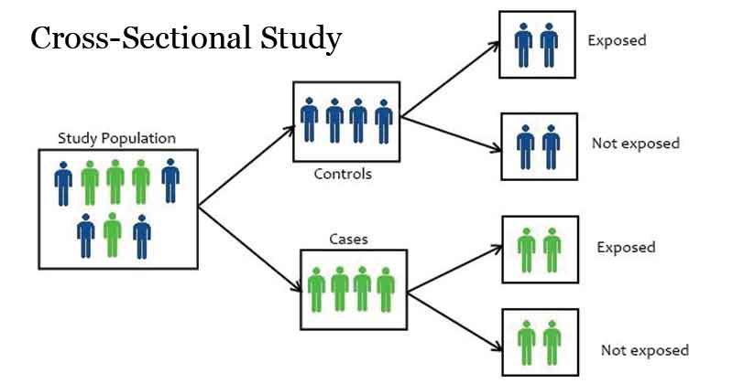
Figure 23: Importance of cross sectional method
(Source: Rindfleisch et al., 2008)

3.11 Ethical Considerations
Proper ethics have been maintained in order to conduct the research. After the survey questionnaires have been formed, the questions have been submitted to the supervisor. The supervisor allowed the research to proceed with a quantitative data collection method. In case of the survey, no out of the context and personal questions have been asked to the customers that may hamper the quality of the survey or hurt the sentiments of the survey participants. Furthermore, the data which has been collected during the survey has been protected with strong password and has been stored in encrypted cloud storage. Likewise, it has also been written and confirmed in the consent form that all the data collected during the survey has been deleted from the records. Finally, the research study has followed all the rules propagated by the Data Protection Act 2018.

3.12 Summary
On the basis of the above discussion, it has been understood that a positivism philosophy has been selected for the proposed research topic. Furthermore, Inductive research approach has been selected in order to conduct the research as the research aim indicates a new perspective which has not been discussed unexplored in previous works. In addition to that, a primary quantitative data collection method has been chosen in order to gain an accurate research outcome. 80 small-scale restaurant executives of India have been chosen in order to collect numerical data. Likewise, Mono quantitative research choice has been considered as the study comprises a survey which is a numerical data collection method. Additionally, Descriptive quantitative research design has been chosen for the research study as the research consists of a survey with 80 small scale restaurant executives of India. On the other hand, a purposive sampling technique has been considered for quantitative data collection methods. The purposive sampling technique has been chosen due to the fact that the current research has a particular purpose which can be executed with this sampling technique. Furthermore, Cross-sectional method has also been considered for the current study as it helps to conclude the research study within a short period of time. At last, proper ethics has been maintained as the supervisor has allowed the research to proceed with a quantitative data collection method.

CHAPTER 4

DATA COLLECTION AND ANALYSIS OF FINDINGS

4.1 Introduction
The following section is about the data collection procedure which has been decided and elaborated in the previous section of methods. This section provides the data collection method and its overall analysis to formulate the discussion and conclusion part of the research. The research has taken surveys as the form of primary quantitative research to analyze the selected participants. The participants are restaurant executives of Indian small-scale restaurants whose important feedback can improve the quality of the data collection method via the survey.

4.2 Data Collection and analysis
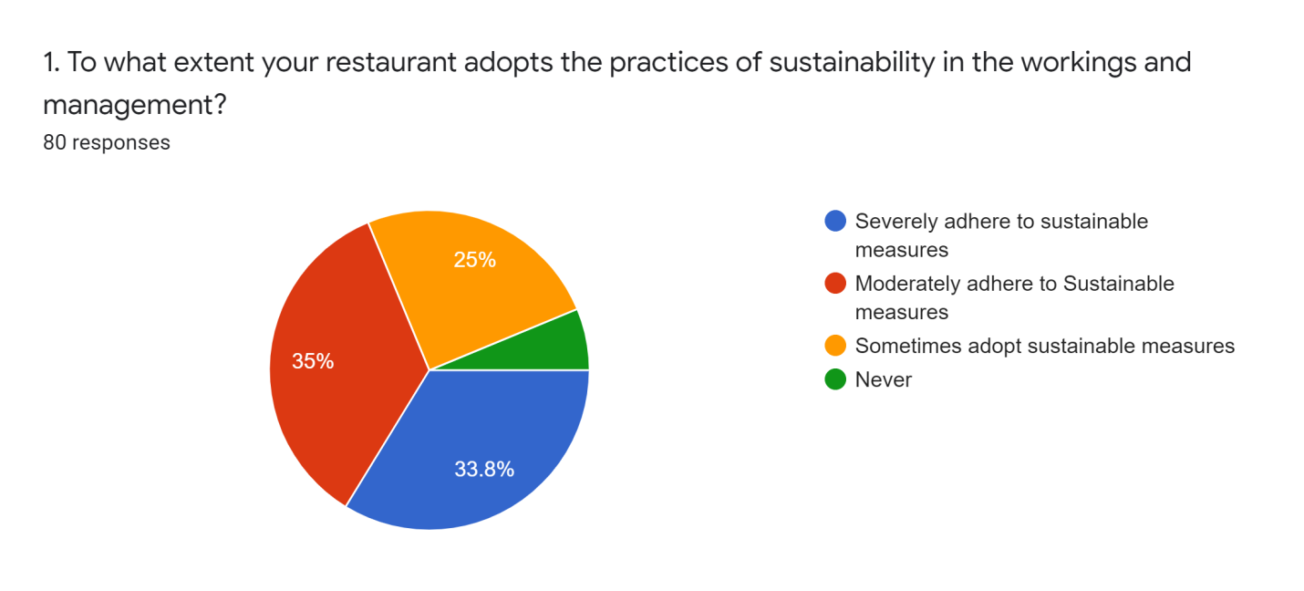
Figure 24: Pie chart of 1st survey question responses
Particulars | No. of Respondents | No. of Responses | Response Percentage
Severely adhere to sustainable measures | 80 | 27 | 33.8
Moderately adhere to Sustainable measures | 80 | 28 | 35
Sometimes adopt sustainable measures | 80 | 20 | 25
Never | 80 | 5 | 6.3

Table 1: Responses to Survey question 1
Analysis: From the table above it may be stated that the maximum number of the small scale Indian restaurants severely adhere to sustainable measures. It could be due to the fact sustainable activities in restaurants in reality favour the company by decreasing the operational expense. Reducing the carbon footprint generated by the restaurant, therefore reducing waste entails saving capital. The reason for moderately adhering to sustainable practices the majority of natural commodities that small scale restaurants incorporate on a daily basis are vegetables and meat that are natural and biodegradable substances, most of the small scale restaurants have reusable cutlery and utensils thereby, they naturally adhere to the sustainable practices that also helps them cut costs. The fast food small scale restaurant chains and delivery/ Tiffin service based restaurants might rarely or never adhere to the sustainable practices given that plastic containers and aluminum foils are widely used by these restaurants. Whereas, the takeaway services in small scale Indian restaurants are found to often resort to plastic cutlery in order to cut costs on expensive renewable sets.
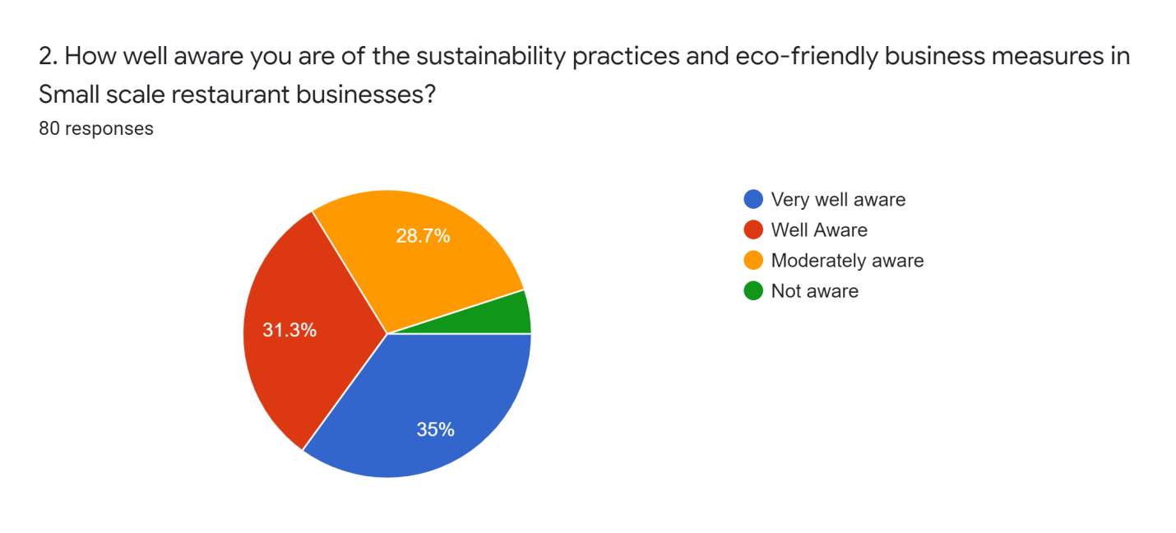
Figure 25: Pie chart of 2nd survey question responses
Particulars | No. of Respondents | No. of Responses | Response Percentage
Very well aware | 80 | 28 | 35
Well Aware | 80 | 25 | 31.3
Moderately aware | 80 | 23 | 28.7
Not aware | 80 | 4 | 5
Table 2: Responses to Survey question 2
Analysis: It may be noted that most of the small scale restaurant businesses in India are only moderately aware about the sustainable measures and eco-friendly business options. This is due to the fact that the literacy rate in the country is only 74.04 %., thereby people and restaurant owners may not be well aware about the sustainable practices and measures that can be adopted in their restaurants. The reason for restaurant executives being well aware regarding the sustainable practices indicating enhancing sustainability in business operation. Individuals in India are becoming more responsible and mindful of the global issues with respect to climate change and sustainability. However, the practice of sustainability among small scale restaurant owners in the country is not well known, resulting in a number of restaurants not being fully aware of the concept of eco-friendly and sustainable business.
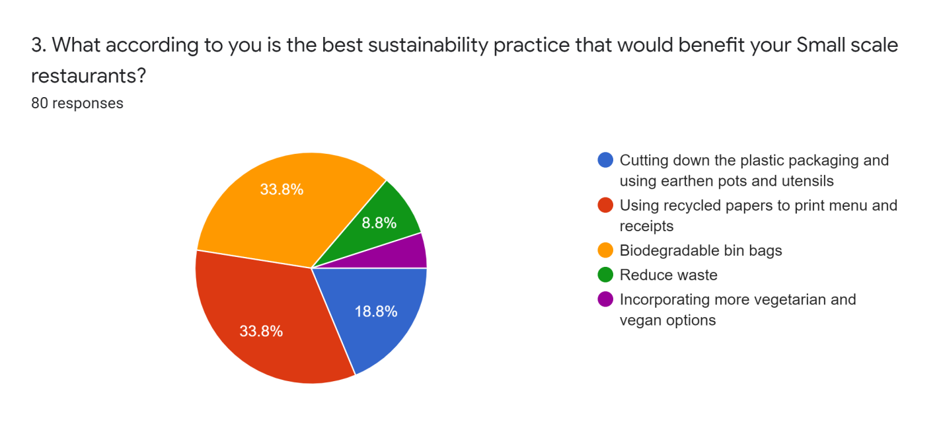
Figure 26: Pie chart of 3rd survey question responses

Particulars | No. of Respondents | No. of Responses | Response Percentage
Cutting down the plastic packaging and using earthen pots and utensils | 80 | 15 | 18.8
Using recycled papers to print menu and receipts | 80 | 27 | 33.8
Biodegradable bin bags | 80 | 27 | 33.8
Reduce waste | 80 | 7 | 8.8
Incorporating more vegetarian and vegan options | 80 | 4 | 5
Table 3: Responses to Survey question 3
Analysis: Oil retention capacity of food cooked in earthen pots are more thereby keeping the dishes moist, thereby consuming less fact while cooking, attracting more health conscious and environmentally aware customers to the restaurant, increasing the brand value. Using recycled paper to write menu and print receipts will help reduce the operating cost of the restaurants. Including vegetarian has the added benefit of increasing an increasingly rising customer base that is especially concerned about the environment. Recyclable bin bags disintegrate whereas traditional bin bags could take many years to break down. Functioning in a manner that protects, maintains, or repairs the ecological landscape, encourages social justice, improves the wellbeing of individuals and societies, and adds to economic stability for owners and investors is that sustainability entails for restaurants.

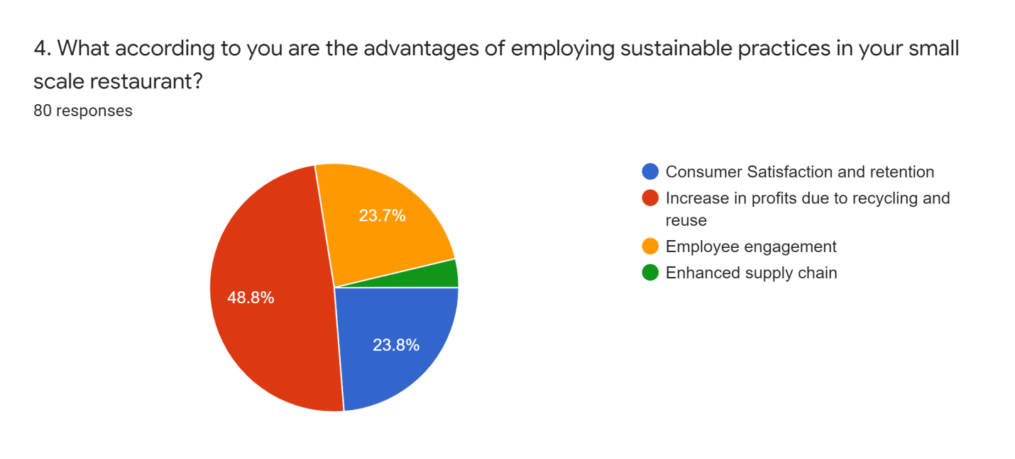
Figure 27: Pie chart of 4th survey question responses
Particulars | No. of Respondents | No. of Responses | Response Percentage
Consumer Satisfaction and retention | 80 | 19 | 23.8
Increase in profits due to recycling and reuse | 80 | 39 | 48.8
Employee engagement | 80 | 19 | 23.7
Enhanced supply chain | 80 | 3 | 3.7
Table 4: Responses to Survey question 4

Analysis: In general, longevity applies to an organizational capacity to continue working in the current and potential. It refers to the capacity to continue or sustain an action or mechanism over time. Customer loyalty is critical to the growth of small scale Indian restaurants, and it aids in developing strong relationships with the trusted clients. Recycling and reusing is not only a smart strategy to protect the earth and decrease pollution but it is also a simple option to save revenue, where reusing utensils and cutlery saves the additional cost of purchasing new ones and the linens used in the dinner service may also be washed, cleaned and reused to save the operating costs. Thereby, small scale restaurants in India were found to be incorporating sustainable practices, owing to the organizational profits incurred. Small scale Indian restaurants as well as fast food franchises often find that eliminating waste especially increasing recycling has a huge effect on waste management and treatment costs.
Recycling systems not only minimize waste and raise money but also give restaurants a more sustainable profile. Sustainability measures and practice in small scale restaurants and employee engagement involve time so creating a consistently productive staff that is eager to make a difference would help the growth of a profitable business. Small scale Indian restaurants may save energy, improve operations, discover product technologies, save money, maximize efficiency, and foster brand culture by monitoring and enhancing cultural, social, as well as economic output within supply chains.
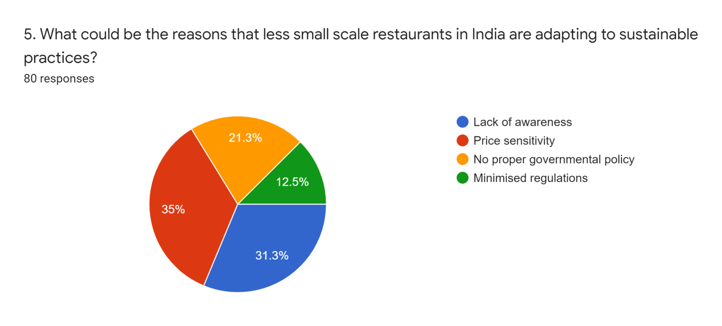
Figure 28: Pie chart of 5th survey question responses

Particulars | No. of Respondents | No. of Responses | Response Percentage
Lack of awareness | 80 | 25 | 31.3
Price sensitivity | 80 | 28 | 35
No proper governmental policy | 80 | 17 | 21.3
Minimised regulations | 80 | 10 | 12.5
Table 5: Responses to Survey question 5
Analysis: It has been noted that most of the small scale restaurants are not well aware about the practice of sustainability in the food and beverage sector and the added organizational benefits of the same.
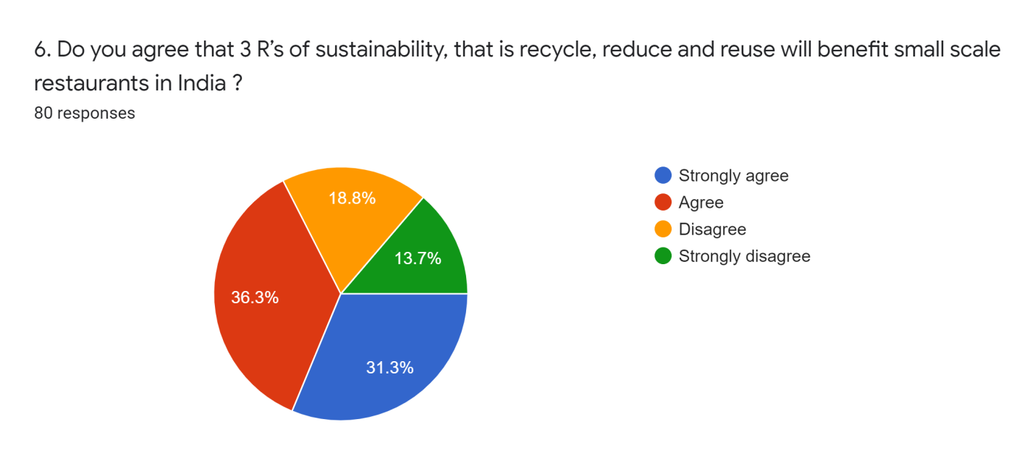
Figure 29: Pie chart of 6th survey question responses
Particulars | No. of Respondents | No. of Responses | Response Percentage
Strongly agree | 80 | 25 | 31.3
Agree | 80 | 29 | 36.3
Disagree | 80 | 15 | 18.8
Strongly disagree | 80 | 11 | 13.7
Table 6: Responses to Survey question 6
Analysis: On the basis of the above table, it has been understood that most of the respondents agree that recycle, reduce and reuse can be beneficial for small-scale restaurants of India. On the other hand, very few participants have not agreed with the fact that recycle, reduce and reuse can be beneficial for small-scale restaurants of India.
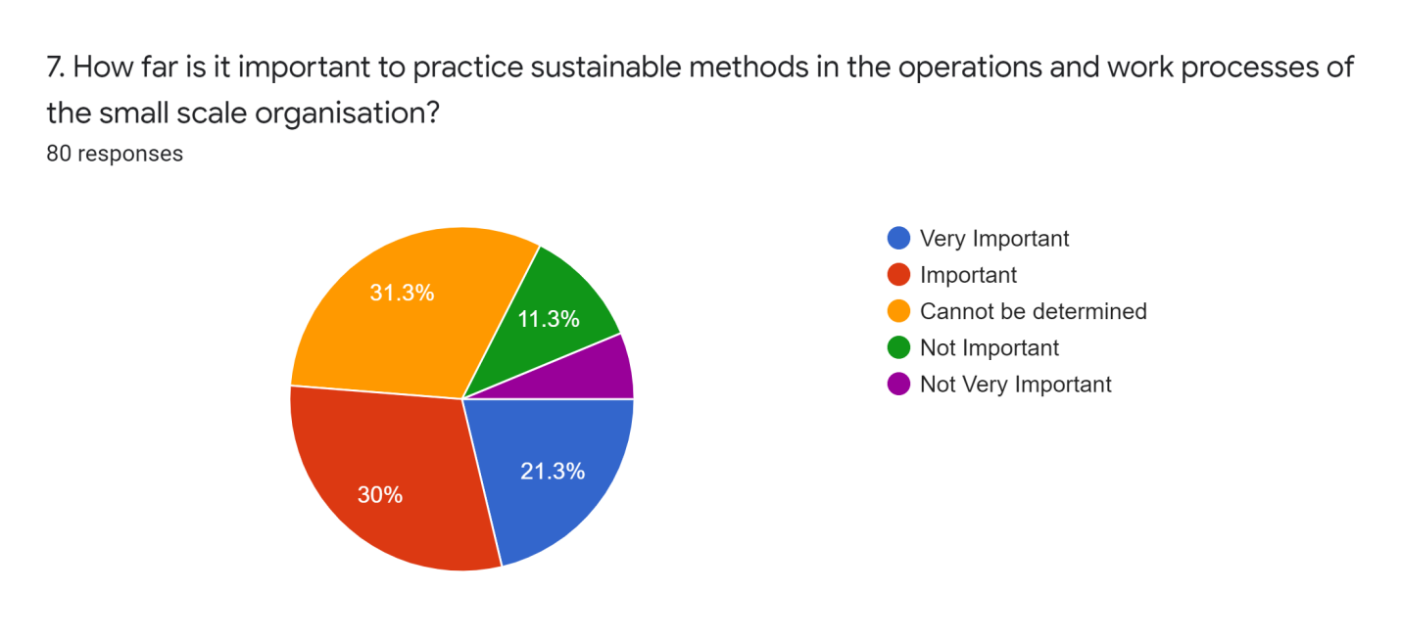

Figure 30: Survey Response of Question 7

Particulars | No. of Respondents | No. of Responses | Percentage
Very Important | 80 | 17 | 21.3%
Important | 80 | 24 | 30%
Cannot be determined | 80 | 25 | 31.3%
Not Important | 80 | 9 | 11.3%
Not Very Important | 80 | 5 | 6.3%

Table 7: Survey Response of Question 7
Analysis:
From the above table, it can be inferred that the maximum number of respondents of the survey feels that it is important for all the small scale business ventures operating in the food industry of India to abide and follow the protocols of sustainability for bringing effective development in terms of sales and profitability. Moreover, associating sustainability with the workforce of the small scale business will enable the brand to enhance its image in the market as well as save resources for future needs. Furthermore, certain respondents are uncertain with regards to the effects of sustainability on the business due to its novel and unique proposition which have not gained enough recognition in the Indian small market industries due to its limited exposures persisting in the global context.

Sustainable methods require mass awareness and training programs for the application of its effective use in the frameworks of small scale organizations which are suspicious and doubtful with regards to the benefits of sustainability due to which certain respondents may not find the approach feasible or important. Therefore, for the given data it could be analyzed that there is high scope and prospects for small scale brands to enhance their position in the current and future market by applying and exploring the offerings of sustainable approach for mitigating tier objectives and goals.
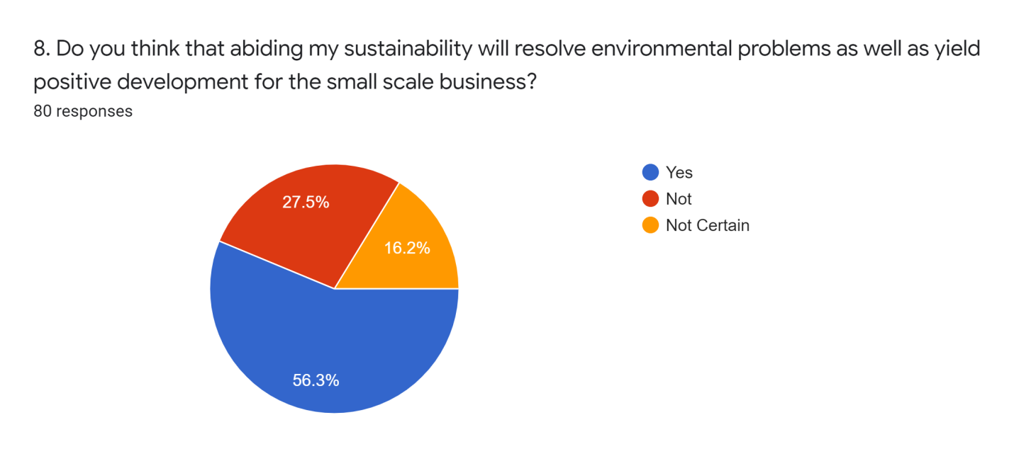
Figure 31: Survey Response of Question 8
Particulars | No. of Respondents | No. of Responses | Percentage
Yes | 80 | 45 | 56.3%
No | 80 | 22 | 27.5%
Not Certain | 80 | 13 | 16.2%

Table 8: Survey Response of Question 8
Analysis:
The above given table highlights the perspective and understanding of the population with regards to the overall capacity of sustainability for improving the present conditions of the human society, environment and the operating small scale business ventures. The participants of the survey highly believe that aligning the activities and operations of the organization will help in improving the current situation of the planet and help in the conservation of the environment for ensuring future survival of the human civilization on Earth. Additionally, sustainable development has enough potential for resolving the problems persisting in the small-scale business ventures persisting in the food sector for delivering quality products to its customers.

However, the role and results of sustainable development are low due to its limited exploration which makes the participants prone to its application in the workforce of the organization. In addition to that, a portion of the participants are also confused due to lack of awareness and information which can possibly result in uncertain implication hampering the development of the business in the global market context. Therefore, it is significant to launch effective awareness programs for having a clear purview of the direction and impact of sustainable development on the small scale restaurants operating in India and worldwide.
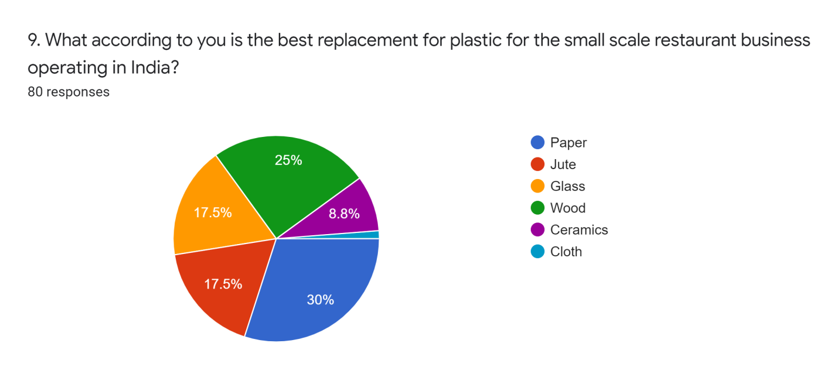
Figure 32: Survey Response of Question 9
Particulars | No. of Respondents | No. of Responses | Percentage
Paper | 80 | 24 | 30%
Jute | 80 | 14 | 17.5%
Glass | 80 | 14 | 17.5%
Wood | 80 | 20 | 25%
Ceramics | 80 | 7 | 8.8%
Cloth | 80 | 1 | 1.2%

Table 9: Survey Response of Question 9
Analysis:
The above responses depicted in the table, provide the insights of the participants with regards to their thought process and understanding for determining the materials for replacing plastic for developing a sustainable society. It can be evaluated that a maximum number of respondents believe that paper and wood can be effective agents for eliminating the use of plastic in the operations, packaging and distribution procedures of the food based industries. Both wood and paper are biodegradable wastes which can be reused after recycling the materials for reducing the overall production cost of the small scale brands to make maximum profits. Moreover, it enables the brand to yield positive exposure by reflecting sustainable methods of developing and packaging goods for enhancing customer engagement and positive marketing of the goods. In comparison to other materials such as jute, glass, ceramics and cloth, the production and maintenance cost of paper and wood are much more reasonable which makes it the most popular choice for the replacement of plastic which aids the small scale food based industries to manufacture large quantities of products with high quality for mitigating the requirements of the entire population of the country as well as make a surplus profit through indulging in business with the international market.
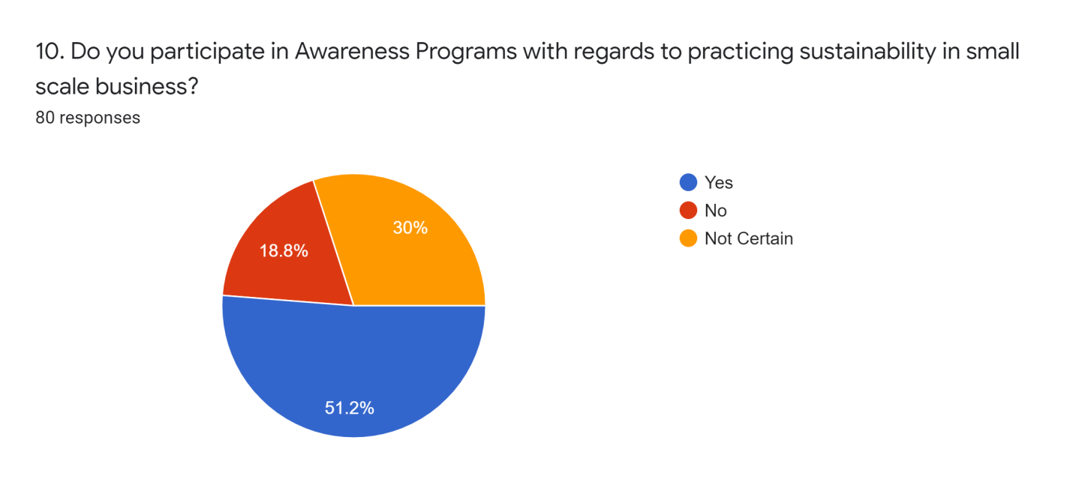
Figure 33: Survey Response of Question 10

Particulars | No. of Respondents | No. of Responses | Percentage
Yes | 80 | 41 | 51.2%
No | 80 | 15 | 18.8%
Not Certain | 80 | 24 | 30%

Table 10: Survey Response of Question 10

Analysis:
From the above responses highlighted in the table, it can be examined that the maximum participants of the survey play an active role for undertaking the programs and activities of sustainability for developing a clear understanding of the offerings and benefits aligned with it. High numbers of respondents are actively involved in exploring the scopes and prospects of sustainable development for applying its use in the small scale restaurant businesses for enhancing its profits and image in the market.

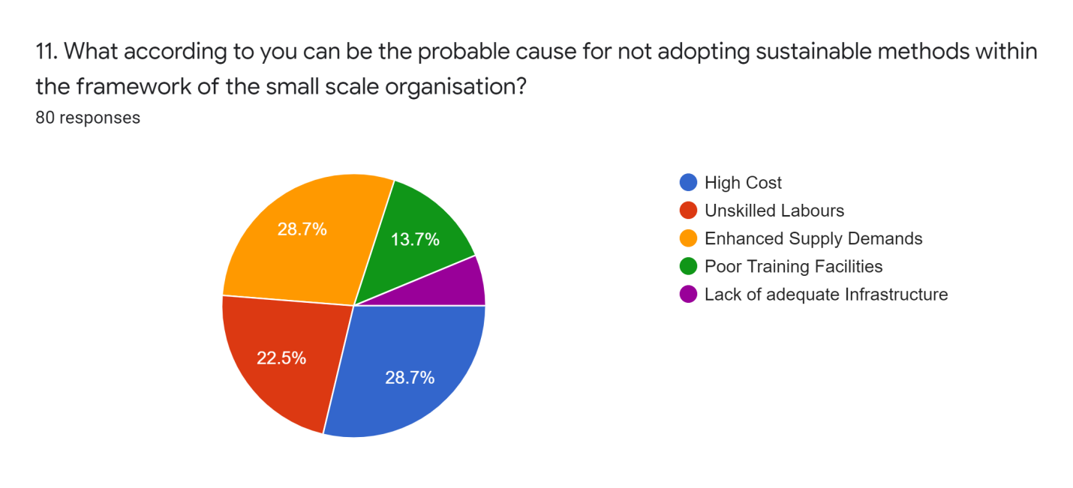
Whereas, on the other hand, relatively half of the participants of the survey are not indulged in the sustainability welfare schemes or are uncertain of its implications and benefits resulting in having neutral take towards the program. This can be due to inadequate information and lack of awareness as well as the requirement of large labor and funds for the effective development of the infrastructure and the business. The availability of limited resources and capital investment makes it infeasible and unfit practice for the majority of the small scale brands. Not all the brands can afford to practice the approaches of sustainability which can potentially possess high risk to the overall survival of the company in the market.

Figure 34: Survey Response of Question 11

Particulars | No. of Respondents | No. of Responses | Percentage
High Cost | 80 | 23 | 28.7%
Unskilled Labors | 80 | 18 | 22.5%
Enhanced Supply Demands | 80 | 23 | 28.7%
Poor Training Facilities | 80 | 11 | 13.7%
Lack of adequate Infrastructure | 80 | 5 | 6.3%

Table 11: Survey Response of Question 11
Analysis:
The above data of the table analyses the factors behind the limited number of businesses applying the practice of sustainability. Based on the responses of the participants, it can be rightly said that the majority of the organization do not have high funds for enrolling to the application of sustainability. Moreover, the heavy demand of supplies and raw materials including the equipment and advanced machines which are of utmost importance for manufacturing goods further burdens the company with additional costs of production. In addition to that, lack of proper training facilities and inadequate expertise and skill in the workers of small scale Indian restaurants also plays a major role for unpopularity of the sustainable practices of developing businesses. The practice of sustainable methods tends to burden the management with extra cost for programming effective strategies and developing advanced infrastructure for the skilled workforce for producing enhanced quality goods. The management of the small scale enterprises of the food based industries do not allocate funds for conducting proper training and orientation sessions for sharpening the skill sets of the labors resulting in the function of traditional methods of manufacturing and packaging as well as distributing goods.
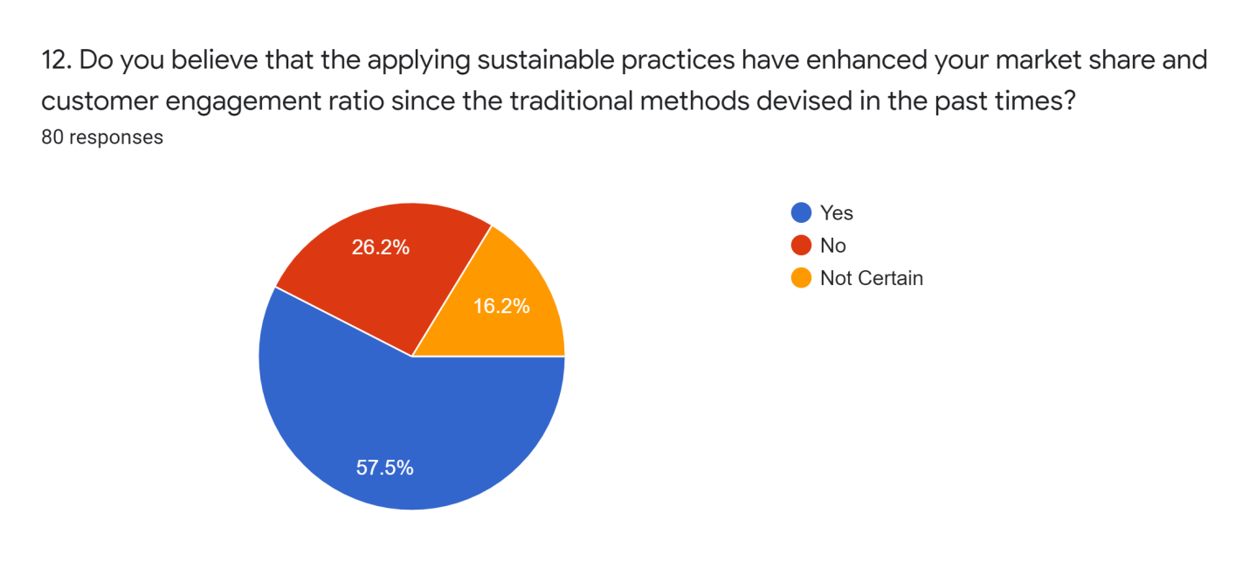
Figure 35: Survey Response of Question 12

Particulars | No. of Respondents | No. of Responses | Percentage
Ye | 80 | 46 | 16.2%
No | 80 | 21 | 26.2%
Not Certain | 80 | 13 | 57.5%

Table 12: Survey Response of Question 12
Analysis:
From the above image, it can be evaluated that maximum number of participants are uncertain with regards to the application sustainability in the small scale restaurants operating in India. The participants of the survey believe that the offerings of sustainable living and developing is a myth which cannot be operated in the roots of Indian subcontinent due to poor exposure and knowledge of the management as well as of the workers functioning in the small scale restaurants. Only a limited number of the participants feel that the sustainable approaches have the capacity and potential to resolve the present problems of work and the environment than the traditional old methods. In contrast to that, the majority of the Indian workforces are prone to change and rely on traditional methods for improving and developing the business rather than utilizing the benefits of modern approaches due high suspicions and contradictions based on stereotypes and prejudices. Therefore, for understanding the overall purview of sustainable development, it is vital for exploring the whole domain of knowledge for gathering effective information of the benefits and drawbacks elicited by sustainability in order to form the most adequate strategy for operating the business efficiently.

CHAPTER 5

FINDINGS AND DISCUSSION

5.1 Findings
Based on the data analysis part which has been discussed in the above section, there are several findings that came into existence. Findings are based on the survey analysis which was executed in the previous section. Sustainable activities in restaurants in reality offer the company better operational expenses by decreasing it. The reason for moderately adhering to sustainable practices of the majority of natural commodities that small scale restaurants incorporate on a daily basis are vegetables and meat that are natural and biodegradable substances. Furthermore, it has also been found that the reason for restaurant executives is well aware about the sustainable practices which indicate enhancing sustainability in business operations. Individual business operations in India are becoming more and more responsible and mindful about the global issues with respect to climate change and sustainability.

In addition to that, recyclable bin bags disintegrate whereas traditional bin bags could cause environmental problems as it takes many years to disintegrate. Likewise, small scale restaurants in India were found to be incorporating sustainable practices, owing to the organizational profits incurred. Small scale Indian restaurants as well as fast food franchises often find that eliminating waste especially increasing recycling has a huge effect on waste management and treatment costs. Additionally, sustainable methods require mass awareness and training programs for the application of its effective use in the frameworks of small scale organizations which are suspicious and doubtful with regards to the benefits of sustainability due to which certain respondents may not find the approach feasible or important. Furthermore, it is significant to launch effective awareness programs for having a clear purview of the direction and impact of sustainable development on the small scale restaurants operating in India and worldwide. Biodegradable wastes enable the brand to yield positive exposure by reflecting sustainable methods of developing and packaging goods for enhancing customer engagement and positive marketing of the goods.

The availability of limited resources and capital investment makes it infeasible and unfit practice for the majority of the small scale brands. The practice of sustainable methods tends to burden the management with extra cost for programming effective strategies and developing advanced infrastructure for the skilled workforce for producing enhanced quality goods. For understanding the overall purview of sustainable development, it is vital for exploring the whole domain of knowledge for gathering effective information of the benefits and drawbacks elicited by sustainability in order to form the most adequate strategy for operating the business efficiently.

5.2 Discussion
As per the ideas of Perramon et al. (2014), the restaurants have started to include green practices within the eating palace for the customers as it can improve the sustainability practices. In addition to that, being aware about the environmental issues has benefitted the restaurant industry to manage and enhance sustainability practices. However, it should also be noted that the restaurant industry requires the special assistance of motivation which makes them work on new sustainability practices. Furthermore, the evolution of a suitable and reliable economy that tends to create sustainability in the small scale Indian restaurants and create awareness among the restaurant owners. The model of sustainability provides assistance to gain focus on the utilization of resources in a limited manner for the enhancement of values in the creation of sustainability (Perramon et al., 2014).

Moreover, as stated by Kopnina (2017), there are several challenges which need to be addressed by the restaurant management; otherwise it can impact the performance of the industry. The challenges are an unhealthy eating environment, huge population growth in smaller eating places making it difficult to maneuver the food supplies. The possible solutions for these problems require big and airy eating places and green management within the restaurant industry. In addition to that, as opined by Prata et al. (2019), recyclable plastics are the best solution for the restaurant industry as it includes biodegradable elements which cause very less Micro plastic pollution. In order to improve the plastic production efficiency and its lifetime, there are several things which are needed to be incorporated such as using alternative (e.g., glass), recycled, or biodegradable materials; improving the design of the plastics to extend its longevity; banning certain types of single-use plastics (e.g., carry bags, plastic drinking bottles, plastic bottle caps, food wrappers, plastic grocery bags, plastic sachets, plastic wrappers). Single uses plastics can single handedly destroy the equilibrium of the environment which can impact the business operation of the restaurants. Moreover, as per the writings of Bhuyan (2017), in the newspaper article of The Economics Times, the author has elaborated that the Indian small -scale restaurants have started improving their sustainable dining in order to improve the customer reviews as well as the quality of the foods.

In addition to that, Avantika Bhuyan (2017) has also shared personal experience by saying, "Today, chefs and restaurateurs are working with producers such as Bhatia to further the cause of sustainable dining — a movement which started haltingly a couple of years ago, but is slowly gathering pace in India" (Bhuyan, 2017). In addition to that, another The Economics Times article has been dedicated to describe the sustainable development within the Indian restaurant industry. The writers, Sreeradha D Basu and Varuni Khosla (2019), have elaborated the impact of sustainable development within the Indian small-scale restaurant. According to them, being a part of small-scale Indian restaurants, sustainable development has played a big role in improving the aspects of future development and reaching targeted goals for the industry.

In addition to that, there are several aspects that the small-scale restaurants have taken into consideration, such as in-house organic gardens, strict farm-to-fork policies and consumer awareness and education initiatives to menus built around local, seasonal produce and reduction of the food loss (Basu and Khosla, 2019). Furthermore, as explained by Kiper (2013), as an initiative of improving sustainable development within the Indian small-scale restaurants, Ecotourism plays a big part in improving these areas. Ecotourism provides numerous improvements regarding customers as well as employee awareness about sustainable development within the Indian small-scale restaurant industry.

CHAPTER 6

CONCLUSION AND RECOMMENDATION

6.1 Conclusion
The dissertation report has focused on the aspects Indian small-scale restaurants and its sustainable development. The perception of the managers towards green practices as well as attitude and anticipated behavioral control also affects the adaptation of sustainable practices in the business operations. Customers pay more for the restaurants that have adopted green practices and sustainable practices in the market.
(Thereby, the first objective: To identify the sustainable practices that will be suitable for the small-scale restaurants in India, has justified and accepted).
Improving sustainable practices in small scale restaurants not only differentiate them from others as well as it provides sustainability in the community. The starting initial step towards sustainability comes from awareness and consciousness regarding green practices in the business operation. Employing sustainable practices in small scale Indian restaurants have multiple advantages that individuals want to invest their resources in sustainable methods, but they also want to gain in a sustainable manner.
(Henceforth, the second objective: To make the restaurant owners aware of the sustainability practices that will develop eco-friendliness in the restaurant business has been justified and therefore accepted).
In addition to that the packaging system of the small-scale restaurants in India should focus on the utilization of renewable or recycled materials that can be reused in the future. The containers for the delivery system should comprise reusable containers instead of plastic for creating eco-friendliness for the surrounding environment. This ensures the restaurant owners a sustainable standard of living in the establishment of small-scale restaurants in India with growth in resources with the utilization of technologies for balancing the ecosystems.
(Henceforth, the third and final objective: To assist the small-scale restaurant owners of India, for implementing the sustainability practices to enhance eco-friendliness in business operations, has been successfully evaluated, thereby its justified and accepted).

6.2 Recommendation
On the basis of the above study, it has been understood that Indian small-scale restaurants have shown the signs of sustainable improvements which might help them in future business propositions. However, it has also been seen that the restaurants can get benefits from new and possible methods in order to improve sustainable development. The recommendations are shown below,
- In order to gain competitive advantages in the market, operators of the restaurants should enhance customers’ experience and understand customers’ needs and expectations.
- A business plan should include business objectives, mission, vision, background and philosophy. Apart from that, business plans should include strength, weakness of the industry, and policies of marketing, price and operations as well as promotion strategies.
- The business plan sets goals for the business owners as well as for the employees and serves as a business tool for effective decision making.
- Small-scale restaurant owners should contact local suppliers of materials from machines to the supply of foods in bulk and make limited utilization in order to avoid waste generation.
- The packaging system of the small-scale restaurants in India should focus on the utilization of renewable or recycled materials that can be reused in the future.
- The containers for the delivery system should comprise reusable containers instead of plastic for creating eco-friendliness for the surrounding environment.
- The business prosperity depends on the functional approaches of the company which should be based on sustainability as it has the capacity for producing bulk of goods in limited and judicious use of resources, energy, costs and time.
- Digitalization of Guest Feedback in the Indian small-scale restaurants should make provision of online feedback of guests by the creation of restaurant websites where the guests can share their experience regarding the restaurant and the food menu.

6.3 Limitations of the study
The dissertation research study has elaborated the aspects of Indian small-scale restaurants and its related sustainable development. However, the research lacks several important aspects which are needed to improve the research study. The study lacks an overview about the entire restaurant industry of India. The study has only focused on small scale restaurants of India, which has prohibited the study to become a greater success. In addition to that, the limitation of data collection methods has also limited the study. The exclusion of primary qualitative research data has prohibited the research study to collect useful information from the managers of various restaurants in India. In addition to that, the limitation regarding time issues has also been faced as not enough research time has been provided which has resulted in not so good data collection procedure.

6.4 Future of the study
The future opportunities of the study is unlimited as future researchers can make good use of the data collected from small-scale Indian restaurants in regard to sustainable development. In addition to that, the information which is related to sustainable development can be beneficial for future usage for researchers. Furthermore, sustainability can be considered to be important for the attainment of the present requirements without wrong utilization of the future requirements by making modifications in the resources. This can be achieved by making stabilization and omitting the utilization of carbon footprints thereby, creating a sustainable environment. Additionally, as per the given research idea, it could be analyzed that there is high scope and prospects for small scale brands to enhance their position in the current and future market by applying and exploring the offerings of sustainable approaches for mitigating tier objectives and goals.

References
Abdelkafi, N. and Täuscher, K. (2016) ‘Business Models for Sustainability From a System Dynamics Perspective’. Organization & Environment, 29(1), pp. 74–96. DOI: 10.1177/1086026615592930.
Anastassiou-Hadjicharalambous, X. and Stylianou, M. (2011) ‘Longitudinal Methods’. In Goldstein, S. and Naglieri, J.A. (eds.) Encyclopedia of Child Behavior and Development. Boston, MA: Springer US, pp. 898–900. DOI: 10.1007/978-0-387-79061-9_1684.
Ashrafi, M. et al. (2018) ‘“How Corporate Social Responsibility Can Be Integrated into Corporate Sustainability: A Theoretical Review of Their Relationships”’. International Journal of Sustainable Development & World Ecology, 25(8), pp. 672–682. DOI: 10.1080/13504509.2018.1471628.
Azungah, T. (2018) ‘Qualitative Research: Deductive and Inductive Approaches to Data Analysis’. Qualitative Research Journal, 18(4), pp. 383–400. DOI: 10.1108/QRJ-D-18-00035.
B. DiPietro, R., Cao, Y. and Partlow, C. (2013) ‘Green Practices in Upscale Foodservice Operations: Customer Perceptions and Purchase Intentions’. International Journal of Contemporary Hospitality Management, 25(5), pp. 779–796. DOI: 10.1108/IJCHM-May-2012-0082.
Bansal, P. and DesJardine, M.R. (2014) ‘Business Sustainability: It Is about Time’. Strategic Organization, 12(1), pp. 70–78. DOI: 10.1177/1476127013520265.
Barbier, E.B. and Burgess, J.C. (2017) ‘The Sustainable Development Goals and the Systems Approach to Sustainability’. Economics: The Open-Access, Open-Assessment E-Journal. DOI: 10.5018/economics-ejournal.ja.2017-28.
Bardhan, R., Debnath, R. and Jana, A. (2019) ‘Evolution of Sustainable Energy Policies in India since 1947: A Review’. Wiley Interdisciplinary Reviews: Energy and Environment, 8(5). DOI: 10.1002/wene.340.
Barro, R., Ursúa, J. and Weng, J. (2020) (w26866) The Coronavirus and the Great Influenza Pandemic: Lessons from the “Spanish Flu” for the Coronavirus’s Potential Effects on Mortality and Economic Activity. Cambridge, MA: National Bureau of Economic Research DOI: 10.3386/w26866.
Bharucha, J. (2018) ‘Tackling the Challenges of Reducing and Managing Food Waste in Mumbai Restaurants’. British Food Journal, 120(3), pp. 639–649. DOI: 10.1108/BFJ-06-2017-0324.
Bhuyan, A. (2017) ‘Millennial India Is Slowly and Steadily Advocating Sustainable Dining Read More at: Https://Economictimes.Indiatimes.Com/Magazines/Panache/Sustainable-Dining-a-Movement-That-Is-Gathering-Pace/Articleshow/60235500.Cms?Utm_source=contentofinterest&utm_medium=text&utm_campaign=cppst’. Available at: https://economictimes.indiatimes.com/magazines/panache/sustainable-dining-a-movement-that-is-gathering-pace/articleshow/60235500.cms?from=mdr.
Boyer, R. et al. (2016) ‘Five Approaches to Social Sustainability and an Integrated Way Forward’. Sustainability, 8(9), p. 878. DOI: 10.3390/su8090878.
Camilleri, M.A. (2017) ‘Corporate Sustainability and Responsibility: Creating Value for Business, Society and the Environment’. Asian Journal of Sustainability and Social Responsibility, 2(1), pp. 59–74. DOI: 10.1186/s41180-017-0016-5.
Cavusoglu, M. (2015) An Analysis of Technology Applications in the Restaurant Industry. scholarcommons.usf.edu. Available at: https://scholarcommons.usf.edu/cgi/viewcontent.cgi?referer=&httpsredir=1&article=6654&context=etd.
Chakrabarty, S. and Wang, L. (2012) ‘The Long-Term Sustenance of Sustainability Practices in MNCs: A Dynamic Capabilities Perspective of the Role of R&D and Internationalization’. Journal of Business Ethics, 110(2), pp. 205–217. DOI: 10.1007/s10551-012-1422-3.
Chattopadhyay, N. and Shah, M. (2014) ‘Exploring Effect of Service Innovation on Business Performance of Restaurants in India’. International Journal of Business Innovation and Research, 8(3), p. 252. DOI: 10.1504/IJBIR.2014.060827.
Davis, K.F. et al. (2019) ‘Assessing the Sustainability of Post-Green Revolution Cereals in India’. Proceedings of the National Academy of Sciences, 116(50), pp. 25034–25041. DOI: 10.1073/pnas.1910935116.
Dewald, B., Bruin, B.J. and Jang, Y.J. (2014) ‘US Consumer Attitudes towards “Green” Restaurants’. Anatolia, 25(2), pp. 171–180. DOI: 10.1080/13032917.2013.839457.
Dewan, G. (2019) Innovation: The Driving Force of Food Retail in India. www.restaurantindia.in. Available at: https://www.restaurantindia.in/article/innovation-the-driving-force-of-food-retail-in-india.12841.
Dhir, A. et al. (2020) ‘Food Waste in Hospitality and Food Services: A Systematic Literature Review and Framework Development Approach’. Journal of Cleaner Production, 270, p. 122861. DOI: 10.1016/j.jclepro.2020.122861.
Dzhengiz, T. and Niesten, E. (2020) ‘Competences for Environmental Sustainability: A Systematic Review on the Impact of Absorptive Capacity and Capabilities’. Journal of Business Ethics, 162(4), pp. 881–906. DOI: 10.1007/s10551-019-04360-z.
E. Halabí, C. and N. Lussier, R. (2014) ‘A Model for Predicting Small Firm Performance: Increasing the Probability of Entrepreneurial Success in Chile’. Journal of Small Business and Enterprise Development, 21(1), pp. 4–25. DOI: 10.1108/JSBED-10-2013-0141.
FICCI. (2017) Indian Food Services Industry: Engine for Economic Growth & Employment A Roadmap for Unlocking Growth Opportunities. massmerize.com. Available at: http://massmerize.com/foodzania/wp-content/uploads/2017/11/Final-Report-2017.pdf.
Flowers, P. (2020) ‘Research Philosophies – Importance and Relevance 0. Introduction’. 2020. Available at: https://www.semanticscholar.org/paper/Research-Philosophies-%E2%80%93-Importance-and-Relevance-0.-Flowers/9b8a94a6a47441054742f4d70e44aeb540d6478c.
Foxall, G. (2014) Strategic Marketing Management (RLE Marketing). 1st Edition. Routledge DOI: 10.4324/9781315762043.
Freeman, E. (2011) Restaurant Industry Sustainability: Barriers and Solutions to Sustainable Practice Indicators. Repository.asu.edu. Available at: https://repository.asu.edu/attachments/56588/content/Freeman_asu_0010N_10634.pdf.
G. R., J., Natarajan, T. and Chandrasekar, K.S. (2019) ‘Digital Food Delivery Apps Revolutionizing Food Products Marketing in India’. International Journal of Recent Technology and Engineering, 8(2S6), pp. 662–665. DOI: 10.35940/ijrte.B1126.0782S619.
Gadenne, D.L., Kennedy, J. and McKeiver, C. (2009) ‘An Empirical Study of Environmental Awareness and Practices in SMEs’. Journal of Business Ethics, 84(1), pp. 45–63. DOI: 10.1007/s10551-008-9672-9.
Gallego-Schmid, A., Mendoza, J.M.F. and Azapagic, A. (2019) ‘Environmental Impacts of Takeaway Food Containers’. Journal of Cleaner Production, 211, pp. 417–427. DOI: 10.1016/j.jclepro.2018.11.220.
Gaviglio, A. et al. (2016) ‘The Social Pillar of Sustainability: A Quantitative Approach at the Farm Level’. Agricultural and Food Economics, 4(1), p. 15. DOI: 10.1186/s40100-016-0059-4.
Geissdoerfer, M., Vladimirova, D. and Evans, S. (2018) ‘Sustainable Business Model Innovation: A Review’. Journal of Cleaner Production, 198, pp. 401–416. DOI: 10.1016/j.jclepro.2018.06.240.
Goodman, A. (2000) ‘Implementing Sustainability in Service Operations at Scandic Hotels’. Interfaces, 30(3), pp. 202–214. DOI: 10.1287/inte.30.3.202.11653.
Gulagi, A. et al. (2017) ‘Electricity System Based on 100% Renewable Energy for India and SAARC’ Merk, B. (ed.). PLOS ONE, 12(7), p. e0180611. DOI: 10.1371/journal.pone.0180611.
Hans, V.B. (2011) ‘Food Security and Sustainability in India’. SSRN Electronic Journal. DOI: 10.2139/ssrn.1745465.
Hillary, R. (2017) Small and Medium-Sized Enterprises and the Environment: Business Imperatives. Available at: http://www.myilibrary.com?id=1034756 (Accessed: 1 February 2021).
Iravani, A., akbari, M.H. and Zohoori, M. (2017) ‘Advantages and Disadvantages of Green Technology; Goals, Challenges and Strengths’. International Journal of Science and Engineering Applications, 6(9), pp. 272–284. DOI: 10.7753/IJSEA0609.1005.
Ivkov, M. et al. (2016) ‘Innovations in the Restaurant Industry: An Exploratory Study’. Ekonomika Poljoprivrede, 63(4), pp. 1169–1186. DOI: 10.5937/ekoPolj1604169I.
Jacobs, G. and Klosse, P. (2016) ‘Sustainable Restaurants: A Research Agenda’. Research in Hospitality Management, 6(1), pp. 33–36. DOI: 10.2989/RHM.2016.6.1.4.1292.
Jaganmohan (2020) Share of Rural Population Having Access to Safe Drinking Water in India from Financial Year 2016 to 2020. Available at: https://www.statista.com/statistics/1130441/india-rural-population-with-access-to-safe-drinking-water/.
Jang, Y.J. (2016) ‘Environmental Sustainability Management in the Foodservice Industry: Understanding the Antecedents and Consequences’. Journal of Foodservice Business Research, 19(5), pp. 441–453. DOI: 10.1080/15378020.2016.1185880.
Kamath, A. (2019) Restaurant Industry: Top Technology Trends To Watch in 2019. www.restaurantindia.in. Available at: https://www.restaurantindia.in/article/restaurant-industry-top-technology-trends-to-watch-in-2019.13156.
Kasim, A. and Ismail, A. (2012) ‘Environmentally Friendly Practices among Restaurants: Drivers and Barriers to Change’. Journal of Sustainable Tourism, 20(4), pp. 551–570. DOI: 10.1080/09669582.2011.621540.
Kopnina, H. (2017) ‘Sustainability: New Strategic Thinking for Business’. Environment, Development and Sustainability, 19(1), pp. 27–43. DOI: 10.1007/s10668-015-9723-1.
Kostoska, O. and Kocarev, L. (2019) ‘A Novel ICT Framework for Sustainable Development Goals’. Sustainability, 11(7), p. 1961. DOI: 10.3390/su11071961.
Kotzab, H. (2005) ‘The Role and Importance of Survey Research in the Field of Supply Chain Management’. In Kotzab, H. et al. (eds.) Research Methodologies in Supply Chain Management. Heidelberg: Physica-Verlag, pp. 125–137. DOI: 10.1007/3-7908-1636-1_9.
Kumar, A. and Narain, V. (2014) ‘Public Policy and Governance in India’. Vision: The Journal of Business Perspective, 18(4), pp. 257–260. DOI: 10.1177/0972262914555815.
Kumar. J, C.R. and Majid, M.A. (2020) ‘Renewable Energy for Sustainable Development in India: Current Status, Future Prospects, Challenges, Employment, and Investment Opportunities’. Energy, Sustainability and Society, 10(1), p. 2. DOI: 10.1186/s13705-019-0232-1.
Kurunthachalam, S.K. (2014) ‘Water Conservation and Sustainability: An Utmost Importance’. Journal of Waste Water Treatment & Analysis, 05(02). DOI: 10.4172/2157-7587.1000e117.
Kwon, H. (2017) ‘Implications of the Sustainable Development Goals for Global Social Policy’. Global Social Policy, 17(2), pp. 206–209. DOI: 10.1177/1468018117703439.
Lo, A., King, B. and Mackenzie, M. (2017) ‘Restaurant Customers’ Attitude toward Sustainability and Nutritional Menu Labels’. Journal of Hospitality Marketing & Management, 26(8), pp. 846–867. DOI: 10.1080/19368623.2017.1326865.
Marom, S. and N. Lussier, R. (2014) ‘A Business Success Versus Failure Prediction Model for Small Businesses in Israel’. 4(2). DOI: 10.5296/ber.v4i2.599.
Martin, N. (2019) How Technology Is Transforming The Food Industry. www.forbes.com. Available at: https://www.forbes.com/sites/nicolemartin1/2019/04/29/how-technology-is-transforming-the-food-industry/?sh=66a1cb3820a3.
McKeever, M.P. (2017) How to Write a Business Plan.
Mensah, J. (2019) ‘Sustainable Development: Meaning, History, Principles, Pillars, and Implications for Human Action: Literature Review’ Ricart Casadevall, S. (ed.). Cogent Social Sciences, 5(1), p. 1653531. DOI: 10.1080/23311886.2019.1653531.
Moore, H.L. (2015) ‘Global Prosperity and Sustainable Development Goals: Global Prosperity and SDGs’. Journal of International Development, 27(6), pp. 801–815. DOI: 10.1002/jid.3114.
Morsing, M. and Spence, L.J. (2019) ‘Corporate Social Responsibility (CSR) Communication and Small and Medium Sized Enterprises: The Governmentality Dilemma of Explicit and Implicit CSR Communication’. Human Relations, 72(12), pp. 1920–1947. DOI: 10.1177/0018726718804306.
Namkung, Y. and Jang, S. (Shawn). (2017) ‘Are Consumers Willing to Pay More for Green Practices at Restaurants?’ Journal of Hospitality & Tourism Research, 41(3), pp. 329–356. DOI: 10.1177/1096348014525632.
Nassaji, H. (2015) ‘Qualitative and Descriptive Research: Data Type versus Data Analysis’. Language Teaching Research, 19(2), pp. 129–132. DOI: 10.1177/1362168815572747.
Nguyen, C.P., Su Dinh, T. and Nguyen, T. (2018) ‘Institutional Quality and Economic Growth: The Case of Emerging Economies’. 8(11), pp. 1943–1956. DOI: 10.1016/j.jbusres.2013.11.02.
Nielsen. (2015) WE ARE WHAT WE EAT. Nielsen. Available at: https://www.nielsen.com/ssa/en/insights/report/2015/we-are-what-we-eat/ (Accessed: 1 February 2021).
Nosratabadi, S. et al. (2019) ‘Sustainable Business Models: A Review’. Sustainability, 11(6), p. 1663. DOI: 10.3390/su11061663.
Nulkar, G. (2014) ‘Does Environmental Sustainability Matter to Small and Medium Enterprises? Empirical Evidence from India’. International Journal of Environmental Studies, 71(4), pp. 481–489. DOI: 10.1080/00207233.2014.924304.
Paradis, E. et al. (2016) ‘Design: Selection of Data Collection Methods’. Journal of Graduate Medical Education, 8(2), pp. 263–264. DOI: 10.4300/JGME-D-16-00098.1.
Parida, V. and Wincent, J. (2019) ‘Why and How to Compete through Sustainability: A Review and Outline of Trends Influencing Firm and Network-Level Transformation’. International Entrepreneurship and Management Journal, 15(1), pp. 1–19. DOI: 10.1007/s11365-019-00558-9.
Patra, R.K., Das, P. and Barkakati, U. (2016) ‘Corporate Social Responsibility and Its Impact on Consumer Behaviour - a Consumer’s Perspective’. International Journal of Sustainable Society, 8(4), p. 278. DOI: 10.1504/IJSSOC.2016.10003325.
Pedercini, M. et al. (2019) ‘Harvesting Synergy from Sustainable Development Goal Interactions’. Proceedings of the National Academy of Sciences, 116(46), pp. 23021–23028. DOI: 10.1073/pnas.1817276116.
Perramon, J. et al. (2014) ‘Green Practices in Restaurants: Impact on Firm Performance’. Operations Management Research, 7(1–2), pp. 2–12. DOI: 10.1007/s12063-014-0084-y.
Poveda, C.A. (2017) ‘The Theory of Dimensional Balance of Needs’. International Journal of Sustainable Development & World Ecology, 24(2), pp. 97–119. DOI: 10.1080/13504509.2016.1201019.
Press India Bureau (2019) ‘India Follows a Holistic Approach towards Its 2030 Sustainable Development Goals (SDGs)’. Available at: https://pib.gov.in/Pressreleaseshare.aspx?PRID=1577014.
Purvis, B., Mao, Y. and Robinson, D. (2019) ‘Three Pillars of Sustainability: In Search of Conceptual Origins’. Sustainability Science, 14(3), pp. 681–695. DOI: 10.1007/s11625-018-0627-5.
Raab, C., Baloglu, S. and Chen, Y.-S. (2018) ‘Restaurant Managers’ Adoption of Sustainable Practices: An Application of Institutional Theory and Theory of Planned Behavior’. Journal of Foodservice Business Research, 21(2), pp. 154–171. DOI: 10.1080/15378020.2017.1364591.
Randhawa, A. and Kumar, A. (2017) ‘Exploring Sustainability of Smart Development Initiatives in India’. International Journal of Sustainable Built Environment, 6(2), pp. 701–710. DOI: 10.1016/j.ijsbe.2017.08.002.
Rezaei, J. et al. (2019) ‘Sustainable Product-Package Design in a Food Supply Chain: A Multi-Criteria Life Cycle Approach’. Packaging Technology and Science, 32(2), pp. 85–101. DOI: 10.1002/pts.2418.
Riahi, K. et al. (2020) ‘Long-Term Economic Benefits of Stabilizing Warming without Overshoot – the ENGAGE Model Intercomparison’. pp. 2–18. DOI: 10.1016/j.techfore.2013.12.00.
Rindfleisch, A. et al. (2008) ‘Cross-Sectional versus Longitudinal Survey Research: Concepts, Findings, and Guidelines’. Journal of Marketing Research, 45(3), pp. 261–279. DOI: 10.1509/jmkr.45.3.261.
RIS. (2016) INDIA AND SUSTAINABLE DEVELOPMENT GOALS: THE WAY FORWARD. ris.org.in. Available at: http://ris.org.in/pdf/India_and_Sustainable_Development_Goals_2.pdf.
Ryan, G. (2018) ‘Introduction to Positivism, Interpretivism and Critical Theory’. Nurse Researcher, 25(4), pp. 14–20. DOI: 10.7748/nr.2018.e1466.
Bringezu et al. (2017) ‘Assessing Global Resource Use: A Systems Approach to Resource Efficiency and Pollution Reduction (A Report of the International Resource Panel)’.
Saini, S., Nandal, M. and Bahamnia, G.D. (2020) ‘Effective and Sustainable Solid Waste Management in India: A Challenge’. In Arora, P.K. (ed.) Microbial Technology for Health and Environment. Microorganisms for Sustainability. Singapore: Springer Singapore, pp. 267–287. DOI: 10.1007/978-981-15-2679-4_10.
Scharlemann, J.P.W. et al. (2020) ‘Towards Understanding Interactions between Sustainable Development Goals: The Role of Environment–Human Linkages’. Sustainability Science, 15(6), pp. 1573–1584. DOI: 10.1007/s11625-020-00799-6.
Setia, M. (2016) ‘Methodology Series Module 3: Cross-Sectional Studies’. Indian Journal of Dermatology, 61(3), p. 261. DOI: 10.4103/0019-5154.182410.
Shafi, M., Liu, J. and Ren, W. (2020) ‘Impact of COVID-19 Pandemic on Micro, Small, and Medium-Sized Enterprises Operating in Pakistan’. Research in Globalization, 2, p. 100018. DOI: 10.1016/j.resglo.2020.100018.
Sharma, R. (2009) ‘Sustainable Development: The Way for Future, Where Are We?’ Indian Journal of Community Medicine, 34(4), p. 276. DOI: 10.4103/0970-0218.58381.
Shenoy, M. (2016) ‘Industrial Ecology in Developing Countries’. In Clift, R. and Druckman, A. (eds.) Taking Stock of Industrial Ecology. Cham: Springer International Publishing, pp. 229–245. DOI: 10.1007/978-3-319-20571-7_11.
Shrivastava, R. (2021) Available at: https://www.indiatoday.in/india/story/india-grows-more-food-wastes-more-while-more-go-hungry-1752107-2020-12-22.
Singh, S.K. et al. (2014) Waste Management in Restaurants: A Review. www.ijeert.org. Available at: http://www.ijeert.org/pdf/v2-i2/3.pdf.
Soini, K. and Birkeland, I. (2014) ‘Exploring the Scientific Discourse on Cultural Sustainability’. Geoforum, 51, pp. 213–223. DOI: 10.1016/j.geoforum.2013.12.001.
Sonnemann, G. et al. (2015) ‘Life Cycle Management: Implementing Sustainability in Business Practice’. In Sonnemann, G. and Margni, M. (eds.) Life Cycle Management. LCA Compendium – The Complete World of Life Cycle Assessment. Dordrecht: Springer Netherlands, pp. 7–21. DOI: 10.1007/978-94-017-7221-1_2.
Spangenberg, J.H. (2005) ‘Economic Sustainability of the Economy: Concepts and Indicators’. International Journal of Sustainable Development, 8(1/2), p. 47. DOI: 10.1504/IJSD.2005.007374.
Sudhir Sinha (2017) ‘The Challenges And Dilemma Of Sustainable Development: India’s Response’. Available at: http://www.businessworld.in/article/The-Challenges-And-Dilemma-Of-Sustainable-Development-India-s-Response/03-06-2017-119426/.
Tajvidi, M. and Karami, A. (2015) ‘Research Strategy’. In Product Development Strategy. London: Palgrave Macmillan UK, pp. 45–78. DOI: 10.1057/9781137501394_3.
Talan, A., Pathak, A.N. and Tyagi, R.D. (2020) ‘The Need, Role and Significance of Sustainability’. In Surampalli, R. et al. (eds.) Sustainability. Wiley, pp. 21–41. DOI: 10.1002/9781119434016.ch2.
Tan, B.-C. and Yeap, P.-F. (2012) ‘What Drives Green Restaurant Patronage Intention?’ International Journal of Business and Management, 7(2), p. p215. DOI: 10.5539/ijbm.v7n2p215.
The Economist. (2021) Available at: https://foodsustainability.eiu.com/india/.
The World bank (2018) Fair Progress? Economic Mobility across Generations Around the World. Available at: https://www.worldbank.org/en/topic/poverty/publication/fair-progress-economic-mobility-across-generations-around-the-world.
Thi Bich Vân, N. (2018) ‘Bamboo - the Eco-Friendly Material – One of the Material Solutions of the Sustainable Interior Design in Viet Nam’ Mottaeva, A. and Melović, B. (eds.). MATEC Web of Conferences, 193, p. 04014. DOI: 10.1051/matecconf/201819304014.
Timans, R., Wouters, P. and Heilbron, J. (2019) ‘Mixed Methods Research: What It Is and What It Could Be’. Theory and Society, 48(2), pp. 193–216. DOI: 10.1007/s11186-019-09345-5.
Tiseo (2019) Global Environmental Impacts of the Meat Industry by Type 2019. Available at: https://www.statista.com/statistics/1065756/environmental-footprint-meat-industry-globally-by-type-2019/#:~:text=The%20traditional%20meat%20industry%20is,the%20emissions%20from%20pork%20production.
TOI (2017) The Zero-Waste Restaurant on Sampige Road Read More at: Http://Timesofindia.Indiatimes.Com/Articleshow/60251991.Cms?Utm_source=contentofinterest&utm_medium=text&utm_campaign=cppst. Available at: https://timesofindia.indiatimes.com/city/bengaluru/the-zero-waste-restaurant-on-sampige-road/articleshow/60251991.cms.
Trafialek, J. et al. (2019) ‘Restaurant’s Multidimensional Evaluation Concerning Food Quality, Service, and Sustainable Practices: A Cross-National Case Study of Poland and Lithuania’. Sustainability, 12(1), p. 234. DOI: 10.3390/su12010234.
Turcu, C. (2013) ‘Re-Thinking Sustainability Indicators: Local Perspectives of Urban Sustainability’. Journal of Environmental Planning and Management, 56(5), pp. 695–719. DOI: 10.1080/09640568.2012.698984.
UN SDG (2018) ‘India - Sustainable Development - the United Nations’. Available at: https://sustainabledevelopment.un.org/content/documents/15836India.pdf.
UNSSC (2016) Sustainable Development - What Is There to Know and Why Should We Care?. Available at: https://www.unssc.org/news-and-insights/blog/sustainable-development-what-there-know-and-why-should-we-care/.
Vanham, D. et al. (2019) ‘Environmental Footprint Family to Address Local to Planetary Sustainability and Deliver on the SDGs’. Science of The Total Environment, 693, p. 133642. DOI: 10.1016/j.scitotenv.2019.133642.
Virji, H. et al. (2019) ‘The Sustainability–Peace Nexus in the Context of Global Change’. Sustainability Science, 14(6), pp. 1467–1468. DOI: 10.1007/s11625-019-00737-1.
Vivien, F. (2008) Sustainable Development: An Overview of Economic Proposals. Journals.openedition.org. Available at: https://journals.openedition.org/sapiens/227.
Wang, X. et al. (2012) ‘Capacity to Sustain Sustainability: A Study of U.S. Cities’. Public Administration Review, 72(6), pp. 841–853. DOI: 10.1111/j.1540-6210.2012.02566.x.
Whittinghill, L. and Starry, O. (2016) ‘Up on the Roof: Considerations for Food Production on Rooftops’. In Brown, S.McIvor, K.and Hodges Snyder, E. (eds.) Sowing Seeds in the City. Dordrecht: Springer Netherlands, pp. 325–338. DOI: 10.1007/978-94-017-7453-6_23.
Williams, A. (2017) ‘Sustainability Strategies for Small Business Restaurant Owners’. 4(1). DOI: 10.1186/s40497014-0010-7.
Woiceshyn, J. and Daellenbach, U. (2018) ‘Evaluating Inductive vs Deductive Research in Management Studies: Implications for Authors, Editors, and Reviewers’. Qualitative Research in Organizations and Management: An International Journal, 13(2), pp. 183–195. DOI: 10.1108/QROM-06-2017-1538.
World Economic Forum (2017) ‘What India Can Teach the World about Sustainability’. Available at: https://www.weforum.org/agenda/2017/10/what-india-can-teach-the-world-about-sustainability/.
World Economic Forum (2020) ‘How Conscious Consumerism Is Taking Root in India’. Available at: https://www.weforum.org/agenda/2020/01/conscious-consumerism-is-taking-root-in-india/.
Xanthos, D. and Walker, T.R. (2017) ‘International Policies to Reduce Plastic Marine Pollution from Single-Use Plastics (Plastic Bags and Microbeads): A Review’. Marine Pollution Bulletin, 118(1–2), pp. 17–26. DOI: 10.1016/j.marpolbul.2017.02.048.
Basu, S.D. and Khosla, V. (2019) ‘How India’s Luxury Hotels and Restaurants Are Becoming More Sustainable’. 2019.
Kiper, T. (2013) ‘Role of Ecotourism in Sustainable Development’. In Ozyavuz, M. (ed.) Advances in Landscape Architecture. InTech. DOI: 10.5772/55749.
Prata, J.C. et al. (2019) ‘Solutions and Integrated Strategies for the Control and Mitigation of Plastic and Microplastic Pollution’. International Journal of Environmental Research and Public Health, 16(13), p. 2411. DOI: 10.3390/ijerph16132411.

APPENDIX A

Part 3: Griffith College Ethical Approval Form
This form should be completed by the researcher (with the advice of the Research Supervisor), for all research which involves human participants.
Research Title | THE AWARENESS OF SUSTAINABILITY PRACTICES AMONG SMALL-SCALE RESTAURANTS IN INDIA
Researchers/Student | ALENA BABU
Supervisor(where relevant) | VLASISOS SARANTINOS
Programmer of Study(Where relevant) | MSc in International Business Management

Checklist:
Please attach to all forms
Summary of Project Proposal
Participant Information Sheet
If applicable, application should also include the following
Draft Consent Form
Draft Research Instrument e.g. survey, interview schedule, Interview schedule, focus group questions etc.
Part (a)
1 | Will you describe the main research procedures to participants? | YES
2 | Will you tell participants that their participation is voluntary? | YES
3 | Will you obtain written consent for participation? | YES
4 | If the research is observational, will you ask participants for their consent to being observed? |  |  | N/A
5 | Is the right to freely withdraw from the research at any time made explicit to participants? | YES
6 | Will you tell participants that their data will be treated with full confidentiality and that, if published, it will not be identifiable as theirs? | YES
7 | Will you debrief participants at the end of their participation? |  |  | N/A
8 | Will your research involve discussion of topics which the participants might find sensitive? |  | NO

9 | Will financial inducements (other than reasonable expenses or compensation for time) be offered to participants? |  | NO
10 | Will your project involve deliberately misleading participants in any way? |  | NO
11 | Is there any realistic risk of any participants experiencing either physical or psychological distress or discomfort? |  | NO
12 | Does your research involve participants who are particularly vulnerable or who may feel unable to give informed consent e.g. Prisoners; children; people for whom English is not their first language; learners in a programmer you teach on? | YES
13 | Will any non-anonymized and/personalized data be generated and/stored? |  | NO

If you answered YES to any of questions 8 to 13 please complete Part (b) of this form. If there are any other ethical issues that you think the Committee should consider, please explain them in Part Two of this form. It is the researcher’s obligation to bring to the attention of the Committee any ethical issues not covered on this form.

Part (b) For each question 8 to 13 that you answered YES, please give a summary of the issue and action to be taken to address it (no more than 300 words in total):

Signed (by Researcher): ALENA BABU
Date: 24-04-2019

APPENDIX B

THE AWARENESS OF SUSTAINABILITY PRACTICES AMONG SMALL-SCALE RESTAURANTS IN INDIA

Dear Sir/Madam,

My name is Alena Babu. I am currently doing my research paper as a part of my course (MSc in International Business Management in Griffith College, Dublin. My research is to assess knowledge and awareness of SUSTAINABILITY PRACTICES AMONG SMALL-SCALE RESTAURANTS IN INDIA. As a citizen, your input and opinions are of great help to this study. In this view, I kindly request you to take a few minutes of your busy schedule to complete the attached questionnaire. The interest in this survey is open to choose and you are permitted to pull back at any minute. I guarantee that there is no hazard related to this research questionnaire and the responses given will be kept confidential as it will be strictly used for this survey alone. Moreover, the personal details (name and address) will not appear on my paperwork associated with my study. I appreciate you taking the time to complete this questionnaire and thank you in advance for facilitating my research.

Yours Sincerely,

Alena Babu

MSc International Business Management.

- To what extent your restaurant adopts the practice of sustainability in the workings and
Management

- Severely adhere to sustainable measures
- Moderately adhere to sustainable measures
- Sometimes adopts sustainable measures
- Never

- How well you are aware about the sustainable practice and eco-friendly business measures in small scale restaurant business?

- Very well aware
- Well aware
- Moderately aware
- Not aware

- What according to you is the best sustainability practice that would benefit your Small scale restaurant?

- Cutting down the plastic packaging and using earthen pots and utensils
- Using recycled papers to print menu and receipts
- Biodegradable bin bags
- Reduced waste
- Incorporating more vegetarian and vegan things

- What according to you are the advantages of employing sustainable practice in your small scale restaurant?

- Consumer satisfaction and retention
- Increase in profits due to recycling and reuse
- Employee engagement
- Enhanced supply chain

- What could be the reason that less small scale restaurant in India are adapting to sustainable practices?

- Lack of awareness
- Price sensitivity
- No proper governmental policy
- Minimized regulations

- Do you agree that 3Rs of sustainability, that is recycling, reduce and reuse will benefit small scale restaurant India?

- Strongly agree
- Agree
- Disagree
- Strongly disagree

- How far is it important to practice sustainable methods in the operations and work processes of the small scale organization?

- Very important
- Important
- Cannot be determined
- Not important
- Not very important

- Do you think that my sustainability will resolve environmental problems as well as yield positive development for the small scale business?

- YES
- NO
- NOT CERTAIN

- What according to you is the best replacement for plastic for the small scale restaurant business operating in India?

- Paper
- Jute
- Glass
- Wood
- Ceramics
- cloth

- Do you participate in awareness program with regards to participating sustainability in small scale business?

- YES
- NO
- NOT CERTAIN

- What according to you can be the probable cause for not adopting sustainable methods within the framework of the small scale organization?

- High cost
- Unskilled labors
- Enhanced supply demands
- Poor training facilities
- Lack of adequate infrastructure

- Do you believe that the applying sustainable practice have enhanced your market share and customer engagement ratio since the traditional methods devised in the past times?

- YES
- NO
- NOT CERTAIN

