

Influence of cultural and external factors in consumer behaviour on adoption of modern financial technologies (FinTech) in developing countries: An Example of Bosnia and Herzegovina.

Research dissertation presented in partial fulfilment of the requirement of
MSc in Accounting and Finance
Griffith College Dublin

Dissertation Supervisor: Kevin O’Hara

Student Name: Luka Krtinic

January 2021
Candidate declaration

Candidate Name: Luka Krtinić

I certify that the dissertation entitled: INFLUENCE OF CULTURAL AND EXTERNAL FACTORS IN CONSUMER BEHAVIOUR ON ADOPTION OF MODERN FINANCIAL TECHNOLOGIES (FINTECH) IN DEVELOPING COUNTRIES: AN EXAMPLE OF BOSNIA AND HERZEGOVINA.

Submitted for the degree of: MSc in Finance and Accounting Management is the result of my own work and that where reference is made to the work of others, due acknowledgment is given.

Candidate signature:

Date:

Supervisor Name: Kevin O’Hara

Supervisor signature:

Date:
Dedication

This research is my dedication to my parent’s. Two people
who have made all of this come true by their constant support, efforts
and love. After all, this is not only my dream coming true but theirs
as well.
Acknowledgments

To my mother and father, Ranka Vukčević Krtinic and Darko Krtinić, who were the biggest part of this whole project and who have been with me through the hard times and good times. This is the big step in my life and I would not be able to take it without them.
To my girlfriend, Una, who was there to help me move on when I felt I couldn’t do it. She was my main motivation and inspiration for this research.
To all my family, who were part of my life during this research and who were endlessly supportive of this research to happen.
To my supervisor, Kevin O’Hara, for his guidance, time, effort and nerves to always give me a right suggestion and direct me in the right direction.
To my friends, who have helped me in many ways in this research and who are proud of me today for making it happen. Special mention to Stefan, good friend of mine, who is psychology student and person who helped me to create and conduct well-designed survey. To Filip, who have motivated me throughout the process, provided great help with literature and different sources of information to make this research as good as possible.
To my dear friend Omar, who was my roommate in Dublin for two years and the only person who was there with me through it all, we both started with the very first exam on our journey and now we are grateful to say to both be here at the final stage of our master studies.
To all my colleagues and friends from Griffith College, who were there to advise me and support me in my work with special mention to Jonathan Malgor and Ludmila Braga.
Finally, to all who have directly or indirectly contributed to the completion of my masters and this stage of my life.

Abstract
Over the last decade, FinTech as a term revolutionized the banking sector and the economy in general. Over the years it has proved itself to be more cost efficient, time efficient, reliant and secure way of banking in most of the aspect in comparison to traditional banking and as such was widely incorporated by the consumers, SME’s and eventually on national level throughout the world.
However, in Bosnia and Herzegovina in 2020 it still does not seem to be the case regardless of all the opportunities that it provides to the developed countries. Furthermore, many researches have shown that developing countries are those that have adopted FinTech with ease as it represented the key to the economic growth of the country.
For this reason, this research aims at understanding the first layer which needs to be addressed prior to technology adoption and it is an individual customer. The research aims to identify the key barriers imposed by cultural factors covered in Hofstede’s national culture dimensions and external factors of trust, security, complexity, observability and perceived usefulness in order to understand customer behaviour regarding the matter of FinTech adoption on the territory of Bosnia and Herzegovina.

Keywords: FinTech, Bosnia and Herzegovina, Hofstede’s dimensions of national culture, Diffusion of Innovation Theory by Rogers

Table of Contents

1. Introduction 13
1.1 Topic overview 13
1.2 Research purpose 16
1.3 Significance of the study 17
1.4 Aim of the research 18
1.5 Research objectives 18
1.6 Structure of the study 20
2. Literature Review 21
2.1 Overview 21
2.2 History of FinTech 21
2.3 FinTech impact on traditional banking sector 22
2.4 Opportunities of FinTech 24
2.4.1 FinTech opportunities for national economy 24
2.4.2 FinTech opportunities for SME’s 25
2.4.3 FinTech opportunities during pandemic of COVID-19 26
2.5 Limitations of FinTech 27
2.6 Factors influencing consumer adoption of FinTech in developing countries 29
2.7 Applicable theories in relation to adoption of financial technologies in developing countries 29
2.7.1 Diffusion of Innovation Theory by Rogers 30
2.7.2 Macro environmental factors influencing adoption 33
2.8 Review of Hofstede’s dimensions of national culture 33
2.9 Connection between cultural factors and external factors: Review of Computer Based Media Index (CMSI) 38
2.10 Influence of security, complexity (perceived ease of use) and initial trust on adoption of FinTech 40
2.10.1 Trust 40
2.10.2 Complexity 40
2.10.3 Security 41
2.10.4 Issue of trust and security in Western Balkans 41
2.11 Process of FinTech adoption in Bosnia and Herzegovina 42
3. Conceptual framework 45
4. Conclusion 47
5. Research Design 48
5.1 Overview 48
5.2. Research Onion Presentation 49
5.3 Research Philosophy 49
5.4 Research Approach 51
5.4.1 Deductive Approach 51
5.4.2 Inductive approach 53
5.5 Research Strategy 54
5.5.1 Choice of research strategy 59
5.6 Research Methodology 60
5.7 Research Design 60
5.8 Data Collection methods 61
5.8.1 Primary Data Collection 61
5.8.2 Data Analysis 62
5.8.3 Sampling Strategy 64
5.8.4 Sources of Data 66
5.9 Data limitations 68
6 Data presentation and analysis 69
6.1 Overview 69
6.2 Presentation of findings and discussion 70
6.2.1 Demographics of the participants 70
6.2.2 FinTech rate of adoption in Bosnia and Herzegovina 80
6.2.2.1 Usage of FinTech by different age groups 84
6.2.2.2 Usage of FinTech depending on the place of living 85
6.2.3 Evaluation of Hofstede’s dimensions of national culture on territory of BiH 87
6.2.3.1 Uncertainty Avoidance 87
6.2.3.2 Individualism vs collectivism 92
6.2.3.3 Power distance 94
6.2.3.4 Long term vs short term 97
6.2.3.5 Masculinity 102
6.2.4 Review of external factors that influence the adoption (Complexity, security, trust, observability and relative advantage) 104
6.2.4.1 Complexity 105
6.2.4.2 Security and Trust 106
6.2.4.3 Observability 109
6.2.4.4 Relative Advantage 111
6.3 Conclusion of the chapter and review of findings 114
7. Research contribution, limitations and suggestions for further research 116
7.1 Contribution of findings for the research questions 116
7.2 Research limitations 118
7.3 Suggestions for further research and practice 119
Appendices 120
APPENDIX A – SURVEY QUESTIONS 120
APPENDIX B – NOTIFICATION FORM FOR LOW RISK PROJECTS 126
APPENDIX C – PLAIN LANGUAGE STATEMENT 131
Bibliography 135

Table of Figures
1: Traditional vs digital banking (Advantages and Disadvantages) (authors work based on the literature read on FinTech SWOT analysis) 24
2: Definition of diffusion process by (Rogers, 1983) 31
3: Calibrated positions of the countries on five dimensions of culture in 2006 (Podrug, Pavicic and Bratic, 2006). 34
4: Hofstede's National Culture parameter's on the example of Bosnia and Herzegovina 2019 35
5: Authors work bases on research by (Slyke et al., 2004) 39
6: Individual usage of the internet for internet banking services(Eurostat, 2019) 43
7: Conceptual Framework developed by author 46
8: Research Onion by (Saunders, Lewis and Thornhill, 2010) customized for author’s requirements 49
9: The process of deduction by (Bryman and Bell, 2011) 52
10: Age categorization of survey participants developed by the author 71
11: Categorization of the participants in accordance to their marital status; developed by author 72
12: Categorization of participants according to their place of living; developed by the author 73
13: Categorization of the participants by their employment status; developed by the author 75
14: Categorization of the participants by the Banks in which they have their accounts opened 76
15: Reasons for choosing above mentioned bank; developed by the author 77
16: Amount of time the participants are visiting their Bank branch in a period of one year; developed by the author 78
17: The way in which the participants were informed on term of FinTech; developed by author 80
18: Participants not aware of the term of FinTech categorized by years of age; developed by the author 81
19: Awareness of FinTech services across the three BiH entities; developed by the author 82
20: Figure showing the ratio of participants using FinTech services vs those who are not; developed by the author 83
21: Usage of FinTech by different age groups; developed by author 84
22: Usage of FinTech in all three entities in BiH; developed by author 85
23: First survey question regarding uncertainty avoidance; developed by the author 88
24: Second survey question regarding uncertainty avoidance; developed by author 89
25: Third question regarding uncertainty avoidance; developed by author 91
26: First question regarding individualism vs collectivism; developed by author 92
27: Second question on individualism vs collectivism; developed by author 93
28: First question regarding power distance; developed by author 95
29: Representation of the first question categorized by entities; developed by author 96
30: First survey question on long-term vs short-term orientation; developed by author 98
31: First question on long-term vs short-term orientation categorized by entities; developed by author 99
32: Second survey question on long-term orientation vs short-term orientation; developed by author 100
33: Second question on long-term vs short-term orientation categorized by entities; developed by author 101
34: Survey question on masculinity vs femininity dimension; developed by author 103
35: Influence of complexity on adoption of FinTech in Bosnia and Herzegovina; developed by author 105
36: Factor of complexity reviewed against different age groups; developed by author 106
37: Influence of trust factor in adoption of FinTech in Bosnia and Herzegovina; developed by author 107
38: Review of trust factor categorized by age group 108
39: Influence of security factor on adoption of FinTech in Bosnia and Herzegovina; developed by author 108
40: Influence of security factor categorized by the age groups; developed by author 109
41: Influence of observability factor in adoption of FinTech in Bosnia and Herzegovina; developed by author 110
42: First survey question regarding the advantages of FinTech; developed by author 111
43: Second survey question on advantages of FinTech; developed by author 112
44: Third survey question on advantages of FinTech; developed by author 113

Introduction

Topic overview
21st century is widely known as the period known for rapid changes in many sectors of many different industries and it is considered as a time when technology is at its peak.
Hecht (2018) wrote an article for Forbes explaining how technology has influenced almost each significant industry. First of all, I.T. is cited as the most improved industry of 21st century as certain subsectors of this industries such as artificial intelligence, cloud computing and big data are projected to have the greatest impact on the future of all industries. However, apart from IT there are many industries driven by technology such as healthcare, real-estate, retail and hospitality, education and finally banking services.
Each and every one of the above mentioned industries have been improved by the technology. Healthcare for example which is facing one of the greatest crises with the outrage of COVID-19 pandemic is facing huge downturns of profitability. However, with the upgrades in biotech, health data management and other scientific improvements, researches have been able to find the Pfizer vaccine in relatively short period of time. This might result in the suppression of the pandemic and saving of many people lives.
Regarding the real-estate technology has enriched the industry with flat-fee online brokerages (Hecht, 2018). For retail sector for example technology has improved the buying experience from the very simplistic ways of buying such as introduction of cashier machines where buyers can perform their shopping faster and avoid the queues by simply scanning bar codes on the machines and perform the payments at the same place. Digitalization has enabled retailers to improve the sales by having the review options which are giving them an insight into customer’s channel preferences therefore attracting more loyal customers, evaluation of shopping frequency, average spending by the customers, optimization of customer targeting and customization of the products on the basis of customer’s past experience. (Dawson, 2019).
Furthermore, education institutions have used a range of technological tools in form of digital platforms to keep their existence during the pandemic.
This research aims at how the modern technologies have influenced the banking sector as well as to obtain an understanding on how different cultural and external factors may influence the behaviour of potential consumers. Banking sector is considered to be among one of the most technology-affected industries of 21st century. Considering that banks have had rather static but successful business models throughout their existence, new innovations such as crowdfunding’s, cryptocurrencies, online payments and other FinTech innovations have created rather disruptive environment on finance markets.
FinTech is a short for financial technologies and the term itself is nothing new in the world of banking. Basically, every new innovation in banking sector that enhances the provision of banking services is considered to be a “financial technology” from the time of first telegraphs, connection of international banks to banking systems, introductions of ATMs all the way to the electronic transfers of funds. Everything mentioned above represented revolutionary discoveries in the field of banking in terms of time efficiency and service accuracy which ultimately lead to the greater customer satisfaction. (Živković, 2020).
Unlike many other improvements that Banking sector has seen throughout the years (please see the “History of FinTech” section) FinTech 3.0. is seen as the most revolutionary improvement of service provision as it is connecting financing services with digital technologies. The line between these two is that even though finance and money always involved technology to certain extent (ATM machines e.g.) it has never been the case that people could manage their finances from their home which is not only more time efficient but it is also cheaper way of banking. (Lai and Samers, 2020).
For this reason, there are many different definitions of FinTech. For example (Arner, Barberis and Buckley, 2015) define FinTech as simply as ways of using the technology in order to come to the financial solutions. On the other hand, Financial Stability Board (FSB) is the body established to coordinate level of work of national financial authorities and regulatory bodies in order to promote proper implementation of effective regulatory and financial sector policies is defining FinTech as ‘technologically enabled financial innovation that is giving rise to new business models, applications, processes and products (FSB, 2017).
There are many more definitions on FinTech and most of them are pointing to the different aspects of FinTech depending on industry and specific concerns of different studies. However, by reading of the literature, there is very limited amount of literature on FinTech in BiH, and as many are focusing either on the technological segment or geographical segment FinTech, this paper aims at understanding the cultural and other external factors influencing the adoption of FinTech from the perspective of the consumers.
This kind of innovation operates in between of technology and finance sectors which leaves the space for new entrants into the banking market throughout creating a new products and services that significantly differentiates from the traditional banking market as the platforms created by the big tech companies are changing everything from the ways of how payments are being handled all the way to the investments and borrowings processes (Lai and Samers, 2020).
Lai and Samers (2020) advocates the importance of FinTech in terms of it’s rapid growth; It has achieved great interest on the market very rapidly, so from the first significant investment in 2014 which amounted to $1.8 billion it reached an incredible $137.5 billion in 2019 (which was a slight downfall in comparison with record investment at the end of 2018 amounting $141 billion) (Samuel, 2020).
There is no doubt that online banking can significantly improve financial sector in developing countries. As per (Popper, 2017) developing countries are facing significant losses due to the over extensive use of cash. But it is not only the behaviour of customers that dictates the adoption but important part is also being played by the local banks and local regulators. As such, both bodies will be directly affected by the inclusion of FinTech and it’s carrying new entrants within the financial market but will not be neglected by them. But broad application of financial technologies in the emerging markets is carrying certain challenges which are sometimes hardly faced by the regulatory bodies of far more developed countries such as keeping track with the technological changes, improve the cooperation with the global financial and non-financial peers in areas like data rights and competition and the ability to adequately control and oversee companies which are exceeding the national jurisdictional borders of the country.(Petralia et al., 2019)
Most Western Balkans regulatory bodies are ‘state based’ which means that regulations are aligned around traditional finance providers such as banks, insurance providers and credit companies. On the other hand, FinTech firms do not fall under those traditional finance providers and as such they may represent a threat for escaping regulatory oversight or operate under less rigid rules. Considering the above, this may impose an unattended regulatory environment especially if it expands over several different sectors. This is concerning regulatory bodies that rapid implementation and integration of FinTech companies within the market may fail to deliver quality services in terms of customer and data protection. So far, the only specialized regulatory bodies regarding supervision of FinTech are established in North Macedonia and Montenegro in 2019 (Odorović, McKain and Garvey, 2020).
For Bosnia and Herzegovina, it represents the biggest challenge as financial sector jurisdictions are differentiating on the entity levels of Republic of Srpska and Federation of BiH and in accordance to the CCAF report, it is still unknown when and if the regulatory body could be established on the state level.
Another motivation behind this research is to analyse the implementation of FinTech in the emerging markets during the pandemic of COVID-19. As per Haidar (2020), FinTech has a significant effect on not only financial inclusion, but also on the quality of life of people in developing countries. Furthermore, considering the recent events imposed by the COVID 19 pandemic, people are forced to adapt to unique circumstances they are found in, to use the knowledge in order to protect themselves and others around them but in the same time to keep their productivity on the satisfying level and continue being useful members of the community. As the pandemic has raised significant barriers in face-to-face communication, Central Bank of Bosnia and Herzegovina has started to digitally educate BiH citizens on the benefits of financial technologies and how they might improve their finance experience in these times. (Central Bank of Bosnia and Herzegovina, 2019).

1.2 Research purpose
However, considering all of the benefits of the financial technologies, even though it exists and is used in Bosnia and Herzegovina it does not seem to be persuasive enough for the society to adopt it in significant measure. According to CCAF report on FinTech innovations in Western Balkans, these countries have seen certain growth in the usage of FinTech over the recent years (Odorović, McKain and Garvey, 2020). However, in 2019, only 8% of the total Western Balkan population (Serbia, Bosnia and Herzegovina, Croatia, Romania, North Macedonia, Albania, Montenegro etc.) have been using FinTech services which is rather insignificant amount in comparison to the 58% of the EU population. Furthermore, (Odorović, McKain and Garvey, 2020) state that the number of people having a bank accounts in the Western Balkans is also far behind their EU neighbours amounting to only 61,3% compared to the 95,3% in the EU. This percentage is especially low if we take into consideration that 80,3% of Western Balkan households do have internet access and 98,8% are active mobile phone users.
Therefore, this research will be focused on trying to explain consumer behaviour in relation to the adoption of financial technologies using Hofstede’s five national cultures dimension model and Rogers diffusion of innovation theory model.
The author intends to give special attention given to the TAM model that highlights ’perceived usefulness’ and ’perceived ease of use’ as the key drivers behind adopting new technologies (Bagozzi, 2007).
However, as the author believes that components of ‘perceived usefulness’ and ‘perceived ease of use’ are not the only external factor indicators that are influencing consumer adoption of innovation, the author will cover only Rogers diffusion of innovation theory as it covers two mentioned TAM model components along with other influential factors (relative advantage, perceived risk, observability, trialbility etc.).
Following the context above, this research will be focusing onto answering the following questions:
- What are the main advantages and limitations of wider incorporation of FinTech in Bosnia and Herzegovina as a developing country?
- What is the consumer perception on usage of FinTech in Bosnia and Herzegovina and if there are some, what are the main barriers in the adoption process?
- To what extent do cultural factors influence the adoption of FinTech in Bosnia and Herzegovina?
- To what extent do factors of complexity, trust, security and usefulness influence the adoption of FinTech in Bosnia and Herzegovina?

1.3 Significance of the study
In a technology driven world FinTech is shaping the banking sector in a way that it makes financing way cheaper, faster and more efficient than ever before. As such, this study aims at examining the area of this global trend with an emphasis on developing countries and FinTech effects on their economies. As a revolutionary innovation of 21st century it is important to estimate the pace in which the developing countries are incorporating those changes in the banking sector.
For this reason, the intention of this research is to capture the key elements and obstacles in transferring to the new level of financing. In this chapter the author will try to summarize how well is FinTech incorporated within the BiH market.
Furthermore, the author aims to explain how does the BiH population react to the change and how important are cultural factors and external factors of security, complexity, trust and usefulness of the FinTech in the adoption process.

1.4 Aim of the research
The key motivation for the research lies within the fact that even though FinTech is widely adopted and blooming in the rest of the world it does not seem to be the case for Bosnia and Herzegovina. It is important to limit the research as there are two aspects of this problem. First one has been considered by (Odorović, McKain and Garvey, 2020) and it has been directed within the regulatory framework considering the question of regulatory limitations which the authorities cannot meet due to the country structure and inability to meet proper regulation requirements. Therefore, the author will not focus on answering this question as it is beyond one’s ability to make significant improvements in this field of study.
On the other hand, considering the fact that population of BiH has an access to the FinTech services, but use it almost exclusively for the most basic features of FinTech e.g. checking their balance via mobile devices, the author aims at understanding what are the internal and external factors and barriers preventing use of FinTech to its full potential. In order to gain further understanding, the author will evaluate the lack of FinTech usage against the cultural factors as they can be closely related to the adoption of new technologies especially due to Bosnia and Herzegovina being multi-cultural county, as it is consisted out of three different nationalities that are representing three different cultural units.
As the conclusion, the main objective of this research is to understand key barriers that are incapitating wider incorporation of FinTech within the population of Bosnia and Herzegovina as well as to evaluating key advantages of FinTech which tend to improve consumer behaviour.

1.5 Research objectives
The overall aim of this study is to understand the influence of FinTech on the territory of BiH in terms of financial incorporation and consumer perception. Therefore, the research objectives of this study can be listed in several categories:
- To critically assess the cultural base of the country as it plays and important part in the acceptance of significant industry changes such as the inclusion of FinTech in everyday life of the consumer.
- Analyse the data against the developed models in relation to this topic and to obtain greater understanding on the phenomenon by evaluating the actual results on the example of the Bosnia and Herzegovina.
- To obtain a deep understanding on the current adoption and usage phase of FinTech in Bosnia and Herzegovina and to confirm the findings with a clear reasoning on the key adoption barriers.

The authors motivation for performing and in-depth topic of this research is as he is a citizen of Bosnia and Herzegovina. Per latest research performed by (Sen Nag, 2019) Bosnia and Herzegovina is the fifth least developed country in Europe where GDP is main parameter of poverty. Also, it ranks rather high on the list of most corrupted countries of Europe having the score of 38/100 on the CPI (corruption perception index) with only Moldova, North Macedonia and Albania scoring less (Transparency International, 2018).
Furthermore, as a finance student, I have found out from discussions with my fellow colleagues and friends that most of them, even though they represent the millennial generation, are not using any kind of FinTech or they are using its potential superficially to the extent that they do have mobile banking just for the purpose of checking their account status rather than making any payments. There are many reasons behind this such as low financial literacy of the population, extremely high cash-use levels, reduced levels of trust in financial services etc. (Odorović, McKain and Garvey, 2020).
However, as I personally was not exposed and introduced to the mobile banking in Bosnia and Herzegovina I decided to investigate in more detail why is this the case and what contributes to the usage of financial technologies in the countries of different development status.

1.6 Structure of the study
This study was structured into five chapters, as follows:
1. Introduction: The first chapter of this work will be focused on the review of the topic highlighting reasons why the author has chosen to investigate this area of finance. It is further improved with the main questions and objectives which are defining the rest of the research as well as the significance of the research for possible further studies. A presentation of the research structure is provided the reader with better orientation.
2. Literature Review: In this chapter author is evaluating the materials in relation with the topic with special accent on the adoption factor in developing countries. Used literature is used to the extent to cover the professional books and previous researches on similar or same topic in order to underpin the research. As a part of the literature review, the author has also included the conceptual framework which represents the models and theories on which basis author plans to draw the conclusions of the findings.
3. Methodology and Research Design: This chapter represents detailed explanation on which techniques were used for data collection with explanations on why those techniques were used. It is following the form of Research Onion where each chapter will cover each layer of the onion.
4. Presentations of Findings and Discussions: This chapter is concerned with analysis and review of the findings from the used survey. The author also uses applicable findings of other authors for the comparative purposes.
5. Conclusion: Last chapter will include the comparison of the obtained results to the previously defined research questions and objectives. Based on the conclusions drawn from the analysis and comparisons of findings with objectives, the author will provide the further suggestions on the research topic as well as listing of the limitations of the research.

Literature Review

Overview
The main goal of this literature review is to encompass the factors that influence the adoption of financial technologies. The literature review section will be split in several sections; First section will deal with the overall term of financial technologies which will be explained in great detail to enhance the further understanding of the work. Further sections are going to examine the existing literature on the defined research questions including the conceptual framework as the underpinning base for the primary data collection and its analysis.
Hence, the literature review will be including the following:
- History of FinTech with all of its components as well as the key advantages and limitations of its inclusion.
- Detailed breakdown of financial technologies comparison to the traditional banking describing what additional needs of the customers do financial technologies satisfy and how it fills the gap between the financial and technological sector.
- Detailed review of the security, trust and complexity concepts from the existing literature and how it might reflect on the consumer behaviour and adaption of new technologies.
- Conceptual framework and introduction on how I plan to use it to interpret the data.

History of FinTech
There are three major development phases in the history of FinTech: the very first introduction of telegraph in 19th century marks the era of FinTech 1.0 (1866-1967), which was interlinked with technology but it was still perceived mostly as analogue industry, introduction of ATMs was the first significant breakthrough in banking sector and it is characterized by the first digitalization of financial services. This era is commonly known as FinTech 2.0 (1967-2008). FinTech 3.0 was the last and the modern era of FinTech which involves 21st century juncture of technology (Big Tech companies) and financial sector (Traditional banking institutions) (Arner, Barberis and Buckley, 2015).
The first steps of financial technologies may be much older than one would believe. Actually, the very first interpretation of financial technology goes back all the way to 1838 to the introduction of first telegraph and this was the introduction for the first global financial globalization.
In the 20th century, banking crosses its paths with technology for the first time when first ATMs were introduced by Barclays Bank in 1967 (Arner, Barberis and Buckley, 2015). This was the first innovation in the banking sector that significantly enhanced the banking. Post economic crisis in 2008, former chairmen of the United States Federal Reserve, Paul Volcker when asked on ideas for reforming the financial services was really unsatisfied with the current financial systems stating that he does not see any relationship between financial innovation and the economic growth at the time as well as that ATMs are the most important innovation in the last 20 years that proved itself really convenient for both customer and the banks and yet that it is more of a mechanical than financial innovation (New York Post, 2009).
However, financial sectors started investing significantly in the IT solutions years before the crisis meaning that financial services have been the driving power for the development of information technology we know today. However, FinTech 3.0 was the direct result of the economic crisis in 2008. Many researchers believe that it shaped the way it is today for two main reasons: Firstly, due to the huge losses, traditional banks lost the trust of the customers and have created rather bad public image in the eyes of the consumers. Secondly, approximately 9 million Americans have lost their jobs creating a huge disruption on the job market (Kell, 2014). This has ultimately led to the entrance of the Big Tech companies in the financial market enabling them to provide financial services directly to the customers through the technological advancements completely excluding the banks from mediation.

2.3 FinTech impact on traditional banking sector
According to Lai and Samers (2020) Fintech is significant for the global economy for several reasons: First of all, it emerged rapidly between 2010 and 2019, by active investments in Fintech jumped from $1,8 billion up to $56 billion. Also, FinTech is already endangering traditional banking market by offering lower costs, higher efficiency, greater convenience and products which suit customer needs and profiles accordingly and rise of millennials, largest generation in world history that represents a new demographic group which have completely different expectations from their banking providers than previous generations (Hinrikus, 2016).
As per Arslanian (2016), Associate Professor at the Hong Kong University, Fintech was a result of the gap which was created and was getting wider over the time between the what banks offer to their customers and what customer needs actually are. According to him, this gap made Fintech what it is nowadays as it was so big that it even attracted non-traditional banking companies to jump in and catch the opportunity such as Apple, Facebook, Amazon etc. (Arslanian, 2016). Even though there are many different views on FinTech depending on the literature, it is for a fact that FinTech significantly is considered to be disruptive way of financing on traditional banking for a following reasons:
First of all, unlike traditional banking, FinTech companies are not providing range of services but rather aim to enhance the given product commonly through price.
Also, Odorović, McKain and Garvey (2020) claim that FinTech companies are operating in open platforms, meaning that they are building up on the already existing financial products and services which enables them to capitalize on the already existing customer bases.
Ultimately, the usage of new technologies gives FinTech companies access to the customer databases through e-commerce and mobile transaction histories (Odorović, McKain and Garvey, 2020) giving them the possibility to be more precise in estimating credit scores towards previously unbanked or underserved households.
All of the above mentioned things are ultimately leading to an increased customer satisfaction, improved financial management for customers and most importantly it enables cheaper and faster services. (Odorović, McKain and Garvey, 2020).
In the past, banking sector has been challenged where many credit unions grew outside of the scope of traditional banking or when mutual funds challenged banks with indications that it may prove to be a safer place for customer savings than banks deposits function. However, FinTech 3.0 represents much more radical way as it is hard for traditional banks to follow the speed of technology development, networks and flexibility that reach enormous global masses and their ability to adopt in different jurisdictions without making significant changes to the very concept of digital payments (Petralia et al., 2019). However, even though payments represent the most contested banking activity, banks are still stable at holding lending and deposit-taking activities.
In accordance to Vives (2017) traditional banking is primarily focusing on providing general banking products and services while on contrary, FinTech is putting the customers in the first plan by tailoring all of the products and services to the customer needs. This difference in product and services customization represented the turning point in China banking system as banks were mostly developing their products customized for the needs of huge state owned multi-companies while neglecting the individual needs of the customers. This resulted in technological companies such as Alibaba in seeing an opportunity in the fact that most of the people in China own a smartphone (approximately 1,5 billion people) which was their chance to enter and change traditional financial industry. (China: mobile users 2019, 2020). Einhorn (2015) emphasised FinTech importance for the developing countries in particular where many rural areas may have aggravating access to the bank. A great example of Einhorn’s claims are coming from the example of Kenya and development of M-Pesa. M-Pesa is often described as the pioneer of digital payments and was introduced back in 2007. M-Pesa was developed due to the indispensable needs of the Kenyans who were unable to physically deliver the cash payments for their rent’s and utilities (McGath, 2018). M-Pesa also contributed FinTech development in term of inter-transactions between the people as Kenyans soon started sending money through the platform to their relatives eventually resulting to the creation of network of physical agents that could either receive the deposits or make the payments over the platform (McGath, 2018).
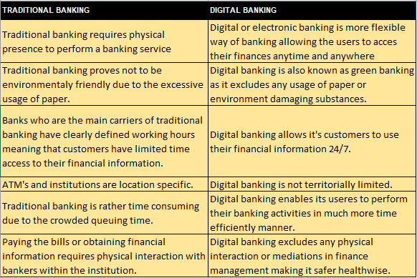
1: Traditional vs digital banking (Advantages and Disadvantages) (authors work based on the literature read on FinTech SWOT analysis)

2.4 Opportunities of FinTech

2.4.1 FinTech opportunities for national economy
According to the (World Bank, 2018) FinTech offers wide range of the opportunities for improvement of national economy and infrastructure which national authorities are eager to foster. It is believed that FinTech is especially useful for the developing countries and underserved populations not only for the promising cost reduction but also for narrowing information asymmetry, increasing competition and broadening access to the financial services, even though it is likely to be a timely process to implement. Furthermore, it enables general economic growth, enhancing international payments and strengthening supervisory and regulatory compliance.
FinTech is considered to be a revolutionary discovery in banking due to its direct effect on the financial sector in terms of how savings and investments are managed within the economy resulting in affecting the economic growth in great measure (Yueh, 2020).
FinTech contributes to national economy in many ways. For example, it forces more productive way of the cash flow within a national border. In many developing countries capital is invested in only certain areas of the national infrastructure for example in building markets as a view of safe investment.
According to FSB (2017), FinTech not only encourages the economic growth but also improves financial stability. Walker (2019) believes that FinTech has significantly contributed to the fall in money laundering activities as it is much harder to achieve due to the all the tracking systems which cash-less payments are enabling. Main benefits to financial stability stated are diversification and decentralization within the financial systems of the countries which may lead to the reduction of financial shocks in certain instances. Efficiency in terms of stabilisation of business models of domestic firms and contributes the overall economic growth. It further enables national economies to assess the risks more effectively and reduce the financial information gaps. Finally, it enables greater access to financial services which is of significant importance of enabling stable economic growth and reduce the exposure risk in investments (FSB, 2017). Lai and Samers (2020) further claims that key FinTech opportunities lies in suiting customer profiles through greater product customization, better efficiency and lower costs.

2.4.2 FinTech opportunities for SME’s
In a modern economy in developing countries, the key to growing the national economy is throughout small and medium enterprises as they are the key actors of capital inflows in the national budget. By application of FinTech it is believed that it will contribute an access to funding to SMEs. It provides more flexible way of financing their primary activities as it is an alternative way of receiving cash in cases where banks are either unable or unwilling to do so (Eriksson von Allmen et al., 2020). In the same time, those funding applications are short processes which can be completed in within few hours’ time and those funds are made available within one-week time instead of up to five weeks in developing countries.
Finally, FinTech providers are mostly giving loans with the lower interest rates in comparison with the banks. (Drummer et al., 2015). Furthermore, it benefits the loss of capital as FinTech lenders are able to identify the entity’s ability to repay the loans much faster and with much greater accuracy (Tater, 2016).
However, previous experiences in the developing countries have shown that this can lead to the severe problems in the housing market and stagnating of capital eventually leading to the overall downturn of the economy. Also, FinTech encourages national growth as SME will control enough capital to invest which might potentially lead to the economic growth and job creation in the market. (Drummer et al., 2015).

2.4.3 FinTech opportunities during pandemic of COVID-19
It is also believed that pandemic will strongly encourage the digitalization of financial services and that one of the most affected sectors tend to be SME’s. Apart from the benefits stated above, digital payments tend to also support governments in the time of crisis by enabling them to provide quick financial support to the affected sectors and simplify the economic recovery (Eriksson von Allmen et al., 2020).
Furthermore, FinTech enabled the people to overcome the physical interaction restrictions with increased use of contactless micro-transactions as an alternative for physical payments (Haidar, 2020). Apart from the implied measures by governments during the pandemic of COVID-19, consumers have started rapidly moving to the contactless payments for the sake of hygienic and safe way of purchasing (Fifth Third Bank, 2020).
According to the The World Bank (2020), after the first wave of COVID-19, FinTech has continuously enabled the improvement in expansion of financial services using the digital platforms, especially in the developing countries in all types of financial services except for lending.
As the conclusion to the chapter, FinTech has been growing rapidly over the last decade and it seems it has not yet reached it’s peak. Even though in most of emerging markets use of cash is still widely used the governments are strongly encouraging the wider use of FinTech. According to Chishti and Barberis (2016) back in 2016 cash production used to cost up to 1,5% more in comparison with the non-cash economy and FinTech has showed the tendency to eventually completely exclude cash payments from the use. In connection to Chishti and Barberis claims, today the burden of cash handling is mostly felt by SME’s as recent industry survey has shown that cash handling costs retailers 3,638 pounds a year which adds up to 17,8 billion pounds over the entire nation (Walker, 2019).

2.5 Limitations of FinTech
Despite the fact how healthy FinTech seems for the global economy, it certainly carries significant risks with its adoption for both financial system and customers. National authorities are facing many difficulties in connection with consumer protection, compliance with existing regulatory systems of the country, legal systems and possibility of legislation evasion and threatening of financial integrity. Apart from this, in order to benefit from the FinTech, country has to face transition challenges which may be particularly hard for the less developed and emerging markets. Most of the risks however are directly connected to the cybersecurity and how it can be controlled within existing regulatory framework (Odorović, McKain and Garvey, 2020).
Cyber risk is a global phenomenon as it attacks any online activity and not exclusively the online banking. However, as online banking includes the most confidential data such as personal and financial information, this represents the main concern for FinTech companies. (Blake et al., 2020) believes it is extremely difficult to control cyber risk as different organizations have different cybersecurity levels which makes it difficult for FinTech companies to follow how an attacker may corrupt the supply chain. Therefore, it is necessary for FinTech companies to protect their customer’s security in a reliable way but further burden may be imposed by rigorous regulations, lack of expertise if it is an emerging market.
This put’s a serious concern on the confidentiality and integrity of the personal financial information and banks around the world are making huge investments in regard with this problem and are still suffering huge amounts of financial damages due to the cybercrime. (Custers, Pool and Cornelisse, 2018)
In case of Bosnia and Herzegovina (BiH), Financial Intelligence Department (FID) is the key representative of financial security in regard to cyber criminal and the body itself is compliant with international standards of battle against money laundering activities. FID is operational as organizational unit since 28.12.2004, since then the legal framework regarding money laundering has been changed two times and current framework is applied in 2014. According to this body Bosnia and Herzegovina is facing serious money laundering problems over the years. An example from 2017 was when out of 528 reports on the ‘suspicious’ money flows (33,092,265€) from which banks reported 278 potential money laundering operations (25.963.693€) leaving 7,128,572€ completely out of sight of financial institutions (SIPA, 2019, p. 6).

2.6 Factors influencing consumer adoption of FinTech in developing countries
From the consumer point of view (Chen, 2016) and (Johnson, 2016) are both advocating that poorer countries with higher rates of corruption and those who have been war zones are having more positive and rapid reactions to the merging of traditional banking with modern digitalization leading to the faster adoption of FinTech than many richer countries.
As the main objective of this research, author is specifically interested in why is the FinTech so poorly adopted among the population of Bosnia and Herzegovina while out of 3,5 million people, 2,37 million have everyday access to the internet services which refers to approximately 67,7% of total population (Kemp, 2020).
This problem has led many researches to further investigate the factors which are influencing the new technology adoption and to evaluate to which extent adoption rate deviates among different cultures (Singh et al., 2006). Most of the authors have come up with the similar conclusions, mostly that adoption rates significantly depends on the stage of adoption as well as on the perceived ease of use and perceived usefulness as a components of Technology Acceptance Model (TAM) (McCoy, Galletta and King, 2007). Diffusion of Innovation Theory by Rogers represents an alternative for TAM model. Even though TAM is mostly used model for researching topics of IT related adoptions, (Slyke et al., 2004) believes that Diffusion of Innovation Theory provides richer amount of variables therefore making it more detailed and precise model to analyse and confirm the research findings.

2.7 Applicable theories in relation to adoption of financial technologies in developing countries
Theories that proved themselves to be most useful for analytics of this matter are: Theory of Reasoned (TRA), Theory of Planned Behaviour (TPB) and Technology Acceptance Model (TAM) (Asongu and Odhiambo, 2017; Nguena, 2019)
- Theory of Reasoned (TRA) was pioneered by (Fishbein and Ajzen, 1975) goes under assumption that all customers are thinking rationally when considering all the possible outcomes of their actions before adopting an innovation.
- Theory of Planned Behaviour (TPB) is the extension of the previous theory by the same author. Theory states that personal attitude to the certain behaviour, perceived control of the behaviour and subjective beliefs are all required in order to form individual’s intentions and behaviours in face of innovation change. (Ajzen, 1991)
- Technology Acceptance Model (TAM) was first established by (Davis, 1989) that states the adoption to change depends on the perceived ease of use and on how useful the technological innovation is.
All of the mentioned factors are based on national level. Those theories are used to evaluate how prepared the potential customers are to the change from psychological perspective.
There are many factors that have been taken into consideration when it comes to the adoption of FinTech in developing countries and they are grouped depending on whether they are affecting micro or macro environment of the country. Among the most widely used theories for clarifying the reasons for adoption of technologies are diffusion of innovation theory (DIT) and UTAUT model (Wessels and Drennan, 2010). Since there is no of empirical evidence and research on application of mentioned theories and models for the territory of Bosnia and Herzegovina, this paper will hopefully contribute to the closure of those gaps in literature. The author intends on using the Diffusion of Innovation theory model in combination with Hofstede’s national culture model frameworks as the main conceptual framework and it might be restructured with purpose of better reasoning for example of Bosnia and Herzegovina. The use of following models in theories will be based on the information collected from customer surveys with special attention on factors of complexity and trust as it currently represents the biggest struggle for adoption in BiH.

2.7.1 Diffusion of Innovation Theory by Rogers
This theory explains why, how and how rapidly does emerging technology spreads throughout different cultures. Diffusion theory was developed by (Rogers, 1983) and it can be defined as process of communicating the matters of innovation over time through channels among members of society (Rogers, 1983). According to (Rogers, 1983) adoption of innovations represent very lengthy process of filling the gaps between from the moment when they are made available to the moment when they are fully accepted.
(Rogers, 1983) further states that each innovation includes the overall process of recognizing the problem which triggers the research and development activities in order to find appropriate solution for the problem. This can be directly related to the adoption of financial technologies as a solution for the economic growth and usage of the technology for the improvement of standards of living to what I referenced in section 3.2.1. Further, Rogers advocates the concept of basic and applied research usually refers to the technological advancements. He defined technology as a “Design for instrumental action that reduces the uncertainty in the cause-effect relationships involved in achieving a desired outcome” and sees it as a synonymous to the innovation. This step is directly connected to the recognition of the problem as he believes that applied technological knowledge will ultimately lead to the scope of solutions for problem solving. This section refers to the much broader aspect than just Bosnia and Herzegovina and it is directly referred to in the section 2.3 History of FinTech which is considering the direct influence of digitalization as a way of improvement of post economic crisis banking systems.
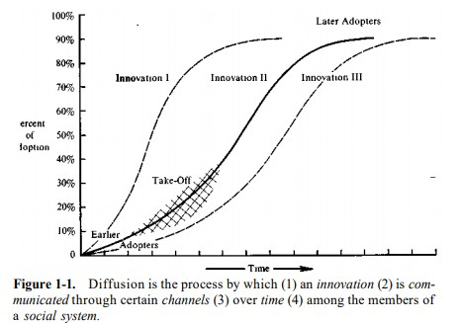
2: Definition of diffusion process by (Rogers, 1983)
(Rogers, 1983) talks about 6 factors that influence adoption of innovation: relative advantage, complexity, compatibility, observability, trialability and perceived risk.
Relative Advantage – Measures customer’s perception on how beneficial the innovation is compared to its predecessor. Eventually, it improves the efficiency and economic benefits to the society. According to the research by (McCloskey, 2006) in terms of technological advancements, customers believe that new technology is in most cases more useful than the last one. Furthermore, in (Rogers, 1983) book “Diffusion of Innovation”, relative advantage is the first and key driver to the rate of adoption of new technologies. It is believed that relative advantage carries subcomponents such as economic profitability, lower costs of service/product and time and effort efficiency
Complexity - Second factor of DIT that gives an insight in how difficult the new innovation is to understand and use (Rogers, 1983). Even though some innovations are much easier clarified and adoptable than the others, higher level of complexity is inversely proportional to the adoption rate within the society.
Compatibility – This factor explains how well would an innovation fit in people’s beliefs and habits as an existing value. It is believed to be a crucial part of innovation as if it confronts society’s beliefs and life styles it can trigger rapid acceptance of the adoption (Rogers, 1983). The basic concept behind this factor is that the more compatible the innovation is, the lower the level of consumer uncertainty is. One of the compatibility indications is the extent of innovation that influence personal needs of a customers. As people in BiH are using smartphones on a daily basis, this factor tends to positively affect wide adoption of mobile banking in BiH (faktor.ba, 2019).
Observability – Observability factors determines how visible the innovation and its effects are to the consumer groups and if they can be easily discussed (Rogers, 1983). In case of mobile banking, this factor refers to the user’s ability to approach his financial information anytime he/she wants and seeing the effect of the transactions within minutes. As per observability factor, mobile banking applications are widely accepted throughout the world. However, in developing countries this problem can be directly related to the promotion of FinTech.
Trialability – Term gives an information on how much time society can experiment with innovation before deciding to adopt it. The more time people have to adopt the more comfortable they become with innovation (Rogers, 1983). According to (Rogers, 1983) earlier innovations were more sensitive to this factor than modern world innovations. This factor was not being tested within the survey as financial institutions or providers of these services were not among the segment group of the survey. However, this has been theoretically described in section 3.2.1 Process of FinTech adoption in Bosnia and Herzegovina.
Perceived Risk – It represents the correlation between the personal doubt in consistency of the innovation and real behaviour of innovation (Rogers, 1983). This factor is of particular importance in process FinTech adoption as it entails the issue of trust and security factors faced by the consumers in relation to acceptance of new technologies. Trust and security issues are explained in more detail in section 3.3.

2.7.2 Macro environmental factors influencing adoption
On macro environmental aspect this work is looking at the adoption of modern financial technologies on the territory of BiH. First perspective taken into consideration is international transfers of funds in developing countries as BiH has relatively close connections with Russia and Turkey (on the basis of religion and history between the countries) and many domestic people that are living abroad (people who either left during the war or students). This gives the opportunity for easier fund transfer between countries what reflects positively on the developing economies (Fawcett and Parrado, 2020). Last macro-environmental factor that influenced the acceptance of online banking in BiH refers to the ability of improving investment activities. In face of preparation campaign of entrance to the EU, BiH will have to increase overall investments within the borders of the country (Sattler, 2020).

2.8 Review of Hofstede’s dimensions of national culture
In his original model, Geert Hofstede included the first four cultural dimensions: power distance index, uncertainty avoidance, individualism and masculinity (Slyke et al., 2004).
In his study of key factors that are influencing consumer behaviour in adoption of mobile banking (Bankole, Bankole and Brown, 2017) mentioned culture as one of the main contributors to the adoption of new technologies. Hofstede defines culture as “the collective programming of the mind distinguishing the members of one group or category of people from others” (Hofstede and Minkov, 2010). Hofstede further defines five dimensions of national culture:
- Power distance index (PDI) – The extent to which less powerful members of the group or society accept and expect that the power is unequally distributed
- Uncertainty avoidance index (UAI) – The extent to which the members of group or society feel threatened by unknown situations.
- Individualism vs collectivism (IDV)– the extent to which individuals are integrated into groups.
- Masculinity vs femininity (MAS) – the extent to which gender roles are assigned in a culture
- Long term vs short term orientation (LTO) – A society’s preference to be more forward looking or future oriented.

One of the authors main ambitions regarding this research is to evaluate cultural background of Bosnia and Herzegovina and draw the conclusion how population’s cultural behaviour may influence the adoption of FinTech together with consumer behaviour models. However, many researchers suggest that Hofstede’s cultural dimensions are not always showing relevant results, especially if the author is using a smaller sample (Eringa et al., 2015). Podrug, Pavicic and Bratic (2006) who have made the first inter-cultural comparison on the basis of Hofstede’s dimensions have found rather interesting information regarding compared countries of study: Croatia, Slovenia and Bosnia and Herzegovina. Firstly, (Podrug, Pavicic and Bratic, 2006) came to the conclusion that despite the small geographical distance between the countries and the fact that those countries constituted the unity for 74 years, cultural differences are still very evident. Furthermore, in comparison with the evidence obtained by (Podrug, Pavicic and Bratic, 2006) in 2006, it is evident that culture of one nation can deviate significantly in period of 14 years.
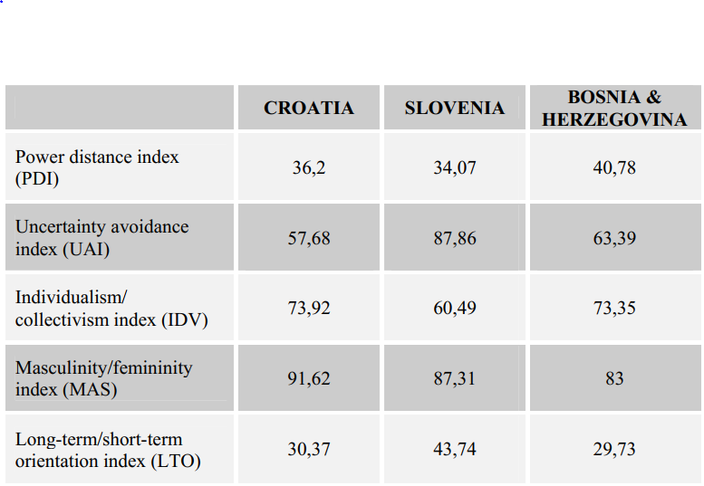
3: Calibrated positions of the countries on five dimensions of culture in 2006 (Podrug, Pavicic and Bratic, 2006).

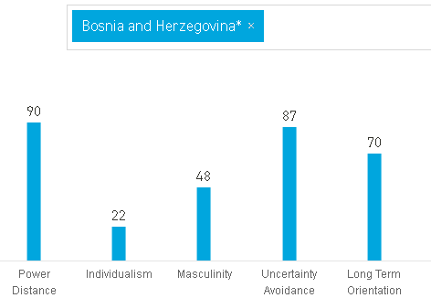
4: Hofstede's National Culture parameter's on the example of Bosnia and Herzegovina 2019
In order to represent the cultural framework of Bosnia and Herzegovina, the author used the first inter-cultural model made for Bosnia and Herzegovina as well as updated parameters for Bosnia and Herzegovina from “hofstede-insights.com”.
However, the author, (Podrug, Pavicic and Bratic, 2006) clearly stated in the research that Hofstede’s dimensions of national culture are calculated on the basis of much smaller population of survey participant and data cannot be representative of the whole country.
- PDI – With an extremely high rate of power distance, as explained briefly earlier, this factor refers to the question on how less powerful members of the society react to the unequal distribution of power. Erumban and de Jong (2006) published a study in which they advocated that adoption of new technologies significantly depends on the power distance level, more precisely, that power distance is negatively correlated with the adoption of new technologies. Accordingly, Herbig and Palumbo (1994) explained that countries with higher power distance are perceived to be slower in adoption of new technologies. Rogers (1983) gives special attention to the centralization of power when it comes to the adoption of new technologies. He argued that the more centralized the organization is, the less need for innovation and change it has. In case of Bosnia and Herzegovina, it is very important to consider the fact that Bosnia and Herzegovina is weakly regulated country with three different entities where each entity has different religion and different representatives within the country as main national authorities. This fact by itself suggests that there is a lot of interest conflict between the entities and their representatives. On the other hand, all of the representatives of three different entities are presiding their nations for over 20 years now, where chairman’s of the country are rotating every 4-8 years but all of them are advocating the same management policy making the country stagnating. This directly refers to the fact that all power is centralized around three men. People are mostly dissatisfied with the authorities but as most of the young people are not showing any interest in voting at elections and at the same time older, pre-war population constructs most of the voting body, it is almost impossible to change the political situation within the county as people in actuality do not have the ability to influence the work of authority by any chance.
- Individualism – With the very low score of individualism, it can be concluded that BiH is collectivist culture. Harzing and Hofstede (1996) were one of the first to bring out the correlation between individualism and change. More precisely, they said that countries with low levels of individualism (high levels of collectivism) are more likely to show resistance to change. (Erumban and de Jong, 2006) have supported Hofstede and Harzig’s claims by claiming that collectivism is negatively connected with the adoption of new technology. (Rogers, 1983) also mentioned in his “Diffusion of Innovation Theory” that individualism dimension is closely related to the power distance, as collective cultures have more tendencies to be dependent on power figures or in this case authorities. In case of Bosnia and Herzegovina, the collectivism reflects throughout three dominant ethnicities represented by three main political parties (Bosniaks, Croats and Serbs). Each party has its own political affiliation whose priorities can deviate from significant to none. Yet most of the people are choosing to be a part of the party or support their party based on their nationality rather than individual preferences. These people are functioning as a group while the people who do not have any political preference cannot stand alone against the force of collectivism. As the ethnical collectivism represents important factor within the cultural models of Bosnia and Herzegovina it significantly influences every aspect of society including the attitude towards the adoption of the FinTech.
- Masculinity – Unlike the first two dimensions of national culture, the author has not found significant connection between masculinity and new technology adoption. Ozbilen (2017) said that societies that generally respect success and achievements are expected to perform better than countries with low masculinity score. With the average score of 48 it can be concluded that BiH is rather balanced between two cultures of achievements, competition and success.
- Uncertainty Avoidance – This represent the most important factor for conducting of the research as it is directly related to the acceptance of new technologies and switching from one habit to the other according to many researchers.Søndergaard (2001) and Ozbilen (2017) both support the belief that countries with high level of uncertainty avoidance will increase the possibility of being repulsive towards the change. With extremely high score of 87, Bosnia and Herzegovina is rather adversely oriented toward the change and that resulted in a slower progress of FinTech adoption in recent years. Even though people are dissatisfied with the current situation of the country, they are unlikely to change their way of living, while individuals who are seeking for change and better life standards are mostly moving to the more developed European countries (mostly Germany, Austria, France and UK). (Podrug, Pavicic and Bratic, 2006) have concluded in their research that high uncertainty avoidance in Balkan Countries can be associated with communism regime legacy. They also believe that high level of traditionalism and nationalism are huge contributors to the high uncertainty avoidance.
- Long term orientation – Hofstede defined this cultural dimension as point in time on which one country may focus on it’s success and development. Long term orientation refers to the sacrifice of the short term success in order to achieve greater success in the long run, while short-term oriented countries are placing stronger emphasis on the past and present rather than to the future (Hofstede and Minkov, 2010). In his study of this particular cultural dimension (Smit, 2012) made a point that this particular dimension was tested on the example of China and that ever since it may be hard to understand for European, American and Africa countries as most of them are short-term oriented. However, Gereet Hofstede simplified the term to the point where long term orientation simply represents “thinking outside of box” and focusing on the future rather than on present situation of the country. On the other hand, short term oriented countries tend to recall on the event from the past and are strongly holding to their tradition. With the score of 70, Bosnia and Herzegovina is presented as a long term orientated country which makes this cultural factor specially interesting for the author. From the personal experience as a native Bosnian, the author was surprised that Bosnia is seen as a long term oriented country as it is post war country and as mentioned before, the country of three different folks. As such, the author believes that people in Bosnia and Herzegovina are strongly holding onto tradition and are not willing to let go of the past events so easily even for the sake of the brighter future.

2.9 Connection between cultural factors and external factors: Review of Computer Based Media Index (CMSI)
Ashraf, Thongpapanl and Auh (2014) have delegated that apart from perceived usefulness and perceived ease of use, culture represents as important factor as mentioned components of diffusion of innovation theory. As many researches are showing that customer behaviour in adoption varies significantly depending on the cultural background (Srite and Karahanna, 2006), this research will focus on evaluating where Bosnia and Herzegovina can be found on adoption axis.
In his research on the factors of risk and trust on adoption of e-commerce, (Pavlou, 2003) said that adoption levels of e-banking depends on the culture, development level of the country and consumer trust in banking services. In case of Bosnia and Herzegovina, people lack trust for financial institutions all the way back to 1990s with split of Yugoslavia.
Ashraf, Thongpapanl and Auh (2014) made a connection for technology acceptance applicability for the countries with high CMSI or computer based media index which describes the culture with high levels of uncertainty avoidance, masculinity and power distance and low level of individualism – namely, Bosnia and Herzegovina as per “insight-Hofstede”. CMSI is a term developed by (Straub, Keil and Brenner, 1997) computer-based media support index (CMSI) to evaluate the correlation between the first four cultural dimensions and evaluate how they may influence the adoption and acceptance of new technologies. The index is calculated by summing the index scores for power distance, masculinity vs femininity and uncertainty avoidance and subtract the index score of individualism vs collectivism factor. The computer based media index has not been often used among the researches for proving the adoption of online services, but it some scholars have used it to defend the hypothesis that high level of CMSI negatively impact customer’s intentions to engage in online transactions (Slyke et al., 2004).
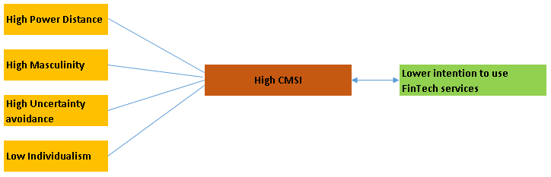
5: Authors work bases on research by (Slyke et al., 2004)

2.10 Influence of security, complexity (perceived ease of use) and initial trust on adoption of FinTech

2.10.1 Trust
Ashraf, Thongpapanl and Auh (2014) said that in the online environment, trust can be defined as a crucial factor as doubtful customers perceive online transactions to be of high risk and unreliable. Lianos (2019) further states that trust of consumers towards their suppliers is much harder to achieve in online environment. A survey by (Centre for International Governance Innovation, 2019) examined the trust of e-commerce and online shopping from 24.000 respondents in 24 different countries. 22% of those respondents said that they are not using online platforms for any kind of purchases and 49% of them stated that the main reason for doing so is lack of trust in the quality of the service provided and security of their personal data.
Aljaafreh and Al-Ani (2015) believes that winning consumers trust in the developing countries is such an important factor that it should be the very first step in the adoption of FinTech 3.0. McKnight, Choudhury and Kacmar (2002) defined the initial trust as the concept that evaluates the overall trust of consumers on innovations at the very beginning of new relationship and before customers form a structured opinion on that relationship. Aljaafreh, Al-Ani and Alzoubi (2014) is talking about two types of trust, initial trust and ongoing trust. He believes that initial trust is more applicable to the developing countries as it is formed without any reliability on the previous knowledge (Eujin and Suresh, 2016), while ongoing trust is lengthy process which requires previous experience of the consumers.

2.10.2 Complexity
According to (Pavlou, 2003), complexity represents a predictor of new technology acceptance in developing countries. (Taylor and Todd, 1995) highlighted that the complexity represents the first barrier to adoption for the people who have no experience. This may be of particular importance for the older population as they lack technological experience in general.
This further puts additional pressure to the FinTech companies and application developers as if the service is too complex to use, it may be perceived as useless - (Davis, 1989) advocated that perceived ease of use is a direct determinant of the perceived usefulness in the eyes of the customer. Scholars have not paid significant attention to the factor of complexity individually but rather through it’s influence on the perceived usefulness.

2.10.3 Security
Security represents one of the key factors in the financing industry not only for the customers but for the service providers as well as once that it shows inability to protect its customers, clients actions will be in accordance with the bad reputation (Mobile Marketing Association, 2009) . In that name, the least that customers expect in return is the same security as in traditional banking.
Zwinggi (2020) draws a significant correlation between the consumer’s trust and online security. He advocates that platforms for cybersecurity and digital trust need to make entry barriers for undesirable consumers much stronger and penalties much higher. He further states that in case that if FinTech providers are able to build in the confidence in the behaviour of the consumers by introducing safe and reliable services within the online environment, this could ultimately lead to the boost of economic activity and better service offerings.

2.10.4 Issue of trust and security in Western Balkans
One of the key reasons behind the distrust towards the banking sector in Western Balkans is the great collapse of so called “Ljubljanska Banka”. Ljubljanska Banka (today NLB Bank) was one of the greatest banks in Yugoslavia. However, with the commencement of Yugoslavia breakdown back in 1991, Ljubljanska Banka has formed a new bank called “Nova Ljubljanska Banka (NLB)”. Allegedly, all of the customer funds were transferred from old bank to the NLB, however, 165.000 thousand people in BiH only have never received their funds up to this day.
To this day it is estimated that Ljubljanska Banka has lost approximately 385 million EUR and the case is not resolved up to this day (Hojnik, 2016). Distrust in the banking system of BiH is further disturbed as there have been many similar cases in recent years such as with “Banka Srpske” which is currently on the edge of bankruptcy due to the enormous criminal proceedings against them for abuse of customers financial resources (Radio Television BN, 2020). Furthermore, Pavlou and Fygenson (2006) are claiming that customer distrust in the financial institutions can significantly reflect on the consumer perception over online control of their finances as well as their confidence, and as such, imposing barriers for the FinTech adoption.

2.11 Process of FinTech adoption in Bosnia and Herzegovina

The research by (Živković, 2020) has shown that banks are contributing to approximately 90% of the financial market while the insurance companies are taking remaining 10% of the financial market in BiH. Apart from this, banks are currently in favourable position, not only due to the huge market share, but also because the lack of multi-corporations operating on the territory of BiH that can trigger consumer behaviour. Digitalization and trend of change is constantly imposing pressure on banks while in the same time, market regulations are constantly following and harmonizing in alignment with FinTech changes on the global market. Expectedly, as innovations are growing the risks that banks are facing are also increasing while it is challenging for banks to produce risk policies that can follow all of the upcoming changes. Banks in the developing countries such as BiH are answering those challenges in two different ways. Firstly, banks were eager to introduce and improve in the field of financial technologies independently leading to some of the greatest banks in the country to opening the sectors which were exclusively indebted to the innovations in financial technologies. However, as this process was extremely costly and final outcome was never quite certain, banks have slowly started to abandon these systems and have started to form partnerships with the country, universities and other business sectors. Those partnerships are widely known as „FinTech incubators “and „FinTech accelerators “. Even though those trends are much more recognized in the developed countries, as BiH is mostly dominated by the foreign banks, same trend was seen to be applicable to those banks. (Terzić, 2017).

In the research conducted by (Eurostat, 2019) it has been evaluated on how many individuals are using the digital banking type of services between 16 and 74 years of age. Digital banking in this instance includes features such as bill payments, overview of balances and transactions per account and other. Per visual data from research performed in 2019, in figure 5, it is noticeable how Bosnia and Herzegovina is on the very bottom of European countries using online banking and it significantly lags behind the neighbour countries (Serbia and Croatia) who are also described as developing countries.
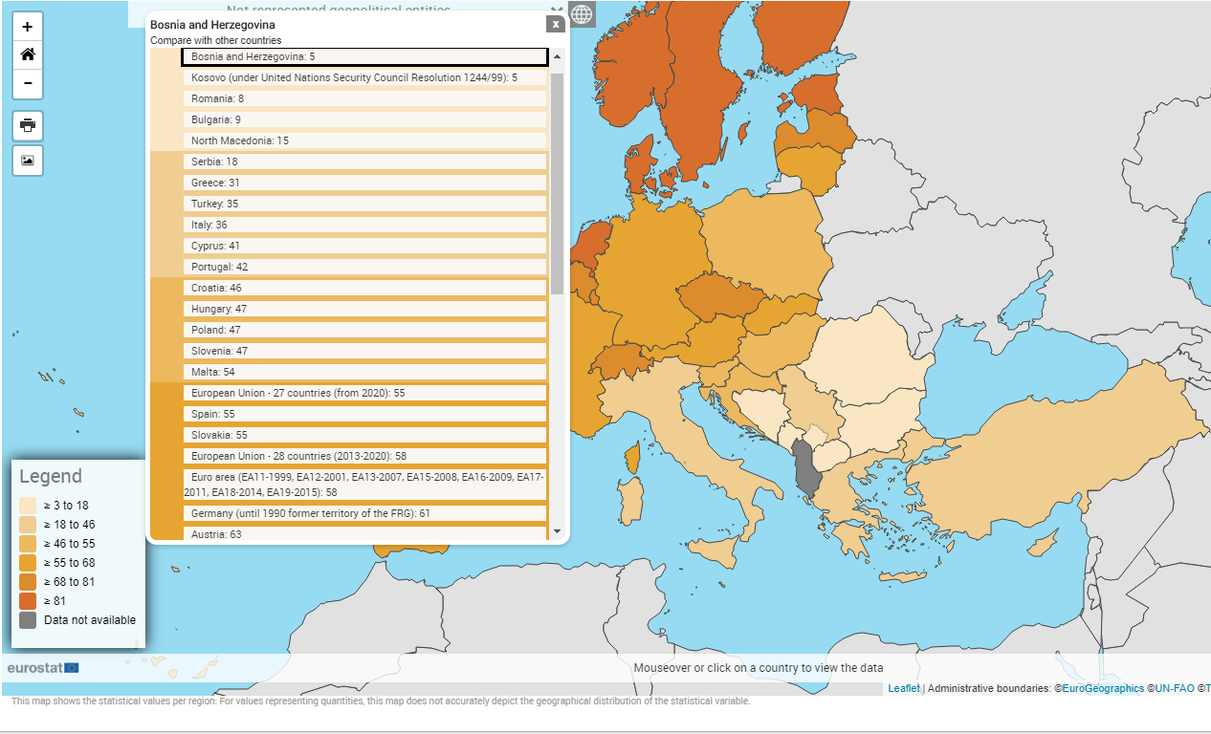
6: Individual usage of the internet for internet banking services(Eurostat, 2019)
This overview shows how little has Bosnia and Herzegovina been investing in the development of internet banking and what is really interesting, that until 2018, there were no information on usage of financial technologies on the territory of Bosnia and Herzegovina.
Per research performed by (Terzić, 2017) the very first data on usage of any form of FinTech 3.0 are emerging in 2007 when the total use of this services was around 16.000 (both retail and non-retail segments). Considering other European countries, it is noticeable that e-banking appeared later than expected. In 2008 Central Bank of BiH did not even produce the data on usage of mobile banking but instead it just made a mention in the published annual reports that “small number of population is using these services”.

In the more recent years BiH has started investing more and putting more effort in development of internet banking. Today 22 out of 29 banks are providing e-banking services to the customers and they are the driving forces in promotion of these services by marketing campaigns, educational articles and direct contact to the customers when they are visiting bank branches (Terzić, 2017).
According to the Published reports on card business and payment systems of BiH for 2019 by Central Bank of Bosnia and Herzegovina, 22 out of 29 banks in Bosnia and Herzegovina are offering e-banking services. The amount of total users of the service has increased for 14,6% in comparison to the last year from which 57% of the users were using mobile banking while remaining 43% were using internet banking (Centralna Banka BiH, 2020).
It is stated that 96% of the non-retail segment is using online banking while retail segment is mostly deciding for mobile banking. In 2019 there were total of 24.180.079 digital transactions in the total amount of 46.983.098.447 EUR (Centralna Banka BiH, 2020).

3. Conceptual framework
Conceptual framework is defined as an instrument that link key concepts of the research and provide a comprehensive understanding of the researchable phenomenon (Jabareen, 2009). This instrument can be applied in various ways by the researchers with purpose of developing original ideas and concepts regarding their research. (Jabareen, 2009) further states that each concept within the conceptual framework is playing an epistemological, “how things work” and ontological assumptions that refers to the nature of reality or “the way things are”.
However, it is important to refer to the fact that framework does not simply list the concepts but represents a structure in which each and every element of the framework plays an important role within the research (Jabareen, 2009).
Based on the above stated information, conceptual framework will represent the main connection between the literature review, design of methodology and finally collection and presentation of data.
The research questions and objectives allowed the author to connect two different concepts to the adoption of the FinTech in Bosnia and Herzegovina.
First one covers the cultural background of the country and general predispositions to the adoption of new technologies imposed by the Hofstede’s dimensions of national culture. The author aims to correlate the cultural background with the adoption through the use of computer based media index (CMSI).According to Straub, Keil and Brenner (1997), countries that score high on power distance, uncertainty avoidance, masculinity and low score on individualism dimension are considered to have low computer-based media support index (CMSI) and as such are more likely to positively react to the adoption of innovation. However, it is important to highlight that the author will not statistically cover the actual data as per (Berisha, 2015) the formula for calculating the Hofstede’s cultural dimension is not developed for the use of single national culture unless being compared to the another culture. For this purpose, CMSI index will be only used for the descriptive purposes of whether Bosnia and Herzegovina represents high CMSI country or not.

Second concept refers to the external elements which are faced by every individual based on personal characteristics that are exploited when facing changes to their routine. For this purpose, the author tends to evaluate factors that are influencing the adoption of innovation developed by Rogers. Once again, it is important to mention that for the relevance of the research, as diffusion of innovation theory by Rogers was developed back in 1983, the author will evaluate only those factors which are of significant importance for the adoption of modern technologies such as FinTech. Considering the previous statement, the author will cover the factors of trust, complexity, security, relative advantage and observability.
The structural framework of the study can be seen in the figure bellow:
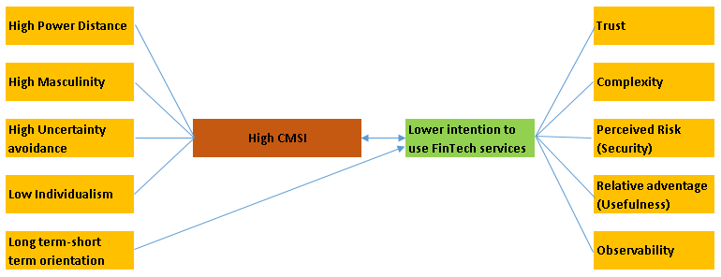
7: Conceptual Framework developed by author

4. Conclusion
The literature review section included the aspects of the topic that prove themselves relevant for the established research objectives.
As presented in the literature review, FinTech 3.0 is present on the financial market for years and is currently the on-going global trend that is reshaping the way banking is performed. However, even though it exists in Bosnia and Herzegovina, banks and authorities are struggling to incorporate this trend in the daily lives of BiH citizens.
Therefore, the very first part of the literature is concerned with term of FinTech 3.0, how technology emerged to the banking sector and how it may improve economy of the developing countries. Also, I have paid the attention to the barriers and limitations which country may face in adoption of this new trend therefore putting myself in shoes of authorities rather than just consumers when it comes to the application of FinTech.
Further I have given the most attention in the work to the customer behaviour in relation to any kind of change in order to determine the reasons for slow evolution of FinTech in Bosnia and Herzegovina. Through the literature I have established that this is directly relatable to the national culture so I have also presented the behavioural patterns of the BiH society.
In the last part of work, I have conducted a reading on the main individual factors which may influence slower rates of adoption and I have made a breakdown of how security and trust may influence consumer behaviour. Also I have revised the professional literature of financial stability board (FSB) and world bank to get a deeper insight on how FinTech providers are coping with resolving those deficiencies and how they are keeping the database out of scope of potential intruders.
In the last section of the work, I have presented a conceptual framework that is revolving around Diffusion of Innovation theory by Everett Rogers which explains individual acceptance of change and reaction of society to the innovations in order to create a base for my primary research conducted through survey of overall population of Bosnia and Herzegovina.

Research Design

Overview
This sections aims to present the overall approach to the study, more precisely it illustrates the methods which will be used to present and analyse collected data. In order to create a precise guide through the research process, the author will be using Research Onion, a model developed by Mark Saunders. Bryman and Bell (2011) suggested using this model due to it’s adaptability to almost every kind of research methodology. Saunders, Lewis and Thornhill (2009) described this model as an instrument used for presenting the research process into great details as each layer of the onion describes a more detailed stage of the research. The author will open the section with research philosophy description, section that will focus onto including research questions and how they will be interpreted and answered throughout the research. The research philosophy section will be followed up by the research method section. This section will deal with evaluating and choosing the appropriate method for conducting the research along with the arguments for choosing it. Further, in this part of the thesis, author will focus onto describing why the author chose the particular topic of consumer behaviour in adoption of financial technology and how he plans to structure a survey that will produce relevant data for the research. In the final part of the work, the author will focus on data collection and how he intends to analyse and interpret the collected data along with presentation of all the research limitations that author has came across during the study.

Research Onion Presentation
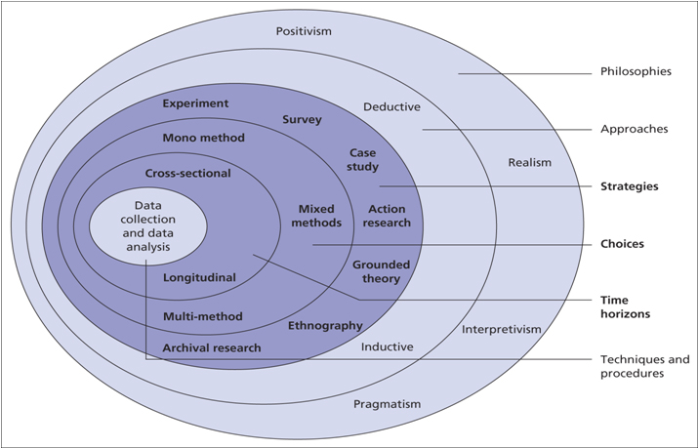
8: Research Onion by (Saunders, Lewis and Thornhill, 2010) customized for author’s requirements

Research Philosophy
As it was noted in the overview section, this part of the study will focus on research philosophy which represents the first layer of the research onion by Saunders. In order to advance in the study, the author paid special attention to each element of the first onion layer which consists out of positivism, interpretivism and realism.
Bryman and Bell (2011) defined positivism as epistemological position that draws the connection between natural sciences methods to the study of social reality. To this day positivism has been widely used in research methodology mainly because many authors are looking at it from different perspectives and it is believed that it contains elements from both, deductive and inductive approach. Some authors like Neuman (2000) have tried to simplify this view to the extent that it assumes the reality exists regardless of which phenomena is a subject of study and that it is consistent between the subjects.
Realism on the other hand, has two different perspectives. One side of realism is considered to be rather similar to the positivism theory as it shares two main positivism values which lies in the belief that both theories are advocating that natural and social sciences should have the same approach to the data collection and similar explanation to the phenomena. On the other side, authors such as Östlund et al.(2011) are advocating the perspective that realism theory is significantly different from positivism in terms of phenomena perception, contradicting Neumann’s claims and stating that even though reality existence is unquestionable, social phenomena is created by each individual and can vary significantly depending on the participants viewpoint. Bryman and Bell (2011) defined two types of realism: empirical and critical realism. Empirical realism believes that reality generally can be understood if the appropriate methods are applied to the research. Critical realism which represents more specific form of realism advocates the view that reality will only be understandable if one succeeds to understand the structure that generates those events. As the conclusion between two different realism approaches, the main difference is considered to be that critical realism does not believe in cognition of reality through the empirical methods but rather that reality can only be understood through practical and social knowledge (Bryman and Bell, 2011).
Third component of research philosophy layer is interpretivism. Interpretivism is reflected as a contrast to the positivism approach (Bryman and Bell, 2011). The main difference lies within the very definition of the term as interpretivist scholars believe that the core of the social sciences which is represented by people and institutions is fundamentally different from those of natural sciences. Simply said, interpretivist scholars are advocating that different logic and research approach is required in means of the distinctiveness between humans and natural order.
In the structuring of the research itself, the author has had the inner dilemma between the two approaches of positivism and interpretivism even though they represent two contradictory forces. However, the research topic is so specific that it overlaps with two main principles of both social theories. The dilemma arose with (Wright, 1971) reflecting a comparison between the two theories stating that main feature of positivism lies within aspiration to explain human behaviour while intepretivists put an accent on understanding the human behaviour
As a conclusion, the author chose the interpretivist research philosophy as great attention in this research is given to the cultural factors as well as to the external factors that are influencing customer’s adoption of FinTech, the research will be directed in a way of understanding why people in Bosnia and Herzegovina are feeling reluctant towards the adoption of FinTech rather than explaining what factors are influencing their behaviour.
Furthermore, the author shares the opinion that the phenomena exist, but unlike the positivist beliefs, there are so many different factors which might influence consumer behaviour that it is irrelevant to think that individual behaviour will not depend on each and every participant. (Bryman and Bell, 2011) have given an example of the Hofstede’s cultural dimension as a one of the best known representatives of interpretivism approach. Similarly, like Hofstede, the author did not develop the hypothesis on which basis he intends to support the claims of the research, but rather developed the determinants (cultural factors and external factors) which have emerged throughout the process of data analysis.

Research Approach
(Bryman and Bell, 2011) defined explanatory also known as descriptive approach as most used approach among the scholars for expanding the existing literature and knowledge on the phenomenon. They put an accent on already examined trends and topics by previous survey researches. As the topic on consumer behaviour regarding adoption of new financial technologies is a specific subject of research in terms of demographical parameters, the author was limited with literature for the territory of Bosnia and Herzegovina. For this reason, the author was using similar researches by other scholars on the topic but for the other developing countries. According to Dudovskiy (2018), explanatory research aims to secure relevant description of social systems and structure along with the interrelated factors and their relationship between events. Another reason behind choosing explanatory approach is that it provides a relevant feedback regarding a research as well as it proved itself economic in terms of time and resources.
(Saunders, Lewis and Thornhill, 2009) have identified two main approaches to the research, deductive and inductive theories which are main representatives of the second layer of the research onion. It is of high importance to choose which theory will be used to conduct a research depending on whether the theory is directing the research (deductive theory) or whether theory is a result of the research (inductive theory) (Bryman and Bell, 2011).

5.4.1 Deductive Approach
The key aspect of deductive theory is explained as the direct connection between the research and theory. This approach asks the author to look back to the previously developed literature and knowledge on the phenomenon and develop the hypothesis respectively that will be a subject to the empirical research. (Bryman and Bell, 2011) stated that the key issue with this approach is the authors ability to appropriately consider and develop the sub concepts of the hypothesis as they have to be translatable from the theoretical to researchable units. Apart from this, (Kothari, 2004) said that basis of the deductive approach is the existing theoretical knowledge which is later being put in comparison with the specific knowledge derived from the research. (Bryman and Bell, 2011) further explain the last step of deductive approach involves induction as the author is supposed to enrich the existing knowledge on the phenomenon by contributing to the existing literature that was the key guidance for the research with implications of his findings. (Bryman and Bell, 2011) further explained that deductive approach has clearly defined structure in which “one step follows the other in a clear, logical sequence” as shown in the figure below. Most scholars share the attitude that deductive approach is more commonly used for the quantitative data analysis but many social researches have been given as an example in (Bryman and Bell, 2011) book that show that this does not exclude the use of deductive theory for qualitative type of research.
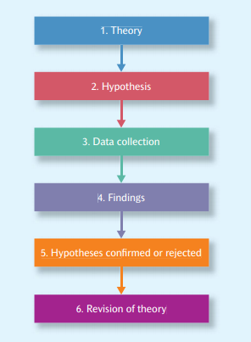
9: The process of deduction by (Bryman and Bell, 2011)

5.4.2 Inductive approach
(Bryman and Bell, 2011) are defining inductive approach as simple as the opposition to the deductive approach or in other words, the approach in which the theory and improved knowledge on the field is an outcome of the research. Beiske (2007) explained that marrow of inductive approach is that there is usually no conceptual framework on which the research is being based but rather that the author develops a research focus after the data has been collected. However, (Bryman and Bell, 2011) believe that even though inductive approach is usually associated with the process of generation of new theories, it is infrequently the case that authors findings can be embedded within the existing theories. As such, it is concluded that just like the deductive approach contains the inductive element, inductive approach is seen among the scholars as the alternative for the deductive approach and as such also carries the deductive element in the research. (Bryman and Bell, 2011) established this stance by understanding that even when theory is the outcome of the research, many authors will collect additional data from the existing theories and overlapping knowledge in order to determine the relevance of the generated theory. As an alternative to the deductive approach, it is believed that inductive approach is preferable for performing the qualitative research but it does not exclude the use of the induction among the quantitative research.
On the basis of the previously reviewed literature on different research approaches, the author believes that appropriate approach for the research is inductive approach. As per (Saunders, Lewis and Thornhill, 2010) the key of interpretivism lies in the author’s neutrality without any assumptions of understanding the researched topic. This seems like the right way to conduct the research as even though the whole work is being supported by the existing literature on Hofstede’s cultural dimensions and Rogers diffusion of innovation theory, it still develops new findings and new knowledge on the topic for the territory of Bosnia and Herzegovina. Due to the lack of the empirical research on the topic on the territory of Bosnia and Herzegovina, the author has used the work of (Ashraf, Thongpapanl and Auh, 2014) as the main guidance of the research as Ashraf et. al conducted the research on the very similar topic for the territory of Pakistan and Canada. From this, it can be concluded that the is aware of the deductive element of the research, however, the inductive element is indispensable from the research and it is reflected in the fact that the research is being conducted for the Bosnia and Herzegovina, and it may be seen as innovative element as there is no published work that connects consumer behaviour models and cultural factors which are influencing the adoption of FinTech in BiH. Furthermore, the author intends on using the survey to collect and analyse the data for two main reasons. First of all, there are many different factors defined which might influence the consumer behaviour in process of adoption. Secondly, as a build up on the first reason, the author believes that it is necessary to review relatively larger portion of respondents in order to obtain relevant research data and this is only achievable by performing a survey on the chosen sample.

5.5 Research Strategy
The research strategy can be defined as the part of the research in which the author is supposed to explain in detail how he intends to perform the research (Saunders, Lewis and Thornhill, 2010). (Bryman and Bell, 2011) defined two “sub-layers” of research strategy, first one refers to the quantitative and/or qualitative research which further branches to different types of research (case study, survey, experimental survey, grounded theory, ethnography and action research).
As per (Bryman and Bell, 2011), the key difference between quantitative and qualitative method is that the first one uses numerical measurements for the interpretation of the results while the second one does not. However, most modern researchers believe that the differences between the two go way deeper than this one reason. (Bryman and Bell, 2011) have made a simplification of the two terms by stating that quantitative research usually takes deductive approach; or testing of the theory and that it is specific way of analysis for positivism research philosophy. On the opposite, the qualitative method is usually linked with interpretivism and inductive approach; generating the theory. However, (Bryman and Bell, 2011) are clearly stating that these are generally accepted terms for quantitative and qualitative method but that it does not strictly have to follow the model e.g. quantitative research can be conducted in inductive as well as in interpretivism manner and vice versa.

When it comes to the type of research being conducted, (Saunders, Lewis and Thornhill, 2010) has given many different options for the form of the research itself. He stated six main approaches to the study:
- Experimental study
- Survey
- Case study
- Grounded theory
- Ethnography
- Action research
In the following section the author will define and briefly look at each of the mentioned elements due to the better understanding and justification of the choice in the end.

1. Experimental Study
(Saunders, Lewis and Thornhill, 2010) has defined experimental study as one in which the author conducts and experiment and draw the conclusions on the basis of comparison between the actual and expected results. (Saunders, Lewis and Thornhill, 2010) further explains that this approach is suitable for any kind of research, quantitative or qualitative and that it includes a limited number of factors which are being a subject of examination.
On the other hand (Bryman and Bell, 2011) claims that this approach is rarely used nowadays among the researchers due to the usual inability to maintain the control over the study. The way in which the experimental study is usually conducted is that the author tends to define and manipulate and independent variable in order to establish whether in fact the independent variably influences the depended variable. However, (Bryman and Bell, 2011) believes that large number of independent variables that the researchers tend to cover cannot be manipulated. An example given for this claim refers to the case of gender effect in the workplace. In this case the independent variable is gender and the author cannot simply manipulate gender in a way that some people are made male while the others are made female (Bryman and Bell, 2011). In his book, (Saunders, Lewis and Thornhill, 2010) defines two types of experimental research: laboratory experiment and field experiment.
As a conclusion to the first type of study, (Bryman and Bell, 2011) believes that good experimental study provides an extremely relevant data and internal validity but that it is also very hard to achieve effectively.
2. Survey
Survey represents one of the most used methods for data collection and it proved itself especially useful for business studies. Survey is defined as a form of various set of questions asked of defined sample of audience in order to get an insight into the researchable objectives (Bryman and Bell, 2011). It is often used by defining one or more variables in time and to establish causes of those variables on the examined data (Bryman and Bell, 2011). As per (Bryman and Bell, 2011) the first step that needs to be undertaken in order to examine the connection between the variables is to have a clearly defined method for measurement. As it was mentioned earlier, the survey may represent both, quantitative and/or qualitative data.
Even though it represents most commonly used way of data collection, (Bryman and Bell, 2011) highlighted several issues imposed by use of survey as a research method and those are:
- Reliability – This issue refers to the quality of the questions being asked from the sampled audience. (Bryman and Bell, 2011) claims that „Primary matters to the quality of the measures that are employed to tap the concepts in which the researcher is interested, rather then matters to do with research design“.
- Replicability – This issue is present in most of the quantitative researches. It refers to the high level of reduplication of matters such as selection process of survey participants, design of main research concepts, analysis of data etc. (Bryman and Bell, 2011)
- Validity - (Bryman and Bell, 2011) believes that internal validity of the surveys represent a weak spot as it may be difficult to understand the causalities from the obtained data as survey’s are providing the author with association’s of data rather than original findings. On the other hand, Bryman believes that external validity is strong side of the surveys but only in cases when sample has been chosen randomly or in other words, the less random the sample is, the less valid the survey will be.
On the other hand, survey’s have many advantages that may facilitate the research itself:
- Representativeness and accessibility– Depending on person’s connection, it is relatively easy to reach the higher amount of people and as such making the generated data more relevant. Furthermore, as most of the surveys nowadays are being developed in an online environment, it enables the author to reach the desired audience on many different ways (via mobile phones, e-mails, social media etc.) as well as to reach people from around the globe. (Sincero, 2018)
- Low costs – When conducting the survey, it is extremely cheap way of gathering data from huge amount of people. Most surveys will only require the author to pay the construction of the survey itself while it is completely free to collect responses via free link that is being sent to the respondents. (Sincero, 2018)
- Author’s bias – As the data is usually being collected from a larger population, surveys are eliminating the author’s subjectivity and possibility of manipulation of data. (Sincero, 2018)
- Statistical interpretation – The overall results of the research are usually more understandable as they can be interpreted throughout the graphs and other tools for visual presentation of findings. (Sincero, 2018)
3. Case Study
(Bryman and Bell, 2011) defined case study as an assessment of a single unit with aim to establish the key features of the problematics and draw the conclusions. (Bryman and Bell, 2011) claims that case study is almost exclusively used for single event, single person, single organization or single location. (Silverman, 2005) believes that this research method is widely used for the conduction of business researches such as investments in different contexts or comparison of past and present experience of a company (Silverman, 2005).
What differentiates the case study from other research method is the overall focus on a concrete situation or organization (Bryman and Bell, 2011). Similarly like a survey method, even though case study is usually connected to and use within the context of qualitative research, (Bryman and Bell, 2011) believes this is not appropriate as quantitative research does not necessarily exclude use of case study.
4. Grounded Theory
(Bryman and Bell, 2011) defined grounded theory as a qualitative research method that is almost exclusively inductive. It is usually used in form of interviews which are transcribed, coded and then grouped in accordance with mutual factors for all of the respondents. (Bryman and Bell, 2011) differentiated this research approach from others by the fact that grounded theory implies that data collected is being analysed after the research has been completed rather then where data is being analysed in order to determine whether it fits previously developed theories.
5. Ethnography
(Bryman and Bell, 2011) has defined ethnography as type of research in which researcher observes the people and aims to understand their cultural interaction. What differentiates this approach from others is that the researcher puts himself in the shoes of the participants or in this case observed unit (at least one person) and aims to understand their individual perception on certain human behaviour. (Bryman and Bell, 2011)

6. Action Research
Action research has roughly been defined by (Bryman and Bell, 2011) as an approach in which the author and the respondent collaborate in the diagnosis of a problem as well as in assessing the possible solutions for the problem. It has further been defined as type of research which results in „re-education, changing pattern of thinking and action“ and that it aims at contributing to both, theoretical and practical knowledge within the field (Bryman and Bell, 2011). He claims that action research findings should have broader impact than just on one situation that is being studied. (Wiles, Crow and Pain, 2011) claim that action research is usually linked to the qualitative method and that it is not commonly used in business but rather in professions such as teaching and nursing where participants and researcher can deepen their understanding of the profession and their professional approach to their work.

5.5.1 Choice of research strategy
The subject of the research has been divided in two parts, first part which focused on explaining the concept of FinTech with all of its advantages and disadvantages while the other part is considering more psychological insight into adoption of FinTech among the population of Bosnia and Herzegovina. As the research is mostly oriented towards the external factors and theoretical models which are explaining consumer behaviour, the author aims to answer these questions along with all the challenges and difficulties caused by implementation of FinTech in everyday life of the customer base.
Based on the already determined research questions, the author will perform the quantitative analysis in form of the survey in order to approach the problematics with high level of details in order to obtain relevant findings that will improve the existing knowledge in this field of research.
The author believes that the survey is appropriate research method for this study for a simple reason that the research problem has to be assessed against the larger population. Furthermore, the author has defined several indicators within the research which need to be examined (external factors and cultural factors). As the questions regarding these factors may be misinterpreted, the author believes that it is more appropriate to evaluate each of the factors through one or more survey questions rather than to rely on several open question answers as the possibility of data misinterpretation is higher.

Research Methodology
With purpose of simplifying the empirical research the research questions will be answered throughout two key sections. First section is literature review which focused on the answering of the first research question which is preoccupied with evaluating the key aspects of the FinTech adoption and how it might positively and negatively influence the developing economies. This part of the research is based on the existing literature in order to set the framework for the further research. Furthermore, the author has given the special attention to the existing models on the acceptance and adoption of new technologies with the goal of contributing to the field by collecting and analysing the data for BiH.
In the second section of study, the author will be using the survey method in order to answer the remaining three questions. As it was mentioned in the earlier section of research chapter, the author intends on using quantitative approach in form of the survey for the primary collection of data. This approach is considered to be appropriate by the author due to the high level of subjectivity of included factors and as such, the research requires relatively high number of participants in order to obtain an admissible picture on the researched phenomena.
(May, 2011) defined the quantitative approach as effective in cases where high number of respondents are available, where data can be measured quantitatively and in cases where statistical methods can be used to analyse the collected data.

Research Design
(Saunders, Lewis and Thornhill, 2010) defined time horizon as the layer of the research onion which is concerned with the time in which the research is taking place. Unlike the other layers of the research onion, time horizon is believed to be independent of the specific research approach and methodology (Saunders, Lewis and Thornhill, 2010). Furthermore, both (Saunders, Lewis and Thornhill, 2010) and (Bryman and Bell, 2011) are defining two main components of this layer and those are cross-sectional and longitudinal.
Cross-sectional design is the method of research used to determine the specific phenomenon in the specific lapse of time. Cross-sectional design is often defined as social survey design which refers to the collection of data on more than one subject in specific point in time in order to collect data in connection with at least two variables which are then being subject to examination in order to identify patterns of association (Bryman and Bell, 2011). (Bryman and Bell, 2011) explained that even though both designs are seen as experimental types of the design, as cross-sectional design usually includes more variables and more respondents, the answers are believed to be generated in the same time which is not a usual characteristic of the experimental approach as it considers the respondents to be tested prior to the experimentation (Bryman and Bell, 2011). Furthermore, as different questioned variables are examined simultaneously, the examiner does not have the opportunity to manipulate the data. As the conclusion of the term, (Bryman and Bell, 2011) are closely relating survey and cross-sectional design in terms that survey almost exclusively employs cross-sectional design. However, cross-sectional design does not exclusively include surveys as the research method (Bryman and Bell, 2011).
Longitudinal design approach is usually used when the phenomena is examined over extended period of time and in which the research subject is usually directly referring to the examination of change over period of time (Goddard and Melville, 2004). The starting point of longitudinal design on the other hand includes presentation of phenomena on vertical and horizontal axes and measures the interconnection between the variables over the period of time. However, (Bryman and Bell, 2011) said that longitudinal design is rarely used in practice, but it is usually being used as an extension form of surveys and questionaries’ within a cross-sectional design.
Considering both of the above defined designs, the author intends on using cross-sectional design as the research put focus on the specific point in time. Apart from that, the research is submissive to the constant changes as nature of „adoption “may change significantly on a yearly and even monthly basis depending on many factors and needs of the population. As such, the following research may be exhausting to follow in the future.

5.8 Data Collection methods

5.8.1 Primary Data Collection
The key instrument for the primary data collection will be a survey. (Bryman and Bell, 2011) defined primary data as data that is derived directly from the respondents. However, it does not exclusively refer to the data that is being produced by the author but data used by the other authors can also be considered to be a primary data or the one that refers to the data being analysed.
A survey is described as being especially useful in exploratory research as they allow collection of large amount of data on global levels in very economical ways. Furthermore, well developed survey makes the questions more understandable for the people increasing the relevance of information by excluding factor of uncertainty (Saunders, Lewis and Thornhill, 2010, p. 144). However, the main reason for choosing this approach is the sample size the author intends on covering, time limitation as well as its ability to suggest potential reasons and solutions to the concrete customer behaviour. The overall objective of the survey will be to show how much importance do customers put on each of the factors influencing barriers towards adoption in order to gain a clear understanding of psychological profile of people from BiH regarding technological innovations such as online banking.

5.8.2 Data Analysis
For the purpose of analysing the data the author intends on using the secondary data analysis along with the exploratory data analysis. (Turkey, 1977) has defined exploratory data analysis as a method which not only describes but also visually presents the data with aim of organizing data in charts and/or in two types of exploratory data, graphical and non-graphical in which graphical method refers to the data analysis via visual or diagrammatical way, while non-graphical method involves calculation of summary statistics.
Furthermore, the author decided to use secondary data analysis for a several reasons. First of all, the research evolves around the previously defined factors by Rogers as well as to cultural factors by Hofstede and therefore the research leans on the existing theories. Second reason is that research will include comparison with the existing data in order to draw the conclusions (e.g. comparison of actual results with existing measurement of Bosnia and Herzegovina national culture factors).
Apart from this, (Bryman and Bell, 2011) has defined several advantages of secondary data analysis:
- Cost and time – The secondary data analysis enables the author the access to the relevant sources of information which enables the author of the research to collect and analyse it while investing low resources for data collection and analysis.
- High-quality data – Most of the data used are of extremely high quality. For example, relevance of the data collected on platforms such as Sage, EBSCO, Research Gate etc. are always reviewed by the experts in the field of the research prior to the data publication.
- Opportunity for cross-cultural analysis – This opportunity is directly relatable to the first opportunity as it is easier and cheaper to familiarise with similar researches in other countries via secondary data what represented a significant barrier back in the years.
- Reanalysis may offer new interpretations – The author can use the data analysis by the other authors and potentially get an insight in how to improve the existing knowledge on the topic. For example, if the prior research was taken several years ago and the author has defined certain limitations to the research, it is possible that overtime some of these limitations have been overcome.
In the end, the author chose two approaches to data analysis as he believes it will provide more relevant findings. The author decided to go with these methods for a simple reason that (Saunders, Lewis and Thornhill, 2010) believes that graphical interpretation of the data is typical and most useful for interpretivist research with inductive approach. Furthermore, as there are two different groups of factors tested within the survey, it would be extremely hard and insecure to try and interpret those two groups together using the statistical data. For example, (Bryman and Bell, 2011) claims that it is highly impractical to use official statistic for the interpretation of cultural data. Bryman’s claims are arising from the previously highlighted limitations of using the statistics in researches conducted by other scholars such as failure to measure full effects, change in a way in which presented figures are recorded, exclusion of the importance of certain factors while giving too much importance to the other factors etc.
For the above mentioned reasons, the structure of the data analysis section will look as follows. The section will be opened by general introduction to the sample audience where the author graphically presents the pie of respondent’s demographics (sex ratio, age ratio etc.). From the introduction part, the author will then cover the first research question which refers to the usage of FinTech in Bosnia and Herzegovina where the general picture is presented on FinTech usage by all the respondents. Apart from that, one of the research aims is to find the gap between the generations, where each age group is filtered and data is presented against the same chart of FinTech usage within BiH. This will enable author to get an insight whether the usage is dependent on the age of potential customers or in other words whether the generation Z (younger population; born in 1997 and onwards) tends to increase the usage of FinTech in BiH in the following years.
Following part of data analysis will be divided in two parts, first part will involve reconciliation of cultural factors and their influence on the adoption of FinTech. As these questions in the survey were taken by all the participants, the results are shown in general with purpose of showing the relevance of presented data on national culture factors on Insight-Hofstede against the actual results. This will enable the author to check the relevance of CBMI to the adoption of FinTech in Bosnia and Herzegovina.
Second part will focus onto impact factors defined by Rogers in Diffusion of Innovation theory. This set of questions was divided on two parts; one set of question was taken by the people who are using FinTech while the other was aimed at population that do not use FinTech services. However, both set of questions have reflected on the factor of complexity, usefulness, security and trust but from the different perspective. This will enable the author to evaluate the impact of those factors on the overall adoption of FinTech services by reflecting the findings from this section to the findings from the first section on general usage of FinTech.

5.8.3 Sampling Strategy
On of the most important indicators of survey relevance is the sampling method. (Bryman and Bell, 2011) defined several sampling methods from which two most used ones are purposive sampling and probability sampling (non purposive sampling).
The key assumption of the purposive sampling method refers to the specified participants that are representing the research audience; in other words, unlike the probability sampling, the participants are chosen intentionally for specific parameters in a strategic way rather than randomly (Bryman and Bell, 2011). As the author has collected the responses using his personal connections via social media and as the survey covered specific participants on the basis of nationality (all of the participants had to be citizens of Bosnia and Herzegovina) and specific age groups, it can be concluded that the author has used this sampling strategy for the collection of responses.
Probability sampling represents most used way of sampling when the quantity of the sample is important and it is common way of sampling for quantitative research. It is often being used for generalization of population. So for example if the research is focused on problematic of a specific town or country, then the results can only be relevant if the participants are citizens of the focused town or country (Bryman and Bell, 2011). Also, probability sampling omits any bias as the sample is being chosen on a random basis.
As the research is considering the acceptance of FinTech on the national level, the chosen population equalled to the total of 3.394.000 which is the overall population of Bosnia and Herzegovina. The key issue with this sampling method was the inability to exclude infants and older population and author believes that it could result in approximately +/-10% of relevant population to be tested. By using the Sample Size Calculator, the author established that appropriate level of participants would be minimum of 423 with 95% of confidence level and 5% margin of error. Confidence level is defined as a statistical probability that parameter value falls within the observable population. Margin of error refers to the maximum allowable difference between sample size and population tested. E.g. if 65% of participant answered that they use FinTech with 5% margin of error, it would refer that 62.75% and 67,25% of population would answer in same way (Martin, 2017).
In the survey completed by 450 participants, the author has divided the participant’s intro three segments bellow:
The people that survey will be focused on are divided in three customer segments:
- Young People (18-30 years old) – This is the most important group as they are new generation that is very well introduced to the technology driven environment as well as generation that will get affected by mobile banking the most as future generations.
- Middle-aged people (31-50 years old) – This are mostly employed people and are believed to be most familiar with term of FinTech services as well as to use them in the greatest measure among the categories.
- “Older” generation (over 50 years of age) – This is the least active group as they usually believe it is too stressful and frustrating to switch to another aspect of banking. This group represents an important category as the author believes to find out the most about barriers to adoption from this group of people
The survey will take place in data collection from the potential FinTech users in Bosnia and Herzegovina which represents rather large sample as it can be seen from the participant categorization above. The goal of the survey is to measure the use of FinTech in Bosnia and Herzegovina as well as to understand the barriers that are preventing complete adoption of FinTech potential on national level. The survey is planned to be structured from several types of questions: demographic questions, Likert-type scales and rank order questions.
Likert type scale will cover the part of questions regarding general interpretation of mobile banking services among the society, rank order questions will focus mainly on the key psychological and cultural factors influencing consumer behaviour as it will enable the author to rank each of the factors importance. In order to develop relevant conclusion, the author will create particular set of questions regarding cultural factors as well as to the psychological factors.

Survey will include between 20 and 25 questions. The survey will be constructed from Likert type scales and ranked order questions. An example of Likert type scales question would be „Use of FinTech should contribute to the time saving” with 5 options: 1. Strongly Agree, 2. Agree, 3. Neutral, 4. Disagree and 5. Strongly Disagree. I chose this option as it offers participants the chance to choose neutral response since I can make a good use of this response as one of the key research assumptions are that customers in BiH are not using FinTech services to it’s full potential. Ranked order questions on the other hand will be occupied with the psychological profile of the customers. The main purpose of ranked order questions is to collect data that is applicable to the diffusion of innovation theory factors and Hofstede’s cultural factors. Example of ranked order question would be as follows: From 1-5 where one is being least important and 5 is being most important, what factors in your personal experience raise the barriers in adoption of mobile banking:
- Complexity of use
- Security of customer finances and data integrity (perceived risk)
- Lack of information on FinTech 3.0
- No personal need for improved financial services.
- Trust in online transactions

5.8.4 Sources of Data
Primary data was collected by conducting a survey with several varieties of questions. The survey took place through the electronic platforms of Facebook and e-mails where the author created a universal Survey Monkey link which is accessible through each of those platforms. After the testing of the pilot, the author has contacted all of the potential participants and explained them the purpose of the survey as well as to what is expected to them in order to reduce the risk of question misinterpretation. Furthermore, the author has created two surveys, one in Bosnian which was the initial survey sent to the participants due to the language barriers as well as to reduce the chance of misunderstanding the questions which are being asked of them. The second survey was created in English and it is being used for the requirements of the faculty; both surveys can be seen in appendixes section. The survey took place from 23rd of December until 31st of December 2020. The survey lasted 10 minutes on average with completion rate of 90% on the sample size of 450 people.
For secondary sources, the author mostly used the books on the phenomenon. As most of those theories were introduced in 20th century, the references may also be perceived as obsolete, but as those are established models which were not updated in recent years and are still being used for evaluation of adoption rates among the societies, they can be seen as relevant for the research. For generation of this data, the author mostly used online library databases such as Sage, EBSCO and Research Gate.
On the other hand, in order to obtain the fresh statistical data as well as to include recent trends and pandemic, the author used newspaper articles mostly from the World Economic Forum.
All of the survey participants were firstly asked if they could take some time to complete the survey with brief but detailed explanation on the topic of the survey. In order to collect as many answers as possible, the author personally contacted his direct friends and acquaintances but also used the help of his closest friends and family to reach larger number of population of diverse age categories.

Data limitations
According to (Adams et al., 2007, p. 111) the biggest drawback of the surveys is the potential of designing it badly as the response rate is not usually higher than 20% even with well-developed questionaries’ so it would slightly reduce the chance of gathering enough data to draw relevant conclusions from the research. The author intends on using Survey Monkey software for the construction of the interview.
(Bryman and Bell, 2011) believe there are several limitations in using surveys for measuring consumer behaviour for specific phenomena.
- Problem of meaning – First limitation refers to the possible misinterpretation of the asked question.
- Problem of omission – If the question is not well structured, the participant may give inappropriate answer due to the lack of understanding on what is being asked from them.
- Problem of memory – Participants may not remember for sure what represents the key barrier that influences their behaviour. However, this may be resolved by giving the participants the opportunity to choose more than one option in certain questions.
- Social desirability effect – This limitation refers to the possibility that questions are being answered with the goal of providing desirable outcome rather than real outcome.
- Question threat – If questions are perceived to be threatening, offensive or intimidating in any way, the respondents may fail to provide an honest opinion.
- Gap between stated and actual behaviour – There is a high likelihood that people fail to objectively recognize their personal behaviour in certain circumstances which may be inconsistent.

6 Data presentation and analysis

6.1 Overview
The aim of this research was to evaluate the impact of different factors that are influencing consumer adoption of new technologies. Scope of the survey covered 447 participants between 18-60 years of age which were chosen randomly in order to act as representative sample for the entire population of BiH. As it can be seen from the previous chapter of the research, central objectives of the research are to evaluate general usage of FinTech in BiH, to assess to which extent do cultural factors influence the adoption and usage of FinTech and to review factors of complexity, security and trust and how they may influence the adoption of FinTech.
The participants were chosen on the basis of authors personal connections. Therefore, the choice of the participants is considered to be purposive, even though author’s personal connections contributed to 1/5 of the total respondents, while the remaining responses were collected on the branching principle. Considering that vast majority of the respondents were author’s personal connections along with the personal connections of author’s closest relatives, the sample cannot be considered random. Apart from this, sampling was done on two fixed determined parameters of participant’s age and gender and as such, evaluated audience is considered to be within a specific range of population i.e. purposive.
The structure of the data analysis will begin with the first research question that refers directly to the usage of financial technologies in Bosnia and Herzegovina. This section will be followed by the discussion on impact of cultural factors on the adoption of FinTech and to test and try to correlate the low adoption and usage rate of FinTech with high level of computer based media support index. Latest part of the data analysis will cover the matter of factors of complexity, trust and security and to what extent do they pose the barriers towards the overall adoption.

6.2 Presentation of findings and discussion

6.2.1 Demographics of the participants
The introduction to survey was made by asking the participants set of 8 demographic questions. The purpose of these questions is to get an insight into the character traits of the respondents. Apart from this, this further enables the author to analyse the research topic from the demographic aspects. For example, comparison can be made between male and female population in order to determine who is more open to use of FinTech and more liberal towards the innovation. It also enables the author to consider these questions as subsections to which different variables can be tested against.
The survey was taken by 447 participants’ out of which 164 respondents were male, while 283 respondents were female meaning that 63,3% of sample size were female respondents while the remaining 36,69%.
These participants were further divided into 5 different categories on the basis of their age. Categories were from 18-25 years of age, 26-35, 36-45, 46-55 and over 55 years of age.
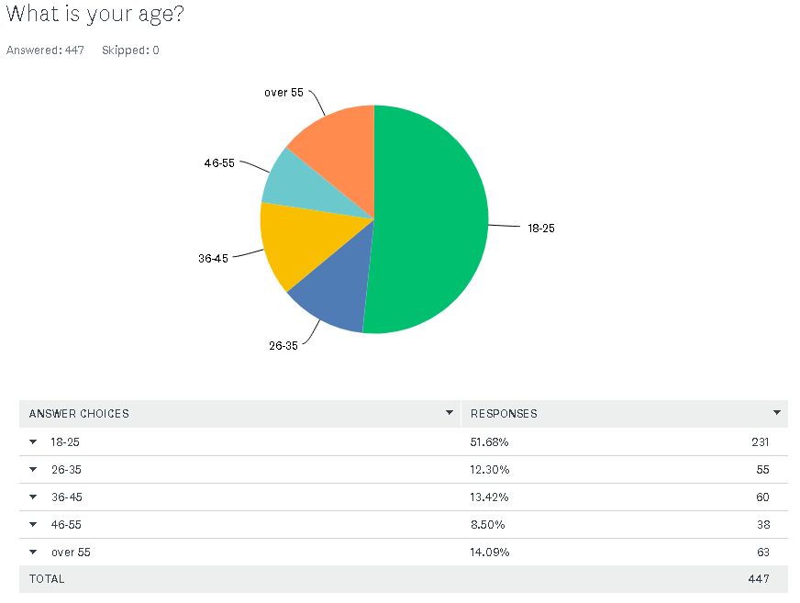
10: Age categorization of survey participants developed by the author
As it was expected, a vast majority of the respondents were in the category between 18 and 25 years, as the key target of this survey is Z generation which are key carriers of new technological era. Out of total 447 respondents 231 of them were under the first category which represents total of 51,68% of sampled population. This way of categorization will further benefit the research when it comes to the assessment of cultural factors for Bosnia and Herzegovina as the last evaluation of Hofstede’s dimensions of national culture were conducted back in 2006 by (Podrug, Pavicic and Bratic, 2006). It will enable the author to review and analyse the change in these factors which is unquestionable considering the generation gap between this research and the one back in 2006.

Next demographic question referred to the marital status of the participants.
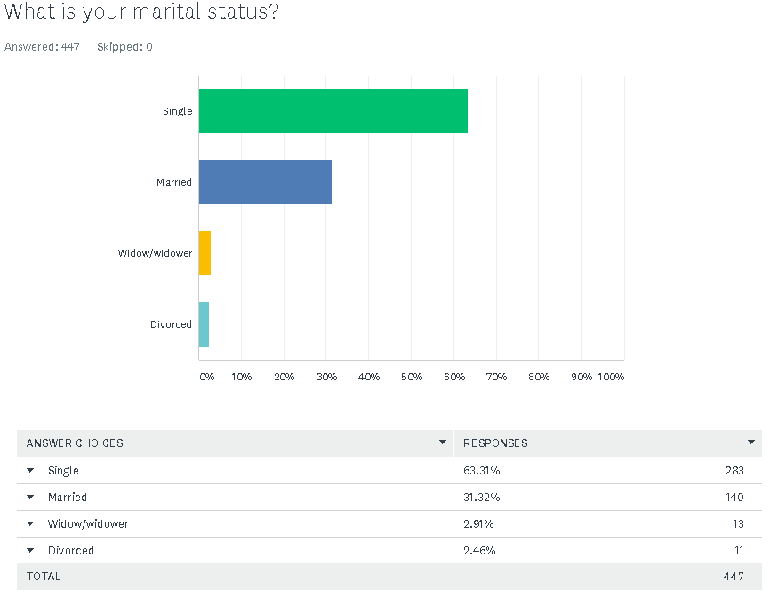
11: Categorization of the participants in accordance to their marital status; developed by author
The purpose of this question was to get a closer insight into the participant’s characteristics and it won’t be benefiting the research in terms of new knowledge gained and therefore it won’t be analysed.

Following question was in regard with the participant’s place of living:
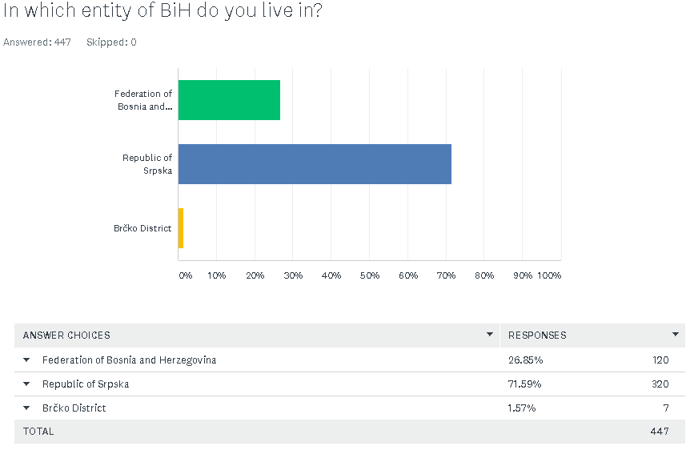
12: Categorization of participants according to their place of living; developed by the author
This question is of special importance for the research as Bosnia and Herzegovina has rather complex national structure. It is divided into two entities, Federation of Bosnia and Herzegovina and Republic of Srpska, along with one district which is named Brčko District. All of the three are organized in a different way, Federation of Bosnia and Herzegovina is composed of 10 cantons, while cantons are further divided into cities and municipalities. On the other hand, Republic of Srpska has no cantons but is only constructed out of cities and municipalities and Brčko District is a unique administrative unit. It is important to highlight that each of the entities is mostly composed out of specific national group, so Republic of Srpska is mostly inhabited by Serbs, Federation of Bosnia and Herzegovina by Bosniaks and Brčko District by Serbs and Bosniaks, while Croats are the minority national group and they are inhabiting many different parts of Bosnia and Herzegovina, mostly Federation of Bosnia and Herzegovina (Agency for statistics of Bosnia and Herzegovina, 2019).
However, for the purpose of the research, as there is certain amount of Serbs in Federation of Bosnia and Herzegovina and Bosniaks in Republic of Srpska, the author took the information from the last census of Bosnia and Herzegovina, to get an insight in the exact number of nationalities living in the different entities. Per the last census in 2013, Federation of Bosnia and Herzegovina was inhabited by 1.562.372 Bosniaks, 497.883 Croats and 56.550 Serbs. Republic of Srpska is inhabited by 171.839 Bosniaks, 29.645 Croats and 1.001.299 Serbs. Brčko District is the smallest administration unit and is represented by just one city called Brčko and it is inhabited by 35.381 Bosniaks, 17.252 Croats and 28.884 Serbs (Agency for statistics of BiH, 2013).
Apart from the mentioned information, it is important to say that each of the entities have each regulatory bodies and each of three nations is culturally different as they speak different languages, share different religions etc. (Agency for statistics of BiH, 2013). This section will be of particular importance for the author as it will be used as sub-section for testing the cultural differences between the entities as well as to what extent is FinTech adopted within each entity.
One of the limitations of this research which will be evaluated later on is that as the author himself is the citizen of Republic of Srpska and due to most of his connections being from the same entity, majority of the people that have taken the survey were from Republic of Srpska which may influence the distribution of data analysed between the entity to certain extent.
Following question was covering the matter of participant’s employment status:
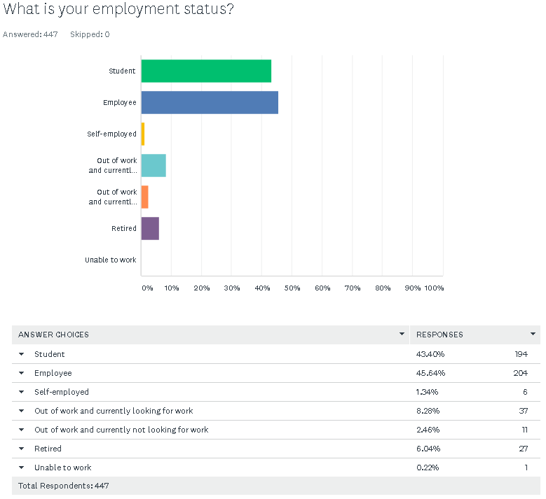
13: Categorization of the participants by their employment status; developed by the author
This question enables the author to get a further categorization of FinTech usage depending on the potential user’s employment status as well as to evaluate how widespread is use of FinTech between three categories especially and those are students, employees and self-employed population and retired population. As per the survey, majority of the participants were either students or employees.

Following three demographic questions were in relation to the banks in which the participant’s have their bank accounts opened:
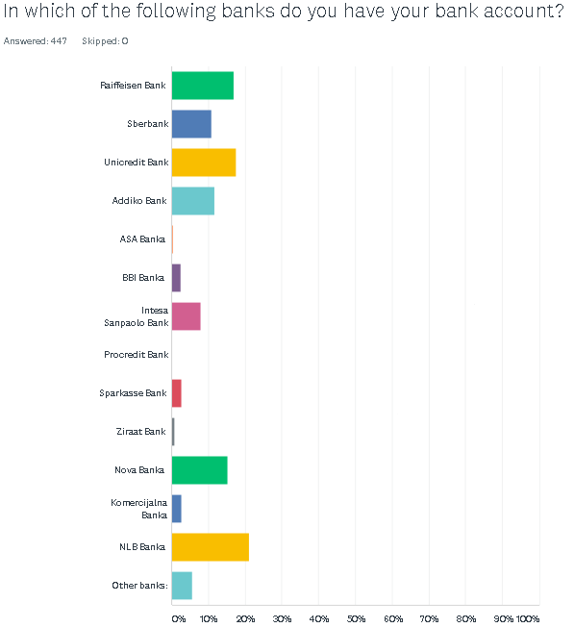
14: Categorization of the participants by the Banks in which they have their accounts opened

The point of following questions was to get an insight into which Banks in Bosnia and Herzegovina are most commonly used where the author tends to draw the correlation between the Banks and to what extent do those banks promote the FinTech.
It is important to mention that this question had given participants the option to choose another Bank which is not on the list. As several responses were referring to the Vakufska Banka, Naša Banka and MF Bank, which are domestic banks, these will also be taken into consideration in data analysis.
This question was followed up by the question on why people chose their bank for the purpose of understanding what values and services do consumers value the most in traditional banking.
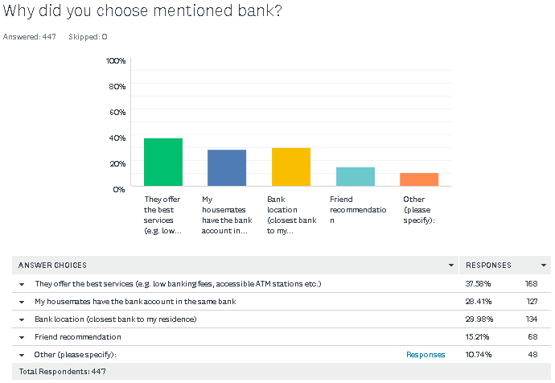
15: Reasons for choosing above mentioned bank; developed by the author
168 respondents (37,58%) answered the lower costs and accessibility of the Banks ATM’s as the main reason for opening the account in this bank. This leads to the conclusion that 38% of sampled population represents suitable consumer group for FinTech services as the cash usage is lowering every year while the card payments are seeing significant increases. Apart from this, it is generally believed that FinTech services are more cost efficient than traditional banking services. Second most often chosen option (134 participants 29,98%) is the location of the bank being closes to users places of living. This group of people who may not be using the FinTech also represent potential users as they can manage their payments from home without visiting the bank branch. Third option chosen in significant amount is “My housemates have the bank account in the same bank” (127 participants; 28,41%). Other two options were friend recommendation (68 participants; 15,21%) while remaining 48 participants (10,74%) have chosen the “other option” where most participants were either employees of the bank so they opened the account for the job purposes or they were asked from their employers to choose specific bank.
Last question in the survey within the demographic set of questions was covering the matter on how often do sampled population visit the bank branches. This question simply shows how strong is population in Bosnia and Herzegovina tied to the traditional banking.
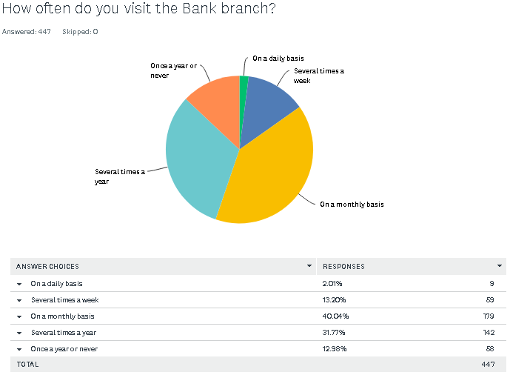
16: Amount of time the participants are visiting their Bank branch in a period of one year; developed by the author
179 participants of the sampled population answered that they are visiting bank branches on a monthly basis (40,04%). This enables the author to draw the conclusion that 40% of the tested population are still paying their monthly bills for their phones, internet, utilities etc. in the bank branches which further leads to the conclusion that significant percentage of the tested population is still inclined to the traditional banking. Apart from this, many participants answered that they are visiting the bank branch several times a year, which can be closely linked to the larger payments they are making several times a year or in case of performing international transactions to their families. However, this data can also be interpreted that certain amount of population are using the FinTech services and therefore do not have the need for visiting the bank branch.
This question enables the author to make an assumption that the participants who are visiting their banks on a monthly basis or more often are still more certain in traditional banking, while the people who are visiting bank branches on a yearly basis feel comfortable with FinTech and use it on a daily basis. In such scenario, 240 people are still highly reliable on the banks which is 53% of the sampled population while the remaining 207 (47%) may be moving to the new way of banking.

6.2.2 FinTech rate of adoption in Bosnia and Herzegovina
As it can be seen from the previous chapters of the research, the matter of adoption of FinTech in Bosnia and Herzegovina represents the first research question as well as first research objective of the thesis. The author has approached this phenomenon from two straightforward questions in the survey. In question number 17 which was answered by all the survey participants, people were asked how were they informed on the term of FinTech. In this question, among the other possible choices, participants were also given the option to choose that they are not informed with the term at all which would end the survey as they would no longer represent the relevant audience for the further research. Apart from that, it is important to mention that by the point, 23 respondents have not finished the survey and as such did not answer this question. For this reason, total tested population for further research will be 424.
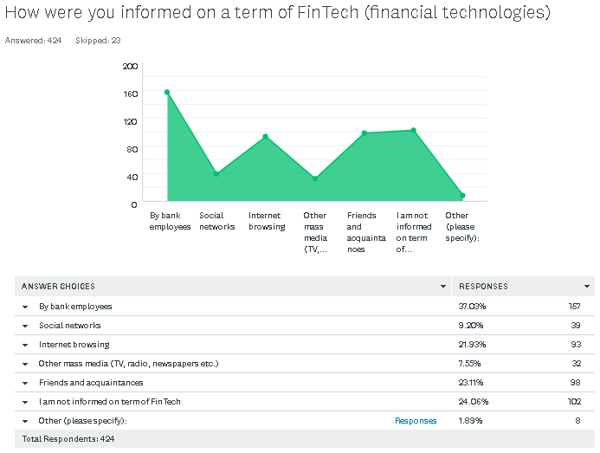
17: The way in which the participants were informed on term of FinTech; developed by author
From the figure 17 it can be seen that 157 participants (38,03%) have found out about FinTech by bank employees. This confirms the claim that Banks are the key drivers of FinTech revolution in Bosnia and Herzegovina and that the are the main promoters of FinTech for the potential consumers (Odorović, McKain and Garvey, 2020). Apart from that, significant amount of participants (98; 23,11%) have informed themselves about the term via online FinTech companies advertisements or by the friends and acquaintances who are using the feature (98; 23,11%).
However, 102 participants which is 24,06% of tested population said that they are not informed on the term of FinTech which is significant number considering the fact that FinTech concept is widely used across the work for over 10 years now. The lowest percentage of the population have chosen the other option and most of them have been introduced to the term during their studies. Even though it caught small amount of the responses, author believes that inclusion of FinTech in the systems of higher education is big step forward towards the wider adoption.
In order to gain further understanding on which groups are not informed on the term of FinTech, the author has analysed the survey data in Microsoft Excel. The author filtered all of the respondents in order to determine two variables against each other, first one was age gap while the second one was the option “I am not aware of FinTech. Presentation of the results are as follows:
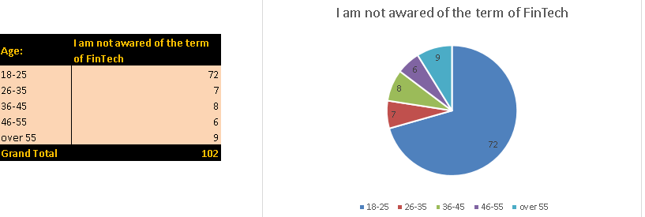
18: Participants not aware of the term of FinTech categorized by years of age; developed by the author
Due to the inconsistency between the age group, the author believes the most appropriate approach to the analysis would be to take ratios of each group to the total population. This means that 31% of people between 18-25 years of age (72/231) are not aware of the term which is quite significant amount, 13% of 26-35 age group (7/55), 13% of 36-45 age group, 16% of the 46-55 age group and 14% of people over 55 years of age are not informed on the term.
Results from the above are decent representations of one population as all of the percentages which are not exceeding 20% are acceptable. However, worrying fact is that over 30% of younger generation of participants are not informed on term of FinTech and author believes this can be prescribed to the lack of financial literacy among the younger population.
The second subsection of authors interest in this area is in connection to this matter was to understand how many people are not informed on term of FinTech in three different entities. Once again, due to the higher response rate from Republic of Srpska, the author will draw the conclusions on the basis of percentages on the overall tested population.
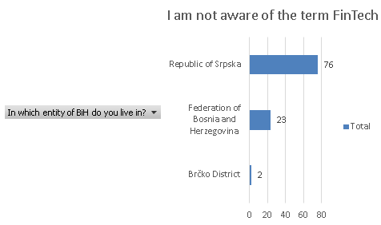
19: Awareness of FinTech services across the three BiH entities; developed by the author
From the figure above we can conclude the following:
1. Republic of Srpska – 24% of tested population from this entity is not aware of the term.
2. Federation of Bosnia and Herzegovina – 19% of tested population from this entity is not aware of the term.
3. Brčko District – 29% of the tested population from this entity is not aware of the term. However, tested population on Brčko District cannot be taken as relevant as only 7 participants took the survey from this entity while 2 of them said they were not informed on the term of FinTech. Due to the unrepresentative sample size, all the conclusions drawn for this entity could be unintentionally misinterpreted.
Second question in estimating the usage of FinTech has been examined by simply asking the participants whether they use any FinTech services or not, with particular emphasis on mobile and online banking as most used FinTech services. As this question was asked of the participants after the question on how they were informed on the term of FinTech, 102 participants who previously answered they were not informed are by the logical process of thoughts considered to not be using the FinTech and were not shown this question. It is important to mention that apart from 102 respondents who were not shown this question and 23 respondents who earlier abandoned the survey, 4 more participants left by this stage of the survey and therefore, their responses were not collected.
Out of 318 who took this part of the survey 175 participants said they are using FinTech services to some capacity (55,03%) while the remaining 143 participants said that even though they are informed on the term, they are not using it’s features (44,97%).
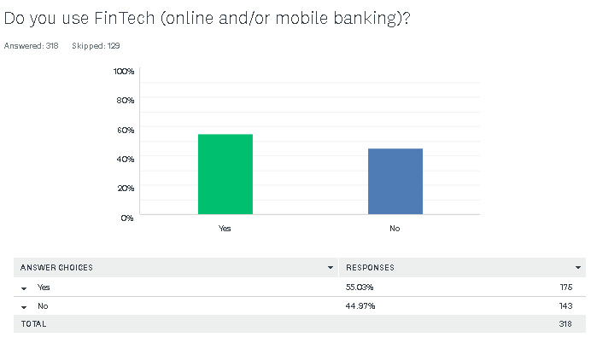
20: Figure showing the ratio of participants using FinTech services vs those who are not; developed by the author
It can be concluded from the figure above that more people are using FinTech in Bosnia and Herzegovina, however if we consider the data from those who are not informed on the term we get significantly different results. That would lead to conclusion that 175 people who are using FinTech services are put against 245 people who either do not use any of FinTech features or are not even introduced to them. This would further mean that 41% of people are currently using FinTech services while 59% of them do not, which is considered to be significant range considering the sample of 420 participants.
With purpose of better understanding, the author has compared this question to the several previously defined subsections:
- Years of age
- Place of living

6.2.2.1 Usage of FinTech by different age groups
Furthermore, the author has categorized the answers from figure 20 in order to determine how is the usage distributed between the different age groups of the participants.
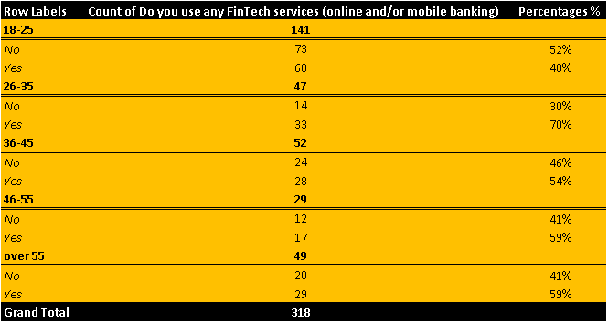
21: Usage of FinTech by different age groups; developed by author

From the figure above it is evident that most of the sampled population are relatively equally distributed between the two choices except the age group between 25-35 year of age which are significantly more engaged in usage of FinTech. Another point worth mentioning is that figure above strengthens the point that younger generations lack usage of FinTech services if we consider the data from figure 17. However, it also brings surprising information on usage of FinTech among the population over 55 years of age as this category was least expected to be aware and use the FinTech services.

6.2.2.2 Usage of FinTech depending on the place of living
In the following section author tends to use the collected data to try and find the correlation between the usage of FinTech in three different entities of BiH. For this purpose, the author has divided collected responses by entities by using Microsoft Excel tools in combination with survey monkey presentation.
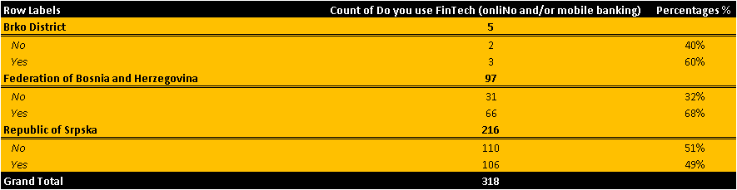
22: Usage of FinTech in all three entities in BiH; developed by author
Due to the cultural differences between the entities explained in the previous section of the chapter, the key motivation for this subsection was to measure whether the results may differ among the two different entities. Once again, due to the sample size for Brčko District, it will not be included in the analysis of this research section. However, two major entities are showing significant differences in FinTech usage. From the figures above we can conclude that Federation of Bosnia and Herzegovina are relying significantly more on the use of FinTech. If we refer to the previous section on the awareness of the term of FinTech we can develop more representative set of figures which shows that in Federation of Bosnia and Herzegovina still 55% of population are using the FinTech services (23 respondents from Federation of BiH said they are not familiar with the term and therefore the author added this number to the number of population that is not using any FinTech services in BiH). On the other hand, in Republic of Srpska, per figure above slightly less people are using FinTech in comparison to those who do not. However, if we add 76 participants from Republic of Srpska who said that they are not aware of the term we get come across much greater deviation between the findings. That would mean that 186 out of 292 participants from Republic of Srpska are not using FinTech services what is 64% of tested population in comparison with 36% who are using it. This represents a significant gap between the two entities and should be a subject for further research.

6.2.3 Evaluation of Hofstede’s dimensions of national culture on territory of BiH
These section will cover the key five dimensions of Hofstede’s national culture which were tested in the survey by designing set of socio-cultural questions to be answered by the participants. In order to strengthen the point and contribute to the relevance of the data, the author has constructed two questions for each of the relevant dimensions of national culture where one question was looking strictly at sociological aspect while being undermined with another question for the same dimension including the FinTech aspect of cultural dimension where appropriate.
In order to delimit the research from the possible misinterpretation of data, it is of high importance to emphasize that certain dimensions of national culture could not be put in comparison with adoption of FinTech such as long term vs short term orientation and as such were only assessed from socio-cultural aspect.
The two key objectives of this research is to evaluate actual results versus presented results on “Insight-Hofstede” and to evaluate how CMSI factor may influence consumer adoption of FinTech in Bosnia and Herzegovina. For this reason, special attention was given to the dimensions of uncertainty avoidance, which is closely related to the adoption of new technologies, power distance and individualism and collectivism which were all presented in the survey in form of socio-cultural aspect and in regard to FinTech adoption, while long term vs short term and masculinity vs feminity factors are only giving information on the cultural aspect of BiH as these dimensions are not directly linked to the adoption of FinTech.

6.2.3.1 Uncertainty Avoidance
As it was mentioned in the previous section, this dimension is closely related to the adoption of the new technologies as it was defined by the Hofstede as “fear of unknown” (Hofstede and Minkov, 2010). It is therefore believed that cultures with high uncertainty avoidance s are more repulsive towards the change e.g. adoption of new technologies (Slyke et al., 2004).
According to the presented data in literature review chapter on Hofstede’s dimensions of national culture Bosnia and Herzegovina had extremely high index of 87 for this particular dimension.
This dimension was evaluated through three different questions due to it’s importance.

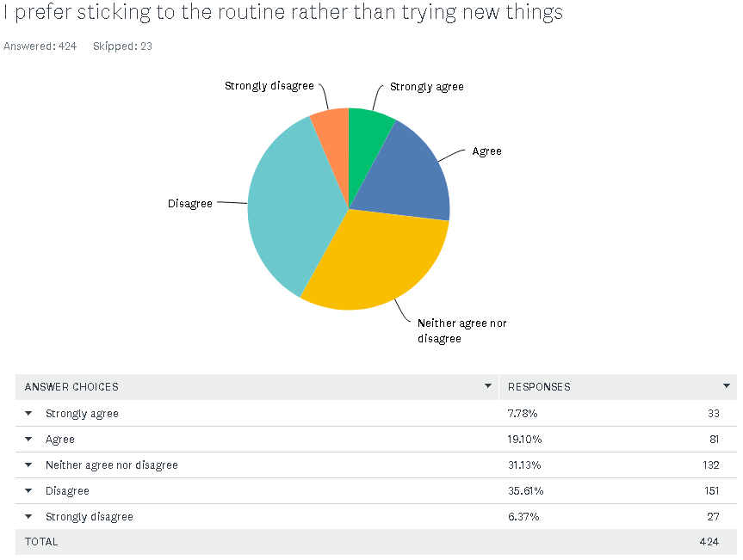
23: First survey question regarding uncertainty avoidance; developed by the author
First question was evaluating the uncertainty avoidance from the social aspect. It was designed to measure uncertainty avoidance on the assumption that cultures who are preferring to sticking to their everyday routine are believed to position highly on uncertainty avoidance dimension and vice versa. People were also given the “Neither agree nor disagree” type of question as author believes that those participants who may be indecisive on whether they agree or disagree with the proposed claim can remain neutral on the matter. For this reason, neutral responses will not be included in analysis of the results. In order to simplify the presentation of the results, participants who claimed to strongly agree and agree are categorised in one group of answers as well as those participants who claimed that they either disagree or strongly disagree.
In the figure above, the data shows that 41,98% of respondents answered that they are keen to try new things rather than stagnating with their everyday life routines in comparison to 26,99%. This further leads to conclusion that per first social question, tested population does not qualify highly on the uncertainty avoidance as it was claimed by Hofstede.

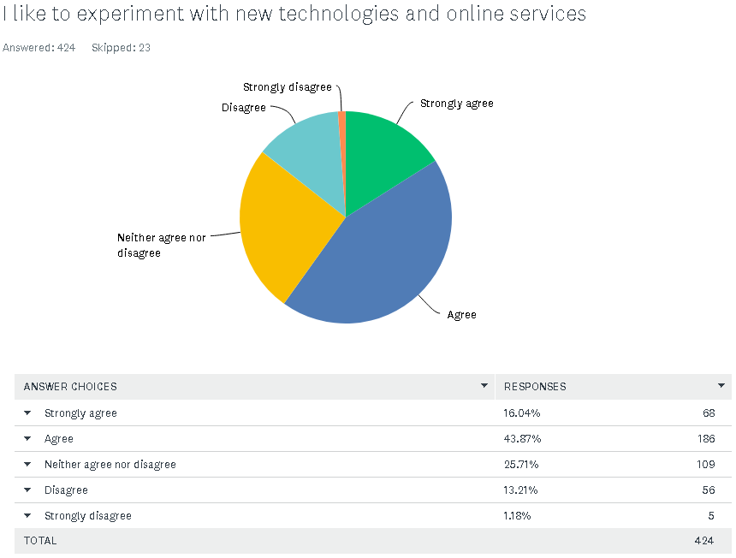
24: Second survey question regarding uncertainty avoidance; developed by author
Second question on uncertainty avoidance is more technologically oriented where people were simply asked if they enjoy in trying new technological innovations, platforms etc. Second point of this question was to strengthen the point on the assessment of uncertainty avoidance by constructing it in form of “mirror question”. This can be seen in comparison with the first question in figure 22 where people were indirectly directed to answer that they prefer sticking to the routine which is influencing high uncertainty avoidance. In this second question, claim was structured in a way to influence low uncertainty avoidance by ignoring the “fear of change”. This enabled the author to see whether the participants were actually reading the questions which puts relevance on the collected answers or whether they made their choice randomly. However, the results in figure 23 are showing that 59,91% of respondents answered positively to the question while only 14,39% said that they are not willing to experiment with something new. Remaining 25,71% remained neutral on this question.
This compliments the answers on the first question on the uncertainty avoidance as participants once again chose to rather try something new in technology then to stick to the existing technologies. Therefore, it can be concluded that actual results are mismatching with already presented results by Geert Hofstede and that BiH culture positions lower on the uncertainty avoidance dimension than expected.
From the first question, a new assumption can be drawn as the author believes that the main reason for the deviation between actual results and results on “Insight-Hofstede” is the generation gap between the two researches. Once again it is important to highlight that the major age category of this research is between 18-25 years of age. As this are representatives of new generation who are born and living in technologically advanced era, these results were expected by the author, regardless of the present mismatch.

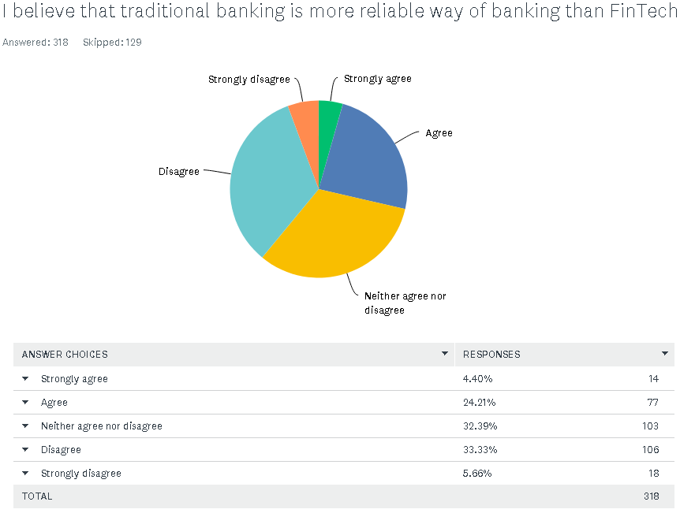
25: Third question regarding uncertainty avoidance; developed by author
Third and final question on uncertainty avoidance referred directly to the research topic of FinTech adoption. The third question was designed to confirm the uncertainty avoidance dimension as it was basically constructed in a way to cover key points of first two questions; question of routine which is presented as a term of traditional banking, and question of technology experimentation which is presented in term of FinTech. This question was also constructed in a way to indirectly condition high uncertainty avoidance.
The results of the third question are showing the same results as first two questions as vast majority of the participants disagreed with the fact that traditional banking is more reliable way of banking (38,99% disagreed with the claim in comparison to 28,60% while 32,39% of people remained neutral on this matter.

This set of questions led us to two important findings:
- Presented uncertainty avoidance dimension by Geert Hofstede does not seem to be complimentary to the actual results conducted by this research due to the younger population.
- Lower uncertainty avoidance for Bosnia and Herzegovina may refer to the fact that Bosnia and Herzegovina is not a country of high CMSI index which will eventually mean that cultural factors are not influencing lack of FinTech adoption in BiH.

6.2.3.2 Individualism vs collectivism
Key assumption of this Hofstede’s dimension was that Bosnia and Herzegovina is collectivist culture by scoring 22 on Hofstede’s model. Furthermore, this question is not closely related to the adoption nor change and as such was treated as socio-cultural matter.
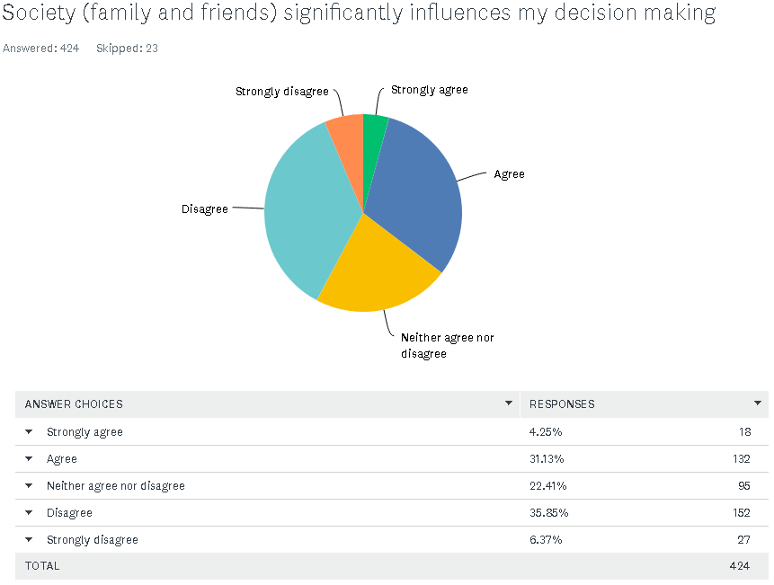
26: First question regarding individualism vs collectivism; developed by author
The aim of the first question was to evaluate how participants are making important decisions in their life. Depending on how participants are making their decisions, the author was able to draw the conclusions on this cultural matter; if their decisions are significantly influenced by their families and friends, it would lead to the conclusion that culture in BiH is rather collectivist and vice versa.
Results shown in the figure 25 are showing however that 35,38% of participants believe that their families and friends are influencing their decision making while 42,22% claimed that they are individually deciding what is good for them and what is not, with remaining 22,41% remaining neutral.
Therefore, the actual results in the first question are denying to certain extent the key assumption for this question of Bosnia and Herzegovina being strongly collectivistic culture.

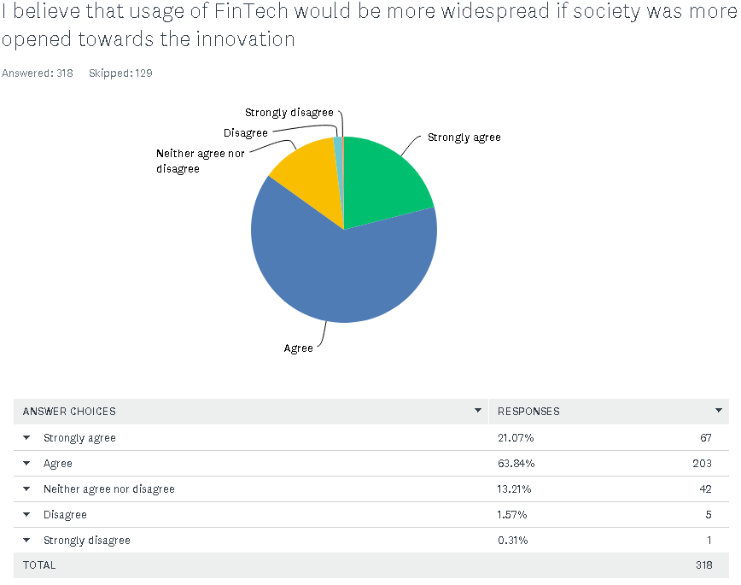
27: Second question on individualism vs collectivism; developed by author
Second question on individualism vs collectivism dimension was correlated with usage of FinTech for the research purpose. It is putting the society variable as a collective against the adoption; meaning that people were asked whether the Bosnia and Herzegovina society as a whole drives the usage of new technologies or, if disagreed with the claims above, technology adoption is depending individually by each person or unit of society.
The answers are strongly referring that people believe that repulsiveness towards the innovations are collective matter with 84,91% of participants agreeing with the claim against the 1,88% who disagreed with the claim, remaining 13,21% of participants remained neutral on this matter.
This represents the problem for the further analysis as two conclusions from two answers are contradictory. First question is referring that Bosnia and Herzegovina is individualistic country while the second question refers the opposite by quite enough. However, it is of significant importance to mention that second question was answered by lower number of tested population, as was not shown to the population unaware of the FinTech term. As such, the author believes that first question on it’s own shows more relevant findings, not only due to the number of answers but also for the variety of answers. This belief is underpinned by the fact that second question was one sided which may be interpreted as lack of understanding of the question or that question was structured to lead to generally accepted opinion.
Considering the information above, results of the first question will be considered as more relevant but as such it refers to the culture of Bosnia and Herzegovina as individualistic rather than collectivist country which may mean it is more open to the innovations than some collectivist cultures (Deufel, Kemper and Brettel, 2019).

6.2.3.3 Power distance
The dimension of power distance is defined as the extent to which less powerful members of society accept and expect that power is distributed unequally (Hofstede and Minkov, 2010). Again for the purpose of estimating this dimension level to the actual results, the author was looking at these problematics solely from socio-cultural aspect. The starting assumption from both, the author and Hofstede is that Bosnia and Herzegovina is ranked high on the scale of power distance dimension with score of 90. This means that society in Bosnia and Herzegovina are aware and accepting of unequal power distribution between the citizens and authorities. Once again, this matter cannot be observed from the technology adoption perspective and as such, author has evaluated this factor through two socio-cultural questions.
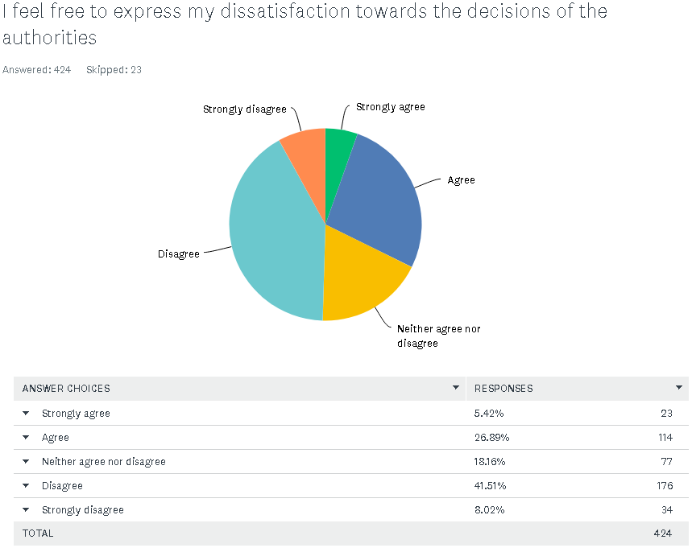
28: First question regarding power distance; developed by author
In the first question participants were directly asked on how they feel in showing dissatisfaction towards their authorities. It is important that both, Hofstede and many other scholars have evaluated this dimension of national culture within the organizations and is mostly used to define the mutual relations between the employees and employers.
From the figure above it can be seen that 49,52% of participants said they cannot oppose their authorities while 32,31% said they can do it without potential consequences for their attitudes.
To get a closer insight into the cultural differences between the entities, the author has divided responses per this parameter.
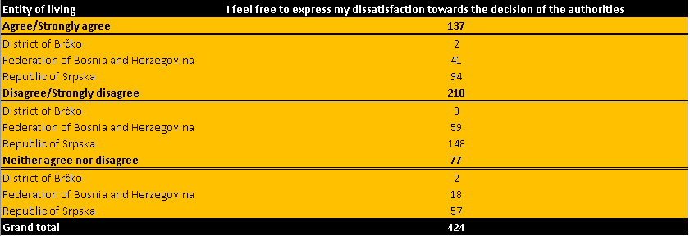
29: Representation of the first question categorized by entities; developed by author
From figure above we can conclude that 31% of tested population from Republic of Srpska feel free to show their dissatisfaction towards the authorities, while 49% believes they cannot express their opinion without being endangered in certain way. In Federation of Bosnia and Herzegovina, same as percentage of participants believe that they can express their dissatisfaction while 44% believes they cannot express their dissatisfaction toward the authorities.
This leads us to conclusion that power distance dimension is generally high for the territory of Bosnia and Herzegovina and that the starting assumption proved right. Furthermore, the results have shown that power distance does not differ between entities or in other words does not depend on existing cultural differences between the two entities.

6.2.3.4 Long term vs short term
Long term versus short term dimension is generally considered to be a social matter whereas long term distance is considered to be a characteristic of the countries that are sacrificing short term success in order to achieve greater success in the future (Deufel, Kemper and Brettel, 2019). This can be seen from the example of investing in ones’ education systems with goal of providing more competent workforce in the future. On the other hand, short term countries tend to hold onto their traditions and are observing any kind of change with suspicion.
Hofstede defined Bosnia and Herzegovina as long term oriented country by giving it score of 70 (Hofstede Insights, 2019) for this parameter. However, the author believes that society in Bosnia and Herzegovina is rather short term oriented as it is post war country. In connection with that, the author believes that even younger generations are limited by recalling the events from the past which are transmissing from generation to generation.
Furthermore, due to the cultural differences of three different nationalities in one country, each of the nationalities are strongly holding on their traditions which is typical indicator for short term countries.
The author has estimated this matter throughout two questions both of which are focused on the social aspect of the participants.
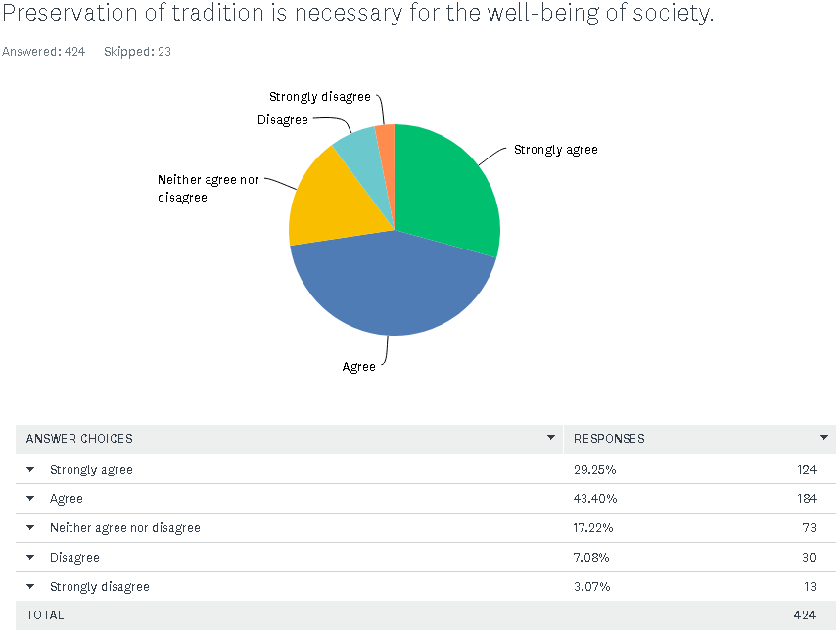
30: First survey question on long-term vs short-term orientation; developed by author
In figure 30 we can observe that population of Bosnia and Herzegovina are strongly holding to their traditions. As it was explained earlier in the work, as each nationality is defined by different religion (Muslims, Catholics and Orthodox), it is believed that losing your tradition may eventually lead to the loss of people’s personality. As it can be seen as above, tradition does represent an important factor in cultural framework of Bosnia and Herzegovina as total of 308 respondents believe that preservation of tradition is important for the future development of society which is 72,64% of tested population. On the other hand, 43 participants who are 10% of tested population do not believe that tradition is considered significant and representative factor for a single nation.

In order to develop further understanding, the author categorized collected responses per entities of BiH.
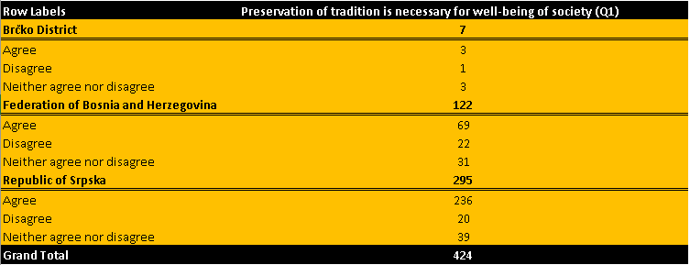
31: First question on long-term vs short-term orientation categorized by entities; developed by author
Considering that 236 (78%( of Republic of Srpska population believes that preservation of tradition is of key importance for the well-being of society and only 20 (7%) believes that it is not, we can conclude that this entity can be defined as short term oriented culture. On the other hand, in Federation of Bosnia and Herzegovina, 69 (60%) of population consider tradition as important factor in comparison to 22 (19%) who believes it is not.
Although both entities strongly hold to their traditions, it can be concluded that people of Republic of Srpska consider it slightly more important. In this estimation, the author also takes into consideration the difference in sampled population from both entities but it can be concluded with significant amount of assurance that country in general is rather short term oriented on the basis of the first question.
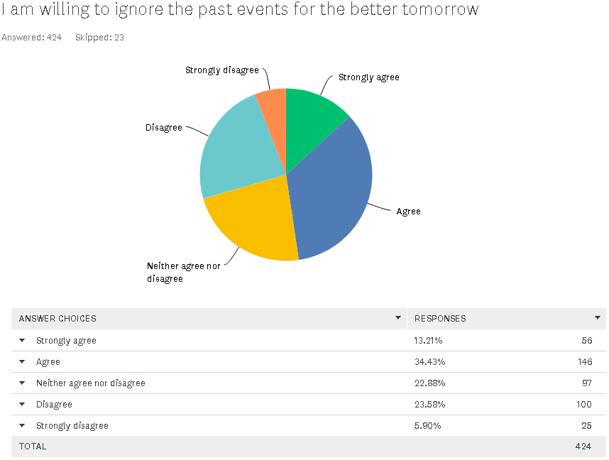
32: Second survey question on long-term orientation vs short-term orientation; developed by author
Unlike the first question on short term vs long term orientation that emphasized the matter of tradition, the second question is looking at other characteristic of short term oriented country which are past events. As the country in which the war which happened over 20 years ago but is still often talked about, it is unquestionable that it left long term consequences for generations to come. However, from the listed data it is evident that majority of respondents (202 – 47% of tested population) claims they are willing to get over the past for the better future. In contrast to this, total of 125 respondents which is 30% of population believes that past events cannot be ignored and that it will not reflect positively in the future development of the country.

Similarly, like the figure above, the author categorized the above data by each entity individually.
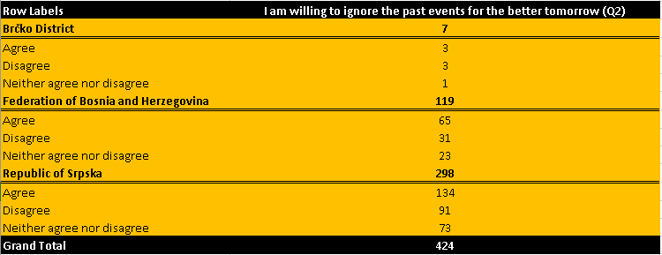
33: Second question on long-term vs short-term orientation categorized by entities; developed by author
134 respondents from Republic of Srpska have answered they are willing to ignore the past for the better tomorrow which represents 44% of tested population while 91 participants which is 30% of total sample believe that past is too important to be ignored. Data for Federation of Bosnia and Herzegovina 56% claims that they are more future oriented in comparison to 26% who are not willing to ignore the past.
This question exceeded author’s expectations as Bosnia and Herzegovina are showing indications to focus on the future and become long term oriented country. This subject is good material for further research as this research was taken mostly by younger population which leaves the space to test this dimension again in several years.
As the conclusion to the section, the author firmly believes that Bosnia and Herzegovina is still mostly short term oriented country but with good indication for change. This is important fact for adoption of new technologies as short-term oriented countries tend to be much more repulsive to adoption then long term oriented cultures (Deufel, Kemper and Brettel, 2019).

6.2.3.5 Masculinity
Masculinity is final evaluated dimension of Hofstede’s national culture. This dimension has the rating of 48 per Geert Hofstede, and as such can be defined as masculine culture but with rather low score as everything bellow 40 is considered feminine culture and as such, Bosnia and Herzegovina is placed somewhere in between.
(Deufel, Kemper and Brettel, 2019)) mentions the correlation between masculinity and innovation by stating that “masculine cultures are more likely to positively react to the technological innovations as these cultures are seeking for achievements and success” but did not present the direct correlation between the two terms.
As this matter does not benefit the research regarding the knowledge on FinTech adoption in any way, it was included in the analysis as one of the cultural dimensions but the author did not give it detailed attention.
Question of masculinity was evaluated by asking the participants whether they believe that women are treated equally to men in Bosnia and Herzegovina.
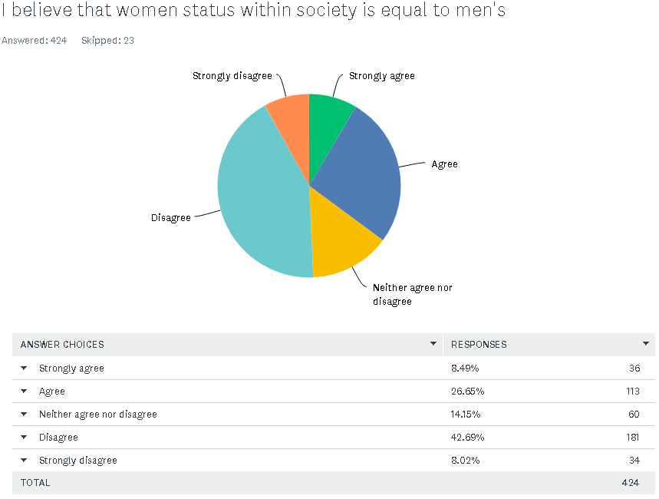
34: Survey question on masculinity vs femininity dimension; developed by author
In the above information it is evident that most of the participants believe that women are unequally placed in the society in comparison to the men. 215 participants (51% of sample) believes the question statement is wrong while the 149 (35%) of them believe that women rights are equal to men’s in Bosnia and Herzegovina.
Findings from this question are confirming Hofstede’s claims showing that Bosnia and Herzegovina tends to be masculine culture. Considering the fact that deviation between the two main choices is not significant, it can be concluded that score of 48 for this dimension is relevant as the population is not overly favourable on either side.

6.2.4 Review of external factors that influence the adoption (Complexity, security, trust, observability and relative advantage)
The author has approached this phenomenon from two sides, by dividing two sets of question for the participants depending on whether they are users of FinTech services or not. Set of questions have been designed to evaluate key FinTech benefits as the key arguments for wide incorporation of FinTech usage in Bosnia and Herzegovina on the basis of responses by FinTech users. On the other side, the author aims to evaluate what are the key perceived limitations of FinTech. This set of questions was asked from the participants that said they do not use FinTech. Second set of questions embedded factors of security, complexity, trust, relative advantage and observability to evaluate which of these factors are preventing them from using FinTech features and to what extent. For the purpose of more relevant presentation and as questions were designed in a way to be as simplified and understandable as possible, the participants were given only “yes” or “no” options to answer the questions.
All of these factors were developed in diffusion of innovation theory by Rogers but are tailored in a way to compliment the research. One of the key research objectives is to contribute to the further evaluation of importance of mentioned factors on the adoption of FinTech.

6.2.4.1 Complexity
(Rogers, 1983) defined complexity as an insight in how difficult the innovation is to understand and adapt to the wider population. He further puts special importance on this question as higher levels of complexity are invertly proportional to the rate of adoption.
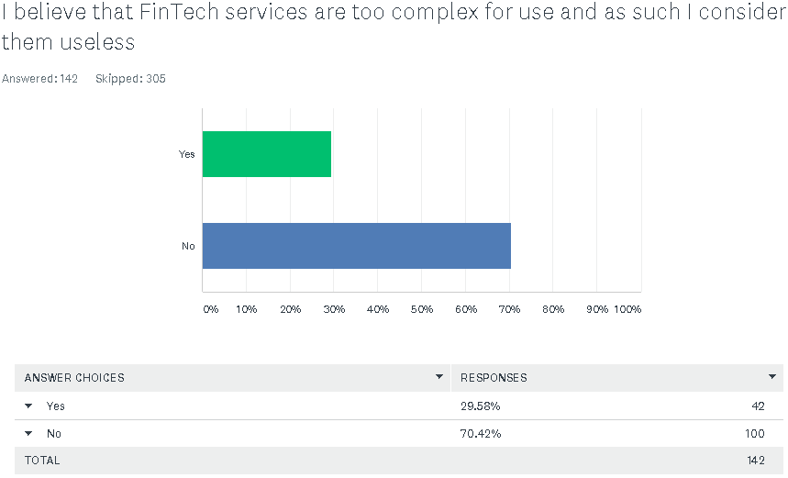
35: Influence of complexity on adoption of FinTech in Bosnia and Herzegovina; developed by author
From the information in the figure above, majority (70.42%) of respondents said that complexity is not the main reason for denying the use of FinTech. Remaining 29,58% have claimed this to be the main reason for not using FinTech.
The author has further categorized the question of complexity per year of age of participants in order to gain an understanding on which age groups are affected by complexity of innovation the most as the logical assumption would be that younger generation give less credibility to the factor of complexity in comparison to those over 55 years of age.
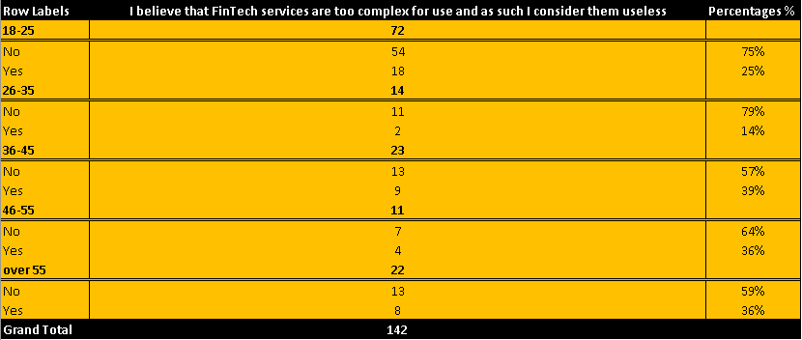
36: Factor of complexity reviewed against different age groups; developed by author
As from the assumption made, figure above shows that year of age is positively correlated with influence of complexity meaning that older the potential user is, the more complex perception of FinTech is obtained. However, the author believes that complexity factor will almost certainly reduce with generational change.

6.2.4.2 Security and Trust
Factor of security was not covered by Rogers in diffusion of innovation theory but author believes that in recent times it is as important as any of the other factors. Afolabi (2015) defined security as a matter that has to deal with any danger to the person itself or their precious values.
In this research we are particularly looking at the concept of cyber security which emphasise the mater of protecting any kind of personal or financial data that may be made visible on digital platforms (Zwinggi, 2020). For this reason, the author has asked the participants whether they are concerned about misuse of their personal information.
Concept of security is therefore closely related to the concept of trust as people would not dare to engage in any kind of online transaction unless they are guaranteed complete security of data (Ashraf, Thongpapanl and Auh, 2014).
For this reason, the author has tested those concepts in two survey questions.
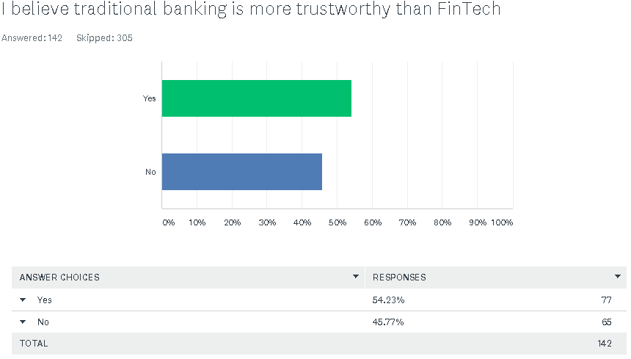
37: Influence of trust factor in adoption of FinTech in Bosnia and Herzegovina; developed by author
Information above enables author to conclude that trust represent significant limitation in incorporation of modern financial technologies. Out of total 142 participants who were asked this question, 54% said that they are still suspicious in the FinTech providers and are more likely to continue with traditional way of banking. Remaining 46% believe that FinTech is probably better way of banking, but are still not convinced enough to switch to FinTech.
This section was further broken down to the age categories (figure 28) of the participants and as it was expected the most trust issues are shown in the population over 55 years of age due to the lack of technological literacy. However, as it represents an important factor not only in the adoption of the technologies but in general, trust issues are present in significant matter across all of the age groups.
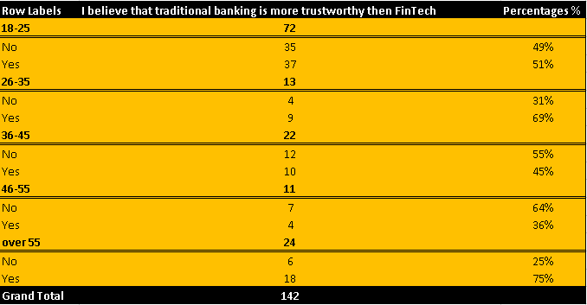
38: Review of trust factor categorized by age group
Second survey question refers to the security factor and can be seen in the figure bellow:
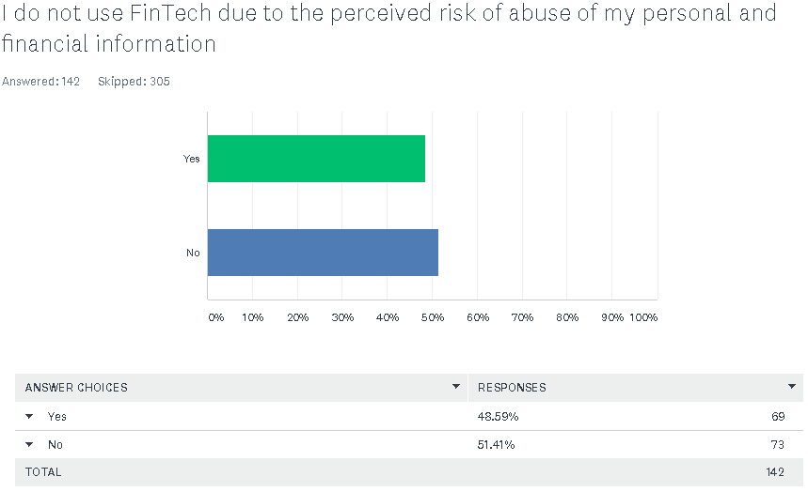
39: Influence of security factor on adoption of FinTech in Bosnia and Herzegovina; developed by author
From this figure we can see similar problem such as in question regarding the factor of trust. Although, majority of respondents chose “no” option for this question, 49% of participants are fearful of their personal data breach potential. However, this is completely expected response as the FinTech requires special regulations and specialised regulatory bodies in order to enable complete security to the FinTech customers but in country like Bosnia and Herzegovina, requirements for these bodies have not yet been met (Odorović, McKain and Garvey, 2020).
Similarly like with the security, presented data categorised by years of age does not seem to find the pattern between the two variables as most of the age groups equally consider the factor of security to be the main barrier towards the incorporation of FinTech (please see the figure bellow for the presentation of data).
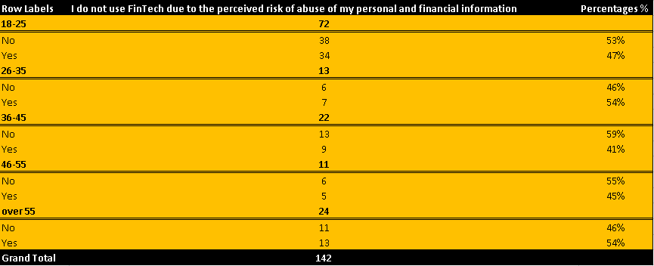
40: Influence of security factor categorized by the age groups; developed by author

6.2.4.3 Observability
Third external factor which author believes is of crucial importance is observability. Observability was defined by (Rogers, 1983) as the extent to which the innovation is visible and accessible to the potential users. This external factor is considered to be of high importance as it refers to the direct promotion of the innovation. This means if innovation is not promoted enough than potential customer base will not be informed on it’s effects and features, regardless of whether it would fit within the certain population or not.
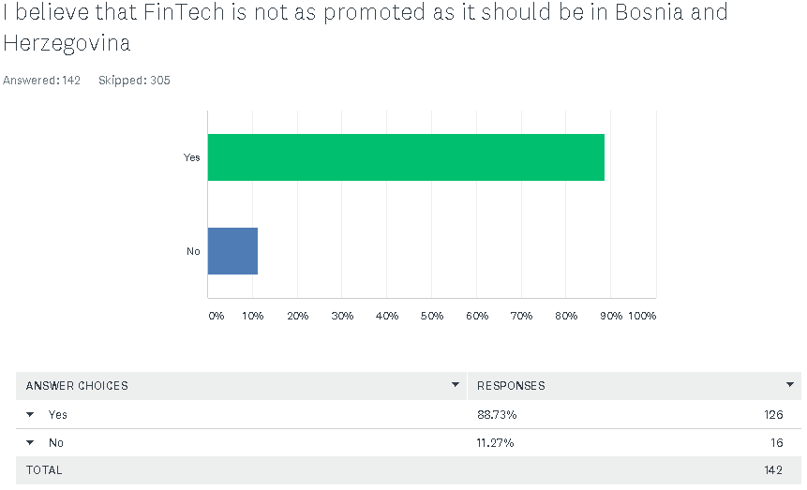
41: Influence of observability factor in adoption of FinTech in Bosnia and Herzegovina; developed by author
From this figure we can see that vast majority of the respondents 89% believe that FinTech is not well promoted for the advanced use and wider incorporation in BiH financial system. This confirms two important points:
Firstly, this information can be considered relevant as almost one fourth of the total participants answered that they are not informed on the term of FinTech and those participants were not shown this question. However, this means that even 142 people who are familiar with the term do not use it because they do not know much more about FinTech and it’s features. This leads us to the conclusion that out of 447 participants who took the survey, 128 of them (28%) do not actually know much about FinTech.
Secondly this information was confirmed by Central Bank of Bosnia and Herzegovina by stating that banks will increasingly educate people on FinTech and it’s abilities due to the cheaper way of banking and safer way of banking during the COVID-19 pandemic (Centralna Banka BiH, 2020).

6.2.4.4 Relative Advantage
(Rogers, 1983) claimed that relative advantage is key driver of innovation in emerging markets. Relative advantage is defined as customer’s perception on beneficial advancements of the innovation in comparison to it’s predecessor (Rogers, 1983).
For the purpose of this research, this means putting the FinTech concept against the concept of traditional banking and author have designed several questions regarding this matter.
As it was mentioned in the opening sentence, this directly refers to the advantages of FinTech and as such these were measured exclusively against the population that is using FinTech services as this category of total sample are the only relevant users that can compare the two concepts of FinTech and traditional banking. For the purpose of the research, the author has chosen some generally accepted advantages of FinTech over traditional banking such as cost efficiency, time efficiency and better control over customer finances. The results can be seen in figures bellow:
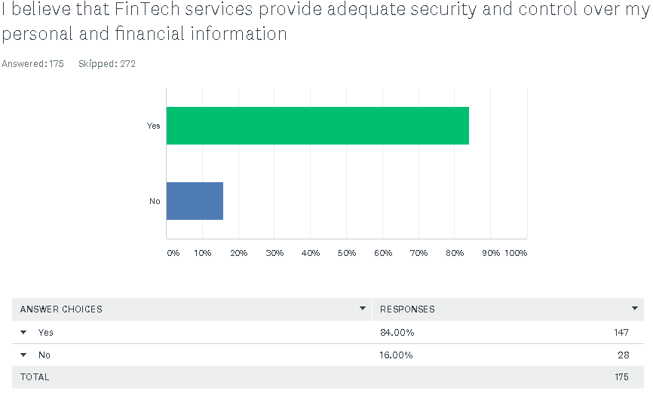
42: First survey question regarding the advantages of FinTech; developed by author
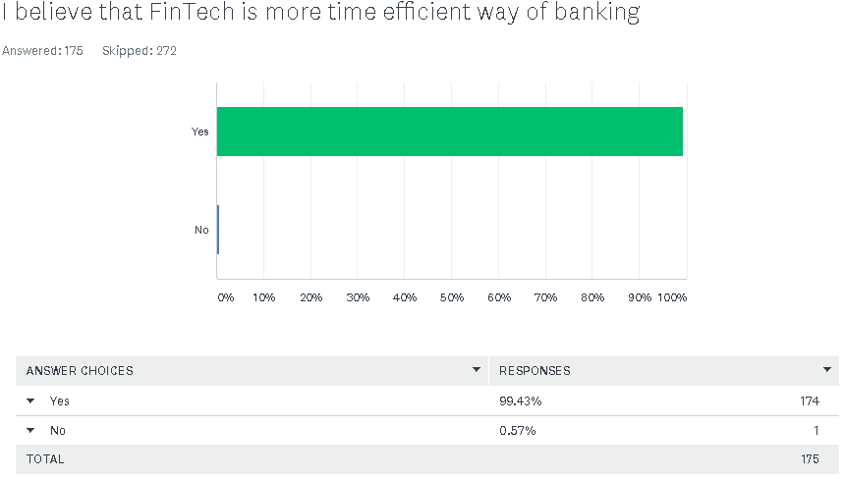
43: Second survey question on advantages of FinTech; developed by author

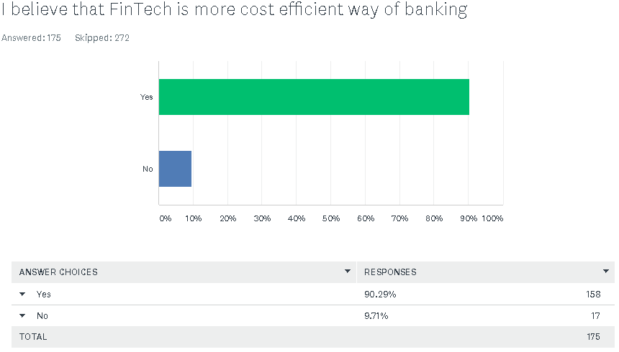
44: Third survey question on advantages of FinTech; developed by author
As it can be seen from the figures above, most of FinTech users in Bosnia and Herzegovina who are using FinTech services regularly believe that FinTech offers more efficient banking experience in terms of cost and time consumption. 99,43% of participants claim that they are spending less time managing their finances in comparison to traditional banking. Furthermore 90% of users believe that FinTech is cheaper way of banking. Finally, 84% of FinTech users believe that FinTech providers are enabling them with both, adequate security and control over their finances and personal information, but remaining 16% are still doubtful over the breach of their personal information.

6.3 Conclusion of the chapter and review of findings
The data analysis contributed to author’s ability to get an overall insight into the general usage of FinTech in Bosnia and Herzegovina along with the explanation and relevant reasoning behind the collected data.
First research question was to evaluate the extent to which FinTech is being used on the territory of Bosnia and Herzegovina and to what potential. The basic assumption which was made by the author was that adoption rate of FinTech in Bosnia and Herzegovina is on the low level. This claim was supported in the chapter 6.2.2 FinTech rate of adoption in Bosnia and Herzegovina where author got an insight in what percentage of tested population actually use FinTech services. Final results showed that 58% of total population tested are still not using FinTech services. More precisely, out of 58% of population, 34% of population are informed on the term of FinTech but simply are not using it while the remaining 24% are not aware of the meaning of FinTech.
Following chapter was covering Hofstede’s dimensions of national culture with application on case of Bosnia and Herzegovina. In conclusion of this chapter, the author gained an understanding on culture variability and how significantly it can change over relatively short period of time. This knowledge was obtained by comparing the actual results against Hofstede’s data for Bosnia and Herzegovina and this research have shown some significant differences;
Uncertainty avoidance dimension was given a total score of 80 for Bosnia and Herzegovina while the primary research showed quite different results which led to conclusion that society in Bosnia and Herzegovina does not tend to avoid the unknown and as such represent a suitable soil for FinTech incorporation.
Individualism was the next reviewed dimension of national culture. Hofstede determined Bosnia and Herzegovina as rather collectivist country and this was aligning with authors expectations. However, it turned out that Bosnia and Herzegovina is slowly turning to more individualistic culture which also compliments the ability to adapt FinTech more efficiently as per (Deufel, Kemper and Brettel, 2019).
Power distance was the next dimension that was tested against Hofstede’s results on national culture of BiH. Hofstede determined power distance dimension as extremely large with score of 90. By asking the participants on how they communicate their dissatisfaction to their authorities, the actual results indeed showed that society in BiH is aware and acceptable of the unequal distribution of power among the less powerful members of society and as such, the author believes this dimension was well evaluated by “Insight-Hofstede”.
Long term vs short term dimension section assessed the matter of tradition and connection to past events in order to determine this cultural dimension for Bosnia and Herzegovina. Even though this dimension was also ranked relatively high by Hofstede with total score of 70 (meaning that Bosnia and Herzegovina is long term oriented country) the actual results showed that as post war country, society in Bosnia and Herzegovina is still short term oriented, not willing to put future development of the country before the tradition. However, the results have shown the indication of switching to long term orientation over the time as most of the people are willing to give up on past events for the greater good of the country.
Last dimension tested was masculinity. This dimension was rather neutral on the Hofstede’s scale scoring overall of 48. This dimension was tested on question of women equality to men in the Bosnia and Herzegovina society and it has shown similar results to the ones projected by Hofstede.
The author however believes that cultural factors benefit further research on the topic significantly as the majority of population was younger generation enabling the author to anticipate the cultural change on the territory of one nation for the years to come.
Last section of the work was evaluating impact of complexity, security, trust, relative advantage and observability in the process of adoption of FinTech. The results have shown that greatest barrier to the adoption of FinTech is related to the observability or promotion of the FinTech on the territory of BiH. This claim is further substantiated by the fact that 24% of total survey participants were not informed on the term of FinTech.
Other than this factor, research has shown that factors of trust and security are representing significant barriers towards the adoption as potential users still do not believe the control systems of FinTech providers and are afraid that their valuable data may be misused and subject to cyber criminal.
Apart from this, the author has confirmed already known assumption in the more developed country and it refers to the FinTech superiority over traditional banking. This assumption was supported by the factor of relative advantage which was tested against the population that used both, FinTech and traditional banking services and results were almost unanimously in favour of FinTech’s cost efficiency, time efficiency and control over finances.

7. Research contribution, limitations and suggestions for further research

7.1 Contribution of findings for the research questions
By reviewing the overall results of the survey, author gain an insight in main research questions developed from the research:
The current phase of FinTech adoption and usage in Bosnia and Herzegovina
As it was explained in the introduction section within the aim of the study, the author aimed to understand the reasons behind the low usage rates of FinTech in Bosnia and Herzegovina despite it’s wide use through the entire world.
The research shows that this problem is a direct result from regulatory bodies on national level as well as to the consumer behaviour regarding switching to new way of banking. As research by Odorović, McKain and Garvey (2020) claims, Bosnia and Herzegovina has rather complex national structure and as such, it takes special effort to develop relevant regulatory bodies which would drive the wider incorporation of FinTech on national level.
On the other hand, the results of the survey are showing that majority of tested population is either willingly not using any kind of FinTech services or are not even aware of the term due to the lack of promotion. Author approached this question with implementation of generally main barriers towards the adoption of innovations so the research was firstly asking what is the general perception of population on FinTech and whether they use it or not. Once the assumption that people in Bosnia and Herzegovina are not following this global trend to the expected extent, the author emphasized the other two research questions on why people are not using it by breaking down many different factors which may influence this consumer behaviour.
Considering that most of the tested population were people between 18 and 25 years of age, current adoption phase of FinTech seems to be on an extremely low level but however the author believes that COVID-19 pandemic will eventually lead the transition to the digital payment systems over traditional way of banking.

Influence of cultural factors on the adoption of FinTech in Bosnia and Herzegovina
In the second research question, the author wanted to understand what is the actual cultural background of the Bosnia and Herzegovina and how it may reflect the reaction on innovation and change which is ultimately leading to the acceptance of new technologies.
In this part of the research, the author has evaluated Hofstede’s dimension of national culture for the territory of Bosnia and Herzegovina. This contributed the research in a way to show the difference between actual results and results shown by Hofstede for the Bosnia and Herzegovina. As results have differentiated significantly from the results developed by Hofstede, the author believes that contribution of this research is giving an insight in the change of cultural background in Bosnia and Herzegovina as author tested the questions mostly against new generation which is believed to be mostly exposed to the FinTech revolution in the future.
This assumption was made as results have shown that Bosnia and Herzegovina is starting to look like innovation friendly oriented culture in contrary to the research performed by the Hofstede and this further strengthens the claim from the first research question that population of Bosnia and Herzegovina is showing tendencies to incorporate FinTech services in the near future.
Influence of complexity, trust, security, usefulness and observability factors on adoption of FinTech in Bosnia and Herzegovina
This question gave the author an insight in some general barriers which are existing prior to the acceptance of innovation for the global population regardless of the development level of the country. Therefore, these findings tend to contribute to the existing approach to the adoption of FinTech as no such research was taken on the territory of Bosnia and Herzegovina.
From the results of the survey, the author has concluded that currently the most significant barriers for wider incorporation of FinTech are represented by the lack of promotion of the FinTech, further resulting in uninformedness of population. This means that people mostly do not use FinTech services as they do not know what they are offering and how they may influence their banking experience.
Apart from this, it is evident from the findings that people in Western Balkan’s in general and especially in Bosnia and Herzegovina still have significant trust and security issues towards the financial institutions and as such will always take significant time prior to completely switching to the new way of banking.

7.2 Research limitations
The author has faced several limitations in performing the research. Very first limitation refers to the fact of assessing the usage of FinTech on level of entire population considering the accessibility to the number of author’s personal connections.
However, this limitation was overcomed by making a representative sample of the population and try and evaluate the phenomenon against this sample. Even though the author was able to draw general conclusions on the phenomenon from the performed survey, the data should still be taken with a grain of salt as there is still possibility for slight deviation between shown results against actual behaviour of the population.
Furthermore, due to the author’s lack of diversification in personal connections, there was unequal ratio of participants by age groups and therefore most of the answers had to be evaluated against this categorization as the key representative. This ended up having many benefits for the research itself such as for the matter of cultural changes within the society, but still implied certain limitations such as limited access to the data by older age groups which had significantly lower amount of participants.
Similarly, like the above, as author is personally citizen of the particular entity, the personal connections were well in the favour of the entity of Republic of Srpska. However, unlike the age categorization of the participants, this categorization did not significantly influence the assessment of survey results as author was still able to draw relevant conclusions by putting the survey questions against this category.
Final limitation refers to the financial literacy of the participants. This claim is seen from the fact that 24% of the tested population were not introduced on the FinTech term and as such it means that author did not get the chance to test the external factors by Rogers in connection with FinTech on this part of population which can be considered as significant as it is ¼ of total population.

7.3 Suggestions for further research and practice
As research which is following the implementation of recent trends in Bosnia and Herzegovina, this leaves a lot of space for further research on the topic. Research results have shown overall that Bosnia and Herzegovina as a post war country which is changing the very essence of it’s cultural trademark such as high uncertainty avoidance and collectivist oriented country still does not seem ready for wide incorporation of FinTech. However, as it can be seen from previous section, this cultural changes and generational change in the population are opening many possibilities for further research of the topic such as:
- Future researches could focus on evaluating how COVID-19 has impacted the adoption of FinTech in Bosnia and Herzegovina as coercive factor.
- Further examination of cultural factors and how they shape the new generations. This is the phenomenon which should be evaluated over the period of several years to come but it can show interesting results for sociological researches.
- Opportunity to perform a cross cultural research for Bosnia and Herzegovina and other Western Balkan countries which contributes to the existing literature by clearly defining how cultural factors influenced the adoption of FinTech across different cultures.
- As banks and governments have finally started promoting FinTech due to safety restrictions during the pandemic, future researches could focus on assessing how increased promotion of the FinTech has influenced actual use of FinTech in Bosnia and Herzegovina.

Appendices

APPENDIX A – SURVEY QUESTIONS

ADOPTION OF MODERN FINANCIAL TECHNOLOGIES (FINTECH – ONLINE AND MOBILE BANKING) ON THE TERRITORY OF BOSNIA AND HERZEGOVINA
Demographic questions:
Q1: What is your gender?
- Male
- Female

Q2: What is your age?
- 18-25
- 26-35
- 36-45
- 46-55
- Over 55

Q3: What is your marital status?
- Single
- Married
- Widow/widower
- Divorced

Q4: In which entity of BiH do you live in?
- Federation of Bosnia and Herzegovina
- Republic of Srpska
- Brčko District

Q5: What is your employment status (check box)
- Student
- Employee
- Self-employed
- Out of work and currently looking for work
- Out of work and currently not looking for work
- Retired
- Unable to work

Q6: In which of the following banks do you have your bank account opened? (check box)
- Raiffeisen Bank
- Sberbank
- Unicredit Bank
- Addiko Bank
- ASA Banka
- BBI Banka
- Intesa Sanpaolo Bank
- Procredit Bank
- Spakasse Bank
- Ziraat Bank
- Nova Banka
- Komercijalna Banka
- NLB Banka
- Other banks (please specify):

Q7: Why did you choose mentioned bank?
- They offer the best services (e.g. low banking fees, accessible ATM stations etc.)
- My housemates have the bank account in the same bank
- Bank location (closest bank to my residence)
- Friend recommendation
- Other (please specify):

Q8: How often do you visit the Bank branch?
- On a daily basis
- Several times a week
- On a monthly basis
- Several times a year
- Once a year or never

Cultural questions
Q9: I prefer sticking to the routine rather than trying new things
- Strongly agree
- Agree
- Neither agree nor disagree
- Disagree
- Strongly disagree

Q10: I feel free to express my dissatisfaction towards the decisions of the authorities
- Strongly agree
- Agree
- Neither agree nor disagree
- Disagree
- Strongly disagree

Q11: Society (family and friends) significantly influences my decision making
- Strongly agree
- Agree
- Neither agree nor disagree
- Disagree
- Strongly disagree

Q12: I find it hard to disagree with generally accepted opinions
- Strongly agree
- Agree
- Neither agree nor disagree
- Disagree
- Strongly disagree

Q13: Preservation of tradition is necessary for the well-being of society
- Strongly agree
- Agree
- Neither agree nor disagree
- Disagree
- Strongly disagree

Q14: I am willing to ignore the past events for the better tomorrow
- Strongly agree
- Agree
- Neither agree nor disagree
- Disagree
- Strongly disagree

Q15: I believe that women status within society is equal to men’s
- Strongly agree
- Agree
- Neither agree nor disagree
- Disagree
- Strongly disagree

Q16: I like to experiment with new technologies and online services
- Strongly agree
- Agree
- Neither agree nor disagree
- Disagree
- Strongly disagree

Q17: How were you informed on a term of FinTech (financial technologies) (check box)
- By bank employees
- Social networks
- Internet browsing
- Other mass media (TV, radio, newspaper etc.)
- Friends and acquaintances
- I am not informed on term of FinTech
- Other (please specify):

Cultural questions in relation to FinTech
Q18: I believe that traditional banking is more reliable way of banking than FinTech
- Strongly agree
- Agree
- Neither agree nor disagree
- Disagree
- Strongly disagree

Q19: I believe that usage of FinTech would be more widespread if society was more opened towards the innovation
- Strongly agree
- Agree
- Neither agree nor disagree
- Disagree
- Strongly disagree

Q20: Do you use FinTech (online and/or mobile banking)?
- Yes
- No

Q21: I believe that FinTech services provide adequate security and control over my personal and financial information
- Yes
- No

Q22: I believe that FinTech is more time efficient way of banking
- Yes
- No

Q23: I believe that FinTech is more cost efficient way of banking
- Yes
- No

Q24: I believe that FinTech services are too complex for use and as such I consider them useless
- Yes
- No

Q25: I believe that FinTech is not as promoted as it should be in Bosnia and Herzegovina
- Yes
- No

Q26: I believe that FinTech does not satisfy my personal needs in segment of banking services
- Yes
- No

Q27: I believe that traditional banking is more trustworthy than FinTech
- Yes
- No

Q28: I do not use FinTech as it is too complicated to transfer to from traditional banking
- Yes
- No

Q29: I do not use FinTech due to the perceived risk of abuse of my personal and financial information
- Yes
- No

Q30: I do not use FinTech because I do not have an adequate access to the sources of communication
- Yes
- No

Q31: I do not use FinTech for another reason (please specify; answer is not obligatory):

Q32: Do you believe that FinTech have contributed to banking sector during the time of COVID-19 pandemic?
- Yes
- No


APPENDIX B – NOTIFICATION FORM FOR LOW RISK PROJECTS

Griffith College Dublin
RESEARCH ETHICS COMMITTEE
NOTIFICATION FORM FOR LOW-RISK PROJECTS
Application No. (office use only)
Section A: Applicant Details
PROJECT TITLE: | Influence of cultural and external factors in consumer behaviour on adoption of modern financial technologies (FinTech) in developing countries: An Example of Bosnia and Herzegovina.
APPLICANT NAME: | Luka Krtinić
SCHOOL/UNIT: | Griffith College – Dublin
APPLICANT EMAIL: | lukakrtinic1@gmail.com
If a student applicant, please provide the following additional information:
Programme of Study: | MSc in Accounting and Finance
Supervisor Name: | Kevin O’Hara
Supervisor Email: | kevin.ohara@griffith.ie

Section B: Questions
1. Notification Review is reserved for low-risk social studies that fall under the following classifications. Please indicate your project type below:

Please mark as appropriate:
X | Anonymous Survey (the topic will not elicit significant difficulties for participants)
 | Observation (without audio or visual recording) of a public setting
X | Questioning participants regarding their opinions on products or services
 | Questioning students about standard educational practices
 | Study will monitor the impact of participants’ daily activities
 | Questioning public figures/professionals in their professional capacity regarding their professional activities
 | Analysis of existing anonymised data which has been provided to the researcher by a third party
 | Collection of biological samples which are anonymised and do not require invasive techniques (e.g. hair, nails).
 | Other Please explain:

2. Please provide a justification for why your study is considered to be low-risk?
I believe that the study is of low level as for the participants, the survey conducted is of anonymous nature and as such no confidentiality breach will be caused regarding participant’s personal data. Apart from that, the information and findings of the research are the result of author’s work for the exclusive purpose of knowledge extending in the field. As such no individual or company is going to be influenced by the findings of the research.
3. Please describe how your participants will be recruited?
Via online survey on social media
4. Informing your participants – Plain Language Statement
A Plain Language Statement (PLS) should be used in all cases. This is written information in plain language that you will be providing to participants, outlining the nature of their involvement in the project and inviting their participation. The PLS should specifically describe what will be expected of participants, the risks and inconveniences for them, and other information relevant to their involvement. Please note that the language used must reflect the participant age group and corresponding comprehension level – if your participants have different comprehension levels (e.g. both adults and children) then separate forms should be prepared for each group. The PLS can be embedded in an email to which an online survey is attached, or handed/posted to individuals in advance of their consent being sought. A copy of the PLS should be attached to this application. See link to sample templates on the website: http://www4.dcu.ie/research/research_ethics/rec_forms.shtml

Please confirm whether the following issues have been addressed in your plain language statement for participants:

 | YES or NO
Introductory Statement (PI and researcher names, school, title of the research) | YES
What is this research about? | YES
Why is this research being conducted? | YES
What will happen if the person decides to participate in the research study? | YES
How will their privacy be protected? | YES
How will the data be used and subsequently disposed of? | NO
What are the legal limitations to data confidentiality? | NO
What are the benefits of taking part in the research study (if any)? | NO
What are the risks of taking part in the research study? | NO
Confirmation that participants can change their mind at any stage and withdraw from the study | NO
How will participants find out what happens with the project? | YES
Contact details for further information (including REC contact details) | YES

If any of these issues are marked NO, please justify their exclusion:

5. Capturing consent – Informed Consent Form
In most cases where interviews or focus groups are taking place, an Informed Consent Form is required. This is an important document requiring participants to indicate their consent to participate in the study, and give their signature. If your participants are minors (under 18), it is best practice to provide them with an assent form, while their parents/guardians will be given the Informed Consent Form. In cases where an anonymous questionnaire is being used, it is enough to include a tick box in the questionnaire (underneath the information section for participant), where the participant can indicate their consent. See link to sample templates on the website: http://www4.dcu.ie/research/research_ethics/rec_forms.shtml. A copy of the Informed Consent Form should be attached to this application.

Note – IF AN INFORMED CONSENT FORM IS NOT BEING USED, THE REASON FOR THIS MUST BE JUSTIFIED HERE:

Important Notes:
- Please ensure you attach any additional relevant documentation to your application: E.G. copy of Survey/Questionnaire, copy of Interview/Focus Group schedule, copy of permission/approval from external sources (i.e. approval to access individuals in an organisation, school, community group)
- The application should consist of one electronic file only. The completed application must incorporate the plain language statement, informed consent form and all supplementary documentation
- All sections of the application form must be answered. The completed application must be proofread and spellchecked before submission to Research Ethics Comittee
- Your application must be submitted on TurnitIn by week 9 as separate submission. Student applicants must e-mail their supervisor on that– this applies to all student applicants (masters and postgraduate). The form should be approved and signed by the supervisor in advance of submission to Griffith’s ethics committee.

Applications which do not adhere to these requirements will not be accepted for review and will be returned directly to the applicant. The administrator to the Research Ethics Committee will assess, on receiving such notification, whether the information provided is adequate.
Please note: Project supervisors have the primary responsibility to ensure that students do not take on research that could expose them and the participants to significant risk, such as might arise, for example, in interviewing members of vulnerable groups such as young children. In general, please refer to the Research Ethics Guidelines (REC) for further guidance on what research procedures or circumstances might make a higher level of ethical approval necessary.
DECLARATION BY PRINCIPAL INVESTIGATOR(S)
In the case of student applicants the Principal Investigator is their supervisor.

The information contained herein is, to the best of my knowledge and belief, accurate. I have read the University’s current research ethics guidelines, and accept responsibility for the conduct of the procedures set out in the attached application in accordance with the form guidelines, the REC guidelines, the Colleges policy on Conflict of Interest, Code of Good Research Practice and any other condition laid down by the Griffith College Research Ethics Committee. I have attempted to identify all risks related to the research that may arise in conducting this research and acknowledge my obligations and the rights of the participants.
If there exists any affiliation or financial interest for researcher(s) in this research or its outcomes or any other circumstances which might represent a perceived, potential or actual conflict of interest this should be declared in accordance with Griffith College policy on Conflicts of Interest.
I and my co-investigators or supporting staff have the appropriate qualifications, experience and facilities to conduct the research set out in the attached application and to deal with any emergencies and contingencies related to the research that may arise.
Electronic Signature(s):
Principal investigator(s):
________________________________________________________________________

Print Name(s) here:
_____________________________________________________________________________
Date: ______

APPENDIX C – PLAIN LANGUAGE STATEMENT
Plain Language Statement

Influence of cultural and external factors in consumer behaviour on adoption of modern financial technologies (FinTech) in developing countries: An Example of Bosnia and Herzegovina.

Researcher:
Luka Krtinić

Supervisor:
Kevin O’Hara

Course:
MSC Accounting and Finance
You are invited to participate in the above research project, which is being conducted by Luka Krtinić, a master’s degree student in accounting and finance management at the Griffith College Dublin. The main objective of this study is to evaluate the usage and adoption rate of FinTech in Bosnia and Herzegovina as well as to evaluate potential barriers to the adoption from consumer point of view on the basis of cultural and external factors.
Therefore, it is important for you to understand why the research is taking place and for this reason you should take some time to decide whether you want to participate in the research. Research is anonymous and voluntary.
The research has been carefully developed with the assistance of Mr. Kevin O’Hara, supervisor of the research and long time lecturer at the Griffith College Dublin. If you have any queries regarding the research, please do not hesitate to contact me for any further information needed.

What will you be asked to do?
In case that you agree to participate in the survey, you would be asked to take about 5 minutes of your time to complete it. The survey is completely anonymous and you won’t be asked any king of offensive personal questions. Questions regarding your personality will be asked exclusively for data comparison purposes and will not be used in any other context.

How will my confidentiality be protected?
You will not be asked for any identificial information, the only personal information provided will be in regard to your age, gender, place of living and employment status. The author would only be able to correlate further answers of the survey with information above, but answers will not be able to identify the participant. All of the participants are given the participant ID which is automatically given by the survey monkey software and will not provide any further information. As participant ID is not entered by the participant, the author will not be able to identify the identity through participant’s ID.

How will I receive feedback?
If the thesis is accepted by the faculty and whether it satisfies all of the requirements imposed by College, the author hopes that entire work will be published and available on academic platform as a part of published papers.

Do I have to take part?
As it was mentioned above, the participation is voluntary. As such, whether you wish to withdraw from the research at any stage, you can feel free to do so without any further consequences. In case that you decide not to participate in the survey, your decision will not affect any relationship you may have with the author or with the College. This means that your decision will not affect any services you may want to receive from the college in the future.

Where can I get further information?
If you have any questions regarding the research itself or the concrete parts of the survey which may be of your interest, please do not hesitate to contact the author of the research. Author’s contact information can be found bellow:

Luka Krtinić
Mail: lukakrtinic1@gmail.com
Tel: +387 66966058

If you have any concerns about the conduct of the project which you do not wish to discuss with the research team, please contact:

Dr Garrett Ryan,
Griffith College Research Ethics Committee
South Circular Road, Dublin 8, Ireland

Mail: garrett.ryan@griffith.ie
Tel: +353 1 4163324

How do I agree to participate?
If you would like to participate in the research, please indicate that you have understood all of the information above by signing the form and returning it to the author by e-mail. The researcher will then contact you to mutually agree on the convenient time for you to complete the research.
.

-

Bibliography
Adams, J. et al. (2007) Research Methods for Graduate Business and Social Science Students. 1st edn. Response Books. Available at: https://www.academia.edu/7289461/Research_Methods_for_Graduate_Business_and_Social_Science_Students (Accessed: 4 May 2019).
Afolabi, M. (2015) ‘Concept of Security’, in, pp. 1–11.
Agency for statistics of BiH (2013) Popis 2013 u BiH / Census in BiH in 2013. Available at: http://www.statistika.ba/#link4 (Accessed: 13 January 2021).
Agency for statistics of Bosnia and Herzegovina (2019) Bosna i Hercegovina u brojevima 2019./ Bosnia and Herzegovina in numbers in 2019, p. 68. Available at: http://www.bhas.gov.ba/data/Publikacije/Bilteni/2020/NUM_00_2019_TB_0_BS.pdf.
Ajzen, I. (1991) ‘The theory of planned behavior’, Organizational Behavior and Human Decision Processes. (Theories of Cognitive Self-Regulation), 50(2), pp. 179–211. doi: 10.1016/0749-5978(91)90020-T.
Aljaafreh, A. and Al-Ani, A. (2015) ‘Conceptualizing Initial Trust in Internet Banking Services: A Pilot Study’, p. 9.
Aljaafreh, A., Al-Ani, A. and Alzoubi, Y. (2014) ‘Factors Influencing Customer’s Initial Trust of Internet Banking Services in the Jordanian Context: A Review’, Journal of Electronic Banking Systems, 2014, p. 10.
Arner, D. W., Barberis, J. N. and Buckley, R. P. (2015) ‘The Evolution of Fintech: A New Post-Crisis Paradigm?’, SSRN Electronic Journal. doi: 10.2139/ssrn.2676553.
Arslanian, H. (2016) (593) How FinTech is Shaping the Future of Banking | Henri Arslanian | TEDxWanChai - YouTube. Available at: https://www.youtube.com/watch?v=pPkNtN8G7q8 (Accessed: 11 July 2020).
Ashraf, A. R., Thongpapanl, N. (Tek) and Auh, S. (2014) ‘The Application of the Technology Acceptance Model under Different Cultural Contexts: The Case of Online Shopping Adoption’, Journal of International Marketing. SAGE Publications Inc, 22(3), pp. 68–93. doi: 10.1509/jim.14.0065.
Asongu, S. and Odhiambo, N. (2017) ‘Mobile banking usage, quality of growth, inequality and poverty in developing countries’, SAGE, 35(2), pp. 303–318.
Bagozzi, R. (2007) (PDF) The Legacy of the Technology Acceptance Model and a Proposal for a Paradigm Shift, ResearchGate. doi: 10.17705/1jais.00122.
Bankole, O. O., Bankole, F. O. and Brown, I. (2017) ‘Mobile Banking Adoption in Nigeria - Bankole - 2011 - The Electronic Journal of Information Systems in Developing Countries - Wiley Online Library’. Available at: https://onlinelibrary.wiley.com/doi/10.1002/j.1681-4835.2011.tb00330.x (Accessed: 17 August 2020).
Beiske, B. (2007) Research Methods. Uses and Limitations of Questionnaires, Interviews, and Case Studies. GRIN Verlag.
Berisha, G. (2015) Hofstede’s Cultural Dimensions I Formula I Constants in front of mean scores?, ResearchGate. Available at: https://www.researchgate.net/post/Hofstedes_Cultural_Dimensions_I_Formula_I_Constants_in_front_of_mean_scores (Accessed: 16 January 2021).
Blake, M. et al. (2020) Systems of Cyber Resilience: Secure and Trusted FinTech, World Economic Forum. Available at: https://www.weforum.org/reports/systems-of-cyber-resilience-secure-and-trusted-fintech/ (Accessed: 17 August 2020).
Bryman, A. and Bell, E. (2011) Business research methods. 3rd edn. Oxford University Press. Available at: https://b-ok.cc/book/5153461/9cce58 (Accessed: 18 December 2020).
Central Bank of Bosnia and Herzegovina (2019) Modern Technologies as a Channel for Providing Financial Services. Available at: https://cbbh.ba/press/ShowNews/1255?lang=en (Accessed: 1 July 2020).
Centralna Banka BiH (2020) Objavljeni izvještaji o kartičnom poslovanju i platnim sistemima BiH za 2019. godinu / Published reports on card payments and other payment systems of BiH in 2019. Available at: https://www.cbbh.ba/press/ShowNews/1240 (Accessed: 17 August 2020).
Centre for International Governance Innovation (2019) 2019 CIGI-Ipsos Global Survey on Internet Security and Trust, Centre for International Governance Innovation. Available at: https://www.cigionline.org/internet-survey-2019 (Accessed: 18 August 2020).
Chen, L. (2016) ‘From Fintech to Finlife: the case of Fintech Development in China’, China Economic Journal. Routledge, 9(3), pp. 225–239. doi: 10.1080/17538963.2016.1215057.
China: mobile users 2019 (2020) Statista. Available at: https://www.statista.com/statistics/278204/china-mobile-users-by-month/ (Accessed: 6 August 2020).
Chishti, S. and Barberis, J. (2016) The FINTECH Book : The Financial Technology Handbook for Investors, Entrepreneurs and Visionaries. 1st edn. West Sussex. Available at: http://web.a.ebscohost.com.ezproxy.gcd.ie:2048/ehost/ebookviewer/ebook/bmxlYmtfXzEyMDIwODJfX0FO0?sid=4d6a4910-d60a-481d-89ac-fa212b47056d%40sessionmgr4008&vid=4&format=EB&rid=1 (Accessed: 11 January 2021).
Custers, B. H., Pool, R. L. and Cornelisse, R. (2018) ‘Banking malware and the laundering of its profits’, European Journal of Criminology, pp. 1–18. doi: 10.1177/1477370818788007.
Davis, F. D. (1989) ‘Perceived Usefulness, Perceived Ease of Use, and User Acceptance of Information Technology’, MIS Quarterly, 13(3), pp. 319–340. doi: 10.2307/249008.
Dawson, M. (2019) Four fintech trends retailers need to embrace in 2019, Finextra Research. Available at: https://www.finextra.com/blogposting/16758/four-fintech-trends-retailers-need-to-embrace-in-2019 (Accessed: 16 January 2021).
Deufel, P., Kemper, J. and Brettel, M. (2019) ‘Pay Now Or Pay Later: A Cross-Cultural Perspective on Online Payments’. Available at: http://www.jecr.org/node/585 (Accessed: 14 January 2021).
Drummer, D. et al. (2015) ‘The Future of FinTech - A paradigm shift in Small Business Finance’. World Economic Forum. Available at: https://www.weforum.org/reports/future-fintech-paradigm-shift-small-business-finance (Accessed: 17 August 2020).
Dudovskiy, J. (2018) The Ultimate Guide to Writing a Dissertation in Business Studies. 1st edn. Available at: https://www.goodreads.com/work/best_book/56441500-the-ultimate-guide-to-writing-a-dissertation-in-business-studies-a-step (Accessed: 3 May 2019).
Einhorn, B. (2015) ‘Credit Scores Come to Debt-Leery Chinese’, Bloomberg.com, 7 February. Available at: https://www.bloomberg.com/news/articles/2015-07-02/china-credit-scores-come-to-a-debt-leery-culture (Accessed: 6 August 2020).
Eriksson von Allmen, U. et al. (2020) How COVID-19 is rapidly evolving digital financial inclusion, World Economic Forum. Available at: https://www.weforum.org/agenda/2020/07/digital-financial-inclusion-covid19/ (Accessed: 11 January 2021).
Eringa, K. et al. (2015) ‘How relevant are Hofstede’s dimensions for inter-cultural studies? A replication of Hofstede’s research among current international business students’, Research in Hospitality Management. Routledge, 5(2), pp. 187–198. doi: 10.1080/22243534.2015.11828344.
Erumban, A. A. and de Jong, S. B. (2006) ‘Cross-country differences in ICT adoption: A consequence of Culture?’, Journal of World Business, 41(4), pp. 302–314. doi: 10.1016/j.jwb.2006.08.005.
Eujin, K. and Suresh, T. (2016) A Model of Customers’ Trust in E-Businesses: Micro-Level Inter-Party Trust Formation: Journal of Computer Information Systems: Vol 48, No 1. Available at: https://www.tandfonline.com/doi/abs/10.1080/08874417.2007.11645998 (Accessed: 18 August 2020).
Eurostat (2019) Eurostat - Tables, Graphs and Maps Interface (TGM) map. Available at: https://ec.europa.eu/eurostat/tgm/mapToolClosed.do;jsessionid=hTjj7GewqzEDsXi6emLuhomOI-ad1uvHkGzbQFHZw0bfmF7PlOmO!902293985?tab=map&init=1&plugin=1&language=en&pcode=tin00099&toolbox=types (Accessed: 12 August 2020).
faktor.ba (2019) U BiH više korisnika mobitela nego stanovnika / Number of people using mobile phones in BiH exceeds number of population. Available at: https://www.faktor.ba/vijest/u-bih-vise-korisnika-mobitela-nego-stanovnika/59185 (Accessed: 18 August 2020).
Fawcett, B. and Parrado, E. (2020) ‘Innovation in Payments and Fintech: A comparison of the Chinese and Indian ecosystems’. World Economic Forum. Available at: http://www3.weforum.org/docs/WEF_Innovation_in_Payments_and_Fintech_China_India_ENG_2020.pdf (Accessed: 17 August 2020).
Fifth Third Bank (2020) COVID-19’s Impact on the Future of Fintech. Available at: https://www.53.com/content/fifth-third/en/financial-insights/business/grow-business/covid-19-impact-on-future-of-fintech.html (Accessed: 20 January 2021).
Fishbein, M. and Ajzen, I. (1975) Belief, attitude, intention, and behavior : an introduction to theory and research. Reading, Mass : Addison-Wesley Pub. Co. Available at: https://trove.nla.gov.au/version/26117886 (Accessed: 22 April 2019).
FSB (2017) Financial Stability Implications from FinTech: Supervisory and Regulatory Issues that Merit Authorities’ Attention, p. 65. Available at: https://www.fsb.org/2017/06/financial-stability-implications-from-fintech/.
Goddard, W. and Melville, S. (2004) Research Methodology: An Introduction. Juta and Company Ltd. Available at: https://books.google.ba/books/about/Research_Methodology.html?id=bJQJpsU2a10C&redir_esc=y (Accessed: 20 December 2020).
Haidar, B. (2020) COVID-19 shows the importance of fintech in emerging markets, World Economic Forum. Available at: https://www.weforum.org/agenda/2020/05/covid-19-importance-mobile-solutions-emerging-markets/ (Accessed: 16 August 2020).
Harzing, A.-W. and Hofstede, G. (1996) ‘Planned Change in Organizations: The Influence of National Culture’, Research in the Sociology of Organizations, 14, pp. 297–340.
Hecht, J. (2018) How Technology Is Driving Change In Almost Every Major Industry, Forbes. Available at: https://www.forbes.com/sites/jaredhecht/2018/11/30/how-technology-is-driving-change-in-almost-every-major-industry/ (Accessed: 12 November 2020).
Herbig, P. A. and Palumbo, F. (1994) ‘The effect of culture on the adoption process: A comparison of Japanese and American behavior’, Technological Forecasting and Social Change, 46(1), pp. 71–101. doi: 10.1016/0040-1625(94)90019-1.
Hinrikus, T. (2016) What will the bank of the future look like?, World Economic Forum. Available at: https://www.weforum.org/agenda/2016/02/what-will-the-bank-of-the-future-look-like/ (Accessed: 18 August 2020).
Hofstede, G. and Minkov, M. (2010) Cultures and organizations: software of the mind ; intercultural cooperation and its importance for survival. Rev. and expanded 3. ed. New York: McGraw-Hill. Available at: https://e-edu.nbu.bg/pluginfile.php/900222/mod_resource/content/1/G.Hofstede_G.J.Hofstede_M.Minkov%20-%20Cultures%20and%20Organizations%20-%20Software%20of%20the%20Mind%203rd_edition%202010.pdf (Accessed: 18 August 2020).
Hofstede Insights (2019) Compare countries, Hofstede Insights. Available at: https://www.hofstede-insights.com/product/compare-countries/ (Accessed: 18 January 2021).
Hojnik, J. (2016) ‘Slovenia v. Croatia: The First EU Inter-State Case before the ECtHR’, EJIL: Talk!, 17 October. Available at: https://www.ejiltalk.org/slovenia-v-croatia-the-first-eu-inter-state-case-before-the-ecthr/ (Accessed: 20 December 2020).
Jabareen, Y. (2009) ‘Building a Conceptual Framework: Philosophy, Definitions, and Procedure’, International Journal of Qualitative Methods. SAGE Publications Inc, 8(4), pp. 49–62. doi: 10.1177/160940690900800406.
Johnson, S. (2016) ‘Competing visions of financial inclusion in Kenya: the rift revealed by mobile money transfer’, Canadian Journal of Development Studies / Revue canadienne d’études du développement. Routledge, 37(1), pp. 83–100. doi: 10.1080/02255189.2016.1140022.
Kell, J. (2014) ‘U.S. recovers all jobs lost in financial crisis | Fortune’, Fortune. Available at: https://fortune.com/2014/06/06/us-jobs-may/ (Accessed: 18 August 2020).
Kemp, S. (2020) Digital 2020: Bosnia & Herzegovina, DataReportal – Global Digital Insights. Available at: https://datareportal.com/reports/digital-2020-bosnia-and-herzegovina (Accessed: 11 January 2021).
Kothari, C. R. (2004) C.R. Kothari Research Methodology Methods and Techniques. 2nd edn. New Delhi. Available at: https://www.academia.edu/33779875/C_R_Kothari_Research_Methodology_Methods_and_Techniques (Accessed: 19 December 2020).
Lai, K. P. Y. and Samers, M. (2020a) ‘Towards an economic geography of FinTech’, Progress in Human Geography, p. 0309132520938461. doi: 10.1177/0309132520938461.
Lai, K. P. Y. and Samers, M. (2020b) ‘Towards an economic geography of FinTech’, Progress in Human Geography. SAGE Publications Ltd, p. 0309132520938461. doi: 10.1177/0309132520938461.
Lianos, I. (2019) Five ways to increase trust in e-commerce, World Economic Forum. Available at: https://www.weforum.org/agenda/2019/03/five-ways-to-restore-trust-in-e-commerce/ (Accessed: 18 August 2020).
Martin, C. (2017) The Quantitative Research Sample Size Calculator. Available at: https://blog.flexmr.net/sample-size-calculator (Accessed: 8 January 2021).
May, T. (2011) Social Research: Issues, Methods and Process. 4th Edition. Maidenhead, Berks: Open University Press/Mc Graw-Hill.
McCloskey, D. W. (2006) ‘The Importance of Ease of Use, Usefulness, and Trust to Online Consumers: An Examination of the Technology Acceptance Model with Older Customers’, Journal of Organizational and End User Computing (JOEUC), 18(3), pp. 47–65. doi: 10.4018/joeuc.2006070103.
McCoy, S., Galletta, D. and King, W. (2007) ‘Applying TAM across cultures: The need for caution’, EJIS, 16, pp. 81–90. doi: 10.1057/palgrave.ejis.3000659.
McGath, T. (2018) M-PESA: how Kenya revolutionized mobile payments, N26 Magazine. Available at: https://mag.n26.com/m-pesa-how-kenya-revolutionized-mobile-payments-56786bc09ef (Accessed: 27 February 2019).
McKnight, D., Choudhury, V. and Kacmar, C. (2002) ‘The impact of initial consumer trust on intentions to transact with a web site: a trust building model’, J. Strateg. Inf. Syst. doi: 10.1016/S0963-8687(02)00020-3.
Mobile Marketing Association (2009) mbankingoverview.pdf, p. 13. Available at: https://www.mmaglobal.com/files/mbankingoverview.pdf (Accessed: 27 February 2019).
Neuman, W. (2000) Social Research Methods: Qualitative and Quantitative Approaches, Teaching Sociology. doi: 10.2307/3211488.
New York Post (2009) ‘“The only thing useful banks have invented in 20 years is the ATM”’, New York Post, 13 December. Available at: https://nypost.com/2009/12/13/the-only-thing-useful-banks-have-invented-in-20-years-is-the-atm/ (Accessed: 18 August 2020).
Nguena, C.-L. (2019) ‘On financial innovation in developing countries: The determinants of mobile banking and financial development in Africa’, Journal of Innovation Economics Management, Prépublication, pp. 1–26.
Odorović, A., McKain, G. and Garvey, K. (2020) Fintech Innovation in the Western Balkans, Cambridge Judge Business School. Available at: https://www.jbs.cam.ac.uk/faculty-research/centres/alternative-finance/publications/fintech-innovation-in-the-western-balkans/ (Accessed: 13 November 2020).
Östlund, U. et al. (2011) ‘Combining qualitative and quantitative research within mixed method research designs: a methodological review’, International Journal of Nursing Studies, 48(3), pp. 369–383. doi: 10.1016/j.ijnurstu.2010.10.005.
Ozbilen, P. (2017) ‘The Impact of Natural Culture on New Technology Adoption by Firms: A Country Level Analysis’, 8, p. 7.
Pavlou, P. A. (2003) Consumer Acceptance of Electronic Commerce: Integrating Trust and Risk with the Technology Acceptance Model. SSRN Scholarly Paper ID 2742286. Rochester, NY: Social Science Research Network. Available at: https://papers.ssrn.com/abstract=2742286 (Accessed: 9 December 2020).
Pavlou, P. A. and Fygenson, M. (2006) Understanding and Predicting Electronic Commerce Adoption: An Extension of the Theory of Planned Behavior. SSRN Scholarly Paper ID 2380168. Rochester, NY: Social Science Research Network. Available at: https://papers.ssrn.com/abstract=2380168 (Accessed: 9 December 2020).
Petralia, K. et al. (2019) The disruptive impact of new technology on the banking industry, World Economic Forum. Available at: https://www.weforum.org/agenda/2019/09/disruptive-impact-new-technology-banking-industry/ (Accessed: 16 August 2020).
Podrug, N., Pavicic, J. and Bratic, V. (2006) ‘CROSS-CULTURAL COMPARISON OF HOFSTEDE’S DIMENSIONS AND DECISION-MAKING STYLE WITHIN CEE CONTEXT’, p. 16.
Popper, N. (2017) ‘Cellphones, Not Banks, May Be Key to Finance in the Developing World’, The New York Times, 21 December. Available at: https://www.nytimes.com/2016/09/22/business/dealbook/cellphones-not-banks-may-be-key-to-finance-in-the-developing-world.html (Accessed: 19 April 2019).
Radio Television BN (2020) Banka Srpske u stečaju prodaje staro željezo/Bank of Srpska ahead of bankrupcy is selling scrap iron to get out of the crisis, Radio Televizija BN. Available at: https://www.rtvbn.com/3997164/banka-srpske-u-stecaju-prodaje-staro-zeljezo (Accessed: 20 December 2020).
Rogers, E. M. (1983) Diffusion of innovations. 3rd ed. New York : London: Free Press ; Collier Macmillan.
Samuel, J. (2020) 2019 Another Blockbuster Year for Fintech: KPMG Pulse of Fintech - KPMG Global, KPMG. Available at: https://home.kpmg/xx/en/home/media/press-releases/2020/02/2019-another-blockbuster-year-for-fintech-kpmg-pulse-of-fintech.html (Accessed: 16 August 2020).
Sattler, J. (2020) BiH i Evropska unija / BiH and European Union, Europa.ba. Available at: https://europa.ba/?page_id=484 (Accessed: 18 August 2020).
Saunders, M., Lewis, P. and Thornhill, A. (2009) ‘Understanding research philosophies and approaches’, Research Methods for Business Students, 4, pp. 106–135.
Saunders, M., Lewis, P. and Thornhill, A. (2010) Research Methods for Business Students. 5th edn. Harlow, United Kingdom: Pearson Education Limited. Available at: https://www.academia.edu/34673883/Research_Methods_for_Business_Students_5th_Edition_Mark_N._K._Saunders (Accessed: 3 May 2019).
Sen Nag, O. (2019) The Poorest Countries In Europe, WorldAtlas. Available at: https://www.worldatlas.com/articles/the-poorest-countries-in-europe.html (Accessed: 16 August 2020).
Silverman, D. (2005) Doing Qualitative Research: A Practical. Available at: https://www.researchgate.net/publication/279187183_Doing_Qualitative_Research_A_Practical.
Sincero, S. (2018) Advantages and Disadvantages of Surveys. Available at: https://explorable.com/advantages-and-disadvantages-of-surveys/ (Accessed: 9 January 2021).
Singh, N. et al. (2006) ‘Understanding international web site usage: A cross‐national study of German, Brazilian, and Taiwanese online consumers’, International Marketing Review, 23(1), pp. 83–97. doi: 10.1108/02651330610646304.
SIPA (2019) Pranje Novca i Finansiranje Terorističkih Aktivnosti: Statistički podaci i otkriveni pojavni oblici u 2017 godini; Money Laundering and activities of Finance Terrorism: Statistical data and new ways of appereance in 2017. Bosnia and Herzegovina: SIPA: Police, p. 21.
Slyke, C. V. et al. (2004) ‘The Influence of Culture on Consumer-Oriented Electronic Commerce Adoption’, p. 7.
Smit, C. (2012) Long Term Orientation Hofstede; Here are Some Real Examples, Culture Matters. Available at: https://culturematters.com/long-term-orientation-hofstede-examples/ (Accessed: 10 January 2021).
Søndergaard, M. (2001) ‘• Geert Hofstede, Culture’s Consequences: Comparing Values, Behaviours, Institutions, and Organizations Across Nations,’ International Journal of Cross Cultural Management, pp. 243–246.
Srite, M. and Karahanna, E. (2006) The role of espoused national cultural values in technology acceptance | MIS Quarterly. Available at: https://dl.acm.org/doi/10.5555/2017296.2017303 (Accessed: 9 December 2020).
Straub, D., Keil, M. and Brenner, W. (1997) ‘Testing the technology acceptance model across cultures: A three country study’, Information & Management, 33(1), pp. 1–11. doi: 10.1016/S0378-7206(97)00026-8.
Tater, M. (2016) ‘How Fintech Supports Small Business Funding’, Entrepreneurship Life, 24 July. Available at: https://www.entrepreneurshiplife.com/fintech-supports-small-business-funding/ (Accessed: 11 January 2021).
Taylor, S. and Todd, P. A. (1995) ‘Understanding Information Technology Usage: A Test of Competing Models’, Information Systems Research. INFORMS, 6(2), pp. 144–176.
Terzić, T. (2017) ‘RAZVOJ INTERNET BANKARSTVA U BOSNI I HERCEGOVINI / DEVELOPMENT OF ONLINE BANKING IN BOSNIA AND HERZEGOVINA’, Naučni skup EKONBIZ, 0(17), pp. 289–298.
The World Bank (2020) Fintech Market Reports Rapid Growth During COVID-19 Pandemic, World Bank. Available at: https://www.worldbank.org/en/news/press-release/2020/12/03/fintech-market-reports-rapid-growth-during-covid-19-pandemic (Accessed: 20 January 2021).
Transparency International - The globe coalition agains corruption (2018) Results - 2018 - CPI, Transparency.org. Available at: https://www.transparency.org/en/cpi/2018/results (Accessed: 16 August 2020).
Turkey, J. (1977) Exploratory Data Analysis. 1st edn. Addison Wesley. Available at: https://b-ok.org/book/1080770/7342f1 (Accessed: 10 January 2021).
Vives, X. (2017) ‘The Impact of Fintech on Banking’, p. 9.
Walker, M. (2019) ‘The Benefits of a Cashless Society | The Fintech Times’, 17 April. Available at: https://thefintechtimes.com/benefits-cashless-society/ (Accessed: 20 January 2021).
Wessels, L. and Drennan, J. (2010) ‘An investigation of consumer acceptance of M‐banking’, International Journal of Bank Marketing. Emerald Group Publishing Limited, 28(7), pp. 547–568. doi: 10.1108/02652321011085194.
Wiles, R., Crow, G. and Pain, H. (2011) ‘Innovation in qualitative research methods: a narrative review’, Qualitative Research. SAGE Publications, 11(5), pp. 587–604. doi: 10.1177/1468794111413227.
World Bank (2018) Bali Fintech Agenda, World Bank. Available at: https://www.worldbank.org/en/topic/fintech (Accessed: 17 August 2020).
Wright, G. H. von (Georg H. (1971) Explanation and understanding. Ithaca, N.Y. : Cornell University Press. Available at: http://archive.org/details/explanationunder0000wrig (Accessed: 19 December 2020).
Yueh, L. (2020) Don’t underestimate the power of the fintech revolution, World Economic Forum. Available at: https://www.weforum.org/agenda/2019/04/dont-underestimate-fintech-it-could-be-the-next-revolutionary-technology/ (Accessed: 11 January 2021).
Živković, D. T. (2020) ‘FINANSIJSKE TEHNOLOGIJE I INOVACIJE KAO KLJUČNI FAKTOR DALJEG RAZVOJA BANKARSTVA NA BALKANU / FINANCIAL TECHNOLOGIES AND INOVATIONS AS KEY FACTORS OF FURTHER DEVELOPMENT OF BANKING SECTOR IN BALKANS’, Naučni skup EKONBIZ, 0(19), pp. 146–155.
Zwinggi, A. (2020) ‘Cybercrime Prevention: Principles for Internet Service Providers’. World Economic Forum. Available at: http://www3.weforum.org/docs/WEF_Cybercrime_Prevention_ISP_Principles.pdf (Accessed: 18 August 2020).

Term of „concept“ refers to the reviewed litereature and represent the points around which the research is being covered (Bryman and Bell, 2011).

