THE IMPACTS OF A REDUCTION ON ALCOHOL EXCISE TAX ON IRISH CONSUMER BUYING BEHAVIOUR

Research dissertation presented in partial fulfilment of the requirements for the degree of MSc in Accounting and Finance Management

Griffith College Dublin

Dissertation Supervisor: Janette Maxwell

Ana Beatriz Barbirato Thedim Ferraz

4th June 2021

Candidate Declaration

Candidate Name: Ana Beatriz Barbirato Thedim Ferraz

I certify that the dissertation entitled: The impacts of a reduction on alcohol excise tax on Irish consumer behaviour

submitted for the degree of: MSc in Accounting and Finance Management, is the result of the my own work and that where reference is made to the work of others, due acknowledgment is given.

Candidate signature:

Date:

Supervisor Name: Janette Maxwell

Supervisor signature:

Date:

Dedication

I dedicate this work to my mother, Danuza Barbirato, and my father, Augusto Thedim. All your help and support through my whole life had made it possible for me to get where I am. I could not have done it without you. This accomplishment is yours!

Acknowledgements

Firstly, I would like to thank my best friend and housemate, Ana Severini, who has supported me through the course of my Masters’ Degree, being always present in such challenging times.

I also would like to thank my boyfriend, Rafael Porto, for all his love and patience and to have always encouraged and believed in me, even when I did not. I could not have done it without you.

I am especially grateful for all the support my supervisor Janette Maxwell has given to me, being always extremely helpful and guiding me during the course of this study.

Thanks for all the respondents who took their time to respond my questionnaire and, last but not least, thanks to my classmates and friends, Dalete Sousa and Tais Bezerra, who have walked through this path with me, and helped me every time I needed it.

Abstract

THE IMPACTS OF A REDUCTION ON ALCOHOL EXCISE TAX ON IRISH CONSUMER BEHAVIOUR

Ana Beatriz Barbirato Thedim Ferraz

Purpose: The aim of this study is to advance an understanding of the impacts of lower alcohol excise tax rates on Irish consumer buying behaviour. To enable this analysis, the study explores how sensitive Irish consumers are to price, considering different genders, ages, and socio-economic status. It also includes an analysis of the main variables which can influence the purchase behaviour of alcoholic beverages. In addition, it covers how inclined Irish consumers are to switch their preferences to another brand or category of alcoholic beverage, in order to avoid the price increase, and the reasons behind this attitude. Finally, it seeks a conclusion about the appropriateness of a reduction on alcohol excise tax, considering all the groups, variables and behaviour patterns identified and analysed.

Methodology: This research is based on a hypothetical-deductive approach, where an online questionnaire, composed by close-ended questions is implemented, involving all the areas above and seeking to answer the hypotheses proposed. A quantitative analysis is applied to interpret the data collected.

Relevance: The unique characteristic of this research provides extensive insights about several areas, including the responsiveness of Irish consumer to price changes on alcoholic beverages and the main variables affecting the purchase decision. The identification of such variables provides valuable knowledge to the Irish drinks and hospitality industry, and its importance for national and global economy cannot be understated. The study also adds relevant perceptions about the implementation of sin taxes, and how effective such taxes are on achieving their purpose, which can be useful for government and policy makers.

Findings: The findings of this research show that a reduction of alcohol excise tax may not impact significantly the Irish consumer buying behaviour. Even though the role of price is confirmed, it does not vary significantly between gender, age, or social-economic status. In addition, quality has proven to be the most relevant variable for Irish consumers, and to vary significantly between levels of consumption. The brand loyalty and the substitution effect are also identified.

Keywords: Alcohol; Excise Taxes; Consumer Behaviour; Quality; Levels of Consumption; Brand Loyalty; Substitution Effect.

Table of Contents

Candidate Declaration ii
Dedication iii
Acknowledgements iv
Abstract v
Table of Contents vi
List of Figures viii
List of Tables x
List of Abbreviations xii
Chapter 1: Introduction 1
1.1 Overview 1
1.2 Research Purpose 1
1.3 Significance of the study 3
1.4 Research Objectives 5
1.5 Structure of the Study 6
Chapter 2: Literature Review 7
2.1 Overview 7
2.2 History of Taxation 7
2.3 Alcohol Taxation in Ireland 8
2.4 Sin Taxes 11
2.5 Alcohol Price Interventions: Potential Harms and Consumer Responses 12
2.5.1 Alcohol Tax Policy Intervention 13
2.5.2 Alcohol Consumption and Health Outcomes 14
2.5.3 Consumer Alternative Responses to Price Increase 16
2.6 Conclusion: Current Gaps in Literature 17
2.7 Conceptual Framework 18
Chapter 3: Research Objectives and Hypotheses 20
3.1 Main Objectives 20
3.2 Sub Objectives and Hypotheses 21
Chapter 4: Research Methodology and Methods 23
4.1 Overview 23
4.2 Research Philosophy 23
4.3 Research Approach 24
4.4 Research Strategy 25
4.5 Data Collection Methods 26
4.5.1 Research Sampling 26
4.5.2 Nature of Data 27
4.5.3 Questionnaire Design 27
4.5.4 Structure Procedure 28
4.5.5 Pilot Test 30
4.5.6 Responses Collection Procedure 31
4.5.7 Data Storage and Confidentiality 31
4.5.8 Approach to Data Analysis 31
4.6 Ethical Issues 31
4.7 Conclusion 32
Chapter 5: Presentation and Discussion of the Findings 33
5.1 Overview 33
5.2 Respondents Profile 33
5.3 Respondents Consume and Preference of Alcoholic Beverages 36
5.4 Drinks Purchase and Preferred Drink 40
5.5 COVID-19 Analysis 41
Hypotheses Results and Discussion 43
5.6 Factors Influencing the Buying Decision 43
5.6.1 Consumer Awareness and Response to Alcohol Taxation 43
5.6.2 Role of Price 46
5.6.2.1 Testing Null Hypothesis by Gender, Age and Salary 47
Gender 48
Age 50
Salary 51
5.6.3 Other Variables 53
5.7 Brand Loyalty and Substitutes 61
5.7.1 Brand 61
5.7.2 Type of Beverage 66
5.8 Level of Consumption and Price Sensitivity 68
5.9 Conclusion 70
Chapter 6: Conclusions and Recommendations 71
6.1 Overview 71
6.2 Implications of Findings for Research Questions and Objectives 71
6.3 Contributions and Limitations of the Research 73
6.3.1 Contributions 73
6.3.2 Limitations 74
6.4. Recommendations for Practice 74
6.5. Recommendations for Further Research 75
6.6. Final Conclusions 75
References 77
Appendices A
Appendix A – Literature Review Complement - Changes on Alcohol Excise Tax Rates A
Appendix B – Literature Review Complement – Excise Tax Rates Comparison between Ireland and other EU countries B
Appendix C – Consent Form C
Appendix D – Survey Monkey Questionnaire D

List of Figures

Figure 1: Alcohol duty rates per unit for selected products by region (Angus et al., 2019) 4
Figure 2: Alcohol Products Tax rates for spirits, beer and wine (Revenue, 2020a) 9
Figure 3: Alcohol Products Tax rates for other fermented and intermediate beverages (Revenue, 2020a) 10
Figure 4: Conceptual Framework Taxation and Possible Health Outcomes (Elder et al., 2010). 13
Figure 5: Conceptual causal model of alcohol consumption and health outcomes. (Sharma et al., 2017) 15
Figure 6: Conceptual Framework (Author) 19
Figure 7: Gender Analysis (Author) 34
Figure 8: Age (Author) 35
Figure 9: Salary (Author) 36
Figure 10: Level of Consumption (Author) 37
Figure 11: Started Drinking Age (Author) 38
Figure 12: Motivation Behind Start Drinking (Author) 39
Figure 13: Local of Consumption (Author) 40
Figure 14: Preferred Drink (Author) 41
Figure 15: COVID-19 Changes (Author) 42
Figure 16: Covid-19 Changes (Author) 43
Figure 17: Taxation Awareness (Author) 44
Figure 18 : Excise Tax Awareness (Author) 44
Figure 19: Way you were made aware (Author) 45
Figure 20: Think about Price (Author) 47
Figure 21: Notice Price Changes (Author) 47
Figure 22 : Gender and Price (Author) 50
Figure 23: Age and Price (Author) 51
Figure 24: Salary and Price (Author) 53
Figure 25: Strictly Related to Price (Author) 54
Figure 26: Price is an Important Factor (Author) 55
Figure 27: Other Variables are more Important than Price (Author) 56
Figure 28 : Other Variables (Author) 57
Figure 29: Purchase the Same Brand (Author) 62
Figure 30: Inclined to Switch to Another Brand (Author) 65
Figure 31: Reasons to Switch to Another Brand (Author) 65
Figure 32: Inclined to Switch to Another Type of Drink (Author) 67
Figure 33: Reasons to Switch to Another Type of Drink (Author) 67

List of Tables

Table 1: Gender (Author) 34
Table 2: Age (Author) 35
Table 3: Salary (Author) 36
Table 4: Level of Consumption (Author) 38
Table 5: Started Drinking Age (Author) 39
Table 6: Local of Consumption (Author) 40
Table 7: Purchased Drinks (Author) 41
Table 8: COVID-19 Changes 42
Table 9: Taxation Awareness (Author) 44
Table 10: Excise Tax Awareness (Author) 45
Table 11: Response to Excise Taxes (Author) 46
Table 12: Response to Excise Taxes (Author) 46
Table 13: Case Processing Summary (Author) 48
Table 14: Cross Tabulation Gender and Price (Author) 49
Table 15: Chi-Square Test - Gender and Price (Author) 49
Table 16: Case Processing Summary (Author) 50
Table 17: Cross Tabulation Age and Price (Author) 50
Table 18: Chi-Square Test - Salary and Price (Author) 51
Table 19: Case Processing Summary (Author) 52
Table 20: Cross Tabulation Salary and Price (Author) 52
Table 21: Chi-Square Test - Salary and Price (Author) 52
Table 22: Strictly Related to Price (Author) 54
Table 23: Strictly Related to Price (Author) 54
Table 24: Price is an Important Factor (Author) 55
Table 25: Price is an Important Factor (Author) 55
Table 26: Other Variables are more Important than Price (Author) 56
Table 27: Other Variables are more Important than Price (Author) 56
Table 28: Ranking of Variables (Author) 58
Table 29: Correlation (Author) 59
Table 30: Case Processing Summary (Author) 59
Table 31: Categorial Variable Codings (Author) 60
Table 32: Classification Table (Author) 60
Table 33: Binary Logistic Regression (Author) 61
Table 34: Purchase the Same Brand (Author) 62
Table 35: Categorial Variables Codings (Author) 63
Table 36: Classification Table (Author) 63
Table 37: Binary Logistic Regression (Author) 64
Table 38: Inclined to Switch to Another Brand (Author) 64
Table 39: Inclined to Switch to Another Type of Drink (Author) 66
Table 40: Descriptive ANOVA (Author) 69
Table 41: One-Way ANOVA (Author) 69

List of Abbreviations

Abbreviations | Description
ANOVA | Analysis of Variance
COVID-19 | Coronavirus Disease 19
CSO | Central Statistics Office
DIGI | Drinks Industry Group of Ireland
EU | European Union
Exp (B) | Exponential Value
H | Hypothesis
H0 | Null Hypothesis
Ha | Alternative Hypothesis
P | Significant Difference Value
PWC | PricewaterhouseCoopers
SD | Standard Deviation
SPSS | Statistical Package for the Social Sciences
VAT | Value Added Tax
WHO | World Health Organization
€ | Currency of the European Union

Chapter 1: Introduction

Overview

This chapter aims to introduce sufficient background information related to the topic of this study, justify the choice of the topic, and outline its significance. The chapter is structured on subtopics, including research purpose, the significance of the study and the research objectives. An overview of the sections of this study, including a brief explanation of what each of them comprises, will also be presented at the end of this chapter.

1.2 Research Purpose

The theme of this research encompasses the relation between taxation on Alcohol, consumer consumption behaviour and its impact on Ireland’s economy.

Alcohol is considered a price sensitive item, which means an increase on the cost of alcohol leads to a reduction on its consumption, whereas a decrease on its cost leads to a consumption increase. Based on this, alcohol pricing policy is commonly used as a tool to reduce its consumption, in order to minimize potential health and social harms related to it, and taxation is one of the main mechanisms used to achieve this reduction on consumption, and, therefore, in theory, harmful behaviours related to it (DrugNet Ireland, 2012).

This area has been the focus of several studies all over the globe. However, most of them fail in consider that if the price of a specific drink is increased by taxation, the consumer may switch their purchase to another drink or brand in order to avoid the price increase. In addition, most of the models do not consider individual and social aspects when analysing the elasticity of demand for alcoholic beverages, and neither other variables rather than price that might affect the consumer buying decision.

In this same view, studies have showed that sin taxes, taxes imposed on products considered potential harmful for society, such as alcohol and cigarettes, are more likely to influence consumption of moderate consumers than abusers’ ones (Snowdon, 2012). Therefore, as supported by Thornton (2005), however it is reasonable to state that excise taxes lead to a reduction on average consumption, the relation between it and reductions of sin is still unclear and the aspect that should be considered it is not the amount of alcohol which is being consumed, but the way is being consumed. It is unquestionable that excise tax is a great source of revenue for governments, however, it does not only unduly penalises the moderate buyers, but can also be considered regressive, thus breaching both horizontal and vertical tax equity, two normative principles of public finance (Hoffer et al., 2018).

When considering the alcohol excise tax in Ireland, in accordance with DIGI (2019) the country ranks as second-highest overall excise tax on alcohol, only after Finland, the highest excise tax on wine, the second highest on beer, and the third highest on spirits. This statistic goes in contradiction to the relevance and importance of the Drinks and Hospitality sector for the country. It was estimated that, in early 2020, the sector was responsible to employ 180,000 people and generate up to €7.6bn to the countries’ economy, which represented approximately 2.3% of the Gross Domestic Product (I. PwC, 2020). In addition, the sector is intrinsic related to Ireland’s tourism sector and manufacturing exports and linked to the well-being of both national and global economy. Moreover, COVID-19 pandemic has hugely affected Irish hospitality sector and studies have showed that the impacts of the pandemic could be felt in the sector until 2025 (O’Neill, 2020). This outlines the importance of analysing alcohol taxation rates and its impacts in Irish Economy.

Aiming to fulfil the gap described in the paragraphs above, the focus of the research is to evaluate how a reduction on such taxes would affect Irish consumer buying behaviour. For this exploratory study, the author aims to undertake an extensive analysis of how individual and social aspects might affect the consumer decision related to alcoholic beverages, so as the impact of other variables such as quality, brand, availability and promotion and the role of price on that decision, considering the substitution effect. Ultimately, this research aims to conclude about the appropriateness of a reduction on alcohol rax rates in Ireland, considering all the variables mentioned above.

1.3 Significance of the study

It is understandable that one of the reasons behind the imposition of high alcohol tax rates is related to the fact that as the consumption of goods such alcohol is associated to negative health consequences, a reduction in consumption is seem as beneficial for society. In this view, a number of measures were introduced in Ireland through the Public Health Alcohol Act 2018, aiming to minimize those potential harms (Health Research Board, 2021). Furthermore, in addition to the global strategy to reduce the harmful use of alcohol (WHO, 2010), WHO has recently issued an update report on the evidence and recommended alcohol policy actions for the EU, which emphasizes the importance of taxation on preventing alcohol related harms (WHO, 2020).

The focus of those measures, however, should be on reducing the binge drinking, the kind of drinking that can result in intoxication, accidents, and negative social and economic outcomes. In contradiction to that, the high alcohol excise tax imposed by governments has a direct influence on customers purchasing power and affects the moderate drinkers more deeply than heavy drinkers. Studies have shown that the price elasticity of alcohol drops from -0.44 to -0.28, when comparing moderate to heavy drinkers, which illustrates that the last ones are least responsive to an increase on price (Snowdon, 2012). In addition, excise taxes are regressive, which means it affects low-income households more heavily than high-income ones. If the imposition of higher excise taxes rates is not minimizing the unpleasant effects of drinking and, instead, negatively influencing the moderate drinkers purchasing power and disproportionately affecting the low-income groups, there is a point to be considered and analysed.

Additionally, a comparison of the alcohol taxation between the 28 EU countries, shows that Ireland has an extremely high level of alcohol excise tax, ranking as the highest wine excise tax, second highest on beer and on overall excise tax level, and the third highest on spirits, (Angus et al., 2019). Considering the relevance of Irish drink and hospitality sector for both national and global economy, this clearly represents an obstacle for the countries’ economic growth.

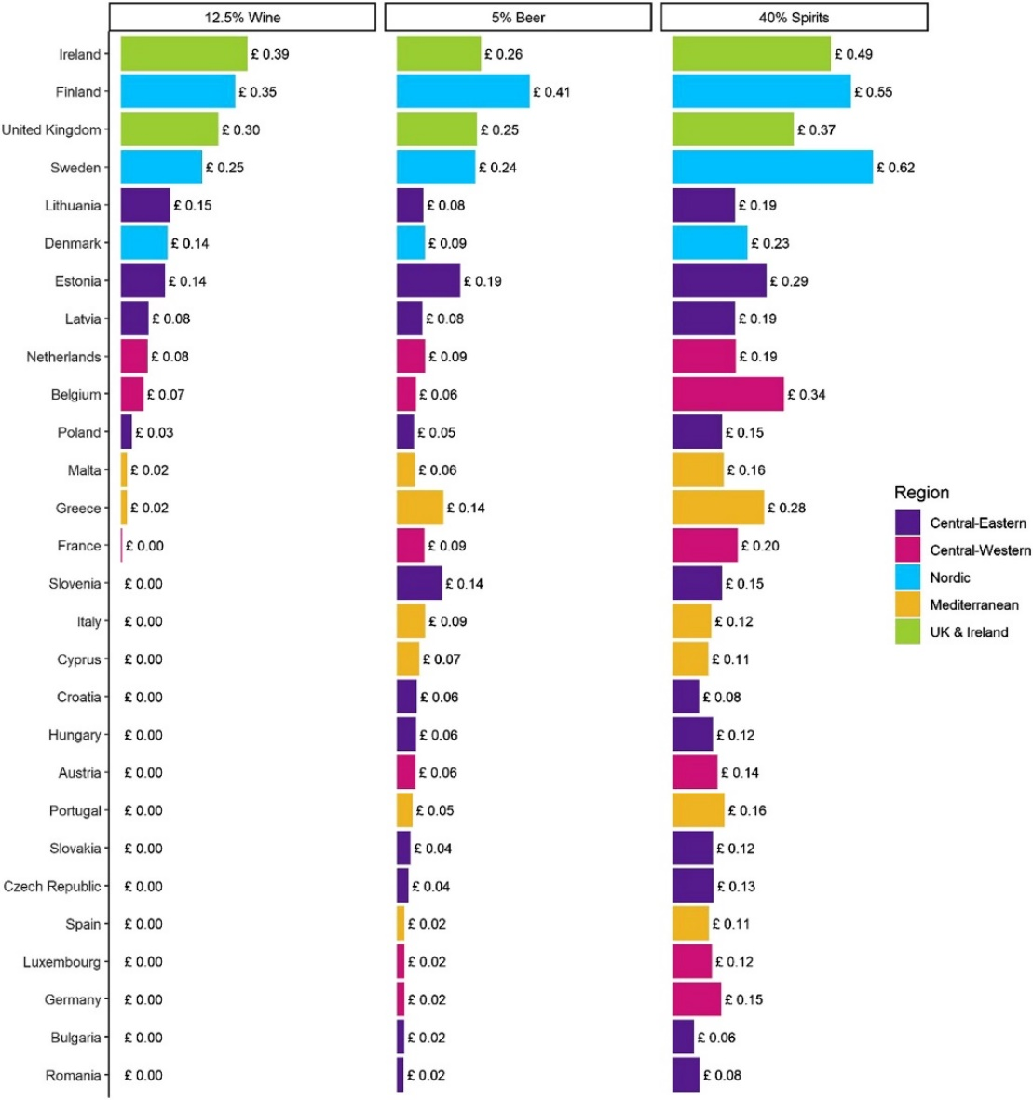
Figure 1: Alcohol duty rates per unit for selected products by region (Angus et al., 2019)

It is important to outline that no academic research have come out with answers involving all the questions raised before, as it englobes not only the relation between levels of consumption, introduction of taxation and possible harms derived from alcohol consumption, a topic that has been extensively explored by many researchers and theorists, but also the impacts of lower excise taxes specifically applied in Irish economy, considering many individuals and social variables.

The results of the research might be of interest to the drinks and hospitality sector, government, companies related directly or indirectly to the hospitality industry and consumers. It is also expected that will provide basis for other researchers to explore some of the areas presented on this study.

1.4 Research Objectives

Based on the issues identified and explained above and on the focus of the research outlined in the previous chapter, the overall aim of this research is to advance an understanding of the impacts of lower alcohol excise tax rates on Irish consumer buying behaviour.
The main objectives of this study are:

- Identify the excise tax rates and models applied to the different alcohol beverages in Ireland.
- Critically evaluate models and frameworks relevant to understanding the relation between alcohol taxation policies and levels of consumption.
- Explore the relationship between levels of consumption and individual and social variables, considering the substitution effect on price and other variables that may affect the consumer buying behaviour.
- Conclude about the appropriateness of alcohol excise tax reduction based on the data collected through this research.

Considering this, a number of subobjectives will guide this research, aiming to fulfil all the main objectives. The subobjectives of this study are listed below, and the purpose of each of them followed by the hypothesis which will guide this research will be detailed explained on chapter 3.

Sub Objective 1 – Explore the role of price on Irish consumer buying behaviour of alcoholic beverages, considering the effect on different groups.

Sub Objective 2 – Identify main variables, other than price, that influences Irish consumer buying behaviour of alcoholic beverages.

Sub Objective 3 – Explore how inclined Irish consumers are to switch to other brands of alcoholic beverage in other to avoid the price increase.

Sub Objective 4 – Explore how inclined Irish consumers are to switch to other types of alcoholic beverage in other to avoid the price increase.

Sub Objective 5 – Conclude about the appropriateness of an excise tax reduction on alcohol, considering all the different groups, variables and preferences analysed.

From this, arises the overall research question: What are the impacts of a reduction on alcohol excise tax rate would have on Irish consumer buying behaviour? It is important to consider the role of all the variables involved on alcohol purchasing decision and the degree to which these variables can influence the consumers’ decision.

1.5 Structure of the Study

To enable the fulfilment of all the objectives and subobjectives and aiming to answer the overall research question, this dissertation is divided into six sections.

It begins with an introduction, covering a brief explanation of current gaps related to alcohol taxation, pricing policy and elasticity of demand. It also places the importance of Irish hospitality sector for the country and the global economy, and how the high alcohol tax rates can negatively impact it. The objective of this section is to clarify the purpose, significance, and objective of this dissertation.

The second chapter of this study is the literature review, where a critical review of pertinent literature will be carried out, considering the history of taxation and the historical and current taxation imposed on alcoholic beverages in Ireland. It goes further, reviewing the theory behind excise taxes and alcohol price interventions and analysing the possible consumers responses to it. The objective of this chapter is to provide a base of understanding for an applicable elaboration of the exploratory research.

The following chapter includes the research objectives, subobjectives and hypotheses which guided this exploratory study. In this chapter, the purpose of each subobjective is defined, providing a robust explanation of the reason behind each of the hypotheses proposed.

In chapter 4, a detailed methodology which this researched was based is defined. In brief, the philosophy that will guide this research is critical realism and a hypothetical-deductive approach will be adopted, with a quantitative collection and analysis of data.

The following chapter includes an extensive presentation and explanation of the findings, followed by the final chapter, which will present a conclusion to this study, also offering the main contributions and limitations and recommendations for practice and further research.

Chapter 2: Literature Review

2.1 Overview

This chapter comprises pertinent literature review regarding taxation on alcohol and consumer responses related to it, including contextual, conceptual, and empirical literature. The review is divided by theme rather than by type of literature, due the nature of the topic of the research and the existence of more than one type of literature in the same source.

The literature review will build a good understanding of the theory available to enable the implementation of the primary research and to answer the research question and objectives. The chapter was structured in a number of sub sections covering a brief explanation of the history of taxation; the alcohol tax rates in Ireland; the nature and role of sin taxes and the potential harms and consumer responses related to alcohol.

2.2 History of Taxation

According to Adam Smith (1776), tax is a compulsory compensation imposed by the government on people or entities to collect the spending necessary to finance public welfare.

The first set of principles related to taxation was written by Adam Smith in 1776, aiming to build a fair tax system, and is comprised by four Canons of Taxation. The Canon of Equity states that the amount paid by an individual to the government should depend on his capability to pay. In the Canon of Certainty, both the taxpayer and the government should be aware of the amount of tax and in which form the tax should be paid and collected. Canon of Convenience involves the time and the way the payment is made, being, as far as possible, convenient for the taxpayer. Finally, Canon of Economy comprises the administration of the tax imposed, where the amount collected should be higher than the costs to its collection (Smith, 1776).

Over the years, in order to englobe the increasing functions of the state, many principles were added to the original ones such as Productivity, Elasticity, Flexibility, Simplicity and Diversity. Preez (2015) provides an overview of the main principles adopted to guide taxation through the years, from the principles written by Adam Smith in 1776, till the Davis Tax Committee in 2015. Based on that, it is noticeable that the attitudes regarding the tax system have changed and many economists and theorists have tried to design an ideal tax structure. However, till this day, no theoretical framework or conclusive literature related to build a tax system have been universally recognised.

When placing the history of taxation in Ireland, even though the first mention to the Irish taxation system can be found on the date of the City of Dublin in 1316, when comparing the country to other developed nations, the number of publications related to the history of Irish taxation system can be considered very small (Clarke, 2015).

Moreover, the excise duty was first introduced in Ireland in 1643 and was only regularised and consolidate in the 1662 Excise Act, where a large number of products, both imported and home produced, were taxed. This included items such as beer and spirits, which were subject to additional taxes in the 1690 Additional Excise tax. Taxes in other products such as tobacco and wine were increased in further legislations, providing an increase in the tax revenue collection (Clarke, 2015).

2.3 Alcohol Taxation in Ireland

Nowadays, there are two different types of taxes imposed on alcohol in Ireland: VAT and excise tax. VAT is an ad valorem tax which is charged as a per cent of the price. The amount of VAT will necessarily increase when alcohol price increases, due the nature of the VAT tax that is charged on the price of the good. In most countries, the VAT rate for all different types of beverages are the same (DIGI, 2019). In Ireland, since the 2012 Budget, the VAT rate has been 23%, except for a period from September 2020 to March 2021, where the VAT rate was temporarily reduced to 21%.

Excise tax, however, is a particular tax that is based on the amount of alcohol present in the beverage, and it is not influenced by the price of the product. It is, therefore, an absolute figure charged per unit of alcohol comprised in the beverage. Even though the same amount of excise tax will be charged over a specific quantity of beverage, independent of where it is sold, the amount paid for the beverage for the final consumer will be higher. As VAT is charged on the excise value, an increase in excise tax leads to a price rise due the excise plus 23% VAT increase, if passed on by the retailer to customers (DIGI, 2019).

The tables below (Revenue, 2020b) show the current excise tax rates per beverage in Ireland, including the description or usage, as the volume of alcohol present in the beverage and the sparkling nature of the beverage may influence the tax rate. The first table outlines spirits, beer, and wine, whereas the second one comprises other fermented and intermediate beverages.

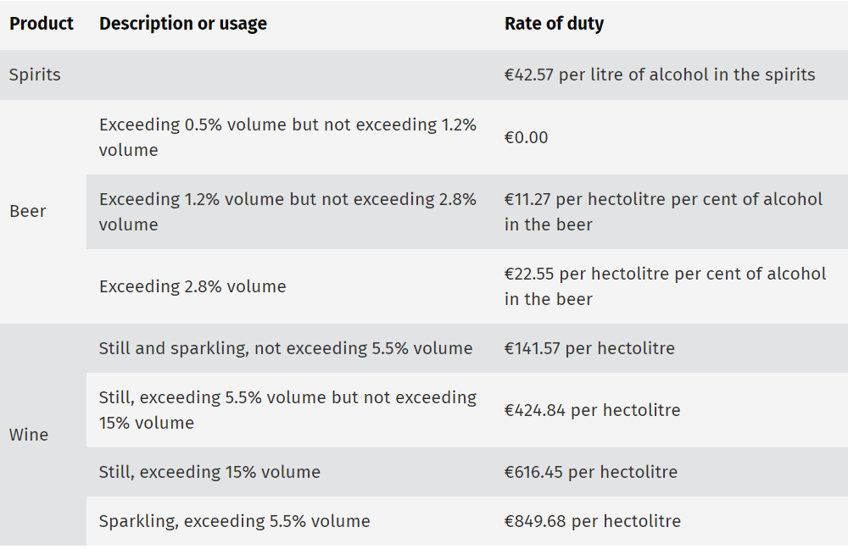
Figure 2: Alcohol Products Tax rates for spirits, beer and wine (Revenue, 2020b)
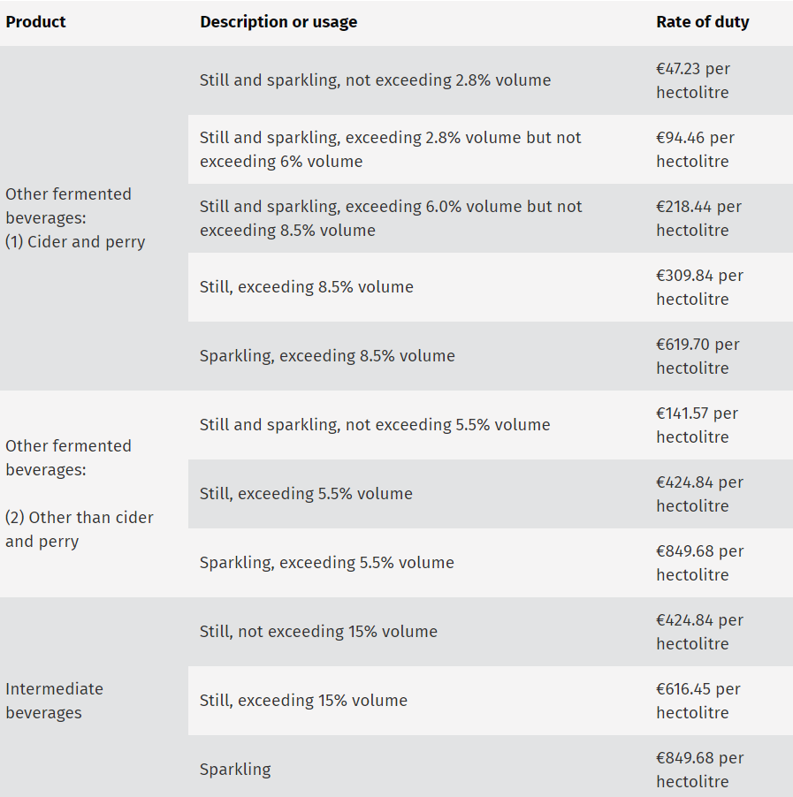
Figure 3: Alcohol Products Tax rates for other fermented and intermediate beverages (Revenue, 2020b)

As a matter of comparison, a summary of the changes per type of alcoholic beverage from 1993 to 20014 can be seen on (Appendix A). This changes resulted in the countries’ amount of excise receipts in 2019 being €1,235.4 million (Revenue, 2020b), an increase of almost 150% from 2010 numbers.

In general, a vast variation of alcohol tax rates and tax mechanisms employed can be seen on different countries, and so does differences between types of beverages and qualities and styles of each beverage. Studies have shown that the reason behind the difference in tax rates in EU countries is related to factors such as current and historical aspects (Angus et al., 2019). When comparing Ireland to other EU countries, Ireland’s position indicates an extremely higher excise tax rate. The comparison between Ireland and other EU countries related to alcohol excise taxes is showed in the table on (Appendix B).

2.4 Sin Taxes

Sin taxes originally derived from sumptuary laws established in the medieval period. In that period, the imposition of regulations aiming to restrict personal overspending in food, beverages, clothes, and domestic utensils, were commonly structured based on moral and religious grounds (Hunt, 1996). Nowadays, as the consumption of goods such alcohol is related to negative health consequences, a reduction in consumption is seem as beneficial for society(Hoffer et al., 2018). In this view, sin taxes have been justified as a tool to minimize the unpleasant effects of the consumption of these goods.

There are, however, many objections to the imposition of such taxes. First of all, several studies concluded that heavily drinkers are less responsive to changes in price than moderate drinkers (Ayyagari et al., 2009; Wagenaar et al., 2010; Snowdon, 2012; Griﬃth et al., 2017). This means that an increase in price will, somehow, generate a decrease on alcohol consumption for both heavy and moderate drinkers but the extent to which will affect each group will vary. If the justification to impose or increase alcohol taxation is to correct externalities, but the individuals who may represent more risks to society, the ones who binge drink, are not being effective responsive to price changes, the imposition of such taxes are simply being used as a tool to meet revenue shortfalls, relying on consumers usually addicted to the goods to generate an enormous amount of revenue for governments every year.

Even if it is considered that the main goal of sin taxes is to generate revenue, in the long term it can be extremely difficult to sustain and end up declining. The reason behind that involves that the potential revenue such taxes can generate in the long-term is related to the tax rate or the level of consumption. Considering that it is imposed not on its value, but on the quantity sold, the maximization of revenue collection depends on either an increase of tax rates or an increase in consumption (The Pew, 2018). Saying that, the calculation of the most appropriate alcohol taxation in different contexts is an area of disagreement and cause many controversial ideas.

These disagreements also commonly question another objective of the implementation of a sin tax: redistribute wealth. Many countries bring up concerns about the regressive nature of sin taxes, which means that low-income households will be disproportionately affected by the tax increase when compared to high-income ones. The regressive nature of sin taxes is supported by (Hoffer et al., 2018), and indicates that such taxes breach both horizontal and vertical tax equity, two normative principles of public finance. Horizontal tax equity implies the concept that households within equal income category should bear the same tax burden. Sin taxes breach this concept as the tax burdens differ by consumption choices, and not income. Vertical tax equity implies the concept that the tax increase should be proportional to the income increase, but on sin taxes a decrease on tax burden can be seen when income rises. The regressive nature of sin taxes can be seen when analysing income groups and even more when considering individual buyers (Snowdon, 2013a). Furthermore, they are regressive not only in the short-term but also in the long-term. This reinforces the idea that the regressive nature of sin taxes unduly penalises low-income consumers, who will spend a much greater proportion of their income to pursue a good than the wealthier ones.

2.5 Alcohol Price Interventions: Potential Harms and Consumer Responses

The downward-sloping demand curve is one of the fundamental law of economics and implies the inverse relationship between price and quantity demanded, which means an increase on price will lead to a fall on the quantity consumed. In the past, some theories were raised about the non-appliance of this concept to the demand of products such as alcohol. However, more recently, many studies have focused on this matter and, in general, have concluded that increases in alcohol price does lead to a reduction in consumption (Gallet, 2007; Wagenaar et al., 2010; Xu and Chaloupka, 2011).

In this context, the use of taxation and pricing policies aiming to minimize the potential harms caused by alcohol consumption has been the focus of numerous studies for many years. The World Health Organization (WHO), advises governments to implement such tools, aiming to increase alcohol beverages cost and, therefore, to minimize potential alcohol-related harm (WHO, 2010). Recently, an intensification of these policies related to alcohol pricing control can be identified and it is stablished that taxation on alcohol is imposed in more than 90% of the countries in the world (Sharma et al., 2017).

2.5.1 Alcohol Tax Policy Intervention

The Guide to Community Preventive Services issued a report where more than seventy papers were reviewed, and an analysis of the efficiency of alcohol tax policy interventions in order to minimize high levels of alcohol consumption and its related harms was performed. The conceptual framework of this study is outlined in the figure below and represents the causal relationship between a higher alcohol tax rate and a reduction in excessive consumption and associated harms.

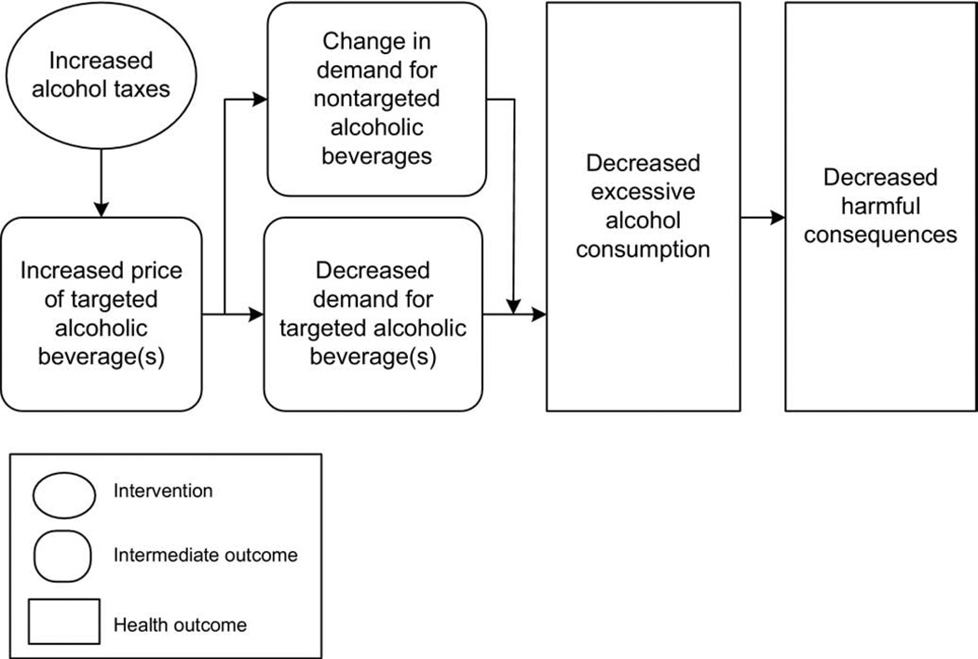
Figure 4: Conceptual Framework Taxation and Possible Health Outcomes (Elder et al., 2010).
The very first stage of the conceptual framework is based on the assumption that the higher tax rate is passed on to the buyer, increasing the alcohol prices. The second stage then, is based on the Law of Demand, where the alcohol price increase results in a decrease in the demand of the good. A decrease in demand is expected to lead to a decrease in higher levels of alcohol consumption and, thus, to its dangerous outcomes.

There are several factors that may question the model proposed above. First of all, the effect on price does not depend only on the alcohol tax rate or the method of taxation adopted by the country, but also if the cost of the tax is being fully passed to the consumers. Moreover, the effect of inflation over time has also to be considered when analysing prices (Sharma et al., 2017).

The model also fails to consider the various categories of alcoholic drinks and the different tax rates imposed on them. The tax increase over a specific type of alcoholic beverage, called the “targeted” alcoholic beverage in the model above, does not consider the substitution effect and the possibility of a higher intake of the beverages that are not being influenced by the increase of taxes (Elder et al., 2010). In this view, when ignoring the substitution effect, and the many other variables that might affect the levels of consumption, the model fails in achieving its main goal, which is proving the relationship between the tax increase and the decrease in possible harmful outcomes.

Furthermore, even though taxes on alcohol beverages may characterize a significant part of its price, different categories of alcohol can have different costs, tax rates and selling prices. In conclusion, the final price of the good can vary substantially from one category to another due a number of factors, aside from its volume of alcohol and tendency to cause harm (Vandenberg and Sharma, 2016) .

2.5.2 Alcohol Consumption and Health Outcomes

In this view, Sharma et al. (2017) also states that a public health policy should take into consideration not only the individual behaviour of the drinker, but also the causes of issues and the possible solutions. In accordance with it, the table below (Sharma et al., 2017) shows that the frequency of drinking, use patterns and the incidence of alcohol-related harm are moulded by a number of micro and macro factors such as age, sex, religion and culture. It also outlines the variable factors such as how affordable or available is the product, its marketing campaigns and the policies and regulations involved.

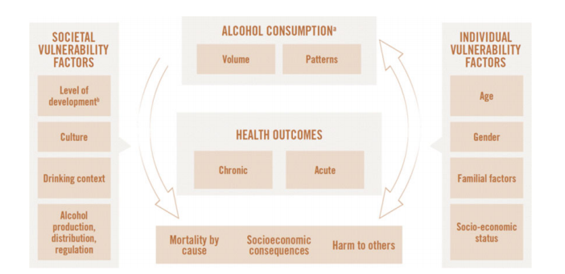
Figure 5: Conceptual causal model of alcohol consumption and health outcomes. (Sharma et al., 2017)

Based on this, it is understandable that the impact of the use of taxation in order to change drinking behaviour and boost health effects can be feel differently depending on the population and how responsive they will be to price changes. In general, most models fail on considering those individual and social elements and the degree of which those variables will influence the consumer behaviour.

However, many studies have adopted an approach to analyse the pattern of alcohol consumption on different income levels and drinkers’ categories (See Section 2.4). As outlined before, the effect of an increase of alcohol price for different groups and categories of alcohol, and, therefore, the magnitude it will influence health outcomes and minimize potential harms, gives rise to discordances about the optimal alcohol tax and the most appropriate pricing police.

In accordance with Thornton (2005) the extension which alcohol can be benign or threatening will depend on how it is being consumed, and, therefore, the most important aspect when analysing alcohol policy is not the amount is being consumed but how it is being consumed. Moreover, in a historical point of view, alcohol has an important role in the civilization of humanity and the foundation of medicine and can lead to positive outcomes for both individual and society, related to health and economic impact (Freeman, 2000). The concerning aspect is related to binge drinking, which is the kind of drinking that can result in intoxication, accidents, and negative social and economic outcomes. However, a number of studies have failed in proving the relation to the imposition of sin taxes and the reduction in related harms, as, for example, traffic accidents. This can be explained by the several facts presented in the previous topic, where the nature of sin taxes being regressive and failing in addressing the tax burden to the heaviest drinkers, which are the ones considered more likely to cause negative outcomes to society.

2.5.3 Consumer Alternative Responses to Price Increase

Even though a higher alcohol taxation can generate revenue gains for government, the consumer response to price increases needs to be deeply analysed. In order to mitigate this price increase, consumers may use substitutes either maintaining the same beverage type but as a less expensive option of it, purchasing, for example, lower-quality beverage instead of premium brand ones, or substituting the category of alcohol they are consuming, in order to pay less for it. The last one may signify a higher intake of alcohol and both substitutions mentioned above can lead to a maintenance or even an increase of a consumer alcohol consumption (Gruenewald et al., 2006).

The published literature on alcohol beverage pricing policies, taxes, and possible harmful outcomes, fails when treating alcohol beverages as a simple good, when it is, in fact, a complex good including different beverage categories and quality brands. (Gruenewald et al., 2006; Liu, 2018). In this view, failing in accounting for product quality and a possible substitution effect can greatly bias the analysis of price elasticity demand for alcohol. It is understandable that defining the quality of alcoholic beverage is not trivial, as it involves not only aspects that can be measured such as the aging of a whiskey, but many others subjective elements, such as taste and image.

In accordance with (Liu, 2018), consumers may also try to avoid the taxation, and therefore, the price increase, either legally or illegally. Therefore, such taxes on alcohol can also give rise for adverse outcomes, such as creation of black markets and increase on traffic or leading to an expansion of online and cross-border purchases.

2.6 Conclusion: Current Gaps in Literature

The scope of this study encompasses the relation between taxation on Alcohol, consumer consumption behaviour and its impact on Ireland’s economy. As pointed out in the previously chapters, there are substantial gaps in the research related to the effect of taxation in changing consumer behaviour, considering different types of alcoholic beverages, different groups of consumers, and how responsive they are to price changes.

The first gap identified is that most existing literature is centred on own-price elasticity of alcohol. In this case, the literature fails in considering the substitution effect, and, thus, the possible increase of consumption in one type of alcoholic beverage when there is an increase on price of other. This would be analysed by the cross-price elasticity of demand for alcohol and the total effect on price should be based on both own-price and cross-price elasticity. Even though the combination of both parameters is essential to enable an analysis of the full outcome of a pricing policy or a taxation strategy, there is not much data available related to cross-price elasticity on alcohol (Sharma et al., 2017).

Moreover, the studies related to alcohol taxation and optimal price are generally based on the assumption that the manufacturers and sellers will pass on the full amount of the tax increase to the consumer, but this might not occur. Considering an imperfect market competition, the degree to which prices rise in relation to the tax rate will depend on variables, as, per example, how sensitive the consumer is to the change in price. In addition, specific groups, such as underage drinkers, that may respond differently for price changes and indicates different levels of consumption and health outcomes, are generally not within the scope of the studies (Elder et al., 2010).

Another key issue is related to the extent to which the reduction of potential alcohol-related harms can be measured reliably. Even though the price elasticity of demand is negative for both moderate and heavy drinkers, the effect of a price increase can be felt differently from one group or individual to another, and so is how it will influence health outcomes and minimize potential harms. This gives rises to inconsistencies between theorists and economists about the most appropriate alcohol pricing police and the optimal alcohol tax.

The final gap is related to the scarce number of studies and evidence related to consumer behaviour. Most studies analyse the relation between the increase of price and the decrease in demand, but fail to acknowledge the micro and macro environment, such as age, gender, culture, that are moulding the consumer purchase decision and other variables that will affect the decision other than price. Nowadays, for example, consumers tend to be more loyal to brands, which may indicate that an increase in price will not change their decision to buy that specific product. Supporting this, Gruenewald et al. (2006) states that consumers tend to pay more for some brand of alcoholic drinks due differences in attributes of the good, including taste, image, and packaging.

On the basis of the above discussion, it becomes evident that there are major gaps in literature related to alcohol taxation and optimal price and the consumer buying behaviour, and an implementation of a primary research focused on this is expected to be beneficial for academic and practical purposes.

The next section will present the conceptual framework developed based on the literature review carried out on this chapter and focused on the current gaps of literature presented above, which will provide a broader understanding of the proposed primary research and enable a better perception of how this study will aim to answer the research overall question, objectives and hypotheses proposed.

2.7 Conceptual Framework

The development of a conceptual framework simplifies the research process, supporting the selection of the key concepts that are relevant to the topic and the ones that must be eliminated (Fisher and Buglear, 2010). Overall, in a conceptual framework the author expresses the relationship between the main concepts of the research, providing a map that shows the connection between the concepts and how it all fit together. It gives the researcher a more comprehensible structure to implement the research and provides to the reader a clearer idea, in simple steps, about what is involved in the study.

Based on this, a conceptual framework was developed by the author and it is shown below, comprising the key concepts and how they are related, in order to clarify the proposed research structure. Considering the approach proposed and the variables identified and analysed, the framework was based on cause-and-effect relationship between the variables. The theoretical elements will give a core of understanding to the implementation of the primary research, aiming to fulfil the main objectives of this research and to answer the overall research question: “What are the impacts of a reduction on alcohol excise tax would have on Irish consumer buying behaviour?”. The model proposed will also assist in defining the sub objectives and hypotheses that will be tested further on.

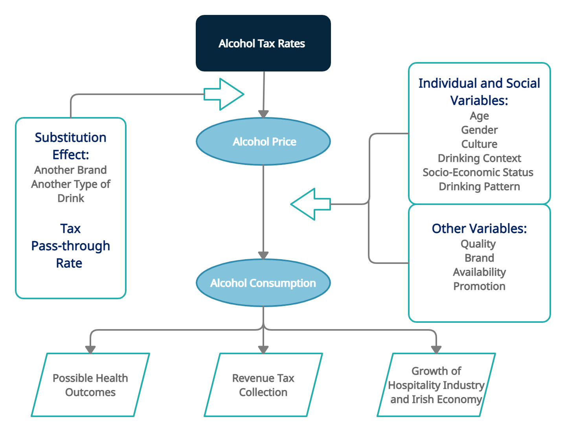

Figure 6: Conceptual Framework (Author)

The conceptual framework shown in Figure 6 identifies the effect of an intervention on alcohol tax rates would have on alcohol price, and therefore, in alcohol consumption, considering the different variables that may influence consumer behaviour related to it. It also specifies the relation between the level of consumption and various outputs such as health outcomes, revenue tax collection and the growth of hospitality industry and Irish economy.

The first element of the framework, the intervention on alcohol tax rates directly influences alcohol price. However, as mentioned on the current gaps of literature on the chapter above, will be influenced by facts such as the substitution effect and the actual tax rate that producers and retailers will pass on to the final customer.

The second element, alcohol price, can have a significant impact on level of consumption, but many individual and social factors, such as age, gender, culture, drinking context, socio-economic status and drinking pattern can influence the buying decision, and therefore, the level of consumption. Moreover, other variables other than price need to be considered such as quality, brand, availability, and promotion of alcoholic beverages, as they may also influence the consumer decision.

In this view, the extent to which an intervention on alcohol tax rates can generate an impact on health outcomes, revenue tax collection and growth of hospitality sector and Irish economy will depend on all the mediator variables listed below.

Based on this, a number of sub objectives and hypotheses have been set out and will be presented on the next chapter.

Chapter 3: Research Objectives and Hypotheses

Based on the literature review that have been carried out and the concepts and cause-and-effect relationship between the variables defined in the Conceptual Framework and considering the overall aim of this research being to advance an understanding of the impacts of lower alcohol excise tax rates on Irish consumer buying behaviour a number of hypotheses have been developed to be further tested. The main objectives are listed below, followed by the sub objectives and hypotheses.

3.1 Main Objectives

- Identify the excise tax rates and models applied to the different alcohol beverages in Ireland.
- Critically evaluate models and frameworks relevant to understanding the relation between alcohol taxation policies and levels of consumption.
- Explore the relationship between levels of consumption and individual and social variables, considering the substitution effect on price and other variables that may affect the consumer buying behaviour.
- Conclude about the appropriateness of alcohol excise tax reduction based on the data collected through this research.

It is understandable that objectives 1 and 2 were fulfilled through the secondary research in the literature review chapter. To enable the fulfilment of the other objectives, what follows is a list of sub objectives and hypotheses to be tested.

3.2 Sub Objectives and Hypotheses

Sub Objective 1 – Explore the role of price on Irish consumer buying behaviour of alcoholic beverages, considering the effect on different groups.

Purpose - Alcohol is considered a price sensitive item, which means an increase on the cost of alcohol leads to a reduction on its consumption, whereas a decrease on its cost leads to a consumption increase. However, some groups might be more sensitive to price than others. The objective is to explore in which extent Irish consumers are sensitive to price and to analyse the degree of sensitivity in different groups.

• H1 – The price of an alcoholic beverage is a significant factor for Irish consumers when purchasing it, but their sensitivity to price will vary between groups.

Sub Objective 2 – Identify main variables, other than price, that influences Irish consumer buying behaviour of alcoholic beverages.

Purpose - The impact of the use of taxation in order to change drinking behaviour can be feel differently depending on the population, considering individual and social aspects. The objective is to identify the variables that most influence Irish consumer behaviour when it comes to alcoholic beverages.

• H2 - The consumer buying behaviour of alcoholic beverages is influenced by many factors, other than price.

Sub Objective 3 – Explore how inclined Irish consumers are to switch to other brands of alcoholic beverage in other to avoid the price increase.

Purpose – Consumers are becoming more loyal to specific brands, which indicates that they may be less sensitive to price changes. The objective is to explore in which extent they are willing to maintain their level of consumption, even if the price increases.

• H3 – Consumers are willing to pay more for a specific brand of alcoholic beverage because they are loyal to it.

Sub Objective 4 – Explore how inclined Irish consumers are to switch to other types of alcoholic beverage in other to avoid the price increase.

Purpose - Empirical studies indicate that consumers may try to avoid the price increasing by switching their preferences to other types of alcoholic beverage. The objective is to explore in which extent they are willing to change their purchase for a less expensive type of drink.

• H4 – If the price increases, consumers will switch their preferences to another type of alcoholic beverage.

Sub Objective 5 – Conclude about the appropriateness of an excise tax reduction on alcohol, considering all the different groups, variables and preferences analysed.

Purpose – The objective is to conclude if a reduction on excise tax on alcoholic beverages would be appropriate, considering the effect on Irish consumer buying behaviour, and taking into consideration the many variables involved, the individual preferences and the effect of substitution.

• H5 – If the price decreases, moderate drinkers will consume more, which can be beneficial for the hospitality and drinks industry in Ireland.

The following chapter comprises the methodology implemented on this research.

Chapter 4: Research Methodology and Methods

4.1 Overview

This chapter will specify the main elements to implement the primary research. It includes the methodology applied in the collection of data, how the data collected will be analysed, any ethical issue or research limitation that may appear and how they can be overcome.

Managing the methodology and ensuring the techniques applied are connected to the aims and objectives is one of the key points of any research. In this view, Saunders et al., (2007) presents a Research Onion framework, where the research problem is central, involved by layers that will define the methodology and motivation related to the research. Defining those aspects is essential to implement the study proposed and will be explained in detail below.

4.2 Research Philosophy

A research philosophy not only enable the researcher to expand his way of thinking and analysing the outcomes of the data collection method but also connects the theories and the research strategy. Saying that and considering its importance, a number of factors should be considered in this specific research when choosing the philosophical approach. There are four core elements of research philosophy: Positivism, Realism, Interpretivism and Pragmatism.

According to Fisher and Buglear, (2010), the realist approach pursues systematic understanding of the world but acknowledge that it is affected by subjectivity. This approach is based on finding the processes that cause events and its theories should be verifiable and have some generalisability. The realist approach is divided in two main categories: direct and critical. While the first one defends the idea of a solid representation of reality, the second one adds other levels of reality to the same belief, taking into consideration other variables and what influences them.

Due the exploratory nature of this research and being one of the objectives to conclude about the appropriateness of a reduction on alcohol excise tax in Ireland, but also taking into consideration the number of variants that may influence consumer behaviour related to alcohol, and, therefore, levels of alcohol consumption, a critical realist approach seems to be the most appropriate philosophical approach to be implemented. The author believes that this method will enable the fulfilment of the research’s objectives, exploring the general aspects of the variables but also considering the subjectivity involved in the consumer behaviour.

4.3 Research Approach

The research approach is one of the main components of any research and includes the plans and methods to be implemented when performing the study. There are three main techniques that can be adopted: Inductive approach, Deductive Approach or a mix of both, known as the Abductive Approach (Saunders et al., 2007).

The deductive approach aims to elucidate relation between conditions or variables. In this approach, the first stage is the creation of specific theories, usually developed from a critical reading of pertinent literature, followed by the development of hypotheses or prepositions that will be tested through the analyse of data collected.

Considering the exploratory nature of the research, the time frame, the research philosophy chosen and more important, the emphasis of this research being to understand the impacts of a lower alcohol excise tax rate in Irish consumer behaviour, a hypothetical-deductive approach is the most indicate one for this study, as it is expected to answer not only the overall research question but also lead to achieve the objectives and subobjectives of this research.

4.4 Research Strategy

There are several strategies available to researchers and the best method must be chosen considering the research question and objectives and other aspects such as time frame, or any limitation that the researcher may face. In accordance with (Saunders et al., 2007), the main researches strategies are: experiments, case studies, surveys, action research, ethnographies, grounded theories and archival research. It is important to outline that literature does appoint an ideal strategy, as the best approach should be determined by the author in accordance with his/her circumstances and the emphasis of the study.

Surveys are an extremely popular choice for researchers for several reasons. First of all, it is a feasible strategy, and can generate data from a large sample in a short period of time. It also provides a large range of possibilities of how to gather this data, as the surveys can be implemented through many ways: via social media, websites, e-mails, telephone, face-to-face, and so on.

The secondary research that has been carried out has enable the author to get a broader understanding of the theories, frameworks and current gaps present in literature regarding alcohol policies, sin taxes and the consumer responses related to alcoholic beverages, which has led to the formulation of hypotheses to be tested. To gather data for the primary research proposed on this study, the author has opted for the implementation of online questionnaires. The reason for this choice includes the constraint time available to do the research, and the limitations to gather information rather than online due COVID-19 pandemic restrictions. But more importantly, the author believes that the questionnaire can gather distinct data from a larger sample, enabling more accurate answers to the hypotheses proposed and to the research question. The design and procedure involved on the questionnaire will be explained in more detail on the next subsections.

Defining the time horizon of a research is another important fact when defining the strategy of any research. Time horizon refers to the time period of the study and is related to the collection of data, specifying when and how it will be collected and analysed. There are two designs of time horizon: longitudinal and cross-sectional research. While the first one analyses changes that occur over a period of time, the second one focus the analysis at a particular time (Saunders et al., 2012). A cross-sectional research is the most appropriate approach in this particular study, considering the limited time available for collection of data.

4.5 Data Collection Methods

Once the research philosophy, approach and strategy are defined, the selection of the most suitable data collection method will enable the researcher to align the theory to the research questions and objectives. The data collected should be sufficient to fulfil all the subobjectives and hypotheses proposed.

In order to explain the methodology used in this study, the following subchapters will describe the research sampling, the nature of data and the data storage and confidentiality. It will also include details about the questionnaire design and procedure.

4.5.1 Research Sampling

Research Sampling techniques provides an opportunity to researches to infer conclusions about a population, by analysing data from a smaller group, which facilitates the collection and volume of data.

Two types of research sampling techniques are available to researchers: probability or presentative sampling and non-probability or judgemental sampling. This study will be based on probability sampling, as the author believes that is the best approach, considering the strategy chosen and the exploratory nature of the research.

The sample will be made by Irish people and people from other nationalities living in Ireland, aged between 18 and 65+. It is expected that the collecting of data will gather information of people from different gender, age, and social status. The reason for that is that the researcher aims to get an understanding of how a lower alcohol excise tax would impact the Irish consumer behaviour and as outlined in the literature review chapter, the individual variables involved have a significant impact on consumer buying behaviour and cannot be ignored.

The initial target response rate have been set to 100 responses, as in accordance with (Saunders et al., 2012), a high margin of error can be identified on samples smaller than 100.

4.5.2 Nature of Data

As already mentioned before the collection of primary data will be made through online questionnaires. A quantitative approach is expected to be undertaken, considering the nature of data collected from the questionnaire to answer the hypotheses already outlined before, this seems to be the most appropriate approach for this study.

The questionnaire will be comprised by four sections, aiming to fulfil all the subobjectives proposed. The questions will be mostly closed-ended questions and the choice of this type of question is to make the questionnaire simpler, but with pertinent questions, and try to get a large sample of answers. Moreover, the author will give attention to diversify the types of questions, including multiple choices, checkboxes, scale rate and ranking questions, making the questionnaire pleasing and guaranteeing a robust data collection.

More details about the design and procedure of the questionnaire are presented in the following subsections.

4.5.3 Questionnaire Design

The design of the questionnaire is essential to guarantee that the data collected can be considered reliable and robust, and also that the data is consistent with the objectives of the research. (Saunders et al., 2007) defines three main steps that should be followed by researchers when designing the questionnaire: individual questions must be designed carefully; the layout must be clear and pleasant; and the purpose of the questionnaire must be explicit.

Considering that, the author has carefully designed the questionnaire, aiming to fulfil the research objectives and to maximize the response rate. Questions were created in accordance with the research subobjectives and seeking to answer the hypotheses proposed. The author has focused on using familiar words and terms, to avoid any bias or confusion to the responders. To guarantee the layout is clear, easy to navigate and understandable, the questionnaire was divided in four sections that will be fully explained in the next subchapter. Also, the purpose of the questionnaire was defined in the very first stage, so as the guarantee of confidentiality of data, and all the responds were aware of it before commencing the questionnaire.

4.5.4 Structure Procedure

The author has spent a significant amount of time to build and set up the questionnaire. In the first stage, the questions were drafted and divided in sections, considering the hypotheses and subobjectives previously identified. In this stage, the author was concerned to the language employed and the flow of the sections, to guarantee all the questions were clear for the responders.

The second stage was comprised by the choice of platform where the questionnaire would be implemented. After an extensive research of the platforms available, the researcher decided to use SurveyMonkey.com. The reason for its choice included the fact that the platform provides several features, such as change the layout, the structure and the flow of the question and sections, easy and different ways to collect responses and to export the data collected. Also, the author was familiar with the platform, as she has used it before in other studies. In this stage, the variety of questions, trying to make the questionnaire as pleasant as possible and the time for completion for the questionnaire was also considered, avoiding that the survey was too long, which may have led people to not complete it.

In accordance with Survey Monkey the estimated time to complete it was 5 minutes. This information was disclosed in the very beginning of the questionnaire, so the responds were aware of the extent of the survey before commencing it. The questionnaire was composed for mostly close-ended questions, however, many questions had an option entitled “other”, where the responders had the chance to express other idea than the ones presented in the options, to guarantee the answers were accurate. All the questions should be answered by the responders and if a question were skipped, the following message appeared: “This question requires an answer” and would not allow them to proceed to the next section, to avoid possible gaps in the data.

The questionnaire was formed by four sections, each of them in a separate page, with the title of the section and any note regarding to a specific word or term that may have caused confusion specified on the top of the page. A list of the sections and a brief explanation of the reason for each of them is presented below:

- Introduction: Aims to build a profile of the sample with questions related to age, gender, socio-economic status, as this is expected to affect the consumer behaviour related to alcohol. In addition, a question related to the responder’s residency is also presented in this section, as the study is focused on Irish consumers.

- Consume and Preferences of Alcoholic Beverages: Aims to understand the preference and pattern of consume of alcoholic beverages, including questions related to the weekly amount of alcohol consumed, the age and the reason the respondents started consuming alcohol, the location where they usually consume it, the preference drink and which drinks they have purchased lately. Also, it includes question related to changes in pattern of drinking after COVID-19 has emerged.

- Factors Influencing the Buying Decision: Aims to understand the role of price and other variables such quality, brand, promotion and availability on the buying decision, including questions related to the main variables that would affect their decision. Questions related to consumer awareness to alcohol taxation, excise tax and how they were made aware of such taxes is also presented in this section.

- Brand Loyalty and Substitutes: Aims to understand how inclining the consumers are to switching their preferences to other brand or other type of drink, in order to avoid a price increase. Questions were designed to understand the extend they are willing to switch for several different drinks.

4.5.5 Pilot Test

The objective of pilot tests is to enhance the survey, identifying any problems that may cause any issues to the respondents and, thus, in the data collected (Saunders et al., 2012).

Survey Monkey offers a feature, where a link is generated of a preview of the questionnaire. In this point, no data is collected or stored, it is simply a tool to analyse how the questions and sections are displayed and can be used to identify any possible issue. The whole process of pilot testing was conducted using this tool. In the first moment, the link was sent to the supervisor of this study, and the feedback received was extremely important on modifying some questions and adding others.

The preview was then sent to a sample of 14 people, all Irish residents, but of different nationalities, backgrounds, gender, and age. After carefully going through the questions and sections, the respondents offered their feedback related to the survey, answering questions related to time of completion, the flow and layout of the questions and sections, the clarity of information and instructions and any issues they have faced.

The pilot test proved to be extremely useful as the author was able to identify a few issues. A list of the problematic areas and how they were overcome is listed below:

- Technical Issues: Some questions that required more than one answer were not properly set to enable the respondents to select more than one answer. This was easily corrected by going through the settings of the specific questions and updating it.
- Wording Issues: Some words used were causing confusion to the respondents. In some questions, the words were replaced by others, and in others, some notes were added to clarify what was being asked.
- Similarity of questions: Some questions were very similar to each other, which caused the respondents to feel like they were answering the same thing. This was overcome by changing the layout of some questions and putting key words of similar questions in bold, to make it clearer.

After considering the feedback received and making the specific changes, the questionnaire was ready to be distributed.

4.5.6 Responses Collection Procedure

When the survey was finalized and ready to be distributed, Survey Monkey system for collect responses was accessed. The platform offers several ways to distribute the questionnaire, including e-mail, social media, website and weblink collector. There is also the possibility to buy responses of a specific target audience. Due the resources limitation and the time constraint, the author has opted to use the weblink collector. Using this collector, SurveyMonkey generated a hyperlink, which was distributed by the author on different platforms, such as WhatsApp, Facebook Groups, Instagram, and e-mail. The questionnaire was active, and responses were collected for two weeks.

4.5.7 Data Storage and Confidentiality

Data privacy is a key aspect of a research development and must be correctly accessed. To guarantee the confidentiality and preserve the identity of all the respondents, no personal data will be collected. All the information gathered through the online platform will be properly collected and stored.

4.5.8 Approach to Data Analysis

The data collected in this study will be analysed using a mix of descriptive and inferential statistics. Once the primary data collection is completed, it will be classified under several contexts, and a descriptive analysis will be made to describe the sample. All the hypotheses outlined will be tested and to enable this analysis, the author will advance several statistical analyses via SPSS, making inferential analysis to the population.

4.6 Ethical Issues

The researcher is aware of all relevant ethics matters and standards outlined by Griffith College, and has been approved in the relevant ethical documents related to this study. Based on that, the author will conduct all the collection of data in this research, following the guidelines related to dignity of the participants.

As the data collection method is questionnaire, all the participants will be aware, before the beginning of the questionnaire, of the researched topic, and also of the voluntary nature of their participation, that no personal data will be stored and that the confidentially of their answers is preserved. The questionnaire will be made considering the topic of the research and questions will be clear and coherent to avoid any confusion.

The researcher will constantly revise any possible ethical issue that may rise to guarantee the research is in accordance with all ethical laws and guidelines. The researcher will agree to act in an ethical and professional way, not offering any risk for the name of the author, the college, or the supervisor.

4.7 Conclusion

Over this chapter, the author explained in detail the reasons which have led her to choose each of the approaches based on the research methodology implemented by Saunders.

Summing up, the philosophy that will guide this research is critical realism, aiming to achieve the research objectives, exploring the general aspects of the variables but also considering the subjectivity involved in the consumer behaviour. After extensive reading of literature available regarding the topic selected and the current gaps in literature identified, the theoretical evidence gathered gave rise to the construction of a Conceptual Framework, which demonstrated the specific theory present in this study. What followed was the development of hypotheses which will be tested through the collection of primary data. Considering that, and the exploratory nature of the research, the time frame, the research philosophy chosen and the overall aim of this study a hypothetical-deductive approach will be adopted.

To gather data for the primary research proposed on this study, the author has opted for the implementation of online questionnaires, due the possibility to gather distinct data from a larger sample, aiming to accurately answer the hypotheses proposed and the research question. In addition, the time horizon proposed is a cross-sectional research, focusing the analysis at a particular time.

This study will be based on probability sampling, comprising Irish residents aged between 18 and 65+, and it is expected to gather data from different groups to guarantee a reliable and robust sample. Considering the nature of data collected from the questionnaire to answer the hypotheses proposed, a quantitative approach is expected to be undertaken.

The result of the analysis of the quantitative data, through descriptive and inferential statistic, using different approaches to conduct several statistical analyses, is expected to answer the questions raised in this study and provide base for other researchers.

The next chapter will cover the presentation and discussion of the findings.

Chapter 5: Presentation and Discussion of the Findings

5.1 Overview

The presentation and discussion of the findings will be presented in this chapter. To enable a better understanding, the chapter will be divided into sections. The first section will cover the profile of the respondents, followed by sections related to the analysis of each of the sections of the questionnaire with the results for each of the hypotheses proposed.

5.2 Respondents Profile

The initial target response rate has been set to 100 responses and the total completed questionnaires were 205, 105% more than the initial target. However, the author has opted for excluding people who are currently not living in Ireland, due the focus of the research being on Irish consumers, which gave a total sample of 179 respondents.

The first four questions were related to demographic information, including gender, age, residency, and salary range. Even though the goal was to have the demographic data split evenly, the findings show bias in some of the data, but the author believes there is still a robust response rate to ensure reliability in the data. When analysing gender, of the 179 participants, 63% were female, 36% were male and only about 1% preferred not to disclose.

Figure 7: Gender Analysis (Author)

Gender
 |  | Frequency | Percent | Valid Percent | Cumulative Percent
Valid | Male | 65 | 36.3 | 36.3 | 36.3
Valid | Female | 112 | 62.6 | 62.6 | 98.9
Valid | Prefer not to disclose | 2 | 1.1 | 1.1 | 100.0
Valid | Total | 179 | 100.0 | 100.0
Table 1: Gender (Author)

The second demographic variable was age. The intent was to gather data from people of all ages, to ensure a more comprehensive analysis of the impacts of a lower excise tax would have on Irish consumer behaviour. However, of the 179 participants, the vast majority, 81% were people aged between 18 and 34. Of the percentage left, people aged 35 to 44 accounted for 17% of the sample, and only 2% were over 44 years old.

Figure 8: Age (Author)

Age
 |  | Frequency | Percent | Valid Percent | Cumulative Percent
Valid | 18-24 | 42 | 23.5 | 23.5 | 23.5
Valid | 25-34 | 102 | 57.0 | 57.0 | 80.4
Valid | 35-44 | 31 | 17.3 | 17.3 | 97.8
Valid | 45-54 | 3 | 1.7 | 1.7 | 99.4
Valid | 55-64 | 1 | .6 | .6 | 100.0
Valid | Total | 179 | 100.0 | 100.0
Table 2: Age (Author)

The third question was related to the residency of the respondent. The question was set out with three options: Ireland, Other EU country and None of the above. Initially, the researcher aimed to include both Ireland and other EU country residents on the analysis. However, as only seven (3%) of the respondents stated to be living in other EU country, the author has decided to focus only on Irish residents, excluding both other EU residents and Non-EU residents of the analysis.

The fourth question was related to salary range. As outlined in the literature review, sin taxes tend to have a greater effect on low-income individuals than on wealthier ones. In accordance with (CSO, 2020), the 2019 annual average salary was €40,283. In the sample analysed about 90% of the respondents received less than the average salary. This might indicate a limitation to the results; however, the current COVID-19 situation should be considered. The numbers of 2020 annual average salary have not been officially released by CSO till the date of this research, and considering the impacts of the pandemic, there is a possibility that the respondents answers to their currently salary are not completely consistent.

Figure 9: Salary (Author)
Salary
 |  | Frequency | Percent | Valid Percent | Cumulative Percent
Valid | Less than €15,000 | 66 | 36.9 | 36.9 | 36.9
Valid | €15,001 and €25,000 | 61 | 34.1 | 34.1 | 70.9
Valid | €25,001 and €35,000 | 33 | 18.4 | 18.4 | 89.4
Valid | €35,001 and €45,000 | 10 | 5.6 | 5.6 | 95.0
Valid | Above €45,000 | 9 | 5.0 | 5.0 | 100.0
Valid | Total | 179 | 100.0 | 100.0
Table 3: Salary (Author)

5.3 Respondents Consume and Preference of Alcoholic Beverages

The second section of the survey was related to consume and preferences related to alcoholic beverages. In the first stage, the findings of each question will be presented separately, followed by an analysis of the correlation of some of those variables.

The first question of this section involved the weekly average volume of alcohol consumed by the respondents. As highlighted in the literature review, moderate drinkers tend to be less responsive to price changes than the heavier ones. Of the sample analysed, over 84% of the respondents usually have up to 8 drinks per week, with 10% of them not drinking at all. This may seem like a limitation to the findings, but the author has opted to maintain these responses in the total sample, as the fact that they do not normally drink, does not mean that they do not purchase alcoholic drinks. This was corroborated by the other answers during the course of the questionnaire, where most of those respondents affirmed to had purchased drinks in the last 6 months. That said, the analysis of how the casual drinkers or non-drinkers respond to price increase can be beneficial to the final findings. In addition, the respondents who usually have more than 8 alcoholic drinks per week accounted for only almost 16% of the sample, with nearly 6% having more than 16 weekly drinks.

Figure 10: Level of Consumption (Author)

Level of Consumption
 |  | Frequency | Percent | Valid Percent | Cumulative Percent
Valid | 0 | 19 | 10.6 | 10.6 | 10.6
Valid | 1-4 | 105 | 58.7 | 58.7 | 69.3
Valid | 5-8 | 27 | 15.1 | 15.1 | 84.4
Valid | 9-12 | 12 | 6.7 | 6.7 | 91.1
Valid | 13-16 | 6 | 3.4 | 3.4 | 94.4
Valid | More than 16 | 10 | 5.6 | 5.6 | 100.0
Valid | Total | 179 | 100.0 | 100.0
Table 4: Level of Consumption (Author)

The following two questions were focused on at what age the respondents started consuming alcohol and the reason which led them to start consuming it. In the first question, related to the age, the answers were varied. The legal age for drinking in Ireland is 18 years old. Considering said, more than 66% of the respondents have started drinking before 18 years old, 18% exactly at 18 years old and only 16% had their first drink at an older age. The second question involved the motivation behind the attitude to start consuming alcohol. Curiosity and the desire of being more socially outgoing and confident ranked as the first ones, representing up to 77% of the total sample. Of the 14 responses which included other reasons, there were various answers, including enjoyment, taste and to feel more relaxed.

Figure 11: Started Drinking Age (Author)

Start Drinking Age
 |  | Frequency | Percent | Valid Percent | Cumulative Percent
Valid | 11 | 1 | .6 | .6 | .6
Valid | 12 | 2 | 1.1 | 1.1 | 1.7
Valid | 13 | 4 | 2.2 | 2.2 | 3.9
Valid | 14 | 20 | 11.2 | 11.2 | 15.1
Valid | 15 | 36 | 20.1 | 20.1 | 35.2
Valid | 16 | 33 | 18.4 | 18.4 | 53.6
Valid | 17 | 23 | 12.8 | 12.8 | 66.5
Valid | 18 | 32 | 17.9 | 17.9 | 84.4
Valid | 19 | 11 | 6.1 | 6.1 | 90.5
Valid | 20 | 7 | 3.9 | 3.9 | 94.4
Valid | 22 | 3 | 1.7 | 1.7 | 96.1
Valid | 23 | 2 | 1.1 | 1.1 | 97.2
Valid | 25 | 2 | 1.1 | 1.1 | 98.3
Valid | 26 | 1 | .6 | .6 | 98.9
Valid | Other | 2 | 1.1 | 1.1 | 100.0
Valid | Total | 179 | 100.0 | 100.0

Table 5: Started Drinking Age (Author)

Figure 12: Motivation Behind Start Drinking (Author)

On the fourth question of this section, the respondents were asked about the location they usually consume alcohol. It was clear that the social aspect of drinking is a strong factor when analysing drinking pattern, considering that 46% of the respondents declared to usually drink at a pub or social setting and 40% at home with friends. In contrast to that, only 10% usually drink at home by your own, and less than 1% at a work or college function.

Figure 13: Local of Consumption (Author)

Local of Consumption
 |  | Frequency | Percent | Valid Percent | Cumulative Percent
Valid | In a pub or other social setting | 83 | 46.4 | 46.4 | 46.4
Valid | At a work or college function | 1 | .6 | .6 | 46.9
Valid | At home with your friends | 72 | 40.2 | 40.2 | 87.2
Valid | At home by your own | 17 | 9.5 | 9.5 | 96.6
Valid | Other | 6 | 3.4 | 3.4 | 100.0
Valid | Total | 179 | 100.0 | 100.0
Table 6: Local of Consumption (Author)

5.4 Drinks Purchase and Preferred Drink

Still on the same section of the questionnaire, respondents were asked to select all the drinks they had purchased in the last 6 months. The vast majority affirmed to had purchased beer and wine on this period, with expressive numbers of almost 80% of the total sample. The following question was regarding their preferred drink and, in the same view, beer and wine ranked as the first ones, accounting together for 78% of the answers. In both questions, there were a significant number of answers in the “other” answer choice and included drinks not specific listed in the options such as liquors, run, and cider.

Answers | Frequency | Percent
Beer | 139 | 78%
Wine | 131 | 73%
Gin | 65 | 36%
Vodka | 54 | 30%
Whiskey | 44 | 25%
Other Spirits | 30 | 17%
Other (please specify) | 22 | 12%
None of the above | 4 | 2%
Table 7: Purchased Drinks (Author)

Figure 14: Preferred Drink (Author)

5.5 COVID-19 Analysis

The final two questions of section 2 were designed to understand if the COVID-19 pandemic has changed the consume and purchase behaviour of alcoholic drinks. With imposed lockdowns and pubs and restaurants closed for most of the year and considering the social aspect of drinking observed in questions above, it was expected that this might have affected the amount and the type of drink or brand the consumers used to purchase.
Firstly, the respondents were asked if their preferences have changed since COVID-19 has emerged. The results showed an almost even result, with 51% of the respondents saying it has impacted their preferences and 49% stating it has not. Out of the 91 respondents who affirmed it has changed their preferences, 81% has affirmed they have either purchasing less or more drinks, with 40% having decreased their purchase level, against 41% which have increased it. Moreover, 22% have changed the type of drink they used to purchase and only 7% declared changes related to the brand. In conclusion, it is hard to assume if COVID-19 pandemic has had a significant impact on alcoholic purchase and consumption on the population, considering this specific sample. However, for those who had changed their pattern of drinking since the pandemic has emerged, it has more likely affected the volume of alcohol purchased, either increasing or decreasing, and in a lesser extent the type of drink and brand purchased.

Figure 15: COVID-19 Changes (Author)

COVID-19 Changes
 |  | Frequency | Percent | Valid Percent | Cumulative Percent
Valid | No | 88 | 49.2 | 49.2 | 49.2
Valid | Yes | 91 | 50.8 | 50.8 | 100.0
Valid | Total | 179 | 100.0 | 100.0

Table 8: COVID-19 Changes

Figure 16: Covid-19 Changes (Author)

Hypotheses Results and Discussion

5.6 Factors Influencing the Buying Decision

In this section, consumers were asked about variables influencing their decision to purchase alcoholic beverages. To guarantee a better understand, the analysis will be divided into consumers awareness and response to alcohol taxation, the role of price, and the role of other variables.

5.6.1 Consumer Awareness and Response to Alcohol Taxation

This part was comprised by four questions related to the respondent’s awareness and response to alcohol taxation. Initially, they were asked if they were aware of alcohol taxation, followed by their awareness of excise tax on alcohol and how they were made aware of it. The final question was related to their response to such taxes, where they were asked to rate a statement involving the relation between their knowledge of excise tax and level of consumption.
The results showed that 58% of respondents allege to be aware of the alcohol taxation in Ireland, but when asked about excise tax, only 39% claim to know about it. Of these respondents, the way they were made aware of excise tax presented to be varied. An expressive number of answers was related to Internet (39%) and Social Media (27%), which was expected considering the wide-ranging information available nowadays. In contrast, only 9% affirmed to be informed about excise tax at the point of purchase. Most of the answers out of the 9% of “others” was related to school/college and workplace.

Figure 17: Taxation Awareness (Author)

Taxation Awareness
 |  | Frequency | Percent | Valid Percent | Cumulative Percent
Valid | No | 75 | 41.9 | 41.9 | 41.9
Valid | Yes | 104 | 58.1 | 58.1 | 100.0
Valid | Total | 179 | 100.0 | 100.0
Table 9: Taxation Awareness (Author)

Figure 18 : Excise Tax Awareness (Author)

Excise Tax Awareness
 |  | Frequency | Percent | Valid Percent | Cumulative Percent
Valid | No | 109 | 60.9 | 60.9 | 60.9
Valid | Yes | 70 | 39.1 | 39.1 | 100.0
Valid | Total | 179 | 100.0 | 100.0
Table 10: Excise Tax Awareness (Author)

Figure 19: Way you were made aware (Author)
All things considered, the consumer awareness of alcohol taxation is still low. While the majority seems to know that there is imposition of taxes on alcohol, 2 out of 5 people appears to not have knowledge about alcohol excise taxes. Moreover, the sources from where the information is being obtained, including social medias and internet, might indicate a superficial knowledge of the topic.

This may explain why, when the respondents were asked in the fourth question to rate the following statement: “If I were aware of the excise tax rates on alcoholic beverages, I would still buy the same amount of drinks.”, almost 45% of them were neutral and 43% agreed or strongly agreed. This result indicates that the respondents are somehow indifferent to the excise tax rates, which might be related to the lack or superficial knowledge of such taxes. Further analysis should be made to understand this relationship but have not been performed as it is not the scope of this study and there is not enough data collected to achieve a reliable result.

Strongly Disagree | Disagree | Neutral | Agree | Strongly Agree | Weighted Average
2% | 11% | 44% | 26% | 17% | 3.45
Table 11: Response to Excise Taxes (Author)

Response to Excise Taxes
 |  | Frequency | Percent | Valid Percent | Cumulative Percent
Valid | Agree | 47 | 26.3 | 26.3 | 26.3
Valid | Disagree | 19 | 10.6 | 10.6 | 36.9
Valid | Neutral | 79 | 44.1 | 44.1 | 81.0
Valid | Strongly Agree | 30 | 16.8 | 16.8 | 97.8
Valid | Strongly Disagree | 4 | 2.2 | 2.2 | 100.0
Valid | Total | 179 | 100.0 | 100.0

Table 12: Response to Excise Taxes (Author)

5.6.2 Role of Price

H1 – The price of an alcoholic beverage is a significant factor for Irish consumers when purchasing it, but their sensitivity to price will vary between groups.

As alcohol is a price sensitive item, levels of consumption are expected to be affected by price changes. However, as discussed in the literature review, individual and social variables will influence how responsive the individual will be to the variation on price. That said, in order to answer the first hypothesis proposed in this study, an overview analysis of the questions related to price will be presented, followed by a crosstabulation and an analysis of variance to understand the effect of gender, age and salary on price.

The first two questions asked related to price questioned the respondents if they think of price when purchasing an alcoholic beverage and if they usually notice price changes. The results of both questions represented an expressive figure, with 83% of the respondents stating to think of price and 72% noticing price changes when purchasing alcoholic beverages. These outcomes reinforce the theory and the importance of price on the alcohol buying decision.

Figure 20: Think about Price (Author)

Figure 21: Notice Price Changes (Author)
The extent to which each group, divided by gender, age and salary, will be responsive to price changes was further analysed through a crosstabulation of the variables, performing a Chi Square Test.

5.6.2.1 Testing Null Hypothesis by Gender, Age and Salary

The following analysis will involve a crosstabulation through SPSS of price with each of the following variables: gender, age, and salary. All the analysis will be made on the same basis of hypotheses, where:

H0: There is no relationship between price and the specific variable.
Ha: There is a relationship between price and the specific variable.

The data related to price derived from question 13 of questionnaire, where respondents were asked if they think about price when purchasing an alcoholic beverage. The data from gender, age, and salary, derived from questions 1, 2 and 4, respectively.

For a valid Chi Square test, three requirements must be met:
- Data resulted from a random sample
- Two categorical or nominal variables.
- A minimum of five values for each combination of variables.

The first two requirements were met, however, due the constraint number of answers of some categories of the questions, Fisher's Exact Test was performed with the chi-square test and the analysis will be made considering it results.

Gender

The following tables shows the Case Processing Summary, where there are none missing cases and shows the total sample is 179, the crosstabulation of Gender and Price, with the exact amount and the expected amount and the Chi-Square test, representing the relation between gender and price.

Case Processing Summary
 | Cases
 | Valid |  | Missing |  | Total
 | N | Percent | N | Percent | N | Percent
Think about Price * Gender | 179 | 100.0% | 0 | 0.0% | 179 | 100.0%
Table 13: Case Processing Summary (Author)

Think about Price * Gender Crosstabulation
 |  |  | Gender |  |  | Total
 |  |  | Male | Female | Prefer not to disclose | Total
Think about Price | Yes | Count | 48 | 99 | 1 | 148
Think about Price | Yes | Expected Count | 53.7 | 92.6 | 1.7 | 148.0
Think about Price | No | Count | 17 | 13 | 1 | 31
Think about Price | No | Expected Count | 11.3 | 19.4 | .3 | 31.0
Total |  | Count | 65 | 112 | 2 | 179
 |  | Expected Count | 65.0 | 112.0 | 2.0 | 179.0
Table 14: Cross Tabulation Gender and Price (Author)

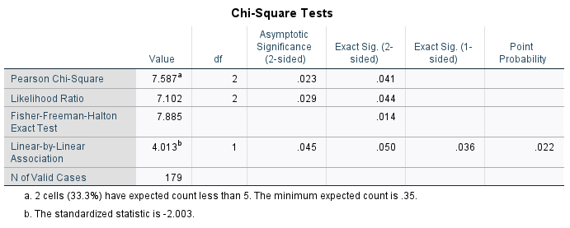
Table 15: Chi-Square Test - Gender and Price (Author)

As outlined before, the analysis will be made looking at the result of Fisher's Exact Test. As the result gives a p value of 0.14, which is greater than 0.05, we fail to reject the null hypothesis, which implies there is no statistic relationship between gender and price. The bar chart below provides a visual representation of the relation between the variables analysed.
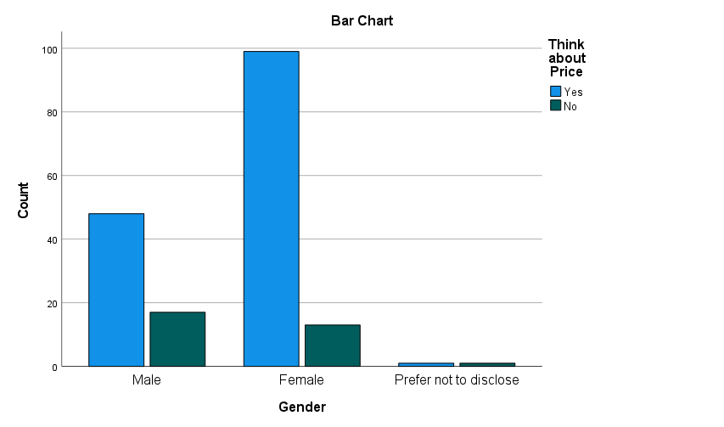
Figure 22 : Gender and Price (Author)

Age

Still in the same view, the Case Processing Summary is disposed above, followed by the crosstabulation of age and price and the relation between them is represented trough the Chi-square test.

Case Processing Summary
 | Cases
 | Valid |  | Missing |  | Total
 | N | Percent | N | Percent | N | Percent
Think about Price * Age | 179 | 100.0% | 0 | 0.0% | 179 | 100.0%
Table 16: Case Processing Summary (Author)
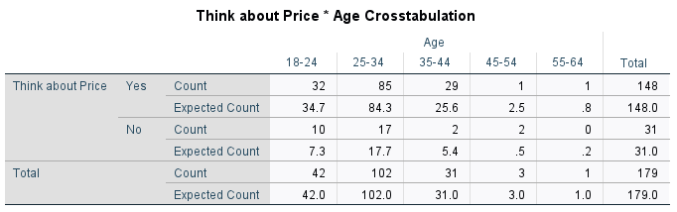
Table 17: Cross Tabulation Age and Price (Author)

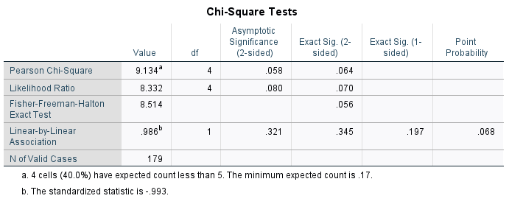
Table 18: Chi-Square Test - Salary and Price (Author)
Again, the null hypothesis is failed to be rejected, as the p value, considering Fisher’s Exact Test, is 0.56, greater than 0.05 and, therefore, this indicates that there is no corelation between age and price. The bar chart below provides a visual representation of the relation between the variables analysed.

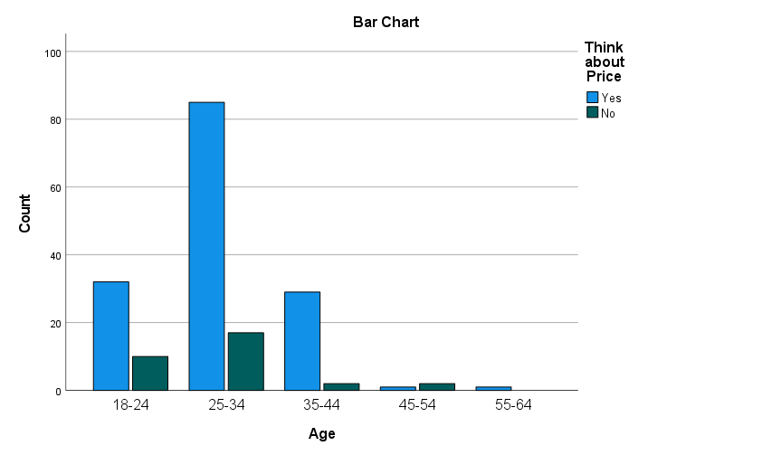
Figure 23: Age and Price (Author)

Salary

The last variable analysed also includes the same steps of the first ones, considering the case process, the crosstabulation and the Chi-square test results. This aims to understand the relationship between salary and price.

Case Processing Summary
 | Cases
 | Valid |  | Missing |  | Total
 | N | Percent | N | Percent | N | Percent
Think about Price * Salary | 179 | 100.0% | 0 | 0.0% | 179 | 100.0%
Table 19: Case Processing Summary (Author)
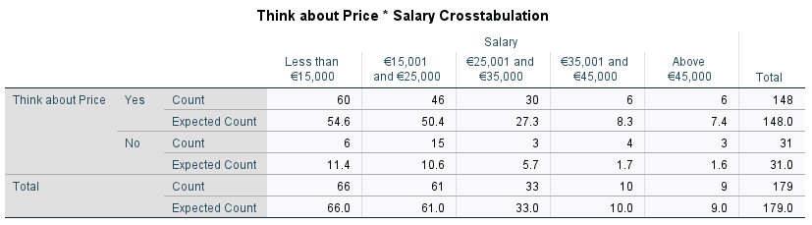
Table 20: Cross Tabulation Salary and Price (Author)
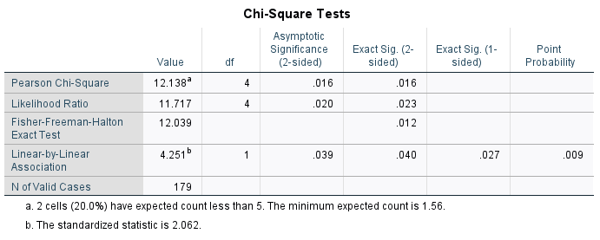
Table 21: Chi-Square Test - Salary and Price (Author)
In this situation the p value is also greater than 0.05, representing 0.12 in this case, and, thus, the null hypothesis cannot be rejected. This implies that there is no relationship between salary and price. For a better visualization, the graph bellow represents the relation between the two variables.
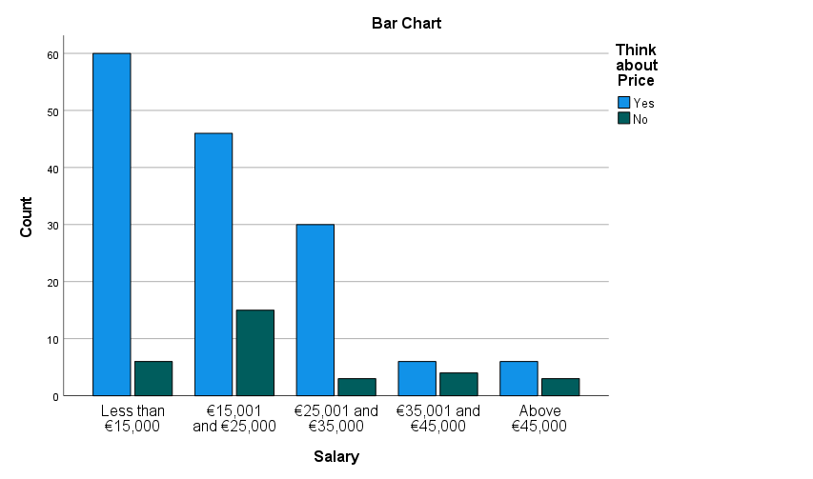
Figure 24: Salary and Price (Author)

5.6.3 Other Variables

• H2 - The consumer buying behaviour of alcoholic beverages is influenced by many factors, other than price.

Still considering the impact of price, but now considering the many variables involved, the questions proposed expected to get a broader understanding of the factors influencing the alcohol buying decision. Respondents were asked to rank the three following statements: “My decision on buying an alcoholic beverage is strictly related to price”, “Price is an important decision factor when buying an alcoholic beverage” and “Other variables, such as quality or brand, are more relevant than price when buying an alcoholic beverage”.

The results from the first question shows that almost half of the respondents (48%) disagree or strongly disagree of the statement, with indicated that their alcohol buying decision is not strictly related to price and, thus, involve other variables. Out of the percentage left, only 7% strongly agree with the statement, and indicates price as the most relevant variable. In contrast, in the second question, 59% of the respondents considered price as a significant decision factor and only 7% strongly disagreed with the statement, which indicates price is not considered in their buying decision. Ultimately, the third question presented consistent results to the first two, with 62% of the answers agreeing or strongly agreeing to the statement and only 10% disagreeing or strongly disagreeing, which reinforces the relevance of other variables in the buying decision.

When analysing the results for the three questions together, it is clear that price is an important factor for most of the individuals, however, the buying decision is also affected for other variables than price.

Figure 25: Strictly Related to Price (Author)

Strongly Disagree | Disagree | Neutral | Agree | Strongly Agree | Weighted Average
14% | 34% | 23% | 22% | 7% | 2.73
Table 22: Strictly Related to Price (Author)

Strictly Related to Price
 |  | Frequency | Percent | Valid Percent | Cumulative Percent
Valid | Agree | 39 | 21.8 | 21.8 | 21.8
Valid | Disagree | 61 | 34.1 | 34.1 | 55.9
Valid | Neutral | 42 | 23.5 | 23.5 | 79.3
Valid | Strongly Agree | 12 | 6.7 | 6.7 | 86.0
Valid | Strongly Disagree | 25 | 14.0 | 14.0 | 100.0
Valid | Total | 179 | 100.0 | 100.0
Table 23: Strictly Related to Price (Author)

Figure 26: Price is an Important Factor (Author)
Strongly Disagree | Disagree | Neutral | Agree | Strongly Agree | Weighted Average
7% | 8% | 26% | 45% | 14% | 3.52

Table 24: Price is an Important Factor (Author)
Price is an Important Factor
 |  | Frequency | Percent | Valid Percent | Cumulative Percent
Valid | Agree | 81 | 45.3 | 45.3 | 45.3
Valid | Disagree | 14 | 7.8 | 7.8 | 53.1
Valid | Neutral | 47 | 26.3 | 26.3 | 79.3
Valid | Strongly Agree | 25 | 14.0 | 14.0 | 93.3
Valid | Strongly Disagree | 12 | 6.7 | 6.7 | 100.0
Valid | Total | 179 | 100.0 | 100.0
Table 25: Price is an Important Factor (Author)

Figure 27: Other Variables are more Important than Price (Author)
Strongly Disagree | Disagree | Neutral | Agree | Strongly Agree | Weighted Average
3% | 7% | 29% | 46% | 16% | 3.65
Table 26: Other Variables are more Important than Price (Author)

Other variables are more important than price
 |  | Frequency | Percent | Valid Percent | Cumulative Percent
Valid | Agree | 82 | 45.8 | 45.8 | 45.8
Valid | Disagree | 12 | 6.7 | 6.7 | 52.5
Valid | Neutral | 52 | 29.1 | 29.1 | 81.6
Valid | Strongly Agree | 28 | 15.6 | 15.6 | 97.2
Valid | Strongly Disagree | 5 | 2.8 | 2.8 | 100.0
Valid | Total | 179 | 100.0 | 100.0
Table 27: Other Variables are more Important than Price (Author)

In order to understand the other variables involved in the purchase decision of alcoholic drinks, the following two questions were focused on these other variables. In the first one, respondents were asked to select all the variables that influence their purchase decision between: Quality, Brand, Availability and Promotion – Campaigns and Advertisements. An “other” option was also available, where five varied answers were given including personal taste, quantity and rating on apps. Availability was the factor that was seen as less affect the buying decision with 21%, followed by promotion with 36%. More than half of respondents selected brand as a decision factor (54%) and 3 out of 4 consider the quality of the beverage when purchasing an alcoholic beverage.

Figure 28 : Other Variables (Author)
In addition, respondents were asked to rank the factors that most influence their purchasing decision. The table below shows the number of answers and the score for each option. As it is observed, the results are consistent with the previous question, as quality ranks as the first one, followed by price and brand. In the two low positions are availability and promotion, respectively.

The results of all the questions together, indicates that the importance of price cannot be understated but the quality of alcoholic beverages seems to be the most relevant fact impacting the consumer buying decision. Attention must be paid to the other factors as well, specially brand, and further studies focusing on those variables might ensure a better understanding and analysis of their impacts on alcohol levels of consumption.

Ranking | Variables | 1 | 2 | 3 | 4 | 5 | Score
1st | Quality | 57 | 31 | 33 | 32 | 26 | 3.34
2nd | Price | 42 | 42 | 38 | 30 | 27 | 3.23
3rd | Brand | 15 | 52 | 55 | 39 | 18 | 3.04
4th | Availability | 31 | 32 | 33 | 45 | 38 | 2.85
5th | Promotion - Campaigns and Advertisements | 34 | 22 | 20 | 33 | 70 | 2.54
Table 28: Ranking of Variables (Author)

To get a broader understand of the relation between level of consumptions and those variables, the researcher has used SPSS to undertake a binary logistic regression model. In this analysis, question 5 of the questionnaire was used to obtain data about the level of alcohol consumption of the respondents. The answers were divided into two main categories: casual drinkers and non-casual drinkers. While the first included the answers between 0 to 8 weekly drinks, the second comprised the remaining answers, representing people who affirm to consume more than 9 drinks per week. Data from questions 13 and 14 were also included, aiming to understand the correlation between price and levels of consumption. Ultimately, data from question 22 was incorporated, where the list of other variables such as quality, brand, availability, and promotion were included, considering relevant if the respondent had selected it or not relevant if he/she had not.

Firstly, an analysis of correlation was made, aiming to understand if any variable had a significant correlation with each other, which might indicate an issue in the analysis. For the table below, when analysing the correlation coefficient (r), none of them presented a result greater than 0.7 or -0.7, which indicates that none of the variables are highly correlated to each other and the model is valid.

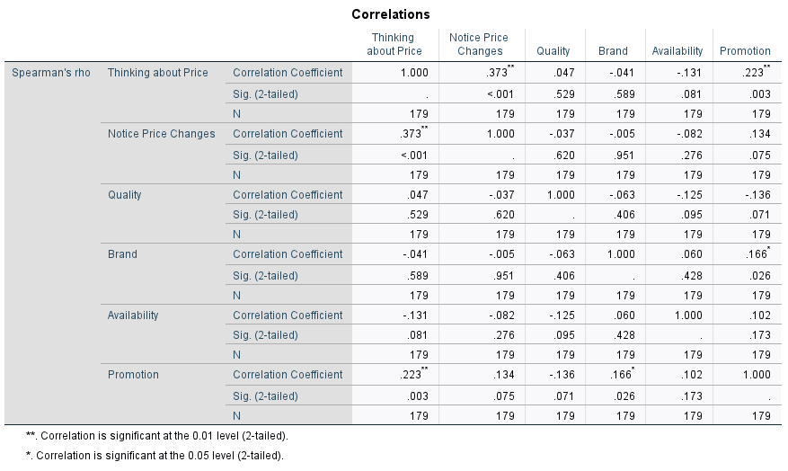
Table 29: Correlation (Author)
Secondly, the binary logistic regression model was performed, based on two hypotheses:

H0: There is no relationship between the specific variable and levels of consumption.
Ha: There is a relationship between the specific variable and levels of consumption.

Case Processing Summary
Unweighted Casesª |  | N | Percent
Selected Cases | Included in Analysis | 179 | 100.0
Selected Cases | Missing Cases | 0 | .0
Selected Cases | Total | 179 | 100.0
Unselected Cases |  | 0 | .0
Total |  | 179 | 100.0
a. If weight is in effect, see classification table for the total number of cases.
Table 30: Case Processing Summary (Author)

Categorical Variables Codings
 |  | Frequency | Parameter coding
 |  | Frequency | (1)
Promotion | Relevant | 65 | 1.000
Promotion | Not Relevant | 114 | .000
Notice Price Changes | Yes | 129 | 1.000
Notice Price Changes | No | 50 | .000
Quality | Relevant | 135 | 1.000
Quality | Not Relevant | 44 | .000
Brand | Relevant | 96 | 1.000
Brand | Not Relevant | 83 | .000
Availability | Relevant | 37 | 1.000
Availability | Not Relevant | 142 | .000
Thinking about Price | Yes | 148 | 1.000
Thinking about Price | No | 31 | .000
Table 31: Categorial Variable Codings (Author)

Classification Table^{a,b}
 | Observed |  | Predicted
 |  |  | Casual Drinker |  | Percentage Correct
 |  |  | No | Yes | Percentage Correct
Step 0 | Casual Drinker | No | 0 | 28 | .0
Step 0 | Casual Drinker | Yes | 0 | 151 | 100.0
Step 0 | Overall Percentage |  |  |  | 84.4
a. Constant is included in the model.
b. The cut value is .500
Table 32: Classification Table (Author)
As it is represented on the tables above, the total sample was 179, with no missing cases, and the total casual drinkers accounted for 84% of the sample. The list of the variables and their codes is also shown.

The table below comprises a summary of the statistics results of all the variables analysed. As can be seen, all the variables, except quality, presents a p value greater than 0.05. This means that the null hypothesis cannot be rejected, and there is no relationship between the variables and the level of consumption. Quality, however, has a p value <0.05, which means the null hypothesis has been rejected and that there is a significant statistical relationship between quality and level of consumption. Further analysis can be made looking at other information presented on the table. The Exp(B), for example, is an odds ratio and indicates the exponentiation of the B coefficient. The results indicate that thinking about price for example, would influence 1.2 times more a casual drinker than a non-casual one. In contrast, when looking at notice price changes, brand, availability, and promotion, the Exp(B) is below zero, which means these variables has little or no effect on the level of consumption. For all the variables, the degrees of freedom (df) is 1, and this is due the fact that the model contains only one predictor.

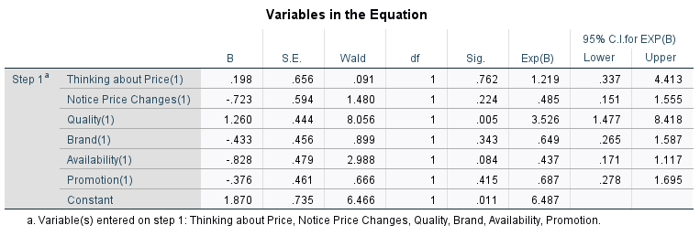
Table 33: Binary Logistic Regression (Author)

5.7 Brand Loyalty and Substitutes

The very last section of the questionnaire, included questions related to brand loyalty and the effect of substitution, including how incline Irish consumer are to switch their preferences to another brand or type of drink, in case of a price increase, and the reasons behind that action. This analysis will be made first of all, focusing on the brand loyalty and aiming to answer the third hypothesis proposed on this study. What follows next is an analysis of the effect of substitution related to type of drink.

5.7.1 Brand

• H3 – Consumers are willing to pay more for a specific brand of alcoholic beverage because they are loyal to it.

Consumers are becoming more loyal to specific brands, which indicates that they may be less sensitive to price changes. The last section of the findings presented above, also corroborated the importance of brand on the alcohol buying decision. The first question related to brand asked the respondents if they usually buy the same brand of their preferred alcoholic beverage. The results shows that nearly 82% of the respondents usually buy the same brand, which suggests their brand loyalty.

Figure 29: Purchase the Same Brand (Author)

Purchase the Same Brand
 |  | Frequency | Percent | Valid Percent | Cumulative Percent
Valid | Yes | 146 | 81.6 | 81.6 | 81.6
Valid | No | 33 | 18.4 | 18.4 | 100.0
Valid | Total | 179 | 100.0 | 100.0
Table 34: Purchase the Same Brand (Author)

Comparing the results above to the preferred type of drink, an analysis was made to the relation of the brand loyalty to the preferred drink of each respondent. The analysis was made through a binary logistic regression model, using data from question 24 above and question 10, where the respondents were asked about their preferred drink. The first two tables present the categorial variables codings and the classification, for information purpose only.

Categorical Variables Codings
 |  | Frequency | Parameter coding
 |  | Frequency | (1)
Others | Preferred | 8 | 1.000
Others | Not Preferred | 170 | .000
Wine | Preferred | 51 | 1.000
Wine | Not Preferred | 127 | .000
Vodka | Preferred | 7 | 1.000
Vodka | Not Preferred | 171 | .000
Gin | Preferred | 10 | 1.000
Gin | Not Preferred | 168 | .000
Whiskey | Preferred | 7 | 1.000
Whiskey | Not Preferred | 171 | .000
Other Spirits | Preferred | 4 | 1.000
Other Spirits | Not Preferred | 174 | .000
Beer | Preferred | 91 | 1.000
Beer | Not Preferred | 87 | .000
Table 35: Categorial Variables Codings (Author)

Classification Table^{a,b}
 | Observed |  | Predicted
 |  |  | Purchase the Same Brand |  | Percentage Correct
 |  |  | Yes | No | Percentage Correct
Step 0 | Purchase the Same Brand | Yes | 144 | 0 | 100.0
Step 0 | Purchase the Same Brand | No | 34 | 0 | .0
Step 0 | Overall Percentage |  |  |  | 80.9
a. Constant is included in the model.
b. The cut value is .500
Table 36: Classification Table (Author)

The next table show the results of the binary logistic regression model. In this case, all drinks have a p value < 0.05, which shows no relationship between the drink and the brand loyalty. However, when analysing the Exp(B), individuals who have wine as their preferred drink are 1.14 more likely to purchase the same brand. In the same view, for individuals who whiskey is the first choice of drink, they are 1.2 times more inclined to be loyal to the brand. When analysing beer and gin, however, the Exp(B) shows a result below 0, which indicates there is little or no influence on their brand loyalty. In addition, all the respondents who indicated vodka and other spirits as their first choice of drink, are casual drinkers and, for thar reason the p value is close to 1 and the Exp (B) is zero. It is understandable that this is a limitation to the findings, as the number of respondents who selected those beverages is significantly smaller than the ones who selected beer and wine.

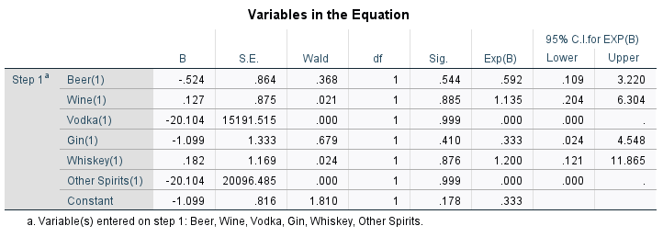
Table 37: Binary Logistic Regression (Author)

The next two questions related to brand analysed how inclined the individuals would be to switch to another brand for each of the drinks listed and the reasons would lead them to change. The results showed that more than 50% of the respondents considered somewhat probable or very probable to switch to another brand and about 18% not probable or somewhat improbable, when considering beer and wine. In contrast, when considering the other drinks such as gin, vodka, whiskey and other spirits, the answers showed that the respondents were inclined to be more neutral, with the percent left being slightly greater to the choices related to probable than the ones of not probable.

Drink | Not Probable | Somewhat Improbable | Neutral | Somewhat Probable | Very Probable
Beer | 7% | 11% | 26% | 41% | 15%
Wine | 9% | 8% | 29% | 26% | 28%
Vodka | 12% | 8% | 42% | 19% | 19%
Gin | 12% | 10% | 36% | 20% | 22%
Whiskey | 16% | 11% | 39% | 17% | 16%
Other Spirits | 13% | 4% | 49% | 17% | 17%
Table 38: Inclined to Switch to Another Brand (Author)

Figure 30: Inclined to Switch to Another Brand (Author)
The following question consisted of the reasons behind the attitude of switching to another brand. More than 60% of the respondents confirmed the desire of having a better-quality product at the same price, and about 50% stated that the reason for switching to another brand is related to save money and to try a new product that been promoted. In comparison, only a little more than 10% had confirmed the relation between switching to another brand because no longer identify themselves with their preferred brand.

Figure 31: Reasons to Switch to Another Brand (Author)
The results of both questions together, reinforce the importance of quality in the consumer behaviour related to alcoholic beverages. A point to be analysed is the fact that most of the individuals who respond this questionnaire listed beer or wine as being their first choice of drink, however, they are likely to switch to other brands of their preferred drink. This might be due for a number of factors such as the wide-ranging variety of this type of beverage or that the quality of this type of drink does not change per category as much as spirits, for example. That said, it is clear from the overall view of previous questions that brand is an important factor, but it is hard to conclude if Irish consumers are willing to pay more for a specific brand of alcoholic beverage because they are loyal to it, and further studies need to be made to understand this relationship.

5.7.2 Type of Beverage

• H4 – If the price increases, consumers will switch their preferences to another type of alcoholic beverage.

The last two questions of the survey were designed to understand if the consumers are willing to switch to another type of drink, in case of a price increase and the reasons behind this attitude. When analysing beer, the percentages are almost even, with 38% saying it is not probably or somewhat improbable that they would change to another drink and 40% saying it is probable. In relation to wine, 28% states it is not probable or somewhat improbable, against 47% who consider it probable. Again, when analysing spirits, such as gin, vodka, whiskey and others, a tendency to be neutral is identified, but in this case, the percentage of people stating that it is probable they would switch to another type of drinks is expressively more than the ones saying they would not.

Drink | Not Probable | Somewhat Improbable | Neutral | Somewhat Probable | Very Probable
Beer | 23% | 15% | 22% | 23% | 17%
Wine | 17% | 11% | 25% | 28% | 19%
Vodka | 13% | 7% | 34% | 20% | 26%
Gin | 12% | 8% | 37% | 18% | 25%
Whiskey | 16% | 9% | 40% | 15% | 21%
Other Spirits | 16% | 4% | 42% | 14% | 23%
Table 39: Inclined to Switch to Another Type of Drink (Author)

Figure 32: Inclined to Switch to Another Type of Drink (Author)

The final question was related to the reasons why they would make those changes. To get a higher quality product at the same price and to save money were the main reasons identified, with 58% and 54%, respectively. To adapt to circumstances had also a significant number (34%), and it is reasonable considering that people may had to adapt with the recent lockdown resulted from COVID-19 pandemic, and this may have led to them to drink more of one specific drink than another. The desire to increase the volume of alcohol ingested for the same price was also considered by 22% of the respondents.

Figure 33: Reasons to Switch to Another Type of Drink (Author)

In accordance with the questions above, although the substitution effect is identified, it is hard to tell the extent it will have an impact on levels of consumption, as the results presented are varied. Considering the two preferred drinks, beer and wine, the largest percent seem related to not switching the type of drink was on beer. In contrast, one of the greatest percentages observed related to changing the consume to another drink was on wine. There might be other reasons behind that attitude that were not identified during the course of the questionnaire and, even though the substitution effect is recognized, the extent it will affect each of the drinks and have an impact on levels of consumption requires further analysis.

The fifth and final subobjective of this study was to conclude about the appropriateness of an excise tax reduction on alcohol and is based on the following hypothesis.

5.8 Level of Consumption and Price Sensitivity

• H5 – If the price decreases, moderate drinkers will consume more, which can be beneficial for the hospitality and drinks industry in Ireland.

From table 33 presented before, it was showed that the extent of which thinking about price can have an influence on consumption is felt differently from casual to non-casual drinkers. Considering that, the next analysis used questions 4 and 19 of the questionnaire, aiming to understand the relation between each drinker category and their relationship with price. On question 4 the respondents were asked about the average weekly alcoholic drinks they have per week, while in question 19 they were asked to rank the statement “My decision on buying an alcoholic beverage is strictly related to price”.

The data from those questions was imported to SPSS and a One-Way ANOVA was conducted, to understand the relevance of price on different levels of consumption. The hypothesis for a One-way ANOVA are as follows:

H0: There exists no difference in the role of price on different levels of consumption.
Ha: There exists difference in the role of price on different levels of consumption.

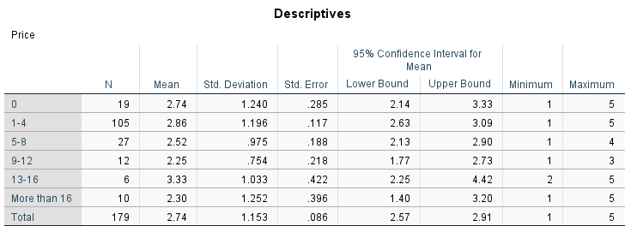
Table 40: Descriptive ANOVA (Author)
From looking at the descriptive statistic presented on the table above, the mean for each of the levels of consumption are varied. Individuals who have from 13 to 16 weekly drinks are more likely to consider price as the main factor related to their purchase decision. All other categories appear to be between not considering price as the main factor and be neutral to it. The results presented were varied, and the distribution of the responses between the categories might be seem as a limitation to the final findings.

ANOVA
Price
 | Sum of Squares | df | Mean Square | F | Sig.
Between Groups | 9.694 | 5 | 1.939 | 1.478 | .199
Within Groups | 226.965 | 173 | 1.312
Total | 236.659 | 178

Table 41: One-Way ANOVA (Author)
The final table presents the ANOVA results, and as it can be observed above, There were no statistically significant differences between group means as determined F(5,173) = 1.478, p = . 199. This implies the null hypothesis cannot be rejected, and there is no significant difference between the role of price on different levels of consumption.

From these results and considering all the other analysis made through the course of this study, it is not possible to conclude that if the price decreases moderate drinkers will consume more, as there are many other variables, especially quality, that have been proved to be extremely relevant on the Irish buying behaviour of alcoholic drinks.

5.9 Conclusion

This section was divided into various sections, to guarantee that the results and interpretation of all the questions were presented, so as the answers for the hypotheses proposed on this study. In conclusion, it was not possible to determine exactly how a reduction of alcohol excise tax would impact on Irish consumer buying behaviour. However, the analysis of findings provided an extensive and varied range of information regarding the motivation behind Irish consumers when purchasing alcoholic beverages.

The importance of price was confirmed. However, there was no significant difference on how the individuals of different gender, age or salary consider price on their buying decision. In addition, all the variables presented were considered relevant for the consumers. Quality has been proved to be the most relevant of all, even more than price, and it was proved to vary significantly between levels of consumption.

Moreover, brand was another major variable identified as affecting Irish consumer behaviour. Even though the majority of people affirmed to usually purchase the same brand of alcoholic beverage, it was not possible to stablish a relationship between the preferred type of drink and their inclination to be loyal to a brand. For that reason, it was not possible to affirm that Irish consumers are willing to pay more for a specific brand because they are loyal to it.

The effect of substitution was also identified for different drinks categories, but the results presented to be varied and was not possible to estimate the degree of which the consumers would switch to another type of drink in order to avoid a price increase. In both analyses, including brand and type of drink, the relevance of price and quality was reinforced. The reasons behind the attitude of switching to another brand or another type of drink are related to save money or get a better-quality product at the same price.

The final analysis showed there is no significant difference between the role of price on different levels of consumption. For that reason and considering the relevance of the other variables analysed in the study, it is not possible to conclude in which extent a reduction on excise tax would affect Irish consumer buying behaviour.
The next chapter discuss the analysis further, with recommendations from the research, with regards to how the research and findings relate to the literature reviewed.

Chapter 6: Conclusions and Recommendations

6.1 Overview

This chapter is comprised by a review of the findings, considering the overall research question “What are the impacts of a reduction on alcohol excise tax rate would have in Irish consumer buying behaviour?”, the main objectives and subobjectives.
Based on this, the main contributions of this study and its limitations will be discussed, followed by recommendations for practice and further research. Ultimately, final conclusions will be presented.

6.2 Implications of Findings for Research Questions and Objectives

The use of taxation and pricing policies aiming to minimize the potential harms caused by alcohol consumption is supported by The World Health Organization (WHO) and it is stablished that taxation on alcohol is imposed in the majority of countries in the world(Sharma et al., 2017). However, the degree of which the imposition of such taxes can be effective on reducing potential harms, will depend on how sensitive each individual, or group of individuals, will be to the price change, considering its personal and social aspects. In addition, not only price, but other variables, must be considered when analysing consumer behaviour related to alcoholic beverages.

There are diverse tax rates and mechanisms which vary between countries, and between beverage types and categories. That said, Ireland imposes considerably high excise taxes on alcohol when compared to other EU countries, and this fact contradicts the relevance and value of the Drinks and Hospitality sector for the country and for the global economy.

Considering that, this research was undertaken aiming to evaluate how a reduction on such taxes would affect Irish consumer buying behaviour and seeking to answer the follow: How sensitive to price are different groups of Irish consumers? What other variables, rather than price, would influence Irish consumer behaviour? How inclined Irish consumers are to switch to other brands or other type of drinks in case of a price increase? And lastly, would a decrease on excise taxes have a greater effect on moderate drinkers, which could be beneficial to the drinks and hospitality sector, and the economy as a whole?

A questionnaire was implemented with Irish consumers aged from 18 to 65+ years old, comprising questions related to all the areas outlined above. A quantitative data was collected and analysed to answer the questions and hypotheses proposed. In conclusion, it was not possible to determine if the reduction of alcohol excise taxes would have a significant impact on Irish consumer buying behaviour related to alcoholic beverages. The reasons for that are varied. It is important to outline that even though price is an important factor on the purchasing decision, other variables, especially quality, have proved to be effective on the decision. If consumers are willing to pay more for a high-quality alcoholic beverage, manufactures may adapt to the changes in alcohol tax rates by adjusting their pre-tax prices in a way that the price of low-quality goods are maintained, whereas the price of high-quality ones are maintained or increased, which may signify the changes in tax duties are not being effective. Moreover, the majority of Irish consumers are not aware of the excise taxes imposed on alcohol and their level of consumption seems not to be affected by their perception of such taxes.

The highlights of this study are:

- Overall, the role of price is reaffirmed, but against previous studies the sensitivity to price does not vary between different genders, ages, or social-economic categories on Irish consumers.
- The majority of Irish consumers are not aware of sin taxes imposed on alcohol and it seems not to affect their level of consumption.
- Quality is the most important factor influencing the purchasing decision of alcoholic beverages, and there is a relationship between quality and levels of consumption. This outlines the importance of considering the product quality on the estimation of price and income effects on sales, as supported by the literature review.
- Irish consumers are loyal to the brand of their preferred alcoholic beverage and the substitution effect is identified, supporting the importance of analysing alcohol as a complex good, considering different beverages and quality brands.
- The importance of price does not vary significantly between different levels of consumption, which goes in contradiction with previous studies and preclude the conclusion about the effect of a reduction of sin taxes, and thus, price, on moderate drinkers.
- In accordance with the current gaps identified in the literature, the study has confirmed the importance of analysing not only the many variables involved on consumer behaviour related to alcoholic beverages, but also the cross-price elasticity of demand for alcohol and the tax pass-through rate, when considering alcohol taxation and optimal price.
- Finally, the research has deeply analysed and explained all the findings to answer the objectives and sub objectives of this study, providing useful information for practice and academic purposes.

6.3 Contributions and Limitations of the Research

6.3.1 Contributions

There are plenty of studies analysing the elasticity price of demand for alcoholic beverages, but very few acknowledging the impact of other variables than price and social and individual aspects. The unique characteristic of this study, encompassing multiple variables and different groups, in addition to the level of importance of the Irish drinks and hospitality industry for both national and global economy, outlines the relevance of the study and the significance of the findings.

The results of the findings provide several relevant insights about Irish consumer buying behaviour related to alcoholic beverages, including how responsive they are to price changes and the main variables that affect their decision. The results can be beneficial for the drink and hospitality sector, providing very useful information about the Irish purchasing behaviour. In addition, policy makers can benefit from the findings, considering them when analysing the imposition or future changes to alcohol excise tax rates.

6.3.2 Limitations

The author acknowledges that the sample size can be considered small. Even though it had overcome the initial target, a larger sample size would generate more reliable data to conclude about a population. Moreover, the author recognises a mismatch of sample sizes with respect to some of the variables, such as age, salary range and levels of consumption and that can also have affected some of the statistical results of the study. Even though the author has supervised the responses while the questionnaire was online to ensure an appropriate mix of answers, the time available and the manpower were an obstacle to obtain a larger and diverse sample. For that reason, generalisation could not be applied, and the findings are related to the sample analysed and not the complete Irish population.

Finally, the author acknowledges that the final objective of the research, to conclude about the appropriateness of a reduction of alcohol excise tax in Ireland could not be entirely fulfilled. The reason behind that is that, to understand the impact of a reduction of such taxes would have in economy, other areas besides the consumer point of view needed to be analysed, such as the government revenue tax collection and the impact on drinks and hospitality industry. Again, the author would have needed more time and manpower to be able to conduct such analysis. In addition to that, COVID-19 had constrained face to face interactions, which implicated that all the data collected had to be obtained through online platforms.

6.4. Recommendations for Practice

As outlined before, this study has provided many insights about Irish consumer buying behaviour related to alcoholic beverages, and the many variables that can affect this behaviour. The drink industry must give special attention to those variables, especially to the quality of beverages, as this seem to be the variable that have the most effect on Irish consumers. The drink and hospitality industry should give more attention to those variables when preparing their businesses plans, in order to maximize results.

Government and policy makers should revise the variables affecting the alcohol purchase decision and consider not only the price and the potential revenue deriving from the imposition of excise taxes, to guarantee that changes on such taxes are also having an impact on binge drinking and minimizing potential harms. Moreover, attention must be paid to how the excise tax rates are influencing consumption and the drinks and hospitality sector, considering its importance to national and global economy.

6.5. Recommendations for Further Research

This research has explored a significant range of different areas and variables related to alcohol consumer behaviour and present many areas which can be further explored. Due the limitation of responses in some of the categories, such as age, salary and levels of consumption, more research is needed to account for these groups.

The results had shown that Irish consumers are loyal to brands and that the substitution effect is identified, but the degree of relevance on how inclined they would be to change to another brand or type of drink to avoid a price increase, could not be confirmed. Further research is necessary for a more accurate perception of these areas.

Furthermore, the effect of COVID-19 pandemic on the volume of alcohol consumed, the type of drink and the brand, including the reasons behind these changes, offers a wide and relevant are for further researchers.

Finally, the results of the findings of this study could not state about the appropriateness of a reduction on alcohol excise tax on Irish economy. However, it has definitely stated the importance of accounting for product quality and the substitution effect when analysing price elasticity of alcohol and to guarantee an effective tax policy. In this view, a more longitudinal and extensive research should be made to understand not only the consumers perspective over a longer period of time, but also the government and the drinks and hospitality industry side.

6.6. Final Conclusions

In conclusion, this research shows that there are numerous areas to be explored and researched regarding to the consumer behaviour of alcoholic beverages. The research has found that even though price has an important role on consumer behaviour, Irish consumers tend to be more influenced by the quality of the beverage than by its price. Against the presented literature review, the sensitivity of price does not seem to vary between different groups and levels of consumption. However, the researcher acknowledge that these statistical results might have be affected by the sample size and distribution and further research need to be made.

That said, it was not possible to conclude if a reduction on excise tax would have a significant impact on Irish consumer buying behaviour and for a final conclusion about the appropriateness of a reduction of such taxes, other areas would need to be analysed.
The findings presented on this study, however, present to be particularly important for the drink and hospitality sector, as understanding the main variables affecting the purchasing decision can be helpful on maximizing their results, especially when consider the hard situation the sector is facing caused by COVID-19 pandemic. Moreover, it is essential that governments and policy makers are aware of what is driving the consumer to purchase the goods, to ensure the tax policy in place is being effective.

References

Anderson, P., Chisholm, D. and Fuhr, D.C. (2009) ‘Effectiveness and Cost-Effectiveness of Policies and Programmes to Reduce the Harm Caused by Alcohol’. The Lancet, 373(9682), pp. 2234–2246. DOI: 10.1016/S0140-6736(09)60744-3.
Alcohol and Public Policy Group (2010) ‘Alcohol: No Ordinary Commodity - a Summary of the Second Edition’. Addiction, 105(5), pp. 769–779. DOI: 10.1111/j.1360-0443.2010.02945.x.
Angus, C., Holmes, J. and Meier, P.S. (2019) ‘Comparing Alcohol Taxation throughout the European Union’. Addiction, 114(8), pp. 1489–1494. DOI: https://doi.org/10.1111/add.14631.
Ayyagari, P. et al. (2009) (w15124) Sin Taxes: Do Heterogeneous Responses Undercut Their Value? Cambridge, MA: National Bureau of Economic Research DOI: 10.3386/w15124.
Casswell, S. and Thamarangsi, T. (2009) ‘Reducing Harm from Alcohol: Call to Action’. The Lancet, 373(9682), pp. 2247–2257. DOI: 10.1016/S0140-6736(09)60745-5.
Chaloupka, F.J. Reducing Underage Drinking: A Collective Responsibility. DOI: 10.17226/10729.
Clarke, P. (2015) ‘THE HISTORICAL DEVELOPMENT OF THE IRISH TAXATION SYSTEM’.
Cnossen, S. (2005) Theory and Practice of Excise Taxation: Smoking, Drinking, Gambling, Polluting, and Driving. Oxford University Press Available at: https://oxford.universitypressscholarship.com/view/10.1093/0199278598.001.0001/acprof-9780199278596 (Accessed: 3 November 2020).
CSO. (2020) Earnings and Labour Costs Annual Data 2019 - CSO - Central Statistics Office. Available at: https://www.cso.ie/en/releasesandpublications/er/elca/earningsandlabourcostsannualdata2019/ (Accessed: 21 May 2021).
Dalton Hugh (1922) Principles Of Public Finance. Available at: http://archive.org/details/in.ernet.dli.2015.210757 (Accessed: 27 January 2021).
DIGI. (2019) DIGI Tax Report 2019. Available at: http://www.drinksindustry.ie/assets/Documents/DIGI-Tax-Report-2019.pdf (Accessed: 3 November 2020).
DIGI. (2020) Employment in the Drink and Hospitality Industry. Available at: http://www.drinksindustry.ie/assets/support-you-local-employee-report-web.pdf (Accessed: 3 November 2020).
DrugNet Ireland. (2012) Alcohol and Drug Research Newsletter. Available at: https://www.drugsandalcohol.ie/19131/1/Drugnet_44_-_Web.pdf (Accessed: 5 December 2020).
Dutkowsky, D.H. and Sullivan, R.S. (2017) ‘Excise Taxes, over-Shifting, Cross-Elasticity, and Tax Revenue’. Applied Economics Letters, 24(2), pp. 113–116. DOI: 10.1080/13504851.2016.1167821.
Elder, R.W. et al. (2010) ‘The Effectiveness of Tax Policy Interventions for Reducing Excessive Alcohol Consumption and Related Harms’. American Journal of Preventive Medicine, 38(2), pp. 217–229. DOI: 10.1016/j.amepre.2009.11.005.
Fisher, C.M. and Buglear, J. (2010) Researching and Writing a Dissertation: An Essential Guide for Business Students. 3rd ed. Harlow, England ; New York: Financial Times/Prentice Hall.
Freeman, D.G. (2000) ‘Alternative Panel Estimates of Alcohol Demand, Taxation, and the Business Cycle’. Southern Economic Journal, 67(2), pp. 325–344. DOI: 10.2307/1061473.
Gallet, C.A. (2007) ‘The Demand for Alcohol: A Meta-Analysis of Elasticities’. The Australian Journal of Agricultural and Resource Economics, 51(2), pp. 121–135. DOI: 10.1111/j.1467-8489.2007.00365.x.
Griﬃth, R., O’Connell, M. and Smith, K. (2017) ‘Tax Design in the Alcohol Market’. p. 64.
Gruenewald, P.J. et al. (2006) ‘Alcohol Prices, Beverage Quality, and the Demand for Alcohol: Quality Substitutions and Price Elasticities’. Alcoholism: Clinical and Experimental Research, 30(1), pp. 96–105. DOI: 10.1111/j.1530-0277.2006.00011.x.
Health Research Board. (2021) Alcohol Consumption, Alcohol-Related Harm and Alcohol Policy in Ireland. Available at: https://www.hrb.ie/fileadmin/2._Plugin_related_files/Publications/2021_publications/2021_HIE/Evidence_Centre/HRB_Alcohol_Overview_Series_11.pdf (Accessed: 13 May 2021).
Hoffer, A. et al. (2018) ‘Regressive Effects: Causes and Consequences of Selective Consumption Taxation’. SSRN Electronic Journal. DOI: 10.2139/ssrn.3211628.
Hunt, A. (1996) Governance of Cons Passion: A History of Sumptuary Law. Springer.
Liu, F. (2018) ‘Sin Taxes: Have Governments Gone Too Far in Their Efforts to Monetize Morality?’ 59, p. 29.
Mankiw, N.G. (2009) ‘Smart Taxes: An Open Invitation to Join the Pigou Club’. Eastern Economic Journal, 35(1), pp. 14–23. DOI: 10.1057/eej.2008.43.
O’Donoghue, T. and Rabin, M. (2006) ‘Optimal Sin Taxes’. Journal of Public Economics, 90(10–11), pp. 1825–1849. DOI: 10.1016/j.jpubeco.2006.03.001.
O’Neill, K. (2020) Hospitality Could Feel Covid-19 Impact for Years, Say Business Reps. Irish Examiner. Available at: https://www.irishexaminer.com/news/arid-31008464.html (Accessed: 26 November 2020).
Preez, H.D. (2015) ‘A Construction of the Fundamental Principles of Taxation’. p. 258.
Purshouse, R.C. et al. (2010) ‘Estimated Effect of Alcohol Pricing Policies on Health and Health Economic Outcomes in England: An Epidemiological Model’. The Lancet, 375(9723), pp. 1355–1364. DOI: 10.1016/S0140-6736(10)60058-X.
PwC. (2020) Tax Facts 2020. Available at: https://www.pwc.ie/publications/2020/tax-facts-2020.pdf (Accessed: 3 November 2020).
PwC, I. (2020) ‘Covid-19 and the Irish Hospitality Sector: Impact and Options’. p. 18.
Rabinovich, L. et al. ‘Further Study on the Affordability of Alcoholic Beverages in the EU’. p. 169.
Revenue. (2020a) ‘Alcohol Products Tax and Reliefs Manual’. p. 65.
Revenue. (2020b) Alcohol Products Tax Rates. Available at: https://www.revenue.ie/en/companies-and-charities/excise-and-licences/excise-duty-rates/alcohol-products-tax.aspx (Accessed: 3 November 2020).
Revenue. (2020c) Quarterly Alcohol Breakdown. Available at: https://www.revenue.ie/en/corporate/documents/statistics/excise/quarterly-alcohol-breakdown.pdf (Accessed: 7 December 2020).
Saunders, M.N.K., Lewis, P. and Thornhill, A. (2007) Research Methods for Business Students. 4th ed. Harlow, England ; New York: Financial Times/Prentice Hall.
Saunders, M.N.K., Lewis, P. and Thornhill, A. (2012) Research Methods for Business Students. eighth edition. New York: Pearson.
Sharma, A., Sinha, K. and Vandenberg, B. (2017) ‘Pricing as a Means of Controlling Alcohol Consumption’. British Medical Bulletin, 123(1). DOI: 10.1093/bmb/ldx020.
Sharma, A. and Vandenberg, B. (2019) ‘Heterogenous Wealth Effects of Minimum Unit Price on Purchase of Alcohol: Evidence Using Scanner Data’ McCollister, K.E. (ed.). PLOS ONE, 14(12), p. e0225538. DOI: 10.1371/journal.pone.0225538.
Sharma, A., Vandenberg, B. and Hollingsworth, B. (2014) ‘Minimum Pricing of Alcohol versus Volumetric Taxation: Which Policy Will Reduce Heavy Consumption without Adversely Affecting Light and Moderate Consumers?’ Schooling, C.M. (ed.). PLoS ONE, 9(1), p. e80936. DOI: 10.1371/journal.pone.0080936.
Smith, A. (1776) An Inquiry into the Nature and Causes of the Wealth of Nations. Available at: https://www.rrojasdatabank.info/Wealth-Nations.pdf (Accessed: 27 January 2021).
Snowdon, C. (2013a) ‘Of Course Sin Taxes Are Regressive’. p. 28.
Snowdon, C. (2013b) ‘The “Sin Taxes” That Make the Poor Poorer’. p. 52.
Snowdon, C. (2012) ‘The Wages of Sin Taxes’. Available at: https://static1.squarespace.com/static/56eddde762cd9413e151ac92/t/573da5009f7266965c8d6369/1463657737237/The+Wages+of+Sin+Taxes+CJ+Snowdon+ASI_0.pdf (Accessed: 3 November 2020).
The Pew, C.T. (2018) Are Sin Taxes Healthy for State Budgets? Available at: https://www.pewtrusts.org/-/media/assets/2018/07/sin_taxes_report.pdf (Accessed: 26 May 2021).
Thornton, M. (2005) ‘Harm Reduction and Sin Taxes: Why Gary Becker Is Wrong’. In Advances in Austrian Economics. Bingley: Emerald (MCB UP ), pp. 357–376. DOI: 10.1016/S1529-2134(05)08014-2.
Vandenberg, B. and Sharma, A. (2016) ‘Are Alcohol Taxation and Pricing Policies Regressive? Product-Level Effects of a Specific Tax and a Minimum Unit Price for Alcohol’. Alcohol and Alcoholism, 51(4), pp. 493–502. DOI: 10.1093/alcalc/agv133.
Wagenaar, A.C., Tobler, A.L. and Komro, K.A. (2010) ‘Effects of Alcohol Tax and Price Policies on Morbidity and Mortality: A Systematic Review’. American Journal of Public Health, 100(11), pp. 2270–2278. DOI: 10.2105/AJPH.2009.186007.
WHO. (2020) Alcohol Pricing in the European Region.
WHO. (ed.) (2010) Global Strategy to Reduce the Harmful Use of Alcohol. Geneva: World Health Organization.
Xu, X. and Chaloupka, F.J. (2011) ‘The Effects of Prices on Alcohol Use and Its Consequences’. Alcohol Research & Health, 34(2), pp. 236–245.
Young, D.J. and Bielińska-Kwapisz, A. (2002) ‘Alcohol Taxes and Beverage Prices’. National Tax Journal, 55(1), pp. 57–73. DOI: 10.17310/ntj.2002.1.04.

Appendices

Appendix A – Literature Review Complement - Changes on Alcohol Excise Tax Rates

Year | Beer (4.3% ABV Pint) | Still Wine (12.5% ABV bottle) | Spirits (40% ABV glass) | Cider (4.5% ABV Pint)
1993 | €0.45 | €1.94 | €0.39 | €0.22
1994 | €0.49 | €2.05 | €0.39 | €0.25
2002 | €0.49 | €2.05 | €0.39 | €0.47
2003 | €0.49 | €2.05 | €0.55 | €0.47
2009 | €0.49 | €2.46 | €0.55 | €0.47
2010 | €0.38 | €1.97 | €0.44 | €0.37
2013 | €0.47 | €2.78 | €0.52 | €0.46
2014 | €0.55 | €3.19 | €0.60 | €0.54
Overall Increase | 22.22% | 64.43% | 53.85% | 145.45%

Table 1: Changes on Alcohol Excise Tax Rates (Revenue, 2020a) – Adapted by the Author

Appendix B – Literature Review Complement – Excise Tax Rates Comparison between Ireland and other EU countries

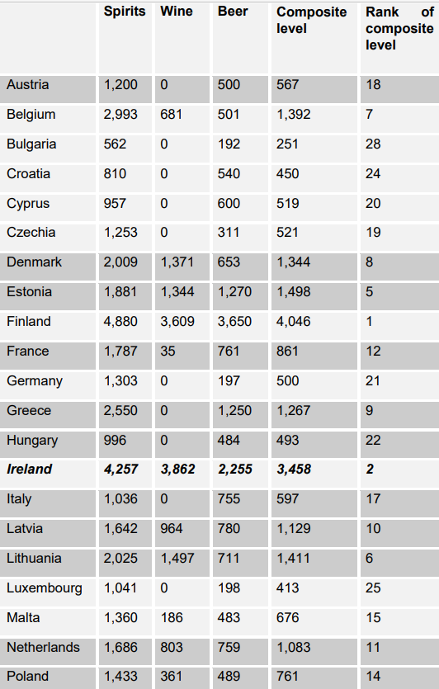
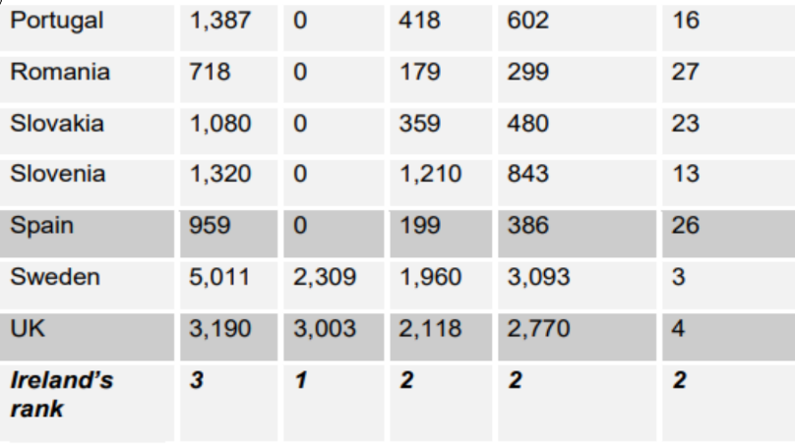

Figure 1: Excise Tax Rates Comparison between Ireland and other EU countries (DIGI, 2020)

Appendix C – Consent Form

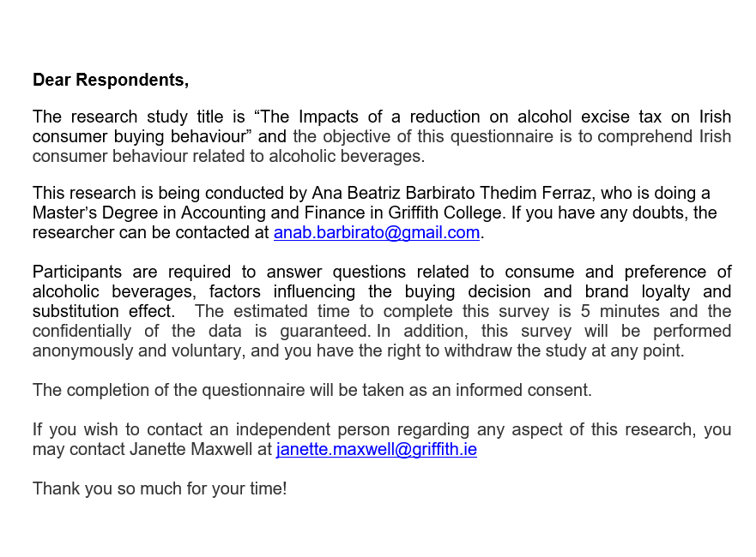

Appendix D – Survey Monkey Questionnaire

