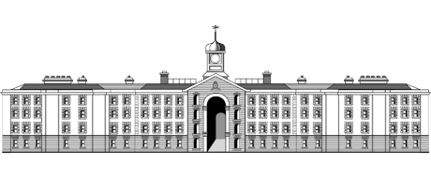
Griffith College Dublin
Cover Page
Student name: | Alan Buckley
Student number: | 2945771
Faculty: | Teaching and Learning
Course: | MAELD |  |  |  | Stage/Year: | 2
Module: | Dissertation
Study Mode: | Full time |  |  |  | Part-time | X
Lecturer Name: | Alice Childs
Dissertation Title: | Towards a Training Intervention To Assist Recruiters to Level The Playing Field In Their Interview Process When Dealing With Neurodiverse Candidates
No. of pages (excluding this page): | 109
Disk included? | Yes |  |  |  | No | X
 | (e.g. number of pieces submitted etc.)
Academic Misconduct:
I understand that I will be subject to the penalties imposed for breaches of academic conduct as defined in the College’s Academic Misconduct Procedure (QA J6).
I agree to allow Griffith College to deposit this dissertation in electronic format in Griffith Online (go.griffith.ie), Griffith College’s open access institutional repository on my behalf.
Signature:  Date: 16.07.23
Please note: Learners MUST retain a hard / soft copy of all assignments and must SIGN the Assignment Submission Sheet provided by the lecturer / member of Faculty as proof of submission.

Towards a Training Intervention To Assist Recruiters to Level The Playing Field In Their Interview Process When Dealing With Neurodiverse Candidates
By
Alan Buckley

Dissertation submitted in partial fulfilment of the requirements for MA in Education and Learning Development (QQI)

Faculty of Teaching and Learning
Griffith College Dublin

July 2023

Declaration

I hereby certify that this material, which I now submit for assessment on the programme of study leading to the award of the MA in Training and Education, is my own; based on my personal study and/or research, and that I have acknowledged all material and sources used in its preparation. I also certify that I have not copied in part or whole or otherwise plagiarised the work of anyone else, including other learners.

Signed:

Dated: 16.07.2023

Final Word Count of Report Section, excluding, Artefact, Acknowledgements, Contents, Referencing, Appendices, etc.
8122

Preface and Acknowledgments
All of this began with a conversation with Niamh O’ Keeffe in a canteen one night in January 2020, where she bullied/convinced/persuaded/bullied me into undertaking a Masters. Given all the hardship since, I’m still not sure if I should thank her or not, be she definitely deserves a mention!!
I would like to thank Griffith College who provided the opportunity to complete the Masters under their direction. I would like to thank each of my lecturers who, over the course of the Postgraduate Diploma and during a global pandemic, delivered insightful modules in often difficult circumstances. I would like to thank my Thesis Supervisor Alice Childs whose guidance and direction helped me to see my way through the fog.
Eoin Costello was a source of ideas and structure and without his input the Artefact would still be a work in progress!
I would like to thank those who contributed their time during the Primary Research Interviews, professionals who took time out of their busy schedules and whose opinions, experience and insights helped to form the final Artefact.
Special thanks are due to my colleagues and friends in Griffith College, in particular Sarah Ward and Sinead O Dea, fellow troopers in the trenches who helped keep me focused and sane during the last 3 years!
None of this would have been possible without the start in life my parents Denis and Kathleen gave me, providing a wonderful family life, instilling in me the values of hard work, resilience and honesty, putting me through school and who, despite not quite knowing what I do, support me anyway!
Finally my wife Dee, who inspires me with her work ethic, focus, dedication, humility and grace, and is my partner in life’s journey. I wish I was more like her.

Dedicated to the memory of Tess Cremin, “my best friend in Kanturk”

Suggested Terminology
Neurodiversity: the biological reality of infinite variation in human neurocognitive functioning and behaviour, akin to ‘biodiversity’ in the natural world. The term ‘neurodiversity’ is now also being used to describe the fast-emerging sub-category of workplace diversity and inclusion that focuses on including people who are neurodivergent.
The neurodiversity paradigm: a perspective on neurodiversity that suggests neurodiversity is the result of natural human variation, and that there is no one ‘normal’ brain type. Stands in contrast to the highly medicalised perspective (until recently, the dominant perspective globally) that views Autism, ADHD and others as ‘disorders’ to be treated.
Neurodivergent: having cognitive functioning different from what is seen as
‘normal’ – while the term appears to reflect the ‘medical model’ above, it is a term that most neurodivergent people are comfortable with. Neurodivergence may be largely or entirely genetic or innate – such as dyslexia – or could be acquired, such as via an incidence of brain trauma.
Neurodivergence: the state of being neurodivergent. It’s worth noting that a common misuse of language is to talk of ‘an individual’s neurodiversity’ – better would be ‘an individual’s neurodivergence’.
Neurodiverse: this term is often used instead of ‘neurodivergent’, yet is potentially problematic (akin, perhaps, to referring to an African-Caribbean person as ‘racially diverse’). A group can be neurodiverse – an individual is likely better described as neurodivergent.
Neurotypical: given the biological fact that there is no such thing as a ‘normal’ brain, neurotypical is best thought of as ‘not neurodivergent’ – that is, within parameters of neurocognitive style that have not been either medically defined as ‘disorders’ or culturally defined as ‘neurodivergent’. It’s important not to draw simple lines in the sand between ‘neurotypicals’ and neurodivergent people – human neurodiversity is a highly complex spectrum, in which everyone sits.
Neurominority: a group such as Autistic people, or Dyslexic people, defined by sharing a similar form of innate neurodivergence. There is invariably great variety within each neurominority demographic.
(CIPD/OPTIMIZE, 2018)

Acronyms
ADHD | Attention Deficit Hyperactivity Disorder
UCD | University College Dublin
MTU | Munster Technological University
CIPD | Chartered Institute of Professional Development
IBEC | Irish Business and Employers Confederation
DEASP | Department of Employment Affairs and Social Protection
ESRI | Economic and Social Research Institute
ETB | Educational Training Boards
OCD | Obsessive Compulsive Disorder
ADD | Attention Deficit Disorder
EBL | Enquiry Based Learning
PBL | Problem Based Learning
BERA | British Educational Research Association

Figures and Tables
Page | Figure/Table
26 | Table 1: Primary Interview Candidate Profiles
38 | Figure 1: Conscious/Competence Training Model
47 | Figure 2: Kolb’s Learning Cycle
48 | Figure 3: Enquiry Based Learning Approaches
49 | Figure 5: Problem Based Learning
51 | Figure 5: The Learning Pyramid - Image

Table of Contents
Declaration 3
Preface and Acknowledgments 4
Suggested Terminology 6
Acronyms 8
Figures and Tables 9
Abstract 12
Chapter One: Introduction 15
Chapter Two: Evidence of Research 18
2.1 - Introduction 18
2.2 - Secondary Research /Literature Review 19
2.2.1 - Recruitment Methodologies 19
2.2.2 –Disability and the Workplace 23
2.2.3 - Neurodiverse Support Organisations 24
2.3 - Primary Research 25
2.3.1 – Methodology 25
2.3.2 - Themes 27
2.4 - Conclusion 35
Chapter Three: Developing the Product 37
3.1 - Introduction 37
3.2 – Aim 37
3.3 – Key Objectives 38
3.4– Designing the Artefact 39
3.4.1 – Learning Designers’ Primary Interviews 39
3.4.2- Adult Learning Theory 45
3.4.3 - Framework 48
3.5 – Ethics 51
3.6 – Limitations of the Artefact 52
3.7 – Conclusion 53
Chapter 4: Conclusion 54
Reflection 54
Relation to other work 54
Further Development 55
References 56
Appendices 63
Appendix 1 – Interview Behavioural Biases 63
Appendix 2 – Primary Interview Questions 66
Appendix 3 - Participant Information Form – Content Creators 69
Appendix 4 - Participant Information Sheet Neurodiverse Support Officers 71
Appendix 5 – Participant Information Sheet – Recruiters 73
Appendix 6 – Participant Consent Form 75
Appendix 7 – Ethical Approval Form 77
Part 2 - The Artefact 82
Declaration 84
Theme, Scheduling and Structure of the Artefact (Lesson Plan) 85
Lesson Plan Template Used 87
Recruiters Neurodiversity Awareness Training Day - Lesson Plan 89
References 109

Abstract
The purpose of this project is to develop an intervention to assist recruiters to make the interview process easier for neurodiverse candidates.
The idea for this topic has its roots in the Innovation for Learning Module of the Postgraduate Diploma. An article, where Dominic Cummings (the former adviser to British Prime Minister Boris Johnson) called for more “gifted weirdos” to be recruited to the civil service, triggered an interest in neurodiversity (Sayal, R., 2020). This led to further research on the topic and to a piece which stated that in order to facilitate this diverse thinking, business leaders needed to alter their culture to accommodate such individuals (Reynolds and Lewis, 2017). However businesses are often echo-chambers who recruit in their own image, and thus, how to break this cycle?
The chosen format for this research was Dissertation by Practice, which would enable the development of something that would be of practical benefit to recruiters and neurodiverse applicants.
The researcher works in employment enablement programmes, delivering material in the job-skills and performance-enhancement fields and therefore the development of a tool that would add to the body of work already developed by key support organisations such as AHEAD, the National Learning Network and Ability@Work, was a strong motivator for choosing Dissertation by Practice.
The information-gathering phase of the project consisted of Secondary Research of articles, journals, interviews and reports from industry and neurodiverse support organisations; and Primary Interviews with Recruiters, Neurodiverse Support Officers and Learning Designers (to seek input on designing the Artefact).

The research phase sought to answer three key questions:
- To what extent might the current recruitment methodologies discriminate against neurodiverse people?
- Why / How? (bias? prejudice? unwillingness? lack of awareness?)
- What can be done about it?
What emerged from the research was that the interview process was indeed generally more difficult for neurodiverse applicants, because the key things recruiters assess (and which the process is designed to uncover) are often (though not always), areas where neurodiverse applicants may struggle (communication skills, interpersonal connection, etc.).
The reason this imbalanced system is used, is generally because it is an established, easy to use, mainstream approach; however it does not easily facilitate people who do not fit the norm. As such, neurodiverse individuals are not really considered and are something of a blind spot.
The solution is a training day (presented in the Artefact) designed to open recruiters’ eyes’ to the potential of neurodiverse talent and trigger the desire for recruiters to reconfigure their own recruitment processes.
Guided by Adult Learning Theory, the training day takes a Guided Discovery/Problem Based Learning approach, scaffolding the interactive exercises over the day, to trigger the motivation of recruiters to change their interview process, and thus benefiting all.

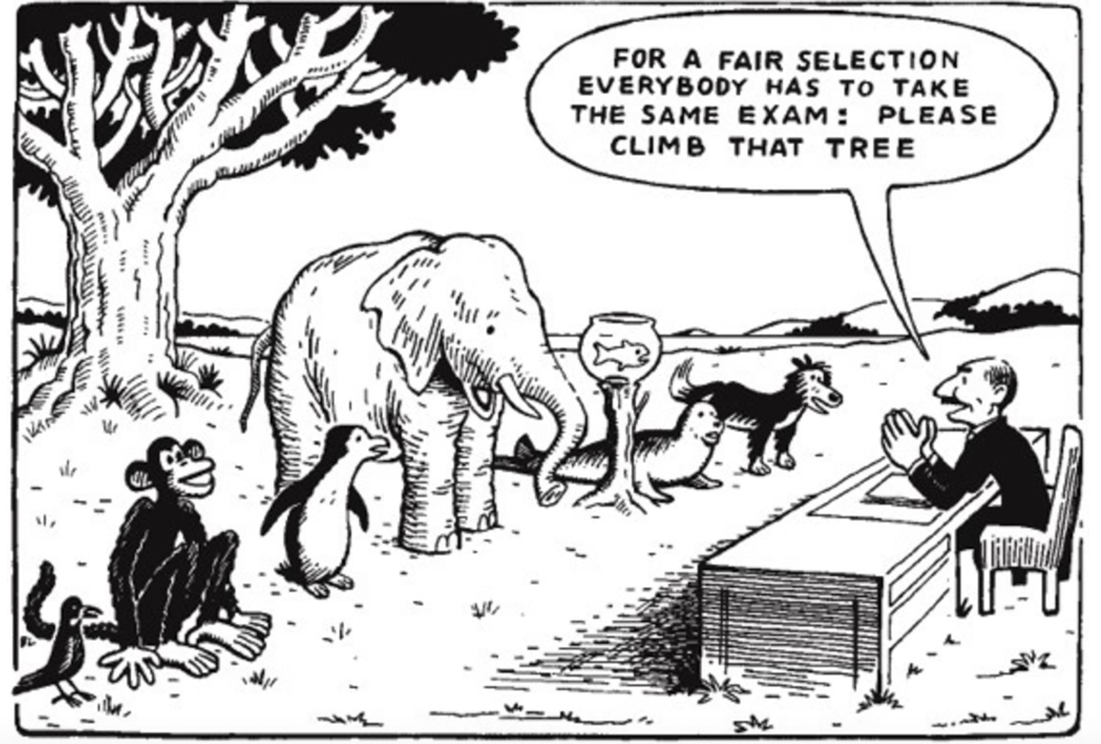

Chapter One: Introduction
The purpose of this project is to develop a training intervention to make the job-interview process easier for neurodiverse candidates.
It seeks to establish whether the recruitment process is a barrier to neurodiverse applicants’ ability to interview effectively, either because recruiters are conditioned to seek aspects of personality/communication styles that neurodiverse candidates may struggle with, or if the interview format itself (however unintentionally) hinders neurodiverse applicants from performing as well as neurotypical applicants.
Neurodiversity can be defined as differences in perception or information processing styles (Reynolds and Lewis, 2017), encompassing conditions including Hypersensitivity, Dyslexia, Asperger Syndrome, Autism and Dyspraxia.
In education for example, AHEAD reported that in the academic year 2019/20, students with disabilities who engaged with support services represented 6.3% of the student population, (AHEAD, 2020a). Alternative assessments and Universal Design for Learning (DCU, 2021), display concrete action in Further/Higher Education to accommodate different psychological (and physical) styles. Similarly, Culturally Relevant Pedagogy (CRP) values diversity in education and encourages tutors to adapt their pedagogy to accommodate neurodiverse learners (Shmulsky, Gobbo and Vitt, 2022).
In industry, such systemic supports are not as robust, and seeking employment, (through the recruitment process) is potentially more challenging for neurodiverse individuals when compared to their neurotypical colleagues (IBM, 2020). Recruitment processes can be complex and pressured experiences, where multiple interview techniques isolate and assess particular aspects of applicants’ personality, skill, knowledge, attitudes, as well as their ‘organisational cultural fit’. Behavioural Tests, Stress Interviews, Competency Based Interviews and Assessment Days are some of the situations applicants can encounter, (Morgan McKinley, 2020).
This report will explore recruiters’ perspectives regarding the reasoning, purpose, methodology and accessibility of their recruitment processes and the experiences of disability support organisations in their role of assisting neurodiverse jobseekers to achieve employment.
The report seeks to answer three key questions:
- To what extent might the current recruitment methodologies discriminate against neurodiverse people?
- Why / How? (bias? prejudice? unwillingness? lack of awareness?)
- What can be done about it?
To answer these questions the report will explore the following:
The current recruitment methodologies
What are the current recruitment methods, and what is the rationale for them? What are the potential knowledge and/or skills gaps of recruiters in their awareness of neurodiversity (especially ‘invisible disability’)?; their opinions on how accessible these systems are for neurodiverse applicants, and how willing/able are they to accommodate neurodiverse applicants within their processes.
The view of Neurodiverse Support Organisations
The view of recruitment from the perspective of disability support organisations is explored; assessing the successes and weaknesses of the current tools/resources; identify other barriers and suggest actions they believe may aid neurodiverse jobseekers.
Building on these findings, the ultimate objective is to develop a training intervention/resource that inspires recruiters to accommodate neurodiversity during the interview process.
Broadly, it is also hoped the report will highlight the untapped resource of neurodiversity, exploring different characteristics of neurodiversity and the strengths neurodiverse talent brings.
The chosen format for this research is Dissertation by Practice, to enable the development of something tangible that would be of practical benefit to recruiters and neurodiverse applicants.
The researcher works in employment enablement programmes, delivering material in the job-skills and performance-enhancement fields and therefore has a professional interest here. Developing something that may highlight the supports provided by neurodiverse support organisations such as AHEAD, National Learning Network and Ability@Work, which assists vulnerable individuals to access employment was a strong motivator for choosing Dissertation by Practice.
A further need exists in the wider Irish macroeconomic landscape, which justifies this project. More accessible job interviews that allow neurodiverse applicants and recruiters to align their interests may help to address some of the Irish economic skills shortages.
There are recruitment shortages in many sectors, particularly front-line and customer-facing positions, which is impacting on employers’ ability to provide services, meet customer demand, grow their business and deal with current economic challenges (Morahan, George, 2022). This “War for Talent” is effecting every sector, including Hospitality, Pharma, Local Government and Retrofitting (Murray, 2022); and though this project is not primarily economically focused, it still sits neatly within the Irish economic situation in 2023, by suggesting alternate pools of talent that recruiters could access more effectively if they could reassess (and reconfigure) how they screen for applicants.

Chapter Two: Evidence of Research

2.1 - Introduction
Diversity/equality as a social justice force is driving awareness and change in culture, language, self-identity and decision-making in public life.
Gender-identity, sexual-orientation, diversity at senior levels in organisations; these discussions are taking place at every level of society (Guerrouj, Lahcene, 2020), (Irish Tech News, 2023).
The Equality Acts 1998-2015 for example, focused attention on disability, mobility, physical accessibility, visual impairment etc. with the numbers of physically impaired people at work increasing (AHEAD, 2020b).
However, a less-visible and lesser-discussed element of diversity is neurodiversity.
Neurodivergence has a lesser profile, perhaps because of its ‘invisibility’, but also because, arguably, people are less comfortable with discussing neurodivergence. Thomas Armstrong, author of The Power of Neurodiversity, wrote:
humans have tended to use significantly more positive language when discussing cultural diversity or biodiversity than when discussing neurodiversity. Instead, negative and medicalised language has dominated the lexicon – witness the very terms ‘Autism Spectrum Disorder’ and the double negative in ‘ADHD (CIPD/OPTIMIZE, 2018).
A view echoed in an interview with a member of the Program Management for University For All, in UCD when discussing neurodiverse accommodations;
“…I think there's fear around us in terms of being able to provide that level of flexibility…”.
The MTU Student Counseling Officer also suggested a potential neurodiverse blind spot:
I don't think there's an unwillingness, I really don't. I found most places I work are very considerate of people. They want things to be as easy as possible and I've never come across a situation where people go, ‘Oh, we don't even look at that’ (…) I just find it is not as in your face as all the other things going on in our culture at the moment….
This ‘blind spot’ will be explored through Primary and Secondary Research, encompassing reports, articles, published pieces and the views of neurodiverse support workers and frontline recruiters, examining the overlap between neurodiversity and employability, and making a case for a training intervention/Artefact to address it.

2.2 - Secondary Research /Literature Review

2.2.1 - Recruitment Methodologies
Recruitment has evolved from traditional one-to-one interviews, to more practical group assessment days and psychometric/personality tools to uncover criteria that recruiters seek.

Such is the competition for talent, that recruiters must go to greater lengths to capture graduates’ attention, using such techniques as ‘a day in the life’ videos, (VidYard, GoPro, Netflix) or ‘Cancelling Culture-Fit’ (Facebook); the recruitment process is becoming ever-more elaborate (LinkedIn Talent Solutions, 2018).

The Irish Civil Service for example has a five-stage process (Public Appointments Service, 2022):
- Application: (Typically through Publicjobs.ie) CV’s are uploaded, eligibility checked and shortlisted
- Testing: Scenario-based questions assess candidates, using Assessment Questionnaires, Verbal Reasoning Assessments, Numerical Reasoning Assessments and Deductive-Logical Thinking Assessments. Additionally, Job Simulation/Situational Judgement Tests which can be multiple choice paper-based or text-based options
- Skills Assessment: Replication of authentic, work-based scenarios, Group Assessment and Role Play, Media Exercise, Presentation, Work Samples and Personality Questionnaires
- Interview: Often two-stage process (Preliminary Interview and Final Interview). Competency Based process assessing Problem Solving, Teamwork, Decision Making, and Team Leadership.
- Pre-Employment/Clearance: Proof of Qualifications, Garda Vetting, Medical checks, etc.

Though methods vary, the process still seeks to establish data about participants’ cultural fit, ability to perform effectively, contribution to the organisation by adding value to their role and potential for further development (CIPD, 2020).

A study of almost 1300 hiring-managers conducted by LinkedIn Learning distilled it to 6 key desired characteristics (LinkedIn Talent Solutions, 2016):
• Adaptability
• Culture-Add (as opposed to Culture Fit)
• Collaboration
• Leadership
• Growth potential
• Prioritisation
Interpersonal flexibility, qualifications and experience are key attributes recruiters desire.
Bias
A key flaw in recruitment is that it is run by (and assesses) people, who may bring inherent bias. (Derous et al., 2016) for example writes that bias can encapsulate obesity, physical unattractiveness and disabilities, among others.

In a Harvard Business Review article, Professor Iris Bohnet writes of the trend of gender reinforcement, where,
Replicating ourselves in hiring, contributes to the prevalent gender segregation of jobs, with, for example, male bankers hiring more male bankers and female teachers hiring more female teachers” (Bohnet, 2016),

And in a study that explored the link between the employability of Autistic applicants and disclosure of the condition, it was found that:
Participants rated Non-Autistic candidates more favourably on all employment measures (first impressions, employability, and endorsement), and “hired” Non-Autistic candidates more frequently, compared with Autistic candidates. Providing additional information about Autism did not result in improved ratings. (Flower, Dickens and Hedley, 2021)

In a publication on optimising the recruitment process – A Head For Hiring: The Behavioural Science Of Recruitment And Selection - the CIPD warned against several biases that can creep in with applicants during the interview process, and which could complicate recruiters’ jobs in determining the best person-role-organisation fit;

people may be overconfident in how successful they will be (optimism bias), short-sighted when considering how much they will value a particular job or an aspect of a job (myopic bias or temporal discounting), stick to the sectors or job roles that they are currently in (status quo bias), consider their own characteristics more heavily than the characteristics of other people who may be applying for the job (egocentric bias), or overestimate how many people work in an industry in total when estimating their probability of getting the job (base rate neglect).
(CIPD, 2015)

(Interestingly, though this report does mention the danger of the selection process being prone to groupthink (affinity bias) at the cost of widening the organisations diversity pool, it specifically mentions race, gender, ethnicity and socioeconomic status as the bases of diversity. Disability- of any kind- and neurodiversity were not mentioned anywhere in the report.)

For a more comprehensive list of bias please see Appendix 1 - Interview Behavioural Biases.

The cost of poor selection can be high, not just in lost time or financially but also its impact on organisational-culture, morale and best practice. Disengagement can be contagious, unsuitable employees can lead to other staff departing the organisation and the legacy issues caused by poor selection may require re-training and recalibrating of existing staff to re-establish good working practices (Fatemi, 2016).

Because of this, it may be argued that recruiters will often play it safe during recruitment and anything that does not fit the ‘ideal profile’ is often treated warily, something acknowledged by the HR Manager of the Sligo hotel during the Primary Interviews:
I think we do have to remind ourselves that some people are kind of pre-professionally evolved…there's ways to interact in social situations where you know you have to be on best behavior and do this and do that. And it's just part and parcel of life. But I think, as interviewers we could give people a little bit more leeway, perhaps because we don't know what their experiences are.

2.2.2 –Disability and the Workplace
Some multinationals embrace the potential of neurodiversity, and have developed appropriate programmes including SAP’s Autism At Work Programme, IBM’s Ignite Autism Spectrum Disorder programme and Orange Telecom’s NeuroTeam Programme.

However Orange believe that in general;
Few companies take neurodiversity into account and disability policies rarely include specific guidance. This can lead to discrimination, especially in terms of employment: 85% of people with a condition in France are long-term unemployed, with their talent going to waste
(CIPD, 2020).

A view reflected by Andy Williams of IBM;
People who are Autistic struggle to get through the standard hiring process…. engaging in small talk or making eye contact can be an overwhelming challenge for them and create an uncomfortable situation for the interviewer
(IBM, 2020).

In the UK just over half of disabled people aged 16-64 are employed, compared with around 80% without a disability (Office for National Statistics, 2020), with just 22% of people with Autism, for example, in employment, echoing the French situation suggested by Orange Telecom.

Similarly, IBEC reported that in Ireland approximately 36.5% of people aged 15-64 with a disability were likely to be in employment, compared to just under 73% of neurotypical people (IBEC/Employers for Change/ Open Doors, 2021).

Dara Ryder, Chief Executive of AHEAD commented that though most organisations have disability and inclusion policies in place,
In practice, there is still a lack of understanding of disability amongst HR staff, with negative words like ‘limitations’ or ‘challenged’ being the first that come to mind. Also there’s a tendency to think of physical disabilities first, when most disabilities are in fact hidden. This lack of understanding tends to lead to a disconnect between a strategic aspiration to hire more people with disabilities and actions on the ground.
(Keogh, Olive, 2021).

2.2.3 - Neurodiverse Support Organisations
A key target of the Irish Government is to achieve an employment figure among those with a disability of 33% to 38% by 2024 (Government of Ireland, 2015). The National Disability Authority have comprehensive resources and toolkits to aid employers in providing disability equality training (National Disability Authority, 2014), in addition to initiatives including Ability@Work’s Disability Awareness Package for employers (Ability@Work, 2018), and the DEASP and AHEAD’s joint initiative Building Inclusive Workplaces (AHEAD, Dept. of Employment Affairs and Social Protection, Dept. of Public Expenditure and Reform, 2018).

Employment figures suggest that neurodiverse individuals still struggle to achieve substantial breakthroughs in employment (ESRI et al., 2021). The WAM Programme Statistics Report 2020, discussed interview accommodations, reporting that almost 4 out of 5 candidates who attend a face-to-face interview have ‘invisible’ disabilities, which may not be obvious at first glance to the employer. For example, candidates who have mental health difficulties, Dyslexia, or an ongoing illness such as Cystic Fibrosis (AHEAD, 2020b).

So while State-backed workplace supports are available, along with physical accommodations during interviews, the readings may indicate a need for more awareness of invisible disability during the interview stage, helping recruiters to identify it and respond positively.

2.3 - Primary Research

2.3.1 – Methodology
Data Collection balances the resources available to the researcher and the best fit with the research question (Galauner, 2021).
Carter et. al., referencing Kaplowitz (2000, 2001) write that one-to-one interviewees were more likely to discuss sensitive topics and stimulate discussion about different topics when compared to Focus Groups (Carter et al., 2014).
One-to-one Zoom interviews were conducted during April – May 2023. Participants were carefully chosen to represent a balanced sample between recruiters, disability support officers and learning designers.
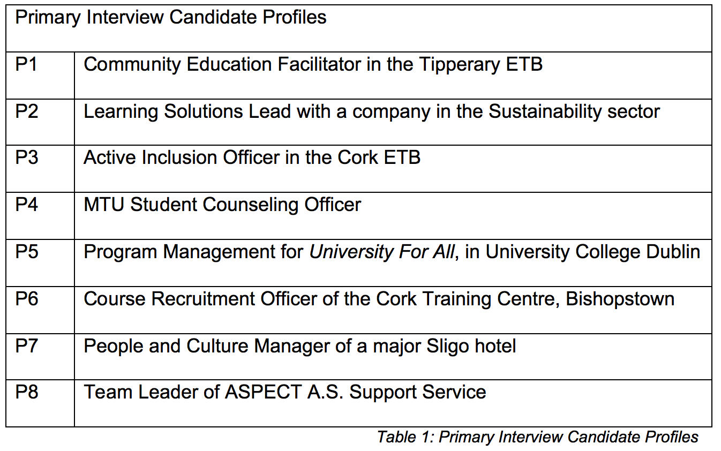
Recruiters were asked questions regarding recruitment systems, desired candidate qualities, their awareness of diversity/neurodiversity, disclosure and previous accommodations made for interviewees.
Disability Support Officers were asked questions concerning recruitment systems, strengths/weaknesses of Employment Enablement Programmes, categories of neurodiversity who perform well during interviews (or poorly), disclosure, accommodations to the interview format that would assist neurodiverse applicants and later diagnoses v’s people diagnosed earlier in life.
Note: The Learning Designers’ responses were primarily related to the structure/format of the Artefact. These will be explored more thoroughly in Chapter 3.

2.3.2 - Themes
The major themes that emerged from the Primary Interviews were-
- Organisation Culture
- The Current Interview Format
- Neurodiversity Awareness and Bias
- Disclosure
- Why existing Neurodiverse Support Tools are not being utilised by Recruiters

1 - Organisation Culture
In the discussion of organisation culture, views were decidedly mixed. P1 made an interesting point about organisations and trust:
When Covid came the world changed, and we all thought, that the world will be different now (…..) and what's the first thing that companies did when there was the first sign that Covid was ending? They brought everybody back to the office, because whether it's a lack of trust in people, it's like we need to see them in front of us
Candidate P3, public sector worker, who occupies an office with neurodivergent people, commented:
I don't think the ETB are smart enough to have just decided on that. I don't. They don't DO joined up thinking so I don't think that was their reasoning at all. They actually need double the amount of people in active inclusion, because active inclusion is so huge
P5 (speaking from an academic point) outlined her view:
One of the challenges in any large organisation (…..) is their varying levels of understanding, varying levels of engagement, and in an academic context, varying levels of autonomy that academics would have. So it can be difficult to implement change when it's optional. Essentially there are a lot of competing priorities
P4, also an academic, was more positive however:
I don't think there's an unwillingness, I really don't. I found most places I work are very considerate of people. They want things to be as easy as possible for people and I've never come across a situation where people go ‘oh, we don't even look at that’
P8 (neurodiverse support) had an interesting insight:
My experience would be (and I know it sounds weird) but often the bigger the company, the more open they are; but that's possibly because they've got more scope, probably more than a small, one- man-band operation. They might have the time, they might have somebody they can dedicate to diversity

2 – The Current Interview Format
Regarding the interview format, the following were insights:
P1:
My perspective of the recruitment process is its very formal. It's also extremely universal. The approach that's taken in, I would say, 95% of organisations that I've gone for an interview, for example, or engaged in a recruitment process with, it's been exactly the same. So it’s a standard recruitment process
P3:
However, going to your question around the interview itself, is that it is not suited for people with invisible needs

P4:
I think it's very institutional or old-fashioned, the way it's done and I know that comes out of a need for every industry to be identical. So people have a fairness; but I think, in seeking equality, you lose the equity piece where, in order to have the same advantage for something, people need to be treated differently
P5 was very critical of the process:
The recruitment processes? How inclusive are they? They're not inclusive because they're so rigid…… [re: choice of assessment and building and flexibility]… one of the requirements that we see all the time is everybody must be interviewed in the same way. They should be asked the same questions. They do the same task, they have to do the same presentation, and these are the restrictions. This view is that that makes it equitable. If we ask everybody, to exactly the same thing, (which is always very funny to me when I think about the cartoon, you know everybody's gonna climb the tree, same assessment whether you’re a fish or an elephant or a monkey), that's the opposite of equity, to force everybody to do the same thing. But there's safety in saying this, and I think that there's a real reluctance to make a change
Interestingly, P4 and P5 both mentioned equity as an important factor, which is not found in standardisation (which gives the appearance of fairness but not the substance).
P6 explained her organisations process:
I suppose it's very difficult in 15 minutes pick up on that. You watch people's body language, you watch their eye contact. But some people find it very uncomfortable to make eye contact….the other thing is we always like open ended questions so that you're not pushing someone into a corner where they feel trapped We [assess] Motivation, Work Experience, Education & Training Communications & Interpersonal Skills…They mark them on the same criteria where it's 25 points for each and I think this has 4 sections in it
P7’s system is very codified, but does leave room for individual opinion:
We score 14 Standard Key Competencies for all roles, we would look for evidence of that at 5 different levels, so kind of ‘No Evidence’ of being able to perform, up to Number 5, which would be ‘Exceptional’. Then, we look at 4 levels of evidence, so ‘None’ right up to ‘Exceptional’. It's not a hard and fast rule though, we take a holistic overview on how they perform as a whole, and obviously depending on the role which areas we can kind of train on, areas we can improve and grow people

3 - Neurodiversity Awareness and Bias
P7 outlined that:
Any kind of unconscious bias could creep in. It's always gonna be a possibility. Because, listen, I might think differently. You might think differently to me, and so on
P5 said:
What we want is that people can choose to engage in whatever way they would like, and that they're not forced to have a limited experience or a negative experience because they're different from the perceived ‘average’ students which of course, we know there's no such thing

She also went on to say:
It's difficult to tell students or graduates to disclose before their interview when we don't know what they're going into in terms of the preconceived notions that somebody might have with the discrimination they might face
When discussing the idea of how equipped organisations are to accommodate neurodiverse applicants P5’s view was:
Take a paper candidate - this is Jerry. Jerry suffers from the following conditions, XYZ… What can you do to accommodate Jerry in a job interview? And are these conditions already in place? How likely is it that you would be in a position to do this and is there a fear of difference? It potentially could be embarrassing…It could be that they have a very traditional approach to recruiting and ‘there's not a lot that we can do as an organisation to help people who might find your recruitment process deeply uncomfortable’ and that's a difficult position to put anyone in
P3 discussed something similar:
I have had staff come to me saying they don't even want to tell me their name, but they're in this X department doing this job, and they’re Dyslexic and they’re just not able to do a part of the job, and they're afraid to say it
P4:
A lot of people with Autism if they work for you, and I have experienced it myself, are routine, reliable, considerate, intelligent people who are doing a lot more and a lot better than a lot of neurotypical people. So it's this assumption that it [their condition] takes from their ability to do the work, when really they’re doing things just as well
P5 discussed the deficit model and the differing approaches between academia and industry:
To me it almost feels like it's the opposite of what we're doing the rest of the time where we're telling students ‘You know, we're not asking you as a square peg, to fit into this round hole where, instead, we're throwing everything open and it's inclusive’. And then it comes to assisting a student with recruitment. And it's like, ‘Okay, well, here's how you're going to be square peg, for this role of recruitment. And here's what you should wear, and here's what you should say, and here's how you should engage in this process’, and we're back to the traditional deficit model which we've tried to reverse in the University and say, ‘there's not something missing in you, we're doing something wrong, and we're going to change it’. But it's back to ‘okay, here's how you're going to fit in with this recruitment process’
She did go on to echo something raised by P8 in the previous section:
I think it's certainly the feeling is public sector jobs are more equitable with recruitment experience. I'm a bit more encouraged to disclose, because it's more like the University Sector. So this layer of protection there, through the bureaucracy that we work in
But when comparing physical disabilities to invisible ones:
With physical disabilities, it's easier for industry….they can see the disability, and therefore they can understand it…they come in and the accommodations that a person would need are straightforward….physically accessible office, flexibility in your hours, things like that ….where somebody who might have Autism or Dyspraxia, OCD, ADD, or ADHD, it's much more difficult for people to understand what accommodations they might need or what impact that has. And there's all the built-in discrimination and preconceived ideas that people have
P6 (on Disability Awareness as a part of Interview Skills training):
I'm trying to think back now when I did my Interview Skills Training. I don't think it [Disability Awareness as a subject] was included. I can't remember. Now, that being said, maybe it was…. know what, I don't think it was….

4 - Disclosure
Disclosure is a complex issue:
P5 said:
It's challenging. If you require an accommodation during the interview process then yes, I would encourage you to disclose. The level of disclosure is something to look at as well, though in terms of how much you disclose…I would recommend that initially people disclose just what's necessary. So we've seen students who disclose and then also give people things like their entire educational psychologist report to their placement supervisor, which produces negative results every time
P3 (diagnosed late in life herself):
The first time that I put myself forward as an Autistic person, I received the letter from the college, and receiving a ‘yes, you can come on our course, you know, even though you're Autistic’, it's kind of the first time that I had sort of revealed myself as this new person
P6 (and the Application form ‘Disclosure Box’):
Yeah, I suppose you will come across it, and I suppose it's probably your fear of being stigmatised, or maybe it's something that they're not even aware of themselves, and they end up in the situation that they're in [diagnosis], and it's sort of all of a sudden all too real

P7’s experience of disclosure:
It's something that we wouldn’t ask. If I'm ringing someone to come in for an interview, it wouldn't be asked quite so directly, as in there wouldn't be a box to tick, but there would be a case of ‘is there any kind of adjustments that need to be made’. It's not necessarily something that's been disclosed to me. As in, we don't ask for it to be disclosed, if you don't require it to be a disclosed
P8 summed it up neatly:
It's based on their lived experience, quite often it might be how comfortable they are with their diagnosis. Some people might resent it, see as a barrier to them being ‘normal’

5 – Why Neurodiverse Support Tools are not being utilised by Recruiters
P4’s view was:
I don't think it's being utilised. Because I think of the changing climate around mental health. We're not there yet. We get so much stuff about ethnicity awareness, and religion, race, all these things in particular and neurodivergence isn't one of the ones that comes up. Now that said, there might be somewhere, but I've never noticed
P7:
I am aware of funding in place…..back to work programmes and such, where there is additional support available. But when it comes to general recruitment, we go through the usual processes….individual applies for that job, will be given kind of the same chances as anybody else applying….I just don't think it's something that we've actively been in discussions with any organisations, with regards to that, with the exception of Down Syndrome Ireland
P5 described cultural capital and privilege:
It's difficult to make a change in an industry that has been the same way…. That there is a perception, ‘but it's always been this way. It's always worked this way’, and people want to protect their privilege. I think cultural capital comes into it a lot

2.4 - Conclusion
Overall, organisations seem sympathetic to neurodiversity, with little evidence of hostility towards the demographic. However recruiters follow established methods when onboarding new talent and their focus is finding the best fit for the role/organisation.
Consequently, they largely do not consider, or actively pursue, neurodiverse applicants; they simply don’t register.
The lack of engagement with neurodiverse supports and tools was due to lack of awareness of their availability, of neurodiversity not being front to mind, and perhaps an element of protecting the privilege of the decision makers
Standardised interview processes were seen as creating the illusion of equity but in practice did the opposite.
Interestingly, the ability and/or willingness to adapt interview processes to accommodate physical disability was seen as more straightforward and easier to understand, than invisible disability.
Disclosure was a complex overlapping of applicants’ lived experience (which determined their comfort with their conditions), their fear of being stigmatised, along with the perceived openness of the recruiting organisation to disclosure.
The support tools are there, as is the willingness of applicants to disclose their need for accommodation in the right environment.
But it does seem to hinge on the recruiting organisations taking the initiative; it would seem that the key is to raise awareness among recruiters of the availability and value of neurodiverse talent; to overcome the perception of neurodiversity being a cultural burden or being lesser-skilled; to recognise their own position of privilege and ultimately reassess how they recruit.
Chapter 3 will outline the steps that were followed when using these insights to create a learning intervention to address this.

Chapter Three: Developing the Product

3.1 - Introduction
Chapter 2 established that neurodiversity is largely a blind spot for recruiters, whose techniques to find talent can be difficult for anybody ‘outside the norm’.
Crucially however, they are generally sympathetic to neurodiversity once they are aware of it.
Therefore: What can be developed to exploit this sympathy in a positive way; to encourage attitudinal and behavioural change?

3.2 – Aim
Neurodiverse Support organisations such as AHEAD, AsIAm and AbilityFocus, already provide wonderful resources (AHEAD, 2013), (Ability Focus, 2023), so the Artefact will not replicate these.
Rather, the Artefact will be a training day, whose aim is to heighten awareness of the availability of neurodiverse talent, the challenges they face trying to compete equally, and ultimately to create a lightbulb moment, the motivation for recruiters to change their own processes.
Ultimately it is to establish a human connection; to encourage empathetic action.
The Conscious/Competence Training Model contains 4 stages (Childs, A, 2017b), (Conscious Competence Model, 2016). Before Stage 2 (Conscious Incompetence) can be reached, awareness, in the form of a “lightbulb” moment must occur.
The Artefact’s aim is to facilitate that lightbulb moment.
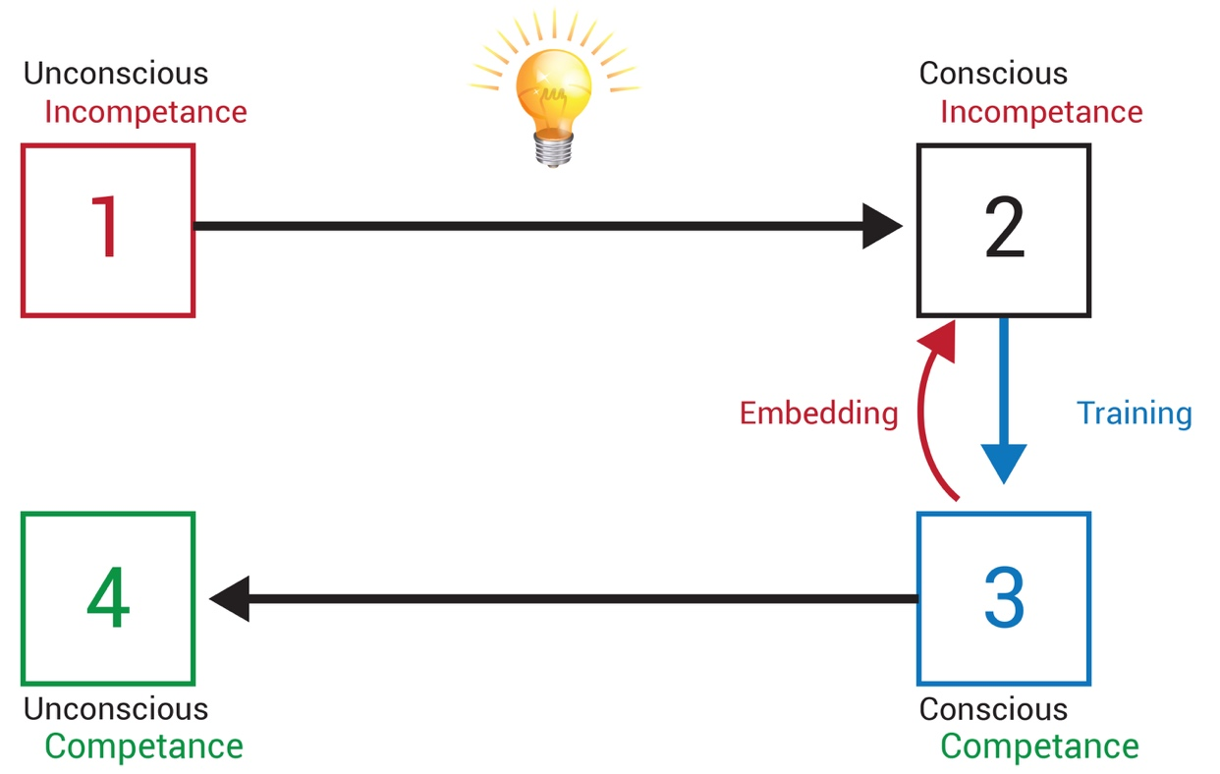
Figure 1: Conscious/Competence Training Model
(Graphic - Researchers own)

3.3 – Key Objectives
Several Objectives underpin the main Aim:
- Highlight the notion of “Privilege”, as introduced by interviewee P5 in the primary interviews
- Open recruiters’ eyes’ to the everyday challenges faced by neurodiverse applicants. That they are “living in a world that’s not made for me” (Ferris, F and James, N, 2021)
- Establish clearly that disability does not mean taking a “lesser” candidate; neurodiverse applicants often excel at many day-to-day activities
- Review their recruitment systems: “How accessible is my interview process for this person?”

3.4– Designing the Artefact
“Instructional Design is the process through which an educator determines the best teaching methods for specific learners in a specific context, attempting to obtain a specific goal.” (Gillis, P., 2020b)
The Artefact design involved a coming together of several strands:
- Primary Interviews with Professional Learning Designers in the mechanics of preparing a training intervention such as this.

- Key learning points acquired during the modules studied in the Postgraduate Diploma in Education, Learning and Development (i.e.: adult learning theory, module design, teaching techniques, organisational learning, etc.)

- Primary Interviews with neurodiverse supporters and recruitment professionals, yielding key insights in terms of their objectives, day-today pressures and what kind of intervention may be effective.

3.4.1 – Learning Designers’ Primary Interviews
During the Primary Interviews with the Learning Designers, the following themes emerged:
- Outcomes
- Pre Reading
- Trust
- Duration
- Subjects/Content
- Teaching Methods
- Reflection

Outcomes:
P2:
Think about what they'll be doing in their workplace once they've completed the training program, then create the learning outcomes from that space, you know, working backwards

Pre Reading:
P1:
The more information you can give learners, and the more you can set their expectations, the better. What I found when I was teaching was learners wanted an idea of how the day was gonna go
P2:
Your workshop time is precious (…) so I'd be thinking… can you give them maybe some prereading to get some of the basic concepts say, because as well as just the topic you set their expectations

Trust:
P1:
Not everyone likes facing another learner straight up (…) you've got to be cognizant of the fact that you've got some people that might be extremely shy, might be very uncomfortable in social situations
P2:
I would always give good time at the start for introductions and for the groups to get to know each other, build trust. I think building trust in the group is hugely important in the day

P1:
It potentially could be embarrassing. It could be that they have a very traditional approach to recruiting and the whole point of the day is to say ‘look, there's not a lot that we can do as an organisation to help people who might find your recruitment process deeply uncomfortable’ and that's a difficult position to put anyone in

Duration:
P2:
I'm thinking of a one day program. The likelihood is you learn a new skill and what it's about, arming that learner with the tools to go back to the workplace, and maybe have those conversations with their manager
P1:
I don't think people look at the reflective practice as difficult. It gets you thinking. Most people don't think on a daily basis and it's tiring. So even 5 min of reflective practice. You're saying 4 separate junctures over a full day
P2:
I've actually found sometimes an hour can be just maybe a little bit too long. So maybe between 30 and 45 min. It's usually probably enough on time

Subjects/Content:
Biggs & Tang, referencing Gardner;
The greatest enemy of understanding is coverage (…) If you’re determined to cover a lot of things, you are guaranteeing that most kids will not understand, because they haven’t had time enough to go into things in depth, to figure out what the requisite understanding is, and be able to perform that understanding in different situations (Biggs J. and Tang, C., 2007, p. 82)
P2:
For full day training (…) I would tend to go with three is a magic number (…) so you have two blocks in the morning. And two in the afternoon, but that you would cover three ‘teaching blocks’, and then have the final block bringing it all together, which creates a space for people to look at their next steps
P1:
People in that industry coming in for a diversity day or an awareness session they're gonna need an Awareness session first, they're gonna need that before the group think. And before they come up with the solutions

Teaching Methods:
P1:
You want to create an environment based on trust. That would be one of the big things for me. You want to make it some bit fun, relaxing
P3:
It has to be personable. They have to make that connection with somebody, that it's not just a very formal training, flip chart business, you know, PowerPoint, knowledge. It has to be a kinaesthetic workshop, it has to be role-playing, something that enables them to really think about how it how it is for that person.…….it has to be active, active, active every time
P1:
Things like peer learning and collaborative work. They just tend to flow a bit easier. So if you build those strategies into your classroom… people are going to learn at a deeper level
P2:
The other one that's coming out for me are presentations (…) we would tend to combine our assessments with a presentation to end a program, and I think the presentation as an assessment tool, it's such a rich assessment, because you're really getting the persons full personality and their thinking
P1:
Give them a candidate on paper, for example, who has Autism….you set up a number of barometers around them, maybe they are uncomfortable in social situations, or formal situations, certain sets of criteria, and your organisation, your structures, what do you do to support that candidate? Or do you just have a standard process across the board?
P1:
And maybe potentially doubting their recruitment process and saying, ‘are we potentially discriminating against people?’ Are they potentially doing themselves a disservice by excluding a cohort of people who could be potentially amazing candidates and valuable to their organisation

P2:
If you saw a video case study/scenario in the workshop it can be highly effective because what comes across in a couple of minutes of a video could take your 20 min to explain in person

Reflection:
Reflection is “the thread that makes continuity of learning possible, and ensures the progress of the individual” (Whitaker, Dr. T, 2017, p. 40)
P2:
I think reflective writing is a really gorgeous assessment tool, because what you're testing there is not only that they understand, maybe the topic, but that they’re also sharing their own personal thinking around that
P2:
What interweaves in the day is that they're building a reflective journal or they're building an activity or they’re practicing maybe sessions, skills and knowledge throughout the day, so that it has all the experiences of the practice within the workshop day. So it enables them to bring those knowledge and skills into their workplace

3.4.2- Adult Learning Theory
Personal development underlies many of the contemporary theories of Adult Learning (Tusting, Karin and Barton, David, 2003). In this vein, the theories of Knowles, Rogers and Kolb in particular, were key influences in deciding the theme and style of the Artefact, which would be a training day that seeks attitude change and personal development (by highlighting the blind spots inherent in the participants’ attitudes to recruitment).
Knowles’ Theory of Adult Learning presents six key characteristics of adult learners which the Learning Designer needs to consider when designing a training intervention:
- Self-concept moves from a dependent personality to self-directing human being
- Growing reservoir of experience acts as a resource for learning
- Readiness to learn becomes increasingly oriented to the developmental tasks of their social roles
- Time perspective evolves from postponed application (of knowledge) to immediate application; learning shifts from subject-centeredness to problem-centeredness.
- More motivated by Internal personal factors than External pressures/coaxes
- Need to know the value of what they are learning and the why behind the need to know
(Bouchrika, I., 2021), (Childs, A, 2017a)

Essentially, effective adult learning is driven more by purpose, and the need for problem solving, than by external pressures; crucially learners’ own experiences frame the context of new learning; and harnessing this internal motivation is a key task for the Learning Designer.

Similarly Carl Rogers outlined two types of learning: Cognitive (‘meaningless’) and Experiential (‘significant’), where the key qualities of Experiential Learning were:
- Personal involvement,
- Self-initiated,
- Evaluated by learner
- Pervasive effects on learner.

Under Rogers’ theory, effective learning occurs when:
…(1) the student participates completely in the learning process and has control over its nature and direction, (2) it is primarily based upon direct confrontation with practical, social, personal or research problems, and (3) self-evaluation is the principal method of assessing progress or success.
(Culatta, R., 2023)

Knowles and Rogers are in harmony with their views on internal motivation/purpose, the importance of problem solving to facilitate new learning and adults’ own experience/reflection as requirements to frame new learning.

Kolb suggested a framework where adult learning could occur, in which Discovery and active participation are critical components, writing that “knowledge is created through the transformation of experience” (Gillis, P., 2020a) (Kurt, 2020), (Childs, A, 2017c).

Kolb’s 4 Stage Learning Cycle presents a series of experiences (or steps) adult learners go through and reflect upon, and thus create new learning internally (echoing Knowles’ and Rogers’ principles) as opposed to simply assimilating externally presented data.
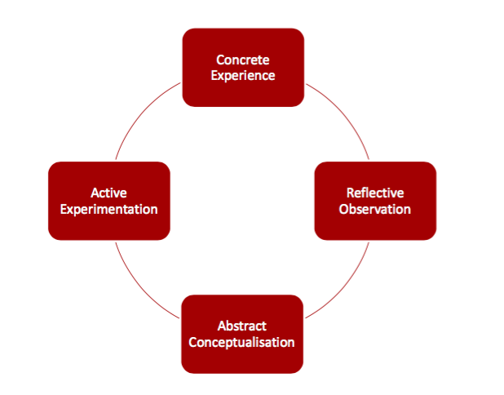
Figure 2: Kolb’s Learning Cycle

With Kolb, an activity/problem is presented to learners (Concrete Experience), which, once completed, is reflected on (Reflective Observation), generating new learning (Abstract Conceptualisation) which is then tried out (Active Experimentation). Over time Kolb’s Model was reworked to include distinctive learning styles, with suggestions on how best to engage these distinctive categories of learner.

Summary
Knowles, Rogers and Kolb therefore have common suggestions on key elements that adult learning initiatives, (i.e.: the Artefact) should contain:
- Problem solving as a central component
- Active, meaningful engagement
- A problem that is personally/professionally centred
- An environment that is stimulating and self-constructing (as opposed to externally driven)
- Learning needs to be an ‘on your feet’, practical experience that challenges learners to find their own solutions to problems, rather than simply presenting them with the answers.

3.4.3 - Framework
Taking the suggestions of the Learning Designers and marrying them with the problem solving ethos of the Adult Learning Theories of Kolb, Rogers and Knowles, one andragogical framework which may naturally encompass these tenets is Guided Discovery (EduTech, 2006), (Mayer, 2014), or Enquiry Based Learning (Barrett, T. and Cashman, D., 2010).
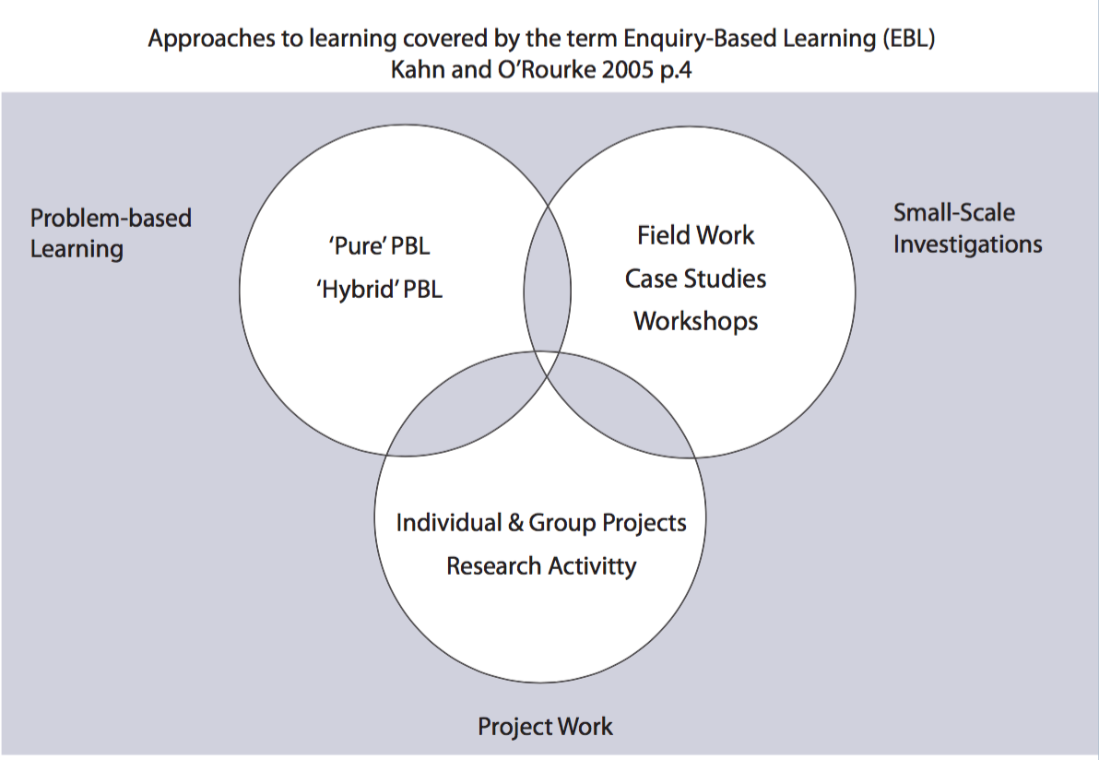
Figure 3: Enquiry Based Learning Approaches
PBL has been successfully used in University College Dublin for example in modules including Healthcare, Biosystems Engineering and English Language Teaching.

In the EBL/PBL cycle:
They set the ground rules for effectively working as a team. They define the problem. They brainstorm their ideas about the problem. They identify what they don’t know about the problem and need to research. They phrase these learning issues as questions. Between tutorials they research these learning issues as they relate to the problem. Teams share the research they have done and work together towards a resolution of the problem and to produce the product required.
(Barrett, T. and Cashman, D., 2010)
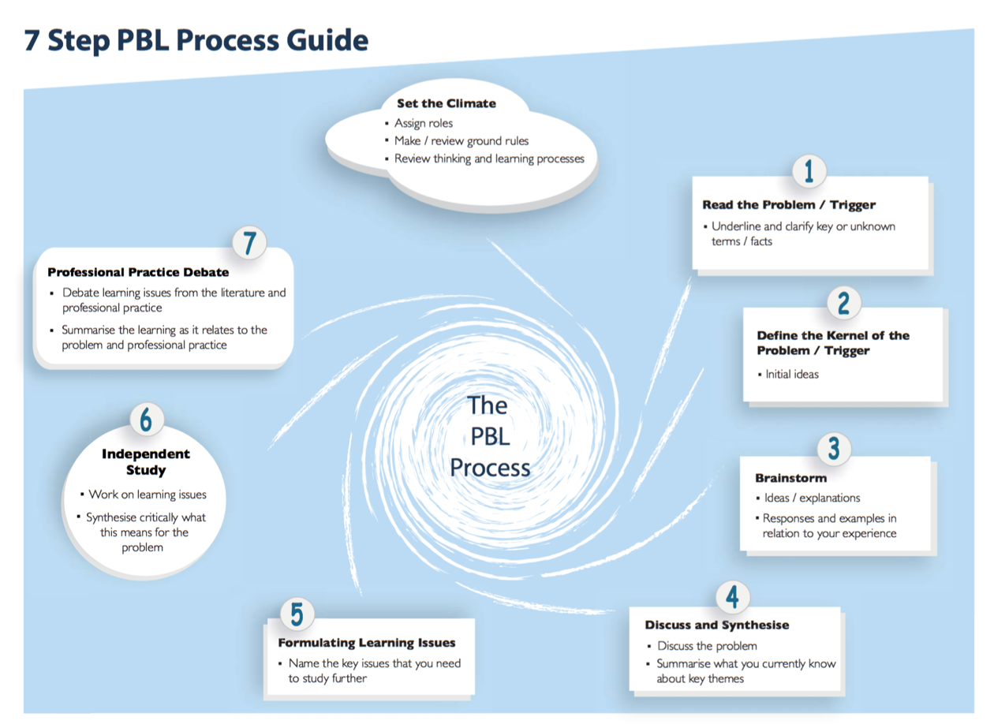
Figure 4: Problem Based Learning (Barrett & Cashman)
Many formats can be used to introduce the problem to the group; case studies, cartoons, DVD’s, etc. (Barrett, T. and Cashman, D., 2010).
In order for EBL/PBL to be effective, Tom Curran, Biosystems Engineering Module Coordinator in UCD, advised that it is difficult for a group to behave as a team, therefore mutual respect, shared contributions and a leader to facilitate decision-making is crucial. Likewise, shared responsibility and setting a schedule is important to maintain momentum. (Barrett, T. and Cashman, D., 2010)
One potential drawback of PBL is it often takes place over a semester, or some prolonged time period, allowing learners to encounter natural learning obstacles, have time to research and agree collective responses, trial their theories and progress as a team.
The proposed Artefact is a one-day session with the “EBL/PBL” element occurring in the afternoon, thus limiting the research and response time.
However the faculty of Veterinary Medicine actually incorporated EBL/PBL into their Assessment by using:
A ‘short’ case, solved in real time, which is given to groups of up to 16 students 2 hours before the examination (50%). While a sound basis of underpinning factual knowledge is required and arises from proactive research, the assessment criteria emphasise systematic analysis, efficient research, logical prioritisation, and intelligent integration of adjunctive knowledge. Through this the student is, above all, expected to ‘define the right question’ rather than necessarily ‘get the right answer
(Barrett, T. and Cashman, D., 2010)
This would suggest that effective, EBL/PBL can indeed occur in shortened sessions, assuming proper organisation and some element of prereading with some kind of underpinning factual knowledge occurs.
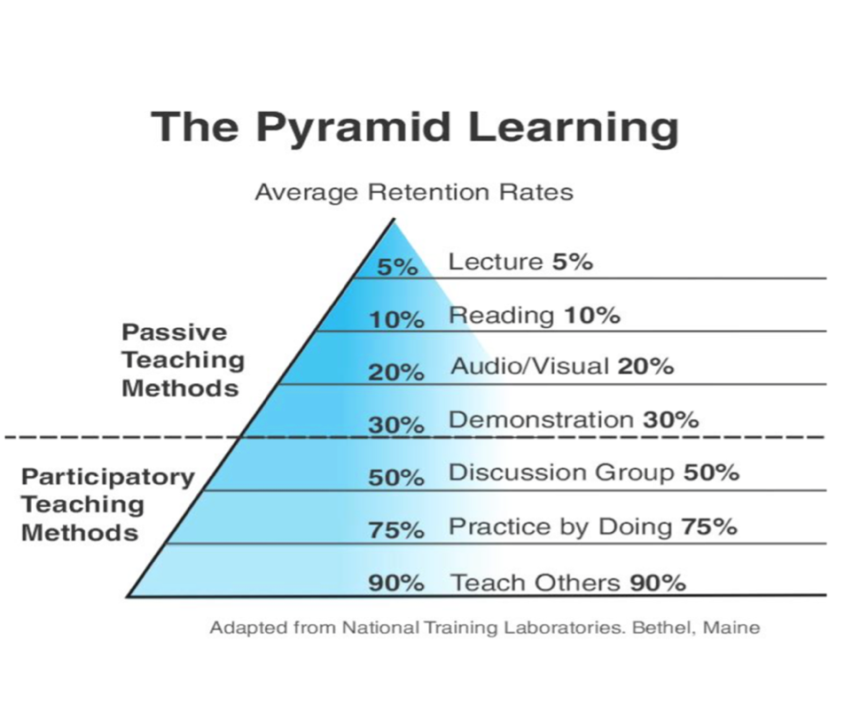
Figure 5: The Learning Pyramid - Image (Childs, A, 2017a)

3.5 – Ethics
One activity will expose recruiters to the challenges Neurodiverse candidates face by presenting testimonies of real people telling their stories, possibly in an aural format to add more emotional context, as suggested by P8 during the primary interviews:
If it helps you, Alan, just to say if you were doing something like that and you want us to come in and present for 10 minutes, 30 minutes or possibly link one of our clients maybe if they were willing to. Obviously there's a whole area of consent and all that but like there's nothing like hearing from the horses mouth
A key research principle is minimise harm/distress (BERA, 2018, p. 2). Any such interview would be done in cooperation with the participant and the Neurodiverse Support Officer, screening any questions for potential harm/discomfort and agree best practice in conducting the interview to ensure safety and confidentiality.

3.6 – Limitations of the Artefact
“Feedback for and as learning are vital elements of all assessment strategies and viewed as central to constructive learning in an incremental manner” (O’Riordan, Dr. F, Childs, A, and O’ Toole, M, 2016),
The nature of assessment in a short course such as this was problematic. Assessment is a great method of capturing learning and the researcher would have been loath to omit this aspect of the Artefact.
Projects, collection of work, exams etc. were considered as Assessments, but were rejected due to available time and the nature of the module outcomes (which were attitudinal in nature). However interviewee P2 suggested combining the reflective activity with the Assessment:
We would tend to combine our assessments with a presentation to end a program, and I think the presentation as an assessment tool, it's such a rich assessment, because you're really getting the person's full personality and their thinking
Though writing mainly on teaching practice, Dr. Ciara Farrells also espouses the effectiveness of reflection:
[Reflection on Action] refers to critical reflection that takes place after practice, leading to new theories and thus to improved practice the next time the action is undertaken. Reflection-on-action needs to be carefully managed, because individuals may be overly critical, focus only on negative aspects or problems, or see mistakes as failures rather than opportunities for change. Ghaye and Ghaye (1998) argue that, used appropriately, reflection-on-action means that experience never becomes a liability, because it involves professional and constructive—rather than negative or destructive—self-scrutiny.
(O ’Farrell, Dr. C., 2007, p. 26)
Therefore though the training day is not Assessed per-se, which may be a weakness in the approach, the use of Reflective Journaling, Shared Reflection etc. may act as a method of assessment, enabling the participants to harness the learning and bring it to their organisations, which ultimately is the overall aim of the Artefact.

3.7 – Conclusion
The Artefact will be an interactive day of training, where participants will have their recruitment techniques challenged, by exposing them to testimony of those who the process discriminates against, and which through the application of Guided Discovery/Enquiry Based Learning, will facilitate the participants to devise their own solutions through reflective journaling and shared feedback.

Chapter 4: Conclusion
The purpose of this project was to develop a training intervention to assist recruiters to make the interview process easier for neurodiverse candidates.
The research phase sought to answer three key questions:
- To what extent might the current recruitment methodologies discriminate against neurodiverse people?
- Why / How? (bias? prejudice? unwillingness? lack of awareness?)
- What can be done about it?
The outcome of the research was that the process was indeed more difficult for neurodiverse applicants because the key things recruiters seek (and which the process is designed to uncover) are often (though not always) areas where neurodiverse applicants struggle.
The research informed a Guided Discovery/Problem Based Learning intervention, to open recruiters’ eyes’ to the potential of neurodiverse talent, the existing supports and the need to reconfigure their own recruitment processes.

Reflection
I believe the strengths of the Artefact are that it is built on a mutual need (recruiters and applicants), the participants are the organisations’ key decision makers, it follows the principles of adult learning and the objectives (attitudinal change) are both realistic and achievable.

Relation to other work
The artefact also sits neatly with other established neurodiverse tools; rather than adding to the existing resources from different agencies, it instead simply seeks to draw the attention of recruiters towards them. Therefore it will not displace existing resources or compete for attention.

Further Development
Further development could look at the duration and sequencing of the sessions. A lot of work occurs in one day, which could be a lot to process (Biggs J. and Tang, C., 2007, p. 82), and generally PBL occurs over a period of time. Possibly this could be more effective as a two-day (or two half-day) session where the blind spots are revealed in the first session and the solutions devised in the subsequent session. However this could only be definitively decided following feedback after several rounds of the initial Artefact being delivered.

References
(Note: The resources for Gillis, P. and Childs, A. were downloaded copies of the class notes that were available from the class Moodle Page at the time when the researcher was a student in those modules. Moodle access to these modules has since been removed, so the references provided here refer to the digital copies on the researchers own laptop, and not the Moodle page, hence the lack of a URL address)
*
Ability Focus (2023) Ability Focus | Disability Awareness | Disability Awareness Specialists, Ability Focus | Disability Awareness | Disability Awareness Specialists. Available at: https://abilityfocus.ie/ (Accessed: 23 January 2022).
Ability@Work (2018) ‘Ability@Work Disability Awareness Package’. Available at: https://abilityatwork.ie/employers/ (Accessed: 25 January 2022).
AHEAD (2020a) ‘Students with Disabilities Engaged with Support Services in Higher Education in Ireland 2019/20’, p. 94. Available at www.ahead.ie (Accessed 16.02.22)
AHEAD, Dept. of Employment Affairs and Social Protection, Dept. of Public Expenditure and Reform (2018) Building Inclusive Workplaces. Available at www.ahead.ie (Accessed 16.02.22)
AHEAD (2013) WAM Advice for Employers. Available at: https://www.ahead.ie/userfiles/files/shop/free/WAM_Advice_for_Employers_Web_Version.pdf. available at www.ahead.ie (Accessed 16.02.22)
AHEAD (2020a) ‘Students with Disabilities Engaged with Support Services in Higher Education in Ireland 2019/20’, p. 94. Available at www.ahead.ie (Accessed 16.02.22)
AHEAD (2020b) The WAM Programme Statistics. Available at www.ahead.ie (Accessed 16.02.22)
Barrett, T. and Cashman, D. (2010) ‘A Practitioner’s Guide to Enquiry and Problem-Based Learning:’ UCD Teaching and Learning. Available at: www.ucd.ie/teaching/resources/innovative teaching/small groups/EPBL Guide.pdf (Accessed: 22 June 2023).
BERA (2018) Ethical Guidelines for Educational Research, fourth edition (2018). Available at: https://www.bera.ac.uk/publication/ethical-guidelines-for-educational-research-2018-online (Accessed: 9 January 2022).
Biggs J. and Tang, C. (2007) ‘Biggs and Tang Teaching for Quality Learning at University Third edition’.(Accessed 23.06.2023)
Bohnet, I. (2016) ‘How to Take the Bias Out of Interviews’, Harvard Business Review, 18 April. Available at: https://hbr.org/2016/04/how-to-take-the-bias-out-of-interviews (Accessed: 7 June 2023).
Bouchrika, Imed, Phd (2021) The Andragogy Approach: Knowles’ Adult Learning Theory Principles, Research.com. Available at: https://research.com/education/the-andragogy-approach (Accessed: 14 June 2023).
Carter, N. et al. (2014) ‘The Use of Triangulation in Qualitative Research’, Oncology Nursing Forum, 41(5), pp. 545–547. Available at: https://doi.org/10.1188/14.ONF.545-547. (Accessed 04.06.2023)
Childs, A (2017a) Module 2 ‘Lecture 2 Pedagogical Practice, Griffith College Dublin, GCC-2’. Accessed 23.06.2023
Childs, A (2017b) Module 2 ‘Lecture 4 Pedagogical Practice, Griffith College Dublin GCC’. Accessed 16.06.2023
Childs, A (2017c) Module 2 ‘Lecture 5 Pedagogical Practice Griffith College Dublin GCC’. Accessed 16.06.2023
CIPD (2015) A Head For Hiring: Behavioural Science of Recruitment and Selection. Available at: https://www.cipd.ie/news-resources/reports/behavioural-science-recruitment (Accessed: 23 February 2022).
CIPD (2020) Interview Selection Methods Factsheet. Chartered Institute of Professional Development. Available at: https://www.cipd.ie/news-resources/practical-guidance/factsheets/selection-methods (Accessed: 23 February 2022).
CIPD/OPTIMIZE (2018) Neurodiversity At Work. Available at www.cipd.org. Accessed 23.02.2022
Conscious Competence Model – (2016) BusinessBalls.com. Available at: https://www.businessballs.com/self-awareness/conscious-competence-learning-model/#conscious-competence-theory-origins (Accessed: 13 June 2023).
Culatta, Richard (2023) ‘Experiential Learning (Carl Rogers)’, InstructionalDesign.org. Available at: https://www.instructionaldesign.org/theories/experiential-learning/ (Accessed: 14 June 2023).
DCU (2021) Universal Design for Learning Introduction | Teaching Enhancement Unit, Dublin City University. Available at: https://www.dcu.ie/teu/universal-design-learning-introduction (Accessed: 9 January 2022).
Derous, E. et al. (2016) ‘Why your stigma isn’t hired: A dual-process framework of interview bias’, Human Resource Management Review, 26(2), pp. 90–111. Available at: https://www.sciencedirect.com/science/article/abs/pii/S1053482215000546. Accessed 07.06.2023
EduTech (2006) Guided discovery learning - EduTech Wiki. Available at: https://edutechwiki.unige.ch/en/Guided_discovery_learning (Accessed: 14 June 2023).
ESRI et al. (2021) Identification Of Skills Gaps Among Persons With Disabilities And Their Employment Prospects. ESRI. Available at: https://www.esri.ie/publications/identification-of-skills-gaps-among-persons-with-disabilities-and-their-employment. (Accessed 23.01.2022)
Fatemi, F. (2016) The True Cost Of A Bad Hire -- It’s More Than You Think, Forbes. Available at: https://www.forbes.com/sites/falonfatemi/2016/09/28/the-true-cost-of-a-bad-hire-its-more-than-you-think/ (Accessed: 25 February 2022).
Ferris, F and James, N (2021) ‘Supporting Students With Neurological Differences (Webinar)’.
Flower, R.L., Dickens, L.M. and Hedley, D. (2021) ‘Barriers to Employment: Raters’ Perceptions of Male Autistic and Non-Autistic Candidates During a Simulated Job Interview and the Impact of Diagnostic Disclosure’, Autism in Adulthood, 3(4), pp. 300–309. Available at: https://www.liebertpub.com/doi/full/10.1089/aut.2020.0075. (Accessed 07.06.2023)
Galauner, B. (2021) Pfeiffer Library: Research Methodologies: What are research methods? Available at: https://library.tiffin.edu/researchmethodologies/whatareresearchmethods (Accessed: 12 January 2022).
Gillis, P. (2020a) Module 4, Psychology of Learning, ‘Individual Difference’. Griffith College Dublin (Accessed 23.06.2023)
Gillis, P. (2020b) Module 4, Psychology of Learning, ‘Instructional Design’. Griffith College Dublin (Accessed 24.06.2023)
Government of Ireland (2015) Comprehensive Employment Strategy for People with Disabilities. Available at https://assets.gov.ie/18906/1120bc6ad254489db9571c74e8572f44.pdf (Accessed 23.01.2022)
Guerrouj, Lahcene (2020) Why Are Equality and Diversity Important in the Corporate World?, Salesforce EMEA Blog. Available at: https://www.salesforce.com/eu/blog/2020/12/equality-and-diversity-in-corporate-world.html (Accessed: 12 March 2023).
IBEC/Employers for Change/ Open Doors (2021) Disability And Employment. Available at: https://www.ibec.ie/connect-and-learn/media/2021/07/18/improving-employment-opportunities-for-people-with-disability-in-ireland.(Accessed 11.01.2022)
IBM (2020) Neurodiversity. Available at: https://www.ibm.com/thought-leadership/passion-projects/neurodiversity (Accessed: 11 January 2022).
Irish Tech News (2023) ‘10% Year-on-year Increase in the Number of Women in Senior Management Roles in Ireland - Irish Tech News’, 8 March. Available at: https://irishtechnews.ie/increase-women-in-senior-management-roles-ireland/ (Accessed: 4 June 2023).
Keogh, Olive (2021) ‘Irish Companies Still Failing Those With Disabilities At Work’, The Irish Times, 5 November. Available at: https://www.irishtimes.com/business/work/irish-companies-still-failing-those-with-disabilities-in-work-1.4717143.(Accessed 23.01.2022)
Kurt, D.S. (2020) ‘Kolb’s Experiential Learning Theory & Learning Styles’, Educational Technology, 28 December. Available at: https://educationaltechnology.net/kolbs-experiential-learning-theory-learning-styles/ (Accessed: 14 June 2023).
LinkedIn Talent Solutions (2016) ‘30 behavioral interview questions to identify high-potential candidates’. LinkedIn. Available at https://bentleydownloads.s3.amazonaws.com/alumni/LinkedIn-Behavioral-Question-Guide.pdf. (Accessed 04.06.2023)
Mayer, R.E. (2014) The Guided Discovery Principle in Multimedia Learning. Cambridge University Press. Available at: https://books.google.ie/books?hl=en&lr=&id=r3rsAwAAQBAJ&oi=fnd&pg=PA371&dq=guided+discovery&ots=iUhV72T5T0&sig=xjnVnaacL4ShyADo_wnFix88Q0I&redir_esc=y#v=onepage&q=guided%20discovery&f=false (Accessed: 22 June 2023).
Morahan, George (2022) ‘BusinessPlus’, Recruitment And Retention The Biggest Challenges Facing State Agencies, 6 October. Available at: https://businessplus.ie/jobs/recruitment-retention-state-agencies/ (Accessed: 12 March 2023).
Morgan McKinley (2020) The Different Types Of Job Interviews And What To Expect | Morgan McKinley Recruitment. Available at: https://www.morganmckinley.com/article/different-types-job-interviews-and-what-expect (Accessed: 9 January 2022).
Murray, S. (2022) Skills shortage: Irish employers urgently need more trained and experienced workers, Irish Examiner. Available at: https://www.irishexaminer.com/news/spotlight/arid-40811664.html (Accessed: 12 March 2023).
National Disability Authority (2014) Provide disability equality training to staff | The National Disability Authority. Available at: https://www.nda.ie/resources/accessibility-toolkit/provide-disability-equality-training-to-staff/ (Accessed: 25 January 2022).
O ’Farrell, Dr. C. (2007) ‘Teaching Portfolio Practice in Ireland’. Trinity College Dublin. Available at https://www.tcd.ie/academicpractice/Assets/pdf/Academic%20Practice%20Resources/Teaching_Portfolio_Practice_in_Ireland.pdf (Accessed 24.06.2023).
Office for National Statistics (2020) Outcomes for disabled people in the UK - Office for National Statistics. Available at: https://www.ons.gov.uk/peoplepopulationandcommunity/healthandsocialcare/disability/articles/outcomesfordisabledpeopleintheuk/2020 (Accessed: 11 January 2022).
Orange (2021) Disability, cognitive diversity: how can digital technology become more inclusive?, Corporate. Available at: https://www.orange.com/en/newsroom/news/2021/disability-cognitive-diversity-how-can-digital-technology-become-more-inclusive (Accessed: 9 January 2022).
O’Riordan, Dr. F, Childs, A, and O’ Toole, M (2016) ‘Teaching, Learning and Assessment (TLA) Strategy’. Griffith College Dublin.
Public Appointments Service (2022) Our Recruitment Process | publicjobs.ie. Available at: https://www.publicjobs.ie/en/information-hub/our-recruitment-process#stage-2-testing (Accessed: 25 February 2022).
Reynolds, A. and Lewis, D. (2017) ‘Teams Solve Problems Faster When They’re More Cognitively Diverse’, Harvard Business Review, 30 March. Available at: https://hbr.org/2017/03/teams-solve-problems-faster-when-theyre-more-cognitively-diverse (Accessed: 9 January 2022).
Sayal, R. (2020) Dominic Cummings calls for ‘weirdos and misfits’ for No 10 jobs, www.theguardian.com. Available at: https://www.google.com/search?q=dominic+cummings+gifter+weirdos&rlz=1C5CHFA_enIE745IE745&oq=dominic+cummings+gifter+weirdos&aqs=chrome..69i57.8024j0j15&sourceid=chrome&ie=UTF-8 (Accessed: 13 July 2023).
Shmulsky, S., Gobbo, K. and Vitt, S. (2022) ‘Culturally Relevant Pedagogy for Neurodiversity’, Community College Journal of Research and Practice, 46(9), pp. 681–685. Available at: https://www.tandfonline.com/doi/full/10.1080/10668926.2021.1972362. (Accessed 12.03.23)
Tusting, Karin and Barton, David (2003) ‘Models of adult learning: a literature review’. Lancaster University. Available at: https://languageforwork.ecml.at/Portals/48/ICT_REV_LFW/Models-of-adult-learning_2003.pdf (Accessed: 2 April 2023).
Whitaker, Dr. T (2017) ‘A Handbook And Tool Kit For Teaching, Learning And Assessment In Independent Higher Education Institutions In Ireland’. HECA. Available at https://www.teachingandlearning.ie/resourcehub/ (Accessed 22.06.23)

Appendices

Appendix 1 – Interview Behavioural Biases
Affinity bias – the tendency to like people who are similar to us or remind us of someone we like.
Attribute substitution – occurs when someone has to make a complex judgement and uses an easy-to-interpret attribute to make the decision. This may, for example, lead someone to believe that people behave in situations such as interviews in the same way they do in ‘real life’ – causing them to misinterpret signs of anxiety.
Availability heuristic – when trying to decide how likely certain events are, they are heavily influenced by the ease with which these events come to mind (Tversky and Kahneman 1973).
Base rate neglect – people are more influenced by individual examples than general information, so tend to ignore statistical information that describes the set from which a specific case is drawn.
Cognitive load – the ‘strain’ put on someone’s brain: for example by trying to remember a long sequence of random numbers.
Confirmation bias – the tendency to search for, or interpret, information that confirms one’s preconceptions (Nickerson 1998).
Decision fatigue – decision-making depletes cognitive resources (that is, ‘mental energy’) so after each decision we have a little less left for the next decision.
Egocentric bias – the tendency to consider one’s own characteristics more heavily than the characteristics of other people.
Endowment effect – people tend to value objects they own more than equivalent objects they do not own.
Groupthink – occurs among groups of people where dissent and deliberation is side-lined in favour of harmony and conformity; where individuals suppress their own opinions to not upset the perceived group consensus.
Halo effect – describes how judgements about some aspects of an object may influence how other aspects of an object are judged (Nisbett and Wilson 1977).
Loss aversion – people demand far more to give up an object they already possess than they would pay to acquire it. More generally, it shows how we are psychologically wired to prefer avoiding losses rather than acquiring similar gains (Kahneman and Tversky 1979).
Myopic bias – individuals tend to be focused on the present and immediate future rather than the near or far future.
Optimism bias – the belief that ‘good things will happen to me, bad things to others’.
Out-group homogeneity – the perception that everyone from a different group than our own (for example, in their ethnicity or social class) is similar.
Peak-end effect – a classic finding from behavioural economics is that judgements of experiences are disproportionately influenced by the peak moment and ending of that experience (Kahneman 2000).
Self-serving bias – the tendency to believe that success is linked to people’s own characteristics but failure is linked to external factors.
Signalling theory – examines communication between individuals, focusing especially on the way communication influences judgements: communicating or withholding a piece of information can convey a signal to the receiver of that information.
Social desirability bias – the tendency to give a perceived socially desirable response to a question, instead of a response that accurately reflects an individual’s true feelings.
Social norms – the common values, behaviours and expectations of a particular group.
Status quo bias – the tendency to stick to the status quo course of action or avoid making a decision entirely (Samuelson and Zeckhauser 1988). Diverting from the status quo seems riskier than sticking to the current situation.
Stereotype threat – a phenomenon where members of a stereotyped group often perform worse on tests (a naturally stressful situation) when their identity as part of that group is highlighted or they are primed to think about it.
Sunk cost fallacy – people stick with projects they should not because they have already invested non-recoverable costs. This is a form of commitment bias, where individuals make bad decisions in the present to justify decisions they have made in the past (Staw 1976).
System 1 – a mode of thinking that is fast, intuitive and emotional. For example, it’s what happens when we try to solve:2+2.
System 2 – a mode of thinking that is more slow, conscious and effortful. It is triggered when making infrequent or important decisions. For example, it’s what happens when we try to solve: 371 x 13.
Temporal discounting – our tendency to prioritise the short term over the long term.
Source CIPD: A Head For Hiring: The Behavioural Science Of Recruitment And Selection (2015)

Appendix 2 – Primary Interview Questions
 | Key topics to cover in the One To One interviews:
 | Recruiters | Diversity Support Officers
 | Their current recruitment system  Question: “Can you outline how you currently recruit and what you look for in a candidate?”  ”How well do you believe the current recruitment methodologies suit neurodiverse participants?” | Their views on the current job recruitment systems  Question: ”How well do you believe the current recruitment methodologies suit neurodiverse participants?”  “Where might they struggle with the current systems?”
 | Why this particular system was chosen  Question: “Why/how did you arrive at this recruitment model?”  “What key attributes does it seek to uncover?”  “Have you ever amended or changed this system in the past, and if so can you provide details” | Existing Job Skills Programmes and their strengths and weaknesses  Question: “Where do you feel the efforts to date have succeeded and where/how might you feel they have not been as successful?”  Prompt: this is a key question, as it may help to sketch out the outlines of the final training intervention by suggesting areas to focus on
 | The strengths and potential drawbacks of this methodology  Question: “Where does this model benefit you and where/how might it be a weakness or drawback?”  “How successful have you been in finding your ideal candidate?”  “Where might it have let you down?” | The “scale” of neurodiversity and the relative readiness for the interview process of the different groups on this scale; those least capable and those most capable. Are there categories who do particularly well at interview, or particularly badly  Question: “Are there categories of neurodiverse applicants who do particularly well at interview versus those who may not? Are there patterns you have observed? Are there individuals you feel would not be ready for the interview process and if so, why?”
 | The level of awareness of diversity and neurodiversity  Question: “Could you outline your understanding of diversity, of neurodiversity and its different forms?”  “How confident would you be in recognising ‘invisible’ forms of neurodiversity?”  “In your experience, do you have evidence (or do you believe) your recruitment process places neurodiverse candidates at a disadvantage?”  “Could you outline the changes to this process you believe may make a difference to these candidates?” | Whether it would be advantageous or disadvantageous for neurodiverse applicants to disclose their condition prior to interviews  Question: ”In your experience do you believe that disclosure of a neurodiverse condition would adversly affect a candidates chance of success? If so, why?”
 | Any diversity related needs that applicants may have ever disclosed prior to interviews  Question: “Is neurodiversity something an applicant has ever requested accommodations for and if so were you able to meet them?”  “At what stage in the process were these requests made?”  “Does your organisation actively invite disclosures of this nature?” | Accommodations to the current interview format they believe could assist neurodiverse applicants  Question: “In your experience, do you have evidence (or do you believe) the recruitment process places neurodiverse candidates at a disavantage?”  “Could you outline the changes to this process you believe may make a difference?”
 | Accommodations they could readily implement to the current interview format if requested by an interview candidate  Question: “How capable would you feel your process would be to accommodate requests such as sensory rooms, interpreters, etc?”  “Resources may include, financial, structural, personnel, etc. Can you outline which of these (or others) you could potentially facilitate?” | Misplaced positivity when it comes to the interview process?  (Prompt: AHEAD reported that 4 out of 5 candidates they work with did not require special accommodations in interviews, but is this belief misplaced?; is there evidence that candidates feel they are more equipped for the interpersonal nature of the interview process than they actually are; is there a possible blindspot in this area?)
 | The cost/benefit of more comprehensive adjustments to the interview process if needed  Question: “Would you believe such accommodations would be worth the investment? Do you believe they would entice skills you currently find difficult to source?”  (Prompt: This question will seek to understand if there is a lack of resources, skill, or will when it comes to adapting their processes) | Later diagnoses v’s people diagnosed earlier in life? Differences, etc?  (Prompt: Are there patterns or trends of capability between candidates who were diagnosed as neurodivergent earlier in life as opposed to those with later diagnoses? In recent times some high profile figures have revealed they are neurodivergent and it would be interesting to explore if this has an impact on candidates’ confidence or capability to navigate the interview process).
The organisations cultural awareness

Question: “If a neurodiverse person did indeed get recruited, how comfortable or capable would you find existing staff in working with them? What difficulties would you envisage?”

(Prompt: this question is seeking to uncover if there are barriers after the recruitment process which may manifest themselves at the interview stage itself)

Appendix 3 - Participant Information Form – Content Creators
Participant Information Sheet

Dear ----------
My name is Alan Buckley and I am completing a Master of Arts in Education, Learning and Development, with the Faculty of Teaching and Learning at Griffith College Dublin. As part of my studies I want to develop a training intervention that would assist recruiters to level the playing field in their interview process when dealing with neurodiverse candidates.
I have approached you to be a part of the process because of your experience in content creation, programme design etc. and I believe that your experience would greatly assist in this project.
Please note it is completely up to you to decide whether or not to take part. If you do decide to take part you will be given this information leaflet to keep and asked to sign a consent form.
If you decide to take part you are still free to change your mind at any time and without giving a reason.
While there will be no direct benefits to participants, it is hoped that the project will result in an artefact that will aid recruiters and neurodiverse individuals alike by perhaps facilitating access to an untapped resource of talent.
If you decide to take part in the study the following will happen:
- I will arrange with you a suitable time to meet and to interview you.
- All interviews will be either face to face and audio-recorded, or will occur on Zoom and will be recorded (whichever is the agreed most convenient method).
- The interview will last approximately 20-30 minutes.
- I will ask questions about
- Your views on the current job recruitment systems
- Existing Job Skills Programmes and their strengths and weaknesses
- The “scale” of neurodiversity and the relative readiness for the interview process of these different groups on the scale; those least capable and those most capable. Are there categories who do particularly well at interview, or particularly badly, etc.
- Would it be advantageous or disadvantageous for neurodiverse applicants to disclose their condition prior to interviews
- Accommodations to the current interview format you believe could assist neurodiverse applicants
- The cost/benefit of more comprehensive adjustments to the interview process if needed

Then I will listen to the recording and type up what was said. Any hard files will be kept safe in a locked cabinet, the data will be password protected, and all recordings and transcripts will be destroyed after graduation or after 24 months, whichever is sooner. If the research takes place on Zoom, the interview will be recorded to my password protected computer which is considered a safer location than the Cloud and the file will be password protected to prevent access by any individual who for whatever reason may have gained unauthorised access to the computer.
I give my assurance that all information gathered as part of this research will be destroyed after graduation or in 24 months, whichever is sooner.
You don’t have to take part in this study. You can refuse to take part or withdraw from the research at any time without giving a reason. Additionally, you have the right to access, rectification, erasure and the right to object to the data being processed up to the point of data analysis when the data will be anonymised. Up to this point you are free to withdraw your data, without giving a reason for withdrawing, and without your withdrawal having any adverse effect for you.
You will be given the opportunity to review the interview once it has been transcribed to avoid any unintentional misrepresentation.
At a later date if you have any concerns about the study or what you said during our interview, you can contact me at alan.buckley@griffith.ie or 086 6602865.
No known conflict of interest exists in the research topic, and this research is not sponsored by any third party.
Thank you for reading this leaflet.

Appendix 4 - Participant Information Sheet Neurodiverse Support Officers
Participant Information Sheet (Diversity Support Officers)

Dear ----------
My name is Alan Buckley and I am completing a Master of Arts in Education, Learning and Development, with the Faculty of Teaching and Learning at Griffith College Dublin. As part of my studies I want to develop a training intervention that would assist recruiters to level the playing field in their interview process when dealing with neurodiverse candidates.
I have approached you to be a part of the process because of your experience in working with neurodiverse individuals, and I believe that your experience would greatly assist in this project.
Please note it is completely up to you to decide whether or not to take part. If you do decide to take part you will be given this information leaflet to keep and asked to sign a consent form.
If you decide to take part you are still free to change your mind at any time and without giving a reason.
While there will be no direct benefits to participants, it is hoped that the project will result in an artefact that will aid recruiters and neurodiverse individuals alike by perhaps facilitating access to an untapped resource of talent.
If you decide to take part in the study the following will happen:
- I will arrange with you a suitable time to meet and to interview you.
- All interviews will be either face to face and audio-recorded, or will occur on Zoom and will be recorded (whichever is the agreed most convenient method).
- The interview will last approximately 20-30 minutes.
- I will ask questions about
- Your views on the current job recruitment systems
- Existing Job Skills Programmes and their strengths and weaknesses
- The “scale” of neurodiversity and the relative readiness for the interview process of these different groups on the scale; those least capable and those most capable. Are there categories who do particularly well at interview, or particularly badly, etc.
- Would it be advantageous or disadvantageous for neurodiverse applicants to disclose their condition prior to interviews
- Accommodations to the current interview format you believe could assist neurodiverse applicants
- The cost/benefit of more comprehensive adjustments to the interview process if needed

Then I will listen to the recording and type up what was said. Any hard files will be kept safe in a locked cabinet, the data will be password protected, and all recordings and transcripts will be destroyed after graduation or after 24 months, whichever is sooner. If the research takes place on Zoom, the interview will be recorded to my password protected computer which is considered a safer location than the Cloud and the file will be password protected to prevent access by any individual who for whatever reason may have gained unauthorised access to the computer.
I give my assurance that all information gathered as part of this research will be destroyed after graduation or in 24 months, whichever is sooner.
You don’t have to take part in this study. You can refuse to take part or withdraw from the research at any time without giving a reason. Additionally, you have the right to access, rectification, erasure and the right to object to the data being processed up to the point of data analysis when the data will be anonymised. Up to this point you are free to withdraw your data, without giving a reason for withdrawing, and without your withdrawal having any adverse effect for you.
You will be given the opportunity to review the interview once it has been transcribed to avoid any unintentional misrepresentation.
At a later date if you have any concerns about the study or what you said during our interview, you can contact me at alan.buckley@griffith.ie or 086 6602865.
No known conflict of interest exists in the research topic, and this research is not sponsored by any third party.
Thank you for reading this leaflet.

Appendix 5 – Participant Information Sheet – Recruiters
Participant Information Sheet
Dear ----------
My name is Alan Buckley and I am completing a Master of Arts in Education, Learning and Development, with the Faculty of Teaching and Learning at Griffith College Dublin. As part of my studies I want to develop a training intervention that may assist recruiters to reassess their interview process when dealing with neurodiverse candidates.
I have approached you to be a part of the process because of your experience in recruitment, and I believe that your experience would greatly assist in this project.
Please note it is completely up to you to decide whether or not to take part. If you do decide to take part you will be given this information leaflet to keep and asked to sign a consent form.
If you decide to take part you are still free to change your mind at any time and without giving a reason.
While there will be no direct benefits to participants, it is hoped that the project will result in an artefact that will aid recruiters and neurodiverse individuals alike by perhaps facilitating access to an untapped resource of talent.
If you decide to take part in the study the following will happen:
- I will arrange with you a suitable time to meet and to interview you.
- All interviews will be either face to face and audio-recorded, or will occur on Zoom and will be recorded (whichever is the agreed most convenient method). The interview will last approximately 20-30 minutes.
- I will ask questions about:
- Your current recruitment system
- Why this particular system was chosen
- The strengths and potential drawbacks of this methodology
- Your level of awareness of diversity and neurodiversity
- How “neurodiverse friendly” your recruitment process may be
- Any diversity related needs that applicants may have ever disclosed prior to interviews
- Accommodations you could readily implement to the current interview format if requested by an interview candidate
- The cost/benefit of more comprehensive adjustments to the interview process if needed

Then I will listen to the recording and type up what was said. Any hard files will be kept safe in a locked cabinet, the data will be password protected, and all recordings and transcripts will be destroyed after graduation or after 24 months, whichever is sooner. If the research takes place on Zoom, the interview will be recorded to my password protected computer which is considered a safer location than the Cloud and the file will be password protected to prevent access by any individual who for whatever reason may have gained unauthorised access to the computer.
I give my assurance that all information gathered as part of this research will be destroyed after graduation or in 24 months, whichever is sooner.
You don’t have to take part in this study. You can refuse to take part or withdraw from the research at any time without giving a reason. Additionally, you have the right to access, rectification, erasure and the right to object to the data being processed up to the point of data analysis when the data will be anonymised. Up to this point you are free to withdraw your data, without giving a reason for withdrawing, and without your withdrawal having any adverse effect for you.
You will be given the opportunity to review the interview once it has been transcribed to avoid any unintentional misrepresentation.
At a later date if you have any concerns about the study or what you said during our interview, you can contact me at alan.buckley@griffith.ie or 086 6602865.
No known conflict of interest exists in the research topic, and this research is not sponsored by any third party.
Thank you for reading this leaflet.

Appendix 6 – Participant Consent Form
Consent Form
Research Title: Towards a Training Intervention To Assist Recruiters to Level The Playing Field In Their Interview Process When Dealing With Neurodiverse Candidates
I_________________ (insert participant name) understand that Alan Buckley, a student of Griffith College, is undertaking a research project on neurodiversity and the job recruitment process, to develop a training intervention or resource which may make this process easier for both recruiters and interviewees.
It has been explained that no anticipated risks or harm to me, my organisation or any other stakeholder is envisaged as a result of this interview or the research itself and that the benefits of this research would be a resource that would assist recruiters to better attract and recruit neurodiverse talent, while also assisting neurodiverse job applicants to navigate the interview process and increase representation of neurodiversity in the workplace.
It has been explained that this interview, which should last no more that 20-30 minutes, will discuss recruitment and neurodiversity and will take place either face to face, or on Zoom, whichever is most convenient. I understand that the interview will be recorded and the conversation transcribed to allow for further analysis. Any hard copies of this transcription and related materials will be locked securely when not in use.
I understand that I am free to withdraw from the study at any time up to the analysis of findings, at which stage the data will be anonymised. Up to this point I am free to withdraw my data, without giving a reason for withdrawing, and without my withdrawal having any adverse effect for me.
It has been explained that I will have the opportunity to review the interview after transcription to avoid any unintentional misrepresentation and that data will be stored securely on the researcher’s password protected laptop and a backup on an encrypted USB memory stick.
Further protection measures will include secure password protection for all data gathered, access to the data will be restricted to the researcher and those required by the wider Griffith Programme team, and file sharing and data transfer will be limited to these persons. I understand that all information gathered as part of this research will be destroyed after graduation or in 24 months, whichever is sooner.
I understand that this research will be published in form of a Masters dissertation and, where possible, may be published in academic journals and presented at appropriate conferences.
Should I have any queries redarding this project, I understand that I can contact the Research Supervisor, Alice Childs at alice.childs@griffith.ie
It has been comfirmed to me that this research has received Ethical Approval from Griffith College and I confirm that my participation in this interview is entireley voluntary and there will be no consequesnce if I withdraw at any time.
I hereby give consent to participate in this interview.

Participant: ____________________________________________ Date: ____________

Researcher _____________________________________________ Date: ______________

Appendix 7 – Ethical Approval Form
Part 3: Griffith College Ethical Approval Form
This form should be completed by the researcher (with the advice of the research supervisor), for all research which involves human participants.
Research Title | Towards a Training Intervention To Assist Recruiters to Level The Playing Field In Their Interview Process When Dealing With Neurodiverse Candidates
Researcher(s)/Learner | Alan Buckley
Supervisor (where relevant) | Alice Childs
Programme of Study (where relevant) | MAELD

Checklist:
Please attach to all forms:
Summary of Project Proposal (no more than 500 words) | X
Participant Information Sheet | X
If applicable, application should also include the following:
Draft Consent Form | X
Draft Research Instrument e.g. survey, interview schedule, focus group questions etc | X

Part (a)
 |  | Yes | No | N/A
1 | Will you describe the main research procedures to participants? | Y
2 | Will you tell participants that their participation is voluntary? | Y
3 | Will you obtain written consent for participation? | Y
4 | If the research is observational, will you ask participants for their consent to being observed? |  |  | N/A
5 | Is the right to freely withdraw from the research at any time made explicit to participants? | Y
6 | Will you tell participants that their data will be treated with full confidentiality and that, if published, it will not be identifiable as theirs? | Y
7 | Will you debrief participants at the end of their participation? | Y
8 | Will your research involve discussion of topics which the participants might find sensitive? |  | N
9 | Will financial inducements (other than reasonable expenses or compensation for time) be offered to participants? |  | N
10 | Will your project involve deliberately misleading participants in any way? |  | N
11 | Is there any realistic risk of any participants experiencing either physical or psychological distress or discomfort? |  | N
12 | Does your research involve participants who are particularly vulnerable or who may feel unable to give informed consent e.g. prisoners; children; people for whom English is not their first language; learners in a programme you teach on? |  | N
13 | Will any non-anonymised and/personalised data be generated and/stored? |  | N

If you answered YES to any of questions 8 to 13 please complete Part (b) of this form. If there are any other ethical issues that you think the Committee should consider, please explain them in Part (b) of this form. It is the researcher’s obligation to bring to the attention of the Committee any ethical issues not covered on this form.
Part (b)
For each question 8 to 13 that you answered YES, please give a summary of the issue and action to be taken to address it (no more than 300 words in total):

Potential other ethical issues:
n/a

Signed (by Researcher):
Date: 06.02.23

To be completed by the supervisor (in the case of a learner application)

PLEASE TICK ONE

As the supervisor of this research project, I confirm that I believe that all ethical issues relating to research have been dealt with in accordance with the College’s policy on research ethics.
x

The application requires the attention and approval of the Research Ethics Committee. (In general, forms which answer ‘yes’ to questions 8-13, should be forwarded to the Research Ethics Committee).

Comments:

Signed (Supervisor): 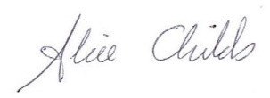
Date: 10 Feb 2023

Summary of Project Proposal (no more than 500 words)
The aim of this project is to develop a training intervention that may potentially assist recruiters to make the interview process easier for neurodiverse candidates.
It will seek to establish whether the recruitment process is proving to be a barrier to neurodiverse applicants being able to interview effectively, either because the thought of the interview process itself is too daunting for individuals to apply in the first case, or if the actual interview format (however unintentionally) hinders neurodiverse applicants, when compared to their neurotypical colleagues, and then will use the collected data to create an artefact that will assist recruiters to facilitate neurodiverse applicants through the interview process .
Neurodiversity can be defined as differences in perception or information processing styles, encompassing conditions including Hypersensitivity, Dyslexia, Asperger Syndrome, Autism and Dyspraxia.
In the academic field for example, AHEAD reported that in the academic year 2019/20, students with disabilities who engaged with support services represented 6.3% of the total student population. Through developments including alternative assessments and Universal Design for Learning, there is concrete action in Further/Higher Education to accommodate different psychological (and physical) styles.
In industry however these kind of systemic supports may not be as robust, and seeking access to employment, (by way of the recruitment process) may potentially be more challenging for neurodiverse individuals compared to their neurotypical colleagues.
Recruitment processes can be complex and pressured experiences, with a range of interview techniques that isolate and assess particular aspects of applicants’ personality, skill, knowledge and attitudes. Behavioural Tests, Stress Interviews, Competency Based Interviews and Assessment Days are just some of the varied situations applicants can encounter.
This project will explore the perspectives of recruiters regarding the structure, reasoning, purpose, methodology and accessibility of their recruitment processes and the experiences of disability support organisations in their role of assisting neurodiverse jobseekers to navigate these situations.
The project has three key objectives:
Firstly, to explore the potential knowledge and/or skills gaps of recruiters in their awareness of neurodiversity (and the potential advantages that neurodiverse talent can bring to an organisation), their rationale for the recruitment systems they use, and their ability to accommodate neurodiverse job applicants within their interview processes.
The second objective is to explore the experiences of key disability support organisations in order to understand the view of the recruitment process from their perspective, outline resources already in place, where these resources are performing well and where they may not, identify other possible barriers and perhaps suggest some actions they believe may aid neurodiverse jobseekers.
Building on the findings of these stages, the ultimate objective is to develop a training intervention/resource that will aid recruiters in accommodating neurodiversity. The nature of this artefact is to be determined, but may take the form of an information session, a sample training module, some form of resource such as a booklet, an away day or some other aid.

Part 2 - The Artefact

Griffith College Dublin
Cover Page
Student name: | Alan Buckley
Student number: | 2945771
Faculty: | Teaching and Learning
Course: | MAELD |  |  |  | Stage/Year: | 2
Module: | Dissertation
Study Mode: | Full time |  |  |  | Part-time | X
Lecturer Name: | Alice Childs
Dissertation Title: | Towards a Training Intervention To Assist Recruiters to Level The Playing Field In Their Interview Process When Dealing With Neurodiverse Candidates
No. of pages (excluding this page): | 26
Disk included? | Yes |  |  |  | No | X
 | (e.g. number of pieces submitted etc.)
Academic Misconduct:
I understand that I will be subject to the penalties imposed for breaches of academic conduct as defined in the College’s Academic Misconduct Procedure (QA J6).
I agree to allow Griffith College to deposit this dissertation in electronic format in Griffith Online (go.griffith.ie), Griffith College’s open access institutional repository on my behalf.

Signature: Date: 16.07.23
Please note: Learners MUST retain a hard / soft copy of all assignments and must SIGN the Assignment Submission Sheet provided by the lecturer / member of Faculty as proof of submission.

Declaration

I hereby certify that this material, which I now submit for assessment on the programme of study leading to the award of the MA in Training and Education, is my own; based on my personal study and/or research, and that I have acknowledged all material and sources used in its preparation. I also certify that I have not copied in part or whole or otherwise plagiarised the work of anyone else, including other learners.

Signed:

Dated: 16.07.2023

Theme, Scheduling and Structure of the Artefact (Lesson Plan)

The outcome of the Dissertation Report was the need for a training day aimed at Human Resource professionals, to heighten awareness of the availability of neurodiverse talent and motivate them to review and reconfigure their recruitment processes to accommodate such applicants.

This Artefact is the lesson plan for that training day.

Once the need for such a training intervention had been identified, following Primary and Secondary research, the theme, scheduling and structure of the training day were the next items to be addressed.

The theme of the training day would follow the Adult Learning theories of Knowles, Rogers and Kolb (Bouchrika, Imed, Phd, 2021),(Culatta and Pm, 2020),(Kurt, 2020), resulting in a series of Enquiry Based Learning / Problem Based Learning exercises (Barrett, T. and Cashman, D., 2010) that would bring learners along a journey of insight and self-discovery.

The scheduling of the training day would follow a Scaffolded Learning approach (UCC, 2023), reflecting Vygotsky’s Zone of Proximal Development (Instructionaldesign.org, 2023) (Tusting, K. and Barton, D., 2003) where each activity builds on the learning outcomes of the previous one, to bring the learners along a pathway of escalating knowledge and learning, creating deeper self-directed understanding, peer learning and resulting in a greater chance of embedding attitudinal change.

The structure of the training day was based on the recommendations of the Learning Designers interviewed in the Primary Research phase. Participant P2 for example, recommended:
I suppose, again, it's just something I picked up from my own kind of experience. But for me, 3 is a magic number, so I would tend to break the day into quarters. So, you have, kind of, 2 blocks in the morning, and 2 in the afternoon, but that you would cover 3, I suppose ‘teaching blocks’, and then have the final block as, you know, bringing it all together, and it's creating a space for people to look at their next steps

Further recommendations included:
P2:
I'm thinking of a one day programme. The likelihood is you learn a new skill and what it's about, arming that learner with the tools to go back to the workplace, and maybe have those conversations with their manager
P1:
I don't think people look at the reflective practice as difficult. It gets you thinking. Most people don't think on a daily basis and it's tiring. So even 5 min of reflective practice. You're saying 4 separate junctures over a full day
P2:
I've actually found sometimes an hour can be just maybe a little bit too long. So maybe between 30 and 45 min. It's usually probably enough on time

Consequently, the 4 main blocks (as P2 recommended), are layered to activate schema, take account of cognitive load, (Gillis, P., 2020), (Medical College Wisconsin, 2022), avoid potentially embarrassing realisations/insights (as P1 recommended ) and achieve the following aims:
- Establish Trust within the group to facilitate the sharing of experiences and knowledge later on (Barrett, T. and Cashman, D., 2010)
- Icebreaker to get participants familiar with each other and see themselves less as an individual and more of a team, as suggested by Tuckman (Stein, J.), (Mind Tools, 2022)
- Introduce Neurodiversity (based on Pre Reading) to ensure participants clearly understand what it really is, (a teaching strategy used by Peter Gillis in the Psychology of Teaching and Learning module prior to its commencement in 2020).
- Present a written Case Study and then an audio interview of a Neurodiverse individual using multiple means of presentation to account for different learning styles (Childs, A, 2017) to present the human face of the topic, and to establish the ‘human cost’ of the current imbalanced job recruitment processes, as suggested by Participant P8 during the Primary Interviews
- In advance of the learners reviewing their own job recruitment processes, they will first practice on a sample job vacancy, to get them used to applying their newfound appreciation of neurodiversity and employing critical thinking and diagnostic skills. By first getting the learners to do this, it may help avoid some of the potential awkwardness and embarrassment from insights gleaned when reviewing their own processes (as flagged by Learning Designer P1) by seeing they are by no means unique in possessing ‘discriminatory’ recruitment processes.
- Using the experience learned from the previous activity, the learners then review their own process to identify where the barriers, challenges and impediments exist for the neurodiverse job applicants. There may be barriers in their process that may have been present in the previous exercise, which may make the process less emotionally fraught than it otherwise could be.
- Lastly, following suggestions from Participant P2 from the Primary Interviews, to take advantage of the power of reflection to share the knowledge of the day and share best practice, offer mutual support and return to their roles determined to effect change.
Note: Sidebar Comments have deliberately been included in the Lesson Plan to explain the rationale for the various activities, based on Pedagogy, industry best practice and Learning Designers’ recommendations.

Lesson Plan Template Used

The layout/structure of the lesson plan has been adapted from the template used by Cambridge University for their CELTA English Language Teaching Course, which the researcher was a student on, in University College Cork, in 2019.

The purpose of the CELTA lesson plan is to include sufficient clarity, structure and detail that if the tutor was unable to take the lesson at short notice, a substitute could fill in for them and would know exactly what was required at each point, from the aim of the stage, their timings and duration, to the resources required and what the tutor and the students would be doing at each point. Everything is mapped out clearly.

There is some CELTA terminology that has been kept as it is a useful tool when it comes to labelling the Teacher/Student interaction:

T = Teacher
S = Student (singular)
Ss = Groups of students (including pairs, multiple numbers, etc.)
Sss = Whole Class
So for example if an activity involved the tutor lecturing to the whole class (who are note taking and listening for example), the terminology would read: T-Sss

Recruiters Neurodiversity Awareness Training Day - Lesson Plan

Lesson No. | Teacher | Date | No. of students | Duration | Level
1 of .. | Alan Buckley | 16th July 20XX | 15 | Full Day | HR Managers or Above

Lesson Focus: | Attitude Change regarding the recruitment process and its suitability for Neurodiverse applicants.
Main aim(s): | - The main aim is to create a “lightbulb” moment for recruiters and for them to leave the session determined to make their interview processes easier for neurodiverse applicants
Secondary aim(s): | - Highlight the notion of “Privilege”  - Open recruiters’ eyes’ to the everyday challenges faced by neurodiverse applicants- they are “living in a world that’s not made for me”  - Establish clearly that disability does not mean taking a “lesser” candidate; neurodiverse applicants often excel at many day-to-day activities  - Review their recruitment systems: “How accessible is my interview process for this person?”
Learning outcome(s): | By the end of the day the learners will:  - Become aware of Neurodiversity and the different ways it can manifest.  - Have their eyes opened to the everyday challenges that the world as it has been created forces upon neurodiverse applicants. That they are “Living in a world that’s not made for me”  - Have been introduced to the notion of “Privilege”  - Realise that that Disability does not mean taking a “lesser” candidate; neurodiverse applicants often excel at many day to day activities  - Look at their recruitment systems with fresh eyes and to ask themselves truly: “How accessible is my interview process for this person?”
Personal aims:  These might be: building rapport, getting to know learners’ names, being more confident etc.  For subsequent sessions personal aims can largely rely on action points from previous sessions feedback. | - To assess the viability of the Training Day as something that is effective in its aim  - That the session is something that learners engage with and enjoy  - To establish precisely whether the one day format is the most effective when working through an EBL/PBL methodology.  - To continue to improve my eliciting of answers from the class and not “lecture” or provide the answers.  - Be aware of individuals’ level of comfort/discomfort with insights that may emerge during the session. “Lightbulb” moments can sometimes be uncomfortable experiences.  - To assess the chosen techniques and their effectiveness, i.e.: the case studies, etc. That the employed materials, resources, technical aids enhanced the exercises.  - Use CCQ and ICQ questions appropriately, to effectively elicit and check understanding
Pre Reading | Pre reading will be issued one week in advance of the training day (to allow sufficient time to prepare but not too far in advance where it may be forgotten) and will consist of links to key Neurodiverse Support Organisations to familiarise learners with the key terms of the neurodiverse landscape:  The pre reading will form part of Activity 1 on the training day. 5 areas of neurodiversity will be divided across the 15 participants (in groups of 3, selected at random), with each group being directed to one neurodiverse type only.  Group A – Autism  https://asiam.ie/ & https://www.asdireland.ie/  Group B – Dyspraxia  https://www.dyspraxia.ie/  Group C – Dyslexia  https://dyslexia.ie/  Group D – ADHD  https://adhdireland.ie/  Group E – Aspergers Syndrome  https://cluas.ie/ & https://familydoctor.org/condition/aspergers
Supplementary materials: | Whiteboard, Audio CD/USB, PowerPoint, Flip Charts, Post-It Notes, Printed Case Study of Neurodiverse Applicant, Printed copies of each Participants Recruitment Process, Worksheets for Activities 2.2 and 2.3.
Assumptions: | The Learners have the self-critical/self-reflection abilities necessary for the training day and they are all willing participants.  They also have the authority to effect change in their workplaces or can begin the process.
Anticipated Problem | Solution
You can consider classroom management issues such as seating, instructions, use of technology, as well as issues with the learners’ cultural knowledge etc.
Please state why you anticipate the problem.
Trust: Both of the Learning Designers and the UCD guideline on EBL/PBL emphasised the importance of trust building at the beginning of the session, in order to encourage disclosure and engagement. Without this, the emotional connectivity and subsequent peer learning, reflection and corrective work may be more difficult to achieve. | In the pre reading communications, emphasise the importance of creating a trusting environment, one of shared discovery.  In the opening activity on the Training Day itself, a Paired Introduction activity may be helpful in encouraging the participants to get to know each other, as opposed to a general Introduction exercise.  Also throughout the session, reinforce the importance of trust and monitor for blockages and necessary intervention to overcome reluctance (for example sharing ones own history with this topic and ones own failures to embrace it)
Commercial Confidentiality: This lesson contains exercises that will encourage participant’s to explain in some detail the mechanics of their recruitment systems. This is commercially sensitive information and is a potential barrier to openness | Several approaches to this issue.  - Request participants sign a form of non disclosure agreement in advance of the session  - Additionally in advance of the session ask participants if there are any potentially commercially sensitive areas when it comes to recruitment methodologies they wish to avoid discussing  - During the session steer the discussion and conversation in such a way as to avoid anything potentially commercially sensitive
Embarrassment/Shame/Emotional Reaction: Autism can be an emotive topic, one that people may be embarrassed speaking about, or could potentially feel a certain regret following exposure to the case studies/testimonies that will be presented during the training day | Provide reassurance that the reason the training session is being delivered in the first place is because this is common across the board and the majority of people just needed a time out to focus on this topic.  Additionally keep alert for any potentially deep upset etc.
Timing: Learning Designer P2 suggests sessions not exceeding 45 minutes, feeling an hour may be too long | The exercises may demand more time than this especially the EBL/PBL aspects of the day. Breaking larger sessions up into smaller segments with breaks will allow for this.

Time  Mins. | Stage  Label | Procedure |  | Interaction | Aim(s) of Stage (how do these relate to your overall aims and help to achieve them?)  The aim here is to: …....
Time  Mins. | Stage  Label | What Tutor Does | What The Students Do | Interaction
9:00am – 9:05 | Welcome and Lead In  5 Minutes | Tutor presents the topic of the days training, which is to explore Neurodiversity and its relationship with the standard job application process.  It will take place using group work, paired work, individual reflection and case study analysis.  Establish Housekeeping and teamworking rules, and especially the notion of Trust- this is a confidential, safe space where what is discussed is not shared outside the room. | Sss listen and respond with their observations | T-Sss  Sss - T | To prepare the students for the day ahead.  Create the housekeeping and ground rules, and to establish the importance of trust.  Much of the day involves disclosure which will require non-judgemental attitudes and confidentiality.
9:05 – 9:10 | Aims and Objectives  5 Minutes | Aims and Objectives will be outlined | Sss listen and respond with their observations | T-Sss  Sss - T | To ensure the students know clearly what they will be able to know/do and the days end.
9:10 – 9:45 | Introductions  35 Minutes | Begin with a Paired Introduction exercise.  Often when groups are asked to introduce themselves, participants can be shy, giving brief answers in the hope that focus will move to someone else.  With Paired Introductions, each person questions their partner, learns about them (including one odd fact) and subsequently introduces the partner to the room, thus generating better  engagement and conversation. | Sss interview each other, make notes and then at the end of the exercise, present their partner to the room, including one random/interesting fact. | T-Sss  Sss - T  S-S  S-Sss | To break the ice, get to know each other, begin the process of collaboration and contribution to group dynamics.
9:45 – 9:50 | Activity 1  Introducing Neurodiversity  5 Minutes | Tutor introduces the activity and sets the ground rules of the exercise.  Prior to the course each learner received some pre reading on a particular category of neurodiversity.  In groups of 3 the learners will consult with each other, noting key features of the shared Neurodiverse condition they read and their own reflections, experiences and views on it. (30 minutes).  Each group will then present their findings to the whole class. (30 minutes). | Sss listen and respond with their observations  Question tutor on any point of clarification  Sss confirm they understand the nature of the exercise | T – Sss  Sss - T | Establish ground rules and get learners comfortable with the exercise.
9:50 | Stage 1.1 | Assign groups and direct them into different parts of the room, which has notepaper, Post-It notes and Flip Charts.  Group A – Autism  Group B – Dyspraxia  Group C – Dyslexia  Group D – ADHD  Group E – Aspergers Syndrome | Sss break into each group to begin consultation with each other on what they learned about their particular Neurodiverse condition. | T-Sss  Sss - T  Ss | Get learners actively working as soon as possible and engaging with each other.  Engage reflective thinking  Engage Peer to Peer learning.  Activate schema
9:50 – 10:20 | Stage 1.1  30 Minutes | Tutor roves and monitors, observing the groups, checking for understanding and comprehension. Probes and guide where necessary.  Checks for difficulties and blockages in group dynamics. | Ss work together, consulting on their readings of their topic and notes their findings on the flip chart, constructing their presentation as they go. | Ss | Engage peer learning and groupwork skills
10:20 – 10:30 | Comfort Break  10 Minutes
10:30 – 11:00 | Stage 1.2  30 Minutes | Tutor invites Groups in turn to present to the class the essentials about their particular Neurodiverse condition.  5 minutes maximum each group.  Tutor monitors timekeeping, perhaps uses strategic questioning to reinforce learning or encourage elaboration  Observes class for comprehension | In their groups, each team presents their topic to the class.  Class notes key features of the various other neurodiverse conditions presented.  Ask questions where necessary. | T - Sss  Ss - Sss | Open learners awareness to the range of Neurodiverse conditions, the specifics of each one and encourage presentation and engagement skills.  Build knowledge foundation in advance of Activity 2 by Peer Learning.
11:00 – 11:15 | Stage 1.3  15 Minutes | Tutor summarises the key points made by each group about the various Neurodiverse conditions. Adds to these with any relevant information from the tutor materials filling in any blanks.  Invites questioning | Sss listen and respond with their observations and/or questions | T – Sss  Sss - T | To wrap up the stage with the class more familiar with the different strands of neurodiversity and have laid the groundwork for Activity 2
11:15 – 11:30 | Coffee Break  15 Minutes
11:30 – 11:40 | Reflection and Journaling  10 Minutes | Tutor invites learners to reflect on the previous activity in their Reflective Journals, note key insights, points of note etc. How they felt and any new learnings etc. | Sss reflect in their Journals | T-Sss  S | Engage reflective learning, make sense of their thoughts and feelings following the previous activity
11:40 – 11:45 | Activity 2  Neurodiversity and the Job Recruitment Process  5 Minutes | Tutor introduces the activity, setting the ground rules of the exercise and checks for understanding  The class will be presented with a real life Case Study Testimonial of a Neurodiverse person which will explain from a personal perspective the key features of their Neurodiverse condition, and how it affects their life and employment prospects. The reading will take 10minutes. | Sss listen and respond with their observations  Question tutor on any point of clarification  Sss confirm they understand the nature of the exercise | T – Sss  Sss - T | Establish ground rules and get learners comfortable with the new exercise.
11:45 – 11:55 | Stage 2.1  Case Study Reading  10 Minutes | Tutor roves and monitors, observing the individual learners, checking for understanding and comprehension. Probes and guides where necessary. | Sss read the case study and make any relevant notes | T  S | To put a human form to the neurodiverse concepts that learners built up in Activity 1 and continue the scaffolding process to build towards Activity 3 later on.
11:55 – 12:15pm | Stage 2.2  Audio Interview  20 Minutes | Tutor plays an audio interview of a real neurodiverse person, where they go into depth explaining how they feel living in a world “that is not designed for them”, explaining their feelings of frustration, anxiety, depression, helplessness and hopelessness etc. when confronted with the world as it is and the job recruitment process.  Tutor will distribute a prepared worksheet to accompany the interview with key triggering questions such as “how is this person’s experience making you feel?”, “how would you feel in their situation?” etc.  20 minutes in total including replays, pauses to complete the worksheet and a second playing if necessary. | Sss listen to the interview testimonial and complete the worksheet. | T  S | This layering technique is designed to add the human voice to the materials the learners had just read, and establish the idea of their own Privilege.  By explaining in their own words their personal perspective of their Neurodiverse condition, and how it affects their life and employment prospects it is designed to encourage an emotional response in the learners, one of sympathy and realisation of their own position of Privilege.  Additionally the interviewee establishes clearly in their own words that their disability does not mean they are not capable of working effectively, that they have key skills they bring to the workplace
12:15 – 12:20 | Stage 2.3  Job Vacancy Matching  5 Minutes | Tutor introduces the activity and sets the ground rules of the exercise.  The class will be broken into three groups of 5, with the groups containing one each of the neurodiverse conditions from the pre-read, specifically Autism, Asperger’s, Dyslexia, Dyspraxia and ADHD.  The class will be presented with a Civil Service Job Vacancy, along with details about the Recruitment Process from the Application Process through to the Screening and Interview stages.  In their groups the learners will work together using their flip charts, to outline in their professional views, how the neurodiverse candidate they have just read about and listened to would manage this process, noting positives, strengths, challenges both personal and professional (25 minutes).  Learners will then present their completed work to the class. (21 minutes maximum). | Sss listen and respond with their observations  Question tutor on any point of clarification  Sss confirm they understand the nature of the exercise | T- Sss  Sss - T | Establish ground rules and get learners comfortable with the new exercise.  This exercise is key to the following activity, Activity 3.  By practicing on a real Job Vacancy, the learners apply critical thinking and diagnostic skills, on a recruitment methodology that is not as potentially emotionally sensitive as their own organisations, therefore laying the groundwork for the next Activity when they will then review their own processes, thereby making the organisational change process less painful.
12:20 – 12:45 | Stage 2.3.1  25 Minutes | Tutor roves and monitors, observing the individual learners, checking for understanding and comprehension. Probes and guides where necessary. | Sss break into each group and work through the exercise using flip charts | Ss  T | To scrutinise the job Recruitment Process by highlighting the inbuilt obstacles and challenges that would be experienced by anybody who is not neurotypical.  To look at the process and plot, at each stage, where someone who was neurodiverse might struggle (or alternatively might do well).  Open learners awareness of the challenges of the one size fits all recruitment model and reduce potential awkwardness or guilt about their own process, which will occur in the next activity.  Engage Peer Learning and engage critical analysis and reflection.  Apply the insights of the various Neurodiverse conditions to the Recruitment Process.
12:45 – 1:06 | Stage 2.3.2  21 Minutes | Tutor invites Groups in turn to present their completed work and any other materials to the class, 7 minutes maximum each, 21 minutes in total.  Tutor monitors timekeeping perhaps uses strategic questioning to reinforce learning or encourage elaboration  Observes class for comprehension | In their groups, each team presents their findings to the class.  Class notes key features of the various neurodiverse conditions.  Ask questions where necessary. | T - Sss  Ss - Ssss | Open learners awareness of the challenges of the one size fits all recruitment model.  Engage Peer Learning and engage critical analysis and reflection.
1:06 – 1:15 | Stage 2.4  9 Minutes | Tutor summarises the key points made by each group about the Recruitment Process. Adds to these with any relevant information from the tutor materials, filling in any blanks, perhaps referencing relevant Legislation, Regulations etc.  Invites questioning | Sss listen and respond with their observations and/or questions | T – Sss  Sss - T | To wrap up the stage with the class and have laid the groundwork for Activity 3  Ensures no gaps in knowledge or understanding.
1:15 – 2:00 | Lunch Break  45 Minutes
2:00 – 2:10 | Reflection and Journaling  10 Minutes | Tutor invites learners to reflect on the previous activity in their Reflective Journals, note key insights, points of note etc. How they felt and any new learnings etc. | Sss reflect in their Journals | T-Sss  S | Engage Reflective Learning, make sense of their thoughts and feelings following the previous activity, build on previous reflections.
2:10 – 2:15 | Activity 3  Review of Own Recruitment Process  5 Minutes | Tutor introduces the activity, sets the ground rules of the exercise and checks for understanding.  Think-Pair-Share Exercise.  Firstly building on the previous exercise, individually the learners will now scrutinise their own Recruitment Process (copies of which they will have been asked to bring to the session) and assess their process with Neurodiverse candidates in mind.  Look for Gaps, Challenges, Obstacles, Legislative or Regulators factors etc.  Exercise will last 30 minutes.  After this the learners will then consult with a partner and in pairs compare their processes and will share insights and identify any oversights. This will last 30 minutes.  Finally there will be a whole group session where the insights of the class are mapped on the wall. | Sss listen and respond with their observations  Question tutor on any point of clarification  Sss confirm they understand the nature of the exercise | T – Sss  Sss – T | Establish ground rules and get learners comfortable with the new exercise.
2:15 – 2:45 | Stage 3.1  30 Minutes | Tutor roves and monitors, observing the individual learners, checking for understanding and comprehension. Probes and guide where necessary.  Checks for difficulties and blockages in self-assessment of the process. | S work individually, consulting their Recruitment Process as mapped out prior to the course and notes of their learning so far during the training day.  Think: “do I need this step/procedure?”  If “no”, can it be discarded?  If “yes” can it be adapted for neurodiverse candidates? | S  T | Engage prior learning and diagnostic/investigative skills
2:45 – 3:15 | Stage 3.2  30 Minutes | Learners are invited to consult with a partner and in pairs compare their processes and share insights and identify any oversights.  Tutor roves and monitors, observing the pairs, checking for understanding and comprehension. Probes and guide where necessary.  Checks for difficulties and blockages in self-assessment of the process.  This will last 30 minutes. | Sss listen and respond with their observations  Work in pairs on the exercise | T – Sss  Sss – T  S-S | Establish ground rules and get learners comfortable with the new exercise.  Engage Reflective Insights and findings, use their partners perspectives and observations of the recruitment process to build on insights gleaned in the previous exercise.  Justify/Defend the methodology where appropriate and facilitate peer learning and peer feedback.
3:15 – 3:25 | Comfort Break  10 Minutes
3:25 – 3:55 | Stage 3.3  Open Class Feedback  30 Minutes | Tutor divides whiteboard up into 5 sections reflecting the stages of the Recruitment Process – Advertisement, Application Process, Screening, Interview Format, Actual Interview.  As class provide insights on their processes the tutor records them per Stage.  Tutor uses checking questions to establish understanding, probes and guides conversation where necessary.  Tutor plays the part of the conductor, directing, controlling and channelling feedback and capturing all data. | Sss listen and respond with their observations | T – Sss  Sss – T | Capture the insights, pointers, methodologies, tips etc. of the exercise.  Ensures no gaps in knowledge or understanding.  Key stage in the day: Ensure learners return to their place of employment with a sense of what needs to change and the desire to do so.
3:55 – 4:05 | Stage 3.4  10 Minutes | Tutor summarises the key points made by each pair and the class as a whole about their Recruitment Process.  Adds to these with any relevant information from the tutor materials, filling in any blanks, perhaps referencing relevant Legislation, Regulations etc.  Invites questioning | Sss listen and respond with their observations and/or questions | T – Sss  Sss - T | To wrap up the stage with the class and have laid the groundwork for Activity 4  Ensures no gaps in knowledge or understanding.
4:05 – 4:15 | Comfort Break  10 Minutes
4:15 – 4:25 | Reflection and Journaling  10 Minutes | Tutor invites learners to reflect on the previous activity in their Reflective Journals, note key insights, points of note etc. How they felt and any new learnings etc. | Sss reflect in their Journals | T-Sss  S | Engage Reflective Learning, make sense of their thoughts and feelings following the previous activity, build on previous reflections.
4:25 – 4:45 | Activity 4  Final Reflection and Wrap Up  20 Minutes | Tutor introduces the activity and sets the ground rules of the exercise and checks for understanding  Whole Class Exercise.  Tutor recaps on the work of the day- Activities 1, 2 and 3.  Now invites whole class reflections on the learnings, insights, challenges, feelings of the group covering anything discussed during the day.  Uses structured questioning to entice feedback and engagement.  “What Challenges might you encounter in seeking to change your recruitment processes?”  “What was the most challenging thing for you today?”  “What surprised you?” | Sss listen and respond with their observations  Question tutor on any point of clarification  Sss confirm they understand the nature of the exercise | T – Sss  Sss – T | Establish ground rules and get learners comfortable with the new exercise.  Key aim of this stage is to bring all learning throughout the day to a conclusion, encourage final reflection and sharing of ideas, thoughts etc.  To encourage any lingering doubts or negative feelings (guilt, etc.) to be shared and justified.  Act as a form of decompression and bringing learners back to the outside world.
4:45 – 5:00 | Summary and Close  15 Minutes | Tutor recaps on the opening Aim and Objectives of the day and adds to these with any relevant information from the tutor materials, filling in any blanks, etc.  Invites questioning | Sss listen and respond with their observations and/or questions | T – Sss  Sss - T | To wrap up the day  Ensures no gaps in knowledge or understanding.
5:00 | Day Concludes

References

(Note: The resources for Farrell, Y., Gillis, P. and Childs, A. were downloaded copies of the class notes that were available from the class Moodle Page at the time when the researcher was a student in those modules. Moodle access to these modules has since been removed, so the references provided here refer to the digital copies on the researchers own laptop, and not the Moodle page, hence the lack of a URL address)

Barrett, T. and Cashman, D. (2010) ‘A Practitioner’s Guide to Enquiry and Problem-Based Learning:’ UCD Teaching and Learning. Available at: www.ucd.ie/teaching/resources/innovative teaching/small groups/EPBL Guide.pdf (Accessed: 30 June 2023).

Bouchrika, Imed, Phd (2021) The Andragogy Approach: Knowles’ Adult Learning Theory Principles, Research.com. Available at: https://research.com/education/the-andragogy-approach (Accessed: 14 June 2023).

Boud, D. (2001). Making the move to peer learning. In Boud, D., Cohen, R. & Sampson, J. (Eds.) (2001). Peer Learning in Higher Education: Learning from and with each other. London: Kogan Page (now Routledge), 1-20. Available at https://www.researchgate.net/profile/David-Boud/publication/309967818_Making_the_Move_to_Peer_Learning/links/5995553baca272ec908c44a5/Making-the-Move-to-Peer-Learning.pdf. (Accessed 15.07.23)

Childs, A. (2017), Lecture 4, Pedagogical Practice, ‘Multiple Intelligences/Learning Styles’. Griffith College Dublin (Accessed 10.07.2023)

Culatta, Richard (2023) ‘Experiential Learning (Carl Rogers)’, InstructionalDesign.org. Available at: https://www.instructionaldesign.org/theories/experiential-learning/ (Accessed: 14 June 2023).

Farrell, Y. (2020) Week 3, Strategic Learning and Development, ‘Strategic Influencing Skills’. Griffith College Dublin (Accessed 11.07.2023)

Gillis, P. (2020) Module 4, Psychology of Learning, ‘Memory’. Griffith College Dublin (Accessed 10.07.2023)

Instructionaldesign.org, (2023), Social Development Theory (Lev Vygotsky),Available at http://www.instructionaldesign.org/theories/social-development/. (Accessed 15.07.2023)

Kurt, D.S. (2020) ‘Kolb’s Experiential Learning Theory & Learning Styles’, Educational Technology, 28 December. Available at: https://educationaltechnology.net/kolbs-experiential-learning-theory-learning-styles/ (Accessed: 14 June 2023).

Medical College of Wisconsin (2022), Cognitive Load Theory, Available at https://www.mcw.edu/-/media/MCW/Education/Academic-Affairs/OEI/Faculty-Quick-Guides/Cognitive-Load-Theory.pdf. (Accessed 15.07.2023)

Mind Tools, (2022), Forming Storming Norming And Performing Rebranded Video, Available at https://www.mindtools.com/abyj5fi/forming-storming-norming-and-performing. (Accessed 13.07.23)

Stein, J., Using the Stages of Team Development | MIT Human Resources, Available at https://hr.mit.edu/learning-topics/teams/articles/stages-development. (Accessed 14.07.23)

Tusting, Karin and Barton, David (2003) ‘Models of adult learning: a literature review’. Lancaster University. Available at: https://languageforwork.ecml.at/Portals/48/ICT_REV_LFW/Models-of-adult-learning_2003.pdf (Accessed: 2 April 2023).

UCC, (2023), Short Guide 2: Scaffolding Learning, Available at https://www.ucc.ie/en/cirtl/resources/shortguides/shortguide2scaffoldinglearning/. (Accessed 01.07.2023)

