

EXPLORING THE IMPACT OF FINTECH ON THE FINANCIAL SERVICES DURING THE COVID-19 PANDEMIC IN 2020-2021

Research dissertation presented in partial fulfilment of the requirements for the degree of MSc in Accounting and Finance Management

Griffith College Dublin Dissertation

Supervisor: Mr Michael Bosonnet

Student Name: Mr Fabiano Camilo
Student Number: 2975239

Date:

CANDIDATE DECLARATION

Candidate Name: Mr. Fabiano Camilo

I certify that the dissertation entitled: Exploring the impact of fintech on the financial services during the covid-19 pandemic in 2020-2021.

submitted for the degree of: MSc in Accounting and Finance Management is the result of the my own work and that where reference is made to the work of others, due acknowledgment is given.

Candidate Name: Mr Fabiano Camilo

Candidate signature:

Date:

Supervisor Name: Prof. Michael Bosonnet

Supervisor signature:

Date:

DEDICATION

I would like to dedicate this work to my family, especially to my parents, my mother, Mrs Francisca Oliveira Camilo, who has always been there to support and help me with my studies and my father, Mrs Julio Camilo. Even though they have never had a chance to study in their life. They have sacrificed their own lives to ensure that my brothers and I have an opportunity to study and finish college. My father has played an essential role in my life where I have never seen him spending a penny on himself to ensure the family have the best that he could provide to the family.

I also want to dedicate it to my brothers Mr Juliano Camilo and Mr Daniel Camilo, that anything in life can be possible as long as we believe in ourselves and make sacrifices for a better life.

ACKNOWLEDGEMENTS

Firstly, I would like to thank my partner for his patience, love, and support. I could not get it done without his help, primarily through this COVID-19 Crisis.

Secondly, I would like to thank my supervisor Mr Michael Bosonnet at Griffith College, for all his support and guidance during this dissertation and for being a role model in our community.

I also would like to acknowledge Mr Henry Dominguez for supporting me through my studies and all respondents of this research for their time, support and dedication. Special thanks to Mrs Siofra Almeida, Mr Alan Threadgold and Mrs Helen Cornale, who have dedicated their time to help my dissertation. I also want to thank my colleagues Ms Dalete Sousa, Mr Andre Carvalho and Mr Shirish Merchant for working as a team through this Pandemic crisis.

ABSTRACT

Exploring the impact of fintech on the financial services during the covid-19 pandemic in 2020-2021.

Mr Fabiano Camilo

Purpose: This research study demonstrates the exploration of Fintech services around the world focused on main Ireland and concentrating on the current time of the COVID-19 Pandemic. This research focuses on exploring the impact and changes of Fintech services in the Irish market during the COVID-19 crisis, highlighting the adoptions undertaken by the government and the companies' innovation.

Methodology: The methodology approach used in this research was interpretivism approach by using a qualitative research methodology. The primary data was collected through one-to-one interviews via Zoom call and Teams meeting based on cross-sectional studies that gather the data from different participants at a single point and time. The interviews were focused on experts of Fintech services from various fields and backgrounds, which supports the findings of this dissertation.

Findings: The finding of this research shows the innovation in the Fintech field and the changes that was forced to put in place because of the COVID-19 Pandemic. This research reflects on the revolution that fintech had before COVID 19 and during the Pandemic. The study shows that businesses had to adapt to new Fintech services to survive during the Pandemic.

Research Limitations: The main limitation of this research was time management and time-consuming, where time management is where the interview took place in different times frames based on the time flexibility of the experts, as stated in Chapter 5, the other one was time-consuming interpretation is limited, and the interviewees could understand the question in different away and answering something off-topic.

Keywords: Fintech, Online Banking, Cryptocurrencies, Shares, Payment services, Portfolio Management, Financial Services, Innovation, COVID-19, Pandemic, Crisis.

Table of Contents
CANDIDATE DECLARATION I
DEDICATION II
ACKNOWLEDGEMENTS III
ABSTRACT IV
1 INTRODUCTION 1
1.1 Establishing a territory 1
1.2 Establishing a niche 4
1.3 Occupying the niche 5
2 LITERATURE REVIEW 7
2.1 What is Fintech? 7
2.1.2 Types of Fintech Companies. 7
2.2. THE EVOLUTION OF FINTECH 8
2.2.2 In the early years 9
2.2.3 Present time 9
2.2.4 In the digital age 11
2.2.5 Current development of fintech industry 12
2.2.6 Present time of COVID19 crisis and Fintech 13
2.2.7 Future of Fintech Services in Ireland. 14
2.2.9 Fintech. 15
2.2.9 The Evolution of Financial services with Fintech. 18
2.2.10 Payment Revolution. 20
2.2.11 Lending Revolution. 22
2.4.1 Conclusion. 26
3 RESEARCH METHODOLOGY AND METHODS 27
3.1.1 Research Introduction. 27
3.1.2 Research Question and objective. 28
3.1.3 Proposed Methodology. 28
3.1.4 Research Onion. 28
3.1.5 Research Philosophy. 29
Epistemology 30
Pragmatism 30
Ontology 31
3.1.6 Research Approach. 31
3.1.7 Research Strategy. 32
3.1.8 Research Choice. 33
3.1.9 Time Horizon. 34
3.1.10 Data Collection Method. 35
3.1.11 Conclusion. 36
4 FINDINGS AND DISCUSSION 37
4.2 Questions Interview. 37
4.2.1 How did you get involved in Financial services (Fintech)? 37
4.2.2 What is the impact or changes that Financial Services (Fintech) have in the Cryptocurrencies and payment services? 38
4.2.3 Is Financial services (FinTech) affecting or changing any segments of the banking business model during the Pandemic? 40
4.2.4 What a segment of the Irish market do you think FinTech sees tremendous adoption & growth during the Pandemic? Payment services, Shares, crypto, portfolio management? 41
4.2.5 What do you think about the Irish government approach to adopting a new type of Financial service (Fintech services) in order to help business and the population of Ireland? 42
4.2.6 Do you consider Financial service (FinTech) the new business model for all business types? Why? 43
4.2.7 Would you like to add a piece of extra information in changes on financial services during the pandemic? 44
4.2.8 Key Findings 45
4.2.9 Research conclusion. 49
5 CONCLUSION AND RECOMMENDATION 52
5.1 Introduction 52
5.2 Implications of Findings for the Research. 52
5.3 Contributions and Limitations of the Research. 53
5.1 Contributions of the research. 53
5.2 Limitations of the Research. 53
5.4 Recommendations for Practice. 54
5.5 Recommendations for Future Research. 54
5.6 Final conclusion and Reflections. 55
REFERENCES 56
APPENDICES A
Appendix A – Email to Participants A
Appendix B – Semi-Structed interview Questionnaire B
Appendix C – Semi-Structed interview Questionnaire C
Appendix D – Plain Language Statement for Research Participants D
Appendix E – Informed Consent Form F

LIST OF FIGURES

Figure 1: Top 5 European Investment Activity. (Cbinsights, 2015b). 1
Figure 2: Total Fintech activity in Ireland 2017-2020. (KPMG, 2021). 2
Figure 3: Global Fintech Financing Activity. (Cbinsights, 2015b). 4
Figure 4: Evolution of Financial Services with Fintech (Swamy, 2015). 19
Figure 5: Consumer spending volume in Ireland. (Take-profit.org, 2020.) 20
Figure 6: Stripe’s Payment volume has grown quickly.(CBINSIGHTS, 2020.). 21
Figure 7 : Conceptual Framework (Saunders et al., 2019) 25
Figure 8: The Research Onion (Saunders et al., 2006). 29
Figure 9: Research Purpose and strategy (Saunders et al., 2006) 33
Figure 10: Global Cryptocurrency 2020-2026 (Dataintelo, 2021.) 39
Figure 11: Fintech Business Model 2020 (UppLabs, 2020) 44

LIST OF ACRONYMS

ACRONYMS FULL FORMS
B2B………………………………………….: Business To Business
B2C………………………………………….: Business To Customer
B2G………………………………………….: Business To Government
COVID-19…………………………………...: Corona Virus Disease 19
P2P…………………………………………..: Peer to Peer
F2F…………………………………………..: Friend to Friend
IFSC………………………………………....: International Financial Service Centre
SMS………………………………………….: Small and Medium Enterprise
GDPR………………………………………..: General Data Protection Regulation
PUP………………………………………….: Pandemic Unemployment Payment
EWSS………………………………………..: Employment Wage Subsidiary Scheme

1 INTRODUCTION

1.1 Establishing a territory

This dissertation is going to examine the financial services industry around the world focusing on the main Ireland by analysing the impact on the financial and technology industries in the before and up to the current times.

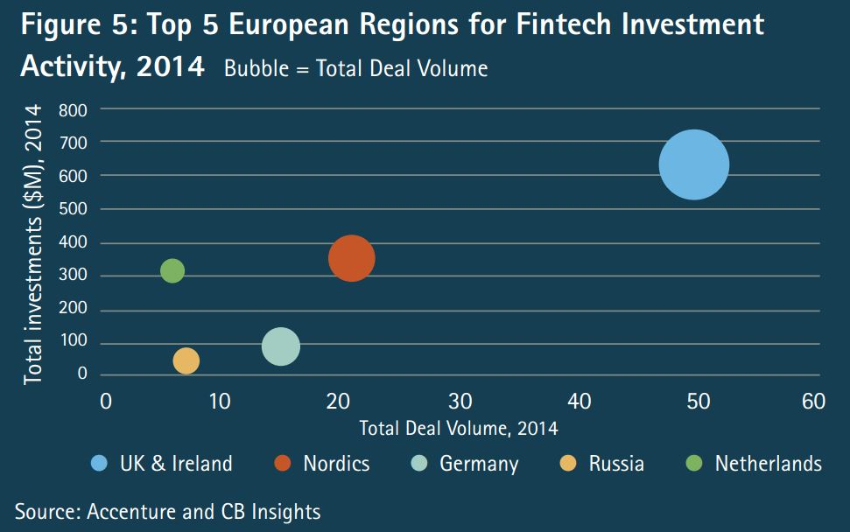

Figure 1: Top 5 European Investment Activity. (Cbinsights, 2015b).

It is well known that Fintech has grown enormously through the years by facilitating the access of the services through the platforms by providing fast, safe and user-friendly access to Business to Business (B2B) and Business to Customers (B2C) services and so on. The effect of Fintech has been studied extensively in recent years based on the evolution and impact on the digital world by securing faster and safer transactions among entities, the digital transformation will keep growing worldwide such as the financial services like a hurricane. The dissertation will demonstrate the brunt of Fintech is having on our financial sector during and through COVID19 outbreak in Ireland.
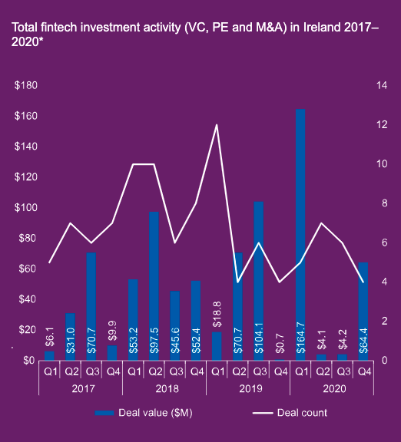

Figure 2: Total Fintech activity in Ireland 2017-2020. (KPMG, 2021).

The Fintech industry has gone through an intensively evaluation since the creation of the financial services up to the 2008 crisis which had destroyed plenty of economies and a few of them are still recovering from the damages caused in 2008. Following the 2008 crisis the industry has changed dramatically through the growth of new type of technologies and innovation. The study of financial services and digital services have become an important aspect of entities financial life as all the transactions are made through online platforms as such as payments, investments and applications.

Fintech is believed to play a significant role in the day-to-day business where the services provide facilities for companies or clients to use the services or vice versa, business which has used the Fintech services for the last few years and has engaged in millions of transactions between people and business on the daily basis. In 2015, Facebook introduced the Free Friend to Friend (F2F) or Person to Person (P2P) payments services through messages where transactions are easily managed from the comfort of their phones (Facebook, 2021).

Truong, (2016) concluded that the growth of digital technology has unquestionably changed the world in the past decades. As digital services are growing daily and gradually changed customer behaviour and c the traditions of doing business. The changes apply to all the industries, especially the financial industry. It has also been deviating to digital services since the establishment of Fintech. Fintech has aided diverse financial services with great customer experience and flattered cost by utilising technology. Even though with new development, this technological sector was founded and it is a stable ground for developing the future for financial services.

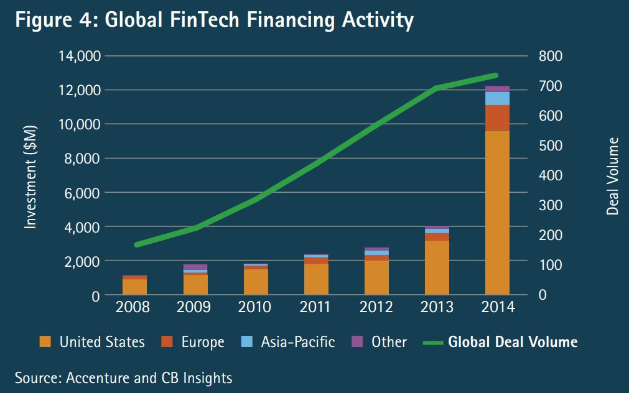

Figure 3: Global Fintech Financing Activity. (Cbinsights, 2015b).

The change of Fintech has so far constructed an interdisciplinary sector that has indeed altered the financial field. This resulted is compelling challenges for the classic banks and payment methods. Nonetheless, it dramatically boosts financial services resilience and adoption. The consecutive competitions have addressed new targets for the improvement of the financial sector (Truong, 2016).

1.2 Establishing a niche

Bittar, (2019) stated that ''in spite of the FinTech entities impact the financial tools, all the participants were confident about FinTech entities since they could make the financial entities alter their way of thinking and make them more open to changes collaborate with the newcomer in the market. Nonetheless the way for cooperation between FinTech companies and insurers is full of drawbacks due to the legacy system of insurers, which makes it more harder to connect the new systems with the old ones, the positiveness raised from their confidence that their history and experience fortified them to be able to remedy with FinTech companies and alleviate any negative impacts'' (Bittar, 2019). However, these studies have failed to recognize the period of time of 2020 and 2021 when the COVID19 outbreak that had contaminated the entire world in a short of period of time. By giving an opportunity to analyse this gap of period of time.

As a result, no comprehensive theory appears to exist through and during the outbreak as it is a recent unpresented event which we will gain the understanding that the impact t Fintech services has had around the world, but specially in Ireland.

‘’ Exploring the impact of Fintech on the Financial services during the COVID-19 Pandemic in 2020-2021’’

The overall aim and objective of this research it to get an in-depth understanding from an industry experts and political overviews as to what impact Fintech has have or will have on the industry in Ireland through and during the outbreak. This qualitative research approach will gain a significant understanding of insights from individuals that uses the services or works on the financial services and the entrants into the Fintech industry, a political overview and an economical perspective. It will also give an opportunity for future researchers to understand how the business, Irish government, and users are accepting the changes of Fintech before, during, and after the outbreak.

These differences need to be analysed in order to gain a better understanding of the impact of Fintech services in the Irish society but gaining knowledge of how companies have adopted the new platforms in order to keep going with the market and what the government has done in order to help the businesses and how users have felt about it.

1.3 Occupying the niche

The aim of this paper is to analyse the gap not yet covered during this unprecedented time of a pandemic where the entire world had to adapt to new ways of working and lifestyle changes in order to get through it, especially in the financial sector where all types of systems had to go online in order to protect the human race. The present research will be conducted online with members of companies, government and clients of the financial sector around the world, focusing on the main Ireland.

This paper evaluates the effect on the Fintech evaluation through and during the COVID 19 outbreak by analysing the customer behaviour through accepting the services provided by business and analysing the acceptance of the new services provided by companies through new types of services by aiming at facilitating the life of the users. The aim is to understand how the business, government and clients are accepting the changes before and during the Covid-19 with adaptations through the market.

In this paper, we argue that the government and businesses had to change the way of doing business by adopting new systems to ensure that the human race is safe at this present time and also how clients have accepted the changes introduced during the outbreak.

This research will start with the revolution of the Fintech sector as the main chapter (Literature Review), it will cover the earlier years of Fintech up to the present time and the whole changes during the life time of the Fintech from the beginning up to the present time. The literature will investigate the crisis of 2008 and the changes that was adopted into the market. The literature review will talk about the evaluation of Financial services and technology globally and also focus on Ireland and where it is in the market nowadays and where it will be in the future.

Following the methodology approach to this paper, this section discusses how the research method was directed by the biographer. By concentrating on the scholastic techniques in use to complete a scientific approach in order to answer the research question approached in this research. The main focus is interviews which will lead to a qualitative approach through the interviews within the industries, clients and so on.

Those interviews will lead to main results of the findings based on the analysis of the interviews, the questions will be designed to approach prominent level of COO’s, Financial Controller’s, investors, such as executives, and clients. Interviews have been confirmed with a few candidates as such Mr Henry Dominguez who is an Executive of United States Postal Service based in Mississippi, United Estates of America, Mr Alan Threadgold who is the COO of Book Assist based in Dublin, Ireland, Mr Barry Horan who is a Financial controller of Grace Healthcare which has a huge experience in Fintech based on the previous jobs, and Ms Helen Cornelius, Financial controller and investor through different fields, but main focus in Fintech services as such Xero platform and others. Mrs Siofra Almeida is an executive trade executor at Northern Trust Ltd, dealing with, daily payments executions.

Those interviews will lead to the most essential element of the chapter which is the “Results” of analyse and findings which will result in the impact of Fintech in the world and the evolution of it through and during the outbreak.

2 LITERATURE REVIEW

2.1 What is Fintech?

Fintech stands out Financial technology, which indicates to entities whose trade financial services are mainly is founded on e-commerce platform to launch goods, services and online financial tools much more accurately, faster and safer. Particularly, the Fintech services are developing type of e-commerce services in the 21st century that some start-up entities are trying to change the shape of the classic transaction into new ones, modern and much more impressive ways by applying high-tech accessories in financial sectors such as mobile payments, e-money transfers, loans, asset management and even fundraising. The entities are active in online banking, online payments and online money transfers, and transaction clearing. Besides, their presence is significant in the industry of different currencies (Grima et al., 2016).

For example, The technology used in financial transactions is network payment technology, networking lending, digital wallets, mobile banking, and cryptocurrency blockchain, aiming to drive much more excellent benefits with huge adaptability for the financial services transactions as well as assist to minimize charges for clients or companies (Walden, 2020). Based on the Walden and Grima which is noted that the world will not survive without Fintech development as the society has a need for the faster and safer services provided by companies as such as bank and brokers.

2.1.2 Types of Fintech Companies.

In 2016, Financial technology entities could be divided into two major groups: competitive Fintech Ventures and Collaborative Fintech Ventures. The article in 2016 stated that Accenture analyse that Competitive Fintech entities would cause natural difficulty and create challenges for financial industry. These entities have accomplished much success by concentrating on supplying new benefits for their clients through technology services instead of focusing on large revenue. For instance, the companies' strategies which is the favoured price displayed by entities focus on supporting, providing and recommending optimal solutions for their clients. Furthermore, the card credit and debit service has also been developed by Square to maximize benefits for micro-merchants (Accenture, 2016.). Brue, (2020) states the importance of the fintech in the market that the collaborative approach which has lending to establish banks relevance and innovation while giving FinTech start-ups decades of trust, customer loyalty, and, ultimately, security for their users (Brue, 2020.).

In different circumstances, Accenture also states the emphasize of the importance of Collaborative Fintech Companies in targeting at financial institutions development. The Collaborative Fintech Ventures deal with the existing financial association as their potential clients. Hence, the way of trying to support, provide and bring new and more feasible improvement in the new future. Additionally, they assist financial institutions perfect their existing enterprise, minimize costs, simplify methods and everyday financial services through modernization and application of high-tech services. (Accenture, 2016.). McGee (2020), states that focus on FinTech, Healthnet and AI Cognitive SaaS Cloud Solutions. Supporting growth ventures that make a difference, Evolution helps clients when they need it most, building the architecture for scale-ups to leverage the benefits they develop and grow (McGee, 2020).

2.2. THE EVOLUTION OF FINTECH

2.2.1 The history of Fintech

The whole word uses modern technology services for their financial activities and management, such as smartphone payment, online banking, wired trading applications, Facebook, Instagram, Revolut payment facilities, and other types of payments through the online platform such as network and cloud. However, most of the users are unaware of when/where it come from or anything more specifically about the goods/ services or history, that are entirely unexplored or listed about Fintech, except for investors or individuals who specialise in the financial industry.

The evidence demonstrates that existence of Fintech has wholly alternated lives and built a significant twisting point in the relationship between human and financial transactions such as online payments, loans applications and lines of credit (Credit card application or check credit score). However, Fintech is not unknown as a new service of innovative technology since it has been here for a long time. persons are just going on to use and enhance the correlate with technology improvement to create modernization and revolutionise the common financial sector (The Economist, 2015.).

2.2.2 In the early years

The invention of the printing press allowed countries to issue paper currency as evidence for the first come out of financial technologies in the world (Harris, 2016.). Yet, in 1860s, persons saw more seemingly the existence of the financial technology services through the new creativity of the Telegraph and the successful formation of the first cable line trans-Atlantic, which was an introduction for the globalisation financial structure. Additionally, in 1918 the Telegraph played an important part and fundamental in the process of the Fedwire payment service facilities because it was used to perform money transfers among the traditional banks. Therefore, the money transfers through the Telegraph was a trendy application for the financial sector during this time, and it continued to grow until the early 1970s (Zerucha, 2016.). The history of Ireland's International Financial Services Centre (IFSC) started in 1987. The time was when the IFSC was created. However, it is the previous dates back early to 1970s that the Central Bank of Ireland is the regulator for the financial sector in the country. The origins of the bank dates back to 1943 when it was first founded (Financedublin, 2015.). All the authors in this paragraph engages on the revolution on fintech which links to my research question.

2.2.3 Present time

After developing the telegraphic message, a few new services were advanced and released on the market to support the financial industry primarily. One of the classic financial products in this period was the credit cards come up with by Diners Club in 1950 (Zimmerman, 2016).

The Credit cards development and success went on leading to other technologies, such cash machine in 1960, which facilitated to clients to withdraw their money directly from the automatic teller machine also known as ATM instead of going to the banks physically. However, at that time, the banks still held a fundamental part of the operating most of the financial transactions among market (Harris, 2016.).

The technology services looked incomplete to provide, assistance and restore all the function of a traditional bank and bringing the best support for the financial services. Thus, the enhancement and the stable growth of modern technology services were essential to creating modernization for the universal financial sector. (Zerucha, 2016.).

The first electronic system called Quoton was developed in 1960 (Zimmerman, 2016), which was built like a broad computer tele, was developed to assist brokers and announce the pricing of the stock market. In 1966, to create a ground and framework for a durable development of financial technology in the future, the Global Telex Network was begun and universally advertised to the public (Buckley, 2017.). After that, the Clearing House Interbank Payment System's appearance which has added an important part of the support the development of payment transactions in the US dollar between banks around the world. In 1970, the first electronic stock trading was settled and put into place. Furthermore, to assist the data storage safely and optimally, mainframe computers were installed in most financial institutions in the 1980s (Zerucha, 2016.).

Despite the fact that the time that the most of the technology applications were extensively required in all banks, financial headquarters, trading centres and offices, technology was still only considered as a useful support tool behind the scene for the financial sectors. The industry that were unaware of the presence of the E- trade until it was announced to the world in 1982. The incredible E-Trade Model which has successfully developed the influence and need of e-technology to the whole financial sector (Zimmerman, 2016). However, the evolution of Fintech was indeed promoted by the growth of the Internet technology in the 90s. By emphasizing the establishment of the Internet which has driven to the arrival of the first online trading broker services to provide the support and implementation of the E-commerce model. Therefore, the banks entities decided to update the trends by implementing and applying the new features to their financial entities. Thus, the bank decided to announce to their clients the new feature called online banking (Zerucha, 2016.).

2.2.4 In the digital age

According to Desai (2015), in 2000 was the year that marked the turning point for the Internet's incredible development. It was because the internet was able to connect and be extensively used in the most countries worldwide. So, it became a valuable support tool for the ongoing development of Fintech. For instance, a lot of Fintech's framework with upgraded functions and high progressive applications have been invented and universally used in many financial fields such as financial management risk, cash management, data analysis systems, and online trading platforms. The impressive development of the Internet has composed an essential for presenting many Fintech entities after a few years later (Desai, 2015.). Harris (2016) states that crowdfunding websites are opening new ways of funding for entrepreneurs, many of whom are launching their unique technologies, thereby creating a constant stream of innovation (Harris, 2016.).

Nonetheless, Fintech has devoted to build a new image for the universal financial industry and provided a lot of developments to solve the issues and obstacles clients regularly face in their financial transactions. The PayPal company was one of the classic illustration of financial technology sector which the companies was cutting edge of creativities and changes in e-commerce and money management through online platforms and payment service. A good example to show the growth of Fintech was the evolution of the e-commerce platform called eBay and Amazon. This website allows the customers to shopping online an extensive variety of goods through different stores on the webpage and rapidly make secure payments online. Apart from that the entities could create their own bargaining markets or host some auctions to sell the goods at better prices. Thus, it was considered an extreme change in financial technology in this digital world.

After that, a faster growth in smartphone technology in the online transactions were revamped and simplified using financial support applications through smartphones. For example, instead of the bank to transfer the money, clients can make payments through online banking application on mobile devices. The technologies help the clients minimise the transactions' costs as the clients can receive money instantly without waiting too long and saving time for the customers. Then, the Machine advisers were created to assist and provide fast information for clients by reducing workforce costs and costs the clients would have to pay for hiring private consultants (Narisetti, 2020.). New financing avenues and fundraising websites were created and universally used with plenty of models to provide online services with more powerful benefits for their clients, such as for online crediting, online lending, online payment and online funding services. As a result, the existence and continuous development of Fintech have caused immense pressure and challenges for traditional banks (Desai, 2015.). Murray (2019) discussed that in recent years, innovative technology has significantly changed banking and the way people bank that customers have become increasingly tech-savvy as their expectations continue to change and grow. As discussed among the authors who are Narisetti, Desai and Murray, the Fintech revolution is the way to the future by highlighting the benefits of Fintech services. By analysing the three authors and publication, it is visible that there is a gap of five years of renovation and all the authors agree to the same content.

2.2.5 Current development of fintech industry

The financial technology has astonished the international financial industry and the traditional bank method since it successively accomplished an impressive growth in the market and captured a lot of outstanding achievements in recent years. The table one demonstrates the totalling worldwide investment in Fintech firms from 2008 to 2014. Based on table one, it demonstrates the evident that was a massive increase in international investment in financial technology entities between 2008 and 2014. By illustrating the investment of over 1.2 Billion in the Fintech companies, and around 160 deals closed in 2008. However, After five years, the amount invested in the financial technology companies grew dramatically to approximately 400 million in 2013, which increased by nearly 300% compared to the amount obtained in 2008 (Deloitte, 2017.).

The United States was the most attractive investment destination in the world. The volume of investments in Fintech entities were approximately 340 million, accounting for over three-quarters of the total financial technology investments worldwide in 2013. Considering that Europe just achieved nearly 400 million, Asia and some other places received only 200 million.

In 2015, The Fintech growth continued to develop and became one of the sectors that has been attracting the most investment in the world. The statistics from Accenture on CB Insight data demonstrates that the worldwide financial technology investment rose 82%, from more than 122 million in 2014 to over 222 million in 2015. The US remained the world's leading position in the number of financial technology investments, with more than a 40% increase in 2015. Besides that, Europe also marked a boom when the amount of money invested in Fintech companies grew by approximately two times between 2014 and 2015, and the deal closed up more than 50%. For the Asia-Pacific region, the amount invested in financial technology firms increased rapidly to over 400 million in 2015, growing nearly four times compared to 2014. The majority of this growth was contributed by China, with more than 1.950 million and India, with almost 1.650 million (Accenture, 2016.).

2.2.6 Present time of COVID19 crisis and Fintech

The virus hit Ireland in early 2020, which quickly spread out through the country, forcing the Irish Government to make faster decisions to keep everybody safe. At present, the virus has created uncertainties and fair to all the type of industries and business except for the Fintech industry, which has delivered financial services to supply the market, developing a new kind of platform to keep up with the market's needs.

Most countries have switched to 100% online transactions to keep the human race well safe and protected from getting infected with the COVID 19 virus, which broke out in China and quickly spread out to the entire world by killing economies, business and people's lives. The governments all over the world have created grants and support to help the business through this pandemic, such as website grants to help the company keep up with sales, which automatically benefits the fintech world. Therefore, more grants are available in the market to help businesses.

On 7 September 2020, KPMG released its latest report related to the Irish fintech industry by focusing on the first half of 2020. KPMG, (2021) discussed that Ireland has seen a record period of activity in the first quarter of 2020 in the fintech industry with 328.6 m recorded in VC, PE and M&A transactions across eight deals. The report noted that sales volume has declined from the same period last year, which saw 14 deals take place. However, the value of the deals recorded so far this year is more than double the total for all of 2019, where 155.6 m was recorded across 26 deals (Earley, 2020).

According to Scally (2021) who is partner and fintech lead at KPMG based in Ireland, big deals had been secured by prepaid financial services. Fintech had been a massive boost to the Fintech industry in Ireland Last year. Anna also said that she expected the interest and investment in the Irish fintech industry would remain hot during 2020, mainly as the UK and global fintech work to ensure they can service their customers across Europe in the wake of Brexit.

Ireland’s attractiveness as a place for global fintech to do business also remains strong, with Mastercard announcing plans to grow its European technology hub on a new campus site in Leopardstown at the beginning of last year (Earley, 2020).

2.2.7 Future of Fintech Services in Ireland.

Ireland’s Minister of the state for financial services, Credit union, and Insurance Sean Fleming TD on 1th February 2021, launched the new Financial action plan for 2021. It contains new measurements to build on the resilience shown by the IFS sector over the last years. The new program is committed to the full potential of the industrial and aids the national economic recovery (Fintech Ireland, 2021.).

New actions:

- Developing a department of finance Fintech group and establishing proposals for increased financial services collaboration in the grand canal innovation district.
- Establishing a new Master programme in Fintech innovation and promoting careers for women in the Financial Services industry as part of the jobless ordinary campaign.
- Establishing a portfolio of sustainable finance education programmes.
- Working with the Department of finance office tasked with encouraging greater competition in the Irish insurance market.
- Promoting the investment Limited partnership vehicle.

Ongoing initiatives:

- Engaging at the EU level on the latest Capital markets union proposal and finance developments.
- Engaging sustainable finance innovation programme supporting the development of new IFS environmental, social and governance products and services.
- Maintaining a regional focus in developing the IFS sector.

As the international Financial services sector in Ireland will play a significant role in global economic recovery and the transitions to a digital and continuous future. The Irish finance is the strategy for developing the international financial services (IFS) sector in Ireland to 2025 and was part of the government programme (Fintech Ireland, 2021.).

2.2.9 Fintech.

Overview.

Freedman (2006) discussed, in his book the introduction to Financial Technology, which he has perceived financial technology for the meaning that the author defines financial technology as being disturbed with developing systems that value, build and process financial goods such as bonds, stocks, contracts, money, payment, transactions and applications (Freedman, 2006).

The author illustrated how financial products include price, time and credit. Freedman analysed how economic systems, which can be viewed as similar to commercial systems, involve applying, buying and selling products in different market at different times through trading system and trading technology such as IG trade, Capital.com and Revolut. Financial involves secure communication to others in a market through common language with quick delivery of information and news, public or private, through a communication system. Trading has several actions: auctioning, negotiating, buying, selling, borrowing, leasing, brokering, dealing and so on. The Fintech can be broken down into a few different areas within the financial sector.

- Asset Management.

Asset management refers to the management of the investment on behalf of the other clients who wants to grow their income for the future. This process has a dual command as such as appreciation of a client’s assets in a short-time or over-time while mitigating risk. The role of an asset manager consists of determining what investments to make or avoid, that will grow a customer’s portfolio (Ang, 2014). A good example of it is the Setenta.ie an Irish company stablished on 90’s in Ireland which has been performing well in the Irish Market since then.

- Cryptocurrency.

The origin of cryptocurrency commenced in 2008, which was invented by Satoshi Nakamoto through an organisation named Bitcoin. The Bitcoin is a payment system which uses peer to peer technology that conducted without any central banks. The Cryptocurrency and Bitcoin are an online currency, and the network issues this. When we investigates at how the Federal Reserve System, where the governments can manipulate currency through printing money. However, it cannot control cryptocurrency as this is decentralised. Banks do not issue the downside of Bitcoin or cryptocurrency, nor is it guaranteed by bank. Reveal a new start-up which is a cryptocurrency similar to Bitcoin (Gimigliano, 2016).

- Investment Management.

Investment management is another vital tendency in Financial technology, which engages into dealings such as buying and selling investments within a portfolio (virtual wallet). By banking, budgeting and taxes can come under Investment Banking. However, it consists of portfolio management. Forbes debates about the Investment management which people invest in different accounts at the same time, the investment management takes the form of mutual funds. Mutual funds are run by money managers who invest these funds to receive capital gains for these investors. Lead investment managers direct these mutual funds towards stocks and bonds that make up the funds (Forbes, 2013.). The administration fees has been reduced and the clients have been reaping the benefits and more honest professional advice. The development of new products within investment management such as crowdsourced ETF’s.

- Payments.

The payment entities have impressive improved from the massive evolution on the financial technology. The entities associated are always investing for new innovative ways to make the process simpler, more accessible and transparent, from transferring an item of value from one party to another. The new FinTech that starts up outshining in this sector is the Irish company Stripe. Stripe is a unique online payment platform allowing which allows sellers or buyer or people who accepts payments online through platform. They have been classified as the new PayPal, which already offers this service. The new innovative firm was set up by two Limerick brothers and is now valued at a staggering 36 Billion. The company has been touted as a firm rival to PayPal (Taylor, 2020.)

- Trading.

This last department of FinTech is within the trading industry again, seeing significant advancements. More open access to Wall Street's stock markets, investment ideas and real estate. For instance, entities such as IG trader and Tradingview offer a connection among clients, investors & traders, it is like Facebook or any other social media platform. The entities supply diverse sources of supplying information on forex, cryptocurrencies, bonds and stocks and markets across the web and social media platforms. The FinTech Exchange is one of the most popular event with FinTex association in Chicago that was created to publish the latest in financial technology for financial markets and trading companies. The event will illustrate the different available for trading software, analytics, market data and cloud computing (Fxstreet, 2020.)

2.2.9 The Evolution of Financial services with Fintech.

Based on the Irish Government's plan for IFS 2020 aims at growing the financial sector in Ireland and create more than 10,000 jobs in the country, which helps the financial sector or FinTech market to be increased. In his article for the Irish Times, Ciaran Hancock states that the level of job creation that FinTech could provide in the Irish market and would benefit the worldwide nation. It is estimated that the IFS 2020 strategy in the Irish market could create half of 10,000 planned new jobs in the financial sector. According to Deloitte, a total of over 5,000 jobs could be made in the FinTech sector over the next five years.

Dalton (2017) states in the article, the financial services industry faces difficulties with the new legacies platforms and I.T planning, which prevents their expansion and capacity from being inventive. Hancock (2020) acknowledge that Mr Dalton states how FinTech start-ups disrupt business models while current financial service firms remain cautious and stagnate. Mr Dalton and Deloitte have this view on FinTech. Our idea is that the FinTech and financial services industries are interrelated and mutually dependent. The connectivity among the sectors need to be significantly enhanced (Hancock, 2015.).

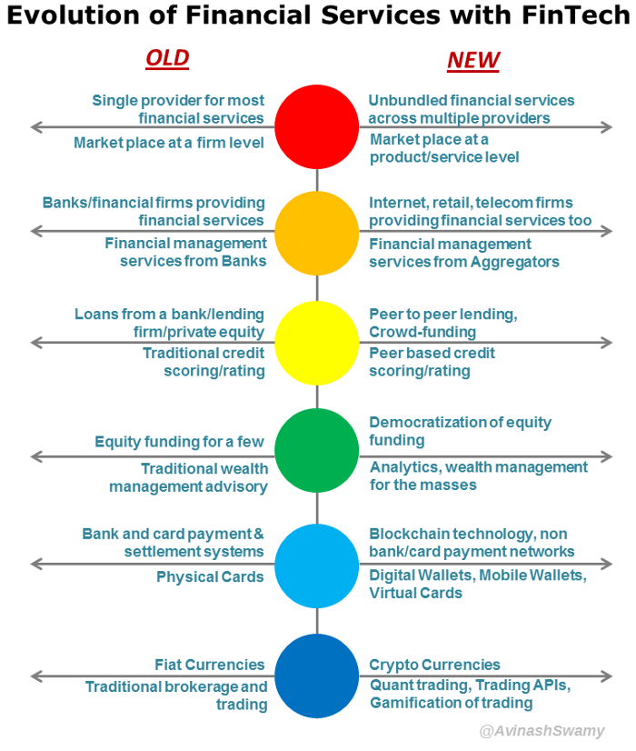
Figure 4: Evolution of Financial Services with Fintech (Swamy, 2015).

The Irish Fintech industry saw record activity in the first six months of 2020, with the amount of 277.9 Million recorded in mergers and acquisitions in eight different deals, according to KPMG. The agreement was announced in November 2019. However, it was renegotiated against the background of the global Covid19 crisis, and it did not finalise until March 2020.

As Anna Scally states in the article that the sizeable deals in Ireland secured by Prepaid Financial services, Payzone and Fenergo have been an enormous boost for the Irish economy and the Fintech sector during the year of 2020 during the COVID-19 crisis, and she also says that expects a high volume of investment in the Irish Fintech industry. Mainly because the UK is leaving Europe at the end of 2020 (Gleeson, 2020.).

2.2.10 Payment Revolution.

Accenture states that FinTech and online banking platform are the future growth in technology between the UK and Ireland, which has risen from 264 million in 2013 to 623 million in 2014, which amounts to an astonishing 42% of Europe's total investment. The majority of this growth came in the FinTech or financial technology sector. Ireland's IFSC and London's Silicon Roundabout area are the main focus for FinTech Innovation. In the payments sector which has showed an staggering evolution in the Irish’s financial sector (Accenture, 2014.).

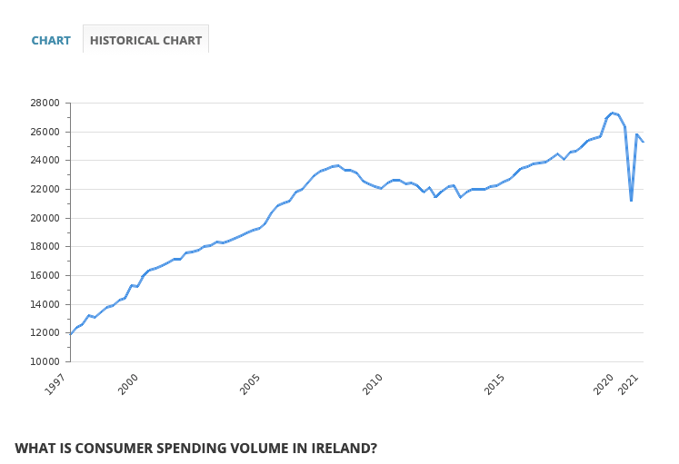
Figure 5: Consumer spending volume in Ireland. (Take-profit.org, 2020.)

Another Irish well-established company in the payments sector is Realex Ltd. which is located in Dublin. The company is one of Europe’s largest and fastest-growing online payment gateways around the world. The company was founded in 2000 and today report processing over €28 Billion in payments of online and mobile businesses worldwide. Realex supplies payment processing services to companies such as Virgin Atlantic, GSK, and Paddy Power. According to their Financial report in 2014 the performing profit of 2.1 million for the year (CNBC.com, 2015).

The Irish Stripe company has grown internationally, created by two limerick brothers. It runs around 600,000 payments transactions per year that result in annual revenue of 9 million, and Stripes runs in more than 100 countries around the world. (IDC, 2018.). Stripe is identified as rival or adversary to PayPal, which provides the same types of services. Stripe has signed a contract with Appel Pay along with Visa, which facilitates the payment transactions between B2C and B2B (Brame, 2018.). Gennaro (2019) states that Stripe and PayPal are two of the most well-known payment solutions that let you collect money online. To collect funds from your site visitors through your website, your business needs a payment provider to collect money.

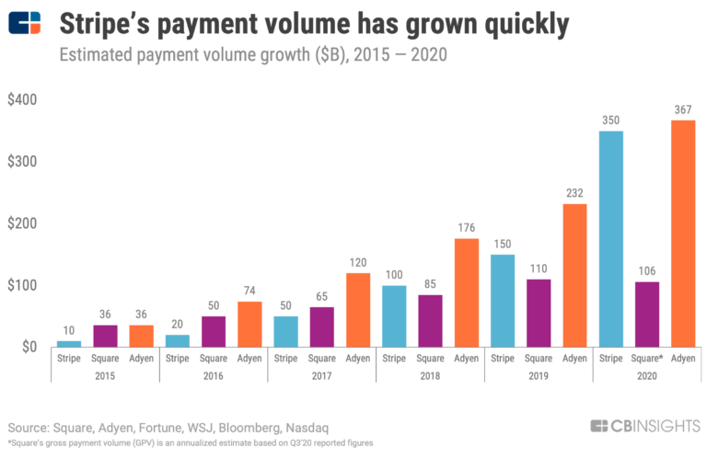

Figure 6: Stripe’s Payment volume has grown quickly.(CBINSIGHTS, 2020.).

2.2.11 Lending Revolution.

With the evolution of the financial services industry through FinTech, the critical areas involved in this change is how lending money to clients and how it is present being controlled. Price Water House Coopers report how powerful forces are changing the financial sector. The report explain how the retail banking industry is promptly revamping around the world. The belief is that the retail banking industry will be seen totally changed due to clients expectations and technology revamps (PWC, 2016.). It is a good point to show here that it is AIB bank where you can apply for a loan and through the application (app), and your loan can be approved as fast as it can be completed your application's loan. It may take a minute or seconds, and it also depends on your credit score credibility.

One of the European bank increased win rates by a third and average margin by over 50 per cent due to slashing it is time to yes on small and medium enterprise (SME) lending money for a period of 20 days to less than ten minutes, far outpacing the competition. On their analysis proves that a bank with a balance sheet of 250 billion could simply earn as much as 230 million in annual profit, by digitising credit proposal and analysing the data, which improves time and quality of the business. By minimising risks, higher satisfaction and faster approval on the leading money and improving the financial performing of the company (Chappell et al., 2018). In this article, the author stat says benefits of the lending revolution to Business to business (B2B) and Business to customers (B2C), which benefits the entity by creating faster-entering data, much quicker way of analysing the data before approving the loan, and it also complies with General Data Protection Regulation (GDPR) regulations in other to maintain the data secure and not to share information. A better way to explain it is by giving an example. AIB Bank provides online loan approval where the AIB clients have to hold an account in the bank for at least six months before applying for a loan. The loan process takes less than two minutes to be filled out with personal information, which the client provides will be analysed with the client's bank statement. The client also has a credit score in the bank based on salary, transactions, etc. There is no need for the clients to go to the bank to get a bank down the street to apply for the loan with a lot of documents.

Financial technology is a crucial opportunity to the Irish market to find out how the industry in Ireland has been changed and grown for the last few years and by analysing other markets to improve the Irish industry as Ireland wants to be the future Financial sector in the world.

2.3 Critical Literature review.

The author has stated that the financial services have seen development since it first appeared back in the 1860s. The history of Ireland's International Financial Services Centre (IFSC) started in 1987 when the IFSC was founded. However, the origins came from far earlier than it. In the 1950s, the Credit card emergence and success led to other technologies, such as ATMs in 1960, which eased people to withdraw their money directly from the cash machine known as ATM instead of going to the physical banks. However, at that time, the banks still held an essential role in performing most of the financial transactions among entities.

Therefore, we can see the evolution of Fintech and financial services at this point and time, where we can see this through mobile phones' growth to smartphones and smart devices that have access to instant broadband in the form of 3G up to 5G leading up to the 6G. Technology is growing at a rate that is not expected. The financial sector has endorsed tremendous change due to technology improvement from online banking, online platforms, online transfer Peer to Peer (P2P). The P2P is a form of direct lending of money to people or entities without an official financial company being part as an intermediary in the deal., etc. It is a new ambiguous term of FinTech, a financial technology has been improving the whole world's financial services sector.

The FinTech Services, as the author stated which comes in several diverse services and groups, from payment entities to payments in point of sale, which is based on intelligence machine and peer to peer payments. Clients on traditional banking is interacting from the way we alliance with their banks from mobile applications and online banking. The lending services are changing from the traditional banks, which can now be offered in the form of peer-to-peer lending and crowdfunding. FinTech is growing quickly and shaping how consumers or businesses run in the financial services industry.

This study will now dig deeper into the financial technology sector, concentrating mainly on the Irish market. The author will investigate a larger scale the overall effect that FinTech is having on our financial services industry. Research into the financial industry themselves to understand how they are dealing with this exciting innovation to the new start-ups in the sector, as already highlighted above.

The investment looks to continue over the next few years in FinTech globally and most certainly in Ireland following the Irish government's recent strategic approach with IFS 2020. The new IFS 2021 plan to build on the IFS's resilience sector over the last years. The new program is committed to the full potential of the industrial and aids the national economic recovery by focusing on developing a department of Finance Fintech group and establishing proposals for increasing financial services, and also to establishing a portfolio of sustainable finance education programmes.

Considering this, researchers will have become interested in forwarder investigation on the Gap not yet cover in relation to the Covid-19 pandemic in the current times, which will attract forward studies on this topic.

2.4 Conceptual Framework.

The conceptual framework is the researcher's idea on how the research problem will have to be explored. From Saunders (2012) research projects, you will be planning to explore your data and develop theories from them that you will subsequently relate to the literature. This is known as an inductive approach. In this case, the author will explore the fintech services on the Irish Market and the changes and impacts that have happened during the COVID 19 Pandemic 2020-2021. The author is using the inductive approach to this paper which the primary data collection will be gathered through an online call. The second stage of the data collection is to analyse the pattern. The next and last is the theory collected after the interviews interview and data analysis.

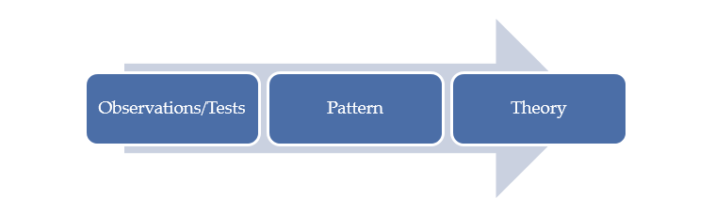
Figure 7 : Conceptual Framework (Saunders et al., 2019)

The first element is observations/test, which is linked to the data collected through the online interview in this case used as a zoom call, The primary data was collected through a semi-instructor interview where the interviewer interacts with the interviewees by asking the question from experts of the Fintech field the data is collected from a point and time for a group of experts. Those questions are Open-ended, and the analysis is Narratives description. The narratives of the interviews will be found in Chapter 4 - Findings and discussion, where it gives a background on the interviews between questions and answers. Saunders (2012) discussed that It is less likely that you will be working completely inductively where you collect your data and then analyse it to see what theory emerges.

The next element is the Pattern, the data analysis and recommendations for further studies or a qualitative approach based on the grounded theory. Grounded theory (Glaser and Strauss, 1967) is often thought of as the best example of the inductive approach, although this conclusion would be too simplistic. It is better to think of it as ‘theory building’ through a combination of induction and deduction (Saunders et al., 2012). The conclusion and recommendations are going to be found in Chapter 5 - Conclusion and Recommendations.

The next and last is this dissertation's theory was an inductive approach. I chose to go to the question to the theory like the bottom -up. Even though I started with an introduction and literature review, I knew I was going to interview experts. The best approach for this paper would be qualitative data. The theory will be found in the Chapter 2 – Literature Review. Saunders (2012) stated that the author may end up with the same theory, but you would have gone about the production of that theory using an inductive approach: theory would follow data rather than vice versa as with deduction. Especially where the author uses an inductive, grounded approach, which are likely to be essentially descriptive, as your analysis develops, the author will create a more hierarchical approach to categorising your data, whereby some category codes or labels will be developed and used to indicate analytical linkages between and interpretation of the data emerging (Blumberg et al., 2011).

2.4.1 Conclusion.

This chapter was essential to contextualise and help readers understand the full importance of Fintech services in the financial services in Ireland and the changes during the COVID-19 Pandemic during the crisis of 2020 and 2020. The next chapter is the Methodology and research design, which will shape up the approach selected to this paper by linking theory to Methodology into findings to finalise the conclusion and recommendations to this paper.

3 RESEARCH METHODOLOGY AND METHODS

3.1.1 Research Introduction.

This study's approach explores the Fintech industry's effect or Financial technology, which has had in the Irish Fintech market. In order to identify the concerns and the evaluation in the sector during the COVID-19, that start-ups companies have and what approach they think it is necessary to respond. The research focuses on Ireland and the Financial services now and how it will be in the future, and the impact after COVID-19. The study is designed to collect the data and analysis methods and the associated dilemmas that exams this nature can encounter.

The author has selected the Research Onion approach for this paper, where the first layer is the Philosophies. The author has chosen interpretivism philosophy for this paper, from Blumberg (2011) states that interpretivism is the social world which is built with meaning from people, the researcher is part of what is observed, and interests drive research. The author is using this approach to explore the market. The next layer is the Approaches which inductive approach is going to be the most suitable for this paper. Saunders (2006) argues that the inductive approach Research approach involves developing a theory due to the observation of empirical data, which will be focusing on collecting primary data through the interviews.

The next layer is the strategy where the author will use the grounded theory qualitative approach with is a non-standardised interview where it will be a one-to-one interview over the phone or zoom call. Saunders (2006) states that the semi-structured and in-depth interviews are non-stan-diarised. These are often referred to as qualitative research interviews. The next layer of the onion is choice, the author will use the mono-method to obtain qualitative data collection, based on the interviews. The next layer is the time horizon which is the Cross-sectional studies which will gather data from different partakes part single point and time. The next and last layer is the Techniques and procedures where the author will use the primary data collection to interpret this qualitative data on this study.

3.1.2 Research Question and objective.

Saunders (2006) states that the research question is a crucial key for the researcher to demonstrate the research question's approach to the readers understanding of the topic process, which should leave the reader in no doubt as to precisely what your research seeks to achieve. Therefore, it is essential to ensure that the objectives are precisely written and will lead to observable outcomes. The question designed for this research will identify and assess the services' changes in the current time (Saunders et al., 2006). Blumberg (2011) engages that the answer the question to provide the desired information needed to make a decision on concerning the research embarrassment (Blumberg, 2011.).

Research Question,

‘’ Exploring the impact of Fintech on the Financial services during the COVID-19 Pandemic in 2020-2021’’

3.1.3 Proposed Methodology.

Saunders (2006) developed a diagram called Research Onion which gives a breakdown of the research method and how it should be conducted. The Research onion is split up into several parts, which will guide the researcher to understand how to approach the grounded theory. The methodology will guide the research to select a suitable strategy and philosophies to gather the data to be analysed.

3.1.4 Research Onion.

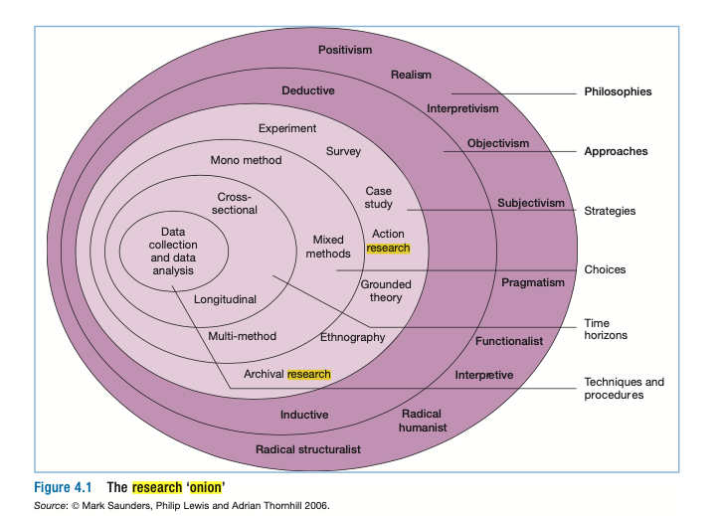
Figure 8: The Research Onion (Saunders et al., 2006).

3.1.5 Research Philosophy.

What is research philosophy?
Research philosophy is an over-arching term relating to the development of knowledge and the nature of that knowledge. The research philosophy believes how the data about a phenomenon should be gathered, analysed and used (Cityu.edu.hk, 2021.).

By exploring the research onion by taking the first layer of the onion, the philosophies approach follows the methodology to conduct the research. Blumberg (2011), discuss how research is conducted embedded in science's broader philosophies. Saunders (2006) state how assumptions are in all the stages of research methods, and the research can be adopted into any beliefs and how views the world. These assumptions will support those research strategy and the methods selected as part of the strategies. The author has selected Interpretivism approach to this paper the other approach may not be suitable for this paper, such as Pragmatism, Objectivism, Subjectivism, and Positivism.

Epistemology

The philosophy of Epistemology is how to gain knowledge and the beliefs to build an understanding of it and how to apply the knowledge gained that is believed acceptable and valid (Wahyuni, 2012). There is also the gaining of knowledge that society and their behaviours require a subjective understatement since subjectivity is inherent within all human (Blumberg et al., 2011). This approach shows where it stands by a level of acknowledgement is acceptable in the field of studies designed, which is split up into three different styles of Epistemology are Interpretivism, and positivism.

- Interpretivism: The interpretivism is the epistemological position that advocates the necessity to understand differences between humans in their role as social actors (Saunders et al., 2006). The main principles of interpretivism are the social world is built with a meaning from people, the researcher is part of what is observed and research is driven by interests (Blumberg et al., 2011). The author intends to use this approach to analyse the impact in the Fintech or Financial services industry is having on the sector during and through the COVID 19 through analysing the market such as investment, government decisions and the need of the services and also analyse the human behaviour the researcher chooses an interpretative approach.

- Positivism: Saunders (2006) argues that positivism is the epistemological position that advocates are working with observable social reality. The emphasis is on highly structured methodology to facilitate replication, and the end product can be law-like generalisations similar to those produced by the physical and natural scientists. The Positivism is much more suitable for a quantitative methods such as social surveys.

Pragmatism

Saunders (2009) argues that the most crucial determinant of pragmatism is adapting to the research question that one may be more appropriate than the other for answering particular questions, which leads to the same achievement. Pragmatism is generally viewed as the most popular paradigm for mixed methods social enquiry (Greene, 2007.). The pragmatism may not be ideal for this paper for the reason that is focused on reaching the goal which may ignore a few factors in order to get the job done.

Ontology

The word ontology originates from the Greek words for thing and rational account (Given, 2018.), from (Saunders, 2009) states the Ontology being highlighted as the nature of reality. It simply defines the value of each individual based on experience, which leads to the acknowledgement of their wishes. The ontology might not be suitable for this paper as refers to thing that exist in the social like a physique bank and assumptions about the form and nature of that social reality.

3.1.6 Research Approach.

The next stage to take on is the research approach that will be used to conduct this paper, the research approach is broken into two parts, the deductive approach and the inductive approach.

- Deductive Approach - The deductive approach Research approach involving the testing of a theoretical prop-position by the employment of a research strategy designed explicitly for it is testing (Saunders et al., 2006). Bryman and Bell, (2007) states that deductive method is the common relationship between research and theory which the letter is conducted with reference to hypotheses and ideas inferred from the former. A deductive research approach is the one that people typically associate with scientific investigation. The author will not use this approach in the paper as the author is focus on qualitative approach not on quantitative.

- Inductive Approach - The inductive approach Research approach involves developing a theory as a result of the observation of empirical data (Saunders et al., 2006). The inductive approach argument is entirely different from a deductive approach type as it does not have the same relationship reasons and conclusion (Blumberg et al., 2011). The author will use this approach to conduct this paper.

The author will use inductive approach which focus on interviews with the names listed above. This approach will provide the research with an excellent opportunity to understand the industry in far more lucrative way and the impact that it has had by analysing qualitative data.

3.1.7 Research Strategy.

The research strategy is the next part of the onion research, the research strategy General plan of how the researcher will go about answering the research questions (Saunders et al., 2006). Blumberg (2011) define research design as the blueprint for fulfilling research objectives and answering the research questions. (Bryman and Bell, (2015) describes the research strategy as a framework for collecting and analysing data and that the choice of the research strategy reflects on the decisions about the priority being given to a range of dimensions of the research process.

The research strategy for the investigation on the impact FinTech during and through COVID-19 is having within the Irish Financial services industry will involve four to six structured interviews leading to the success of this case. Saunders et al., (2006) states that structured interviews use questionnaires based on a predetermined and standardised questions where the interviewer ask the question and the interviewee answer it which may not create an interaction between parts. As a structured interviews are used to collect quantifiable data they are also referred to as quantitative research interviews.
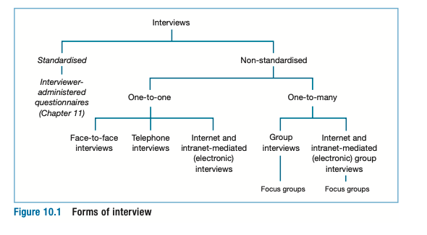
Figure 9: Research Purpose and strategy (Saunders et al., 2006)

The semi-structured and in-depth (unstructured) interviews are non-standardised. These are often referred to as qualitative research interviews (Saunders et al., 2006). In semi-structured interviews the researcher will have a list of themes and questions to be covered, although these may vary from interview to interview. The author will use the grounded theory strategy in this paper which will evaluate the impact Fintech is having during and through COVID 19 in the Irish sector. By collecting the qualitative data to analyse why is the impact of FinTech changing the landscape of the financial services which is explanatory. For this research paper, the qualitative grounded theory research, the author believes in a single data collection technique, in order to gather all the data in an in-depth interview which will use the mono-method to obtain qualitative data collection. Saunders (2012) states that research strategy in which theory is developed from data generated by a series of observations or interviews principally involving an inductive approach.

3.1.8 Research Choice.

The Research Choice is the next part of the research onion, which refers to the methods used for quantitative and qualitative research. Saunders (2006) discuss that one way of differentiating quantitative and qualitative research is to distinguish between numeric data and non-numeric data.

- Qualitative Research - The qualitative research stands for data obtained by the researcher from first-hand observation, interviews, questionnaires, recordings made in natural settings, documents, and artefacts. The data are normally nonnumerical. Qualitative research usually emphasizes words rather than quantification in the collection and analysis of data (Bryman and Bell, 2015). Qualitative interview Collective term for semi-structured and unstructured interviews aimed at generating qualitative data (Saunders et al., 2006).

- Quantitative Research - Quantitative research is a research strategy that focuses on quantifying the collection and analysis of data. It is formed from a deductive approach where the emphasis is placed on the testing of theory, shaped by empiricist and positivist philosophies (Antwi and Hamza, 2015). The quantitative data Numerical data or data that has been quantified (Saunders et al., 2006). Bryman and Bell, (2015) states that quantitative research usually emphasizes quantification in the collection and analysis of data. The author will be focusing on Primary data collection in this paper where it focus on inductive approach.

For this research paper, the qualitative grounded theory research, the author believes in a single data collection technique, in order to gather all the data in an in-depth interview which will use the mono-method to obtain qualitative data collection. The in-depth interview will be semi-structured which will be allowing room for follow up questions where it is suitable with a programme of questions that seek depth of information from respondents. Interviews might be recorded to allow researcher to adequately scrutinise and evaluate the data. Every single interview will play a significant role for knowledge gained to be use as a source in this research.

3.1.9 Time Horizon.

The next stage of the research onion is the time horizon, from Saunders (2006) states that the snapshot time horizon is what we call here cross-sectional, while the diary perspective we call longitudinal. We should emphasise here that these time horizons to research design are independent of which research strategy you are pursuing or your choice of method (Saunders et al., 2006).

- Longitudinal Studies – The longitudinal study is repeated over an extended period, tracking changes in variables overtimes (Blumberg et al., 2011). The main strength of longitudinal research is the capacity that it has to study change and development (Saunders et al., 2006). The author will use this approach as the author focus on a snapshot situation rather than long-term analysis.

- Cross-Sectional Studies - This approach is a type of research where you gather the data from many different participates at a single point in time. In cross-sectional research, you observe variables without influencing them. Saunders (2006) describes that the research will be cross-sectional, the study of a particular phenomenon (or phenomena) at a particular time. Cross-Sectional is the study conducted only once and reveals a snapshot of one point in time (Blumberg et al., 2011). This approach will the most suitable to investigate the impact of fintech during and through COVID 19.

3.1.10 Data Collection Method.

The data collection is the process of obtaining and measuring information on variables of interest, in an established systematic fashion that enables one to answer stated research questions, test hypotheses, and evaluate outcomes. Qualitative is used broadly as a synonym for any data collection technique (such as an interview) or data analysis procedure (such as categorising data) that generates or uses non-numerical data (Saunders et al., 2012).

- Primary Data Collection - The author will take the primary data collection approach as the central part of the research. This research will focus on interviewing four to six experts in the industry's financial services in Ireland and around the world. The primary data technique plays an essential part in interpreting this qualitative data on the grounded theory; the researcher then develops theories relating to the topic.

- Secondary Data Collection - The secondary data refers to data that is collected by someone other than the primary user. Familiar sources of secondary data for social science include censuses, information collected by government departments, organizational records, and data collected for other research purposes. The author will not be using this approach for this paper.

3.1.11 Conclusion.

The author has selected the Research Onion approach for this paper, where the first layer is the Philosophies. The author has chosen interpretivism philosophy for this paper, and the next layer is the Approaches which inductive approach will be the most suitable for this paper. The next layer is the strategy where the author will use the grounded theory qualitative approach with is a non-standardised interview where it will be a one-to-one interview, and the next layer of the onion is choice. The author will use the mono-method to obtain qualitative data collection.

The next layer is the time horizon, and the Cross-sectional studies will gather data from different participants at a single point and time. The next and last layer is the techniques and procedures where the author will use the primary data collection to interpret this qualitative data on this study. The next chapter of this paper is the findings and discussion on this grounded theory being explored based on the data collected through the methodology chose.

4 FINDINGS AND DISCUSSION

In this chapter, the author will collect the data by interviewing the candidates at the same point and time. The primary data collection is focused on the interviewees who are specialised in financial services (Fintech) with a background in financial services in the share market, payments services, cryptocurrencies and portfolio management. Those interviewees have diverse backgrounds and different fields of Fintech. Those interviews will link to the Findings of this dissertation. The findings will be the last part of the chapter highlighting the Key findings 1 and 2 and the links to the littered review.

4.2 Questions Interview.

4.2.1 How did you get involved in Financial services (Fintech)?

The Fintech field is massive and there are different segments in the financial services market. Ms Siofra Almeida (Interview 1) discusses how she got into the financial market at the time, Ms Almeida was in college and started apply for jobs in the financial field and she finally got a position on a hedge fund administration where the primary duty is to protect investor interest and Mr Henry Dominguez (Interview 2) started getting involved in the financial market when he applied his pension saving into the share market after 2008 and in one year the increase in his pension was massive. Therefore, Mr Dominguez decided to learn more about the market and making better decisions in order to grow his income in order to have a better retirement, his investments is worth 4 million at this present time and his position on The United Post Office is involved in the financial field. Mrs Helen Cornale (Interview 3) stated that she started working as an accountant assistant in an entity in Australia with supplied portfolio management to clients from the entire world. Mrs Cornale fell in love with the growth of income in her client's accounts every month, where she decided to invest in the share market and manage another account of her families members. Mr Alan Threadgold (Interview 4) stated that Mr Threadgold came from the Golf Industry into a Tech company which services the Golf and Hospitality Industries. Both businesses, through their platforms, provide payment platforms or access to payment platforms. He is also a CIMA qualified accountant, and I have a good knowledge of portfolio management as he studied it and have some investments. It is clear to see that the participants have gotten involved in the Fintech field by studying accounting, financial or both. It is discussed how they got the jobs in their field of Fintech in Ireland and outside of the country. Those interviewees are classified experts in different segments of Fintech.

4.2.2 What is the impact or changes that Financial Services (Fintech) have in the Cryptocurrencies and payment services?

Ms Siofra Almeida (Interview 1) stated that in her position, she does not deal with Cryptocurrencies payments execution, it is a different department. However, she invests in Bitcoin and another few cryptocurrencies as part of her private investments. Ms Almeida stated that investing in cryptos has become easier than before and any investor can get in the game as long as investor has money, it has been a huge changed since 2019 if you look at PayPal and Revolut both offers variety of crypto payments and crypto investments. The payment services has improved massively TransferWise and Revolut, you can transfer money to different accounts and the money hit the other bank account in less the 30 seconds and also the features that Fintech offers to secure your investments are marvellous, such as facial recognition. From Mr Henry Dominguez (Interview 2) stated that due to the pandemic, there is going to be changes and competition for business growth. Banks has developed online banking payments due to the Pandemic where before my teas issued cheques and post them to our clients outside of The United States, especially with the Irish Business which has changed the way of making payments during the Pandemic. In regards to cryptocurrencies entities has made changes in order to get new investor a good example of it is the crypto.com which offers debit and credit cards and cash back, free Netflix, free Spotify and the payments are made by cryptocurrencies. Mrs Helen Cornale (Interview 3) discussed the payments services changes in Xero accounting software where the entity has adopted new payments services to facilitated the client's life and satisfaction. The most significant changes on the platform are called ‘’go cardless.’’ The client needs to sign a mandate online that takes less than one minutes, and the company collects the payment from their accounts, and the invoice is due to be paid. The Stripe payment platform adopted by Xero is the new revolution where the client receives an invoice by email. It can be paid straightaway by clicking on the invoice and filling in the debit/credit card information. I have my investments in cryptocurrencies in crypto.com, where I get passive income by investing my money on the platform. I make a profit in two diverse ways as the coin grows and passive income. Mr Alan Threadgold (Interview 4) Discussed that Fintech will make both more accessible to the public, who at this stage have become extremely frustrated with the slow bureaucratic nature of the legacy banks. The transfer of funds has always been too slow, and despite some improvements, it is still not quick enough, especially with Ulster bank and Bank of Ireland. The FinTech’s make access more accessible and provide enhanced security without delaying the transfer process. Also, the public can look to get involved in purchasing and trading cryptocurrencies online from their mobile phones without the need to approach financial institutions or designated providers, other institutions provide better and faster payment services as pay by link, direct debtor collection, which has improved the payments services. All the participates have agreed that the payment services have improved lately, and the cryptocurrencies have been facilitated to the new investor to get involved in the market. However, Mr Threadgold stated that a few Irish banks have to improve the services to keep up with the demand. The global Cryptocurrency ATM Market is valued to reach USD 158.2 Million by 2023, growing at 52.4% over the forecast period 2020-2026 (Dataintelo, 2021.).

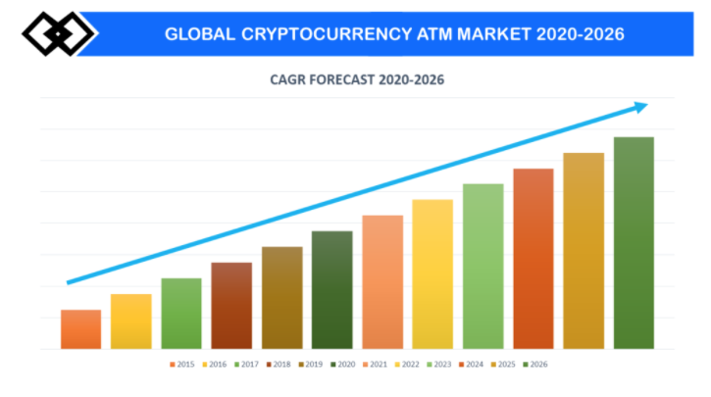
Figure 10: Global Cryptocurrency 2020-2026 (Dataintelo, 2021.)

The picture above shows the growth from 2015 to the started the Pandemic and what they expect the growth in 2026. Growth in market capitalisation resulting in high adoption of cryptocurrencies for all type of payments coupled with increasing adoption of Cryptocurrency ATM in the hospitality industry is the key growth drivers of the market (Dataintelo, 2021.).

4.2.3 Is Financial services (FinTech) affecting or changing any segments of the banking business model during the Pandemic?

Ms Siofra Almeida (Interview 1) stated that she has not seen any bad affecting the business. However, it has had a lot of changes on the banking business model where Revolut is a good example of it, anyone can open a bank account as fast as five minutes and that is because what Fintech has changed in the market, there is no need to go to the bank an book an appointment and wait for 3 weeks to get a bank account settled. Another substantial change in my eyes is the loan application which can be approved in less than one minutes. Mr Henry Dominguez (Interview 2) stated that due the pandemic, there is much more competition and entities has adopted recent changes on the business model as such as online banking, online payments, online shopping. A notable example of online banking is Western Union where I use to send money to my family member in need outside of the states. Now the payment is made online which can be paid by credit/debit card and the person get the payment at the same instant where before the money could take one or two weeks to arrive in the, specifically location. Mrs Helen Cornale (Interview 3) stated that there are many changes going on, such as the Direct debit payment collection application, which was done by going to the bank and now it is done online. The bank sent me a link, and I needed to fill out the form and upload the pdfs as requested, the same for loans and other applications through online banking. I have not seen any harmful effect on the changes that the bank has introduced in their services. It facilitates my life, primarily because I am based in Sidney, and it is extremely complicated to leave here to go to Ireland, where I have 20% of my investments. Mr Alan Threadgold (Interview 4) stated that Fintech is providing new start-up institutions with the opportunity to quickly gain traction in new markets. As the public grow more and more frustrated with the banks there is massive opportunity for these new FinTech’s. The successful growth and expansion of Revolut, N24 and others during the Pandemic is a prime example. People can continue to bank in a fast, efficient and secure way without the need to go to branches and leave themselves potentially exposed to COVID-19. Without the FinTech’s the pandemic would have had even more impact on the world’s populations. The interviewees have gotten to the same point the new start-up institutions and banks have adopted new fintech services in order to provide efficiency to their clients. It is clear that revolution in Banking business model as such as N24, Revolut and Wester Union. O'Connell (2020) noted that while banks have long been encouraging consumers to use digital channels for their banking needs, there was no way to predict how aggressively that trend would accelerate due to Covid-19.

4.2.4 What a segment of the Irish market do you think FinTech sees tremendous adoption & growth during the Pandemic? Payment services, Shares, crypto, portfolio management?

Ms Siofra Almeida (Interview 1) I would say retail payments, through services such as revolution etc., have had colossal adoption. Online shopping has had a considerable increase; online payment services and security have been the ones to benefit here. Hopefully, there will be more growth – buying currencies and storing in advance is a good feature, but many currencies are lacking. Once restrictions globally have eased for international travel, it is another area that they could further develop. You can often see online how using Revolut in GBP saves you money buying online, buying online, and then using services such as address pal – it is opening more of a market and has expanded with it, and still has a lot of room to grow. Mr Henry Dominguez (Interview 2) stated the payments services where the government created grants to business to develop new platforms to help the business grow and provide goods to the people during the pandemic such as takeaways, flower shops, smalls bookstores, and so on. Small local businesses that have to adapt to the new world to survive during the pandemic by developing new systems as such websites with online payment have made the business survive during this crisis. Mrs Helen Cornale (Interview 3) highlighted the payments services as I stated in the question up above with the Xero account software to implement new services in the platform to help the business growing faster. The payments services increase the business's cash flow, making the company healthy and strong to invest in different fields. Mr Alan Threadgold (Interview 4) believe that a lot of people have exposed themselves to Fintech during the pandemic as they had time to learn about and dabble in the likes of shares and crypto. For many including myself this would not have been of interest to me in the past where I would have had to contract with designated companies and pay high fees in order to get involved. Now access is readily available and people can learn from the comfort of their own home. I believe that we will see a greater breath of involvement in these areas as a result of Fintech and the restrictions that have been in place during the pandemic. The payment services for shopping online have a meaningful change by making it easier to buy online. All the participants agreed that the payments services have grown in Ireland in different sectors.

4.2.5 What do you think about the Irish government approach to adopting a new type of Financial service (Fintech services) in order to help business and the population of Ireland?

Ms Siofra Almeida (Interview 1) stated has seen much more changes outside of her work online shopping, payments services, changing currencies. One example of it is that that the Irish government applied the Pandemic Unemployment Payment (PUP payment) as an online payment where people do not need to collect the money in the Post office anymore, The Irish Government also has offered grants to business to adopt new services such as websites, payment services platforms and accounting software and so on. By adopting new financial services model to help the business to grow during the pandemic. Mr Henry Dominguez (Interview 2) discussed that he is amazed with the approach of the Irish Government in order to help business to survive during the Pandemic, The US Government has not helped much the business to survive during this current time which led business to close down. Mrs Helen Cornale (Interview 3) discussed the revenue adaptation about the payroll and the other payments such as Employment Wage Subsidy Scheme (EWSS) and the Pandemic Unemployment Payment with help the business (PUP), where Fintech has played a significant role in facilitating the services to help the company and the population of Ireland, in my investment I was able to claim the EWSS and the grants offered by the government to help my investments keep going. So, I think that the Irish Government approach to help business was incredible and faster-paced. Mr Alan Threadgold (Interview 4) stated that the Irish Government have been too slow in their approach even though it has adopted so many changes and make different approaches. They are too heavily connected through shareholdings with the legacy banks and they face huge challenges now as Ulster Bank and KBC withdraw from the Irish market. I believe they need to position themselves to be more proactive and to be able to enable rapid progress and they need to make it easier for new FinTech’s to set up and service the Irish population. We can use our Island status as an excuse for many challenges that we face however slow adoption of Fintech is not one of them. All participants have stated the Irish Government's approach by offering funds and grants to help businesses get through this crisis. Especially by incentivising business to adopt new financial services to supply the community with goods and services. It also stated the government's payment services to help the community by keeping the community safe.

4.2.6 Do you consider Financial service (FinTech) the new business model for all business types? Why?

Ms Siofra Almeida (Interview 1) fairly short answer here is yes, because it drives efficiency, it cuts out steps and reduces costs (once you evolve past costs generated by moving from legacy processes/systems). Less manual tasks mean that employees can be redistributed within the organization where they can be of more value. Mr Henry Dominguez (Interview 2) stated that no, the business model should be based and incorporated on the needs and services of each individual. The concept can be used but structured to the individual companies model and purpose. Mrs Helen Cornale (Interview 3) I considered yes, for the financial services where all companies should have updated software and services to facilitates the client's life and the business in the future. Mr Alan Threadgold (Interview 4) highlighted that he is the opinion that all businesses must embrace Fintech. The buying public want ease of access and use and security of their data and personal finances. If you want them to trade with you then you need to meet these demands from the outset. We have seen how many businesses have pivoted during the pandemic and could only do so because of the availability of Fintech. Many may never go back to their old way of doing business as they have pivoted so successfully. The participants have stated that business has to adopt new services to the market in order to improve their services. Embracing Fintech services into the company will help business have better data analysis and a faster cash inflow into the firms. These statistics show the Fintech firms affecting the business models of their banks down below.

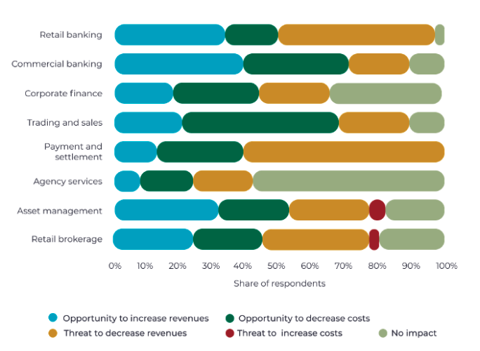
Figure 11: Fintech Business Model 2020 (UppLabs, 2020)

The new Fintech business model services help businesses to grow by minimizing costs, increasing revenue and driving efficiency into the businesses.

4.2.7 Would you like to add a piece of extra information in changes on financial services during the pandemic?

Ms Siofra Almeida (Interview 1) stated that it is really highlighted how out of date some companies were. We still have issues where someone needs original signatures on something, and then we are sending a courier up and down Dublin to get our signatures. We have companies who will not accept email or swift based transactions, and they have to be faxed and realistically, who has a fax machine at home? There are a few outdated processes that everyone just dealt with as a minor inconvenience but is now front and centre. Mr Henry Dominguez (Interview 2) stated because of the pandemic, man customers have used up all of their savings due to either going out of business, losing their jobs or reducing hours. Financial companies need to help investors get back on their feet by supplying low-interest loans and incentives for them to reinvest. All the current uncertainty around when and if this pandemic will end makes people uncomfortable, not just about investing but surviving day by day. Mrs Helen Cornale (Interview 3) stated that all the business has to improve the services to grow as we are in a fast grow generation where services can be considered old after 3 to 6 months if the platform is not up to date with the market. I read an article the other day saying how many businesses have adopted new venues during the pandemic in order to provide goods to their clients. Mr Alan Threadgold (Interview 4) discussed that the government should have provided more support to business in order to grow as the Irish Government investing into business by helping them to adopt new Fintech services into the companies which drive efficiency and safer transactions and data protection and builds a better economy which creates more job opportunity. For instance, The government gave the business 2500 euros to small businesses to adopt websites, Fintech services into the business to help them get by during this time. It reflects on online shopping as you do not need to go to the cheaper to get food you can buy from your home's comfort and use your phone. It also has helped smalls business to survive during this pandemic by adopting payment services into the business. At this point, participants have decided to add some valuable information to this studying in different fields of Fintech where companies have to embrace the fintech services to the business and the government has to invest more in the Irish market to help small to grow.

4.2.8 Key Findings

Key findings 1: The innovation and the transformation of payment services During the COVID-19 Pandemic.

The Findings in this research cover the gap of studies based on the implications of the COVID-19 Pandemic by creating a lot of uncertainties in the market. The author highlights the findings through the qualitative interview collection data where expertise was involved in an interview at a single point and time.

The author stated that the Key for the business to get cash inflow into the company is to have an excellent payment services platform. The Irish government has also created funds to help small and medium business to get through the Pandemic. The author believes that the respondent's answers stated the evolution through payment services during the covid-19 crisis. The companies have worked hard to develop better software to implement new services by ensuring safety, where entities such as banks, brokers, small business offers, and various payments services platforms to obtain money and security by driving efficiency into the business and client's life. The payment services have grown to form the earlier ages, but it had a massive increase of development and embarrassment because of the Pandemic.

Evidence - Link it to the interview:

According to the interviews responses from Questions 4.2.2, 4.2.3 and 4.2.4, clearly heightened the evolutions of payment services in the Financial industry in Ireland. Ms Almeida responded to question 4.2.4 that Online shopping has had a considerable increase; online payment services and security have been the ones to benefit here, Question 4.2.3, has had a lot of changes on the banking business model where Revolut is an excellent example of it, anyone can open a bank account as fast as five minutes, and that is because what Fintech has changed in the market, and also on question 4.2.2, The payment services have improved TransferWise and Revolut massively, you can transfer money to different accounts and the money hit the other bank account in less the 30 seconds and also the features that Fintech offers to secure your investments are marvellous, such as facial recognition and Mr Threadgold response to question 4.2.3 that The successful growth and expansion of Revolut, N24 and others during the Pandemic is a prime example. People can continue to bank in a fast, efficient and secure way without the need to go to branches and leave themselves potentially exposed to COVID-19.

According to Mr Dominguez response to question 4.2.3, now the payment is made online, which can be paid by credit/debit card. The person gets the payment at the same instant where before the money could take one or two weeks to arrive in the specific location, questions 4.2.4, the government created grants to business to develop new platforms to help the business grow and provide goods to the people during the Pandemic such as takeaways, flower shops, smalls bookstores, and so on. Small local businesses that have to adapt to the new world to survive during the Pandemic by developing new systems as websites with online payment have made the business survive during this crisis.

According to Mrs Cornale response to question 4.2.4, the Xero account software implements new services in the platform to help the business grow faster. The payments services increase the business's cash flow, making the company healthy and strong to invest in different fields. The author observed that there are different fields of payment services developed since the start of the Pandemic, such as Accounting software platforms, online banking and websites providing goods and services, ''There is a huge impact on e-commerce in the Irish market''.

Discussion:

As the author stated in the literature review, chapter 2 shows the revolution in the financial service in Ireland before and during the COVID-19 Pandemic and all the participants have agreed that the payment services have improved lately, and the cryptocurrencies have been facilitated to be used as a payment method. The literature review connects to the primary data collected from the interviews with the experts. Chapter 2 stated that the evolution of Fintech services in the world and focused on the Irish market, highlighting the revolution in Financial Services from the early ages up to the current times; chapter 2.2.9 demonstrates cryptocurrencies and payment services evolution in the Irish market.

The experts interviewed by the author clearly state the growth in the services and the efficiency that Fintech services have in the financial services industry in Ireland, which minimises cost and drives efficiency to the business .Dataintelo (2021.) stated that the growth in market capitalisation resulting in high adoption of cryptocurrencies and payment services for all type of payments coupled with increasing adoption of Cryptocurrency ATM in the hospitality industry is the key growth drivers of the market. Based on the analysis, the author confirms the increase and evolution in payment services during the covid-19 pandemic. McNally (2021) states that the total volume of contactless payments in March 2021 was €60.2 million, increasing 37% on the previous March and from Coleman (2021) stated that online payment services for retailers grew by a seismic 159% in 2020. To give this context, the average annual growth from 2017 until 2019 had been 32%.

Key findings 2: Evolution on the Fintech online banking during COVID-19.

The second findings are based on the evolution of banking services in the financial services sector by implementing fintech services to ensure safety, security, and efficiency, which flows into the business by providing high services to business to business and business to customers. The findings highlight the progress that banks have taken on in order to deliver excellent services to the industry. Banks have implemented fintech services in order to deal with the COVID-19 Pandemic. As so many uncertainties were raised in public health, the government implemented safety instruction to put in place to save lives. So, the banking industry has to adapt to the new crisis by implementing new fintech services to serve the public and keep up with the demand in the market.

Evidence - Link it to the interview:

According to Mr Dominguez on question 4.2.3, there is much more competition in the market. The entities have adopted recent business models, such as online banking, online payments, and online shopping. Mrs Cornale highlighted that Banks had implemented Fintech services to ensure safety in services provided by the bank during the COVID-19 Pandemic. Mr Threadgold stated that The successful growth and expansion of Revolut, N24 and others during the Pandemic is a prime example. People can continue to bank in a fast, efficient and secure way without the need to go to branches and leave themselves potentially exposed to COVID-19. Without FinTech’s the Pandemic would have had even more impact on the world’s populations. According to Ms Almeida on response of the question 4.2.2 that banks as TransferWise and Revolut, you can transfer money to different accounts and the money hit the other bank account in less the 30 seconds and also the features that Fintech offers to secure your investments are marvellous, such as facial recognition. It is clearly that all the interviews has stated that bank have embraced Fintech Services in to business in order to service the population.

Discussion:

The author ensured that the online banking evolution in Ireland had been highly successful in services provided to the clients. The author also highlighted that in chapter 2 is linked to the interview questions. The development of traditional banking and the changes along the year also shows where the services were before COVID-19 Pandemic and where it is now. Byrne (2021) confirms that clients are leaving the traditional banks in droves. They are moving to Revolut, which has more than 1 million customers, and N26, which now has about 200,000. We are moving towards an era of decentralised finance. McNally (2021) states that the total volume of contactless payments in March 2021 was €60.2 million, increasing 37% on the previous March in credit card and debit card payments related to bank transactions and Coleman (2021) noted that online payment services for retailers grew by a seismic 159% in 2020. To give this context, the average annual growth from 2017 until 2019 had been 32%. Which clearly shows the evolution of online banking and the services provided by them.

4.2.9 Research conclusion.

This chapter is a sum up of the interviews questions giving an overview of each question and conclusion. The first questions are based on how the interviewees got into the Fintech (Financial services) field, where most of the participants has studied at some point and time a subject related to finances or worked in the area. Most of the interviewees developed an interest in working by getting involved in different fields of Fintech and gaining knowledge through it. On the second question, all the interviewees stated the payment services changes and highlighted the changes and development by giving good examples in different applications, markets, and areas. The interviewees also show valuable experience and knowledge of cryptocurrencies by highlighting platforms they used for investments and the changes in the market. The same information is linked to the growth in cryptocurrencies and payment services in the ATM market, which is valued at 158.9 million by 2023 (Dataintelo, 2021.). Which confirm the key findings 1 and 2 in this chapter.

The following questions are focused on affecting or changing any banking business segments during the Pandemic, where all participants highlighted the improvement and goods changes in the banking services during the Pandemic. They have also given some examples of the changes in the platforms they use daily, weekly or monthly. It was also discussed that banks have long been encouraging consumers to use digital channels for their banking needs. There was no way to predict how aggressively that trend would accelerate due to Covid-19 (O'Connell, 2020). The next question is focused on the tremendous adoption growth in the Irish market during the Pandemic. Most of the interviews highlighted the changes in the payment services underlining the incredible impact that it had on the lifestyle of shopping online or having new features on the system that they use to work. From McNally (2021) states that the total volume of contactless payments and online payment has increased dramatically during the Covid-19 Pandemic 2020 and 2021. Which confirm the key findings 2 in this chapter.

The next question is related to the Irish government and the approach of adopting new Fintech services to help the business and the population where. All the interviewees stated that they were surprised by the Irish government approach by fasting-paced new systems to support the companies and people of Ireland. The interviewees gave examples of the services lighting changes the tremendous impact they had on the Irish Market. The following question is related to Fintech if it is considered to be the new business model type. In these question, the interviewees have agreed that services should be adopted to provide the needs for the clients with drives efficiency between the business and the clients. The new Fintech business model services help businesses grow by minimizing costs, increasing revenue and driving efficiency into the companies.

The author can conclude that Fintech services have developed over the years. Still, it has a significant development during the COVID-19 Pandemic which pushed Business to adopted new services into the companies to keep up with the market, which could have possibly taken another few years to be developed was fast-paced because of the Pandemic. However, Business needs to create or bring new platforms into the Business to keep up with the market. The next question is given to the interviewees added an extra piece of information in the Financial services where most of the interviewees agreed that business needs to keep improving and a business needs to catch up with the market. The last part of this chapter is based on findings and the key finding 1 demonstrate the evolution and the adoption through the COVID-19 Pandemic, the key findings 2 shows the changes in online banking and the adoption made through it. The next chapter is the conclusion and recommendations.

5 CONCLUSION AND RECOMMENDATION

5.1 Introduction

This final part of the research proposal brings together the chapter's introduction, literature review, research methodology, and data analysis. The analyses of this dissertation commenced at exploring the financial services around the world and focused on Ireland, highlighting where Fintech started and where it is at the present moment. A large part of the future of financial services both globally and here in Ireland is this ambiguous term of FinTech or financial technology. This research was to delve into FinTech here in Ireland to explore the impact on our traditional financial service providers during the pandemic. The information and data from this qualitative piece will provide our academics and practitioners with a great insight into this field for the ongoing future.

This research proposal was designed to answer the following questions:

‘’ Exploring the impact of Fintech on the Financial services during the COVID-19 Pandemic in 2020-2021’’

In this chapter, the author will cover the implications in regulations of the findings, the contribution of the research that explains how the questions were designed, and the contribution it had to this paper. It also stated the limitation on the research management and time-consuming that the author had. It is also discussed the recommendation for practice the changes in the services, such as cryptocurrencies and payment services during COVID-19 Pandemic. The author also discusses the recommendations for future research, highlighting that researchers can explore the COVID-19 Pandemic and the final conclusion and reflections. The author assured that it brings insights about the Fintech services development.

5.2 Implications of Findings for the Research.

The findings acquired from the primary data collection has produced some excellent results discussed in the earlier chapter. The findings of this study have various realistic areas that can be explored in the Irish market, such as regulations that have to be improved with were not investigated or fully covered in the questions with the interviewees. Even though the Irish Government has implement ideas to help the Fintech

The Irish economy does not have a specific regulatory framework governing the use of FinTech in alternative finance activities or FinTech companies broadly as demonstrated on the literature review. In most cases, the FinTech industry spills outside the regulatory ambit as they do not involve regulated activities. Regulators do not suitably capture an integrated Fintech-driven environment, and systemic risk implications come to the fore that can threaten the stability of entire economies with may implicate in further researches.

5.3 Contributions and Limitations of the Research.

5.1 Contributions of the research.

The contributions for qualitative interviews play an essential role in this dissertation where interviewees can think and reflect on their answers to the questions by creating an interaction with the author. Qualitative interviews can directly benefit participants by providing space for participants to talk, self-reflect, and encourage them to emotionally cleanse themselves of experiences that may weigh on them (Flick, 2017).

The research questions, which are designed to explore the impact on the Financial services industry in Ireland, will provide a deeper understanding of the Irish Market's changes and the impact it has had on it by focusing on exploring the changes during the Pandemic which also links to the exploration of the literature review.

5.2 Limitations of the Research.

The main limitations of this dissertation are the time management and the time-consuming process of the interview via zoom. Time management is where the interviewees are constantly busy with workloads and time flexibility; one good example is Mrs Cornale which manage multiples projects and run a few businesses plus her investments around the world. The author could not set a time and date for the interview, which time management was an issue. The author eventually interviewed her at 3 A.M. Dublin time. The same with the other interviewees, time was an issue even though all the interviewees wanted to be part of these dissertations.

The other one was time- consuming, where interpretations are limited. So, the questions may be asked in different shapes of ways to understand without harming any feelings of the interviewees. Personal experience and knowledge influence the observation and conclusions of the interview.

5.4 Recommendations for Practice.

The empirical findings demonstrate the development over the years in Fintech in the Financial Services field among the Business to Business, Business to Government, and Business to Customers, highlighting the tremendous impact it has had on the economy and the job creations of the Irish market, which also has contributed to the economic growth in all the economies.

The changes noticed on the Fintech services is the Payment services with has driven high efficiency, low cost, and security to do business online such as shopping online. The other change is on the cryptocurrencies, which has had an enormous transition and how it operates by bringing new features to the business and clients. New adoption has been adopted to the crypto where the client can use to currency as real money to make payments. The author states the Fintech services significantly impact the economies by driving efficiency to business and clients by minimizing cost, stress and helping with life balance.

5.5 Recommendations for Future Research.

The author of this research focuses on Fintech services worldwide, emphasizing in the Irish market the aims, objectives and methodology applied to this paper raised a set of good and adverse effects were goods that we can see in the studies that the Fintech services in the financial market have grown in the last past years. The bad part of it is that many businesses have not implemented the new services into the business.

The author is this research uses the inductive method for this dissertation, and the author also would recommend using this approach or the deductive approach. The author would recommend applying the findings in the new current times of the Pandemic as the COVID-19 Pandemic has not entirely ended yet. The author also suggest future research to explore the latest legislation and plans brought by the governments worldwide to support Fintech in Financial Services. This would be a recommendation for future studies to explore small and medium business how has not embraced the Fintech Services.

The overall research in this dissertation was to find the impact of Fintech Services in the Financial Market and the changes that businesses have to implement in order to continue in the market.

5.6 Final conclusion and Reflections.

The author is confident that this research will create more interest in exploring this field by entities, employees, employers, investors, and governments in all the countries to adopt new Fintech services to the business to improve business approach and customer satisfaction.

The author is assured that it could bring some insights about the Fintech of developing in all the countries well developed or not. Fintech services have a massive contribution to the economy and an extraordinarily possible growth to the economy and economies worldwide. The author's approach to this paper shows that the past literature has an extremely changed on the Fintech services in Ireland and around the world. The contribution of the expertise interviewees brought an excellent value to the changes in the Fintech market that has happened during the COVID-19 Pandemic and the market growth in Ireland.

REFERENCES

(2) Facebook. Available at: https://www.facebook.com/payments_terms (Accessed: 7 March 2021a).
4 New Online Money Management Tools Worth A Try. Available at: https://www.forbes.com/sites/nextavenue/2013/09/13/4-new-online-money-management-tools-worth-a-try/?sh=25100abb3268 (Accessed: 29 March 2021b).
Accenture-Fintech-Evolving-Landscape.Pdf. Available at: https://www.accenture.com/t20161011T031409Z__w__/pl-en/_acnmedia/PDF-15/Accenture-Fintech-Evolving-Landscape.pdf (Accessed: 13 March 2021c).
Accenture-Transforming-Corporate-Payments-Digital-Age.Pdf. Available at: https://www.accenture.com/_acnmedia/PDF-42/Accenture-Transforming-Corporate-Payments-Digital-Age.pdf (Accessed: 13 March 2021d).
Ang, A. (2014) Asset Management: A Systematic Approach to Factor Investing. Oxford University Press.
Antwi, S.K. and Hamza, K. (2015) ‘Qualitative and Quantitative Research Paradigms in Business Research: A Philosophical Reflection’. European Journal of Business and Management, p. 10.
Blumberg, B., Cooper, D.R. and Schindler, P.S. (2011) Business Research Methods. McGraw-Hill Higher Education.
Brue, M. Collaboration Is The New Competition In FinTech. Forbes. Available at: https://www.forbes.com/sites/moorinsights/2020/12/16/collaboration-is-the-new-competition-in-fintech/ (Accessed: 11 April 2021).
Bryman, A. and Bell, E. (2007) Business Research Methods. Oxford University Press.
Bryman, A. and Bell, E. (2015) Business Research Methods. Oxford University Press.
Ch3.Pdf. Available at: http://www.is.cityu.edu.hk/staff/isrobert/phd/ch3.pdf (Accessed: 16 April 2021e).
Chappell, G. et al. (2018) ‘The Lending Revolution: How Digital Credit Is Changing Banks from the Inside’. (6), p. 8.
CNBC.com, S.C.| S. to. (2015) UK and Ireland Becoming a Force in ‘Fintech’. CNBC. Available at: https://www.cnbc.com/2015/04/17/uk-and-ireland-becoming-a-force-in-fintech.html (Accessed: 2 April 2021).
COLUMN: The History of Fin-Tech – Bankless Times. Available at: https://www.banklesstimes.com/2016/06/27/the-history-of-fintech/ (Accessed: 13 March 2021f).
Cryptocurrency ATM Market Size, Growth | Industry Report, 2026. Dataintelo. Available at: https://dataintelo.com/report/cryptocurrency-automated-teller-machines-atms-market/ (Accessed: 20 May 2021g).
Dcfs-Fintech-by-the-Numbers.Pdf. Available at: https://www2.deloitte.com/content/dam/Deloitte/tr/Documents/financial-services/dcfs-fintech-by-the-numbers.pdf (Accessed: 14 May 2021h).
Deloitte-Es-Fsi-Performance-Magazine-24.Pdf. Available at: https://www2.deloitte.com/content/dam/Deloitte/es/Documents/servicios-financieros/Deloitte-es-fsi-performance-magazine-24.pdf (Accessed: 14 May 2021i).
Desai, F. The Evolution Of Fintech. Forbes. Available at: https://www.forbes.com/sites/falgunidesai/2015/12/13/the-evolution-of-fintech/ (Accessed: 13 March 2021).
Earley, K. (2020) Irish Fintech Sector Sees Record Investment during Pandemic. Silicon Republic. Available at: https://www.siliconrepublic.com/start-ups/irish-fintech-investment-ireland-kpmg-report (Accessed: 14 March 2021).
FinanceDublin.Com - The IFSC Story. Available at: http://www.financedublin.com/the_ifsc_story.php (Accessed: 23 March 2021j).
FinTech and RegTech in a Nutshell, and the Future in a Sandbox. CFA Institute. Available at: /en/research/foundation/2017/fintech-and-regtech-in-a-nutshell-and-the-future-in-a-sandbox (Accessed: 26 April 2021k).
Flick, U. (2017) The SAGE Handbook of Qualitative Data Collection. SAGE.
Freedman, R.S. (2006) Introduction to Financial Technology. Elsevier.
FULLTEXT01.Pdf. Available at: http://umu.diva-portal.org/smash/get/diva2:1326743/FULLTEXT01.pdf (Accessed: 7 March 2021l).
Future of Banking in Ireland: Statements: 10 May 2021: Seanad Debates (KildareStreet.Com). Available at: https://www.kildarestreet.com/sendebates/?id=2021-05-10a.91&s=speaker%3A486 (Accessed: 21 May 2021m).
Gimigliano, G. (2016) Bitcoin and Mobile Payments: Constructing a European Union Framework. Springer.
Gleeson, C. Irish Fintech Industry Saw Record Activity in First Six Months. The Irish Times. Available at: https://www.irishtimes.com/business/irish-fintech-industry-saw-record-activity-in-first-six-months-1.4348556 (Accessed: 1 April 2021).
Grima, S. et al. (2016) Contemporary Issues in Finance: Current Challenges from Across Europe. Emerald Group Publishing.
Hancock, C. Ireland Could Add 5,000 Jobs in FinTech by 2020, Says Deloitte. The Irish Times. Available at: https://www.irishtimes.com/business/financial-services/ireland-could-add-5-000-jobs-in-fintech-by-2020-says-deloitte-1.2149133 (Accessed: 1 April 2021).
IDC_Business_Value_of_Stripe_Platform_Full Study.Pdf. Available at: https://stripe.com/files/payments/IDC_Business_Value_of_Stripe_Platform_Full%20Study.pdf (Accessed: 2 April 2021n).
Ireland Consumer Spending 2021. Historical Data | Take-Profit.Org. Take-Profit. Available at: https://take-profit.org/en/statistics/consumer-spending/ireland/ (Accessed: 2 April 2021o).
Launch of a Collaborative Fintech Venture Studio in Scotland. (2020a) FinTech Scotland. Available at: https://www.fintechscotland.com/launch-of-a-collaborative-fintech-venture-studio-in-scotland/ (Accessed: 11 April 2021).
McNally, T. Almost €10 Billion Worth of Contactless Payments Made over the Past Year. TheJournal.ie. Available at: https://www.thejournal.ie/contactless-payments-5431859-May2021/ (Accessed: 20 May 2021).
Mixed Methods in Social Inquiry | Wiley. Wiley.com. Available at: https://www.wiley.com/en-us/Mixed+Methods+in+Social+Inquiry-p-9780787983826 (Accessed: 17 April 2021p).
Murray, M. Money Changing: How Smart Technology Is Disrupting Banking. The Irish Times. Available at: https://www.irishtimes.com/special-reports/smart-living/money-changing-how-smart-technology-is-disrupting-banking-1.3986249 (Accessed: 14 May 2021).
News. fintech IRELAND. Available at: https://fintechireland.com/news.html (Accessed: 27 March 2021q).
NY-FinTech-Report-2014.Pdf. Available at: http://pfnyc.org/wp-content/uploads/2014/06/NY-FinTech-Report-2014.pdf (Accessed: 1 April 2021r).
On The Money: The Irish E-Commerce Report 2021. Wolfgang Digital. Available at: https://www.wolfgangdigital.com/blog/irish-ecommerce-report-2021 (Accessed: 20 May 2021s).
Press-Releases. FXStreet. Available at: https://www.fxstreet.com/brokers/press-releases (Accessed: 29 March 2021t).
Pulse of Fintech H2 2020 – EMEA - KPMG Global. (2021) KPMG. Available at: https://home.kpmg/xx/en/home/insights/2021/02/pulse-of-fintech-h2-20-emea.html (Accessed: 27 March 2021).
Pwc_fintech_global_report.Pdf. Available at: https://www.pwc.com/il/en/home/assets/pwc_fintech_global_report.pdf (Accessed: 3 April 2021u).
Saunders, M. et al. (2006) Research Methods for Business Students (4th Edition). 4 edition. Prentice Hall.
Saunders, M. et al. (2019) ‘“Research Methods for Business Students” Chapter 4: Understanding Research Philosophy and Approaches to Theory Development’. In pp. 128–171.
Saunders, M., Lewis, P. and Thornhill, A. (2012) Research Methods for Business Students. Pearson.
Saunders, M., Lewis, P. and Thornhill, A. (2009) Research Methods for Business Students. Pearson Education.
Shift to Digital Banking Speeding up Erosion in Trust. (2020b) Available at: https://www.rte.ie/news/business/2020/1211/1183827-accentures-survey-on-bank-trust/ (Accessed: 20 May 2021).
Stripe Teardown: How The $36B Payments Company Is Supercharging Online Retail | CB Insights. CB Insights Research. Available at: https://www.cbinsights.com/research/report/stripe-teardown/ (Accessed: 2 April 2021v).
Stripe vs. PayPal. Available at: https://zapier.com/blog/stripe-vs-paypal/ (Accessed: 13 May 2021w).
Stripe vs PayPal - Which One Is Better? (Pros and Cons). (2019) WPForms. Available at: https://wpforms.com/stripe-vs-paypal-which-one-is-better/ (Accessed: 13 May 2021).
Swamy, A. (2015) Evolution of Financial Services Industry — c/o FinTech. Medium. Available at: https://medium.com/@avinashswamy/evolution-of-financial-services-industry-c-o-fintech-23d2112dad2b (Accessed: 1 April 2021).
Taylor, C. The Irish Start-Ups Turning to Stripe for Online Payments. The Irish Times. Available at: https://www.irishtimes.com/business/technology/the-irish-start-ups-turning-to-stripe-for-online-payments-1.4242718 (Accessed: 29 March 2021).
The Fintech Revolution. (2015a) The Economist, 9 May. Available at: https://www.economist.com/leaders/2015/05/09/the-fintech-revolution (Accessed: 13 March 2021).
The Future of FinTech and Banking: Global Fin Tech Investment Triples In 2014. (2015b) CB Insights Research. Available at: /research/fintech-and-banking-accenture/ (Accessed: 27 March 2021).
The Sage Encyclopedia of Qualitative Research Methods (Book, 2008) [WorldCat.Org]. Available at: https://www.worldcat.org/title/sage-encyclopedia-of-qualitative-research-methods/oclc/185031301 (Accessed: 17 April 2021x).
The-next-Normal-the-Recovery-Will-Be-Digital.Pdf. Available at: https://www.mckinsey.com/~/media/mckinsey/business%20functions/mckinsey%20digital/our%20insights/how%20six%20companies%20are%20using%20technology%20and%20data%20to%20transform%20themselves/the-next-normal-the-recovery-will-be-digital.pdf (Accessed: 14 May 2021y).
Truong, O. ‘HOW FINTECH INDUSTRY IS CHANGING THE WORLD’. p. 54.
UppLabs. (2020) Fintech Business Models. Medium. Available at: https://medium.com/the-capital/fintech-business-models-c4601da7f8a3 (Accessed: 21 May 2021).
Vosloo_JJ_Chapter_5.Pdf. Available at: http://dspace.nwu.ac.za/bitstream/handle/10394/12269/Vosloo_JJ_Chapter_5.pdf?sequence=6 (Accessed: 16 April 2021z).
Wahyuni, D. (2012) ‘The Research Design Maze: Understanding Paradigms, Cases, Methods and Methodologies’. Journal of Applied Management Accounting Research, 10.
Walden, S. (2020) What Is Fintech And How Does It Affect How I Bank?. Forbes Advisor. Available at: https://www.forbes.com/advisor/banking/what-is-fintech/ (Accessed: 13 March 2021).
Zimmerman, E. (2016) ‘The Evolution of Fintech’. The New York Times, 6 April. Available at: https://www.nytimes.com/2016/04/07/business/dealbook/the-evolution-of-fintech.html (Accessed: 26 April 2021).

APPENDICES

Appendix A – Email to Participants

Dear Participant,

I am an MSc student at Griffith College based in Co. Dublin, Ireland and this research is a part of my master’s program. As a principal researcher, I would humbly congratulate you that you have been selected as the participant for this study. The research focuses on exploring the impact of Fintech in the financial services in Ireland during the COVID-19 2020 and 2021.

- Plain Language Statement – Which informs you what is expected from you as a participant and the benefits of this research. Your participation is voluntary and entirely confidential. It provides a contact of the Ethical Committee offer for reporting any unethical conduct during the research undertaken.
- Informed consent Interview – This is an interview through which you agree to participate in this study through the telephone or via zoom.
- Setting a date for the Interview – If you have agreed to be part of this research, I would be sending an email with the google calendar with the time and date and the zoom link attached to it. Please, confirm the invitation to the meeting if this time is not suitable, I will gladly arrange another time.

The interview will take between 30 to 45 minutes. No personal data will be collected and complied with the GDPR legislation. The findings of the research will be included in my final dissertation. The results of this paper will be provided to you at your request.

If you have any queries regarding this dissertation, please contact me on,

Mobile: 083 899 4908
Email: Fabianopayffer@gmail.com

Thank you very much,
Mr Fabiano Camilo.

Appendix B – Semi-Structed interview Questionnaire

Questionnaire:

1 - How did you get involved in Financial services (Fintech)?

2 - What is the impact or changes that Financial Services (Fintech) have in the Cryptocurrencies and payment services?

3 - Is Financial services (FinTech) affecting or changing any segments of the banking business model during the Pandemic?

4 - What segment of the Irish market do you think FinTech sees tremendous adoption & growth during the Pandemic? Payment services, Shares, crypto, portfolio management?

5 - What do you think about the Irish government approach to adopting a new type of Financial service (Fintech services) in order to help business and the population of Ireland?

6 - Do you consider Financial service (FinTech) the new business model for all business types? Why?

7 - Would you like to add a piece of extra information in changes on financial services during the Pandemic?

Appendix C – Semi-Structed interview Questionnaire

Topic: Impact in Fintech services during the Pandemic 2020-2021.
Interviewer: Author.
Interviewees: Bio of interviewees will be found in Chapter 4 – Finding and Decision.

Interview settings:

Participant 1: Interview conducted at 01:00 A.M. on date 03rd May 2021 via Google meeting 45 minutes spent on the interview (Mr Dominguez).

Participant 2: Interview conducted at 18:00 P.M. on date 04th May 2021 via Zoom call, 40 minutes spent on the interview (Mrs Almeida).

Participant 3: Interview conducted at 03:00 A.M. on date 08th May 2021 via Teams meeting call, 43 minutes spent on the interview (Mrs Cornale).

Participant 4: Interview conducted at 21:00 P.M. on date 11th May 2021 via Zoom call, 40 minutes spent on the interview (Mr Threadgold).

Sum up of duration of the interviews: 2 Hours and 47 minutes.

The interviewees have agreed that with the GDPR legislation and requested not to share the video or any audio recorded.

Appendix D – Plain Language Statement for Research Participants

Research Study Title: EXPLORING THE IMPACT OF FINTECH
University: Griffith College, Graduate Business School.
Principal Investigator: Dr Garrett Ryan.
Researcher Name: Fabiano Camilo
Email: Fabianopayffer@gmail.com

Details of what involvement in the Research Study will require
This project involves taking part in qualitative semi-structured interviews. The interviews responses will be recorded and seek to gather information on your experience of Financial sector. Questions are directed towards your thoughts on exploring the impact of Fintech on the Financial services during the COVID-19 Pandemic in 2020-2021. I estimate the interviews will take no longer than 45 minutes to complete.

Potential risks to participants from involvement in the Research Study (if greater than that encountered in everyday life)
I do not anticipate any risk to participants as a result of participation in this Research Study.
Benefits (direct or indirect) to participants from involvement in the Research Study
The objective of this Research Study is to gain new knowledge that will enable understand the revolution on the Fintech services during the Pandemic. This study may, therefore, be of benefit to you by providing you with the opportunity to contribute to body of knowledge on impact of Fintech during the Covid-19 Pandemic. So that you and or society may benefit.
Advice as to arrangements to be made to protect the confidentiality of data, including that confidentiality of information provided is subject to legal limitations
Every effort is made to ensure the confidentiality of the participant. Participant names will not be recorded, as all participants will be assigned a code. Where used, recorded interviews/survey data will be downloaded to a password-controlled computer, typed transcripts/survey results are held within password-controlled documents. Participant biographical details and or mention of other persons will be omitted in the final report. Confidentiality of information provided is subject to legal limitations.
Advice as to whether or not data is to be destroyed after a minimum period
Audio tapes/Survey data will be destroyed on the successful completion of this master’s degree in full compliance with GDPR regulations.
Statement that involvement in the Research Study is voluntary
Involvement in this Research Study is voluntary. Participants who decide to take part may withdraw from the Research Study at any point. There will be no penalty for withdrawing before all stages of the Research Study are complete.

If participants have concerns about this study and wish to contact an independent
person, please contact:

Dr Garrett Ryan
Graduate Business School
Research Committee
Griffith College
South Circular Road, Dublin 8, Ireland

Phone: + 353 1 416 3324
Email: garrett.ryan@griffith.ie

Appendix E – Informed Consent Form

Research Study Title:
University: Griffith College, Graduate Business School.
Principal Investigator: Dr Garrett Ryan.
Researcher Name: Fabiano Camilo
Email: Fabianopayffer@gmail.com
Clarification of the purpose of the research

The aim of this research is to explore the impact of Fintech on the Financial services during the COVID-19 Pandemic in 2020-2021. Furthermore, through a combination your participation and the latest research into Fintech, this research will add to body of academic understanding of (Research Subject).
Confirmation of particular requirements as highlighted in the Plain Language Statement

As stated in the Plain Language Statement. This project involves taking part in qualitative semi-structured interviews. The interviews responses will be recorded and seek to gather information on your experience of Financial sector.

Participant – please complete the following (Circle Yes or No for each question)

Have you read or had read to you the Plain Language Statement Yes/No
Do you understand the information provided? Yes/No
Have you had an opportunity to ask questions and discuss this study? Yes/No
Have you received satisfactory answers to all your questions? Yes/No
Are you aware that interviews will be audiotaped? Yes/No
Confirmation that involvement in the Research Study is voluntary
Involvement in this Research Study is voluntary. Participants who decide to take part may withdraw from the Research Study at any point. There will be no penalty for withdrawing before all stages of the Research Study are complete. Audio tapes data will be destroyed on the successful completion of this master’s degree in full compliance with GDPR regulations

Advice as to arrangements to be made to protect the confidentiality of data, including that confidentiality of information provided is subject to legal limitations
Audio tapes/Survey data will be destroyed on the successful completion of this master’s degree in full compliance with GDPR regulations.

Participant Signature:
I have read and understood the information in this form. My questions and concerns have been answered by the researcher, and I have a copy of this consent form. Therefore, I consent to take part in this research project
Participants Signature: ________________________________________
Name in Block Capitals: _______________________________________
Witness: ____________________________________________________
Date: _______________________________________________________

