

GRIFFITH COLLEGE DUBLIN

Comparison and Contrast between the roles of management accounting and financial accounting in TATA Motors

Research dissertation presented in partial fulfilment of the requirements for the degree of MSc in Accounts and Finance
Griffith College Dublin

Dissertation Supervisor: George E Latridis

Jude Allen Xavier

4 June 2021
Dublin, Ireland

Candidate Declaration

Candidate Name: Jude Allen Xavier

I certify that the dissertation entitled: Comparison and Contrast between the roles of management accounting and Financial accounting in Tata Motors

Submitted for the degree of: MSc in accounts and finance is the result of the my own work and that where reference is made to the work of others, due acknowledgment is given.

Candidate signature: Jude Allen Xavier

Date: 04/06/2021

Supervisor Name: George E Latridis

Supervisor signature: 
Date: 04/06/2021

COMPARISON AND CONTRAST BETWEEN THE ROLES OF MANAGEMENT ACCOUNTING AND FINANCIAL ACCOUNTING IN TATA MOTORS

Acknowledgement
I want to thank most to my supervisor for helping and guiding me in the entire research. Moreover, I am also thankful to my family in overcoming all types of barricades during my dissertation stage.

Abstract
Management accounting system portrays the entire Management process dual performed in the organization to lead the company towards a better position by implementing effective strategies and planning to manage the organizational operations and functions. The financial accounting system provides strategies to lead the organization it's a successful position by measuring strategies related to financial operations and functions of the organization related to budget, cost, and price of the company. The entire management and financial accounting system of Tata motors have been described to get a clear idea. The entire study has provided information to understand the impact of financial accounting schemes on the company's growth and development. The various effects and impacts of the Management accounting system have also been described in this section to provide relevant information to give a clear vision of the management accounting system. Various differences and similarities have also been described in detail between the financial accounting system and the Management accounting system. There are also descriptions about the research rationale, research questions, Research approach, research structure, the significance of the research to fulfill the research process effectively. Management accounting also plays a critical role in the decision-making process of the organization for improving the performance by making effective strategies, planning, and implementing the plans as per the requirements. In strategic decisions, the importance of Management accounting system and financial accounting system is inevitable. The importance of boat accounting systems in developing the strategic decisions of Tata motors has been described to provide a relevant understanding and clear view of the section. Apart from that, various processes have also been described to point out the significance of both the accounting system to influence strategy and decision-making processes. In the methodology research onion, research philosophy, Research design, strategy, research approach, data collection, data analysis sampling of the data, ethical consideration, reliability and validity of the data, and limitations have been significantly described. In the data analysis process, both the primary and secondary data processes have been used to prove validity and accountability for the entire data collection process. The next chapter analyses the findings and results of the data analysis and data collection process to get a clear idea.

Table of Contents
Chapter 1: Introduction 7
1.1. Introduction 7
1.2. Background of the study 7
1.3. Problem of Statement 8
1.4. Research Aims and Objectives 8
1.5 Research Rationale 9
1.6 Research Questions 9
1.7 Research approach 9
1.8 Significance of the research 10
1.9 Research Structure 10
1.10 Summary 11
Chapter 2: Literature Review 13
2.2 Impact of Financial accounting to increase profitability of the company 14
2.3 Impact of Management accounting in enhancing innovative in the company 16
2.4 How do financial and management accounting systems affect business performance for the organisation? 16
2.6 Recognise the impact of Tata motors financial accounting scheme on the company 19
2.7 Understand the effect of management accounting systems on the performance of the company 21
2.8 What are the roles and responsibilities of the management and financial accounting system of Tata motors? 22
2.8 The similarities and differences among the responsibilities of Management accounting and Financial accounting systems of Tata Motors 24
2.9 Importance of both accounting systems in the process of enhancing Tata Motors in strategic decisions 26
2.10 Process can be used by both accounting systems in the process of enhancing Tata Motors; strategic decision? 29
2.11 Hypothesis 30
2.12 Literature Gap 30
2.13 Conceptual Framework 31
Chapter 3: Methodology 33
3.1 Introduction 33
3.2 Research onion 33
3.3 Research Philosophy 34
3.4 Research design 34
3.5 Research strategy 34
3.5 Research Approach 35
3.6 Data Collection 35
3.7 Data Analysis 36
3.8 Sampling Method 36
3.9 Ethical Consideration 37
3. 10 Reliability and validity of data 37
3.11 Limitations 38
3.12 Summary 38
Chapter 4: Data Analysis 40
4.1 Introduction 40
4.2 Primary Analysis 40
4.3 Secondary Analysis 49
4.4 Summary 54
Chapter 5: Findings 56
Chapter 6: Conclusion 63
6.1 Conclusion 63
6.2 Recommendations 64
6.3 Limitations 65
6.4 Future Scope 65

Chapter 1: Introduction

1.1. Introduction
Managers and executives employ management accounting, also known as managerial accounting, for taking action about a company's daily operations. Managerial accounting is distinguished by the fact that it is focused on the present and future patterns rather than past results. Financial accounting has been used to portray a company's financial performance to outside stakeholders. This helps the executive committee, stockholders, future investors, and banking firms to see how the business operated in the past over a particular time span. There are some similarities and differences between the role and responsibilities of management accounting and the financial accounting team of Tata Motors.
This chapter provides a brief background of the study and the reason for conducting the research. The main problem statement along with aims and objectives are presented. The significance, research rationale, and approach have been included in the following section. Finally, a brief summary and the structure of the research have been presented for a better understanding for the research audiences.

1.2. Background of the study
The implementation of financial management accounting is primarily used for positively assessing current business operating approaches as well as maintaining relevant corporate strategic planning (Usenkoet al. 2018). Financial accounting is used in any appropriate business establishment, but Management Accounting is most often used in manufacturing concerns, where a large number of active units are available for efficient and profitable maintenance of business performance (Pavlatos and Kostakis, 2018).
Tata Motors is a leading Indian automobile manufacturer that focuses on the development of an efficient management accounting system and also a financial accounting system to enhance the corporation's business efficiency. According to the study of Yadav and Singh, (2020), the overall revenue of the company was over 37 billion US dollars in the year 2020. The company’s major products are passenger cars, pickup trucks, and also luxury vehicles. The Tata Motors Corporation focuses on various accounting approaches and strategies in order to improve the organization's overall business performance. The worldwide information surge created through current information systems has an effect on existing social life throughout every part of the world, making informatisation one dominant topic of its twenty-first century. Increasing world economic information does have a significant effect on existing corporate management and indeed the accounting system, requiring the financial computation scheme to swiftly evolve. Analysis demonstrates how and when to integrate accounting and financial innovation, when to use financial systems to inform online information, where to use machines, systems, and communication systems, information systems and safety, as well as how to acquire, structure, transmit, store, and then use software, and other.
Financial accounting specialists are all in charge of publicising a corporation's as well as institution's financial circumstances. The job includes gathering and storing information, recognising patterns, including projecting future demands. Furthermore, financial accountants generate thorough reports and explain account statements to firm leaders, including non-accounting groups. Auditing as well as accounting principles are indeed interested in financial accounting, although they vary in a number of different ways. Accountants typically collaborate alongside businesses to analyse financial accounting departments' findings. Management accountants generally are largely concerned in accounting services as well as internal communication within the same firm, including such accounts receivable, payable, including wages. Management accountants get a variety of formal functions as well as goals, thus their tool ranges vary from standard costing system to broader management tools such as portfolio analysis. The study can potentially rent a spot and be expanded upon in business performance management.

1.3. Problem of Statement
The research problem related to the topic that will be identified here is to develop an understanding of various roles and activities of management accounting and financial accounting team of Tata Motors. There are some similar tasks and also many contrasting ones among these two departments of the Indian automobile giant (Hassan and Shrivastava, 2019). The problem of the study is based on evaluating the role of each department and compares those to provide a better understanding to the research audience.

1.4. Research Aims and Objectives
According to the current context, the primary goal of this research project is to assess the relationship between the overall functions of management accounting and financial accounting of the largest automobile manufacturing firm in India.
The objectives of the research are:
- To recognize the impact of Tata Motors' financial accounting scheme on the company's results.
- To understand the effect of management accounting systems on the performance of the company.
- To determine the similarities and differences among the responsibilities of Management accounting and Financial accounting systems of Tata Motors.
- To comprehend the importance of both accounting systems in the process of enhancing Tata Motors' strategic decisions.

1.5 Research Rationale
The study has been conducted based on the interest of the researcher in the roles and responsibilities of management and financial accounting in large-scale manufacturing firms (Choudhari and Jagnade, 2018). It can be stated that Tata motors focus on the successful application of management accounting method in its corporate process since it aids in the determination of potential courses of action for the enterprise in order to achieve business goals, according to the findings. There are certain overlapping between the roles of the two departments and also a number of differences. The study aims to evaluate and outline the major activities of these departments and their importance to Tata motors.

1.6 Research Questions
The important research questions that this study aims to answer are as follows:

- What are the roles and responsibilities of the management and financial accounting system of Tata motors?
- How do financial and management accounting systems affect business performance for the organization?
- What similarities and differences are there among the roles and activities of Management accounting and Financial accounting systems of Tata Motors?
- What process can be used by both accounting systems in the process of enhancing Tata Motors' strategic decision?

1.7 Research approach
In order to compare the role of financial and management accounting in Tata Motors' industry, the study entails extensive research and analysis. To achieve the goals and address the research questions, the analysis uses a particular methodological approach. The study will follow positivism as a research philosophy that can help in gaining factual knowledge on the research subject. A descriptive research approach will be implemented to critically evaluate the role of two accounting departments of the company.

1.8 Significance of the research
The researcher's preference of this subject will be based on an examination of comparisons and contrasts in the role of Tata Motors' management accounting system and financial accounting system. The significance of the research highlights the importance of the research work where it has used to identify the critical functions that are performed by the management accounting and financial accounting department of Tata motors (Sohrabi, 2017). The study aims to outline the areas that are under-evaluated in previous studies on the subject.

1.9 Research Structure
This study has been conducted by following the research structure that comprises five different stages. Each of these stages is crucial in determining goals and achieving research objectives in a systematic and concise manner. The six stages are an introduction, literature review, methodology, data analysis & findings, and conclusion.

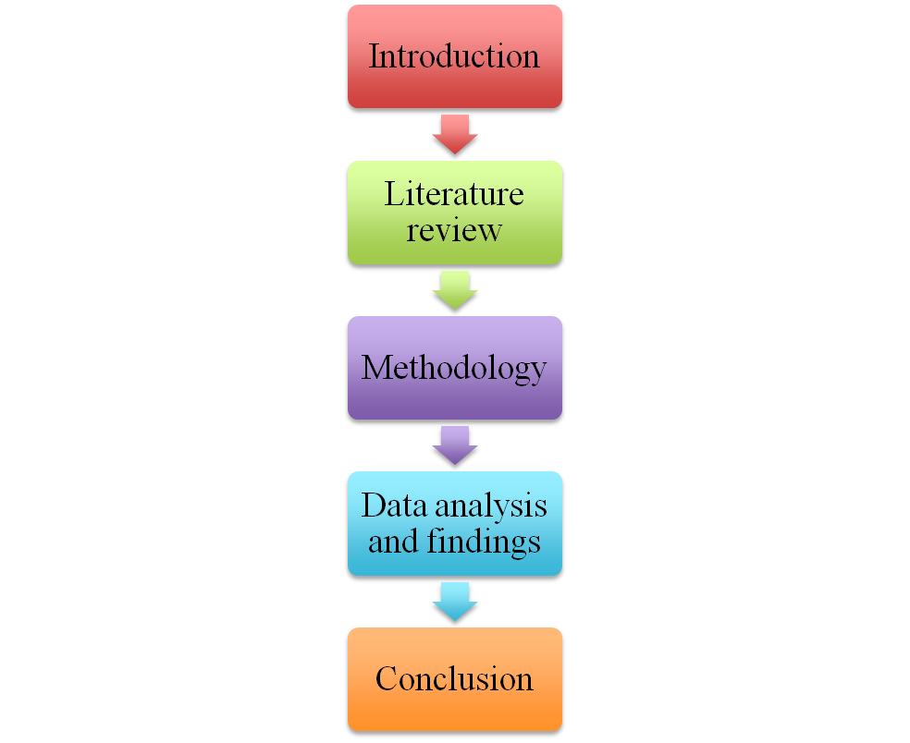

Figure 1. Research structure
(Source: Created by researcher)
The above diagram has been presented that includes different stages of the structure that has been followed to conduct the research.

1.10 Summary
It can be summarized that the study aims to address the functions of management and financial accounting and their logical comparison. This study can be beneficial and provide valuable knowledge to those related to the business and academic fields. Other researchers would be able to benefit from the above data in order to conduct new research. The research would also assist other researchers in conducting proper analyses using the information gained from the above research.

Chapter 2: Literature Review
2.1 Impact of Management accounting in quality management
The impact of the Management accounting system in managing the quality of the products and services is inevitable. Management accounting systems pose a significant influence on developing and improving the quality of the products and services. As Management accounting systems help provide relevant information and data regarding different locations, resources, materials of the manufacturing and production process of an organization, the users and managers can identify the operations that can help improve the quality of the products. According to Machado and Alves, (2017), by reviewing, analysing, and identifying information related to product quality, customer satisfaction, needs and requirements of the customers, buying and purchasing decisions, the organizational managers and leaders make effective decisions and strategies to enhance the quality of the products. They try to gain maximum satisfaction from the customers and improve the performance level and development. The management accounting system in Tata motors helps in identifying the various issues related to product quality and the challenges and limitations of the products with the help of the analysis of the information and data gathered from multiple communication tools like social media, digital media, and other communication tools used in marketing strategies (Amanda, 2019). This collected information helps the management departments team make significant decisions and strategies for improving the quality of the products, providing the customers with satisfactory outcomes, and enhancing their satisfaction and loyalty regarding the automobiles of Tata motors. Management accounting systems also provide information to the managers about the impacts of implementing green initiatives on improving the product quality and managing the satisfaction of the consumers that can also help enhance the organization's performance. The management accounting system also performs the formation and implementation of effective quality management and quality improvement processes. The primary purpose of this implementation of quality management and improvement programs in the organization is to enhance the organization's competitive advantages and market share. The major programs of the management accounting system are associated with the just-in-time program and the total quality management process. Both of these programs are very crucial for enhancing quality management in the organization. The organizational managers gather relevant information regarding the current market change, the demands of the customers, and the supply of the products. With the help of this information, the managers also predict the future needs of the products. It helps them implement effective strategies to adjust the production and manufacturing of good quality products to satisfy the customers' demands. According to Romashko and Dovgopol (2020),The managers also get help with the management accounting system to use just in time methods to pay adequate attention to the depreciation of unnecessary stocks by identifying and analysing the supplies, resources, and materials. In time, inventory strategies can help Tata motors reduce unnecessary waste in the production and manufacturing process and reduce extra costs and expenditures. The Management According system gets help to meet the forecasting and predicting demands of the customers with the help of this just in time method. As defined by Dewi and Meirina (2020), The Management accountants use just in time method and total quality management to go parallel with the expected demand and information about the resources and manufacturing process. Thus, they can reduce unnecessary waste and timely delivery and supply the products to meet the customers' satisfaction (Ishanka and Gooneratne 2018). Thereby, it can help the managers focus on the total quality management with the help of minimization and reduction of the irrelevant costs and wastes to improve the product quality for enhancing organic profitability.

2.2 Impact of financial accounting to increase profitability of the company
As stated by Hirdinis, (2019), A condition wherein an organization generates any gain is known as profitability. Whenever the total percentage of money inside a fact exceeds the total number of expenditures, the business is growing. Because certain accrual-base transfers need not necessitate working capital, if such an institution executes its financial transactions using the cash method of accounting, using revenue growth indicator might not even be fulfilled mostly by cash flows created by the company. In a statistical standpoint, one principal goal of the research article is really to discover an actual important association between the organization's financial performance and indeed the corporation's needs. All collected data were analysed also with ‘Statistical Package for the Social Sciences' in order to improve the findings' dependability. As a result, it is apparent that now the working capital element as well as profit indicators play an essential part (Ayuba et al., 2019). The major goal of this research is to look into the impact of working capital management affecting Tata Motors' earnings. It moreover considers the financial performance as a significant driver. In addition, findings were published in a study report aimed at determining the relationship involving Tata Motors' capital structure and profitability. It's often analysed throughout the report why it needs to take steps to improve the organization's revenue level. This research document focuses on numerous facts, including such secondary information acquired from a Tata Motors statement which revealed the company's annual gross profit.
As mentioned by Husnain et al., (2021), Clients should examine all of a company's running expenditures to see whether areas are excessively large in comparison with industry standards. Dollars gained through examining operating expenses will instantly translate into increased profits. Inside a company, one might undertake an evaluation of current ineffective services and products categories. Also, examine all services and products margin levels and seeing which items should be deleted since they're not adding to the end result. This research article directly shows that responsible for the control are expected to become harsher than in the past, which might have a significant impact on success of the vehicle company's company. Social opinions have shifted dramatically over the years, from seeking greater smooth services to the users to valuing security and quality capabilities in buying decisions, and consumer behaviour can evolve in a variety of ways. As a result, it might have a massive negative effect on the industry.
As stated by Asare et al., (2017), With a growing number of networks with new items, along with establishing new clients, including the investigation and choice regarding attitude modifications in order to obtain a rather more profitable product or service combination, they receive a lot of attention. From a financial standpoint, using key performance assists in focusing on per-unit product or service efficiency improvements and even some providing strategic techniques for addressing management systems or selling costs, which aids in strategic decision-making. This also assists the revenue recognition control system with determining economic health, such as return on investment and economic benefit. There are a few other aspects to helping with the use of a genuine equilibrium scoreboard that aid in strategic decisions, including such creating plans for fresh clients and items, offering an understanding of the largest profits and losses, and financial performance, among others.

2.3 Impact of Management accounting in enhancing innovative in the company
As mentioned by Doktoralina and Apollo, (2019), this research helps us make sense about how business associate management accountants of their use of management accounting systems help organisations with differentiation strategies improve exploration innovation performance. Several lines of research established a link among strategies as well as management accountants' roles in organisations, as well as the connection involving management accountants' roles with future product development. Assessing the impact of management accountants as well as management accounting systems on organisations' innovativeness has become extremely relevant, not even though knowing this will enable organizations to increase extra efficient regulatory strategies by taking into consideration what accounting professionals could indeed affect introspective creativity (Azudin and Mansor, 2018). Based on these facts, clients could speculate which two dimensions influence the link among product differentiation and experimental creativity: management accountants' increased business manager alignment but also their eventual need for management accounting systems besides awareness centred as well as decision — making process. Numerous current revelations have prompted the current study. First is that businesses are becoming increasingly reliant on innovation and creativity.
As mentioned by Labunska, Petrova and Prokopishyna, (2017),The main piece of data suggests that a company's management accounting function could have a major effect on innovation activities through concentrating managers' attention to the following challenges of implementing strategies even in the time of product development cycle. A conceptual model utilizing data collected across 240 enterprises from different nations provides evidence for the anticipated 3 -path mediated impact. Overall, these results suggest that even the management accounting department might play a role in performance management in companies that place a high value on customer service. Overall, these results demonstrate that within companies that value exploratory innovation, even management accounting divisions can play a role in strategic management.
As stated by Yunis, Tarhini and Kassar, (2018), incorporating a balanced transfer card within Tata Motors' business operations that has Components throughout one's supply chain including the process of innovation, operational procedure, including article specific service, will indeed be advantageous from either a management accounting standpoint. Throughout the instance of creativity, Tata Motors' executives analyse their consumers' objectives and design products and services that can fulfil those demands, all while adhering to a strategy framework that helps business, reach their objectives. Administration processes, on either side, are used to create value through the development and production of current supplies to customers (Doktoralina and Apollo, 2019). Finally, the post-sale assistance approach is the ultimate step in revenue transformation, at least from the viewpoint of the operation process. Additional study may elaborate upon that production's findings and investigate several of the linkages that have not been collected for the study. Various teams can use Innovative Management to evaluate overall success as well as engage within monetary terms. It is indeed great for tracking how activities, libraries of ventures, and even entire businesses continue to evolve. More crucially, it allows for a consistent vocabulary as well as accountability structure to be used to explain various different projects.

2.4 How do financial and management accounting systems affect business performance for the organisation?
From the view point of Kesumawati, Putri and Dwirandra, (2019), the management information as one of the most precious products of management accounting procedure which plays a role in predicting the consequences of various alternative actions that can be carried out in various activities like planning, supervision, making any decisions regarding the tasks. It can be stated that the features of management accounting is very useful and it is mainly based on the managerial perceptions as decision making are categorized in four aspects. The sectors are aggregation, scope, integration and timeliness. The definition of Scope can be stated as it is related to the provision of data which gives focuses on internal as well as external companies. On the other hand the timeliness is related to the speed of reporting. The definition of aggregation gives the references of its work as it provides a summary of information in the areas of functions. The research paper reflects the matter of fact that the department of decision making makes an integrated part in the entire system of the management. It is also evident from the research paper that the management accounting system plays a important role in the context of the performance of management. From the market survey it can be stated that the management accounting system is not only applied to manufacturing as well as trading companies but it can also be implemented on the sectors of services to the companies. The study paper reflects the matter of fact that the t Service companies are involves in the sectors of business units whose activities are mainly involves in producing products that are intangible with the intention of gaining profits.
As per the view point of (Teru, Idoku and Ndeyati, 2017), in recent Businesses world the trade is operate in a highly competitive as well as changing global business environment. Therefore it is quite evident that it requires information system that provides speedy responses to the complex business issue so that the problems can be solved easily. It is ascertained from the research paper that when companies and businesses adjust to regulate their computerized technique of internal control management the machinery according to accounting information system (AIS), there would be assurances of the reliability of financial information processes. This thing is important as it is confidential and therefore it cannot be disclosed in front of any other parties. It is also important that the rapid improvement in the context of information technology shows the way to generate as well as make use accounting information systems (AIS). On the other hand it is also evident that the qualitative characteristics of any accounting information system (Ameen, Ahmed and Abd Hafez, 2018). Therefore it is clearly shows in the research paper that there are various prospective of financial management which emphasize the sectors of business in numerous ways. Therefore, it is shows that the study focused and looks at the influence of accounting information systems (AIS) for effective internal control on firm's performance.

2.5 Recognise the impact of Tata motors financial accounting scheme on the company
From the view point of Breuer and Upadrasta, (2017), the role of values as well as changing values in innovation is not yet well recognised. The risk values of Tata Motors based on some aspects like market entry suffering from a gap between customer values, proposition of value and marketing evaluation, improvement guided by the main management vision of safe as well as affordable mobility of Indian “Scooter Family”. On the other hand it is also reflects the market penetration based on repositioning the product as a smart, modern city car for young achievers. The study paper also reflects the matter of fact that, smart and modern city car for young achievers. It is evident that In 2003 Ratan Tata, CEO of Indian Tata Motors, announced to create a small four-wheel vehicle (Ax and Greve, 2017). A new technological view has been established by this proposal where a huge amount of financial opportunities has been involved. The car was nearly about $2000 so that it can be affordable for the growing middle class families of India. The initial planning of Tata Motor was to invent some vehicle which can provide a safe alternative of scooter where a family can make their voyage. Nano was known as “a great symbol of Indian-style socialism” as well as “the dream of millions of Indians”. The costing of the vehicle was much inexpensive than the other four wheelers therefore it earned more revenue from the market. The selling scale of Nano was much higher therefore it boost up the financial scale of the organisation a lot.
As opined by (Raj, 2020), the ERP is a integrate management procedure that is mainly used by the trade for the context of meeting the needs of their daily. Tata Motors have been using many ERP packages as per their requirements as well as business requirement. It has been identified that most of the functional areas are involved to be finance and accounting, cash management, costing activities, quality control and managing the manufacturing methods. The ERP system keeps the consumers connected, even it help in solving their issues in real time by implementing the procedure of CRM (Customer Relationship Management). The study paper also reflects the matter of fact that, ERP procedure in the company TATA MOTORS. It is also shown that how does it makes effect on the long term business policies and the advantages of it in the scene of long term (MEGHANA, ALI and VEERAIAH, 2020). The implementation of ERP procedure provide more integrated and modernize business system and process for TATA which helps them in enhancing their financial system too. The improvement in the context of the flow of communication within an organization of TATA by their financial scheme has been found here (Goel, 2021). The study paper also enlighten the matter of fact that the implementation of ERP will be very effective for TATA MOTORS in terms of increasing productivity, efficiency and the reduction of cost for streamlining the process. The significance that the organisation is analysing aspects like Return on Investment (ROI) in order to apply the ERP software in the company is analysed in the paper in a proper manner.

2.6 Understand the effect of management accounting systems on the performance of the company
As per the point of view of Hassan and Shrivastava, (2019), the article paper mainly attempts to investigate the effect of working capital management in the context of profitability of Tata Motors. Even it also evaluates the usage of cash conversion cycle as an important determinant. The Lazaridis as well as Tryfonidis’s findings has been take places in the research paper in the context of finding the relationship between working capital management and profitability of the Tata Motors. Even it is also evaluated in the paper that how it takes places to enhance the profit scale of the organisation (Som and Goel). The study paper reflects various matters of fact, such as the secondary data has been obtained from the report of Tata Motors where it is mentioned the annual profit margin of them. The main objective of the research paper is to find out the significant relationship among the working capital management of the organisation and the necessity of the company in a statistical prospective. The data have been analysed using SPSS for generating better reliability of the results. Therefore it is clearly indicates that the working capital component and the profitability indices has a significant role.
As opined by Mishra, Khadse and Srivastava, (2021), the Tata Motors has one of the most efficient as well as impressive marketing campaigns in the car sector are the marketing campaign for TATA engines. The repute of Tata Motors Corporation clearly shows the reason why it is not difficult for them to manufacture more than 4 million different styles of vehicles such as automobiles, vans, industrial vehicles in India. A huge number of varieties is take places in their organisation and along with that the budget of individual vehicles are much cheaper than other companies. These things make extra advantages for attending more customers. Therefore it is evident that Tata Motors also has been become the largest car maker in the Indian market today. The study paper reflects the matters of fact that Government laws are likely to get stricter from the previous time therefore it could have a direct effect on the future of the business of the Automobile industry (Raj, 2020). In recent time a huge changes in the mind of people has been take places such as demanding more seamless user services to prioritizing quality and safety functionality by purchase choices, customer behaviour can shift in various forms. Therefore it can affect the organisation both in positive as well as in negative manner. The COVID-19 situation also makes an impact on this industry as people now days trying to avoid public transportation. Therefore it is quite evident that a huge number of private transports will influence the demand of the potential passengers in the context of private vehicle. The study paper clearly shows the new age generations intentions regarding personal vehicle as well as the financial strategies to grab the market place. Even it is also notified in the paper that the pandemic situation makes an effect to enhance the number of private vehicle consumers.

2.7 What are the roles and responsibilities of the management and financial accounting system of Tata motors?
From the view point of MEGHANA, ALI and VEERAIAH, (2020) it is evident in new age business world that the offer of credit is a normal thing. Not even a single business can exist without endorsing the units in credit. Therefore it can be stated that the basic difference between credit deals and the deals of money is the time hole in the context of the receipt of money. The study paper enlightened the matter of fact that the receivable administration of exchange acknowledges is mainly known as the Management of Receivables. Even from the aspects of the receivables there are some components who are involved in the parties such as the three most essential sectors of working capital, stock and money, the administration. It is identified that after the inventories the receivable known as the most significant spots. Even it is also evident that it consequently helps to establish a sizeable bit of current resources in the organisation. The capital of the firm plays the most important role as it helps to put resources into receivables. This amount is quite similar to a sum which is put resources into the context of money and the stock. A recent survey shows that the current resources in India are around 33% from the view point of the receivables. Additionally it can also state that the exchange credit is also plays a significant role in the market device because it acts as a bridge of the conveyance arranges in the field of promoting their individual production and the production gathering. On the other hand it is also shows in the research paper that the client is the individual who speaks to the association's case or resources (Junaidi, 2020). They are the personnel from whom receivables or book-obligations are to be gathered in the fraction of a second is mainly refers as indebted individuals. In contrast, it is also identified in the research paper that in the time when supplies as well as the administrations are sold under a simultaneousness agreeing the client to pay for them sometime in the not too distant future, the sum due from the client is mainly records as information of the receivable. The research paper shows the receivables organization practices follow by the band, even it is also identify the ratios to analyse the company's receivables (Kamran, 2020). Additionally, it helps to determine the relationship of receivables with sales as well as it provides the guidance to locate out the force of receivables on the operational capital of the business of Tata Motors. Most importantly the research paper shows the most feasible suggestion in the context of improving the receivable position. The entire research paper indicates the various aspects of the receivable that plays an integral part in the entire management of the Tata motors. On the other way it can be stated that the main objective of the research paper has precisely find out by investigating the different aspects of the study.

2.8 The similarities and differences among the responsibilities of Management accounting and Financial accounting systems of Tata Motors
According to MEGHANA, ALI and VEERAIAH, (2020), Management Accounting and financial accounting in Tata Motors are the pillars of their management system. There are some similarities and dissimilarities between these two management systems whether responsibilities are different from each other. In case of similarities of these two accounting systems where both are considered as a part of the total information accounting system. Both of the information accounting systems have the responsibility of dealing with economic events which are essential for the organisation. Tata Motors qualifies this economic event with rupees for both of the accounting systems. The responsibility of this to the accounting system is basically concerned and associated with expenses, financial statements, cash flows, liabilities, revenues and assets. Tata Motors focuses on from the perspective of both of the accounting systems that accumulate and classify the information regarding accounting for financial statements preparation. It is the responsibility of both of the accounting systems to use some databases for developing financial reports and statements. Another responsibility of both of these accounting maths systems refers to determining and measuring the cost of various account periods, sections and departments. Lastly can be said that the concepts and the principles for using this to accounting management systems as cost allocation and cost accumulation. Including all the similarities, these two accounting systems also have some dissimilarity.
On the other hand the dissimilarities start from its root where the definition of these to accounting management suggest that financial accounting refers to a process for recording liabilities, assets, expenses and revenues which is associated with the present business enterprise. In contrast Management Accounting defines an accounting application as well as statistical Techniques for particular Poppers to produce and interpret Information Design for assisting management with different functions to promote maximum envisage and efficiency, co-ordinate and formulate future plans along with subsequent measures to execute. In case of Tata Motors the financial accounting has the responsibility for the external business enterprise where Management Accounting focuses on the hai and top level executive of management system of the company (Beerbaum, 2021). The financial accounting system of Tata Motors provides reports which are not beneficial for organising, stuffing, planning, decision making, controlling and directing. On the other hand the Management Accounting includes reports which are fairly beneficial for organising, proper learning, directing and many more. The reports of financial accounting are basically prepared as well as supplied to the shareholders, financial analyst, creditors, government authorities, trade unions, stoke exchanges and many outsiders where is is accounting management develops and prepares its report for supplying different management executive levels which is considered as the inner part of the Tata Motors management Beerbaum, (2020). The process of preparing and maintaining the entire system of financial accounting has a limited period but on the other hand the system of Management Accounting where the information are collected for section, department, division wise as well as like for various purposes of their need. Dissimilarities in between these two accounting systems are where GAAP is important in case of financial accounting but not important in Management Accounting.
According to Singh, and Srivastava, (2019), Management Accounting provides important and useful advice for management systems to make impactful decisions for any company. Management Accounting extracts outcomes from the department of financial accounting as well as provides transparency to management for enhancing decisions. Before Tata Motors an automobile company also uses this information for making operational improvements. it means that the information of Management Accounting helps managerial personnel to make beneficial decisions (Mishra, Khadse and Srivastava, 2021). On the other hand it can be said that internal operation may also be developed for this information for instance companies are capable of performing well where the information of Management Accounting is quite beneficial to Tata Motors for improving their formals in an accurate way.
Tata Motors has maximized their revenue through the expenses deduction like the major Management Accounting type is cost accounting. it can be said that way revenue is exceeded bi expenditures, organisation incurs losses as well as they have to come up with the same. The reports which are related to cost are also prepared which is beneficial for the company to reduce their expenses. Therefore internal operations are controlled as well as strengthened appropriately (Dokania, 2019). The major roles and responsibilities of Management Accounting along with financial accounting refers to-
1. Planning- it is essential As It is crucial for every business like where budget is important to prepare. Management accounting always helps in taking decisions along with preparing the budget for the entire budget processing which is prepared through the accounting reports. Tata Motors always assets goals for upcoming periods and also assess their plans to achieve their objectives (Choudhari and Jagnade, 2018).
2. Organising- another main function of financial accounting and Management Accounting is to control as well as prepare performance reports for the management which are then compared and matched with the results of budget for or assessing actual output. Tata Motors always utilizes these reports to organise their plans for taking actions.
3. Decision Making- it is considered as the major component of financial and accounting management as these high managerial personnel get information to take advance decision for Organisational Development (Nath and Dwivedi, 2021).
Basically the process order actions of accounting management focus on the provided information where managerial personnel take effective decisions. The roles and activities of Management Accounting a store focus on building Tata Motors' internal managing system as well as achieving its objectives. Detail information is provided by Management Accounting regarding cost which helps to make decisions on budget (Simlai and Guha, 2019). On the other hand in case of financial accounting which provides information which is imported for the users who keep stake? Another important goal of financial accounting is to give financial statements for providing it to the stakeholders for analysing and taking decisions. It is very essential for the management of Tata Motors as the financial statements which are provided to their users for accounting information. Lastly, it can be said that the activities and rules of Management Accounting as well as financial accounting systems of Tata Motors are very essential with its similarities and dissimilarities.

2.9 Importance of both accounting systems in the process of enhancing Tata Motors in strategic decisions
As mentioned in (Khuntia et al., 2021), Management Accounting plays a very crucial role in Tata Motors where the basic activities of accounting management refers to assisting our guide the entire management to perform its roles effectively. Management accounting is important as its functions are making plans organising, directing along with controlling it. Management accounting is important for serving the vital data resources for making management plans. The information such as documents and accounts are the major sources of information which provide huge data quantities regarding the previous progress of Tata Motors which helps to take decisions about the future planning. It is also essential as a data accounting request decision which needs to be perfectly classified and compiled.
As mentioned in Khuntia et al., (2021), Management Accounting plays a very crucial role in Tata Motors where the basic activities of accounting management refers to assisting guide the entire management to perform its roles effectively. Management accounting is important as its functions are making plans organising, directing along with controlling it. Management accounting is important for serving the vital data resources for making management plans. The information such as documents and accounts are the major sources of information which provide huge data quantities regarding the previous progress of Tata Motors which helps to take decisions about the future planning. It is also essential as a data accounting request decision which needs to be perfectly classified and compiled.
The Purchase figures of Tata Motors for various months can be classified for knowing the total purchase which is made during every time product, supplier and territory wise. According to Novas, Alves and Sousa, (2017), Management Accounting is to analyse data for impactful planning as well as decision making. Therefore the ratio is calculated as winner’s trends are forecasted. It is also beneficial for Tata Motors as Management Accounting includes communicating management which provides plans for upward, outward and downward. It basically means that Management Accounting helps to identify the consistency and feasibility of different plans' segments. Management accounting is essential Tata Motors as its management accounting helps to translate given strategies and objectives into particular aims to attain through a particular source and time for impactful establishment of those aims effectively. It presents accounting information though the most beneficial management way.
As stated in Narwane et al., (2020), along with the management accounting financial accounting is also important for the accounting system of Tata Motors. Management Accounting focuses on its main concern regarding the information which financial accounting provides. Therefore it can be said that management is an art to get School control as well as operations coordination without a fit financial accounting designed system. it can be saved that here financial accounting and Management Accounting are complementing each other to fulfil the organisational objective. Financial accounting is important as it supplies information for loss and profit accounts as well as balance sheets for external parties such as the government, investors, banks creditors and shareholders. one of the most important and essential benefits of financial management where it analyses financial statements which provides a conception for the investors regarding deciding to invest their funds. Therefore, Tata Motors are beneficial from their financial management as it helps to to get funds from their investors. Another key feature of financial management which is very important for Tata Motors is that it helps the regulatory authorities for ensuring that Starter Motor is following and maintaining the standards of required accounting. The analysis of financial statements is also beneficial for the government agencies to analyse the taxation of Tata Motors (Zhang et al., 2020). The most effective key feature of financial management as the analysis of financial statements helps to understand and compare the organisational performance and also identify as well as determine the financial weaknesses and strengths in it.

2.10 Process can be used by both accounting systems in the process of enhancing Tata Motors; strategic decision?
According to Nath and Dwivedi, (2020), enhancing the strategic decisions of Tata Motors it is necessary to focus on both accounting systems such as Management Accounting and financial accounting system. The most affecting process which can be included is a balanced scorecard. This process emphasizes financial measures regarding the past performance which helps to focus on the future performance (Ahmadzai, 2020). It also focuses on the management accounting system which also provides a comparison between the past performance and present objectives as well as the future outcomes. Tata Motors focuses on implementing a balanced scorecard as the measures and objectives of this particular procedure related to organisational strategy and vision (Snehvrat, and Dutta, 2018). It represents four perspectives such as customer, business process, internal and financial. the objective of using this process into the Management Accounting of Tata Motors referred to gain and clarifying strategy related to both financial and Management Accounting, communicating strategy for the entire organisation, aligning person and departmental aims to the strategic plan, working as a bridge for strategic objectives for making decisions regarding annual budget and long term aims.
Tata Motors will be benefited through the balanced scorecard as it deals with revenue along with every activity or action week can enhance the organisational revenue base (Junaidi, 2020). The major focus goes to the increasing number of upcoming and new products as well as establishes new customers and the research and decision about mood changes for getting more profitable services or products mix. From the financial perspective the balanced scorecard helps to focus on per unit reducing service or product cost as well as provides the strategic plans of reducing general administration or selling cost which it also helps in the strategic decision (NAGTILAK and KADAM). It also helps the financial accounting management system to measure the financial performance for instance investment return as well as economic added value. There are few parts of assisting utilisation of a true balance scorecard which helps in strategic decisions such as provides designs for new customers and goods, providing an idea about highest losses and profits, company profitability and many more.
From the management accounting perspective, it will be beneficial for Tata Motors to incorporate a balance School card into their internal business process which has Stir proceed your value chain such as innovation process, operations process and Post Sale service process. In the case of innovation, the managers of Tata Motors research the customers' needs and create the services and products to meet the customer satisfaction which is related to a strategic plan that helps to achieve their goals. On the other hand, operation procedures deploy value creation which is related to the production and delivery of existing services and goods to the customer (Karabag, Borah and Berggren, 2018). Lastly, the Post Sale service procedure represents the last procedure for value change from the perspective of the operation process. Tata Motors will be beneficial if it becomes responsive for their customers to deliver their services all products. Sales services always include repair activities and warranty, defect treatment and Returns, customer payments Administration and customer complaints or problems resolution after providing the sales services. Therefore the entire procedure of balanced scorecard will be beneficial for the Tata Motors to take strategic decisions for the company's benefits.

2.11 Hypothesis
H1: Management accounting and financial accounting have a particular role to play in the organizational culture of Tata Motors.
H2: Management accounting and financial accounting have no role to play in the organizational culture of Tata Motors.

2.12 Literature Gap
As mentioned by Patjoshi (2021), the literature gap that can be found in this case is related to the understanding of the importance of management and financial accounting. According to the collected research articles and journals in the literature review defines that it has a direct impact on the company's growth; however, various articles states that every company has focused on each accounting system. Moreover, gaps regarding the importance or the connection that exists between both of these sectors are yet to be learned. Furthermore, depending on the literature gap, learning about the ways in which both areas of managerial; and financial accounting can be managed in order to achieve a better organizational result.
On the other hand, Tata Motors is known for having a prominent market position and based on every strategy and actions, and the company is increasing growth in its every path; however, the gap regarding the ways in which both managerial and financial accounting can be implemented within the work culture will be learned from the research presentation, furthermore, in recent years the effectivity of the accounting system on the work and employee culture and knowledge gap regarding the impact will be met with utmost clarity as well.

2.13 Conceptual Framework
Conceptual frame work is one of the most effective and equally essential part of the research paper. The research paper is mainly depending on the comparison and contrast between the roles of management accounting and financial accounting in Tata motors. The main purpose of the Conceptual frame work helps to upsurge the inclusive consideration of the market of Tata Motors to vibrant the visualization of the investigation efficiently. Conceptual frame work similarly helps to visually explain all of the key insights or variables along with the connotations amongst the research paper that necessitates involves three major theoretical perceptions to get better and updated outcomes.

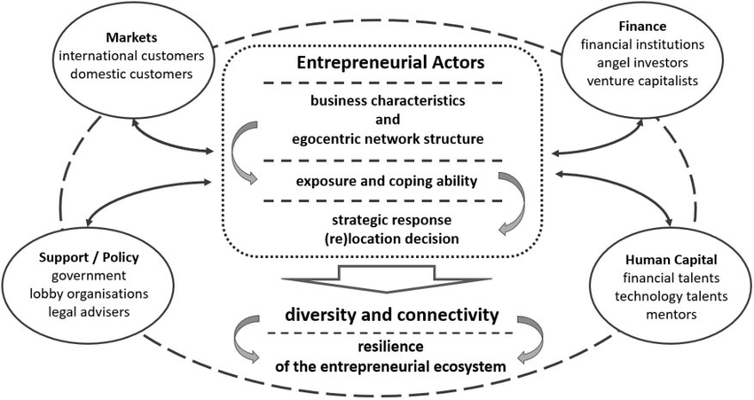
Some prime causes behind constructing an accepted conceptual framework would be that it establishes a basis enabling establishing accounting standards, and foundation for solving accounting conflicts, including core concepts that don't have to be duplicated within accounting standards. This contributes to ensuring that perhaps the Guidelines are conceptually consistent and also that the same group of transactions are evaluated consistently in order to offer valuable information to shareholders, borrowers, as well as other lenders. Each management accounting theoretical framework evolved from just a series of frames classified in aspects of something like a derived demand of managerial accounting in within process of management, the method by which usefulness of management accounting results could be evaluated, the criteria that could be used to assess management accounting methods and systems, as well as the abilities that are necessary. One main goal of managerial costing would provide a financial representation of organizational resources' utilisation as well as associated effect and cause insights regarding historical, current, and foreseeable organisation of economic operations. Managerial pricing assists managers throughout its analysis and decision-making, as well as in optimising the attainment of an organisation's strategic goals. A financial accounting conceptual model is basically coherent logical sets of interconnected aims including principles that really can contribute to appropriate attention and even that regulates the origin, purpose, and boundaries of financial accounting as well as financial statements. This qualitative approach was used in this analysis, which was conducted in corporate organisations. This research found a link between firm strategy with management accounting in both procedure and practise. The findings highlight the significance of well-defined roles and duties in accounting information. Management accounting stressed the importance of communications, since environmental changes as well as other priority areas currently necessitate a quick reaction.

Chapter 3: Methodology

3.1 Introduction
In any research presentation, the importance of the methodology section cannot be ignored as it is helping the entire project learn about different methods that can be helpful for the project to attain its set aim and objectives with an accurate project understanding. On the other hand, the importance of the data collection and its impact on a project is also attained from the methodology chapter.

3.2 Research onion
Research onion is one of the most significant part of the research paper that helps to Reflects the step-by-step elaboration of the research work by including a briefing of the research methodology related sections. The first part of the research methodology is associates with the research philosophy which is linked with the positivism research philosophy. That helps the research paper to relate with the fact that it has the credibility to analyse the selected research topic from an observational point of view. The second part of the research methodology is associates with the research design which is based on the descriptive research design. That helps the research paper to interpret the major reason as well as consequence of the research related issue. The third part of this research methodology is associates with the research strategy that reflects qualitative and quantitative research strategy. The fourth part of the research paper is associates with inductive research approach that related to the fact that it creates a direct impact on the result as its process can provide different solutions regarding the research topic. The fifth part is associates with data collection and data analysis. The sixth part is associates with the sampling method and seventh part is ethical consideration. The eighth part is linked with reliability and variability. The ninth part is reflecting the limitations of the research and the tenth part is focused on the summary of the research methodology. That helps to complete the methodology section positively (Sahay, 2016).

3.3 Research Philosophy
As stated by Kumar (2018), positivism as a research philosophy has been utilized in this case; the main reason for using this philosophical approach is related to the fact that it has the credibility to analyse the selected research topic from an observational point of view. Moreover, depending on the hypothesis the positivism can be evaluate the collected information with utmost efficiency and effectivity, and it is further supported by different assumptions and theories as well. Therefore, by selecting positivism as research philosophy, Tata motors can utilize the impact of both managerial and financial accounting with utmost efficiency.

3.4 Research design
Descriptive research design is the most effective part of the research paper that helps to increase the efficiency and effectivity of the research paper. On the other hand, it includes numerous features that appreciate the important difficulties which is not well investigated earlier and helps the researchers to highlights those points accordingly. It also generates new strategic approaches for understands the major factors that influence research work positively. It is also assistances to cultivating the strategic circumstances by including disruptive innovation. Its positively involves the operative features to simplify the outcomes of the research paper for gaining suitable certain significances in an operative way (Akhtar, 2016).

3.5 Research strategy
Both qualitative and quantitative research approaches are needs to be added in this part to get an effective research outcome. Both of these two strategic approaches are helps to conduct the research by liable on the preliminary research method for applying the research in systematic method. Qualitative research strategy, helps to collect information from a massive number of connected as well as significant articles and journals. Quantitative research strategy benefits to gather information by conducting survey and interview. So, implementation of these to strategic approaches will help to cover all of the information resources accordingly (Brannen, 2017).

3.5 Research Approach
As described by Ragab and Arisha (2018), by using an inductive research approach, in this case, attainment of a better result will be possible. The main reason for using the inductive research approach in this project is related to the fact that it creates a direct impact on the result as its process can provide different solutions regarding the selected topic entirely based on the made hypothesis. Another reason for choosing the inductive research approach is related to the fact that it increases the chances of data collection from previous experience and from that drawing judgment and new decisions to influence the project’s topic current situation. Based on this approach inductive method has a beneficial role to play in the entire project result and outcome.

3.6 Data Collection
As defined by Snyder (2019), the role of a data collection method has a direct impact on the entire project result. In this case, both primary and secondary data collection methods will be used; the main reason behind using both of the methods is related to the fact that it will be presenting a clear understanding of the selected research topic. In two ways, data collection methods can be performed, such as primary data collection method another one is secondary data collection method where direct sources of information are utilized in the primary method, and indirect information sources are utilized on the secondary method. In this case, to perform primary data collection method survey as a research paper’s data collection tool has been utilized which will be providing a direct understanding of the topic from employee’s point of view, whereas in order to perform the secondary data collection method, different topic related articles, journals, and books will be gathered, and their information on the topic will be presenting a clear idea about the selected topic in a detailed way. In this case, as the topic is aiming to discuss the role and impact of both managerial and financial accounting on the company thereby selecting both primary and secondary data collection methods will be responsible for presenting direct information.

3.7 Data Analysis
As opinionated by Mishra and Alok (2017), the responsibility of a data analysis method Is to evaluate the collected information and present a proper outcome, and to meet this objective, and the paper has used both qualitative and quantitative methods in the project. The main reason for using the mixed method is related to the fact that it provides a clear understanding of the theories and observational concepts that can be utilized in the project for attaining a better research result. On the other hand, the value of the mixed analysis method from a research presentation cannot be ignored as well, as it creates a direct impact on the data evaluation process, which determines the result and its effectiveness. Furthermore, by using the mixed method, the selected research presentation has been used as well to define the role and impact of both financial and managerial accounting on the Tata motors business culture, as the theoretical definition of management and financial accounting and statistical evidence of the related data and number regarding impacts of the methods on the company growth determines the effectivity of the selected project's importance in a positive direction.

3.8 Sampling Method
As mentioned by da Silva (2017), the importance of the sampling method from a research methodology cannot be ignored, moreover the project is using the random sampling attainment of a larger audience or population for the project, sampling has become an easy task to perform. Moreover, in the selected project, by using random sampling, the area regarding the selected population has increased a lot which has further created a positive impact on the research outcome too.

3.9 Ethical Consideration
As stated by Roberts and Allen (2015), the importance of ethics from a research present cannot be denied as based on proper ethical consideration and its management, taking accurate decisions for attaining better results becomes an easy task. According to the Data Protection Act, keeping personal information confidential and secure from other sources plays a vital role. On the other hand, avoiding plagiarism at any cost is another important approach to ethical consideration. Apart from this, giving credit to every secondary source’s authors has a proper role to play in the organizational understanding. Furthermore, submitting a project on time is another considering factor. Therefore, by meeting every ethics presentation of accurate result outcome is possible.

3. 10 Reliability and validity of data
Reliability and variability are the two major parts of a research paper that strengthens the entire effectivity of the research paper. It is mainly focused on the varied along with the wide-ranging research related data. In term of the reliability and variability of the research paper it can be stated that the major data is gathered from the employees and market associated experts. The researchers are also gathered major data from a large number of books, articles as well as journals. It has been significant to note that the reasons of the altering procedure of interpretation style can be identified more effectively that has been significant for collecting reliable and accurate data to offer an operative conclusion to the research. In addition, it is quite understandable that the data that are gathered from the dependable sources that upsurges the validity and reliability of the research in a positive and effective way. Most significantly, Primary as well as secondary data bases have been re-evaluated for assuring the rationality along with reliability of the research significance by decreasing the capacities of haphazard mistake. Accordingly, the development of the enquiries has been asked to the candidates who are mostly based on the measures to Confirms that the applicants can get the ability to distribute the most dependable as well as correct perceptions and ideas about the research work (Heale and Twycross, 2015).

3.11 Limitations
The below are the limitations of management accounting and financial accounting functions:
The key shortcomings of management accounting are highlighted in the following points. The below are the constraints:
a) Centred on Documents, b) Inadequate understanding and knowledge of relevant threads, c) Making Decisions Based on Intuition, d) Inconsistency and lack of coordination, e) No Management Substitute, f) There is a lack of perspective, g) Factors that aren't measurable, h) Expensive, i) Not in the final stages of development, and j) Psychological reluctance.
The shortcomings in financial accounting are shown in the mentioned sequence. The below are the limitations of financial accounting functions:
a) Does Not Have Enough Information, b) Cost Control Isn't Possible, c) Historically significant, d) Keeping track of actual costs, e) Price Fixing Difficulties Subject, f) Technical g) Consensus on Accounting Principles, h) Accounting Principles Cannot Be Evaluated, i) Make Comprehensive Data Available, and j) It's possible to alter it.

3.12 Summary
Based on the entire understanding of the research methodology, it can be stated that with the proper understanding of the methods and procedures that can be used in the project as a whole, learning about the ways implementing them is learned too. Based on the presentation, it can be stated that the project will mostly be using secondary sources in its data collection result. Yet, a survey with a minimum number of employees will also be collected in order to have a clear understanding of the topic that will be responsible for an accurate result. The importance of ethics in a research presentation cannot be ignored, as well as it creates a direct impact on the entire understanding of the ways in which taking ethical and proper decisions for the company will become an easy task. Furthermore, different limitations related to the project are also discussed here, and managing them with utmost efficiency can be effective for presenting a detailed research result too.

Chapter 4: Data Analysis

4.1 Introduction
The importance of the data analysis from a research paper cannot be ignored as it is responsible for the selected topic in a particular manner; in this project, the collected information with the help of direct and indirect sources has been analysed here in order to present a detailed understanding of the topic. On the other hand, in order to analyse the collected data using the mixed method that comprises both qualitative and quantitative methods have helped a lot, and depending on the used methods, attainment of a better research outcome has been easy to attain as well.

4.2 Primary Analysis
The primary data collection method in this project is known for collecting information from direct sources, and every direct source in the project has helped to present information that has state the importance of both finance and managerial accounting within the work culture (Richardson, 2017). Moreover, the information has been collected from the employees who have provided a direct source of information related to the topic. In the following, the gathered information and their survey response have been analysed with the help of proper percentage evaluation in order to provide a direct understanding of the topic.
Furthermore, in the following section, 15 different questions had been asked to the selected employee population in a random sampling method for presenting a detailed research outcome to the project.
Question 1: Do you think Management Accounting and Financial Accounting are an important part of your business organization?
Response Analysis:
Based on the response it can be stated, Everyone of the participants who took part, in the research survey, which is 100 percent of them, thinks that in order to run an organizational culture importance of both financial and managerial accounting cannot be ignored as it provides a clear idea about the way in which company can attain growth.
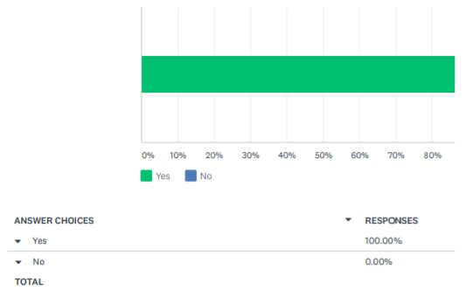
Question 2: Do you think your organization has implemented special methods to manage Management Accounting and Financial Accounting?
Response Analysis:
Based on the survey response it can be stated that around 57.14 percent thinks thar their organisation has implemented proper methods and strategies in order tri manage the financial and managerial accounting while rest of the 42.86 percent participants still think the company has not implement any methods to manage the needs.
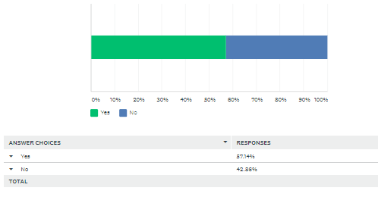
Question 3: Do you think your job role has changed due to Management Accounting and Financial Accounting methods implementation?
Response Analysis:
According to the survey response it can be stated that the job role of 42.86 percent’s have changed a lot especially due to the implementation of new financial and management accountings on the other hand, rest of the 57.14 percent has felt no change in their work role or responsibilities.
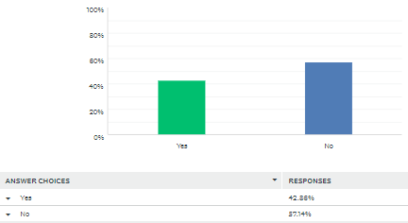
Question 4: Do you think your organization is taking measurements to manage the impact of Management Accounting and Financial Accounting?
Response Analysis:
With the help of this survey question it can be stated that 71.43% thinks that their company has taken different actions and strategies in order to manage the impact of managerial and finance accounting while rest of the 28.57% does not believe in the statement.
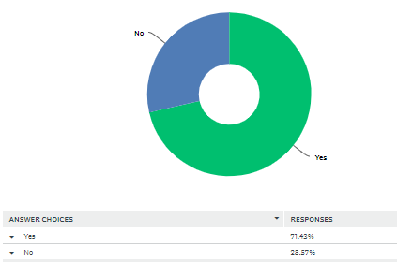
Question 5: Do you think, Management Accounting and Financial Accounting is creating an impact on your organizational performance?
Response Analysis:
Based on the survey result it can be stated that according to 57.14% participants that the organizational activities that are managing the managerial and financial accounts are responsibly creating an impact on the perforce while 28.57% pf them thinks it has a huge impact and 14.29 thinks that the impact is a lot too.
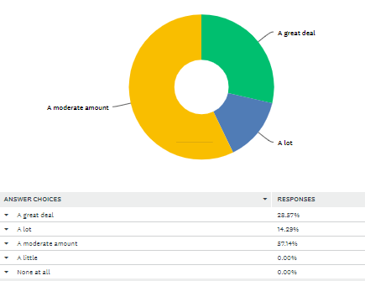
Question 6: Do Management Accounting and Financial Accounting are connected to one another?
Response Analysis:
57.14% of the participants think that they are is a likely connection between the Management Accounting and Financial Accounting, while 14.29 percent think the connection is very likely while rest of the 28.5 percent of them has a moderate response towards the existing connection as well.
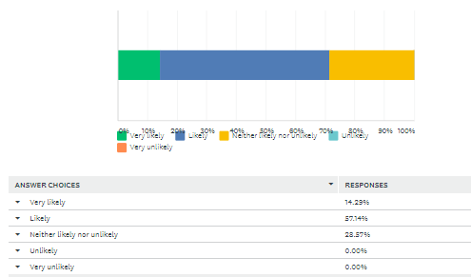
Question 7: According to you, among Management Accounting and Financial Accounting which are more effective in the organizational culture?
Response Analysis:
The response states that around 71.43% of the participants think that both Management Accounting and Financial Accounting are important for effective work culture while 14.29 percent thinks it is Management Accounting and rest of the 14.29 percent thinks it is Financial Accounting.
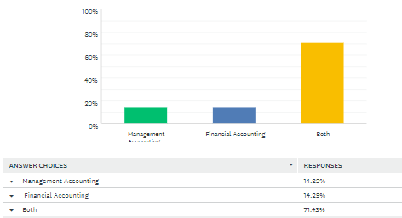
Question 8: Did you change your performance values based on the Management Accounting and Financial Accounting methods?
Response Analysis:
The importance of both Management Accounting and Financial Accounting in the work culture cannot be ignored and depending on this around 42.86% participant has change their work actions and activities while 57.14 percent of the participant still has not made any changes to cope up with new work changes.
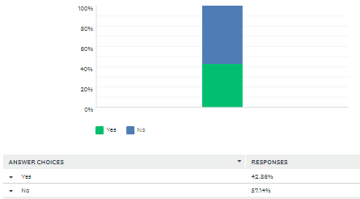
Question 9: What are the roles and responsibilities of the management and financial accounting system of Tata motors?
Response Analysis:
Based on the research report it can be stated that 40 percent of the participant thinks that the value of management and financial accounting system in Tata Motors cannot be ignored while 20 percent thinks it has a moderate value while rest of the 40 percent thinks the value of roles and responsibility of the selected areas are moderate.
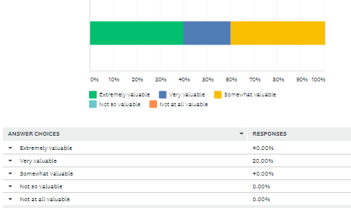
Question 10: How do financial and management accounting systems affect business performance for the organization?
Response Analysis:
80.00% of the participants think that financial and management accounting systems affect business performance for the organization in an effective way while rest of the 20 percent thinks the effect is extreme.
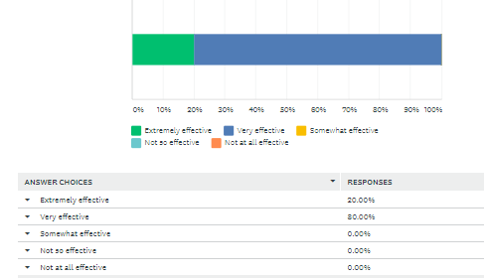
Question 11: Is there any similarities and differences among the roles and activities of Management accounting and Financial accounting systems of Tata Motors?
Response Analysis:
On a moderate level of 60 percent, the participants thinks that there is an existing similarity and dissimilates can be found among the roles and activities of Management accounting and Financial accounting systems of Tata Motors, while 40 percent of the participants are likely to agrees that the existing comparing and contrasting roles of the Management accounting and Financial accounting systems within the selected work culture.
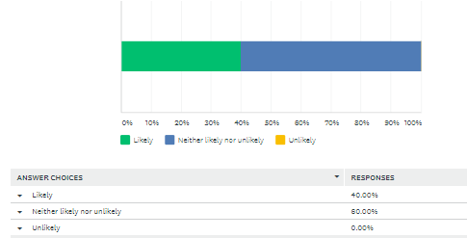
Question 12: Is there any process that can be used by both accounting systems in the process of enhancing Tata Motors’ strategic decision?﻿
Response Analysis:
80.00% of the used participant in the survey thinks that any process that can be used by both accounting systems in the process of enhancing Tata Motors’ strategic decision while 20 percent does not agree to the statement.
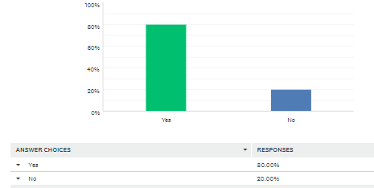
Question 13: According to you, is implementing change within the culture of the financial and management accounts are important or not?
Response Analysis:
60.00% are agreeing to the fact that implementing change within the culture of the financial and management accounts are important while 40 percent thinks it is not important.
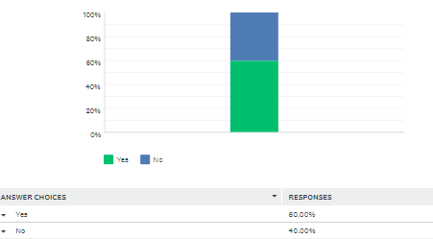
Question 14: According to you, is performing the survey will help to bring change in your work culture?
Response Analysis:
60.00% of the survey participants thinks that the survey result will help to bring change in the work culture of Tata Motors while 40 percent dies not agree to this idea.

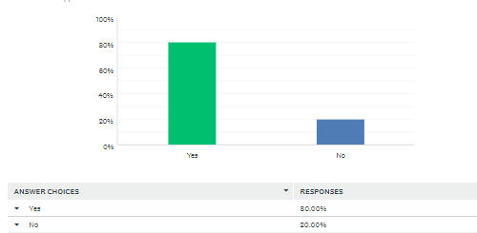
Question 15: According to you, are your company is planning to implement change based on the survey result?
Response Analysis:
60.00% of the survey participants thinks that company is planning to implement change based on the survey result while 40 percent dies not agree to this idea.
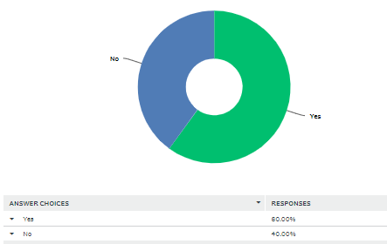

4.3 Secondary Analysis
The research project has collected related data and information with the help of secondary sources as well. In order to perform this analysis, the research report has collected information from different indirect sources, and it has been analysed based on the identified themes as well. Therefore, the collection of diverse yet connected information for the project topic will be attained from the thematic analysis as well.
Secondary analysis
Strategic implementation for the organizational performance
As per Pasch (2019), the management accounting system is associated with the importance of making a strategic plan to participate in the effective decision-making process to improve the quality of the performance. The accounting managers can help in improving the performance of the organization by implementing and developing strategies to improve the internal process of the organization and the activities related to accounting management. Business partner orientation of Management accounts also plays a very crucial role in the Management accounting system. Business partner orientation of Management accounts used in management accounting systems to create an interactive communication system that helps in effective decision making and implementation of innovative strategies. Effective and innovative budgets created by the management accountants can help improve the organization and functions in activities and thus can improve the performance. Innovative strategies are also important for maintaining the quality of the management accounting system. Strategic management accounting helps in a multitude of activities and processes of the business organization starting from the identification, collection, selection, and analysis of the information and data of the accounting process to help the entire business management team to make decisions and plans for the further organizational activities. The financial information helps provide and direct the entire Management accounting team leaders and managers to make significant actions and activities to perform the management operations. Managers of the organization can make effective decisions and can also plan for needful actions to achieve the goals and objectives of the company with the help of the strategic management accounting system. By implementing strategies for developing a communication system, exploring financial information, creating a budget, the management accounting systems in Tata motors can also bring positive impact on organizational growth and development. Thereby, the management accounting system can also provide relevant and reliable data and information to make effective decisions at the right time to influence the performance of the company.
Improvement of human capital
According to Novas, Alves and Sousa (2017), the Management Accounting system has also played a huge role in developing the intellectual capital, human capital, relational capital and structural capital of the organization that also brings a positive influence in enhancing the performance of the organization. The Management accountants can make effective strategies and plans to reduce unnecessary cost in different organizational activities by identifying and reviewing the accounting operations and save the extra cost for implementing effective training for the employees to develop their skills and enhance the intellectual property of the employees that can be crucial for and enhancing the behaviour of the employees.
Increasing behaviour of the employees
As per Murdayanti and Purwohedi (2018), a Financial accounting system is a mechanism that can motivate the behaviour of the employees and can also influence the entire organizational culture by providing reliable and reasonable information to the managers and the leaders of the organization. Superior support, work motivation, clarity of the goal, effective training programs are the major factors used in the financial accounting system that can be crucial for improving the behaviour of the employees and can also make a significant work culture. A Financial Management accounting system can be implemented in the organization to maintain the strategic planning and activities of the organization for enhancing the behaviour and culture of the organization.
Enhancing the quality of the service
According to Sedevich-Fons (2018), maintenance and management of the quality is another factor for the management accounting experts and practitioners because depending on the quality the performance of the organization is evaluated. The Strategic Management accounting team develops planning and strategies to improve the quality of the services and information. The management accounting system has proved to be one of the most crucial factors for organizational growth and performance. Management accounting system provides relevant information and data to the organizational management accounting systems. By developing strategies for effective cost strategies to implement effective price and enhancing the brand valuation the accounting system tries to develop the quality of the information and data. Effective cost-related information and quality based data can help the accounting managers make significant strategies to perform the relevant activities in the organization and make strategies regarding competitive price reaction market growth elasticity of the market economic skill and development of the organization. By making strategies to enhance the satisfaction of the customer by developing a strong leadership process and engaging the people, improving the quality of the manufacturing process and also developing the quality of the products the company can enhance the performance level. It can organize activities and management planning to lead the entire organization towards the making of a better management team. Management accounting system performs the activities of performance measurements, and also management and planning of the budget, forecasting the major procedures that are needed to review and prepare the managerial accounting information process.
Issues related to the quality management
According to Thenikusuma and Muis (2019), the Implementation of the Regional financial accounting system has a significant and positive impact on the quality of the presentation of their financial report. In the globalisation era, it is important to maintain the quality of the financial reports for improving the performance of the organization and create a positive impact on organizational growth and development. Maintaining the transparency of the financial report is also important while providing financial information. For this purpose to maintain the qualitative structure of the financial information and financial statements the organization can review the financial report and that can help make strategic plans for further organizational functions. The major obstacles found in the financial reports are associated with a lack of training and knowledge of the financial managers and the lack of practices of the human resource managers. To maintain the quality of the financial reports human resource plays a crucial role. To get the best quality financial statement it is also important to maintain the reliability and validity of the resources from where the financial information is collected. For producing and increasing the value of the financial information and developing its reliability, it is important and required to engage an expert and qualified accounting manager. Human resource needs to increase the competency of the managers by providing effective skill related programs in training so that they can perform their best. So the collection of the financial information and utilising the information effectively can be possible. Another important factor is the development of the infrastructure facilities that are a major crucial tool for increasing the success of developing the performance of the organization while preparing financial statements. Improving the infrastructure facilities can be useful for implementation of the effective financial accounting standards. It can also maintain the quality of the financial information and can also improve the organizational performance of Tata motors. It is very important to attain a better financial report in terms of quality and infrastructure. To get a good quality financial report it is important to collaborate on the infrastructure and the competencies of the human resource managers and the accounting managers.

4.4 Summary
Depending on the entire understanding of the data analysis section, it can be stated that the importance of both financial and managerial accounting cannot be ignored as both of them are responsible for creating a long term impact on organizational growth and development (Ameen et al. 2018). On the other hand, to know about the selected topic in a detailed manner, the usage of both primary and secondary data has helped a lot as it portrayed a clear and direct understanding of the topic. Furthermore, to perform the analysis taking help from the mixed methods has really paid odd as a detailed understanding of the topic has been gained from the research presented as well. Depending on the research result, it can be stated the organization that on the global level is still finding it is hard to manage both managerial and financial accounting all at once (Wu and Wang, 2020). Apart from this, based on the data analysis, it can be stated that the importance of data collection procedures cannot be ignored as they are responsible for defining the entire understanding of the topic in an accurate manner as well.

Chapter 5: Findings
The impact of Tata Motors financial accounting scheme on the company
It can be seen as a straightforward understanding of the study and the primary priority discovered in the article above: The impact of Tata Motors financial accounting scheme on the company. The Enterprise Resource Planning system maintains the consumers engaged, and this also helps in solving their issues and problems by incorporating the Customer Relationship Management method. It has also been discovered that TATA's financing system has improved the channel of information throughout their firm. The research article further leaves the impression how implementing ERP would be extremely beneficial to TATA MOTORS throughout in addition to enhancing production, effectiveness, and cost savings through process optimization. The importance of the business evaluating variables such as Return on Investment in addition to using Enterprise Resource Planning software inside the business is thoroughly examined in the research. The research report also depicts the reality of TATA MOTORS' Enterprise Resource Planning methodology. Tata Motors effectively integrated ERP in such a transition plan, as the company had reaped the preceding significant advantages. In a year, the ERP services professionals had produced quantifiable improvements throughout Tata Motors' enormous Technology ecosystem. This is also demonstrated how it has an impact on long-term corporate policies as well as the benefits it provides mostly in the immediate future. TATA now seems to have a more streamlined and modernised corporate processes and systems thanks to the introduction of ERP operations, which further assists them manage their financial framework.

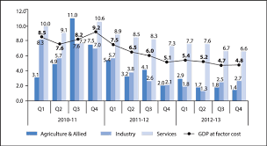
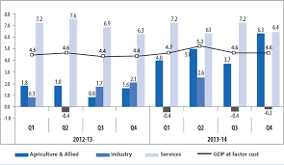
Justification
The financial accounting system is considered an act of recording system that records many financial transactions and financial events and financial statements for providing relevant information to the management department and leaders for enhancing the decision-making process to achieve the organizational goals. Managers keep the records of the various financial statements, including negotiations with the customers regarding the delivery and supply of different services and products. Financial accounting system also keeps a record for the financial statements and negotiations of organizational leaders and business machines, including the corporate leaders of Tata motors, while making logistics management and supply chain processes with the various national and international suppliers. Depending on these records, the managers and leaders of the organizations identify the major areas that need to be improved and developed for the achievements of the objectives and goals of the corporation. (Lepădatu, 2018)
The effect of management accounting systems on the performance of the company
The observations were made on the findings and also on the basis of determining the correlation among TATA MOTORS working capital management and performance. It is also analysed in the report how it took steps to improve the organization's profits level. The management accounting system, commonly known as managerial accounting, evaluates corporate activities in order to generate data, internal annual statements, to assist managers in reaching corporate objectives. The TATA MOTORS management accounting system gathers institutional data from multiple sources and makes it available towards the company's executives. This method aids TATA MOTORS in properly structuring decision problems including assigning alternative outcomes. Managers should concentrate on meeting standards in order to implement an accounting system throughout the organisation. The research article demonstrates the reality that government restrictions are expected to become harsher across periods, which might have a significant influence on the progress of the automobile sector. Therefore, management of TATA MOTORS would be able to determine whether one should remove or extend its product range and the performance reporting while using current methodology. The management accounting system also delivers sales and production statistics to TATA MOTORS managers who take appropriate decisions in response to the manufacturing situation. As a result, Tata Motors had already evolved into becoming the biggest automobile manufacturer in India presently.
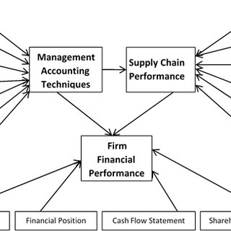

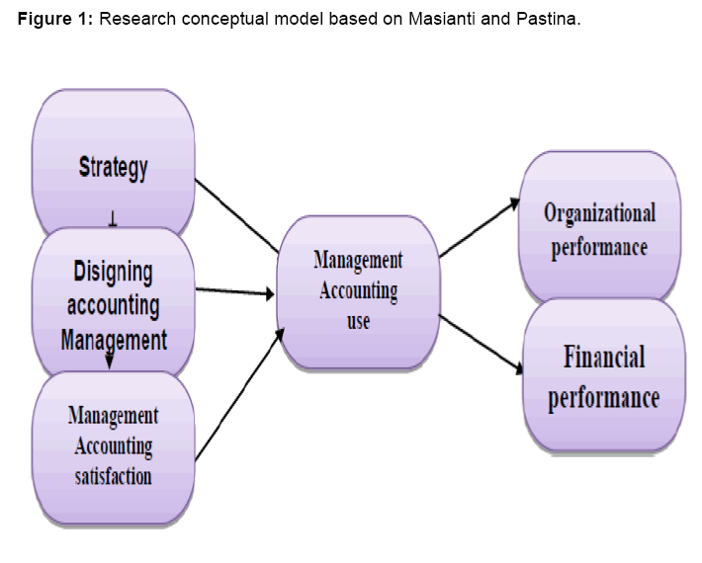

Justification
The management accounting system is approved to be a storehouse of a huge amount of collected information and data provided to analyse the process of implementing necessary alternatives, eliminating unnecessary alternatives, and getting help and support to attain the goals and objectives. By analysing this recorded information and data related to the locations, resources, organizational activities, and various documents, the managers can identify the weaknesses and unnecessary activities related to the organizational functions. Management leaders can get the necessary help and support to make wise decisions and implement effective strategies to eliminate the weak areas with strong alternatives that can help improve the organizational performance. (Hurloiu, Rusu and Hurloiu, 2018)
The similarities and differences among the responsibilities of Management accounting and Financial accounting systems of Tata Motors
Throughout the article provided, we could see a straight comprehension of the research as well as the key objective. We may deduce from facts that management accounting assists TATA MOTORS executives in making choices. Management accounting, often referred to as cost accounting, seems to be the method of recognizing, evaluating, understanding, and disseminating information to the managers in order to aid in the achievement of corporate objectives. It also aids in determining the relationship between collections and sales, along with providing suggestions including how to find the impact of receivables upon TATA MOTORS' operating resources. The similarities between such major accounting systems, both of which are regarded to be part of a larger data accounting system. Such data accounting systems will be in terms of dealing with economic trends that are critical to the organization's success. For both the accounting systems, Tata Motors defines the related spending using rupees. Above all, the research article demonstrates the much more practical solution for increasing the receivable status. The complete study outlines the many facets of receivables, which play an important role in TATA MOTORS' management process. It is also possible to argue that the exchange credit serves an important function throughout the market system since this serves mostly as a link between transportation arrangements within that sphere of encouraging individual productivity and output collection. The client, according to the TATA MOTORS research report, is the one who communicates to an organisation's purpose or capabilities. Differences begin when Financial accounting is defined as a procedure in documenting obligations, investments, expenditures, including earnings that are related only with current company activity, according to the description of management accounting. Management Accounting, on the other hand, refers to a combination of accounting software with statistical methods used by specific tools to create and understand data. The financial and management accounting platform's main significant function is to undertake a budget analysis to determine current expenditure and make recommendations for future operations. Users must make smarter, proof based judgments once management accounting process is finished with appropriate cost analysis.

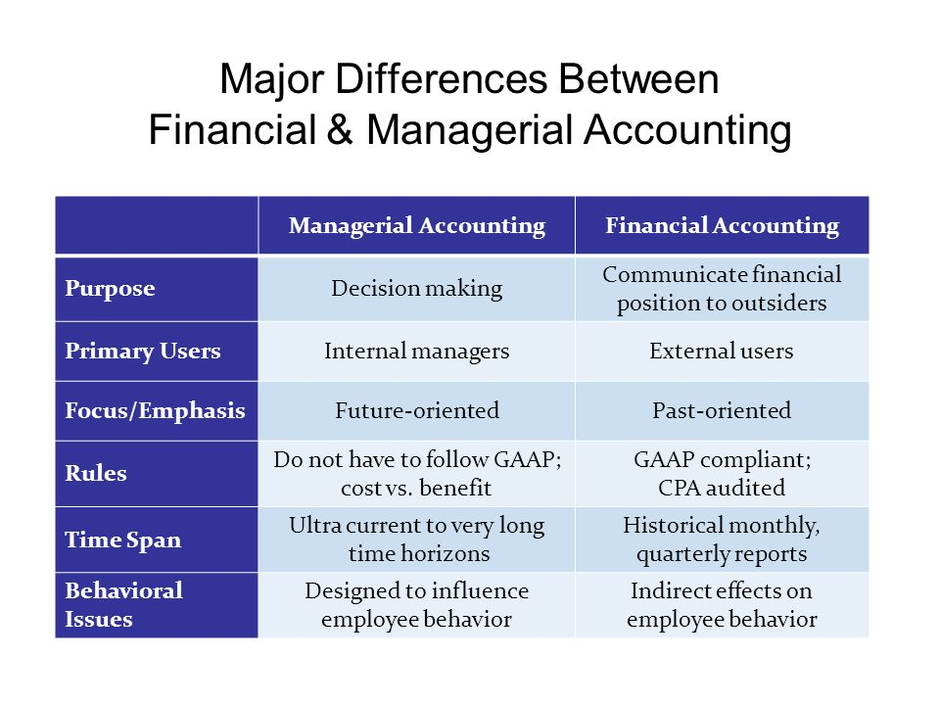
Justification
The accounting system provides relevant information and data to increase understanding of the major weaknesses and challenging areas and promote effective strategies for strengthening the weak areas. Management accounting provides information about the various activities related to the management department of the organization of Tata motors. Analysing the information about various company activities related to price, production, manufacturing, and cost provides help to achieve and attain the corporate goals and objectives. Management accounting is crucial for analysing the data to fix the future steps and activities of the company to attain the most desired outcomes and results with the help of the management accounting system.
As stated by Young, Cohen and Bens (2018), The financial accounting system provides relevant information and data about the financial statements to identify the areas where the major portion of the expenditure is performed and happened. By identifying These areas, the managers can make strategies and decisions to eliminate unnecessary costs and expenditures and provide aids to eliminate the unnecessary costs and expenditures and lead them towards more savings of the organization.
The importance of both accounting systems in the process of enhancing Tata Motors' strategic decisions
Based on the research findings of the future potentials, we can conclude that TATA MOTORS' financial accounting perspective will indeed be advantageous when it becomes sensitive to its consumers' needs for all goods. While supplying sales services, client complaints or difficulties are indeed resolved through analyst work including warranties, defective care and returning, client pays administration, including customer dissatisfaction or issues settlement. As a result, TATA MOTORS might gain advantage from the full Balanced Scorecard approach in making strategic decisions again for benefits of the company. From a management accounting standpoint, including a balance Credit card within TATA MOTORS' business strategy, that has Stirred proceed ones supply chain including the idea generation, operational procedure, and post-sale services rendered, would be useful. When it comes to creativity, TATA MOTORS' executives analyse their consumers' needs and develop products or services to fulfil those demands, all while adhering to a strategy solution that allows companies reach their objectives. Management processes, but in the other side, are used to create value through the distribution and production of current services and items to customers. Accounting is essential towards operating a company since it allows organizations to maintain revenues and expenses, maintain statutory compliance, as well as offer quantifiable financial investors with information, administration, and indeed the authorities which could be used to make strategic decisions.

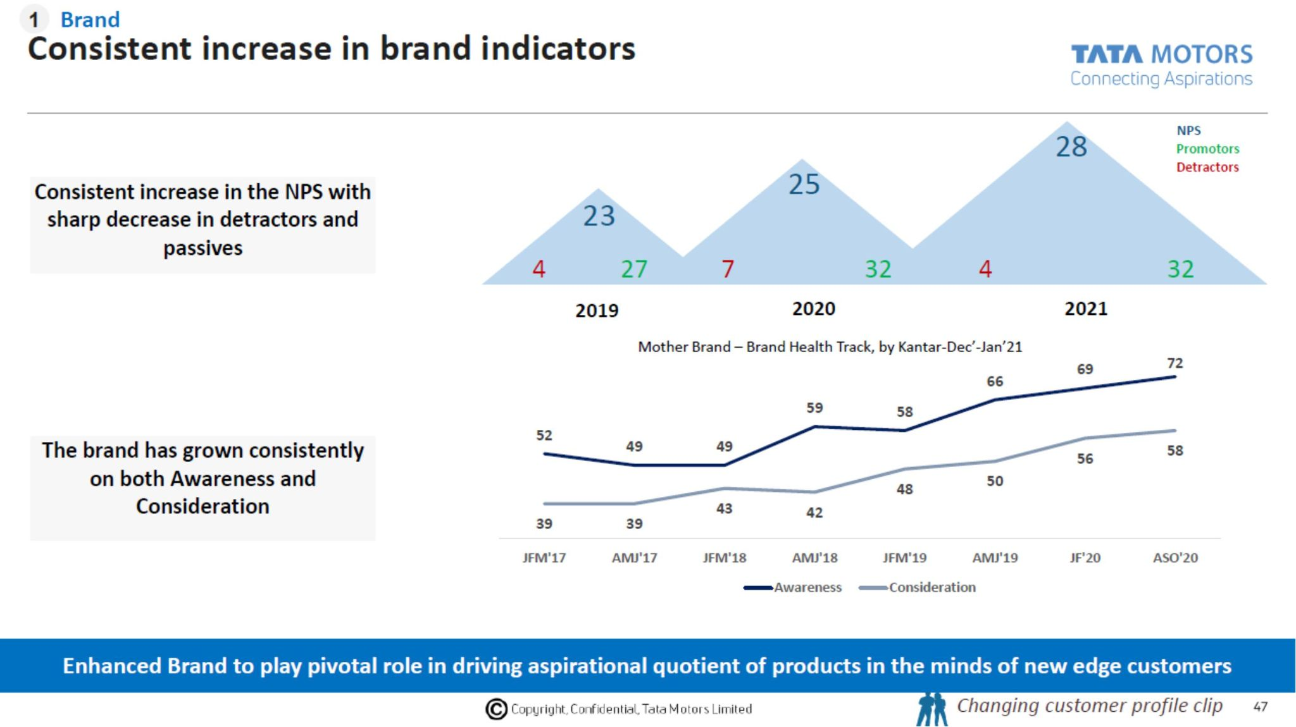
Justification
As defined by Mehta and Bhojwani (2020), the management accounting system plays a crucial role in the entire decision-making process of the company by making the strategic decisions more scientific and modern with the help of a multitude of information about the various alternatives and methods of revenue and cost. These wide ranges of processes and techniques suggested by the management accounting system provide information about making prices, eliminating unnecessary costs, and saving the costs for major organizational functions that are collected and analysed. This relevant information helps the accounting managers and leaders of the organization make sound decisions and create effective strategies to perform the major functional activities in the organization to enhance the performance rate and development. Qualitative information and data are also important for making such decisions and strategies and performing the management accounting system effectively and successfully. Using relevant to valued genuine and accountable information and data can help the leaders make effective strategies without getting distracted and interrupted by unnecessary conflicts.
According to Osadchy et al. (2018), the financial accounting system reviews the entire financial statement prospects and analyses the contents and the various structures of the financial statements. Analysing the financial statements with the management team can make effective decisions about the various financial statements whether to reduce unnecessary costs and create a budget. A manager also makes decisions in management teams operating financial accounting systems. The financial managers identify the various issues related to the financial statement of the organization. Identifying the major issues and challenges in the financial procedures, the managers can get the necessary help in bringing dynamics and making critical decisions by reviewing the information and data about the financial statements. Based on the research understanding stating the fact that with the help of accounting and financing management.
Summary
The organizations can create a work culture that is responsible for creating a long term impact on the growth and development value of the company (Zyznarska-Dworczak, 2018). However, the concluding statement is responsible for discussing the ways in which the identified threats like poor understanding of the system and process can be managed as well (Ozili, 2021). The better ethical implementation will be reducing the negative and poor threat for the project presentation it will be better the data and topic's value in a proper way (Caperchione et al. 2019). Furthermore, by implementing the used project theories and frameworks, the research result can be benefitted in an appropriate manner. Apart from this, another recommendation that can be made in the project is to select a topic more focused on one subject area rather than two as it will be stating the importance and role of one key area with clear efficiency that too without any gap in it. To manage the recommendation that can be used here is related to the enhancement of budget and time as both of these factors are responsible for creating an impact on the understanding of the topic. Furthermore, depending on the research presentation the increment budget, the attainment of better secondary sources will become easy (Allain, Lemaire and Lux, 2021). In contrast, the secondary sources access will be responsible for presenting a better and detailed topic understanding. Furthermore, an improved time limit for submitting the project will help similar projects to perform their tasks by taking plenty of time, which will further provide scope to enhancing or working on the identified loopholes as well. On the other hand, the limitation inability to understand ethical management, which can make a long term impact on the project presentation. Furthermore, in this case, the project budget was really low, which constrained the paper accessing different and needed sources and papers, which created an impact on the research result as well (Robson, Young and Power, 2017). On the other hand, the scope to learn about the topic along with the knowledge of ways that can be implemented in a clear manner in order to improve the topic’s efficiency within the work culture moreover, the limitations and its management will be presenting a better research value to the project as well (Warren, Jonick and Schneider, 2020). On the other hand, the scope of the project discusses the deliverables along with features, tasks, dealings, and deliverables will be presenting an idea about the ways in which future projects can attain their set aim and objectives as well.

Chapter 6: Conclusion

6.1 Conclusion
Depending on the understanding of the research presentation, it can be stated that in recent years the importance of both financial accounting and managerial accounting in the work culture cannot be ignored as both of these are responsible for creating a long term impact on the organization result (Pashayeva, 2020). The understanding of the ways in which the accounting values can be managed is well defined in the project too.
Apart from this, the entire research presentation has followed a precise method to present an accurate research result; moreover, it has used a particular stage analysis too that has helped the project attain its result in a precise manner (Narayanaswamy, 2017). For example, the paper stated the fact that in 6 different stages, the understanding of set aim and objective has been attained. Furthermore, the introduction section presented a basic and detailed knowledge of the aim and objective and also discussed the set aim and objectives for the project. At the same time, the literature review is responsible for defining the topic with different perspectives yet interlinked journals and articles, along with the presentation of methodology, which described different methods which have helped the project attain the set aims and objectives (Hlaciuc et al. 2017). On the other hand, the data analysis section evaluated the collected data and information with proper analysis tools; apart from this, the findings provided solutions to deal with the identified issues related to the selected topic. Furthermore, the conclusion section here is providing the final points related to the project. It provides a detailed understanding of the ways in which the future of similar projects can be driven in a proper way.

6.2 Recommendations
Based on the understanding of the research project, it can be stated that there are different recommendations that can be mentioned in the presentation, and based on the solutions, the future of research solutions will become an easy task to perform as well.
Another recommendation regarding time enhancement can be stated that it will be able to access a better number of participants as well who will be creating a positive impact on the entire result value for the project.

6.3 Limitations
The limitations related to the entire project are related to the fact of insufficient budget and time allocation, which created an impact on the result. The primary sources have limitations in them as well as in this case the participants are bounded with various policies and rules which creates a bias point of view towards their responses (Rikhardsson and Yigitbasioglu, 2018).
On the other hand, the insufficient time allocated for each task gave no time to work on any loopholes as rereading the result was unable to do due to the fact it has no time before the deadline the tight schedule impacted the project in a defective manner.
Apart from these, there are a few other constraints related to the project that can be defined too, such as quality as due to insufficient time checking the work before submitting was unable to perform which might have created an impact on the quality of the outcome; moreover, the quality was comprised by keeping an insufficient project budget at well.

6.4 Future Scope
The main scope related to the project is twill by helping similar projects to avoid the mistakes made in the project to present a better understanding of the topic. Apart from this, the theoretical implementation of the related framework can be performed in a better way in order to provide a detailed understanding of the selected topic in the future as well.

References
- Ahmadzai, S., 2020. Report on Tata Group and Its Growth Strategies.https://www.academia.edu/download/57197372/Report_On_Tata_Group_Growth_Strategies.pdf
- Akhtar, D.M.I., 2016. Research design. Research Design (February 1, 2016). https://papers.ssrn.com/sol3/papers.cfm?abstract_id=2862445
- Allain, E., Lemaire, C. and Lux, G., 2021. Managers' subtle resistance to neoliberal reforms through and by means of management accounting. Accounting, Auditing & Accountability Journal. https://www.emerald.com/insight/content/doi/10.1108/AAAJ-12-2018-3799/full/html
- Amanda, R.I., 2019. The Impact of Cash Turnover, Receivable Turnover, Inventory Turnover, Current Ratio and Debt to Equity Ratio on Profitability. Journal of research in management, 2(2).https://pdfs.semanticscholar.org/8665/844b09d9758fd638a5f3ee63312502b1ebfd.pdf
- Ameen, A.M., Ahmed, M.F. and Abd Hafez, M.A., 2018. The Impact of Management Accounting and How It Can Be Implemented into the Organizational Culture. Dutch Journal of Finance and Management, 2(1), p.02.https://www.djfm-journal.com/article/the-impact-of-management-accounting-and-how-it-can-be-implemented-into-the-organizational-culture
- Ameen, A.M., Ahmed, M.F. and Abd Hafez, M.A., 2018. The Impact of Management Accounting and How It Can Be Implemented into the Organizational Culture. Dutch Journal of Finance and Management, 2(1), p.02. https://www.djfm-journal.com/article/the-impact-of-management-accounting-and-how-it-can-be-implemented-into-the-organizational-culture
- Ameen, A.M., Ahmed, M.F. and Abd Hafez, M.A., 2018. The Impact of Management Accounting and How It Can Be Implemented into the Organizational Culture. Dutch Journal of Finance and Management, 2(1), p.02.https://www.djfm-journal.com/article/the-impact-of-management-accounting-and-how-it-can-be-implemented-into-the-organizational-culture
- Asare, N., Alhassan, A.L., Asamoah, M.E. and Ntow-Gyamfi, M., 2017. Intellectual capital and profitability in an emerging insurance market. Journal of Economic and Administrative Sciences.https://www.emerald.com/insight/content/doi/10.1108/JEAS-06-2016-0016/full/html
- Ax, C. and Greve, J., 2017. Adoption of management accounting innovations: Organizational culture compatibility and perceived outcomes. Management Accounting Research, 34, pp.59-74.https://www.sciencedirect.com/science/article/pii/S1044500516300427
- Ayuba, H., Bambale, A.J.A., Ibrahim, M.A. and Sulaiman, S.A., 2019. Effects of Financial Performance, Capital Structure and Firm Size on Firms' Value of Insurance Companies in Nigeria. Journal of Finance, Accounting & Management, 10(1).http://search.ebscohost.com/login.aspx?direct=true&profile=ehost&scope=site&authtype=crawler&jrnl=21532818&AN=136487068&h=rDwYP3q%2BjxBnGcKfjUffkWPdYZIhFF8NaitA6VQNimn0S6%2FITg%2FectVfpBVFrkrsZmhzPfoT%2Fw0de6lsCG96VQ%3D%3D&crl=c
- Azudin, A. and Mansor, N., 2018. Management accounting practices of SMEs: The impact of organizational DNA, business potential and operational technology. Asia Pacific Management Review, 23(3), pp.222-226. https://www.sciencedirect.com/science/article/pii/S1029313216300148
- Beerbaum, D., 2020. Benchmarking and best-practice analysis in Financial Accounting–the case of Related Party Disclosures. Journal of Applied Research in the Digital Economy (JADE).https://www.researchgate.net/profile/Dirk_Beerbaum/project/Benchmarking-in-Financial-Accounting-The-case-of-the-Financial-crisis/attachment/5b0b246fb53d2f63c3ce6b11/AS:631014040797184@1527456879441/download/Benchmarking_best+practice+analysis_DRAFT_27052018.pdf?context=projectUpdatesLog
- Beerbaum, D., 2021. Benchmarking and Accounting-a field study. Available at SSRN 3824291.https://www.researchgate.net/profile/Dirk_Beerbaum/publication/342313653_Benchmarking_and_Accounting_-_a_field_study/links/5eecce7192851ce9e7f0be67/Benchmarking-and-Accounting-a-field-study.pdf
- Beerbaum, D., 2021. Benchmarking and Accounting-a field study. Available at SSRN 3824291.https://www.researchgate.net/profile/Dirk_Beerbaum/publication/342313653_Benchmarking_and_Accounting_-_a_field_study/links/5eecce7192851ce9e7f0be67/Benchmarking-and-Accounting-a-field-study.pdf
- Brannen, J. ed., 2017. Mixing methods: Qualitative and quantitative research. Routledge. https://books.google.com/books?hl=en&lr=&id=YSIuDwAAQBAJ&oi=fnd&pg=PT6&dq=qualitative+and+quantitative+strategy+&ots=rTU-LeUiI-&sig=MirIbHhu5WEPDBH5oViJRtusIAc
- Breuer, H. and Upadrasta, V., 2017. Values-based product innovation–The case of Tata Nano. Breuer, H. &Upadrasta, 2017.
- Caperchione, E., Cohen, S., Manes-Rossi, F. and Brusca, I., 2019. Innovations in public sector financial and management accounting—for better or worse?. https://www.tandfonline.com/doi/abs/10.1080/09540962.2019.1583906
- Choudhari, A.A. and Jagnade, M.S., 2018. The Analysis of Financial Operations of Tata Motors, Pune Plant. Business Strategies, p.42.
- Choudhari, A.A. and Jagnade, M.S., 2018. The Analysis of Financial Operations of Tata Motors, Pune Plant. Business Strategies, p.42.https://asmbusinessreview.in/wp-content/uploads/2019/07/ASM-Business-Review-July-2019.pdf#page=42
- Choudhari, A.A. and Jagnade, M.S., 2018. The Analysis of Financial Operations of Tata Motors, Pune Plant. Business Strategies, p.42. https://asmbusinessreview.in/wp-content/uploads/2019/07/ASM-Business-Review-July-2019.pdf#page=42
- da Silva, C.S.R., 2017. Research design-the new perspective of research methodology. Journal of Education, Society and Behavioural Science, pp.1-12. http://journaljesbs.com/index.php/JESBS/article/view/16285
- Dewi, M.K. and Meirina, E., 2020. EFFECT OF TOTAL QUALITY MANAGEMENT AND JUST IN TIME ON PRODUCTION COST EFFICIENCY IN PT SEMEN PADANG. Jurnal Manajemen dan Bisnis, 9(2), pp.114-124.https://journal.stieindragiri.ac.id/index.php/jmbi/article/view/201
- Dokania, H., 2019. What makes Variation in Investment Decisions in Similar Firms: A Materiality Perspective (Doctoral dissertation, Concordia University).https://spectrum.library.concordia.ca/985880/
- Doktoralina, C. and Apollo, A., 2019. The contribution of strategic management accounting in supply chain outcomes and logistic firm profitability. Uncertain Supply Chain Management, 7(2), pp.145-156.http://m.growingscience.com/beta/uscm/2965-the-contribution-of-strategic-management-accounting-in-supply-chain-outcomes-and-logistic-firm-profitability.html
- Doktoralina, C. and Apollo, A., 2019. The contribution of strategic management accounting in supply chain outcomes and logistic firm profitability. Uncertain Supply Chain Management, 7(2), pp.145-156. http://m.growingscience.com/beta/uscm/2965-the-contribution-of-strategic-management-accounting-in-supply-chain-outcomes-and-logistic-firm-profitability.html
- Goel, M., 2021. A CRITICAL APPRAISAL OF CORPORATE SOCIAL REPORTING DISCLOSURE PRACTICES IN INDIA AND ITS IMPACT ON FINANCIAL PERFORMANCE.https://shodhgangotri.inflibnet.ac.in/jspui/bitstream/123456789/9100/1/synopsis.pdf
- Goel, M., 2021. A CRITICAL APPRAISAL OF CORPORATE SOCIAL REPORTING DISCLOSURE PRACTICES IN INDIA AND ITS IMPACT ON FINANCIAL PERFORMANCE.https://shodhgangotri.inflibnet.ac.in/jspui/bitstream/123456789/9100/1/synopsis.pdf
- Hassan, M. and Shrivastava, S.K., 2019. Working Capital Management and Its Impact on the Profitability of Tata Motors. In Proceedings of 10th International Conference on Digital Strategies for Organizational Success.
- Hassan, M. and Shrivastava, S.K., 2019. Working Capital Management and Its Impact on the Profitability of Tata Motors. In Proceedings of 10th International Conference on Digital Strategies for Organizational Success.
- Heale, R. and Twycross, A., 2015. Validity and reliability in quantitative studies. Evidence-based nursing, 18(3), pp.66-67. https://ebn.bmj.com/content/18/3/66.short
- Hirdinis, M., 2019. Capital structure and firm size on firm value moderated by profitability.https://www.um.edu.mt/library/oar/handle/123456789/43966
- Hlaciuc, E., Vultur, P., Cretu, F. and Ailoaiei, R., 2017. The interface between financial and management accounting. The USV Annals of Economics and Public Administration, 17(2 (26)), pp.103-110. http://annals.seap.usv.ro/index.php/annals/article/viewArticle/983
- Hurloiu, L., Rusu, B. and Hurloiu, I.I., 2018. Modern perspectives of financial management accounting approach in the current economy. EcoSoEn, (1-2), pp.81-86.https://ibn.idsi.md/vizualizare_articol/68868
- Husnain, M., Anwar, M.M., Hameed, F. and Khan, M.T., 2021. Corporate governance characteristics and firm profitability: empirical evidence from emerging equity market. International Journal of Management (IJM), 12(3).https://www.researchgate.net/profile/Muhammad-Khan-1119/publication/350133748_Article_ID_IJM_12_03_014_Corporate_Governance_Characteristics_and_Firm_Profitability_Empirical_Evidence_from_Emerging_Equity_Market/links/60531f9592851cd8ce4bde64/Article-ID-IJM-12-03-014-Corporate-Governance-Characteristics-and-Firm-Profitability-Empirical-Evidence-from-Emerging-Equity-Market.pdf
- Ishanka, S. and Gooneratne, T., 2018. Total quality management and changes in management accounting systems in a manufacturing firm: A case study. Asia-Pacific Management Accounting Journal, 13(1), pp.45-75.http://arionline.uitm.edu.my/ojs/index.php/APMAJ/article/view/685
- Junaidi, M.H., Customer Satisfaction on Supply Chain Management Practices: A Study of Toyota and Tata Motors in Kingdom of Saudi Arabia.https://core.ac.uk/download/pdf/234627689.pdf
- Junaidi, M.H., Customer Satisfaction on Supply Chain Management Practices: A Study of Toyota and Tata Motors in Kingdom of Saudi Arabia.https://core.ac.uk/download/pdf/234627689.pdf.
- Junaidi, M.H., Customer Satisfaction on Supply Chain Management Practices: A Study of Toyota and Tata Motors in Kingdom of Saudi Arabia.https://core.ac.uk/download/pdf/234627689.pdf
- Kamran, Q.M., Indian Automobile Industry: A Study on the Financial Performance of selected Automobile Manufacturers.https://rrjournals.com/wp-content/uploads/2020/09/123-126_RRIJM200508029.pdf
- Karabag, S.F., Borah, D.J. and Berggren, C., 2018. Separation or integration for successful acquisition? A comparative study of established and emerging economies’ firms. Journal of Applied Economics and Business Research, 8(1), pp.1-23.https://pdfs.semanticscholar.org/ba3a/2f6ae32e09c6e2a5a5379b2f32c501c8d827.pdf
- Kesumawati, N.K.A., Putri, I.M.A.D. and Dwirandra, A.A.N.B., 2019. The role of business strategies, environmental uncertainty and decentralization as moderating the effect of management accounting systems on managerial performance. International Research Journal of Management, IT and Social Sciences, 6(3), pp.37-45.
- Khuntia, J., Kathuria, A., Rojas, M.A., Saldanha, T. and Celly, N., 2021. How Foreign and Domestic Firms Differ in Leveraging IT-enabled Supply Chain Information Integration in BOP Markets: The Role of Supplier and Client Business Collaboration. Journal of the Association for Information Systems.https://www.researchgate.net/profile/Abhishek-Kathuria-2/publication/344729637_How_Foreign_and_Domestic_Firms_Differ_in_Leveraging_IT-enabled_Supply_Chain_Information_Integration_in_BOP_Markets_The_Role_of_Supplier_and_Client_Business_Collaboration/links/601e912f458515893984f479/How-Foreign-and-Domestic-Firms-Differ-in-Leveraging-IT-enabled-Supply-Chain-Information-Integration-in-BOP-Markets-The-Role-of-Supplier-and-Client-Business-Collaboration.pdf
- Kumar, R., 2018. Research methodology: A step-by-step guide for beginners. Sage. https://books.google.com/books?hl=en&lr=&id=J2J7DwAAQBAJ&oi=fnd&pg=PP1&dq=research+methodology+&ots=cvngFBRHji&sig=UNV-2sROjlFyodyG1kM_m_ptcvE
- Labunska, S., Petrova, M. and Prokopishyna, O., 2017. Asset and cost management for innovation activity. Economic annals-XXI, (165), pp.13-18.http://www.irbis-nbuv.gov.ua/cgi-bin/irbis_nbuv/cgiirbis_64.exe?C21COM=2&I21DBN=UJRN&P21DBN=UJRN&IMAGE_FILE_DOWNLOAD=1&Image_file_name=PDF/ecchado_2017_165_4.pdf
- Lepădatu, G., 2018. PRAGMATISM OF THE ACCOUNT INFORMATION, UNDER APPLICATION OF INTERNATIONAL FINANCIAL REPORTING STANDARDS. Knowledge Horizons. Economics, 10(1), pp.12-16.https://orizonturi.ucdc.ro/arhiva/KHE%20nr.%201%20-%202018/2.%20PRAGMATISM%20OF%20THE%20ACCOUNT%20INFORMATION.pdf
- Machado, M.J.C.V. and Alves, P.C.R., 2017. Quality in management accounting: approach by activities in large companies. International Journal of Productivity and Quality Management, 21(3), pp.392-409.https://www.inderscienceonline.com/doi/abs/10.1504/IJPQM.2017.084463
- MEGHANA, M., ALI, S.S. and VEERAIAH, D., 2020. A STUDY ON ACCOUNTS RECEIVABLE MANAGEMENT OF TATA MOTORS.
- MEGHANA, M., ALI, S.S. and VEERAIAH, D., A STUDY ON ACCOUNTS RECEIVABLE MANAGEMENT OF TATA MOTORS.http://shabdbooks.com/gallery/510-june2020.pdf
- MEGHANA, M., ALI, S.S. and VEERAIAH, D., A STUDY ON ACCOUNTS RECEIVABLE MANAGEMENT OF TATA MOTORS.http://shabdbooks.com/gallery/510-june2020.pdf
- MEGHANA, M., ALI, S.S. and VEERAIAH, D., A STUDY ON ACCOUNTS RECEIVABLE MANAGEMENT OF TATA MOTORS.http://shabdbooks.com/gallery/510-june2020.pdf
- Mehta, P. and Bhojwani, M., 2020. Paradigm shift in the management accounting practices in India. RVIM Journalof Management Research, 12(1), pp.15-24.https://rvim.edu.in/wp-content/uploads/2020/09/jan-june-2020.pdf#page=16
- Mishra, A., Khadse, M.A. and Srivastava, S.K., 2021. Tata Motors Marketing Strategies in Automobile Industries in India: A Study. Psychology and Education Journal, 58(1), pp.5836-5844.
- Mishra, A., Khadse, M.A. and Srivastava, S.K., 2021. Tata Motors Marketing Strategies in Automobile Industries in India: A Study. Psychology and Education Journal, 58(1), pp.5836-5844.http://psychologyandeducation.net/pae/index.php/pae/article/view/3658
- Mishra, S.B. and Alok, S., 2017. Handbook of research methodology. http://www.nkrgacw.org/nkr%20econtent/nutrition%20and%20dietetics/PG/II.M.Sc%20N&D/BookResearchMethodology.pdf
- Murdayanti, Y. and Purwohedi, U., 2018. The Usefulness of Financial Accounting Systems in Islamic Education Institutions: Lessons Learned. Academy of Accounting and Financial Studies Journal, 22(3), pp.1-14.http://sipeg.unj.ac.id/repository/upload/jurnal/THE_USEFULNESS_OF_FINANCIAL_ACCOUNTING.pdf
- NAGTILAK, D.A. and KADAM, Y.J., TO STUDY EXPENDITURE ON HUMAN RESOURCES OF TATA MOTORS FROM 2010 TO 2019.https://www.academia.edu/download/62176197/15_Nagtilak___Kadam20200223-78243-o914c0.pdf
- Narayanaswamy, R., 2017. Financial accounting: a managerial perspective. PHI Learning Pvt. Ltd.. https://books.google.com/books?hl=en&lr=&id=0yYrDwAAQBAJ&oi=fnd&pg=PP1&dq=FINANCIAL++ACCOUNTING&ots=Vw6mZBrOI4&sig=JBH_7l_iGO4hMDyGVsf6hT4G4PQ
- Narwane, V.S., Raut, R.D., Mangla, S.K., Gardas, B.B., Narkhede, B.E., Awasthi, A. and Priyadarshinee, P., 2020. Mediating role of cloud of things in improving performance of small and medium enterprises in the Indian context. Annals of Operations Research, pp.1-30. https://link.springer.com/article/10.1007/s10479-019-03502-w
- Nath, K. and Dwivedi, R., 2021. Aesthetic Exploration of Organizational Theatrics: a Case of Tata Motors’ Jaguar Land Rover Acquisition. Philosophy of Management, pp.1-18.https://link.springer.com/article/10.1007/s40926-020-00160-y
- Nath, K. and Dwivedi, R., 2021. Aesthetic Exploration of Organizational Theatrics: a Case of Tata Motors’ Jaguar Land Rover Acquisition. Philosophy of Management, pp.1-18.https://link.springer.com/article/10.1007/s40926-020-00160-y
- Nath, K. and Dwivedi, R., Aesthetic Exploration of Organizational Theatrics: a Case of Tata Motors’ Jaguar Land Rover Acquisition. Philosophy of Management, pp.1-18.https://link.springer.com/article/10.1007/s40926-020-00160-y
- Novas, J.C., Alves, M.D.C.G. and Sousa, A., 2017. The role of management accounting systems in the development of intellectual capital. Journal of Intellectual Capital.https://www.emerald.com/insight/content/doi/10.1108/JIC-08-2016-0079/full/html
- Novas, J.C., Alves, M.D.C.G. and Sousa, A., 2017. The role of management accounting systems in the development of intellectual capital. Journal of Intellectual Capital.https://www.emerald.com/insight/content/doi/10.1108/JIC-08-2016-0079/full/html
- Osadchy, E.A., Akhmetshin, E.M., Amirova, E.F., Bochkareva, T.N., Gazizyanova, Y. and Yumashev, A.V., 2018. Financial statements of a company as an information base for decision-making in a transforming economy.https://www.um.edu.mt/library/oar/handle/123456789/33582
- Ozili, P.K., 2021. Accounting and financial reporting during a pandemic. In New Challenges for Future Sustainability and Wellbeing. Emerald Publishing Limited. https://www.emerald.com/insight/content/doi/10.1108/978-1-80043-968-920211005/full/html
- Pasch, T., 2019. Strategy and innovation: the mediating role of management accountants and management accounting systems’ use. Journal of Management Control, 30(2), pp.213-246. https://link.springer.com/article/10.1007/s00187-019-00283-y
- Pashayeva, I., 2020. MANAGEMENT ACCOUNTING SYSTEM IN HIGHER EDUCATION AND ITS DISTINCTIVE FEATURES FROM FINANCIAL ACCOUNTING. Economic and Social Development: Book of Proceedings, 3, pp.724-727. https://www.researchgate.net/profile/Samira_Abasova3/publication/344229164_Influence_of_innovative_development_factors_to_improve_human_capital_in_Azerbaijan/links/5f5e62ba299bf1d43c01b8f4/Influence-of-innovative-development-factors-to-improve-human-capital-in-Azerbaijan.pdf#page=735
- Patjoshi, P.K., Liquidity Management and Financial Performance A Case Study of Tata Steel. https://www.researchgate.net/profile/Pramod_Patjoshi/publication/333395600_Liquidity_Management_and_Financial_Performance_A_Case_Study_of_Tata_Steel/links/5ceccdeda6fdcc18c8e74589/Liquidity-Management-and-Financial-Performance-A-Case-Study-of-Tata-Steel.pdf
- Pavlatos, O. and Kostakis, X., 2018. The impact of top management team characteristics and historical financial performance on strategic management accounting. Journal of Accounting & Organizational Change.
- PHORNLAPHATRACHAKORN, K. and NA-KALASINDHU, K., 2020. Strategic management accounting and firm performance: Evidence from finance businesses in Thailand. The Journal of Asian Finance, Economics, and Business, 7(8), pp.309-321.https://www.koreascience.or.kr/article/JAKO202026061031640.page
- Ragab, M.A. and Arisha, A., 2018. Research methodology in business: A starter’s guide. Management and Organizational Studies, 5(1), pp.1-14. https://www.researchgate.net/profile/Mohamed_Ragab7/publication/321769066_Research_Methodology_in_Business_A_Starter's_Guide/links/5a311456aca2724bf72185bf/Research-Methodology-in-Business-A-Starters-Guide.pdf
- Raj, V., 2020. Project of Functional Analysis in ERP Implementation in TATA MOTORS (Doctoral dissertation, InstytutOrganizacjiSystemówProdukcyjnych). http://repo.pw.edu.pl/info/master/WUT9e4b8ae3ea944faba2841f8e7ebf8418/
- Raj, V., 2020. Project of Functional Analysis in ERP Implementation in TATA MOTORS (Doctoral dissertation, Instytut Organizacji Systemów Produkcyjnych).http://repo.pw.edu.pl/info/master/WUT9e4b8ae3ea944faba2841f8e7ebf8418/
- Raj, V., 2020. Project of Functional Analysis in ERP Implementation in TATA MOTORS (Doctoral dissertation, InstytutOrganizacjiSystemówProdukcyjnych).
- Richardson, A.J., 2017. The Relationship between Management and Financial Accounting as Professions and Technologies of Practice. The Role of the Management Accountant: Local Variations and Global Influences. https://books.google.com/books?hl=en&lr=&id=CnE3DwAAQBAJ&oi=fnd&pg=PT287&dq=MANAGEMENT+ACCOUNTING+AND+FINANCIAL++ACCOUNTING&ots=MZCgoRrUkM&sig=p3pFtRExgzK-QQlwpRl20f2Vis0
- Rikhardsson, P. and Yigitbasioglu, O., 2018. Business intelligence & analytics in management accounting research: Status and future focus. International Journal of Accounting Information Systems, 29, pp.37-58. https://www.sciencedirect.com/science/article/pii/S1467089516300616
- Roberts, L.D. and Allen, P.J., 2015. Exploring ethical issues associated with using online surveys in educational research. Educational Research and Evaluation, 21(2), pp.95-108. https://www.tandfonline.com/doi/abs/10.1080/13803611.2015.1024421
- Robson, K., Young, J. and Power, M., 2017. Themed section on financial accounting as social and organizational practice: exploring the work of financial reporting. Accounting, Organizations and Society, 56, pp.35-37. http://eprints.lse.ac.uk/69822/1/Power_Themed%20section.pdf
- Romashko, O. and Dovgopol, I., 2020. THE" JUST IN TIME" METHOD IN STRATEGIC MANAGEMENT ACCOUNTING. Economics, Business and Social Sciences, p.82.http://conferencii.com/files/archive/2020-12.pdf#page=82
- Sahay, A., 2016. Peeling Saunder's research onion. Research Gate, Art, pp.1-5. https://www.researchgate.net/profile/Arunaditya-Sahay/publication/309488459_Peeling_Saunder's_Research_Onion/links/5813283508aedc7d89609ea8/Peeling-Saunders-Research-Onion.pdf
- Sedevich-Fons, L., 2018. Linking strategic management accounting and quality management systems. Business Process Management Journal.https://www.emerald.com/insight/content/doi/10.1108/BPMJ-02-2018-0038/full/html
- Simlai, D. and Guha, M., 2019. FINANCIAL STABILITY, PROFITABILITY AND GROWTH ANALYSIS: A STUDY ON SELECT INDIAN AUTOMOBILE COMPANIES. Journal of Commerce & Accounting Research, 8(1).https://www.academia.edu/download/63168759/Financial_Stability__Profitability_and_Growth_Analysis_-_A_Study_on_Select_Indian20200501-80646-zpjmd.pdf
- Singh, R. and Srivastava, S.K., 2019. Implementation of IFRS as Indian Accounting Standard for Similarity in Financial Reporting in India: Challenges & Benefits. American Journal of Theoretical and Applied Business, 5(4), pp.90-96. https://www.researchgate.net/profile/Ram_Singh18/publication/336716822_Implementation_of_IFRS_as_Indian_Accounting_Standard_for_Similarity_in_Financial_Reporting_in_India_Challenges_Benefits/links/5daea1e4299bf111d4bfa533/Implementation-of-IFRS-as-Indian-Accounting-Standard-for-Similarity-in-Financial-Reporting-in-India-Challenges-Benefits.pdf
- Snehvrat, S. and Dutta, S., 2018. Multi-level ambidexterity in new product introduction at Tata Motors, India: The role of metaroutines. Journal of Organizational Effectiveness: People and Performance.https://www.emerald.com/insight/content/doi/10.1108/JOEPP-07-2017-0062/full/html
- Snyder, H., 2019. Literature review as a research methodology: An overview and guidelines. Journal of Business Research, 104, pp.333-339. https://www.sciencedirect.com/science/article/pii/S0148296319304564
- Sohrabi, M., 2017. The Relationship between Non-Financial Innovative Management Accounting Tools and Risk and Return of Iranian Stock Market Listed Companies. Dutch Journal of Finance and Management, 1(2), p.40.
- Som, B.K. and Goel, H., Ratio Analysis: A Study on Financial Performance of Tata Motors.https://www.lloydbusinessschool.edu.in/Research-Publication/pdf/complete-paper-himanshu-goel-1-3-2021.pdf
- Teru, S.P., Idoku, I. and Ndeyati, J.T., 2017. A review of the impact of accounting information system for effective internal control on firm performance. Indian Journal of Finance and Banking, 1(2), pp.52-59.
- Thenikusuma, K. and Muis, N., 2019. The Effect of Implementation Regional Financial Accounting System, Human Resource Competency and Infrastructure Facilities to the Quality of Financial Report. Human Resource Competency and Infrastructure Facilities to the Quality of Financial Report (January 10, 2019).https://papers.ssrn.com/sol3/papers.cfm?abstract_id=3313401
- Usenko, L.N., Bogataya, I.N., Bukhov, N.V., Kuvaldina, T.B. and Pavlyuk, A.V., 2018. Formation of an integrated accounting and analytical management system for value analysis purposes.
- Warren, C.S., Jonick, C. and Schneider, J., 2020. Financial accounting. Cengage Learning. https://books.google.com/books?hl=en&lr=&id=zW7LDwAAQBAJ&oi=fnd&pg=PP1&dq=FINANCIAL++ACCOUNTING&ots=DZB77h8rB7&sig=ZwbRdFRefUz_kwZ-Y279x1kYl7o
- Wu, Y. and Wang, X., 2020, February. Application of blockchain technology in the integration of management accounting and financial accounting. In The International Conference on Cyber Security Intelligence and Analytics (pp. 26-34). Springer, Cham. https://link.springer.com/chapter/10.1007/978-3-030-43309-3_4
- Yadav, T.R. and Singh, J.P., 2020. Impact of Working Capital Management on Profitability: A Case Study of Tata Motors Ltd.
- Young, S.D., Cohen, J. and Bens, D.A., 2018. Corporate Financial Reporting and Analysis: A Global Perspective. John Wiley & Sons.https://books.google.co.uk/books?hl=en&lr=&id=JHpyDwAAQBAJ&oi=fnd&pg=PA1&dq=financial+reporting+and+analysis&ots=tEk4TnnM-S&sig=kX8GVrUL6XAizLsGNrKwddJwtZs
- Yunis, M., Tarhini, A. and Kassar, A., 2018. The role of ICT and innovation in enhancing organizational performance: The catalysing effect of corporate entrepreneurship. Journal of Business Research, 88, pp.344-356.https://www.sciencedirect.com/science/article/pii/S0148296317305246
- Zhang, H., Song, M., Yang, X. and Li, P., 2020. What are Important Technologies for Sustainable Development in the Trucking Industries of Emerging Markets? Differences between Organizational and Individual Buyers. Sustainability, 12(1), p.224. https://www.mdpi.com/2071-1050/12/1/224
- Zyznarska-Dworczak, B., 2018. The development perspectives of sustainable management accounting in central and Eastern European countries. Sustainability, 10(5), p.1445. https://www.mdpi.com/2071-1050/10/5/1445

