STRATEGIC PROCUREMENT OF
PHARMACEUTICAL INDUSTRIES

Abstract
Procurement is an integral process with the pharmaceutical industry and is required to meet up the organizational goals. Considering the need for procurement integration within the pharmaceutical industry, the companies aim at integrating the essentials of technological innovations to substantiate the process of procurement and strategic sourcing. The current research paper aimed at unfurling the complications of global procurement strategies and processes within the pharmaceutical industry. The literature review of the research includes information about the challenges and solutions of strategic sourcing in the pharmaceutical industry. The study follows a mixed method of analysis by conducting survey questions and interviews on the selected samples, who belong to the pharmaceutical sector. The findings of the study show that there has been manifold variations and innovation within the pharmaceutical sector. The challenges include issues of illegal trading of unauthorized drugs, shortages in drug supplies due to the decisions of the manufacturers, and decentralization of the supply chain and procurement process, and lack of adequate visibility. The possible solutions include recommendations to integrate disruptive technologies of RFID for greater visibility and centralization of the supply chain and sourcing process.

Acknowledgement
This dissertation is dedicated to all the people who were involved from the beginning until the end. First, I wish to express my deepest appreciation and gratitude to my thesis supervisor for his guidance and insights throughout the study. I would like to thank all my lecturers and the course coordinators in making my time throughout the curriculum so valuable and enjoyable. I would like to sincerely thank all generous industry professionals who involved in my research and made the collection of primary data possible. Your knowledge, experience and devoted time were much appreciated. Finally, I would like to thank all my family members and friends for their constant encouragement, patience and support throughout the course of study and research. I would like to express my gratitude by thanking by supervisor, mentor, friends and family members to support in completing this particular research paper. Further, I will say that I have gained proper knowledge and this research will also help me in future to complete similar projects.
Thank you

Declaration
I solemnly declare that this is my own work and I have maintained proper academic conditions. This research work has been used for only academic purpose. I have considered all the academic guidelines. Furthermore, the research content is authentic and reliable. I also certify that I have not copied in part or whole or otherwise plagiarized the work of anyone else, including other students.

Table of Contents
Chapter 1: Introduction 7
1.1 Introduction 7
1.2 Background of the study 7
1.3 Rationale of the study 8
1.3.1 What is the issue? 8
1.3.2 Why is it an issue? 8
1.3.3 Why is it an issue now? 9
1.3.4 What this research shed light upon? 9
1.4 Research Aim 9
1.5 Research Objectives 9
1.6 Research Questions 10
1.7 Significance of the study 10
1.8 Structure of the research 11
1.9 Summary 11
Chapter 2: Literature Review 13
2.1 Introduction 13
2.2 Empirical Research 13
2.3 Research Gap Analysis 13
2.4 Digitization of procurement channel in pharmaceutical industries 14
2.5 Sustainable procurement in pharmaceutical industries 14
2.6 Supplier relationship management of pharmacy companies 15
2.7 Procurement performance systems in the pharmaceutical supply chain 16
2.8 E-procurement in pharmacy supply of goods 17
2.9 Lean procurement methods in pharmacy chains 18
2.10 Critique of literature review 19
2.11 Theoretical Perspective 20
2.12 Conceptual framework 21
2.13 Drug supply challenges in sourcing of pharmacy chain 22
2.14 Technological innovation in strategic sourcing of pharmacy channel 23
2.15 Sustainability in pharmaceutical strategic sourcing 24
2.16 Pricing and the strategic sourcing form of pharmacy chain 25
2.17 Sustainability in pharmaceutical industries 25
2.18 Importance of supply chain in the pharmaceutical industry 26
2.19 Inadequate funding and bureaucracy in the procurement process 27
2.20 Logistics in pharmaceutical industries 27
2.21 Summary 28
CHAPTER 3: Research Methodology 30
3.0 Introduction 30
3.1 Research outline 30
3.2 Research philosophy 30
3.2.1 The justification behind using positivism research philosophy 30
3.3 Research approach 31
3.3.1 The justification behind using the deductive research approach 31
3.4 Research design 31
3.4.1 The justification behind using a descriptive research design 32
3.5 Data type 32
3.6 Data collection process 32
3.9 Sampling 32
3.10 Data analysis 33
3.11 limitation of the research 33
3.12 Ethical consideration 33
3.13 Time frame 33
Chapter 4: Data analysis 35
4.1 Introduction 35
4.2 Survey responses 35
4.3 Interview responses 47
4.4 Overall findings 52
4.5 Summary 54
Chapter 5: Conclusion and Recommendation 55
5.1 introduction 55
5.2 Linking with the objectives 55
5.3 Implications of the study 58
5.4 Recommendations 58
6.0 Reference List 59

List of tables
Table: Holistic approach of procurement 36
Table: Compliance challenges in strategic procurement 38
Table: strategic purchasing in gaining better understanding 39
Table: Importance of workforce training and development 40
Table: Inaccurate data that leads to inventory shortage 41
Table: Negative impact of procurement on brand image and reputation 43
Table: Poor regulatory environment in procurement 44
Table: Business process management in procurement 45
Table: Intellectual property challenges in procurement 46
Table: Development of low-cost procurement process 47
Table of figures
Fig: Structure of the Research 13
Fig: Kraljic model of procurement portfolio management 18
Fig: Lean-agile procurement approach model 20
Fig: Category management and strategic sourcing link model 23
Fig: Pharmaceutical drug supply procurement model 25
Fig: Response to question 1 38
Fig: Response to question 2 39
Fig: Response to question 3 40
Fig: Response to question 4 42
Fig: Responses to question 5 43
Fig: Response to question 6 44
Fig: Response to question 7 45
Fig: Response to question 8 46
Fig: Responses to question 9 47
Fig: Response to question 10 49

Chapter 1: Introduction

1.1 Introduction
With the time, the pharmaceutical industry has transformed in a significant manner and the pharmaceutical organizations have focused on maintaining the balance on the internal support to influence its workforce for building a sustainable revenue stream and product supply. In order to maintain this flow and transparent regulatory compliances, strategic procurement is highly required for the pharmaceutical industry which can create the potential scope and opportunity to maintain the functionalities and both the direct and indirect expenditures. In this particular research, it will be focused on the associated issues and challenges regarding the pharmaceutical industry which the industry has faced during its procurement process.

1.2 Background of the study
In the time of global competitive markets, all the industries have focused on the innovation process of the product and services for attracting the customers. In this situation, only the organizations of the pharmaceutical organizations do not get the scope of drug innovation because of its exceptional nature and crucial essentiality. However, it has been identified that the considered industry has focused on promoting innovation in its procurement processes for increasing the value of its existing collaboration related to the business functions and management processes. In order to promote innovation, the pharmaceutical firms have targeted to set deadlines and meet all the requirements for the serialisation compliance for the drugs. However, this target has proved quite challenging for the different pharmaceutical firms, especially for the SME sectors. It has been identified that almost 30% of the pharmaceutical organizations have been unable to prepare themselves for the serialisation process. As a result, the pharmaceutical firms have faced some potential challenges, such as lack of internal resources, unavailability of the clients or vendors, disrupted productivity, and so on. In order to mitigate these issues, the considered organizations have required focus on making more critical strategic decisions through developing seamless operational plans. The pharmaceutical industry plays a crucial role in providing goods and/or services at the best price, at the right quality and quantity, especially at the right place and to the right person. Thus, it can be said that pharmaceutical companies are critical in the management of the health of people. Therefore, under the pharmaceutical companies, the operation of procurement plays the most important role as the medicines or drugs are required to reach the desired destination that is to the patient at the right point of time. Any misconduct will lead to many hazardous conditions such as deteriorating health or sometimes even death. However, this industry has been facing issues such as corruption, increased competition, conflicts regarding patent rights, etc. which are not ideal as this industry plays a crucial role in the lives of people around the globe. In order to mitigate this issue, the organizations are required to make a detailed analysis of the study, construct a critical strategic plan such that the problem areas can be resolved, and finally develop a plan that is seamless and encourages the growth of the company. Therefore, in such a competitive market the industry is required to innovate its procurement process as that is the only area where the industry is allowed to innovate.

1.3 Rationale of the study

1.3.1 What is the issue?
The current competitive business environment has become a potential issue for the organizations through which it has become quite challenging to maintain a particular position in the market. However, the competitive environment has significantly impacted the pharmaceutical industry specifically because of the existence of strict policies and emerging power of the pharmaceutical suppliers. The lack of existing suppliers has created high demand for the raw materials which are required for developing the pharmaceutical products. As a result, cost control has become highly problematic. Since there is a lack of suppliers in the market potential frauds and poor quality delivery can exist that can significantly impact the industries. As pharmaceutical industries are required to be affordable to the people, however, this can increase the price and create a disadvantageous situation for the industry.

1.3.2 Why is it an issue?
By considering the competitive environment of the global market, it has become essential for the pharmaceutical firms to focus on making critical and strategic procurement decisions for maintaining a seamless operational flow by managing the availability of the raw materials along with controlling the costs. It is an issue since a high price of drugs and medicines will generate poor health for the people as not everyone will be able to afford the medical bills. This will directly affect the economy of the country as poor health of the people will reflect on the slow growth of the economy.

1.3.3 Why is it an issue now?
Due to the above discussed issue, it has become quite challenging for the pharmaceutical organization to enable the emergence of the collaborative sourcing by maintaining the desired capital investment. As a result, procuring the raw materials currently has become a potential issue for the pharmaceutical industry. It has become an issue in the present scenario as procuring the raw material is limited to a number of companies that use these situations in order to gain a monopoly and set prices according to their power. This has put the pharmaceutical companies in a disadvantageous position.

1.3.4 What this research shed light upon?
This particular research will shed light on the issues and requirements of the procurement process that need to be managed and improved for regulating the overall innovative compliances. Along with this, the research will shed light on the issues the pharmaceutical industry is facing and how this industry will be able to cope with the situation while incorporating various strategies. It will also shed light on the procurement process of the industry and the potential risk it is required to bear.

1.4 Research Aim
The main aim of this research is to evaluate the strategic procurement process of the pharmaceutical industry by identifying the potential issues which are mainly restricted to the pharmaceutical organizations to maintain their supply capabilities.

1.5 Research Objectives
The major objectives associated with the research work are given below.
- To identify the issues related to the strategic procurements in the pharmaceutical industry
- To analyse the impact of issues which restricted the pharmaceutical firms from fulfilling the demand supply
- To analyse the existing complexities of the procurement processes in the pharmaceutical industry
- To evaluate the benefits of the strategic procurement process in the pharmaceutical industry
- To address the potential strategic procurement processes which can improve the service capability of the pharmaceutical industry

1.6 Research Questions
The main research questions associated with the study are mentioned below.
- What is the strategic procurement process?
- What is the significance of the strategic procurement process in the pharmaceutical industry?
- What are the ways strategic procurement is initiated in the pharmaceutical industry?
- What are the major issues that are acting as barriers in the procurement process attainment in the pharmaceutical industry?
- What are the outcomes of initiating their facet of the strategic procurement process within the pharmaceutical industry?
- What are the persisting challenges that are affecting the procurement process assimilated to the pharmaceutical industry?

1.7 Significance of the study
According to the stated issues, it is quite clear that the role of strategic procurement processes is quite vital in shaping and improving the pharmaceutical industry. Therefore, it is highly required to conduct research for understanding the vitality of the strategic procurement processes. Moreover, it is also required to analyze the potential challenges related to the procurement processes which have restricted the management of the pharmaceutical firms in fulfilling the demand of the supply by the pharmaceutical firms. The significance of this study is to make a detailed analysis of the issues the pharmaceutical industry is facing. Once a detailed analysis is done the study will be able to suggest the industries various ways by which the company can overcome the challenges and how it will help the company to grow in the future. Since the pharmaceutical industries play a crucial role in obtaining a healthy nation it is therefore important to understand its importance. In a similar way, it will conduct a detailed analysis of the procurement process through the literature review, followed by in depth methodology which will enable us to indicate the numbers, and later the analysis will help in understanding in detail the methodology conducted. This will help in providing recommendations to the pharmaceutical companies which will be useful to them in their business operation. Moreover, when the potential risks in the procurement process are indicated it becomes easy for the firms to identify the challenge, and proper measures can take place such that the probable risk can be minimized.

1.8 Structure of the research
In order to conduct this research, it is required to follow a specific structure through which the research work will be completed in an efficient and appropriate manner which is given below.
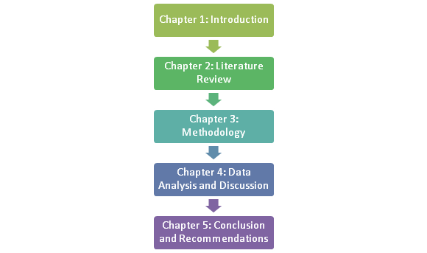

Fig: Structure of the Research
(Source: Self-developed)

1.9 Summary
This overall chapter has helped the researcher to refer to the major issues which have particularly impacted the global pharmaceutical industry due to potential challenges in the strategic procurement processes. That is why, this particular research has specifically aimed to illustrate and evaluate the strategic procurement process of the pharmaceutical industry by identifying the potential issues which are mainly restricted to the pharmaceutical organizations to maintain their supply capabilities. Moreover, this chapter has also indicated the importance of understanding the vitality of the strategic procurement processes particularly in the pharmaceutical industry because promoting innovation is quite hard for renovating the pharmaceutical products. That is why it is required for the considered industry to focus on improving its cost management infrastructure for building a potential and strategic procurement infrastructure. This particular research will allow the researcher to identify the risks and challenges of the pharmaceutical industry experience. Once the researcher is able to identify the various risks such as risks in the procurement process, the challenge of pricing, etc, will allow them to make a strategic plan such that an improved cost management structure is formulated that will be universally accepted by the companies. This is the only industry that will not be able to incorporate innovation in its manufacturing or other production operation, thus it will invest heavily in its R&D department in order to find ways to incorporate innovation in its procurement process. This is why it is essential for the industry to create a strategic procurement infrastructure.

Chapter 2: Literature Review

2.1 Introduction
The global supply chain for pharmaceutical products is complex. The products are wide ranging and many require specialist transport systems to protect the integrity of the product. There is complex licencing, quality control and import/export regulations too, all of which add to the costs of supplying pharmaceuticals from the original manufacturer through to the end user in a hospital setting or in community health care. The literature review will provide wide research into the various issues structured for strategic sourcing and the challenges faced under such framework. The pharmaceutical industry is reviewed in relevance to the past literature models and the current evidences through importance given to technological innovation, new sourcing strategies and the category management framework.

2.2 Empirical Research
Procurement channels of the pharmacies are found to be highly distributed in the global market as per the regions with sustainability as a main integral component of the chain. The pharmacy procurement channel is different from the other inventory channels in terms of the high-cost goods and the bulk items sent across the borders. Due to a lot of regulations and the certifications required in the pharmacy inventory sourcing, third-party agents are not involved without proper authentication (Hawkins et al. 2011). This implies that procurement channels of the pharmacy industry are highly regulated with monitoring systems for measuring inconsistencies in the supply flow of goods from one unit to another (Rosenbaum et al. 2017). However, it has been reported that procurement channels have got defects like the hacking of confidential data of patients through the use of e-procurement technologies. The use of chatbots and other e-procurement systems like IOT make the procurement system vulnerable to external risks. It thus implies that the pharmaceutical industry has a critical procurement system to optimize function.

2.3 Research Gap Analysis
Strategic sourcing of procurement channels through the category management is the most popular strategy taken up by the pharmaceutical firms to promote the conservation of biofuels and natural resources. Much of the procurement standards under the ecological and economic subsystem principles are used in category management. But, this portion is limited in much of the previous literature articles along with the digitization of the procurement channel; in the supply chain of the pharmacy stores through technical support in support activities. The current research thus, highlights the gaps from previous literature review on the strategic procurement methods of the pharmaceutical industry.

2.4 Digitization of procurement channel in pharmaceutical industries
The pharmacies are including digitization in the security functioning of the global supply chain in the current scenario. As per the value chain framework theory of strategic marketing, the profitability found in the pharmacy stores through big data analytics is creating the procurement channel function more effectively. Primary activities like the inbound logistics and the sales and marketing make the pharmacy stores attain the digital logistic system through attachment of digitized workflows. According to Rosenbaum et al. (2017), transparency and agility are focused on the supply chain model through the value chain framework's procurement system. The pharmacy industry in the UK through the Internet of Things is modulating the value chain for creating more security systems and restricting the illegal flow of goods. As per the global production network perspective, to innovate the supply chain system; the pharmacy companies are involving chatbots in the logistics system for faster client interaction through web technologies; the automation in the supply chain by the pharmacy industries is evolving with the introduction of more systems like the logistic information system for scanning the product and service flow across the geographical borders. This is agreed by Bienhaus and Haddud (2018) in their article, where the inclusion of wireless ad-hoc networks as used in the value chain network provide a high amount of marketing and sales support in the procurement channel This suggests that per Porter's value chain model, most of the support activities provided by the IT department influence the monitoring of the pharmacy distribution channel in the current scenario. Procurement channels of pharmacy industries in support activities of the organizational channel especially in the UK require diverse control on network lines. Requirements of such control keep the pharmacies track of the procurement channel for destabilizing illegal flow from the UK to other regions like the US, Asia, and Europe where trafficking of illicit goods is common.

2.5 Sustainable procurement in pharmaceutical industries
The initiative for sustainable procurement in the strategy of international business by the pharmaceutical companies is a great move. Kumar et al. (2019) in the report highlights that in the pharmaceutical company, procurement followed with carbon footprint standards reduces the negative impact from the environmental perspectives. This also frames a part of the corporate social responsibility associated with the supply chain's procurement channel. A lot of greenhouse gas emissions involved in the extraction of the raw materials for the research and development section of pharmacies create environmental damage Ethical business practices under the procurement sustainability concept give pharmacy companies to provide efficacy in the provision of medical equipment and tablets to clients in various geographical borders. The unsustainable practices as per PESTLE analysis of the pharmacy industry indicate moderate to high impact. However, the overall sustainability of the procurement channel is measured through a balanced scorecard by the pharmacies. The disagreement to a certain extent is expressed by Alzoubi et al. (2020), who proposes that a proper audit of the supply chain right from the initial procurement stage ; gives the pharmacy companies adequate control on the monitoring and supervision of suppliers. The sustainability concept thus adopted in the procurement stage of the supply chain makes the pharmaceutical companies in the UK adopt economic development through CSR activities too in the communities affected by the operations. From the ecological point of view, pharmacy chains operate with green labels in their procurement along with pharmacy vendors in proper authenticated supply certifications. This implies the sustainability in the pharmacy chain is mainly adopted as a strategy for bringing environmental awareness as well as brand reputation through ecological significance in the industry.

2.6 Supplier relationship management of pharmacy companies
Pharmaceutical laws applied to each country are taken into account with the supplier's code of conduct involved in each partnership. The long-term relations framed with the hospital centers in different diverse markets enrich the supplier relationships through strategic alliances in procurement effectiveness.
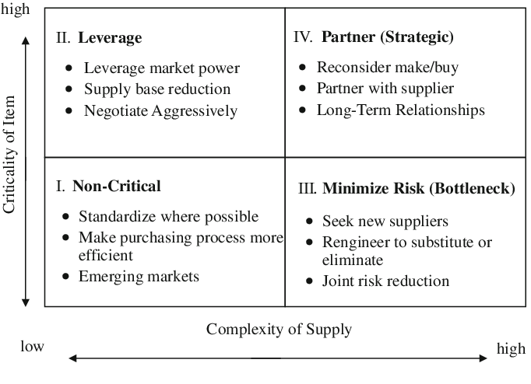

Fig: Kraljic model of procurement portfolio management
(Source: Hawkins et al. 2011)

Negotiations with certain suppliers are possible to the extent that pharmaceutical goods are charged based on the bargaining power of suppliers and buyers in the region. Lorenzini et al. (2018) states that a lot of pharmacies have used the supplier relationship in procurement models to develop supplier collaboration in the channel to gain profits with third-party agents. This highlights that supplier conflict although acts as a barrier in the relationship management with vendors in procurement, yet the logistics system entails market growth with more distribution of products that are not reached with internal supply chains of companies. As per Schofield and Breen (2006), the criticism is presented towards the Kraljic model of procurement portfolio management, that companies use either the strategy of diversification and balance or exploitation. In terms of balance strategy, the companies maintain a fine balance with the profit and loss provided through negotiation policy with vendors, This however has been found to create disturbances with unethical practices towards balancing the number of goods with the supply chain's target. Most of the time, just-in-time delivery channels also get disturbed due to the failure of balance provided in the procurement channel by the agents, wholesalers, and distributors with target achievements; causing exploitation in the market.

2.7 Procurement performance systems in the pharmaceutical supply chain
The performance systems used in the supply chain of pharmaceutical companies state systematic measurement of the procurement of goods flow with proper benchmark study. Strategic procurement requires monitoring systems in the procurement evaluation and control for designing better methods. Most of the performance systems are being done with a focus on the procurement channel's efficacy. Performance system models for procurement are used by companies like GlaxoSmithKline for checking the internal controls in the system. Vendors like retailers being an important end-point for the client interaction provide the orders that help in the order management.Talluri et al. (2006) considers that performance systems, therefore create a better platform for the pharmacies to maintain the balance in the material requisition as well as the inventory audit of the obsolete goods and the stock; that are unused. Inventory control systems being a part of the performance system check the pharmacy's raw inventory in the procurement channel concerning acceptance levels and the level of defects. Thus, this causes disturbance in the full flow of the goods. Logistics which are attached to the procurement channel is being monitored too with this performance systems. Feedback is an integral part of the system maintains the communication flow among the vendors in the procurement channel. But, according to Hung et al. (2005), a lot of pharmacies thus; find it helpful to connect with the company's head branch for any performance issues like corrupted flow of goods and emergency stock requirements This strategic option for procurement efficiency makes the pharmacies gain better market control concerning inventory and the supplier audit through such systems. Thus, it implies that performance systems are a good strategic procurement move for the pharmacies to regulate the functions occurring in the system. It has been found that most of the time, procurement channels fail to fulfil the targets of raw materials like medicines and the equipment required by the clients reaching lately.

2.8 E-procurement in pharmacy supply of goods
The e-procurement concept in the pharmaceutical supply chain makes the companies adopt the technological innovation brought through the online system. E-procurement system as a strategy in the procurement channel helps the pharmacies to keep track of all the inventory and the people handling such inventory through online technologies. E-procurement carried out through an e-logistic and distribution system gives an integrated framework for the supply chain network. Lee and Whang (2001) presents in their articles, that e-procurement systems consist of e-inventory audit, e-category management, and the e-material planning systems. This reduces the manual systems with defects and the prevention of corrupted functions in the system. In all the ERP systems handled by the pharmacies, it has been found that the e-procurement channel reduces the conflict between the channel partners due to big data handling in the online systems of the organization. Although the e-procurement system helps in better competitive advantage creation through the efficient flow of goods yet the cybercrime attached to e-procurement creates barriers. This is also supported by Bartsch et al. (2012), who stated that e-procurement system being a procurement strategy makes the pharmacies enable them to keep a digital tracking logged into every unit of the procurement system. Hacking of confidential data of patients and the information from prescriptions of doctors in the inventory stocking channel can create problems in e-procurement. Thus, the movement of stock from one unit to another can be monitored. But, the risk of extracting information through hidden motives of the internal employees of pharmaceutical companies like IT staff and manufacturers can cause a data breach. However, there is a high risk in executing e-procurement but the benefit of automated handling of tasks can be done with cost minimization.

2.9 Lean procurement methods in pharmacy chains

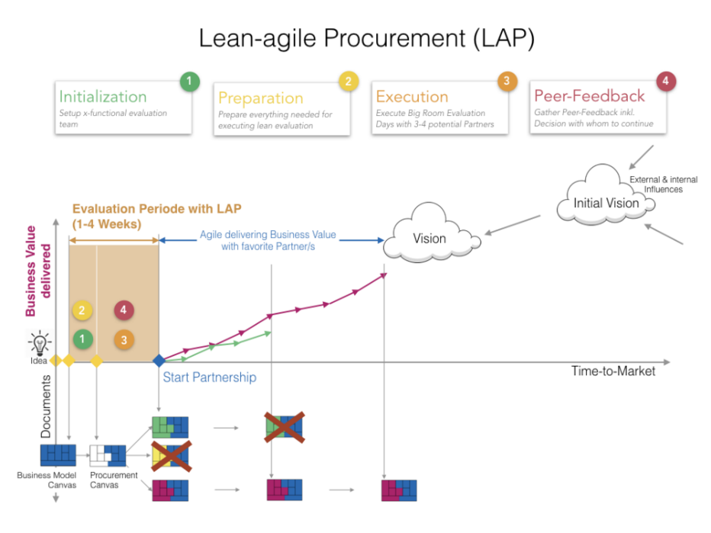

Fig: Lean-agile procurement approach model
(Source: https://www.lean-agile-procurement.com/lap-approach-step-by-step)

The lean method of manufacturing pharmaceutical goods in the procurement channel gives an advantage in quality maintenance. The six-sigma concept is used in the pharmaceutical industry to maintain the quality in terms of overall supply chain operations right from the starting point of the last stage. Lean-Agile Procurement Approach as per Jordan et al. (2019) is used mainly as the procurement strategy by the pharmacies to obtain registered and sustainable supplies from vendors. This states that lean manufacturing models used in the pharmacy industries provide benefits in zero-waste management and the total quality framework is also ensured through each step of the channel. Agile methodology combined with lean procurement gives real-time deliveries with divided procurement teams working on inventory tracking. The business value with suppliers are documented with the agile teams creating a process of total quality maintenance through authentic documentation. Pontes et al. (2019), however stresses the fact in comparison to the approach that pharmacies are required to adopt such an approach for enhancing their accountability in the supply chain process concerning internal process regulations. But, the partnerships that are formghed in the procurement channels with suppliers are nurtured through collective feedback in the form of participative models. The full procurement channel with the business value gets delivered to the respected partners in the supply chain as per the schedule of inventory activities. The LAP approach makes the pharmacies combine the full process of obtaining tenders and the quotas with the suppliers through a systematic team-based process through agile teams. Multi-functioning teams in the procurement channel make the manufacturing of pharmacy goods be in line with the orders sent from the clients.

2.10 Critique of literature review
The discussion of this section has overall covered by the considered topic selected for the research 'Strategic procurement in Pharmaceutical industries' where different subjective areas have been discussed in the above section of the literature review and in this portion, the above-stated discussion will be reviewed critically. Generally, the above discussion has covered the digitalized and sustainable procurement channels of the pharmaceutical industries. Moreover, the procurement performance system of the pharmaceutical supply chain has been reviewed. Moreover, it has been reviewed the relationship of the pharmaceutical organizations with its suppliers along with the existed e-procurement process which is generally associated with the pharmacy goods supply process. Again, the review section also stated the lean procurement process which is currently essential for the global pharmacy chains.
The digitalization concept of the pharmaceutical industry generally refers to the security functioning process which enhances the quality and value of the data analytics of the global pharmaceutical chain. In order to gain profitability, pharmaceutical stores have started to create big data analytics for procuring channel functions. On the other hand, the pharmaceutical industry has attached with the inbound logistics for attaining the sales and marketing activities through digitalized workflows. In the different European regions including the UK and Ireland the digitalized procurement channels of the pharmaceutical supply chain channels have kept in the potential monitoring process for maintaining the properness of the activities.
However, in the case of a sustainable process in the pharmaceutical industries, it has been identified that the pharmaceutical companies have followed the procurement process by reducing the standards of the carbon footprints in order to reduce the negative impact in terms of environmental perspective. The CSR is identified as the essential element in the procurement channels of the global pharmaceutical supply chain. The pharmaceutical companies have followed a proper audit facility for controlling the supervision and monitoring process of the suppliers. From the ecological point of view, it has been identified that the global pharmaceutical industry has operated green labels in the procurement for enhancing environmental awareness to maintain ecological significance. Here is not the end. Most of the global pharmaceutical stores including all the European countries have considered the supplier relationship in its procurement models for promoting and enhancing the value of the supplier collaboration. It has not only enhanced the profitability but also has restricted the supplier conflict to release the barriers for building a potential relationship with the management with the vendors through procurement.

2.11 Theoretical Perspective
Based on the views of Uygun, 2017 there are different determinant factors that have been identified which have quite a potential importance in promoting the strategic procurement of the pharmaceutical organizations. This consideration can be expressed through a relevant theoretical concept- 'Resource Dependency Theory'. By considering the application of this specific theoretical perspective, the RDT is an essential and effective factor that has helped in analysing the strict management which has contributed to procurement development growth in the medical and drug production organizations. RDT or the Resource Dependency Model is the potential concept through which the pharmaceutical organizations have able to engage in the transactional engagement with the other firms in order to outsource or acquire the scarcity of the resources. In the pharmaceutical industry, the scarcity has referred to the different medical equipment as well as some disposable items which are generally outsourced in the external environment are highly responsible in creating potential high dependency and sometimes the outsourcing partners of the pharmaceutical companies have resulted in unequal power and authority of exchange. That is why; it is highly required for pharmaceutical organizations to focus on managing and straightening the internal resources for the fulfilment of resource transactions in the industry. It is a potential stage of strategic procurement where both the labour supply and managing facilities have helped in developing the production scale of the pharmaceutical companies. By diversifying the supply chain processes with proper resource engagement the supply chain processes of the pharmaceutical organizations will be able to set a potential connection with the external firms in terms of procurement. This theoretical perspective has helped in determining and managing the strategic changes for adjusting the raw materials which have mainly developed by the entities for meeting the procurement business objectives. Moreover, the pharmaceutical supply chains have focused on developing its local delivery processes of drugs as well as medical devices in order to slay down the ineffective decision-making process.

2.12 Conceptual framework

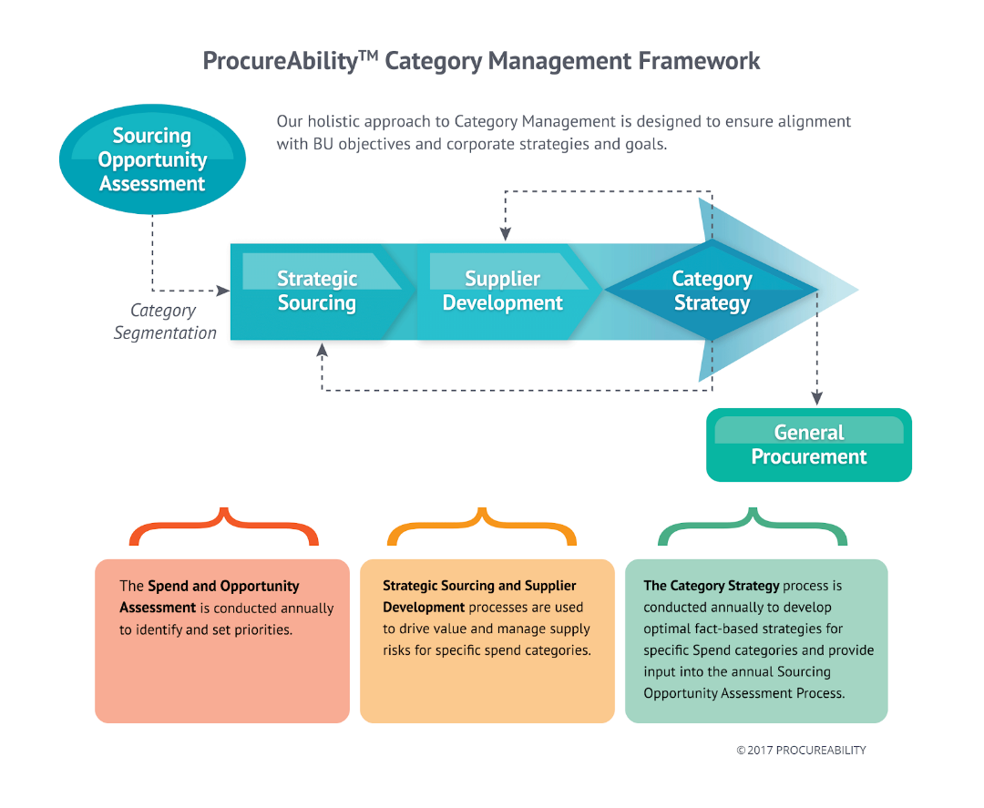

Fig: Category management and strategic sourcing link model
Link: https://procureability.com/category-management/
The strategic sourcing which is performed as a base for the category management of the inventory to be taken care of, creates the main domain of pharmacy sourcing channel. Strategic sourcing is preliminary to the category management which gets conducted in order to categorize the sourcing channel units along with the amount of supplying inventory lots that will be distributed. In the given figure, it can be seen that strategic sourcing is directly related with the supplier relationship development. Category segmentation of the pharmaceutical drugs is the area where the supplier chain gets affected with reimbursements and the cost of sharing. Due to this, a holistic approach towards souring assessment is undertaken for the verification of the suppliers and the tender documentation that are required for contractual agreements in sourcing. Settanni et al. (2017) states that most of the supply chain risks occurring in the sourcing channel are found to be occurring due to lack of proper strategic sourcing. The general procurement of drugs in the pharmaceutical sourcing strategy occurs after the category management, which highlights the fact that inventory management challenges are the main reason of procurement failure. The category strategy which is formed for the strategic sourcing consequences consist of inputs from the annual sourcing opportunities that determine the overall inventory budget and the specific categories to be focusing on the sourcing department. Mehralian et al. (2015) in disagreement to it states that the procurement approach however often fails to provide the right good at the right price to the right buyer. This occurs from the gap in the strategic sourcing goals and the category management strategy. The speed of inventory delivery across the geographical borders of the supply chain makes category management very crucial for sustaining the quality management across the agile procurement channel. The strategic sourcing of drug supply from the manufacturers down to the inventory being reached to the beneficiaries in this framework should get optimized with technological innovation. This implies the necessary requirement of creating a strategic sourcing plan aligned with the category management through the help of technology.

2.13 Drug supply challenges in sourcing of pharmacy chain
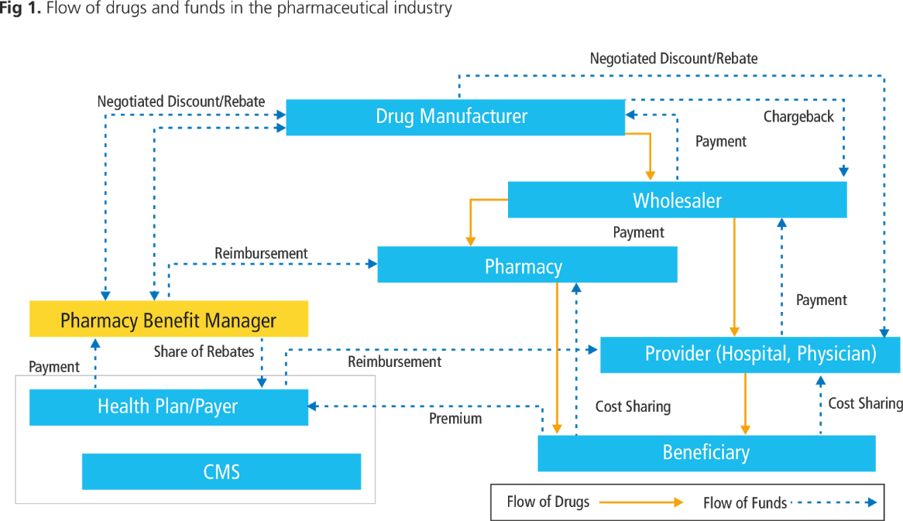

Fig: Pharmaceutical drug supply procurement model
Link: https://www.gep.com/white-papers/track-and-trace-in-the-pharmaceutical-industry-serialization-strategies-and-a-roadmap-for-procurement

The drug manufacturer being the top most controlling department in the full procurement channel maintains the decisions of manufacturing. All the negotiations regarding the price and the rebates made in the pharmaceutical drug supply initiates right from the drug manufacturers. The drug manufacturers maintain the relationship with the wholesalers with whom the payments and the discounts are being exchanged. The strategic sourcing partners who create a huge impact on the full sourcing channel are the manufacturer, wholesalers and the retailers of the drug supply. Reimbursement being provided to the pharmacy retailers brings the share of rebate to the health units of hospitals. The flow of drugs in the sourcing channel occurs through a hierarchical ladder where the drug manufacturer supplies the drugs to the wholesalers and the pharmacy chain outlets supplies the medicines to the beneficiaries. These beneficiaries in patients of the hospital or individual buyers are the most impact creating parties in the channel. Pharmacy benefit managers who take control of the whole sourcing channel for maintaining the flow of funds and the drugs take control of the reimbursement and the cost sharing options to the health benefit payers. Category management of drugs in the inventory is performed for the overall flow of proper inventory to the providers. The sourcing channel between the providers and the beneficiaries create most of the disruptions in the process. Wholesalers are the most suffering party among the others in the sourcing channel due to the price discrimination with differential pricing criteria set by the drug manufacturers. Defective inventory supply of drugs to the providers create the backward supply chain process of supplier complaints and the reorder supply to be provided. Such kind of sourcing channel hazards create financial risk to the firm and the client loss occurs at a large scale.

2.14 Technological innovation in strategic sourcing of pharmacy channel
The service innovation which is used in the pharmacy sourcing channels are mainly through blockchain technology nowadays. Clauson et al. (2018) clears the findigs that authentication of the suppliers through the block-chain technology makes the firm gain better insights into the supplier -buyer networks. Most of the technological innovations carried out for the sustainable operations in the procurement channel consist of the software that deals with procurement management. The supplier networks are managed through blockchain technology in the form of spatial tracking mechanism. Majority of the relationships are found disruptive in dealing with pharmaceutical drugs supplied to the medical stores due to the less safety control measures and the evaluation of the channels. Technological innovation brought through geo-spatial location tracking software’s in the inventory that are disposed of to the suppliers into the global channels create better performance of the sourcing department. The strategic sourcing is highly influenced from the emerging gig economy trends that make the supply chain agile with systematic evaluation and the collaboration of all departments like marketing, IT, HR and the finance units with the procurement unit of the pharmacy chains. One of the most crucial technological innovations in the pharmaceutical drug sourcing being made is automation of the supplier network feedback. But the third-party channel conflict occurring in the global distribution procurement channels with the suppliers create less effectiveness of the blockchain technology. Nematollahi et al. (2018) agrees to it moderately and indicates that requirements of the suppliers in terms of ethical values are less incorporated through technological changes which makes the importance of staffing proper suppliers based on verification. High-level pricing discrimination made along with the disrupted channels of supply to other sources for internal profits by the suppliers cannot be eliminated through such technological innovation on the sourcing channel. Such kind of communication through automated feedback producing systems maintains transparency as well as assesses the risks of counterfeiting of drugs or the illegal mechanism.

2.15 Sustainability in pharmaceutical strategic sourcing
The sustainability in strategic sourcing has been very much dependent on the ailments of the patients sourcing parties. The purchasing goals of pharmaceutical firms get impacted on a big scale from the supply chain sustainability threats due to high financial budget. The spend analysis suggests that most of the business operations in the procurement channel for the pharmaceutical chains require the contracts with verified suppliers. The illegal operations which are conducted through shipping of unauthorized drugs from the third-party agents in the sourcing channel create much financial and legal risk. Most of the medical centers are found to be having complex supplier relationships that impact the innovative approaches produced in the chain. Kelle et al. (2012) in the article provides that he strategic procurement in terms of sustainability in the supplier channels are to be met through true supplier partners that will provide the USP advantage to the firm. The drugs that exceed the price level of micro-purchase threshold create bigger problems for the pharmacy chains across the global borders for supply. The portfolio management with the buyers and the suppliers arranged through lean procurement is highlighted to be the efficient technique for bringing agility in the sourcing process. Pareto analysis conducted for inventory control of the procurement channel helped the firms to conduct systematic evaluations of the purchase cost of each pharmaceutical drug supplied and the parties involved with the solicitation of drugs. Marucheck et al. (2011) in addition to it emphasizes that the necessity of conducting all the periodic evaluations through federal supply schedule and the open market purchases to the medical and pharmacy retail stores are to be calculated for monitoring. It is found that spend categories as indicated from the Pareto analysis for inventory control management of the pharmacy firms can lead to better savings with the purchase centres. The Federal supply schedule, thus, verified through determining the potential size of supplier firms and the purchasing centres with quantities specified make the sustainable operations better.

2.16 Pricing and the strategic sourcing form of pharmacy chain
Differential pricing and value-based pricing are the two main approaches of pricing that are suggested by WHO health department to follow for better sourcing effectiveness. Shapiro (2004) believes that the strategic sourcing of the pharmacy channels that are widespread across the global borders involve parallel trade that will bring much improvement in the purchase benefits. But, the disadvantage of such differential policy by the firms with involvement of other third-party channels will create disruptions in terms of regulatory framework. The policy commitment is not strong in case of differential policy which acts as a barrier to implement it. On the other hand, in agreement to it, Shah (2004) comments that the value-based pricing has got buyers that are ready to purchase the drugs at higher prices from geographical borders in relevance to the quality and delivery schedule. The value as evaluated from the high-priced medicines bring much clarity into the pricing effectiveness. Technical evaluation tools used in measuring the value of the whole drug prices assorted to the suppliers, make the importance of reimbursement too in the pricing strategy of sourcing. High-price pharmacy drugs and medicines supplied in the geographical borders bring much confidential discounts that help the sourcing be performed smoothly with no import-export barriers. Henceforth, price negotiations through external price referencing codes on the drug; make the strategic sourcing of high-valued medicines obtain profit for pharmacy chains.

2.17 Sustainability in pharmaceutical industries
The term sustainability plays a crucial role in both organizations as well as for researches. According to (Raju et al. 2016), pharmaceutical companies are actively participating in sustainability through the development of medicines that have the same medicinal value while reducing the environmental impact. Environments are negatively affected by the packaging the pharmaceutical companies adopt. Therefore, they have this industry working towards selecting an appropriate packaging system that not only does the purpose as well as creates less damage to the environment. According to (Raju et al. 2016) a comparison is made between two types of packaging namely, PVC blister and aluminium blister. To conduct a meaningful comparison, the method of LCI is used. However, it has been studied that PVC blisters perform better than aluminium packaging as the environment is gravely affected by the aluminium foils used in this industry. Similarly, according to (García González, 2020), pharmaceutical companies use plastic in their various activities. As the environmental conditions are deteriorating, many industries such as consumer goods, fashion, etc., have been incorporating sustainability, while the light is not put on the waste generated by the pharmaceutical company. However, in recent times, this industry has been focusing on reducing the waste generated by it by moving towards a plastic-free packaging phrase. Even though the packaging creates a large amount of waste in this industry it is important to note that during the procurement or extraction of raw material for this industry high amounts of greenhouse gases are also emitted. Therefore, it is the social responsibility of the pharmaceutical industry to focus on its production as well as packaging operations such that waste generated is reduced and sustainable methods are used.

2.18 Importance of supply chain in the pharmaceutical industry
The supply chain performs the crucial role of delivering medicines or drugs to the patients that require them. Therefore, in the pharmaceutical company, the supply chain does a wide range of important tasks. However, this section of the operation faces various challenges. According to (Moosivand et al. 2019), pharmaceutical companies have realized that to have a competitive advantage among the various competitors, improving the supply chain is the key. Various distribution channels such as manufacturers, wholesalers, vendors have the role to provide required medicines to patients. The vendors such as the retailers have the job to provide medicine by interacting with the patients and enquire about the requirements of the patients so that the manufacturer can produce accordingly. However, while understanding the concept of the supply chain in pharmaceutical companies it is crucial to realize the challenges it faces. The various challenges are the inability to forecast, the lead generation is long, lack of optimum target inventory, and the high cost in the supply chain. Therefore, it is crucial to understand that the pharmaceutical industry is competitive and to maintain its advantage the companies are required to give attention to their supply chain operation. Therefore, to enhance the supply chain, innovative methods need to be used that incorporate technology, the companies are required to have a good strategic plan that will enable them to put the focus on the supply chain and manage a good system of point of origin to point of consumption (Ganguly et al. 2019).

2.19 Inadequate funding and bureaucracy in the procurement process
Insufficiency is regarded as one of the challenges that pharmaceutical companies face in the procurement process. This is the result of the corruption that prevails in the market. According to Muhiaet al. (2017), during the time of payment, if the budget exceeds, necessary changes are made which compromises the actual budget. This lack of funds can cause various problems such as delayed payments to the suppliers, lack of trust, and then ultimately the denial of the suppliers to make any supplies to the company. this will affect their production process thereby affecting a larger picture of doing drugs to the right person at the right time. This can also be due to corruption that exists in the market. Corruption in the form of money laundering where the money does not reach the desired destination and thus negatively impacting the industry. while on the other hand bureaucracy can have a negative impact on the procurement process. Too much government involvement in the operation of the industry will hamper the working of the industry and ultimately the procurement process. There are situations where the contracts get delayed, payment delay to suppliers, cost rise, and the manipulation of contracts and lack of fair competition drastically affect the process. this leads to poor treatment of the patients that can lead to many deaths. Sometimes lack of drugs can be generated that will lead to poor health. Similarly, pricing is crucial to the effectiveness of the process. Ideally, it is important for pharmaceutical industries to follow a pricing system that is customer-focused which means the companies set the prices according to what customers believe they are worth. However, this may not always be the case (Dubois et al. 2019). The freedom of manufacturers to price their products has given them the monopoly this has caused a challenging atmosphere for the people. This is going to evaluate the issues related to the supply of raw materials within the pharmaceutical industry. The raw materials are required to be

2.20 Logistics in pharmaceutical industries
Another issue that has been noticed is in the transportation process during the procurement process. when drugs are required to be distributed in smaller sources the problem of transportation arises. On the contrary, many drugs are required to be stored in a special manner such as in an allocated temperature that can become problematic for this industry. therefore the logistics are required to be a crucial process that allows the products to reach the required destinations at the right time. According to de Campos et al. (2017), proper logistics is required as pharmaceutical products are considered as the end of life and end of use goods. Therefore a strategic framework is required where the industries need to reduce their environmental impact at the same time not compromise on the supply of the product. Pharmaceutical companies can only innovate in their procurement process (Caille et al. 2019). In the pharmaceutical industry, the scarcity can be referred to the different medical equipment as well as some disposable items which are generally outsourced in the external environment are highly responsible in creating potential high dependency and sometimes the outsourcing partners of the pharmaceutical companies have resulted in unequal power and authority of exchange (El Mokriniet al. 2016). Most of the technological innovations carried out for sustainable operations in the procurement channel consist of software that deals with procurement management. The supplier networks are managed through blockchain technology in the form of a spatial tracking mechanism (Romasanta et al. 2020). The majority of the relationships are found disruptive in dealing with pharmaceutical drugs supplied to the medical stores due to the fewer safety control measures and the evaluation of the channels. Technological innovation brought through geospatial location tracking software's in the inventory that is disposed of to the suppliers into the global channels create a better performance of the sourcing department. Therefore, it is crucial to realize that logistics play a crucial role in pharmaceutical industries.

2.21 Summary
The overall literature review section of the stated research paper has provided a potential concept of procurement in the global pharmaceutical industries by providing a special focus on the European context. There are several themes developed for the review purpose which includes the digitalized concept, e-procurement, sustainable procurement, and so on. not only that, in this section, the relationship between the pharmaceutical supply chain and procurement performance system, pharmaceutical organizations and its suppliers, and the lean procurement process have been discussed. This review has stated the execution of the different procurement processes for managing the high risks and cost minimization of the pharmaceutical industry. In this section, the contextual and theoretical perceptions have been raised which have discussed mainly the different concepts of strategic procurement which are mainly involved in the pharmaceutical industry. There are some implications that have been identified too, where it has been identified that the collaboration with the different pharmaceutical organizations has a potential business service network through innovation and procurement strategies. Based on the empirical pieces of evidence the impact of the procurement strategies is highly crucial where risks control, supply chain management, HR, and innovations and development have to carry forward with the strong procurement solutions. There are a lot of pharmacies that have identified which used the supplier relationship in procurement models to develop supplier collaboration in the channel in order to gain profits with third-party agents. Supplier conflict although acts as a barrier in relationship management with vendors in procurement, yet the logistics system entails market growth with more distribution of products that are not reached with internal supply chains of companies.

CHAPTER 3: Research Methodology

3.0 Introduction
This chapter is going to reveal the methods that the researcher has been selected for completing the research successfully. Research methods provide a strong base to the research therefore selecting potential and efficient methods of research essential to derive best from the research.

3.1 Research outline
Elements and components which are used for the computation of research are selected on the basis of strategic and tactical sections such as design, approach, and philosophy of the research. The research is going to evaluate the issues related to the supply of raw materials within the pharmaceutical industry. In order to complete the research has been selected positivism philosophy, deductive approach, and descriptive design (Mohajan, 2018). Primary and secondary sources are going to be used for collecting data regarding the topic of the research that can be helpful for analysis and derive the result of the research. Simple random sampling has been used in order to select potential participants for the data collection process.

3.2 Research philosophy
Research philosophy is helpful for determining the psychology of the research at the initial stage of the research. It can be helpful to Lead or direct the research in the right way. The pharmaceutical industry is a wide area to discuss and the data collection will be completed with primary and secondary processes therefore the positivism research philosophy can be helpful for the researcher. Because it will consider the positive facts of the research topic that can be helpful together with information in a logical and scientific way (Zangirolami-Raimundo et al. 2018). This can be helpful for the researcher to gain knowledge and information about the issues that the pharmaceutical industries are facing due to the high demand for raw materials and low supply chain capability.

3.2.1 The justification behind using positivism research philosophy
The justification behind using the positivism research philosophy lies in the aim to recognize the positive facets of the research topic. Considering the subject to focus on the fundamentals of strategic procurement in the pharmaceutical company, the use of the positivism philosophy allowed the researcher to develop the study scientifically and set down a strong platform for developing the hypothesis (Gough and Lyons,2016) . The use of this philosophy helps in measuring the results from the findings and literature review (Prasad, 2017).

3.3 Research approach
The research approach is capable of creating a platform that can be helpful for providing a transparent idea of the sequences and phases of the entire research that provide proper planning of the research. In this research, the researcher has chosen a deductive approach that can be helpful to utilize the present research framework and theories at their best to derive the best outcome of the research (Basias and Pollalis, 2018). This approach can be helpful for the researcher to identify the issues impacting the issues that the pharmaceutical industry is facing by adopting existing theories and frameworks.

3.3.1 The justification behind using the deductive research approach
The justification behind the use of the deductive research approach lies in the prospects of using the current study framework and includes the theoretical interpretations to derive the best study outcomes. The approach helped the researcher to recognize the issues about the strategic procurement processes and explain the causal relationships between the concepts and the variables (Woiceshyn and Daellenbach, 2018). It allowed the researcher to engage in measuring the key concepts of the study quantitatively and generalize the research findings to successfully meet up to a certain extent (Tuffour, 2017).

3.4 Research design
Research Design is helpful to set the primary target of the research which has to be achieved through completing the overall study. Potential Research Design also helpful for the researcher to find potential answers to the question that can arise during the research. Research has chosen descriptive design in order to complete the research as it will be helpful to find the answers to the questions while completing the research efficiently. answers to the research questions can be helpful for the researcher to gain adequate information and data.

3.4.1 The justification behind using a descriptive research design
The justification behind using the descriptive research design helped in locating the comprehensive aspects of the study and allowed the researcher to find relevant answers to the key questions that are raised through the study. The possible outcomes of using the descriptive research design allowed the researcher to develop statistical information on the fundamentals of the subject and have been used to deduce results (Nassaji, 2015). The data is varied in nature, which is supported by the use of the descriptive research design and allowed the researcher to use surveys, observation, and empirical responses to ensure that the findings of the study are pertinent and authentically placed (Jagtap and Jagtap, 2015).

3.5 Data type
In order to complete the research, the researcher has selected primary and secondary data. primary data has been collected by conducting surveys with participants and conducting interviews with participants of the pharmaceutical industry. secondary data will be collected through the literature that has been present in the research from various articles and journals related to the research topic. primary data will be considered as first-hand data as the participants are the source of the primary data. The answers to the survey and interview are going to be considered as primary data that will be analyzed to obtain the result of the research (Zangirolami-Raimundo et al. 2018).

3.6 Data collection process
In order to collect data for completing the research, the researcher has selected both primary and secondary data collection processes. a secondary source of data will be collected from the evidence of literature and various information and knowledge gathered from various articles and journals relevant to pharmaceutical companies and issues that are facing the industry currently. Along with this the impact of the issues on the pharmaceutical industry also can be gained from various articles and journals. secondary data will support the primary data by providing effective evidence. open-ended questions have been used in interviews and close-ended questions have been used for the survey.

3.9 Sampling
For completing the survey and interview researcher is going to select participants by using a random sampling method within a large number of participants to identify the potential respondents. For the survey, 52 employees have been selected by the researcher and for completing the interview 5 managers have been interviewed by the pharmaceutical industry (Zangirolami-Raimundo et al. 2018).

3.10 Data analysis
collected data has been analyzed by using the qualitative and quantitative form of data analysis techniques. The data analysis techniques are helpful for the researcher to study strategic procurement in the pharmaceutical industry for completing the research successfully. Quantitative data analysis technique can determine the statistical significance of the research result by providing graphs charts related to the answers and qualitative data analysis can provide a brief understanding by observing the answer of the interview and question. Both the analysis techniques can be helpful for ensuring the reliability and validity of the data that has been collected from various sources (Ørngreen and Levinsen, 2017).

3.11 limitation of the research
As the pharmaceutical industry is a white area to discuss and the industry is facing huge issues and problems currently. Therefore the small number of participants cannot represent the overall pharmaceutical industry and their answers can not be considered as the whole industry representation. This is a limitation of the research along with these there is a huge source of information and knowledge regarding the research topics but it's a limitation for the research to identify the potential source that can be selected to complete the research.

3.12 Ethical consideration
In order to complete the research, no one has been forced to participate in the research. Every participant participated in the research voluntarily. Collected data and information will be protected by the Data Protection Act of 1988. The data will be used only for completing the research but it was not used for any other purpose. Data will be stored in a password-protected database.

3.13 Time frame
activities | week 1 | week 2 | week 3 | week 4 | week 5 | week 6 | week 7 | week 8 | week 9 | week 10 | week 11 | week 12
Topic selection and approval
Literature review
research methodology
data collection
data analysis
findings
conclusion and recommendation
closure of project

Chapter 4: Data analysis

4.1 Introduction
The fourth chapter of a research study tends to talk about the provision of an extensive insight onto the potential analytic evaluation derived from the collected data. This includes the evaluation of primary data that involves the initiation of both survey and interview. The primary aim of the survey is to be able to gain insight into the potential views and opinions that the employees of the pharmaceutical industry perceive regarding strategic procurement. In addition to this, the aim of the interview is to record their expressive views regarding the extent to which they have faced potential complexities while carrying out procurement activities.

4.2 Survey responses
1. How far do you agree that the holistic approach of procurement would guide business units to acquire best transport options?
Options | Responses | Percentage of response | Total no. of respondents
Strongly agree | 27 | 51.92% | 52
Agree | 13 | 25% | 52
Neutral | 2 | 3.84 | 52
Disagree | 7 | 13.46% | 52
Strongly disagree | 3 | 5.76% | 52

Table: Holistic approach of procurement
(Source: self-developed)
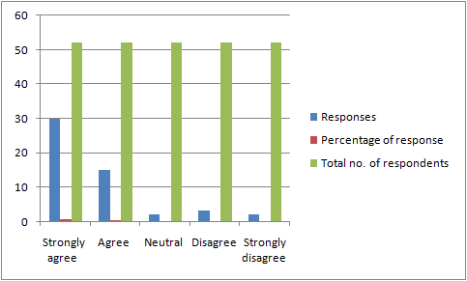

Fig: Response to question 1
(Source: self-developed)
Analysis
In accordance with the given propositions, it has been found that the respondents were asked about the extent to which the holistic approach of procurement would help in guiding business units. This is known to acquire the best transport options. It has been found that the holistic approach of strategic procurement works as an internal consultant. This helps in acquiring proper business insight into the different regulatory environment and regimes of custom. Over 51% of the respondents agreed to his proposition whereas, 13% of the respondents disagreed with this proposition. This is because it tends to create potential levels of complexity within the logistics chain to a great extent.
2. Do you agree that compliance challenges in globalisation are one of the operating factors of strategic procurement in the industry?
Options | Responses | Percentage of response | Total no. of respondents
Strongly agree | 30 | 57.69% | 52
Agree | 15 | 28.84% | 52
Neutral | 2 | 3.84% | 52
Disagree | 3 | 5.76% | 52
Strongly disagree | 2 | 3.84% | 52

Table: Compliance challenges in strategic procurement
(Source: self-developed)

Fig: Response to question 2
(Source: self-developed)
Analysis
The second question was asked to the research participants in accord with identifying the issues of compliance within the global markets. The compliance with health regulations is considered to be a significant factor in the pharmaceutical supply chain. Hence, the participants were asked about the extent to which it intends to create a negative implication on the strategic procurement complexities. Over 57% of the respondents have agreed to the fact that medicinal ingredients often tend to face healthcare regulatory compliance issues. This is an outcome of globalisation, which further creates hindrance in the supposed logistical chain processes. However, over 5% of the respondents agreed to this, and stated that if the operating factors are fulfilled properly, then the compliance issues are often less of a chance to come.
3. How far do you agree that strategic purchasing would help in gaining a better understanding of the logistics chain?
Options | Responses | Percentage of response | Total no. of respondents
Strongly agree | 15 | 28.84% | 52
Agree | 10 | 19.23% | 52
Neutral | 2 | 3.84% | 52
Disagree | 13 | 25% | 52
Strongly disagree | 12 | 23.07% | 52

Table: strategic purchasing in gaining better understanding
(Source: self-developed)
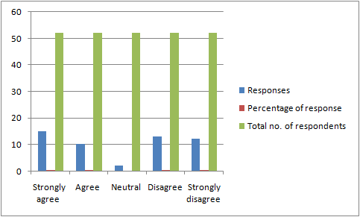

Fig: Response to question 3
(Source: self-developed)
Analysis
The third question was asked to the research participants regarding the potential mitigating actions that need to be taken into account. This includes the initiation of the processes of strategic purchasing. Temperature controlled transport is found to involve a definite number of stallholders, which requires the collaboration and integration that is considered a fundamental aspect. Hence, the respondents were asked about their definite views and opinions that needs to be taken into consideration. it has been found that, over 23% of the respondent have strongly disagree to this proposition. It is because of the complexity of strategic phenomenon of procurement within the premises of pharmaceutical industry. However, 28% of the respondents have agreed to this proposition that strategic purchasing is considered to be a significant element in the facilitation of proper procurement strategic directions to a great extent.
4. How far do you agree that workforce training and development is essential for the facilitation of strategic procurement within the pharmaceutical industry?
Options | Responses | Percentage of response | Total no. of respondents
Strongly agree | 23 | 44.23% | 52
Agree | 12 | 23.07% | 52
Neutral | 4 | 7.69% | 52
Disagree | 9 | 17.30% | 52
Strongly disagree | 4 | 7.69% | 52

Table: Importance of workforce training and development
(Source: self-developed)
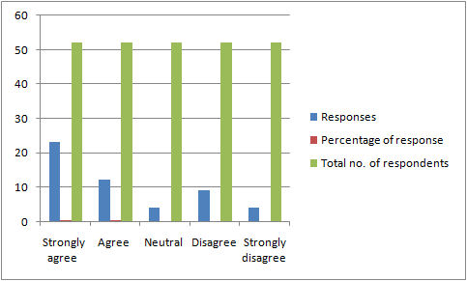

Fig: Response to question 4
(Source: self-developed)
Analysis
As per the given proposition of the research aspect, it is important to be able to identify the major aspects that the defined research topic tends to aim at. It is to be noted that, the initiation of workforce training and development would help in the facilitation of proper strategic procurement processes and procedures within the premises of the pharmaceutical industry. It tends to include the response where over 44% of the respondents have strongly agreed to this definite proposition. However, 17% of the respondents have disagreed to this definite proposition staying at the initiation of workforce training and development is not considered enough for the coalition for pope strategic procurement directions. Hence, based on which assumption, it can be stated that the survey question received a mixed response.
5. Do you agree that the presence of inaccurate data would lead to shortage of inventory?
Options | Responses | Percentage of response | Total no. of respondents
Strongly agree | 13 | 25% | 52
Agree | 7 | 13.46% | 52
Neutral | 2 | 3.84% | 52
Disagree | 16 | 30.76% | 52
Strongly disagree | 14 | 26.92% | 52

Table: Inaccurate data that leads to inventory shortage
(Source: self-developed)
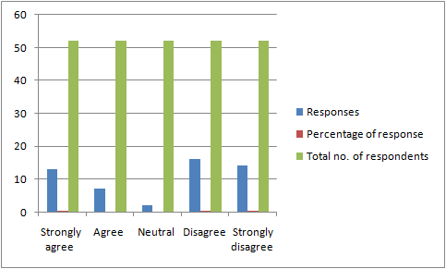

Fig: Responses to question 5
(Source: self-developed)
Analysis
Over 26% of the respondents have disagreed to the fact that inaccurate data might be one the basic factors that are responsible for the creation of complexities within the primes if the pharmaceutical industry to a great extent. It tends to show that the accuracy of data is not the ultimate parameter, which eventually creates a shortage of inventory. The data inaccuracy is one the technical aspect, which has lesser connections with procurement. However, 25% of the respondents have agreed to this proposition. They have stated that the inaccuracy of data is one of the fundamental reason bending the lack of inventory storage spaces, which creates complications.
6. How far do you agree that complexities in the strategic procurement results in hindering brand image and reputation of pharmaceutical companies?
Options | No. of responses | Percentage of response | Total no. of respondents
Strongly agree | 19 | 36.53% | 52
Agree | 11 | 21.15% | 52
Neutral | 2 | 3.84% | 52
Disagree | 12 | 23.07% | 52
Strongly disagree | 8 | 15.38% | 52

Table: Negative impact of procurement on brand image and reputation
(Source: self-developed)
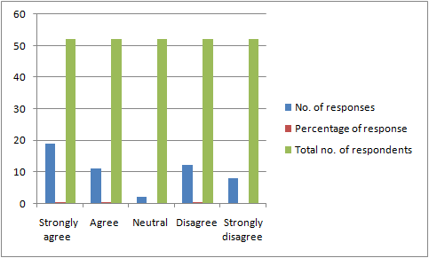

Fig: Response to question 6
(Source: self-developed)
Analysis
The sixth question aimed at the identification of the potential complexities in the strategic procurement that results in hindering brand image and reputation. Hence, the employees were asked about their experience in this regard, where over 36% of the respondents have agreed to this proposition. They have stated that the increasing complexities in procurement eventually results in delays in delivery. This hampers the reputation and image of the pharmaceutical companies to a great extent. However, 23% of the responded have stated that it is partially responsible for hindering brand image. However, these respondents believed that changes in the regulatory environment are also associated with hindered brand image and reputation.
7. Do you agree that a poor regulatory environment contributes to the increasing complexities in the procurement process in the industry?
Options | No. of responses | Percentage of response | Total no. of respondents
Strongly agree | 23 | 44.23% | 52
Agree | 10 | 19.23% | 52
Neutral | 2 | 3.84% | 52
Disagree | 10 | 19.23% | 52
Strongly disagree | 7 | 13.46% | 52

Table: Poor regulatory environment in procurement
(Source: self-developed)
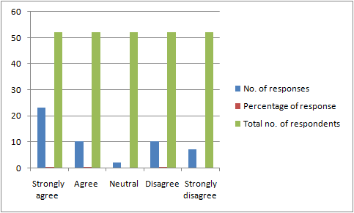

Fig: Response to question 7
(Source: self-developed)
Analysis
The presence of a poor regulatory environment is one of the major reasons behind the increasing levels of procurement complexities within the pharmaceutical industry. Based on this understanding, the research participants were asked about their opinion regarding the presence of a poor regulatory environment. Over 44% of the respondents have agreed to this proposition that the presence of poor regulations regarding procurement has eventually resulted in delivery delays. This change in regulation is known to affect the process of procurement within the pharmaceutical industry to a great extent.
8. How far do you agree that business process management would help in mitigating procurement complexities in the pharmaceutical industry?
Options | No. of responses | Percentage of response | Total no. of respondents
Strongly agree | 21 | 40.38% | 52
Agree | 9 | 17.30% | 52
Neutral | 2 | 3.84% | 52
Disagree | 14 | 26.92% | 52
Strongly disagree | 6 | 11.53% | 52

Table: Business process management in procurement
(Source: self-developed)
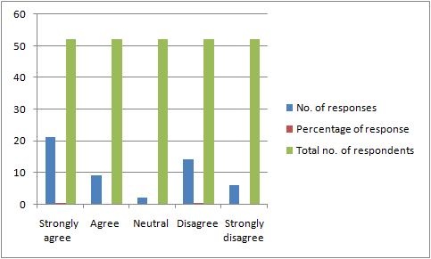

Fig: Response to question 8
(Source: self-developed)
Analysis
The initiation of business process management is found to help procurement methods to gain stability in the logistics and supply chain to a great extent. Therefore, over 40% of the respondents have strongly agreed to this proposition. The business process management process would involve the review and approval of items from potential suppliers. However, over 11% of the respondents have stated that, supplier selection is the foremost strategic direction that needs to be initiated before the association of business process management effectively.
9. Do you agree that intellectual property challenges create negative implications for the hindrance in the procurement activities in the industry?
Options | No. of responses | Percentage of response | Total no. of respondents
Strongly agree | 17 | 32.69% | 52
Agree | 13 | 25% | 52
Neutral | 1 | 1.92% | 52
Disagree | 14 | 26.92% | 52
Strongly disagree | 7 | 13.46% | 52

Table: Intellectual property challenges in procurement
(Source: self-developed)
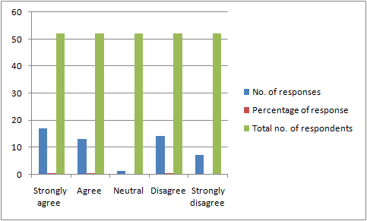

Fig: Responses to question 9
(Source: self-developed)
Analysis
This definite analytical question is based on the identification of the challenges of intellectual property that creates complication in the procurement of the pharmaceutical industry. Over 32% of the respondents have strongly agreed to the fact that intellectual property challenges include the breach of copyright of medicines that are being manufactured by definite pharmaceutical companies. However, over 26% of the respondents disagreed to this proposition stating that apart from intellectual challenges that might come in the way.
10. Do you agree that the development of low-cost procurement distribution channels would help in the facilitation of industry development?
Options | No. of responses | Percentage of response | Total no. of respondents
Strongly agree | 15 | 28.84% | 52
Agree | 11 | 19.23% | 52
Neutral | 5 | 9.61% | 52
Disagree | 9 | 17.30% | 52
Strongly disagree | 12 | 23.07% | 52

Table: Development of low-cost procurement process
(Source: self-developed)
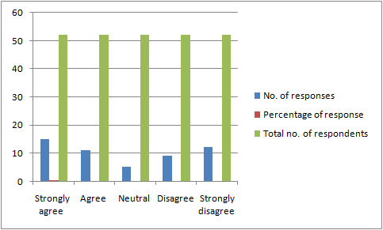

Fig: Response to question 10
(Source: self-developed)
Analysis
The last question was addressed to identify the extent to which the initiation of low-cost procurement methods that would help in the facilitation of a distribution channel effectively. Based on this proposition, over 28% of the respondents strongly agreed to this proposition. They are of the opinion that if the procurement pricing strategic directions are stabilised effectively, then it will be beneficial for the association of proper distribution channels. This is further responsible for the development of industry activities.

4.3 Interview responses
1. What are the major strategic procurement activities that are the most important in the pharmaceutical industry?
Manager 1 | Manager 2 | Manager 3 | Manager 4 | Manager 5
I firmly believe that one of the major strategic procurement activities that is considered important in the pharmaceutical industry is that of the development of a sourcing for an outsourcing strategy. This helps us to be able to identify the basic warehousing stock and transportation costs that are required for facilitating the provision of strategic solutions. | I think supplier selection is a major strategic procurement element that helps us to rely on suppliers. Our logistics chain is highly dependent on the suppliers who are able to provide us with the necessary ingredients for manufacturing medicines. | The conducting of an internal needs analysis is capable of identifying the potential needs and targets that helps in the development of a procurement strategy. This has helped us to see the involvement of collection of several types of data to a great extent. | I agree with the fact that the development of a sourcing strategy helps in the initiation of assessing the supplier requirements and the transportation channels that need to be acquired. | I personally believe that it is important to negotiate with the suppliers and select the winning bid. This helps us to get the best suppliers and the best quality products for our medicine manufacturing.

Analysis
In order to gain insight into the definite strategic procurement activities that are considered to be the most effective. The research respondents were asked about their views and opinions regarding the importance of these activities. The first and third manager stated that, the initiation of a sourcing strategy. The managers added that it provides them with a thorough understanding about the spend category and helps them to evaluate the supplier marketplace effectively. On the other hand, another major response that comes into the forefront is that of supplier selection. This helps in creating a significant dependence on the provision of necessary ingredients that are required for medicine manufacturing. It further includes negotiation with the suppliers that helps in selecting the winning bid.
2. According to you, what is the difference between strategic sourcing and procurement in the pharmaceutical industry?
Manager 1 | Manger 2 | Manager 3 | Manager 4 | Manager 5
I think that strategic sourcing is considered to be price centric methodology whereas procurement processes that go beyond cost saving and contract management. This helps is to be able to achieve potential business objectives effectively. | I think sourcing is focused on the direction of goods and services that are required for business development. Whereas, procurement is funded to focus on indirect goods and services. | Procurement processes are known to support tactical day-today activities. However, I believe that sourcing is known to represent strategic planning and supplier development. | Procurement helps in driving efficiencies and pursues proven processes. It is acquired by solving complex business problems that helps in ensuring compliance. | I agree with the fact that sourcing is about solving complex problems that helps in ensuring compliance. Whereas, procurement is the representation of planning and supplier relations to a great extent.

Analysis
The research respondents were asked about the differences between sourcing and procurement within the premises of the pharmaceutical industry. Most of the respondents have opined that strategic sourcing is considered to be a price centric methodology. This is known to help the achievement of potential business objectives to a great extent. Furthermore, another major perspective, which is derived from the interview, is that it helps in the representation of strategic planning and supplier development. In addition to this, the responses stated that sourcing is known to ensure compliance whereas procurement focuses on the planning of supplier relations.
3. As per your experience, what are the major issues that you are facing owing to the current strategic procurement in the industry?
Manager 1 | Manager 2 | Manager 3 | Manger 4 | Manager 5
One of the major issues that I believe is the most prevalent is the inability to be able to manage global supplier relationships. | Lack of supplier chain visibility is an issue, which is involved with the incomplete obeying of the consumer assurance processes that hinder supposed tragic procurement activities in the pharmaceutical industry. | Procurement strategic direction tends to require proper transportation and storage requirements. The strict regulations have often hindered ur supposed warehousing processes, which provides unusual hurdles for the industry at a larger scale. | I believe that the strict regulations on procurement and transportation are a major problem that we have faced over the years. The changes in logistics and procurement regulations make it difficult for us to abide by the compliance measures that change. | I agree with the fact that the potential levels of transportation and definite requirements for medicines create strategic sourcing professional to create obstacle in the supposed business process.

Analysis
For the association of proper strategic directions, it is important to be able to gain insight into the definite issues that the current procurement methods are being perceived in the pharmaceutical industry. One of the notable issues that comes into the forefront is that of rigidity in transportation and storage regulations. Sudden changes in the regulatory compliance potentially create dire consequences of obstacles to a great extent. The regulations that cover the transportation and storage of drugs used for medicine manufacturing are often faced with delays owing to such rigid regulations. It is especially important in terms of ingredients such as biological drugs that are required for the facilitation shipping and storage within specific cold temperatures. Apart from this, another major issue that is prevented is that of lack of supply chain visibility.

4. What are the legal barriers you had to face in the procurement of pharmaceutical materials?
Manager 1 | Manager 2 | Manager 3 | Manager 4 | Manager 5
I feel that legal barriers are challenging while engaging in the process of procurement for the pharmaceutical companies. There have incidences of the illegal flow of goods and raw materials | Yes, there are challenges, which include destabilizing illegal flow from the UK to other locations including Europe, Asia, and the USA | There are issues of illegal mechanism in terms of drug labeling and risks of counterfeiting | Yes, there are illegal shipping of unauthorized drugs by the third-party agents | There are illegal systems of sourcing leading to financial risks

Interpretation
The 4th question indicates finding the legal barriers in the procurement process for the pharmaceutical industry. The findings have highlighted the aspects of illegal processes of mechanism and trading of drugs in the supply chain process. The UK pharmaceutical industry shows that there are existing illegal processes of drug labelling and illegal shipping of unauthorized raw materials.

5. Why do you think the current procurement process of the pharmaceutical industry needs to be improved?
Manager 1 | Manager 2 | Manager 3 | Manager 4 | Manager 5
I believe, there should be greater visibility of the processes | The information about the procurement process for the pharmaceutical sector needs to be centralized | The process of supply chain and procurement shall be highly visible | There must be a feedback system to gather views and opinions | A possible focus on visibility along with integrating disruptive technology

Interpretation
The 5th question of the interview focuses on finding the changes that are needed within the procurement process for the pharmaceutical sector. The responses suggest that the majority of the respondents focused on the aspects of integrating higher visibility in the process of procurement. The visibility of the supply chain and procurement process of the pharmaceutical sector, including the UK market shows less percentage of visibility. Therefore, there is a need to integrate disruptive technology, including RFID to ensure greater visibility within the process. Additionally, the respondents have also stated the need for having a centralized system of operation and a compact feedback process to corroborate greater visibility within the supply chain and procurement process.

6. What are your views on collaboration across business functions in developing procurement processes effectively?
Manager 1 | Manager 2 | Manager 3 | Manager 4 | Manager 5
Engaging in a collaborative procurement process, which would lead to better designing of the supply chain process | There must be centralization of the procurement of goods and services that will have common objectives among the organizations | I think there should be a focus on developing and enhancing a long-term relationship with the suppliers | There should be a common platform for encouraging a workshop among the business teams to contribute towards developing an effective procurement process | There should be a common charter for supply chain and procurement and allow the business teams to focus on finding the need for strategic procurement processes

Interpretation
The responses drive the need for encouraging collaboration across business teams and functions that would certainly contribute towards better management of strategic procurement and supply chain processes. The responses show that the collaboration across business activities leads to the facilitation of collaborative procurement and supply chain, contributing to better management of supply chain and strategic procurement for the pharmaceutical industry.

4.4 Overall findings
After an extensive assessment, it is important to be able to identify some of the major findings that have been derived from the research study. It is to be noted that, both the survey and the interview has been conducted in order to create a proper insight and knowledge into potential methods and procedures. In order to fulfil the requirements of the problem statement and objectives of the research that has been initiated. The finding from the data that has been collected tends to include the identification of the holistic approach of procurement that it tends to perceive. Most of the responses have agreed to the proposition that it is important to reduce the increasing complexities of the current strategic procurement process. However, the research participants of the survey were asked to address their views regarding the compliance challenges that are known to create issues in the operating factors of strategic procurement. The respondents are of the opinion that the potential changes in the current regulatory environment in the procurement process have created a significant level of complexity in the pharmaceutical industry to a great extent. Furthermore, the survey questions consisted of the potential identification of strategic directions, which can be considered effective for the mitigation of the current strategic procurement challenges. One of such processes is the initiation of strategic purchasing. This would help the pharmaceutical companies to be able to gain a better understanding about the logistics chains in an effective manner. In addition to this, the research results have shown that the initiation of workforce training and development is considered essential for the initiation of strategic procurement processes within the industry.
On the other hand, there is a lot of knowledge and insight that is essentially derived from the interview responses managed to record individual opinions regarding the current procurement activities carried out by the pharmaceutical companies. The responses from the interview have shown that the development of sourcing strategy is one of the major foundations of strategic procurement that is prevalent within the premises of the pharmaceutical industry. This tends to include the initiation of supplier selection, which is regarded as the major strategic activity for the development of proper procurement channels. In addition to this, the responses from the interview show a brief insight into the complex issues that the pharmaceutical industry is facing at the moment. The managers have opined that lack of supplier visibility due to lack of proper supplier selection is one of the major reasons behind the increasing complexity in the sector. The presence of improper regulations regarding the procurement facilitation is another major complex issue, which the managers have faced over the past few years. Due to the sudden changes in the current regulatory environment has resulted in pharmaceutical companies changing their working processes in accord with their regulations that have been set. However, the managers have also stated that obstacles in transportation towards the acquisition of logistics and procurement are some of the major aspects that come into the forefront. On the other hand, the managers were asked about giving an insight into the potential legal barriers that the pharmaceutical companies often tend to face. This includes the illegal flow of goods and raw materials. Furthermore, the illegal trading of drugs in the supply chain processes have compromised their procurement activities to a great extent. Therefore, based on these definite assumptions, it can be stated that the data collection with the help of interview and survey has managed to provide significant knowledge about the ways with which strategic procurement can be carried out. The questions asked by the researcher tend to aim at fulfilling the aspects of the research problem, which has further helped in the identification of potential issues and protective actions that the pharmaceutical companies need to take into account.

4.5 Summary
In light of above assessment and analytic perspective, it is important to be able to identify certain definite perspectives. It is important to note that the fourth chapter of the research study has managed to provide a comprehensive description of the potential ways with which the facilitation of strategic procurement processes can be taken into account.

Chapter 5: Conclusion and Recommendation

5.1 introduction
This is the ending chapter of the research that captures the conclusions derived from the findings of the above chapter and aligning the same with the literature review section. The findings derive ideas on the strategic procurement processes and the issues related to the same for the pharmaceutical industry, especially in the UK. The conclusion chapter of grounded on the quintessential aspects of linking the objectives of the study with the findings, establishing the purpose of the research, responding to the research questions, and establishing the results of the study. The implications of these findings followed by the resultant recommendations shall also be explained in this chapter. The recommendations are based on the findings of the study and cater to the fundamental aspects of reliving the core theme of the research.

5.2 Linking with the objectives
Objective 1: Identification of the issues related to strategic procurement in the pharmaceutical industry
This is the first objective of the research and caters to finding the 'pain points' in the strategic procurement process within the pharmaceutical industry. From the findings of the study, it is obvious that the leading issues that impact the strategic procurement process for the pharmaceutical industry include less share of the pharmaceutical market on a global scale. The responses from the data collected and the literature obtained from the existing database have hinted at the facts that the complications of inventory management, visible supply chain and tracking process along with costs incurred in outsourcing the logistics system are quite challenging for the pharmaceutical companies, especially for the SMEs in the UK market. Therefore, the issues have been successfully highlighted meeting the first objective of the research.
Objective 2: Analysing the impact of the issues that restrict the pharmaceutical firms from fulfilling the demand-supply
This is the second research objective that focuses on finding the issues that restrict pharmaceutical firms from fulfilling the demand-supply system of drugs. The findings of the research suggest that supply chain and procurement optimization is a major imperative within the pharmaceutical industry. The leading problems that lead towards shortages in drug supply and fulfillment of the demand and supply process include the lack of an adequate framework to identify the need to balance future capacity with anticipated demands in the face of the very significant uncertainty, which may arise out of competitor activities or simulated trials. The ability to locate the nodes of supply chain processes and tax havens have become some of the major aspects that tend to disrupt the robust infrastructure of the process. Additionally, the drug manufacturers being the top controlling agents might find an issue with the process of production and distribution. This is often evident in the case of SME pharmacy companies in the UK, who rely on the big suppliers and drug manufacturers for an adequate supply of the drugs. These drug manufacturers have a good rapport with the wholesalers in the market and impose a strong impact on the sourcing system and channel. The empirical data and responses also add to the fact that the flow of drugs in the sourcing channel occurs through the hierarchical ladder, wherein the manufacturer may feel like selling the drugs directly to the wholesalers. This possibly creates a disturbance in the supply chain process, refraining the pharmaceutical firms to be able to keep up with the demand-supply process. Therefore, from the above findings, it is obvious that a physical system of supply chain and procurement process of pharmaceutical companies tend to face issues related to a dearth in drug shortages and hence might not live up to fulfilling the demand-supply needs.
Objective 3: Analysing the existing complexities of the procurement process in the pharmaceutical industry
This is the third research objective and captures the existing complexities within the procurement process of the pharmaceutical industry. The findings of the study highlight categorical challenges that are faced by the pharmaceutical sector during the procurement process. Considering the overall biggest challenges, it has been found that keeping up with the complications of globalization has been one of the factors. With the inception of the globalization process, there have been issues about the changes in the regulations and focusing on the aspects of sustainability. Keeping up with sustainability standards, it is difficult for pharmaceutical companies to integrate the strategic procurement process. The lack of visibility in the supply chain process has been one of the key challenges. The supply chain visibility process encourages regulatory and consumer assurance in regards to the process of counterfeiting, however, questions have been raised on the visibility of the entire process. Additionally, other factors include geographic shifts in the market along with changes in the trading regulations, and alterations in the transportation and storage requirements have been equally challenging. These challenges have been significantly highlighted in the research, allowing the researcher to meet the objective successfully.
Objective 4: Evaluating the benefits of the strategic procurement process in the pharmaceutical industry
This is the fourth objective of the research and defines the benefits of the strategic procurement process within the pharmaceutical industry. The findings of the study corroborate the existing and recognizable benefits of strategic procurement in the pharmaceutical sector. The pharmaceutical industry has been experiencing profound changes over the last few years. The impact of globalization along with the climatic changes have shifted interest from following the conventional processes of procurement into incorporating a more sustainable process. The integration of the strategic supply chain and procurement process within the pharmaceutical sector has led to an ever-increasing complexity of multinational corporations to focus on their logistic operations and activities. The benefits the include cost reduction and greater visibility in the process of supply chain and procurement. The pharmaceutical companies have been following the process of visible and optimizing the process of strategic procurement and supply chain to facilitate the process of gaining competitive advantage. This process will additionally lead to encouraging the sustainable processes of procurement and enhance the level of profit. Focusing on the aspects of reducing the costs and improving the value proposition, the fourth objective of the research is successfully met and caters to the core aspect of the study.
Objective 5: Addressing the potential strategic procurement processes that can improve the service capability of the pharmaceutical industry
This is the fifth and last objective of the research and emphasizes the aspect of finding the potential strategic procurement process that can facilitate the improvement of the service capability of the pharmaceutical industry. The findings of the study suggest that developing and sustaining consistent Supplier Relations and Supplier Performance is the key element behind the successful strategic procurement process within the pharmaceutical sector. With the integration of disruptive innovations, the pharmaceutical companies would be able to develop the knowledge on understanding the supply chain and procurement process, allowing the researcher to meet the objective, successfully.

5.3 Implications of the study
The study is a comprehensive learning kit highlighting the theoretical, empirical, and academic findings on the subject of strategic procurement in the pharmaceutical industry. The research initiates the narrative by locating the challenges of procurement in the pharmaceutical sector, with a special focus on the UK pharmacy companies, and cascades into relative aspects of finding the possible challenges of drug shortages and restrictions from fulfilling the demand and supply process. The end of the study establishes the need to integrated the strategic procurement processes followed by recommending ways to support the same in the long run.

5.4 Recommendations
Placing attention on the subject of strategic procurement in the pharmaceutical sector, and its relative challenges, the study seems to follow a critical way of dealing with the subject. It is recommended to conduct the next research work on the subject using the systematic approach, as that would enable the research to begin with locating the challenges and finding the relative solutions, along with evaluations of the benefits and challenges of each. The recommendations advised for the study include the below points:
- Using a systematic approach to collate the evidence of empirical studies and find out responses to the particular research question and come up with pertinent answers
- There shall be minimum bias on the study approach and focus must be laid on finding the solutions along with discussing the benefits and challenges of each
- Adapting flexibility in product design and packaging by incorporating the Agile framework
- Focus on enhancing the visibility of the supply chain and procurement process by integrating RFID technology and knowing where the cost incurred by increasing a better cost management process for indirect categories
- Encouraging effective CRO partnership models within the process of strategic procurement

6.0 Reference List
Alzoubi, H., Ahmed, G., Al-Gasaymeh, A. and Kurdi, B., 2020. Empirical study on sustainable supply chain strategies and its impact on competitive priorities: The mediating role of supply chain collaboration. Management Science Letters, 10(3), pp.703-708.
Bartsch, P., Lux, T., Wagner, A. and Gabriel, R., 2012, November. E-procurement in hospitals–an integrated supply chain management of pharmaceutical and medical products by the usage of mobile devices. In International Conference on Wireless Mobile Communication and Healthcare (pp. 406-412). Springer, Berlin, Heidelberg.
Basias, N. and Pollalis, Y., 2018. Quantitative and qualitative research in business & technology: Justifying a suitable research methodology. Review of Integrative Business and Economics Research, 7, pp.91-105.
Bienhaus, F. and Haddud, A., 2018. Procurement 4.0: factors influencing the digitization of procurement and supply chains. Business Process Management Journal.
Caille, S., Cui, S., Faul, M.M., Mennen, S.M., Tedrow, J.S. and Walker, S.D., 2019. Molecular complexity as a driver for chemical process innovation in the pharmaceutical industry. The Journal of organic chemistry, 84(8), pp.4583-4603.
Clauson, K.A., Breeden, E.A., Davidson, C. and Mackey, T.K., 2018. Leveraging blockchain technology to enhance supply chain management in healthcare: an exploration of challenges and opportunities in the health supply chain. Blockchain in healthcare today, 1(3), pp.1-12.
de Campos, E.A.R., de Paula, I.C., Pagani, R.N. and Guarnieri, P., 2017. Reverse logistics for the end-of-life and end-of-use products in the pharmaceutical industry: a systematic literature review. Supply Chain Management: An International Journal.
Dubois, P., Gandhi, A. and Vasserman, S., 2019. Bargaining and international reference pricing in the pharmaceutical industry. Working paper, Harvard University.
El Mokrini, A., Dafaoui, E., Berrado, A. and El Mhamedi, A., 2016. An approach to risk assessment for outsourcing logistics: Case of pharmaceutical industry. IFAC-PapersOnLine, 49(12), pp.1239-1244.
Ganguly, A., Chatterjee, D. and Talukdar, A., 2019. Knowledge Sharing Barriers Affecting Pharmaceutical Supply Chain Performance. In Global Supply Chains in the Pharmaceutical Industry (pp. 269-291). IGI Global.
García González, A., 2020. Exploring The Effects Of Plastic-Free Packaging In The Pharmaceutical Industry.
Hawkins, Timothy &Gravier, Michael & Powley, Edward., 2011. Public Versus Private Sector Procurement Ethics and Strategy: What Each Sector Can Learn from the Other. Journal of Business Ethics. 103. 567-586. 10.1007/s10551-011-0881-2.
Hung, Y.C., Huang, S.M., and Lin, Q.P., 2005. Critical factors in adopting a knowledge management system for the pharmaceutical industry. Industrial Management & Data Systems.
Jordon, K., Dossou, P.E., and Junior, J.C., 2019. Using lean manufacturing and machine learning for improving medicines procurement and dispatching in a hospital. Procedia Manufacturing, 38, pp.1034-1041.
Kelle, P., Woosley, J. and Schneider, H., 2012. Pharmaceutical supply chain specifics and inventory solutions for a hospital case. Operations Research for Health Care, 1(2-3), pp.54-63.
Kumar, A., Zavadskas, E.K., Mangla, S.K., Agrawal, V., Sharma, K. and Gupta, D., 2019. When risks need attention: adoption of green supply chain initiatives in the pharmaceutical industry. International Journal of Production Research, 57(11), pp.3554-3576.
Lee, H.L. and Whang, S., 2001, November. E-business and supply chain integration. In Standford Global Supply Chain Management Forum (Vol. 2).
Lorenzini, G.C., Mostaghel, R., and Hellström, D., 2018. Drivers of pharmaceutical packaging innovation: A customer-supplier relationship case study. Journal of Business Research, 88, pp.363-370.
Louie and Garrett (2010)
Louie, S. and Garrett, S.A., GSL Solutions Inc, 2010. Pharmacy supply tracking and storage system. U.S. Patent 7,747,477.
Marucheck, A., Greis, N., Mena, C. and Cai, L., 2011. Product safety and security in the global supply chain: Issues, challenges and research opportunities. Journal of Operations Management, 29(7-8), pp.707-720.
Mehralian, G., Zarenezhad, F. and Ghatari, A.R., 2015. Developing a model for an agile supply chain in pharmaceutical industry. International Journal of Pharmaceutical and Healthcare Marketing.
Mohajan, H.K., 2018. Qualitative research methodology in social sciences and related subjects. Journal of Economic Development, Environment and People, 7(1), pp.23-48.
Moosivand, A., Ghatari, A.R. and Rasekh, H.R., 2019. Supply Chain Challenges in Pharmaceutical Manufacturing Companies: Using Qualitative System Dynamics Methodology. Iranian journal of pharmaceutical research: IJPR, 18(2), p.1103.
Muhia, J., Waithera, L. and Songole, R., 2017. Factors affecting the procurement of pharmaceutical drugs: A case study of Narok County Referral Hospital, Kenya. Med Clin Rev, 3(4), p.20.
Nematollahi, M., Hosseini-Motlagh, S.M., Ignatius, J., Goh, M. and Nia, M.S., 2018. Coordinating a socially responsible pharmaceutical supply chain under periodic review replenishment policies. Journal of Cleaner Production, 172, pp.2876-2891.
Ørngreen, R. and Levinsen, K., 2017. Workshops as a Research Methodology. Electronic Journal of E-learning, 15(1), pp.70-81.
Pontes, A.T., de Paula, I.C., de Campos, E.A. and Lopes, E., 2019. Analysis of the lean healthcare utilization in the context of pharmaceutical services. Sistemas&Gestão, 14(2).
Raju, G., Sarkar, P., Singla, E., Singh, H. and Sharma, R.K., 2016. Comparison of environmental sustainability of pharmaceutical packaging. Perspectives in Science, 8, pp.683-685.
Romasanta, A.K.S., van der Sijde, P. and van Muijlwijk-Koezen, J., 2020. Innovation in pharmaceutical R&D: mapping the research landscape. Scientometrics, pp.1-32.
Rosenbaum, M.S., Ramírez, G.C., Edwards, K., Kim, J., Campbell, J.M. and Bickle, M.C., 2017. The digitization of health care retailing. Journal of Research in Interactive Marketing.
Schofield, R.A., and Breen, L., 2006. Suppliers, do you know your customers? International Journal of Quality & Reliability Management.
Settanni, E., Harrington, T.S. and Srai, J.S., 2017. Pharmaceutical supply chain models: A synthesis from a system view of operations research. Operations Research Perspectives, 4, pp.74-95.
Shah, N., 2004. Pharmaceutical supply chains: key issues and strategies for optimisation. Computers & chemical engineering, 28(6-7), pp.929-941.
Shapiro, J.F., 2004. Challenges of strategic supply chain planning and modeling. Computers & Chemical Engineering, 28(6-7), pp.855-861.
Talluri, S., Narasimhan, R., and Nair, A., 2006. Vendor performance with supply risk: A chance-constrained DEA approach. International Journal of Production Economics, 100(2), pp.212-222.
Tseng, J.H., Liao, Y.C., Chong, B. and Liao, S.W., 2018. Governance on the drug supply chain via gcoin blockchain. International journal of environmental research and public health, 15(6), p.1055.
Zangirolami-Raimundo, J., Echeimberg, J.D.O. and Leone, C., 2018. Research methodology topics: Cross-sectional studies. Journal of Human Growth and Development, 28(3), pp.356-360.
Gough, B. and Lyons, A., 2016. The future of qualitative research in psychology: Accentuating the positive. Integrative Psychological and Behavioral Science, 50(2), pp.234-243.
Prasad, P., 2017. Crafting qualitative research: Beyond positivist traditions. Taylor & Francis.
Woiceshyn, J. and Daellenbach, U., 2018. Evaluating inductive vs deductive research in management studies. Qualitative Research in Organizations and Management: An International Journal.
Tuffour, I., 2017. A critical overview of interpretative phenomenological analysis: a contemporary qualitative research approach. Journal of Healthcare Communications, 2(4), p.52.
Nassaji, H., 2015. Qualitative and descriptive research: Data type versus data analysis.
Jagtap, S. and Jagtap, S., 2015. Aesthetic design process: Descriptive design research and ways forward. In ICoRD’15–Research into Design Across Boundaries Volume 1 (pp. 375-385). Springer, New Delhi.

