GAMBLING AS A SAFETY NET TO RECESSION THROUGH PROGRESSIVE TAXATION

Research dissertation presented in partial fulfilment of the requirements
for the degree of
MSc in Accounting and Finance
Griffith College Dublin

Dissertation Supervisor: Janette Maxwell

Student Name: Cyril Kigen 3089623
29th May 2023

Candidate Declaration

Candidate Name: Cyril Kigen

I certify that the dissertation entitled: Gambling as A Safety Net to Recession Through Progressive Taxation

submitted for the degree of MSc in Accounting and Finance is the result of my own work and that where reference is made to the work of others, due acknowledgment is given.

Candidate signature: Cyril Kigen

Date: 31st May 2023

Supervisor Name: Janette Maxwell

Supervisor signature: Janette Maxwell

Date: 31ST May 2023

Dedication

To future me for not quitting.

Acknowledgements
First, I would like to sincerely thank the Business Faculty of Griffith College Dublin for giving me an opportunity to pursue my Master’s in Accounting and Finance. From the superb lecturers to the amazing non-teaching staff who made my study period in Griffith College possible and the amazing people I came across in the college.
Next, I would like to thank my supervisor Janette Maxwell for the continuous support and advice for my master’s dissertation research study. This thesis was completed smoothly and favourably under her able guidance along the whole dissertation stage.
I would like to express my deep gratefulness and endless love to my mother for enabling me to study abroad which has really given me much exposure and opened world of opportunities to be explored. Also, to my sister and my grandparents for their existence, care, endless love, support, and encouragements without any hesitation.
Thank you to all my fellow students who I have come across the during the study period and with whom I shared ideas, encouragement, laughter and collaborated with in assignments and group projects. Also thank you to all the respondents who offered their contribution to this dissertation, without whom this study would not have been possible.
Lastly, I would like to thank the friends I have made from college who made my study period bearable and enjoyable. From studying together, sharing a laugh, encouraging each other, and clapping for each other when results are achieved. This friendship I am sure will extend outside college and be even bigger. Also, to my old friends who provided their support and encouragement when times got tough and their understanding when I disconnected to focus on studies. Thank you all!

Abstract
In this dissertation, the main aim was to establish if gambling could provide a safety net to recession through progressive taxation. The elements of the study were established to be financial crisis, behaviourism, gambling industry and economic stimulus where thorough literature review was done on them, and conceptual framework formed with testable hypotheses. The research employed pragmatism paradigm which combines both interpretivism paradigm and positivist paradigm. To reach a conclusion and overall understanding of the mentioned concepts, both quantitative and qualitative study were conducted. The quantitative study employed linear regression equations where a relationship was established between lottery consumption and recession indicators which were unemployment figures and Consumer Price Index (CPI). From this, it was found that men in employment gamble more than women in employment and that unemployed figures of females have a high impact on lottery sales as compared to unemployed figures of males. There was a strong positive correlation between lottery sales and Consumer Price Index (CPI) as compared to unemployment figures. These were based on statistical analysis hence the mini poll survey conducted to gather qualitative opinion. If asked if they would still gamble if the lottery winnings were taxed, many weren’t sure if they would closely follow by others who said they would continue in lottery participation. Over 73% preferred that the lottery winnings be taxed than increase in other taxes for example income tax. Their ethical opinion on gambling was also collected and their view on current government tax regime. In conclusion, lottery consumption in Ireland seems to be recession proof or to increase when the factors indicating recession increase. The findings from the mini poll survey also indicate that introduction of taxation on lottery winnings is much viable and may be welcomed by the population more than it may face resistance to it meaning the government can benefit from this research but detailed qualitative study needs to be further done with tax experts and legislators.

Table of Contents
Candidate Declaration II
Dedication III
Acknowledgements IV
Abstract V
List of Figures VIII
1 Introduction 1
1.1 Overview 1
1.1 Research Purpose 2
1.2 Significance of the Study 2
1.3 Research Objective 3
1.4 Structure of the Study 4
2 Literature Review 6
2.1 Overview 6
2.2 Financial Crisis 6
2.3 Behaviourism 7
2.4 Gambling Industry 8
2.5 Economic Stimulus 10
2.6 Conceptual Framework 11
2.7 Conclusion 13
3 Methodology and Research Design 15
3.1 Overview 15
3.2 Research Philosophy and Approach 15
3.3 Research Strategy 17
3.4 Collection Primary Data 18
3.4.1 Sources 18
3.4.2 Access and Ethical Issues 20
3.5 Approach to Data Analysis 20
3.6 Conclusion 24
4 Presentation and Discussion of the Findings 25
4.1 Overview 25
4.2 Findings 25
4.2.1 Unemployment figures 25
4.2.2 Consumer Price Index (CPI) 31
4.2.3 Mini Survey Poll 34
4.3 Discussion 39
4.3.1 Unemployment Figures 40
4.3.2 Consumer Price Index (CPI) 41
4.3.3 Mini Survey Poll 42
4.4 Conclusion 44
5 Concluding Thoughts on the Contribution of this Research, its Limitations and Suggestions for Further Research 45
5.1 Implications of Findings for the Research Questions 45
5.1.1 Correlation between Lottery Consumption and Recession in Ireland 45
5.1.2 Gathering data from a sample population data set of those who participate in gambling or lottery and their opinion about it 46
5.1.3 Impact on lottery participation if progressive taxation on winnings would be introduced 47
5.1.4 Progressive taxation on lottery winnings as a safety net to recession 47
5.2 Contributions and Limitations of the Research 48
5.2.1 Contributions of the Research 48
5.2.2 Limitations of the Research 48
5.3 Recommendations for Practice 49
5.4 Recommendations for Future Research 50
5.5 Conclusion and Reflections 50
References 51
Appendices A
Appendix A – Plain Language Statement A
Appendix B – Informed Consent Form C
Appendix C – Survey Questionnaire E
Appendix D – Useful Links H

List of Figures
Figure 1: National Lottery Ireland Sales Review in € millions 9
Figure 2: Conceptual Framework, developed by the author 11
Figure 3: The Research ‘Onion’ (Saunders, Lewis and Thornhill, 2015) 16
Figure 4: Data analysis Process (Calzon, 2023) 21
Figure 5: Rough guidelines for how to describe the strength of correlation coefficients (Wayne W. LaMorte, 2021) 23
Figure 6: Unemployment line graph of both sexes of persons aged 15 years and over from 1998 to 2022 26
Figure 7: Total National Lottery Sales (€ Million) Line Graph 26
Figure 8: Combined Unemployed Persons Both Sexes and National Lottery Sales Line Graphs 27
Figure 9: National Lottery Sales in € millions Vs Unemployed Persons in (000) Both Sexes Chart 28
Figure 10: Statistical analysis of National Lottery Sales in € millions Vs Unemployed Persons in (000) Both Sexes Chart 28
Figure 11: Combined Unemployed Males in (000) and National Lottery Sales in € Millions Line Graphs 29
Figure 12: National Lottery Sales in € Millions Vs Unemployed Males (000) Chart 29
Figure 13: Statistical Analysis of National Lottery Sales in € Millions Vs Unemployed Males (000) 30
Figure 14: Combined Unemployed Females in (000) and National Lottery Sales in € Millions Line Graphs 30
Figure 15: National Lottery Sales in € Millions Vs Unemployed Females (000) Chart 31
Figure 16: Statistical Analysis of National Lottery Sales in € Millions Vs Unemployed Females (000) 31
Figure 17: Consumer Price Index (CPI) Base Dec.2011=100 Line Graph 32
Figure 18: National Lottery Sales in € Millions Line Graph 32
Figure 19: Combined Line Graphs of Consumer Price Index (CPI) Base Dec.2011=100 and National Lottery Sales in € millions 33
Figure 20: National Lottery Sales in €Millions Vs (CPI) Base Dec. 2011=100 Chart 33
Figure 21: Statistical Analysis of National Lottery Sales in € Millions Vs (CPI) Base Dec.2011 34
Figure 22: Percentage Distribution of ‘how often did you gamble or play the lottery in the past?’ 35
Figure 23: Percentage Distribution of ‘how often do you gamble or play the lottery currently?’ 35
Figure 24: Pie Chart of ‘How much is your salary annually?’ 36
Figure 25: Pie Chart of ‘How much do you spend on gambling or lottery weekly?’ 36
Figure 26: Pie Chart of ‘How much have you ever won from gambling or lottery?’ 37
Figure 27: Timestamp by the gender identifying with and if they knew lottery winnings in Ireland is tax free. 37
Figure 28: Pie Chart of ‘Would you still gamble or play the lottery if the winnings were taxed? 38
Figure 29: Pie Chart of ‘Would you prefer your income taxes not to be increase or be taxed on your gambling or lottery winnings?’ 38
Figure 30: Pie Chart of ‘Do you think you have been positively impacted by the good causes the national lottery runs?’ 39

Introduction

Overview
An age-old rebuke levelled at national lotteries is that they are a tax on the poor or tax on people who can’t do math. The criticism is borne out by countless studies showing those on lower incomes tend to play more and spend more than their richer counterparts hence having a regressive tax incidence (Hansen et al., 2000). Governments have a problem of raising revenue during recession using the conventional way and have adopted other unconventional methods such as national lotteries. This paper will focus on investigating whether progressively taxing gambling winnings in countries that have adapted legalized gambling into their economies could help governments raise more revenue especially during recession as some of the gambling activities have proven to be recession proof (Horváth and Paap, 2012).
There are three major types of legalized gambling activities namely casino gambling, lottery, and parimutuel wagering. Casino and Pari-mutuel wagering which requires some level of skill and knowledge seem not to be recession proof while lottery tickets which is luck based seem to be recession proof (Zheng et al., 2013). This paper will concentrate on lottery activities, though not exclusively, since lottery activities dominates many markets and varies from region to region on how it is regulated.
Lotteries is a type of gambling in which money generated from sale of tickets is contributed to a common pool. After the house “take-out” is removed, the remainder of the revenue is awarded to the winner(s) as the jackpot. Each lottery usually has different rules but generally the players typically pay a certain amount in order to pick from a predetermined set of numbers. A drawing of numbers is held weekly or after a certain period by the lottery organizers. To win the lottery, one must have matched the numbers they picked to the winning numbers. If there are multiple players with the same winning numbers, the jackpot is divided between them. If no one wins, the prize money is added to the next jackpot as a “rollover” (Rodgers, 2020).
Governments usually regulate lotteries by controlling what percentage of lottery revenues the state keeps for earmarked projects and setting the rules from time to time such as how many numbers a player must match to win the jackpot. Many of the lotteries are state owned monopolies whose surpluses accrue as tax revenue while others are privately operated but regulated, with tax (and other deductions) being a contractually specified proportion of revenue (Walker, 1998). Lotteries has helped governments raise revenue through more conventional means.

Research Purpose
This research paper will seek to establish if lotteries are recession proof in Ireland and whether applying progressive taxation to gambling activities especially lotteries could help governments which have integrated lotteries into their economy raise more revenue especially during recession since lotteries have been found to be recession proof (Horváth and Paap, 2012) which is also backed with recent research conducted in Iowa’s gaming industry (Zheng et al., 2013).
Many lotteries are state owned especially in the United States of America and have tax obligations both at state level and federal level. In Europe, many of the lotteries have tax free prizes (Euro-Millions.com, n.d.). This is still a form of regressive taxation and in which the government only benefits by dictating the percentage of revenue to be earmarked for good causes (Hansen et al., 2000). This research paper will try and establish whether applying progressive taxation to lottery winnings can help the government raise more revenue without leading to a decline in its participation and not in any way encouraging addiction to gambling (Salonen et al., 2018). Previous researches on changes of tax policy on lotteries have been conducted in the United States of America which already had tax obligations on the prizes (Rodgers, 2020). This research paper will however focus in Europe and more so in Ireland where the prize winnings are tax free and will try to establish the impact if the change in policy is introduced.

Significance of the Study
To governments, this research paper would prove helpful to them in that they will gain an understanding of what to expect if they do adapt progressive tax policies on gambling companies and whether it would help them raise more revenue in an unconventional way. In particular, countries that have tax free lottery prizes would stand to benefit more as this research paper is build upon data set from such country (Walker, 1998).
The taxpayer or the constituent will also benefit from this research in that if governments can raise more revenue through unconventional means, this means they wouldn’t be taxed more to fund state projects as the additional revenue raised by taxing the gambling companies would be used for earmarked projects. Rational legislators attempt to maximize the support of their constituents both through spending policies that provide benefits to constituents and through reducing the tax burden on constituents (Davis and Filer, 1992).

.

Research Objective
The main aim of this research paper is to evaluate the impact of progressively taxing lottery winnings in Ireland and whether it could help governments raise more revenue especially during recession.
The following research objectives would facilitate the achievement of the research aim.
- To find if a correlation exists between economic recession and gambling and particularly in Ireland. From the data set gathered, the use of statistical theories namely Pearson Bivariate correlation and Linear regression equation will be applied to try to establish if there still exists a correlation between recession and gambling and if a train of thoughts could come from the interpretation of the data set.

- To gather a sample data set of the population that buys lottery tickets and the motives of why they participate in the lottery. The sample data set which will be collected through questionnaires will try and target a random population of those that participate in gambling so that their findings can be used to deduce if lotteries are still recession proof. This new sample data set would be key to this research since it will give some insights of current situation the globe is in including recovery from the Covid-19 Pandemic and will seek to build on findings earlier researched on.

- To analyse from the sample data set collected the impact on lottery participation if progressive taxation on winnings would be introduced. This will go a long way in forming of hypothesis of this research paper as it would be primary source of information of what to expect if progressive taxation on winnings is introduced.

- To establish if progressive taxation on lottery winnings could provide the safety net for recession. By conducting high qualitative interviews with tax experts and advisors, this paper will try to establish the impact if lottery winnings are progressively taxed and whether it is achievable or feasible. Using findings drawn from the analysis of the sample data set collected and other relevant literature, this will be put forward in discussions with the tax experts and advisors and their recommendations will be of importance as to whether the research aim is attainable.

The research objectives set out are attainable and realistic and will be keen to achieve the research aim by the end of this research paper.

Structure of the Study
This research paper consists of five chapters which are Introduction, Literature review, Research methodology, Discussion of Findings, and conclusion. The first chapter is focused on the general introduction, background of the study, the research problems, the aims, and objectives of the research paper as well as the significance of the study or what is set to be achieved by the end of the study.
Chapter two focuses on literature review. This chapter unearths existing literatures and journals upon which the research topic is built upon. It combines and summarizers other academic scholar’s views to give founding base to the claims this research paper will add onto.
Chapter three which is research methodology expounds on how the research aim and objectives would be achieved. The research hypothesis is formed in this chapter and ways to get answers for the hypothesis elaborated further.
Chapter four which is discussion of findings focuses on the results of the hypothesis asked in the previous chapter. The sample data set collected is analysed statistically and discussions held around the data collected and prior existing literature to come up with meaningful findings and recommendations.
The last chapter is the conclusion part where it helps the reader understand why the research paper would matter to them It includes implication of the findings, its contributions and limitations, any further recommendations for future research work and final conclusions and reflections.

Literature Review

Overview
This section contains the literature review split into five themes which critiques, and analyses previous research and journals written in line with the research topic. The essence of the literature review is to understand the themes to be used in this research properly, setting the scene for the study considering previous research and highlighting gaps in the literature that the study aims to fill. This research paper contains literature review concerning financial crisis that leads the economy into recession, Behaviourism which is how people cope up when faced with difficulties, Gambling Industry, Statistical Correlation and finally Progressive Taxation.

Financial Crisis
Financial crisis occurs when the world is facing economic uncertainties with unfavourable conditions to conduct businesses, collapse of markets, debt crises and dilapidated economy. From an economical point of view, economic recession occurs when the country’s Gross Domestic Product (GDP) declines for two or more consecutive quarters (Howrey, 2001). Some economists argue that index of consumer sentiments can be used as a predictive measure of recession as it represents future changes in household spending (Huynh, 2022).
Financial Crisis is not a new phenomenon and can be traced back hundreds of years. They have been more than 13 recessions since world war II with three occurring in the 21st century (Klebnikov, 2022). Although financial crisis isn’t a new phenomenon, it would be incorrect to say that the recent global financial crises are no different than all of those that have come before. The nature and origins of financial crises have in fact changed dramatically over the long run-in important ways like banks having deposit insurance and string corporate governance reducing the impact of recent crisis (Bordo and Meissner, 2016)
At microeconomic level, a company’s cash reserves reduces significantly during financial crisis (Chamberlain and Fosso, 2022) due to reduced purchasing power of the consumer forcing the companies to have low/negative returns eventually causing the market equilibrium to collapse (Buturac and Teodorović, 2012). Unemployment arises from the collapse or dwindling finances of these companies since they cannot retain more employees. Banks also face distress during the economic crisis which is measured by the bank’s credit default swap spreads (CDS) hence they may restrict lending out due to the decline in their balance sheet (Spatareanu et al., 2017). Companies that heavily rely on banks as their source of funds are heavily impacted and the ones who don’t even have access to the banks are more impacted than the ones who have. This causes the borrowing interest rates to rise during recession. This will mean the profit margins of the companies would reduce in recession hence the revenue the government receives.
Even though the economic recession can be predicted, and its effects mitigated, occurrence of unforeseen events such as Covid-19 pandemic (Taylan et al., 2022) and the Russian war on Ukraine leads to new developments in the economic world which were unforeseen. This leaves us begging the question, “Are we currently in recession?” and “How big is its impact in the current world”.

Behaviourism
Behavioural psychology argues that humans behave or function in conjunction with the consequences of their environment (Wells, 2014) . Researchers have done extensive work in this area to understand how human behave when exposed to certain environments. In recession times, both the young and the old are affected by the crisis (Paulin, 2019). The old adults rely on the assets they have accumulated over their lifetime which loses value during recessions while the young adults have trouble finding jobs or retaining the one’s they had on onset of recession. Due to these financial constraints, consumers look for economic level-headedness, adopting and assuming cheaper options (Sarmento et al., 2019).
Marketers have capitalised on this by using classical conditioning when advertising (Allen and Madden, 1985) where the advertisement has positive features that create enjoyment in the person exposed to it hence when the buyer sees the product online or in the store, a positive response is created making him or her more likely to purchase the product.
The tough economic burden coupled with classical conditioning advertising creates the perfect recipe for selling to people cheap products and hence I believe gambling companies especially lottery gambling does capitalize on these with the ‘get rich quick’ or ‘it could be you’ catchphrases and products where one can win huge money by using small amounts of money to buy the lottery tickets.

Gambling Industry
Gambling had been viewed as form of leisure in the past but has evolved over time to it even being businesses projects. Even though it is part of the modern day world, it still ignites heated debates centred around its social, ethical and economic issues (Salonen et al., 2018). Despite concerns over potential negative externalities related to the addictive nature of gambling many countries have come to embrace legalized gambling as one method of raising government revenue. Compared to the more politically challenging options of raising income, sales, or property taxes, legalized gambling allows consumers to voluntarily participate in an activity that generates revenue typically earmarked for widely supported state functions such as education (Rodgers, 2020).
Gambling refers to any activity involving wagering of monetary value, on an outcome that is purely dependent on chance, with the possibility of winning a greater price .There are three legalized gambling activities – Casino, Lottery and Pari-mutuel wagering (Baldridge and Sylvester, 2008). Casino gambling has evolved from what used to be people going to a physical location to place a bet to modern online era where one can place a bet on online casino sites (Lindner et al., 2021). Pari-mutuel wagering which requires some level of skill is traditionally associated with horse racing and greyhound racing, but it can be used on any sports event in which the participants finish in a ranked order. Its been on the decline in recent years as its associated with the older generation and also the short concertation span of the new generation (Roy Kaplan, 1990).
Lottery which has been adopted by many countries as alternative way of raising revenue has become a recreational activity for millions of people. Lottery tickets are luck based and has even been dubbed ‘Tax on people who can’t do math’ but still is multibillion industry. Americans spent nearly $105.3 billion on lottery tickets in 2021 (Anisha Kohli, 2023) while in Ireland the total National Lottery sales were over €1.05 billion (Laura Slattery, 2022).Recent research shows that people faced with financial difficulties which can be caused by recession are more likely to buy lottery tickets than those not in financial crisis as the win large jackpots with low initial stakes appeals to them more (Olason et al., 2017).
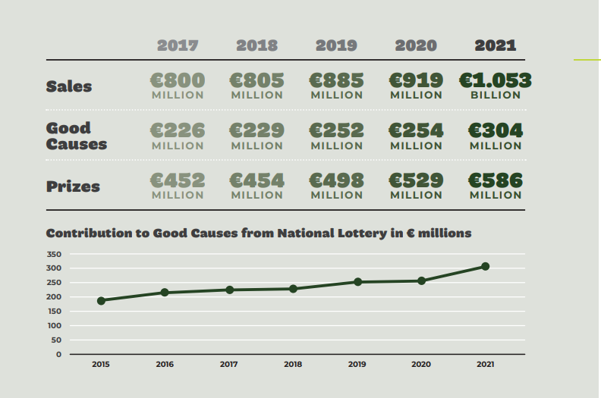
Figure 1: National Lottery Ireland Sales Review in € millions
Lottery tickets consumption isn’t impacted by recession. The research conducted on the gambling-related disorders (Delfabbro, 2013) used longitudinal evidence relating to the stability of gambling-related problems and lottery tickets proved to withstand test of time. Study from Sweden that used household data on general gambling expenditure also indicated that gambling on lottery tickets seem to be on the increase with time (Romild et al., 2014). Collectively the studies illustrate that lotteries are recession resistance but casino and parimutuel betting are not. There exist little empirical findings if that is still the case in these current economic times coupled with the Covid-19 Pandemic and current Russian war on Ukraine which has worsened the financial crisis.
The adoption of online gambling where one can place bets or buy lottery tickets online has also fuelled the growth of the gambling industry and the recent pandemic ignited the fire since many people spent more time on their phones with no work to do (Egerer and Marionneau, 2019). This may mean that participation in gambling activities and more so in lottery is going to continue to increase even when the economy isn’t looking good as the ‘It could be you’ slogan may appeal to many who want to place bets using low stakes and take chances of winning big prizes.

Economic Stimulus
When recessions occur, governments try to mitigate its effects by providing substantial economic stimulus, increasing public expenditure and providing tax reliefs to its people(Marangos, 2022).All this entails the government spending more money from the budget which already is constrained due to the bad state of the economy. Governments have adapted to unconventional methods of raising revenue that does not involve additional tax to its people by adapting lotteries as an alternative way to raise revenue(Hansen et al., 2000). The revenue raised from them is often earmarked for specific government activities such as educational and cultural programmes. In the US many states, such as New York, income, property, sales, and other tax rates historically have been so high that there has been substantial voter resistance to further increases in these tax rates. Beginning in the 1960s, legislators in some of these high tax effort states realized that adopting a state lottery might generate significant spendable revenues for the state without having to raise other existing tax rates (Davis and Filer, 1992).
In Ireland after the great recession of 2008, the government decided to sell the national lottery license to raise revenue for the state to help recover from the economic crisis. It was sold to a consortium comprising Ontario Teachers Pension Plan (the owner of the Camelot Group), An Post and An Post pension funds for €405 million (Éanna Ó Caollaí, 2013). The government still regulates it and dictates the projects to be earmarked as good causes but doesn’t gain the surpluses that accrue as tax revenue. The lottery tickets in Ireland are V.A.T exempt and winnings are all tax free (Euro-Millions.com, n.d.). This means that apart from the good causes the government directs spending on which can sometime not be highly effective(Bowden and Elrod, 2004) and the corporation tax paid by the company holding the licenses, governments don’t benefit in any other way from the multi-billion-dollar industry.
Even though state lotteries were historically viewed as regressive revenue production, recent research indicates that they become less regressive as they progress through their individual life cycle and as new marketing efforts become more prevalent(Miyazaki et al., 1998). Progressive taxation where the high income earners are taxed more to raise more revenue for the governments has been viewed to be more acceptable according to recent study of a focus group in England (Prabhakar, 2012). Even though progressive taxation has been on the controversy side for a long time (Domonkos, 2016), it has been proved to have far more good implications than negative implications.
Thus, from the review of literature on areas of taxation of lotteries and progressive taxation, governments have benefited from adopting such policies. What this research will seek to add on existing literature is whether the government of Ireland can benefit more by progressively taxing the lottery winners as it is tax free winnings at the moment.

Conceptual Framework

Progressive taxation

Figure 2: Conceptual Framework, developed by the author
The conceptual framework chosen is concept map. This is because it shows visual representation of ‘ideas’ which forms part of the research project as well as the relationship between them.

ECONOMIC CRISIS ELEMENT
This relates to FINANCIAL CRISIS THEME in the literature review, in the first paragraph where the indicators of whether a country is experiencing or is headed to an economic crisis are identified. By looking at a country’s Gross Domestic Product (GDP) and its unemployment rates, this element can be measured by checking if there is a drop in GDP in two or more consecutive quarters or if the unemployment rate rises by at least 0.3% points in a single month then declines for two consecutive months. Another hypothesis proposition is to check whether changes in the interest rates indicates economic crisis. Another hypothesis would be to ask the consumer their sentiments concerning the economy as this has also been proven can be used to predict if we are in recession.

GAMBLING ELEMENT
This relates to BEHAVIOURISM THEME in the literature review where humans produce a response when coupled with a specific event or crisis in their environment. This can be measured by asking people who bought the lottery tickets or gamblers in general if they bought more tickets recently as compared to the past or how they are coping up with the tough economic times. This also relates to GAMBLING INDUSTRY THEME in the literature review, in paragraph three where lottery tickets experience incremental sales even in recession because gamblers try their luck to win large jackpots with low initial stakes. This can be measured by looking at revenue data of luck-based gambling or lotteries over time and testing if it’s been on the increase or not by calculating the difference between revenues of each year.

PEARSONS BIVARIATE CORRELATION ELEMENT
In situations where results of a hypothesis have not been proven to be statistically significant, the calculations of the power of statistical tests are important (Öner, 2022). When testing two continuous variables, the Bivariate Pearson Correlation statistical technique helps determine if there exists a relationship between the two continuous variables. The continuous variables being independent of each other, this statistical technique also indicates the strength of the linear relationship and the direction of the linear relationship (Uraibi and Midi, 2019). This can be measured by looking at the coefficients of the statistical method applied which ranges from -1 to +1. If its -1, then there exists a negative strong correlation between the continuous variables and if its +1 then the continuous variables have a positive strong correlation. The test would help us establish if there is a correlation between lottery tickets being bought with economic recession.

PROGRESSIVE TAXATION ELEMENT
This relates to ECONOMIC STIMULUS THEME in the literature review in paragraph one where governments impose measures to increase revenue and at the same time shielding the ordinary citizen. This is among the unconventional methods the governments have adapted to raise revenue through ways that doesn’t involve the conventional ways like increasing property tax. This element can be measured by looking at tax laws and regulations acts that is available in the public domain. A testable preposition would be asking the lottery consumers what their thoughts on progressive taxation are and how will hey react if lottery winnings were progressively taxed. Another hypothetical or testable proposition would be asking tax experts or advisors the impact of progressively taxing gambling companies.

Conclusion
Economic crisis has the effect on gambling participation with lottery tickets specifically having an increase during the time of recession. Behaviourism study has helped researchers come up with findings that have been used by the gambling industry companies where they focus their marketing strategies during recessions to specific products such as lottery tickets during recession times and capitalizing on the ‘get rich quick’ idea during the tough economic times.
Government involvement by progressively taxing lottery winnings could prove fruitful as a way of mitigating the adverse effects of the economic crisis and that is why I have adapted economic stimulus as a theme. Progressive taxation is becoming accepted in many societies, and this should be looked at or applied to gambling industry. The literature reviewed has helped set a solid foundation to this research by helping me stand on shoulders of giant researchers that have established breakthroughs in the gambling industry. This research would add additional knowledge to the vast existing ones and with regards to progressive taxation which is still unexplored.

Methodology and Research Design

Overview
This chapter focuses on the research methodology used to evaluate if progressively taxing lottery winnings can help the government raise more revenue especially during recession. It will cover the philosophy employed, the strategy to be used and how primary data will be gathered from which sources and how the data gathered would be treated to produce a valid research outcome. It also covers the reason why the specific research and data analysis method was chosen with in detail description of each method and process. There is also a section that contains the research access and ethical issues while the last part contains a conclusion that gives a summary of what this chapter covers without going into detail.

Research Philosophy and Approach
Choosing a research paradigm for a research project helps establishing a solid foundation for the study’s research and its methodologies. A paradigm investigates how knowledge is understood and researched, and it explicitly outlines the objective, motivation, and expected outcomes of the research (Abbadia, 2022). The proper implementation of a research paradigm in research provides researchers with a clear path to examine the topic of interest.
To choose the appropriate research philosophy and strategy, it is important to understand the various approaches to research that exist. There are five research paradigms which include positivism, realism, interpretivism, post-modernism and pragmatism as illustrated in figure 3.
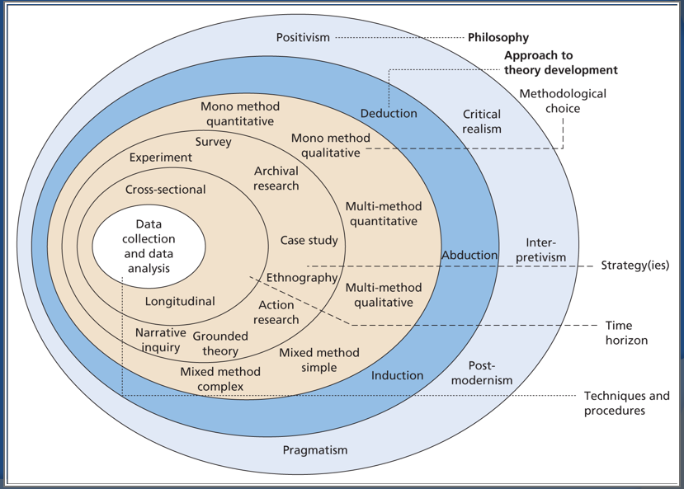
Figure 3: The Research ‘Onion’ (Saunders, Lewis and Thornhill, 2015)
The positivist paradigm is based on the assumption that a single tangible reality exists—one that can be understood, identified, and measured and that knowledge can and must be developed objectively, without the values of the researchers or participants influencing its development (Park et al., 2020). As a result, quantitative approaches are utilized to quantify this reality.
The interpretivism paradigm assumes that reality is subjective, multiple and socially constructed. It adopts the position that people’s knowledge of reality is a social construction by human actors, and so it distinctively rules out the methods of natural science(Chowdhury, 2014). It implies we can only understand human behaviour through their experience of that reality, which may be different from another person’s shaped by the individuals’ historical or social perspective. Interpretive approach relies on questioning and observation to discover or generate a rich and deep understanding of the phenomenon being investigated. This is closely associated with qualitative methods of data collection.
This research employs pragmatism paradigm which combines both interpretivism paradigm and positivist paradigm. Pragmatism involves research designs that incorporate philosophical or methodological approach that works best for the particular research problem that is being investigated hence enabling pragmatic researchers to conduct research in innovative and dynamic ways to find solutions to research problems (Kaushik and Walsh, 2019). This is followed by an examination of many aspects of a research problem using a combination of quantitative and qualitative approaches (Abbadia, 2022).
By applying pragmatism approach in this study, the positivist paradigm will be used when identifying if gambling or lottery participation is still recession proof from analysing the sample data set collected. Previous research work in this field of gambling had been conducted using positivist approach and conclusion were drawn that lottery is recession proof. By using the same approach, this research aims to establish if that is still the case in the current economic times and whether government can benefit from progressively taxing the lottery winnings especially during recession.
Adopting the interpretivist paradigm would help answer my last research question by collecting opinions from the sample population group. My research purpose focuses on progressively taxing gambling activities especially lottery winnings and whether by doing so creates a safety net for governments in recession. Interpretivist paradigm would help unravel this as the opinion and advice of tax experts would indicate whether the research purpose would be achievable. Although tax laws are certain and almost a fact, they were formed by experts based on their knowledge at the time of formation and this could have changed overtime and maybe the opinion of the sample population collected can be an indication for a need of change.

Research Strategy
A research strategy refers to a step-by-step plan of action that gives direction to the researcher’s thought process (Chetty, 2020). Research strategies enables researchers to conduct research in a systematic and orderly manner leading them to choose the appropriate research tools for data collection and data analysis. Th appropriate research strategy is dependant upon the research topic, the purpose of the research, resources available to the researcher and the philosophical approach the researcher has adapted.
This research paper uses quantitative strategy with surveys and questionnaires as the tools for the strategy. The quantitative strategy will be used to collect primary data which will be numerical. The Survey data used would contain data of the population including unemployment figures and the Consumer Price Index (CPI). The questionnaires would contain questions of where, when, what and how often on a measurable scale. This data would be essential in analysing if gambling especially lottery participation is still recession proof and how the sample data subjects would react if lottery winnings were progressively taxed.
The questionnaires also involve getting opinion of people concerning certain facts or problem. The analysis of the findings would then follow to come up with meaningful and reliable interpretation from the data.

Collection Primary Data
This section refers to the data that is used in this research with regards to how it was collected, where it was collected from, when and who were the subject matters of this data. It also contains the access and ethical issues concerning the collection of the primary data.

Sources
This research contains two main sources of primary data. One is entirely quantitative while the other is a mixture of quantitative and qualitative. The mixed method combines the advantage of both data sets of qualitative and quantitative to provide the best understanding of the research problem while making up for the weaknesses of both approaches (Khaldi, 2017).
The first source of primary data which is purely quantitative is the data from the surveys conducted by the Central Statistics office (CSO). The Central Statistics Office is the national statistical office whose purpose is to impartially collect, analyse and make available statistics about Ireland's people, society and economy. Since it conducts the national census and holds over 3,000 surveys on households every week all through the year, it gives a very accurate picture of the economic and social situation of the citizens of Ireland, in a way and with a level of detail that no one else can gain. This is like the mother of all surveys since it covers almost the entire population given its resources and not necessarily a sample population. The data to be collected would be factors to indicate recession including unemployment figures and inflation rate which is measured by Consumer Price Index (CPI). This would be analysed against the revenue the National Lottery recorded which can be found from their official website to establish if the hypothesis exists.
The second source of primary data that is both quantitative and qualitative is the use questionnaires as the tool. The questionnaires would contain open ended and close ended questions which will have numerical scales to make them easy and answerable in a good amount of time. In todays world where ‘Less is always More’, questionnaires need to be short, sweet, and effective with high completion rates. For a higher success rate, the survey shouldn’t take long or more than 10 minutes to compete as people these days complete surveys using their mobile phone while they are grabbing their coffee or lunch breaks (Steve Wigmore, 2022).
The recent pandemic was the last nail to the coffin for conducting physical survey using questionnaires and the shift is now to online surveys with platforms such as Google forms and Survey monkey making it easily accessible. The survey needs to be precise and mindful of respondent’s time by only asking what you need and starting with a friendly easy to answer questions. A good survey response rate ranges from 5% to 30% with an excellent response rate being 50% or higher (Chung, 2022).
The response from the survey would help this research in understanding the participation of the general population in gambling activities or lottery in the current economic times and what would be their response if the lottery winnings were progressively taxed. The survey would target random population and would try and get as many responses as possible. The questionnaire may contain easy closed ended questions such as:
- Do you gamble or participate in the lottery?
- How long have you been gambling or playing the lottery?
- How often do you gamble or play the lottery in the past?
- How often do you gamble or play the lottery currently?
- How much do you spend on gambling or lottery weekly?
- How much is your salary annually?
- How much have you ever won from gambling or lottery?
- Would you still gamble or play the lottery if the winnings were taxed?
- Do you think you have been impacted by the good causes the national lottery runs?
- Would you prefer your income taxes not to be increased or be taxed on you gambling or lottery winnings?
- What is your ethical view on gambling and the lottery?
- What is your view of the current government tax regime?
The close ended questions would make answering the questionnaire easy and fast while the last open-ended questions would help give a qualitative view of the topic and problem at hand. This will be analysed and compared against the earlier analysis to see if it is consistent and new findings from them recommended.

Access and Ethical Issues
With regards to ethical issues, (Robinson-Pant and Singal, 2020) states that,
“…ethics education still tends to focus on the preparation and initial stages of the research. Although the current impact agenda has put more emphasis on dissemination as integral, rather than at the end of a project, ethical concerns are often narrowly conceived in terms of how to anonymise informants’ identities or field sites, and how to protect sensitive data.”
During this study, most of the ethical requirements has been satisfied as a plain language statement and ethical form have been filled out. The participants of the survey were provided with consent form stating they have the option to opt out of the survey at any time as they are not being forced to partake in the research and assured how their information provided will be kept confidential. The researcher also must behave ethically when presenting and discussing findings in an honest way and ensure the dissemination of the data is appropriate through the correct channels.

Approach to Data Analysis
Data analysis is the process of collecting, modelling, and analysing data using various statistical and logical methods and techniques. In order to establish a trail of evidence , (Rabiee, 2004) states that a clear procedure of data analysis should be documented and understood as this would allow another researcher to verify the findings and provide a safeguard against selective perception and increases the rigour of the study. This research uses quantitative method to analyse the data. There exists five stages to data analysis according to (Calzon, 2023) which is illustrated in figure 4 below.
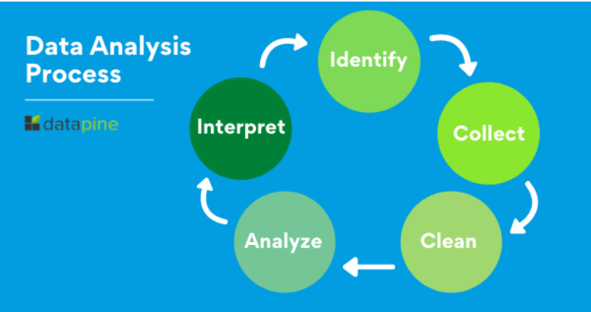
Figure 4: Data analysis Process (Calzon, 2023)
The first step is identifying which type of data you need and why you need it in the first place. Going back to the research objectives and purpose will help one come up with questions that one needs to identify the data to be collected. The second step would be data collection. Since it’s a quantitative analysis and partially qualitative, relevant data would be collected from the surveys conducted by Central Statistics office and the use of questionnaires on the sample data. The third step is cleaning up the data and only taking what is useful to have a meaningful analysis. The fourth step is analysis which in this case the quantitative part would use statistical analysis while the qualitative part would use narration analysis. This part is discussed in more detail below but its basically finding patterns, trends and correlation that can help one come up with conclusions. The last part is interpretation where it involves coming up with courses of action based on the findings.
The quantitative analysis in detail would entail linear regression analysis and Pearson’s correlation analysis. Linear regression analysis is a linear approach for modelling the relationship between a scalar response (dependent variable) and one or more explanatory variables (independent variable)(Agiakloglou et al., 2022) . A linear regression line has an equation of the form Y = bX + a, where X is the explanatory variable and Y is the dependent variable. The slope of the line is b, and a is the intercept (the value of y when x = 0). Linear regression analysis would be performed on the data gathered from the survey from Central Statistics office (CSO) and revenue the National Lottery records annually in € millions. The National Lottery sales in € millions would be the dependent variable while the unemployment figures and Consumer Price index from the Central Statistics Office (CSO) would be the independent variable or the explanatory variable. To establish if the linear regression model is a good fit to the data, a correlation coefficient needs to be established.
The Pearson Correlation Coefficient statistical technique helps determine if there exists a relationship between the two continuous variables. The continuous variables being independent of each other, this statistical technique also indicates the strength of the linear relationship and the direction of the linear relationship (Uraibi and Midi, 2019). This can be measured by looking at the coefficients of the statistical method applied (R) which ranges from -1 to +1. If its -1, then there exists a strong negative correlation between the continuous variables and if its +1 then the continuous variables have a strong positive correlation (Ly et al., 2018). The test would help us establish if there is a correlation between lottery tickets being bought with economic recession and help come up with a general conclusion using deductive reasoning. The product of R squared (R²) gives a result which is interpreted in terms of percentage to explain how much of the dependent variable is explained by the independent variable(Bobko and Karren, 1979). The table below in figure 6 provides some rough guidelines for how to describe the strength of correlation coefficients.
Correlation Coefficient (r) | Description
+1.0 | Perfect positive + association
+0.8 to 1.0 | Very strong + association
+0.6 to 0.8 | Strong + association
+0.4 to 0.6 | Moderate + association
+0.2 to 0.4 | Weak + association
0.0 to +0.2 | Very weak + or no association
0.0 to -0.2 | Very weak - or no association
-0.2 to – 0.4 | Weak - association
-0.4 to -0.6 | Moderate - association
-0.6 to -0.8 | Strong - association
-0.8 to -1.0 | Very strong - association
-1.0 | Perfect negative association
Figure 5: Rough guidelines for how to describe the strength of correlation coefficients (Wayne W. LaMorte, 2021)
The qualitative analysis would entail cluster analysis and narrative analysis which would help answer the research question which is can gambling provide a safety net to recession through progressive taxation. Cluster analysis is described as grouping of data points into subgroups, in such a way that the elements within a same group are more similar to each other than they are to the elements of a different one(Aquilanti et al., 2021). Based upon the response and feedback from the open-ended questions, their subjective interpretation of the topic of discussion would help me form an opinion based on the data collected from them. I would then organize my data into coding frame recording the occurrence of each code. I would try and establish codes that are in line with my main themes which are (progressive taxation and gambling companies). I will list all the codes making sure they are exhaustive and mutually exclusive. I would then mark on the side the occurrence of each code by the name or the code number. I would then record the frequency each code re-appears and try to focus on the main ones. This would aid in my narrative analysis and use of inductive reasoning to come up with a general conclusion.

Conclusion
This research adopted pragmatism paradigm which combines both interpretivism paradigm and positivist paradigm. The research design chosen is a mixed approach of both quantitative and qualitative when collecting primary data. Interpretivism paradigm will be used when analysing the quantitative data as these are facts while positivist paradigm when the qualitative data is being analysed as that would entail opinions. The tools used in collection the primary data are surveys conducted by the Central Statistics Office (CSO) and online questionnaires. The sources of data are the survey data conducted by the Central Statistics Office (CSO) which is the national statistics office whose mandate is to conduct the national census and they also conduct statistical surveys regularly. The second source of data is a sample data set of the population preferably who gamble or play the lottery. This chapter also shows how the data collected would be analysed and conclusions drawn using both inductive reasoning and deductive reasoning. The data from the Central Statistics office would be analysed using Linear Regression equation and Pearson’s Bivariate Coefficient to establish if there exists a relationship or correlation between gambling and recession in Ireland. The data from the sample population set would be analysed using cluster analysis and narrative as the sample population is small to draw statistical inference from.
The potential outcome from gathering the data and analysing is that a relationship between gambling or lottery participation would be established and the strength of their correlation. Analysis in detail for example based on each sex would be done for comparisons even though this might have a limitation to only male and female because the data only had the two options. In the past, males used to gamble more than women and by analysing the data, this would be established if it is still the case or not. The opinions of the sample population data set would also be organized into cluster and narrative analysis to depict the aspect of introduction of taxation on the lottery. The size of the sample data set is expected to be small and not that big as the resources to conduct a huge survey like the ones conducted by Central Statistics office isn’t available. The presentation and discussion of the findings will be done in the next chapter in detail.

Presentation and Discussion of the Findings

Overview
The aim of this study is to establish hypothesis testing on whether gambling or lottery is still recession proof and if there exists a correlation between them especially in Ireland. To establish this, relevant data collected from Surveys conducted by Central Statistics Office were analysed against revenue The National Lottery Ireland has been reporting using linear regression and Pearson’s correlation. Having derived meaningful discussions and findings from the analysis, it is compared with the data from the mini survey conducted and to see if it goes hand in hand or not and the aspect of progressive taxation on the winnings when introduced.

Findings
This research paper combines two surveys, the first survey which is on a large scale and is conducted by the Central Statistics Office which is the national statistical agency and the second survey which is on a small scale conducted through questionnaire on a sample population. The data gathered from the Central Statistics Office was consistent and included data from the year 1998 to 2022 such as the Unemployment rate which also further classified it based on genders. It also included the Consumer Price Index (CPI) which is used as a measure of inflation of a country. Both data gathered were analysed against data of revenue received from the National Lottery which was accessible from their official website. The second survey which was conducted by means of questionnaire was able to get over 110 responses and after cleaning the data 104 responses were valid for use. In summary, the process of data collection is satisfied as a whole.

Unemployment figures
The unemployment figures gathered from the Central Statistics office was grouped into quarters and consisted of figures from the year 1998 to 2022 which meant 100 quarters. The unemployment figures are grouped into quarters because one can be unemployed in one quarter and be employed in the next hence totalling them yearly can be misleading. The figures were available for both sexes and further classified into male and female. The figures represented persons aged 15 years and above who were able and willing to work at the existing labour rate and conditions, but they were unable to find work. Figure 6 shows the unemployment line graph of both sexes of persons aged 15 years and above living in Ireland.

Figure 6: Unemployment line graph of both sexes of persons aged 15 years and over from 1998 to 2022
To get useful analysis from the above data gathered, revenue from the National Lottery is required for the same time frame 1998 to 2022. This was accessible from an independent assessment conducted on socio-economic impact of the National Lottery by Indecon Research Economists which can be found on the National Lottery website. Figure 7 shows the total national lottery sales (€ Million) line graph.

Figure 7: Total National Lottery Sales (€ Million) Line Graph
The two-line graphs of unemployment figures and National lottery sales in € million can be combined to give a visual representation of how they relate even before further data analysis is done on them. Figure 8 shows the combined line graphs

Figure 8: Combined Unemployed Persons Both Sexes and National Lottery Sales Line Graphs
The naked eye can deduce findings by looking at the combined line graphs but by conducting further data analysis using statistical methods is when can be absolutely guaranteed of finding a relationship from group sets of data. Linear regression was performed on the two data sets with the unemployment figures being the dependent variable while the National Lottery sales in € millions being the independent variable. A linear regression equation was established, and Pearson’s correlation coefficient R. Figure 9 shows the National Lottery Sales in € millions Chart while Figure 10 shows its statistical analysis.

Figure 9: National Lottery Sales in € millions Vs Unemployed Persons in (000) Both Sexes Chart

Linear Regression Equation |  |  |  | Y=0.5501x+607.4
Pearson's Correlation R |  |  |  | 0.327078
Slope |  |  |  | 0.550119
Intercept |  |  |  | 607.0436
Figure 10: Statistical analysis of National Lottery Sales in € millions Vs Unemployed Persons in (000) Both Sexes Chart
The data can be further analysed based on the gender of the unemployed persons to establish the relationship between the two data sets. The same process for analysing the above data set of both sexes and the National Lottery sales in € millions is used but now for individual sexes of male and female. Figure 11 shows the combined line graphs of unemployed males and the National Lottery sales in € millions. This just gives a visual representation of how the two group sets of data relate.

Figure 11: Combined Unemployed Males in (000) and National Lottery Sales in € Millions Line Graphs
Further analysis of the group data sets was conducted using statistical methods such as linear regression and Pearson’s Correlation Coefficient giving rise to figure 12 which is the National Lottery Sales in € Millions Vs Unemployed Males (000) Chart and Figure 13 which is the statistical analysis.

Figure 12: National Lottery Sales in € Millions Vs Unemployed Males (000) Chart

Linear Regression Equation |  |  | Y= 0.7809x + 621.47
Pearson's Correlation R |  |  | 0.303337
Slope |  |  | 0.780947
Intercept |  |  | 621.4743
Figure 13: Statistical Analysis of National Lottery Sales in € Millions Vs Unemployed Males (000)
The same process for data analysis is applied to the data set of unemployed women giving rise to Figure 14, 15 and 16.

Figure 14: Combined Unemployed Females in (000) and National Lottery Sales in € Millions Line Graphs

Figure 15: National Lottery Sales in € Millions Vs Unemployed Females (000) Chart

Linear Regression Equation |  |  | Y= 1.7063X + 583.48
Pearson's Correlation R |  |  | 0.361517
Slope |  |  | 1.706312
Intercept |  |  | 583.481
Figure 16: Statistical Analysis of National Lottery Sales in € Millions Vs Unemployed Females (000)

Consumer Price Index (CPI)
The Consumer Price Index (CPI) which is a measure of the average change in prices over time in a fixed market basket of consumer goods and services was obtained from the Central Statistics Office which is the national statistical office. We took the base to be December 2011 where the CPI is 100 and did collect data from the year 2008 to 2022 because in 2008 there was a great world recession and analysing data from that period would bring out a better understanding of the hypothesis. Figure 17 shows the Consumer Price Index line graph with the base Dec. 2011= 100.

Figure 17: Consumer Price Index (CPI) Base Dec.2011=100 Line Graph
To analyse the data, revenue from the national lottery sales was also needed to be obtained for the same time frame 2008 to 2022. This was accessible from their website and the figure 18 below shows its line graph.

Figure 18: National Lottery Sales in € Millions Line Graph
The two line graphs can be combined to give visual representation of the hypothesis being tested having not done advanced statistical analysis on the data. Figure 19 shows the combination of both line graphs even though the range in values for Consumer Price Index (CPI) is small hence one cannot easily interpret the data with a naked eye.

Figure 19: Combined Line Graphs of Consumer Price Index (CPI) Base Dec.2011=100 and National Lottery Sales in € millions
Linear integration and Pearson’s Correlation Coefficient R is performed on the data to give statistical insights that the naked eye cannot see. National lottery sales in € millions was plotted with it being the dependent variable while the Consumer Price Index being the independent variable giving rise to figure 20 and figure 21.

Figure 20: National Lottery Sales in €Millions Vs (CPI) Base Dec. 2011=100 Chart

Linear Regression Equation |  |  | Y= 24.447x - 1681.2
Pearson's Correlation R |  |  | 0.512819
Slope |  |  | 24.44702
Intercept |  |  | -1681.23
Figure 21: Statistical Analysis of National Lottery Sales in € Millions Vs (CPI) Base Dec.2011

Mini Survey Poll
The mini survey was conducted to check if gambling or lottery participation is being affected by the recession and what would be the impact of progressive taxation on the lottery winnings. Out of the 110 responses from the survey, 104 of them were valid for analysis having cleaned the data. The survey included questions that could help group the data based on their gender, age, marital status, employment status and their opinion on tax. Out of the 105 responses, 57 were female and 48 were male. To determine how often they participate in the lottery, they were asked how often they used to participate in the past and how often they participate currently, and the responses were analysed by pivot tables and pie charts.
The response got when the participants were asked ‘How often they gamble or play lottery in the past?’ and ‘How often they gamble or play the lottery currently?’ can be analysed using the bar graphs below where an increase in the percentages can be noticed even though not that significantly as seen in figure 22 and figure 23

Figure 22: Percentage Distribution of ‘how often did you gamble or play the lottery in the past?’

Figure 23: Percentage Distribution of ‘how often do you gamble or play the lottery currently?’
In the literature review, players of the lottery or gamblers were influenced by their type of jobs and how much they earned from those jobs. Therefore, it was essential to get this data from the sample population of how much they earned annually as shown in figure 24.
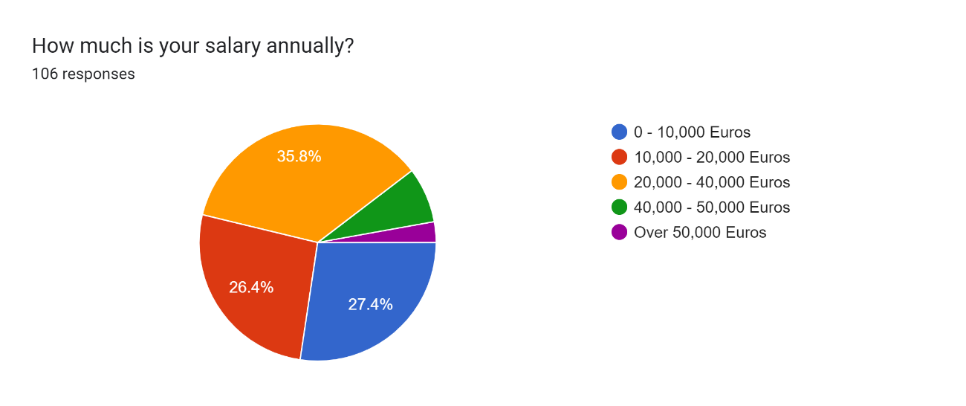
Figure 24: Pie Chart of ‘How much is your salary annually?’
Having established how much they earn annually, it was also important to know how much they spend on gambling or playing the lottery and how much they have ever won back which is illustrated in figure 25 and figure 26.
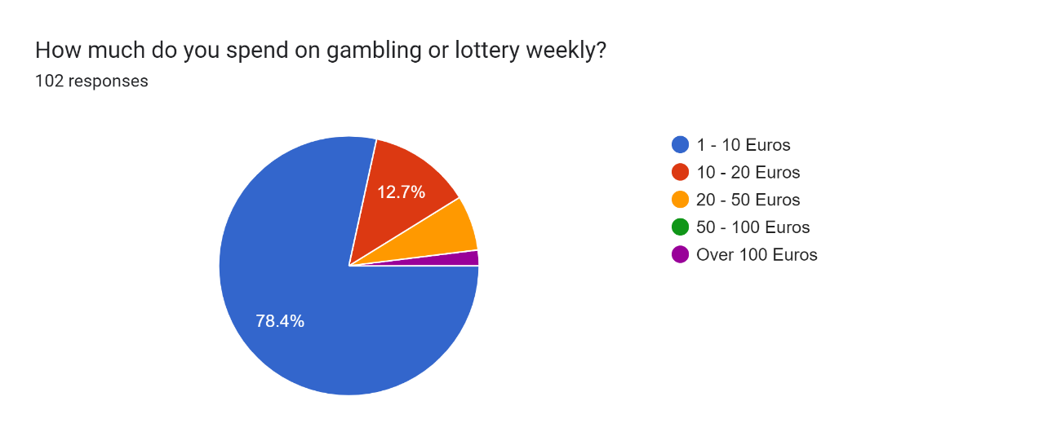
Figure 25: Pie Chart of ‘How much do you spend on gambling or lottery weekly?’
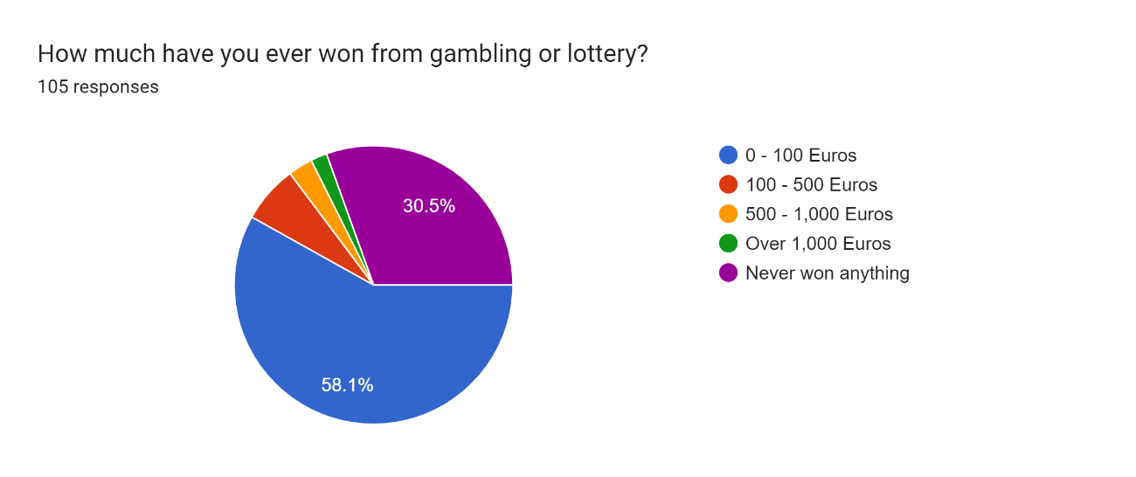
Figure 26: Pie Chart of ‘How much have you ever won from gambling or lottery?’
To introduce the concept of taxation and whether it affected their gambling decisions, the sample population was asked if they knew lottery winnings in Ireland is tax free and if they would still gamble if the winnings were taxed. Figure 27 and 28 shows their responses.

Figure 27: Timestamp by the gender identifying with and if they knew lottery winnings in Ireland is tax free.

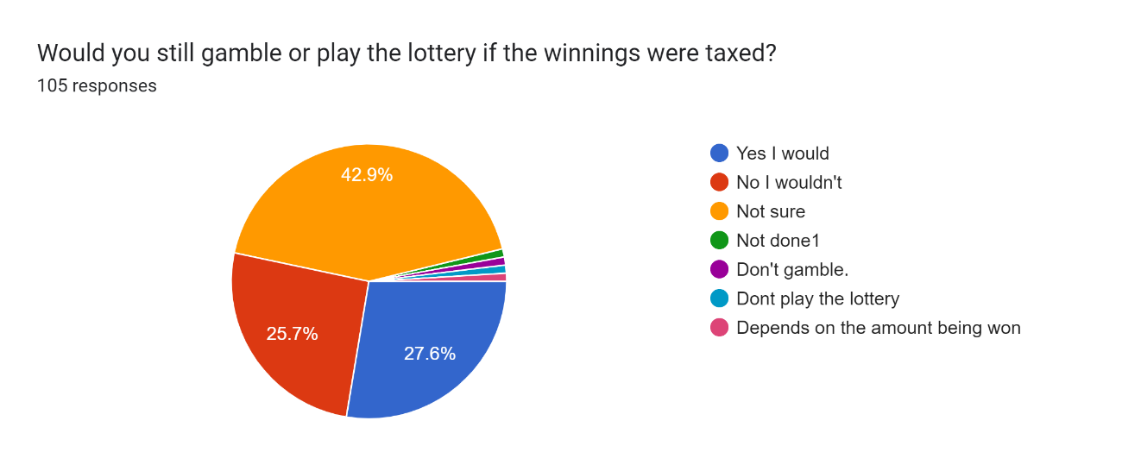
Figure 28: Pie Chart of ‘Would you still gamble or play the lottery if the winnings were taxed?
The sample population was also asked if they had a choice of the income taxes not to be increased but their gambling or lottery winnings to be taxed and below is their response in figure 29.
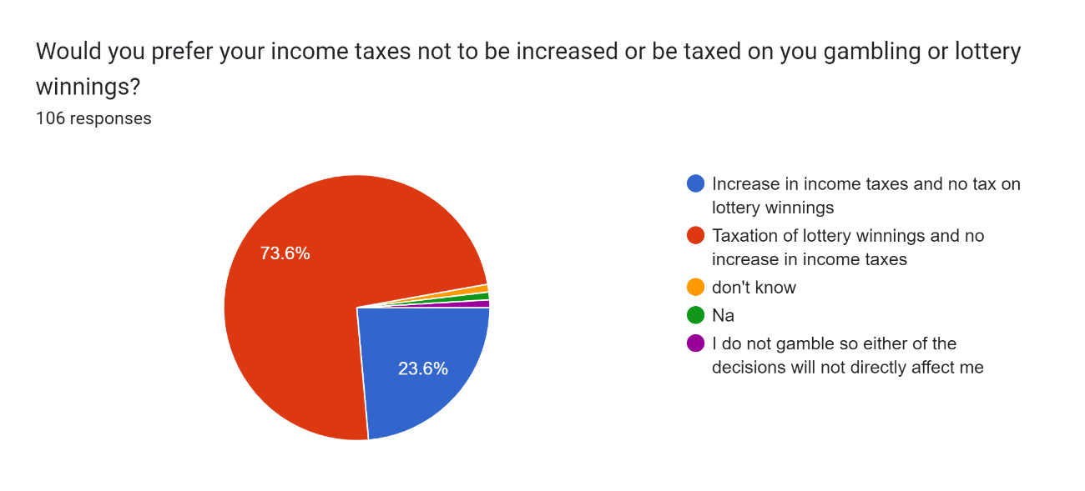
Figure 29: Pie Chart of ‘Would you prefer your income taxes not to be increase or be taxed on your gambling or lottery winnings?’
Having established that the lottery winnings in Ireland is free, the sample population was asked if they knew or have been positively impacted by the good causes the national lottery runs and below was their response in figure 30
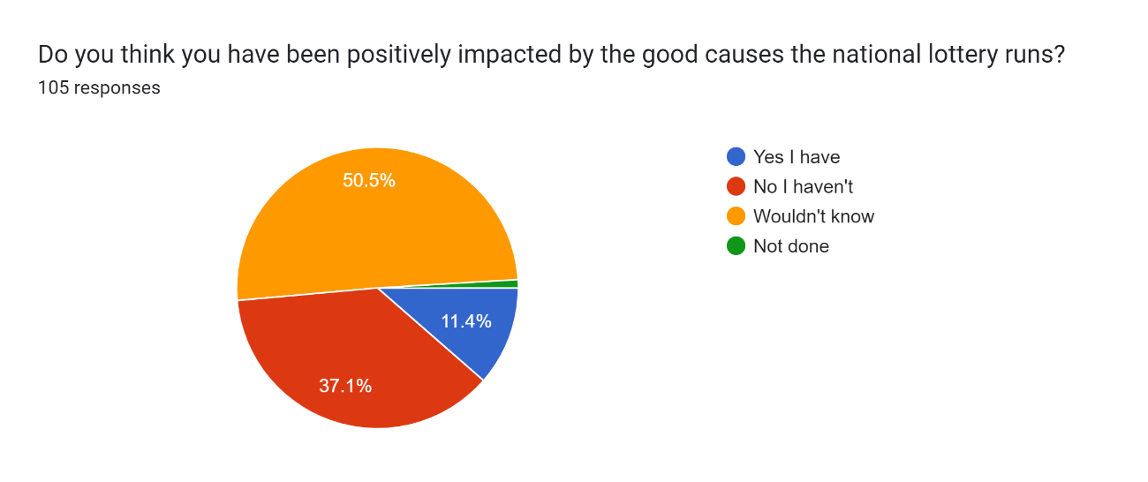
Figure 30: Pie Chart of ‘Do you think you have been positively impacted by the good causes the national lottery runs?’
The sample population was also asked open ended questions about their opinion on gambling and lottery and there were different responses with the common ones being it’s an individual choice, source of entertainment, should be regulated so as not to lead to addiction and even others mentioning it being a waste of money. Some mentioned it is a source of government to raise revenue which when further analysed using the second open ended question which was their view of the current government tax regime, many people suggested that the government should tax more activities that promote harmful behaviour and ease tax burden on the common person which they mentioned being too high.

Discussion
This study is intended to establish if gambling or lottery is still recession proof by investigating the national lottery revenue against factors that indicate recession including unemployment figures and Consumer Price Index (CPI). The study also introduces the factor of progressive taxation on lottery winnings by conducting a mini survey on a sample data and trying to deduce the hypothesis being tested. These will be discussed in this section, based on the findings from the analysis and compare with previous scholars’ research findings.

Unemployment Figures
In the previous literatures, there are evidences that suggest that when a recession occurs, its leads to a higher unemployment figures since economic activities slows down (Buturac and Teodorović, 2012). Gambling activities particularly lottery increases in times when recession is being experienced implying lottery to be recession proof (Horváth and Paap, 2012). The results of this study seem to be consistent with this earlier research.
By looking at the combined line graphs of the unemployment figures of both sexes and the National Lottery sales in € millions at a glance in figure 7, one can draw a conclusion that an increase in unemployment figures leads to a decrease in National lottery sales while a decrease in unemployment figures leads to an increase in National Lottery sales. This could be true but by further analysing the data using statistical methods such as Linear regression and Pearson’s Correlation Coefficient, we can draw statistical inferences. The linear regression equation is Y=0.5501x+607.4 with the National Lottery Sales in € millions being the dependent variable Y and the unemployment figures being the independent variable X. Interpretation of this equation implies that for every unit increase in unemployment figures, the National Lottery sales in € million increases by 0.5501 times and that if the unemployment figures is zero, the National lottery sales would be 607.4 million Euros.
By using the Pearson’s Correlation Coefficient, it gives R to be 0.327078 indicating a weak correlation but statistically significant and R² to be 0.107 indicating that 10.7% of National Lottery Sales in € millions (dependent variable) movement can only be explained by the Unemployment figures of both sexes (independent variable). This means that unemployment figures are one of the factors that significantly contribute to the movement of National Lottery sales but isn’t the only factor.
Further analysis of the data based on gender gives us combined line graphs of each gender and the National Lottery sales in € millions in figure 10 and figure 13 that when looked up in a glance may indicate that an increase in unemployment figures of each gender leads to a decrease in the National Lottery sales in € millions and a decrease in unemployment figures of each gender leads to an increase in National Lottery Sales in € millions. This may be true but only by analysing the data using statistical means is when a statistical inference can be drawn. Statistical analysis gives a linear regression equation for unemployed males to be Y= 0.7809x + 621.47 and for unemployed females to be Y= 1.7063X + 583.48 where the unemployment figures are the independent variable X while the National Lottery sales in € millions are the dependent variable Y. The interpretation of the equation means that for every unit increase in unemployed males, the National Lottery sales increase by 0.7809 times while for every unit increase in unemployed females, the National Lottery sales increase by 1.7063 times. This means that unemployment figures of women influence the National Lottery sales in € millions more than the figures of men do. The equations also mean that when the unemployment figures for males is zero, the National Lottery sales would be 621.47 million Euros and when the unemployment figures for females is zero, the National Lottery sales would be 583.48 million. This may mean that men who are in employment gamble more than women in employment.
The Pearson’s correlation coefficient for unemployed male’s figures gives R to be 0.303337 indicating weak correlation between the unemployment figures and the National Lottery sales in € millions but to be statistically significant. It gives R² to be 0.092 indicating that 9.2% of the National Lottery sales in € millions can be explained by the unemployment figures of males. The Pearson’s correlation coefficient for unemployed female’s figures gives R to be 0.361517 indicating weak correlation between the unemployment figures and the National Lottery sales in € millions but statistically significant. It gives R² to be 0.1307 indicating that 13.07% of the National Lottery sales in € millions can be explained by the unemployment figures of females.

Consumer Price Index (CPI)
Consumer Price Index (CPI) which is a measure of inflation is the average change overtime in prices of a basket of goods and services consumed by households. Earlier research indicates that during recessions the purchasing power of the consumer reduces (Chamberlain and Fosso, 2022) and also that Lottery consumption remains to be recession proof (Horváth and Paap, 2012). The results of this study seem to be consistent with this earlier research.
The combined line graphs of the Consumer Price Index Base Dec.2011 = 100 from the year 2008 to 2022 and the National Lottery Sales € for the same time frame in figure 18 cannot be easily interpreted at a glance since the movement of the Consumer Price Index (CPI) is small. By performing further statistical analysis on the data enables us to interpret the data in depth. The Linear regression equation from the analysis is Y= 24.447x - 1681.2 where the Consumer Price Index Base Dec.2011 = 100 is the independent variable X while the National Lottery sales in € millions is the dependent variable Y. The meaning of this equation is that for a unit increase in the Consumer Price Index (CPI) which essentially means a decrease in the consumer purchasing power, there is a unit increase in the National Lottery sales in € millions by 24.447 times and that if the Consumer price index is zero which essentially can never happen, the National Lottery sales would be -1,681.2 million Euros. This indicates that when there is recession, the (CPI) increases leading to the increase of National Lottery sales in € millions.
The Pearson’s correlation coefficient gives R to be 0.512819 indicating a strong correlation between the data that is statistically significant and R² to be 0.263 implying that 26.3% of the National Lottery sales in € millions can be explained by the Consumer Price Index Base Dec.2011 = 100 as the independent variable.

Mini Survey Poll
The mini poll survey was conducted to check if the findings of the above analysis and earlier research are consistent and introduces the aspect of progressive taxation on the lottery winnings. The findings seem to be consistent and of great addition to the existing research.
When the participants of the poll were asked how often they gambled in the past and how often they gamble currently, there seem to be an increase in their participation in the gambling as seen in figure 21 and figure 22. Even though the response was majorly rare and never, the people who never gambled in the past seem to be reducing as 35.24% said they never gambled in the past, but this reduces to 33.33% currently and those who gambled often also increased to 5.7% from 4.76%. This seem to be consistent with earlier research since the economic climate seems to be harsh currently hence, we expect people to gamble more as seen in the other data analysis. Though it shows an increase of participation of women in gambling and lottery which contradicts the earlier findings that men in unemployment gamble more than women meaning this sample population may be skewed.
Their average annual salary ranged from 20,000 to 40,000 Euros which is closer to the national average salary of 45,000 Euros annually meaning we can use the sample data in analysing their spending. 78.4% of them used 1-10 Euros while 12.7% used 20-40 Euros. Even though lottery or gambling is seen as a luxury item or activity, the amount they gambled with seem to be small to have huge financial impact on them. Likewise, 58.1% of them have won less than 100 Euros,6.7% winning 100- 500 Euros, 2.9% winning 500 – 1000 Euros, 1.9% winning over 1000 Euros while 31 % never won anything which presumably consist of those who don’t gamble.
When the poll participants were asked if they know the lottery winnings in Ireland were tax free, the female participants who knew it is tax free were 34 while those who didn’t know were 23 and the male participants who knew it is tax free were 29 while those who didn’t know were 19. This means that almost half of the sample population and maybe then the entire population don’t know the lottery winnings to be tax free. The question ‘Would you still gamble or play the lottery if the winnings were taxed?’ was asked and the response was that 42.9% of them were not sure if they would gamble or play the lottery, 27.6% said they would gamble or play the lottery,25.7% said they wouldn’t gamble or play the lottery while the other responses were small or close to insignificant. This may mean if the lottery winnings were progressively taxed, more than 28% would still play the lottery with 43% unsure which can swing either way meaning government can raise a good chunk of revenue by taxing these activities. This seem to be consistent with the next question which was ‘Would you prefer your income taxes not to be increase or be taxed on your gambling or lottery winnings?’ with 73.6 % saying they would prefer that and 23.6% saying they would prefer their income taxes to be increased but their lottery winnings not to be taxed. The reasoning behind being its better to go out there and work for your income and be taxed less on it than someone winning a huge amount they haven’t worked for and still not being taxed on it. This may mean the government could raise more revenue by taxing the lottery winnings.
Since the government doesn’t tax the lottery winnings, they only gain by regulating the good causes activity carried out by the National Lottery which the sample population 50.5% mentioned they wouldn’t know if they have been impacted by the good causes’ activities,37.1% saying they haven’t been impacted by these activities and only 11.4% saying they have been impacted. If the government taxed the lottery tickets or winnings and directing the funds towards activities that are of public interest, the population may seem to change their perspective about gambling and lottery and their tax burden may even be less since the government will have alternative sources of revenue.

Conclusion
The findings of this study are in concurrent with the earlier research that lottery consumption is recession proof. By using both unemployment figures and Consumer Price Index (CPI) as a measure of inflation or even the hard economic times being experienced, they have both indicated to have a positive correlation to the National Lottery sales. Introduction of taxation on the lottery activities seems viable if the findings from the sample population is anything to go by.
The unemployment figures seem to have a weak correlation with the National Lottery Sales but being statistically significant. The unemployment figures for females seem to have a better correlation to the National Lottery sales as compared to the unemployment figures for males with 13.07% of the National Lottery sales in € millions being explained by the female unemployment figures as the independent variable while 9.2% of the National Lottery Sales in € millions being explained by the male unemployment figures as the independent variable. This also implied that more men in employment gamble more that women in employment.
The Consumer Price Index (CPI) has a strong correlation with the National Lottery sales as compared with the unemployment figures with 26.3% of the National Lottery sales in € millions being explained by the Consumer Price Index Base Dec.2011 = 100 as the independent variable. This seems to be the best fit model to be used on this data so far. This could also be explained by the human behavioural psychology where during tough times people resort to hope and try to win huge amounts of money using small stakes thereby leading to increase in lottery consumption (Sarmento et al., 2019).
The mini survey poll was also agreeing with the analysis done above with the disparity being that more women in employment gamble than men who are in employment which may indicate the sample population to be skewed.

Concluding Thoughts on the Contribution of this Research, its Limitations and Suggestions for Further Research

Implications of Findings for the Research Questions
This research aimed to establish if gambling could provide a safety net to recession through progressive taxation. To establish this, the objectives set were to establish if there existed a correlation between gambling and recession particularly in Ireland, to gather sample data set of the population that buys lottery tickets or gambles along with their characteristics, to analyse from the sample data set collected the impact on lottery participation if progressive taxation on winnings would be introduced and finally to establish if progressive taxation on lottery winnings could provide the safety net for recession. The research method used is mixture of both quantitative and qualitative. The primary sources of data were two surveys one conducted by the Central Statistics Office (CSO) which is the National statistics office so has nationwide data while the other source is a mini survey poll conducted by the researcher on a sample population whereby 110 participants took part in it. The researcher used online or digital questionnaires to gather the data of the sample population while The Central Statistics office (CSO) uses the National Census and holds surveys of over 3,000 households weekly through out the year to gather the data. The data was then analysed using Linear regression analysis and Pearson’s Correlation coefficient for the quantitative part while the qualitative part analysed the responses into codes noting down which codes reoccurred the most and the use of cluster analysis. The implications of the findings are broken down below according to each objective they relate to.

Correlation between Lottery Consumption and Recession in Ireland
There exists a weak positive correlation of 0.327078 between lottery consumption and unemployment figures of both sexes as one of the indicators of the recession but is statistically significant. The linear regression equation being Y=0.5501x+607.4 meaning that for every unit increase in unemployment figures of both sexes, the National Lottery sales in € million increases by 0.5501 times and that if the unemployment figures is zero, the National lottery sales would be 607.4 million Euros. 10.7% of the National Lottery Sales in € millions (dependent variable) movement can only be explained by the Unemployment figures of both sexes (independent variable).If the data is further analysed based on sexes, the unemployment figures for females seem to have a better correlation to the National Lottery sales as compared to the unemployment figures for males with 13.07% of the National Lottery sales in € millions being explained by the female unemployment figures as the independent variable while 9.2% of the National Lottery Sales in € millions being explained by the male unemployment figures as the independent variable.
There exists a strong correlation of 0.512819 between lottery consumption and Consumer Price Index (CPI) with 26.3% of the National Lottery sales in € millions being explained by the Consumer Price Index Base Dec.2011 = 100 as the independent variable making it the best fit model to be used on the data so far as compared to the unemployment figures. The linear regression equation being is Y= 24.447x - 1681.2 meaning that for a unit increase in the Consumer Price Index (CPI) which essentially means a decrease in the consumer purchasing power, there is a unit increase in the National Lottery sales in € millions by 24.447 times and that if the Consumer price index is zero which essentially can never happen, the National Lottery sales would be -1,681.2 million Euros. This indicates that when there is recession, the (CPI) increases leading to the increase of National Lottery sales in € millions which is in agreement with earlier research conducted by (Horváth and Paap, 2012). The research question ‘Does a correlation exist between gambling and recession?’ seems to be answered in depth with the findings.

Gathering data from a sample population data set of those who participate in gambling or lottery and their opinion about it
The responses from the survey conducted using online questionnaires were sufficient to enable this objective to be achieved. The survey got over 110 responses but after cleaning the data, 104 responses were valid to be used. This included data of their age, gender, their type of employment, how much they spend on gambling, how much they have ever won, if they knew lottery is tax free, their thoughts on introduction of taxation to lottery and their ethical view on gambling or lottery. Achieving this objective was essential to move forward to achieve objective three and four. The mini survey sample data set is however small and may not depict the true picture of the population that gamble and their view on introduction of progressive tax on winnings. This may mean that the data may be skewed so even though the objective was achieved, more resources in terms of money, skill, time, and different tools of gathering the data may lead to a more accurate result.

Impact on lottery participation if progressive taxation on winnings would be introduced
The findings from the mini poll survey indicate that introduction of taxation on lottery winnings is likely viable and may be welcomed by the population more than it may face resistance to it with 42.9% of them not sure if they would gamble or play the lottery if progressive taxation on winnings would be introduced, 27.6% said they would gamble or play the lottery,25.7% said they wouldn’t gamble or play the lottery while the other responses were small or close to insignificant. This may mean if the lottery winnings were progressively taxed, more than 28% would still play the lottery with 43% unsure which can swing either way meaning government can raise a good chunk of revenue by taxing these activities. with 73.6 % of those who participated in the survey indicating that they would prefer that their income taxes not to be increased rather tax their gambling or lottery winnings and 23.6% saying they would prefer their income taxes to be increased but their lottery winnings not to be taxed. The reasoning behind being it’s better to go out there and work for your income and be taxed less on it than someone winning a huge amount they haven’t worked for and still not being taxed on it. This may mean the government could raise more revenue by taxing the lottery winnings agreeing with earlier research by (Domonkos, 2016) proving that progressive taxation has far more good implications than negative implications. The research question ‘What is the Impact on lottery participation if progressive taxation on winnings would be introduced?’ seems to be answered with these findings.

Progressive taxation on lottery winnings as a safety net to recession
Even though the research didn’t get time to interview tax experts, the opinions from the open-ended questions on the survey indicate that gambling or lottery is an individual choice, source of entertainment, should be regulated so as not to lead to addiction and even others mentioning it being a waste of money. Some mentioned it is a source of government to raise revenue which when further analysed using the second open ended question which was their view of the current government tax regime, many people suggested that the government should tax more activities that promote harmful behaviour and ease tax burden on the common person which they mentioned being too high in these tough economic times. By implementing the above suggestion of progressively taxing the lottery winnings, the government could raise more revenue without increasing income taxes during recession. This finding is quite new and there exist a gap in the literature review with regards to it to back it up. The research question ‘How can Progressive taxation on lottery winnings provide a safety net to recession?’ seems not to be fully answered with the findings only partially because the lack of time to interview the tax experts and get their qualified opinion regarding this matter and policy.

Contributions and Limitations of the Research

Contributions of the Research
This research has added contribution to existing literature on gambling and recession by conducting an in-depth analysis of lottery consumption in Ireland against the economic performance which in this study unemployment figures and Consumer Price Index (CPI) were used as a measure of recession. It seemed to be agreeing with earlier research that lottery is recession proof according to the analysis of the findings even though there may be limitations to it. The aspect of progressive taxation on the winnings seems to be a new addition to the literature with scarce research on it even though this study didn’t dive deeper into it but just took the right direction.

Limitations of the Research
There were many limitations when conducting this research right from data collection to its analysis. Gathering the data from the first survey conducted by the Central Statistics Office (CSO) had its limitations as they provided data for persons aged 15 years and above unemployed figures while the age one must be to play the lottery or gamble is over 18 years of age. Even though the data reflected the entire unemployed population, it could have been more efficient if the data of those who are unemployed and are able to gamble could have been made available i.e., those above 18 years. The unemployment figures were also quarterly because the assumption was a person could be unemployed in one quarter and be employed the next one hence one could not tally them annually. The National Lottery Sales in € millions are recorded annually which meant during data analysis, the assumption that revenue was equal in all the four quarters of the year was made. Existence of online gambling also posed a limitation to this research as the revenue spent outside Ireland on lottery tickets were not taken into consideration as the data was unavailable.
The data analysis also used Linear Regression analysis and Pearson’s Correlation Coefficient. The fundamental limitation of regression analysis is that it would reveal the relationship but does not assure that there is a causal relationship between the independent and dependent variables. The Pearson’s Correlation Coefficient (R) explains the strength of association between two variables while (R²) indicates the variation of the dependent variable explained by the independent variable. If the independent variable is more than one like in this case (Unemployment figures and Consumer Price Index), (R²) needs to be adjusted which proved to be an uphill task for me as a novice researcher.
When conducting the mini survey, access to research participants proved a challenge. The survey did not make a provision for it to be conducted in languages other than English. Additional research participants could have led to a broader dataset that could have yielded more robust findings. The respondents may not have also given true responses therefore affecting the outcome of the research. Moreover, the data collection is limited in this study due to the time constraints as this is a graduate dissertation where a limited period is given to conduct the research. This affected this research as there was no time to interview the tax experts and advisors and get their qualified opinion regarding the last question.

Recommendations for Practice
The recommendation for practice is that the lottery and gambling industry is a multi-billion-dollar industry which is ever growing even in recession that could have huge implications for the government and the people in general when properly regulated and controlled. There could be potential gain in taxing the lottery winnings which could provide more revenue for the government during tough economic times and may even change people's opinion regarding lottery participation. Even though the National Lottery does have many good causes activities, the response from the mini poll suggested that many people are not being impacted with it and would be happier if the government could be in control of the excess revenue and direct it to causes of public interest. The government seems to be the main beneficiary of this study and gambling companies in a way because they can know how their revenue is going to change when the economic cycle happens.

Recommendations for Future Research
In terms of future research, recommendations and suggestions would be to conduct more detailed qualitative research on the field of taxation of the lotteries and gambling companies where tax experts would be involved along with law makers to come up with current laws and opinions that reflect current changes and dynamics. Lottery consumption is seen to increase in recession as discussed in detail in chapter 4. However, further research is needed to be conducted on other factors that drives the upwards trend of lottery consumption in recession and where this may indicate growth in problem gambling.

Conclusion and Reflections
In conclusion, lottery consumption increases during recession with the sales of National Lottery in € millions having a strong positive correlation to Consumer Price Index (CPI) as compared to the unemployment figures where the correlation is weak but statistically significant. Introduction of taxation on lottery winnings seem to be viable and needs further research on it.
Conducting this research has been a great opportunity to study the topic which is of huge interest to me. Apart from achieving the objectives, the research taught me the importance of data where one can draw patterns and analysis in depth. It has increased my research ability by making me aware that I must dig deeper to find more details. It has taught me to analyse big data using analytical software like Excel and my ability to question and tell the difference between information and data and that there is more than what meets the eye which is a critical skill in the world. I have learnt that information offers context which is dependent on data and not vice versa. If I were to do this again, I would be more knowledgeable than I was before hence a better output.

References
Abbadia, J. (2022) Research Paradigm: An Introduction with Examples. Mind the Graph Blog. Available at: https://mindthegraph.com/blog/research-paradigm/ (Accessed: 5 April 2023).
Agiakloglou, C., Bera, A. and Deligiannakis, E. (2022) ‘Evaluating Measures of Dependence for Linearly Generated Nonlinear Time Series along with Spurious Correlation’. Journal of Economics & Finance, 46(3), pp. 535–552. DOI: 10.1007/s12197-022-09579-7.
Allen, C.T. and Madden, T.J. (1985) ‘A Closer Look at Classical Conditioning’. Journal of Consumer Research, 12(3), pp. 301–315. DOI: 10.1086/208517.
Anisha Kohli (2023) How the Mega Millions Is Designed to Spark ‘Lottery Fever’. Time. Available at: https://time.com/6247265/mega-millions-jackpot-drawing-lottery-fever/ (Accessed: 25 March 2023).
Annual Reports | About Us | Irish National Lottery. Available at: https://www.lottery.ie/about/annual-reports (Accessed: 23 May 2023).
Aquilanti, L. et al. (2021) ‘A Mean Field Games Approach to Cluster Analysis’. Applied Mathematics & Optimization, 84(1), pp. 299–323. DOI: 10.1007/s00245-019-09646-2.
Baldridge, J. and Sylvester, J.T. (2008) ‘Business of Gambling’. Montana Business Quarterly, 46(4), pp. 8–11.
Bobko, P. and Karren, R. (1979) ‘The Perception of Pearson Product Moment Correlations from Bivariate Scatterplots’. Personnel Psychology, 32(2), pp. 313–325. DOI: 10.1111/j.1744-6570.1979.tb02137.x.
Bordo, M.D. and Meissner, C.M. (2016) ‘Chapter 7 - Fiscal and Financial Crises’. In Taylor, J.B. and Uhlig, H. (eds.) Handbook of Macroeconomics. Elsevier, pp. 355–412. DOI: 10.1016/bs.hesmac.2016.04.001.
Bowden, R.G. and Elrod, H.E. (2004) ‘State Lotteries: Their Effect on Equal Access to Higher Education’. Journal of Hispanic Higher Education, 3(1), pp. 73–85. DOI: 10.1177/1538192703259339.
Buturac, G. and Teodorović, I. (2012) ‘The Impacts of the Global Recession on Southeast European Countries’. Eastern European Economics, 50(1), pp. 78–97. DOI: 10.2753/EEE0012-8775500105.
Calzon, B. (2023) What Is Data Analysis? Methods, Techniques, Types & How-To. BI Blog | Data Visualization & Analytics Blog | datapine. Available at: https://www.datapine.com/blog/data-analysis-methods-and-techniques/ (Accessed: 6 April 2023).
Chamberlain, T.W. and Fosso, J.C.V. (2022) ‘Impact of the Global Financial Crisis on Corporate Investment in France’. International Advances in Economic Research, 28(1/2), pp. 57–59. DOI: 10.1007/s11294-022-09849-4.
Chetty, A.W., Priya. (2020) How to Formulate a Research Strategy?. Knowledge Tank. Available at: https://www.projectguru.in/how-to-formulate-a-research-strategy/ (Accessed: 6 April 2023).
Chowdhury, M.F. (2014) ‘Interpretivism in Aiding Our Understanding of the Contemporary Social World’. Open Journal of Philosophy, 2014. DOI: 10.4236/ojpp.2014.43047.
Chung, L. (2022) What Is a Good Survey Response Rate for Online Customer Surveys?. Delighted. Available at: https://delighted.com/blog/average-survey-response-rate (Accessed: 6 April 2023).
Davis, J.R. and Filer, J.E. (1992) ‘The Lottery as an Alternative Source of State Revenue’. Atlantic Economic Journal, 20(2), p. 1. DOI: 10.1007/BF02298871.
Domonkos, S. (2016) ‘Who Wants a Progressive Income Tax?: Determinants of Tax Policy Preferences in Post-Socialist Eastern Europe’. East European Politics and Societies, 30(2), pp. 423–448. DOI: 10.1177/0888325415602055.
Éanna Ó Caollaí (2013) Preferred Bidder Selected for National Lottery. The Irish Times. Available at: https://www.irishtimes.com/news/social-affairs/preferred-bidder-selected-for-national-lottery-1.1549493 (Accessed: 16 March 2023).
Egerer, M. and Marionneau, V. (2019) ‘Cultures and Spaces of Convenience Gambling’. Nordic Studies on Alcohol and Drugs, 36(2), pp. 125–139. DOI: 10.1177/1455072518807792.
Euro-Millions.com, A.K. Tax on EuroMillions Winnings. EuroMillions. Available at: https://www.euro-millions.com/tax (Accessed: 24 March 2023).
Hansen, A., Miyazaki, A.D. and Sprott, D.E. (2000) ‘The Tax Incidence of Lotteries: Evidence from Five States’. Journal of Consumer Affairs, 34(2), p. 182. DOI: 10.1111/j.1745-6606.2000.tb00090.x.
Horváth, C. and Paap, R. (2012) ‘The Effect of Recessions on Gambling Expenditures’. Journal of Gambling Studies, 28(4), pp. 703–717. DOI: 10.1007/s10899-011-9282-9.
Howrey, E.P. (2001) ‘The Predictive Power of the Index of Consumer Sentiment’. Brookings Papers on Economic Activity, (1), pp. 175–207. DOI: 10.1353/eca.2001.0010.
Huynh, L.N. (2022) ‘Predicting Unemployment and Recessions Using Overall Sentiment of the Economy’. Monthly Labor Review, pp. 1–1.
Kaushik, V. and Walsh, C.A. (2019) (9) ‘Pragmatism as a Research Paradigm and Its Implications for Social Work Research’. Social Sciences, 8(9), p. 255. DOI: 10.3390/socsci8090255.
Khaldi, K. (2017) ‘Quantitative, Qualitative or Mixed Research: Which Research Paradigm to Use?’ Journal of Educational and Social Research, 7(2), pp. 15–24. DOI: 10.5901/jesr.2017.v7n2p15.
Klebnikov, S. (2022) ‘How Does The Market Perform During An Economic Recession? You May Be Surprised’. Forbes.Com, p. N.PAG-N.PAG.
Laura Slattery (2022) National Lottery’s Annual Ticket Sales Pass €1bn Mark for First Time. The Irish Times. Available at: https://www.irishtimes.com/business/2022/07/22/national-lotterys-annual-ticket-sales-pass-1bn-mark-for-first-time/ (Accessed: 25 March 2023).
Lindner, P. et al. (2021) ‘Studying Gambling Behaviors and Responsible Gambling Tools in a Simulated Online Casino Integrated With Amazon Mechanical Turk: Development and Initial Validation of Survey Data and Platform Mechanics of the Frescati Online Research Casino’. Frontiers in Psychiatry, 11. Available at: https://www.frontiersin.org/articles/10.3389/fpsyt.2020.571954 (Accessed: 25 March 2023).
Ly, A., Marsman, M. and Wagenmakers, E. (2018) ‘Analytic Posteriors for Pearson’s Correlation Coefficient’. Statistica Neerlandica, 72(1), pp. 4–13. DOI: 10.1111/stan.12111.
Marangos, J. (2022) ‘Alternative Economic Paradigms to the Greek Financial Crisis’. Journal of Economic Issues (Taylor & Francis Ltd), 56(2), pp. 439–445. DOI: 10.1080/00213624.2022.2057173.
Miyazaki, A.D., Hansen, A. and Sprott, D.E. (1998) ‘A Longitudinal Analysis of Income-Based Tax Regressivity of State-Sponsored Lotteries’. Journal of Public Policy & Marketing, 17(2), pp. 161–172.
Olason, D.T. et al. (2017) ‘Economic Recession Affects Gambling Participation But Not Problematic Gambling: Results from a Population-Based Follow-up Study’. Frontiers in Psychology, 8, p. 1247. DOI: 10.3389/fpsyg.2017.01247.
Park, Y.S., Konge, L. and Artino, A.R. (2020) ‘The Positivism Paradigm of Research’: Academic Medicine, 95(5), pp. 690–694. DOI: 10.1097/ACM.0000000000003093.
Paulin, G.D. (2019) ‘Not Fun for Young and Old Alike: How the Youngest and Oldest Consumers Have Fared in Recession and Recovery’. Monthly Labor Review, pp. 1–31.
Prabhakar, R. (2012) ‘What Do the Public Think of Taxation? Evidence from a Focus Group Study in England’. Journal of European Social Policy, 22(1), pp. 77–89. DOI: 10.1177/0958928711425266.
Rabiee, F. (2004) ‘Focus-Group Interview and Data Analysis’. Proceedings of the Nutrition Society, 63(4), pp. 655–660. DOI: 10.1079/PNS2004399.
Robinson-Pant, A. and Singal, N. (2020) ‘Beyond Authorship and Accountability? The Ethics of Doctoral Research Dissemination in a Changing World’. British Educational Research Journal, 46(4), pp. 859–877.
Rodgers, L.P. (2020) ‘Don’t Tax My Dreams: The Lottery Sales Response to Gambling Tax Changes’. Public Finance Review, 48(5), pp. 627–649. DOI: 10.1177/1091142120945287.
Roy Kaplan, H. (1990) ‘The Effects of State Lotteries on the Pari-Mutuel Industry’. Journal of Gambling Studies, 6(4), pp. 331–344. DOI: 10.1007/BF01014588.
Salonen, A.H. et al. (2018) ‘Gambling Participation, Gambling Habits, Gambling-Related Harm, and Opinions on Gambling Advertising in Finland in 2016’. Nordic Studies on Alcohol and Drugs, 35(3), pp. 215–234. DOI: 10.1177/1455072518765875.
Sarmento, M., Marques, S. and Galan - Ladero, M. (2019) ‘Consumption Dynamics during Recession and Recovery: A Learning Journey’. Journal of Retailing & Consumer Services, 50, pp. 226–234. DOI: 10.1016/j.jretconser.2019.04.021.
Spatareanu, M., Manole, V. and Kabiri, A. (2017) ‘Bank Distress and Firms’ Investment during the Great Recession - Evidence from Ireland’. Applied Economics Letters, 24(3), pp. 143–147. DOI: 10.1080/13504851.2016.1170928.
Steve Wigmore (2022) What Is a Good Survey Length for Online Research?. Available at: https://www.kantar.com/north-america/inspiration/research-services/what-is-a-good-survey-length-for-online-research-pf (Accessed: 6 April 2023).
Taylan, O., Alkabaa, A.S. and Yılmaz, M.T. (2022) ‘Impact of COVID-19 on G20 Countries: Analysis of Economic Recession Using Data Mining Approaches’. Financial Innovation, 8(1), pp. 1–30. DOI: 10.1186/s40854-022-00385-y.
Walker, I. (1998) ‘The Economic Analysis of Lotteries’. Economic Policy, 13(27), p. 359. DOI: 10.1111/1468-0327.00036.
Wayne W. LaMorte (2021) The Correlation Coefficient (r). Available at: https://sphweb.bumc.bu.edu/otlt/MPH-Modules/PH717-QuantCore/PH717-Module9-Correlation-Regression/PH717-Module9-Correlation-Regression4.html (Accessed: 23 May 2023).
Wells, V.K. (2014) ‘Behavioural Psychology, Marketing and Consumer Behaviour: A Literature Review and Future Research Agenda’. Journal of Marketing Management, 30(11–12), pp. 1119–1158. DOI: 10.1080/0267257X.2014.929161.
Zheng, T. et al. (2013) ‘Is the Gaming Industry Still Recession-Proof?A Time Series with Intervention Analysis of Gaming Volume in Iowa’. International Journal of Contemporary Hospitality Management, 25(7), pp. 1135–1152. DOI: 10.1108/IJCHM-10-2012-0187.

Appendices

Appendix A – Plain Language Statement

PLAIN LANGUAGE STATEMENT
Introduction to the Research Study
Research Study Title: GAMBLING AS A SAFETY NET TO RECESSION THROUGH PROGRESSIVE TAXATION
University: Griffith College, Graduate Business School.
Principal Investigator: Dr Garrett Ryan.
Researcher Name: Cyril Kigen
Email: cyril.kigen@student.griffith.ie
II. Details of what involvement in the Research Study will require
This thesis involves filling in an online questionnaire which collects non sensitive classification data and also data of gambling participation including the amount one spends on gambling weekly, how much they have ever won, their opinion on taxation of lottery companies, their ethical view of gambling or why they gamble and lastly their view of the current government tax regime. The second part involves collecting data from Central Statistics Office (CSO) which is information available to the public.

III. Potential risks to participants from involvement in the Research Study (if greater than that encountered in everyday life) I do not anticipate any risk to participants because of participation in this Research Study.
IV. Benefits (direct or indirect) to participants from involvement in the Research Study
The objective of this Research Study is to gain new knowledge that will enable the government to understand whether progressively taxing gambling companies could help them raise more revenue during recession times. This study may, therefore, be of benefit to you by providing you with the opportunity to contribute to body of knowledge on so that you and or society may benefit.
V. Advice as to arrangements to be made to protect the confidentiality of data, including that confidentiality of information provided is subject to legal limitations
Every effort is made to ensure the confidentiality of the participant. The email addresses of the participants will not be collected, nor will confidential questions be asked of the participants and the ones asked will have choices or will allow responses that are within the legal limitations.
VI. Advice as to whether data is to be destroyed after a minimum period
Survey data will be destroyed on the successful completion of this master’s degree in full compliance with GDPR regulations.
VII. Statement that involvement in the Research Study is voluntary
Involvement in this Research Study is voluntary. Participants who decide to take part may withdraw from the Research Study at any point. There will be no penalty for withdrawing before all stages of the Research Study are complete.

If participants have concerns about this study and wish to contact an independent
person, please contact:

Dr Garrett Ryan
Graduate Business School
Research Committee
Griffith College
South Circular Road, Dublin 8, Ireland

Phone: + 353 1 416 3324
Email: garrett.ryan@griffith.ie

Appendix B – Informed Consent Form

INFORMED CONSENT FORM

I. Research Study Title: GAMBLING AS A SAFETY NET TO RECESSION THROUGH PROGRESSIVE TAXATION
University: Griffith College, Graduate Business School.
Principal Investigator: Dr Garrett Ryan.
Researcher Name: Cyril Kigen
Email: cyril.kigen@student.griffith.ie
II. Clarification of the purpose of the research

This research paper will seek to establish if lotteries are recession proof in Ireland and whether applying progressive taxation to gambling activities especially lotteries could help governments which have integrated lotteries into their economy raise more revenue especially during recession since lotteries have been found to be recession proof.
III. Confirmation of particular requirements as highlighted in the Plain Language Statement

This thesis involves filling in an online questionnaire which collects non sensitive classification data and also data of gambling participation including the amount one spends on gambling weekly, how much they have ever won, their opinion on taxation of lottery companies, their ethical view of gambling or why they gamble and lastly their view of the current government tax regime.

Participant – please complete the following (Circle Yes or No for each question)

Have you read or had read to you the Plain Language Statement Yes/No
Do you understand the information provided? Yes/No
Have you had an opportunity to ask questions and discuss this study? Yes/No
Have you received satisfactory answers to all your questions? Yes/No
Are you aware that interviews will be audiotaped? Yes/No
IV. Confirmation that involvement in the Research Study is voluntary
Involvement in this Research Study is voluntary. Participants who decide to take part may withdraw from the Research Study at any point. There will be no penalty for withdrawing before all stages of the Research Study are complete.
V. Advice as to arrangements to be made to protect confidentiality of data, including that confidentiality of information provided is subject to legal limitations

Every effort is made to ensure the confidentiality of the participant. Participant names will not be recorded, as all participants will be assigned a code. Where used, recorded interviews/survey data will be downloaded to a password-controlled computer, typed transcripts/survey results are held within password-controlled documents. Participant biographical details and or mention of other persons will be omitted in the final report. Confidentiality of information provided is subject to legal limitations.

VI. Participant Signature:
I have read and understood the information in this form. My questions and concerns have been answered by the researcher, and I have a copy of this consent form. Therefore, I consent to take part in this research project
Participants Signature:
Name in Block Capitals:
Witness:
Date:

Appendix C – Survey Questionnaire
Taxation of Gambling Companies and Lotteries Survey
This form is to help gather sample data of lottery and gambling participation and the impacts the lottery companies have in generating revenue and supporting good causes.

* Indicates required question
Informed Consent
The objective of this research study is to gain new knowledge that will enable the government understand whether progressively taxing gambling companies could help them raise more revenue during recession times. By participating in the survey, you will be contributing to additional research on taxation of gambling and lottery companies and how it impacts the government and its citizens. The survey takes between 5 -10 minutes and can be answered using any mobile device or laptop.
Every effort is made to ensure the confidentiality of the participant. Participant names will not be recorded nor will their email addresses be collected. Survey data will be destroyed on the successful completion of this master’s degree in full compliance with GDPR regulations. Involvement in this Research Study is voluntary. Participants who decide to take part may withdraw from the Research Study at any point. There will be no penalty for withdrawing before all stages of the Research Study are complete..
If participants have concerns about this study and wish to contact an independent person, please contact:
Dr Garrett Ryan, Graduate Business School, Research Committee, Griffith College, South Circular Road, Dublin 8, Ireland , Email: garrett.ryan@griffith.ie
Do you want to participate? *
Yes
No
Survey Part One
Non-sensitive data classification
Which age bracket do you fall under?
18 - 25 Years
25 - 30 Years
30 - 40 Years
40 - 50 Years
Over 50 Years
What is your marital status
Single
Married
Divorced
Widowed
Which gender do you identify with?
Male
Female
Prefer not to say
Other:

Survey part Two
Gambling and lottery participation questions.
How long have you been gambling or playing the lottery?
Less than a year
Over one year
More than three years
More than five years
More than ten years
How often did you gamble or play the lottery in the past?
Often
Less often
More often
Rarely
Never

How often do you gamble or play the lottery currently?
Often
Less often
More often
Rarely
Never
How much do you spend on gambling or lottery weekly?
1 - 10 Euros
10 - 20 Euros
20 - 50 Euros
50 - 100 Euros
Over 100 Euros
What do you do for a living?
Part-time job
Full time job
Businessperson
Unemployed
Other:
How much is your salary annually?
0 - 10,000 Euros
10,000 - 20,000 Euros
20,000 - 40,000 Euros
40,000 - 50,000 Euros
Over 50,000 Euros
How much have you ever won from gambling or lottery?
0 - 100 Euros
100 - 500 Euros
500 - 1,000 Euros
Over 1,000 Euros
Never won anything
Did you know lottery winnings in Ireland is tax free?
Yes, I did
No, I didn't
Would you still gamble or play the lottery if the winnings were taxed?
Yes, I would
No, I wouldn't
Not sure
Other:
Do you think you have been positively impacted by the good causes the national lottery runs?
Yes, I have
No, I haven't
Wouldn't know
Other:

Would you prefer your income taxes not to be increased or be taxed on you gambling or lottery winnings?
Increase in income taxes and no tax on lottery winnings
Taxation of lottery winnings and no increase in income taxes
Other:

What is your ethical view on gambling and the lottery?

What is your view of the current government tax regime?

What is your view of the current government tax regime?

Appendix D – Useful Links

https://docs.google.com/forms/d/e/1FAIpQLSfYSZMy-gz51rLyHb3_kdGN0QwSVp9MaP1wijvJOrUQU0WliA/viewform?usp=sf_link
file:///C:/Users/User/Downloads/socio-economic-impact-independent-report%20(1).pdf
https://data.cso.ie/
https://www.irishtimes.com/business/2022/07/22/national-lotterys-annual-ticket-sales-pass-1bn-mark-for-first-time/

