tHE CHALLENGES OF FRAUD INVESTIGATION PROCESS under Pandemic

Research dissertation presented in partial fulfilment of the requirements
for the degree of
MSc in Accounting and Finance Management

Griffith College Dublin

Dissertation Supervisor: Michael Nicell

André Carvalho Marcelino
04/06/2021

Candidate Declaration

Candidate Name: André Carvalho Marcelino

I certify that the dissertation entitled:
THE CHALLENGES OF FRAUD INVESTIGATION PROCESS UNDER PANDEMIC
submitted for the degree of MSc in Accounting and Finance Management is the result of the my own work and that where reference is made to the work of others, due acknowledgment is given.

Candidate signature: André Carvalho Marcelino

Date: 04/06/2021

Supervisor Name: Michael Nicell

Supervisor signature:

Date: 04/06/2021

Dedication

I would like to dedicate this achievement to my parents and brother, who has shown tremendous support since the beginning of my plan to live abroad. Even though being apart, they always stood by me, cheering me up in the most challenging moments of this journey.

Acknowledgements

I was highly motivated to this master program at the beginning of 2020. However, we have not expected that the covid 19 pandemic would cause tremendous difficulties. I thought it would be hard to complete this course online. Still, Griffith College Dublin created a dynamic environment, always supportive to providing to the students the best experience considering challenging times. Thank you, Graduate Business School, to have helped me out when I needed it and, I must extend the acknowledgement to the professors that guided my colleagues and I throughout the course. Thank you very much for your valuable cooperation to teach and guide us with the best of your ability.

Abstract

THE CHALLENGES OF FRAUD INVESTIGATION PROCESS UNDER PANDEMIC
André Carvalho Marcelino

This study aims to analyse what is happening with the fraud investigation process under the covid 19 pandemic. The objectives are to identify the limitations found by forensic accountants to investigate fraud, analyse the steps of the fraud investigation framework to understand which element needs improvement, and understand if companies are restructuring their activities and how it is affecting the investigation process. These objectives are set to provide relevant information to answer the research question, how can forensic accountants perform a meaningful investigation in challenging times. The author utilised a qualitative open questionnaire to collect primary data from six forensic accountants and fraud examiners. The findings show that the investigation process has not been affected considerably by covid 19, but how companies deal with the issues caused by pandemic may jeopardise the investigation. The author believes that the planning stage requires more time to be performed, and it is necessary a high level of engagement from companies to investigators to create a meaningful scope to uncover fraud.

Table of Contents
Candidate Declaration II
Dedication III
Acknowledgements IV
Abstract ………………………………………………………………………………………………………………………………………………V
List of Figures VIII
1. Introduction 1
Overview 1
1.1 Research Purpose 2
1.2 Significance of the Study 2
1.3 Research Objective 3
1.4 Structure of the Study 3
2. Literature Review 5
Overview 5
Section 1 Fraud and Financial Crime 5
1.1 Financial Crime Overview 5
1.2 Fraud Definition 7
1.3 Fraud Triangle and Fraud Diamond 8
1.4 Fraudster Profile 9
1.5 Fraud Types 10
1.6 Fraud Red Flags 12
1.7 Fraud Statistics 13
Section 2 Forensic Accounting 15
2.1 Audit Definition 15
2.2 Forensic Accounting Definition 15
2.3 Forensic Accountant Profile 17
2.4 Knowledges Skills and Abilities 17
2.5 Investigation Framework 18
2.6 Investigation Techniques 20
2.7 Ethics and Regulatory Aspect 25
2.8 Challenges 26
Section 3 Corporate Governance 27
3.1 Definition 27
3.2 Risk Management 28
3.3 Roles and Structure 29
3.4 Internal Controls Compliance 30
3.5 Challenges caused by Covid-19 32
Conceptual Framework 33
Conclusion 36
3. Methodology and Research Design 37
Overview 37
3.1 Research Philosophy and Approach 38
3.2 Research Approach 40
3.2.1 Research Purpose 40
3.2.2 Research Logic 42
3.2.3 Methodological Choice 42
3.3 Research Strategy 43
3.3.1 Time Horizons 45
3.4 Collection Primary Data 45
3.4.1 Sources 46
3.4.2 Access and Ethical Issues 47
3.5 Approach to Data Analysis 47
Conclusion 49
4. Presentation and Discussion of the Findings 50
Overview 50
FINDING 1: PANDEMIC HAS NOT CHANGED THE ORIGINAL FRAUD INVESTIGATION PROCESS 50
Evidence 51
Discussion 52
FINDING 2: COMPANIES SEEKING TO RESTRUCTURE THEIR OPERATIONS DEMAND MORE ANALYSIS FROM FORENSIC ACCOUNTANTS AND DELAY IN THE INVESTIGATION PROCESS 53
Evidence 53
Discussion 55
OVERALL DISCUSSION 56
CONCLUSION 56
5. Concluding Thoughts on the Contribution of this Research, its Limitations and Suggestions for Further Research 58
Implications of Findings for the Research Questions 58
Contributions of Findings and Limitations of the Research 59
Recommendations for Practice of Findings 60
Recommendations for Future Research 60
Final Conclusion and Reflections 60
References 62
Appendices A
Appendix A – Covering letter to survey/interview subject A
Appendix B – Sample survey/interview questions C
Appendix C – Sample completed survey/interview transcript D
Appendix D – Plan Language Statement F
Appendix E – Inform Consent Form H
Appendix F – Results J
Appendix G – Data Analysis K

List of Figures

Figure 1 Types of financial crimes – (Source Pwc’s 2000 Global Economic Crime and Fraud survey) 6
Figure 2 The fraud triangle (source Adapted from Singleton, 2010) 8
Figure 3 Age of fraudster (Source Global Profile of the fraudster, KPMG 2016) 10
Figure 4 Years of service (Source Global Profile of the fraudster, KPMG 2016) 10
Figure 5 Fraud Types - Source adapted from (Doig, 2016) 10
Figure 6 Behavioural red flags – (source ACFE, 2020 Report to the Nations) 12
Figure 7 Types of fraud schemes by Industry – (source ACFE, 2020 Report to the Nations) 13
Figure 8 Relation of the Pandemic with fraud triangle – (source KPMG Fraud Awareness for internal auditors 2020) 14
Figure 9 Audit Objectives – source (Basu, 2006, p.7) 15
Figure 10 Forensic Accountant Skill List – (Source ACFE website) 18
Figure 11 Investigation Process – (Source Garg, 2020, p.p 83) 20
Figure 12 AICPA Principles of Professional Conduct – Source AICPA website. 26
Figure 13 Potential Risk Exposure (Source Adapted from Gray, 2019 p.p. 166) 28
Figure 14 Corporate Governance Structure – Source Tricker 2019. 29
Figure 15 Board of Director's explanation Source (Gray et al., 2019, p.175) 30
Figure 16: Conceptual framework (Source the author) 34
Figure 17 Research Onion (Source Saunders, 2018) 38
Figure 18 Methods to collect primary data (source Wilson, 2014, p. 331) 46
Figure 19 Research Design - source The author 49
Figure 20 Extract from Interviews 54

Introduction

Overview
Companies all over the world have suffered terrible losses over the years caused by Economic and Financial Crimes. This situation has affected entities and individuals, deteriorating savings and capital, pension funds lost values, government scandals such as corruption, tax evasion become often.
Especially nowadays, when technology has brought several advantages for people and businesses, it has also created vulnerabilities allowing criminal organisations to get benefits and explore it. They are trained with advanced skills, becoming extremely hard to track and discover their act.
The most commons and practicable financial crimes are Corruption, Tax Evasion, Capital flights, Smuggling, bank and insurance Fraud, Organized Crime, Terrorism Financing, Pyramid Schemes, and Money laundering.
Due to the coronavirus outbreak, many companies may have reported an increase in fraudulent activities. External and internal perpetrators commit it. One reason for that is companies had to avoid face-to-face contact with clients. This particularity became a challenge for entities to keep a trustworthy relationship and proportionate a secure environment for clients and companies.
For example, Gardai released a report in March 2021 about the number of losses in the Irish market related to fraud in debit and credit card. The amount sums up € 22 million in 2020, according to the Banking & Payments Federation Ireland (BPFI).
Influenced by a scandal discovered in Brazil a few years ago, politicians and the most prominent Brazilian entrepreneurs created an enormous operation scheme to bribe the parliament in exchange to obtain contracts that yielded billions of Brazilian reais for themselves and companies. The scandal has achieved massive repercussions over the years in the country, causing several losses for its primary petroleum industry. Furthermore, many other corruption cases have discovered in the investigation and new studies from different sectors.
The operation, baptised as "Operation Car wash," was responsible for investigating Brazilian soil. The process counted with judges, attorneys' general office, investigators, Ministry of Justice, and Federal police. Reading through the news and the operation purpose impressed the author with the results, especially the investigation process's framework. Therefore, understanding and comprehend financial crimes and their particularities has motivated the author to contribute something similar in a particular moment.
Besides that, The author was inspired by a recent article published by the Association of Certified Fraud Examiners, Fraud in the wake of covid 19: Benchmark Report, which demonstrates some potential effects in business and the study of these issues.

Research Purpose
The research tries to understand the fraud investigation framework by analysing the activities performed by forensic accountants, its techniques, comprehension about what vulnerability companies face, corporate governance system, the reliance of internal controls, management and board of directors' engagement and the impact of covid 19 in entities. Furthermore, to understand if the pandemic has impacted the investigation process significantly and comprehend how difficult it is to elaborate a concise and reliable work under coronavirus pandemic. And by the end of the study, the author aims to find reasonable answers for the following question, how can forensic accountants perform a meaningful investigation in challenging times?

Significance of the Study
The author believes the research is fundamental because it covers the fraud investigation process mainly. Still also, the researcher explains the nature of fraud, fraud types, fraudster profile, and this broad analysis can proportionate to companies, forensic accountants and fraud investigators an overview about what is going on to fraud investigation under pandemic. Moreover, this analysis is suitable to present helpful considerations about developing potential solutions to overcome the barriers brought by the pandemic and how entities can secure themselves about potential threats.

Research Objective
The objectives of the research are.
- Identify the limitations found by forensic accountants to investigate fraud.
- Analyse the steps of the fraud investigation framework to understand which element needs improvement.
- Understand if companies are restructuring their activities and how it is affecting the investigation process

Structure of the Study
The research consists of the introduction outlining the research objectives, purpose and significance of the study.
The second chapter corresponds to the literature review used to support the explanations of the central theory of the research. This chapter covers fraud definition, fraud types, fraudster profile, the mechanism to uncover fraud and fraud statistic. Also, the literature review explains the meanings of forensic accounting, the profile of forensic accountants, characteristics of the investigation process, techniques and challenges faced by these professionals. To conclude chapter two, the author believes it is important to demonstrate the area in the companies responsible for settling rules to prevent financial crimes and corporate governance. This subsection defines corporate governance, risk management, the structure of the department, internal control explanations, and challenges caused by covid.
Chapter three demonstrates the methodology chosen by the author to help him to collect primary data. The author adopted a pragmatism philosophy because it focuses on practical matters and will give more flexibility to explain the theory and provide a suitable data collection and analysis. Using explanatory studies, the author sends an open questionnaire to forensic accountants and fraud investigators to gather qualitative data and analyse it by using thematic analysis.
Chapter four consists of explaining the findings, providing reliable evidence to support and discussing the relevant points with the literature review, research question and objectives. This chapter is supported by appendices that demonstrate the questionnaire, sample answer and approach, inform consent form, plan language statement data coding and data analysis explanation.
Chapter five is the conclusion by the author, by reflecting the findings with the research questions, outlining its implications, contributions, limitations and recommendations for future research.

Literature Review
Chapter one outlined the initial considerations by the author about the research, explaining the research question, research objectives, research purpose significance and structure. The literature review aims to help the author to support its analysis by analysing what has been studied about financial crime, fraud, forensic accounting and corporate governance.

Overview
(O’Gorman, 2014) defines the purpose of the literature review as simple. It is used to educate the reader by giving information about what is studied so far before finding an argument or justification. Also, (O’Gorman, 2014) mentioned a quote from (Bruce, 1994, p. 2018) to clarify the reason for literature review, where “it is purpose is to provide background to and justification for the research undertaken.”
In addition, (Saunders et al., 2019) stated that students are often quite afraid of literature review because it is not only the process of searching and finding literature. But because the requirement of academic works consists of a critical analysis of this literature. “to make reasoned judgements about the value of each piece of work and to organize ideas and findings of a value into written product know as a critical review.” (Saunders et al., 2019, p.72). In other words, this process demands critical thinking by the researcher to analyse the potential relationship and contribution that the theory can be relevant for the research.

Section 1 Fraud and Financial Crime

Financial Crime Overview
It is not the first time we hear about financial crimes, and it will not be the last. According to (Frunza, 2015) the first step to characterise any misconduct of financial transactions is usury, which started in the Greek cities during the Roman period. Furthermore, if we jump to actual times, we can count several types of misconduct with high and mighty technology that helps fraudsters to accomplish their criminal activities.
In the global economic crime and fraud survey 2020 (Pwc, 2020b) analysed over 99 territories globally, half of the respondents (5,000) have reported fraud in the last 24 months, totalising over 42 billion dollars in losses. Analysing figure 1 hereafter, we can see the types of financial crimes reported.
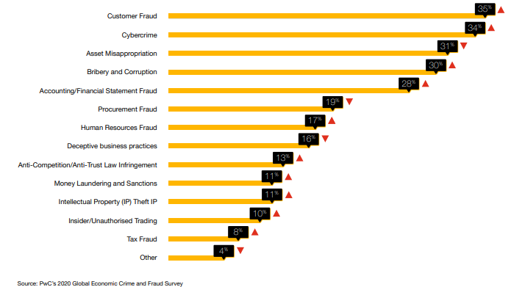
Figure 1 Types of financial crimes – (Source Pwc’s 2000 Global Economic Crime and Fraud survey)
Studies have reported that this type of crimes are committed externally and internally in an organisation, and the profile of criminal can vary from age, gender, status, positions.
(Edelbacher et al., 2012) say that a person who commits white-collar crimes has a high status in their occupations. Especially because management and board of directors have substantial power in their hand, adding to the knowledge acquired, it may become easy to organise fraudulent activities and threaten people they work with to minimise the effects and hide the situation.
(Gottschalk, 2016), One reason to account for financial crime is that the opportunity appears when a fraudster identifies a weakness in a business or individuals' operations. And, when there is an opportunity, it will be followed by a risk.
According to (Pasco and June, 2012), there are several types of white-collar crimes. And they can be classified as corruption, bribery, embezzlement, money laundering, terrorist financing, market abuse, fraud, cyber-crime, tax evasion, etc. However, explaining the characteristics of all these crimes would be highly complex, and the author should adapt the purpose of the research. Therefore, the focus of the project will be on fraud explanation only.

Fraud Definition
Considering the definition of fraud by the Cambridge dictionary, "the crime of getting money by deceiving people." It seems a straightforward explanation to understand, but we realise that this crime is much broader than we would imagine once we go wide into this world.
Fraud is an act that involves false representation, regardless of if it is intentional or not, misappropriating information or providing incorrect and untrustful statements to another party, causing damage to satisfy a specific purpose or intention of gaining something (Chen, 2021).
The Association of Certified Fraud Examiners (ACFE) considers fraud as any act of crime that uses deception to gain something. Also, any other intentional act to deprive or stole property or money from companies or individuals using unfair abilities and actions. However, (Dutta, 2013) has a different view of fraud; for him, fraud is not only related to theft assets but is also linked with concealing them. In addition, in its books, Dutta wrote that "FBI characterises fraud as comprising of deceit, concealment, and or violation of trust (Dutta, 2013, p. 3).
(Singleton and Singleton, 2010) brings an analogy to fraud where the concept is simple, related to injury, where: "fraud can also be associated with injury. One person can injure another either by force or through fraud."
The amplitude of fraud is vast; it does not distinguish organisation. All entities are not immune from it. Regardless of industry, size, years of activity, location, public or privates, profitable or non-profitable, all companies are subject to fraud and damage. Following this path, the fraudsters might be in organisations or outside. According to the Association of Certified Fraud Examiners (ACFE), considering "in company fraud," the primary responsibilities are from employees, managers, officers, and even owners, and outside of the organisation might be customers, suppliers, and other parties
Mentioning again the Pwc's report 2020, 39% of frauds are committed by external perpetrators, while 37% for internal, and a third variable where there is a collision between external and internal, 20%.

Fraud Triangle and Fraud Diamond
When we decide to figure out and overcome a situation or a problem, it is essential to understand the nature and what caused the issue. Therefore, (Singleton and Singleton, 2010) affirm that the best way to explain how fraud occurs is through the fraud triangle (Figure 2).
This affirmation explains because it is beneficial before preventing, detecting, and responding to fraud, it is necessary to understand why perpetrators commit fraud. In addition, The Association of Certified Fraud Examiners (ACFE) states that the fraud triangle is the most widely and accepted model to comprehend why people commit fraud.
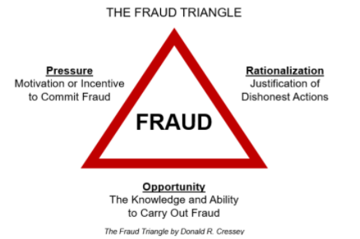
Figure 2 The fraud triangle (source Adapted from Singleton, 2010)
Developed in 1950', the fraud triangle resulted from a study that Donald Cressy carried out and his participation on the dissertation committee to interview some fraudsters to comprehend the reasons for committee fraud (Singleton and Singleton, 2010). The results of this analysis were that all interviewers have the same three common points:
1. Pressure: this element consists of personal motivation from fraudsters' personal life as starting point. It usually is characterised as financial strain or any stress. For example, an addicted person by drug or gambling might need money to pay out a debit or keeping using or practising.
Moreover, people can find a different motivation, such as an employee who feels injustice by not having received a bonus or a promotion, and financial statement fraud when there is the knowledge that a company has high stock prices and performance bonuses (Singleton and Singleton, 2010).
2. Rationalisation: (Mario, 2020) demonstrates that although people are entirely sure that the act committed is wrong, they find ways and reasons to justify their actions. Also, many fraudsters do not have criminal records and believe it worth the attempt. In case of getting caught, there are convinced that they will repay, for example, stealing money from companies.
3. Opportunity: As the own element name says, opportunity perpetrators explore weaknesses in companies, generally related to the lack or absence of internal controls. Singleton and Singleton shows a citation from Cressey's research, where “fraudsters always have the knowledge and opportunity to commit fraud." Association of Certified Fraud Examiners (ACFE) defines this element as "perceived opportunity which defines the method by which crime can be committed."
Many authors consider the fraud diamond an extension of the fraud triangle by adding a fourth element (capability). Also, it is believed that this new extension can improve either fraud prevention or fraud detection (Wolfe and Hermanson, 2004). The element capability states that the individual has deep knowledge and confidence for doing the crime and has found a potential fraud opportunity with ample chances to make it real.

Fraudster Profile
As explained before in section 1.3, the fraud triangle can provide comprehension of why people commit fraud. But in addition to that, demonstrate who they are will make more explicit the understanding of the fraud universe.
(Singleton and Singleton, 2010) says to the explanation that fraud criminals usually the person's profile characterise as someone who is not suspect or least suspect, and that's why fraud becomes challenging to prevent or detect.
Considering the Global report Profile of Fraudster, released by (KPMG, 2021), most fraudsters are men, 79%, and the proportion of women has increased from 13% to 17% compared with 2010. Their age is exposed in figure 3.
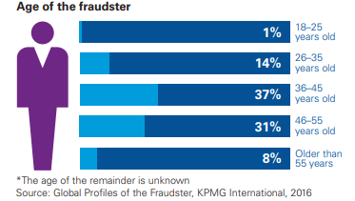
Figure 3 Age of fraudster (Source Global Profile of the fraudster, KPMG 2016)
Also, the survey found out that the company employs 65% per cent of fraudsters, and 21% are former employees. Sometimes people imagine that initial employees may not commit fraud, but figure 4 shows that the scam is committed by employees who have less than one year of service, and the highest corresponds to those who have more than six years.
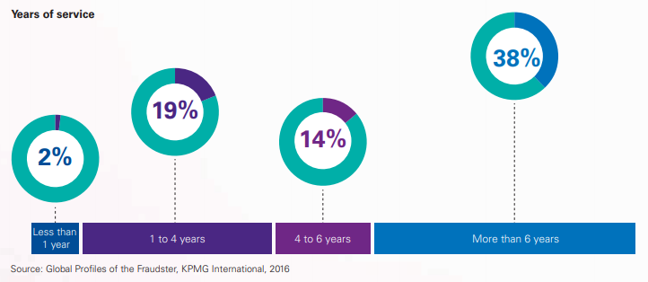
Figure 4 Years of service (Source Global Profile of the fraudster, KPMG 2016)

Fraud Types
The fraud universe is extensively large; we can name a type of fraud using alphabet letters. For example, some types of fraud are in figure 5 below.
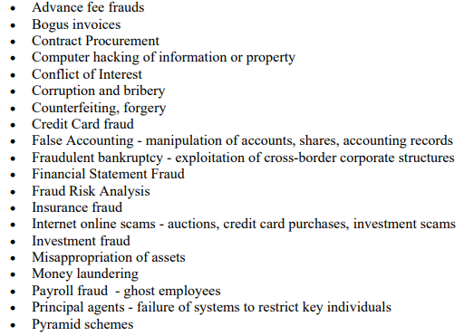
Figure 5 Fraud Types - Source adapted from (Doig, 2016)
A forensic accountant or fraud investigator may be required to investigate many types of frauds stated above; however, it is advantageous to categorise these investigations into groups that will be easier to overview the range of analyses (Garg, 2020).
1. Corruption
Corruption is defined in three distinct types of corruption fraud: conflicts of interest, bribery, and extortion.
- Conflict of interest is sometimes not characterising as non-financial benefits, but the action of getting an advantage to achieving a personal gain: bribery and extortion.
- Bribery is the act of offer money to someone to gain influence.
- Extortion is when money is demanded, being contrary o bribery (Garg, 2020)
2. Asset Misappropriation
Asset misappropriation is considered by (Garg, 2020); the most common type of fraud falls into this category. They are cashing theft, fraudulent disbursements, inventory fraud, and misuse of assets.
- Cash theft: stealing physical cash.
- Fraudulent disbursements: Using the company's funds to make fraudulent payments, e.g., payment to fictitious suppliers and employees.
- Misuse of assets: Using a company's support for personal advantages (Garg, 2020).
Moreover, (Golden et al., 2006) adds another characteristic of this type of fraud, employee fraud. It corresponds to a misuse of their positions to take advantage of the company, for example, payroll fraud, billing schemes, expense reimbursement, check to temper, etc.
3. Financial Statement Fraud
Well known as fraudulent financial reporting, this type of fraud causes a material misstatement of financial statements. Can be included on that, falsification of accounting records, omissions, balance disclosures, intentional misuse of accounting standards (Garg, 2020). Also, (Golden et al., 2006) make a relationship with employees. Therefore, there is an intentional motivation to falsify, manipulate, and alter accounting records to satisfy a need or hide a potential situation that can cause a huge problem.

Fraud Red Flags
(Singleton and Singleton, 2010) defines red flags as a tool to trace what criminals left behind at the scene of the crime. Considering its nature being from many different factors such as suspicious transactions, lifestyle changes, and people behaviours. (Harvey, 2018) affirms that following the clues given by the red flags become a reliable tool to identify the fraudster. Considering his study to Association of Certified Fraud Examiners (ACFE), he found out that the following behavioural red flags are presented in studies since 2008.
- Living beyond means
- Financial difficulties
- Unusually close association with a vendor or customer
- Excessive control issues or unwillingness to share duties
- Recent divorce or family problems
- A general "wheeler-dealer" attitude involving shrewd or unscrupulous behaviour.
To reinforce this affirmation, (ACFE 2020) explained in the report to the nations that the primary red flag to detect fraud in 42% of the respondents was living beyond means (figure 6). However, the report has a different view, including "irritability, suspiciousness or defensiveness," related to potential issues associated with working performance, absenteeism, fear, and excessive tardiness.
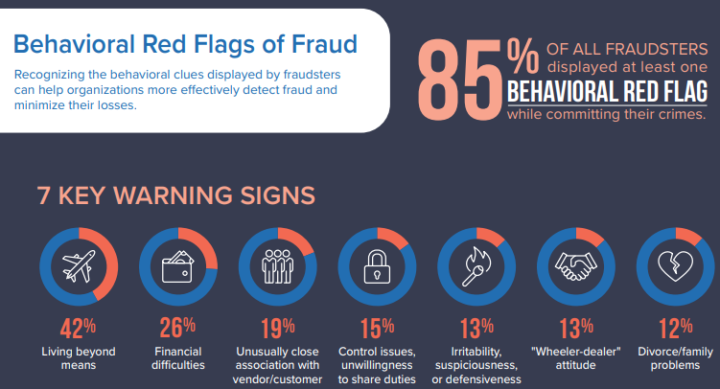
Figure 6 Behavioural red flags – (source ACFE, 2020 Report to the Nations)
Also, (Samociuk and Iyer, 2017) adds that red flags are an efficient way of detecting fraud. There are two approaches to strengthen the capability to detect: training employees and proactively seeking red flags. He believes that the employee plays a unique role in this process; that is why it is fundamental to provide them with the opportunity to expand their knowledge and make them think critically.

Fraud Statistics
Covid 19 has brought a considerable problem to countries, but the effects are in peoples' health and their jobs, personal life, leisure, and business. Due to the uncertainty caused by the pandemic, companies worldwide have accounted for enormous difficulties and situations related to fraud.
Figure 7 demonstrates the type of crime by industry considering the ACFE's report to the nation 2020. As we can see, corruption is far the most reported crime considering the range of sectors analysed.
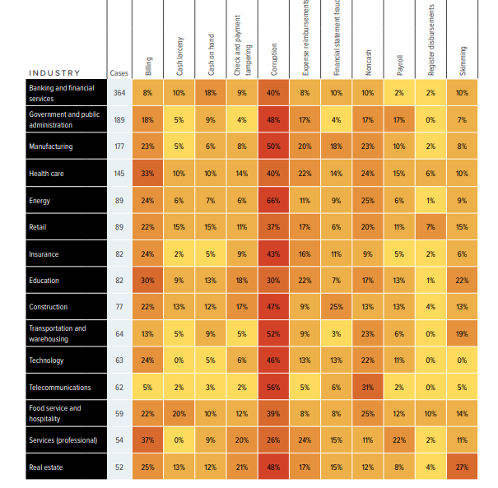
Figure 7 Types of fraud schemes by Industry – (source ACFE, 2020 Report to the Nations)
KPMG, on the report Fraud Awareness for Internal Auditors 2020, has demonstrated that companies are not free from losses caused by pandemic 19. And these losses are financially and non-financially. Financially speaking, the fraud losses are expressed by decreasing market capitalisation, raising the cost of capital, direct damage/cash drain, and investigation cost. And the non-financial aspect is described by losing customers, employee frustration, political and reputational damage, and loss of confidence.
In addition, in the same report, KPMG brought an exciting analysis by demonstrating the effects of fraud through the fraud triangle (Figure 8). The figure shows us that companies are losing confidence in internal controls due to people's work from home because of misconduct and a higher lack of supervision. Beyond that, many companies have suffered losses in revenues and consequently profits, occasioning a natural reduction of the workforce, making people absorb activities and may feel overwhelmed due to the circumstances.
This fact can negatively affect another part of the fraud triangle. Employees may feel pressured by the company, family and do not feel comfortable about their job security. Consequently, it might affect their integrity and make them weakened and commit crimes.
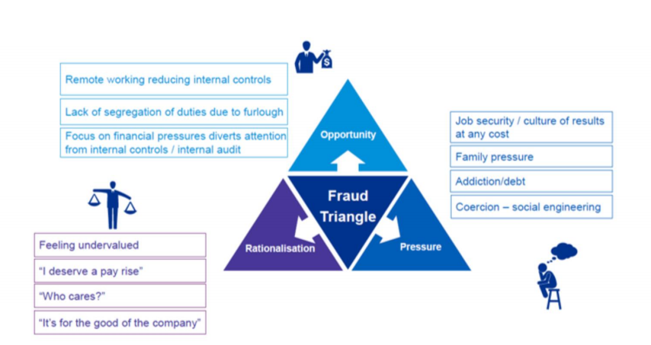
Figure 8 Relation of the Pandemic with fraud triangle – (source KPMG Fraud Awareness for internal auditors 2020)
If we narrow down the analysis to Ireland, we can materialise the effects of fraud under the covid 19 pandemic. According to (Garda, 2021) there was a significant increase in investment fraud scams since the Pandemic started. Since online transactions have become more frequent, fraudsters scam people passing by investment managers presenting professional charts and graphs to demonstrate potential gains. This increase is by 120%, and most victims have lost more than €40,000.
In addition to that, the government is not free from fraud schemes. Second (Daly, 2021), who wrote a piece of news for The Journal. i.e., in a second attempt, a man was arrested in Ireland accused of phishing emails to collect data to apply for Pandemic Unemployment Payment (PUP). Gardai believes that around 73 people responded to the survey to get data, and it is estimated that €187,000 was paid out regarding PUP after these applications.

Section 2 Forensic Accounting

Audit Definition
A concept and understanding about audit are unclear for some people and organisation, believed that the primary objective is to detect fraud. And it is an erroneous understanding. The audit is responsible for examining the company's financial statements to understand whether the financial transactions were recorded fairly and accurately according to the accounting standards and present fair analysis errors.
The audit can be done internally by the company's employees, externally by accounting firms, and Internal Revenue Service when a country's tax authority performs an audit. And in some cases, auditors may come across fraudulent activities, and they are responsible for disclosing the incidents. The following pictures demonstrate audit objectives.
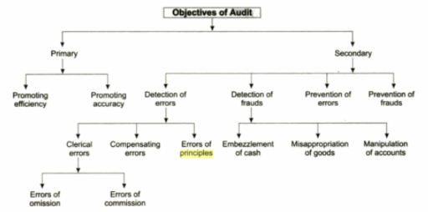
Figure 9 Audit Objectives – source (Basu, 2006, p.7)

Forensic Accounting Definition
Forensic accounting is the area that incorporates a distinct set of skills to support professionals in the financial investigation process. The term "Forensic," according to the Webster's Dictionary, means, "Belonging to, used in or suitable to courts of judicature or public discussion and debate." In other words, the area creates a suitable analysis for the court, form the basis for discussion, debate, and dispute resolution.
According to the American Institute of Certified Public Accountants (AICPA), forensic accounting aims to collect, analyse, and evaluate evidential matters using specialised knowledge and investigative skills. The area reunites knowledge in accounting, auditing, and investigative skills to organise and carry out financial examination and analysis of individuals and companies. (Rezaee, 2019a) presents three general areas for the profession, litigation support, expert witness, and financial investigation. Forensic accounting is utilised in the litigation process:
When quantification of damages is needed, parties involved in legal disputes use the quantifications to assist in resolving disputes via settlements or court decisions. For example, this may arise due to compensation and benefit disputes. In addition, the forensic accountant may be utilised as an expert witness if the disagreement escalates to a court decision. (Chen, 2020.)

Also, Chen defines forensic accounting for financial investigation:
Forensic accounting is also used to discover whether a crime occurred and assess the likelihood of criminal intent. Such crimes may include employee theft, securities fraud, falsification of financial statement information, identity theft, or insurance fraud. (Chen, 2020.)
Therefore, the necessity of the area applies when a failure in companies' and individuals' operations is identified. Forensic accountants are fundamental to analyse and evaluate the nature of the problem, track all steps performed by criminals, and provide relevant evidence for further disputes in court.
Typically, police, banks, government, and large accountancy firms have their forensic accounting department specialising in royalty audits, construction, anti-money laundering, fraud, personal injury claims, and insurance claims. However, due to the vast range of financial crimes and disputes, the department counts with expertise in tax evasion, computer forensics, business valuation, money laundering, reorganisation, insolvency and bankruptcy, post-acquisition such as breaches of warranties or earn-outs and Economic damage calculating, whether they be suffered through breach of contract or tort.

Forensic Accountant Profile
According to Criminal Justice Degree Schools, 2020, "Forensic accountants use their forensics and accounting expertise to help prevent, detect, and prosecute financial crimes." And the Association of Certified Fraud Examiners (ACFE) adds,
"Forensic Accountants are employed by public accounting firms' forensic accounting divisions; by consulting firms specialising in risk consulting and forensic accounting services; or by lawyers, law enforcement agencies, insurance companies, government organisations or financial institutions."
The entry-level for this profession usually requires a bachelor's degree in accounting or criminal justice. Besides that, some positions may need those professional to hold certifications or master's degree. Also, there is a vast range of training to become and strengthen your skills as a forensic accounting investigator (Culpepper, 2018). However, The Association Graduate Careers Advisory (AGCAS, 2020) presents a different requirement for the profession. The AGCAS editors explain that people can get into this profession holding a degree in any subject without having an accountancy degree. Still, besides work experience, a qualification from a recognised professional body will be essential.
Typically, a forensic accountant is a member of a recognise accountancy body as certified public accountants (CPA), and pursue forensic accounting credentials such as certified fraud examiner (CFE), certified forensic accountants (CR. FA), or certified financial forensics (CFF) (Forensic Accountant Career Guide, 2020).

Knowledges Skills and Abilities
According to ACFE, professionals must self-evaluate their knowledge, skills, and abilities to build a strong background and contribute to entities. Figure 9 shows some characteristics that employers would like to see in their potential forensic accountants.
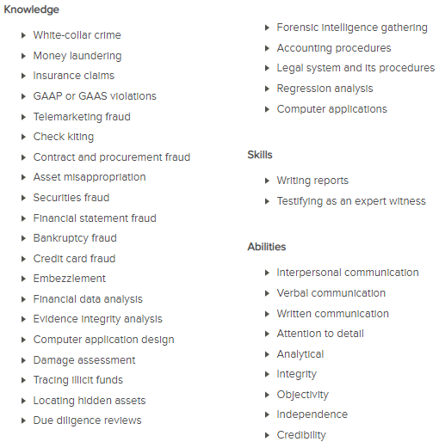
Figure 10 Forensic Accountant Skill List – (Source ACFE website)
Besides that, (Roufa, 2019) shares some ordinary skills and abilities with the previous figure. Still, he adds some specific soft skills to be a forensic accountant that makes the professional even more qualified, such as:
Analytical skills: Forensic accountants need to have strong analytical skills to identify patterns or a lack of practices due to looking beyond the number and discovering financial inconsistencies or clues.
Math skills: "Forensic accountants should be able to look at a set of numbers and quickly deduce what they mean."
Attention to detail: "Criminal activity related to finances often is subtle, and it takes a detail-oriented accountant to pick up the smallest inconsistencies that might indicate something is not right."
In addition, (Chew 2017) says that an efficient forensic accounting needs to develop some additional skills, for example, Innovation, flexibility, negotiation skills, composure, robustness, professional credibility.

Investigation Framework
(Golden et al., 2006) defines in his book that forensic accountants should create suitable solutions and alternative investigations plan for the client. The focus must be on the situations which cause concern aiming at illegal discovery facts. To create an effective method to lead the investigation and attend the primary goal, the investigation program should answer questions such as who, what, where, when, how and why crimes were committed and their relations. Besides that, (Kranacher and Riley, 2019) affirms that these questions must be answered because, during a trial, forensics accountant or fraud examiners will be required to explain each aspect of the case.
(Culpepper, 2018) brings a straightforward way to understand the steps of forensic accounting investigation:
- Map out the Investigation
This stage consists of meeting the client and understanding the reason for the concern, identifying potential financial documents to support, identifying issues and inconsistencies that may arise, postulating motives, and knowing if the evidence is relevant to support them and develop a plan to carry out the investigation.
- Gather Evidence
Gather evidence is the most critical moment of the investigation process; forensic accounting uses many different techniques and tools to gather and analyse data to understand all the issues and concerns presented by the client. Some of the methods utilised are analyses of financial records, identifying patterns, applying audit techniques, testing internal financial controls to find out the lack of security, observing potential suspects and their behaviour, and interrogating them.
- Prepare the Report
By this moment, a forensic accountant will draw up all analysis and understanding found throughout the investigation and formulate a comprehensive report explaining its conclusions with a wide range of details. The statement utilises the structure to describe the questions that must be answered by Golden 2006 (what, who, why, when, where, how) at the beginning of this sub-section.
- Testify in Court
When a forensic accountant develops their report, it will be created considering accounting terminologies and professional vocabulary pertinent to professionals of this area. Forensic accounting may be invited to translate dense languages during a trial and make further explanations in court.
However (Garg, 2020) brings a different structure from Culpepper, 2018, where Garg breaks down the initial step from Culpepper ( Map Out the Investigation) in two other tasks as follows in table 2. I believe this approach gives each stage more power, makes more precise the functions, and strengthens the ability to see what is needed and collect relevant information.
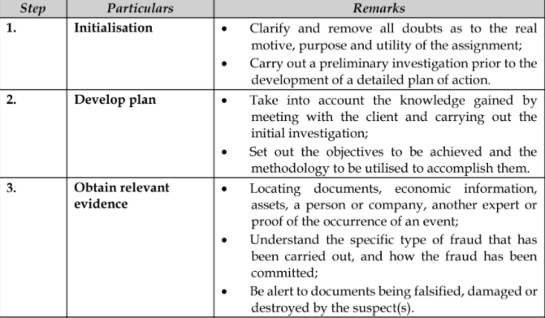
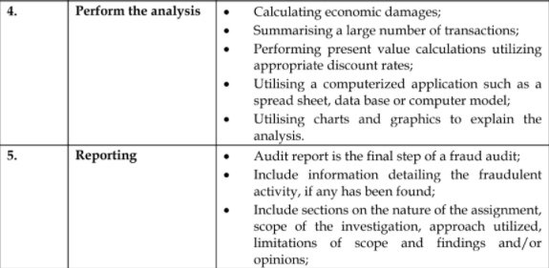
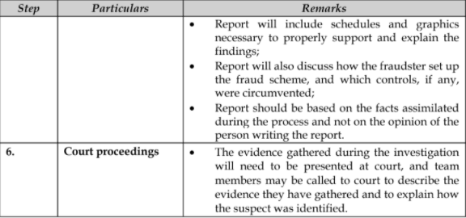
Figure 11 Investigation Process – (Source Garg, 2020, p.p 83)

Investigation Techniques
Forensic accountants are provided with many ways and tricks to intensify and perform a fraud investigation. The red flags mentioned before can be considered a technique that helps these professionals perform analysis to identify potential fraud cases.
Suppose the company and professionals understand the red flags and add up the fraud triangle analysis to identify fraudsters' profile. In that case, it becomes a beneficial action to know where to look at (Golden, 2011). Because understanding what type of transactions or account are more likely to fraud and analyse the fraudster's profile and motivation, and this relationship with risk assessment, the investigator can understand the area of great scrutiny and develop a plan to focus on it.
Timing
It is a crucial element of forensic accounting investigation. Due to the massive and extensive analysis that must be performed and the inquiry, timing becomes a fundamental professional technique. (Golden et al., 2006) states:
Investigating can be a lengthy process due to the volume of data requiring review. Transaction review takes time; document review takes time, email review takes time. Investigative leads may take the team into areas not contemplated at the outset of an investigation. A looming deadline is rarely a good reason to trim procedures and back away from a thorough investigation as initially planned. (Golden et al., 2006, pp.295–298)

Communication
Golden believes communication is a vital technique to improve the relationships within the team, with the client to get an effective data collection, but also to prevent unanticipated complications:
Unanticipated complications can often occur when communicating with international, multicultural teams and across multiple time zones. The absence of clear, frequent, and timely communications can result in misunderstood timelines and deadlines, missed conference calls, dissatisfaction, even fee disputes. If in doubt, communicate. Even if not in doubt, communicate (Golden et al., 2006, p.296).

Interviews
It is said that forensic accounting investigators believe an efficient interview solves most white-collar crimes, and the skill of the professionals play a fundamental role in it. The purpose of an interview is to explore the interviewer answer and behaviour to obtain information. And in some cases, it can lead to admission; however, it is a difficult task (Golden, 2011).
There are a few considerations that investigators must be aware of before and during the interviews at the planning stage. (Rufus et al., 2015) defines three steps for interviews:
- Planning stage: it Consists of carrying out three basic steps.
- Identify the role of a witness and its relations to another witness.
- Develop a list of questions to test the hypothesis for gathering evidence.
- Develop a schedule to carry out the interviews (that is, who, when and where).
- Doing Stage: Implementation of interview plan. It is essential to reinforce how unique the interview is. It requires a set of adjustments, but there are a few ordinarily applicable guidelines.
- Create the desired setting. Always prioritise safety arrangement and act as a team.
- Begin with preliminary questions, and then move to informational ones.
- Norm, the interviewee. Establish a standard body language to identify potential changes in behaviour.
- Be an active listener.
- Encourage the interviewee to do most (80% - 85%) of the talking.
- In case of feeling lost or threatened, finish the interview.
- Take notes.
- To close the interview, offer the interviewee the chance to add something else.

- Final stage: The final stage means transcribing your notes. According to (Rufus et al., 2015), it is essential to carry out interviews with two interviewers. While on make questions and analyse the interviewee behaviour, the other can take all notes that he judges necessary, and perhaps no information can go missing. Therefore, it is essential to transcribe the messages into a "memorandum of the interview" to improve readability and reliability.
Besides that, (Golden et al., 2006) enhances crucial points which can support the interviewer to avoid further issues from the interview and compromise the data gathering:
Solid investigative work and previous interviews can help the forensic accounting investigator focus on the subject at hand, develop a line of questioning designed either to carry the investigation forward or to elicit an admission, and contemplate what approach is likely to be the most effective. Among the issues to consider are the following (Golden et al., 2006, p.351).

- Timing: Ensure that the time is sufficient to carry out the interview and avoid potential action that can disturb the investigation, such as compromises straight after the interview.
- Location. Prioritise the interview in the business or whenever the participants request. But it is vital to find a quiet place and a room far from potential distractions.
- Legal Issues: Considering potential exposure to a company, forensic accounting must always seek advice from the council to deal with situations.
- Recording: It is considered a powerful negotiating tool in settlement talks. However, some country/states believe recording a violation of state law. Therefore, forensic accountants must always analyse how possible it is.

Audit techniques
The International Audit and Assurance Standard Board (IAASB, 2009) defines under International Standard on Auditing (ISA) 330 the auditor responses to assessed risk. The objective is "to obtain sufficient appropriate audit evidence regarding the assessed risks of a material misstatement by designing and implementing appropriate responses to those risks." The IAASB stated two approaches:
- Substantive Procedures: procedure used to detect material misstatements at the assertation level through a test of details (classes of transactions, account balances and disclosures) and substantive analytical methods.
- Test of controls: procedures aim to evaluate the effectiveness of controls in preventing or detecting, and correcting material misstatement.

Analytical Procedures
(Golden, 2011) says:
Analytic procedures have long been useful investigative techniques when the subject matter of the investigation is likely to be reflected in company accounting records and financial statements. The use of analytic techniques based on financial statement information is fairly pervasive in business. (Golden, 2011, p.365).

This technique is handy for business in general for many different purposes, such as utilising managers to evaluate performance, banks analysis for granting loans, auditors to validate the compliance of accounting standards. In addition, the stakeholders to understand the business results over a period and assess the performance of the Board and management.
Vertical Analyses
It is used to compare elements of financial statement. This analysis is commonly expressed in percentage; this analysis aims to tell the amount determined account worth about another along the accounting period.
Horizontal Analysis
This analysis aims to evaluate the change from elements of financial statement over the accounting period. For example, receivables in 2018 was $100,000.00 while in 2019 $80,000.00. It means a reduction of 20%.
Ratio Analysis
This analysis usually provides financial and non-financial information. The ratios analysis combines many financial statements and is generally compared amid years, on a historical basis or against a benchmark. An example of ratios is the current ratio (the ability of the business to pay its short-term liabilities with short-term assets. The threshold of ratio is 1 to 1), and profit margin ratio (analyse the profit achieved by selling the company's product), many other ratios.
It is essential to explain that the percentages and absolute number expressed by horizontal, vertical and ratio will not be helpful. Instead, this analysis aims to compare and understand the reasons and motivations that occur over the years that cause an increase or reductions in the indexes.
Data mining
Data meaning is understood as a process to transform raw data into useful information. Data mining deal with highly structured data such as ERP system and database. Companies use software to look at patterns, trends, and anomalies in a large amount of data. This process provides more understand about "their customers to develop more effective marketing strategies, increase sales and decrease costs. Data mining depends on effective data collection, warehousing, and computer processing (Twin, 2020).
(Golden, 2011) says that data mining analysis may include:
• Scanning transaction listings.
• Identifying gaps in check runs or shipping documents.
• Identifying duplicate invoice numbers, payments, or payroll transactions
to the same payee.
• Matching return dates and credit memos to test for proper cut-off.
• Comparing recent invoice prices with costs on the perpetual inventory
Records.
• Filtering to identify all new suppliers, nonstandard journal entries,
accounts under dispute, and the like
• Stratifying or grouping customer accounts by balance size or employees
by overtime pay.
Text Mining
Text mining is considered a complementary analytical procedure of data mining; text mining is "the process of transforming unstructured text into a structured format to identify meaningful patterns and new insights" (IBM Cloud Education, 2021).

Ethics and Regulatory Aspect
Like any other professional, forensics accountants must comply with the authorities' standards and code of conduct. However, as the profession can be performed for a different purpose, there are a few considerations that professional must follow and respond to. For example, when CPAs perform forensic accounting activities, they must follow the American Institute of Certified Public Accountants (AICPA). But when forensic accountants are required to provide a valuation of services, they should adopt the National Association of Certified Valuators and Analyst (NACVA)(Rezaee, 2019b).
According to AICPA, the code of conduct set six principles that require a commitment to moral behaviour and emphasise maintaining the public's trust. The explanation of them is described in table 3 as follows.
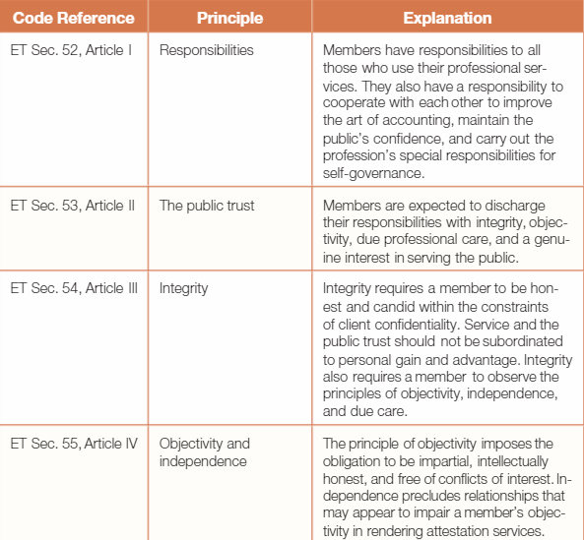
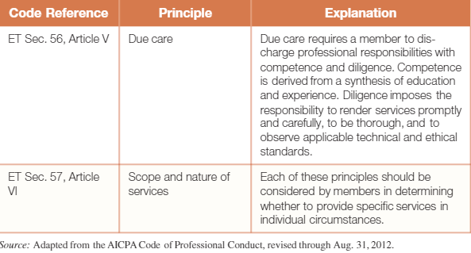
Figure 12 AICPA Principles of Professional Conduct – Source AICPA website.
The profession has shown considerable growth across the years, making professionals even more qualified to perform their activities. However, this absorption of more knowledge and better professional practices is usually set by authorities who provide a legal framework and support them. In exchange, they must follow the set of rules and standards imposed on them.

Challenges
A recent article in the Journal of Accountancy (Wiesenfeld, 2020) affirms that the execution of the forensic accounting profession will find some difficulties since and along covid 19 pandemics.
According to him, some activities are crucial to developing consistent work, such as face-to-face interviews. He affirms that although the interview process may be carried out in zoom or skype, it is not as effective as in person. This process is also an opportunity to review documentation, "provide sheds light on previously unclear transactions and financial activity."
In addition to that, (SDC CPAs, 2021), in its report affirms that the covid 19 outbreak has brought the opportunity to criminal to launch new types of fraud, forensic accountants suffer delays "to the inevitabilities of remote work, such as slower collaboration and communications."
The covid 19 made companies organise their workforce and put them to work from home. This initiative is not helpful for the investigation point of view affirms Shan-Hernandez for the article from the journal of accountancy mentioned before. She believes it is causing a delay and difficulty to be agile in the check and analysis of the investigation process as she or the team cannot be contacted rapidly.
Differently, (Deloitte, 2018) in its article about the challenges for the profession, even before the pandemic hit, the accountancy firm had studied some issues that the work may face over the years, as:
- The vast amount of data: entities face constant growth in collecting, processing, and storing data. Aliened to it, the number of mobile business devices and social media has implied even more control and certainty about data management.
- Static reporting designed for business as usual: Legal, compliance and internal audit teams may face some issues regarding collecting information from other departments. It happens because departments may tailor and organise information as it is helpful to them. Sometimes, the control of valuable information may differ from a department to another.
- Begin to lay a solid technology foundation
- Due to the impressive growth of technology, companies must constantly analyse their I.T. systems to utilise the best software to provide an effective and reliable data collection and analysis and fraud monitoring process.

Section 3 Corporate Governance

3.1 Definition
(Rezaee, 2019b) The main reasons that fraud occur are because companies have no compliance with corporate governance, weak and unreliable internal control system, and improper regulations and standards.
Companies operating in many different markets have diverse stakeholders and are subject to the following foreign jurisdictions. According to (Gray et al., 2019), companies may face additional challenges over the year to operate in a secure environment due to the particularities. Although management and board of directors aim to enhance reliability with their clients and shareholders, they are responsible for establishing mechanisms to minimise business risk and improve the security in business operation.
This affirmation is what corporate governance stands for. Although it is considered a broad topic, corporate governance is characterised as the structure that defines the process, rules, practises and relationship among shareholders, management, board of directors, employees, clients and all stakeholders (Klettner, 2016).
Therefore, (Chen, 2021b) adds that corporate governance aims to provide a framework that can express the company's objective evolving all spheres and departments in the organisations, creating corporate actions plans and internal controls system to guide the performance and corporate disclosure.`

3.2 Risk Management
Keeping a robust corporate governance regulation lined up with risk management become an effective measure to minimise the impact of business risk. However, considering the volatility of the financial market and the enormous challenges companies face, it has raised many questions about governance in organisations and how the business risk is following governance principles (Wright et al., 2013).
(Gray et al., 2019) The business risk a company exposes depends on its size, market, types of operation, and how it is financed and location. Moreover, establish two elements of the business life help the management to understand the risk that a company is exposed, are:
the role of a company in general, operating as a profit entity towards achieving corporate goals, and impacting the society through the nature and scope of its operations and its relationship with diverse stakeholders; and (ii) the identification of risks that threaten the achievement by a company of its goals, which will therefore threaten any benefits to society and stakeholders accruing from corporate activity (Gray et al., 2019, pp.295–298).

Figure 13, as follows, demonstrate what types of business risk a company may be exposed to.
Figure 13 Potential Risk Exposure (Source Adapted from Gray, 2019 p.p. 166)

3.3 Roles and Structure
Some have asked why separation from those responsible for operations and those who control the board should exist. And the answer is not complex. Mainly because codes regulate corporate governance practices, the objective is to avoid a concentration of power and avoid potential misconduct and ineffective control.
(Gray et al., 2019) stated that there are several reasons to separate the role of CEO and chairman. First, either position requires total commitment, and being responsible for both may compromise the quality and effectiveness of the job. Second, attribute one person the responsibility to run the business operation (CEO) and act as a chairman would give substantial power over the strategy and executive functions of the company. In other words, "this concentration of power may stifle debate and discussion by the board and reduce the perspective from where challenges and dispute arise (Gray et al., 2019, p.172). Finally, one of the primary responsibilities of the chairman is to review the CEO's performance and set appointments and remuneration. And being both may compromise the chairman's independence because how could a chairperson review the CEO's account if he is both.
For (Tricker 2019), a clear view of corporate governance structure and its relationships will clarify governance problems and their source. Figure 14.
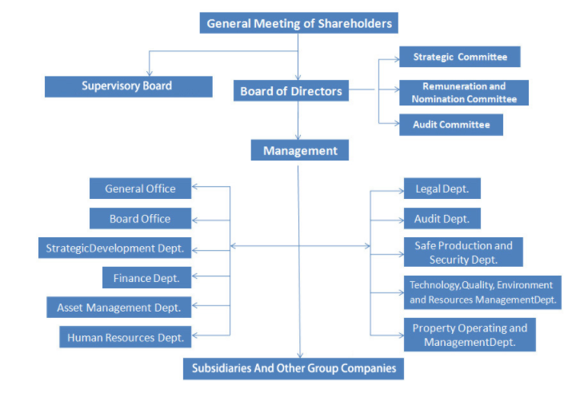
Figure 14 Corporate Governance Structure – Source Tricker 2019.
Shareholders are commonly called stockholders; they can be individuals or companies that own at least a share (Hayes, 2021). Besides holding a public company's voting and non-voting shares, they take some management duties in hiring some professional hands. Also, they have rights of assets in the liquidation of a company, but only after the payment of creditors (Raval, 2020).
Because shareholders are considered a primary beneficiary, they are engaged to set practices, monitoring the compliance of corporate governance rules and internal controls. To accomplish it, they set representatives who act in their interest and are responsible for ensuring all guidelines are followed (Tricker, 2019).
The CEO elected by the board represents management, and this professional is responsible for developing strategic plans to guide the business operation lined up with a business objective. Also, it is the CEO's responsibility to monitor departments' activity to ensure it is flowing according to business practices. The structure varies from company to company. The board determines it, and the CEO has the responsibilities to hire competent and efficient Directors to deal with strategic and operational issues to attend to the business mission.
As follows in figure 15, the meanings of terminologies of the board of directors and its types.
Figure 15 Board of Director's explanation Source (Gray et al., 2019, p.175)

3.4 Internal Controls Compliance
For (Rezaee 2019), internal controls are a reunion of companies policies that help the organisation minimise business risk, errors, irregularities and prevent and detect fraud. However, the engagement of the management plays a fundamental role to ensure that these practices are being followed and in compliance with laws and regulations.
In an article from Financial Reporting Council (FRC, 2005), Internal Control: The Guidance for Directors, the author notes four essential points about the importance of internal control system and risk management, which are:
- A company's internal control system has a vital role in the management of risks that are significant to the fulfilment of its business objectives.
- Internal control facilitates the effectiveness and efficiency of operations, helps ensure the reliability of internal and external reporting and assists compliance with laws and regulations.
- Effective financial controls, including maintaining proper accounting records, are an essential element of internal control. (…) also contribute to the safeguarding of assets, including the prevention and detection of fraud.
- (…) Therefore, a sound system of internal control depends on a thorough and regular evaluation of the nature and extent of the risks to which the company is exposed. Therefore, internal control aims to help manage and control risk appropriately rather than eliminate it (FRC, 2005).
Furthermore, the guidance explains three elements that should be performed to ensure the internal control system. The elements are focused on:
- Maintaining a sound of internal controls
The internal control system must reflect the company's risks, show its materiality, likelihood of materialising, and ability to mitigate risk. For that, the guidance classifies essential elements of the internal control system: respond to significant business, financial and compliance risk; ensure the quality of internal and external reporting; ensure appropriate compliance with law and regulations.

- Reviewing the effectiveness of internal control
To revise the effectiveness of the internal control system, the board should be aware of all issues related to it and receive reports explaining the system's primary considerations even because the board must write on the annual report the effectiveness throughout the year.
To revise the internal control reports, the board should: comprehend the risk and evaluate how it has been identified, analysed, and managed; access the effectiveness of internal control system by analysing failings and weakness that have been reported; consider promptly actions to correct the effects and issues; consider the necessity to strengthen the monitoring of internal control system.

- The board statement on internal control
The board should issue an annual report showing the carried-out performance analysis of the effectiveness of the internal control system. The statement should explain the methods, periodicity, risks findings, risks actions plan, weaknesses and measures taken to minimise the risk exposure or cease them.

3.5 Challenges caused by Covid-19
The business environment faces challenges constantly, from all unusual sizes, from many different impacts, and some may require more effort to overcome. And with covid 19 will not be different, and it might be for some companies even more challenging.
The board of directors must have a broader engagement with the company's policies review and direct connection with management to analyse and provide the best solutions for reliable operation. Especially now, they are demanded to have an elevated level of resilience to adapt to adversities brought by the pandemic and make a revision of corporate governance aspects to guide the company to the right way.
By the end of last year, (Paine 2020) affirmed:
Whether Covid-19 is truly an inflexion point for corporate governance is yet to be seen, but there is no doubt that the pandemic has challenged core premises of the agency-based model of governance in ways that have important implications for boards (Paine, 2020).

In other words, he explained that the pandemic had caused issues over businesses, and the companies must adjust their effort to present resilient strategies. The article implies a different level of accountability under these dark times.
Also, it is explained that the company's primary objective was to provide sustainable and efficient solutions to preserve and maximise shareholders' rights while before the pandemic outbreak. Now, it is necessary to look out for stakeholders' point of view. This affirmation is explained because pandemic has hit not only a single company, where "society depends on well-functioning companies to meet its most basic needs for food, shelter, communication." Therefore, there are more stakeholders evolved in this process.
It means it is time for the board to look beyond the shareholders' priority and adapt its policy to make a more accessible environment for stakeholders. Stakeholders are understood as clients, employees, suppliers, the community, and shareholders. The goal should be to understand the needs of the whole chain evolved in businesses cooperation and establish a close analysis to adopt regulations to make favourable to them. Of course, the reality may vary from stakeholder to stakeholder, but it is crucial to revise policies related to it and develop effective measures to deal with each particularity.
In addition to that, (Pwc 2020) notes that the board should be careful to consider dividends, incentives and liquidity. Due to uncertainties arising from the pandemic, the board should analyse its operation and take a step back regarding rewards and incentives if necessary. The company may have outstanding bonuses and have said about an increase in incentives to employees; however, the company's liquidity is a crucial point.
Besides that, even more, the board must carry out a careful assessment of the corporate governance and internal control system, to understand the impact that was caused throughout the year, potential actions, and the adaptations made on the process, and provide a concise and fair disclosure on the annual report.

Conceptual Framework
A conceptual framework is an element that helps the researcher to illustrate what expects with the dissertation by defining the variable of the study and the relation among them (Swaen, 2015). And it is typically developed based on the literature review of existing topics. (Fisher, 2010) affirms “a conceptual framework is formed by patterns of concepts and their relationship.” The researcher aims to work out how the concepts fit together.
(Fisher, 2010) says there are many ways to express the connection of these concepts. Considering the nature of the following research, the most practical that helps the researcher better connect theories with research question is Stage in a process. This conceptual framework is based on logic and proper order and often illustrated by boxes and arrows (Fisher, 2010).
The author believes this is the best option because the research analyses the fraud investigation process, which follows a structured approach in a staged manner. Considering the phases of the investigation process as first stage map out, second gather evidence, third analysis evidence and the last report. Typically, the investigation framework contains one more element, testifying in court, but this element is not tested because it reflects only when forensic accountants must explain is a procedure in court, and it is not affecting the investigation itself.
Figure 16: Conceptual framework (Source the author)
Considering the research question, how can forensic accounting perform a meaningful investigation in challenging times? The literature review covers the main areas that affect the investigation process. The collection of primary data is the complement to respond to the research questions. The following points explain each element of the conceptual framework and its relevance for gathering evidence.
Map out
This element means the initial stage of the investigation process. It is the moment that an initial conversation starts between investigator and company to understand the origin of the concerns, aiming to analyse potential vulnerabilities, types of fraud, companies' structure, likely documents, companies' internal control system to draw up an initial plan to gather evidence. This element contains relevant considerations of section 1 Financial crime, section 2 Forensic Accounting and section 3 Corporate governance.
The method to gather primary data is a qualitative approach, asking an open question to forensic accounting and fraud investigators seeking to get the potential failures of the initiation process considering the points stated before.
Gather Evidence
This is the essential part of the investigation process. By this stage, the investigation plan is settled, and the forensic accountant performs techniques to gather data. This stage is responsible for analysing the company's fraud characteristics, measuring its impact, providing a framework to comprehend the reliability of the internal control system and management engagement on its corporate governance policies, interviews, and implications of covid on it. This element is highlighted under all aspects of the literature review, as it has exposure to areas such as fraud, investigation process, and corporate governance chapter.
For gathering data, it is applied an interview with forensic accounting professionals. To analyse the potential limitations of the investigation process, how they evaluate the company's collaboration, the type of extra work they must do to gather reliable information, the vulnerabilities that companies typically show, the competence of the investigative team, potential concerns with the professionals, issues related to regulatory bodies, concerns about data protection, interviews techniques and approaches.
The suitable method remains the same. It is used as a qualitative questionnaire with an open question but applying further questioning does not satisfy the interviewer or new doubts.
Analysis
This stage consists of analysing all information acquired in data gathering. This element is covered by chapter 2.5 Investigation framework and 2.6 Investigation techniques that shows the methodologies used to analyse data.
Considering a qualitative inquiry, the questions aim to ask the limitation of analytical techniques and tools, its vulnerabilities, and the impact of covid 19 to perform this analysis and requirement of innovative technologies, comprehension of how forensic accountants help companies minimise the business risk and failures.
Report
This is the final element of the conceptual framework. This stage demonstrates all analysis and evidence found throughout the investigation to the client in the investigation process. It is highlighted under section 2.5 investigation framework.
By interviewing the professionals with open questions, the research aims to ask forensic accountants the challenges found to report under covid 19, the impact, and any improvements they think would benefit the investigation process to provide a meaningful report.

Conclusion
This chapter was responsible for demonstrating the conceptual framework chosen by the author and explaining how the literature review research question and further data collection fit together. Also, it is outlined the explanation of the fraud investigation stages and what potentially the author seeks to find after collecting data. The following chapter explains the methodology and research design applied to support the data collection.

Methodology and Research Design

Overview
Research is used for business and academic purposes. However, to perform reliable research, the researcher must follow a set of rules which will bring uniformity to the information. We may find many types of definitions of research. In a general understanding (Collis and Hussey, 2013), research is inquiry and investigation, systematic and organized, increasing knowledge. Guide by research questions which is used to give direction and define a line of the project.
Besides that, (Saunders et al., 2019), in a citation by Walliman 2011 conclude that the term research is erroneous because missing some essential points, such as collecting information without a clear purpose, reordering facts without interpretation or little relevance to everyday life.
For this reason, (Saunders et al., 2019) affirms that an exact number of research characteristics are: the purpose of research is clear, data are collected systematically, and interpreted systematically. Finally, research has to find answers to a question using scientific procedures (Kothari, 2004).
Therefore, to start materialising these affirmations, the following sections aim to demonstrate the relevant structure to carry out a practical and systematic research process. It is used the research onion to map out the research methodology and explain its importance. The methodology is understood to the structure and the meanings of the process to systematically analyse data, utilising a suitable approach and technique that can better describe your research purpose (Mukherjee, 2019).
The research onion figure 17 is a method developed by Saunders 2007 to break down a particular piece of your research methodology to organise the elements and approaches to be undertaken. According to (Crossley and Jansen, 2021), the simplest way to understand what the research onion stands for is about the different decisions you have to conduct the process systematically. In other words, this tool helps the researcher to think holistically and support the decisions that must be made.
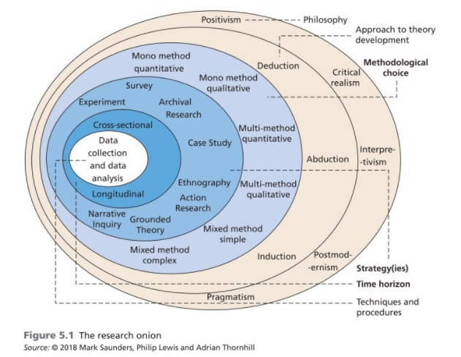
Figure 17 Research Onion (Source Saunders, 2018)
The following subsections of this chapter are used to describe the research methodology based on research onion. The research aims to analyse the fraud investigation processes to find how forensic accountants can make a meaningful investigation in challenging times. Also, comprehend how covid 19 has impacted this process and covers corporate governance and fraud concerns.

3.1 Research Philosophy and Approach
It is said by (Ng and Coakes, 2014) that methodology is about research instance. And many researchers understand it as beliefs about the nature of the things in the world by supporting the critical choices in your research. (Saunders et al., 2019) affirms that these beliefs are used to differentiate the assumptions in each philosophy. There are three main research assumptions to distinguish research philosophy: ontology, epistemology and axiology (Saunders et al., 2019, p.133).
Ontology is considered the assumptions about the nature of reality. Also, it gives form about the way you see and study your research objective. Furthermore, this assumption determines how you see business and management and your choice of research for your research project (Saunders et al., 2019, p.133). Epistemology refers to the study of knowledge. “Theories of what constitutes knowledge and understanding of phenomena, and how to explain how we achieve our beliefs” (O’Gorman, 2014, p.59). (Saunders et al., 2019) The phenomenon subject to analysis complements this affirmation: numerical, text and visual data, facts and opinions, including narrative and stories. Axiology refers to the role of values and ethics. Researchers face the extent they wish to see the results of their values on the research as a benefit thing (Saunders et al., 2019). Moreover, axiology is seen as a branch of philosophy that deals with matters, such as ethics, aesthetics, or religion (O’Gorman, 2014, p.59).
Once we have these assumptions explained, it is possible to jump to the five significant philosophies in business and management: positivism, critical realism, interpretivism, postmodernism, and pragmatism. Of course, the philosophy most adequate to the research is pragmatism.
Positivism
Positivism is characterised as a philosophical stance of the natural scientist and evolves an observation of social reality to produce law-like generalizations. “Positivists focus on scientific empiricist method design to yielded data and facts uninfluenced by human interpretation” (Saunders et al., 2019, p.144).
Critical Realism
Critical realism is concerned with the nature of causation, agency, structure, and relations, and the implicit or explicit ontologies we operate with. Does it ask what we mean by realism in the social world? (Archer et al., 2016)”. In other words, it is related to what we see and what we experience.
Interpretivism
This philosophy is related to the researcher interpreting the research elements by integrating the human interest in the research. Interpretivist believes the best way to connect to reality is through social constructions such as language, experiences practises (Dudovskiy, 2017).
Postmodernism
Considered a set of critical, strategic, and rhetorical practises, postmodernism is related to “the role of language and power relations seeking to question accepted ways of thinking and give voices to marginalised views” (Saunders et al., 2019, p.149).

Pragmatism
Pragmatism is focused on a practical matter; the aim is to research from a valuable perspective. Crossley and Jansen note:
It strives to reconcile both objectivism and subjectivism, facts and values, accurate and rigorous knowledge, and different contextualised experiences. (…) Reality matters to pragmatists as practical effects of ideas, and knowledge is valued for enabling actions to be carried out successfully (Crossley and Jansen, 2021, p.151).

Also, Saunders explains that pragmatist starts its research in a problem and aims to contribute to a practical solution. Therefore, this paradigm is driven by process of inquiry, moving by the idea that something might be wrong. Although the study aims to comprehend the fraud investigation under pandemic, which is a particular situation, it is believed this paradigm is focused on practical outcomes that will give more flexibility to explain the theory and provide a suitable data collection and analysis. In addition, (Crossley and Jansen, 2021) states, "pragmatism is not committed to (or limited by) one specific philosophy."

3.2 Research Approach

3.2.1 Research Purpose
According to (Collis and Hussey, 2013), the examination of characteristics of different types of research provides the researcher with the ability to examine its similarities and differences. Research can be classified in purpose, process, logic. And its classification led to that research can be fulfilled either exploratory, descriptive, explanatory or evaluative purpose, or some combination (Saunders et al., 2019).
Exploratory
This approach is suitable when the researcher asks open questions about what is happening and gains insights about a topic of interest. Questions based on what and how during the data collection aims to explore an issue, problem or phenomenon to clarify the understanding about them (Saunders et al., 2019).

Descriptive
This study goes further than exploratory because this study consists of describing a phenomenon as it exists. Typically it is used to identify and obtain information about a problem or issue (Collis and Hussey, 2013).
Analytical or Explanatory
This study aims to create a causal relationship between the variables by analysing a situation or a problem (Saunders et al., 2019). Besides that, (Collis and Hussey, 2013) say that this study is a continuation of descriptive, where the researchers go deep in a study to explain why a phenomenon is happening.
Evaluative
This study seeks to find out how something works. Guide by questions of what, why and how, evaluative research in business management is understood of comprehension of the main areas of an organization such as policies, cost strategy, marketing campaign etc. (Saunders et al., 2019).
Combined
The researcher may choose to combine the studies exploratory, descriptive, evaluative, and explanatory with more than one purpose.
To support that, it is undertaking an explanatory study on this dissertation. (Collis and Hussey, 2013) when a researcher chooses this approach, the aim is to go beyond to describe points or characteristics. Still, the objective is to analyse and explain when a particular situation is happening. Furthermore, (Saunders 2019) complements its idea by adding that the explanatory studies extend their approach by exploring the relationship and patterns of the problem in question. The research aims to understand the concerns about fraud investigation under pandemic and comprehend the relationships of the variable that affect the investigation itself seeking to present reliable answers to the research question (How Can forensic accountants perform a meaningful fraud investigation during challenging times?).

3.2.2 Research Logic
The following element of research onion is the approach to theory development. The approach goes among deductive, inductive, and abductive. Deductive research is when a conceptual and theoretical structure is developed and tested by empirical observation. In contrast, inductive research develops theory by observing practical reality (Collis and Hussey, 2013). Abductive goes on the contrary of deductive (from theory to data), inductive (data to theory); this approach is flexible, moving back and forth, and commonly combining both mentioned before (Dudovskiy, 2018). Besides that, (Saunders et al., 2019) says the abduction approach starts with observing facts, then developing a unified theory and its justifications of potential causes of how it has occurred. It means the explanation of the observation is not 100% defined, uses utmost theory offers until further information.
(Saunders et al., 2019) justify that the abductive system is most likely to be adopted by pragmatist due to the flexibility resembles pragmatism philosophy. According to the author, the relation of this approach with the research is that, until collecting primary data, the research question is not answered. However, the literature review provides meaningful information about potential issues, the preliminary data analysis of the fieldwork and proper utilisation of techniques tools of the investigation process. Therefore, the best choice for this research is abductive research.

3.2.3 Methodological Choice
Continuing the explanation of the elements of research onion, at this stage, the researcher must choose which methodological option best suit the research. Commonly, it is characterised as quantitative design, qualitative design, and mixed-method. The easiest way to understand them in a rough definition is for quantitative study to be expressed in numbers using statistical methods. Qualitative means descriptive data, or those which cannot be translated into numbers, using interpretative methods. In addition, (Saunders, 2019) says, qualitative is data generated by words and images, not numbers. And mixed methods consist of using either quantitative and qualitative (Collis and Hussey, 2013).
Later, the reader will be informed that the researcher will collect data from forensic accountants to understand some aspects of fraud investigation and its relationship with another variable. Considering it, the best methodological choice is qualitative. Because, by sending open questions to them, it will be possible to interpret their point-of-view and construct patterns to answer the research question. Also, to reinforce the use of this methodological choice, (Saunders et al., 2019, p.179) states that qualitative is suitable for pragmatism philosophy, and "qualitative approach also used abductive approach to theory development."

3.3 Research Strategy
The next element of research onion is a research strategy, which means the researcher undertakes to achieve his or her goal. It is understood that the plan addressed to answer the research question and the link between the philosophy and methods to collect data (O’Gorman, 2014). Also, Saunders affirms that due to various types of strategy, the researcher may get confused about which option to choose, or some can be seen as inferior to others. However, he affirms not getting yourself to choose and attaching names and labels but choosing the best one to help you achieve a reasonable level of coherence.
(Bougie and Sekaran, 2020) states that the research strategy is a plan to help the researcher achieve his or her goal and help to answer the research question. The following research strategies experiments, survey, ethnography, case studies, grounded theory, narrative inquiry and action research are described below.
Experiments
With roots in natural science, “the purpose of the experiment is to study the probability of a change in an independent variable causing a change in another, dependent variable.” (Saunders et al., 2019, p.190). Thus, it used hypothetical explanations instead of research questions.
Survey
Extremely popular in research contexts, the survey seeks to gather quantitative and qualitative on many types of research questions. For example, they are commonly used in exploratory studies and deductive research to collect data about problems, people or situations (Bougie and Sekaran, 2020).

Ethnography
This strategy is used to study the culture or social world of a group. The author in this study seeks to observe the particularities of a group, such as characteristics, behaviour, attitudes etc. (Ríos and Campo, 2013).
Case study
Saunders, 2019 p.p. 196 from Yin 2018 note, "a case study is an in-depth inquiry into a topic or phenomenon within its real-life sitting." Its focus on collecting about an event, particular person, business unit or organization (Bougie and Sekaran, 2020).
Grounded Theory
Referred to a methodology or method of inquiring and the result of the research process. Grounded seeks to develop, formulate, and test prepositions until the theory is developed (Crossley and Jansen, 2021).
Narrative Inquiry
Narrative inquiry is the method to interpret events or sequence of events by telling a story, and it generally can be to describe the nature of the outcome. Narrative inquiry preserves the ability to say the events chronologically, respecting the participant point of view to enlarge understanding and aid analysis (Saunders et al., 2019).
Action Research
(Ng and Coakes, 2014) classifies action research in the cyclic process of action-reflection on the results of action and further action based on this reflection. It reflects active participation of the researcher involving an examination of beliefs, values and assumptions.
Considering the strategy taken, the best that can help address the study to collect valuable and coherent data to attend to the research question is the case study. To complement it, (Yin, 2017) says as much as your research questions try to explain how or why a particular phenomenon works, the case study will be suitable. Therefore, the researcher considers the fraud investigation process under pandemic a phenomenon that needs to be understood because the covid outbreak caused consequences to the process that may have compromised the quality of the work of some professionals and caused losses to companies.

3.3.1 Time Horizons
Another element of the research onion is time horizons, which consists of the number of times the research will be carried out. It is divided into cross-sectional and longitudinal. The longitudinal study is conducted over multiple points in time (weeks, months, years). While the cross-sectional is focused on a particular point in time (Crossley and Jansen, 2021). Therefore, the research aims are to study the fraud investigation process under pandemic, a specific point of time; then, it is adequate to use a cross-sectional time horizon.

3.4 Collection Primary Data
Investigating fraud under pandemic is a challenge. Expanding the knowledge about it may increase the chance to present a different analysis of the phenomenon and contribute to another point of view. To attend to the research question, the research aims to collect from forensic accountants and fraud investigators to comprehend what is going on with the fraud investigation process under pandemic. The primary data collection seeks to provide insights about the investigation approach, methodology, tools used, team characteristics, experiences, actions, internal controls, most vulnerable stages, and risk assessment.
According to (Wilson, 2014), there are many ways to collect primary data, and the three most common options are interviews, questionnaire and observation figure 18. These methods help the researcher gather a large amount of data from various sources (Bougie and Sekaran, 2020).
Interviews require the presence of an interviewer. This method is beneficial for gathering large amounts of data because the interviewer may ask open questions to extract as much information as possible. There are three types of interview methods, structured, unstructured, and semi-structured. The structure corresponds to a set of interview questions. It may produce short questions, but it is easier to compare the answer from respondents. Unstructured, typically referred to as an in-depth interview. The interviewer begins with a broad question to the respondent discuss openly. And the last, semi-structured is flexible way, based on a set of structured questions, the interviewer may add a specific question in case the interviewee raises some different points (Wilson, 2014).
A questionnaire corresponds to a set of questions sent to the participants to respond as they are available, and it does not require the interviewer's presence. It can be used either quantitative and qualitative data (Saunders et al., 2019).
The observation collection tool comprehends an observation of actions, behaviour, consumer, investors, company in a particular situation. Observations means be in a field to understand how a specific condition is done (Bougie and Sekaran, 2020).
For this research, the author has selected some professionals and will send structured questionnaires through email or LinkedIn to collect relevant primary data to answer the research question.
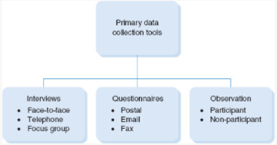
Figure 18 Methods to collect primary data (source Wilson, 2014, p. 331)

3.4.1 Sources
Typically, your research question and objectives give insights about the sample that you must choose. However, sometimes it will not be possible to collect data from all potential data available to you because of time, money, and access. Therefore, it is where sampling techniques stands for. In addition, it helps the researcher to reduce the amount of data you need to collect, focusing on a subgroup (Saunders et al., 2019, p.292).
As the research focuses on fraud investigation, the study will collect primary data sending a questionnaire by email or LinkedIn to 6 participants. They are forensic accountants, fraud examiners and fraud investigators, with different positions in companies, but all of them has deep exposure to fraud investigation.

3.4.2 Access and Ethical Issues
Sometimes, collecting primary data may be compromised because the researcher depends on reliability to gain access to gather the information. Furthermore, the appropriateness of the sources is related to the research question, objectives and research design (Saunders et al., 2019). Therefore, a barrier to collect data may appear and make the research even more difficult if you depend on one or more sources. There are many types of access; for this research, the author will utilise internet-mediated access, which corresponds with using computer technology (email, webcams, instant messaging) to deliver the questionnaire to collect primary data. As the author is focused on analysing the fraud investigation process, it will not be hard to find professionals to explain their activities.
Besides that, research students must be aware of ethical issues to develop responsible work and honesty. Especially when there is a human evolvement in the research, it is required by the university to approve the ethical aspects of the projects. The ethics aspects refer to the research point of view and the parties related to project, such individuals, companies, and government (Wilson, 2014).
According to (Saunders et al., 2019), “ethics refer to the standards of behaviour that guide your conduct concerning the rights of those who become the subject of your work or those who are affected by it. These ethical aspects are expressed in appendix A and B.

3.5 Approach to Data Analysis
Quantitative data analysis involves numerical data. Qualitative data analysis consists of a vast range of data sources, such as observation, written text, visual data and spoken word, and qualitative data analysis deal with a considerable amount of information (Wilson, 2014). Therefore, data analysis can be extensive, complex, and time-consuming, and it demands an efficient organisation process.
The researcher has chosen thematic analysis to structure his analysis to analyse the data collected through the questionnaires mentioned before. Thematic analysis is the approach that seeks to identify patterns and themes after data collection for further analysis—often considered as a general approach because of its flexibility; this approach is bot attached a particular research philosophy giving more flexibility to the researcher (Saunders et al., 2019).
The author considers thematic analysis a straightforward way to organize the data collection, mainly because the research corresponds to connected points that can affect the fraud situations. Moreover, using the thematic approach is possible to analyse them by themes and create relationships and patterns.
(Saunders et al., 2019) classifies the procedures to apply thematic analysis in 4 stages, become familiar with your data, code your data, search for themes and relationships, and refine themes and test prepositions.
Becoming familiar with your data correspond to read many times to acquire a deep understanding of the responses and initiate initial codes. When your data is collected through interviews, you start to become familiar once you transcribe the interviews. The familiarity with the data begins when the researcher receives the questionnaire's responses sent through LinkedIn or email.
The second stage consists of coding your data. Reading through your data collected and starting to generate potential keywords or phrased that better can help you organize your themes. In addition, coding your data supports the researcher to pinpoint areas that need further development and analysis.
The third stage stands for searching for themes and relationships. After coding your data, the researcher seeks to identify the relationship and patterns of the codes created that can help answer the research question.
The last stage is refining themes and test prepositions. By this moment, the author analyses the themes created to understand the necessity to organize them and better can reflect hypothesis to be tested and potential relationship to answer the research question.
To materialize this affirmation above, the researcher will send the questionnaire by email or LinkedIn to six participants; after receiving their responses, the author starts to read the answer to generate codes. By coding the data through Microsoft excel, the researcher will be able to identify potential ideas that can create themes. For that, the information will be reorganized into categories to reflect better the areas to be studied. After that, an analysis of the relationship of the categories to create patterns to answer the research question. Once this analysis is concluded, the author will discover the findings responsible for satisfying the research question.

Conclusion
This chapter just covered the methodology adopted by the author to collect primary data. The research design chosen was pragmatism philosophy, abductive approach, mono method qualitative, explanatory studies, cross-sectional. Send the questionnaire to the participants and thematic analysis as an analytical tool figure 19. Chapter four consists of the report of the findings. The explanations and the evidence found through the data analysis and relation with literature review.
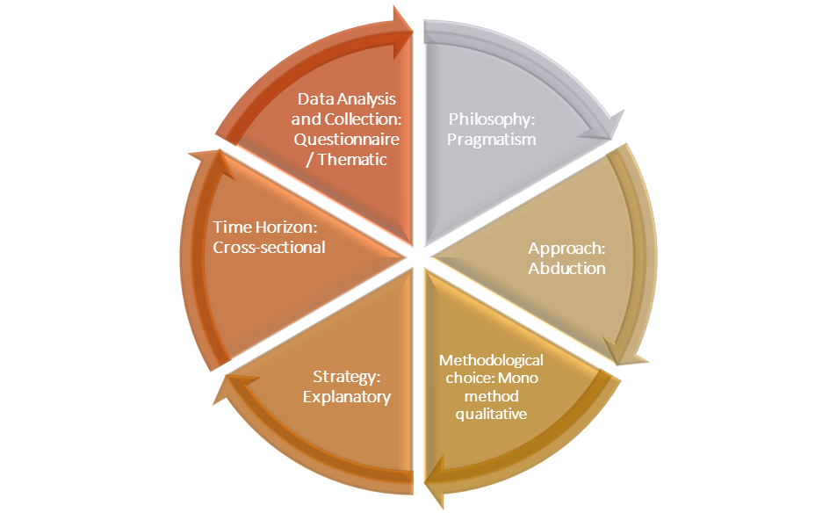
Figure 19 Research Design - source The author

Presentation and Discussion of the Findings

Overview
Chapter 3 covered previously demonstrated how and why the author chose the suitable research design for his research, considering the excellent approach to support the data collection. It was selected to collect data from forensic accountants and fraud investigators to understand their point of view through a qualitative open questionnaire containing five questions related to the fraud investigation process and its particularities.
Chapter 4 stands for the presentation and analysis of the findings acquired through the questionnaire. The author chose the thematic analysis to help him better organize the data to reach conclusions. The thematic analysis provides a straightforward method to analyse data by coding the participants' responses, allocating them into categories, and creating themes that turn out to be the research findings.
The research aims to answer the research question, how Can forensic accountants perform a meaningful fraud investigation in challenging times. The responses analysis found two significant areas; the pandemic has not changed the original fraud investigation process. Second, companies seeking to restructure their operations demand more forensic accountants' analysis and delay the investigation process.

FINDING 1: PANDEMIC HAS NOT CHANGED THE ORIGINAL FRAUD INVESTIGATION PROCESS
We know that changes might scare us sometimes, especially when we are not prepared for it. But, on the other hand, the impacts can be favourable and unfavourable, and consequences are remarkable and remembered constantly. Through the qualitative questionnaire, the author came across a different conclusion from what he thought at the beginning of the research.
To bring a positive answer to the research question, the author genuinely believed that the answer would be that forensic accounting should use different tools and technologies to strengthen the fraud investigation process due to the current difficulties that the pandemic brought to businesses. But he found out that this belief was wrong. The investigation process does not require a new revolutionary technique, tool, or technology to overcome the challenge and perform a meaningful investigation. Still, the fraud investigators need expressive adaptability to adequate their plan to the circumstances.
As is said by (University of Cambridge, 2016) in a quote by Charles Darwin, "It is not the strongest of the species that survives, nor the most intelligent that survives. However, it is the one that is most adaptable to change."

Evidence
According to appendix F, the chart helps the reader to start understanding what the author discovered. The chart shows that only two respondents of six demonstrated any difficulty to perform the investigation under pandemic. And it turned out that among the four stages, only two have suffered the impact. The stages are gathering evidence and analysing the evidence.
Respondent 1 said about the second stage of fraud investigation gather evidence, "Due to the pandemic, travel is limited so gathering laptops, desktops and mobile devices became a challenge." Going deep in the analyses of contents on physical devices is a well-detailed procedure to find a connection to frauds, and this barrier can delay the investigation process and compromise its effectiveness.
Also, respondent 1 adds to the potential issues on third stage analysis evidence, "Interviews became a challenge due to the pandemic. You must perform video calls so you can't look at the person and see body language." And participant 6 said that "(…) challenge for fraud examiners basically for the new normality as work from home, the lack of training in the remote investigation has affected (…)."
The author observed by the answers from fraud investigators that it can have different effects caused by the pandemic depending on the industry that the forensic accountants are investigating. And considering the effectiveness of the response from a company to the adversities, it can potentialize or minimize the fraud risk and consequently determine if the investigation process is affected or not. For example, respondent 4 explains, "…there was little to no impact. Businesses with a strong online or e-commerce presence were already all set to care for pre-covid fraud and risk management."

Discussion
As stated before, at the beginning of the research, the author believed to answer the research question will be necessary to find out new techniques and technologies. Sometimes we think the solution is much ahead of us, but we are wrong sometimes, and the answer is obvious.
Once we go back to the literature review, it was explained in section 2 Forensic Accounting the stages of the investigation process, and a powerful technique to solve most white-collar crimes is the interviews. The literature review (Wiesenfeld, 2020) affirms that although the interview process may be carried out in zoom or skype, it is not as effective as in person. This process is also an opportunity to review documentation, "provide sheds light on previously unclear transactions and financial activity."
The analysis of the interviewee is fundamental to find out any potential red flags and misconduct activity. Therefore, considering the scenario, location, times, and personal activities, an extensive plan is deemed to create a suitable plan with efficient questions to collect data from people.
Moreover, forensic accountants and fraud examiners need to check some pinpoint areas to create patterns to help them reach out to fraudulent activities. And as stated by respondent 1, access to computers, laptops, emails and mobile devices, or any device type can help seek tips become a challenge.
On the other hand, it was mentioned in chapter 2.1, Fraud and Financial Crime, explaining the fraud triangle and its importance to comprehend why crimes are committed. It was said that, based on three pillars, a fraud triangle is a helpful tool to understand the motivations of perpetrators, to seek the routes and potential vulnerabilities of the company. First, the fact of most companies moves their activity for working from home, where there is a lack of supervision, gives people the opportunity and easy access to create, perform, and execute fraudulent activity without providing the chance to management to catch the action and make difficult for forensic accountants to reach evidence.
The fraud triangle example plus travel restriction and lack of training to perform activities when working from home are challenging for the investigation process. But, on the other hand, respondent 1 says, "The pandemic just proved that working remotely is possible and, most of the times, more efficient." But for that, a high level of adaptation is necessary.
The first finding demonstrates that the investigation process is fine in general. The resources and technologies are sufficient to investigate, and some challenges are related to the matter of approach and time. Some respondents have experienced some issues, such as increased volume of activities, needed overtime to perform all analysis. This fact led us to conclude that forensic accountants must develop a different approach for the investigation process to overcome the barrier mentioned before about collecting physical evidence, conducting online interviews, and performing analysis. More time is needed to create a plan, gather evidence, analyse it, and report fraud. They must adapt their procedures to this new environment to overcome the potential challenges and keep an efficient investigation.

FINDING 2: COMPANIES SEEKING TO RESTRUCTURE THEIR OPERATIONS DEMAND MORE ANALYSIS FROM FORENSIC ACCOUNTANTS AND DELAY IN THE INVESTIGATION PROCESS
Since the pandemic hit, a business may not have been prepared for what was coming, and immediate responses were required to minimize the business risk and potential chance of fraudulent activities. Through a coding extract from the interviews, the author observes that many answers lead to an adaptation of procedures, internal controls systems, guidelines, and processes. And this transition will affect the forensic accountants’ performance due to the extensive analysis required to gather and analyse evidence.

Evidence
Considering the last question of the interview, outline further challenges that companies may face to prevent fraud post-pandemic, in your opinion. 5 respondents of 6 have given their opinion about additional challenges that companies will meet to avoid fraud.
Figure 20 Extract from Interviews
Fraud schemes, people behaviour, and a business change course to online activities will bring consequences if the companies do not adequate to these changes.
When there is a potential optimization in a company, before applying the new plan, the department conducts research and develops a scope for the implantation. Many situations must be tested before utilizing a new system, for example. Respondent 2 states, “But the pandemic brought the online process that could be challenged for most companies to adapt the process and have a good IT service to help to prevent potential concerns about cyber-attack.” Especially new fraud types will demand companies to review their IT systems and internal control system to evaluate the efficiency against the threat.
In addition to that, respondent 5 demonstrate how the investigation is done, “The investigation is done using machine learning platforms, rules-based systems and data analysis of possible trends as flagged by the systems and tools.” If the system and tools do not flag the trends, the forensic accountant and company have a problem that can compromise the prevention and discovery of fraud roots.
Therefore, many improvements can be made, and an investigation may take place along this process. However, between the ageing process until the new ones, forensic accountants come across many data to analyse, which causes a delay in the investigation process. As a result, they will need more time to perform the analysis to achieve a reasonable opinion.

Discussion
Extensive analysis already was the duty of forensic accountants when investigating fraud. But now, companies facing more vulnerabilities, and this amount can be much more extensive than before.
It was noted on the literature review that, forensic accounting area aims to collect, analyse, and evaluate evidential matters using specialised knowledge and investigative skills. Thus, the area reunites knowledge in accounting, auditing, and investigative skills to organise and carry out financial examination and analysis of individuals and companies American Institute of Certified Public Accountants (AICPA). Also, Forensic accountants are fundamental to analyse and evaluate the nature of the problem, track all steps performed by criminals, and provide relevant evidence for further disputes in court.
The quote from the five respondents above demonstrates a potential increase in cyber-fraud. This situation will require even more the development of a secure IT system that can block potential failures and make the company liable to fraud. Furthermore, the literature review explained in a report released by Delloite, 2018 about some further challenges for the profession to minimize the fraud exposure, such as constantly analysing their I.T. systems to utilise the best software to provide valuable and reliable data collection and analysis process and fraud monitoring.
IT department plays a fundamental role to help forensic accountants to access physical devices, support system understanding, clarify system upgrade, and provide general assistance through data collection and analysis. However, once they are busy developing strategies to minimize business exposure to risk, they may not be easy to access to cooperate with the investigation process.
Besides that, according to the potential challenges stated before from the respondents, the top management might be engaged with their team to revise the company’s structure to analyse if there is any vulnerability that can cause suspicious activity. Also, the literature review states the elements that should evaluate by the board of directors aiming to ensure total compliance with the corporate governance system, which are maintaining the sound of internal control, ensure that the current plan is working, reviewing the effectiveness of the internal control, and the disclosure of the annual report.
Depends on the moment of the year and the company’s current situation, entities have the busiest periods and summing up the potential occurrence of fraud, the overall environment might be highly challenging, and one investigation through this particularity must have massive cooperation of the management, directors, all departments, and employees to help forensic accountants to provide a reliable analysis.

OVERALL DISCUSSION
Considering the research objectives, analyse the investigation framework, find vulnerabilities on it, and evaluate the impacts of the management review. The author was surprised with the findings because he believed that the only way to provide a meaningful investigation under this challenging time would be with different technologies and tools due to uncertainties caused by covid 19.
But the first findings show him that the investigation process itself has not suffered a huge impact, and it may be overcome simply by adding more time and analysis. The second findings show that companies are in the middle of organising their activities to adequate to the situations and demands and present more reliable security against fraud.
However, this process can cause difficulties to the investigation process because it required the full involvement of management, directors, and employees to respond to the queries highlighted by forensic accountants. Sometimes, a deep analysis of procedures, system, and documents is necessary to reach an acceptable answer. And the company might be busy with internal reorganization and consequently not being able to cooperate as expected. As a result, forensic accountants will need more time to collect evidence and sometimes perform a series of previously done analysis.

CONCLUSION
This chapter coverer the findings found by analysing the questionnaire sent to six forensic accountants and fraud examiners. The analysis concludes that the fraud investigation process has not been affected by the pandemic. However, forensic accountants and fraud examiners must overcome the barrier of collecting biological data and online interviews. Besides that, the author found out that the potential optimization imposed by companies can delay the investigation process and required more analysis by the investigators.
The next chapter stands for the conclusion of the dissertation, demonstrating the implications, considerations, limitations, and suggestion for further research

Concluding Thoughts on the Contribution of this Research, its Limitations and Suggestions for Further Research
The previous chapter demonstrated the analysis of the findings that the author found after data collection. The author observed that it is not required new technologies and tools to strengthen the fraud investigation process. However, companies must apply some changes to their operation to adequate to the latest trends, which would cause difficulty to perform the investigation, demanding more analysis and consequently more time. Chapter five stands for the conclusion of the research by referring to implications, contributions, limitations, and recommendation for further study.

Implications of Findings for the Research Questions
The research question is, how can forensic accountants perform a meaningful fraud investigation in challenging times? At the beginning of the research, the author genuinely believed that this tough time would bring some difficulties to forensic accountants. He concluded from its previous reading that some professionals and accountancy firms had reported several issues that pandemic brought. Therefore, about the investigation process, it was unclear in each degree it has affected. So, the author decided to explore this universe to expand their knowledge.
After data collection, the author concludes that the fraud investigation process remains the same for some professionals but no for others. Also, he believes what is affecting the investigation process is the type of industry that forensic accounting performing an investigation. Many companies suffer different realities and operations, and the response to fraud and challenging times is different from each other.
So, the author concludes that the most impacted stage of the investigation process was gather and analysing evidence. Because the investigation analyses physical evidence to find potential red flags to lead to fraudulent activities, another technique is interviewing people. It turns out to be one of the most efficient ways to analyse the actions and people`s behaviour to match and create patterns to uncover fraud. And, due to the pandemic travelling to collect and analyse physical evidence is a challenge and to do online interviews.
The second finding stands for the adaptation that the pandemic caused to businesses and consequently affects fraud investigation performance. Again, it is noted that some companies will present more issues at this time than others. It is well known that structured companies tend to show fewer vulnerabilities and immediate effective changes to overcome situations. And those who are going to transitions times will make the occupation of forensic accounting even more difficult due to performing more analysis, making deep revisions, finding collaboration during the investigation, challenges to collect evidence and delay on the investigation report.
In general, the author believes the research questions were well responded to, and the answer is adaptation. The author thinks this challenging time will require more time on the first stage of the investigation, map out. Because this stage is essential to observe the nature of the problem, how the fraud was noted, the company`s structure and series of information should be acquired before developing a plan. Forensic accountants analyse the best way to overcome potential issues, adequate its gather evidence process collection, sufficient schedule to find reliable internal collaboration, and a massive dependency of IT department, especially for the companies going through process revision and system upgrade.

Contributions of Findings and Limitations of the Research
The author believes the research was significant for forensic accountants and fraud examiners and even more for businesses. Because it will help them to develop a better understanding of the fraud types, provide a valuable mechanism to find its roots, and consequently create barriers and securities for business activities and fraud investigation framework.
As the research considered primary data collection, the author had to talk with some forensic accountants and fraud investigators to collect their perspective of the fraud and investigation framework. However, due to the business environment that everybody is in, it was not easy to find available professions to interview by zoom, skype, or call. So instead, many participants required the question through a word file or website link to respond to them.
Even though this approach has been enough to collect data and present a concise analysis, interviewing the participants would have been a better idea if the author did not face issues related to the participant schedule. The research would have been richer in details and presented much more insights to respond to the research question.

Recommendations for Practice of Findings
The author believes the forensic accounting team will have to spend more time planning and more knowledge about the business practices. Also, they will have to get a high level of engagement of the company, especially these areas that offer huge support, like IT.
Collaboration is the key to contribute to a meaningful investigation. On the other hand, forensic accountants should consider a delay in the investigation and disclose this particularity to the first meeting with the client to avoid biases.

Recommendations for Future Research
The author believes that analysing the point of view of forensic accountants and the companies can provide richer discussion in future research because this approach allows understanding both sides indivisually. And mainly comprehending the business practices from a particular industry is more beneficial to create relationships between the company and investigators. Besides that, the most valuable data collection is through interview. It allows the researcher to collect detailed primary data and develop better connections among the hypothesis to be tested. Therefore, the focus should be on interviewing the participants rather than collecting data through a questionnaire or survey.

Final Conclusion and Reflections
The author believes that challenging times do not affect negatively only. People and management should see the bright side brought by the crises as an opportunity to review some aspects that may not work effectively as before.
Therefore, this research demonstrates relevant points that should be improved to maximize business security and decrease business risk. Also, it explained how important is the precise scope of the investigation, and the crucial role of professionals who can fight against financial crimes. Due to the technological boom, companies are provided with plenty of solutions to help their business; however, it demands a reliable plan to adhere to new technologies, mainly qualified human resource who can deal with it effectively.

References
ACFE Report to the Nations | 2020 Global Fraud Study. Available at: http://www.acfe.com/report-to-the-nations/2020/ (Accessed: 22 April 2021).
Archer, M., Decoteau, C. and Gorski, P. (2016) What Is Critical Realism?. Theory Section. Available at: http://www.asatheory.org/2/post/2016/12/what-is-critical-realism.html (Accessed: 1 June 2021).
Basu. (2006) Auditing: Principles and Techniques. Pearson Education India.
Bougie, R. and Sekaran, U. (2020) Research Methods for Business: A Skill Building Approach. John Wiley & Sons, Incorporated.
Chen, J. (2021a) Fraud Definition. Investopedia. Available at: https://www.investopedia.com/terms/f/fraud.asp (Accessed: 15 April 2021).
Chen, J. (2021b) What Corporate Governance Means for the Bottom Line. Investopedia. Available at: https://www.investopedia.com/terms/c/corporategovernance.asp (Accessed: 28 April 2021).
Chew, B.-L. (2017) Forensic Accounting and Finance: Principles and Practice. Kogan Page Publishers.
Collis, J. and Hussey, R. (2013) Business Research: A Practical Guide for Undergraduate and Postgraduate Students. Macmillan International Higher Education.
Crossley, J. and Jansen, D. (2021) Saunders’ Research Onion: Explained Simply (+ Examples). Grad Coach. Available at: https://gradcoach.com/saunders-research-onion/ (Accessed: 30 April 2021).
Culpepper, T. (2018) The 4 Steps Forensic Accountants Use to Protect Your Finances. Culpepper CPA. Available at: https://culpepper-cpa.com/2018/07/12/forensic-accountants/ (Accessed: 6 April 2021).
Daly, A. (2021) Second Man Arrested in Relation to Pandemic Unemployment Payment Fraud Scheme. TheJournal.ie. Available at: https://www.thejournal.ie/phishing-scam-pandemic-unemployment-payment-man-arrested-5376006-Mar2021/ (Accessed: 23 March 2021).
Deloitte, D. (2018) Overcoming Data Challenges in Forensic Investigations. Deloitte United States. Available at: https://www2.deloitte.com/us/en/pages/advisory/articles/overcoming-data-challenges-in-forensic-investigations.html (Accessed: 26 April 2021).
Doig, A. (2016) Fraud: The Counter Fraud Practitioner’s Handbook. CRC Press.
Dudovskiy, J. (2018) Abductive Reasoning (Abductive Approach). Research-Methodology. Available at: https://research-methodology.net/research-methodology/research-approach/abductive-reasoning-abductive-approach/ (Accessed: 28 May 2021).
Dudovskiy, J. (2017) Interpretivism (Interpretivist) Research Philosophy. Research-Methodology. Available at: https://research-methodology.net/research-philosophy/interpretivism/ (Accessed: 1 June 2021).
Dutta, S.K. (2013) Statistical Techniques for Forensic Accounting: Understanding the Theory and Application of Data Analysis. FT Press.
Edelbacher, M., Kratcoski, P. and Theil, M. (2012) Financial Crimes: A Threat to Global Security. CRC Press.
Fisher, C. (2010) Researching and Writing a Dissertation. Available at: https://ereader.perlego.com/1/book/812201/1 (Accessed: 29 April 2021).
FRC. (2005) REVISED GUIDANCE FOR DIRECTORS ON THE COMBINED CODE. Available at: https://www.frc.org.uk/getattachment/fe1ba51a-578d-4467-a00c-f287825aced9/Revised-Turnbull-Guidance-October-2005.pdf (Accessed: 28 April 2021).
Frunza, M.-C. (2015) Introduction to the Theories and Varieties of Modern Crime in Financial Markets. Academic Press.
Garg, C.K. (2020) Forensic Audit of Financial Crimes & Frauds. Wolters Kluwer India Pvt Ltd.
Global Profiles of the Fraudster: Technology Enables and Weak Controls Fuel the Fraud - KPMG Global. (2021) KPMG. Available at: https://home.kpmg/xx/en/home/insights/2016/05/global-profiles-of-the-fraudster.html (Accessed: 22 April 2021).
Golden, T.W. (2011) A Guide to Forensic Accounting Investigation. John Wiley & Sons.
Golden, T.W., Skalak, S.L. and Clayton, M.M. (2006) A Guide to Forensic Accounting Investigation. Hoboken, N.J: J. Wiley.
Gottschalk, P. (2016) Investigation and Prevention of Financial Crime: Knowledge Management, Intelligence Strategy and Executive Leadership. CRC Press.
Gray, I., Manson, S. and Crawford, L. (2019) The Audit Process: Principles, Practice and Cases. Cengage Learning EMEA.
Harvey, T. (2018) The 6 Most Common Behavioral Red Flags of Fraud. ACFE Insights. Available at: https://www.acfeinsights.com/acfe-insights/6-common-red-flags-fraud (Accessed: 22 April 2021).
Hayes, A. Forensic Accounting. Investopedia. Available at: https://www.investopedia.com/terms/f/forensicaccounting.asp (Accessed: 31 March 2021).
Hayes, A. (2021) Shareholder Definition. Investopedia. Available at: https://www.investopedia.com/terms/s/shareholder.asp (Accessed: 28 April 2021).
IAASB. (2009) INTERNATIONAL STANDARD ON AUDITING 330 THE AUDITOR’S RESPONSES TO ASSESSED RISKS. IFAC. Available at: https://www.ifac.org/system/files/downloads/a019-2010-iaasb-handbook-isa-330.pdf (Accessed: 27 April 2021).
IBM Cloud Education. (2021) What Is Text Mining?. Available at: https://www.ibm.com/cloud/learn/text-mining (Accessed: 27 April 2021).
Klettner, A. (2016) Corporate Governance Regulation: The Changing Roles and Responsibilities of Boards of Directors. Routledge.
Kothari, C.R. (2004) Research Methodology: Methods and Techniques. New Age International.
Kranacher, M.-J. and Riley, R. (2019) Forensic Accounting and Fraud Examination. John Wiley & Sons.
Mario, V., CPA. (2020) The Fraud Triangle and Your Business. Kreischer Miller. Available at: https://www.kmco.com/resource-center/cpce/content-hubs/business-strategy/the-fraud-triangle-and-your-business/ (Accessed: 21 April 2021).
Mukherjee, S.P. (2019) A Guide to Research Methodology: An Overview of Research Problems, Tasks and Methods. CRC Press.
Neville, S. (2021) Gardaí Warn of 120% Increase in Investment Fraud Scams during Pandemic. Irish Examiner. Available at: https://www.irishexaminer.com/news/courtandcrime/arid-40239956.html (Accessed: 23 March 2021).
Ng, W. and Coakes, E. (2014) Business Research: Enjoy Creating, Developing and Writting Your Bussinessproject. Available at: https://ereader.perlego.com/1/book/1589419/25.
O’Gorman, K.D. (2014) Research Methods for Business and Management: A Guide to Writing Your Dissertation. Good Fellow Publishers Ltd. Available at: https://ereader.perlego.com/1/book/868836/76 (Accessed: 3 June 2021).
Paine, L.S. (2020) ‘Covid-19 Is Rewriting the Rules of Corporate Governance’. Harvard Business Review, 6 October. Available at: https://hbr.org/2020/10/covid-19-is-rewriting-the-rules-of-corporate-governance (Accessed: 28 April 2021).
Pasco, G.A. and June, D.L. (2012) Criminal Financial Investigations: The Use of Forensic Accounting Techniques and Indirect Methods of Proof, Second Edition. CRC Press.
Pwc. (2020a) COVID-19: Some Considerations Relating to Corporate Governance. PwC. Available at: https://www.pwc.com/mt/en/publications/tax-legal/covid-19-some-considerations.html (Accessed: 28 April 2021).
Pwc. (2020b) PwC’s Global Economic Crime and Fraud Survey 2020. PwC. Available at: https://www.pwc.com/gx/en/services/forensics/economic-crime-survey.html (Accessed: 22 April 2021).
Raval, V. (2020) Corporate Governance: A Pragmatic Guide for Auditors, Directors, Investors, and Accountants. CRC Press.
Rezaee, Z. (2019a) Forensic Accounting and Financial Statement Fraud, Volume I. Available at: https://ereader.perlego.com/1/book/955325/4.
Rezaee, Z. (2019b) Forensic Accounting and Financial Statement Fraud, Volume II: Forensic Accounting Performance. Business Expert Press.
Ríos, V.R. and Campo, E.P. del. (2013) Business Research Methods. Theory and Practice. ESIC.
Roufa. (2019) Forensic Accountant Job Description: Salary, Skills, & More. The Balance Careers. Available at: https://www.thebalancecareers.com/forensic-accountant-job-information-974648 (Accessed: 1 April 2021).
Rufus, R.J. et al. (2015) Forensic Accounting, Global Edition. Pearson Higher Education & Professional Group.
Samociuk, M. and Iyer, N. (2017) A Short Guide to Fraud Risk: Fraud Resistance and Detection. Routledge.
Saunders, M., Thornhill, A. and Lewis, P. (2019) Research Methods for Business Student. 8th edn. Pearson Available at: https://www.perlego.com/book/971477/research-methods-for-business-students-pdf (Accessed: 3 June 2021).
SDC CPAs. (2021) The Continuing Challenges of Forensic Accounting during COVID-19. SDC CPAs, LLC. Available at: https://sdccpa.com/hot-topics/the-continuing-challenges-of-forensic-accounting-during-covid-19/ (Accessed: 26 April 2021).
Singleton, T.W. and Singleton, A.J. (2010) Fraud Auditing and Forensic Accounting. John Wiley & Sons.
Swaen, B. (2015) Developing a Conceptual Framework for Research. Scribbr. Available at: https://www.scribbr.com/dissertation/conceptual-framework/ (Accessed: 27 May 2021).
Tricker, B. (2019) Corporate Governance: Principles, Policies, and Practices. Oxford University Press.
Twin, A. (2020) Data Mining: How Companies Use Data to Find Useful Patterns and Trends. Investopedia. Available at: https://www.investopedia.com/terms/d/datamining.asp (Accessed: 27 April 2021).
University of Cambridge. (2016) The Evolution of a Misquotation. Darwin Correspondence Project. Available at: https://www.darwinproject.ac.uk/people/about-darwin/six-things-darwin-never-said/evolution-misquotation (Accessed: 19 May 2021).
Wiesenfeld, J. (2020) COVID-19 Challenges to Forensic Accounting. Journal of Accountancy. Available at: https://www.journalofaccountancy.com/newsletters/2020/oct/coronavirus-challenges-forensic-accounting.html (Accessed: 26 April 2021).
Wilson, J. (2014) Essentials of Business Research A Guide to Doing Your Research Project. 2nd edn. SAGE Publications Available at: https://www.perlego.com/book/1431511/essentials-of-business-research-a-guide-to-doing-your-research-project-pdf (Accessed: 19 May 2021).
Wright, M. et al. (2013) The Oxford Handbook of Corporate Governance. OUP Oxford.
Yin, R.K. (2017) Case Study Research and Applications: Design and Methods. SAGE Publications.

Appendices

Appendix A – Covering letter to survey/interview subject
Analysis of Fraud Investigation process under Pandemic
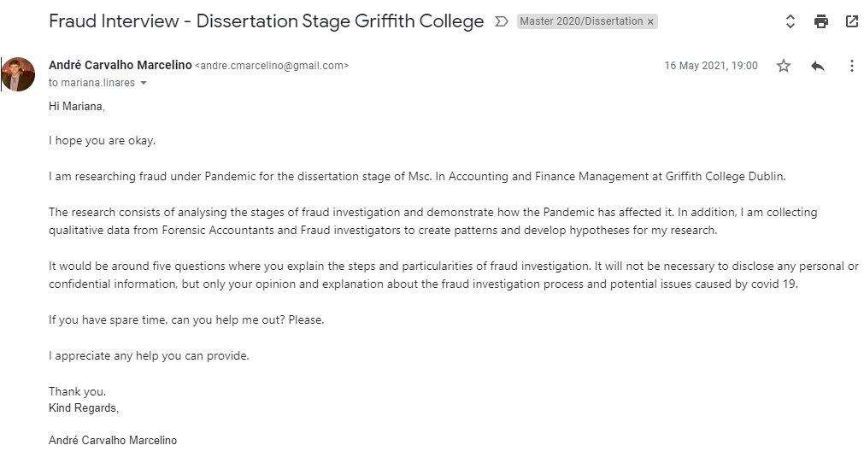
Dear participant,

The research is for the dissertation stage of Msc. In Accounting and Finance Management at Griffith College Dublin.

The present work consists of 5 questions about the fraud investigation process under Pandemic and its potential impacts. The questionnaire aims to help the researcher answer the following research question: How Can forensic accountants and fraud examiners perform a meaningful fraud investigation during challenging times?

Your participation is voluntary. All the information provided is confidential and used for dissertation purpose only. No names, companies or any personal data will be required to answer the questions.

Please, fill in the questions stating your opinion about the fraud investigation process, explaining the stages of the investigation, primary considerations, characteristics, and potential impacts caused by covid 19.

If you have further questions, do not hesitate to reach me out through: andre.cmarcelino@gmail.com; andre.carvalhomarcelino@student.griffith.ie.

I appreciate your help.

Thank you so much.
André Carvalho Marcelino

Appendix B – Sample survey/interview questions
- Please explain in detail how it is performed in the initial stage of a fraud investigation process. And demonstrate the impacts that the Pandemic might have brought to this stage.

- Please explain as much as possible how it is typically performed activity of gathering Evidence for fraud investigation purpose (techniques, types of Evidence, assistance by management, issues). And demonstrate how the Pandemic might have affected this stage.

- Please explain how it is the process to analyse Evidence of the fraud investigation framework (structure, calculations, techniques, tools, software) and the potential implications of covid 19 to perform an efficient analysis.

- Please explain the main characteristics of a fraud investigation report and potential issues that the Pandemic might have caused to this stage in your opinion.

- Outline further challenges that companies may face to prevent fraud post-pandemic, in your opinion.

Appendix C – Sample completed survey/interview transcript
- Please explain in detail how it is performed in the initial stage of a fraud investigation process. And demonstrate the impacts that the Pandemic might have brought to this stage.

Respondent 6: In the initial stage of fraud investigation will vary depends on the nature of the business and type of investigation you are performing; General speaking, fraud investigation start for the rise of a suspicious activity or suspected wrongdoing which the source could come from a tip (hotline) or unusual patterns detected. In an unexpected social phenomenon as the current Pandemic the behaviour of the human being will be affected due to uncertainty. It will bring crisis related to many aspects in how any individual will face the crisis. In this case and related to the current Pandemic, fraud investigation has been affected in relation with two stages of the fraud triangle (Rationalisation and Opportunity) where no only fraudster have a considerable opportunity to commit fraud; honest people would be attracted to cheat and commit fraud so the fraud investigation also will turn and look into places where we wouldn't imagine before it could happen.

- Please explain as much as possible how it is typically performed activity of gathering Evidence for fraud investigation purpose (techniques, types of Evidence, assistance by management, issues). And demonstrate how the Pandemic might have affected this stage.

Respondent 6: Gathering Evidence is always a challenge for the fraud investigation purpose due to the regulations, policies, framework, and laws that you must comply with. The evidence needs to be accepted and valid when presented in a case, and good evidence must be kept safe within the chain of custody. The techniques will vary from investigation to investigation. In my case, pandemic did not affect this stage of the fraud investigation due to the agreement within the parties involved, giving written authorisation when a suspicion of fraud arose.

- Please explain how it is the process to analyse Evidence of the fraud investigation framework (structure, calculations, techniques, tools, software) and the potential implications of covid 19 to perform an efficient analysis.

Respondent 6: Structure - Number of the case (Folio), Evidence previously gathered, a detailed chain of custody (that is important) and Status (Accepted as Evidence for other issues or dismissed). `
Techniques: Forensic photography as Evidence is analysed and compared against real data (signatures, fingerprints, emails, calls. Etc). Software: Data Analytics such a MySQL, SAP, Password Manager, and data encryptor (When you need to keep safe and private as possible all the Evidence).
In this case, I think it has been the most affected. It has been a challenge for fraud examiners basically for the new normality as work from home. In addition, the lack of training in remote investigation has affected and again depends on the confidential agreement most accessible or harder to complete.

- Please explain the main characteristics of a fraud investigation report and potential issues that the Pandemic might have caused to this stage, in your opinion.

Respondent 6: The report has many characteristics, and I'm personally would not mention them as separate due to the report itself as a complete description of the case. Since the first hint or finding until the conclusion leads to determine if a fraud is being committed or the opposite when the Evidence is not enough to confirm your hypothesis or the evidence, shows that no fraud has been committed.

- Outline further challenges that companies may face to prevent fraud post-pandemic, in your opinion.

Respondent 6: Lack of visibility; as I mentioned above, good employees can turn bad people when rationalisation and opportunity are presented. In this case, as post-pandemic work from home when nobody is watching over. Lack of specialised training of the fraud team in place if they have. Stick with new internal policies that would help with remote investigation and compliance of the employees.

Appendix D – Plan Language Statement
PLAIN LANGUAGE STATEMENT
Introduction to the Research Study
Research Study Title: The challenges of fraud investigation process under pandemic.
University: Griffith College, Graduate Business School.
Principal Investigator: Dr Garrett Ryan.
Researcher Name: Andre Carvalho Marcelino
Email: andre.cmarcelino@gmail.com; andre.carvalhomarcelino@student.griffith.ie;
II. Details of what involvement in the Research Study will require

This project involves taking part in researching about the stages of the fraud investigation process and for that it will be necessary to talk with some forensic accountants to understand their point of view of the investigation under pandemic. The interviews/survey responses will be recorded. Questions are directed towards your thoughts on process, standards and accounting roles and techniques. I estimate the interviews/survey will take no longer than 30 minutes to complete.
III. Potential risks to participants from involvement in the Research Study (if greater than that encountered in everyday life) I do not anticipate any risk to participants as a result of participation in this Research Study.
IV. Benefits (direct or indirect) to participants from involvement in the Research Study
The objective of this Research Study is to expand or gain new knowledge that will enable understanding about the fraud investigation process under pandemic and shows the affect caused by it. This study may, therefore, be of benefit to you by providing you with the opportunity to contribute to body of knowledge on Accounting and Finance so that you and or society may benefit.
V. Advice as to arrangements to be made to protect the confidentiality of data, including that confidentiality of information provided is subject to legal limitations
Every effort is made to ensure the confidentiality of the participant. Participant names will not be recorded, as all participants will be assigned a code. Where used, recorded interviews/survey data will be downloaded to a password-controlled computer, typed transcripts/survey results are held within password-controlled documents. Participant biographical details and or mention of other persons will be omitted in the final report. Confidentiality of information provided is subject to legal limitations.
VI. Advice as to whether or not data is to be destroyed after a minimum period
Audio tapes/Survey data will be destroyed on the successful completion of this master’s degree in full compliance with GDPR regulations.
VII. Statement that involvement in the Research Study is voluntary
Involvement in this Research Study is voluntary. Participants who decide to take part may withdraw from the Research Study at any point. There will be no penalty for withdrawing before all stages of the Research Study are complete.

If participants have concerns about this study and wish to contact an independent
person, please contact:

Dr. Garrett Ryan

MSCIB Programme director
Graduate Business School
Office: A109

Griffith College
South Circular Road, Dublin 8, Ireland

Phone: + 353 1 416 3324
Email: garrett.ryan@griffith.ie
Website: www.griffith.ie

Appendix E – Inform Consent Form
INFORMED CONSENT FORM

I. Research Study Title: The challenges of fraud investigation process under pandemic.
University: Griffith College, Graduate Business School.
Principal Investigator: Dr Garrett Ryan.
Researcher Name: Andre Carvalho Marcelino
Email: andre.cmarcelino@gmail.com; andre.carvalhomarcelino@student.griffith.ie;
II. Clarification of the purpose of the research

The research tries to understand the fraud investigation framework by analysing the activities performed by forensic accountants, its techniques, comprehension about what vulnerability companies face, corporate governance system, the reliance of internal controls, management and board of directors' engagement and the impact of covid 19 in entities. Furthermore, to understand if the pandemic has impacted the investigation process significantly and comprehend how difficult it is to elaborate a concise and reliable work under coronavirus pandemic. And by the end of the study, the author aims to find reasonable answers for the following question, how can forensic accountants perform a meaningful investigation in challenging times?
III. Confirmation of particular requirements as highlighted in the Plain Language Statement

This project involves taking part in researching about the stages of the fraud investigation process and for that it will be necessary to talk with some forensic accountants to understand their point of view of the investigation under pandemic. The interviews/survey responses will be recorded. Questions are directed towards your thoughts on process, standards and accounting roles and techniques. I estimate the interviews/survey will take no longer than 30 minutes to complete.

Participant – please complete the following (Circle Yes or No for each question)

Have you read or had read to you the Plain Language Statement Yes/No
Do you understand the information provided? Yes/No
Have you had an opportunity to ask questions and discuss this study? Yes/No
Have you received satisfactory answers to all your questions? Yes/No
Are you aware that interviews will be audiotaped? Yes/No
IV. Confirmation that involvement in the Research Study is voluntary
Involvement in this Research Study is voluntary. Participants who decide to take part may withdraw from the Research Study at any point. There will be no penalty for withdrawing before all stages of the Research Study are complete.

V. Advice as to arrangements to be made to protect confidentiality of data, including that confidentiality of information provided is subject to legal limitations
Audio tapes/Survey data will be destroyed on the successful completion of this master’s degree in full compliance with GDPR regulations.
VI. Participant Signature:
I have read and understood the information in this form. My questions and concerns have been answered by the researcher, and I have a copy of this consent form. Therefore, I consent to take part in this research project
Participants Signature: Andre Carvalho Marcelino
Name in Block Capitals: ANDRE CARVALHO MARCELINO
Witness:
Date: 17/12/2020

Appendix F – Results
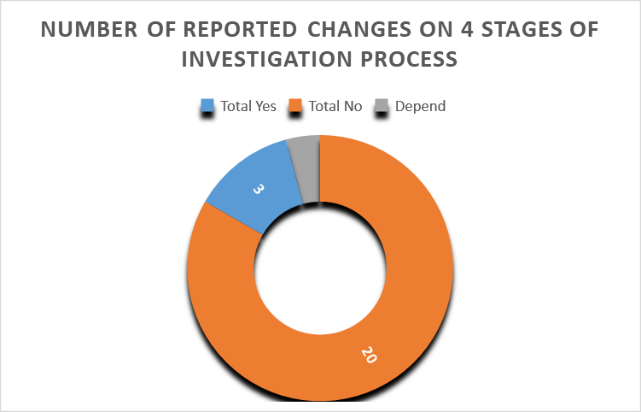

Appendix G – Data Analysis
To test the first hypothesis, the author would like to understand if there is little, relevant or no change to the investigation process. For that, he created the chart in appendix F to measure the number of participants who have experienced (yes) any change in the fraud investigation. Curiously only three answers among twenty-four have said there was relevant impact caused by the Pandemic.
The chart was created on Microsoft excel based on the analysis of the responses individually analysing how each participant performed the stages of the investigation under pandemic, and the author classified in yes or no the responses to create the chart. Most of them believes in on impact due to the pandemic in many different degrees.
According to two respondents, the only second and third stage of the investigation process presented a relevant issue in their activities. However, these stages correspond to the most significant part of the investigation. After developing a plan and scope of the investigation, forensic accountants seek to explore the companies’ activities to gather evidence. It can be going through transactions, how an action is performed, documentation, contracts, reports, business structure, interviews, physical inspections, etc.
The first participant said that the second stage of the investigation process (gather evidence) suffered an impact because of the travel restrictions. The second respondent also classified that the third stage of the investigation process was affected by the Pandemic. Where to perform online interviews to analyse facts, test hypothesis, and to analyse the interviewee behaviour, such as body language, it is not effective as before. This particularity is extremely useful to raise potential misconduct of employee or interviewee.
In addition, respondent six said that despite professionals having robust tools to investigate, working from home has brought some difficulties due to the lack of training to perform activities with more certainty. "I think it's been the most affected, and it's been a challenge for fraud examiners basically for the new normality as work from home, the lack of training in the remote investigation."
The second finding was obtained by analysing the responses individually on Microsoft excel to understand potential issues that can affect the efficiency of the fraud investigation. The author used thematic analysis to extract from the respondent’s answers codes assigned to themes to lead to the finding.
The author observed a big necessity for revising the business activity to minimize the fraud risk through the initial analysis of the facts reported. Especially now, where companies have increased the number of people working from home, some internal procedures may not be suitable anymore to ensure the company’s data are protected.
Besides that, the effectiveness of a reliable plan to prevent fraud will be performed mainly from the IT department. It will be necessary to provide a deep analysis through technological security to verify potential gaps that can lead to fraud. On the other hand, coding the data showed a critical necessity for effective communication in the company and external bodies. Because of the changes that a business may be liable to, especially for the beneficial changes, it is necessary to make the whole entity aware of the requirements, the ongoing plans, further reviews, and constant optimization.

