Foreign Exchange Reserve Scale in China

Research dissertation presented in partial fulfilment of the requirements
for the degree of
MSc in Accounting & Finance Management
Griffith College Dublin

Dissertation Supervisor: Dr George E. Iatridis

Student Name: Xiaochen Cai
3rd September 2021

Candidate Declaration

Candidate Name: Xiaochen Cai

I certify that the dissertation entitled:
Foreign Exchange Reserve Scale in China
submitted for the degree of: MSc in Accounting & Finance Management is the result of my own work and that where reference is made to the work of others, due acknowledgment is given.

Candidate signature: 

Date: 3/9/2021

Supervisor Name: Dr George E. Iatridis

Supervisor signature:

Date:

Dedication

The dissertation is firstly dedicated to the most important person in my life, my mother. Thank you for inspiring me, supporting me and giving me the opportunity to see this wonderful world.

This research is also dedicated to my father, thank for always believing in me, teaching me the way to solve difficulties and keeping an optimistic attitude.

Acknowledgements

Firstly, I am so appreciative for supports and understands of my family and friends when undertaking the research, they gave me great encouragement when I encountered problems.

More importantly, I want to express my sincere thanks to my dissertation supervisor, Dr George E. Iatridis, who patiently answered all my questions, encouraged me when I was unconfident and was always able to obtain some valuable advice from him.

Lastly, I would like to thank my best friend, Lin, for guiding me through the hypotheses testing stage.

Abstract

Foreign Exchange Reserve Scale in China

Xiaochen Cai

In recent years, the dramatic increases in foreign exchange reserves of developing countries have caused a series of important financial problems. The research into the optimal range of foreign exchange reserves may provide a critical index to evaluate a country’s financial position. This study proposed a method to measure the optimal foreign exchange reserve scale in the context of potential impacts of the Covid-19 and the U.S-China trade war on the economy of China. This research also tentatively identified relationships between some financial variables and the scale of foreign exchange reserves. An improved method was taken from a scientific standpoint and deductive research was employed by collecting quantitative data. The data analysis for this paper was carried out by using correlation analysis and different types of regression analysis.

The results of this research indicated that the China’s foreign exchange reserve scale hold on to the optimal range so far. This research also aware that imported primary products have a linear relationship with the foreign exchange reserve scale, the short-term debt was significantly correlated with the foreign exchange reserve scale through comparing with other external debts, and the fluctuation of foreign exchange reserves was not affected by the transformation in foreign exchange systems. Except that, tariff changes and the trade war also have possible impacts on the foreign exchange reserve scale. Therefore, the dissertation suggested that the government should expand investments, diversified foreign exchange reserve assets, etc. Through taking these measures to ensure that foreign exchange reserves in China continue maintaining the optimal scale.

Keywords: Covid-19, Trade War, Foreign Exchange Reserves, Optimal Scale, Agarwal Model

Table of Contents
Candidate Declaration II
Dedication III
Acknowledgements IV
Abstract V
List of Figures VIII
1 Introduction 1
1.1 Overview 1
1.1 Research Objective 1
1.2 Significance and Justification 3
1.3 Structure of the Study 4
2 Literature Review 5
2.1 Overview 5
2.2 Foreign Exchange Reserves 6
2.3 History of Foreign Exchange Reserves in China 6
2.4 Optimal Scale Determinate 8
2.5 Covid-19 12
2.6 The Trade War 13
2.7 Conceptual Framework 15
2.8 Conclusion 17
3 Methodology and Research Design 18
3.1 Overview 18
3.2 Research Philosophy and Overall Approach 18
3.3 Research Strategy and Data Collection 19
3.4 Approach to Data Analysis 21
3.5 Access and Research Ethic Issues 21
3.6 Conclusion 23
4 Presentation and Analysis of Data 23
4.1 Overview 23
4.2 Hypotheses 24
4.3 The Improvement of the Agarwal Model 24
4.4 The Variable Considered 27
4.5 Hypotheses Testing 31
5 Discussion of Research 36
5.1 Discussion of Hypotheses 36
5.2 Discussion of Findings 38
6 Conclusion and Recommendations 42
6.1 Overview 42
6.2 Implications of Findings for the Research 42
6.3 Contributions and Limitations of the Research 42
6.4 Recommendations for Practice 43
6.5 Suggestion for Future Research 45
References 47
Bibliography 51
APPENDICES A
APPENDIX A – HYPOTHESIS 1 DATABASE A
APPENDIX B – HYPOTHESIS 3 DATABASE B
APPENDIX C – HYPOTHESIS 4 DATABASE C

List of Figures
Figure 1: Forex Reserves in China from 1980 to 2020 8
Figure 2: Conceptual Framework by author 16
Figure 3: Optimal Range and Actual Value in China 27
Figure 4: China's Foreign Trade in 2020 29
Figure 5: The Result of Pearson's Correlation Analysis by Author 33
Figure 6: The Result of Chow Test by Author 34
Figure 7: The Result of Linear Regression Analysis by Author 35
Figure 8: The Q-Q Scatter Plot by Author 35
Figure 9: The Result of Logistic Regression Analysis by Author 36
Figure 10: The Relationship between Foreign Exchange Reserves and Tariffs, Trade War by Author 37
Figure 11: The Determination of Coefficients for Variables by Author 40
Figure 12: Optimal Range and Actual Value of Foreign Exchange Reserves by Author 40
Figure 13: Optimal Range and Actual Value from 2000 to 2020 by Author 41

Introduction

Overview
Since the end of the 1970s, the foreign exchange market has gradually developed and expanded in China with the implementation of the reform and opening-up policy (Wang and Lin, 2020). After undergoing constant changes and upgrades, the foreign exchange market in China currently has maintained an overall balance between supply and demand. Foreign exchange reserves have the ability to supervise the foreign exchange market. This research investigates the scale of China's foreign exchange reserves under current complicated macro environments. To explore the appropriate model and correct methods of measuring the foreign exchange reserve scale in China. The main purpose of the research is to evaluate the current foreign exchange reserves from its optimality, find its suitable ranges and give some constructive recommendations. Therefore, the topic of this research is “An exploratory study on the foreign exchange reserve scale in China".

Research Objective
From the standpoint of China’s foreign exchange reserves, this research plans to achieve the following objectives:
- Understand the concept of foreign exchange reserves and the development history in China.
- Using an appropriate approach to evaluate the optimality of the current foreign exchange reserve scale in China.
- Providing valuable recommendations based on the influences of variables.

The research question addresses on what is the current condition of the China’s foreign exchange reserve scale under the influences of different variables. With an overview of the past, China’s foreign exchange reserve scale has been growing rapidly and accumulating continuously, which arouses great interests from domestic scholars. In fact, the earliest statistical record of China’s foreign exchange reserve scale can be going back to the 1950s, when the total foreign exchange reserves were only 157 million U.S dollar and the overall situation was sluggish. But from the 1990s, because the government has become more aware of the importance of foreign exchange reserves, its annual growth rate has boosted by nearly 40 percent. In 2006, foreign exchange reserve scale has broken through one trillion U.S dollars for the first time in China and surpassed two trillion U.S dollar three years later, in 2009. It overtakes Japan, Russia, South Korea and other countries to rank first in the world. Despite the fact that the State Administration of Foreign Exchange (SAFE) formally ended the compulsory foreign exchange settlement system in 2012 and allowed domestic institutions to retain foreign exchange for their needs, its upward trend has not abated. The scale of foreign exchange reserves had exceeded three trillion U.S dollar in China in late 2016.

Generally speaking, it is not easy to define an optimal range of the foreign exchange reserve scale in a country. There are a lot politics, economy and society aspects need to be considered. On the one hand, sufficient foreign exchange reserves can help to keep long-term domestic political stability, effectively improve economic development, expand cultural exchanges and maintain the market value of local currencies. On the other hand, when reserves held by the country far exceed its market demands, any political, economic and society policy changes may lead to serious problems or even economic losses (Zhou et al., 2018). At the same time, the excess reserves produce additional costs as well, such as holding costs, or opportunity costs, because when a country puts the same amount of money into foreign exchange reserves, it loses the money to do other things, and so on. These shortcomings have adverse effects on the healthy development of the economy. However, insufficient foreign exchange reserves also have drawbacks, for example, increasing pressure of local currency depreciation, resulting in the lack of confidences to investors and so on. CGTN ([online] 2021) states that as of June 2021, China’s foreign exchange reserve scale is slightly declined, which were fallen by 7.8 billion U.S dollars compared to last month. Under such crucial circumstances, people are beginning to worry about the adequacy of the foreign exchange reserve scale in China. Among them, some insist that there is no need to feel anxious about the scale of foreign exchange reserves, they believe its condition basically remains stable, while some other people hold the opposite view. Then, what are the facts? It really needs to be evaluated with professional knowledge and judgement. Although domestic scholars have conducted in-depth researches, the results are only based on the relatively stable macroenvironment in the past. With the continuous development of the Times, the economy environment has changed radically at home and abroad. Therefore, it is necessary to monitor the foreign exchange reserve scale with the influences of various uncertain factors in the future. Academically, there are many ways to analyse the foreign exchange reserve scale. The key distinction between this research and existing researches is that, the researcher pays attention on the current condition of foreign exchange reserves in China, especially considering important factors of the normalization of the pandemic and the continuation of the U.S-China trade war in this thesis. After that, according to the outcomes found by the researcher, the Chinese government can take some effective measures to maintain its foreign exchange reserves within an appropriate range.

Significance and Justification
Since the 1990s, the globalization has gradually become one of the characteristics in the world economic development. In the 21th century, the process of the global economic integration is accelerating, making the concept of trade barriers slowly weakened. As Katerina and Aneta (2014) said, the world economic is closely linked each other through the economic integration. With the continuous advancement of international trade liberalization, foreign exchange reserves are treated as important driving forces for the sustained growth of the world economy. They are a country’s emergency funds to deal with any possible contingency, for example, the sudden devaluation of local currency. The research of foreign exchange reserves can help a country or a government determine its size to secure that their domestic currency in a favourable position, to hold a competitive price in export transactions and maintain liquidity in financial crisis. Although, the background of this research is China, the outcomes will be beneficial to other developing countries while they deciding on whether or not to adjust their foreign exchange reserve scale in regards to enhance their domestic currency power. The research also considers some potential factors, for example, the pandemic, the U.S-China trade war, in terms of their impacts.

Furthermore, the author is interested in this research not only because of the importance of foreign exchange reserve scale, but also hope that her professional knowledge can make some contributions to her country. Unlike any other type of assets held by countries, foreign exchange reserves are very special. Most investigations of the foreign exchange reserve scale are relatively complex, involving the study of national policies, the application of business disciplines, and the analysis of relevant data collected. In addition, while maintaining a country's economic health and stable development, extensive researches on the foreign exchange reserve scale also bring into play other relevant strengths, such as improving a country's soft power, establishing positive international relations and good national reputation. Therefore, foreign exchange reserves can simultaneously exert multiple influences on a country’s politics, economy and culture. For that reason, it has attracted wide attention in the context of the globalization. Beyond that, the personal experience and knowledge of the author enable her to be familiar with key theoretical knowledge and calculation methods, which also facilitates the smooth running of the research. The author chooses China as the object of research because she knows China’s national condition very well and wishes to provide some valid references for further researches on China’s foreign exchange reserve scale.

Structure of the Study
This paper is consisted of five main parts, each chapter elaborates exploration proposition and discusses on the research objectives. The first chapter describes an overview of the whole research, outlines main objectives of the exploratory research and emphasizes the significance of the research to a country.

The second chapter is about literature reviews on various approaches of foreign exchange reserve scale determinations and the measurement of its optimal range, including different interpretations of some core terminologies, which is critical to fully understand the research objectives. At the end of this chapter, a conceptual framework will be presented which will show most of aspects from the literature review link to the research objectives.

In the research methodology chapter, it clarifies the philosophical, strategy and methodological approach used while conducting the research. For secondary data collection, analytical techniques, as well as potential ethical issues will be dealt with are also included.

The next chapter is separated into two sections, which presents the data collected and the findings obtained. Before starting, the research question is revisited. In the presentation section, all hypotheses are tested, and the analysis of variables is undertaken. In the second section, all findings are explained and further discussed.

The final chapter is about the conclusion, that indicates the implications of research findings, highlights the differences from existing literatures in the previous chapter again and the contributions, as well as the limitations. It also provides some recommendations to the government and future researches.

Literature Review

Overview
It is generally known that literature reviews aim to recognize and evaluate extant researches which are related to the research objectives. As previous stated, the focus of the literature review is on methods for confirming the foreign exchange reserve scale and its affecting variables in order to better insight into what the appropriate range of foreign exchange reserves is. As the beginning of this chapter, it briefly reviews the broad definition of foreign exchange reserves as well as its development history of China. Then, different methods for determining the optimal foreign exchange reserve scale are reviewed. Actually, the study of such topic has already became very common in the academic world for domestic and overseas. The earliest exploration about it can back to 1940s in foreign countries. But to be honest, it is not easy work to proceed the research, and Moore and Glean (2016) agree with this view, it is very challenging to define the appropriateness of a country’s foreign exchange reserve scale. Although there are some achievements after many years’ researches, and related literatures cover a wide variety of such theories, these researches are mainly based on the subjective judgement, and the analysis of relevant variables of foreign exchange reserves in quantitative researches is one-sided. Meanwhile, most researches’ subjects are based on the commonalities of several different countries, and few researchers pay attention to only one country, which consider the influences on its foreign exchange reserves from the economy, current affairs and other aspects combined with the development trend of the global economy. This research will address the gaps in these literatures to gain insight into the optimal foreign exchange reserve scale in China under such a background of the pandemic and the U.S-China trade war. The last part in this chapter provides a detailed explanation of the conceptual framework and the relevant theory.

Foreign Exchange Reserves
People defined foreign exchange reserves was more based on their own cognition in the past, different people have different opinions. Moreover, due to its uniqueness and international influence, according to Kashif et al. (2019), people still have divergence of views in terms of its scopes, the ownerships, the liquidity aspects and so on. In order to achieve cognitive consistency and better application, most of countries and governments have chosen to use the definition given from the International Monetary Fund (2001). It defines that as external assets, foreign exchange reserves are able to be obtained easily and controlled reliable, monetary authorities can use it to finance payment imbalance directly, and intervene foreign exchange markets by influencing exchange rates to adjust the degree of imbalances indirectly. Foreign exchange reserves also known as forex reserves, the central bank is not the only authority which can hold it legally, it can also be hold by other similar monetary institutions. Foreign exchange reserves in a country can be held in various forms, such as gold, cash, treasury bills and deposits, etc. And it also can be held in one or more than one currency. Shi and Nie (2017) assess that the good currency composition can maintain appropriate stability of foreign exchange reserves and enable them to cope well even in response to sudden international financial crisis. It is remarkable that the bulk of foreign exchange reserve assets are U.S dollar-denominated assets in China, mainly in the form of the United States treasury and institution bonds. In other words, the exchange rate is likely to become the key reason restricting the changes in foreign exchange reserves in China.

History of Foreign Exchange Reserves in China
The research on foreign exchange reserves actually has a long history in China, although it is not as early as other developed countries, it still has a satisfactory development. Figure 1 indicates holding of foreign exchange reserves in China from 1980 to 2020 in the below. According to the data, it is roughly composed of three phases. The first phase is from 1980 to 2014. During these 34 years, foreign exchange reserves show a trend of slow accumulation at the early stage and surge rapidly in the later stage. It is because since the end of 2001, China has accession to the World Trade Organization, it accelerated its integration into the world economic environment, further expanded its policies of opening-up as well as maintained a good trade surplus, which also exerted growing influences on national economies. Due to the continued downturn of the Western economy, foreign direct investment to China has increase significantly. Meanwhile, the import and export trade has grew steadily. Furthermore, the rise in interest rate on RMB due to the U.S dollar interest rate has fallen sharply, further promoting the inflow of foreign exchange. Therefore, according to Nie (2017) report, the growth of average annual rate exceeded 13 percent in foreign exchange reserves in 2014. The year 2015 to 2016 is the second phase of its historical development. In December 2015, the total foreign exchange reserves reduced by 107.9 billion U.S dollar. This drop is bigger than economics had expected and adds to concerns about the depreciation of the RMB. As the slowdown of domestic economy and the stock market slumps, the Chinese government has to resort to its foreign exchange reserves to prevent the RMB from depreciation. As a result, its reduced rate is around 25 percent over that two-year period. From 2017 to 2020, China’s foreign exchange reserves greeted with its third phase, with reserves remaining relatively stable at around 3 trillion U.S dollars, even though a slightly decline occurred for a period of time, there is no significant gaps exist compared with previous years.

Figure 1: Forex Reserves in China from 1980 to 2020. Source: SAFE, [online] 2020

In summary, domestic scholars put forward three different views on the current condition of the foreign exchange reserve scale in China, one is excess, another is moderate and the rest is insufficient. Some scholars agree with the first opinion, they think China has excess foreign exchange reserves recently due to a large accumulation in previous years. That is to say, they insist that the supply of foreign exchange reserves in China is more than its demands. Cheng and Liu (2013) also endorse that these excessive foreign exchange reserves in China are accumulated in the past few years. However, as the economic environment is changing rapidly and countries in the world are becoming more interconnected, it is particularly necessary to be able to maintain an appropriate size of foreign exchange reserves to meet the trade needs for the current market. Just as Das and Chowdhury (2019) said that foreign exchange reserves can boost market confidence, meet repayment requirements of a country for their long-term and short-term external debts, improve the competitiveness of a country as well. Conversely, Belkin and Storozhenko (2008) suggest that the foreign exchange reserve scale should be regularly managed and evaluated, especially in the judgment of its optimality.

Optimal Scale Determinate
The earliest research approach is ratio analysis, whose basic idea is to use one or more of the important indexes to evaluate whether sufficient foreign exchange reserves are held by a country. The meaning of ratio analysis, it covers different ratios about foreign exchange reserves to various variables, such as imports volume, finance debt and domestic money supply, etc. The most representative ratio is proposed by Triffin (1947), the ratio between foreign exchange reserves and total imports, which calls “Triffin Ratio” as well. Comparing the historical experience of different countries, Professor Triffin concludes that the highest ratio is 40 percent between imports volume and foreign exchange reserves, if the proportion falls down to 30 percent, the administration of authorities shall make adjustment, and the ratio should not drop off below 20 percent. Beyond that, according to the conversion of the import volume per month, the scale of foreign exchange reserve is appropriate to cover imports needs about three months. But this method is too simple, it is only thinking about single economic factor, imports volume, which may underestimate the influences of others on foreign exchange reserves. This view is supported by Li and Tian (2016) who also emphasize that this method ignores other important financial factors on foreign exchange reserves. As stated by Calvo (1996), this method has gradually improved since 1980s, it takes such factors as trading financing, short-term foreign debts and non-gold reserves into consideration. Despite the method of ratio analysis is succinct and simple to implement, it does have research limitations as well. Ratio analysis is flawed in theory on the economic foundation. In another word, the main function of foreign exchange reserves is to finance the balance of payment deficits, not to pay for imports. In addition, one of major criticisms of ratio analysis work is that different countries have different circumstances, for example, they have different perspectives on the costs and benefits from holding foreign exchange reserves, they have different position in the world economy, etc. All these discrepancies determine the different in foreign exchange reserve policies in different countries, so does the needs of it also. Therefore, it is biased to use the single indicator of total imports as the basis for determine the amount of foreign exchange reserve requirement of different countries, Arize and Osang (2007) agree with it.

Later, due to the continuous accumulation of global reserves, more and more people begin to pay their attention to the study of the appropriate range instead of just holding a large of foreign exchange reserves. If a country’s economy appears external imbalance, it is inevitable to pay the cost for internal adjustment. Because of this, Heller (1966) comes up with cost & benefit model. The assumption is only based on the economic situation of small countries in the world, these countries which may not affect the trade price of goods around the world market. In his point of view, the cost and benefit of holding foreign exchange reserves come from its investments income and adjustment costs saved respectively. If the marginal income equals to the marginal cost, the optimal foreign exchange reserve scale will be generated. The main concern of this model is the cost, Heller considers three variables when he established this model, the holding cost of foreign exchange reserves, the adjustment cost when the economic from external of a country is imbalance and the requirement cost of probability of foreign exchange reserves. For the sake of exposition, this model is confined to the case of balance-of-payment deficit.

After that, some scholars went on to conduct a series of in-depth researches on the cost & benefit model. People have made some attempts on the basis of conditions prevailing in developed countries, but it has not been emphasized that developed countries are different from developing countries in some aspects. In fact, a separate model is really needed for the latter. Agarwal (1971) accepts this demand and seriously considers the differences from institutional and structural perspectives between developed and developing countries, especially the marginal cost causes by holding foreign exchange reserves. He proposes a modified method for identifying the optimal foreign exchange reserve scale in developing countries and argues that most developing countries are constrained by the supply of foreign exchange, they have to balance their foreign exchange budgets to keep foreign exchange revenues in line with expenditures. Developing countries hold foreign exchange reserves to finance short-term and predicable deficits, as well as to cope with unexpected declines in exports earnings and higher imports price. He defines that foreign exchange reserves in the optimal scale as enabling developing countries to finance unexpected short-term payments deficits over a planned period at a fixed exchange rate, while earning a return on reserves equal to its opportunity cost. Kreinin and Heller (1973), Claassen’s (1975) improve this model again. Because of some academic and analytical defects, this model is further supplemented and developed by Hamada and Ueda (1977). They begin to discuss the randomness of external imbalance and its adjustment approach, and introduce some inventory analysis technologies on the basis of continuing Heller model, thus a model to evaluate the foreign exchange reserve scale is established.

Frenkel and Jovanovic (1981) make a big breakthrough in their investigation in the basis of the inventory analysis technology, which making their model once become the most influential measurement model of foreign exchange reserves at that time, namely the buffer stock model. They argue that the optimal scale of a country's foreign exchange reserves is jointly determined by the cost of macroeconomic adjustment when its domestic economy is unbalanced and the opportunity cost of holding foreign exchange reserves. The foreign exchange reserve as a buffer, which is applied for absorbing and weakening the fluctuation of foreign trades in a country, so the optimal foreign exchange reserve scale is actually determined by changes of a country’s foreign exchange balance. But as Cifarelli and Paladino (2009) said, if people want to use this method, they need to adapt this model to the emerging market economies institutional and financial characteristics. Jung (1995) also modifies this model accordingly. In recent years, scholars have not stopped their studying on the Agarwal model, same as domestic scholars. Cheng and Zhu (2020) re-examine some variables which are related to foreign exchange reserves, and point out that in addition to the gross domestic product and imports involved in previous researches, foreign direct investment and exports are co-integrated with foreign exchange reserves as well as they all have long-term effects on it. Therefore, cost & benefit model is more practical than the ratio analysis method, and most domestic scholars prefer to choose this model for references while investigating the appropriate foreign exchange reserve scale in China.

Reserve function analysis is known as regression analysis as well, which is proposed by Flanders (1971), so it is known as Flanders model as well. This approach has been widely used by western economists. The research on the reserve demand function of developing countries is representative to a certain extent, and the factors considered are relatively comprehensive. When Flanders constructs the reserve demand function, he considers the relationship between the ratio of R/M (reserves/imports) and other ten variables, such as the existence of private foreign exchange and international credit market, the rate of return of reserves, the government willingness of changing the exchange rate, and costs of adjusting policies, and so on. He analyses the above variables in detail in determining what demands of foreign exchange reserves are and what the suitable estimation method is, but some variables are difficult to quantify and statistical data are hard to obtain. Therefore, Flanders concludes that any simple model is a conjecture and cannot give an accurate picture of a country’s foreign exchange reserve needs. Frenkel (1974) analyses the reserve demand of developing countries from another perspective and tests whether there are diversities in the structure of reserve demand function for both developed and developing countries. He claims that reserve demand functions of the two types of countries must be analysed separately. Lyoha (1976) also makes a special analysis of the reserve demand of developing countries. His test results of the reserve function are satisfactory according to the actual data, so it could be regarded as a more effective reserve demand function of developing countries.

Ben-Bassat and Gottlieb (1992) formulate a model based on preventive caution motivation. Through the study of this model, it discovers a country holds foreign exchange reserves mainly for the precautionary motive rather than the external transaction motive along with the evolution of reserve demand function, and it assumes that a country's balance of payments is often in deficit. Thus, they built a model to measure the optimal foreign exchange reserve scale to meet precautionary needs. All kinds of foreign exchange reserve scale have their own characteristics, and their generation also has a unique historical background. The function of foreign exchange reserves evolves with the development of economy as well. Drawing lessons from the financial crisis of the United States in 2008, the theoretical circle more focuses on the influence of foreign exchange reserves in helping national economy prevent financial security. The foreign exchange reserve optimization model based on utility maximization has been widely used. The representative one is Jeanne and Ranciere (2011). They assume that there is a small open economy, consumers should distribute their wealth to different periods and assets in a specific time structure in order to pursue utility maximization. According to this framework, a more practical model of foreign exchange reserve scale is obtained.

Covid-19
Recently, coronavirus disease 2019 (Covid-19) is one of the top concerns, which attracts the most attention globally. This virus is first detected in Wuhan, China in December 2019. After that, it spreads widely around the world and has an impact on the world’s politics, economies, cultures and other aspects, especially in the economic aspects in 2019 and 2020. Brammer et al. (2020) point out that the Covid-19 has impacts on all perspectives of global economic and social life profoundly. Governments have to implement a nationwide lockdown, close borders, keep social distance to reduce the number of infected cases. According to the World Economic Outlook Report (2020) publishes on International Monetary Fund, the global economy is predicted to reduce 3 percent in 2020 because policies of quarantines and lockdowns weaken commodity outputs. As Zinecker et al. (2021) said, this is the worst economic and social crisis in decades. It brings such huge uncertainty in financial markets (Phan and Narayan, 2020), and hits the traditional industries of China negatively, for instance, transportation, electric and mining industries, etc. Hence, governments need to consider the influences of the pandemic in domestic economies, like the fluctuation of gross domestic product, the volumes of imports and exports up and down when they decide the foreign exchange reserve scale.

Refer to National Bureau of Statistics of China (2020), there is a sharply decline by 6.8 percent in gross domestic product in the first quarter of 2020 and the economy growth has slowdown in 1.6 percent. Likewise, Fu, Alleyne and Mu (2021) conduct their own investigation on Foreign Direct Investment (FDI) and show that the spread of the pandemic has expected impacts on FDI flows and also indirectly affected the scale of foreign exchange reserves. Despite these negative impacts of the pandemic on economic markets in China are existed, with the strengthening of the pandemic control, some economic and trade activities have begun to recover gradually, as well as some companies have resumed their works and productions. In a word, China’s economy in the post-pandemic period is still considerable, which is supported by some scholars’ studies. In Zhao et al. (2021) opinion, the positive impacts of the pandemic on China’s import and export trades will be greater than the negative impacts. Krasny (2021) also reports that by 2020, China becomes the largest recipient of foreign direct investment in the world.

The Trade War
Usually, a trade war involves countries raising tariff and non-tariff barriers to restrict accesses to their own market for goods, services from other countries. At the same time, through dumping, devaluating foreign exchange and other ways to compete for foreign markets, resulting in a series of retaliation and counter-retaliation measures. The literature reviews of the trade war are centred on economic conflicts of China and America, which should trace back three years ago. In the early stage of 2018, former U.S. Present Donald Trump announced to impose tariffs and implement other trade barriers against China, including raising tariffs on some Chinese imports to 25 percent from the previous 10 percent, imposing sales restriction on more Chinese companies. The trade war has officially started. Despite numerous trade talks between China and America have been conducted after the escalation of the trade war in 2019, the tensions in the trade war did not ease. The situation improved when the two parties researched the phase one agreement on 15 January 2020. In such economic environment, many experts and scholars have launched a heated discussion to find countermeasures against the trade war, so as to maintain foreign trades with a stable and long-term development in China in the future. Indeed, this trade war is widely believed to have been largely a failure by the end of Trump’s presidency. Chang (2020) points that this trade war is likely to be a lose-lose game, he emphasizes that the impact on China would be greater if the focus is solely on the trade flow adjustment. Because as an export-dependent country, there is about 5 percent of Chinese economies is affected by such trade disputes, compared with only about 1 percent in the United States. Liu (2020) also believes that China’s economy is serious shocked by this trade war. Although the Chinese government has actively discussed and resolved the problems arising from the trade war as soon as possible, it still has led to some capital flight and the depreciation of the RMB. Not only that, the losses caused by the continuous imposition of tariffs by the United States will be borne by exporters, importers and consumers. Especially because the consumer’s desire for consumption is closely related to price, the price increase of commodities will inevitably cause the consumer’s desire for consumption to decrease, which will greatly affect exports. This has had a particularly serous impact on the Chinese economy and is worthy of attention.

According to historical experiences, the foreign exchange reserve scale is in closely relation to capital, exports and exchange rate. In addition, the negative influence of U.S.-China trade war has affected Chinese stock markets as well. Conversely, Lester and Huan (2020) hold different views, argues that the trade war actually pushes China to assume greater responsibilities in the global trade markets. In order to response to the trade war, China may open up more to some other sectors, including automobiles, medical cares, finance, pension and media products, etc. As David and Lauter (2018) said, China can withstand the changes that brought about by the trade war, while some policies are issued by Trump affects consumers in American.

Conceptual Framework
This paper has the intention to fill the gap in researches on the current condition of the foreign exchange reserve scale in China. This research question will be supported by relevant valuable literatures. As mentioned above, most of existing analysis models are based on the western economic environment, and they all highlight the foreign exchange reserve scale relates to import volumes, various costs. This research will also look at the discussion about the optimal foreign exchange reserve scale in China while combining it with recent events’ influences in the international community, including the pandemic, the U.S-China trade war. It is essential to consider these emerging variables during the process of the research. This is also something lacking in the existing literature. The researcher will use her own understanding based on the above literatures to form the conceptual framework. The figure 2 shows a schematic for this research.

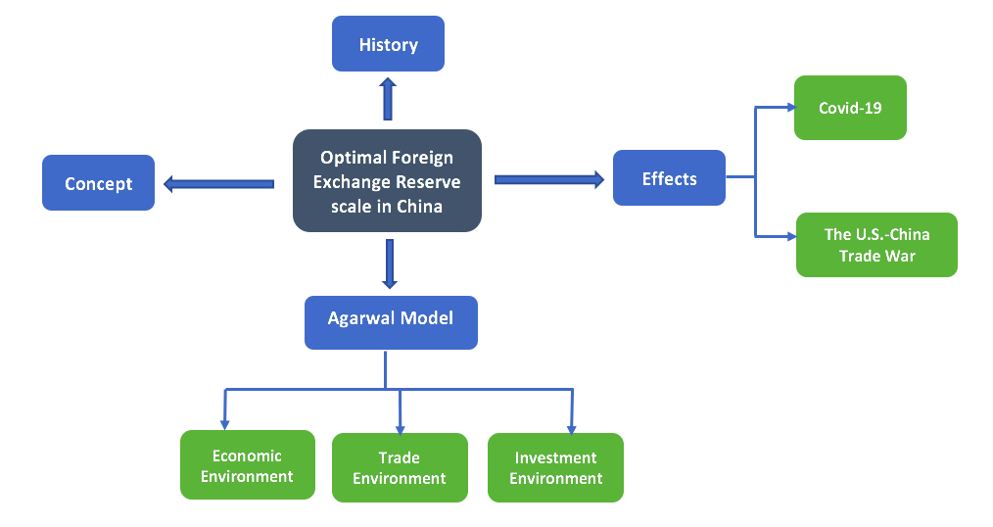
Figure 2: Conceptual Framework by author

The overall research emphasizes the optimal scale of foreign exchange reserves in China, it mainly carries out from four perspectives. The firs element is to understand the concept of foreign exchange reserves through researches of scholars at both domestic and foreign, and the second element is to analyse its history in China, insight the development motivation through the characteristics of different phases. The third element outlines the impacts of the pandemic and the trade war on Chinese economy. The last element is to adopt the most suitable method for Chinese economy to evaluate the scale of the current foreign exchange reserves by considering external factors, which is also one of the research objectives of this paper. All of these elements are interrelated. Cheng and Zhu (2020) insist that countries' demands on foreign exchange reserves is actually the strength of its willingness to hold foreign currency, and the optimal size depends on people's motivation to obtain foreign exchange.

Therefore, the researcher can study the demand for foreign exchange reserve scale in accordance with Keynes's theory of money demand. This theory is established in 1936, which describes three motivations of holding money, namely the transaction motive, the precautionary motive and the speculative motive. Keynes analyses various motivations in detail by holding money, meanwhile, his analysis on the income of people holding money is more accurate and efficiency (Minsky, 1985). Although the main subject of money demand theory is people, the author’s research is focused on a country, this theory still can apply to the analysis of the foreign exchange reserve scale. Essentially, a country's foreign exchange reserves can cover its trade payment needs with other countries. It is like people need to pay foreign currency when they shop overseas. This motive is called the transaction motive. It is the basic needs. But this motivate is not just think about willingness to transact. Brunner and Meltzer (1967) have restated and emphasize the importance of interest rate. Besides that, a country needs to prepare enough foreign exchange reserves to pay foreign investments, just like personal saving deposits, they can be used to store funds to anticipate future projects or face unexpected opportunities. Hence, it is related to both speculative and precautionary motive (Tymoigne, 2003). According to the research results of many scholars and the special situation of China, the evaluation of foreign exchange reserve scale should involve transaction reserves, debt-related reserves, preventive reserves. In order to make the literature more suitable to China’s situation, the researcher choses the modified Agarwal model for improvement and verification when discussing the method of foreign exchange reserve scale. The researcher will emphasize the impacts of those additional variables on the model. In terms of Covid-19, the impacts on exports, gross domestic product, and foreign direct investment are particularly prominent. From the U.S.-China trade war perspective, the focus should on the changes of tariffs, foreign exchange rates.

Conclusion
Through the above literature reviews, it is obvious that the foreign exchange reserve scale is still a challenging topic. Although this area has been heated discussion in many countries, it is still in a progressive stage in academia. Generally, researches in foreign countries are relatively mature. They have proposed a lot of different methods to obtain more reliable results. In China, researches on the foreign exchange reserve scale are mostly with the reference on the foreign methods. And due to the limitation of financial information disclosure requirements, there are fewer relevant studies. As the details of foreign exchange reserves remain a state financial secret, the exact proportion of the allocation has not been made public. This gap becomes the difficulty that researchers face when calculating the scale of foreign exchange reserves. Therefore, researchers choose models that are more in line with China's national conditions through analysing of different methods. They find Agarwal model is the most suitable one. Cheng and Zhu (2020) also state that the Agarwal model is indeed applicable to developing countries. Hence, this paper discusses the Agarwal model, one of the costs & benefit methods, to further study and more comprehensively understand the other key factors affecting the optimal foreign exchange reserve scale.

By comparing with existing researches, the main contribution of this paper is, on the one hand to modify the Agarwal model in terms of economic situation in China, take the influence of the pandemic as well as the U.S-China trade war into account when forecasting the optimal China’s foreign exchange reserve scale. On the other hand, all collected data of the past twenty years can be used to better explain the current condition of foreign exchange reserve scale and strengthen the research on its optimal scale from the empirical side. The results explain changes in foreign exchange reserve scale are related to relevant variables. Then, the Chinese government able to make conducive decisions to maintain the foreign exchange reserves in optimal scale on account of the current global economic situation and domestic development trends.

Methodology and Research Design

Overview
A comprehensive introduction of the research method will be presented in this chapter. It provides the clear guidance for the researcher to carry out her own works and introduces readers with detailed explanations of the main approach, concepts and possible issues involved in conducting the research. Therefore, this chapter lays the foundation for the further works and also offers more reliable and valuable outcomes as well. Due to the importance of this chapter, which is the significant tie for the subsequent researches, the researcher will explicit elaborate on the philosophical influences, the overall methodology, research strategy, data collection, analysis techniques and ethical issues of this research.

Research Philosophy and Overall Approach
According to Saunders and Lewis (2012), all knowledge creation is supported by the research philosophy. It refers to the philosophical standpoint of a person or a research. on the deep level, it is about assumption and beliefs on the development of knowledge. Through understanding the characteristics of this research topic, scientific perspectives play vital role in the whole process of the research, especially in the data collection and analysis, so the philosophy of positivism is the best description to be used in the paper. The researcher tends to study the economic phenomenon and the facts behind it by using the scientific approaches. This intention is consistent with the proposition of positivism, it proposes that knowledge is gleaned from facts and provides the basis for laws to us (Bryman and Bell, 2007). The main work of the research is to further improve and verify the existing model by studying the data of the past twenty years, so as to obtain the foreign exchange reserve scale in optimal range for China, which also one of main objectives of this research. Therefore, in order to achieve this goal, some known influencing variables in China's current economic environment need to be reconsidered. For example, gross domestic product, foreign direct investment, etc., then combined with other new factors to evaluate the current foreign exchange reserve scale is reasonable or not in China.

The perspective of a positivist mainly focuses on the research of measurable variables. Due to these variables exist objectively, they are not subject to personal bias or interpretation, and all relevant data are collected based on the actual situation in the market of China. This requires the researcher to maintain neutral attitude in the process of obtaining data, and to separate herself from information that is only beneficial to the research, so as to avoid influencing the findings of the research. In essence, this is still an exploratory study and the result of this research is not influence by the individual thoughts. Apart from this, the researcher attempts to improve the previously modified Agarwal model to evaluate that the foreign exchange reserve scale can be more suitable for the current condition of China and its development trend. The researcher can generate the hypothesis and test it. If the equilibrium relationship between these variables and their coefficients changes slightly caused by the pandemic and the trade war, then the causal relationship between them need to be reassessed and the reasons for the changes should be clarified. As Saunders et al. (2019) say that, a positivist can develop their hypotheses by testing and verifying existing theories for further researches.

While embarking on the research, the most important step is absolutely to find the best method that can achieve the research objectives maximally. A deductive approach is clearly the best choice. Because it first lays the theoretical foundation for this research which is generated from literature reviews, and tests the development theory through designing the research strategy. And when performing a deductive approach, a theory is a stepping stone that provides an explanation for the relationship between economic variables and underlying concepts. For testing the proposition, the research appropriately adopts quantitative research methods, through the collection of quantitative data of foreign exchange reserves and its corresponding elements to carry out a systematic investigation.

Research Strategy and Data Collection
Research strategy is aligned with research philosophy and is used as an action plan to achieve the research objective. Denzin and Lincoln (2018) indicate that it is the connection between research philosophy and methodology adopted in collecting data. As previously mentioned, the researcher outlines her research philosophy, and the quantitative approach with statistical analysis is picked up as the research design. Because the ongoing research is based on theoretical tests and a lot of numerical weighting, the researchers strongly believe that it is probably the most appropriated approach to adopt. Therefore, experimental strategy with longitudinal studies will be explored in this research. Because the researcher is required to investigate the long-term impacts of major economic variables on the foreign exchange reserve scale in China, and then drawing the conclusion on its optimal ranges.

All these quantifiable data for past twenty years needs to be collected in order to estimate the fluctuation of variables as the world economy evolves rapidly, which includes the exact amount of foreign exchange reserves, total volumes of foreign exchange transactions, external debts, gross domestic product, etc. This quantitative secondary data is collected through government statistical publications and web official notices, such as China Statistical Yearbook and so on. The main objective of this research, as stated before, to attempts to use appropriate methods to access the current foreign exchange reserves in China. Therefore, any changes of the same variable in different time periods need to be accounted for in this research, for example, the increase or decrease of the amount of foreign exchange transactions on a monthly and annual basis, etc. If necessary, the researcher may need to transform some of data from quarterly amounts to annual amounts, unify the data values in different units. And the U.S dollar, as the most common purchase currency, it has a broad and significant influences on the global economy and financial system, meanwhile, it accounts for about 70 percent in China’s foreign exchange reserves. So, it is required to convert some data in local currency to U.S dollar. In consequence, secondary data definitely is a best choice to facilitate the research, and it provides convenient conditions for the research as well. The researcher will collect and analyse data of China over twenty years from 2000 to 2020. Typically, the researcher able to benefit from this kind of secondary resources because the time horizon is limited and the geographical location is given. Due to not participate directly in the data collection, the researcher can obtain more sufficient time and money to continue her own research. What is more, the quality of the secondary data can be relied upon. Because most of these data are collected from authoritative organization in China, for instance, the data of foreign exchange reserves is gathered from National Bureau of Statistic of China, and the statistics on the total amount of foreign exchange transactions can be obtained from the State Administration of Foreign Exchange. These national departments provide more reliable and credible resources for the research.

Approach to Data Analysis
In relation to data analysis technique, the researcher uses correlation and different regression analysis to determine the equation, calculate the coefficient and assess the possible interrelationship of the numerical data variables. That is to say, correlation analysis is applied to confirm the relationship, regression analysis is used to identify whether changes in multiple independent variables cause changes in one dependent variable. Moreover, in order to satisfy the required number for the analysis, regression analysis can also be used to make predictions. It will help the researcher to get a simple and effective approach for data analysis, especially in the economic problem in practice. In this research, a number of independent variables, which, when taken together with their corresponding coefficients, produce a result, called a dependent variable. Gross domestic product, the volume of foreign exchange transaction, foreign direct investment, long-term debts, short-term debts are all main independent variables, the optimal foreign exchange reserve scale is the dependent variable. Through this data analysis, it proves the changes of coefficients under current situation of China and this is the findings that the researcher wants to obtain.

In addition, in order to be able to preserve the best scientific data, this research will use coding to record all information and data collected. All data used for quantitative analysis should be recorded by predetermined codes. It helps to represent the variables which have identified in the theoretical framework and improve the quality of data analysis. Due to the consistency and other advantages of coding, it can cover most areas of the research content and provide useful and valuable references for future researches by supporting sources of data from different aspects. The core objective of this technique is to classify the all collected data effectively. For example, the researcher would like to use the time and specific items as the coding unit, to analysis the trend of foreign exchange reserve scale development in China, the incremental of fixed assets investment in different years, etc.

Access and Research Ethic Issues
Generally, gaining the type of access and anticipating ethics issues are quite crucial parts in the process of the successful research. Gaining access is a prerequisite for obtaining high quality research data. It affects the appropriateness of data source, as well as is closely related to the research question, research objectives and design. Before starting the research, the researcher should insight into data which are required and how to collect it. This is extremely important for this research, because the researcher aims to discover the appropriate range for foreign exchange reserve scale whether is suitable for the current situation in China. It requires a lot data collected and needs the support from the internet-mediated access. This type of access is easier to gain secondary data via the website, like the online publications, government news, etc. It is worth to mentioned that when gaining access to data, the researcher is always requested to pay attention to ethics issues.

The concern of ethical arises at each stage of research. It may emerge when planning the research, gaining assess and analysing data, as well reporting data. Ethics is considered as a behaviour standard that can guide the research. It plays an important role in the whole research. Normally, ethical issues are required to be predicted and pondered over at the earlier phases of the research. This starts when the researcher selecting her research topic. Different research topics are link with different potential ethical issues. For example, the research topic of this paper is about the foreign exchange reserve scale in China, the researcher needs to be objective when formulating the research question and building the research objective. In the process of the research, the researcher needs to maintain professional level, rely on her own abilities to focus on the demonstration of the modified model. Access to secondary data is also associated with ethical issues. As Bishop and Kuula-Luumi (2017) mentioned in their work that researchers pay more attention on the ethical issues when utilizing secondary data. The researcher is required to keep confidential when access some important information or data. And at the stage of analysis, the researcher needs to think about whether her statistical data is accuracy, sufficient and misunderstanding. At the end of research, the researcher has held herself accountable to high standards of behaviours, careful evaluation of the findings and provide useful suggestions. The answers listed in the report will remain anonymous unless otherwise requested. Meanwhile, the researcher will investigate her behaviours based on GCD ethical checklist as well.

In the whole research process, the researcher encountered problem in the coefficient determination part of the regression equation. It took long time to collect and calculate data, as well as justify the results of findings. Under the pressure of data submission, the findings may also be influenced by other variables. At the same time, personal bias should be paid attention to in the research ethical issues. Because it will directly affect the research outcome, especially in the confirmation of the research question, so the researcher needs to be very careful to keep vigilant and be aware of her own bias. Improving the transparency of data collected may be a good way to prevent this issue.

Conclusion
The researcher puts forward a philosophical standpoint which is suitable for this research from an ontological perspective, outlines the most common research strategy, and makes a detailed investigation of quantitative research methods. In relation to the research contents and research questions, this paper explains the rationality to readers, and describes the data analysis techniques in detail. In terms of research access and ethics issues, substantive questions are raised and linked to the background of the investigation. Therefore, an academic background for the presentation of the research results in the next chapter is provided by the above interpretation. It helps to ensure that discussions of findings are truthful and valid.

Presentation and Analysis of Data

Overview
To revisit the research question, which is to investigate, in the context of the pandemic and the escalating trade war, the optimality of current scale of foreign exchange reserves and its related economic variables in China. There is an overview of quantitative data generated from descriptive statistical analysis, and overall interpretation of these as it relates to hypotheses of the research in this chapter. At the beginning, the researcher proposes her hypotheses based on the research question. Through reviewing of the previous method of foreign exchange reserve scale, an improved equation on the basis of current Chinese situation will be presented. The analysis of relevant variables will be involved in this chapter as well.

Hypotheses
All hypotheses are proposed in the context of the pandemic and the U.S-China trade war:
- There is a closely relationship between external debts and the foreign exchange reserve scale.
- The reform of foreign exchange system affects the foreign exchange reserve scale.
- There is a linear relationship between imported primary products and the foreign exchange reserve scale.
- There is the possibility of changes in foreign exchange reserves caused by tariff changes and trade war.

The Improvement of the Agarwal Model
As stated in chapter two, the cost & benefit approach has undergone improvement constantly since it was first proposed in the 1960s. Many scholars have assessed the appropriate foreign exchange reserves scale from the views of different economic variables. Among them, the model proposed by Agarwal (1971) is a creative extension in academia. Because it considers the nature of different countries, in particular, distinguishes the demands for the optimal foreign exchange reserve scale between developed countries and developing countries. It discusses relationships between payment deficits, capital, imports and foreign exchange reserves. This is a historic reform that gives developing countries an advantage in obtaining the appropriated foreign exchange reserve scale. Although Chinese has not published as many researches as foreign countries to the public on the foreign exchange reserve scale, Cheng and Zhu (2020) modify the calculation method of the optimal scale which is suitable for the situation in China from 1990 to 2016 based on the original Agarwal model. There the modified model is:

R = [W × (lgK + lgQ2 – lg Q1) / lgP] + aD +bFDI + cT + dGDP

In the above equation, R represents the optimal foreign exchange reserve scale, W indicates trade payment deficits, K is the proportion of GDP in the fixed assets investments, Q1 and Q2 present the proportion of imported primary products to newly incremental fixed asset investments and to GDP respectively. P is the probability that payment deficit occurred in a given period. In fact, the factors in the square brackets are the original elements in the Agarwal model, but Cheng and Zhu redefine them and take other variables into consideration in the context of China.

The rest of the model shows other variables related to foreign exchange reserves. D represents the amount of external debts, which is the total amount of long-term debts and short-term debts. During the calculation, it divides into Ds and DL. Since Cheng and Zhu believe that the average repayment term for long-term debt is eight years, so a is equal to one eighth, which is 12.5 percent. FDI is short for foreign direct investment, b is annual rate of return on foreign direct investment, which is adjusted in the range of 10 percent to 15 percent to adapt to China’s national condition. T represents the total amount of foreign exchange transactions, ang its coefficient c is from 8 to 18 percent according to international experiences. About the coefficient of Gross Domestic Product (GDP), Zheng and Zhu assume 1 to 4 percent is the suitable range for China. The optimal range of foreign exchange reserve scale in China can be found after getting these figures. The modified model equations are showed as below:

Rmin = W × (lgK + lgQ2 – lg Q1) / lgP + Ds +12.5% DL+10%FDI + 8%T + 1%GDP
Rmax = W × (lgK + lgQ2 – lg Q1) / lgP + Ds +12.5% DL+15%FDI + 18%T + 4%GDP

By using this modified model, Cheng and Zhu calculate the minimum and maximum amount of foreign exchange reserves in China. In the purpose of comparing with the author's research findings properly, Figure 3 only shows the actual value of foreign exchange reserves from 2000 to 2016 and its corresponding optimal range. It can clearly see that from 2000 to 2014, China's foreign exchange reserves are excess, except for 2001. And it is in the optimal scale from 2015 to 2016.

Figure 3: Optimal Range and Actual Value in China. Source: Cheng and Zhu (2020)

According to the extension of Keynes's theory of money demand, the determination of a country's foreign exchange reserve scale can be evaluated on the basis of demands for foreign currency in their domestic market. It has to admit that the improved method has made a certain improvement and contribution to the research and application of the Agarwal model, but there are still some deficiencies for China's economy. The modified model, though, take the need for external debt reserves and precautionary reserves into account, and does not focus only on the balance of payment deficits. It ignores today’s hottest topics, and fails to consider the impact of the pandemic and the trade war. Franziska and Naotaka (2021) claim this Covid-19 pandemic leads to enormous disruptions to global economies could exacerbate the expected slowdown in potential growth over the next decade. The author also agrees, these affects are not short-term and may therefore alter the demand for the foreign exchange reserve scale. Moreover, some coefficients of the modified model are the average range of the estimate obtained in the international environment, without specific adjustment according to the local situation, which is not in line with the reality of the situation in China. Beyond that, the rapid increase in the holdings of long-term external debts over the past years, the continued decline in the imported primary products, and the sharp decrease in the growth of gross domestic product because of the pandemic, all these changes of factors are important to intervene the demand of foreign exchange reserve scale. And under the precautionary motive, China should also consider using a portion of its foreign exchange reserves to guard against currency fluctuations caused by the ongoing trade war. When taking all these factors into consideration in the current economy condition of China, the modified model can be improved as follows:

Rmin = W × (lgK + lgQ2 – lg Q1) / lgP + Ds +14% DL+10%FDI + 8%T + 1%GDP
Rmax = W × (lgK + lgQ2 – lg Q1) / lgP + Ds +14% DL+14%FDI + 16%T + 3%GDP

The Variable Considered
At present, the Covid-19 pandemic is spreading across the world, the global economy is facing a severe recession and the international market is in turmoil. At the same time, China must deal with the consequences of its trade war with the United States. When the Chinese government intends to take some measures to keep its optimal foreign exchange reserve scale, it has to review some identified variables that affect foreign exchange reserves and re-evaluate its determination of coefficients. In general, these variables are from the economic, trade and investment perspectives. Hence, the researcher selects some important variables and conducts a quantitative analysis of them.

This research expands the original statistical data from 2000 – 2016 in the previous literature to 2000 – 2020. By analysing the data of twenty years, the researcher needs to find out how many times the trade payment deficit happened and what is the largest amount of them, so that she can get the value of W and P. Theoretically speaking, the foreign exchange reserve scale is directly affected by trade surplus or trade deficit. For a country, when its amount of exports is greater than the imports, it is called the trade surplus, while trade deficit is vice versa. Therefore, the changes of imports and exports volume have great impacts on the foreign exchange reserve scale. Generally, it is proportion to exports and inversely proportion to imports. In the same circumstance, the larger the exports, the greater demand of the foreign exchange reserve scale, conversely when imports become larger, the demand of the foreign exchange reserve scale would be smaller. Despite this sudden slowdown in world economic growth caused by the pandemic, the foreign trade in China has remained stable on the whole. In 2020, China's imports and exports trade perform well (Huang, 2020). The total amount reaches 4.65 trillion US dollars, with the growth of 1.9 percent compared to the last year (see Figure 4). Moreover, Hancock (2021) believes that China's exports volume has not been affected by the trade war with the United States, but has been improved from the diversity of exported goods, technological sophistication and the export volume. Over the past 240 months, the trade deficit occurred a total of 15 times, the largest of which occurred in February 2012, with a deficit of 31.73 billion U.S dollar. Thus, W = 31.73, P = 15/240 in the improved equation.

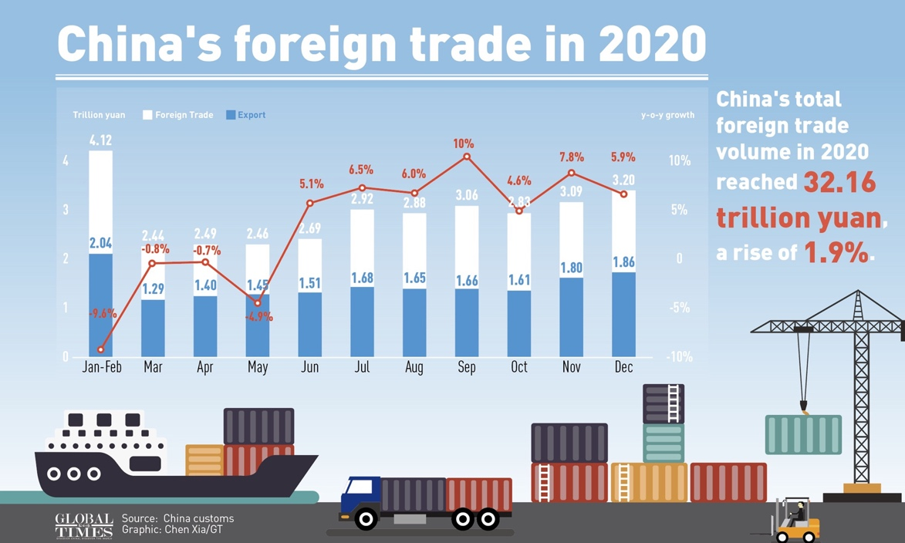
Figure 4: China's Foreign Trade in 2020. Source: Globaltimes.cn. (2021)

According to the Keynes's money demand theory, the external debt is also one of variables which affects the foreign exchange reserve scale. If a country has large external debts, the demand on foreign exchange reserves will increase. This is called precautionary motive. Countries need to prepare enough foreign exchange reserves to pay their debts on time, and adjust it regarding to the amount of their debts, to prevent the credit crisis if they cannot pay their debts on time. At the same time, the researcher needs to focus on the long-term and short-term debts, because different types of external debts have different repayment requirement. In accordance with recent researches in some developing countries (Silk membrane et al., 2017) and Chinese market (Jiao et al., 2019), the repayment maturity of long-term debts is 7.3 years and 7 years respectively, so the researcher assumes that the average maturity of long-term debts for China is 7 years. Hence, D is equal to Ds plus 14 percent DL.

In 2020, the global foreign direct investment decreases 40 percent compared with 2019 refer to the forecast from United Nations Conference on Trade and Development (2020), mainly due to impacts of the pandemic and the global economic recession on the willingness and ability of cross-border enterprises to invest. But Ventura (2021) points that, China’s foreign direct investment inflows continue to increase, it wins for the first time the title of largest recipient globally when other countries are struggling to contain the Covid-19. Since the government has made significant progress in coordinating pandemic prevention and controls, the economy in China has gradually recovered and companies’ profits have improved in the last four to five months of 2020, China is anticipated to attract foreign investment and capital inflows in further years. Refer to International Monetary Funds (1999), it reports that the annual rate of return of FDI in developing countries is around 14 percent. In China’s current condition, the changes of foreign direct investment shake the holding of foreign exchange reserves, so in purpose of making more accurately reflect the range of changes, b can be measured in the range of 10 to 14 percent.

In fact, the total amount of foreign exchange transaction T is related to the foreign exchange reserve scale, which is essentially related to different values of different currencies. Up till now, the U.S dollar remains one of the most important currencies in global foreign exchange reserves, accounting for 61 percent in total. Apart from that, other common currencies, for instance, pound sterling, euro and Japanese yen are also held in proportion by different countries. There are some emerging foreign exchange reserve currencies at the same time, such as Australian dollar, Canadian dollar and so on. As stated in the previous chapter, foreign exchange reserves composition in China are still dominated by U.S dollar. As the State Administration of Foreign Exchange (SAFE) said, Chinese composition structure of foreign exchange reserves recently is about 65 percent in U.S dollar, 26 percent in euro, 5 percent in pound sterling, the remainder in Japanese Yen, which is basically consistent with the international situation. According to MercoPress (2019), the ongoing trade war has affected the value of the currency to some extent, with the US slapping tariffs on Chinese exports and China imposing tariffs on American-made products. This reflects an evolutionary factor at work for changes in the value of currencies and helps to drive foreign exchange trading activity around the world, not just only Chinese Yuan and the US dollar, but for other currencies as well. Although the cumulative trading in the China’s foreign exchange market declines by 13.7 percent in the first half of 2020 and market trading significantly contracted, it gradually picked up as the economy resumed work. The overall effect is not significant. The value of c is slightly changed from 8 to 16 percent.

More importantly, it is necessary to consider the changes in the foreign exchange reserve scale affected by Gross Domestic Product (GDP). If GDP of a country continues to grow, it means that the economic situation of this country is good, people's living standard is high, and disposable incomes of residents are increased. When this condition happens, the demand of foreign exchange for individuals will be increased as well. Based on Keynes' monetary demand theory, it is under transaction motivation, and people will be very eager to hold foreign currencies for their transaction, such as traveling abroad, shopping online or studying abroad. Refer to the statistic from National Immigration Administration, the number of Chinese tourists travelling abroad increases steady as expected in 2019, but the growth rate is obviously slow down. Because of the spread of the pandemic, Chinese outbound tourism has basically stagnated in 2020, total overseas consumption spending by Chinese tourists has also been affected. People's willingness to spend has fallen sharply, leading to less demand for foreign currencies, which has also caused a contraction in foreign exchange transactions. Therefore, GDP indicator can be used as a key factor to calculate the foreign exchange reserve scale. The revised model is improved properly, d is reduced to 1 percent to 3 percent to fit the actual situation. Thus, the researcher can recalculate the optimal scale of foreign exchange reserves in China.

Hypotheses Testing
The improved equation shows the relationship between all relevant factors and the scale of foreign exchange reserves. Although it enables the author to use as evidences to support the above hypotheses, it is still necessary to conduct univariate analysis.

H1: There is a closely relationship between external debts and the foreign exchange reserve scale.
Correlation analysis in JASP is used to test this hypothesis, it can be used to determine whether, and how strongly or closely correlation exists between pairs of variables, especially for quantitative data analysis. The most common measure of linear dependence is Pearson’s correlation coefficient, commonly denoted by “r” (Ly and Wagenmakers, 2018). And it is actually a standardized measure of the covariance, thus its result ranges from -1 to 1. Theoretically, the relationship between two variables depends on whether the “r” is closed to +1 or -1. If closer “r” is, the more closely is related, but if “r” is close to zero, it stands for that two variables are independent. Generally speaking, this influence assessment is decided according to different thresholds, which means the result of the value of ‘r”. If “r” is smaller than 0.1, the effect is tiny, from 0.1 to 0.3, it represents a small effect. When the value of “r” is bigger than 0.3, but smaller than 0.5, people says the effect is moderate. The presence of a large effect when r is greater than 0.5.

It is important to note that the value of “p” as well. It is used to distinguish whether the significant correlation exists in variables, usually by comparing the value of “p” with the level of significance, α. In general, α equals to 0.05 works well. This means that there is a 5 percent risk of concluding that a correlation exists when it does not. The researcher needs to find the significant difference between the correlation coefficient and zero, if the coefficient is zero, it indicates a linear relationship. To sum up, when p is less than α, the correlation is significant, and vice versa. The correlation analysis result in Figure 5 is showed as below.

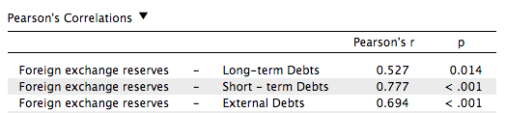
Figure 5: The Result of Pearson's Correlation Analysis by Author

H2: The reform of foreign exchange system affects the foreign exchange reserve scale.
As is known to all, a country usually adopts an effective foreign exchange system to monitor its foreign exchange flows. Chinese foreign exchange system has undergone several changes as the development of foreign trade market. Among them, the reform in 1994 is a further improvement of the past system and the most representative reform. Guo and Han (2004) point out that the foreign exchange system in China has been upgraded to a new level since 1994. For the purpose of testing whether changes of foreign exchange system influence the foreign exchange reserve scale, the author introduced Chow test to conduct structure change regression analysis for this hypothesis. Chow test (1960) is published by the economist Gregory Chow, is usually used as a way to determine whether structures have changed at a given point in time. The distinction of this test is the recorded time series data can be separated into two sections, the breakeven point is same as testing time point to check whether any structural changes has taken place. In this hypothesis, Year 1994 is treated as the breakeven point. There is no significant variance before and after the breakpoint in the equation of the two sub-samples tested by the null hypothesis, and the alternative hypothesis is that there are significant differences. The “P” value obtained by observing the “f” value of the regression result, if it is smaller than 10 percent, negate the original hypothesis, then accept the alternative hypothesis. It is straightforward to obtain the result of Chow test (Lee, 2008). The researcher uses STATA to analyse the data from 1990 to 2020 and the outcomes as below.

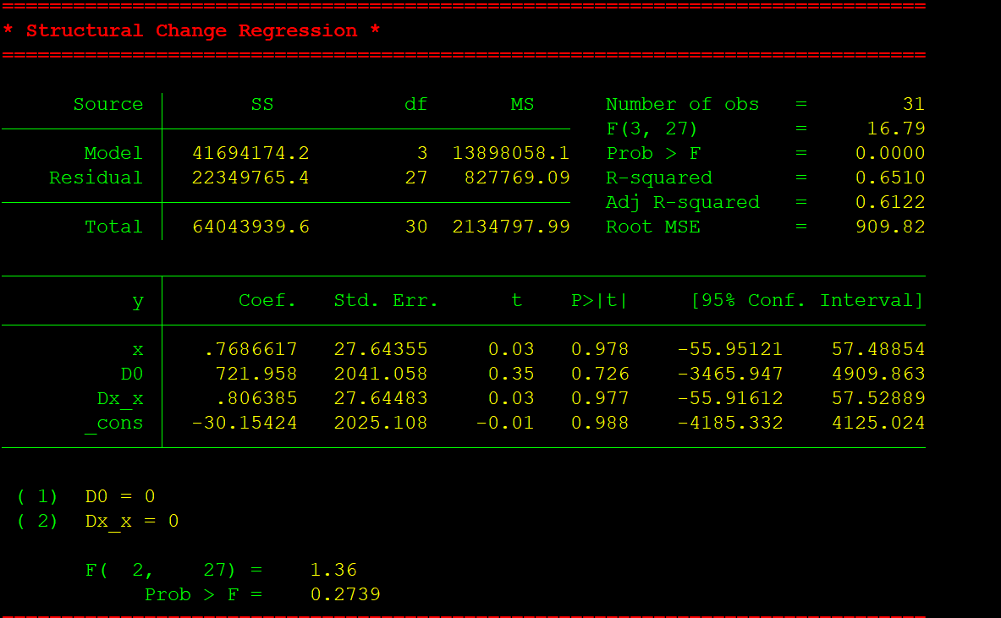
Figure 6: The Result of Chow Test by Author

H3: There is a linear relationship between imported primary products and the foreign exchange reserve scale.
Linear regression is a very effective method to study influence relation that is very common in practical researches. Basically, it studies the influence and relation between a dependent variable y and one or more independent variables x. They are all quantitative data. If there is only one independent variable, it called a unary linear regression, which is known as a simple linear regression as well. This phenomenon is first observed by Francis Galton. In order to test this hypothesis, the author decides to adopts linear regression analysis in JASP. The test outputs (Figure 7) and Q-Q scatter plot (Figure 8) show in the following:

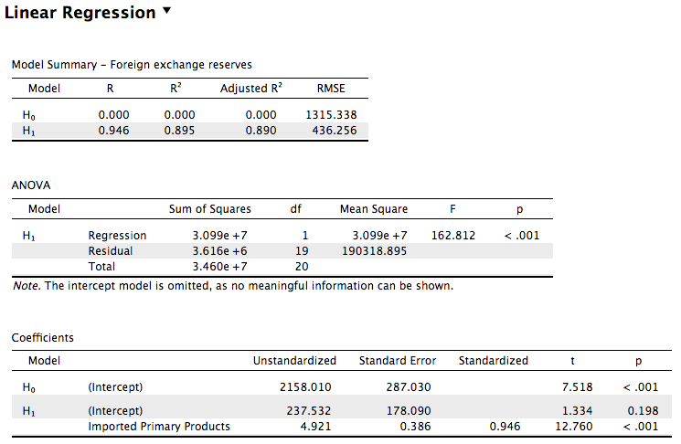
Figure 7: The Result of Linear Regression Analysis by Author

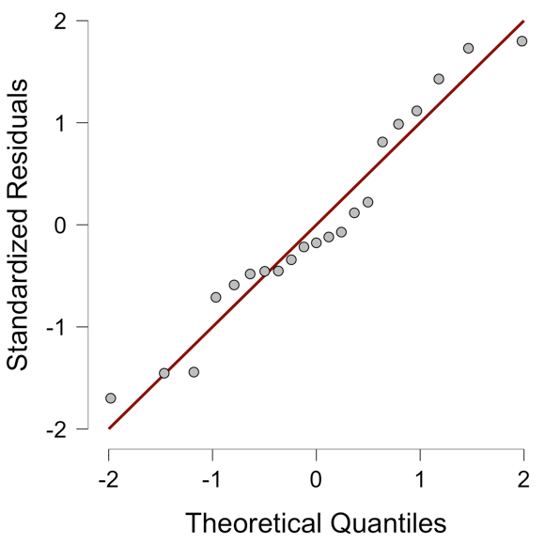
Figure 8: The Q-Q Scatter Plot by Author

H4: There is the possibility of changes in foreign exchange reserves caused by tariff changes and trade war.
A tariff is defined as a tax levied by one country on goods and services imported to another countries. Today, with the trade war between China and the U.S. becoming increasingly intensified, the government's increased intervention in imports and exports could lead to tariffs fluctuations, which would influence the foreign exchange reserve scale as well. For exploring the hypothesis, all relevant data are collected from the official start of the trade war to the signing of the first phase consensus. The author believes that logistic regression analysis is the appropriated method to test this hypothesis. Like other regression analysis methods, a predictive analysis is also conducted in the logistic regression, uses descriptive data to explain the study situation, and classifies the outcome variables. The biggest advantage of this method is that continuous explanatory variables can be used, and it enables researchers to process over two explanatory variables at the same time (Sperandei, 2014). This test results in Figure 9 show as below and the relationship can be visualized through the following scatter plots (Figure 10).

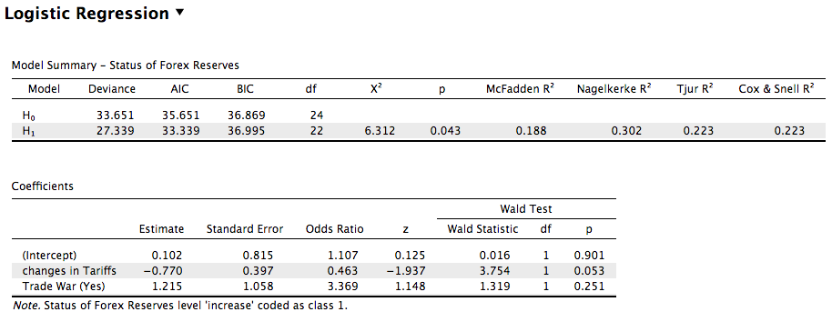
Figure 9: The Result of Logistic Regression Analysis by Author

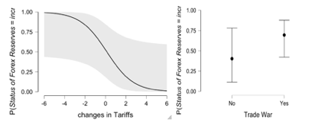
Figure 10: The Relationship between Foreign Exchange Reserves and Tariffs, Trade War by Author

Discussion of Research
This chapter will discuss the quantitative findings of the statistical analysis and test hypotheses of the research whether true or false. The assessment of the foreign exchange reserve scale in China is involved for more systematic discussion on collected data and the potential outcomes of the research question.

Discussion of Hypotheses
Firstly, through the comparison of “r” value, hypothesis 1 finds that the relationship between external debts and foreign exchange reserve scale is existed, because “r” is 0.694, which is greater than 0.5, so the relationship between these two variables is close. The researcher also discovers this relationship exists for all debts, no matter long-term, short-term or the total amount of them. However, by understanding the value of “p”, the correlation between short-term debts and foreign exchange reserve scale is stronger or more significant, while long-term debts are relatively weak. By the end of 2020, China’s total external debts are around 2400.8 billion U.S dollar, in which short-term debts are 1316.4 billion U.S dollar, account for 55 percent in total. Broadly speaking, the relation of the foreign exchange reserve scale to external debts is closely, especially with short-term debts. This finding is in line with the result of the investigation by Fukuda and Kon (2012) across Asian countries, including China, in which they explore the evidence about external debts, the increases of foreign exchange reserves influence the total external debt balance. Misztal (2021) conducts a further detailed research on the composition of external debts, and also find that the factors determine the foreign exchange reserve scale are the changes of short-term debts level. Therefore, Hypothesis 1 is acceptable.

Secondly, Hypothesis 2 assumes the structure breakeven point in the test is Year 1994. According to the result of Chow test, “P” is equal to 27.39 percent, which is greater than 10 percent, it proved that the null hypothesis is valid. That is to say, there is no significant difference in variance before and after the breakeven point, so the emergence of the transformation in the foreign exchange system in 1994 does not influence the foreign exchange reserve scale. Conversely, the scale of foreign exchange reserve may accelerate the development of foreign exchange system. As Wang and Lin (2020) originally suggest, the unexpected accumulation of foreign exchange reserves has complicated foreign exchange policy. Hence, Hypothesis 2 is rejected.

Thirdly, Hypothesis 3 gives the intuitive finding that the correlation between imported primary products and the foreign exchange reserve scale is quite high, which the “R” value is 0.946. The square of “R” indicates that imported primary products accounts for 89.5 percent of the variance in the foreign exchange reserve scale. The regression sum of square and the regression mean square are always identical for the simple linear regression model in the Analysis of Variance table (ANOVA table), it interprets the F-statistic is significant, which the value of “p” is lower than 0.001, and there is a large effect size. The coefficient table tells the coefficients under unstandardized that can be put into the linear equitation. The equitation is y = c + b * x. Which, y represents the estimated scale of foreign exchange reserves, c indicates the constant which is from the value of intercept in model 1, b is the regression coefficient, x is the amount of imported primary products. In that, the equitation is y=237.53 + 4.921x. Through understanding the JASP manual by Goss-Sampson (2019), the Q-Q scatter plot demonstrates that the standardized residuals fit well with the diagonal, it suggests that the hypothesis does not against the linearity and originally expectation. That is to say, foreign exchange reserves increase along with imported primary products. It somewhat resonates with the research by Li and Tian (2016) whom asserted that imports have the positive influences on the scale foreign exchange reserves. Thus, the relationship that acknowledged in Hypothesis 3 is accepted.

Finally, the test of Hypothesis 4 verifies the possibility of relationships between variables. The null hypothesis tested is the relationship between the foreign exchange reserve scale and tariff increases that occur as a result of a trade war is not existed. However, H1 has the lowest Akaike Information Criteria (AIC) score and relatively low Bayesian Information Criteria (BIC) score, which are showed in the model summary, indicating the results are significant related to the predictive variables. Actually, in the coefficients table, changes in tariffs and the occurrence of the U.S-China trade war are both significant variables, which their values of “p” are 0.053 and 0.251 respectively. Another crucial value is the odds ratio, if it is greater than 1 indicates a positive relationship. So, the results show that the occurrence of the trade war is related to the increase of the possibility of changes in the foreign exchange reserve scale, and the adjustment of tariffs is associated with the decrease of the possibility of changes in the foreign exchange reserve scale. Normally, the interpretation of odds ratio 0.463 tells that the possibility of changes in foreign exchange reserve scale is 46.3 percent because of tariff changes. The scatter plots also indicate, the trade war makes it more likely that the foreign exchange reserve scale will change. On the contrary, the tariff adjustment reduces the probability of changes in the foreign exchange reserve scale. Therefore, Hypothesis 4 is accepted.

Discussion of Findings
Based on the improved equation, the determination of coefficients of variables shows in Figure 11. And the optimal range of foreign exchange reserve scale and actual amount of it displays in Figure 12.

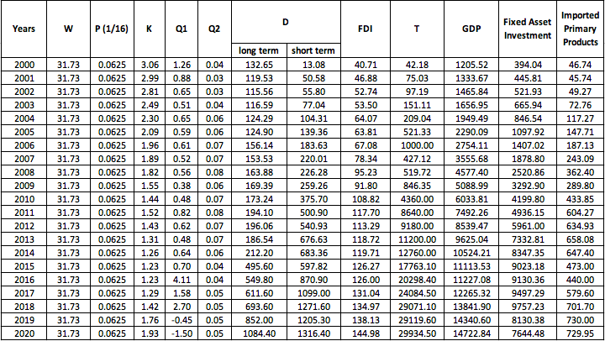
Figure 11: The Determination of Coefficients for Variables by Author

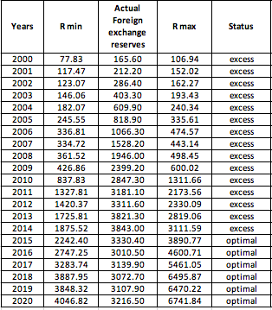
Figure 12: Optimal Range and Actual Value of Foreign Exchange Reserves by Author

Figure 13 can show the optimal range of foreign exchange reserve scale more intuitive, which is easier to tell whether it is in optimal in a year.

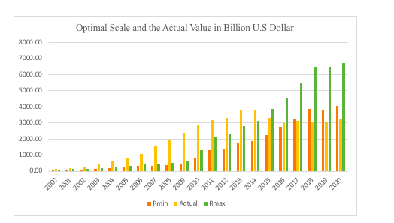
Figure 13: Optimal Range and Actual Value from 2000 to 2020 by Author

From Figure 12 and Figure 13 can be easily seen that foreign exchange reserves are excess in 2000 to 2014 and it is in the optimal scale from 2015 to 2020. The difference with the previous modified equation is the foreign exchange reserve scale in 2001, which excesses to the maximum amount as per current calculation. This is because the improved equation makes the calculation more accurate. And in order to achieve the objective of research, the author also estimates the current condition of the foreign exchange reserves scale in China, which is around 3235.9 billion U.S. dollar at the end of July 2021. Since this research analysis is based on the annual data, so even compares to the optimal range in last year, the condition is still within the optimal range up to now. Despite the expected growth of foreign exchange reserves has been adjusted due to the pandemic and the U.S-China trade war, it is still manageable on the whole. The Chinese government needs to maintain this advantage, so that foreign exchange reserves keep playing a vital role in its economic development.

Conclusion and Recommendations

Overview
The last chapter expounds the research findings of the optimality of Chinese foreign exchange reserve scale and some related variables. The implication of these findings is described in terms of research objectives and the research question. Research contributions and limitations are also covered. Moreover, the purpose of the final chapter is to recommend areas for improvement in practice and to provide suggestions for future researches.

Implications of Findings for the Research
Having said all of above, the foreign exchange reserve scale is experiencing a process from excess to optimal status in China. Regarding to the improved Agarwal model, foreign exchange reserves have been stable within the optimal range since 2015. As discussed earlier in the conclusion, the quantitative data analysis demonstrates that the foreign exchange reserve scale remains at this level even under the dual impacts from perspectives of the pandemic and the U.S-China trade war. The correlation analysis, regression analysis and Chow test show that:
- The external debts, especially long-term debts have less significant relation with the foreign exchange reserve scale.
- A foreign exchange reform in 1994 is not the turning point for changes of foreign exchange reserves.
- Imports of primary products have co-integration with the foreign exchange reserve scale in China.
- Tariff changes and the trade war affect changes in the foreign exchange reserve scale, this area has not been tested and mentioned in the previously researches and literatures.

Contributions and Limitations of the Research
This paper fully analyses the optimal scale of foreign exchange reserves in China in terms of the initial objective of the research. However, it is not only one contribution of the research. This research also improved a modified method from Agarwal model. In terms of the principle of money demand proposed by Keynes, the author has successfully combined current affairs with foreign exchange reserve researches, and considers various economy variables, so as to obtain a conclusion more suitable for the current economic environment. Therefore, this research looks at a series of related concepts in a way that, although currently lacking in peer review experience, or a more systematic study of the literature, it is a new development in the field.

The limitation of this research is that the research data on foreign exchange reserves are still in national financial secrets to some extent, so there are certain difficulties in the accuracy, extensiveness and obtaining years of data. This paper only analyses the date of twenty years. If more data can be collected, the research results will be more reliable and persuasive. In addition, these are not the only factors affecting the scale of foreign exchange reserves. This paper is merely analysing several common variables. Another limitation of this study is the lack of similar empirical literatures. There are many missing links to be filled in, but if there are, it would be interesting to compare this approach with similar methods used in different countries and with global consistency.

Recommendations for Practice
As a symbol of a country’s economic and financial strength, foreign exchange reserves are the material basis for making up its international balance of payment deficit, resisting financial turbulence, stabilizing the national exchange rate and maintain national credibility (Du, Lin and Han, 2018). Therefore, to keep China’s economy healthy, stable and sustainable development, the government need to strengthen the management and operation mechanism construction of foreign exchange reserves in China, especially in the pandemic outbreak of normalized and the trade war under continuous escalation, from the safety, optimality and effectiveness perspectives, find a more scientific and reasonable new way for managing and operating foreign exchange reserves. Hence, the following recommendations can be used for references.

- Determining an appropriate foreign exchange reserve scale
This is one of objectives of the research that has been repeated many times and is therefore a top priority. In estimating China's foreign exchange reserve scale, intervention capacities of governments need to be considered comprehensively. First, from the perspective of imports size, the conventional wisdom seems that a satisfied foreign exchange reserve scale in a country can cover the imports demand of three months. However, this standard is based on the low international trade level and the implementation of the fixed exchange rate system, while China should be measured regarding to its own exchange rate system and imports demand under the impacts of the pandemic and the U.S-China trade war. Secondly, in extreme circumstances, the government should consider using foreign exchange reserves to adjust the exchange rate level in the foreign exchange market to make sure the steadiness of China's exchange rate’s level. It can protect RMB from the significant influence of the trade war. Finally, the government should be considered that China is a developing country, in which more foreign exchange reserves are needed to buy high-tech products and goods from overseas. Meanwhile, the internationalization of RMB has not be completed, so it required to keep enough foreign exchange reserves.

- Increasing investments and the rate of return on foreign exchange reserves
The Belt and Road Initiative was proposed by President Xi in 2013, which encourages and supports Chinese enterprises and institutions to make rational overseas investments. According to statistics, Chinese enterprises' direct investments to those countries along the Belt and Road has exceeded 90 billion U.S dollar, and the average annual increment rate of 5.2 percent during 2013 to 2018. This annual growth rate increases to 18.3 percent at the end of 2020. The government can use large holdings of foreign exchange reserves for strategic industrial investment, which can not only realize the strategic management of foreign exchange reserves in China, but also help improve national competitiveness. In the process of investments, China adheres to the investment principle of safety, liquidity and profitability in the foreign exchange management. It is worth mentioning that, although these three criteria are met to some content in the investment process of U.S dollar, the investment yield is not high. Therefore, China may need to optimize the investment structure and broaden other types of investments. China Investment Corporation is the best choice, which can be relied on and to be responsible for diversifying investment, as well as pay attention to risk management. This is what people often say, while increasing the yield rate, a good risk monitoring system is also needed to established.

- Diversifying foreign exchange reserves
For now, foreign exchange reserves are likely to change with the fluctuation of the U.S dollar exchange rate in China, which lacks autonomy. Although it cannot deny the fact that the importance and convenience of U.S dollar in international settlement, China's foreign exchange reserves will welcome rising challenges as well when face with the economic recession, financial crisis and other threats. Therefore, it is essential to optimize the proportion structure, adjust the U.S dollar proportion of foreign exchange reserves, moderately promote the proportion of other currencies, and realize the diversification in foreign exchange reserves in China. The international importance of euro is growth gradually and some eurozone central banks, such as Germany and France, have included the RMB in their foreign exchange reserves since 2018. So, the government should realize how important to improve the percentage of euro in foreign exchange reserves of China. Deepening cooperation with relevant countries in the context of the Belt and Road Initiative can also lead to a corresponding increase in currency reserves in that country. In addition, the value of gold is relatively stable, normally it is the preferred hedge tool. Gold reserves are also financial assets, which play special roles in stabilizing national economy, suppressing inflation and improving international credit. China's gold reserves are relatively low compared to other countries. As of July 2020, gold reserves in China ranked seventh in the world, accounting for only 3.7% of the foreign exchange reserves. Therefore, China can adjust its gold reserves, but due to its own limitations in liquidity, the appropriate scale of it should be considered.

In the researcher's view, these recommendations can help control the foreign exchange reserve scale at an optimal level. To be sure, there are also other ways to improve the foreign exchange reserve scale. Therefore, new approaches need to be further explored.

Suggestion for Future Research
This research just uses the improved Agarwal model to analyse the optimality of the foreign exchange reserve scale for a specific country, further validation of other countries and different methods is needed as well. The future research direction of the foreign exchange reserve scale in China is to predict its development trend and the impact of international market changes on it, and also to explore why people are not suitable to hold the remaining foreign exchange reserves.

References
Bishop, L. and Kuula-Luumi, A. (2017) ‘Revisiting Qualitative Data Reuse: A Decade On’. SAGE Open, 7(1), pp.1-15.

Bryman, A. and Bell, E. (2007) Business Research Method. 2nd ed. Oxford University Press.

CGTN, 2021. China’s Forex Reserves Fall in June. Beijing: CGTN. Available at: https://news.cgtn.com/news/2021-07-07/China-s-forex-reserves-fall-in-June-11HIBk1v9u0/index.html (Accessed: 14 July 2021).

Chow, G.C. (1960) ‘Tests of Equality Between Sets of Coefficients in Two Linear Regressions’. Econometrica, 28(3), pp. 591–605.

Cortina, J.J., Didier, T. and Schmukler, S.L. (2017) ‘Corporate Debt Maturity in Developing Countries: Sources of Long- and Short-Termism’. World Bank Group, p. 47.

David, L. and Lauter, J.K. (2018) Trump’s China Tariffs Get Bipartisan Support, Reflecting Widespread U.S. Disillusionment with Beijing. Los Angeles Times. [online]. Available at: https://www.latimes.com/politics/la-na-pol-trump-china-tariffs-20180322-story.html (Accessed: 14 August 2021).

Denzin, N.K. and Lincoln, Y.S. (2018) The Sage Handbook of Qualitative Research. fifth edition. Los Angeles, Sage.

Du, S., Lin, X. and Han, X. (2018) ‘Advantages and Disadvantages of Continued Growth in Foreign Exchange Reserves’. Financial Statistical Journal, 1(1).

Fang, Y. and Lu, L. (2011) Does a Correlation Exist between the Foreign Exchange Reserves and the Exchange Rate? An Empirical Study of China. [online] Available at: https://www.semanticscholar.org/paper/Does-a-correlation-exist-between-the-foreign-and-%3A-Fang-Lu/41a2f8c4de893e57a2d6509ef5e55937f64d46c9 (Accessed: 10 August 2021).

Franziska, O. and Naotaka, S. (2021) What Has Been the Impact of the Pandemic on Long-Term Growth Prospects? [online]. Available at: https://blogs.worldbank.org/opendata/what-has-been-impact-pandemic-long-term-growth-prospects (Accessed: 7 August 2021).

Fukuda, S. and Kon, Y. (2012) ‘Macroeconomic Impacts of Foreign Exchange Reserve Accumulation: Theory and International Evidence’. Monetary and Currency Policy Management in Asia, p. 144.

Globaltimes.cn. (2021) Chinese Exports Rise 3.6% in Coronavirus-Plagued 2020; Only Economy with Positive Trade Growth - Global Times. [online]. Available at: https://www.globaltimes.cn/page/202101/1212770.shtml (Accessed: 8 August 2021).

Guo Jinlong and Han Shengjun (2004) ‘Reforms of China’s Foreign Exchange Regime and RMB Exchange-Rate Behaviour’. Chinese Economy, 37(2), pp. 76–101.

Goss-Sampson, M. (2019) Statistical Analysis in JASP - A Students Guide, JASP v 0.14.

Hancock, T. (2021) ‘China Is Exporting More Sophisticated Products Despite Trade War’. Bloomberg.Com, pp. 1–1.

Horn, S., Reinhart, C. and Trebesch, C. (2019) ‘China’s Overseas Lending.’ Cambridge, MA: National Bureau of Economic Research.

Huang, F. (2020) ‘CHINA: Winning Exports Market Share Despite The COVID-19 Crisis’. Euler Hermes, p. 7.

IMF (1999), Foreign Direct Investment in Developing Countries. Finance and Development [online]. Available at: https://www.imf.org/external/pubs/ft/fandd/1999/03/mallampa.htm (Accessed: 2 August 2021).

IMF (2001), Guideline for Foreign Exchange Reserves Management [online]. Available at: https://www.imf.org/external/np/mae/ferm/eng/index.htm (Assessed: 17 July 2021)

IMF (2020), World Economic Outlook, April 2020: The Great Lockdown [online]. Available at: https://www.imf.org/en/Publications/WEO/Issues/2020/04/14/weo-april-2020 (Accessed: 19 July 2021).
Kashif, M., Tonk, U.K. and Ruhi, S. (2019) ‘Impact of Economic Growth and Trade Openness on Foreign Exchange Reserves in Indian Economy’. Optimization: Journal of Research in Management, 11(2), pp. 46–54.

Lee, H. (2008) ‘Using the Chow Test to Analyze Regression Discontinuities’. Tutorials in Quantitative Methods for Psychology, 4.

Ly, A., Marsman, M. and Wagenmakers, E. (2018) ‘Analytic Posteriors for Pearson’s Correlation Coefficient’. Statistica Neerlandica, 72(1), pp. 4–13.

MercoPress (2019), How Has the US-China Trade War Affected Forex? [online]. Available at: https://en.mercopress.com/2019/10/22/how-has-the-us-china-trade-war-affected-forex (Accessed: 8 August 2021).

Misztal, P. (2021) ‘The Size and the Main Determinants of China’s Official Currency Reserves in the Period 1990-2019’. European Research Studies Journal, XXIV (1), pp. 568–582.

NBS (2020), Preliminary Accounting Results of GDP for the Second Quarter and the First Half Year of 2020 [online]. Available at: http://www.stats.gov.cn/english/PressRelease/202007/t20200717_1776596.html (Accessed: 19 July 2021).

Saunders, M. and Lewis, P. (2012) Doing Research in Business and Management: An Essential Guide to Planning Your Project. Financial Times Prentice Hall.

Saunders, M. et al. (2019) ‘“Research Methods for Business Students” Chapter 4: Understanding Research Philosophy and Approaches to Theory Development’. In pp. 128–171.

Sperandei, S. (2014) ‘Understanding Logistic Regression Analysis’. Biochemia Medica, 24(1), pp. 12–18.

Statista (2020), China: Foreign Exchange Reserves 2020. Statista.com [online]. Available at: https://www.statista.com/statistics/278206/foreign-exchange-reserves-of-china/ (Accessed: 19 July 2021).
UNCTAD (2020), Global Foreign Direct Investment Projected to Plunge 40% in 2020 [online]. Available at: https://unctad.org/news/global-foreign-direct-investment-projected-plunge-40-2020 (Accessed: 2 August 2021).

Ventura, L. (2021) ‘China Takes the FDI Title’. Global Finance, 35(3), pp. 8–8.

Wang, G. and Lin, N. (2020) ‘70 Years of China’s Foreign Exchange Market Development: History and Experience’. China Political Economy, 3(1), pp. 3–17.

Zhou, G., Yan, X. and Luo, S. (2018) ‘Financial Security and Optimal Scale of Foreign Exchange Reserve in China’. Sustainability, 10, p. 1724.

Bibliography
Agarwal, J.P. (1971) ‘Optimal Monetary Reserves for Developing Countries’. Weltwirtschaftliches Archiv, 107, pp. 76–91.

Arize, A.C. and Osang, T. (2007) ‘Foreign Exchange Reserves and Import Demand: Evidence from Latin America’. World Economy, 30(9), pp. 1477–1489.

Belkin, V. and Storozhenko, V. (2008) ‘The Rational Use of Russia’s Foreign Exchange Reserves’. Problems of Economic Transition, 50(9), pp. 54–65.

Ben-Bassat, A. and Gottlieb, D. (1992) ‘On the Effect of Opportunity Cost on International Reserve Holdings’. The Review of Economics and Statistics, 74(2), pp. 329–332.

Brammer, S., Branicki, L. and Linnenluecke, M.K. (2020) ‘COVID-19, Socialization, and the Future of Business in Society’. Academy of Management Perspectives, .34(4), pp. 493–507.

Brunner, K. and Meltzer, A.H. (1967) ‘Economies of Scale in Cash Balances Reconsidered’. Quarterly Journal of Economics, 81(3), pp. 422–436.

Calvo, G.A. (1996) ‘Capital Flows and Macroeconomic Management: Tequila Lessons’. International Journal of Finance & Economics, 1(3), pp. 207–223.

Chang, W.W. (2020) ‘Inner Workings of the Chinese Economy and the US–China Trade War’. Review of Pacific Basin Financial Markets & Policies, 23(2), pp. 38-42.

Cheng, T. and Liu, X. (2013) ‘Foreign Exchange Reserves: A New Challenge to China’. Journal of Post Keynesian Economics, 35(4), pp. 621–650.

Cheng, T. and Zhu, J. (2020) ‘An Empirical Analysis about Optimal Scale of China’s Foreign Exchange Reserves’. Journal of Service Science and Management, 13(02), pp. 357–376.

Cifarelli, G. and Paladino, G. (2009) ‘The Buffer Stock Model Redux? An Analysis of the Dynamics of Foreign Reserve Accumulation’. Open Economies Review, 20, pp. 525–543.

Claassen, E.-M. (1975) ‘Demand for International Reserves and the Optimum Mix and Speed of Adjustment Policies’. The American Economic Review, 65(3), pp. 446–453.

Das, A. and Chowdhury, M. (2019) ‘Macroeconomic Impacts of Remittances in Bangladesh: The Role of Reverse Flows’. Economic Notes, 48(3).

Flanders, M.J. (1971) ‘The Demand for International Reserves’. p. 68.

Frenkel, J.A. (1974) ‘The Demand for International Reserves by Developed and Less-Developed Countries’. Economica, 41(161), pp. 14–24.

Frenkel, J.A. and Jovanovic, B. (1981) ‘Optimal International Reserves: A Stochastic Framework’. The Economic Journal, 91(362), pp. 507–514.

Fu, Y., Alleyne, A. and Mu, Y. (2021) ‘Does Lockdown Bring Shutdown? Impact of the COVID-19 Pandemic on Foreign Direct Investment’. Emerging Markets Finance & Trade, 57(10), pp. 2792–2811.

Hamada, K. and Ueda, K. (1977) ‘Random Walks and the Theory of the Optimal International Reserves’. The Economic Journal, 87(348), pp. 722–742.
Heller, H.R. (1966) ‘Optimal International Reserves’. Economic Journal, 76(302), pp. 296–311.

Jeanne, O. and Rancière, R. (2011) ‘The Optimal Level of International Reserves for Emerging Market Countries: A New Formula and Some Applications’. The Economic Journal, 121(555), pp. 905–930.

Jung, C. (1995) ‘Optimal Management of International Reserves’. Journal of Macroeconomics, 17(4), pp. 601–621.

Kashif, M., Tonk, U.K. and Ruhi, S. (2019) ‘Impact of Economic Growth and Trade Openness on Foreign Exchange Reserves in Indian Economy’. Optimization: Journal of Research in Management, 11(2), pp. 46–54.

Kreinin, M.E. and Heller, H.R. (1973) ‘Adjustment Costs, Optimal Currency Areas, and International Reserves’. In Sellekaerts, W. (ed.) International Trade and Finance: Essays in Honour of Jan Tinbergen. London: Palgrave Macmillan UK, pp. 127–140.

Krasny, R. (2021) ‘China Overtook U.S. in Foreign Direct Investment, UN Agency Says’. Bloomberg.Com, p. N.PAG-N.PAG.

Lester, S. and Huan Zhu (2020) ‘The U.S.-China Trade War: Is There an End in Sight?’ CATO Journal, 40(1), pp. 15–25.

Li, X. and Tian, T. (2016) ‘A New Cost-Profit Model for Measuring the Optimal Scale of China’s Foreign Exchange Reserve’. Mathematical Problems in Engineering, 2016, p.2

Liu, K. (2020) ‘China’s Policy Response to the China US Trade War: An Initial Assessment’. Chinese Economy, 53(2), pp. 158–176.

Iyoha, M.A. (1976) ‘Demand for International Reserves in Less Developed Countries: A Distributed Lag Specification’. Review of Economics & Statistics, 58(3), p. 351.

Minsky, H.P. (1985) ‘The Legacy of Keynes’. Journal of Economic Education, 16(1), pp. 5–15.
Moore, W. and Glean, A. (2016) ‘Foreign Exchange Reserve Adequacy and Exogenous Shocks’. Applied Economics, 48(6), pp. 490–501.

Nie, L. (2017) ‘Macroeconomic Impacts of China’s Foreign Exchange Reserve Accumulation: A Vector Autoregression Analysis Using Pure-Sign-Restriction Approach’. Applied Economics, 49(11), pp. 1055–1070.

Phan, D.H.B. and Narayan, P.K. (2020) ‘Country Responses and the Reaction of the Stock Market to COVID-19—a Preliminary Exposition’. Emerging Markets Finance & Trade, 56(10), pp. 2138–2150.
Shi, K. and Nie, L. (2017) ‘Did China Effectively Manage Its Foreign Exchange Reserves? Revisiting the Currency Composition Change’. Emerging Markets Finance & Trade, 53(6), pp. 1352–1373.

Triffin, R. (1947) ‘International Versus Domestic Money’. American Economic Review, 37(2), p. 322.

Tymoigne, É. (2003) ‘Keynes and Commons on Money’. Journal of Economic Issues (Association for Evolutionary Economics), 37(3), pp. 527–545.

Zhao, Y. et al. (2021) ‘Implications of COVID-19 Pandemic on China’s Exports’. Emerging Markets Finance and Trade, 57(6), pp. 1716–1726.

Zinecker, M. et al. (2021) ‘The Covid-19 Disease and Policy Response to Mitigate the Economic Impact in the Eu’. Technological & Economic Development of Economy, 27(3), pp. 742–762.

APPENDICES

APPENDIX A – HYPOTHESIS 1 DATABASE

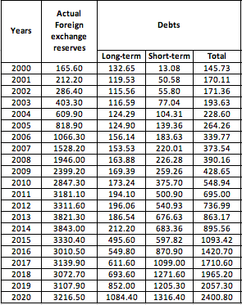

APPENDIX B – HYPOTHESIS 3 DATABASE

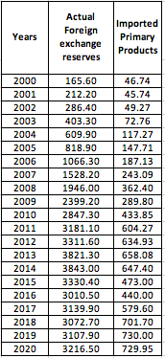

APPENDIX C – HYPOTHESIS 4 DATABASE

