Academic Dissertation

How did the gentrification change the
English Premier League?

By
Maximilian Szostak
3126706

A thesis submitted in partial fulfilment of the requirements for MA in Journalism & Media Communications (QQI)

Faculty of Journalism & Media Communications
Griffith College Dublin

August 2024

Declaration

I hereby certify that this material, which I now submit for assessment on the programme of study leading to the award of the MA in Journalism & Media Communications, is my own; based on my personal study and/or research, and that I have acknowledged all material and sources used in its preparation. I also certify that I have not copied in part or whole or otherwise plagiarised the work of anyone else, including other students.

Signed: 

Dated: 11th June 2024

Abstract

English football has changed a lot since the creation of the Premier League, and this is linked to a far-reaching gentrification process. This dissertation examines how this process has influenced the English Premier League (EPL), particularly in relation to changes in the social background of fans.

The dissertation analyses various possible factors of gentrification, such as the development of ticket prices and spectator numbers, as well as media coverage and fan perception. The aim is to determine which factors have the greatest impact on gentrification and how they have changed football in the long term. To do this, the method of qualitative content analysis according to the German educationalist Udo Kuckartz was applied.

The results show that the various factors of gentrification have led to a noticeable change in the social background of the spectators. In this context, reporting plays just as important a role as the analysis of indicators such as increased ticket prices or average attendance figures since the founding of the Premier League. This in turn provides information about possible future developments in the Premier League and raises important questions about the sustainability of modern football.

Table of Contents

Abstract 3

Acknowledgements 6

Chapter One: Introduction 7
1.1 Overview 7
1.2 Ethical Considerations 9

Chapter Two: Literature Review 10
2.1 Overview 10
2.2 Hooliganism in England 11
2.3 Hate and Racism in the Premier League 14
2.4 Hillsborough and the Taylor Report 17
2.5 Ownership of Premier League Clubs 19
2.6 TV-Deals in the Premier League 22
2.7 Migration and Foreign Players in the Premier League 23
2.8 Critical Assessment of the Literature 25
2.9 How my Dissertation defers from previous Studies 26
2.10 The Research Question 28

Chapter Three: Methodology 29
3.1 Overview 29
3.2 The Qualitative Content Analysis 29
3.3 Planning Stage 30
3.4 Development Stage 32
3.5 Test Stage 38
3.6 Coding Stage 40

Chapter Four: Analysis 42
4.1 Overview 42
4.2 Case Studies 44
4.3 Conclusion of the Case Studies 51
4.4 Diversified Content Analysis 55
4.5 Analysing the Anomalies 58

Chapter Five: Conclusion and Findings 66

Chapter Six: Bibliography 72
6.1 Sources used in the Dissertation 72
6.2 Articles analysed in the introductory Content Analysis 85
6.3 Articles analysed in the Case Studies 88
6.4 Articles analysed in the diversified Content Analysis 94

Chapter Seven: Appendices 99

Acknowledgements

First of all, I would like to express my most sincere thanks to my supervisor Ryan Brennan, who was always there to help me with any questions or uncertainties and provided valuable and constructive feedback. In our personal conversations, I not only felt like I was sitting opposite a competent contact person, but also a person who shared my passion for football.

I would also like to thank the Faculty of Journalism and Media Communications and our programme director Barry Finnegan. During my time at Griffith College, I immediately felt welcome and was able to develop personally.

I would also like to take this opportunity to once again express my special thanks to my fellow students, who made my time in Ireland even more enjoyable. The sense of togetherness during and outside of our courses made it much easier for me to get started. A special thanks goes to my flatmate Carl, who fascinated me every day with his cooking and with whom I found a new friend.

Finally, I would like to take this opportunity to thank my family, friends and everyone close to me for their support during my time in Ireland. A special thanks goes to my parents, who made this study possible for me, and to my girlfriend Lambrini, for daring to take the step abroad together. Even though the last few months were very stressful, we pushed each other to achieve even more in order to overcome this task together.

Of course, I would also like to thank everyone who has not been mentioned by name but who has nevertheless accompanied me on this journey. I would also like to express my sincerest thanks and appreciation to you for putting up with me.

Chapter One – Introduction

1.1 Overview

“The romance of English football is fantastic,
but it has lost its identity under the influence of other cultures.”

As the great Dutch footballer Johann Cruyff captured in his critical tribute to English football, football is an important part of English culture. The English Premier League in particular has a huge influence on this, not only is it one of the most popular football leagues in the world, it is also a significant cultural and economic factor for the country and its inhabitants. But even such a traditional construct as the Premier League has undergone change over time. In the 2022/23 season alone, clubs were able to increase their revenue by 11% to an all-time high of £6.1 billion (Deloitte, 2024). This has been particularly noticeable in recent decades with various changes on and off the pitch. It is not only the league that is evolving, but also the cities in which the teams are based, many of which have undergone an intensive gentrification process as a result of structural change in England. These social and economic changes therefore not only have an influence on the urban environment, but possibly also on the composition of spectators in Premier League stadiums.

While gentrification and its impact on cities and their culture has been extensively documented, the question of how far this process can be applied to the demographics of football fans remains largely unanswered. Is the rising cost of living driving the most loyal fans out of the stadiums and what impact is this having on the social backgrounds of the crowd? Questions like these are crucial to establish a link between social and cultural developments and Premier League spectatorship.

The aim of this thesis is to analyse the possible effects of gentrification on the composition of spectatorship in the English Premier League, with the change in the social background of spectators playing a central role. The main research question is "How did the gentrification change the English Premier League?" To find an answer to this question, the following research questions will be important:
- How have the demographics of Premier League spectators changed over the last few decades?
- Can we identify specific events that have had a major impact on this change?
- How has gentrification affected football culture and related social structures?

The current state of research about gentrification research is quite strong; there are a large number of publications that deal with the social changes in cities and population groups. A broad spectrum of analyses and opinions from a wide range of authors can be found, for example, in Sociological Review, one of the largest journals focusing on sociological research.

Some authors are of the opinion that gentrification is primarily displacing low-income population groups from certain neighbourhoods due to the constantly rising cost of housing and living and is therefore having an impact on the social composition of cities (Paccoud, 2016). Others, however, see no need for displacement through gentrification, as structural change in cities offers new opportunities for housing construction. In London, for example, a large proportion of new residential units are built in old warehouses or office properties and thus reused (Hamnet and Whitelegg, 2007). However, the changing working-class culture also has an influence on the gentrification of cities, with Butler and Hamnett (2009) arguing that the professional classes in England represent an ever-increasing proportion of the population and are thus replacing the working class over time rather than displacing it. Hamnett (2003) also argues that some neighbourhoods inhabited by the working class could gentrify into neighbourhoods inhabited by the professional class.

In terms of the gentrification of Premier League spectatorship, it is important to look at this sociological research as it could be directly related to the change in spectatorship within stadiums. For example, authors in the International Review for the Sociology of Sport report on the various factors of stadium gentrification. The dwindling local identification of fans with their clubs is often cited as an argument (Smith, 2018). For example, fans from the lower and middle classes in particular were able to identify with their clubs through the local connection (Critcher et al., 1973; Taylor, 1971). It can therefore be assumed that the increasing popularity of the European top tier football leagues is attracting new groups of football fans and thus also other identification factors and attitudes (Weber et al., 2021).
Therefore, it can be summarised that the current state of research in the football context is also quite pronounced, but much of the existing research is based on sociological theories. In my dissertation, I try to take a more football and culture-focused approach in order to provide new insights in connection with gentrification and the associated change in the social background of spectators.

To approach the set research questions, two essential elements will serve as methodology. A quantitative analysis of existing publications such as articles or journals, but also books, will be used to examine key indicators of changes in Premier League spectatorship, as well as to identify any changes in the social background of spectators due to sociological or cultural influences. In addition, existing studies and surveys of fans of different Premier League clubs will be analysed according to the research questions in order to identify the social and cultural dynamics as well as the identification factors of Premier League fans. The various approaches make it possible to carry out a comprehensive analysis of gentrification and to analyse and interpret the data and impressions gained in a subsequent evaluation.

This dissertation aims to contribute to the understanding of social and cultural changes within the English Premier League spectatorship in the context of gentrification. It also aims to provide new knowledge about the relationship between the structural changes of cities and regions and the changing demographics of football spectatorship.

1.2 Ethical Considerations

I had already considered possible ethical challenges and limitations in the run-up to this dissertation. However, since I did not conduct any surveys or interviews of my own as part of this work, the relevance of these aspects is limited. Nevertheless, it was ensured that all sources and data used were treated responsibly and in accordance with scientific integrity and in compliance with the National Union of Journalists Code of Conduct.

Chapter Two – Literature Review

2.1 Overview

Football is with 240 million players after Basketball (450 million people) more popular than almost any other sport, which is why there exists an extensive range of publications about it (United Nations, 2024; Library of the Congress, 2024). Due to its commercial success in many regions of the world there is also wide range of articles, books and studies about the EPL. The focus of this chapter is to examine the existing literature on the social background of the spectators in the English Premier League and to approach my research question based on existing studies and surveys, as well as articles and book publications.

In doing so, this chapter will be structured as follows; To narrow my research question, it requires the consideration of several different factors that may be related to gentrification and the changing social background of spectators at EPL matches; therefore, this chapter will examine each relevant factor as a block in chronological order. Events further in the past are dealt with first as this provides an in-depth introduction to the topic and some of the subsequent aspects may build on those previously mentioned. The first step is therefore a categorisation based on existing publications, the second step is the evaluation of existing data, studies and surveys, before a conclusion is drawn on the respective aspect in a third and final step.

The literature review aims to provide a clear understanding of the changing spectatorship in the Premier League and the reasons behind it. The in-depth research and analysis of various sources will also create the basis for further elaboration/examination/analysis of the topic and highlight potential challenges. Based on the results, it is possible to identify gaps in the existing literature and which opinions or views prevail, which in turn enables a targeted approach within the topic and a closing of these gaps.

In order to analyse the relevant literature in as much detail as possible, it is therefore necessary to look at various subject areas, including relevant topics that have had a lasting impact on the history of the Premier League, such as the hooliganism of the 1980s and 90s, but also disasters and catastrophes such as Hillsborough. By analysing existing literature on these topics, it is possible to draw valuable conclusions with regard to changes in spectatorship.

In addition to the historically relevant events, the current situation of the Premier League must also be integrated into the analysis. The increasingly controversial changes in ownership and ownership structures of Premier League clubs since the 2000s play a particularly important role here, but financial and marketing-orientated aspects of recent Premier League history such as the first TV contracts or the entry of Rupert Murdoch and the pay-tv model must also be considered.

The events listed so far offer both sociological and economic aspects, so that an overall picture can be developed based on the various approaches, which in turn can serve for the further work of this dissertation.

2.2 Hooliganism in England

Hooliganism has been an integral part of English football since the 1880s. At that time, gangs of supporters met to intimidate local neighbourhoods. After Preston North End beat Aston Villa 5:0 in a friendly match in 1885, both teams were pelted with stones and sticks and players were beaten on the pitch. Just a year later, Preston North End fans clashed again, this time with Queens Park Rangers fans at a railway station. Since then, the hooligan scene has been present both on and off the pitch in the English leagues. However, the hooligan scene reached its inglorious peak in the 1980s, when the problem was so severe that loyal supporters of various clubs walked away from the stadium for fear of becoming victims of violence themselves (Ingle, 2006).

In the media, hooliganism therefore usually receives a negative reception, with Martha Newson (2017) describing hooliganism as a problem resulting from the masculinity of football and the excessive consumption of alcohol on match days, and the term "the English disease" is also used. Martyn and Taylor (1997) see the origin of the hooligan scene in the stadiums, they would provide a space for creating cohesion and solidarity through violence. These views are shared by Maffesoli (1996), for whom the cohesion between potentially aggressive fan groups is the reason for riots against competing parties. Even though football in England had its origins in the upper middle class, according to Newson (2017). Soon the sport was played and watched by a major part of the working class. Working class people were increasingly associated with the hooligan scene, and others still do today.

But as football has evolved, the hooligan scene has also changed. Whereas violence was usually planned in advance in the heyday of hooliganism, fan violence nowadays usually takes place spontaneously (Doidge and Lieser, 2017; King, 2002; Stott et al., 2007). This spontaneity poses new challenges for the police and clubs, as fights could occur at any match, regardless of whether a game has previously been labelled a high-risk match or not. Often, hostile fan groups mingle with spectators at neutral matches in order to abuse the fans of another club for their violence. According to Ayres and Treadwell (2012), the abuse of drugs such as cocaine or amphetamines plays a major role in disputes, as consumption further lowers the inhibition thresholds for violence. The great popularity of alcohol on gamedays in the 1980s also encouraged violent excesses within the stadiums. This problem was partly solved as the government banned alcohol in the stands and stadium areas with views of the pitch as well as in buses and trains taking supporters to games (Tuohy, 1985).

However, the consumption of drugs cannot be generalised. Some of the most commonly consumed drugs even have a calming effect on the human body. For example, author Ben Jones (2023) reports a decrease in violent offences in football after the start of the rave scene in the late 1980s and early 1990s. In his book entitled Casual culture and football hooligan autobiographies, he analysed the autobiographies of several former hooligans and came to the conclusion that the increased consumption of Ecstasy by people from the hooligan milieu led to a movement away from the violent scene. Many hooligans, especially from Manchester, Liverpool, but also from Blackburn and London, attended techno raves on Friday nights instead of the usual Saturday morning clash with rival fans. In the scene, the Ecstasy or MDMA (methylenedioxymethamphetamine) pills were therefore also known as "happy pills". Jones (2013) goes on to explain that although some younger fans, the so-called "Under Fives", took the place of the departing hooligans after the ecstasy hype, but the scene in England no longer had the same appeal as before, with some rival fan clubs celebrating peacefully together for the first time after years of enmity in the so-called "Summer of Love" in 1991.

The violence referred to in the media as football hooliganism is primarily based on three academic explanations that attempt to explain the causes of hooliganism. The first is the Marxist approach of Ian Taylor (1971), who theorises how economic and social change towards the end of the 1960s led to the alienation of young working-class men from football as clubs sought to attract a more affluent following to pay the increased salaries of players. According to Taylor (1971), this led to resistance from some fans who clashed with rival fans and the police as they felt their club had lost touch with the working class. The second approach comes from Peter Marsh (1978) of Oxford University, who analysed the ritual and performance of violence among Oxford United fans. He found that there was a hierarchy within the hooligan groups. A collective sense of territoriality developed within the group and there was an exchange of tasks within the group, which involved more or less violence depending on the individual. The third approach was developed by the Leicester School, using Norbert Elias' approach to crowd behaviour, and found that social and economic inequalities increased in the 1960s, making life more difficult for working-class people. According to the researchers, the resulting culture was characterised above all by uncivilised and bad behaviour (Dunning et al. 1998). Football matches during this period were therefore used as a place to protest the authorities; instead of organising a peaceful protest, the working class used violence against rival fans and the stewards to make their point publicly.

It is striking here that in two of the three theories the working class is mentioned as a decisive group for violence in football, which could be a first indication of a possible beginning of gentrification in football. However, due to the different approaches taken by the theories, it is not possible to determine when this began. Nevertheless, the theories offer well-founded arguments for the emergence and disengagement of those involved in hooliganism, and they attempt to explain the social background on the basis of the historical context. Therefore, the theories should be taken into further consideration for further work on gentrification.

2.3 Hate and Racism in the English Premier League

Hooligan culture has existed in England for over 140 years now, but since then not only has the scene itself changed through scandals, violent excesses and new trends such as the ecstasy hype, but the world around it has also undergone a drastic transformation during this time. Even in the peak of hooliganism in the 1980s, technological developments such as social media and the internet were still a long way off. To a certain extent, this also explains the rude street fights and confrontations. The invention of these new technologies has created a new platform for hatred and racism, nowadays, you no longer have to fight with other people to vent your anger, especially in connection with football, controversies and arguments between fans of different clubs occur again and again on social media. Racist remarks against individual players based on their origin, religion or skin colour are a widespread phenomenon these days. Especially after poor performances, players are racially insulted and threatened on platforms such as X (formerly Twitter), Facebook or Instagram.

To counter this problem, the organisation "Kick it Out" (KIO) has written an open letter to the management of the social media platforms and called for reforms. One of the signatories to the letter is Brentford Football Club, which is itself represented in England's top division. In their joint statement, Kick it Out (2022) wrote,

"A culture of impunity has developed on social media. The government, and the social media companies, have the power to create meaningful consequences. We are calling on them to do so."

In the background was the British government's Online Safety Act, which had not yet been passed at the time and contained measures and regulations against racism, homophobia, misogyny and hate speech on social media (Gov.uk, 2023). The aim of KIO was to put pressure on the government for a quicker resolution to the negotiations in order to counteract the problems (Kick it Out, 2022).

Platforms such as Facebook, Instagram, WhatsApp, Google, YouTube, Twitter and TikTok offer an extremely dynamic space for interactions between their users. The world of social media and the offline world fuel each other effortlessly (Williams et al., 2019) and they bring complex challenges for football stakeholders. Therefore, the ever-present tension on the internet can both bring out people's best and most productive traits, but also foster their most negative attributes. To investigate this potential, Awan and Zempi (2023) conducted a study in which they examined anti-Muslim hatred on social media that has continued into the real world. Participants in this study reported symptoms such as depression, emotional stress and anxiety due to the persecution on social media.

One of the most well-known examples from the football context is the wave of largely racial hatred towards the three Black British footballers Bukayo Saka, Marcus Rashford and Jadon Sancho after their missed penalties in the final of the 2020 European Championship (which was held in 2021 due to the coronavirus pandemic). Kearns et al. (2022) carried out a content analysis in which they were able to identify 41 posts that met their research criteria and were published between 2005 and 2022. 35 of these publications appeared after 2015. Their analysis showed that Twitter is the most frequently used platform for sharing football-related behaviour and associated hate comments. Over a quarter of the publications focused on football, with 19 of the 41 analysed posts containing racist comments.

This in turn can now be projected back onto the English Premier League and the open letter from KIO. For the contemporary English football fan, spectatorship and social media go hand in hand. (McGillivray and McLaughlin, 2019). The old methods of hooliganism in the stadiums have therefore been mirrored in modern times on social media and are being continued there. As Garland and Rowe (2001) describe, the design of modern stadiums and the use of surveillance technology has also had an impact on the reduced violence in the arenas, but in return, online abuse in football has increased (Bennett and Jonsson, 2017).

According to the British Home Office, the number of hate crimes in England and Wales rose steadily between 2012 and 2022, with around 152,000 hate crimes recorded in England in 2021/22, while in 2022/23 the number fell for the first time in almost 10 years, with 145,214 hate crimes recorded in England and Wales that year (Gov.uk, 2024). In the 2020/21 season, ethical data company Signify produced a report on racist abuse in the English Premier League (EPL), the English Football Leagues (EFL), the Women's Super League (WSL) and of former top footballers. The company found that there was a 48% increase in unmoderated racist abuse this season alone, half of which came from the UK (PFA, 2021).

The severity of the problem led to official social media boycotts. In April 2021, the EPL, EFL and other key stakeholders agreed on a complete boycott of social media. Two years earlier, the Professional Footballers Association (PFA) also called for a boycott to draw the attention of the English Football Association (FA) and the European Football Association (UEFA) to the problem. In both boycotts, the platforms Facebook, Twitter and Instagram were avoided (English Premier League, 2021). To prove the actual severity of the problem, Cleland and Cashmore (2016) surveyed 2,500 football fans about the role of racism in football. 83% of respondents said that racism is now an integral part of the sport. Other authors speak of a well-worn pattern of reporting on racial incidents over the last four decades (Liew, 2021). The most common (Burns and Killock, 2021).

To summarise, it can therefore be said that racism has now reached a critical level in the English Premier League, both online and offline. The existing literature suggests that many contemporary football fans have met racism or experience it on a regular basis. It is therefore important that influential clubs such as Brentford FC work together with organisations such as Kick it Out to stand up for equality and against racism and hate. The role of the media is also important in this issue as it is their job to publicise scandals and racist incidents to encourage people to change. As racism is now a fundamental problem in modern society, whether in the "real" world or on social media, there is no one-size-fits-all solution to this
problem, but it should be everyone's responsibility to stand up against discrimination, as football is ultimately about connecting people, not providing a platform for some people's hatred.

2.4 Hillsborough and the Taylor Report

In the 1989 FA Cup semi-final between Liverpool and Nottingham Forest at Hillsborough Stadium in Sheffield, a stampede broke out in one of the standing terraces after about 5 minutes of play, resulting in 96 Liverpool fans losing their lives and thousands of others suffering or still suffering physical or psychological problems. The incident, subsequently referred to as the Hillsborough Disaster, was to have serious consequences for English football, which still exist today. It is important for this thesis to talk about this incident because of the collision of political, sociological and human views that have had a lasting impact on the spectatorship of English football.

After the incident, the British government opened an official inquiry led by Lord Justice Taylor to investigate the background to the disaster and draw conclusions for the future. In the so-called "Taylor Report", the responsible committee around Taylor published recommendations for measures to avoid an event like the Hillsborough disaster in the future. One of Taylor's most serious findings was that the crowds in stadiums should be better controlled, so all stadiums should be converted to all-seating stadiums from then on (HM Government, 1990). This is what happened and from 1994 the top two English and Welsh leagues became all-seater, followed in 1998 by the European football association UEFA and the world football governing body FIFA, which applied this recommendation to all international competitions. However, since the introduction of the new regulation, there have been critics who fear that fan culture will be restricted by the seat-only stadiums. In his report, Lord Taylor assumed that fans would get used to seats in the stadiums and that this would become standard practice after a period of familiarisation, but he was wrong in this assumption. Rigg (2019) and Turner (2017) analysed matches from the English Premier League and the EFL Championship, which is England's second-highest division. They came to the conclusion that, despite a standing ban, many fans stand in areas of the stadiums that are not designated for this purpose. This in turn leads to ongoing confrontations between supporters, clubs, stewards and the police. For over 30 years now, the national Football Supporters' Association (FSA) has therefore been campaigning for the reintroduction of standing areas in English stadiums. Following that campaign, limited safe standing areas have been introduced in some EPL stadiums in recent years.

The aftermath of the Hillsborough disaster thus led to one of the biggest points of contention in the football fan activism scene (Numerato, 2018). The sociological component of this is very important to consider, as the partial exclusion from the social group of football activists represents a significant social change (King, 1998). The protests of activists and stakeholders over the years are gradually having an impact, and since 2018 all three leading UK parties have officially supported the reintroduction of standing areas in English stadiums.

However, the period immediately after the disaster was characterised above all by uncertainty for fans and fan representatives. Several attempts by the FSA to force the reintroduction of standing areas through fan protests with campaigns such as "Stand Up For Your Right to Stand Up" failed due to a lack of political support at the time. Overall, the work for fan representatives after the disaster was very difficult, as they were faced with a clear policy against standing areas, but the disaster was an extremely dynamic event, especially from a sociological point of view, as it symbolises the cohesion between political and social groups within the fan scenes like no other. Fans from all walks of life took part in the protests and actions to show their strength together. The protests therefore developed a moral component over time, as they campaigned against the draconian actions of the clubs towards fans standing in seating areas (Polletta & Jasper, 2001). The formation of new collective actions against the common opponent therefore led to a hitherto unseen creativity in the fan networks (Jasper, 1997) and also contributed to cohesion within the fan scene.

Overall, it can therefore be said that the Hillsborough Disaster is an important component of the history of English football on many levels and is therefore also relevant to answering the question of gentrification. The divide between fans and politicians caused by the Taylor Report led to a long-lasting debate between the two parties, which is now showing the first small breakthroughs with the introduction of test models for standing areas in English stadiums. Nevertheless, it is still unclear at present whether standing areas will ever again be permitted throughout the English top leagues.

2.5 Ownership of Premier League clubs

It is also important for my work to look at the ownership structure of the English Premier League clubs, because you can draw certain conclusions about a club's spectatorship from the actions and structure of its management. This can also be used to derive the favoured fan clientele and thus in turn draw conclusions about possible gentrification. As a first step, it is advisable to compare the ownership structures of earlier times with modern ones in order to identify differences and similarities. In a second step, the available literature can be used to conduct targeted research into any unusual characteristics.

To trace the history of Premier League club owners backwards, it is best to start at the very beginning, in the founding period of the clubs. Many of today's Premier League clubs were founded in the late 19th or early 20th century, the idea being to create an opportunity for physical activity for workers. They organised themselves into clubs and teams and held their first championships and competitions. This is where the nickname of football comes from: "The Peoples Game" (Goldblatt, 2007). This is because the clubs were founded primarily for the people, and values such as cohesion and loyalty played an important role, especially in England in the early 20th century. British author David Goldblatt (2007) summarises the history of the English clubs in detail in his 1000-page book "The Ball is Round - A Global History about Football". For example, he explains the clubs' connections to the city, such as Stoke City FC from Stoke upon Trent being nicknamed "The Potters" due to the many potteries in the city. In general, industrialisation plays a major role in the history of the clubs, as workers from industrial plants or the steel industry in particular liked to play football in their free time; this phenomenon not only led to the founding of many clubs in England, but also many of the big European clubs such as Borussia Dortmund or Bayer Leverkusen emerged from workers' communities and factory teams (Dahlmann, 2022).

As players' salaries rose and spectator interest in the sport generally increased, clubs became increasingly interesting for businessmen and companies. These initially joined the clubs as sponsors in order to promote their brand or company on the football market, for example through perimeter board or jersey advertising (Dahlmann, 2022). However with the the latest since the nationwide expansion of television technology and the associated TV deals for the broadcasting of football matches, clubs have increasingly moved away from a people-oriented focus and towards a more market-oriented approach (Porter, 2019).

This profit driven model has become pervasive in the modern era; in England in particular, it is common practice for clubs to have investors from overseas countries such as China or the USA in their executive boards. There has been a significant increase in foreign ownership in the Premier League in recent years (Jones et al., 2023). The term "sportswashing" (Jones et al., 2013; Kearns et al., 2023), which refers to a country's efforts to improve its own reputation by organising sporting events (Skey, 2023), is also being used more and more frequently in this context. Events such as the Olympic Games in Beijing 2008, Sochi 2014 or the FIFA Men's World Cup 2022 in Qatar also fall under this term (Brannagan and Giulianotti, 2015; Grix, 2013; Grix and Kramareva, 2017). The aim of sportswashing is also to cover up social problems and oppression in one's own country. In the Premier League, sportswashing has now become common practice. In 2021, the Saudi Arabian Public Investment Fund (PIF) took over the English Premier League club Newcastle United FC, a takeover that is considered controversial because of the mostly financial intentions by the owners (Jones et al., 2023). Since its rebranding to the new name, the English Premier League has undergone a major process of globalisation and commercialisation (Ludvigsen, 2019). A takeover by wealthy investors or consortia primarily brings more capital for the clubs, which is certainly positive, as the money can be reinvested in new players or better infrastructure and can thus also take the club further in European competitions (Ludvigsen, 2019). But many fans see the intention behind the takeovers as critical, as their own interests usually come before the well-being of the club and the fans (Marin and Lee, 2020; Millward, 2011). The old values, such as cohesion and friendship, have no value for most investors and therefore attract the displeasure of the fans, yet it is now vital for many clubs to receive support from investors, as otherwise in many cases it would impact their ability to remain competitive in league.

In the case of Newcastle United, there were therefore mixed emotions from the fans, with some celebrating (Miller and Ahluwalia, 2021) as they hoped for new financial and sporting resources. At the time of the takeover, Newcastle United were bottom of the Premier League without a win of their own. Others had mixed reactions to the new investors, questioning their motives (Uddin, 2022). However, with a few exceptions, many Premier League clubs now have investors such as the PIF on their boards, as the clubs also have to put their own sporting (commercial) interests above those of the fans in order to ensure their success.

But there are also counterexamples, Brentford Football Club being one of them. Although the club from west London now also has an investor, the fans are actively involved in important decision-making processes. Brentford began a major upheaval in 2006, things were not looking good for the club in sporting terms, Brentford were playing in the fourth division in England and the club's owner at the time, Ron Noades, did not care about the club as he prioritised other investments. That year, the Brentford FC Supporters Trust, also known as "Bees United", was founded to help the club. With the help of donations, equity and local sponsors, the Trust bought the club from the then owner and began to stabilise the financial situation as a fan-controlled company (Bees United, 2021).

However, the new owners also knew that they would not be able to manage with their own financial resources for long, so they looked for wealthy fans of the club to recruit them as investors. Bees United finally found one in London businessman Matthew Benham, himself a Brentford supporter since childhood (Bees United, 2022). Benham agreed an investment of almost £3 million with the fan trust, which he increased to £5 million over five years in 2009, giving Bees United the opportunity to buy back the shares they had given up. In 2012, however, Bees United decided to hand over full control of the club to Benham. Due to the continued sporting success and the good relationship between investor and fans, negotiating a deal in which the fans' association around Bees United had a veto right, known as a "golden share", on important sporting and financial decisions. For example, the construction of the Brentford Community Stadium could also have been prevented by the fans' association from 2012 (Bees United, 2021). In the meantime, the "Bees", as Brentford are known due to their crest, have established themselves as a solid mid-table team in the Premier League, with neither majority owner Benham nor the club itself forgetting what the fans have done for the club. As a sign of appreciation, in addition to the "special share", as it is officially called, Bees United has a permanent fan representative on the Brentford FC Board of Directors (Brentford FC, 2024) who represents the wishes and suggestions of the fans to the club management.

Regarding the change in football spectatorship, it is important to analyse and evaluate the individual viewpoints of the fans, as these contain valuable information on a possible change due to the changing interests of the clubs.

2.6 TV-Deals in the Premier League

In addition to the clubs, the league's marketing strategy also changed as the officials realised that broadcasting on national and international television could open up new markets. TV marketing of the Premier League is now regarded as one of the most lucrative sources of income in global sport. The English Premier League was one of the first football leagues to recognise the potential of monetisation and served as a model for many other European competitions. When the English Premier League was founded in 1992, those responsible wanted to revolutionise the way TV was broadcast. Through the introduction of pay-tv services, led by Rupert Murdoch and his Sky Sports empire, the Premier League managed to raise a previously utopian sum of £304 million over five years for the exclusive broadcasting rights to the Premier League (Sports Pro Media, 2018).

Since the introduction of the pay-tv system, the Premier League's TV revenue has increased exponentially. According to BBC Sport (2015), the TV contract for the seasons from 2016 to 2019 was the highest-dated marketing contract in history at £5.14 billion, with the rights for these seasons split between Sky Sports and BT Sport. With a TV deal already concluded for the 2025/26 to 2028/29 seasons, a new all-time high has been reached: the broadcasters Sky Sports and TNT Sports, as well as BBC Sport, which are allowed to broadcast the highlights of the matches, are spending a total of £6.7 billion on the new rights package (Premier League, 2023). This sum does not include the foreign TV deals, which will generate billions in additional revenue for the Premier League. In the current period (2022-25) the foreign TV rights are valued at £5.05, according to analysts, this figure is most likely to increase in the upcoming period (Sports Law Insights, 2024).

The international marketing of the Premier League is therefore another important factor. The English Premier League (EPL) now sells its broadcasting rights to over 200 countries around the world. According to research by the Telegraph (2019), the international TV rights brought in more than four billion pounds in the 2019/2020 season alone. The EPL also organises strategic partnerships with global media groups such as the streaming service Viaplay, which broadcasts the Premier League in Scandinavia and the Netherlands, to reach into new markets (Premier League, 2024).

Thanks to this comprehensive and international marketing strategy, the Premier League has established itself in the global market as one of the financially strongest football leagues in the world and as an independent global brand with partners and fans all over the world.

2.7 Migration and Foreign Players in the Premier League

If you want to understand the background to gentrification in the Premier League, you have to look at the influx of foreign players into the Premier League, as this has led to a lasting change in spectatorship. When it was founded in 1992, just 13 foreign players played in the Premier League, but this number has risen steadily since then. In the 2023/24 season, foreign players made up just under 66% of all Premier League squads (Transfermarkt, 2024). In total, players from over 100 different nations have played in the Premier League, which increased the quality of the game. This diversity on the pitch in turn increases the global appeal of the league from a marketing perspective, as players such as Thierry Henry, Cristiano Ronaldo and Didier Drogba have a large following around the world and brought this with them when they moved to the Premier League. Henry and Drogba, for example, were honoured for their achievements with statues and information boards outside the stadiums (Bleacher Report, 2014). Foreign stars can also benefit the Premier League from an environmental perspective, as TV contracts can be negotiated with new countries to attract a star's fans to the Premier League.

To achieve its current success, however, the Premier League first had to establish itself on the international market in order to attract the interest of foreign players. The immigration of foreign players began as early as the 1890s (Scally, 1998), with players from Ireland and Scotland in particular migrating to the British Isles to play football. Since the end of the Second World War, Scots and Irish players have made up the largest number of foreign players in England to date (McGovern, 2000). Nowadays, however, Premier League clubs scout their games from a much wider player market, with players from South America being particularly popular. Andreff (2009) argues that the increased salaries of footballers have strengthened the migration dynamics in the present. However, salary is not the only factor for most players when it comes to changing clubs; Maguire and Pearton (2000), for example, found that the practice of "following the money", i.e. players always choosing the club with the highest salary, is also linked to political, historical, cultural and geographical factors. Therefore, the decision to migrate depends on a variety of factors. Some players choose to migrate because of the professionalism of European football (Maguire and Stead, 1998; Stead and Maguire, 2000), others want to prove themselves at the European level of competition (Molnar and Maguire, 2008). Elliot (2012) therefore sees these personal motivations of an athlete as a factor in the decision-making process that should not be underestimated.

In terms of fans, the migration of players means one thing above all: they can identify with their fellow countrymen. According to the University of Oxford, for example, 347,000 Germans live in England (The Migration Observatory, 2022). If they are interested in football, they can identify with German matches in England, superstars such as Kai Havertz from Arsenal London or Timo Werner from Tottenham Hotspur offer migrants a figure of identification far away from home, which in turn encourages them to go to the stadiums or engage with the clubs. However, Germany is not the exception; the UK is also home to 280,000 Italians and 412,000 Irish, for example, and these three nationalities alone make up 1.86% of the UK's total population (The Migration Observatory, 2022).

To summarise, it can be said that the migration of footballers does have an impact on spectatorship. On the one hand, structural problems in the players' home countries lead to migration as they seek better prospects abroad (Magee and Sugden, 2002). On the other hand, the highly developed football infrastructure in England, the lucrative salaries and the high media profile of the Premier League attract talented players and established players from all over the world (Elliott and Weedon, 2010). The influx of international players can correlate to higher ticket prices as clubs seek to recoup their investment through income generated from ticket sales and merchandise (Giulianotti, 2011). In this respect, the increase in the number of foreign players is not decisive, but it is still of great relevance. As a result of the higher salary demands and the resulting increases, players have more control over the financial situation of their club. The part of the revenue that goes towards higher player salaries is then passed on to the fans in the form of, for example, higher ticket prices. This in turn could contribute to the gentrification of the spectator base, meaning that traditional fans could be replaced over time by more affluent, cosmopolitan spectators. Processes such as this reveal push and pull factors that demonstrate the broad dynamics of global migration in professional football and its effects (Bale, 2003).

2.8 Critical Assessment of the Literature

The growing body of literature on gentrification in general, and more broadly in the football context, and its impact on society and football has provided a variety of methods by which to assess the impact of gentrification on the English Premier League. However, some publications also raise questions. Questions such as "What approaches should be taken to address the research question?", "How does one define the impact of gentrification on football clubs and fans, and their social background?" and "Do economic and commercial interests influence the way the Premier League is constructed and marketed?" are of particular concern to me prior to the research and this literature review. In order to get to the bottom of these questions, I critically analysed and evaluated the existing literature.

Many of the publications use content analysis, which according to Berelson (1952) is a research technique for the objective and systematic description of manifest communication. A distinction is made between qualitative and quantitative content analyses. Qualitative research is concerned with examining individual cases in detail and evaluating them interpretatively, while quantitative analysis aims to collect as many results as possible and evaluate them statistically. In the following chapter of this dissertation, these two methods are analysed in detail and tested for their suitability in relation to the gentrification of the English Premier League. However, due to the complexity of the topic and the nature of the analytical techniques, no content analysis can fully capture the impact of gentrification on the English Premier League. As such, there is always a gap, albeit a small one, in our knowledge of the process by which economic and social changes influence the structure and dynamics of England's top football league.

The prevailing view of the existing literature according to King (1998) or Giulianotti (2005) claims that the gentrification of football has led to an increasing exclusivity and exclusion of traditional fans, the so-called 'legacy fans', changing the social fabric of fans within stadiums and raising new questions about the identity of clubs and their supporters.

Recent publications have looked at the economic aspects of gentrification. For example, Guilianotti (2011), Szymanski (2015) and Weber (2021) found that the increasing commercialisation of football and rising ticket prices have displaced traditional fans, attracting a more affluent cosmopolitan spectatorship. This is particularly significant in terms of economic and social dynamics. Previous studies have mostly focussed on the economic and sociological aspects of gentrification and have failed to examine the socio-cultural effects in concrete terms.

Relevant studies in this area tend to overlook the stereotyping and marginalisation of traditional fans and instead focus on the impact of gentrification on cities and their economies. Therefore, the possibility of structural biases occurring within the league and clubs in the way they influence organisational, and marketing decisions needs to be monitored and reported in order to confirm such a phenomenon.

Whilst examining the existing literature, it became clear that there are definitely a number of factors, economic and social in nature, that influence the gentrification of the English Premier League. At this point, however, I would like to reiterate that despite the analytical methods used to investigate this issue, complete objectivity is not a given, as the awareness of academics and journalists is characterised by life experiences and personal interests (Kuhn, 1970). It is therefore important to identify this subjective information and influences, as well as possible prejudices, and to consider them separately. In order to counteract the influence of these factors, I have tried to recognise these factors at an early stage during my work on this topic and to critically question them, which in turn has led to a better understanding of the prevailing disagreements within the topic.

2.9 How my Dissertation differs from previous Studies?

My dissertation differs significantly from previous studies in its approach. In contrast to previous research, I not only look at gentrification from its general social and economic aspects, but also make a connection to football and examine the concrete effects of gentrification on the English Premier League. Previous research on gentrification has usually looked at the development of cities and regions and then drawn conclusions about sport and cultural events, including football. Examples of this include research by Paccoud (2017) or Weber (2021) and others, which look at the displacement of certain population groups in urban areas. Other researchers such as Giulianotti (2011) focus on the impact of sport on society and the associated changes. Based on this existing research, I would like to look more specifically and selectively at the impact on football, in particular the English Premier League.

Apart from the existing research, it should also be mentioned that due to the technical progress since the publication of some of the papers, other analysis tools are available to me, which can help, for example, in the processing of large amounts of data or the evaluation of this very data and thus provide additional validation of the written through data analysis.

Another difference lies in the methodology: while previous studies have often used qualitative methods such as interviews or case studies to analyse gentrification, I will also carry out a quantitative content analysis to answer my own research questions. The aim of the analysis will be to collect and analyse data on ticket prices, spectator numbers and demographic data of fan communities. By combining qualitative and quantitative methods, I hope to comprehensively analyse the impact of gentrification on the Premier League and in particular on the changing social background of fans.

As this is a journalistic dissertation, the media, which has largely driven the digital transformation of football, plays an important role and has often been neglected in previous studies. With the rise of social media and other media offerings such as sports streaming services, the way fans consume football has changed. It is therefore important to include these technological changes and measure and categorise their impact on gentrification.

Finally, I will also analyse the commercial decisions and investments, as well as the financial structures of Premier League clubs, as these can also be a possible contributing factor to gentrification. Studies that focus on the sporting factors of gentrification such as X and Y have often overlooked this in the past, however it is important to explain and analyse the financial strategies and constructs of the clubs as this in turn has an impact on the accessibility of football and therefore also highlights a possible exclusivity of the sport. By taking this broad yet focussed approach, I aim to draw a detailed picture of the transformation of the Premier League in the context of gentrification.

2.10 The Research Question

The current academic literature cited and reviewed in this chapter contributed significantly to the final formulation of the research question, which was already formulated in the introduction. Works such as those by Guilianotti (2005) and Taylor (1997) have shown that the general gentrification of football has had a profound impact on fan culture and the social backgrounds of spectators. The work of Goldblatt (2007) and Kearns (2024) and others in turn illustrate the economic and social changes associated with commercialisation and globalisation, as well as the entry of investors in sport. These findings have further developed my already great interest in the topic and brought me closer to the definition of a final research question.

The existing theories of urbanisation and gentrification in urban areas have added further depth to my dissertation. The works of Hamnett (2009) and Critcher (1973) and others have confirmed the concept of gentrification and the assumption that economic interests often determine the social and cultural dimensions of urban spaces, which Hamnett (2009) has illustrated using the example of London, among others, to confirm my hypothesis.

From the findings of the existing academic works and the arguments and viewpoints of the scientists, which were also explained in the literature review, I was able to find my final focus for the following chapters of my dissertation. I was also able to gain a lot of new knowledge and arguments that are important for answering my research question:

How has gentrification changed the English Premier League?

Chapter 3: Methodology

3.1 Overview

To analyse the impact of gentrification on the English Premier League, I will use the method of a qualitative content analysis. The central research question is: "How has gentrification changed the English Premier League?" In order to approach an answer to this question, I will first outline the intricacies of a qualitative content analysis. In doing so, I will first identify my sources used in conducting the analysis, the time period of the analysis will be defined and potential ethical issues and challenges in the research will be identified. Finally, I will discuss existing studies that informed my methodology and were used in the final content analysis.

3.2 The Qualitative Content Analysis

The method I use for this dissertation is a qualitative content analysis. Content analysis is considered by researchers to be a broad and comprehensive method for systematically analysing communication content. The first documented content analysis dates back to the 18th century, according to Krippendorf (2019), unknown Swedish researchers used content analysis to analyse ninety hymns, using written texts as their data source. In the early 20th century, the role of content analysis shifted to a formal research method, which emerged from a critical examination of the contribution of mass media to social change and international conflicts and struggles.

The first comprehensive overview of content analysis was published by Lasswell (1948) and later by Berelson (1952). In his work Content Analysis in Communication Research, Berelson (1952) describes the method as "content analysis is a research technique for objectively, systematically and quantitatively describing the manifest content of communication".

The aim of content analyses is to count and identify the recurring occurrence of certain predetermined characteristics of texts. The results should provide information about the messages, images and representations of the texts, as well as their significance for society.

Frequent topics that are dealt with in content analysis are social stereotyping, misrepresentation or symbolic annihilation. Coined by Tuchmann (1981), the term "symbolic annihilation" describes the under- or non-representation of certain groups. An early example of content analysis is the study by Himmelweit et al. (1958), which found that workers were numerically underrepresented in the television programmes examined, so here one can speak of so-called "symbolic annihilation". Another example is the study by Signorelli and Bache (1999), who analysed television series for the representation of certain professions; their results showed the strong overrepresentation of some professions, whereas other professions only appeared marginally or not at all. Other works such as Hansen (1998) deal with the analysis of previously conducted content analyses on the representation of professions, gender roles, news dissemination, television entertainment or marketing methods.

For my content analysis, I will use the model by Kuckartz (2016). In his model, he describes the process of a content analysis according to a qualitative paradigm. This involves going through different stages, which are described in more detail below. It is important to note that Kuckartz (2016) pursues a primarily inductive approach in his model, which means that changes can be made to the respective phases at any time should the research require this.

3.3 Planning stage

Definition of the Research Problem

The gentrification of the English Premier League has far-reaching effects on the structure and dynamics of sporting events, but also on the clubs' supporters. These changes are often presented in a positive light in the media, arguing that the financial upturn for the clubs has led to better international marketing of the league. However, it is rarely analysed how this gentrification has changed the relationship between the clubs and their fans. Therefore, the representation of this topic by the media will be the central theme of my analysis. With the help of the content analysis, I try to solve my research problem that has been already mentioned in the introduction and apart from that I try gain valuable insights about the factors of gentrification.

The aim of the analysis was to investigate whether gentrification has led to an alienation of fans by their clubs; whether the media's portrayal of gentrification represents a distorted view that neglects the negative impact on fans and whether targeted marketing in the media has helped to distract from this issue. The content analysis allows for an in-depth examination of the media and its content that relates to the Premier League to find out what impact it has on the gentrification of the Premier League and the extent to which it affects the league and its perception.

Selection of the Media Outlet and Sample

When analysing content, whether quantitative or qualitative, it is important to define several suitable metrics before creating a coding scheme. These quantifiable measurements later serve as meaningful reference values to confirm or refute the research problem in the subsequent analysis.

As my research deals with the English Premier League, I decided to investigate the impact of gentrification by analysing the content of three major British media outlets. These include two broadsheets and a tabloid newspaper, namely The Guardian and The Telegraph, as well as The Sun. According to Boyle and Haynes (2009), broadsheets tend to be known for a more balanced form of reporting on social and economic issues. The inclusion of tabloids provides an opportunity to compare the different orientations and explore whether and how the portrayal of gentrification differs between publications.

Due to my location outside of the UK, I am unable to obtain a printed copy of my chosen media outlets. However, technological advances and the way in which news is disseminated via the internet means that almost complete editions of each newspaper can be viewed online and used for this analysis. In order to develop a continuous routine in dealing with the media, I decided to search the newspapers' websites for new content every day at 12 noon in order to add new articles to the analysis. The daily use of the websites has a decisive advantage: by dealing with the media on a daily basis, I was able to gain a greater overview of new developments and trends in the newspapers and increase the number of articles to be compared.

In addition to the three newspapers mentioned, I will also include journals from the two databases Sage and Lexis Nexis (aka LexisUni) to create a deeper analysis of the topic. Adding articles from the two databases allows for the inclusion of more scientific research into the analysis and to create better results in the end.

Articles excluded from the analysis

Excluded from this content analysis are articles relating to major sporting events outside the Premier League, such as the European Championships or the Copa America, as well as news relating to celebrities or advertising. According to Sandvoss (2004), sporting achievements and celebrities are often presented independently of social and economic contexts. Articles with the aforementioned focal points would distort the results of the analysis and influence opinion and are therefore not suitable for the analysis. Millward (2001) also found in his research that coverage of celebrities in a sporting context can neutralise negative coverage of social issues, which would also influence the portrayal of gentrification in the media. In some cases, articles may be excluded from the analysis for other reasons, but this is done with caveats and if this is the case, explicit reference will be made to this special case later on.

3.4 Development stage

Selection criteria

An important part of the journalistic preparatory work is the determination of selection criteria with which the content analysis is carried out. This is accompanied by the determination of units of analysis, which provide information on how large or small the analysis should be, for example whether every single word of a text, every sentence or entire sections of a text should be analysed. As already mentioned in the introduction, the term gentrification must first be defined, and the context of the Premier League must also be included in order to be able to use as precise a definition of the term as possible for the analysis. Studies such as that by Lees et al. (2008) use key terms to analyse gentrification, while others such as Millward (2011) examine paragraphs of texts to look for clues for his study. In my content analysis, I will follow the example of Lees et al. (2008) and research using key terms, in addition I will follow some of Millward's (2011) criteria to get even more depth in my analysis, this comparison of the two methods also allows me to find out the advantages and disadvantages of the methods and adapt the analysis accordingly.

To ensure that these concepts are relevant in the context of football, I have also analysed the role of investors and the commercial developments of the EPL. Therefore, another important dimension was added to my analysis in this regard. Paddison (1993) describes in his research how urban regeneration and marketing can contribute to the transformation of urban spaces, in the case of my research this could be applied to Premier League stadia and clubs.

I therefore used the following key words in my analysis:

- "Gentrification"

- "Urban regeneration"

- "Displacement"

- "Tradition"

- "Investment in stadiums"

- "Premier League investors"

- "Ticket prices"

- "Commercialisation of football"

- "Change in the fan base"

While the other terms were derived from the literature reviewed, I added the terms "Premier League investors" and "Investment in stadiums" as they could play a role in the ongoing gentrification that should not be underestimated. As already mentioned, the entry of investors, who are largely interested in sports washing and profit has led to the alienation of certain fan groups. The modernisation of stadiums and thus rising ticket prices have in turn excluded financially weak fans, so the inclusion of these terms was of great importance in order to be able to explore all aspects of gentrification.

Through these methodological approaches and the definition of key words, I was able to conduct a comprehensive content analysis, the resulting data allows us to understand the economic, social and cultural factors of gentrification and will be explained and interpreted in more detail below.

The Analytical Categories

To be able to quantify the qualitative information from the texts to be analysed, this information is classified into previously defined categories to provide a better overview later on during the evaluation. In addition to the keyword search described above, categories were defined according to which the texts were analysed in order to gain a deeper understanding of the texts. These categories can also be used in the analysis to see whether some articles and texts are fundamentally different from others or whether they have similarities. The categories set for my analysis include:

General identification categories

The general identification categories include the medium in which the publication appeared, the date of publication, as well as the month and year. The genre of the publication, in this case, for example, whether it deals with gentrification in general or in a football context. And finally, the genre of the publication, for example whether the article is a scientific research, a review, a report or an opinion piece by the author, this category allows articles excluded from the analysis to be systematically excluded.

Economic categories

Financial investments: If the publication deals with investments in Premier League clubs and their amount, this category also includes TV rights, sponsorship deals and investments made by club owners and investors. In his work The Comparative Economics of Sports, Szymanski (2010) describes the economic and financial resources of sports clubs as a decisive factor in their success, which is why these are essential for the analysis, as increasing success can also lead to a change in the fan base.

Ticket prices and revenue: Does the publication provide information on the development of ticket prices in the Premier League and their revenue for the clubs. Rising ticket prices threaten to exclude financially weak fan groups; the aim of the analysis is to investigate whether this is intentional or a product of progress. For example, a financial report on the Premier League published by Deloitte (2020) shows that the profitability of Premier League clubs has increased almost tenfold since the 2012/13 season, such trends need to be linked to rising ticket prices and possible effects on gentrification need to be explored.

Socio-cultural categories

Fan demographics: The changes in the demographics of the fan base, including their social background, age and gender. The study by King (1998) has already been mentioned in this context, King (1998) argues with an increasing displacement of traditional fans due to the rise of cosmopolitan and more affluent fans.

Atmosphere within the stadium: Publications are concerned with changes to the stadium experience, including the atmosphere and type of events offered to fans. For example, do some clubs organise family days for young spectators or are there concerts and other events in the stadiums that have an impact on the clubs. Guilianotti (2005) addresses this in his publication and argues that the atmosphere has changed significantly due to new regulations from the national associations and the removal of standing areas. The trend in recent years has been to offer more activities before and after the game. For example, fan festivals and matchday activities are attracting fans to the stadiums earlier, allowing clubs to generate additional income through merchandising and catering. Manchester City, for example, took 10% of its revenue on match days during the season, totalling around €83 million (Deloitte, 2024).

Tradition vs. commercialisation: The publication deals with the tensions between traditional fans and their values and the increasing commercialisation of football. Williams (2013) took an approach in his work on women's football where novel developments in football such as the rise of the women's game are seen as critical by traditionalists, now it is time to consider whether something like this can also be a factor in gentrification in the case of the Premier League. However, the increasing conflict of interest between the fans and the clubs is at the centre of attention. The fans stand for the maintenance of traditional values such as cohesion and loyalty, while most clubs today are primarily profit driven. Many fans therefore fear an increasing alienation from their sport and the values associated with it.

Media categories

Media coverage and perception: How do publications portray the Premier League and which narratives dominate? Depending on the ownership structure and the political and social allegiance, the coverage has a different narrative, Boyle and Haynes (2009) in their study on the world of sports media explored links to pop culture narratives that prevail in sport.

Social media and fan engagement: What role does social media play in the publications and how is fan engagement viewed? In their work on networked sports media, Hutchins and Rowe (2012) emphasised the increasing importance of social media for fan engagement, as it provides a platform for exchange between football fans and club representatives outside of match days.

Globalisation and international reach: How has the Premier League's media presence changed over the years and what impact has global fan engagement had on this, including in terms of opening up new markets and how does the UK media report on this (Maguire, 1999).

Political and regulatory categories

Regulations and policies: How do the publications portray the role of regulatory bodies and policy decisions and what impact does this have on the league. Garcia (2007) examines the role of the European Football Association UEFA and its co-operation with the European Union and its impact on the national leagues.

Financial fair play and football-specific regulations: Financial fair play refers to regulation that does not allow clubs participating in European competitions to spend more money than they earn, this is intended to curb the power of wealthy investors and financiers of clubs (Franck, 2013). How are regulations such as these received by the media and what impact do such regulations have on the league?

These 10 categories cover a broad spectrum of possible factors of gentrification and are therefore important for the implementation and evaluation of the content analysis; the results can be used to see which categories the media report on most frequently and how the coverage is focussed. In addition, differences and similarities between the selected media can be illustrated and analysed.

Adapting a Coding Scheme

Since Kuckartz's (2016) approach is based exclusively on content analysis at the language level, no adaptation of a codebook is required in this case. Nevertheless, the previously defined analytical categories should be tested for reliability in advance of the actual analysis to be able to make minor adjustments. In order to test the validity of the analytical categories, a test period of 3 days was initially scheduled in which the function and reliability of the scheme was tested. After the 3 days, minor inaccuracies could be corrected, and the categories could be better adapted to the topic.

3.5 Test stage

Testing the reliability of the analytical categories using a sample

In order to test the reliability of the analytical scheme, I took a sample consisting of articles from the three newspapers, the date of publication did not play a role, as sports reporting at the current time is mainly focussed on the European Football Championship in Germany and therefore no objective sample of new articles can be taken (as of June 2024). The aim of the sample was to identify and eliminate any inconsistencies and deviations in the coding scheme.

The following learnings emerged from the sample

Expansion of the keyword search: Initially, I deliberately opted for a small number of keywords in order to make the analysis and data collection as focussed as possible. After evaluating the sample, however, it turned out that the ten keywords available were not sufficient to cover all the analytical categories already listed before. Therefore, the number of keywords was increased from ten to 15.

The sample already showed that, although the keywords I selected describe gentrification very well in general, the football context is sometimes not given. I therefore decided to focus the other five keywords more on football in order to obtain more precise analysis results.

Firstly, the term ‘fan demographic’ was included in the analysis, as this is an important indicator for the gentrification of the Premier League, as already defined in the analysis categories. The term fan demographics covers both the social composition of the spectators and their cultural backgrounds. Although the term fan demographics is rarely found in journalistic articles compared to other search terms, when it does appear, the articles are often publications that have been preceded by intensive research and are of high quality.

Next, the term ‘stadium atmosphere’ was added to the list of keywords. Articles that deal with the changing atmosphere within stadiums usually also deal with the change in spectator behaviour, which in turn allows conclusions to be drawn about the gentrification of stadiums. The term is therefore important for the analysis in order to reflect the football context more accurately in the results.

The third term was ‘safe standing’, which can be expanded to ‘safe standing areas’ in one sentence. Since the ban on standing areas in the EPL, a lot has happened on the part of the association; for some time now, the gradual return of safe standing areas in stadiums has been tested as part of a pilot project, so it may be useful to include this term in the analysis in order to capture the reactions of fans and clubs with regard to the return of standing areas.

The penultimate search term, ‘fan culture’, was added to the list. Similar to fan demographics, this term follows the approach of directing the analysis results from general gentrification to football. The role of fan culture is equally important. By analysing the changes in this culture, it is possible to identify the factors that define what it means to be a fan in the EPL and the values with which fans identify, which in turn provides valuable insights for the analysis.

The final term that emerged from the evaluation of the sample is ‘working class’, this keyword explores in an experimental way the extent to which football is still identified with the working class today and whether the hypothesis that football has become alienated from the working class to become an exclusive sport of the middle and upper classes can be confirmed.

Compliance with the analytical categories

During the sample, the importance of adhering to the analytical categories already defined became apparent. When categorising articles into specific categories, it is important that subcategories or those that do not directly correspond to one of the main categories at first glance are correctly categorised. Articles focusing on globalisation and international reach might be thought to fall under the economics category, but articles dealing with international reach and globalisation are by definition a sub-category of Media topics and must therefore be consistently classified there.

Differentiation of the analytical categories

During the sampling process, my previous differentiation of the categories proved its worth. The four main categories, as defined under point 3.5, are sufficient for a differentiated categorisation of articles. The different thematic focuses of the categories, such as economic or socio-cultural aspects, enable the results of the analysis to be clearly analysed according to the different aspects either individually or in relation to each other.

Reliability of the analytical scheme

In order to conduct a final test of the reliability of the coding scheme, I presented my analytical categories to an independent researcher and asked him to also carry out the sample with the same articles. This was carried out on 6 July 2024. The results initially showed minor deviations from my own analysis, but in a new run after the adjustments described above, the independently conducted analyses showed an almost congruent result. As a control measure for the reliability and consistency of the results, this confirmed the suitability of the developed analytical scheme for my analysis.

3.6 Coding stage

In the coding stage, the material previously selected for the analysis is coded, whereby Kuckartz (2016) distinguishes between three basic methods, in my case I will use the content-structuring basic method, as used by Mayring (2022), among others. Here, the texts to be analysed are summarised on a linguistic level. Unlike some quantitative content analyses, no data matrix is created here in which linguistic features are converted into numbers. Kuckartz (2016) uses a matrix divided into cases and categories, creating a table in which the cases, in this case the medium of publication or the title of an individual article, and the analytical categories are compared. In further columns of the table, case summaries and content-related anomalies are entered. This method makes it possible to present the results of the analysis clearly without having to resort to the often complex presentation form of a data matrix. As Kuckartz's (2016) approach is primarily an inductive method, new subcategories can also be created during the analysis, but these should fit thematically with one of the existing main categories. Each new subcategory created during the coding process is documented in order to ensure replicability and so that the content analysis can be carried out as systematically as possible despite all openness. In a final step, the analysis is evaluated by means of supplementary analyses and presentation, for example in the form of figures and tables.

Chapter Four: Analysis

4.1 Overview

In order to gain a better understanding of existing newspaper articles and their thematic categorisation, I first analysed 15 newspaper articles. The research parameters consisted of the keywords ‘gentrification’ and ‘Premier League’ using Google's advanced search, so I scanned the websites of my four specified newspapers for these keywords.

Of the 15 articles most relevant to my topic, six articles were from The Telegraph and the remaining nine articles were from The Guardian. The Sun did not have any articles relevant to the analysis when searching for the set parameters. This emphasises the focus on sport, particularly the Premier League coverage of both The Guardian and The Telegraph. It is also important to mention that all articles are classic reports or opinion pieces, although it should also be noted that they are not the opinion of the author, but the text usually refers directly to the opinion of the fans or readers.

The following results were obtained when analysing the articles with the categories defined in the development phase under point 3.4:

In the case of the economic categories, there is a strong expression of characteristics in the texts. A significant proportion of the articles discuss rising ticket prices and their impact on spectators, with this being the main topic in 12 out of 15 articles. In addition, 11 of the 15 articles deal with financial inventions, in particular with a focus on new stadiums and construction projects. These discussions often highlighted the tension between economic development and the potential gentrification and displacement of local communities, for example through the construction or modernisation of old stadiums that are usually popular with supporters, such as Tottenham Hotspur's White Hart Lane or West Ham United's Boleyn Ground.

However, an interesting overlap can be observed between the economic category and the socio-cultural category. In 12 articles, a change in fan demographics towards a more affluent, often middle-class fan base is argued with rising ticket prices. This also leads to the marginalisation of traditional working-class fans. Changes to the stadium atmosphere are also attributed to the modernisation of stadiums in 13 out of 15 articles, with some articles suggesting that modernisation would permanently alter the traditional atmosphere of matches. In 12 articles, for example, the clubs‘ striving for commercial success is contrasted with the traditional values of the fans; the clubs’ commercialisation efforts are largely rejected and viewed critically by many traditional supporters.

Criticism of media coverage, such as media narratives that emphasise the commercial aspects of football at the expense of the fans, was dealt with thematically in 12 articles. The biggest criticism was that media coverage tends to overlook the negative consequences of gentrification and rising ticket prices. All 12 articles also mentioned a link to criticism voiced by fans on social media, who use this new form of communication to share their points of view and stimulate public discourse.

Political and regulatory aspects were also discussed in 10 articles, mainly relating to the measures taken by Premier League officials to expand the league's global reach and open international markets. Another article also debated how new financial guidelines and regulations affect smaller clubs and local communities.

This initial analysis shows that most of the articles focus on the economic and socio-cultural impact of the Premier League. Financial investment and rising ticket prices are at the centre of the discussion about the changes in fan demographics and the atmosphere within stadiums. Other key topics include tensions between tradition and commercialisation, as well as criticism of media coverage. This also includes the debate on the use of social media as a modern communication medium. Finally, the effects of political and regulatory actions are addressed, albeit not as intensively as the other topics.

The analysis emphasises the complex relationship between economic development, the preservation of tradition and the role of the media in the context of the gentrification of the Premier League. This relationship is illustrated by the overlapping of the analytical categories. For further analyses, it is therefore advisable to pay particular attention to inter-categorical relationships in order to highlight the profound effects and identify similarities and differences.

4.2 Case Studies

In the first analysis, one topic was given more weight: several articles dealt with the relocation of Premier League clubs to modernised or newly built stadiums. In the articles, this fact was presented as a significant factor in the gentrification of the fan base. In order to investigate the actual truth of this statement, I therefore conducted a case study using the example of the two London Premier League clubs West Ham United and Tottenham Hotspur, both of which have moved to a newly built stadium since 2010.

West Ham United

The analysis analysed newspaper articles from the three major British newspapers The Guardian, The Telegraph and The Sun. The articles were written between 2016 and 2022. The terms ‘West Ham’, ‘London Stadium’, ‘Boleyn Ground’ and ‘Upton Park’ were defined as search parameters in Google advanced search; these can appear in any order in the article, but at least one of the terms must be included in the article to be relevant for the search.

As with the previous analysis, the previously defined analytical categories are used and the qualitative content analysis method according to Kuckartz (2016) is applied. In the first step of the analysis, the two case studies are analysed individually and later compared with each other in order to identify similarities and anomalies.

In order to better interpret the results of the analysis, the history of West Ham's change of stadium is briefly summarised. Until the 2015/16 season, West Ham United played at the Boleyn Ground, a football-only stadium with around 35,000 seats in the London district of Upton Park. For the 2016/17 season, the club's management decided to leave the old stadium, which was in need of refurbishment, and look for a new home ground. After a long bidding phase and legal conflicts with rival Tottenham Hotspur, West Ham United was awarded the contract to use the London Olympic Stadium in the London borough of Stratford, which was built in 2012 for the Summer Olympics. The 80,000-seat athletics stadium was reduced in capacity to 60,000 and has now served as West Ham United's home ground for eight years. The running track has been removed in several renovations, but the stadium can still be used temporarily for other sports, such as baseball or athletics. Residential and commercial units were built on the site of the old Boleyn Ground following its demolition (Wikipedia, 2024). A total of 17 relevant newspaper articles matching the search parameters were filtered from the three newspapers mentioned.

Graph 1: Percentage of Occurrence of Analytical Categories – Case Study West Ham United

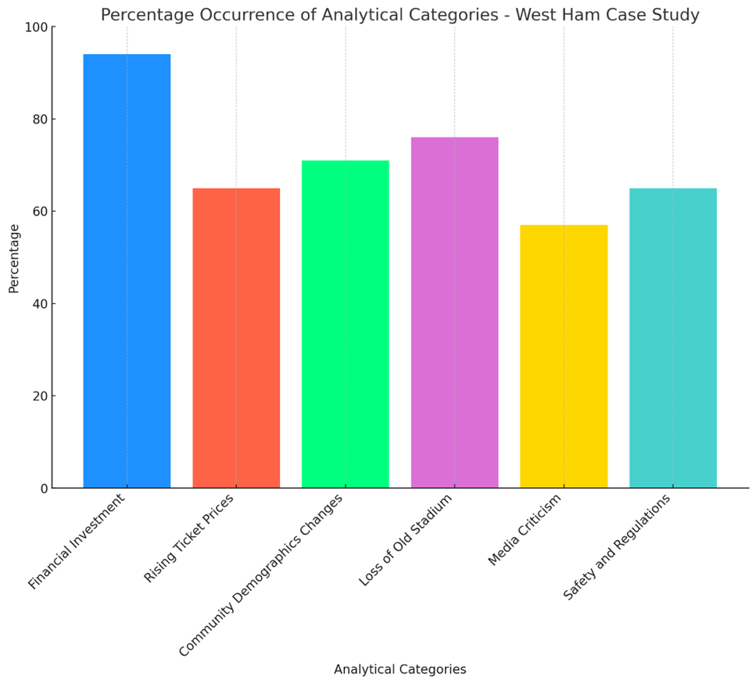

A dominant topic in the articles is primarily the financial side of West Ham United's stadium move. In 16 out of 17 articles (94%), financial investments and the economic challenges of the new stadium are addressed. The high costs of converting the new stadium and the financial losses due to the lack of marketing income as a result of the lack of name sponsorship are cited as key factors. Several articles also criticise the contractual situation between West Ham and the stadium owner, which grants them a low rent in return for the running costs being borne by the taxpayer (The Telegraph, 2018).

In contrast, 11 articles (65%) discuss ticket prices and the associated revenue. The increased capacity of the London Stadium, with around 60,000 seats compared to just under 35,000 at the Boleyn Ground, means higher revenue for the club, but ticket prices have also risen with the move. For the fans, this means higher expenses if they want to watch their club play in the stadium. One of the biggest criticisms from fans is the relatively small sum of £2.8 million that West Ham pay to use the stadium. This sum is extremely low, especially in comparison to the actual operating costs, and is therefore causing displeasure among fans and the taxpayers who bear the operating costs (The Telegraph, 2021).

The concrete effects of changes such as these, namely the changes in fan demographics, are discussed in 12 of the 17 articles (71%). Predominant themes here are the shift from a traditional, predominantly working-class fan base, as was common for a club like West Ham United, to a more diverse audience. A term often used in this context is the loss of the ‘soul’ of the club. The atmosphere in the new stadium is not the same as the square Boleyn Ground, partly due to the circular design, but the Telegraph reports an improvement in the stadium atmosphere, which is also linked to West Ham United's recent rise in success (The Sun, 2016).

The loss of the old Boleyn Ground, a favourite with many fans, is discussed in 13 articles (76%). Many fans had an emotional attachment to the stadium and the club's decision to move to a new stadium for the economic benefits was not understood by many fans. Traditionalists do not feel comfortable in the new state-of-the-art arena after losing their ‘spiritual home’ (The Telegraph, 2018).

However, it should also be noted that the media are not unanimous in their reporting, with 10 of the 17 articles (57%) criticising the negative reporting by the media. The fan protests are often portrayed negatively, as the fans would behave ungratefully towards their club (The Telegraph, 2022).

Compliance with important safety aspects and regulations is covered in 11 articles (65%). This is about compliance with safety standards, which caused major problems, especially in the initial phase after the move. Because many fans were standing on their seats, the capacity of the stadium had to be temporarily reduced to 56,000. The club had further problems with Premier League rivals Tottenham Hotspur, who had also applied to use the London Stadium, accusing the relevant authorities of corruption in their decision in favour of West Ham United.

To summarise, it can be said that the factors of the stadium relocation that could be relevant for gentrification are manifold. As in the first analysis, the focus here is on the conflict between tradition and commercialisation, while sociological and cultural factors and the change in fan demographics are also recurring. These factors are therefore confirmed with regard to a possible gentrification of the Premier League's spectatorship. New factors to be considered include compliance with safety aspects and the construction of modern stadiums and the question at what price is it justified to renovate modern multi-purpose arenas with traditional football stadiums. This case study is therefore a good indicator to identify the recurring and new aspects for gentrification that can be analysed more precisely in the following steps.

Tottenham Hotspur

League rivals Tottenham Hotspur from north London also wanted to move to London Stadium for the 2016/17 season but were eventually turned down by the planning authorities. Due to a lack of alternatives, the Spurs, as the team is known, built a new state-of-the-art stadium on the site of their previous venue, White Hart Lane. In several construction phases, individual stands of the old stadium, which had a capacity of around 36,000, were initially demolished and replaced with elements of the new stadium. The new £1bn stadium was due to be completed by 2017, but delays during construction meant that the stadium was not finished until 2019. In the meantime, Tottenham Hotspur played their home games at Wembley Stadium. Once completed, the Tottenham Hotspur Stadium has a capacity of just over 62,000 seats and is one of the most modern stadiums in the world. It has its own brewery, exclusive VIP boxes and its own dog lavatory. The longest bar in England can also be found at Tottenham Hotspur Stadium (Tottenham Hotspur, 2024).

Newspaper articles from The Guardian and The Telegraph are also used to analyse whether Tottenham's move has had a similar impact on the fanbase as West Ham. A total of 19 articles matched the search parameters and are therefore relevant for the analysis; these are classified according to the same analytical categories as in the West Ham case study and then analysed.

The analysis revealed several key themes that were increasingly discussed by both the media and fans, with the following findings:

Graph 2: Percentage of Occurrence of Analytical Categories – Case Study Tottenham Hotspur

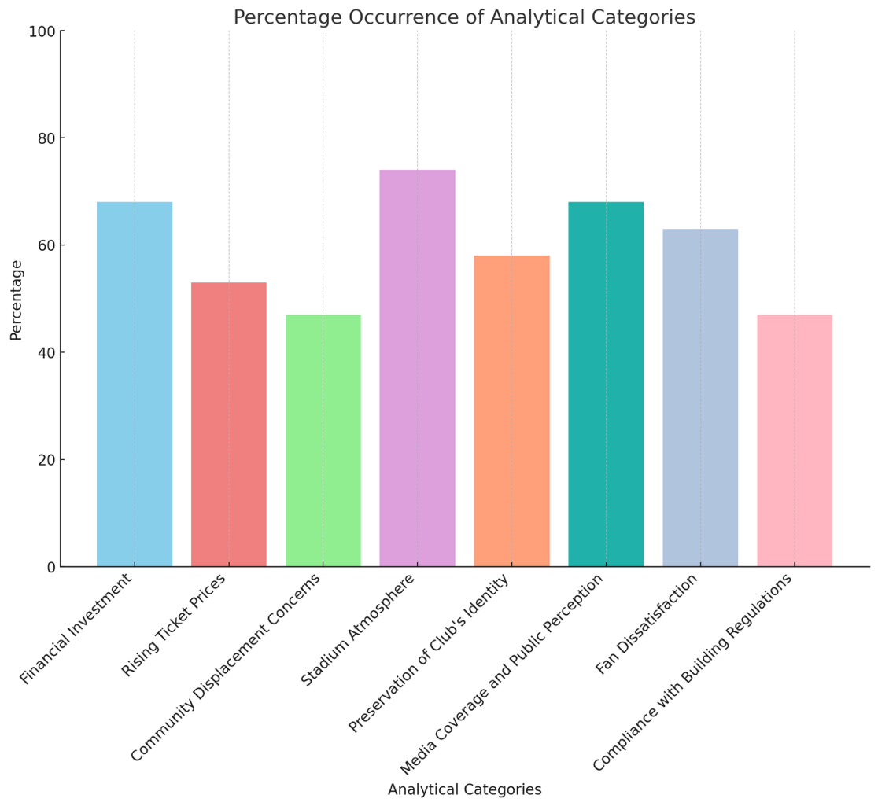

13 out of 19 articles analysed (68%) discuss the financial investment for the new stadium, criticising the high construction costs of around £1 billion, as these were not initially foreseen. Due to delays and organisational problems, the costs for the club rose sharply. In order to refinance the debt of £637 million, the club reduced the annual interest costs to 2.66% by issuing a bond (The Guardian, 2019). This is intended to reduce the financial burden on the club and fans.

In around half of the articles analysed (53%), as in the West Ham case study, the rising ticket prices associated with the move are discussed. One of the 10 articles reports on major fan protests against the increased daily and season ticket prices at Tottenham Hotspur Stadium, especially as fans have already reserved season tickets for the new stadium in advance (The Telegraph, 2018). Other articles report on the positive aspects of the new stadium, due to modern technology, the football pitch can be converted into an American football pitch within a few hours, which enables additional revenue through guest games by prominent NFL teams such as the Tampa Bay Buccaneers or the Jacksonville Jaguars (The Guardian, 2018).

An interesting point is discussed in 9 of the 19 articles (47%); residents fear the loss of community in their neighbourhood and the displacement of lower-income neighbours due to the new stadium. With the help of extensive urban regeneration projects, the area around the stadium is to be developed into a modern lifestyle and tourism destination, but especially in the first year after the stadium opened, many local businesses suffered from closures and matchday postponements due to the Covid-19 pandemic, some of them could not keep their businesses open and had to close due to rising rents (The Telegraph, 2020).

Another highly debated topic in connection with the new stadium is the atmosphere. In 14 of the 19 articles (74%), many articles praised the stadium's impressive acoustics and innovative design. Others, however, express concerns about preserving the traditional atmosphere of the old stadium (The Guardian, 2019). In general, however, reporting on the stadium atmosphere tends to be positive, as the fans have also largely accepted the move.

Nevertheless, even in this case study, there are voices that fear the preservation of the club's identity along with its economic success. This topic is discussed in 11 out of 19 articles (58%), with The Telegraph (2019) referring to it as a ‘Trojan horse of gentrification’, as the new stadium may bring modernity and economic upturn to the club, but also harbours the risk of displacing the club's traditional values and the local community of residents and businesses.

A major topic of contention is the media coverage and public perception of the new stadium, which is reported in 13 of the 19 articles (68%). Here, too, the general mood is mixed, with some articles praising the technological innovations and the sustainability of the stadium, while others criticise the long construction delays and the resulting inconvenience for fans and players. In particular, the club's communication about the progress of the construction project has been criticised, as fans rarely received official information about season ticket sales and the current status of the project (The Guardian, 2019).

This dissatisfaction of the fans is also addressed in 12 articles (63%), due to the lack of communication, fans joined forces on social media to express their dissatisfaction. For example, the Telegraph (2018) writes about a wave of frustration on social media.

A topic that also caused major discussions during West Ham's move is also relevant to Tottenham's move. Nine articles report on problems with compliance with building regulations and safety standards. The Telegraph (2018) writes about the delay in construction as critical safety aspects were not adhered to. The club also had problems as some construction workers were not paid on time or at all due to a contractor's insolvency, which in turn caused negative publicity (The Guardian, 2018).

To summarise, the financial and economic aspects of the stadium construction can also be described as predominant in this example, as can the atmosphere within the new stadium. However, this case study also shows that there are other issues than in the West Ham example, such as the increased acceptance of Tottenham fans. These discrepancies must now be interpreted in a final analysis step and a comprehensive conclusion drawn on the two case studies.

4.3 Conclusion of the Case Studies

Graph 3: Comparison of Analytical Categories between Tottenham and West Ham

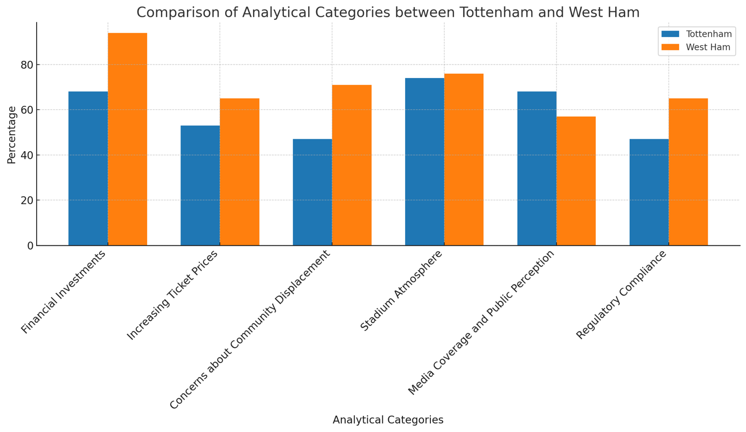

The stadium projects of West Ham and Tottenham have shown that valuable insights into gentrification can also be gained from infrastructure investments in football. Not only the financial and sporting implications, but also the significant social and urban effects can provide information about a change in the Premier League's spectator base.

Financial investments

West Ham United moved into a converted athletics stadium in 2016, which was built for the 2012 Olympic Games and cost around £230 million to convert and use, but thanks to clever contractual agreements, the ongoing usage costs are borne by taxpayers and the club only pays a relatively low stadium rent. Tottenham, on the other hand, ultimately invested over £1bn in building a new stadium from scratch, but they are the sole operator and owner of their arena. This significant investment has in turn led to a change in the surrounding communities, with Tottenham's shiny new stadium transforming the neighbourhood into a modern lifestyle area, whereas West Ham's secluded location in Queen Elizabeth Sports Park means that this is not as important.

Ticket prices and revenue

Both clubs saw an opportunity to attract more spectators to their new stadiums due to the higher capacity, which in turn leads to more revenue for the clubs. However, the higher ticket prices associated with the move and increasingly larger hospitality and VIP offers lead to the displacement of lower-income fans, which in turn is an indication of the gentrification of the spectator base through new stadiums.

Fan demographics

The resulting changes in fan demographics were also noticeable at both clubs. Tottenham is trying to strike a balance with its new stadium, combining the traditional stadium experience with exclusive hospitality packages. West Ham, on the other hand, have been trying to attract more families and younger supporters to the stadium since the move by offering family tickets and discounts, leading to dissatisfaction among traditional fans who fear the loss of their old stadium experience from the Boleyn Ground. In this context, gentrification has led to a generational shift and an alienation of traditional fan communities. However, this alienation is not permanent, as it remains to be seen how the fan demographics in stadiums will change in the coming years.

Stadium atmosphere

The stadium atmosphere is a major point of discussion for both clubs. On the one hand, Tottenham receive praise from the media for their innovative stadium design and the proximity of spectators to the pitch, which promotes the intimate and primal nature of football. On the other hand, West Ham struggle with the problems of an athletics stadium. A circular stadium, initially with a running track, is not as popular with most football fans as a traditional football stadium, despite its modernity and size. With regard to gentrification, in the case of West Ham one can speak of a blurring of traditional fan culture due to reconstruction.

Tradition vs. commercialisation

In both stadium projects, there was a conflict between tradition and commercialisation. Many fans accuse West Ham of disregarding the interests of the fans in the move and only moving for economic reasons, as the new stadium offers little attraction for fans. At Tottenham, this was a little more moderate, as the club enjoyed complete planning freedom due to the new building and was therefore able to respond to the needs of the fans when building the new stadium. In the case of West Ham, however, there was a considerable loss of the club's identity, particularly in the initial phase after the move, which will have to be re-established over time. This change in identity in turn contributes to the gentrification of the spectator base, as some fans no longer identify with their club, but new ones do. For example, the relocation of the stadium and the new Neighbourhood. Some West Ham fans moved away because of the distance to the new stadium, while others found their way to the club because of the proximity of the London stadium.

Media coverage and perception

The media coverage of the two projects differed significantly. Tottenham's project has received far more favourable reviews than West Ham's relocation plans. However, in Tottenham's case this is also linked to considerable debt, whereas West Ham's financial burden of the new stadium has largely been passed on to the city of London. This development has been criticised by the media as this costly project has a negative impact on the local community as a lot of money is being spent on a football stadium rather than creating a better infrastructure.

Fan engagement on social media

Fans at both clubs organised themselves on social media to voice criticism of their club's plans, with the lack of communication from the clubs playing a major role. The fans did not feel sufficiently valued by their clubs, even though they generate a lot of revenue for the club through season tickets and ticket purchases.

Regulations and guidelines

There were also problems with construction and safety regulations in both projects. At Tottenham, the construction of the stadium was delayed and at West Ham, important adjustments had to be made to the Olympic Stadium in order to comply with the regulatory requirements of the EPL. Both delays resulted in high costs that had to be borne by the clubs and, in West Ham’s case, by the taxpayer.

Global reach

Both clubs hoped that the move to the new stadiums would increase their international brand presence by organising events in their stadiums. Tottenham achieved great success by organising NFL games in their stadium. West Ham's London Stadium initially hosted athletics events alongside football, but now hosts concerts by internationally renowned artists in addition to football.

West Ham United

The move from the Boleyn Ground to the London Stadium not only changed many things for the fans and the club, but also for the stadium's surroundings. In Upton Park, the original home of West Ham, residential and office complexes were built after the demolition of the Boleyn Ground in order to continue using the area, but the move of the football club meant a major hurdle for local businesses. The shops near the stadium benefited greatly from the home games, but this income will now be lost as the London Stadium is around 6 kilometres away from the Upton Park district. In its new home in Stratford, the area around the stadium has not changed that much, as the neighbourhood has already undergone considerable structural changes because of the 2012 Olympic Games.

Tottenham Hotspur

Whilst Tottenham have remained loyal to their old ground at White Hart Lane, the construction of the new stadium has had a profound impact on the local community. Even during the construction phase of the stadium, many local businesses and residents were critical of the gentrification of their neighbourhood. The property developments that accompanied the construction of the new stadium have further increased rents and the cost of living in the neighbourhood, which is particularly threatening for the lower-income residents. Some residents have had to give up their homes because they could not cope with the increased costs. Despite the club’s commitment to social building projects in the neighbourhood, some residents still fear social displacement.

To summarise, both stadium projects had a significant impact on gentrification in their respective areas. Overall, Tottenham appears to have been more successful in the realisation and acceptance of the new stadium. West Ham faced more challenges during and even after the move due to the contractual situation and the construction of the stadium, as well as opposition from their own supporters and taxpayers. Nevertheless, both projects offer valuable lessons on how large investments in infrastructure can bring about urban and social change. In both cases, gentrification has led to a noticeable change in fan demographics, the local economy and the social fabric, demonstrating how projects away from the sporting aspect of football clubs can significantly change the structure of urban communities.

4.4 Diversified content analysis

In order to cover all possible factors of gentrification of the audience in the EPL, a final, diversified content analysis will be carried out to identify particularly striking factors. To this end, five representative articles for each topic covered in the literature review are included in the analysis, the purpose of which is to cover as broad a spectrum of possible factors as possible.

The 30 articles in total are thus representative of the findings already obtained from the literature review and to substantiate or refute the data and facts already presented there. A small number of the articles analysed below come from the literature review, and new and relevant articles from the academic databases Sage and LexisUni were also selected for analysis. To make the text easier to read, the full table can be found in the appendix. The results are analysed below using diagrams.

Graph 4: Distribution of Articles by Genre

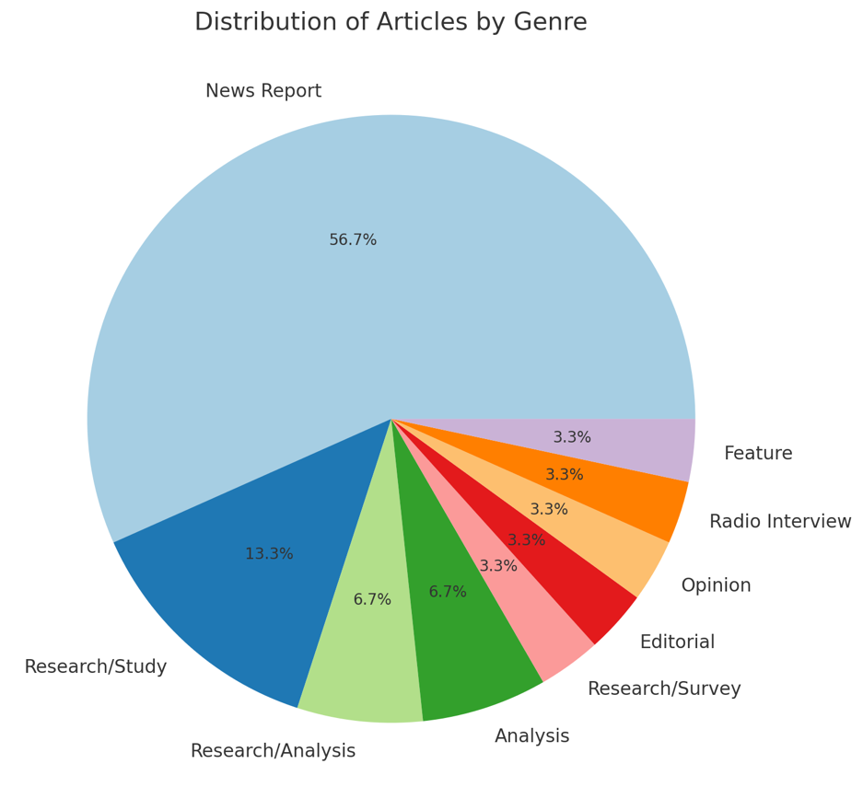

When reading the diagram, it is noticeable that most of the analysed articles are news reports, which suggests that many of the possible factors for gentrification could be sudden events or important news. Other dominant genres that take a more scientific approach are research studies and analyses, as well as surveys. These often provide valuable and detailed insights into specific topics and are therefore essential for interpreting the analysis. Less relevant in this context are genres that are not well represented, such as opinions, as these are subjective publications.

Graph 5: Temporal Distribution of Publications

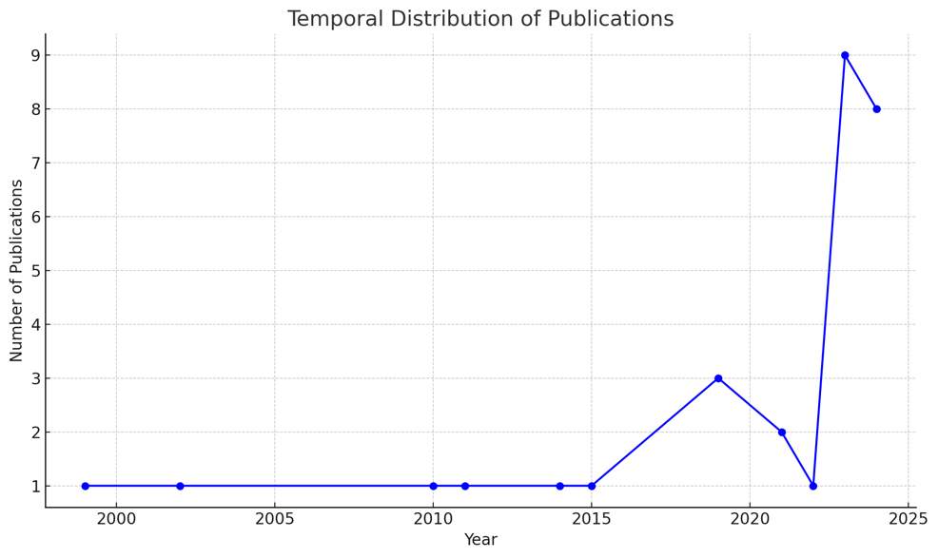

The temporal distribution of the contributions shows a clear increase after 2015, which indicates that gentrification is becoming increasingly relevant. This development correlates with the increasing investments and changes and economic structures of the Premier League and will therefore be examined in more detail in the future. However, important events from the past, such as the Hillsborough tragedy, should not be overlooked, as these have had a lasting impact on English football and with the introduction of important safety-related regulations.

Graph 6: Frequency of Entries in Selected Categories

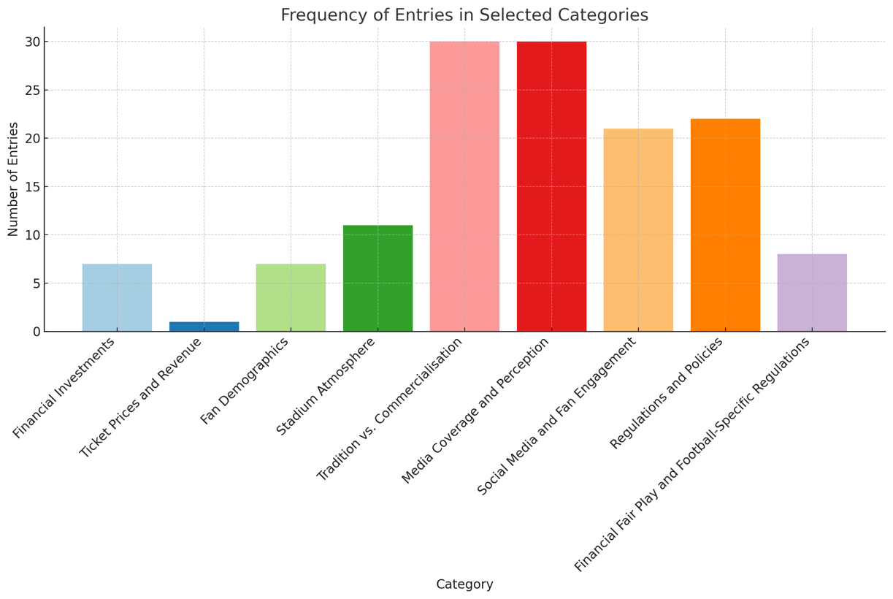

The above diagram shows the most relevant data from the content analysis, as well as the frequency of characteristics of the analytical categories. This can be used to determine the relevance of the factors and to incorporate them into the subsequent interpretation.

Due to the relatively low occurrence of ticket prices, the effects of economic factors on the accessibility and composition of football fans should be investigated. It should also be clarified whether the concerns of fans with lower incomes about rising ticket prices are justified. The relatively high incidence of fan demographic characteristics indicates an active interest in how economic changes affect the social fabric of stadium visitors.

Prominent categories such as Media Coverage and Perception and Regulations and Policies illustrate the power of the media in shaping public discourse and the ongoing debates about new regulations in the Premier League. The high frequencies of these regulatory topics indicate that gentrification is actively being steered by those in charge, which may be related to the ban on standing areas, newly concluded TV deals or new regulations within the stadiums.

Finally, it should be noted that the conflict between tradition and commerce also plays a major role in this diversified analysis. The divergence between the interests of fans and clubs is increasingly leading to alienation and the perceived loss of identity of the clubs amongst its fanbase. It is therefore important to analyse developments such as these in more detail in order to identify trends and future developments.

4.5 Analysing the anomalies

The anomalies and peculiarities that occurred in the last analysis step are examined in more detail in a final analysis step. The following anomalies occurred in the content analysis: on the one hand, articles about ticket prices were poorly represented, although they were identified in the literature review as one of the more important factors in the context of a possible audience. In addition, the high presence of articles dealing with the ongoing conflict between tradition and commerce in English football was striking. In order to choose a suitable form of analysis with regard to the research questions, I decided on a hybrid model to find a possible correlation between the two topics.

To do this, two analyses were carried out. The first analysis looked at the prices of season tickets for Premier League clubs over the last few years. For this purpose, data on the cheapest and most expensive season tickets of all Premier League clubs from the 2012/13 season to the 2023/24 season were compiled in an Excel table. The data were visualised using diagrams and are analysed in more detail below. The full data set can be found in the appendix. The second analysis deals with the spectator numbers in the Premier League since its foundation. For this purpose, all spectator numbers from the 1992/93 season to the present day were compiled in an Excel table and statistically evaluated. The aim of this hybrid method is to identify correlations between the two statistics and to analyse them in a targeted manner in order to answer the research questions.

Ticket prices in the Premier League since the 2012/13 season

Graph 7: Most Expensive Season Ticket Prices from 2012 to 2024

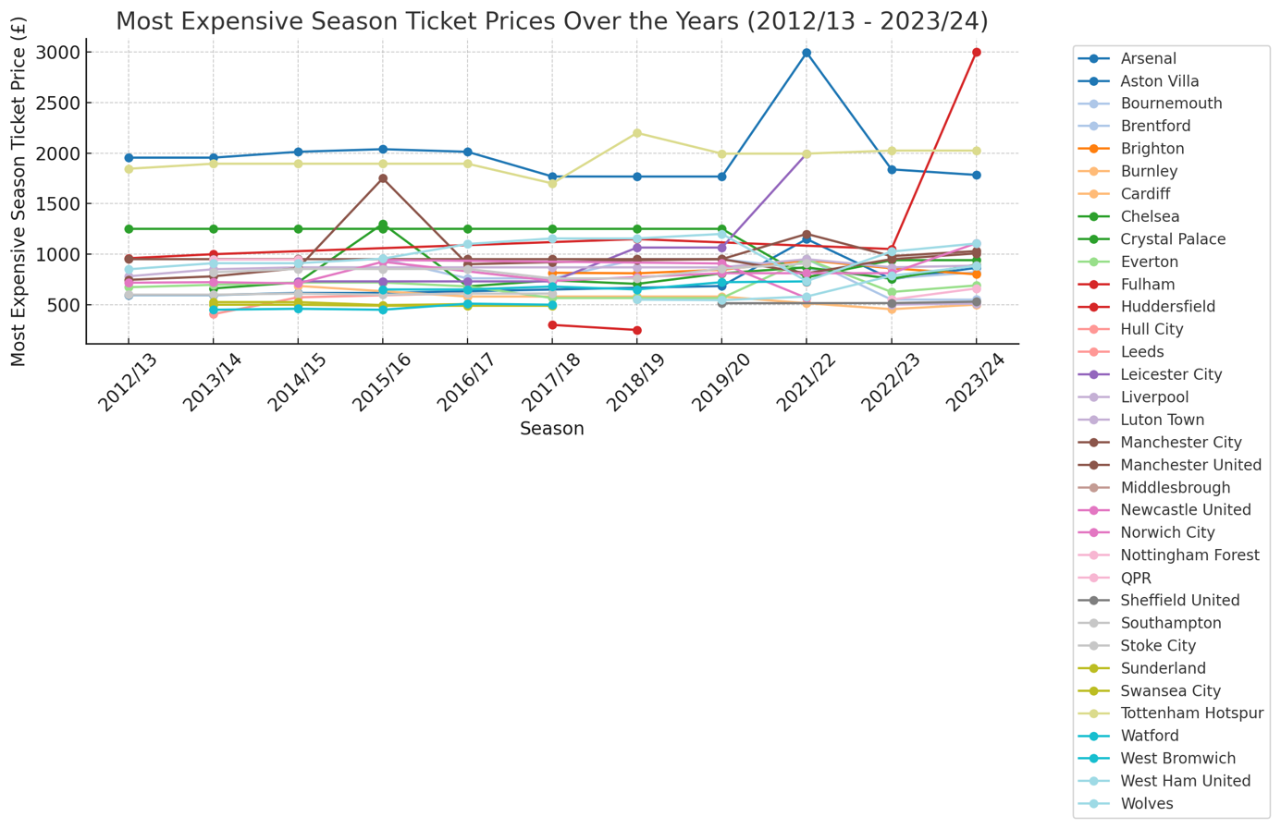

As can be seen in the above diagram, the prices for the most expensive season tickets have always remained at a balanced level, with a few exceptions. The values for Fulham, Arsenal and Tottenham are striking in this diagram. Compared to the other clubs, it is noticeable that Arsenal and Tottenham have been pursuing a significantly higher pricing policy than most of the other clubs for over 10 years. It can therefore be assumed that the two clubs from north London appeal to a more affluent fan base, which will be examined in more detail below. The third striking club is also from London, but from the southwest. The Fulham district, which is home to the Chelsea football club and the Chelsea FC stadium, increased its most expensive season tickets from £839 at the beginning of the 2012/13 season to £3,000 last season. According to a BBC (2024) survey, this extreme increase has caused a major split in the fan scene. On the one hand, there are fans who can understand the club's move, as Fulham has been popular with stadium tourists in recent years due to its moderate ticket prices, and the club hopes that the price increase will attract a more loyal audience. Others, however, fear that more and more fans will turn away from their club precisely because of the rising ticket prices, and that if the club is relegated, only a few spectators will make their way to the stadium.

Graph 8: Least Expensive Season Ticket Prices from 2012 to 2024

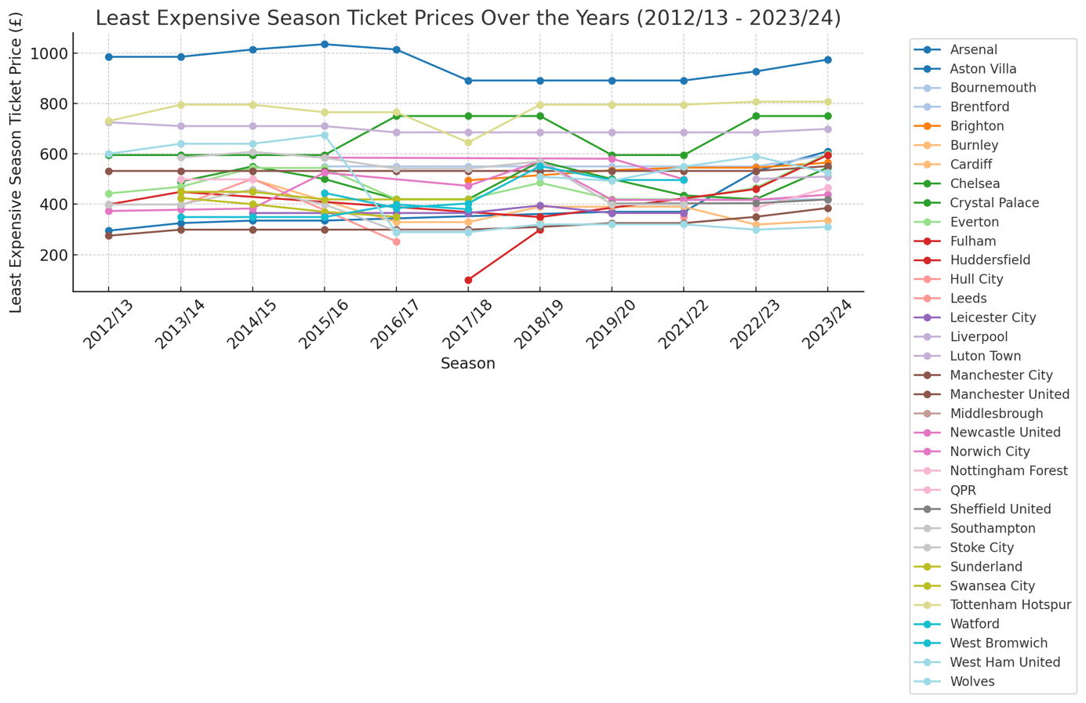

However, if you look at the price changes for the cheapest season tickets in the Premier League clubs, it is noticeable that most clubs have seen an exponential increase up to the mid-2010s. After significant increases in the 2018/19 season, ticket prices initially fell in the following years, but have been rising again slightly since the 2022/23 season. Due to ongoing fan protests at many clubs, including Fulham, Tottenham and Liverpool, some Premier League clubs decided to freeze their ticket prices for the coming years after a reduction in the 2019/20 season, which was also due to the slow onset of the corona pandemic (Football Supporters' Association, 2019).

Graph 9: Average Season Ticket Prices from 2012 to 2024

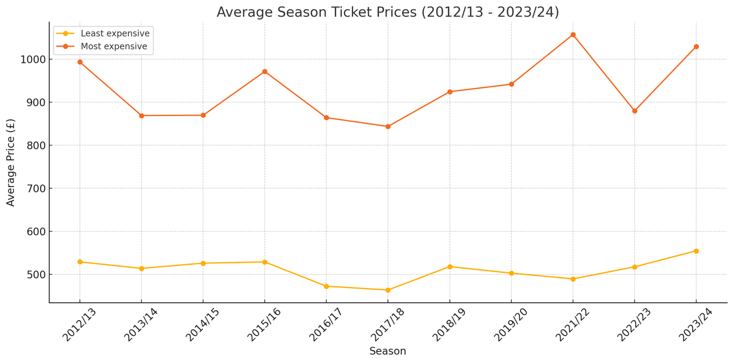

The slight decline and subsequent stagnation in ticket prices is also noticeable in the average values for all Premier League clubs. In addition to the fan protests mentioned above, the decline could also be related to other factors. On the one hand, there are the increasingly frequent demands (BBC, 2018) for internal club regulations such as price caps or discounts for schoolchildren, senior citizens or the disabled. This has forced clubs to rethink their previous profit-driven pricing policies so as not to fall out of favour with their own fans. In addition, competition and the situation on the ticket market play a role in pricing. It is in the clubs' interest to adapt to the general market level and stabilise prices so as not to lose fans to other clubs.

The increase of ticket prices is symptomatic of the gentrification process of the Premier League. The increasing commercialisation of the league, supported by new TV contracts with record volumes and the ever-growing interest in the international marketing of the league, has transformed the economic landscape of football. The resulting profits for the clubs are invested in new players, improved infrastructure and stadium modernisation. The resulting additional costs are passed on to fans in the form of price increases to offset the investments and to generate additional profits. This is now common practice in many of Europe's top leagues, but it can be seen that, especially in the mid-2010s, the financial pain threshold of many fans was reached, and the clubs were forced to react to the protests of their supporters.

The changes in ticket prices over the last 10 years have also led to a shift in the social structures within the stadiums. The gradual increase in prices is making it increasingly difficult for fans from lower-income backgrounds to afford a visit to the stadium. In particular, clubs such as Arsenal and Tottenham are attracting wealthier fans and corporate clients to the stands that were originally occupied by the working class. Nowadays, the stadiums are home to a more diverse and international audience, but this is usually at the expense of the atmosphere.

Although the financial growth and global reach of the EPL is a great success for the clubs, the question arises as to how long this model can exist in terms of sustainability. By continuously raising prices, the clubs risk alienating their most loyal fans, and the cohesion between fans and club, which many clubs have anchored in their traditional values, is also at risk of dwindling. In order to maintain the loyalty of their fans and the associated revenue, it should be in the interest of the clubs and the league officials to take the concerns of the fans seriously and not to pursue their own interests in order to maximise profits.

Attendance of Premier League games since the 1992/93 season

Graph 10: Average Attendance per Season in the Premier League from 1992 to 2024

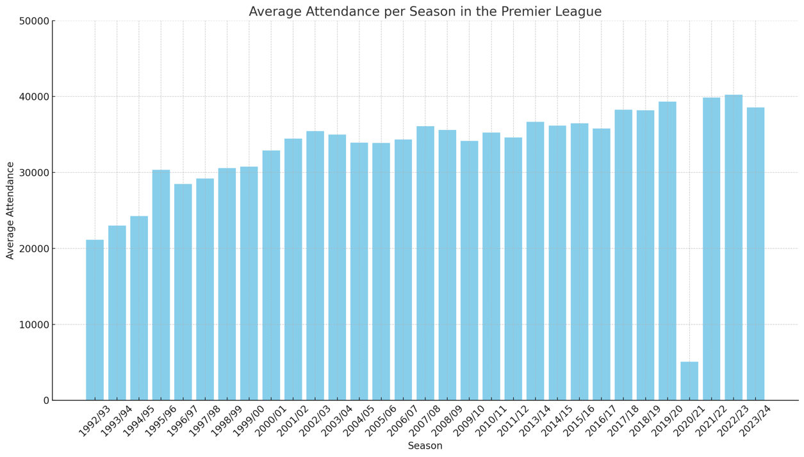

When analysing the rising ticket prices, one is inclined to suspect that fewer fans are flocking to the stadiums as a result. However, a glance at the average number of spectators since the Premier League was founded reveals that this is not the case at first glance. Spectator numbers have increased significantly, particularly in the last 10 years. Looking at the diagram, it is noticeable that the average number of spectators has risen steadily since the league was founded in 1992. In the 2010s, they reached a stable level of around 40,000 fans per game, which indicates a consistently high demand for tickets, even at high ticket prices.

Graph 11: Average Attendance of the top 7 clubs in the Premier League from 1992 to 2024

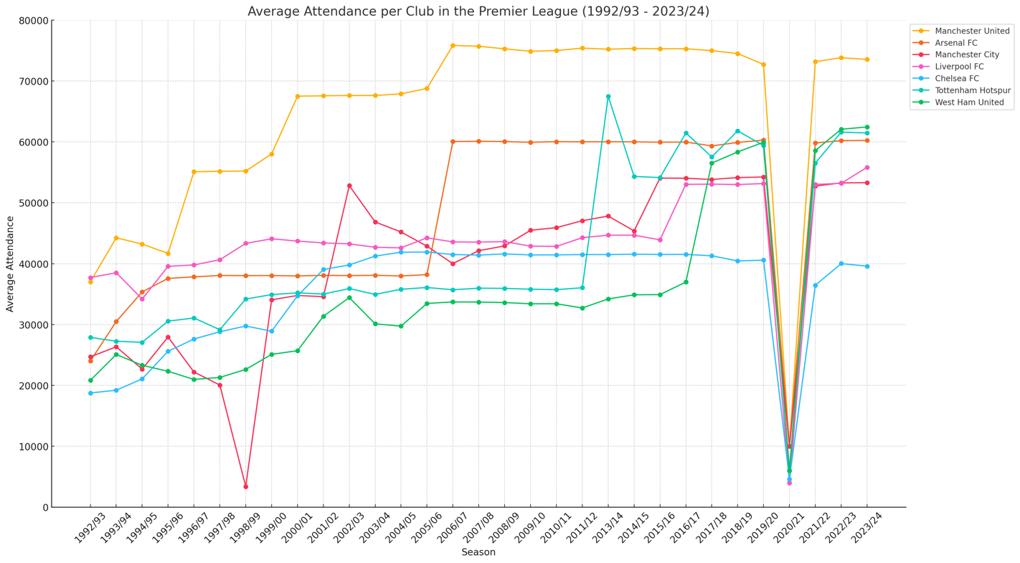

This can be seen in the example of the top 7 clubs in the Premier League, which include Arsenal and Tottenham, who already charge high ticket prices. Even after the significant price increases by Arsenal in 2015 and Tottenham in 2018, the average number of spectators remained unchanged and almost reached the maximum capacity of the stadiums of both clubs in every season with West Ham reaching 99.9% and Tottenham 97,8% of the maximum capacity of their stadiums in the 2023/24 season (Transfermarkt, 2024). The assumption that a decline in spectator numbers is to be expected due to higher ticket prices is therefore not correct.

One reason for the stable to increasing spectator numbers despite higher ticket prices may be the growing international attractiveness of the EPL. International TV marketing makes the league more attractive for international fans who are willing to pay higher sums to watch a game of their club in the stadium.

Another reason for this development is the modernisation of many EPL stadiums. Almost all top clubs, such as Liverpool, Chelsea or Manchester United, have invested large sums in the expansion of their stadiums in recent years, while other clubs such as Arsenal, West Ham or Tottenham have moved into completely new stadiums in the last 20 years. These investments not only increase the capacity of the stadiums, but also their attractiveness. With more comfortable seating, better views and a more modern interior, fans are willing to pay higher prices for this comfort.

In addition to the modernisation efforts of some clubs, football in England still has a deeply rooted social and cultural significance. For many fans, attending a stadium is a tradition that has been lived for several generations, and for older fans in particular it is an important part of their social life. This strong emotional attachment to football therefore makes it impossible for some long-standing football fans to pay the high costs, as they would otherwise have to give up part of their social life.

One exception to be excluded from the analysis of the development of the number of spectators is the 2020/21 season. Due to the Covid-19 pandemic, many games were played behind closed doors and only a small number of spectators were allowed into the stadiums in a few exceptions.

Nevertheless, this development shows that many fans are willing to pay the rising ticket prices to see their team play in the stadium. For gentrification, this means above all that the fan demographics are shifting further, as wealthier fans are taking the place of those with lower incomes. The clubs are therefore relatively relaxed about this situation, as they can be almost certain that they will fill their stadiums according to current developments. However, this mixture of acceptance of traditional and long-standing fans and the influx of cosmopolitan and international fans still presents the clubs with a challenge, as they also have to find a balance between traditional and cosmopolitan fan communities in their pricing policy in order to preserve the identity of the club. A survey by the Football Supporters' Association (2023), in which 10,000 football fans were surveyed on various topics, revealed that 30.3% of fans who said they were attending fewer matches than in previous seasons were doing so because of the increased ticket prices. This in turn reinforces the assumption that existing fans are being replaced by new ones.

Chapter Five: Conclusion and Findings

In the course of my research, insights and trends emerged from my examination of various topics in the Premier League and its history, which worked towards answering the research questions. In order to provide a thorough and well-founded conclusion, the individual chapters of this dissertation will therefore be summarised and processed chronologically in the following, in order to provide a scientifically sound conclusion for this work.

The changes in the English Premier League in recent years indicate a profound gentrification process that has a major impact on the spectators and the associated social structures, and also changes football culture in the long term. In-depth research of the existing literature has revealed several key findings that can help to answer the research questions formulated at the beginning.

The development of the EPL's fan base is closely linked to social changes. The league's history shows that football in England was predominantly a working-class sport in its early days, serving to strengthen local communities (Giulianotti, 2005). As economic conditions and social norms changed over the years, so did the demographics of the fans. The gentrification of football is bringing more cosmopolitan fans into the stadiums in this process (Weber et al., 2021). This change also reflects broader trends in urban gentrification, where rising housing costs are displacing poorer residents in favour of wealthier ones.

The analysis of demographic changes among EPL spectators shows a clear pattern: the traditional fan base, largely made up of working-class people, has been gradually replaced by spectators from the working middle and upper classes. This change is due to several factors. One decisive factor is the rising cost of attending matches, which makes it more difficult for lower-income fans to follow their club live (Goldblatt, 2007). A similar trend has emerged in the analysis of ticket prices, which will be discussed in more detail below. Other reasons for the change are the increasing commercialisation of football, which aims to sell football as an exclusive and modern sport. This is accompanied by the EPL's global marketing strategies to tap into new markets (Kearns et al., 2024). One example of this is the organisation of a number of pre-season matches by well-known clubs such as Manchester City and Liverpool in the Asian region. This is favoured by the influx of foreign players and the resulting increased attractiveness for foreign investment. This extremely dynamic cycle of global brand presence, foreign star players and increased attractiveness for investors has transformed the league and made it even more attractive to an international audience.

Several key events can be identified that have favoured the gentrification process of the EPL. On the one hand, the Hillsborough disaster, in which 97 people lost their lives in 1989, had a significant impact. The subsequent investigations and the Taylor Report marked a turning point with repercussions for English football that continue to this day. The conversion of stadiums into pure seating arenas improved safety, but due to the lower capacity, they contributed to higher ticket prices. This in turn drove traditionalists out of the stadiums and at the same time it also helped to contain hooligans in the stadiums, as they could no longer identify with the sport as they had before the regulation (Rigg, 2019). In this construct, the league emerges as the clear winner, as it has been able to reduce violence and thus increase safety in stadiums, but working-class fans have been the big losers of this period due to increasing alienation (Ingle, 2006; Jones et al.,2023).

A new phenomenon is the rise of social media, which provides a platform for broad discourse and increased global reach. The dark side of social media provides an additional space for the spread of hate and racism beyond the stadiums, which in turn reflects deep-rooted social problems in English football culture (Kick it Out, 2022; Kearns et al., 2022; Gov.uk, 2024).

The gentrification of the EPL has also had an impact on the sense of community within clubs. The sense of togetherness anchored in traditional values is giving way to a more corporate and commercial relationship at an increasing number of clubs (Giulianotti, 2005; Szymanski, 2015). The research shows a strong polarised development, with some clubs, such as Brentford, managing to maintain a family relationship with their fans through inclusive club management (Bees United, 2021; Brentford Football Club, 2024). However, the general trend shows a prioritisation of financial interests on the part of the clubs, which put these above familiarity and community and therefore increasingly lose the activism of their fans (Numerato, 2018).

The methodology, which included content analysis, case studies and statistical analysis of data, provided further important insights into the gentrification process. It became clear that financial investments and infrastructure modernisation have a significant impact on the composition of the audience.

The case studies of West Ham United's move to the London Stadium and the construction of the new stadium for Tottenham Hotspur are representative of how economic interests and urban development projects can impact on fan demographics. The case studies also reveal a complex construct of different interests. The relocations and modernisations of the stadiums are associated with high costs, which are partly passed on to the fans in the form of ticket price increases, which in turn affects the accessibility for lower-income fans. As the literature review also showed, this leads to a change in the fan scene towards a more affluent and international composition of the audience. The analysis of the case studies confirms this and the further analysis of ticket prices reveals another crucial detail. Due to the constantly high demand for Premier League tickets, clubs are not necessarily dependent on their long-standing fans, as more and more cosmopolitan fans are interested in tickets due to the increasing international attractiveness, and they are also willing to pay a higher price for them. In terms of gentrification, this means that no fan is truly irreplaceable, no matter how long they have identified with the club. The data therefore shows that the increasing prioritisation of the club's financial interests is leading to a change in the spectator structure.

This is largely due to rising ticket prices. The example of Fulham clearly shows the financial interests of the clubs behind the pricing policy. A middle-class fan with an average income will find it difficult or impossible to realise an increase in season ticket prices from £839 in 2012 to £3,000 in 2024. This highlights the clubs' attempts to attract wealthy fans and companies by replacing more traditional grandstand areas with hospitality areas and boxes (BBC, 2024).

The increasing modernisation of EPL stadiums has also changed the atmosphere and the stadium experience, and here too a polarised model can be seen. Some clubs are praised for their efforts to maintain the character of a traditional football stadium despite modernisation (The Guardian, 2019), while others are criticised for taking the opposite approach (The Telegraph, 2018). The general trend shows a negative development, as around 76% of the analysed articles report negatively on stadium modernisation and infrastructure investments. These negative reports mostly see the dwindling stadium atmosphere as a critical factor. The progressive alienation of traditional fans is diluting the atmosphere, and the increasing exclusivity of football is taking place at the expense of the mood.

Graph 12: Heatmap of Least and Most Expensive Season Ticket Prices from 2012 to 2024

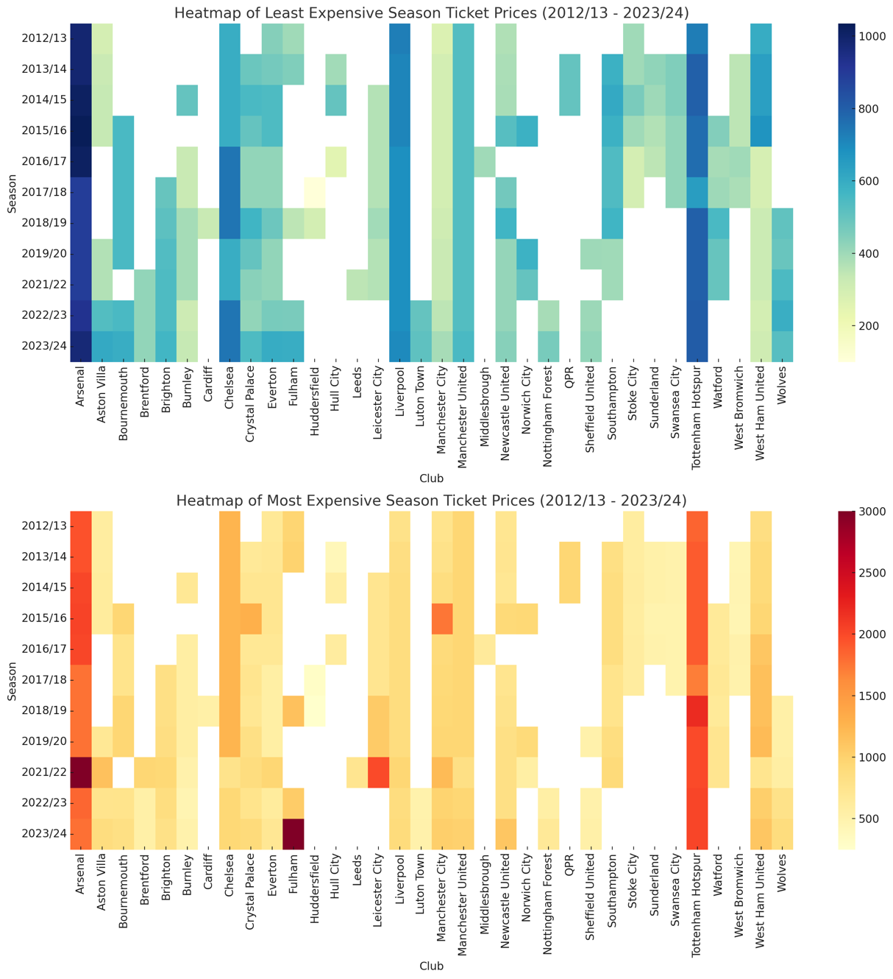

However, the analysis also showed that the pricing policy of recent years has been subject to strong fluctuations, as can be seen from the heat map, there are big differences between the individual clubs. It is not always only the absolute top clubs that pursue a higher pricing policy, but also some mid-table teams. This fact, and the sometimes enormous price fluctuations of price increases of over 150% compared to the previous year, showed the EPL's limits, especially in the 2010s. In 58% of the analysed articles, the role of social media in mobilising fan protests was emphasised (The Telegraph, 2018), which in turn demonstrates the enormous importance of social media as an important platform for organising and exchanging fan opinions, which has permanently changed the dynamics of fan-club interaction (Hutchins and Rowe, 2012).

Graph 13: Percentage Change in Most Expensive Season Ticket Prices from 2012 to 2024

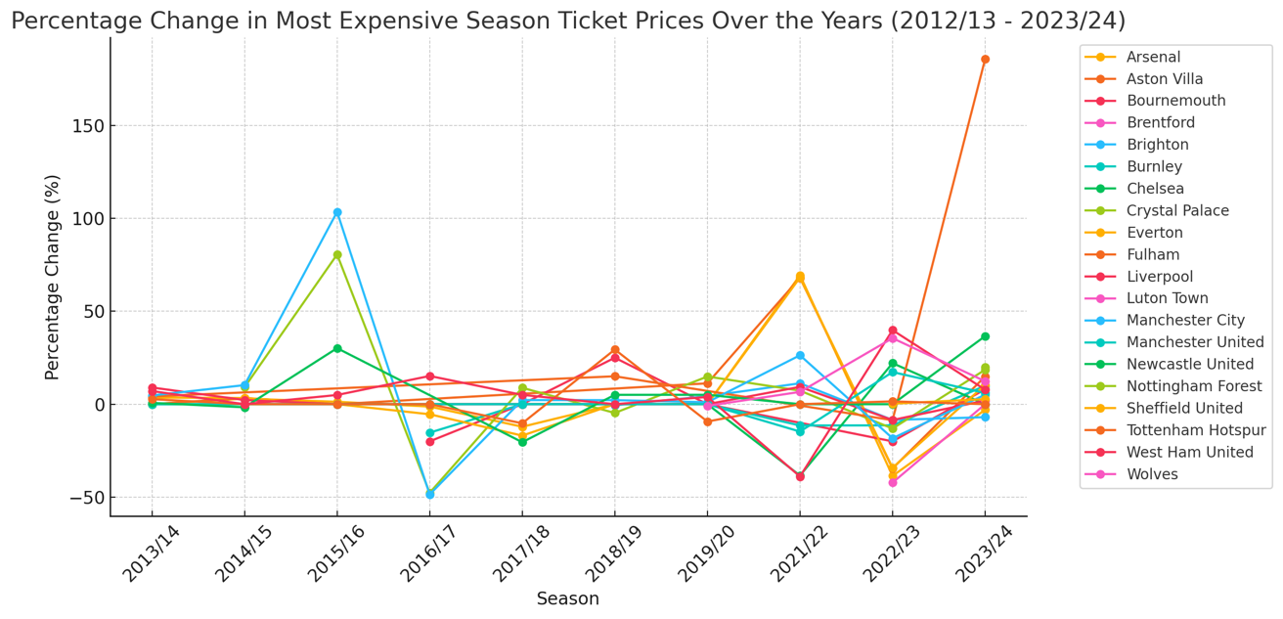

Apart from that, the analysis provided valuable insights into the relationship between urban gentrification and football, with the relocation of stadiums away from their old home grounds threatening the livelihoods of local businesses due to the lack of revenue, while on the other , rents in the vicinity of modernised and newly built stadiums rise, as the polarising effect of football increases the attractiveness of the area and therefore also leads to a displacement towards a more affluent society in this context. This in turn leads to a dissolution of local communities and to an alienation of the identity of the neighbourhood.

In conclusion, it can be said that the process of gentrification has permanently changed the English Premier League. The effects can be traced back to a complex and very dynamic construct of historical events, financial and economic interests, and social values. In particular, the financial boom of the last two decades has led to a significant change in fan demographics. English football is developing from its original form as a working-class sport into an increasingly exclusive billion-pound construct.

The increasing alienation of traditional fans and the advancing commercialisation of the sport represent the greatest challenges for the future. It therefore remains an important task for the league, clubs and fans to find a balance between their conflicting interests in order to preserve the football culture. So that "English football does not lose its identity under the influence of other cultures", as the great Johann Cruyff once said.

Chapter Six: Bibliography

6.1 Literature used in the Dissertation

Awan, I. and Zempi, I. (eds) (2023) Hate crime in football: how racism is destroying the beautiful game. Bristol: Bristol University Press.

Andreff, W. (2009) The economic effect of ‘muscle-drain’ in sport. Labour Market Migration in European Football: Issues and Challenges. London: Birkbeck Sports Business Centre. Available at: https://eprints.bbk.ac.uk/id/eprint/49624/1/Walters%20and%20Rossi%20%282009%29.pdf#page=10
(Accessed 9th July, 2024)

Ayres, T.C. and Treadwell, J. (2012) ‘Bars, drugs and football thugs: Alcohol, cocaine use and violence in the night time economy among English football firms’, Criminology & Criminal Justice, 12(1), pp. 83–100. Available at: https://doi.org/10.1177/1748895811422949.

Bale, J. (2003) Sports geography. 2nd ed. London; New York: Routledge.

BBC Sport (2015) Premier League TV rights: Sky and BT pay £5.1bn for live games. Available at: https://www.bbc.com/sport/football/31357409 (Accessed: 26th June, 2024)

BBC Sport (2024) Premier League ticket price rises – what the fans think. Available at: https://www.bbc.com/sport/football/articles/c1660n3j466o#:~:text=Fulham%20fans%20have%20held%20up,150%20per%20home%20league%20match (accessed 8th August, 2024)

Bees United (2021) Why the “Brentford Model” of Fan Director and Golden Share should be copied. Available at: https://www.beesunited.org.uk/in-focus/why-the-brentford-model-of-a-fan-director-and-a-golden-share-could-work-at-your-club/ (accessed 19th June, 2024)

Bees United (2022) “It’s turned out pretty good” – Ten years owning Brentford by Matthew Benham. Available at: https://www.beesunited.org.uk/in-focus/its-turned-out-pretty-good-ten-years-owning-brentford-by-matthew-benham/ (accessed 19th June, 2024)

Bennett, H. and Jonsson, A. (2017) Sport and discrimination. Edited by D. Kilvington and J. Price. Abingdon New York: Routledge (Routledge research in sport, culture and society, 72).

Berelson, B. (1952); Content Analysis in Communication Research; New York, NY, US: Free Press

Bleacher Report (2014) Thierry Henry's Impact on Aresenal and the Premier League Will Never Be Forgotten. Available at: https://bleacherreport.com/articles/2301939-thierry-henrys-impact-on-arsenal-and-the-premier-league-will-never-be-forgotten (Accessed 4th July 2024)

Boyle, R. and Haynes, R. (2009) Power play: sport, the media and popular culture. 2nd ed. Edinburgh: Edinburgh University Press.

Brannagan, P.M. and Giulianotti, R. (2015) ‘Soft power and soft disempowerment: Qatar, global sport and football’s 2022 World Cup finals’, Leisure Studies, 34(6), pp. 703–719. Available at: https://doi.org/10.1080/02614367.2014.964291.

Brentford Football Club (2024) Fan Engagement Statement. Available at: https://www.brentfordfc.com/en/fan-engagement (accessed 19th June, 2024)

Burns H. and Killock, J. (2021) Racists must be prosecuted, not moderated. Open Rights Group. Available at: https://www.openrightsgroup.org/blog/racists-must-be-prosecuted-not-moderated/ (accessed 6th August, 2024)

Cleland, J. and Cashmore, E. (2016) ‘Football Fans’ Views of Violence in British Football: Evidence of a Sanitized and Gentrified Culture’, Journal of Sport and Social Issues, 40(2), pp. 124–142. Available at: https://doi.org/10.1177/0193723515615177.

Critcher, C., Clarke, J. and Johnson, R. (1973) Working class culture: studies in history and theory. London: Routledge.

Dahlmann, J. (2022) Immer geradeheraus: Tore, Typen, Turbulenzen - mein wilde Zeit als Fußballreporter. 1. Auflage. Hamburg: Edel Sports - ein Verlag der Edel Verlagsgruppe.

Deloitte (2020). Annual Review of Football Finance 2020. Available at: https://www2.deloitte.com/ch/en/pages/technology-media-and-telecommunications/articles/annual-review-of-football-finance.html (accessed 16th July, 2024)

Deloitte (2024). Deloitte Football Money League 2024. Available at: https://www.deloitte.com/uk/en/services/financial-advisory/analysis/deloitte-football-money-league.html (accessed 7th August, 2024)

Doidge, M. and Lieser, M. (2018) ‘The importance of research on the ultras: introduction’, Sport in Society, 21(6), pp. 833–840. Available at: https://doi.org/10.1080/17430437.2017.1300377.

Dunning, E., Murphy, P.J. and Williams, J. (2014) The Roots of Football Hooliganism (RLE Sports Studies). 0 edn. Routledge. Available at: https://doi.org/10.4324/9781315772875.

Elliott, R. (2013) ‘New Europe, new chances? The migration of professional footballers to Poland’s Ekstraklasa’, International Review for the Sociology of Sport, 48(6), pp. 736–750. Available at: https://doi.org/10.1177/1012690212446472.

Elliott, R. and Weedon, G. (2011) ‘Foreign players in the English Premier Academy League: “Feet-drain” or “feet-exchange”?’, International Review for the Sociology of Sport, 46(1), pp. 61–75. Available at: https://doi.org/10.1177/1012690210378268.

English Premier League (2021) English Football announces social media boycott. Available at: https://www.premierleague.com/news/2116111 (accessed 14th June, 2024)

English Premier League (2023) Premier League completes sales process for UK live rights & free-to-air highlights. Available at: https://www.premierleague.com/news/3807882 (Accessed 26th June, 2024)

English Premier League (2024) Premier League broadcast deals for 2025-2028, 20th March. Available at: https://www.premierleague.com/news/3703577 (Accessed 26th June, 2024)

Franck, E.P. (2013) ‘Financial Fair Play in European Club Football - What is it All About?’, SSRN Electronic Journal [Preprint]. Available at: https://doi.org/10.2139/ssrn.2284615.

Football Supporters Association (2019) Stop the greed. Fulham fans protest sky-high ticket prices. Available at: https://thefsa.org.uk/news/stop-the-greed-fulham-fans-protest-sky-high-ticket-prices/ (accessed 5th August, 2024)

Football Supporters’ Association (2023) National Supporters’ Survey 2023: more stats. Available at: https://thefsa.org.uk/news/national-supporters-survey-2023-more-stats/#Cost (accessed 7th August, 2024)

García, B. (2007) ‘UEFA and the European Union: From Confrontation to Co-operation?’, Journal of Contemporary European Research, 3(3), pp. 202–223. Available at: https://doi.org/10.30950/jcer.v3i3.52.

Garland, J. and Rowe, M. (2001) Racism and Anti-Racism in Football. London: Palgrave Macmillan UK. Available at: https://doi.org/10.1057/9780230502529.

Giulianotti, R. (2005) Sport: a critical sociology. Oxford: Malden, MA : Polity.

Giulianotti, R. (2011) ‘Sport Mega Events, Urban Football Carnivals and Securitised Commodification: The Case of the English Premier League’, Urban Studies, 48(15), pp. 3293–3310. Available at: https://doi.org/10.1177/0042098011422395.

Goldblatt, D. (2007) The ball is round: a global history of football. London]: Penguin Books (Penguin sport).

Gov.uk (2024) Hate Crime, England and Wales, 2022 to 2023 second edition. Available at: https://www.gov.uk/government/statistics/hate-crime-england-and-wales-2022-to-2023/hate-crime-england-and-wales-2022-to-2023 (accessed 14th June, 2024)

Grix, J. (2013) ‘Sport Politics and the Olympics’, Political Studies Review, 11(1), pp. 15–25. Available at: https://doi.org/10.1111/1478-9302.12001.

Grix, J. and Kramareva, N. (2017) ‘The Sochi Winter Olympics and Russia’s unique soft power strategy’, Sport in Society, 20(4), pp. 461–475. Available at: https://doi.org/10.1080/17430437.2015.1100890.

Hamnett, C. (2003) ‘Gentrification and the Middle-class Remaking of Inner London, 1961-2001’, Urban Studies, 40(12), pp. 2401–2426. Available at: https://doi.org/10.1080/0042098032000136138.

Hamnett, C. (2009) ‘Spatially Displaced Demand and the Changing Geography of House Prices in London, 1995–2006’, Housing Studies, 24(3), pp. 301–320. Available at: https://doi.org/10.1080/02673030902814580.

Hamnett, C. and Whitelegg, D. (2007) ‘Loft Conversion and Gentrification in London: From Industrial to Postindustrial Land Use’, Environment and Planning A: Economy and Space, 39(1), pp. 106–124. Available at: https://doi.org/10.1068/a38474.

Hansen, A. (ed.) (1998) Mass communication research methods. New York: New York University Press.

Himmelweit, H. T., Oppenheim, A. N., & Vince, P. (1958). Television and the child : an empirical study of the effect of television on the young: By H. T. Himmelweit, A. N. Oppenheim [and] Pamela Vince ; in collaboration with D. Blumenthal [and others]. Oxford University Press.

HM Government. (1990). Final report of the Hillsborough stadium disaster. 15th April 1989 – Inquiry by the Rt Hon Lord Justice Taylor (Cmnd. 962). HMSO. Available at: https://www.jesip.org.uk/wp-content/uploads/2022/03/Hillsborough-Stadium-Disaster-final-report.pdf (accessed 18th June 2024)

Hutchins, B. and Rowe, D. (2012) Sport Beyond Television. 0 edn. Routledge. Available at: https://doi.org/10.4324/9780203120415.

Ingle, S. (2006) When did football hooliganism start? The Guardian. Available at: https://www.theguardian.com/football/2001/dec/13/theknowledge.sport (Accessed 22nd July, 2024)

Jasper, J.M. (1997) The Art of Moral Protest: Culture, Biography, and Creativity in Social Movements. University of Chicago Press. Available at: https://doi.org/10.7208/chicago/9780226394961.001.0001.

Jones, B. (2024) ‘Casual culture and football hooligan autobiographies: popular memory, working-class men and racialised masculinities in deindustrialising Britain, 1970s–1990s’, Contemporary British History, 38(1), pp. 95–117. Available at: https://doi.org/10.1080/13619462.2023.2278534.

Jones, I., Adams, A. and Mayoh, J. (2024) ‘Fan responses to ownership change in the English Premier League: Motivated ignorance, social creativity and social competition at Newcastle United F.C.’, International Review for the Sociology of Sport, 59(1), pp. 101–118. Available at: https://doi.org/10.1177/10126902231179067.

Kearns, C. et al. (2023) ‘A Scoping Review of Research on Online Hate and Sport’, Communication & Sport, 11(2), pp. 402–430. Available at: https://doi.org/10.1177/21674795221132728.

Kearns, C. et al. (2024) ‘‘Best run club in the world’: Manchester City fans and the legitimation of sportswashing?’, International Review for the Sociology of Sport, 59(4), pp. 479–501. Available at: https://doi.org/10.1177/10126902231210784.

Kick it Out (2022) Open Letter Addressing Online Abuse. Available at: https://www.kickitout.org/news-media/open-letter-addressing-online-abuse (accessed 12th June, 2024)

King, A. (1997) ‘The Lads: Masculinity and the New Consumption of Football’, Sociology, 31(2), pp. 329–346. Available at: https://doi.org/10.1177/0038038597031002008.

King, A. (1998) The end of the terraces: the transformation of English football in the 1990s. London; New York: Leicester University Press.

Krippendorff, K. (2019) Content Analysis: An Introduction to Its Methodology. 2455 Teller Road, Thousand Oaks California 91320: SAGE Publications, Inc. Available at: https://doi.org/10.4135/9781071878781.

Kuckartz, U. (2016) Qualitative Inhaltsanalyse: Methoden, Praxis, Computerunterstützung. 3., überarbeitete Auflage. Weinheim Basel: Beltz Juventa (Grundlagentexte Methoden).

Kuhn, T.S. (2012) The structure of scientific revolutions. Fourth edition. Chicago; London: The University of Chicago Press.

Lasswell, H. D. (1948). The Structure and Function of Communication in Society, L. Bryson (ed), The Communication of Ideas. New York: Haper and Brothers.

Lee Ludvigsen, J.A. (2019) ‘Transnational fan reactions to transnational trends: Norwegian Liverpool supporters, “authenticity” and “filthy-rich” club owners’, Soccer & Society, 20(6), pp. 872–890. Available at: https://doi.org/10.1080/14660970.2018.1448796.

Lees, L., Slater, T. and Wyly, E. (2013) Gentrification. 0 edn. Routledge. Available at: https://doi.org/10.4324/9780203940877.

Library of Congress (2024). Sports History: A Research Guide. Soccer. Available at: https://guides.loc.gov/sports-industry/soccer (accessed 6th August, 2027)

Liew, J (2021) English football is consumed by racism and hatred. Can the cycle be broken? The Guardian. Available at: https://case.campusvejle.dk/Engelsk/Engelsk%20A-2022-August%20-%20Racism%20in%20Football%20-%20The%20African-American%20Special/files/194217_4a_2.pdf (accessed 14th June, 2024)

Maffesoli, M. (1996) The contemplation of the world: figures of community style. Minneapolis: University of Minnesota Press.

Magee, J. and Sugden, J. (2002) ‘“The World at their Feet”: Professional Football and International Labor Migration’, Journal of Sport and Social Issues, 26(4), pp. 421–437. Available at: https://doi.org/10.1177/0193732502238257.

Maguire, J. and Pearton, R. (2000) ‘The impact of elite labour migration on the identification, selection and development of European soccer players’, Journal of Sports Sciences, 18(9), pp. 759–769. Available at: https://doi.org/10.1080/02640410050120131.

Maguire, J. and Stead, D. (1998) ‘BORDER CROSSINGS: Soccer Labour Migration and the European Union’, International Review for the Sociology of Sport, 33(1), pp. 59–73. Available at: https://doi.org/10.1177/101269098033001005.

Maguire, J.A. (1999) Global sport: identities, societies, civilizations. Cambridge, UK : Malden, MA: Polity Press ; Blackwell Publishers.

Marin, B. and Lee, C. (2020) ‘Exploring new trends of sport business: Japanese companies’ investment in ownership of foreign football clubs’, Sport in Society, 23(12), pp. 2031–2054. Available at: https://doi.org/10.1080/17430437.2020.1817897.

Marsh, P. (1978) Aggro: the illusion of violence. London: J. M. Dent.

Mayring, P. (2022) Qualitative Inhaltsanalyse: Grundlagen und Techniken. 13. Auflage. Weinheim Basel: Beltz.

McGillivray, D. and McLaughling, E. (2019) Digital football cultures: fandom, identities and resistance. Abingdon, Oxon; New York, NY: Routledge.

McGovern, P. (2000) ‘The Irish brawn drain: English League clubs and Irish footballers, 1946-1995’, British Journal of Sociology, 51(3), pp. 401–418. Available at: https://doi.org/10.1080/00071310050131594.

Miller, T. and Ahluwalia, P. (2021) ‘Editorial: human rights and football’, Social Identities, 27(6), pp. 609–610. Available at: https://doi.org/10.1080/13504630.2021.1995144.

Millward, P. (2011) The Global Football League. London: Palgrave Macmillan UK. Available at: https://doi.org/10.1057/9780230348639.

Molnar, G. and Maguire, J. (2008) ‘Hungarian footballers on the move: Issues of and observations on the first migratory phase’, Sport in Society, 11(1), pp. 74–89. Available at: https://doi.org/10.1080/17430430701717798.

Newson, M. (2019) ‘Football, fan violence, and identity fusion’, International Review for the Sociology of Sport, 54(4), pp. 431–444. Available at: https://doi.org/10.1177/1012690217731293.

Numerato, D. (2018) Football Fans, Activism and Social Change. 1st edn. Routledge. Available at: https://doi.org/10.4324/9781315692302.

Paccoud, A. (2017) ‘Buy-to-let gentrification: Extending social change through tenure shifts’, Environment and Planning A: Economy and Space, 49(4), pp. 839–856. Available at: https://doi.org/10.1177/0308518X16679406.

Paddison, R. (1993) ‘City Marketing, Image Reconstruction and Urban Regeneration’, Urban Studies, 30(2), pp. 339–349. Available at: https://doi.org/10.1080/00420989320080331.

Polletta, F. and Jasper, J.M. (2001) ‘Collective Identity and Social Movements’, Annual Review of Sociology, 27(1), pp. 283–305. Available at: https://doi.org/10.1146/annurev.soc.27.1.283.

Porter, C. (2019) Supporter Ownership in English Football: Class, Culture and Politics. Cham: Springer International Publishing. Available at: https://doi.org/10.1007/978-3-030-05438-0.

Professional Footballer Association (2021) Online Abuse – AI Research Study (Season 2020/21) Available at: https://www.thepfa.com/news/2021/8/4/online-abuse-ai-research-study-season-2020-21 (accessed 14th June, 2024)

Rigg, D. (2019) ‘Time to take a stand? The law on all-seated stadiums in England and Wales and the case for change’, The International Sports Law Journal, 18(3–4), pp. 210–218. Available at: https://doi.org/10.1007/s40318-018-0136-9.

Smith R. (2018) When champions league cash tilts the playing field. The New York Times, 9 February 2018. Available at: https://www.nytimes.com/2018/02/09/sports/soccer/uefa-champions-league.html (accessed 25th July, 2024)

Sandvoss, C. (2004) A Game of Two Halves. Routledge. Available at: https://doi.org/10.4324/9780203561393.

Scally, J. (1998). Simply Red and Green: Manchester United and Ireland: a Story of a Love Affair. Mainstream Publishing.

Skey, M. (2023) ‘Sportswashing: Media headline or analytic concept?’, International Review for the Sociology of Sport, 58(5), pp. 749–764. Available at: https://doi.org/10.1177/10126902221136086.

Sports Pro Media (2018) The rights track: a history of the Premier League’s UK TV deals Available at: https://www.sportspromedia.com/insights/analysis/rise-premier-leagues-uk-tv-rights-income/#:~:text=BSkyB%20transforms%20the%20face%20of,the%20breakaway%20new%20Premier%20League (Accessed 26th June, 2024)

Sports Law Insights (2024) Inside the English Premier League’s latest media rights deal: What does it tell us about the current state of play of the market? Available at: https://www.sports.legal/2024/02/inside-the-english-premier-leagues-latest-media-rights-deal-what-does-it-tell-us-about-the-current-state-of-play-of-the-market/#:~:text=In%20February%202022%2C%20it%20emerged,billion%20for%20the%20same%20period (accessed 6th August, 2024)

Stead, D. and Maguire, J. (2000) ‘“Rite De Passage” or Passage to Riches?: The Motivation and Objectives of Nordic/Scandinavian Players in English League Soccer’, Journal of Sport and Social Issues, 24(1), pp. 36–60. Available at: https://doi.org/10.1177/0193723500241004.

Stott, C. et al. (2007) ‘Variability in the collective behaviour of England fans at Euro2004: “Hooliganism”, public order policing and social change’, European Journal of Social Psychology, 37(1), pp. 75–100. Available at: https://doi.org/10.1002/ejsp.338.

Szymanski, S. (2010) The comparative economics of sport. Basingstoke, Hampshire [England] ; New York: Palgrave Macmillan.

Szymanski, S. (2015) Money and football: a soccernomics guide. New York: Nation Books.

Taylor, I (1971) Soccer consciousness and soccer Hooliganism” In: Cohen S (ed) Images of Deviance, A Pelican Original and National Deviancy Conference. Harmondsworth: Penguin, 134-163. ISBN: 0140212930

Taylor, I. (1972) ‘Chapter 17. “Football Mad”: A Speculative Sociology of Football Hooliganism’, in E. Dunning (ed.) Sport. University of Toronto Press, pp. 352–378. Available at: https://doi.org/10.3138/9781442654044-027.

Taylor, M. and Taylor, R. (1997) ‘Something for the weekend, sir? Leisure, ecstasy and identity in football and contemporary religion’, Leisure Studies, 16(1), pp. 37–49. Available at: https://doi.org/10.1080/026143697375502.

Tottenham Hotspur (2024) The Stadium. Available at: https://www.tottenhamhotspur.com/the-stadium/ (accessed 7th August, 2024)

Transfermarkt (2024) Premier League – Players from foreign countries. Available at: https://www.transfermarkt.com/premier-league/gastarbeiter/wettbewerb/GB1 (accessed 6th August, 2024)

Transfermarkt (2024) Premier League – Attendances 2023/24. Available at: https://www.transfermarkt.co.uk/premier-league/besucherzahlen/wettbewerb/GB1/saison_id/2023/plus/1 (accessed 7th August, 2024)

The Migration Observatory (2022) Migrants in the UK: An Overview. Available at: https://migrationobservatory.ox.ac.uk/resources/briefings/migrants-in-the-uk-an-overview/

(Accessed 9th July, 2024)

The Telegraph (2019) Financial gap between 'big six' and rest of Premier League to grow by up to £75m with overseas TV deal. Available at: https://www.telegraph.co.uk/football/2019/03/28/financial-gap-big-six-rest-premier-league-grow-75m-overseas/ (Accessed 26th June, 2024)

Tuchman, G. (1981) ‘Making News: A Study in the Construction of Reality.’, Social Forces, 59(4), p. 1341. Available at: https://doi.org/10.2307/2578016.

Tuohy, W. (1985) Britain Takes Steps to Avert Soccer Riots : Orders Ban on Alcohol on Buses, at Stadiums. Los Angeles Times. Available at: https://www.latimes.com/archives/la-xpm-1985-05-31-mn-14570-story.html (accessed 6th August, 2024)

Turner, M. (2017) ‘Modern English football fandom and hyperreal, “safe”, “all-seater” stadia: examining the contemporary football stage’, Soccer & Society, 18(1), pp. 121–131. Available at: https://doi.org/10.1080/14660970.2014.980732.

Uddin R (2022) Mainz fans condemn Newcastle United friendly, citing Saudi human rights abuses. Middle East Eye 5/7/22. Available at: https://www.middleeasteye.net/news/mainz-newcastle-united-friendly-condemned-saudi-human-rights (accessed 18th June, 2024)

United Nations. (2024) Basketball: Crafting an Enduring Legacy for A Better Future. Availaible at: https://www.un.org/en/observances/world-basketball-day#:~:text=FIBA%2C%20basketball's%20governing%20body%2C%20estimates,worldwide%20are%20playing%20basketball%20today. (accessed 7th August, 2024)

Weber, R. et al. (2021) ‘Cosmopolitans and communitarians: A typology of football fans between national and European influences’, International Review for the Sociology of Sport, 57(4), pp. 532–551. Available at: https://doi.org/10.1177/10126902211028147.

Weber, R. et al. (2022) ‘Cosmopolitans and communitarians: A typology of football fans between national and European influences’, International Review for the Sociology of Sport, 57(4), pp. 532–551. Available at: https://doi.org/10.1177/10126902211028147.

Williams, J. (2013) A Game for Rough Girls? Routledge. Available at: https://doi.org/10.4324/9780203378755.

Williams, M.L. et al. (2020) ‘Corrigendum to: Hate in the Machine: Anti-Black and Anti-Muslim Social Media Posts as Predictors of Offline Racially and Religiously Aggravated Crime’,
The British Journal of Criminology, 60(1), pp. 242–242. Available at: https://doi.org/10.1093/bjc/azz064

6.2 Articles analysed in the introductory content analysis

Brown, O. (2019) Tottenham’s New Stadium: Beacon of Light or a Trojan Horse for Gentrification?. The Telegraph. Available at: https://www.telegraph.co.uk/football/2019/04/03/tottenhams-new-stadium-beacon-light-trojan-horse-gentrification/. (accessed: 26th July, 2024).

Clavane, A. (2019) Football’s Name-Changing Fetish Shows the Game’s Infected with Greed. the Guardian. Available at: https://www.theguardian.com/commentisfree/2019/mar/19/football-name-changing-fetish-greed-white-hart-lane-tottenham-hotspurs (accessed: 26th July, 2024).
Gibson, O. (2013) ‘Atmosphere and Fans’ Role in Premier League Games Becoming a Concern’. The Observer, 16 November. Available at: https://www.theguardian.com/football/2013/nov/16/premier-league-fans-atmosphere-concern. (accessed: 26th July, 2024).

Gibson, O. (2016) ‘West Ham Know Stratford Makes Sense but Upton Park Goodbye Will Be Hard’. The Guardian, 6 May. Available at: https://www.theguardian.com/football/2016/may/06/west-ham-olympic-stadium-move-upton-park. (accessed: 26th July, 2024).

Ingle, S. (2014) The Price of Football at Christmas 1982: £2.55 a Ticket - but Kits Cost a Bomb. the Guardian. Available at: https://www.theguardian.com/football/blog/2014/dec/21/glenn-hoddle-tottenham-kit-1982-shoot (accessed: 26th July, 2024).

Liew, J. (2017) Millwall – the Football Club That Neutrals Are Starting to Like, Because They Do Care. The Telegraph. Available at: https://www.telegraph.co.uk/football/2017/03/10/millwall-football-club-neutrals-starting-like-do-care/ (accessed: 26th July, 2024).

Lusher, A. (2011) Liverpool Is Top of the Footballers’ Birthplace League. The Telegraph. Available at: https://www.telegraph.co.uk/sport/football/news/8363278/Liverpool-is-top-of-the-footballers-birthplace-league.html (accessed: 26th July, 2024).

Oliver, B. (2016) How Football’s Working-Class Fans Were Sold out for a Fistful of Popcorn. the Guardian. Available at: https://www.theguardian.com/football/2016/sep/17/football-fans-stadium-gentrification (accessed: 26th July, 2024).

Taylor, L. (2019) Relegation Blues: How a Football Team’s Fortunes Can Affect a Whole City. the Guardian. Available at: https://www.theguardian.com/cities/2019/may/08/relegation-blues-how-a-football-teams-fortunes-can-affect-a-city-sunderland. (accessed: 26th July, 2024).

The Guardian. (2005) The Game’s Gone Soft. the Guardian. Available at: https://www.theguardian.com/football/2005/apr/06/sport.comment. (accessed: 26th July, 2024).

The Guardian. (2016) Ultra Culture Could Help Premier League Terraces Take Positive Steps. the Guardian. Available at: https://www.theguardian.com/football/blog/2016/oct/23/premier-league-ultras-european-football. (accessed: 26th July, 2024).

Turner, G. (2010) ‘English Football’s No Longer Just for White Male Fans’. The Guardian, 26 August. Available at: https://www.theguardian.com/commentisfree/2010/aug/26/football-diverse-crowds. (accessed: 26th July, 2024).

Wilson, J. (2023) ‘Football’s Fabric Will Disappear’: The Fear of Sunderland Pioneer Sir Bob Murray. the Guardian. Available at: https://www.theguardian.com/football/blog/2023/oct/14/sunderland-pioneer-sir-bob-murray-jonathan-wilson-inside-football (accessed: 26th July, 2024).

Winter, H. (2014) Premier League Chief Richard Scudamore’s Crusade to Lift England Football. The Telegraph. Available at: https://www.telegraph.co.uk/sport/football/competitions/premier-league/10637493/Premier-League-chief-Richard-Scudamores-crusade-to-lift-England-football.html (accessed: 26th July, 2024).

Woods, A. (2014) It’s Time Fans Were Allowed to Stand at Football Grounds Again. The Telegraph. Available at: https://www.telegraph.co.uk/men/thinking-man/10425094/Its-time-fans-were-allowed-to-stand-at-football-grounds.html (accessed: 26th July, 2024).

6.3 Articles analysed in the case studies

West Ham United

Anthony, A. (2018) ‘It’s Soulless Here’: Why West Ham Fans Are in Revolt. the Guardian. Available at: https://www.theguardian.com/football/2018/apr/29/why-west-ham-fans-are-in-revolt. (accessed 30th July, 2024)

Cross, S. (2020) ‘Goodbye to Our History for Nothing’: Why West Ham Fans Are Protesting. the Guardian. Available at: https://www.theguardian.com/football/2020/feb/28/why-west-ham-fans-are-protesting-against-board-saturday. (accessed 30th July, 2024)

Gibson, O. (2016) ‘West Ham Stadium Faces Losses for Years due to Retractable-Seating Problems’. The Guardian, 2 November. Available at: https://www.theguardian.com/sport/2016/nov/02/west-ham-stadium-losses-retractable-seating-problems. (accessed 30th July, 2024)

Gill, O. and Gartside, B. (2022) Taxpayers Pump Another £30m into West Ham United’s Stadium. The Telegraph. Available at: https://www.telegraph.co.uk/business/2022/01/08/taxpayers-pump-another-30m-west-ham-uniteds-stadium/ (accessed 30th July, 2024)

Hytner, D. (2016) Violence at West Ham: Who Is to Blame and What Must Be Done?. the Guardian. Available at: https://www.theguardian.com/football/blog/2016/oct/27/six-areas-of-contention-west-ham-united-london-stadium (accessed 30th July, 2024)

MacInnes, P. (2018) ‘“The London Stadium Was Supposed to Be the Land of Milk and Honey”’. The Guardian, 1 April. Available at: https://www.theguardian.com/football/2018/apr/01/west-ham-david-sullivan-david-gold-karren-brady-london-stadium. (accessed 30th July, 2024)

MacInnes, P. (2016) ‘West Ham Feeling far from Home after London Stadium Teething Problems’. The Guardian, 11 September. Available at: https://www.theguardian.com/football/blog/2016/sep/11/west-ham-london-stadium-upton-park. (accessed 30th July, 2024)

Rumsby, B. and Burt, J. (2018) Exclusive: West Ham in £100 Million Legal Dispute with Their London Stadium Landlords over Capacity and Revenue. The Telegraph. Available at: https://www.telegraph.co.uk/football/2018/03/12/west-ham-100-million-legal-dispute-london-stadium-landlords/ (accessed 30th July, 2024)

Steinberg, J. (2018) West Ham Players Fear Toxic Stadium Atmosphere Will Damage Survival Bid. the Guardian. Available at: https://www.theguardian.com/football/2018/mar/11/west-ham-pitch-invasions-stadium-security (accessed 30th July, 2024)

The Guardian. (2022) Is the London Stadium Beginning to Feel like Home for West Ham Fans?. the Guardian. Available at: https://www.theguardian.com/football/2022/apr/07/is-the-london-stadium-beginning-to-feel-like-home-for-west-ham-fans. (accessed 30th July, 2024)

The Guardian. (2017) West Ham’s First Season at London Stadium: A ‘Terrible’ Experience or a Step Forward?. the Guardian. Available at: https://www.theguardian.com/football/blog/2017/may/04/west-ham-first-season-london-stadium-slaven-bilic. (accessed 30th July, 2024)

Wallace, S. (2018a) West Ham Can Recover on the Pitch but Can Never Undo One of the Most Disastrous Stadium Moves in Memory. The Telegraph. Available at: https://www.telegraph.co.uk/football/2018/03/28/west-ham-can-recover-pitch-can-never-undo-one-disastrous-stadium/ (accessed 30th July, 2024)

Wallace, S. (2018b) Why Did West Ham Sell over 100 Years of History at Upton Park so Cheaply?. The Telegraph. Available at: https://www.telegraph.co.uk/football/2018/05/12/did-west-ham-sell-100-years-history-upton-park-cheaply/ (accessed 30th July, 2024)

White, J. (2021) After Five Joyless Years the London Stadium Finally Feels like West Ham’s Home. The Telegraph. Available at: https://www.telegraph.co.uk/football/2021/08/27/five-joyless-years-london-stadium-finally-feels-like-west-hams/ (accessed 30th July, 2024)

Williams, R. (2018) Delusions of Stadium Grandeur Haunt West Ham and Club’s Owners. the Guardian. Available at: https://www.theguardian.com/football/blog/2018/mar/12/west-ham-united-olympic-stadium-richard-williams (accessed 30th July, 2024)

Wright, D. (2016) West Ham’s New Stadium Is Just up the Road from Boleyn Ground, but It Feels Another World Away.... The Sun. Available at: https://www.thesun.co.uk/sport/football/1556411/west-hams-new-stadium-is-just-up-the-road-from-boleyn-ground-but-it-feels-another-world-away/ (accessed 30th July, 2024)

Tottenham Hotspur

Ames, N. (2019) Mauricio Pochettino says move to new stadium ‘tough’ before season’s end, the Guardian. The Guardian. Available at: https://www.theguardian.com/football/2019/feb/08/mauricio-pochettino-move-new-stadium-tough-spurs (accessed: 31st July, 2024).

Brown, O. (2019) Tottenham’s new stadium: Beacon of light or a Trojan horse for gentrification?, The Telegraph. The Telegraph. Available at: https://www.telegraph.co.uk/football/2019/04/03/tottenhams-new-stadium-beacon-light-trojan-horse-gentrification/ (accessed: 31st July, 2024).

Brown, O. (2024) Tottenham’s empty seats show north London balance of power has definitively shifted, The Telegraph. The Telegraph. Available at: https://www.telegraph.co.uk/football/2024/04/29/tottenham-empty-seats-arsenal-north-london-derby/ (accessed: 31st July, 2024).

Conn, D. (2018) In the shadow of Spurs’ new stadium local residents fear for future | David Conn, the Guardian. The Guardian. Available at: https://www.theguardian.com/football/2018/nov/01/tottenham-hotspur-stadium-redevelopment-haringey-neighbours. (accessed: 31st July, 2024).

Cooper, J. (2018) ‘Tottenham’s new stadium “looks as if the work is done”’, The Guardian, 16 December. Available at: https://www.theguardian.com/football/2018/dec/16/tottenham-new-stadium-work-is-done (accessed: 31st July, 2024).

Dean, S. (2019) Tottenham cannot assume their new stadium will signal a north London power-shift, The Telegraph. The Telegraph. Available at: https://www.telegraph.co.uk/football/2019/03/01/arsenals-experience-shows-tottenham-cannot-assume-new-stadium/ (accessed: 31st July, 2024).

Hayward, P. (2019) Awe and excitement as Tottenham fans step into a future that already feels like home, The Telegraph. The Telegraph. Available at: https://www.telegraph.co.uk/football/2019/04/03/awe-excitement-tottenham-fans-take-step-future-already-feels/ (accessed: 31st July, 2024).

Hytner, D. (2018) Tottenham facing up to reality check as stadium costs escalate, the Guardian. The Guardian. Available at: https://www.theguardian.com/football/2018/apr/30/tottenham-reality-check-stadium-costs-escalate-mauricio-pochettino. (accessed: 31st July, 2024).

Hytner, D. (2019) Tottenham refinance £637m stadium debt but purse strings will not loosen, the Guardian. Available at: https://www.theguardian.com/football/2019/sep/20/tottenham-refinance-stadium-debt-purse-strings-not-loosen-daniel-levy. (accessed: 31st July, 2024).

Quinn, B. (2018) Spurs criticised as electricians go unpaid for work to finish new stadium, the Guardian. The Guardian. Available at: https://www.theguardian.com/football/2018/nov/30/spurs-criticised-electricians-work-new-stadium. (accessed: 31st July, 2024).

Ronay, B. (2019) Astonishing new stadium brings hope and fear to Tottenham Hotspur, the Guardian. The Guardian. Available at: https://www.theguardian.com/football/blog/2019/apr/03/tottenham-new-stadium-spurs-numbers-game-crystal-palace (accessed: 31st July, 2024).

Moore, R. (2019) Spurs’ new stadium: let’s call it a home win, the Guardian. The Guardian. Available at: https://www.theguardian.com/artanddesign/2019/mar/30/new-spurs-stadium-review-tottenham-hotspur-lets-call-it-a-home-win. (accessed: 31st July, 2024).

Telegraph.co.uk (2018) Workers on Spurs’ new White Hart Lane stadium ‘off their heads on cocaine’ during construction, The Telegraph. Available at: https://www.telegraph.co.uk/football/2018/09/20/spurs-stadium-workers-heads-cocaine-alcohol-construction/. (accessed: 31st July, 2024).

The Guardian (2013) Tottenham’s new stadium masterplan: the fury amid the regeneration, the Guardian. Available at: https://www.theguardian.com/football/2013/oct/30/tottenham-new-stadium-fury-regeneration. (accessed: 31st July, 2024).

The Guardian (2021) Spurs have one of the great stadiums and all it cost them was the team | Jonathan Wilson, the Guardian. Available at: https://www.theguardian.com/football/blog/2021/oct/31/spurs-tottenham-hotspur-stadium-daniel-levy-fans-fury. (accessed: 31st July, 2024).

Tweedale, A. (2018) Tottenham fans’ anger over stadium mess is aimed at the club rather than the team - but things could turn toxic if victories dry up, The Telegraph. The Telegraph. Available at: https://www.telegraph.co.uk/football/2018/08/24/tottenham-fans-anger-stadium-mess-aimed-club-rather-team-things/ (accessed: 31st July, 2024).
Wallace, S. and Percy, J. (2020) Exclusive: Tottenham Hotspur eligible for £125m stadium rebate under ‘Project Big Picture’ proposals, The Telegraph. The Telegraph. Available at: https://www.telegraph.co.uk/football/2020/10/12/exclusive-tottenham-hotspur-eligible-125m-stadium-rebate-project/ (accessed: 31st July, 2024).

White, J. (2020) Deafening silence around Tottenham Hotspur Stadium all too frightening for local businesses, The Telegraph. The Telegraph. Available at: https://www.telegraph.co.uk/football/2020/03/20/deafening-silence-streets-around-tottenham-hotspur-stadium-frightening/ (accessed: 31st July, 2024).

Wilson, J. (2018) ‘How Tottenham’s new stadium delay impacts the key stakeholders’, The Telegraph, 14 August. Available at: https://www.telegraph.co.uk/football/2018/08/14/does-tottenhams-new-stadium-delay-impact-key-stakeholders/. (accessed: 31st July, 2024).

6.4 Articles analysed in the diversified content analysis

Khalique-Loonat, H. (2024) Police dismay as Tommy Robinson has football banning order lifted early, thetimes.co.uk. Available at: https://advance-lexis-com.ezproxy.griffith.ie/api/document?collection=news&id=urn:contentItem:6BY2-P761-JBNF-W1DJ-00000-00&context=1519360. (accessed: 1st August, 2024).

Agence France Presse (2019) Social media boycott as footballers in England say 'enough' over racism. Available at: https://advance-lexis-com.ezproxy.griffith.ie/api/document?collection=news&id=urn:contentItem:5VXN-5PG1-JBV1-X0Y6-00000-00&context=1519360. (accessed: 1st August, 2024).

CE Noticias Financieras (2023) The Premier League and racism: "Before criticizing the rest...". Available at: https://advance-lexis-com.ezproxy.griffith.ie/api/document?collection=news&id=urn:contentItem:68B4-C0D1-JCG7-855V-00000-00&context=1519360. (accessed: 1st August, 2024).

Belfast Telegraph (2019) England Stars front Premier League anti-racism campaign: Raheem Sterling, Callum Wilson, Jordan Pickford, Trent Alexander-Arnold and Tammy Abraham all feature in video messages. Available at: https://advance-lexis-com.ezproxy.griffith.ie/api/document?collection=news&id=urn:contentItem:5X97-9C11-JCJY-G108-00000-00&context=1519360. (accessed: 1st August, 2024).

Canadian Press (2019) Racism protocol implemented for 1st time in Premier League. Available at: https://advance-lexis-com.ezproxy.griffith.ie/api/document?collection=news&id=urn:contentItem:5XTC-J2F1-JBVR-31X1-00000-00&context=1519360. (accessed: 1st August, 2024).

CE Noticias Financieras (2024) Hillsborough tragedy: the event that forever changed english soccer. Available at: https://advance-lexis-com.ezproxy.griffith.ie/api/document?collection=news&id=urn:contentItem:6BTD-WG51-JCG7-84FB-00000-00&context=1519360. (accessed: 1st August, 2024).

CE Noticias Financieras (2021) The tragedy in Hillsborough, England suffered the worst misfortune of its sporting history. Available at: https://advance-lexis-com.ezproxy.griffith.ie/api/document?collection=news&id=urn:contentItem:62RC-STK1-JBJN-M2WC-00000-00&context=1519360. (accessed: 1st August, 2024).

CBC Radio One (2024) 35th anniversary of Hillsborough disaster in Liverpool, England, when 97 people were killed in a crush at a football match. Available at: https://advance-lexis-com.ezproxy.griffith.ie/api/document?collection=news&id=urn:contentItem:6BTP-CDR1-F0BD-C009-00000-00&context=1519360. (accessed: 1st August, 2024).

The Independent (1999) Football: Long Haul to Implement Taylor Report. Available at: https://advance-lexis-com.ezproxy.griffith.ie/api/document?collection=news&id=urn:contentItem:3W7V-JH30-008G-C2CB-00000-00&context=1519360. (accessed: 1st August, 2024).

Daily Echo (2024) Standing coming to St Mary’s – remember when we did it at The Dell?. Available at: https://advance-lexis-com.ezproxy.griffith.ie/api/document?collection=news&id=urn:contentItem:6CDP-N0T1-DY7X-T34H-00000-00&context=1519360. (accessed: 1st August, 2024).

Bird, S. (2023) Premier League toughen rules on club ownership and directors ahead of Man Utd takeover. The Mirror. Available at: https://advance-lexis-com.ezproxy.griffith.ie/api/document?collection=news&id=urn:contentItem:67WX-NHR1-DY4H-K261-00000-00&context=1519360. (accessed: 1st August, 2024).

Booth, D. and Brewin, J. (2024) Premier League clubs vote to tighten shared ownership regulations: football news as it happened. The Guardian. Available at: https://advance-lexis-com.ezproxy.griffith.ie/api/document?collection=news&id=urn:contentItem:6B95-98J1-JBNF-W1P6-00000-00&context=1519360. (accessed: 1st August, 2024).

Cumming, E. (2024) Why England can thank Brentford for its Euros success. The Telegraph. Available at: https://advance-lexis-com.ezproxy.griffith.ie/api/document?collection=news&id=urn:contentItem:6CFV-5J61-DY4H-K3VJ-00000-00&context=1519360. (accessed: 1st August, 2024).

Dalleres, F. (2023) Fan owned AFC Wimbledon named best-run club in English football. CityAM. Available at: https://advance-lexis-com.ezproxy.griffith.ie/api/document?collection=news&id=urn:contentItem:68PY-DR51-JBNF-W0C0-00000-00&context=1519360. (accessed: 1st August, 2024).

Edward, R. (2023) Inside the Premier League’s £6.7bn TV deal – and what it really means. The Independent. Available at: https://advance-lexis-com.ezproxy.griffith.ie/api/document?collection=news&id=urn:contentItem:69T9-PR11-DY4H-K48K-00000-00&context=1519360. (accessed: 1st August, 2024).

Rumsby, B. (2023) Every game outside 3pm blackout to be televised in new Premier League TV deal. The Telegraph. Available at: https://advance-lexis-com.ezproxy.griffith.ie/api/document?collection=news&id=urn:contentItem:69SX-SJV1-JBNF-W54F-00000-00&context=1519360. (accessed: 1st August, 2024).

Pavitt, M. (2023) Premier League ‘plan new 6.30pm Sunday kick-off time’ as part of their next tv rights deal… with executives ‘ready to scrap 3pm Saturday blackout’. Mail Online. Available at: https://advance-lexis-com.ezproxy.griffith.ie/api/document?collection=news&id=urn:contentItem:696R-4YB1-JBNF-W1K6-00000-00&context=1519360. (accessed: 1st August, 2024).

Hughes, M. and Mokbel, S. (2022) Overseas cash now rules Premier League TV deals. Irish Daily Mail. Available at: https://advance-lexis-com.ezproxy.griffith.ie/api/document?collection=news&id=urn:contentItem:64RX-BSW1-DYTY-C2YG-00000-00&context=1519360. (accessed: 1st August, 2024).

Ziegler, M. (2024) Some ‘big six’ clubs unhappy with value of Premier League TV deal. The Times. Available at: https://advance-lexis-com.ezproxy.griffith.ie/api/document?collection=news&id=urn:contentItem:6B36-T0G1-DY4H-K0RY-00000-00&context=1519360. (accessed: 1st August, 2024).

O’Connor, R. (2023) Mauricio Pochettino says the Premier Leagues Identity is Changing. PA Newswire: Sport News. Available at: https://advance-lexis-com.ezproxy.griffith.ie/api/document?collection=news&id=urn:contentItem:6963-41M1-DYTG-N04X-00000-00&context=1519360. (accessed: 1st August, 2024).

Timms, A. (2024) Foreign players revolutionised the Premier League. Should refs from abroad be next?. The Guardian. Available at: https://advance-lexis-com.ezproxy.griffith.ie/api/document?collection=news&id=urn:contentItem:6C4T-X1F1-DY4H-K1C6-00000-00&context=1519360. (accessed: 1st August, 2024).

Ostlere, L. (2023) Foreign players are blocking English talent in Premier League, Gareth Southgate warns. The Independent. Available at: https://advance-lexis-com.ezproxy.griffith.ie/api/document?collection=news&id=urn:contentItem:67SV-RXT1-JBNF-W0TX-00000-00&context=1519360. (accessed: 1st August, 2024).

Ayres, T.C. and Treadwell, J. (2011) Bars, Drugs and Football Thugs: Alcohol, Cocaine Use and Violence in the Night Time Economy among English Football Firms. Criminology & Criminal Justice, 12(1), pp. 83–100. DOI: https://doi.org/10.1177/1748895811422949. (accessed: 1st August, 2024).

Elliott, R. (2014) Football’s Irish Exodus: Examining the Factors Influencing Irish Player Migration to English Professional Leagues. International Review for the Sociology of Sport, 51(2), pp. 147–161. DOI: https://doi.org/10.1177/1012690213519786. (accessed: 1st August, 2024).

McGovern, P. (2002) Globalization or Internationalization? Foreign Footballers in the English League, 1946-95. Sociology, 36(1), pp. 23–42. DOI: https://doi.org/10.1177/0038038502036001002. (accessed: 1st August, 2024).

Chapter Seven: Appendices

The tables have been compressed to save space.
All Tables can also be provided in higher resolution if needed.

Appendix 1: Analytical Table – Case Study West Ham United

Appendix 2: Table of the Diversified Content Analysis
Appendix 3: Analytical Table – Case Study Tottenham Hotspur

Appendix 4: Comparison of Season Ticket Prices from 2012 to 2024
Appendix 5: Average Attendance Table from 1992 to 2024

