
Centre for Promoting Academic Excellence

An Exploration of the Reading Preferences and Habits of Millennial Undergraduate Business Students

A thesis submitted in partial fulfilment of the requirements for
Master of Arts in Training and Education (QQI)

Supervisor: Professor Lloyd Scott PhD
Glennon Mary 2940382
April 2018

DECLARATION

I hereby certify that this material, which I now submit for assessment on the programme of study leading to the award of the MA in Training and Education, is my own; based on my personal study and/or research, and that I have acknowledged all material and sources used in its preparation. I also certify that I have not copied in part or whole or otherwise plagiarised the work of anyone else, including other learners.

Signed: ___________________________

Dated: ___________________________

TABLE OF CONTENTS
TABLE OF CONTENTS iii
TABLE OF FIGURES vi
DEDICATION ix
ACKNOWLEDGEMENTS ix
DEFINITION OF KEY TERMS x
ABSTRACT xi
Chapter one: INTRODUCTION 1
1.1 Background to the research question 1
1.2 Rationale and motivation for this dissertation 1
1.3 Aims of this dissertation 3
1.4 Research Question and Objectives 3
1.4.1 Research question 3
1.4.2 Research objectives of this dissertation 3
1.4.2.1 Research objective one 3
1.4.2.2 Research objective two 3
1.4.2.3 Research objective three 3
Chapter two: LITERATURE REVIEW 5
2.1 Introduction 5
2.2 Who Are The Millennials? 6
2.3 What Has Shaped The Millennial Generation? 7
2.3.1 Parenting 7
2.3.2 Technology 9
2.3.3 Impatience 10
2.3.4 Environment 11
2.3.5 Engagement 13
2.4 Print Versus Digital 15
2.4.1 Print versus digital in an academic setting 16
2.4.2 Format: Print versus digital 17
2.5 Summary 18
Chapter three: METHODOLOGY 20
3.1 Introduction 20
3.2 Research Objectives 20
3.3 Research Philosophy 21
3.3.1 Pragmatic approach 21
3.4 Research Approaches 22
3.4.1 Inductive and deductive approach 22
3.5 Research Strategies 23
3.6 Research Choices 24
3.6.1 Mixed methods 24
3.7 Time Horizons 24
3.8 Data Collection Methods 25
3.8.1 Research design 25
3.8.2 Sampling 25
3.8.3 Pilot phase 26
3.8.4 Ethics, reliability and validity 26
3.8.5 Data collection 28
3.8.6 Data analysis and findings 28
3.9 Summary 29
Chapter Four: RESEARCH FINDINGS AND ANALYSIS 30
4.1 Demographics 30
4.2 Findings and Analysis of Objective One 33
4.2.1 Research objective one 33
4.2.1.1 What technology is owned and used? 33
4.2.1.2 Respondent’s introduction to technology 35
4.2.1.3 Respondents use of technology 38
4.2.1.4 Digital versus Print 42
4.2.1.5 Analysis of Interview Answers 46
4.2.2 Summary 47
4.3 Findings and Analysis of Objective Two 49
4.3.1 Research objective two 49
4.3.1.1 Delivery medium preference 49
4.3.1.2 Reading Instructions and Manuals 56
4.3.1.3 Reading in an Academic Setting 62
4.3.1.4 Comprehension and Retention 64
4.3.1.5 Layout and Format 66
4.3.1.6 Analysis of Interview Answers 68
4.3.2 Summary 69
4.4 Findings and Analysis of Objective Three 71
4.4.1 Research objective three 71
4.4.1.1 Suitability of Delivery Medium 71
4.4.1.2 Analysis of Interview Answers 73
4.5 Further Comments 76
4.6 Conclusion 76
Chapter Five CONCLUSIONS AND RECOMMENDATIONS 79
5.1 Introduction 79
5.2 Digital or Print preference 79
5.3 Effects of medium, format or layout on comprehension or retention 80
5.4 Is the current provision perceived as appropriate for purpose? 80
5.5 Recommendations 82
5.6 Further Research 83
5.7 Limitations and Reflections 83
REFERENCES 84
APPENDIX ONE…Interview questions rationale 103
APPENDIX TWO…Questionnaire questions rationale 107
APPENDIX THREE…Ethical approval forms 114
APPENDIX FOUR…Interview questions and sample answers 119
APPENDIX FIVE…Questionnaire sample answers 145

TABLE OF FIGURES

3.1 Saunders et al., A Research Onion 20
4.1 Gender profile 30
4.2 Age profile 31
4.3 Year of study profile 31
4.4 Nationality profile 32
4.5 Smart phone ownership and usage 33
4.6 e-Reader ownership and usage 33
4.7 Laptop ownership and usage 34
4.8 Another electronic device to read 34
4.9 Another electronic device for other purposes 35
4.10 Childhood technology usage 35
4.11 Age started technology usage 36
4.12 Who introduced technology? 37
4.13 Who introduced technology if before thirteen years old? 37
4.14 Who introduced technology if after thirteen years old? 38
4.15 Computer games played against a computer 38
4.16 Computer games played against strangers 39
4.17 Computer games against people you know in person 39
4.18 Are these peers or family? 40
4.19 Where computer games were played 40
4.20 Hours spent using technology as child 41
4.21 Hours spent using technology now 41
4.22 Did you read books as a child? 42
4.23 Did you read digital or paper? 42
4.24 Was there a reason for your preference? 42
4.25 Do you read books now? 43
4.26 Did you read digital or paper? 43
4.27 Is there a reason for your preference? 43
4.28 Preference for a particular written content in a digital medium 44
4.29 What type of content and why? 44
4.30 Preference for a particular written content in a printed paper medium 45
4.31 Preference of delivery medium for academic purposes 49
4.32 Why in paper medium? 49
4.33 Why in digital medium? 50
4.34 Special software to assist the reading purpose in a digital medium 51
4.35 What software is used? 51
4.36 Notetaking or highlighting to assist comprehension and retention 52
4.37 Format and medium used for highlighting and notetaking 52
4.38 Medium used for reading for pleasure 53
4.39 Why preference for printed medium? 53
4.40 Why preference for digital medium? 54
4.41 Preference of medium when reading for instructions or rules 54
4.42 Why preference for printed medium? 55
4.43 Why preference for digital medium? 55
4.44 Do you print online content to read for your course? 56
4.45 When did you last read a digital manual or set of instructions? 56
4.46 Did you read it completely? 57
4.47 Why was it not read completely? 57
4.48 When did you last read a printed manual or set of instructions? 58
4.49 Did you read it completely? 58
4.50 Why was it not read completely? 59
4.51 Preference for detailed or bullet point instruction format 60
4.52 Why bullet point instructions? 61
4.53 Why detailed instructions? 61
4.54 Preference of delivery medium when reading academically 62
4.55 Why preference for printed medium? 62
4.56 Why preference for digital medium? 63
4.57 Type of reading medium best suited for comprehension of the content 64
4.58 Why preference for printed medium? 64
4.59 Type of reading medium best suited for retention of the content 65
4.60 Why preference for printed medium? 65
4.61 Does layout or format of the content affect reading or comprehension? 66
4.62 What perceived effects 66
4.63 Does digital and printed medium need different format? 67
4.64 Why different format needed 67
4.65 Suitability of delivery medium 71
4.66 Is course content delivered in the most appropriate medium? 72
4.67 What medium would you consider more appropriate? 72

DEDICATION

This dissertation is dedicated to my mother, for instilling in all of us that learning is a lifelong process.

ACKNOWLEDGEMENTS

I would like to thank my supervisor Professor Lloyd Scott, PhD. for his help and guidance during the completion of this dissertation, you made the journey an enjoyable and interesting one. I would also like to thank Dr. Fiona O Riordan, Ms. Kerry Mc Call and all the team at Griffith College for making the complete MATE journey interesting, educational and a wonderful experience.
I wish to acknowledge all those who have played an important part in the completion of this dissertation. I would especially like to thank Orna for the endless questions she had to answer and all her help, as well as Martin for listening to my new found knowledge and answering the same questions over and over when I got confused, without them it would have been a more difficult task.

DEFINITION OF KEY TERMS

The following is a list of the key terms as used in this dissertation and what their definition is with regard to this dissertation.

MILLENNIAL…..The generation born between 1984 and 2002
UBS…..Undergraduate Business Student
MANUAL…..A book/booklet, in either printed or digital medium, used to give detailed instructions on a subject or process.
INSTRUCTIONS…..Instructions given in any of the following forms, student handbook, assessment completion instructions, academic writing guide, examination instructions etcetera or any instructions given in a short or manual form.
FORMAT…..The format or layout of the content, in either digital or written medium, for reading purposes with regard to narrative, font, graphics, video, etcetera.
LAYOUT…..The layout of the content on the page whether in paragraphs, columns, sections etcetera.
DIGITAL MEDIUM…..Content presented to be read on a digital device, for example computer, e reader, smart ‘phone etcetera.
PRINT MEDIUM…..Content presented to be read from printed paper in either books, booklets or sheets etcetera.

ABSTRACT

This paper explores the preferences and habits of millennial undergraduate business students when reading instructions and manuals. It investigates the delivery medium and layout in relation to comprehension and retention of the content read. Moreover the current provision of instructions and manuals, in relation to their perception as being appropriate for their purposes, pertaining to preparing them for their course of study or employment progression is discussed.
An in-depth review of the literature is presented in the areas of millennials, as well as digital versus paper in multiple settings. Primary research, collected using a mixed methods approach, is outlined in detail in chapter three.
A clear preference for material in a print medium for the purpose of reading, comprehension and retention is noted, with supporting argument. A point of interest, a digital platform is preferred to find the material because of better availability, both of content and access to same. The preferred format or layout is in bullet point or other concise form.
The majority believe that the current provision of instructions and manuals by their institute of study is appropriate for their purpose. However an overwhelming majority said they printed online course content to read.
Recommendations, based on the research undertaken, that is believed would ultimately benefit students have been put forward.
An area of further research was identified and outlined in chapter five.

Chapter one: INTRODUCTION

1.1 Background to the research question
Many words are used to describe the millennial generation, entitled, special, impatient, pressured, multitasking, team orientated, arrogant, the stay at home generation or “adultolescents”. They are a generation that are seen as wanting it all and wanting it now, without having to put in the time and effort of previous generations (Alsop, 2008). These are children of parents who worked hard to give them all that they perceived they needed. They had a very structured parent-led life, with constant supervision and extra-curricular activities making up their day with very little time to just be or to think for themselves (Howe and Strauss, 2003). This has led to a great expectation that every aspect of their life will be structured for them with guidance and feedback given constantly (Howe and Strauss, 2000).
Schneider and Stevenson (1999) found that this generation not only have a great respect for authority but relied on it to take care of them and guide them through life. Moreover, all this combined, has led to a generation arriving to higher education expecting a highly structured environment provided by the institute’s authorities, not only in where to be but in what to do and how to do it (Tyler, 2007).
While they are proficient in their own technological environment, it has been shown that this is not necessarily the same technology proficiency that they experience or require in higher education studies. This same use of technology has an ongoing impact on how they communicate and read for comprehension and retention (Wilson, 2004). Their interaction with technology on a personal level is more informal and instant with an emphasis on connectedness, leading to a lower level of ability to communicate in other forms or mediums (Milliron, 2008).

1.2 Rationale and motivation for this dissertation
The researcher works in the retail industry where most employees are millennials and most part time employees are higher education students. Year after year when examination results are released there is the same conversation about where marks were lost, regardless of the higher education institution involved. ‘I didn’t do as well as I expected, I got marked down for academic writing, I was told my argument was not strong enough’, are some of the comments. When questioned on the availability or teaching of academic competencies the answers vary from, ‘no there was none’ to ‘there was something in the library the first week but I didn’t know what it was,’ to ‘yeah the lecturer mentioned referencing but I don’t know what that means’. The latter is especially true at the end of first year results. Exploratory research shows that all the information required to master academic writing is provided by each institution, either as an accredited class or on their virtual learning environment as instructions or a manual. So why are these students saying this? Surely every institution cannot be lacking in the provision of guidance in these areas. When the researcher started thinking about this situation, and looking at it from their own business point of view, a trend that has evolved in the workplace may be linked to this.
Over the past ten years there has emerged a cohort of employees that are willing, or insisting, on signing an employment contract without ever reading the contents. The same applies to safety statements in the workplace in the researcher’s place of business. In order to overcome this, especially in relation to the safety statement, a new safety statement was drafted to include a cartoon to represent the written content. Also included was a requirement to sign that you had read each page and a signature space placed underneath the picture to try to ensure that they had understood the contents. Similar adjustments had to be made to the online training video manual in order to ensure that the content was comprehended and retained. The problem was not that the information was not available or that the employees were capable of reading the content but more so that they appear to have no desire to read long passages of text or watch training instructions in a similar form and are trusting of authority to not ask them to sign anything that is not of benefit to them.
The researcher is interested to find out where this attitude stems from. Is it from their parents, environment, impatience, education or even the technology used to communicate today? To understand better, they have decided to undertake this study.

1.3 Aims of this dissertation
The first aim of this dissertation is to explore what are the reading preferences of millennial undergraduate business students when reading instructions. It also aims to investigate if this preference is reflected in the availability of the content in medium and format by higher education institutions providing general business undergraduate degree programmes of study.

1.4 Research Question and Objectives

1.4.1 Research question
Is the current medium and layout in the provision of instructions, for millennial undergraduate business students, perceived by them as appropriate for their purposes?

1.4.2 Research objectives of this dissertation

1.4.2.1 Research objective one
To identify if there is a preference for digital or printed medium of delivery of instructions among millennial undergraduate business students.

1.4.2.2 Research objective two
To qualitatively evaluate if medium or format influences or affects millennial undergraduate business student’s reading, comprehension or retention of material from instructions.

1.4.2.3 Research objective three
To discern to what extent are the current provision of instructions, perceived by millennial undergraduate business students, as being pertinent with regard to preparing them for their course of study or employment progression.
The use of questionnaires (appendix two) and semi structured interviews (appendix one) will be used in order to collect the data necessary to answer the research question under the above three objectives.
1.5 Dissertation structure
Based on the above rationale and objectives the researcher will endeavour to answer the research question using the following layout.

- Chapter two: Literature review
This chapter reviews what has been published on the subject of the millennial generation from many angles, as well as the implications and preferences of digital versus paper as a reading medium.

- Chapter three: Research methodology
This chapter outlines the methods and approaches adopted in carrying out the research for this dissertation.

- Chapter four: Research findings and analysis Findings will be presented and analysed in this chapter with a critique of the questionnaire and interview answers.

- Chapter five: Conclusions and recommendations

The researcher will conclude with an overview of the research findings and put forward some recommendations based on the results.

A review of the global literature in the relevant areas is presented in chapter two.

Chapter two: LITERATURE REVIEW

2.1 Introduction
In 2014 Guidespark conducted a study to see if millennial employees read their employee handbook that included an outline of their benefit entitlements. Eleven percent said they never opened it while over fifty percent said they did not read most of it. They agreed that benefits were a significant factor in joining a company (87%) or staying (86%) but they did not know what these benefits were. Some companies have realised this and have transformed their handbooks and manuals to include entertaining words, anecdotes, graphics, etcetera, in order to catch the attention of the millennials (Recruiter, 2017).
They are used to scanning vast amounts of information on mobile devices while multitasking from one digital platform to another. They want it and want it now!! Visualization is important to them and they just want the main points in short sound bites that are to the point. With so much fast paced information there is no time for in-depth reading unless something catches their interest (Benninghoff, 2017). Microsoft carried out a consumer insights survey on attention spans of humans and found that the average attention span of twelve seconds in 2000 had dropped to eight seconds in 2013. Reasons advanced for this phenomenon was our evolving, through brain plasticity, to cope with the extra stimuli presented from digital devices (Mitchell, 2018). Small and Vorgan (2008) agreed and put forward that millennials are better at multitasking, responding to visual stimulation and filtering information but not as good with face to face interaction. So with the abundance of technology, is there room for the printed textbook?

2.2 Who Are The Millennials?
Clurman (1997) defines a generation as those that have shared a similar childhood into adult life experience.
In the United States of America in 1950 only twelve percent of households owned a television. That figure had jumped to eighty three percent by 1958. This generation (the Boomers) gathered around the television, as a family group, as they watched world events unfold, from Vietnam to the assignation of the president. Next came Generation X that were more latchkey children, allowed to watch television unsupervised, while waiting for the caregiver to return from work and faced into the recession of the early eighties (Tapscott, 2009).
With economic recovery came the millennial generation. These moved away from television and on to computers with 24/7 access to news and information. People were informed seconds after events happening worldwide (Twenge et al., 2010). This is where the change of attitude came from the latchkey child to the over protected generation. With instant reports of school shootings and crimes against children being reported 24/7, parents became overly involved in every aspect of their children’s lives. They have become known as helicopter or snow plough parents constantly hovering and ready to intervene and dig them out of any issue as they arise in their everyday lives (Tulgan, 2009). As parents protected their child from real threats to their safety, they also started protecting them from ego damaging threats, like not winning the race or not getting the best grades in examinations (Tapscott, 2009).
So no longer were children playing out of doors exploring and making sense of their environment. They were inside playing on computers where they could learn from repeated attempts what course of action could increase their score. Some research would suggest that children that spend time on digital devices from early years, with their brain stimulated by this same technology, have a different physical structure and function. This is especially true if this has happened during the critical “wiring” phases in the brain development (Tapscott, 2009). These differences are apparent with fast moving pictures and also the person’s ability to ‘access, sort, categorise, and remember’ information easily (Tapscott, 2009).
Millennials are generally seen as the generation born between 1984 and 2002. Some would say that they are a generation of over indulged, over protected, special, confident, pressured people as a result of this helicopter parenting, that has left them with a sense of entitlement and a need for instant gratification (Benninghoff, 2017). Technology, with their increasing attraction to video games (Forbes.com, 2018), and their environment also play a role in their behaviour and none so much as in their reading habits and how they consume information.

2.3 What Has Shaped The Millennial Generation?

2.3.1 Parenting
Some studies indicate that parental involvement in a child’s life can be a powerful positive indication of the final outcome, both academically and personally (Ballantine, 1999; El Nokali, Buchanan and Votruba-Drzal, 2010; Miller-Day and Kam, 2010). Other research would posit that the reverse is true when there is too much input from the parents (Kantrowitz and Tyre, 2006; LeMoyne and Buchanan, 2011; Marano, 2004).
Helicopter parenting (Cline and Fay, 1990) has become the style of parenting of the Boomers and Generation X. This over protective, over indulged and over helpful idea of removing any obstacle that might block their child’s path, has resulted in a millennial generation with a sense of entitlement (Gottlieb, 2011; Marano, 2004; LeMoyne and Buchanan, 2011; Padilla-Walker and Nelson, 2012; Segrin et al., 2012). Scientific research has shown that this type of parenting has the opposite effect of the one intended. LeMoyne and Buchanan (2011) argued that it led to an increased use of anxiety, pain and depression drugs. Padilla-Walker and Nelson (2012) showed that their self-confidence was eroded as well as their sense of identity and also that their engagement levels in school suffered. Others postulate that helicopter parenting stunts children’s independent ability to solve problems, deal with hardships or painful experiences and has adverse effects on their social skills (Gibbs, 2009; Gottlieb, 2011; Marano, 2004). Shoup, Gonyea and Kuh (2009) as well as Rutherford (2011) argue that this parenting style also affects academic grades, self-esteem and more importantly the ability or desire to mature into adults.
This has an ongoing effect into the business world, with the same traits showing up in employment environments. Their truculent behaviour causes recruitment issues, privacy issues as well as productivity problems (Howe and Strauss, 2007; Tyler, 2007). Twenge (2006) identified a ‘quitter mentality’ in the children of helicopter parents. They suffer from a sense of helplessness when they encounter problems as they have not had the experience of failure, that is common to many adult experiences, and are unable to see how to continue. Odenweller et al. (2014) concluded that this parenting style led to a generation with neurotic tendencies, an over dependence on those around them for constant validation and support and diminished, if at all existent, coping skills. This presents problems as already mentioned with work based productivity and advancement. Guy and Pentz (2017) contend that the issues that millennials bring to the workplace can be referenced back to Maslow’s (1943) hierarchy of needs. As the first few steps, food, water and shelter are readily available to most millennials, although they still need to earn money to maintain the first step, the succeeding steps of safety and physiological needs are not as difficult to attain as was the case for older generations. This results in the millennial generation moving up the pyramid of needs at a much younger age than the generations before them. As a result students graduating from college and entering the workplace are looking for meaning and purpose from their work more so than monetary reward alone, in order to move to the higher steps of esteem and self-actualisation.
Parenting styles that cause problems are not new as shown in some earlier research (Baumrind, 1991; Koerner and Fitzpatrick, 2002; Ritchie and Fitzpatrick, 1990). This helicopter parenting style presents problems for academic institutions as these children are making their first steps away from this sheltered environment. Hunt (2008) suggests that parents of these young adults should be instructed to give their children space to grow and should take a back seat. Hoekstra (2006) and Santovec (2004) would argue that parents should be involved in some way in first year orientation etcetera. But they all agree with the departure of the parents from the physical campus and their children’s academic environment in higher education. Moreover they also point out that institutions must invest in ways to manage millennial issues in order to maintain enrolment and retention.

2.3.2 Technology
One of the most significant influences that has shaped the millennial generation is the growth of the internet and as a result the access to 24/7 information and communication (Writer, 2015). The hardware, iPhones, iPods, tablets and laptops etcetera, that accompanied this explosion of access, has had the greatest effect on millennial’s lives. This has led to them being able to share information and interests in their lives at the touch of a button. The world has become smaller as a result of social media and collaborative services (Briggs, 2012). The internet is changing how humans socialise and communicate.
Elam et al. (2007) postulated that the overuse of communication technology among the millennial generation was leading to a decrease in meaningful interpersonal skills. Razieh et al. (2012) argued that there was no clear indication that technology was addictive, but posited that there was psychological and behavioural implications with the rate of use. Christakis (2010) compared the established parameters of addiction with that of digital use and believed, in theory at least, that it could be possible. Rao et al. (2012) concluded that digital addicts spend, outside of school or work, forty hours per week on the internet or playing computer games. This is something that some are fearful of in regards to children as they feel there is a greater chance of them suffering from cyber bullying as a consequence (Cassidy, 2014). Cash and McDaniel (2014) posited that technology was addictive in the same way other addictions gave the body a psychological high. This they believe explains the constant need for “likes” on Facebook or “followers” on Twitter.
But is this digital addiction? Rugai and Hamilton-Ekeke (2016) suggest that as the world is a much busier place, technology has assisted the population to function. One small portable device can make telephone calls, take pictures or videos, surf the web, order the shopping, organise activities through group text etcetera, therefore making the smart phone a necessity rather than a luxury. The downside is that most of the communication is impersonal and as a result affects interpersonal face to face communication. Sunwoo and Rando (2002) highlighted this issue, especially among the younger age group. They argued that it led to low self-efficacy, feelings of isolation and a general lack of ability to communicate in a real live setting. Pierce (2009) agreed with this and went further to say that teens that are anxious about face to face interactions rely more and more on their telephones and online communication channels to feel a sense of belonging.
Bugeja (2005) and Aric (2010) propound that even within the family unit and in physical proximity, everyone tends to be on a separate device while watching different content while having family time together. Jagadesh (2013) was in agreement with Mandell (2007) with both finding that the need and use of technology has become so common place, that even when used at inappropriate places or settings, it is no longer seen as an issue. The problem they found was that there is a conflict with what is real and what is virtual and the real world is getting ignored in preference for the online version.
Gandolfi (2010) believes that the draw of technology has an adverse effect on school work and has been linked to some serious consequences, as was found to have similar effects on the brain as alcohol or drugs. Rao et al. (2012) showed in their study that excessive load put on the brain when students tried to study while listening to music was similar to driving while texting or doing any two things at once that involved technology, and led to burnout because of the divided attention.

2.3.3 Impatience
Hill (2014) wrote ‘I’m a millennial, but quite frankly, I’m embarrassed by our laziness. We have a hard time reading something longer than an odd-numbered numbered listicle. We don’t have the patience to absorb a text or question the arguments embedded in the sentences. We want to reach a conclusion without having to think critically. Preferably, in under 140 characters.’
Simon Sinek in his talk ‘Together is better’ highlights the impatience of the millennial generation. He points out that they live, and have always lived, in a world where everything is instant. They can shop at four am, get any information they need at the click of a button, speak to anyone without leaving their chair and even go so far as setting up a romantic date without ever having to speak to the person. So it is not something that should surprise the older generation when the millennials think they can have anything they want when they want it. They just do not know anything different (YouTube, 2018). Deal (2017) argues that the millennial generation are not impatient, but prudent. They are not willing to put in the time paying their dues and will change employers at the drop of a hat. Because they are unsure of the current and future economic situation as well as political stability, thus leading to them also being unsure of their long term employment.
This appears to stem from their 24/7 connectivity and helicopter parenting all their lives. Instant gratification has left the millennial generation with little tolerance for delays or obstacles to what they desire (Sweeney, 2006). ‘They want it all’ and ‘want it now’, appears how the millennial generation is viewed in popular literature. This applies to academic and work settings the same as online shopping or any other aspect of their lives. While they can pay for the fast track delivery, they become frustrated when they cannot advance at their perceived ability or pace and are quick to give up or move employers to overcome this obstacle (Erickson, 2009; Pooley, 2005, 2006; Greenberger et al., 2008).
Twenge (2006) argued that this reward for little effort stemmed from an indulgent, pampered childhood. It is also shown that this generation in the workforce have a below average forbearance for unchallenging work and go so far as to be unproductive in high volume or repetitive work (Corporate Leadership Council, 2005).

2.3.4 Environment
Elliot-Yeary (2012) reported that a third of millennials held their parents above celebrities in their admiration. This, she argues, comes from the parent child constant proximity and as a result a significantly decreased circle of influence. Wilson and Gerber (2008) would agree with this and say that it stemmed from the increased anxiety of the parents to the world around them, being perceived as being more dangerous to when they were growing up. This they believe led to a closed environment that was curtained, well-regulated and safe guarded.
As a result of this the millennial needs a similar relationship with their teachers and employers through constant direction and individual attention. Kotz (2016) posits that the millennial generation displayed heightened levels of tolerance to the wider population. He believes this is due to the increased cultural diversity in their upbringing and found they value civility and respect from their peers.
Some higher education institution executives suggest that this generation has a very low sense of pure play. Allen (2012) posits that this results from an upbringing where every move was planned and overseen with little control given to the child over their activities. This he found led to an expectation that their higher education tuition would be completely structured for them, thus allowing no responsibility for same to fall at their feet. He further believed that this led to a below normal level of self-management and coping skills. Kotz (2016) argues that as a result of their structured environment growing up, the lack of a strict hierarchy in their academic body, leaves some confusion as to where they should seek further information. But despite this he found them to be impatient and open to experiencing new things.
Gallagher (2008) contended that the increased pressure on the millennial to succeed led to a huge rise in the number of higher education students presenting with psychological issues. In 2002 there was an eighty one percent increase in the number of students seeking help for same, according to his research among mental health service providers in higher education institutions. The students believe they deserve good marks for their work and if they do not receive same, they have difficulty dealing with this as they are used to someone solving any problems that arise for them.
Millennials are a generation of multi taskers and most require a stimulating and engaging learning environment as they have grown up listening to music on headphones with the television on, all the while working on their laptops. Thus they may be more attentive than the teacher thinks during a lecture if they are on their laptop (Wilson and Gerber, 2008). But they crave structure and as a result have a strong desire to know what exactly is required from them to succeed academically. They need clear instructions and also need to know how it will benefit them in the long term. Lowery (2001) postulated that the millennial generation are the most protected generation when it comes to child protection laws, rules and regulations. Others argue that as all aspects of their lives were controlled by an authority figure, from the crèche to school to after school activities, that the millennial has grown up to trust authority figures to protect them. Moreover they have become conditioned to their lives being structured and planned by these same authority figures and have come to expect all aspects of their lives to be so (Coomes and DeBard, 2004; Howe and Strauss, 2000). Kotz (2016) in his study found while they were getting this same instruction they craved a silent surrounding. But while they studied, preferring small groups, their preference was for some music or other form of stimulation in the background. He also contended that the millennial preferred assignments or lectures that had a repetitive element, to allow them to master the content before moving on. This correlates with Tapscott (2009) that showed that growing up playing computer games allowed the player to learn the best course of action to achieve the best results from the repetitive action of the game. He also argued that those that grew up playing computer games at critical ‘wiring’ stages of the brain had a physical difference to those that did not.

2.3.5 Engagement
Teachers in many ways experience the same issues in a multi-generational classroom as employers have with managing employees in a similar situation. The millennial generation differ greatly from the Boomers, a generation before them.
Workplace engagement has been shown to increase productivity, reduce employee turnover, give better customer service and ultimately increase profits (Kumar and Sia, 2012). Gilbert (2011) argued that the most engaging activity was managing performance. Millennials need the reassurance and praise that they got from their parents and they need it often and immediately when they perform a task. They also need constant feedback (Bakker, 2011).
BlessingWhite, Inc., (2011) showed that engagement levels at thirty one percent were only slightly higher than Gebaner and Lowman’s 2008 report showing levels of twenty percent in the workforce on a global scale. They repeated their survey in 2011 to show a high of thirty seven percent in India and a low of seventeen percent in China, with most developed countries coming in between thirty and forty percent. They also found that different generations had different engagement levels. The Boomers were the most engaged at thirty nine percent and the millennials were the lowest at sixteen percent. Millennials were found to have expectations beyond their experience from roles and pay to promotion prospects, to the job should suit them, not they suit the job. They feel that starting at the bottom fails to challenge them as they have been led to believe that they are special and they can be anything they want to be. This reality could explain their low engagement score (Tulgan, 2009). Some employers have tried to tackle the issue of millennial engagement in the workplace with the provision of snooker tables, climbing walls, meditation rooms, extra holidays, doctors on site etcetera (Tapscott, 2009; Twenge et al., 2010; Alsop, 2008), but with an engagement rate of sixteen percent, the question is, is it working? Tulgan (2009) argued that meeting the need for fun in the workplace was more to do with bad leadership practices and posited for ‘high maintenance management’, believing that millennials should get what they need not what they want.
Werth and Werth (2011) stated that the key to learning for millennials was to have an active engaging classroom. Based on the research for workplace engagement, better engagement means better productivity, it would appear that if their engagement is higher their learning benefits. Despite their early exposure to video games and computers, their learning capabilities are well beyond this same medium. But the same trial and error that they learned scoring points in those very same games can be used in the classroom to enhance learning (Schullery, 2013).
Teachers should not assume that their students have the same learning style that they possessed as students in a different generation being taught by someone from an even earlier generation. This has an effect on the learning needs of the current student. In order to avoid a negative impact on the learning, similarities rather than differences should be shown (Roberts, Newman and Schwartzstein, 2012). They also state that millennial students need guidance when they are gathering information because of the vast quantities of information available 24/7 on the internet. This is particularly relevant to the millennial learner that was raised by helicopter parents that were hovering ready to give this support and guidance in their everyday life. Some research shows that these same students are more anxious in a new learning environment and benefit from a more structured one (Twenge, 2009).
This same millennial student entering higher education for the first time may need to be guided a lot more in the initial stages of their studies with regards to instructions on how the whole system works from where to be and when to be there, to how to present assignments etcetera. While all this information may be available from the institution, is it available in the correct format or medium? Johnson (2011) argued that most students felt comfortable with printed textbooks, especially in first year, as this was what they were more used to. Is this the most beneficial way to convey instructional information to the millennial generation student in first year?

2.4 Print Versus Digital
Walton (2007) found that sixty eight percent of students preferred a paper textbook as well as ninety two percent of the college faculty. Johnson (2011) contended that when students considered digital textbooks they believed they were less expensive than paper ones and also had the benefit of being able to search easily for keywords. But it was also noted that most students felt comfortable with printed textbooks, especially in first year, as this was what they were more used to. Foderaro (2010) agreed with this and found that only eight percent bought digital textbooks. Jeffress and Lyle (2012) posited that in certain subjects that by the time the book was published some of the information was outdated. Stewart (2009) argued that smaller more specific subject matter books would be more beneficial, as the cost would be lower and if changes were needed they could be made available online at a minimal cost. Dennis (2011) insists that the more experienced the learner the more likely they are to use a digital textbook. This would agree with Johnson (2011). Dennis also argued that the problem with digital textbooks was the constant distraction. This came especially where there was internet access, social media and messaging available alongside. This led to less attention being paid in class leading to a negative impact on examination results.
Sheppard et al. (2008), following on from Young (2000), found that gender or previous use of digital books did not have an effect on a preference for e-books in comparison to printed textbooks. They postulated that those in the study that had used e-books beforehand were more satisfied with e-books than those that had no experience of using them. This however had no effect on their preference for printed textbooks for learning. They concluded that maybe the reason for this preference was that the e-book layout needs to be different than the layout for the printed textbook, in order for the reader to have a more constructive user experience.
Horning (2009) states that the cognitive load of reading a digital or a printed book was basically the same. Both had to be processed and committed to long term memory. The difference that was found was, the layout of the different delivery mediums. Reading online or just from a screen presented a non-linear format with the possibility of different media and interactivity (Coiro, 2003). And also because of the potential for distractions the students had ‘shallow, random and passive interaction’. Others found that there was less comprehension when text was in a non-linear format and that long passages in digital format caused problems with concentration (Sanchez and Wiley, 2009; Carr, 2008). Despite the partnership of millennials with their technology it appears that they have a preference for the printed textbook with some citing that it is more dependable (Spencer, 2006).
According to recent research, millennials are the most likely to have read a book in the last year. Eighty percent have read a book and more often for a specific purpose, whether for school, work or pleasure. An older report showed that the percentage of eighteen to twenty four year olds reading rose dramatically in 2002, which coincided with the increase of millennials in this age bracket. In 2016 seventy two percent of Americans read a paper book versus only thirty five percent having read an e-book. This is obvious when sale trends are observed. E-book sales slowed significantly in 2014 and continued to decline until they plateaued in 2016. Interestingly eighty one percent of these same young adults like to read news or social media on a digital platform (Howe, 2017).

2.4.1 Print versus digital in an academic setting
In academic contexts there is a strong argument that students prefer paper over digital text when it comes to reading (Aase, 2011; Foderaro, 2010; Kawase, Herder and Nedjl, 2009; Liu and Huang, 2007; Wolfe and Neuwirth, 2001).
Vernon (2006) advanced in his research that the reading habits had formed before the student reached higher education and they find it difficult to change these habits. It showed that even when students were given the means to read digitally they preferred to print out the content beforehand and read the paper version. Problems cited for reading online were internet coverage, hard on eyes and headaches among others with the biggest issue being distraction in the form of emails and messaging (Woody, Daniel and Baker, 2010). They also argue that millennials use of technology is undeniable but from an academic context their preference was for paper printed textbooks.
Kawase, Herder and Nejdl (2009) noted that students have different ways to highlight text or take notes when using paper based reading. They hypothesized that this assisted with their comprehension of the text. While it is possible to do similar within digital text, with the right software, it is not as seamless and thus can lead to less comprehension (Aase, 2011; O’Hara and Sellen, 1997). They would also contend that the time needed to complete the online version is seen as time wasting for the millennial student. Schilit, Golorchinski and Price (1998) postulated that adding notes with pen and paper had a much lesser cognitive load than doing so digitally. Pearson, Buchanan and Thimbleby (2009) posit that the issue is not with the preference for taking notes on paper but the lack of technology to provide a product with a similar ease of use. They believe this is a gap that prevents students from interchanging reading habits and medium. Rose (2011) also found that students preferred paper printed text based on the ability to annotate but would be less inclined to print out digital text for economic reasons and less so for environmental reasons. Mercieca (2011) found that some students did not wish to use digital notes or highlighting, rather than not having the knowhow or software to do it. Murray and Mc Pherson (2006) believe that if digital reading specific instruction was given to students, their willingness to use the medium would improve. Chun (2001) postulated that digital text and the provision of instant vocabulary support, like dictionary etcetera, led to greater comprehension of the text being read.

2.4.2 Format: Print versus digital
Martin, Deng and Tang (2007) as well as De Meester et al. (2014) discuss the increase in popularity of electronic books alongside traditional print versions. They present a problem that they believe this presents, that electronic books are being printed using the same format and layout as the original print version, in order to meet demand. They posited that little thought was going to the different layout that may be required for the different medium. Wischenbart (2013) argues that there is a major difference in how print and digital content needs to be laid out. And states that some current publishing software use a print mind set when publishing digital material, when in fact a more multi-platform publishing layout is required.
The current formats of digital book publishing, for example Amazon’s Kindle or Apple’s iBook etcetera, are not interchangeable between the reader formats with the companies using what is called ‘vendor lock in’ (Hoffelder, 2012).
With all this in mind, the publication of an electronic book based on an existing print book is not only expensive but also time consuming, and if corrections need to be made they need to be made across all delivery formats. Polanka (2013) believes this added to the cost of providing an electronic version, while the consumer has the expectation of a cheaper version in electronic form.
But which medium is best for memory and recall? Gallagher, Parsons and Foster (2001a) posit that there is no significant difference between the two mediums when it comes to memory. On the other hand Sundar et al. (1998) disagree with this research. Gallagher et al. (2001b) postulate that there is even more difference for a less experienced user of a digital medium.
Sundar et al. (1998) state an interesting fact that there was a difference in memory and recall between the two mediums, with a preference for print, when the content was for information rather than persuasive purposes. Numerous studies looked at the difference of mediums from different perspectives, for example visual, feeling, fatigue, skimming, reading speed etcetera, to see if these had an effect on memory and recall (Gouldand Grischowsky, 1984; Mutter and Maurutto, 1991; Dillon, Mc Knight and Richardson, 1988; Muter et al., 1982; Dillon, 1992; Murphy, 2000) and print was superior to the digital medium.

2.5 Summary
A shift in attitudes from a latchkey kid of the seventies to the over-protected millennial has brought with it a new set of norms. This generation is shaped by not only ‘helicopter’ and ‘snowplough’ parents, but by an abundance of technology in every aspect of their lives unlike the generation before them. While previous generations learned from play in a more unsupervised outdoor arena, this generation is learning from game play on a technological device sheltered within the emotional and physical boundaries of their family.
This presents problems when this sheltered environment is no longer. They arrive in higher education or workplaces with a sense of entitlement and impatience that is a result of their upbringing. They want it all and want it now! They find it hard to cope if this is not possible with low engagement and loyalty levels and a constant need for validation.
Despite their love and immersion in technology they have a preference for a printed medium when reading for pleasure or academic purposes. They like to manually annotate and highlight sections deemed important. There is a debate as to whether this is due to a lack of familiarity with a digital equivalent on all fronts. Some argue that it assists with comprehension and retention when done manually. Format or layout of the content is believed by some to have no affect here but others argue that the level of experience of the user mattered. Overall a print medium would appear to be the most suitable.

Chapter three: METHODOLOGY

3.1 Introduction
Based on the literature review, it is appropriate to identify the methodological aspects that will allow this research question to be addressed. The concept of the research onion, as described in Saunders et al. (2009), has been used as a template to guide the process from the initial philosophy stage right through to the analysis and conclusions of the data collected. Saunders et al. (2012) posit that research is a methodical operation of data collection to aid knowledge generation and thus the process of doing so must have very definite research objectives that require answers from the research undertaken.
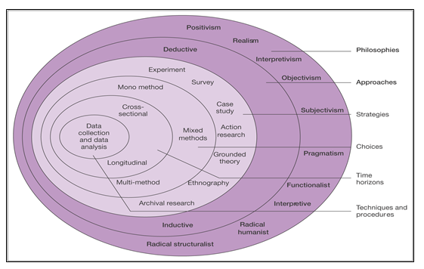
Figure 3.1 The research onion
(Source: Saunders et al., 2009)

3.2 Research Objectives

This study seeks to answer the following question.

Is the current medium and layout in the provision of instructions for undergraduate business students, perceived by them as appropriate for their purposes?

The following three objectives will be explored.

- To identify if there is a preference for digital or printed medium of delivery of instructions and manuals among millennial undergraduate business students.

- To qualitatively evaluate if medium format or layout influences or affects millennial undergraduate business student’s reading, comprehension or retention of material from instructions and manuals.

- To what extent are current provision of instructions and manuals perceived by millennial undergraduate business students as being appropriate for their purposes pertaining to preparing them for their course of study or employment progression?

3.3 Research Philosophy
Before any researcher decides what to research or how to carry out the research, they first must ask themselves why they are doing the research, or what is their philosophical perspective (Remenji et al., 1998)? Burrell and Morgan (1979) suggests that in doing this the researcher must be guided by their values and principles, from their background and culture, with regard to two aspects, the essence of society and the essence of nature. Based on these core assumptions, a philosophical perspective may be formed. Saunders et al., (2009) in their research onion put forward four sub- philosophies, positivism (recognising only what can be scientifically proven), realism (reality exists notwithstanding what the researcher believes), interpretivism (the research of people and situations rather than things) and pragmatism (what best suits to answer the research question).

3.3.1 Pragmatic approach
Creswell (2003), among others, contend that the ontological and epistemological beliefs of the positivist and the interpretivist frame of reference are basically at opposite ends of the chain, rather than being totally divided. Thus they can be used together in research if needed (Brannen, 1992; Teddlie and Tashakkori, 2003). Creswell (2003) further argued that despite these two philosophies using different perspectives and dialogue to construct new knowledge, the utilisation of both viewpoints could be merged to form a pragmatic philosophy. This allows the researcher to use the most suitable approach to best answer the research question, by combining different perspectives, if necessary, thus eliminating any weakness that either one would present. Gorard and Taylor (2004) believe that this mixed methods approach led to a stronger, cogent, accurate entity, in line with the pragmatic philosophy of doing what works best.
Denzin (1970) also posits that the use of qualitative and quantitative research methods allowed for a more robust result. He argued that qualitative methods were not suitable to ascertain how variables interact or correlate to the fact under study. In the same vein he believed that quantitative methods were unable to show the intricacy of the same fact within a given situation. Grey (2004) agreed with him, saying that by using a pragmatic philosophy, with mixed methods, it allowed for triangulation of results and thus gave a more rigorous and robust research answer. Based on this, the researcher is adopting a pragmatic philosophy by utilising whatever approach or method, alone or combined, to best answer the research question.

3.4 Research Approaches
There are three different research approaches to be considered, inductive, deductive and abductive. While an abductive approach seeks to explain some ‘surprising’ fact or ‘puzzle’ with the best possible explanation, it is an onerous task and as such the researcher has discounted it from this study (Bryman and Bell, 2015).

3.4.1 Inductive and deductive approach
Trochin (2006) describes the two sets of research rationales as inductive and deductive approaches. One works from the specific to the general, while the other works from the general to the specific. Silverman (2013) referred to a deductive approach as looking at what research was there already and developing a hypothesis from it. Then collecting the data to either agree or disagree with it. Creswell and Plano Clark (2007) describe an inductive approach as taking a specific theory or question and working back into the existing research and literature to see if it is a new hypothesis or an existing one.
The researcher is going to take a deductive approach to answer the research question. This allows for both quantitative and qualitative data collection methods to be used in order to best test that which has been put forward in previous research relating to the subject (Kothari, 2006).

3.5 Research Strategies
While there are many different names for the same type of research (quantitative, empirical, deductive, explanatory or qualitative, inductive, exploratory, formulative) quantitative and qualitative are the terms being used here (Hinchey, 2008; Saunders et al., 2009; Engel and Schutt, 2005; Kothari, 2006; Bernard, 2006).
Owing to the time constraints of this study, both quantitative and qualitative research will run concurrently. Apart from the aforementioned it will also allow for triangulation of results between the literature and the primary research gathered (Creswell, 2003).
Bryman (2006) postulates that mixed methods should be acknowledged as a third kind of research method in its own right alongside quantitative and qualitative, rather than as a combination of both. The mixed methods approach employed by the researcher is deemed ’fit for purpose’ as this is appropriate and pragmatic to research the problem.
Both the quantitative and qualitative research is weighted equally in this study. The researcher will utilise two different research strategies in order to best answer the research question. The first strategy will be the use of questionnaires in order to find out what is the reading preference of the millennial generation. Bryman and Bell (2011) postulate that this is the most appropriate means to gather information from a large sample, and this will be required in this instance. The second strategy will be semi-structured interviews with some students and some recent graduates in order to ascertain at a deeper level, if these preferences or factors that shaped the generation, have had an effect on their study or employment progression (Bannister et al., 2011).

3.6 Research Choices

3.6.1 Mixed methods
Mixed methods research is defined as combining both qualitative and quantitative research methods in one study in order to answer the research question. Creswell and Plano Clark (2007) would question the concord between the two research methods, but Teddlie and Tashakkori (2003) support the use of the best method, or combination of methods, to answer the research question from a pragmatic point of view. Creswell and Plano Clark (2007) state that there must be at least one qualitative and one quantitative element in any mixed method research approach.
While there might be many reasons to conduct mixed methods research, it can be utilised to bolster each of the research methods that alone may not be so robust. The quantitative can give the figures and numbers and the qualitative can give the stories and explanations (Teddlie and Tashakkori, 2003; Creswell, 2005). With this in mind the use of more than one method eliminates or minimises any impediment that either may possess. It also may highlight a further area of study that the researcher may not have known or thought about (Teddlie and Tashakkori, 2003).
Therefore the researcher will use a mixed method research choice, as this will allow for triangulation of results, and fits best with the pragmatic philosophy being adopted for this study.

3.7 Time Horizons
Saunders et al. (2012) would suggest that the time horizon for a given study should be guided by the research objectives and should be chosen to allow for the possibility of the best answer to the research questions. Either a longitudinal or a cross sectional time horizon may be used. A study, like this one, with time constraints is more suitable to a cross sectional snap shot of what the situation is at a particular time (Creswell, 2005).

3.8 Data Collection Methods

3.8.1 Research design
Research design is the scheme devised by the researcher to best answer the research questions (Saunders et al., 2012). Using the information gathered from the secondary research in the literature review the researcher will conduct exploratory primary research, in order to investigate what are the preferences of millennial undergraduate business students when reading manuals or instructions (Sheilds and Rangarjan, 2013). The researcher also wants to explore if these same preferences have had an effect on their study or employment progression.
This will include both quantitative and qualitative research being conducted simultaneously. This will enable triangulation of results. This mode enables the data that is gathered from the quantitative questionnaires, following the qualitative data from the semi-structured interviews, to be compared to check if they back up each other.

3.8.2 Sampling
Bryman (2012) discusses different sampling techniques that aid in choosing the correct sample to answer the research question. Probability sampling allows for any member of the wider population to be chosen, whereas non probability allows the researcher to choose from a specific cohort that is more suitable for gathering the information required. Random sampling, on the other hand may appear to be an easy choice of selecting a sample at random from the overall population but it has its disadvantages. For example, there may be an imbalance in the sample chosen, for instance age, gender etcetera (Neuman, 2003). Newman (1998) posited for the use of stratified sampling when choosing a large sample for a study.
In the first instance, non-probability stratified random sampling will be chosen, as this will allow the researcher to ascertain if year of study, gender, age etcetera has an impact on the undergraduate business student’s preferences or choices. Consideration will be given to this sample to avoid convenience sampling or snowballing as this could give a biased result (Lucas 2014a; Berg, 2006). The use of questionnaires will allow for a large amount of data to be collected while having a lesser undertaking on the part of the respondents. Also with the use of mainly closed ended questions, the researcher will be able collect the most relevant information without having an extraordinary amount of data to analyse, some of which may be irrelevant. Some questions will allow for deeper expansion on the answers given. The attitudinal and behavioural questions will assist the researcher best in this instance while the fact based stratification questions will show if these have an effect on the preferences shown.
For the second instance, convenience non-probability sampling will be implemented by the researcher for semi-structured interviews with a total of six (two undergraduate business students at both second year and fourth year of their studies as well as two recent graduate) interviews. This sample is known to the researcher, at a superficial level, through their business. These interviews will give a deeper insight into the preferences and experiences of this cohort as they progress through their studies on to employment.

3.8.3 Pilot phase
The pilot phase is performed in order to examine if any adjustments needs to be implemented to the questionnaire questions or layout or to the interview questions. This is basically “a small-scale test of the methods and procedures to be used on a larger scale …” (Porta, 2008).
A sample of ten was chosen for the questionnaire pilot study and two for the interview pilot study. Some minor adjustments were highlighted in two questionnaire questions to clarify what was being asked and an additional two questions added based on the answers received. In relation to the interview questions, it emerged that some would require the researcher to ask a probing “why” where brief answers may be possible.

3.8.4 Ethics, reliability and validity
Ethical issues arise at all stages of the research process, from the actual research project to how the data is collected, analysed and published. Bersoff and Bersoff (2008) noted that ethics must be considered from the conception of the research idea. They argued that ethical issues emerge when the body doing the research, view the subjects of their research as a means to an end rather than giving them the respect that they deserve. Wolf (2009) posited that participant coercion can be an issue that is sometimes hard to see, for example through compensation or a relationship, whether work related or not.
Coyle and Olsen (2005) propose that researchers should adopt a principle of nonmalefience. The American Counselling Association (2005) endorse beneficence by stipulating that participants have a right to informed consent. The code also outlines ways that the study in no way harms the participant before, during or after the research and the benefits of the study to the individual and society be more significant than the risks to the individual. Emmanual et al. (2000) and King et al. (1986) expound that justice must also be considered when undertaking research and the risks and benefits must also be equally distributed not just among participants but among society as a whole. This follows on from research that was carried out where the risks to the research subjects were disproportionate to the value to society of the results, for example the Tuskegee syphilis study. Rosenthal (2008) postulates that there also needs to be social validity to the study and if there was no benefit to society or professional practice of some sort, then the time and effort of the participants was in vain and thus was disrespectful to them.
All participants gave informed consent and were made aware that they could withdraw within a timeframe if they so wished. Anonymity and confidentiality was assured and explained. No identifying data was collected from the surveys and this was communicated in advance of their completion. Ethical approval for this study was granted by the ethics committee of Griffith College Dublin, which is independent to the researcher. (Appendix three)
While these issues arise when selecting a sample and collecting the data, how the data is analysed and presented also presents issues. Creswell (2005) argues that the analysis of the data collected needs to be honest, reliable and valid. Any bias that the researcher may have needs to be made clear from the onset, especially with the analysis of qualitative data, and the steps to overcome this needs to be made clear, for example triangulation of results (Trochin, 2006). In quantitative research the sample size is important so that the power of the study is correct and not causing an error of not finding a relationship in the research when in fact one exists in the wider field (Heppner et al., 2008; Myors, 2008). Heppner et al. (2008) posits that the opposite is also true when the sample size is smaller to allow for the desired results and the researcher presents many of these in order to present a stronger argument. Apart from being unethical, it also undermines the conclusion validity of the study.

3.8.5 Data collection
The researcher will compile questionnaires using Google Forms and distribute via electronic means. Experience from previous research has shown the researcher that more meaningful information can be gained when a hands on analysis, through viewing the data forms is employed, as this is small scale research and so more informative to the researcher.
Semi structured interviews will be conducted with the specifically chosen undergraduate business students and recent graduates in order to ascertain if their preferences and experience back up the information gained from the questionnaires and the secondary research. It will also give the researcher an insight into how or if their preferences or experience has changed or affected their study or employment progression.

3.8.6 Data analysis and findings
The data collected will be analysed and presented with the aid of charts and graphs, where appropriate, to allow for an easier first glance presentation. The data from the questionnaires is produced in both summary (charts) and individual (excel) responses, with additional charts compiled from the data as required. The interviews will be recorded and transcribed by the researcher. Further ‘cleaning up’ of the transcriptions is completed to eliminate purposeless discourse. All six interviews will be transcribed question by question. This allows the researcher to more easily identify themes when coding these transcripts. Coding is used to assemble blocks of related data so that meaning can be gleaned from it (Creswell, 2009). Finally the primary research data will be analysed in conjunction with the secondary data to see if there is a correlation or new information gained (Creswell, 2009).

3.9 Summary
A pragmatic positioning is adopted where deductive reasoning from a mixed methods approach in a cross sectional time horizon is deemed most suitable using both a stratified random and convenience non probability sample. Ethics, reliability and validity is discussed along with collection and analysis of the data.

Chapter Four: RESEARCH FINDINGS AND ANALYSIS

The researcher chose mixed methods to gather the primary research data. One hundred and seventy nine questionnaires were delivered electronically, with fifty seven replies received, giving a 32% response rate. Because of time constraints it was decided to continue with this number as there was a lot of qualitative data contained in the responses. (Appendix five) Six interviews were conducted with one male and one female from each of second year, fourth year and two recent graduates. (Appendix four) Both data collection methods are being used together to reinforce each other.
The primary data collected is presented and analysed in relation to the three objectives of this dissertation study, incorporating the findings from the secondary research.

4.1 Demographics

GENDER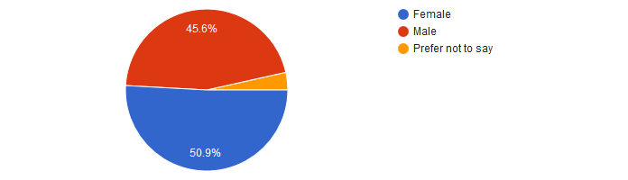
Figure 4.1 Gender profile 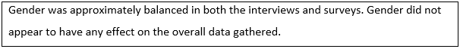 AGE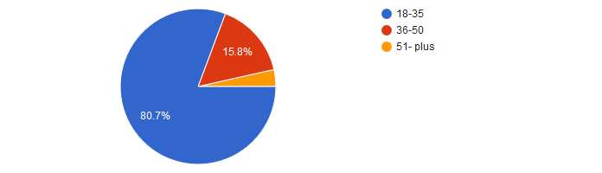
Figure 4.2 Age profile

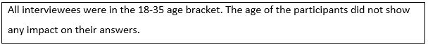

YEAR OF STUDY
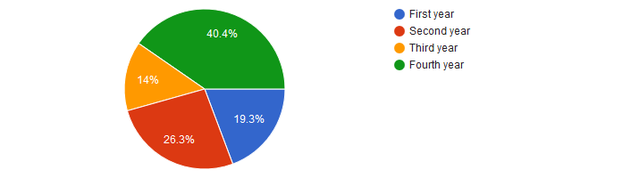
Figure 4.3 Year of study profile

NATIONALITY

Figure 4.4 Nationality profile
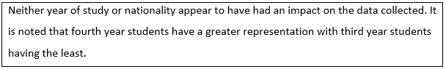

4.2 Findings and Analysis of Objective One

4.2.1 Research objective one
To identify if there is a preference for digital or printed medium of delivery of instructions among millennial undergraduate business students.

4.2.1.1 What technology is owned and used?

Do you own and use a smart phone?

Figure 4.5 Smart phone ownership and usage

Do you own and use an e-reader?
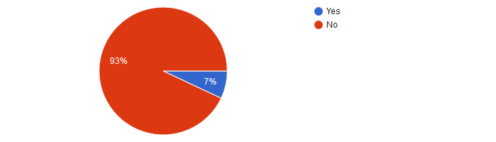
Figure 4.6 e-Reader ownership and usage

Do you own and use a laptop computer?
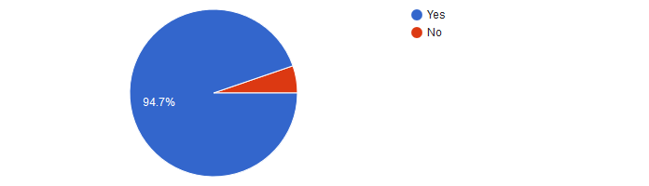
Figure 4.7 Laptop ownership and usage

Do you own and use another electronic device that enables reading? If yes, please specify.

Figure 4.8 Another electronic device to read

Do you own another electronic device for other purposes? If yes please specify what device and for what purpose?

Figure 4.9 Another electronic device for other purposes
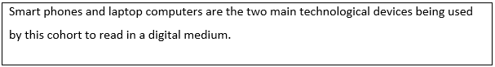

4.2.1.2 Respondent’s introduction to technology

Did you grow up using technology in your childhood?


Figure 4.10 Childhood technology usage
At what age did you start using technology?

Figure 4.11 Age started technology usage
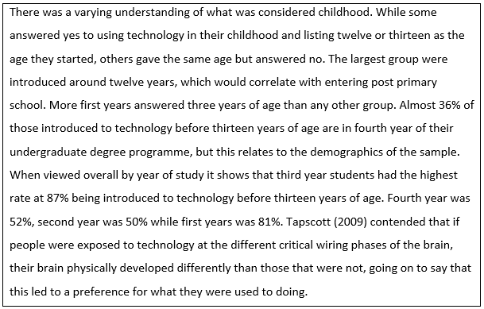

Who introduced technology to you?

Figure 4.12 Who introduced technology?
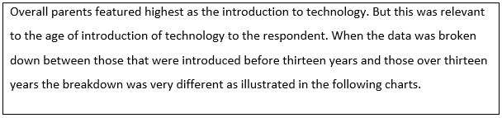
Breakdown of who introduced technology to those that were under 13 years

Figure 4.13 Who introduced technology if before thirteen years old
Breakdown of who introduced technology to those over 13 years.

Figure 4.14 Who introduced technology if after thirteen years old

4.2.1.3 Respondents use of technology
Did or do you play computer games that involved just you playing against the computer?

Figure 4.15 Computer games played against a computer 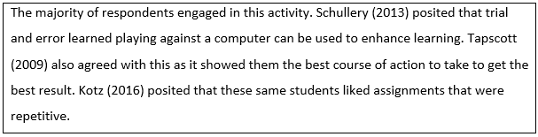
Did or do you play computer games with online friends that you never met in person?

Figure 4.16 Computer games played against strangers 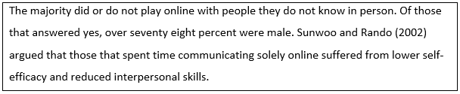

Did or do you play computer games with people you know in person?



Figure 4.17 Computer games against people you know in person

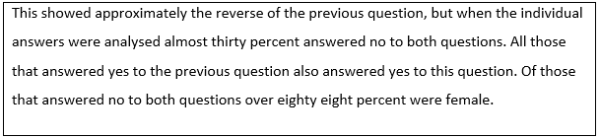
If yes, are these competitors’ peers or family members?
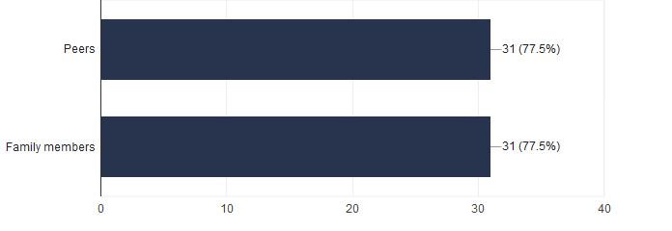
Figure 4.18 Are these peers or family
Did you play with these competitors online (in a different room or location) or in the same location (in close physical proximity)?
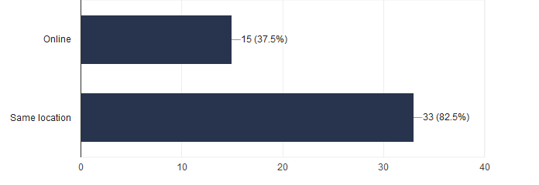
Figure 4.19 Where computer games were played 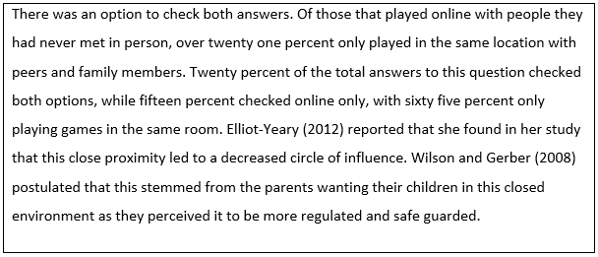

How many hours a day did you spend on technological devices, outside of school purposes, when growing up?

Figure 4.20 Hours spent using technology as child
How many hours per day do you now spend, outside of study or work purposes, on technological devices?

Figure 4.21 Hours spent using technology now 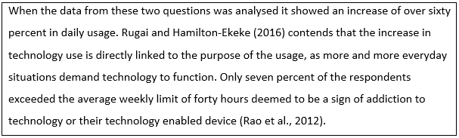

4.2.1.4 Digital versus Print
Did you read books as a child?
Figure 4.22 Did you read books as a child?
If yes, did you read in digital or printed medium?

Figure 4.23 Did you read digital or paper?

Was there a reason for your preference?

Figure 4.24 Was there a reason for your preference?

If yes, what was the reason?
Do you read books now?
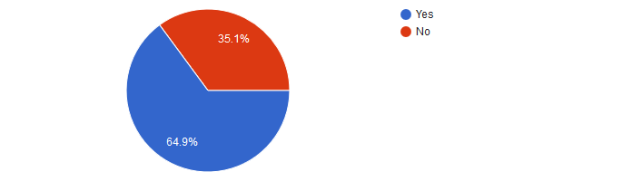
Figure 4.25 Do you read books now?
If yes, do you read in digital or print medium?
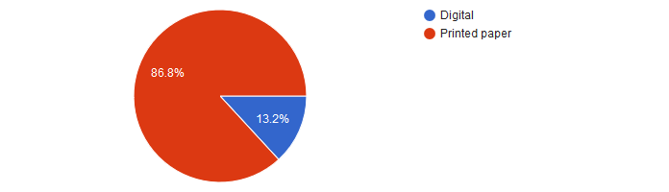
Figure 4.26 Did you read digital or paper?
Is there a reason for your preference?

Figure 4.27 Is there a reason for your preference?
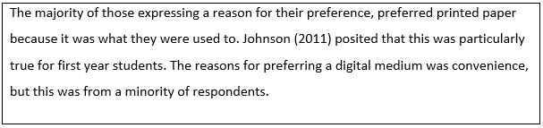
Have you a preference for a particular written content in a digital medium?

Figure 4.28 Preference for a particular written content in a digital medium
If yes, what type of content and why?

Figure 4.29 What type of content and why?
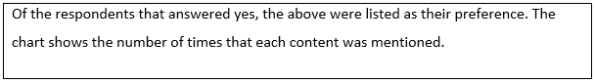
Have you a preference for a particular written content in a print medium?

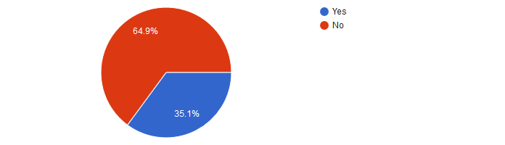
Figure 4.30 Preference for a particular written content in a printed paper medium

If yes, what type of content and why?
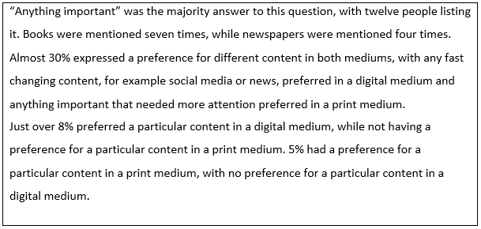

4.2.1.5 Analysis of Interview Answers

The following questions were put to the six people interviewed. (Appendix four).

Might you know what medium business students use to read instructions and manuals for their course of study?
All six people said that business students use an online digital medium to read instructions and manuals. Two pointed out that once they find what they are looking for online, they print out the content to read, and they believe a lot of their classmates do the same.

Do you have experience of this and what has it been?
One interviewee said they preferred to use mixed mediums to read content. The other five said they personally use the online virtual learning environment, provided by their institute, with all five stating that they print off the content they see as important or that they need to remember, in order to read it. Three pointed out that they like to highlight the important parts on the physical page.

Is there any preference for a particular medium within this cohort?
Four said that print was preferred, while two felt a digital medium was the preference. Those that felt print was the preference went on to say that they personally believe it is a more suitable medium for comprehension and retention, but noted online was more suitable to finding what you were looking for first. One respondent argued that it could vary depending on what they were reading.

In your opinion, do you think that your use, or not, of technology has had an influence on your medium and format or layout preference? How?
Two of those interviewed felt that their prior use or not of technology had no effect on their preference of medium. Four believed it had an effect, with two of these indicating that with the connectedness of technology, and their love of this, that the distractions were too much when they read from a digital medium. Dennis (2011) claimed that this constant distraction led to less attention being paid to the content but said that the more experienced student had a greater ability to deal with it. Two others maintained that a digital medium had an advantage because it allowed you to find what you were looking for when you wanted it, thus allowing you to have content on hand that could not get mislaid. This fits in with Benninghoff (2017) when he argued that millennials want instant gratification in every aspect of their life.

4.2.2 Summary
100% of those surveyed owned and used smart phones and 95% laptops, while only 7% an e-reader. The majority did not own or use other digital devices for the purpose of reading. Just over 50% grew up using technology, with the largest group introduced at twelve or thirteen years, but the majority before this age. After this age family had no influence on the introduction of technology.
11% own a game console yet 84% have played computer games against a computer. This would indicate that online gaming is the norm. 25% played online with people they did not know in person, while 70% played with family and peers equally, in close proximity at the same location. This correlates with the literature of the closed circle of influence.
Daily hours spent on technology increased by 60% from childhood, but this could be linked to purpose of usage. Only 7% exceeded the weekly hours deemed to suggest an addiction.
70% read books as a child (100% print) with 65% still reading (87% print) as adults. Those that expressed what influenced their preference cited the lack of e-books in childhood to it is what they are used to in adulthood.
39% expressed a preference for a particular content in a digital medium, which consisted of fast changing content like news or social media. 35% had a preference for particular content in a print medium, with ‘anything important’ being cited most often. This was echoed in the interviews where it was pointed out that the preference of medium could change depending on the content. While all interviewees used their institute’s virtual learning environment, they all said that they print off material to read that they deem important or need to remember, while some believed it was superior for comprehension or retention. It was noted that there was a preference for an online medium to find the material but a print medium to read. Reasons for preferring print was outlined as their love of technology and its connectedness led to too many distractions while reading from a digital platform. Reasons in favour of a digital medium was availability of content when they wanted it, which correlated with afore mentioned impatience of the millennial.
Therefore it would appear that print medium is the preference for reading anything important or requiring concentration to comprehend or remember, but digital is the preference for fast changing content like news or social media.

4.3 Findings and Analysis of Objective Two

4.3.1 Research objective two
To qualitatively evaluate if medium or format influences or affects millennial undergraduate business student’s reading, comprehension or retention of material from instructions.

4.3.1.1 Delivery medium preference
What delivery medium do you prefer to read for academic purposes?
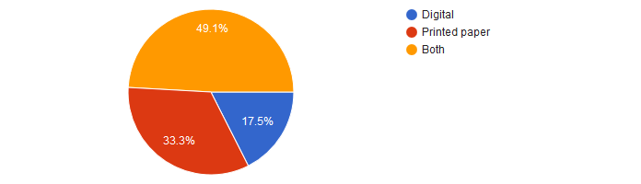
Figure 4.31 Preference of delivery medium for academic purposes
Why in a printed paper medium?

Figure 4.32 Why in paper medium?

Why in a digital medium?

Figure 4.33 Why in digital medium?
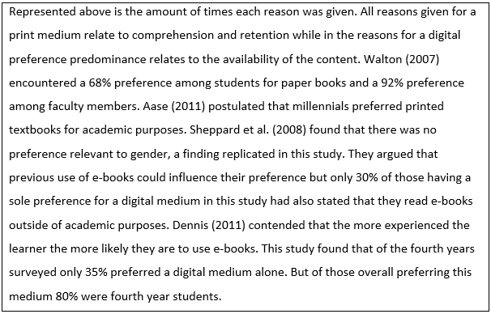

If digital, do you use any special software to assist the reading purpose?

Figure 4.34 Special software to assist the reading purpose in a digital medium
If yes, what software do you use?

Figure 4.35 What software is used?

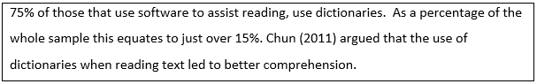

When reading, in any medium, do you use notetaking or highlighting to assist comprehension and retention?

Figure 4.36 Notetaking or highlighting to assist comprehension and retention
If yes, what format or medium do you use?

Figure 4.37 Format and medium used for highlighting and notetaking
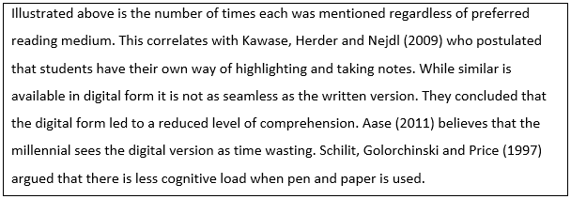
When reading for pleasure, what medium do you prefer?

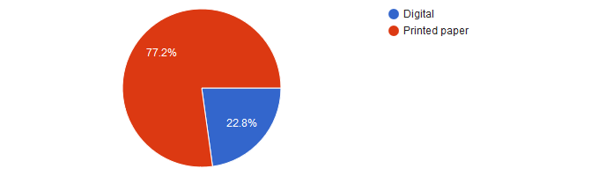
Figure 4.38 Medium used for reading for pleasure
Why do you prefer this medium?
Print medium

Figure 4.39 Why preference for printed medium?

Digital medium

Figure 4.40 Why preference for digital medium?
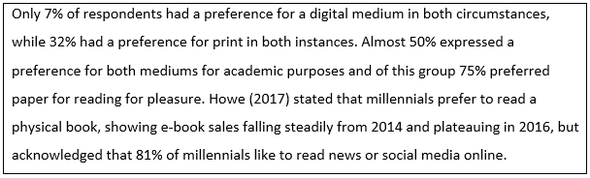
When reading for instructions or rules, what medium do you prefer?

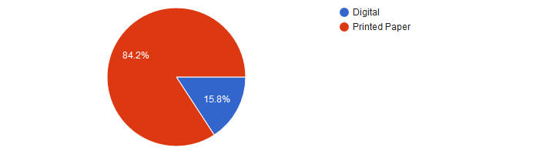
Figure 4.41 Preference of medium when reading for instructions or rules

Why do you prefer this medium?
Print medium

Figure 4.42 Why preference for printed medium?
Digital medium

Figure 4.43 Why preference for digital medium?

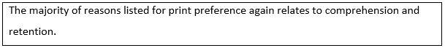
Do you print online content for your course for the purpose of reading?


Figure 4.44 Do you print online content to read for your course?
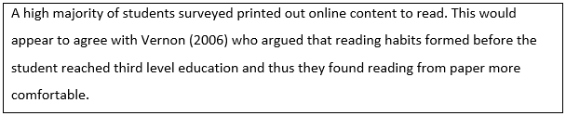

4.3.1.2 Reading Instructions and Manuals
When did you last read a digital manual or set of instructions?

Figure 4.45 When did you last read a digital manual or set of instructions?
Did you read it completely?


Figure 4.46 Did you read it completely?
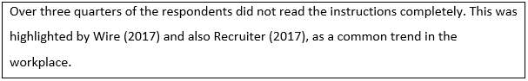
If no, why?

Figure 4.47 Why was it not read completely?

When last did you read a printed paper manual or set of instructions?

Figure 4.48 When did you last read a printed manual or set of instructions?


Did you read it completely?


Figure 4.49 Did you read it completely?

If no, why?

Figure 4.50 Why was it not read completely?

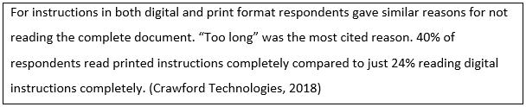

Do you have a preference for detailed instructions or bullet point instructions in a manual or set of instructions?

Figure 4.51 Preference for detailed or bullet point instruction format

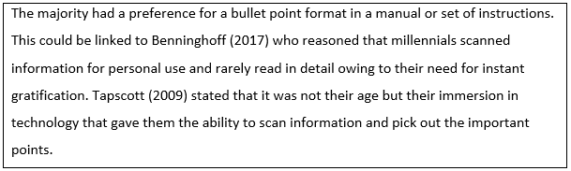

What has influenced your preference?
Bullet point instructions

Figure 4.52 Why bullet point instructions?
Detailed instructions

Figure 4.53 Why detailed instructions?
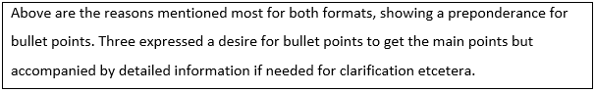

4.3.1.3 Reading in an Academic Setting

What type of delivery medium, in your opinion, is best suited to you for reading academically for your course?

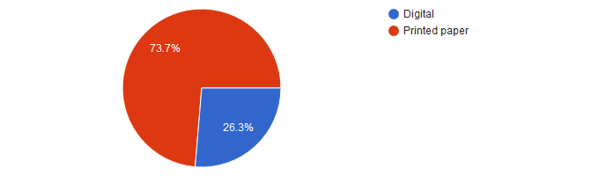
Figure 4.54 Preference of delivery medium when reading academically
Why?
Print medium

Figure 4.55 Why preference for printed medium?

Digital medium

Figure 4.56 Why preference for digital medium?

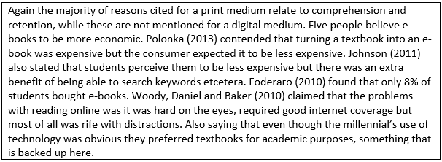

4.3.1.4 Comprehension and Retention

Which type of reading medium, in your experience, is best suited to you for comprehension of the content?

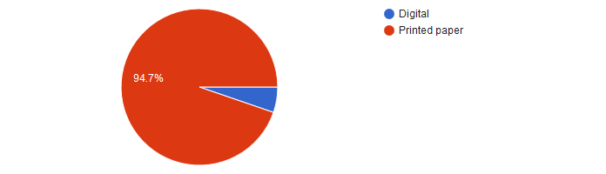
Figure 4.57 Type of reading medium best suited for comprehension of the content

Why?
Print medium

Figure 4.58 Why preference for printed medium?
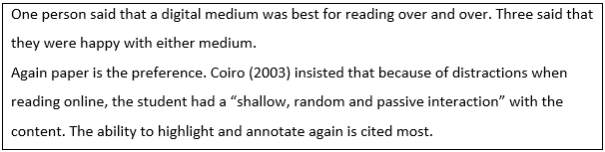

Which type of reading medium, in your experience, is best suited for retention of the content?
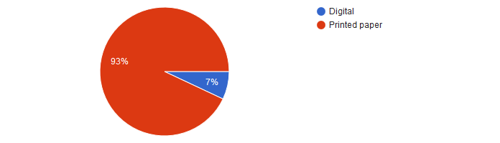
Figure 4.59 Type of reading medium best suited for retention of the content
Why?
Print medium

Figure 4.60 Why preference for printed medium?
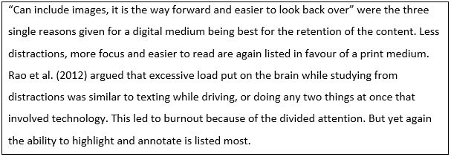

4.3.1.5 Layout and Format
Does the layout or format of the content, in your experience, have an effect on your reading or comprehension of the content?
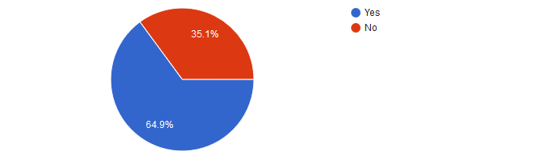Figure 4.61 Does layout or format of the content affect reading or comprehension?
If yes, why?

Figure 4.62 What perceived effects?
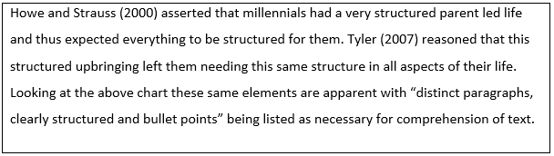 From your experience, does digital and printed content, need to have a different layout or format?

Figure 4.63 Does digital and printed medium need different format?
If yes, why?

Figure 4.64 Why is different format needed?

4.3.1.6 Analysis of Interview Answers

The following questions were put to the six people interviewed.

Is there a relationship between the reading medium and comprehension or retention, in your opinion?
All six interviewed believed there was. They all inferred that a print medium was more conducive to the retention of the material. Five of the interviewees offered an explanation for their choice, saying that it allowed for highlighting the important sections as well as being able to annotate.
While one did not offer an opinion on comprehension, two felt that paper was best suited to this also. One of these relayed that when reading digitally there was too many distractions and this interfered with the comprehension and retention of the material. Three stated that their preference was for a digital medium for comprehension, with one adding that they could use add-ons, like dictionaries etcetera, to fully understand the text.
One of the interviewees elaborated that it may not be the medium alone, but the student’s own habits or nature that could have a bigger effect on comprehension or retention of the material. Three mentioned that format or layout also played a role.

Would you consider, from your experience, that different mediums require different formats or layouts?
Four of the interviewees answered yes to this question, going on to say that books laid out online like paper books is not a good idea. They stated that it is hard to keep focus as the text runs into each other. They felt that a layout like a website or a magazine would be more beneficial. Sanchez and Wiley (2009) argued that long passages in a digital format caused problems with concentration. The others suggested that instructions need to be to the point and clearly laid out and not in a long boring text. They also noted that different content needed different layout. Two of the interviewees did not believe that it mattered if format and medium were interchangeable.

Is there a relationship, in your opinion, between medium and format or layout that affects comprehension or retention of the content read?
All six maintained that layout or format was important. Two suspected that medium also played a part, while the other four judged it to have no effect. One pointed out that medium was important for different learning styles or for those using assistive tools. Another argued that the purpose of the content would have an influence on the medium or format used.

4.3.2 Summary
Half of those surveyed preferred to have both digital and print mediums for reading academically, while only a third preferred print only. Print was deemed to be best for comprehension and retention, with digital for availability. 29% of those preferring digital used software to assist reading, mainly dictionaries, but this equates to only 11% of the overall sample. 81% annotate and highlight to assist comprehension and retention with only one person using a digital version. All interviewees concurred with this.
77% prefer a print medium when reading for pleasure mainly because they find it easier to read, more enjoyable and like the feel of it. While those that prefer digital say it has more content, can stay connected and is more convenient. 84% prefer print when reading instructions stating that it is easier to read, easier to understand and they can annotate and highlight. While the main preference for digital was the availability of videos. 83% print online content for their course for the purpose of reading as did all the interviewees. Vernon (2006) postulated that this stemmed from what they were used to doing in second level education and found it hard to change.
The vast majority had been presented with instructions or manuals, in print and digital mediums, in the previous year with 75% not reading the digital one fully and 60% not reading the print version completely. The main reason cited, for both, was that they were too long. Again the impatience of the millennial is showing through (Hill, 2014). 88% would like instructions in bullet point format. Millennials ability to scan information for main points could play a part in this instance (Small, 2008).
74% believe that a print medium is most suitable for reading academically because they can highlight, annotate, is easier to read and remember. A digital medium was preferred by a minority because of availability of content and economics but with no mention of comprehension or retention. 95% believe that print is best for comprehension and retention because yet again they can annotate and highlight. This keeps coming up throughout the survey and interviews and appears to be the main mechanism in use or preferred for comprehension and retention. Kawase, Herder and Nejdl (2009) would argue that the students own way of highlighting or annotating leads to better comprehension and retention.
65% consider format or layout has an effect on reading and comprehension, stating the clearly structured, distinct paragraphs were best. As mentioned in chapter two the highly structured life of the millennial as a child could account for this preference (Coomes and DeBard, 2004).
Only 30% feel that different mediums require different layouts, with the need for the content to fit on the reading screen seen as the most important. During the interviews it was pointed out that the purpose of the content would have an influence on the layout.
It would appear that medium has a bigger effect on comprehension and retention than layout, with a clear preference for print owing for the ability to annotate and highlight manually.

4.4 Findings and Analysis of Objective Three

4.4.1 Research objective three

To discern to what extent are the current provision of instructions, perceived by millennial undergraduate business students, as being pertinent with regard to preparing them for their course of study or employment progression.

4.4.1.1 Suitability of Delivery Medium

Based on your experience, would you perceive the delivery medium of manuals and sets of instructions, as delivered by your institution, as appropriate for their purposes?

Figure 4.65 Suitability of delivery medium

If no, what medium would you consider more appropriate?

Based on your experience, is your course content delivered in the most appropriate medium for you personally, by your institution?


Figure 4.66 Is course content delivered in the most appropriate medium?
If no, what medium would you consider more appropriate?

Figure 4.67 What medium would you consider more appropriate?

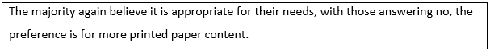

4.4.1.2 Analysis of Interview Answers

The following questions were put to the six people interviewed.

To what extent, from your experience, are the current delivery mediums of instructions or manuals for your course of study appropriate for their purposes?
Four believed that they were appropriate for their purpose, while one believed they were not with one undecided. But all six believed that when the content is delivered online it gives the individual student the choice to print it out or read it on screen. They felt that this best catered for all preferences of delivery medium. The one person that believed that they were inappropriate, felt that not only the delivery medium but the format was flawed from a comprehension point of view.

Would you consider the format or layout of these instructions and manuals to be appropriate for both delivery medium and comprehension?
Five said that the delivery medium and format was appropriate, with one disagreeing. The problem he had was that they had received instructions on a subject with just five bullet points and no further explanation. This same person had found the delivery medium inappropriate. He felt that even if they were supplied with a longer list of bullet points it would have helped a little more. This did not correlate with two other interviewees from the same institution and course, although from different years of study. Of the five that found the format satisfactory for the delivery medium three disagreed that it was suitable for comprehension. Bullet points or more concise instructions was the preferred format. Only one was satisfied with the format for both delivery and comprehension.

To what extent, in your opinion, did the medium, format or layout of instructions or manuals have on your overall learning and assessments in your course of study?
There was a mixed response to this question. Two said it had no real impact while one said it very much impacted, with the other three saying it impacted at different stages of their course. This was also reflected in one of the no answers. They believed that the impact was felt most beneficially in first year, becoming less and less as they progressed through their course. Three pointed out that in the first term of first year they were lost as to what to do or how or where to find out what to do. They said the initial experience was overwhelming. One suggested that maybe a different layout would suit different years of study.
This relates to Twenge (2008) who postulated that millennials were more anxious in a new environment and need a more structured one, with Johnson (2011) maintaining that first year students prefer paper books because it is what they are used to.

Would you consider, from your experience, that your preference of reading medium or format, and the one provided by your institution, has or had an effect on your study or employment expectations or progression?
Four answered no while two said yes to this question. Those that said no went on to say that they themselves adjusted to whatever suited them best in any given situation, thus lessening the impact. One interviewee that answered yes further clarified that she had learned what worked best for her and it was something that she would be taking forward to her workplace. Basically five of the respondents believed they had learned to adjust to an individual situation and how to maximise the available resources for maximum gain. The believed going forward to the workplace this would benefit them. Two noted that their workplace provided instructions in multiple mediums but acknowledged that all workplaces may not have the facilities of their institute for delivery mediums etcetera.

In what medium would you like to see instructions and manuals, for your personal use, provided in for your course of study?
The answered were evenly divided between physical textbooks and online digital medium. Two of the three that prefer an online medium went on to say that this would suit more students as they had the choice to print the content if they so desired. The other person preferring a digital medium, would like it in app format for convenience and ease of use.
Reasons for wanting a printed paper medium varied from more reliable from content to less dependent on chargers and Wi-Fi etcetera. One felt that screen reading is harder on the eyes and less suited to retention of the content. Again the stage of their course had an influence on their preference. One person again made the point of first year students needing more concise guidance on what to do and felt that the overload of information on the virtual learning environment was confusing when you did not know much about any of it. He believed that a concise written book with general assignment instructions would be better as then you could concentrate on the content.

In what format or layout would you like to see instructions or manuals, for your personal use, provided in for your course of study?
Five out of six would like to see more concise instructions, preferable in bullet point format. Three of these five also suggested that a more detailed version could also be available if you needed further information on any heading. One interviewee said he would like a more detailed format as this is what he finds personally more beneficial.

Did you ever get an opportunity to have an input into the format or medium of delivery for instructions or manuals for your course of study?
Four had never been asked for any feedback that they could remember. One said they got end of term feedback forms relating to modules and lecturers and there was a section for other comments so they could have entered something there. Only one was asked for feedback specifically relating to their course, facilities and deliverables.
Interestingly here what is provided, although deemed appropriate for purpose by most from both survey and interviews, it is not the preferred medium or format of the students for reading, comprehension or retention of content. Yet only one person was specifically asked for feedback relating to same.

4.5 Further Comments

Questionnaire respondents were asked the following question.

Is there any further comment you would like to add?
Ten commented that an online medium was the most favourable for obtaining content. While they preferred to read from paper, the benefit from the availability of content outweighed the inconvenience of having to print it to read. One pointed out that for those using assistive technology that online content would be more suitable. Also mentioned was the availability of the online library from their institutions, allowed them to study when they preferred as it had no closing time. One respondent felt that there was more up to date editions of books and journals available in the online library in comparison to a physical library, especially in a smaller institution.

4.6 Conclusion
Tapscott (2009) posited that when people are exposed to technology at the critical wiring phases of the brain it physically develops differently. The research shows that the majority of those surveyed were exposed at these three critical stages before thirteen years (Leisman et al., 2015). Parents were the main introducers of technology to this cohort. Bearing in mind what Tapscott posited 84% of those surveyed played or play computer games against a computer where they learn through trial and error the best course of action for the most favourable result. This same action can be used to enhance learning for the millennial (Schullery 2013), with the use of repetitive assignments or game play (Kotz 2016). The majority played online games with both peers and family in close physical proximity, again showing the closed environment of the millennial growing up and the smaller circle of influence (Elliot-Yeary 2012) as their lives were more structured and safeguarded (Wilson and Gerber, 2008). This parenting style leads to problems for the child, when they leave this environment, especially as they take their first steps into higher education or the workplace (Odenweller et al., 2014).
The weekly use of technological devices, while increased by sixty percent on average from childhood, did not exceed the limit, for the vast majority, that is deemed to be addiction (Rao et al., 2012). This was despite the general perception that millennials are always on a digital device. The downside to all this digital use is that teens that are anxious are more likely to communicate digitally thus eliminating face to face communication in order to have a feeling of belonging (Pierce, 2009).
70% read print books as a child with 65% reading books now, mainly in print. The main reason given was because it was what they were used to. This is especially true for first year students (Johnson, 2011), but as they become more experienced learners their needs change or adapted as suggested from those interviewed. The more experienced learner is more likely to use a digital medium that a first year student (Dennis, 2011). In correlation with the literature review, there was a preference for a digital medium with any fast changing content like news or social media (Howe, 2017) and the impatient nature of the millennial. But with this being used for this information gathering process, first time higher education students would need guidance on how to gather relevant and authentic material (Roberts, Newman and Schwartzstein, 2012). All six interviewees stated that they used online sources to find the material they were researching, but printed it for reading purposes. A staggering 83% of respondents printed out online content for their course.
Knowing the millennial’s impatience (Hill, 2014) and their ability to scan text for important points it is not surprising that the majority did not read either digital or printed instructions completely and would prefer them in concise bullet point format.
There was a clear preference for a print medium for comprehension and retention purposes. Questions that did not specifically ask about this, but why they had a particular preference, cited reasons relating to it, while digital preferences were based on availability. The ability to annotate and highlight leads to greater comprehension and retention (Rose, 2011), and is perceived to be best for same among all the respondents.
Despite this apparent preference for a print medium for reading purposes, the vast majority are happy with the current provision of instructions in an online platform for their course. During the interviews it was discussed that the content online allowed for all preferences to be catered for as well as being more suitable to anyone using assistive tools to aid the reading. Only two people mentioned the cost of printing out the material. Is this because their helicopter hovering parents are providing the facility to remove obstacles? Three interviewees believed while the medium was appropriate the format was not. Their preference was for a more concise or bullet point format, again the impatience of the millennial is showing (Hill, 2014).
Kotz (2016) believes because of the structured environment growing up, millennials need this same structure in their education setting. This was emulated by the interviewees who believe that in first year there is a need for a more structured approach but the need lessens as they progress through their course. They said as they progressed they learned what worked best for them. They noted that in first year a more concise format in print medium would have helped because of the overwhelming amount of information and being unfamiliar with their new environment. Allen (2012) argued because of their upbringing they had an expectation that every aspect of their higher education tuition would be structured with no responsibility falling to them like they were used to.

Chapter Five CONCLUSIONS AND RECOMMENDATIONS

5.1 Introduction

The aim of this study was to firstly explore the reading preferences of millennial undergraduate business students when reading instructions or manuals. Secondly it aimed to ascertain if the provision of this content, by higher education institutions, reflected these same preferences. Many factors have an influence on these preferences, from overprotective parents, structured childhoods and technology among others, that also presents implications for higher education institutions and the workplace.

5.2 Digital or Print preference

An incontrovertible preference has been shown for a print medium for the purpose of reading in both the primary and secondary research (Walton, 2007), yet the majority of the respondents say they are happy with the current online provision of these by their institution. This does not appear to tally, as can be seen an overwhelming majority (83%) print out course content for the purpose of reading. The main reason cited for preferring a print medium was the ability to annotate and highlight. This same reason appeared again and again throughout the survey with the respondents believing it helped with comprehension and retention, something that Rose (2011) agreed with. A digital medium was the preference for finding the required material, with availability being the attraction. Based on the findings it appears that different content requires different mediums and this was pointed out in an interview and was backed up by the survey. Paper was the preferred medium for ‘anything important’ and for annotating and highlighting. A digital medium was preferred for any fast changing content like news or social media, which could have implications for authenticity if used by a novice learner.

5.3 Effects of medium, format or layout on comprehension or retention

What is best for comprehension and retention, as pointed out in the interviews, could have as much to do with the individual learner or content as it does to medium or format. Yet the overwhelming preference, for comprehension and retention, shown in this study was for a paper medium with a concise structured layout or format. As mentioned already 83% print out their course content to read, citing that the capacity to annotate and highlight is the main reason. Is this what they have been taught to do in second level education and find it hard to break the habit (Vernon, 2006), or is it that it has a lesser cognitive load than the digital version (Schilit, Golorchinski and Price (1997)? Either way it is the preferred way to aid comprehension and retention among this cohort.
The structured, overprotected childhoods of the millennials has eroded their self-confidence and engagement and stunted their ability to problem solve and deal with hardships, resulting in a ‘quitter’ mentality (Gottlieb, 2011; Twenge, 2006). This affects academic grades (Rutherford, 2011) and could explain their desire for a concise structured layout or format, with little room to make decisions themselves. Basically been given everything they want not necessarily what they need as pointed out by Tulgan (2009).

5.4 Is the current provision perceived as appropriate for purpose?

Overall it would appear that the current provision of instructions and manuals is perceived by millennial undergraduate business students as appropriate for their purpose, of preparing them for their course of study or employment progression. Some meaningful insights were given. Some discussed that different supports or style of delivery of course content was needed at different stages of their course. It was felt that if a more structured and concise format of instructions was utilised in first year it would expedite the learning curve. This was seen in the literature, and that more feedback in the early stages benefitted them also (Bakker, 2011). Yet again it appears to go back to their upbringing where they had constant attention, guidance and validation. Those that had progressed further through their course, or graduated, explained that they had adapted to what worked best for them or best in an individual given situation. Is this because they had matured and learned as they went or was it the distancing of the influence from the helicopter or snowplough parents? Whatever the reason it was felt that learning to adjust to the best solution prepared them for the workplace, where they will have to make decisions to have maximum gain in any given situation.

5.5 Recommendations
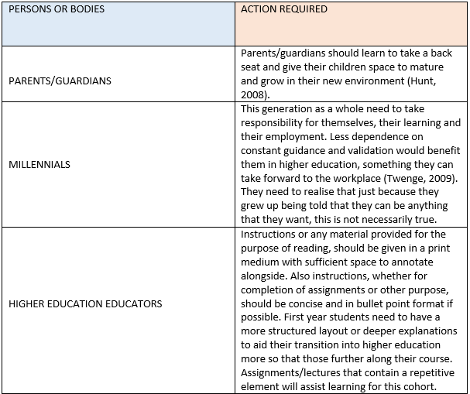
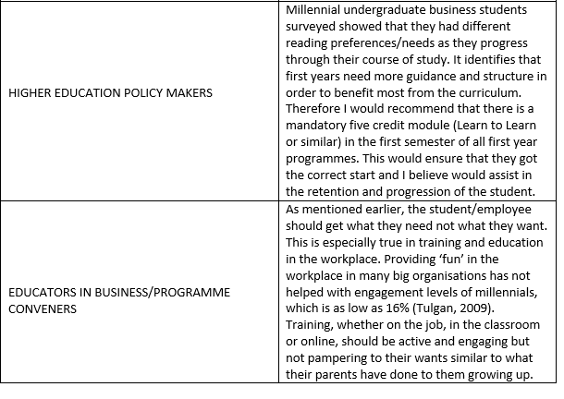

5.6 Further Research

An interesting finding during the literature review, and as it is outside the scope of this study, has led the researcher to propose an area that could warrant further research. Many researchers have noted that if children are exposed to an abundance of technology at the critical wiring phases of the brain that it physically develops differently (Tapscott, 2009). Also the research showed that millennials have been introduced to technology from an early age and are immersed in it as they grow up. They also have a preference for scanning reading material to pick out the main points that they see as important while having no desire to read the complete content (Small, 2008). While this may be seen as passive or surface learning by many older observers, perhaps it is not, and their brain is adept at gathering the information presented. Therefore the researcher believes that a study of this phenomenon could be warranted.

5.7 Limitations and Reflections

The journey through this study was for me a most enlightening experience, not just academically but professionally. This deeper understanding of what has shaped the millennial generation, has allowed me to understand them as people that are a product of their upbringing, the same way we all are. Not only are we trying to teach or work with a generation after our own, but we are doing it with what we were taught from a generation before our own.
When I reflect on what I have learned as a novice researcher, I believe if I was to repeat this study, I would not gather the quantitative and qualitative data simultaneously. While I would still use both quantitative and qualitative collection methods, I would collect the quantitative first and use the data to compose the questions for the deeper qualitative research. I believe this would be a superior pragmatic approach to answer the research question.

REFERENCES
Aase, S., (2011). Print vs online: can there be a cohabitation of competing media and how readers can benefit. Journal of the American Dietetic Association, 111(4), 500–4.

Alch, M.L., (2000). Get ready for a new type of worker in the workplace: The net generation. SuperVision 61(4), 3-7.

Allen, C., (2012). Generational Teaching: Motivating the Minority, 1st ed.
[online] Available at: http://books.google.com/books?id=77HNPGzfVSUC&pg [Accessed 12 Nov. 2017].

Alsop, R., (2008). The trophy kids grow up. San Francisco, CA: Jossey-Bass.

American Counselling Association, (2005). ACA code of ethics. [online] Available at: http://www.counseling.org/Resources/CodeOfEthics/TP/Home/CT2.aspx [Accessed 12 Nov. 2017].

Aric, S., (2010). The impact of screen media on children: A eurovision for parliament.
Journal for Waldorf Rudolf Steiner Education, New Zealand, 15(1).

Bakker, A. B., (2011). An evidence-based model of work engagement. Current Directions in
Psychological Science, 20, 265-269.

Ballantine, J. H., (1999). Getting involved in our children’s education. Childhood Education, 75, 170–171.

Banister, P., Bunn, G., Burman, E., & Daniels, J., (2011). Qualitative Methods In Psychology: A Research Guide. London: McGraw-Hill International.

Baumrind, D., (1991). The influence of parenting style on adolescent competence and substance use. Journal of Early Adolescence, 11, 56–95.

Benninghoff, E., (2017). Millennial Reading Habits | News Media Alliance. News Media Alliance. [online] Available at: https://www.newsmediaalliance.org/millennial-reading-habits/ [Accessed 12 Nov. 2017].

Berg, S., (2006). "Snowball Sampling–I," pp. 7817–7821 in Encyclopedia of Statistical Sciences, edited by Samuel Kotz, Campbell Read, N. Balakrishnan, and Brani Vidakovic. Hoboken, NJ: John Wiley and Sons, Inc.

Bernard, H. R., (2006) Research methods in anthropology: qualitative and quantitative approaches 4th Ed. Alta Mira Press

BersofF, D. M. & Bersoff, D. N., (2008). Ethical perspectives in clinical research. In D. N. Bersoff (Ed.), Ethical conflicts in psychology (pp. 387-389). Washington, DC: American Psychological Association

BlessingWhite, Inc., (2011). Employee engagement report 2011. Beyond the numbers: A practical approach for individuals, managers and executives. [online] Available at: http://www.blessingwhite.com/eee_report.asp [Accessed 12 Nov. 2017].

Borg, W. R. & Gall, M. D., (1996) Educational Research: An Introduction (sixth edition). New York: Longman.

Brannen, J., (1992). Combining qualitative and quantitative approaches: an overview. In J. Brannen (Ed.), Mixing methods: Qualitative and quantitative research (pp. 3–38).
Aldershot/Vermont: Ashgate Publishing Limited.

Briggs, H., (2012). Web addicts have brain changes, research suggests. BBC News Health. [online] Available at: http://www.bbc.co.uk/news/health-16505521 [Accessed 12 Nov. 2017].

Brumberger, E., (2011). 'Visual Literacy and the Digital Native: An Examination of the Millennial Learner', Journal Of Visual Literacy, 30, 1, pp. 19-47.

Bryman, A., (2006) ‘Integrating quantitative and qualitative research: how it is done?’. Qualitative Research, Vol. 6, No. 1, pp. 97-113.

Bryman, A., (2012). Social research methods (5th ed.). Oxford: Oxford University Press.
Bryman, A., & Allen, T., (2011). Education Research Methods. Oxford: Oxford University Press.
Bryman, A., & Bell, E., (2011). Business Research Methods (3rd ed.) Oxford: Oxford University Press.
Bryman, A. & Bell, E., (2015) “Business Research Methods” 4th edition, Oxford University Press, p.27
Bugeja, M., (2005). Interpersonal divide: The search for community in a technological age. New York: Oxford University Press.

Burrell, G., & Morgan, G., (1979). Sociological Paradigms and Organisational Analysis, Hants: Ashgate.

Businesswire, (2017). Study Reveals the Employee Handbook is Becoming Irrelevant. [online] Businesswire.com. Available at: http://www.businesswire.com/news/home/20140402005535/en/Study-Reveals-Employee-Handbook-Irrelevant [Accessed 12 Nov. 2017].

Carr, N., (2008). Is Google making us stupid? Atlantic Monthly, 302 (1), 56-63.
Cash, H. & McDaniel, K., (2014). Digital addiction: Avoiding pitfalls of the online world. Cyber psychology & behavior. USA: National Libriary of Medicine.

Cassidy, S., (2014). The online generation: Four in 10 children are addicted to the internet. [online] Available at: http://www.independent.co.uk [Accessed 28/12/ 2017].

Christakis, D.A., (2010). Internet addiction: A 2lst century epidemic?
[online] Available at: http://www.biomedcentral.com/1741-7015/8/61 [Accessed 28/12/2017]

Chun, D. M., (2001). “L2 reading on the web: Strategies for accessing information in hypermedia”, Computer Assisted Language Learning, vol. 14, no. 5, pp. 67-403

Cline, F. W., & Fay, J., (1990). Parenting with love and logic: Teaching children responsibility. Colorado Springs, CO: Pinon.

Clurman, A., 1997. Rocking the ages: The Yankelovich report on generational marketing. HarperBusiness.

Cohen, L., Manion, L. & Morrison, K., (2013). Research methods in education. Hoboken: Taylor and Francis.

Coiro, J., (2003). Reading comprehension on the internet: Expanding our understanding of reading comprehension to encompass new literacies. Reading Teacher, 56 (5), 458-465.

Coomes, M. & De Bard, R., (Eds.) (2004). Serving the millennial generation. New Directions in Student Services, No. 106.

Corporate Leadership Council, (2005). HR considerations for engaging Generation Y employees. Washington, DC: Corporate Executive Board.

Coyle, A., & Olsen, C., (2005). Research in therapeutic settings: Ethical considerations.
In R. Tribe & J. Mordssey (Eds.), Handbook of professional and ethical practice for psychologists, counsellors and psychotherapists (pp. 249-262). New York, NY: Brunner-
Routledge. doi: 10.4324/9780203323625_chapter_20

Crawford Technologies. (2018). Paper Vs. Digital: Two Sides Survey - Crawford Technologies. [online] Available at: https://www.crawfordtech.com/blog/paper-vs-digital-two-sides-survey [Accessed 11 Apr. 2018].

Creswell, J., (2003). Research design: Qualitative, quantitative and mixed methods approaches. Thousand Oaks, CA.: Sage.

Creswell, J. W., (2005). Educational research: Planning, conducting, and evaluating quantitative and qualitative research. Upper Saddle River, NJ: Pearson.

Creswell, J.W., & Plano Clark, V.L., (2007). Designing and conducting mixed methods
research. Thousand Oaks, CA: Sage Publications

Deal, J., (2017). Millennials Aren’t Impatient. They’re Prudent. [online] WSJ. Available at: https://blogs.wsj.com/experts/2017/05/16/millenials-arent-impatient-theyre-prudent/ [Accessed 4 Jan. 2018].

De Meester, B, De Nies, T, Sigarchian, H, Vander Sande, M, van Campen, J, Van Impe, B, De Neve, W, Mannens, E, & Van de Walle, R., (2014), 'A digital-first authoring environment for enriched e-books using EPUB 3', Information Services & Use, 34, 3/4, pp. 259-268,

Dennis, A., (2011). e-Textbooks at Indiana University: A Summary of Two Years of Research, Kelley School of Business: Indiana University Press.

Denzin, N., (1970). The research act in sociology: A theoretical introduction to sociological methods. London: Butterworth.

Dillon, A., (1992), "Reading from Paper Versus Screens; A Critical Review of the Empirical Literature," Ergonomics, 35(10), 1297-1326,

Dillon, A., McKnight, C. & Richardson, J., (1988), "Reading from Paper Versus Reading from Screen," The Computer Journal, 31(5), 457-464.

Dooley, D., (2001) Social Research Methods (fourth edition). Englewood Cliffs, NJ: Prentice Hall

Elam, C., Gibson, D. & Stratton, T., (2007). Welcoming a new generation to college: the millennial students. Journal of College Admission, 22.

Elliot-Yeary, S., (2012). Generation Y- The Millennial Generation. Generational Guru.
[online] Available at: http://generationalguru.com/2012/02/generation-y-the-millennial-generation/ [Accessed 4 Dec. 2017].

El Nokali, N. E., Bachman, H. J. & Votruba-Drzal, E., (2010). Parent involvement and children’s academic and social development in elementary school. Child Development, 81, 988–1005. doi:10.1111=j.1467-8624.2010.01447.x

Emanuel, E. J., Wendler, D. & Grady, C., (2000). "What Makes Clinical Research Ethical?". JAMA: the Journal of the American Medical Association. 283 (20): 2701. doi:10.1001/jama.283.20.2701

Engel, R. J. & Schutt, R. K., (2005) The practice of research in social work, Volume 1. Sage Publication, Inc.

Erickson, T. J., (2009). Gen Y in the workforce: How I learned to love Millennials and stop worrying about what they are doing with their iPhones. Harvard Business Review, February 2009

Feilzer, M. Y., (2010). Doing mixed methods research pragmatically: Implications for the rediscovery of pragmatism as a research paradigm. Journal of Mixed Methods Research, 4(1), pp.6-16.
Flick, U., (2011). Introducing research methodology: A beginner's guide to doing a research project. London: Sage

Foderaro, L., (2010). In a digital age, students still cling to paper textbooks. The New York Times. [online] Available at: http://www.nytimes.com/2010/10/20/nyregion/20textbooks.html [Accessed 12 Nov. 2017].

Forbes.com. (2018). Forbes Welcome.
[online] Available at: https://www.forbes.com/sites/johnzogby/2014/06/22/millennials-and-video-games-developing-skills-for-the-future/#47ff093847b6 [Accessed 11 Apr. 2018].

Gallagher, R., (2008). National Survey of Counseling Center Directors. The International Association of Counseling Centers, Inc. [online] Available at: http://www.iacsinc.org. [Accessed 4 Jan. 2018].

Gallagher, K., Parsons, J. & Foster, K.D., (2001a), "A Tale of Two Studies; Replicating "advertising effectiveness and content evaluation on the Web,"
Journal of Advertising Research, 41(4),ll-SA.

Gallagher, K., Parsons, J. & Foster, K.D., (2001b), "The Medium is Not the Message: Advertising Effectiveness and Content Evaluation on the Web," Journal of Advertising Research, 4\{A),ll-S4.

Gandolfi, M., (2010). Digital addiction: Mad, bad or simply a reaction?
[online] Available at: http://www.island.edu.hk [Accessed 28/12/2017].

Gebauer, J. & Lowman, D., (2008). Closing the engagement gap: How great companies unlock employee potential for superior results. New York, NY: Penguin.
Gibbs, N., (2009). The growing backlash against overparenting. Time.
[online] Available at: http://www.time.com/time/magazine/article/0,9171,1940697,00.html
[Accessed 28/12/2017].

Gilbert, J., (2011). The Millennials: A new generation of employees, a new set of engagement policies. Ivey Business Journal: Improving the Practice of Management, September-October, 1-3.

Gorard, S., (2001) Quantitative Methods in Educational Research: The Role of Numbers Made Easy. London: Continuum.

Gorard, S. & Taylor, C., (2004). Combining methods in educational and social research.
Maidenhead, Berkshire: Open University Press.

Gottlieb, L., (2011). How to land your kid in therapy. The Atlantic . [online] Available at: http://www.theatlantic.com/magazine/archive/2011/07/how-to-land-your-kid-in-therapy/308555/ [Accessed 28/12/2017].

Gould, J. D. & Grinschkowsky, N., (1984), "Doing the Same Work with Hard Copy and with Cathode Ray Tube (CRT) Computer Terminals," Human Factors, 26, 323-337.

Gould, J. D., Alfaro, L.,V, Bames, R. F., Grinschkowsky, N. & Minuto, S., (1987), "Reading Is Slower from CRT Displays Than from Paper: Attempts to Isolate a Single Variable Explanation," Human Factors, 29,269-299.

Gray, E.G., (2004). Doing research in the real world. London/Thousand Oak/New Delhi:
SAGE Publications Inc.

Greenberger, E., Lessard, J., Chen, C & Farruggia, S. P., (2008). Self-entitled college students: contributions of personality, parenting, and motivational factors. Journal of Youth and Adolescence, 37, 1193-1204.
Guy, Z. & Pentz, T.G., (2017), Career Planning & Adult Development Journal. Summer2017, Vol. 33 Issue 2, p22-25.

Heppner, P P, Wampold, B. E. & Kivlighan, D. M., (2008). Research design in counselling.
Belmont, CA: Thomson Brooks/Cole.

Hill, M., (2014). Why Millennials Can't Read -- And We Should. [online] HuffPost. [online] Available at: https://www.huffingtonpost.com/madeline-hill/why-millennials-cant-read_b_5755090.html [Accessed 31 Dec. 2017].

Hinchey, P.H., (2008). Action research primer. Peter Lang.

Hoekstra, J., (2006). Helicopter parents. St. Olaf Magazine, 14–18, 50. [online] Available at: http://www.stolaf.edu/magazine/2006winter/Helicopter_Parents.pdf [Accessed 28/12/2017].

Hoffelder, N., (2012). It’s official: iBooks now supports Epub3, [online] Available at: http://www.the-digital-reader.com/2012/05/23/official-ibooks-now-supports-epub3/# .Uq6-3vRDvoE, [Accessed 31 Dec. 2017].

Horning, A. S., (2009). The psycholinguistics of literacy in a flat world. The Reading Matrix, 9 (1), 67-76.

Howe, N., (2017). Forbes Welcome. [online] Forbes.com. [online] Available at: https://www.forbes.com/sites/neilhowe/2017/01/16/millennials-a-generation-of-page-turners/2/#16f55b9a65a9 [Accessed 12 Nov. 2017].

Howe, N. & Strauss, W., (2000) Millennials rising: the next great generation. New York: Vintage.

Howe, N. & Strauss, W., (2003). Millennials go to college. Great Falls, VA: American
Association of Registrars and Admissions Officers and Life Course Associates.
Howe, N., & Strauss, W., (2007). Helicopter parents in the workplace. Austin, TX: nGenera.
[online] Available at: http://www.wikinomics.com/blog/uploads/helicopter-parents-in-the-workplace.pdf [Accessed 28 Dec. 2017].

Hunt, J., (2008). Make room for daddy...and mommy: Helicopter parents are here. The Journal of Academic Administration in Higher Education, 4, 9–12.

Jagadesh, K.M.M., (2013). The malady of technology in our lives: Is anyone listening? IETE Technical Review, 30(1): 3-5.

Jeffress, L. & Lyle, S., (2012). Maximizing accessibility of academic publications: Applications of electronic publishing technology. Contemporary Issues in Education Research (CIER), 5 (4), 257-264.

Johnson, J., (2011). Graduate students' reactions to using digital textbooks. (Unpublished student research project). Indiana State University, Terre Haute, Indiana.

Kantrowitz, B. & Tyre, P., (2006). The fine art of letting go. Newsweek. [online] Available at: http://www.usc.edu/student-ffairs/parents/images/TheFineArtofLettingGo.pdf [Accessed 28 Dec. 2017].

Kawase, R., Herder, E. & Nejdl, W., (2009). A Comparison of Paper-Based and Online Annotations in the Workplace. EC-TEL 2009 Proceedings of the 4th European Conference on Technology Enhanced Learning in the Synergy of Multiple Disciplines, Pages 240-253.
King, N. M. P., Faden, R. R. & Beauchamp, T. L., (1986). A history and theory of informed consent (first ed.). New York: Oxford University Press. p. 216. ISBN 0-19-503686-7.

Koerner, A. F. & Fitzpatrick, M. A., (2002). Toward a theory of family communication.
Communication Theory, 12, 70–91. doi:10.1093=ct=12.1.70
Kothari, C., R., (2006) Research Methodology: methods and techniques. New Age International (P) Ltd., 2nd Ed.

Kotz, P.E., 2016. Reaching the Millennial Generation in the Classroom. Universal Journal of Educational Research, 4(5), pp.1163-1166.

Kumar, R. & Sia, S. K., (2012). Employee engagement: Explicating the contribution of work
environment. Management and Labour Studies, 37, 31-43.

LeMoyne, T. & Buchanan, T., (2011). Does ‘‘hovering’’ matter?: Helicopter parenting and its effect on well-being. Sociological Spectrum, 31, 399–418. doi:10.1080=02732173.2011.574038

Lietz, P. & Keeves, J. P., (1997) Cross-sectional research methods. In J. P. Keeves (ed.) Educational Research, Methodology and Measurement: An International Handbook (second edition). Oxford: Elsevier Science, 138 – 49.

Liu, Z. & Huang, X., (2008). Gender differences in the online reading environment.
Journal of Documentation, 64(4), 616–626.

Lowery, J.W., (2001). The Millennials come to campus. About campus: Enriching the Student Learning Experience, 6, 6-12.

Lucas, S. R., (2014a). "Beyond the Existence Proof: Ontological Conditions, Epistemological Implications, and In-Depth Interview Research.", Quality & Quantity, 48: 387-408. doi:10.1007/s11135-012-9775-3.

Mandell, J., (2007). Are gadgets, and the internet, actually addictive? [online] Available at: https://www.lagrange.edu/resources/pdf/ [Accessed 02 Jan. 2018].

Marano, H. E., (2004). A nation of wimps. Psychology Today, 504–170, 58–70, 103.

Martin, C. A.. (2005). From high maintenance to high productivity: What managers need to know about Generation Y. Industrial and Commercial Training, 37(1), 39-44.

Martin, B., Deng, H. & Tian, X., (2007). Expectation and reality in digital publishing: Some Australian perspectives, in: Openness in Digital Publishing: Awareness, Discovery and Access, Vienna, Austria, ELPUB, Vol. 11, 2007, pp. 199–208

Maslow, A. H., (1943). A theory of human motivation. Psychology Review 50(4), 370-396.

Mercieca, P., (2011). “E-book acceptance: what will make users read on screen?”, Victorian Association for Library Automation Conference , Melbourne, pp. 1-11.

Miller-Day, M. & Kam, J. A., (2010). More than just openness: Developing and validating a measure of targeted parent-child communication about alcohol. Health Communication, 25, 293–302. doi:10.1080=10410231003698952

Milliron, V. C. (2008). Exploring millennial student values and societal trends: Accounting course selection preferences. Issues in Accounting Education, 23, 405-419.

Mitchell, K., (2018). Creating Content for the 21st Century Attention Span. [online] bizbuzzcontent. Available at: http://www.bizbuzzcontent.com/blog/creating-content-for-the-21st-century-attention-span/ [Accessed 11 Apr. 2018].

Murphy, K., (2000). "Paper Pages. No! Web Pages," School Library Journal. 46(10). 44.

Murray, D. E. & McPherson, P., (2006). “Scaffolding instruction for reading the Web”, Language Teaching Research, vol. 10, no.2, pp. 131-156.

Muter, P., Latrémouille, S. A., Treurniet, W. C. & Beam, P. (1982). Extended reading of continuous text on television screens. Human Factors, 24, 501–508.
Muter, P. & Mauretto, P., (1991), "Reading and Skimming from Computer Screens and Books: The Paperless Office Revisited." Behaviour and Information Technology. 1O (4) 257-266,

Myors, B., (2006). Statistical power. In Leong, F.T.L. and Austin, J. T., (Eds.), The psychology research handbook: A guide for graduate students and research assistants (pp. 161-171). Thousand Oaks, CA: Sage.

Newman, I., (1998). Qualitative-quantitative research methodology: Exploring the interactive continuum. Carbondale: Southern Illinois University Press

Neuman, W. L., (2003). Social Research Methods: Qualitative and Quantitative Approaches, London: Allyn & Bacon.

Odenweller, K., Booth-Butterfield, M. & Weber, K., (2014). Investigating Helicopter Parenting, Family Environments, and Relational Outcomes for Millennials. Communication Studies, 65(4), pp.407-425.

O’Hara, K. & Sellen, A., (1997). A comparison of reading paper and online documents. In
Proceedings of CHZ97 (Atlanta, GA, March 1997), ACM Press, pp.335-342.

Padilla-Walker, L. M. & Nelson, L. J., (2012). Black hawk down?: Establishing helicopter parenting as a distinct construct from other forms of parental control during emerging adulthood. Journal of Adolescence, 35, 1177–1190. doi:10.1016=j.adolescence.2012.03.007

Pearson, J., Buchanan, G. & Thimbleby, H., (2009). “Improving annotations in digital documents”, Research and Advanced Technology for Digital Libraries, pp. 429-432.

Pierce, T., (2009). Social anxiety and technology: Face-to-face communication versus technological communication among teens. [online] Available at: www.sciencedirect.comlscience/article/pii/S07475 [Accessed 03/01/2018].

Polanka, S., (2013). What librarians need to know about EPUB 3, Technical report, Wright State University.

Pooley, E., (2005). Generation Y: How twenty somethings are changing the workplace. Canadian Business, June 6.

Pooley, E., (2006). Hire Education. Canadian Business, September 9.

Porta M., (2008). A Dictionary of Epidemiology. 5. Oxford: Oxford University Press.

Rao, T., India, V. & Reddy, I., (2012). Is digital boom spelling cerebral doom? Indian Journal of Psychiatry, 54(4): 301-303.

Razieh, J., Ghasempoor, A., Aidari, Z. & Sadehigooghari, N., (2012). The relationship between internet addiction and anxiety in university students. Interdisciplinary Journal of Contemporary Research in Business, 4(1): 942-949.

Recruiter, (2017). Creating a Cool Employee Handbook That Staff Will Actually Read. [online] Available at: https://www.recruiter.com/i/creating-a-cool-employee-handbook-that-staff-will-actually-read/ [Accessed 12 Nov. 2017].

Remenyi, D., Williams, B., Money, A. & Swartz, E., (1998), Doing Research in Business and Management. An Introduction to Process and Method, London: Sage.

Ritchie, L. D. & Fitzpatrick, M. A., (1990). Family communication patterns: Measuring intrapersonal perceptions of interpersonal relationships. Communication Research, 17, 523–544. doi:10.1177=009365090017004007
Roberts, D., Newman, L. & Schwartzstein, R., (2012). 'Twelve tips for facilitating Millennials' learning', Medical Teacher, 34, 4, pp. 274-278.

Rose, E., (2011). “The phenomenology of on-screen reading: University students' lived experience of digitised text, British Journal of Educational Technology, vol. 2, no.3, pp. 515-526.

Rosenthal, R., (2008). Science and ethics in conducting, analyzing, and reporting psychological research. In D. N. Bersoff (Ed.), Ethical conflicts in psychology (pp.390-397). Washington, DC: American Psychological Association.

Rugai; J. & Hamiliton-Ekeke, J., (2016). A Review of Digital Addiction: A Call for Safety Education. Journal of Education and e-Learning Research, 3(1): 17-22.
DOI: 10.20448/journal.509/2016.3.1/509.1.17.22 ISSN |2410-9991

Ruspini, E., (2002) Introduction to Longitudinal Research. London: Routledge.

Rutherford, M. B., (2011). The social value of self-esteem. Social Science and Public Policy,
48, 407–412. doi:10.1007=s12115-011-9460-5

Sanchez, C. A. & Wiley, J., (2009). To scroll or not to scroll: Scrolling, working memory capacity, and comprehending complex texts. Human Factors, 51 (5), 730-738.

Santovec, M. L., (2004). Dual orientations help ‘‘helicopter’’ parents let go.
Recruitment & Retention, 18, 1–8.

Saunders, M., Lewis, P. & Thornhill, A., (2009) Research Methods for Business Students (5th Ed.): Pearson Education Limited.

Saunders, M., Lewis, P. & Thornhill, A., (2012). Research Methods for Business Students (6 ed.): Pearson Education Limited.

Schilit, B. N., Golovchinsky, G. & Price, M. N., (1998). Beyond Paper : Supporting Active
Reading with Free Form Digital Ink Annotations. In: Proceedings of CHI 1998, pp. 249-256.

Schneider, B. & Stevenson, D., (1999). The ambitious generation: America's teenagers, motivated but directionless. New Haven, Conn.: Yale University Press.

Schullery, N., (2013). Workplace Engagement and Generational Differences in Values. Business Communication Quarterly, 76(2), pp.252-265.

Segrin, C., Woszidlo, A., Givertz, M., Dauer, A. & Murphy, M. T., (2012). The association between overparenting, parent-child communication, and entitlement and adaptive traits in adult children. Family Relations, 61, 237–252. doi:10.1111=j.1741-3729.2011.00689.x

Shepperd, J. A., Grace, J. L. & Koch, E. J., (2008). Evaluating the electronic textbook: is it time to dispense with the paper text? Teaching of Psychology, 35,2–5.

Sheilds, P. & Rangarjan, N., (2013). A Playbook for Research Methods: Integrating Conceptual Frameworks and Project management. Stillwater, OK: New Forums Press.

Shoup, R., Gonyea, R. M. & Kuh, G. D., (2009). Impact of helicopter parents. Paper presented at the annual meeting of the Association for Institutional Research, Atlanta, GA.

Silverman, D., (2013). Doing Qualitative Research: A practical handbook. London: Sage.

Small, G. & Vorgan, G., (2008). iBrain: Surviving the technological alteration of the modern mind. New York: Harper Collins.

Spencer, C., (2006). Research on learners’ preferences for reading from a printed text or from a computer screen. Journal of Distance Education, 21 (1), 33-50.
Stewart, R., (2009). Some thoughts on free textbooks. EDUCAUSE Review, 44 (1), 24.

Sundar. S S., Narayan, S., Obregon, R. & Uppal, C., (1998). "Does Web Advertising Work? Memory for Print versus Online Media. Journalism and Mass Communication Quarterly. 75(4). 822-835.

Sunwoo, K. & Rando, K., (2002). A study of internet addiction: Status, causes and remedies. Digital Addicts. [online] Available at: http://en.wikipedia.org/wiki/Digitaladdict
[Accessed 28/12/2017].

Sweeney, R., 2006. Millennial behaviors and demographics. Newark: New Jersey Institute of Technology, 12(3).

Tapscott, D., (2009). Grown up digital. New York: McGraw Hill.

Teddlie, C. & Tashakkori, A., (2003). Major issues and controversies in the use of mixed methods. In A. Tashakkori and C. Teddlie (Eds.), Handbook of mixed methods in social and
behavioural research (pp. 5–27). London: Sage.

Trochim, W. M. K., (2006). Qualitative validity. [online] Available at: http://www.socialresearchmethods.net/kb/qualval.php [Accessed 08/01/2018].

Trochim, W.M.K., (2006). Research methods knowledge base. [online] Available at: http://www.socialresearchmethods.net [Accessed 08/01/2018].

Tulgan, B., (2009). Not everyone gets a trophy: How to manage Generation Y. San Francisco, CA: Jossey-Bass.

Twenge, J. M., (2006). Generation me. New York, NY: Free Press.

Twenge J. M., (2009). Generational changes and their impact in the classroom:
Teaching Generation Me. Medical Education 43(5):398–405.
Twenge, J. M., Campbell, S. M., Hoffman, B. J. & Lance, C. E., (2010). Generational differences in work values: Leisure and extrinsic values increasing, social and intrinsic values decreasing. Journal of Management, 36, 1117-1142.

Tyler, K., (2007). The tethered generation. HR Magazine, 52 (5), 41–46. [online] Available at: http://www.shrm.org/Publications/hrmagazine/EditorialContent/Pages/0507cover.aspx
[Accessed 12 Nov. 2017].

Vernon, R., (2006). Teaching notes: Paper or pixel? An inquiry into how students adapt to
online textbooks. Journal of Social Work Education, 42(2), 417-427.

Waller, R., (2012). 'Graphic Literacies for a Digital Age: The Survival of Layout', Information Society, 28, 4, pp. 236-252, Education Research Complete, EBSCOhost, viewed 21 November 2017.

Walton, E. W., (2007). Faculty and student perceptions of using e books in a small academic institution. Paper presentation at ACRL 13th Annual Conference, Baltimore, MD.
[online] Available at: http://www.ala.org/acrl/sites/ala.org.acrl/files/content/conferences/confsandpreconfs/national/baltimore/papers/92.pdf [Accessed 12 Nov. 2017].

Werth, E. P. & Werth, L., (2011). Effective training for Millennial students. Adult Learning,
22, 12-19.

Wilson, M. E. (2004). Teaching, learning, and millennial students. New directions for Student Services, 106, 59-71.

Wilson, M. & Gerber, E., (2008). How Generational Theory Can Improve Teaching: Strategies For Working with the “Millennials”. Currents In Teaching And Learning, 1, 29-39.

Wischenbart, R., (2013) Global EBook: A Report on Market Trends and Developments, Atlas, O’Reilly.
Wolf, L. E., (2009). IRB policies regarding finder's fees and role conflicts in recruiting research participants. Ethics and Human Research, 31, 14-19.

Wolfe, J. L. & Neuwirth, C. M., (2001). From the Margins to the Center: The Future of
Annotation. Journal of Business and Technical Communication, 15(3), 333–371.

Woody, W., Daniel, D. & Baker, C., (2010). E-books or textbooks: Students prefer textbooks. Computers & Education, 55), 945-948.

Writer, J., (2015). How Growing Up With the Internet Made Millennials Different. [online] Entrepreneur. Available at: https://www.entrepreneur.com/article/247886 [Accessed 3 Jan. 2018].

YouTube, (2018). Simon Sinek | Together is Better | RSA Replay. [online] Available at: https://www.youtube.com/watch?v=AIkfdhGhxDc [Accessed 4 Jan. 2018].

Young, B. J., (2000). Gender differences in student attitudes toward computers. Journal of Research on Computing in Education, 33, 204–216.

APPENDIX ONE…Interview questions rationale

How would you define a reading distribution medium?
This is to ensure that we are both referring to the same understanding of the term being used.

Might you know what medium business students use to read instructions and manuals for their course of study?
To get an insight into what is currently in use by business students.

Do you have experience of this and what has it been?
To further clarify that it is what is being used not just what the respondent thinks is being used and also what they think of the medium in use.

Is there any preference for a particular medium within this cohort?
To establish if the preferences expressed are of a personal nature or that of their cohort.

Is there a relationship between the reading medium and comprehension or retention, in your opinion? Why?
To obtain a qualitative understanding of comprehension and retention of material in relation to the medium used.

How would you define format or layout in relation to a reading medium?
This is to ensure that we are both referring to the same understanding of the term being used.

Would you consider, from your experience, that different mediums require different formats or layouts? Why?
To derive if the layout or format of the material is of relevance depending on the medium in use.

Is there a relationship, in your opinion, between medium and format or layout that affects comprehension or retention of the content read? Why?
To glean, in a qualitative approach, if comprehension and retention of material is affected in the context of the layout and format in relation to the medium being used.

In your opinion, do you think that your use, or not, of technology has had an influence on your medium and format or layout preference? How?
To garner if previous exposure to a particular medium influences current or future preferences for a particular medium.

To what extent, from your experience, are the current delivery mediums of instructions or manuals for your course of study appropriate for their purposes?
To ascertain if the current medium for the provision of material is perceived by the respondent to be the most appropriate for them.

Would you consider the format or layout of these instructions and manuals to be appropriate for both delivery medium and comprehension?
To identify if the current format or layout of the material is suitable to the delivery medium in use as well as for comprehension of the subject matter.

To what extent, in your opinion, did the medium, format or layout of instructions or manuals have on your overall learning and assessments in your course of study?
To establish if there is a perceived link between the delivery of the subject matter and its proposed purpose.

Would you consider, from your experience, that your preference of reading medium or format, and the one provided by your institution, has or had an effect on your study or employment expectations or progression? Why?
To attain an understanding of how the respondent feels with regard to how instructions were provided and as a result how, or if, the provision of those instructions affected their study or employment expectations or progression.

In what medium would you like to see instructions and manuals, for your personal use, provided in for your course of study? Why?
To capture an insight into what the respondent feels would be best suited to them personally for the delivery of instructions for their course of study.

In what format or layout would you like to see instructions or manuals, for your personal use, provided in for your course of study? Why?
Again to see what the respondent feels would be best suited to them personally for the delivery of instructions for their course of study.

Did you ever get an opportunity to have an input into the format or medium of delivery for instructions or manuals for your course of study?
To establish at any time were students that use the instructions asked if they were being provided in the manner that they preferred rather than in a manner that was perceived, rightly or wrongly, by the provider to be the most appropriate for their purpose.

Would you like to comment on anything further that we may not have covered?

APPENDIX TWO…Questionnaire questions rationale

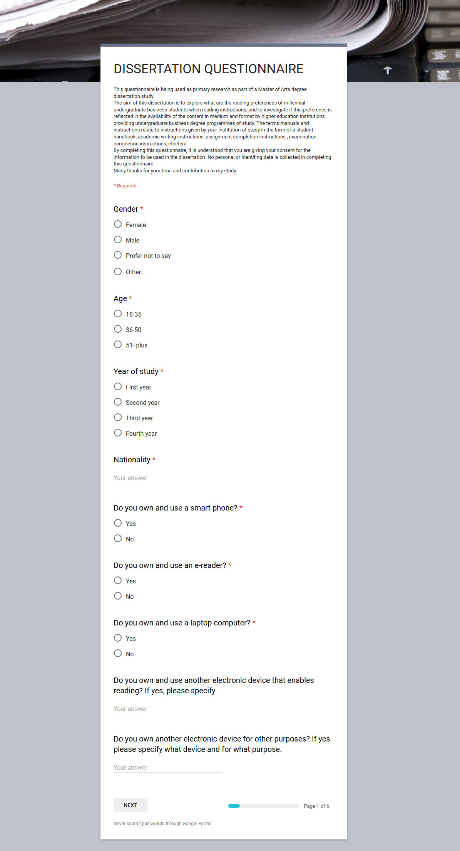

Section one seeks to establish the demographic and the technology that they possess and use. Knowing this will help in the analysis of the data collected.
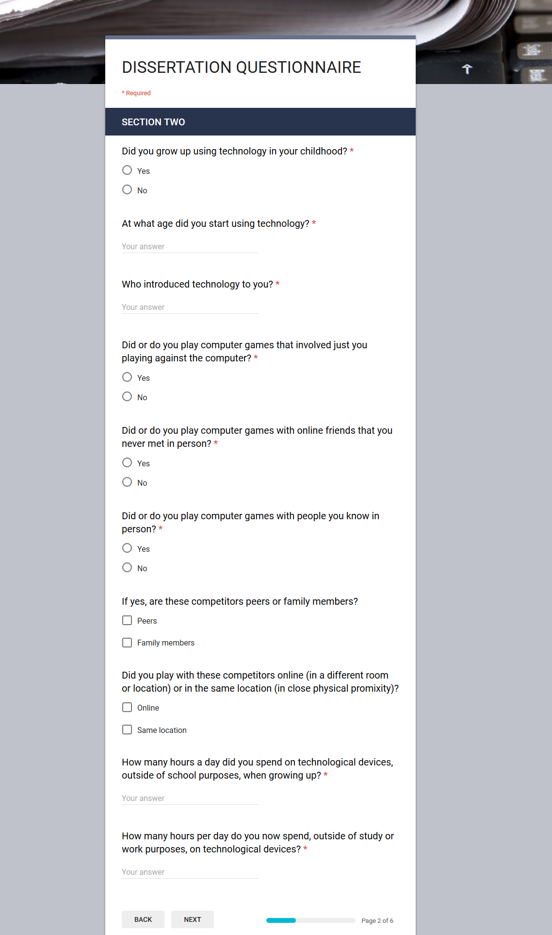

The questioning in this second section is used to ascertain if the use of technology has had an influence on how this generation read or communicate. The research suggests that those that grow up using technology appear to have their brain physically wired differently.
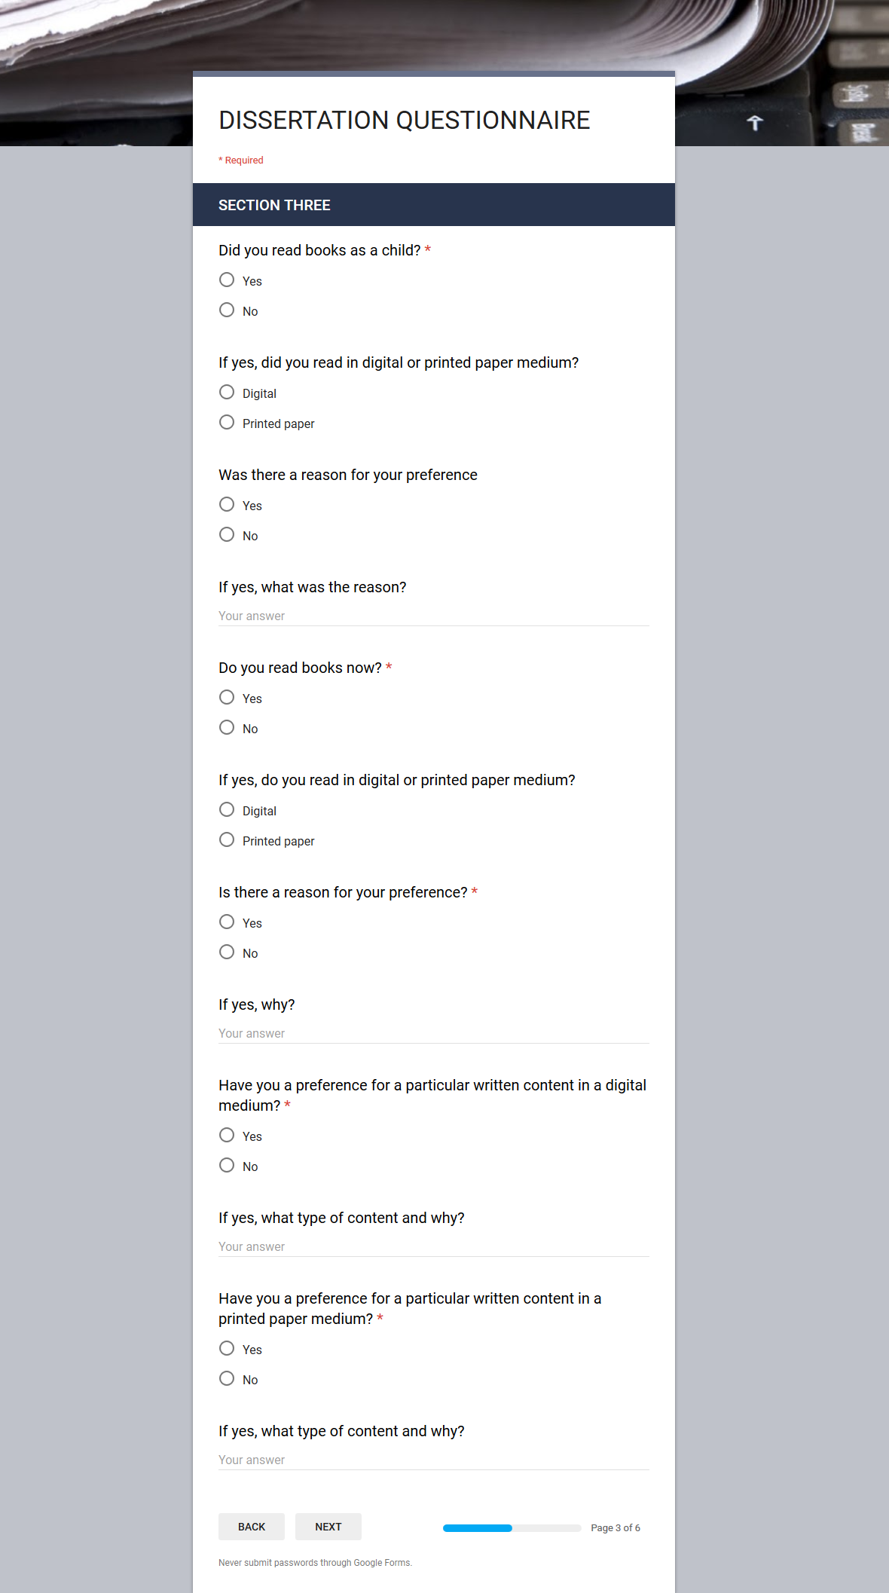

Section three is designed to see if the reading preference is related to what they have been used to growing up from a reading perspective as well as if the content affects the medium preference.

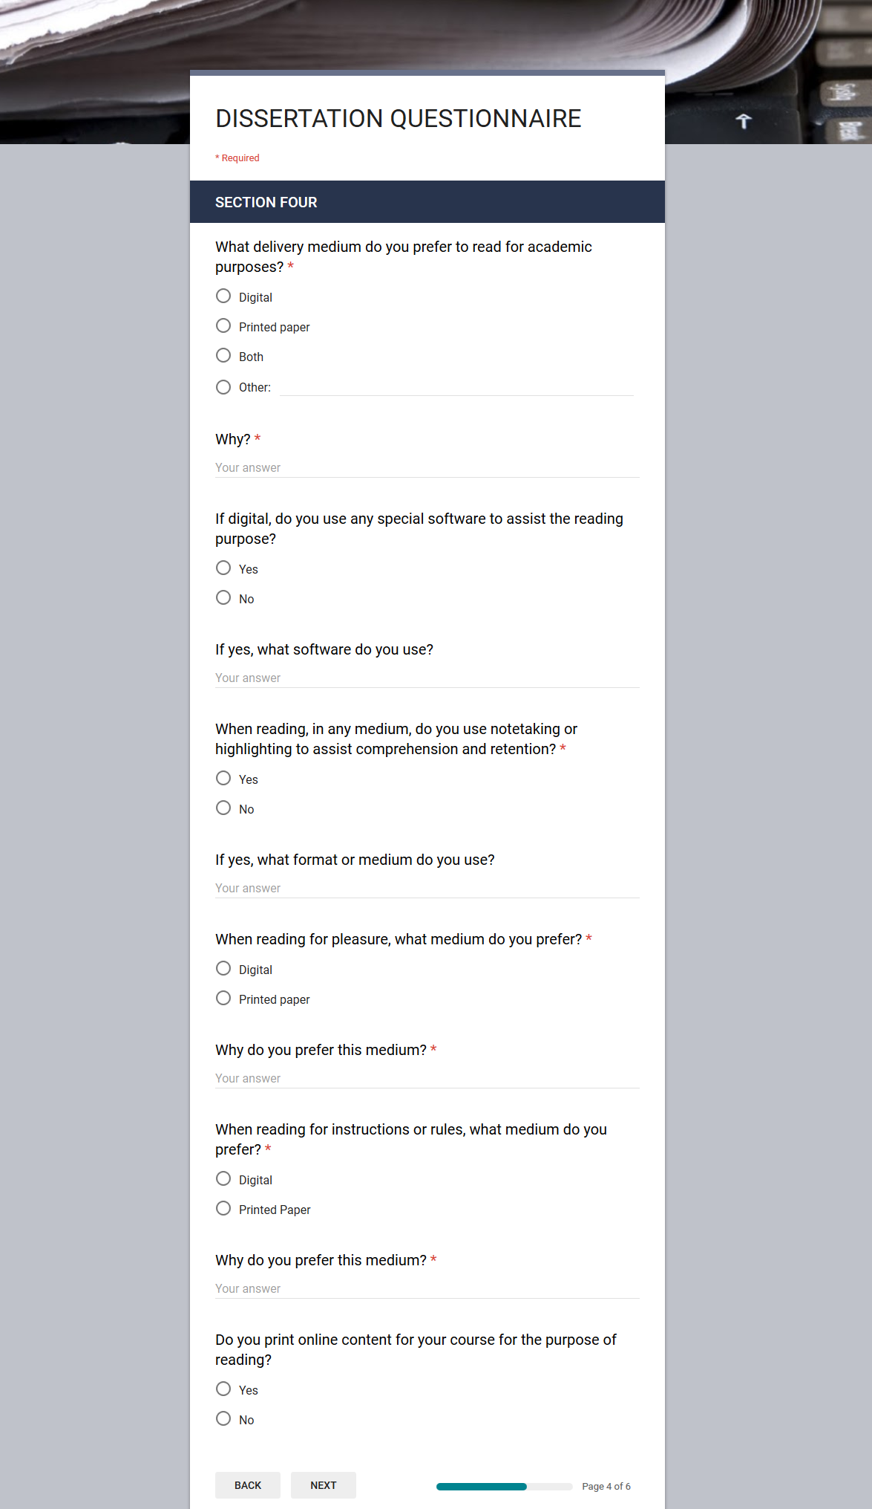

Section four deals with the preferences in an academic setting and seeks to establish if this is different to pleasure or everyday reading outside of this setting. The whole mechanism around the reading for academic purposes is explored.
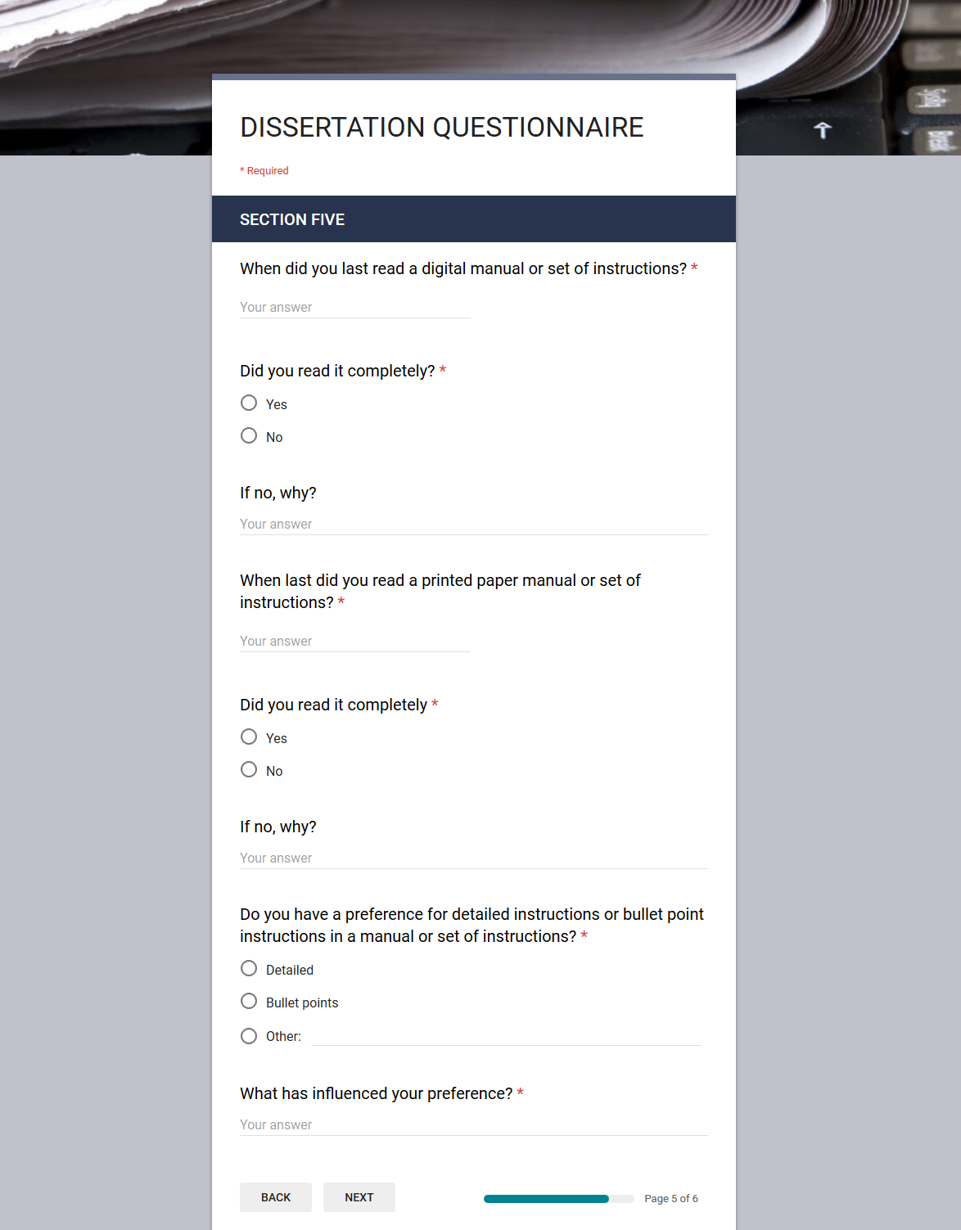

Section five deals specifically with instructions and manuals. This is to inquire if instructions are delivered in the correct format or layout regardless of the medium used. It further seeks to indicate if medium delivery has an impact on whether the manuals or instructions are read in detail or at all.

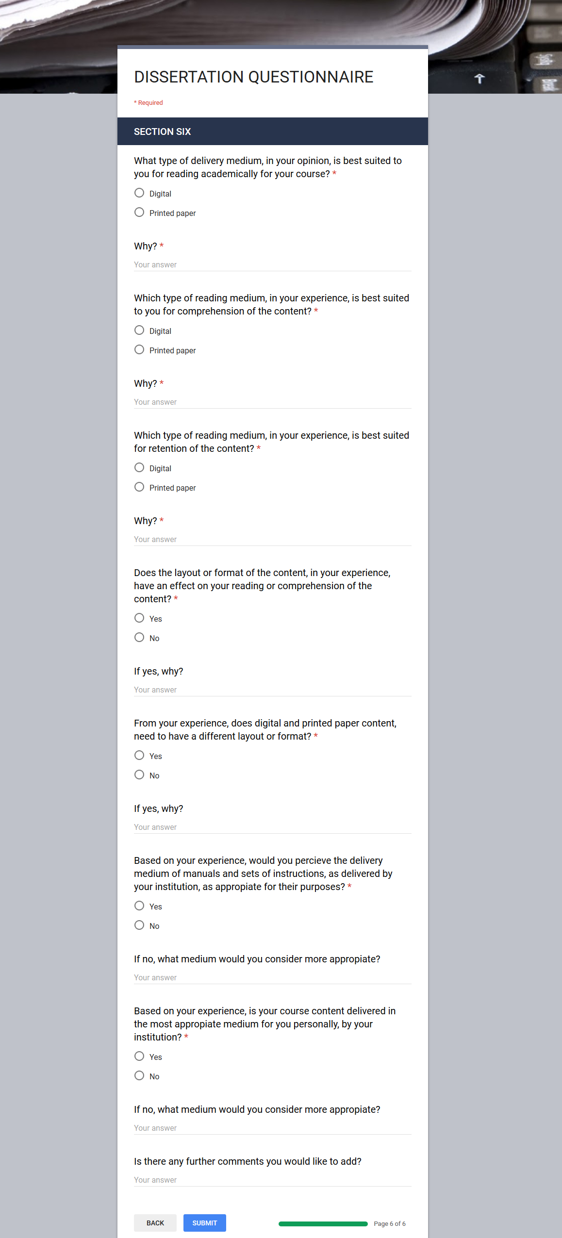

This last section six pursues to explore the comprehension and retention effect that different mediums present to different students. It also aims to determine if the respondents believe that the most appropriate medium with format and layout is currently being provided by their institution for their personal preference.

APPENDIX THREE…Ethical approval forms

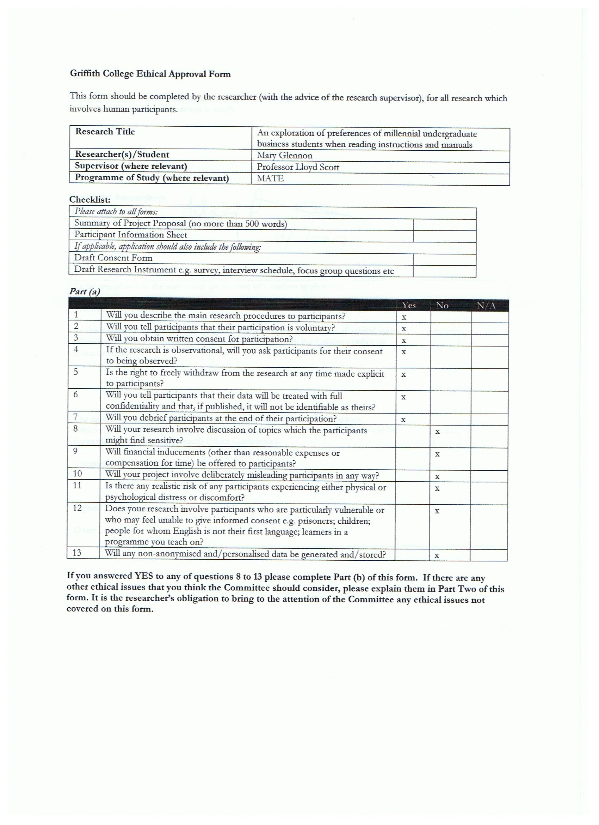
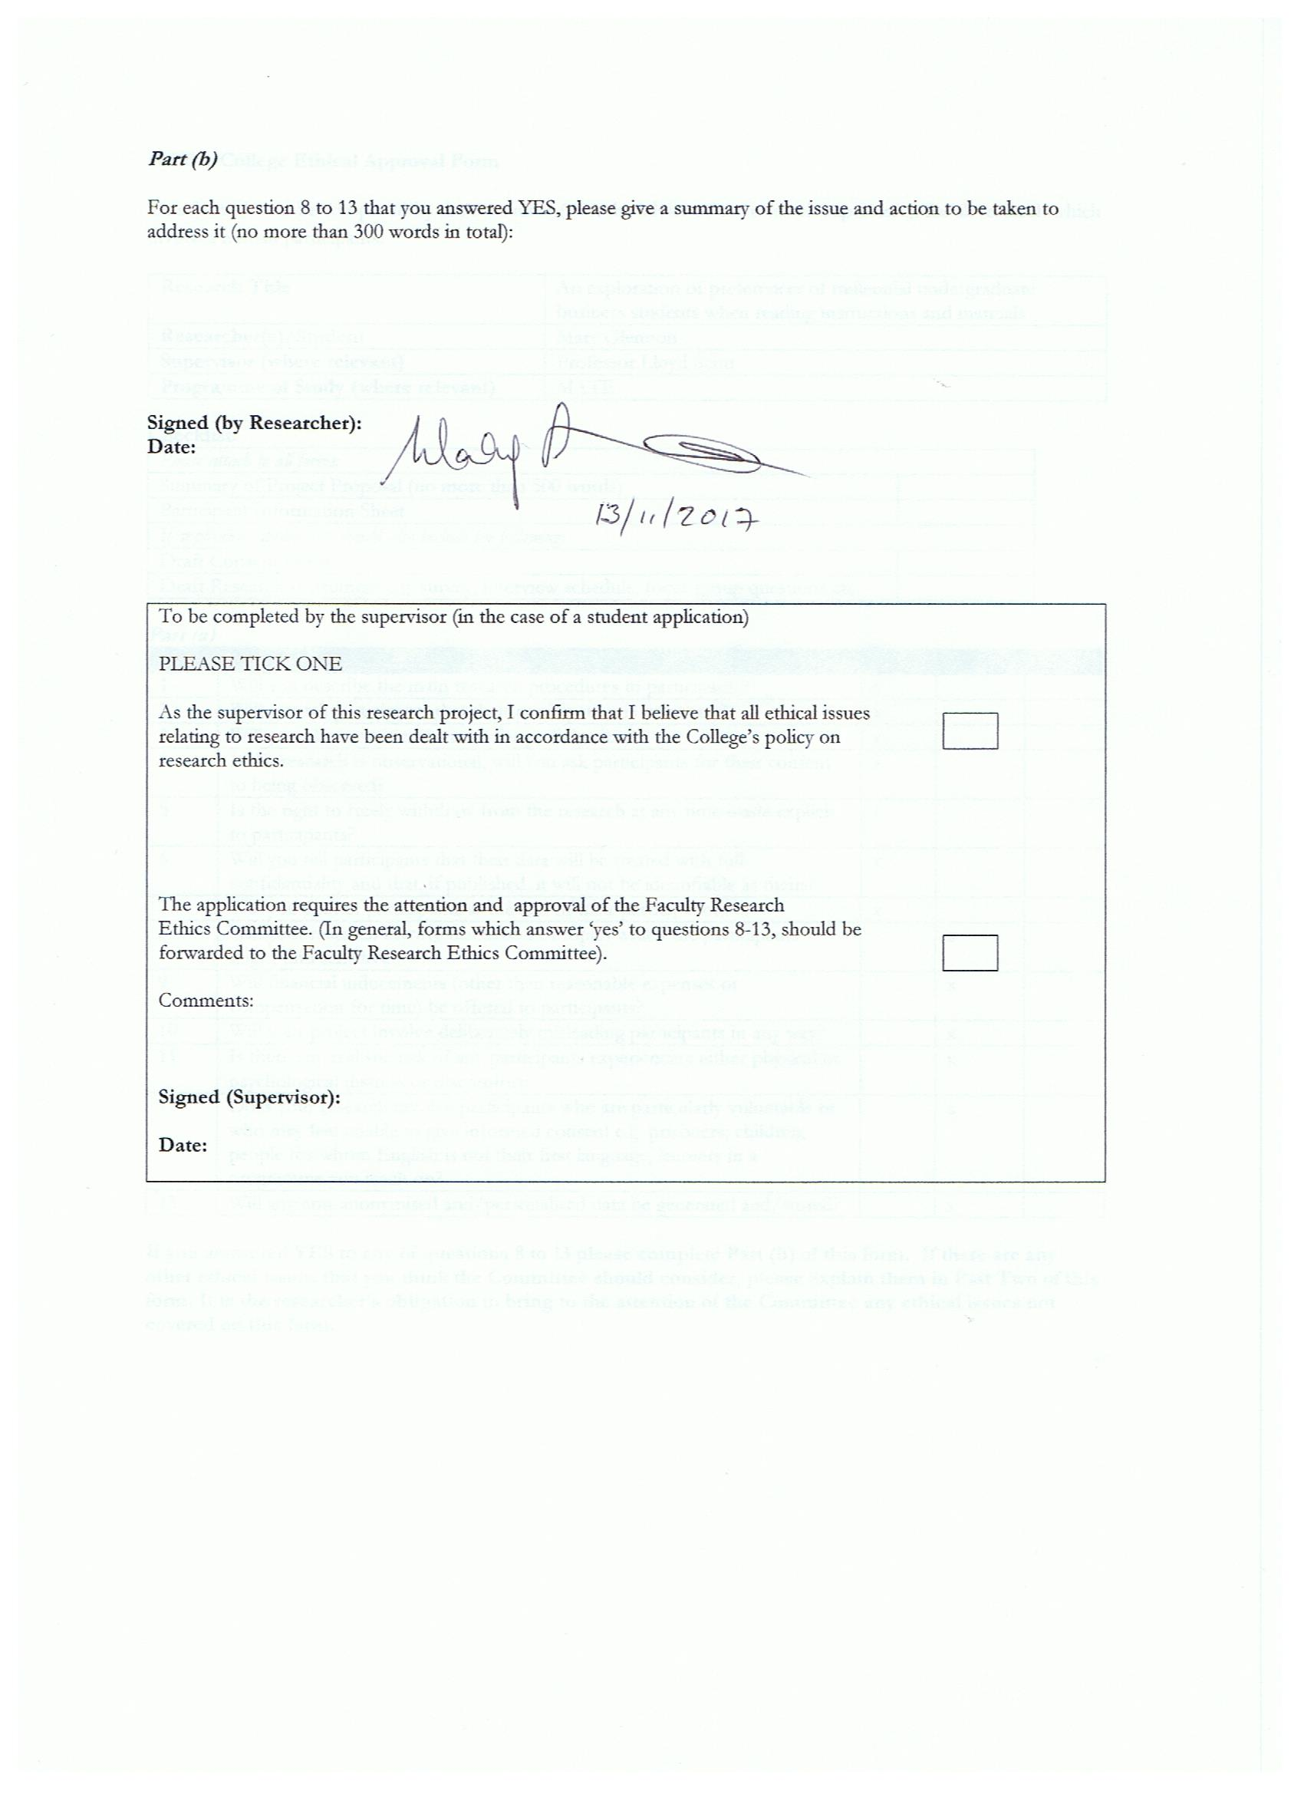


Information Sheet / consent form

Dear ----------
My name is Mary Glennon and I am a student in Griffith College Dublin. As part of my studies I want to explore the preferences of millennial undergraduate business students when reading instructions and manuals. I also wish to establish if these preferences have an effect on their study or employment expectations or progression.
If you decide to take part in the study the following will happen:
- I will arrange with you a suitable time to meet and to interview you.
- All interviews will be tape-recorded. The interview will last thirty minutes.
- I will ask questions about your reading preferences from medium to format to purpose. I will also be enquiring about how your preference affects or affected your learning and current or future employment expectations or progression.
Then I will listen to the tape and type up what was said. The tapes will be kept safe in a locked cabinet and the tapes will be destroyed 1 year after the project is completed.
You don’t have to take part in this study. You can refuse to take part or withdraw from the research within one week of the interview without giving a reason.
The plan for this study has been reviewed by a Research Ethics Board at Griffith College Dublin and has received approval. This office is independent from the researcher.
At a later date if you have any concerns about the study or what you said during our interview, you can contact me at marymglennon@gmail.com.
Thank you for reading this leaflet.

________________
Mary Glennon

Consent form to be completed at interview stage:
I, (Name and Surname) herby confirm that I have a read and understood the purpose of this research inquiry and am willing to be interviewed by Mary Glennon.
------------------------------------------------------ Date:---------------------------------
Signed

DEBRIEF

Thank you very much for taking part in this research study. Your contribution is very much appreciated.
The study in which you just participated was designed to explore preferences among millennial business students when reading instructions or manuals and to ascertain if these preferences have an effect on employment expectations or progression.

Please be assured that your data is confidential and if published the data will not be in any way identifiable as yours.
If you have any questions or concerns about this study or you have any questions as a result of your participation you may wish to contact me and I will do my best to answer your questions.

Contacts:
Mary Glennon (marymglennon@gmail.com)
Alternatively, you may contact my supervisor/Dissertation Coordinator
Professor Lloyd Scott PhD (lloyd.scott@dit.ie)
Thank you again for your participation,

Mary Glennon

APPENDIX FOUR…Interview questions and sample answers

CONDENSED INTERVIEW TRANSCRIPTS FROM ALL SIX INTERVIEWEES

How would you define a reading distribution medium?

Interviewee A (Continued in same order throughout this transcript)
A reading distribution medium is a tool used to distribute visual or text information to an audience.

Interviewee B
The way reading material is delivered to students.

Interviewee C
A way for universities to provide information and instructions to students to help them study and complete assignments.

Interviewee D
I would define a reading distribution medium as a platform of communication.

Interviewee E
I suppose it would be how something is presented to be read as in a book or online etc.

Interviewee F
Probably how something is presented for you to read, like a book or Kindle or such.

Might you know what medium business students use to read instructions and manuals for their course of study?

I would say mainly online in my course as this is how it is presented to us.

Most of our guides and assignment instructions are available online but many of the lecturers also give us hard copies or we can print them out ourselves.

Generally online sources I would say as most colleges now have everything available on Blackboard or similar.

Yes. In our college business students use online webcourses and email. Webcourses is an online podium where lecturers post there class slides, syllabus and past exam papers.

From my experience within my class we all use a mixture of mediums. Online is great for finding what you’re looking for, you know key words and things like that. But when I find what I’m looking for I print it out to use it. A lot of my classmates would do the same.

I imagine just the online guide that they give us at the beginning of the year or for assignments when we get given those. Sometimes there is particular guidelines for the completion of these, which is a great help.

Do you have experience of this and what has it been?

I have used Moodle for getting a lot of information regarding what to do or how to do different assignments etcetera. I print out the important ones so as I can highlight or put notes at relevant sections for easier understanding of what to do.

I have used both digital and printed medium for college assignments and workplace regulations and training. When it comes to instructions for the completion of assignments, I like to print them out so as I can highlight the main important points to keep me on track.

While I was studying in DIT, the college developed an online learning centre called Webcourses or Blackboard Learn. Our lecturers were able to upload the course programme onto this and split the information into different modules. We were also able to download the notes and print them if we wanted to have a paper copy of them. Students also had a section that gave them advice on how to complete assignments or improve their studying and could write to lecturers if they had any further questions.

Webcourses is delivered online. It can be both downloaded onto your mobile device and used on your laptop/computer. Based off my experience classmates download lecture slides and write notes on the pages.

Like I said before I find a combination of mediums work best for me. I also like online when I can use dictionaries etc. But it is easy to get distracted when reading on a digital platform. It’s harder to concentrate and to go back and forth between pages and to mark or highlight what is important.

I don’t think there is a definite preference for one medium over another but I would say that there is a preference for different mediums for different purposes. It’s easier to remember and understand when you read from paper.
Is there any preference for a particular medium within this cohort?

A physical manual with different sections and more detail in the areas of citing and referencing would be more beneficial. It is often mentioned in classes if we can obtain a book with these guidelines etc. Most just print off the content to have at hand and to be able to highlight or to make notes on important parts.

Personally I prefer online sources with regards to college assignments and assessments as I have the option of printing it or not if I decide but I’m not sure what the overall view would be. I would imagine it is similar from what I see around me in class.

I personally preferred having Webcourses available while studying. I found it very easy to use and saved me from having to buy textbooks or fill notepads with every bit of information that was being said in the class. The information on the site was well presented and clear and allowed students to drop in and find what they are looking for very easily. Most students appear to use it in a similar way I would say.

Yes, in my opinion being able to highlight or underline key points during a read is essential for retention. It is harder to retain information digitally from my experience.

I don’t think there is a definite preference for one medium over another but I would say that there is a preference for different mediums for different purposes. It’s easier to remember and understand when you read from paper.

Yes I think there could be. A lot of my classmates would prefer a physical paper book or sheets broken down into sections especially around referencing and how to cite material. That is an area that definitely a paper book would work best for. When reading business material, online is good for the general stuff but if it is something that is specific I definitely believe that there is a preference for it in paper. So I suppose what I’m saying is it depends on what your reading.
Is there a relationship between the reading medium and comprehension or retention, in your opinion? Why?

I think the ability of students to comprehend or remember information is partly due to the medium and its format, and partly due to the individual habits or nature of the person who is receiving the information through the medium. There could also be a correlation between the setting in which he medium is more likely to be used and the effectiveness of the medium. For example, an online service which provides information on any topic could be used in a larger amount of places than a textbook, however a large number of the additional settings in which the online source could be used may not be conducive to proper retention of the information itself.

I would have to say yes. I find that I can comprehend information from a digital source but I find it difficult to retain and prefer a printed copy to retain the information.

Yes. I find that the easier it is to read the material, the easier it is to retain the information. A digital medium is good for comprehension as there are many add ons that can assist, for example dictionary, but when it comes to retention there can be a lot of distractions around the content. Therefore I prefer to read from paper in order to retain the information that I just read.

Yes, if the information is presented clearly it definitely helps the understanding of it. Students will always prefer reading shorter paragraphs where important information is highlighted or laid out in bullet points as opposed to pages and pages of long text. Basically I believe that instructions are easier to understand and remember if presented in a printed to the point format.

Yes definitely. Like I said there is much less distractions when reading from paper and as such makes it easier to retain the information. But everyone is different so what might suit me may not suit everyone. But I see most of my classmates printing out online material in order to better understand and remember it.

Yes, in my opinion being able to highlight or underline key points during a read is essential for retention. It is harder to retain information digitally from my experience.
How would you define format or layout in relation to a reading medium?

The format or layout refers to the physical design and placement of the information within the medium.

How the information is presented.

The format or layout is the way the information is presented. On Webcourses our lecturers would upload their course programme and then split the different modules into different sections. Some created PowerPoint presentations and put their notes into slides, while other lecturers would just write them out in short paragraphs with bullet points. With either way, students were able to follow what was being shown.

The structure of the literature - how it is presented in terms of bullet points or in academia.

How the content is presented to be read. Like a book is paragraphs and a full page while a magazine is shorter columns or headings while online you have the main points but click in for more.

The aesthetic presentation of the information.

Would you consider, from your experience, that different mediums require different formats or layouts? Why?

I think that most formats could use the same common layout, unless it is physically impossible, such as in the case of a book vs a voice recording.

Yes. More informative mediums require a more simplified approach i.e. bullet point while others such as articles require a story based format with a beginning, middle and conclusion.

I don't think different mediums need different layouts. From all the ways I've had to learn from my time in college I found the way I described earlier to be the easiest way by far. Most students I spoke to all agreed that this way was more favourable, that with the subjects being broken up into different sections and easy to follow slides or paragraphs meant that they could find and study the important parts of their course.

Yes I would. This is due to the nature of the literature. In an article the layout should be structured with a clear beginning middle and end. While in an instruction manual information should be given in bullet points.

Yes I think so but it could be just me. I find it hard to read a book online as I find it hard to keep my place. The screen appears to affect my eyes and it all runs into itself. But when I read a website or similar I have no problem reading that and that is more laid out like a magazine. I suppose it depends also on the purpose of the content. What I mean is, is it trying to sell me something or is it there in its own merit like a journal or such.

Definitely, reading text off a screen is tough enough when you struggle with your eyesight therefore the layout must be clear and the font must be big. The engagement in reading a physical book I believe correlates strongly with the layout of the text also.
Is there a relationship, in your opinion, between medium and format or layout that affects comprehension or retention of the content read? Why?

I think the layout and medium can independently vary a large amount until a large effect on the retention of information could be seen. The layout itself may stay constant, with a changing medium and the retention of information could be very similar.

If the material is presented clearly and concisely then you can retain and comprehend it better, regardless of the presentation medium. I mean that the layout or format is more important than the medium that it is been read through.

Yes, the instructions should be easy to read and follow with similar patterns, for example have related topics put together rather than being spaced apart. I would imagine that the medium would not have an effect, but I have never thought about that.

I think once the information is presented clearly and to the point, learning and understanding it becomes much easier to do. I personally found it much easier to learn using the online content that was broken up into sections rather than sitting in a large lecture hall for two hours and taking notes on everything said.

Again I would say yes. Content with different purpose needs a different layout. For example if I am trying to sell you a car and I just write about it in a paragraph like in a book the chances of you remembering all about it would be slim I would imagine. But if I show you a picture of the car with all the specs around it you would remember it better. The reverse would work for a serious academic paper. So purpose would have a big influence on not just layout but medium of presentation as well.

Yes because the visual learner could find the medium of a screen more appealing than the manual learner who enjoys writing notes and highlighting as they go. The font used on a screen would definitely have to be clear and appealing to retain information and similarly the layout of a book could not be just text thrown onto a page it must be structured to identify breaks and separate sections

In your opinion, do you think that your use, or not, of technology has had an influence on your medium and format or layout preference? How?

I don't believe that my use of technology has had a large influence on my preferred medium or format, except in cases where the technology provides a unique format specific to itself.

No, I really don’t think so.

Yes. I definitely believe my love of technology has influenced my preference for using digital mediums where at all possible. I find it is more convenient to use technology for most things. But I still will say that printed paper is best for retention of material because my love of technology has me linked to too many things at once sometimes.

Yes. As all my assignments and assessments were done using my laptop it was very quick and easy to log on to Webcourses and open a couple of tabs to find what I was looking for instead of flicking through different notepads and searching through pages of notes for a brief part of my module.

Maybe. While I like to use technology I also like to get away from it. So maybe if I was younger and had grown up with technology from a very early age it might have a bigger influence. I just like to use whatever will get the job done quickest and easiest.

Yes because technology is used in every area of my life, therefore I enjoy reading an actual book for instructions or information. Technology is too distracting to concentrate on a serious matter due to the leisure time which we spend on it.

To what extent, from your experience, are the current delivery mediums of instructions or manuals for your course of study appropriate for their purposes?

I think the mediums for my course of study are effective, but I use several forms of media to learn information while studying, mainly online information in the form of text and video, and physical textbooks. The use of many forms of media allows students to choose an appropriate medium for themselves. I prefer to use physical textbooks.

They are appropriate as all notes and content is available online which is accessible to all students. If you prefer it in a printed medium you can print out the online version.

The information was mainly online but at beginning of the year you are giving a handbook. This allowed for all preferences to be catered for. With the information available on the student website all the time it allows for students to choose their preference of medium as the year progresses as their preference may change along the way.

Overall I suppose they are fairly appropriate. When it is available online, those who prefer the content printed can do so themselves if they wish. Some of my fellow students may say that they should not have to go to the expense of printing it out and it should be available in multiple mediums.

I think they are fine. The content was delivered online and on Blackboard or similar but most lecturers also gave us out hard copies of the content and any we did not get I just printed myself. I would like to see more physical textbooks though being encouraged. Maybe it’s because of what I was used to in secondary school but even one textbook per subject gives you a guide to the subject from beginning to end.

Not very appropriate as they are a short set of instructions given during your first week based on plagiarism and citing. Not once is there an example or a visual representation of what exactly academic writing is and what they mean by these instructions. I even printed off the MRHA style guide for referencing as I hate viewing it online.

Would you consider the format or layout of these instructions and manuals to be appropriate for both delivery medium and comprehension?

Yes for medium, but my personal preference would be for a more concise to the point content. I find that if the content is extensive I am inclined to lose focus before the end and thus could miss out on something important.

Mostly yes, but I would like to see them in a more concise form. Maybe in bullet points of the important parts or even to have two versions, one that is very detailed and a more brief one for those that may not need to read the detail. Especially as you progress through your course you understand a lot more from experience and just need the headings or similar to guide you.

They are appropriate as all notes and content are available online which is accessible to all students.

Yes and no. All the instructions are given in detail, which is good at times. When I was in first year I would have liked that as I did not understand a lot of what to do or how to do things. But as I went through my course I found that I would have preferred the content in bullet points or similar concise form. I would say that if you have the main points you have gained the knowledge along the way to know what they mean. But in saying that in first year I found all the information too much at times and I would have benefitted from a more simple form of guide especially for completing assignments. Because it was very different from what I did in secondary school I was a bit lost as to how to layout the assignments etcetera.

I’m afraid I must admit I never read a lot of them in detail. They are very long winded. I would like a more concise to the point instructions available alongside the detailed one. That way I had the main points and if I needed to know more I also could. Perhaps in first year I would have used the detailed one more when I was new to third level and getting used to doing assignments etc.

No because they are merely bullet points, there is only 5 bullet points and they lack any detail. A more detailed guide is needed even if it is a longer bullet point version. I don’t think that five points can really say much in the way of instructions.

To what extent, in your opinion, did the medium, format or layout of instructions or manuals have on your overall learning and assessments in your course of study?

The layout and the medium in my course of study can vary a lot while being similarly effective. I would say that the individual’s style of learning has more of an effect than the medium or format used to convey the information.

I feel that I learned a lot from the material presented to me as a student in both printed and digital content.

Not much. I have my own way of learning which didn't need for me to rely on specific mediums etc. I do believe if someone had a real preference for one particular medium and they were unable to get the instructions in that format or medium that it could have a detrimental effect on the final outcome of their assignments or examinations.

It was very influential. Personally I double check everything I do in relation to my course work and having these available to me was extremely helpful.

As I progressed through my course it was less and less. But at the beginning I remember being overwhelmed with all the information and not knowing where to start. I probably would say that a simpler version is needed at the beginning to get you started. Perhaps a different format for different years. Looking back I wonder how I ever got started at all.

It did not have a major impact on my work as I researched academic writing myself and picked up on articles and journals which were referenced along the way. However I remember the whole aspect of academic writing to be very daunting in my first term of first year as I was adapted to writing personal writing essays.

Would you consider, from your experience, that your preference of reading medium or format, and the one provided by your institution, has or had an effect on your study or employment expectations or progression? Why?

Yes, the material that is available online from a website related to my course sometimes reference the reading material that I primarily use to study (textbooks). My preference for learning from physical books works to my advantage in this situation.

No. I just use whatever is relevant to what I am doing.

Yes. I have learned what does not work for me which is good in my opinion. As I am now aware of my preferences I can adjust to these whenever I am reading for my course. This is something that I will take with me into an employment setting, as this will be an advantage for me in progressing in my career.

No. I wouldn’t really say it had an effect on my study or employment expectations. While I have to deal with a lot of instructions and manuals in the retail setting that I now work in, I find that most of these are available in different mediums and I can choose the one most appropriate at any given time. But I am aware some employers don't have the necessary resources to supply the varied mediums that DIT can provide.

Not really as I adjusted to what worked best for me. A lot of the older generations think because we are a generation that uses, and some would say addicted to technology, that we don’t like to read books which is not true. But I must say that I am used to being able to get answers to what I want instantly with Google or such. That could account for why I don’t like to read long winded instructions to get what I want. Bullet points would be a better way to present such stuff. I found when I started work there was a lot of long winded stuff to read and sign so in a way I suppose the ones provided by the college was preparing me for that. But I just signed those as read anyway much the same way we all click accept terms and conditions online. Whoever reads all that. I guess you could get caught out sometime but that wouldn’t be the case in college or work I hope.

Not particularly as I can read books online and although I don’t enjoy staring at a bright screen I can get on with it. I prefer books to study though as I find taking notes as I go and highlighting areas maximises my study experience.
In what medium would you like to see instructions and manuals, for your personal use, provided in for your course of study? Why?

Physical textbooks, I feel that books are the easiest to use form of information, and are much less dependent on the available resources around me - chargers, headphones etc. The two commonly used mediums, online/digital sources and physical books differ a lot in the ease of browsing information, with the book being a much easier to use tool in that regard.

I like them to be digitally presented, as this will mean that they are also accessible to the student in the future. For example if a PowerPoint presentation is used, it is uploaded online for access for the students. If someone prefers it in printed form then they can print it for themselves.

I would like to see them delivered digitally via mobile devices, preferably in an app as this brings a lot more convenience in today's busy technologically enabled world.

I’m happy with the way they were presented. If you wanted to read digitally you could or print the content if you prefer paper. Different things need different mediums so the way they were presented covered all preferences.

I think online in a digital medium is good as I said earlier you can print out if you want. But I will say again there should be more of an emphasis on textbooks for each subject. Maybe I’m old school but you can’t beat a physical book to study with.

Physical hard copies because I do not like reading from a screen, it is hard to retain any information and therefore you must keep clicking back into the guidelines instead of just learning how to reference etc. physically.

In what format or layout would you like to see instructions or manuals, for your personal use, provided in for your course of study? Why?

With my course of study, I like to have information provided as text and diagrams. For complex ideas, both of these formats are effective.

In a format that suits the medium being used. If in a digital medium I then have the option to print it off if I personally want a physical copy but the content to be in a more concise format. Maybe laid out in bullet points with a brief description underneath each point. Or as I said already maybe have two versions a concise and a detailed one. This would allow for a student to be able to dig deeper if they wished on any point that was not clear.

"Short and Sweet" I prefer bullet points with shorter definitions which can be elaborated on when needed

In terms of instructions or manuals I’d like to the format provided in bullet points. This way I can see the clear points that need to be met or avoided.

I think in a more concise form like bullet points. Also I would have to say, especially in first year, if there was instructions in a step by step form in an academic guidelines book it would greatly help to get you started as you would know that is what to do. Knowing what to look for among all the other material on the website is the challenge. Once you get the first few done you a kind of know what to do but it’s very stressful getting started and you don’t really know people too well at that stage and you think you are the only one not knowing etc. and are afraid to ask. First year is stressful enough outside of the academic content so I think that would help. I also think it would get you off to a good start as then you can concentrate on the meat of the assignment when you would have a structure.

Physical books again to maximise my studying experience, short articles can be read online but not books. This is the layout that I find easiest as it’s the medium that I find easiest to read and understand and remember.

Did you ever get an opportunity to have an input into the format or medium of delivery for instructions or manuals for your course of study?

No

No

Yes, at the end of each year, from first to final year, we get to provide feedback to the college on their facilities, courses and deliverables.

Only end of term feedback forms

No

No I did not. We are told where the resources were and it was up to us after that to sort ourselves out.

Would you like to comment on anything further that we may not have covered?

I think the effect of the individual's capabilities to understand or comprehend information is as important as the medium in which the information is presented. For this reason, the medium or format I think should be varied based on the user.

No

Not really I think we covered most things.

No

Well just that everyone is different so different people will comprehend and retain information at different levels and I’m not so sure if that has a greater influence in the final outcome than the medium or layout.

I don’t think there is anything you missed

SAMPLE CONDENSED INTERVIEW TRANSCRIPT

Interviewer
Interviewee

How would you define a reading distribution medium?

I suppose it would be how something is presented to be read as in a book or online etc.

Might you know what medium business students use to read instructions and manuals for their course of study?

From my experience within my class we all use a mixture of mediums. Online is great for finding what you’re looking for, you know key words and things like that. But when I find what I’m looking for I print it out to use it. A lot of my classmates would do the same.

Do you have experience of this and what has it been?

Like I said before I find a combination of mediums work best for me. I also like online when I can use dictionaries etc. But it is easy to get distracted when reading on a digital platform. It’s harder to concentrate and to go back and forth between pages and to mark or highlight what is important.

Is there any preference for a particular medium within this cohort?

I don’t think there is a definite preference for one medium over another but I would say that there is a preference for different mediums for different purposes. It’s easier to remember and understand when you read from paper.

Is there a relationship between the reading medium and comprehension or retention, in your opinion? Why?

Yes definitely. Like I said there is much less distractions when reading from paper and as such makes it easier to retain the information. But everyone is different so what might suit me may not suit everyone. But I see most of my classmates printing out online material in order to better understand and remember it.

How would you define format or layout in relation to a reading medium?

How the content is presented to be read. Like a book is paragraphs and a full page while a magazine is shorter columns or headings while online you have the main points but click in for more.

Would you consider, from your experience, that different mediums require different formats or layouts? Why?

Yes I think so but it could be just me. I find it hard to read a book online as I find it hard to keep my place. The screen appears to affect my eyes and it all runs into itself. But when I read a website or similar I have no problem reading that and that is more laid out like a magazine. I suppose it depends also on the purpose of the content. What I mean is it trying to sell me something or is it there in its own merit like a journal or such.

Is there a relationship, in your opinion, between medium and format or layout that affects comprehension or retention of the content read? Why?

Again I would say yes. Content with different purpose needs a different layout. For example if I am trying to sell you a car and I just write about it in a paragraph like in a book the chances of you remembering all about it would be slim I would imagine. But if I show you a picture of the car with all the specs around it you would remember it better. The reverse would work for a serious academic paper. So purpose would have a big influence on not just layout but medium of presentation as well.

In your opinion, do you think that your use, or not, of technology has had an influence on your medium and format or layout preference? How?

Maybe. While I like to use technology I also like to get away from it. So maybe if I was younger and had grown up with technology from a very early age it might have a bigger influence. I just like to use whatever will get the job done quickest and easiest.

To what extent, from your experience, are the current delivery mediums of instructions or manuals for your course of study appropriate for their purposes?

I think they are fine. The content was delivered online and on Blackboard or similar but most lecturers also gave us out hard copies of the content and any we did not get I just printed myself. I would like to see more physical textbooks though being encouraged. Maybe it’s because of what I was used to in secondary school but even one textbook per subject gives you a guide to the subject from beginning to end.

Would you consider the format or layout of these instructions and manuals to be appropriate for both delivery medium and comprehension?

I’m afraid I must admit I never read a lot of them in detail. They are very long winded. I would like a more concise to the point instructions available alongside the detailed one. That way I had the main points and if I needed to know more I also could. Perhaps in first year I would have used the detailed one more when I was new to third level and getting used to doing assignments etc.

To what extent, in your opinion, did the medium, format or layout of instructions or manuals have on your overall learning and assessments in your course of study?

As I progressed through my course it was less and less. But at the beginning I remember being overwhelmed with all the information and not knowing where to start. I probably would say that a simpler version is needed at the beginning to get you started. Perhaps a different format for different years. Looking back I wonder how I ever got started at all.

Would you consider, from your experience, that your preference of reading medium or format, and the one provided by your institution, has or had an effect on your study or employment expectations or progression? Why?

Not really as I adjusted to what worked best for me. A lot of the older generations think because we are a generation that uses, and some would say addicted to technology, that we don’t like to read books which is not true. But I must say that I am used to being able to get answers to what I want instantly with Google or such. That could account for why I don’t like to read long winded instructions to get what I want. Bullet points would be a better way to present such stuff. I found when I started work there was a lot of long winded stuff to read and sign so in a way I suppose the ones provided by the college was preparing me for that. But I just signed those as read anyway much the same way we all click accept terms and conditions online. Whoever reads all that. I guess you could get caught out sometime but that wouldn’t be the case in college or work I hope.

In what medium would you like to see instructions and manuals, for your personal use, provided in for your course of study? Why?

I think online in a digital medium is good as I said earlier you can print out if you want. But I will say again there should be more of an emphasis on textbooks for each subject. Maybe I’m old school but you can’t beat a physical book to study with.

In what format or layout would you like to see instructions or manuals, for your personal use, provided in for your course of study? Why?

I think in a more concise form like bullet points. Also I would have to say, especially in first year if there was instructions in a step by step form to get you started. Once you get the first few done you a kind of know what to do but it’s very stressful getting started and you don’t really know people too well at that stage and you think you are the only one not knowing etc and are afraid to ask. First year is stressful enough outside of the academic content so I think that would help. I also think it would get you off to a good start as then you can concentrate on the meat of the assignment when you would have a structure.

Did you ever get an opportunity to have an input into the format or medium of delivery for instructions or manuals for your course of study?

No

Would you like to comment on anything further that we may not have covered?

Well just that everyone is different so different people will comprehend and retain information at different levels and I’m not so sure if that has a greater influence in the final outcome than the medium or layout.

SAMPLE RAW INTERVIEW TRANSCRIPT
Interviewer talking, interview questions
Interviewee
I just want to check that we are both talking about the same thing so I just want to ask how would you define a reading distribution medium?
Well I suppose it would be how something is presented to be read as in a book or online etc. Is that what you’re talking about? I’m never too sure what some of these fancy terms mean.
Oh no you’re grand. That’s exactly what I’m talking about. No point asking a load of questions if we are talking about two different things. Will keep going so, don’t want to be delaying you. Am so grateful that you are doing this for me. So the next question I have is
Might you know what medium business students use to read instructions and manuals for their course of study?
Well from my experience within my class we all use a mixture of mediums. Online is great for finding what you’re looking for, you know key words and things like that. But when I find what I’m looking for I print it out to use it. A lot of my classmates would do the same. Ah you know it’s a lot easier to read from paper.
Do you have experience of this and what has it been?
Like I said before I find a combination of mediums work best for me. I like to read from a book or sheets but I also like online when I can use dictionaries etc. But it is easy to get distracted when reading on the computer or phone. It’s harder to concentrate and to go back and forth between pages and to mark or highlight what is important. Maybe I’m just weird but that’s me.
No not at all if it’s what you prefer and it works for you. Now would you know
Is there any preference for a particular medium within this cohort?
I don’t think there is a definite preference for one medium over another but I would say that there is a preference for different mediums for different purposes. It’s easier to remember and understand when you read from paper. And anything that helps you remember is good. Would you agree? Oh whatever works for you. Now next question, or am I going too fast. No not at all, just keep them coming. Grand will continue so.
Is there a relationship between the reading medium and comprehension or retention, in your opinion? Why?
Oh God yes definitely. Like I said there is much less distractions when reading from paper and that makes it easier to remember the information. But sure I suppose everyone is different so what might suit me may not suit everyone. But I see most of my classmates printing out online material in order to read it. It makes it easier for them to understand and remember it. Well I think that is why they do it. Interesting.

How would you define format or layout in relation to a reading medium?
How the content is presented to be read. Would it be like the way a book is in paragraphs and a full page or the way a magazine is shorter columns or headings while online you have the main points but click in for more. Is that what you’re talking about? Yes exactly. God I’m getting good at this. You’re doing great. It’s interesting when you actually think about stuff that you just do day in and day out without thinking about what you’re doing. Do you know what I mean? Yeah I do. Next question please.
Would you consider, from your experience, that different mediums require different formats or layouts? Why?
Yes I think so but it could be just me. I find it hard to read a book online as I find it hard to keep my place. The screen appears to affect my eyes and it all runs into itself. Has that ever happened you? Yeah sometimes. But when I read a website or similar I have no problem reading that and that is more laid out like a magazine. I suppose it depends also on the purpose of the content. What I mean is, is it trying to sell me something or is it there in its own merit like a journal or such. Does that make sense? Yeah that’s perfect.
Is there a relationship, in your opinion, between medium and format or layout that affects comprehension or retention of the content read? Why?
Again I would say yes. Like I was just saying, content with different purpose needs a different layout. For example if I am trying to sell you a car and I just write about it in a paragraph like in a book the chances of you remembering all about it would be slim I would imagine. But if I show you a picture of the car with all the specs around it you would remember it better. The reverse would work for a serious academic paper. So purpose would have a big influence on not just layout but medium of presentation as well. Does that make sense? Yes definitely. Sorry I know I keep asking if it makes sense but just want to make sure you understand what I’m saying. Or more to the point that my answer is relevant. Oh don’t worry you are doing great.
In your opinion, do you think that your use, or not, of technology has had an influence on your medium and format or layout preference? How?
Maybe. While I like to use technology I also like to get away from it. So maybe if I was that bit younger and had grown up with technology from a very early age it might have a bigger influence. I just like to use whatever will get the job done quickest and easiest.
To what extent, from your experience, are the current delivery mediums of instructions or manuals for your course of study appropriate for their purposes?
I think they are fine. The content was delivered online and on Blackboard or whatever you have, you know the college website for students, but most lecturers also gave us out hard copies of the content and any we did not get I just printed myself. If I’m honest I suppose I would like to see more physical textbooks though being encouraged. Maybe it’s because of what I was used to in secondary school but even one textbook per subject gives you a guide to the subject from beginning to end. You can pick it up and look over it. It’s like the module in a box. Interesting.
Would you consider the format or layout of these instructions and manuals to be appropriate for both delivery medium and comprehension?
I’m afraid I must admit I never read a lot of them in detail. They are very long winded. I would like a more concise to the point instructions available alongside the detailed one. That way I had the main points and if I needed to know more I also could. Perhaps in first year I would have used the detailed one more when I was new to third level and getting used to doing assignments etc. But now I don’t really bother with them. I guess I just presume I know what’s in them. I could get caught out there one day.
To what extent, in your opinion, did the medium, format or layout of instructions or manuals have on your overall learning and assessments in your course of study?
Well let me see, to what extent did it help? Well not just help, more the overall effect on your learning. Oh right, well as I progressed through my course it was less and less. But at the beginning I remember being overwhelmed with all the information and not knowing where to start. I probably would say that a simpler version is needed at the beginning to get you started. Perhaps a different format for different years. Looking back I wonder how I ever got started at all.
Would you consider, from your experience, that your preference of reading medium or format, and the one provided by your institution, has or had an effect on your study or employment expectations or progression? Why?
Not really as I adjusted to what worked best for me. A lot of the older generations think because we are a generation that uses, and some would say addicted to technology, that we don’t like to read books which is not true. But I must say that I am used to being able to get answers to what I want instantly with Google or such. That could account for why I don’t like to read long winded instructions to get what I want. Bullet points would be a better way to present such stuff. I found when I started work there was a lot of long winded stuff to read and sign so in a way I suppose the ones provided by the college was preparing me for that. But I just signed those as read anyway much the same way we all click accept terms and conditions online. Whoever reads all that. I guess you could get caught out sometime but that wouldn’t be the case in college or work I hope. Great
In what medium would you like to see instructions and manuals, for your personal use, provided in for your course of study? Why?
I think online in a digital medium is good as I said earlier you can print out if you want. But I will say again there should be more of an emphasis on textbooks for each subject. Maybe I’m old school but you can’t beat a physical book to study with.
In what format or layout would you like to see instructions or manuals, for your personal use, provided in for your course of study? Why?
I think in a more concise form like bullet points. Also I would have to say, especially in first year if there was instructions in a step by step form to get you started. Once you get the first few done you a kind of know what to do but it’s very stressful getting started and you don’t really know people too well at that stage and you think you are the only one not knowing etcetera and are afraid to ask. First year is stressful enough outside of the academic content so I think that would help. I also think it would get you off to a good start as then you can concentrate on the meat of the assignment when you would have a structure. It would make life easier when you are trying to get your head around the whole thing.
Did you ever get an opportunity to have an input into the format or medium of delivery for instructions or manuals for your course of study?
No. Well not that I ever remember. I’m sure I would remember if we were asked.

Would you like to comment on anything further that we may not have covered?
Well just that everyone is different so different people will understand and remember information at different levels and I’m not so sure if that has a greater influence in the final outcome than the medium or layout. But I guess that’s not what this is about.
Thanks very much that was very interesting. Is that it? Yes all done. Well that was painless. Good luck with your thesis and I must have a read when you are finished. No problem. Thanks again.

APPENDIX FIVE…Questionnaire sample answers

SAMPLE OF INDIVIDUAL RESPONSES SHOWN IN EXCEL SHEET

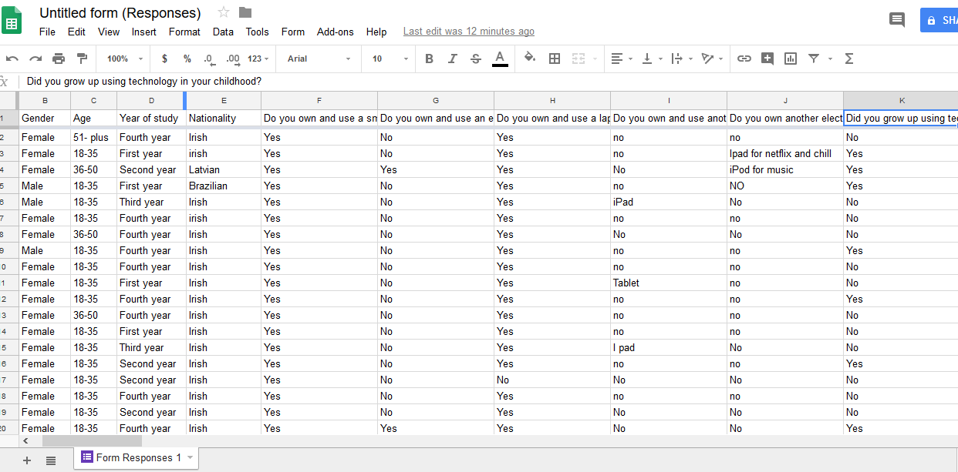

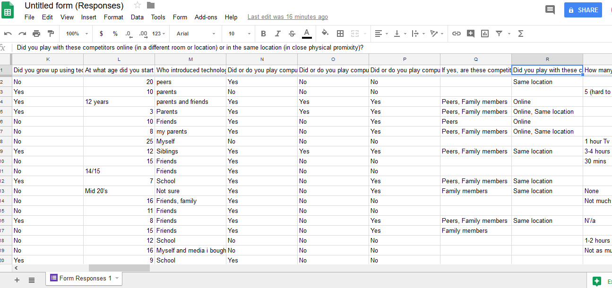

SAMPLE OF SUMMARY RESPONSES

