

The Perils, Predicament of Giggers in the Food Delivery Sector in Dublin
-An empirical study of employment status, benefits, working conditions, and emotional well-being of delivery riders

SACHIN SOMANATHAPURA VEERABHADRAIAH
3021710

MBA
INTERNATIONAL BUSINESS MANAGEMENT

GRIFFITH COLLEGE, DUBLIN
2020 - 2021

The Perils, Predicament of Giggers in the Food Delivery Sector in Dublin
- An empirical study of employment status, benefits, working conditions, and emotional well-being of delivery riders.

SACHIN SOMANATHAPURA VEERABHADRAIAH
3021710
A DISSERTATION PRESENTED IN PART CONSIDERATION
FOR
AWARDING THE DEGREE OF
MASTER OF BUSINESS ADMINISTRATION
in
INTERNATIONAL BUSINESS MANAGEMENT

GRIFFITH COLLEGE, SOUTH CIRCULAR ROAD,
DUBLIN
2020 – 2021

Dissertation Supervisor: Mark Campbell
Date of Submission: 03rd September 2021

CANDIDATE DECLARATION
Candidate Name: Sachin Somanathapura Veerabhadraiah
I Certify that the dissertation titled: The Perils, Predicament of Giggers in the Food Delivery Sector in Dublin (an empirical study of employment status, benefits, working conditions, and emotional well-being of delivery riders).
Submitted for awarding the degree of MBA in International Business Management is the result of my own effort, and where reference is made to the work of others, appropriate credit is provided.
Candidate Name: Sachin Somanathapura Veerabhadraiah
Candidate Signature:
Date: 03rd September 2021

Supervisor Name: Mark Campbell
Supervisor Signature:

Date: 03rd September 2021

ACKNOWLEDGEMENTS
I would like to thank my supervisor Mark Campbell for continually guiding me in completing this piece of work. His continued support and guidance played critical role in completing this research in a timely manner.
My presence here in Dublin would not have been possible without the support of my family and friends for which I am grateful.
I’d like to thank the delivery riders who took their precious time to participate in the research survey and acknowledging the need to carry out this research.
Last but not the least, to Government of Karnataka, India, who has sponsored my studies without which it wouldn’t have been possible for me to pursue this course at all.

DEDICATION
This dissertation is lovingly dedicated to my grandparents, parents, and maternal uncle whose sacrifice, hard work, and perseverance in ensuring I get good education has given me this opportunity to write this dissertation. It wouldn’t have been possible without their blessings and support for which I am eternally grateful.
To my brother, sister, friends, and relatives who shared their words of advice and encouragement prior to starting of the course and during the course to complete the study.
To all the food delivery riders in the city of Dublin, Ireland, who peddle, ride, and drive around bringing delicious food to the consumers to relish at the comfort of their couches.

Table of Contents
CANDIDATE DECLARATION ii
ACKNOWLEDGEMENTS iii
DEDICATION iv
List of Figures vii
List of Tables viii
Abstract 1
1. CHAPTER I 2
1.1. Background 2
1.2. Aims and Objectives 4
2. Chapter II 6
2.1. Literature Review 6
2.1.1. Introduction 6
2.1.2. Contextual Literature 6
2.1.3. The Commodification of the Workforce in Gig Economy 8
2.1.4. Algorithmic Control of Workforce in Platform-Based Work 9
2.1.5. Absence of Employee, Employer Relationship and work meaning 10
2.2. Conceptual Frameworks 12
3. Chapter III 15
3.1. Research Methodology 15
3.1.1. Introduction 15
3.1.2. Overview 16
3.2. Research Philosophy or Paradigm 16
3.3. Research Approach 18
3.4. Research Strategy 18
3.5. Data Collection 19
3.5.1. Primary Data Collection 19
3.5.2. Collection of Secondary Data 20
3.6. Data Analysis 21
3.7. Ethical Issues 21
3.7.1. Data Protection and Privacy 21
3.7.2. Informed Consent 21
4. Chapter IV 22
4.1. Introduction to Data Analysis 22
4.2. Data Analysis and Discussion 22
4.2.1. Objective 1 24
4.2.2. Objective 2 25
4.2.3. Objective 3 27
4.2.4. Objective 4 31
4.2.5. Objective 5 33
4.2.6. Bivariate Analysis to determine the relationship between emotional wellbeing and the working conditions, earnings and benefits available 35
5. Chapter 5 36
5.1. Conclusion 36
5.2. Limitations of the study 37
5.3. Self-Reflections 39
References 40
APPENDIX A A
Plain Language Statement and Informed Consent forms approved by GBS. A
APPENDIX B E
Research Timeline Schedule and Plan E
APPENDIX C F
Survey Questionnaire Extract from Google Forms F
QR Code embedded with questionnaire used in Survey K
APPENDIX D L
Sample rider account rental advertisement from social media (Facebook Market Place) L
Email Communication with the Central Statistics Office M
Email communication with the labour’s Union SIPTU M
Email communication with one of the column writers in WIRED UK M
Email communication with the leading platform providers (Deliveroo, JustEat, and UberEATS) N
Deliveroo N
UberEATS O
JustEat P

List of Figures
Figure i: Conceptualization of Platform based workforce Environment in food delivery sector
Figure ii: Conceptualization of (Dis) Embeddedness and its resulting in Platform based workforce
Figure iii: Overall Conceptual Framework without Data Collection
Figure iv: Conceptualization of Leasing Rider Account for a weekly Fee
Figure v: Conceptual Framework for Data Collection
Figure vi: Overall Research Approach employed in the dissertation
Figure vii: Research participant’s demographics – Sex
Figure viii: Research participant’s demographics – Age
Figure ix: Research participant’s total earnings from fees provided by platform providers
Figure x: Research participant’s earnings after deductions (Account Lease Fee)
Figure xi: Research participant’s work satisfaction considering the earnings and working conditions
Figure xii: Research participant’s earning potential changes
Figure xiii: Research participant’s mode of engagement with the platform providers
Figure xiv: Platform Provider’s break-up for the survey participants
Figure xv: Likelihood of facing threats by the delivery riders
Figure xvi: Kind of threats faced by the delivery riders
Figure xvii: Likelihood of reporting the threats to authorities
Figure xviii: Emotional distress faced by the Delivery Riders
Figure xix: Employment benefit awareness of the delivery riders
Figure xx: Proportion of riders who use the rider’s account on rent
Figure xxi: Range of rental fees paid by the non-account owners
Figure xxii: Perception of riders on the fairness of delivery fee offered by the platform providers
Figure xxiii: Expectation by the delivery rider towards safeguarding their employment and providing social safety net

List of Tables
Table i: Summary of questions and the objectives they address
Table ii: Estimation of Number of Food Delivery Riders in Ireland
Table iii: Crosstabulation of Emotional Distress vs Working Conditions, Earnings, and Available Benefits for the Food Delivery Riders.
Table iv: Chi-Square Tests of independence (Emotional Distress vs Working Conditions, Earnings, and Benefits)

The Perils, Predicament of Giggers in the Food Delivery Sector in Dublin
- An empirical study of employment status, benefits, working conditions, and emotional well-being of delivery riders.

Abstract
This dissertation elucidates the various precarious work conditions inherent in platform-based work, particularly in last mile food delivery sector in the city of Dublin. It includes quantitative analysis of 95 food delivery riders’ responses towards the substandard, precarious working conditions, earning patterns, the existence and proportion of riders in the grey market where an individual leases a rider account for a weekly fee enabled by the platform providers by means of substitution, which causes decreased earnings of such gigger/delivery rider resulting or contributing as a factor for emotional distress, the impact of eased COVID-19 restrictions on their earning potential, work satisfaction and emotional wellbeing, what are their expectation in addressing the issue pertaining to their employment status. Working conditions in platform-based jobs through the eyes of delivery riders and the need to provide better working conditions, employment rights to provide a social safety net for their psychological wellbeing is depicted. It is also found that earnings of a delivery drivers/riders per hours of effort put in generating revenue for the platform providers are well below the national minimum wages as opposed to the claims made by the platform providers to be on par with the national minimum wage and (earnings claimed to be above during peaks hours) causing psychological distress to the delivery riders in addition to the physical exhaustion involved in the kind of work carried out. Bivariate analysis carried out to identify the relationship between the emotional precariousness /distress faced by the food delivery riders owing to the working conditions, earnings, and employment benefits is found statistically significant i.e., the food delivery riders in Dublin are exposed to emotional distress. However, given the financial and time constraints the study is limited to the city of Dublin. Therefore, the generalisation of the results is limited.

Keywords
Gig, food delivery riders, platform-based work, platform provider, algorithmic control, working conditions, emotional distress, social safety, emotional wellbeing

CHAPTER I

Background
While the world needs an economic model that suits and works in the best interest of common people to uplift and provide them better standard of living, employment benefits in the jobs they take upon entering the labour market and provide a social safety net. The work force constituted by the phenomena of gig economy has belittled the workforce by depriving them of employment benefits otherwise available in a traditional economic model which was advanced by the industrial revolution to structured payroll. A research conducted by a leading management consulting firm revealed that the current digital enterprises are shifting this phenomena in the opposite direction (McKinsey & Company, 2016, p.19). The origins of employing the word “GIG”, referring to a job can be traced to as back as 1915, where the jazz musicians referred to their performance (Wallace, 2019) as gigs. Since the advent of technological innovations towards the mid and late 2009 which fuelled the spiralling of new digital enterprises has characterised and gave rise to the platform and location based work which not only disrupted the business models, but the (Berg, Furrer, Harmon, Rani & Silberman, 2018) traditional employment model on which the businesses relied. This dissertation titled “The Perils, Predicament of Giggers in the Food Delivery Sector in Dublin” - an empirical study of working conditions, employment status, benefits, and emotional well-being of food delivery riders, with the objective to empirically evidence the struggles of food delivery riders and call for action from the policy makers and business to safeguard the giggers by revisiting the employment policy around platform-based works particularly in food delivery sector.
A gig is a temporary piece work arising from a consumer at no specific time for a specific period (On demand) which does not exist once the demand is fulfilled. A person involved in fulfilling the demand by means of a mobile application often running on a sophisticated computer algorithm is referred to as a gigger. In this research a gig is a food delivery work and the gigger is a delivery rider who collects the food from a restaurant in the city of Dublin and delivers it to the customer with the assistance of mobile navigational applications (Google Maps, Apple Maps etc.) which enables the riders to follow fastest and shortest distance to the customer’s location. A delivery rider’s roles and responsibilities in its simplest form can be described as the process of collecting a packed meal from point A (restaurant and supermarkets) and delivering it to point B (often a customer’s home) at all times of the day (some restaurants offer late night delivery). A gig allocation to a delivery rider is monitored and controlled by the platform provider with the assistance of a sophisticated computer programme with little or zero human intervention. For instance, Deliveroo, one of the leading food delivery platform providers in Europe uses a powerful predictive algorithm called “Frank” to evaluate and distribute the orders in an efficient way for the restaurant, rider and customer (Deliveroo, 2021a). Deliveroo alone has about 1,100 delivery drivers contracted in Ireland (Doyle, 2021), other leading platform providers such as Just Eat and Uber Eats are also established in this sector contracting a number of delivery drivers.
On demand work characterised by the gig economy boom has radically changed the organization of work, relationship between the employers and employee, a distinction on working hours and rest period is impossible to identify, challenging the traditional social protection, social safety net (De Stafano and Aloisi, 2018) and has come under scrutiny around world for deeming workers as independent contractors, there by circumventing the traditional employment benefits such as paid leaves and insurance (Kaine and Josserand, 2019, p.479). The giggers involved in food delivery related jobs are posed with unsuspected dangers often at its worst scenario on every juncture of their gigs. Take for instance the case of Australian food delivery sector where a prelude data suggests that on an average one food delivery rider has died every two weeks between September 2020 and November 2020 (Zhou, 2020; Carey, 2020). Similarly, the Indian food delivery sector dominated by platform providers like Zomato, Swiggy (Indian version of Deliveroo and JustEat) the delivery rider are reported to be striving job insecurity, low base pay, and inconsistent pay often the riders feel they are enslaved by the enterprises (Sodhi, 2021) despite naming/calling them partners.
The process of gathering and measuring information on interested variables in an established systematic approach that enables one to address the stated research questions, evaluate the outcomes, and/or test the hypothesis is referred to as data collection. Common to all the research irrespective of the field of study. Integrity of the research is dependent on the accuracy of the collected data (Northern Illinois University, 2015). Seen as being scientific in nature with emphasis on numbers and figures quantitative research reduces the effort of researcher in describing the results by using software package such as IBM’s statistical package for social science(SPSS) making it possible to generalise, preserving the objectivity of the researcher, and guarantees respondent’s anonymity (Eyisi, 2016, pp.92–93). Primary data for the intended research has been gathered using a series of combination of closed and open-ended questions (combination of multiple choice and dichotomous questions) keeping in mind the respondents as it is simple and quick to answer, provide consistent responses with an ability to compare the responses with other respondents. It is also easy to analyse the responses for graphical representation in the form of graphs, charts and percentages (SmartSurvey, 2021). The data yielded with descriptive statistical analysis can provide quantifiable all-round view of a respondents’ psychological expectations pertaining to their emotional wellbeing, employment status and benefits. Listed below are the questions devised for this research,
- How many food delivery drivers/riders are there in Ireland?
- What are the employment benefits available for the platform-based food delivery riders in Ireland and, deprived of and the impacts of it on their wellbeing?
- Are there any emotional stress/distress food delivery riders in Dublin exposed to?
- What are the current employment guidelines regulating the delivery riders in Ireland?
- How does a food delivery rider perceive about the working conditions when compared with the earnings?

Aims and Objectives
Over the past two decades a shift from stable, permanent work towards temporary freelancing breed of work is fuelled by the rise of digital platforms which provides greater flexibility at the expense of social security is on the rise which roughly constitutes about 8 to 9 percent of the total workforce in Ireland (Burke-Kennedy, 2020) and is composed of the same precariousness in various forms like that of the case in Australian food delivery industry and elsewhere in Europe or rest of the world. A recent instance which occurred in August 2020, where a 28-year-old Brazilian student working as a rider for the food delivery platform Deliveroo succumbed to death in a case of hit and run in the nation’s capital, Dublin (Tuite, 2021). While the working conditions, employment status of the giggers in various platforms across the world has drawn media and policy makers attention to address the shortcomings evident in the gig economy workforce in the past and in recent times alike, the most recent limelight being the case of UK’s supreme court decision on the UBER driver’s right and employment benefits (Financial Times, 2021) and a similar decision by the French top court (Vidalon and Rosemain, 2020) which is said to be a benchmark decision towards safeguarding the well-being of platform workers and claimed by the industry experts as to reshape the entire gig economic model and its constituents as a whole.
Although (Ford and Honan, 2019) hoists few riveting aspects about the bit part in gig economy in fabricating a formalised and regulated work in some surrounding. The development and scope of the gig economy has called forth for intense discussion about its ramification on ordeal of labour standards, and work, both for the people involved in the gig jobs and traditional jobs as the latter could be impeded by the unmanaged labour market (Kaine and Josserand, 2019, p.480), which may give rise to losing on both the ends of the economic models.
Listed below are the objectives of the research,
- Through secondary research with the Central Statistics Office, Department of Employment and leading platform providers estimate the number of delivery riders that make up the population of the study.
- Through a combination of secondary and primary data to increase knowledge and understanding of the earnings by a food delivery rider.
- Through a combination of secondary and primary data to enhance the knowledge and understanding employment benefits that are available for the food delivery riders.
- Through primary research describe and explain the size (number/proportion) and nature of the ‘grey market’ in rented accounts.
- To elucidate the fairness in casual or gig employment (Food Delivery) when all the bargaining power is with the platform provider.
Following the decision of UKSC on “UBER BV vs others” on 19th February 2021, the EU Commission has said that 11% of the workforce in European Union is providing services through a platform as on the beginning of March 2021 and has launched a six-week deliberation on how to improve the working conditions for platform-based workers in the gig economy is expected by the end of 2021 (Rowe, 2021).
The socio-economic implications due to the expeditious emergence of gig economy platforms which uses digital technologies to intervene workforce on a per-task basis has set off a vigorous policy altercation (Schwellnus et al., 2019, p.3) with a narrative holding the gig economy as a boon to enhance the productivity by providing flexibility to the workforce and with various benefits economically resulting due to the enhanced convenience and consumer choice (Pasquale, 2017) but at what expense is the question to be answered. The raise of precarious and substandard working conditions with uncertain income, workers indulging in the platform based work (Markey and McIvor, 2018) are often cut out from the social safety net. Therefore assessing the work environment created by the platform are pivotal (Healy et al., 2020) where the workers are susceptible to the instability of job, low salaries and poor job quality resulting in a vulnerable population that is most likely to subjected to stress (Freni-Sterrantino and Salerno, 2021). Food delivery riders have been a prime target of anti-social behaviour, where group of young city dwellers every now and then are seen assaulting and attempting to steal their bicycles and belongings which are reported sparsely (one in 3 cases are not reported to the authorities) (MacNamee, 2021) owing to the fact that a great number of riders employment status is questionable (Kilraine, 2021) with the provision provided by platform provider to engage a substitute and allowed by under the rule of law of self-employment.
This dissertation is structured into 5 chapters. The second chapter introduces the readers to literature review section followed by the conceptual framework devised based on the literature review and its constituents. Followed by the end of conceptual framework is Chapter 3 where the overall research approach, each of the research strategies, and process is explained with the rationale behind selecting the said methodology. Data analysis and inferences from the research are set out in Chapter 4 which sets the stage for the final section of this dissertation and concludes the study with dictating the limitations and sets the stage for future research in the realm of platform work, particularly in the food delivery sector.

Chapter II

Literature Review

Introduction
Growing discussion on the peculiarity that characterizes the working for a digital platform on the gig economic model that thoroughly addresses beyond certain case studies and example is currently absent (Gandini, 2019). The gig economy and the workforce that it encapsulates is filled with uncertainties, insecurity, and precariousness consistently in the form of their income generation, working conditions and hours, the invisible emotional turmoil the giggers go through, lack of bargaining power on the hands of giggers despite being classified as independent contractors. A survey conducted by a payroll and business payments processing entity Everee based in the United States of America on the financial stability and expectation of the gig workers depicts some alarming numbers where a whopping 59% (Everee, 2021) of the participants in the survey work for more than one platform, which poses a challenging scenario for the policy makers even if they want to change the policies around employment status of a gigger. Additionally, only 15% of the participants had financial buffer to cover emergency expenses. Whereas 32% of the respondents were unable to make the ends meet and the other 53% were making only enough to cover their bills with no savings, which during these unprecedented times is a situation no one would like to position themselves in resulting in drawing payday loans at hefty interests with the uncertainty of generating enough income may further deteriorate the financial health of an individual. Similarly, a survey of 1,491 workers out of which 721 were fulltime giggers was published in the year 2017 by a leading financial solution provider Prudential, reveals few positive numbers when it comes to the flexibility and more frightening numbers such as a 41% disparity in national average annual income and 34% disparity in long term disability insurance in comparison with the traditional full-time employee (Prudential, 2017). Empirically evidencing similar aspects of the gig economic employment with respect to the food delivery riders in Dublin is attempted in this dissertation to contribute and enhance the knowledge in the domain.

Contextual Literature
Gig economy players have thrived on exploiting the grey areas, loopholes of the labour market and this has had toll on the workforce in various forms. In the wake of benchmark decision on the case of “Uber BV and others (Appellants) v Aslam and others (Respondents)” by the UK Supreme Court, which urged a leading platform provider Uber (an on demand ride hailing service provider), to recognise its drivers as employees and not to classify them as independent contractors, the UK pensions regulator has called for recognising the food delivery riders in the UK to be classified and provided workers status and thus eligible for pensions (Butler, 2021), in resonance with the UKSC the need to recognise other platform based workers as employees is set in motion. Similarly, in the other part of the world, an Australian industrial tribunal has ruled against the unjust dismissal of a delivery rider after being with the platform provider for 3 long years and indicated the relationship between the rider and platform providers as that of employee and employer rather than an independent contractor (Zhou, 2021). When the world was startled with the pandemic, perhaps the food delivery riders who were thought as the essential workers alongside other essential services, had more at stake (Polkowska, 2021). The food delivery platform provider Deliveroo alone has about 1000 plus riders in the Irish market considered as self-employed contractors, with no employment rights and social safety net of employees otherwise offered in a traditional employment set up (Irish Examiner, 2019; Pope, 2021). Having to choose between their safety while out on the streets of major cities delivering food or falling behind on their bills as they were not covered under the benefits that of a worker in traditional employment. The lack of social protection and its importance is well understood by majority of the workers spread in the unregulated gig labour market whose evidence can be seen in a research conducted by (Wood and Lehdonvirta, 2019), why and how the platform workers classified as independent contractors, freelancers, and self-employed are indulging in the traditional collective actions in the form of unionization to tackle the conflicts over pay rates and lack of voice for the workers. Which casts a question, if a worker is classified as self-employed or an independent contractor, why doesn’t that individual have control over price setting for the service rendered by him/her? This notion of price setting by the platform providers is prevalent in most of the on-demand jobs and food delivery sector is no exception. It is the platforms that connect the service seeker and the provider, dictating the price to customer and service fee to the gigger, showcasing that neither the consumer nor gigger has any bargaining power over it. This is another dependency that can be seen as these delivery riders are not self-employed (Kilhoffer et al., 2020), since the basic definition of self-employed means a person quoting his/her price for the piece of work he/she performs. It can be attributed to the grey areas that exists between the traditional employment and self-employment (Aloisi, 2016). Despite the disaggregation of work and individualisation the possibility of collective action for reforms can be noticed, as seen in the past not long ago the rise incidents in the UK and Italy where the couriers for a food delivery platform mobilised (Tassinari and Maccarrone, 2020) demanding reconsideration of the labour laws. A similar strike was called for in the city of Dublin, earlier this year in January raising concerns over the working conditions, lack of security (Pope, 2021) and the increased violence riders have been experiencing on the streets of Dublin to which the law enforcement agency Gardai Síochána had intervened to investigate the concern (Gallagher, 2021). Delivery riders constituted a quarter of the victims of violent crime in a two-week period in February 2021 with more than 60% unreported cases as compiled and quantified for the first time by pro-bono lawyers based in the nation’s capital (Redmond, 2021). Additionally, the lack of public toilet facility in the city has called for attention by academicians and public alike (Maher and Cuffee, 2020; Donohoe, 2021) which is the only means available for the riders while they are on the streets working are often denied by the restaurants to use the facilities in their premises as they are reserved only for customers. These precariat working conditions with no access to the basic ablutions or guarantee of earning even the national minimum wage rate and peddling/riding/driving around the city in harsh Irish weather delivering fresh and hot meals for the consumers while the platform provider enjoys royalty (in the form of service fee/platform fee) for all the orders executed on their platforms calls for intervention by the policy makers to amend the employment laws pertaining to the platform-based workforce especially for the delivery-based workforce. Dublin city senator Marie Sherlock from the labour party also resonated with the arduous working conditions food delivery riders are exposed to, lack of financial support from the platform providers when a rider is injured in the line of duty (Sherlock, 2021). With the new stats published by Eurostat, Ireland ranks second among the EU in terms of minimum wage whereas basic amenities cost such as housing, transport, communication, and recreation cost are among the highest the EU (Reddan, 2021). This when compared with the earnings of a food delivery riders who earns less than the national average, particularly in the city of Dublin can be challenging for an individual who opts to work in the sector by either choice or necessity.

The Commodification of the Workforce in Gig Economy
The work by (Wood et al., 2019b) which highlights (dis)embeddedness of workforce from the social protection net normatively and the stark use of workers who generate revenue to the platforms and contribute to the overall economic development of a region or nation as mere commodities by terming the process as commodification, where the workers are exposed to idiosyncrasy of the external labour market in the absence of bargaining power, lack of employment benefits and inaction by the policy makers to protect these precariat. The (dis)embeddedness can also be attributed to the lack of an organizational structure, little or no contact with platform’s representatives. In addition, (Wood et al., 2019a) exemplifies how the operation of platform provider’s business model results in low pay, social isolation, working irregular and unsocial hours, over work, exhaustion, and sleep deprivation. As described by Guy Standing, an economist, a British professor of Developmental Studies in one of his work “The Precariat” (Standing, 2011), and an opinion column written in a renowned news publisher, the gains from the economic growth are no longer shared equally, with more of the fruits being reaped by those who own the intellectual property (platforms who provide employment in this case) by not leaving enough for those who pin one’s hopes on labour (Standing, 2018), characterised by uncertain, insecure, agency, dubious and phoney self- employment, part time labour, and the phenomenon of crowd labour (Standing, 2015) often working more than the renumerated hours. Thus, the workforce in the platform economy is seen as components of production (earnings for the platform providers) rather than as human quality leading to the substandard working conditions (Wood et al., 2019b, p.935) for the labours (delivery riders in this case) in the gig economic sphere.

Algorithmic Control of Workforce in Platform-Based Work
Sophisticated computer programmes with combinations of complex algorithms at their heart are changing the way world operates and ever changing at a rapid pace. Distributed human jobs are now tracked, monitored and performance measured by computer programmes in an ever growing realm of works (Lee et al., 2015) referred to as algorithmic management, is one of the principle innovations that location based platform service providers business model thrives on and is the backbone of their operations. Independently scattered delivery riders are algorithmically matched to the nearest restaurants within seconds or minutes, and the delivery fee dynamically calculated based on an unknown logic to the rider all through the platform provider’s app on their mobile devices. These secretive algorithms tend to rank the riders to assign a gig which is ruled as discriminatory in nature by an Italian court (Geiger, 2021), which could have profound repercussions on the rider’s livelihoods also the price setting is done by the platform providers despite delivery riders being classified as self-employed, the ratings received which the giggers have no control of (Kilhoffer et al., 2020). However, the latest Spanish cabinet’s “Rider Law” ratifies the platform providers to make their algorithms transparent and educate the riders on how it affects their work (Pérez, 2021) bound by undesired biases (Rubio, 2018) inherent (for now) in artificial intelligence or complex computer algorithms. These benchmarking decisions on the suits filed by the workers in gig economy indicates an increased willingness by the policy makers and other relevant stakeholders to have an enhanced awareness about how these algorithms can evade traditional labour laws.
Having classified 7.2% of the workers as main or secondary platform workers is small in absolute terms but relatively higher in European terms. A remarkable debate on policy has focused on probing of self-employment, and it’s implication for workforces’ rights, the tax, and social protection (Doherty, 2020, p.1), whereas the government has no desire to safeguard the gig workers in Ireland (Gleeson, 2021) by introducing a new category of workforce or classifying the platform workers as employees and retain its binary modes of classifying worker, may be because there hasn’t been a case law directly concerning any platform worker in Ireland unlike in the UK, France and Australia. There is limited empirical research and evidence available on the perils, emotional predicaments posed and undergone by the giggers in food delivery sector around the world more so in Ireland. The platform-based workforce is under- theorised owing to distinctiveness in the advancement of literature (Schor et al., 2020). However, there is abundance of research and study carried out by the academicians on how the platform employers in delivery industry exert control on the workforce known as “algorithmic despotism” to govern and schedule the activities pertaining to the gigs (piece of work) with notable variations across platforms. A research involving 55 respondents working in food delivery gigs took part on in-depth interviews along with a survey of 955 platform delivery riders (Griesbach et al., 2019). The mechanism of algorithmic regulation employed by a leading grocery delivery platform “Instacart” for managing the activities for a gigger came under the purview of media owing to the tighter control exerted by the platform than any other in the industry. Giggers were forced to take on the job even when he/she thought the gig is not worth their time or effort compared to the pay offered for that gig (Eidelson, 2015). These factors contribute to the emotional distress of a gigger when they are not provided with the independence to choose their gigs and their work allotment is controlled by the technology to such an extent where a gigger ends up putting an effort where he/she is not paid for. As described by Karl Marx in one of his original work (Marx, 1894), later edited by Friedrich Engels,
“Hence the resultant extra profit accruing to the capitalist, or capitalist class, arises, and can only arise, in the last analysis, from the fact that the worker, after reproducing the equivalent for the price of his labour-power, must produce an additional product for which he is not paid – i.e., a surplus-product, a product of unpaid labour, or surplus-value”,
the case resonates with the for-platform workers aptly when they are not given the choice to choose their gigs (not applicable in the case of food delivery riders but the impact of rejecting undesired gigs is unknown. A preliminary understanding by the delivery riders is that if they reject a gig their ranking in the system is reduced, resulting in fewer gigs assigned to them) and made to put in additional effort (peddling to another restaurant once the previous order is delivered). Often the distance from a drop location to the next order pickup location is no less than 2.5 KM as described by one of the survey participants, for which they are not paid for contributing to physical and emotional stress along with the inherent financial instability that is part and parcel of the gig economic model.

Absence of Employee, Employer Relationship and work meaning
The increase in gig workforce - both out of choice and essential across job market poses a unique challenge to the organization in terms of managing their data, relations, and the regulators to reform the existing legislative policies (Visier, 2020) to ensure they are safeguarded like in the traditional employment model in case of any conflict that may arise between the platform provider and the gigger as it eliminates the yardstick of human resources management – the employee and employer relationship (Meijerink and Keegan, 2019). Absence of employment relationship between the platform providers (Deliveroo, JustEat, and Uber Eats) and delivery riders endangers the earning potential of a gigger as the gigs are sporadic in nature and often a delivery rider earns less than the prescribed national minimum pay rate for an hour of work which would have been guaranteed under the traditional employee and employer relationship contributing to the generation of substandard income, and may fail to meet the basic needs (psychological needs) derived in the Maslow’s hierarchy of needs (Maslow, 1943) could contribute to the emotional distress of delivery riders.
Labour experience over the years has evolved resulting in work issues, both in the gig economic, and traditional job market alike. As in a generic societal context the kind of work a person does for living defines and is perceived as a constitutive feature of an individual. One’s sense of welfare and identification is tethered with their connection to work (Mumby, 2019). The absence of organizational structure inherent and apparent in the digital gig work platforms is designed as an organizational model that obscures a managerial figure inaccessible by the giggers as everything is controlled, monitored by complex algorithms warding off fellow giggers from socializing reducing the potential to unionization and resistance (Gandini, 2019), the riders can be said to loosely affiliated to the platform providers that enables them to connect with the demand side of the market. The absence of organizational structure, and professional affiliation amongst the workers is found to exacerbate stark emotional strain in the form of anxiety (Petriglieri et al., 2019) which is evident in the case of delivery riders (please refer to empirical data in Chapter 4). Similarly, absence of a holding environment also contributes to the emotional distress, while these delivery riders are seen, tend to create their personal holding environments, interact with fellow riders at city’s landmarks to cater to their emotional wellbeing. This creation of personal holding environment has shown to help the gig workers manage their emotional distress (Petriglieri et al., 2019). In addition, existence of a team like structure is seen to have an impact on wide array of societal functions (Kozlowski and Ilgen, 2006), which can be said to have a negative impact on the food delivery riders’ societal functions, due to the lack of organizational structure or a team like structure which is absent in the whole gig economic employment model.
Following a landmark decision by the supreme court of Spain, one of the EU states, in September 2020 (in favour of a delivery rider), the Spanish cabinet approved a bill which mandates the platform providers such as Deliveroo, JustEat to recognise the delivery riders who were rendering their service to the platform by means of self-employment as employee, thus providing the benefits such as sick leaves and paid time off (Pérez, 2021). This came as a result of the factor that the relationship existing between a delivery rider and the platform is of an employee and employer as they are directed by the platform providers for carrying out a gig/piece of work which underpins to the traditional employment model. The bill has drawn a mixed reaction from the rider, platform providers, unions, and business. While one of the leading platform providers JustEat has welcomed the decision, Deliveroo and other leading platform providers are dispirited (Pérez, 2021). This is evident as Deliveroo is said to be pondering on closing its operations in the EU state of Spain owing to the high costs involved in its operations (Reuters, 2021).
    - Key Food Delivery Sector Figures of Ireland
At the end of year 2019, the Irish food service industry (NI and ROI) totalled a whopping 8.6 billion Euros with a growth forecast of 4.9% for ROI and 3.5% for NI, similar to the year before. In terms of consumer expenditure, the industry was estimated to be valued at 4.51 billion Euros. The effect of pandemic on the industry is forecasted to persist till the end of 2021 with a growth rate somewhere between 16% to 41% whereas it has contracted by 47% in the year 2020. Off-Premises meals (consisting of click and collect, delivery from platform providers and self) grew from 54% to 90% during the pandemic owing to the restrictions (BORD BIA, 2020, pp.42–46), which could be attributed to crucial role played by the delivery drivers for the platform providers. Irish food delivery sector is dominated by 3 key players, Deliveroo, JustEat, and UberEATS with a user penetration rate of 22.4% as of July 2021, further forecasted to penetrate stronger by 2025 to 32.8%. Penetration rate by platform-to-consumer delivery segment has steadily increased over the past 5 years from 3.8% in 2017 to 7.2% as of July 2021. The segment is predicted to grow by a whopping 45% in the next 5 years to have a penetration rate of 10.5% by 2025 (Statista, 2021). In addition, Gigable is one platform provider, which connects the giggers and the gig provider across job spectrum together, primarily food delivery riders’ jobs. Perhaps these astonishing growth figures could be partially attributed to the last mile food delivery riders who make it happen (for the customers and generating revenue for the platform providers). Therefore, understanding the working conditions, ensuring inclusion in the social safety by fair pay, their emotional wellbeing should be a concern for both the platform providers and policy makers to make the gig economic model sustainable in the long run.
The conceptual framework introduced in the following section of the paper is developed with the assistance of limited literature available in the realm of platform-based work and its constituents.

Conceptual Frameworks
Theorising and measuring platform work and its conditions is filled with technical and conceptual challenges (Kilhoffer et al., 2020, p.44) which includes complexities in definitions and lack of standardised terminology. Figure 1 derived from (Kilhoffer et al., 2020) below represents author’s own conceptual representation of platform-based work allocation arrangement between the consumer and the platform based worked intermediated by a platform in its simplest form with the assistance of a software program running on a complex algorithm which is said to manage the work allocation by means of algorithmic control.
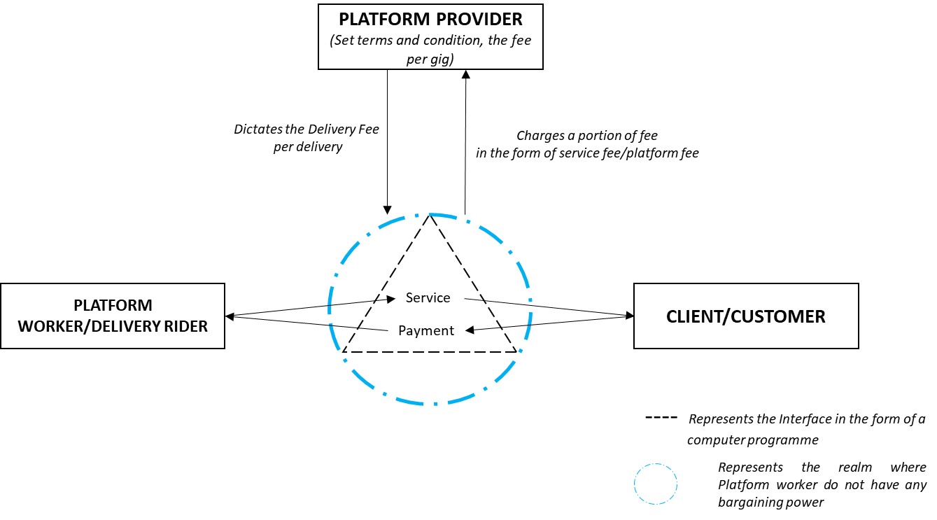
Figure i: Conceptualization of Platform based workforce Environment in food delivery sector
Figure 2, below represents author’s own conceptualization of the outcomes of (dis)embeddedness in the platform based working environment where delivery riders are often commodified, working irregular long hours during unsocial times, with low pay (below average pay per hour) and the exposure to emotional distress are the most common nuances of platform-based work environment. External variables such as the extreme weather conditions adds an additional layer of perils and precariousness to the food delivery riders.
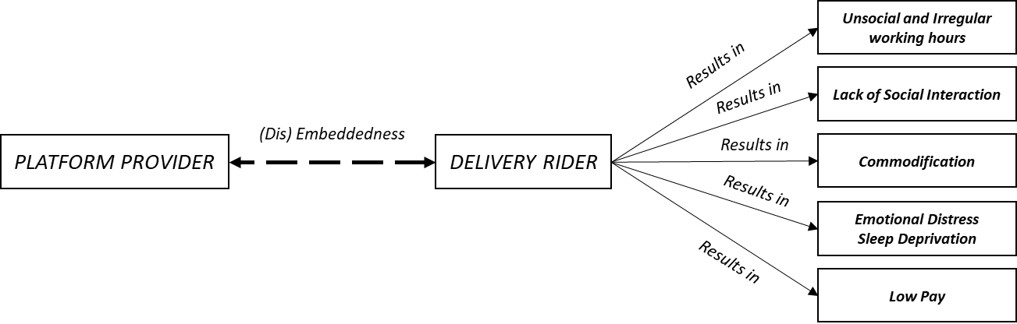
Figure ii: Conceptualization of (Dis) Embeddedness and its resulting in Platform based workforce
Figure 3, depicted below symbolizes author own representation of the overall conceptual framework for the intended research, where externals precarious factors are listed outside of the dotted line and the economic model’s inherent precarious factors are represented inside the dotted line.
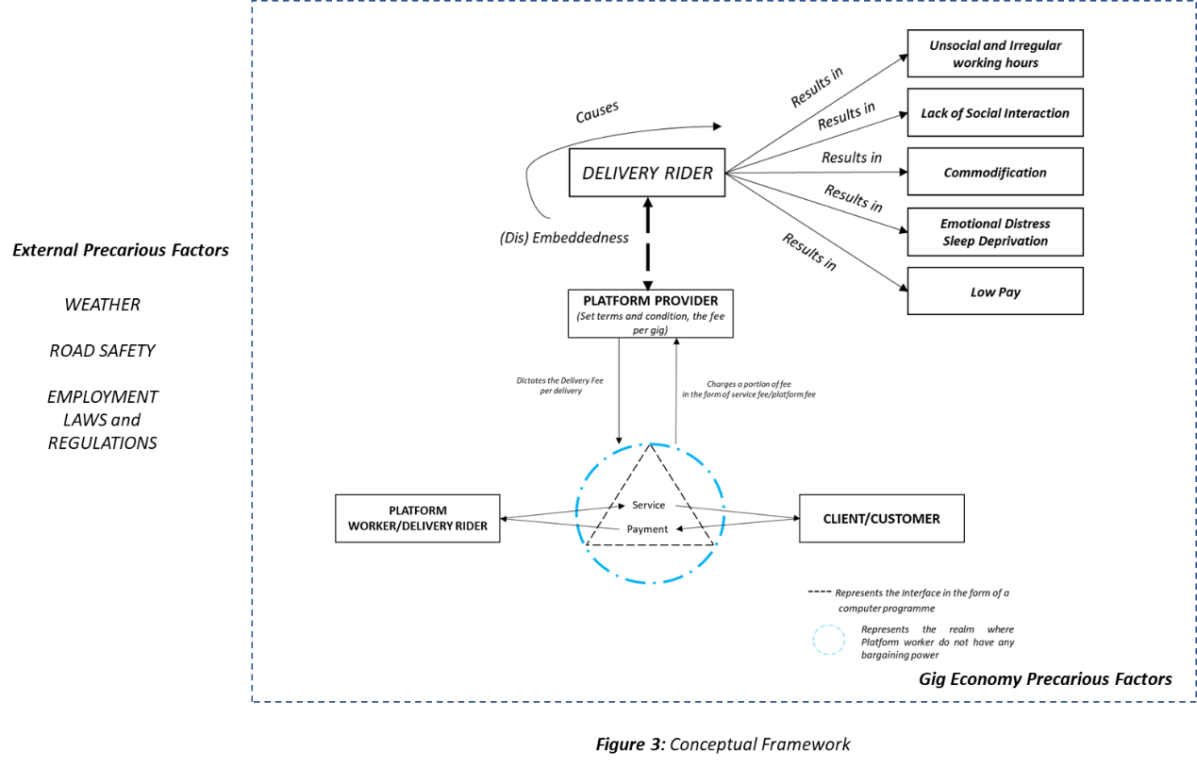
Figure iii: Overall Conceptual Framework without Data Collection
As elucidated in the literature review the gig economic model constitutes work environment resulting in uncertain income, causes emotional distress and the workers are not covered under the social safety net due to the binary categorization of employments in the Republic of Ireland. This binary approach followed in Ireland poses a certain limitation for these delivery riders such as the inability to form a union for collective bargain, which under EU competition laws is viewed as cartel-like behaviour (Pelly, 2021). However, owing to the mounting pressure from the public and trade unions, efforts are in being put to ensure the gig economic employees (inclusive of the food delivery riders) are provided with a fairer work environment and benefits such as minimum wage floor to tackle in-work poverty (Murphy and Dundon, 2021).
Figure 4 below, represents the vulnerable and delivery rider who is exposed to the external precarious factors who leases the rider account from a valid account holder for an arbitrarily weekly fee set by the account holder ranging from Euros 30 to Euros 100 depending on the type of rider account (Regular Bike, E-Bike, Motorcycle or Car) often advertised in market place of Facebook (sample advertisements attached in the APPENDIX) provisioned by sub-contracting clause under employment law and treated as a substitute by the platform provider (Kilraine, 2021a).
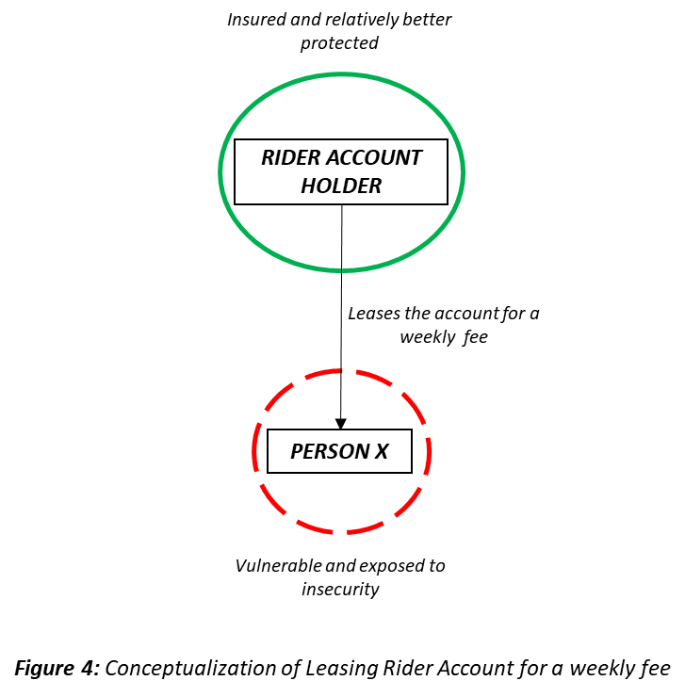
Figure iv: Conceptualization of Leasing Rider Account for a weekly Fee
No literature is available in this regard to conceptualise this aspect of the food delivery sector in Ireland, except contextual framework as mentioned above. This constitutes another grey area in the employment law, which the government has said to address (Kilraine, 2021b) to protect the employment right laws of platform workers.
In terms of the data collection aspects of this dissertation, Figure 5 below outlines the primary and secondary data collection process and methods to address the research objectives outlined in the above section and the research methodology employed in the following section.
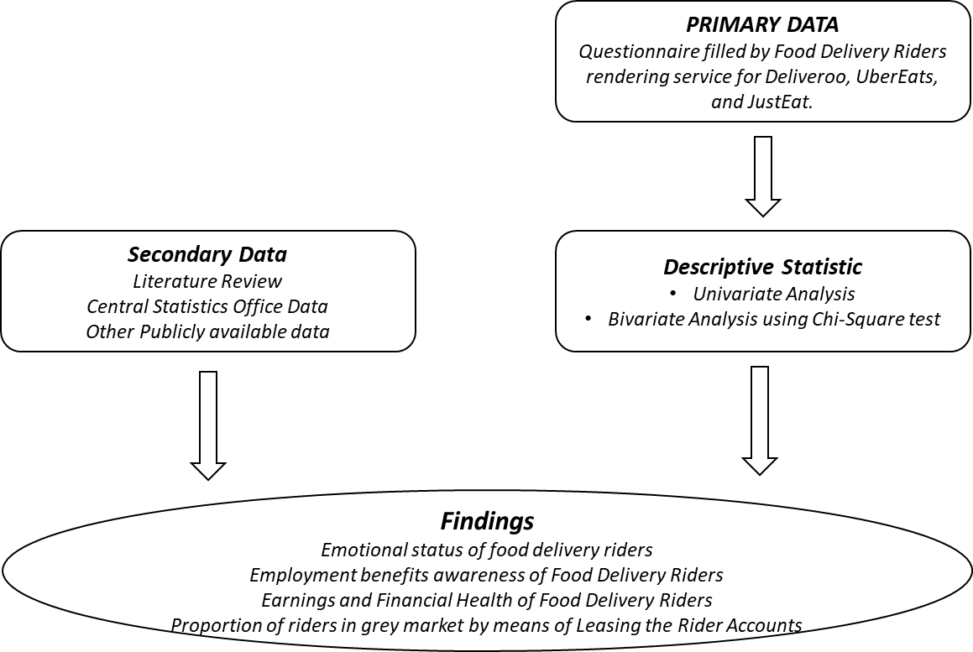
Figure v: Conceptual Framework with Data Collection

Chapter III

Research Methodology

Introduction
The above sections which outlined the generic aspects of employment model in the gig economic sphere and in relevance to the food delivery sector in Dublin, Ireland. If you recall from the introduction, the precariousness faced by the food delivery riders in Dublin (like elsewhere in the world) often in its most dangerous scenario while on the roads, the lack of employment rights and benefits such as sick leave, pension etc., the call by both the policy makers and workers in the gig economic sphere to address the shortcomings of the employment model to safeguard and provide a social safety net for the worker involved in the gig economy. The literature review highlights how the individuals in the gig economic sphere are considered as mere commodities by not paying attention to the human aspects of the employment, the lack of organizational structure resulting in (dis)embeddedness between the platform provider and the riders is said to result in the substandard working conditions (working in unsocial hours), emotional distress, and not to forget the uncertain income, often earning less than the prescribed national minimum wage. Upon looking at all these listed aspects, the absence of extensive empirical literature or evidence on the food delivery riders in Dublin is attempted to address in this dissertation. Owing to the absence of empirical evidence in the chosen field of study, mono method (quantitative) research with a positivist research philosophy which encompasses the scientific approach for finding or arriving at a conclusion is taken up. Primary data is collected in a cross-sectional manner due to the limited availability of resources (time and money) by means of a self-administered survey questionnaire surrounding the research questions and objective to elucidate the perils, and precariousness faced by the food delivery riders in nation’s capital Dublin.

Overview
The overall research approach adapted in the dissertation is depicted in Figure 5, with the assistance of research onion model (Saunders et al., 2009, p.108). Each of the layer in the onion model is defined and justified for choosing the approach in the subsequent headings below.
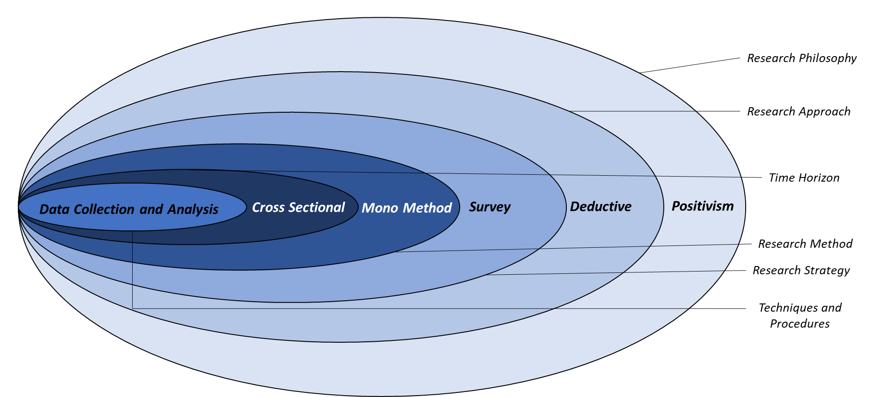
Figure vi: Overall Research Approach employed in the dissertation

Research Philosophy or Paradigm
Research paradigm is defined as the faith or the worldview which ushers a researcher into investigation (Guba and Lincoln, 1994). The notion of research paradigm is a one of those things in the research that most of the early researchers (like myself) and higher education pupils find challenging to articulate and apply in their research proposition (Kivunja and Kuyini, 2017). A paradigm can be defined as a philosophical way of thinking (Bird, 2004) as per renowned American philosopher, first mentioned in one of his work “The Structure of Scientific Revolution”. In an educational set up (this dissertation) research paradigm is employed to express, narrate, and delineate the researcher’s view (My view) of the world (Mackenzie and Knipe, 2006), it implicitly mirrors the lens through which the researchers view the world (Lather, 2011) and how the meaning will be constructed from the research data collected and analysed (Kivunja and Kuyini, 2017). Therefore, it is crucial to have a research paradigm in any research.
This research has been approached in a positivist philosophy, which encompasses the idea that scientific approach is the only way to know the truth about something. The rise of platform, location based on demand work culture resulted from the technological advancements has increased the precariousness and an alternate employment market consisting of contingent workers or temporary workforce employed for a brief period without having to consider the humane aspects, treating the workforce as mere commodities without worrying about the employment benefits or offering social protection that are encompassed in the traditional economic model or employment market. The global modernity has caused drastic changes in the realms of world order, societal policies, and the realm of work (Schmidt, 2017) and is expected to undergo radical changes in the coming years. Global modernity resulting as one of the by-products of globalization has been considered to play a vital role in explaining the rising inequality (Heimberger, 2020) in several developed and developing countries for which European states are no exception. This calls for addressing the issues through data collection and interpretation to elucidate the work environment resulting from such employment opportunities to better safeguard the workforce, which is only possible by shedding light on the perils and precariousness faced by the workforce so that, the platform providers and policy makers can work hand in hand to devise an employment framework from which all the three parties (gigger, platform provider, and the policy makers) are benefitted from. There is no other visible benefit but a bundle of uncertainties to the workforce in food delivery sector or gig workers in general apart from the independence and discretion for the workers to choose their working hours which undermines before the indeterminate financial and social protection provided by their employment. This can only be possible to depict and deduce if we have empirical evidence which is only possible by employing positivism approach which provides survey as one of the means to collect the data to answer my research questions and address the research objectives.
Therefore, the positivism philosophy of research will enable to empirically evidence and address the drawbacks of platform employment in the food delivery sector, about which no significant empirical research is conducted as found in the literature review and highlighted in the limited literature on this. The intended research has been conducted using a quantitative approach to empirically elucidate the perils, and emotional predicaments, the degree of financial risk giggers face particularly in Dublin’s food delivery sector and also to identify the proportion of delivery riders in the grey market who rents rider accounts for a varying weekly fee (enabled by the entitlement of sub-contracting clause of self-employment) and its implication to them which wouldn’t have been possible in a qualitative approach. For instance, by collecting quantitative data with the help of questionnaire the research aims to highlight the proportion of delivery riders who use leased accounts. This will enable to depict the proportion of their earnings which goes towards the lease contributing to the emotional distress. On more example is by having the quantified data about their earning potential during and after the lock down restriction are eased which can help to deduce the relationship between the earnings and their emotional well-being.

Research Approach
Having read the plight of food delivery riders in Dublin, during the height of pandemic when they were classified as essential workers despite the lack of safety underlying in their employment category, the delivery riders served fresh and hot food to the customers at the comfort of their home. While there are no official empirical data available on the number of food delivery riders registered with the platform providers, about earnings, have the riders registered their employment with the revenue office, and about the precarious working conditions. Therefore, empirically evidencing these aspects of the food delivery sector in Dublin could serve as a starting point to ensuring we have data on these kinds of employments. Quantitative research is one of the research method that is used to explain a circumstance by means of collecting numerical data which are then analysed for interpretation by using mathematical methods (Creswell, 2014). The flexibility offered by filling a survey questionnaire providing capability to include a combination of both open ended and close ended questions, ideal for collecting emotional feedback (Ramshaw, 2021). As depicted in the research onion picture above, this dissertation/research is conducted based on the deductive approach. The literature review chapter provided the research with theories elucidating the precariousness evident in the gig economic sphere which encompasses the platform providers. Having carried out the secondary research by means of the literature review, publicly available data gathered from various sources and reasonable estimation in the absence of official data is done.

Research Strategy
The inner most 3 layers of the research onion which constitutes research strategies, time horizons, and the research choices could be thought of as the bedrock of any research design (Saunders et al., 2009, p.136) and it sets out the plan of action on how the researcher intends to answer the research questions. The research design contains the clear, consistent, and coherent objectives obtained from the research questions, enumerates the data sources from which the researcher intends to collect the data from along with any constraints, and ethical issues that may arise. The research purpose can be classified as exploratory, or descriptive as a study can have more than one purpose (Saunders et al., 2009, p.137) which tends to change over time. The research questions devised in section 1 of this research paper have been tackled with a combination of descriptive and explanatory research style to portray an accurate picture, events, and situations posed by the giggers/ riders in the food delivery sector in Dublin with an explanation of relationship between their uncertain income which affects their social protection. The research is focused on finding quantifiable aspects pertaining to the working conditions, employment benefits, and the rider’s emotional well-being. Therefore, of the 4 research strategies under quantitative method, surveying is adopted.

Data Collection

Primary Data Collection
The process of data collection in any research is challenging and more so during this unprecedented time. Data collection can be described as the activity of assembling and measuring information on the study variables to address the research questions and objectives. Primary data for the intended research has been collected from the food delivery riders (combination of Deliveroo, Justeat, and UberEATS) based in the city of Dublin, Ireland by means of a self-administered online survey created in google forms, also embedded in a QR code to make the data collection easier with a brief paragraph outlining the research importance and informed consent or plain language statement was also supplied to the research participants. Research participants were randomly selected in the city when they were at various restaurants to pick-up the food for delivery and at city’s location (concentrated restaurants presence) where the delivery riders are often seen taking break from their work. Each of the survey participants were educated on the research topic, the potential benefits at the end of the research, kind of data collected and its importance. Data collection in any study is posed by several challenges and this dissertation was no exception. Prof Angelo Nicolaides (2020) of University of South Africa, Graduate School of Business Leadership mentions locating the participants, participants who are not really keen to participate in the study, persuading them to take a little time to answer the questions as some of the most common types of challenges faced by students. This has resulted in generating anomalous data in few instances which are highlighted in the data analysis section (Chapter 4.2.1) and reasonable assumptions within the research framework is employed for performing the analysis.
Q1 to Q4 has enabled me to capture the demography and informed consent to address the privacy of the survey participants by not collecting any personally identifiable (PI) data. The first objective of the research which is to estimate the total population of the study is addressed purely based on secondary research and reasonable estimation due to the unavailability of official figures. Multiple attempts were made to collect the data from the platform providers (please see APPENDIX D) themselves along with the assistance of Central Statistics Office in Dublin, Ireland.
The second objective of this dissertation is to increase the knowledge on earnings of a food delivery rider through a combination of primary (Q11, Q12, Q13 and Q14) which asks the survey participants about their earnings and secondary research by means of earnings potential data claimed by the platform providers. Similarly, the third research objective which is to learn about the working conditions, work satisfaction, awareness of employments benefits available for the delivery riders is captured through Q5 through Q10 and Q15. Finally, while the fourth research objective which aims at identifying the proportion of leased rider accounts is addressed through Q16 and Q17, fairness of the employment model prevalent in the food delivery sector where the bargaining power is completely with the platform provider and what the delivery riders are expecting from the policy makers to better safeguard the delivery riders is captured through Q18 & Q19.
The table below summarises how each of the survey questions devised addresses the objectives of this dissertation. List of questions used for the survey can be referred to in APPENDIX C of the dissertation paper together with the QR code to which the same questions were embedded to make the data collection process fluid and safe ensuring the social distancing during this distressing times. It came as no surprise that the participants were vastly reluctant to scan the QR code from their devices, owing to the lack of knowledge and presumed security risks.
Objective 2 – related to the earnings of a delivery rider | Objective 3 – related to employment status, conditions, benefits | Objective 4 – related to the grey market where accounts are leased | Objective 5 – fairness of fee assigned to a delivery & expectations
Q11 | Q5 | Q16 | Q18
Q12 | Q6 | Q17 | Q19
Q13 | Q7
Q14 | Q8, Q9, Q10, & Q15
Table i: Summary of questions and the objectives they address

Collection of Secondary Data
Secondary data enables a researcher to build on available data which translates to better results saving time. It includes publicly available data maintained collected by the government departments, market research organizations and academic articles (Puniello, 2018), and should be reviewed with the same attentiveness as the primary data a researcher collects (Saunders et al., 2009, p.272). The research involved collecting the data from the platform providers, the central statistics office on the total number of food delivery riders in Dublin. However, email requests sent to the platform providers seeking the official numbers yielded no response. The data obtained from the Central Statistics Office turned out to be nugatory due to the absence of classification for delivery drivers under the Standard Occupational Classification (SOC). All the food delivery riders/drivers fall under a broad category bearing the SOC code 821 Road Transport Drivers. Pease refer to the APPENDIX D section for the email communications between the researcher and various bodies during course of this dissertation for secondary data collection.

Data Analysis
The collected data from the randomly selected survey participants has been analysed using Statistical Package for Social Science (IBM SPSS V.28) tool used for interactive statistical analysis and deduced. The need for sampling arises, when we cannot collect the data from the entire population of the intended study (Saunders et al., 2009, p.223). Survey sample size is taken to be 95 (SurveyMonkey, 2021) arrived at with the help of automated tool available in SurveyMonkey website (a market leading cloud-based survey tool) with 95% confidence level (higher confidence value means enhanced accuracy) and a 10% margin of error (lower margin of error means enhanced accuracy). Univariate data analysis by means of descriptive statistics to address each of the research objective, a bivariate analysis by means of chi-square test to statistically identify the significance of earning, employment benefits, and working conditions with the emotional precariousness experienced by the food delivery riders. The collection of primary data from the delivery riders has enabled to take cognizance of the challenges faced by the food delivery riders in Dublin, Ireland.

Ethical Issues
Ethical issues in any research can arise as in any part of overall research such as design, ethical approval, analysis of collected data etc. (Jenn, 2006). Therefore, it is crucial to have all the ethical issues addressed prior to the beginning of any research. Ethics approval for this research was sought and approved by the institutional review board. This research does not foresee any ethical challenges that may arise by ensuring the below listed most common ethical issues as prescribed by (European Commission Directorate General for Research, 2013) have been adhered to.

Data Protection and Privacy
Set as the fundamental principles in the charter of fundamental rights and the treaty on the functioning of the European Union, privacy and data protection are set as fundamental rights which are to be protected at all the time. Data collection will follow proportionality i.e., only the necessary data required to conduct the research will be collected. No PI (personally identifiable) information from the survey participants has been collected. In addition, the collected data has been stored in an encrypted storage device with password protection, to be permanently deleted upon receiving a go ahead from the principal investigator mentioned in the plain language statement.

Informed Consent
Mentioned explicitly by (UNHCR, 1966) under Article 7 as a principle under the treaty of International Covenant on Civil and Political Rights, informed consent is considered as most pivotal principles in any research by many international conventions and guidelines. Informed consent guarantees the subject’s voluntary participation in the research and is considered as one of the most important aspect in addressing the ethical issues in any research. Greater emphasis and care were taken to inform and educate the participants of the intended research’s importance, and potential benefits likely to occur at the end of it. To reiterate, a summary of plain language statement and informed consent for the participation in the research was provided to each of the survey participants as the questionnaire heading which can be found in the APPENDIX C.
In summary, the overall research approach is scientifically chosen as per the philosophical principle used which is rooted in the scientific exploration of truth, facts, and figures. The research objectives listed in chapter 1 of this dissertation are addressed in the next section in line with the research methodology discussed in chapter 3.

Chapter IV

Introduction to Data Analysis
Any data in its raw form convey little or no meaning. Hence only by processing and analysing the collected data and turning them into information will enable a researcher to address the research objective (Saunders et al., 2009, p.414). Quantitative data is a product of the research strategies listed and described in the above section and can range from counts, frequencies etc., The primary data collected as a part of this dissertation is analysed using univariate descriptive analysis addressing each of the research objectives followed by bivariate analysis and statistical inferences for a delivery rider’s employment benefits, earnings, and his/her emotional distress is elucidated.

Data Analysis and Discussion
The data set was collected by means of a self-administered questionnaire consisting of 19 questions, laid out to the food delivery riders across Dublin. The riders from leading platforms like Deliveroo, Uber Eats and JustEat participated by acknowledging to the survey consent. The questionnaire consisted of a set of 17 close ended and 2 open ended questions. While the 17 questions were retained as categorical variables, the other 2 were converted to categorical variables by bucketing the responses based on the sentiment expressed by the riders without affecting the reliability of the data since the categorisation was a simple process.
A total of 98 delivery riders participated in the survey, of which 95 consented to fill the form and agreed to fully participate in the research but 3 participants answered no for the mandatory questions. The 19 attributes are Agree/Disagree, Consent, Sex, Age, Mode of Engagement in Work, Platform Provider, Faced Threats, Kind of Threat, Report to Authorities, Emotional Distress, Working Conditions, Benefits Satisfied, Direct Earnings, Total Earning - Expenses, Change in Earning Potential, Employment Benefits Awareness, Account Owner, Weekly Lease Fee, Delivery Fee Fair, and Facilities for Riders (shortened for data analysis in the IBM’s SPSS tool).
There were few anomalies in the data, which were corrected based reasonable assumptions,
- Anomaly 1: There were 4 instances where owners of the rider account showed that they paid the rent for the account, which cannot be true as the account was not a rented one.
Corrections: The rent amount response for the 4 entries were changed to 0.
- Anomaly 2: In 3 instances, the earnings after deducting expenses exceeded the total earnings. This again cannot be true as the expense is deducted from the total earnings.
Corrections: The earnings after expense are changed to the same earnings range as total earnings, considering the earnings as maximum in the selected range and the rent paid is maximum. (Ex: Total Earnings: 200 - 300 Euro, Account Rent: 40 - 70 Euro, then Earnings after Expense is assumed to be in the range 200 - 300 Euro because 300 - 70=230, which lies in the range 200-300 Euro).
Finally, the cleansed data containing 19 columns and 95 rows were considered for analysis. The analysis was conducted using IBM SPSS. Univariate analysis is performed to obtain the results, addressing the research objectives, followed by a bivariate analysis to identify the statistical significance of emotional distress in relation with working conditions and earnings.
Below two graphs (Figure 7 and Figures 8) shows the demographic distribution of survey participants.
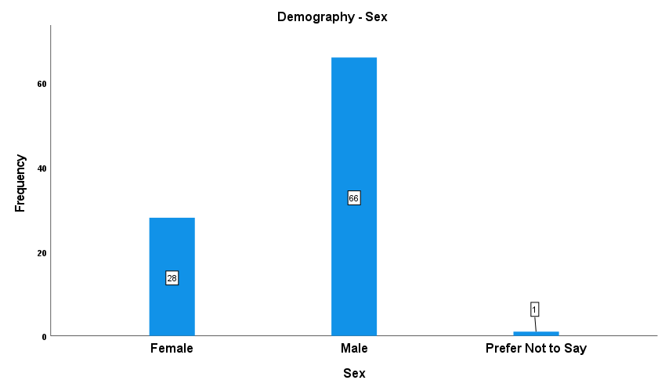
Figure vii: Research participant’s demographics – Sex

The graph above shows the gender distribution from the survey sample. It is evident that a majority, by large margin, are male. While 66 of the survey respondents are male, 28 of them are female and 1 respondent preferred not to state their sex. This could possibly be because of the physical effort involved in the work and external factors like weather, unsocial working hours, and environment, and relatively due to the uncertain earnings inherent in all the platform works. The below visualization depicts the age category distribution in the survey sample. Over 66% of the riders who took part in the survey were aged in the range 25 to 30. While almost 19% were between the age of 31 and 45, 14% of them were below 24 and above 18. There is an outlier in the data, just one rider aged above 45.

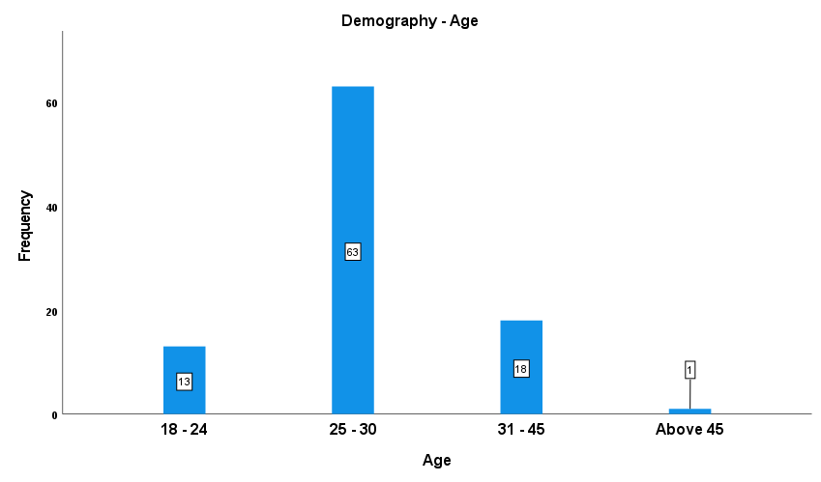
Figure viii: Research participant’s demographics – Age

As food delivery work involves moving from a restaurant to a consumer’s place and from a consumer place to a restaurant for picking up the next delivery, which is a physically demanding task, the demographics from the survey sample clearly shows the trend where male delivery riders aged between 25 and 45 accounted for nearly 65%.

Objective 1
The first objective of this dissertation is to find out the number of food delivery riders in Dublin. The total number of food delivery riders working as self-employed, independent contractors in the nation’s capital Dublin has been a little difficult to arrive at. Multiple email requests were sent to each of the leading platform providers requesting for official figures (see APPENDIX D) which yielded no results and had to resort to estimation based on the limited available data. Deliveroo alone is said to have a fleet of around 1000 (Pope, 2021; Daly, 2021) and Irish arm of the platform is said to have generated 13.8 Million Euros in revenue as per the latest financial data reported (Taylor, 2020). Based on these numbers the revenue for JustEat and UberEATS for the Irish business are found, and riders numbers estimated.
Platform Provider | Revenue in Million Euros | Number of Riders
Deliveroo | 13.8 | 1100
JustEat | 30.83(Morahan, 2020) | 2696
UberEATS | NA | 1142
Table ii: Estimation of Number of Food Delivery Riders in Ireland.
Note: UberEATS number is arrived at by considering the UK Food Delivery App Market Share 27%(Curry, 2020) and comparing it with the Deliveroo 26% due to the unavailability of market specific revenue.

Objective 2
Objective 2 of this dissertation is aimed at enhancing the knowledge about the average earnings of a food delivery riders (both own account users and the grey market users). The below figure shows the distribution of riders based on their total earnings through the platform they are associated with to deliver food. Just like in demographics visuals discussed earlier, this also shows a category in which significant number of elements in the sample lie. 200-300 Euro per week is the earnings range for almost 53% of the riders. While 18.95% earn lower than 200 Euro per week, 27% of them earn between 300-400 Euros per week. A lonely rider earning above 400 Euro accounts to 1% of the total.
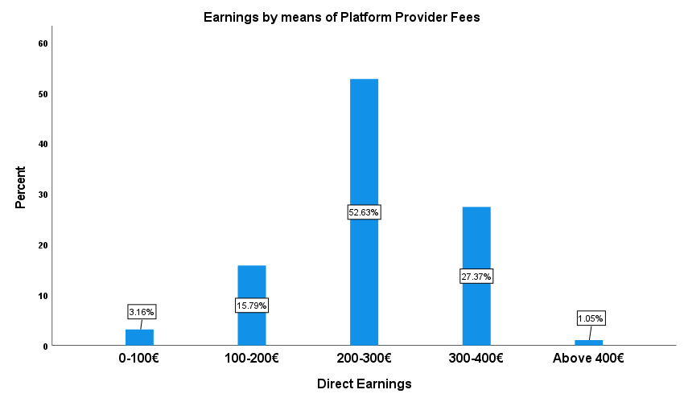
Figure ix: Research participant’s total earnings from fees provided by platform providers
The graph below shows the earnings post expenses i.e., weekly account rent paid by the workforce who rely on the riders accounts available on the grey market (please see Appendix D for sample advertisement). Over 60% of the riders have their take home earnings in the range 200 to 300 Euro per week. The percentage of the earnings in the range 100 to 200 Euro per week goes up when compared to that in total earnings, because a portion of the riders having total earning between 200 and 300 Euro per week fall to the immediate lower category after paying rent. This effect can also be noticed in the category 300 to 400 – percentage dropped significantly.
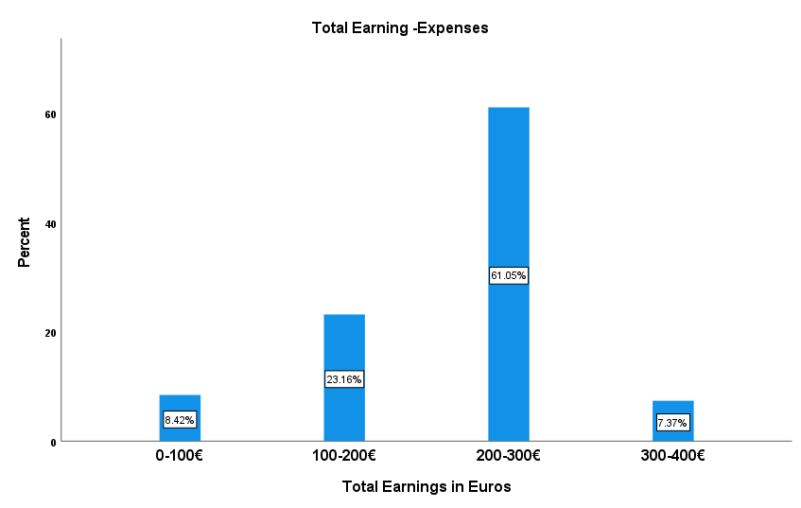
Figure x: Research participant’s earnings after deductions (Account Lease Fee)
Almost 80% of the workforce in the survey sample are not satisfied with the work they do considering the earnings they are able to make and the work environment they are posed to. This number is significant and goes on to show how volatile the job is and how vulnerable the riders are with their financial health.
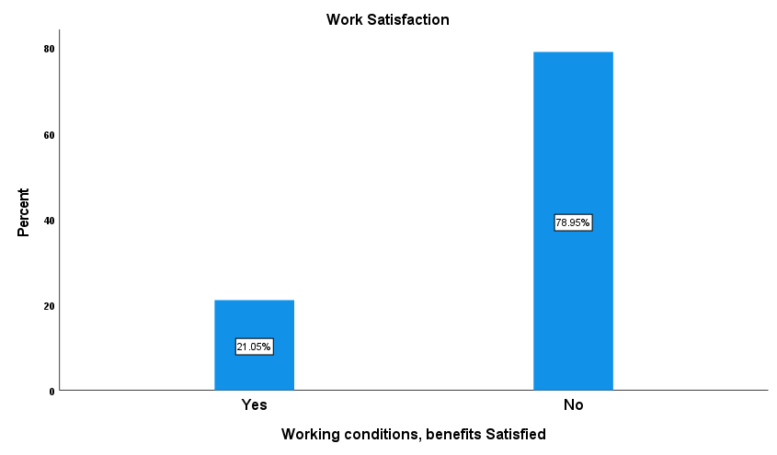
Figure xi: Research participant’s work satisfaction considering the earnings and working conditions
The earnings could hardly help them meet basic necessities. Therefore, as seen in the latter part of the analysis, riders’ expectation in terms of increasing the current minimum fee offered per delivery is noticeable as one of the measures to safeguard their earning and betterment of their financial health. This is one reason why the platform providers and the policy makers should consider addressing these overlooked conditions the delivery riders are working in.
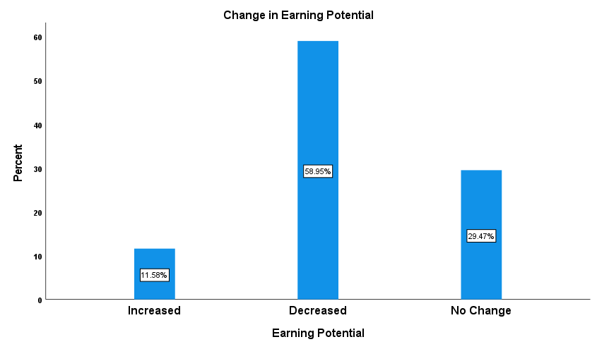
Figure xii: Research participant’s earning potential changes
The tall bar in the middle shows that the earning potential is decreased with the easing up of lockdown restrictions. Of the survey participants 59% of the riders agreed that their earning potential had decreased following the end of certain restrictions that opened outdoor dining facilities in the restaurants across the nation. This could be a temporary scenario, where people are willing to step out after almost a year of lockdown, hence the trend. However, 11.6% of them experienced an increase in their earning potential, i.e., more orders assigned to them, which could possibly be for other reasons like decrease in number of riders or a particular set of riders who were assigned more orders based on the rider ranking (algorithmic control which we have no knowledge of). While 30% of them said that there is no change in earnings during lockdown and post easing of the restrictions.

Objective 3
The third objective was to assess the delivery rider’s awareness on the employment benefits available, the precariousness faced by them in the work engagements and the work satisfaction. Nearly 78% of the riders in the survey sample engage with the platform providers (Deliveroo, UberEATS, and JustEat) as part time workers. These majority could be either students or people working for additional income in their spare time while they have an alternate work arrangement. A quick glance on the proportion of riders who use rented rider accounts (nearly 80% in the surveyed sample) could easily point us in the direction of students who take up this work to meet their expenses. This was also evident in our contextual literature, and (Malekmian, 2021) also showcases this trend in one of his inquiry in Dublin Inquirer, a local independent online newspaper publisher. Over 22% of them work full time as delivery riders, could be either by choice or necessity. But the conditions for them remains the same irrespective of the type of engagement with the platform providers.
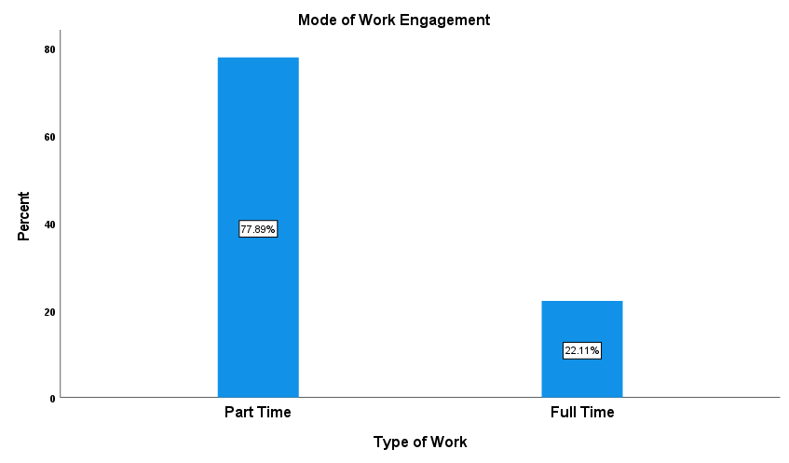
Figure xiii: Research participant’s mode of engagement with the platform providers
Deliveroo has a significant market share – right from small fast-food centres to large restaurants listed in the platform. In the survey sample about 54% of the riders delivered food for the customers ordering food on Deliveroo. Uber eats and JustEat riders have almost the same share in the sample with 24% and 22% respectively. On simple observations the data on platform providers resonates with the general observation on the streets of Dublin. You are more likely to see a delivery rider in a cyan jacket and thermal bag than the riders on orange (JustEat) or black and green (UberEATS). It was also observed that few of the participants operated multiple devices logged in with different platform providers. It was found that they cannot rely on a single platform provider for their earnings and use multiple rider accounts to enhance their earnings. This came as no surprise when looking at the data on earnings of a food delivery rider.
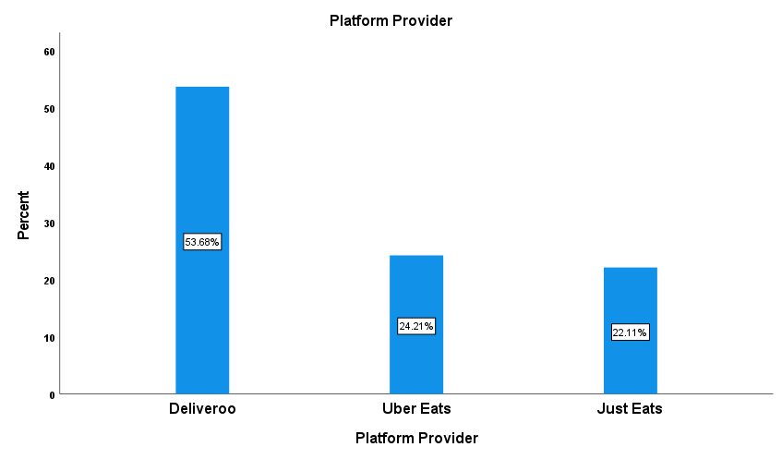
Figure xiv: Platform Provider’s break-up for the survey participants
Note: The break-up does not indicate the actual platform provider’s market shares but only of the survey participants.
From the below bar graph, 48% of the food delivery riders have experienced one or the other kind of threats while performing their duty to the platform providers i.e., delivering food to the customer, while 52% have not. Though the numbers are almost equally distributed, 48% is a significant number and riders experiencing threats is a concern contributing to the work satisfaction factors. The platform providers, for instance Deliveroo has acknowledged the existence of threats faced by the delivery riders and have come up with a reasonable solution to ensure the safety of its riders by introducing safety alarm (Deliveroo, 2021c) which is provided to the riders upon signing up in their platform who claims to be free of charge but it is not the case (Doyle, 2021). They also seek feedback from the riders after completion of the task to address the safety concerns which they would have experienced during the journey. Authorities have also acknowledged this and has also drawn attention of the policy makers (MacNamee, 2021), who think the delivery riders are not adequately paid and respected by the platform providers.
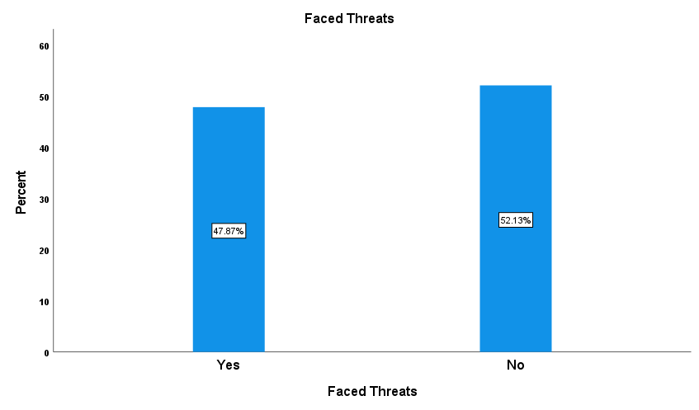
Figure xv: Likelihood of facing threats by the delivery riders
Of the 48% who faced threats, 9.5% said that they were either robbed or experienced a robbery attempt. 18% of them faced racial abuse and 12% faced assault by youths which again is debated and highlighted by mainstream medias (Pollak, 2020; MacNamee, 2021). These two are again the areas of concern and needs action by policy makers and platform providers alike. While 3.1% considered weather conditions as threat which the policy makers cannot do much about addressing the perils, perhaps the platform providers can work on improving their algorithms which they have all the control over to assign the jobs to rider accounts classified as car and motor bikes. In addition, a small proportion of the survey participants about 5.2% faced other safety issues like not comfortable working in unsocial hours or faced trouble with their vehicles.
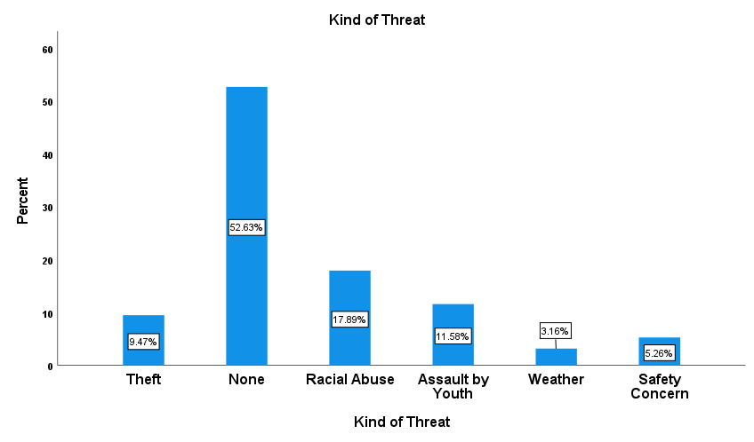
Figure xvi: Kind of threats faced by the delivery riders
From the previous graph it is evident that a total of 40% faced threats some kind of theft, assault, and racial abuse. But as few as 4.26% reported to the authorities, while the rest did not take any action. This could potentially act as a factor contributing to the emotional distress faced by the delivery riders which is in an alarming state as seen in the following figure.
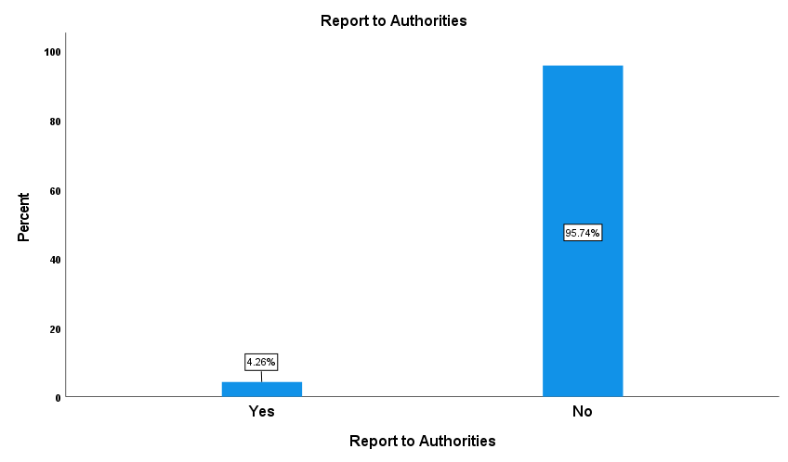
Figure xvii: Likelihood of reporting the threats to authorities
Though the survey question simply asked if they faced any emotional distress (Q10) and satisfied with the working conditions, earnings, and the available employment benefits(Q11) over 68% of them faced emotional distress because of their work. The primary reason for this trend could be due to the substandard working conditions, uncertain income and safety concerns expressed by the survey participants. Emotional wellbeing is an important aspect of any kind of job and the gig economic employment model can be seen to pay seldom attention to it. This is an area where delivery platforms and the policy makers need to devise policy and process to ensure the emotional wellbeing of the delivery riders is addressed and taken care of.
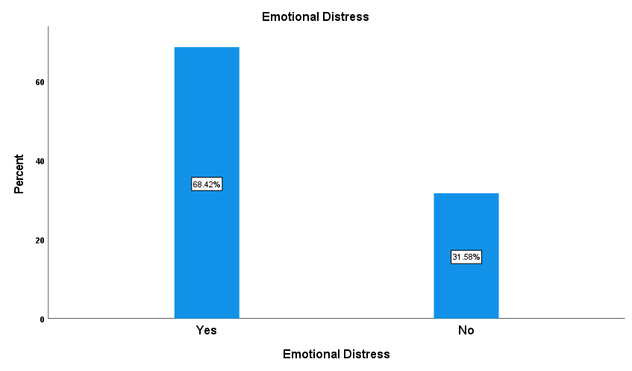
Figure xviii: Emotional distress faced by the Delivery Riders

Objective 4
This objective is aimed at depicting the proportion of riders in the grey market who use leased riders’ account. Below graphical representation shows that 41% of the surveyed participants were not aware if there are any benefits. This could be due to the fact that the proportion of riders were using a rider account leased for a weekly fee. However, only 33.7% of them were sure that they had certain benefits but had no idea of what they were entitled to. 10.5% stated they were aware of food discounts in the restaurants partnered with platforms. But only a fraction (14.7%) of the participants were aware of the free rider insurance benefit available from the platform provider for free of cost. On the contrary one of the leading platform providers, UberEATS demands its riders to have insurance covering the food deliveries as well(UberEATS, 2021), which adds a set up cost for the riders to begin their employment.
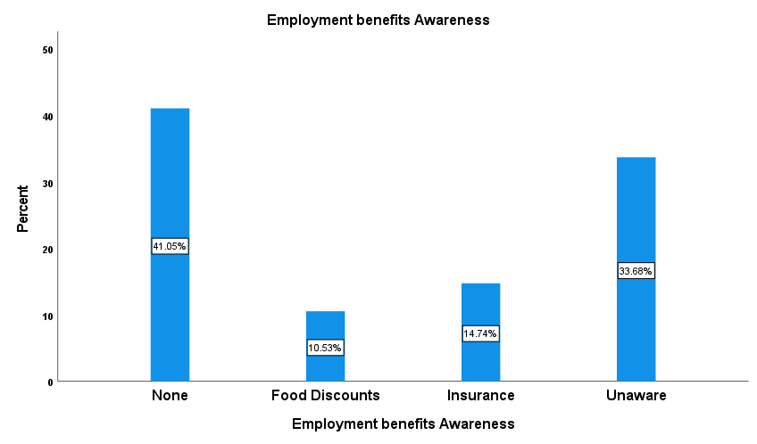
Figure xix: Employment benefit awareness of the delivery riders
Only a small proportion (21%) of the participants were the owners of the rider account. Whereas almost 79% of the riders who participated in the survey were relying on leased rider account from its original owners. This is made possible by the contractual agreement the platform providers engage with the owner of the account. The owners of the rider accounts are entitled to have a substitute rider in their place. However, the platform providers leave the responsibility of verifying the eligibility of the substitute rider or lessee to the account owner (Deliveroo, 2021b), who can be said to have little or no knowledge about the immigration. This arrangement poses a threat to the earning of the riders who use the leased accounts and contributes to a sense of stress.
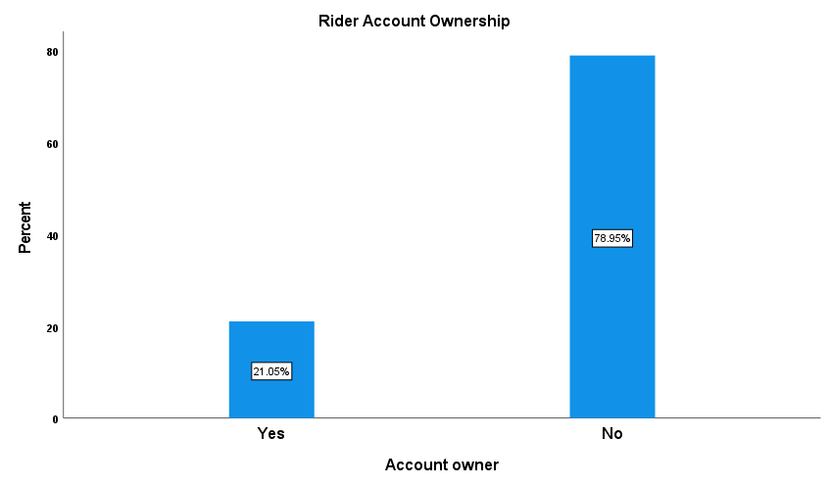
Figure xx: Proportion of riders who use the rider’s account on rent
The riders who rented the account were charged fees by the owners varies depending on the type of account, Bike account, motorbike account or a car account. Of the 79% who rented the account, more than 73% of them paid rent in the range 40 to 70 Euro. 24% of them paid 40 or less. 2.67% of them paid above 70 Euro, which makes up a significant proportion of their earnings as seen in the earlier part of the analysis.
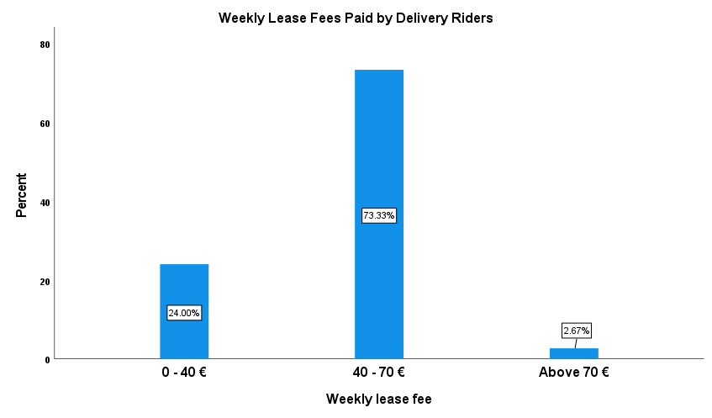
Figure xxi: Range of rental fees paid by the non-account owners

Objective 5
This objective elucidates the employment fairness in the food delivery sector. Fairness in the gig economic employment model has been a topic of debate in the recent past than ever before and has drawn policy makers attention across the world in one or the other form. Be it the recent judgement from the UKSC on the Uber drivers or the Italian court on the algorithmic control of delivery riders. From the below visuals, almost 79% of the riders believe that the pay offered by platform providers are not fair, fees as low as Euros 2.90 for a delivery is set. They believe that they deserve more for their efforts. Only about 21% of the riders were satisfied with the fee offered by the platform providers.
Having understood the demographics of the survey participants and the riders who make the population of the study, nearly 79% of the riders dissatisfied with the delivery fee offered by the platform providers, 43% of them chose ‘Increase the Minimum Delivery Fee’, 36.8% wanted them to consider as employees and provide additional benefits such as sick leaves, paid time off like in the traditional employment model, and about 18% wanted minimum pay per hour to be introduced as a measure to address the concerns of riders.
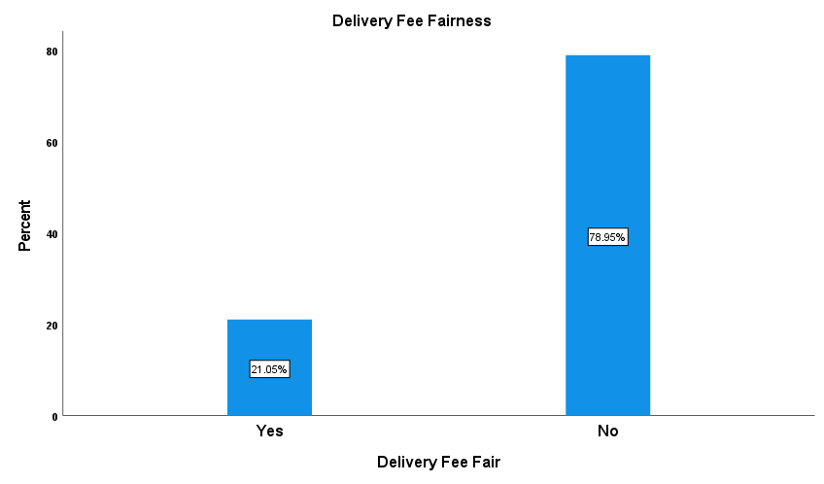
Figure xxii: Perception of riders on the fairness of delivery fee offered by the platform providers
It is worthwhile to mention that one of the survey participants who opened up a little about his plight being an immigrant English language student, had earned only Euros 35 working 7 and half hours, which roughly translates to 4.5 Euros per hours whereas the platform providers claim to figures depicting that their rider partners are earning as high as 13 Euros on an average (Doyle, 2021).
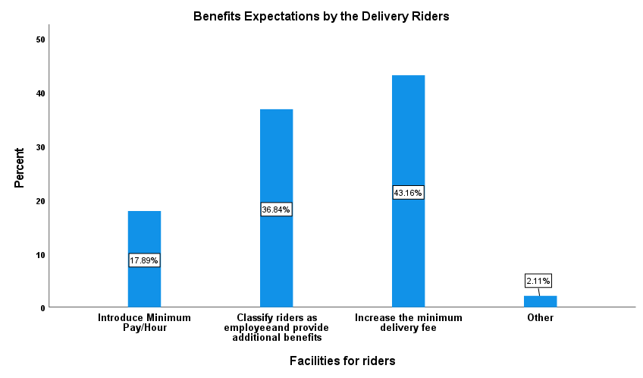
Figure xxiii: Expectation by the delivery rider towards safeguarding their employment and providing social safety net

Bivariate Analysis to determine the relationship between emotional wellbeing and the working conditions, earnings and benefits available
Bivariate analysis is one the simplest methods of quantitative statistical analysis of two variables. A process of analysing two variables to determine relationship between them and to determine if there exists a statistical association between the chosen variables (Sandilands, 2014). Table 2 below depicts the crosstabulation of two categorical variable’s data, namely, Emotional Distress and the measure of survey participants work satisfaction with respect to the working conditions, earnings, and benefits available for the food delivery riders. The corresponding values 0 (represents Yes for Q10 and 11) and 1(represents No for Q10 and Q11) as mentioned in the footnote depicted in the SPSS output shows that the participants who experienced emotional distress owing to the working conditions, earnings, and employment benefits. A staggering 86.2% of the survey participants were susceptible and have experienced emotional distress while being dissatisfied with their work environment, employment benefits and earnings, also more than a quarter of the participants are satisfied with the work engagement but still tend have experienced emotional precariousness at some point in time. Similarly, 63% of the survey population has been dissatisfied with the work arrangement and its constituents not experiencing any emotional. Only about 37% of the participants were satisfied with the work arrangement having no emotional distress. However, nearly 14% of the survey riders were distress but satisfied with the work arrangements.
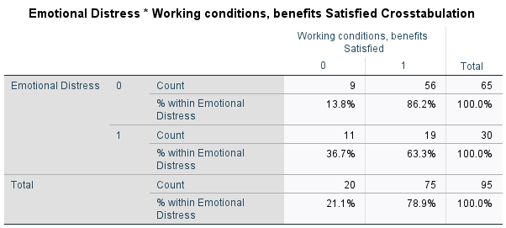
Table iii: Crosstabulation of Emotional Distress vs Working Conditions, Earnings, and Available Benefits for the Food Delivery Riders.
Note: 0=Yes 1=No
Chi-square test is one of the many statistical test available to identify and analyse if there is a some sort of relationship between two categorical variables (Institute for Digital Research & Education Statistical Consulting, 2021) i.e., Emotional Distress and Work Satisfaction in this case.
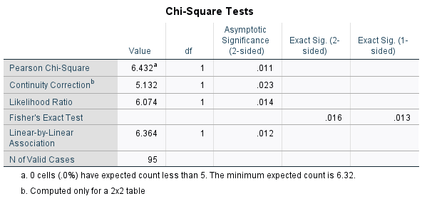
Table iv: Chi-Square Tests of independence (Emotional Distress vs Work Satisfaction)
The test results from Table 3 shows that there is statistically significant relationship between the emotional distress/precariousness experienced by the food delivery riders and work satisfaction (Chi-Square with one degree of freedom =6.432, p=0.011). The work one does can be source of an individual’s joy, whereas as rightly said by Marx in one of his works, modern work is alienated, coupled with the platform providers shrinking the earnings of the delivery rider.

Chapter 5

Conclusion
The platform economy or capitalism is praised by the neoliberal economist, owing to its ability to promote fair labour competition, availability of choices in terms of services and its providers, reduction in the transaction costs, and generating more and more opportunities for individuals and organizations to a level playing ground for providing services to their consumer base (Pasquale, 2017). The counter narrative of platform capitalism by Frank Pasqale (2017), a professor at University of Maryland vividly encapsulates the perils and precariousness the economic model consists of and resonates with the ones faced by the food delivery riders. The dissertation set out to address the research objectives recalled below from chapter 1,
- Estimate the number of food delivery riders in Ireland.
- Increase the knowledge and understanding of the earnings by a delivery rider
- Enhance the knowledge and awareness of the employment benefits available
- Describe the number/proportion of the riders operating in the grey market
- Elucidate the fairness when all the bargaining power is with the platform provider.
While estimating the number of food delivery riders in Ireland has been one of the most challenging one owing to the unavailability of data at the Central Statistics Office and the unresponsiveness from the platform providers for the requests sent seeking official figures, relying on the publicly available data and reasonable estimation was the only option left. It is estimated that there are about 4938 (Deliveroo – 1100, JustEat – 2696 and UberEATS – 1142) food delivery riders in Ireland arrived at with the assistance of publicly available data and some reasonable estimation for calculating the number of riders for UberEATS.
The descriptive analysis carried out to address the remaining objectives (objective 2 to objective 5) have been instrumental in adding knowledge to the existing pool of resources in regard to the working conditions, emotional status, earnings, and work satisfaction of the food delivery riders. The earnings by a food delivery rider are found to be uncertain and often well below the national average while the platform providers claim to have numbers that does not resonate with the rider’s sentiment and data collected in this dissertation.
Though the availability of free riders’ insurance for bike account holders can be said to be the only employment benefit available for a newly signing up rider, the need to have insurance covering their vehicles and food being delivered adds an additional investment cost from prospective riders. The awareness about the employment benefits is found to be sparsely known by the riders. This lack of awareness could be due to the absence of human interaction between the platform providers and the riders or as seen in the data analysis section the existence of grey market where the riders lease a rider account are least bothered about the employment benefits or how it is regulated.
A significant proportion, close to 80% of the survey participants (delivery riders) are operating in the grey market rendering services to the leading platform providers, where rider accounts are leased for a weekly fee. This set up or provision drains the income of a rider further deteriorating the financial health of such delivery riders.
Fairness in gig economic employment model is long debated, the food delivery riders feel the need to address these fairness related issues, be it the delivery fee offered per gig or the way these riders are treated by the society or the employment benefits available.
The dissertation provided me with an opportunity to understand the emergence of platform capitalism or economy which is disrupting the economic models of the organizations around the world while it is being monitored closely by the society and policy makers alike and how changes are being made in the sphere of gig economy across the world.

Limitations of the study
Given the financial and time constraints this dissertation is limited to the food delivery riders in Dublin. Therefore, the generalisability of the results is limited to other situations. Sample sizes significantly impacts the statistics of any study. Primary data collected for this dissertation consisted of 98 responses from the food delivery riders engaged with leading platform providers such as Deliveroo, JustEat, and UberEATS. Further 3 of the responses were excluded from the analysis since the respondents had not consented to be part of the research. Data is also collected cross sectionally i.e., at a specific period in time. Perhaps an extensive study can be conducted longitudinally to identify the trends and patterns in the earnings, work satisfaction and awareness among the riders about availability of employment benefits over the time. In order to better understand the wide array of aspects encompassed in the gig economic sphere further studies inculcating the inputs (data pertaining to the number of riders, earnings trend and patterns, number of hours worked etc.) from the platform providers themselves and a larger sample size covering the major cities where the leading platform providers operate in Ireland could yield significant outputs and information on the aspects discussed in this dissertation pertaining to the food delivery riders. Also, a longitudinal study on each of the platform providers could yield a broader perspective of the platform employment and its variables contributing to the existing knowledge and a better understanding of the delivery rider’s expectations, which can be instrumental in shaping the future of gig economic employment model by the platform providers and policy makers alike. The sample size in this dissertation was small owing to the limitations mentioned above and the findings are limited only to the city of Dublin.
The policy makers or regulators could take cognizance of this dissertation, or a similar study conducted on a larger scale to consider the perils, precariousness existing in the food delivery sector in Dublin or Ireland in addressing the challenges posed by the workforce. Perhaps a reform to modify the current binary classification of employments in the Irish labour market or to classify the food delivery riders as employees by working with the leading platform providers to have them included in the social safety net by providing more benefits such as paid sick leaves, holidays, pension contributions which are currently absent in the employment model. In the absence of which provisions for collective bargain should be accommodated. The regulators could back their reforms with the empirical evidence and voice of the workforce by working with the leading platform providers by keeping in my mind the need and importance to address the concerns elucidated in this dissertation.
Similarly, the platform providers should find ways to engage more with the workforce towards addressing the lack of organizational structure causing (dis)embeddedness which affects the meaning and satisfaction associated with their work resulting in emotional distress. This being the primary role of platform providers, as the workforce is entirely dependent on the platform providers for the gigs, an enhanced participation towards addressing this could provide an opportunity to create a sense of inclusiveness to the workforce to feel a part of an organization.
In addition, the workforce engaged in the food delivery sector should be proactive in understanding and be knowledgeable about the employment benefits currently available and try to provide an overview to the renters if they are subletting their accounts.
The absence of any sort of data pertaining to the food delivery riders in Dublin, Ireland was evident throughout the dissertation process. However, we knew that the food delivery riders are classified as self-employed currently under the Irish employment regulations, but we were not aware of the number of riders, the existence of grey market where rider accounts are leased for a varying weekly fee, the uncertain income, and the emotional distress the workforce is subjected to. I believe this dissertation had been attempted towards addressing the growing concerns surrounding the gig economic sphere as an overall and food delivery sector in particular. Also, the need to evidence the aspects elucidated in this dissertation could serve as starting point towards the reforms of advancing the employment regulations surrounding the gig economic employment which is in boom and particularly important to have socially stable and for an emotionally wealthy society.

Self-Reflections
The findings of this dissertation provide a lens through which platform providers and policy makers can see through to understand from the workforce’s perspective to see the need to have a better working condition, secured earnings/income, open and limited intervention of algorithms in managing the workforce and cater to the emotional wellbeing of the giggers (delivery riders) that propel the revenues for the platforms and the government. The world of business is evolving at a rapid pace, and the human aspects of the employment should evolve hand in hand. At the end of the day if there are no people willing (highly unlikely) to work as a delivery rider or take up temporary gigs the whole employment model and the business model of the platform is at a receiving end of the impacts.

References
Aloisi, A. (2016) (ID 2637485) Commoditized Workers. Case Study Research on Labour Law Issues Arising from a Set of ‘On-Demand/Gig Economy’ Platforms. Rochester, NY: Social Science Research Network DOI: 10.2139/ssrn.2637485.
Berg, J. et al. (2018) Digital Labour Platforms and the Future of Work: Towards Decent Work in the Online World. Available at: http://www.ilo.org/global/publications/books/WCMS_645337/lang--en/index.htm (Accessed: 16 May 2021).
Bird, A. (2004) ‘Thomas Kuhn’. Available at: https://plato.stanford.edu/entries/thomas-kuhn/#ConcPara (Accessed: 19 May 2021).
BORD BIA. (2020) 2020 BORD BIA Irish Food Service Market Insights. Dublin Available at: https://www.bordbia.ie/globalassets/bordbia2020/news--events/foodservice-seminar-2020/2020_bord-bia-irish-foodservice-market-insights.pdf (Accessed: 11 August 2021).
Butler, S. (2021) ‘Gig Economy Couriers Should Be Eligible for a Pension, Says UK Regulator’. The Guardian, 17 May. Available at: http://www.theguardian.com/business/2021/may/17/gig-economy-couriers-should-be-eligible-for-a-pension-says-uk-regulator (Accessed: 21 May 2021).
Carey, A. (2020) ‘Food Delivery Industry Faces “Massive Crisis” Following Worker Deaths’. NewsComAu, 24 November. Available at: https://www.news.com.au/finance/work/at-work/food-delivery-industry-faces-massive-crisis-following-worker-deaths/news-story/ec947077833df3989de52e84100a47ce#.0kjun (Accessed: 26 March 2021).
Creswell, J.W. (2014) Research Design: Qualitative, Quantitative, and Mixed Methods Approaches. 4th ed. Thousand Oaks: SAGE Publications.
Curry, D. (2020) Food Delivery App Revenue and Usage Statistics (2021). Business of Apps. Available at: https://www.businessofapps.com/data/food-delivery-app-market/ (Accessed: 12 August 2021).
Daly, A. (2021) ‘Deliveroo Drivers Strike in Dublin for Better Working Conditions’. TheJournal.Ie, 22 January. Available at: https://www.thejournal.ie/deliveroo-strike-dublin-5332854-Jan2021/ (Accessed: 22 August 2021).
De Stafano, V. and Aloisi, A. (2018) European Legal Framework for Digital Labour Platforms. LU: Publications Office Available at: https://data.europa.eu/doi/10.2760/78590 (Accessed: 26 March 2021).
Deliveroo. (2021a) Deliveroo. Available at: https://deliveroo.ie/about-us (Accessed: 17 June 2021).
Deliveroo. (2021b) Deliveroo | The Deliveroo Riders Website. Available at: https://riders.deliveroo.ie/en/substitution (Accessed: 23 July 2021).
Deliveroo. (2021c) Order Your Free Personal Safety Alarm. Available at: https://riders.deliveroo.co.uk/en/news/order-your-free-personal-safety-alarm (Accessed: 20 August 2021).
Doherty, M. (2020) Peer Country Comments Paper - Ireland. Available at: file:///C:/Users/Sachin%20Somanahalli/OneDrive/MBA/Semester%202/Research%20Methods/RM%202/Resources/Peer%20Country%20Comments%20Paper%20-%20Ireland.pdf (Accessed: 21 May 2021).
Donohoe, A. (2021) ‘“Lack of Public Toilets Is a Female Issue That Will Go on Long after Lockdown”’. DublinLive, 22 April. Available at: https://www.dublinlive.ie/news/dublin-news/opinion-lack-public-toilets-dublin-20444316 (Accessed: 17 May 2021).
Doyle, M. (2021) ‘Deliveroo Riders Speak out on “dangerous” Reality of Delivering Food for as Low as €7.50 an Hour under Time Pressures’. The Irish Sun, 19 May. Available at: https://www.thesun.ie/news/7012593/deliveroo-dangerous-time-pressure-orders-ireland-pay/ (Accessed: 17 June 2021).
Eidelson, J. (2015) ‘Instacart Hounds Workers to Take Jobs That Aren’t Worth It - Bloomberg’. Bloomberg Business Week, 15 July. Available at: https://www.bloomberg.com/news/articles/2019-07-15/instacart-hounds-workers-to-take-jobs-that-aren-t-worth-it (Accessed: 28 March 2021).
European Commission Directorate General for Research (2013) Ethics for Researchers: Facilitating Research Excellence in FP7. LU: Publications Office Available at: https://data.europa.eu/doi/10.2777/7491 (Accessed: 20 May 2021).
Everee. (2021) Gig Worker Survey Report 2021. Available at: https://f.hubspotusercontent00.net/hubfs/8588609/Gig_Survey_2021_v2_021721.pdf?__hstc=62111347.2797604656b0b78385b054f273d1f5a9.1616936113508.1616936113508.1616936113508.1&__hssc=62111347.3.1616936113508&__hsfp=1965059634 (Accessed: 28 March 2021).
Eyisi, D. (2016) ‘The Usefulness of Qualitative and Quantitative Approaches and Methods in Researching Problem-Solving Ability in Science Education Curriculum’. Journal of Education and Practice, 7(15), pp. 91–100.
Freni-Sterrantino, A. and Salerno, V. (2021) ‘A Plea for the Need to Investigate the Health Effects of Gig-Economy’. Frontiers in Public Health, 9, p. 638767. DOI: 10.3389/fpubh.2021.638767.
Gallagher, C. (2021) ‘Gardaí Trying to Defuse Tensions between Food Delivery Workers and Local Youths’. The Irish Times, February. Available at: https://www.irishtimes.com/news/ireland/irish-news/garda%C3%AD-trying-to-defuse-tensions-between-food-delivery-workers-and-local-youths-1.4473355 (Accessed: 17 May 2021).
Gandini, A. (2019) ‘Labour Process Theory and the Gig Economy’. Human Relations, 72(6), pp. 1039–1056. DOI: 10.1177/0018726718790002.
Geiger, G. (2021) ‘Court Rules Deliveroo Used “Discriminatory” Algorithm’. 5 January. Available at: https://www.vice.com/en/article/7k9e4e/court-rules-deliveroo-used-discriminatory-algorithm (Accessed: 21 May 2021).
Gleeson, C. (2021) ‘Government Has No Plans to Create New Employment Status for Gig Workers’. The Irish Times, February. Available at: https://www.irishtimes.com/business/work/government-has-no-plans-to-create-new-employment-status-for-gig-workers-1.4495989 (Accessed: 17 May 2021).
Griesbach, K. et al. (2019) ‘Algorithmic Control in Platform Food Delivery Work’. Socius, 5, p. 2378023119870041. DOI: 10.1177/2378023119870041.
Guba, E.G. and Lincoln, Y.S. (1994) ‘Competing Paradigms in Qualitative Research’. In Handbook of Qualitative Research. Thousand Oaks, CA, US: Sage Publications, Inc, pp. 105–117.
Healy, J., Pekarek, A. and Vromen, A. (2020) ‘Sceptics or Supporters? Consumers’ Views of Work in the Gig Economy’. New Technology, Work & Employment, 35(1), pp. 1–19. DOI: 10.1111/ntwe.12157.
Heimberger, P. (2020) ‘How Economic Globalisation Affects Income Inequality (News Article)’. The Vienna Institute for International Economics Studies. Available at: https://wiiw.ac.at/n-431.html (Accessed: 19 May 2021).
Institute for Digital Research & Education Statistical Consulting. (2021) What Statistical Analysis Should I Use? Statistical Analyses Using SPSS. Available at: https://stats.idre.ucla.edu/spss/whatstat/what-statistical-analysis-should-i-usestatistical-analyses-using-spss/#chisq (Accessed: 22 August 2021).
Irish Examiner (2019) ‘Slave to the Algorithm? What It’s Really like to Be a Deliveroo Rider’. Irish Examiner, 20 February. Available at: https://www.irishexaminer.com/lifestyle/arid-30905680.html (Accessed: 17 May 2021).
Jenn, N.C. (2006) ‘Common Ethical Issues In Research And Publication’. Malaysian Family Physician : The Official Journal of the Academy of Family Physicians of Malaysia, 1(2–3), pp. 74–76.
Kaine, S. and Josserand, E. (2019) ‘The Organisation and Experience of Work in the Gig Economy’. Journal of Industrial Relations, 61(4), pp. 479–501. DOI: 10.1177/0022185619865480.
Kilhoffer, Z. et al. (2020) Study to Gather Evidence on the Working Conditions of Platform Workers: Final Report. LU: Publications Office Available at: https://data.europa.eu/doi/10.2767/26582 (Accessed: 21 May 2021).
Kilraine, J. (2021a) ‘Govt Asked to Improve Conditions for Delivery Riders’. 21 February. Available at: https://www.rte.ie/news/dublin/2021/0221/1198450-deliveroo/ (Accessed: 21 May 2021).
Kilraine, J. (2021b) ‘Govt to Review Employment Law in Gig Economy’. RTE, 9 March. Available at: https://www.rte.ie/news/dublin/2021/0309/1203009-deliveroo/ (Accessed: 21 May 2021).
Kivunja, C. and Kuyini, A.B. (2017) ‘Understanding and Applying Research Paradigms in Educational Contexts’. International Journal of Higher Education, 6(5), p. 26. DOI: 10.5430/ijhe.v6n5p26.
Kozlowski, S.W.J. and Ilgen, D.R. (2006) ‘Enhancing the Effectiveness of Work Groups and Teams’. Psychological Science in the Public Interest, 7(3), pp. 77–124. DOI: 10.1111/j.1529-1006.2006.00030.x.
Lather, P. (2011) ‘Research as Praxis’. Harvard Educational Review, 56(3), pp. 257–278. DOI: 10.17763/haer.56.3.bj2h231877069482.
Lee, M.K. et al. (2015) ‘Working with Machines: The Impact of Algorithmic and Data-Driven Management on Human Workers’. In Proceedings of the 33rd Annual ACM Conference on Human Factors in Computing Systems. CHI ’15. New York, NY, USA: Association for Computing Machinery, pp. 1603–1612. DOI: 10.1145/2702123.2702548.
Mackenzie, N. and Knipe, S. (2006) ‘Research Dilemmas: Paradigms, Methods and Methodology’. Issues in Educational Research, 16. Available at: http://iier.org.au/iier16/mackenzie.html (Accessed: 19 May 2021).
MacNamee, G. (2021) ‘Deliveroo Seeks Meeting with Gardaí after Attacks on Its Cyclists in Dublin City Centre’. TheJournal.Ie, 3 February. Available at: https://www.thejournal.ie/deliveroo-contacts-gardai-over-attacks-5341875-Feb2021/ (Accessed: 20 August 2021).
Maher, I. and Cuffee, D.J. (2020) ‘The Jacks Are Back: Why It’s Time for More Public Loos’. 18 June. Available at: https://www.rte.ie/brainstorm/2020/0618/1148197-public-toilets-ireland/ (Accessed: 17 May 2021).
Malekmian, S. (2021) ‘As Deliveroo Workers Push for Better Work Conditions, There’s Debate About How to Organise’. Dublin Inquirer, 31 March. Available at: https://www.dublininquirer.com/2021/03/31/as-deliveroo-workers-push-for-better-work-conditions-there-s-debate-about-how-to-organise (Accessed: 20 August 2021).
Markey, R. and McIvor, J. (2018) ‘Regulating Casual Employment in Australia’. Journal of Industrial Relations, 60(5), pp. 593–618. DOI: 10.1177/0022185618778084.
Marx, K. (1894) The Process of Capitalist Production as a Whole. International Publisher NY.
Maslow, A.H. (1943) ‘A Theory of Human Motivation’. Psychological Review, 50(4), pp. 370–396. DOI: 10.1037/h0054346.
McKinsey & Company. (2016) Independent Work: Choice, Necessity, and The Gig Economy. Available at: https://www.mckinsey.com/~/media/McKinsey/Featured%20Insights/Employment%20and%20Growth/Independent%20work%20Choice%20necessity%20and%20the%20gig%20economy/Independent-Work-Choice-necessity-and-the-gig-economy-Full-report.pdf (Accessed: 2 January 2021).
Meijerink, J. and Keegan, A. (2019) ‘Conceptualizing Human Resource Management in the Gig Economy: Toward a Platform Ecosystem Perspective’. Journal of Managerial Psychology, 34(4), pp. 214–232. DOI: 10.1108/JMP-07-2018-0277.
Morahan, G. (2020) ‘Profits At Just Eat Rise As Takeaway App Increases Market Share’. Extra.Ie, 9 September. Available at: https://extra.ie/2020/09/09/business/irish/just-eat-profit-market-share (Accessed: 22 August 2021).
Mumby, D.K. (2019) ‘Work: What Is It Good for? (Absolutely Nothing)—a Critical Theorist’s Perspective’. Industrial and Organizational Psychology, 12(4), pp. 429–443. DOI: 10.1017/iop.2019.69.
Murphy, C. and Dundon, T. (2021) ‘Now Is the Time for Ireland to Consider a Fair-Work Agenda’. The Irish Times, 12 March. Available at: https://www.irishtimes.com/business/work/now-is-the-time-for-ireland-to-consider-a-fair-work-agenda-1.4505452 (Accessed: 28 July 2021).
Nicolaides, P.A. (2020) Some Challenges in Data Collection and How to Overcome Them in Times of Pandemic. Available at: https://www.unisa.ac.za/sites/sbl/default/News-&-events/Garden-stories-and-metaphors/Some-challenges-in-data-collection-and-how-to-overcome-them-in-times-of-pandemic (Accessed: 19 August 2021).
Northern Illinois University. (2015) Responsible Conduct of Research. Available at: https://ori.hhs.gov/education/products/n_illinois_u/dfront.html (Accessed: 16 May 2021).
Pasquale, F.A. (2017) (ID 3002529) Two Narratives of Platform Capitalism. Rochester, NY: Social Science Research Network Available at: https://papers.ssrn.com/abstract=3002529 (Accessed: 22 August 2021).
Pelly, N. (2021) Ireland Must Rethink Its Approach to the Gig Economy. Personnel Today. Available at: https://www.personneltoday.com/hr/ireland-must-rethink-its-approach-to-the-gig-economy/ (Accessed: 28 July 2021).
Pérez, G.R. (2021) ‘Spain Approves Landmark Law Recognizing Food-Delivery Riders as Employees’. EL PAÍS, 12 May. Available at: https://english.elpais.com/economy_and_business/2021-05-12/spain-approves-landmark-law-recognizing-food-delivery-riders-as-employees.html (Accessed: 11 August 2021).
Petriglieri, G., Ashford, S.J. and Wrzesniewski, A. (2019) ‘Agony and Ecstasy in the Gig Economy: Cultivating Holding Environments for Precarious and Personalized Work Identities’. Administrative Science Quarterly, 64(1), pp. 124–170. DOI: 10.1177/0001839218759646.
Polkowska, D. (2021) ‘Platform Work during the COVID-19 Pandemic: A Case Study of Glovo Couriers in Poland’. European Societies, 23(sup1), pp. S321–S331. DOI: 10.1080/14616696.2020.1826554.
Pollak, S. (2020) ‘Deliveroo Cyclists : “We Want to Deliver Food without Thinking We Might Be Robbed or Run Over”’. The Irish Times, 5 September. Available at: https://www.irishtimes.com/news/ireland/irish-news/deliveroo-cyclists-we-want-to-deliver-food-without-thinking-we-might-be-robbed-or-run-over-1.4347707 (Accessed: 20 August 2021).
Pope, C. (2021) ‘Deliveroo Riders across Dublin Strike over Working Conditions’. The Irish Times, January. Available at: https://www.irishtimes.com/news/ireland/irish-news/deliveroo-riders-across-dublin-strike-over-working-conditions-1.4465621 (Accessed: 17 May 2021).
Prudential. (2017) Gig Worker in America. Available at: https://www.prudential.com/wps/wcm/connect/4c7de648-54fb-4ba7-98de-9f0ce03810e8/gig-workers-in-america.pdf?MOD=AJPERES&CVID=mD-yCXo (Accessed: 28 March 2021).
Puniello, O. (2018) The Importance of Secondary Data in Research. Public Relations Society of America, Inc. Available at: http://apps.prsa.org/StrategiesTactics/Articles/view/12180/1154/The_Importance_of_Secondary_Data_in_Research?utm_source=prsa_website&utm_medium=facebook_like&utm_campaign=facebook_like (Accessed: 29 July 2021).
Ramshaw, A. (2021) The 16 Key Pros and Cons of Surveys You Need to Understand. B2B Marketing | Customer Feedback | Net Promoter Score | Genroe. Available at: https://www.genroe.com/blog/pros-and-cons-of-surveys/11471 (Accessed: 9 August 2021).
Reddan, F. (2021) ‘Cost of Living in Europe: Are We Paying over the Odds to Live in Ireland?’ The Irish Times, 27 July. Available at: https://www.irishtimes.com/business/personal-finance/cost-of-living-in-europe-are-we-paying-over-the-odds-to-live-in-ireland-1.4627607 (Accessed: 27 July 2021).
Redmond, C. (2021) ‘Faced with Assault, Deliveroo Couriers Are Boycotting Parts of Dublin’. Wired UK, February. Available at: https://www.wired.co.uk/article/deliveroo-couriers-dublin-assault (Accessed: 17 May 2021).
Reuters. (2021) ‘UPDATE 1-UK’s Deliveroo Mulls Ending Spain Operations on High Costs’. Reuters, 30 July. Available at: https://www.reuters.com/article/deliveroo-spain-idCNL4N2P61V9 (Accessed: 11 August 2021).
Rubio, I. (2018) ‘The Dangers of Letting Algorithms Make Decisions for You’. EL PAÍS, 23 November. Available at: https://english.elpais.com/elpais/2018/11/23/inenglish/1542976796_159932.html (Accessed: 11 August 2021).
Sandilands, D. (Dallie). (2014) ‘Bivariate Analysis’. In Michalos, A.C. (ed.) Encyclopedia of Quality of Life and Well-Being Research. Dordrecht: Springer Netherlands, pp. 416–418. DOI: 10.1007/978-94-007-0753-5_222.
Saunders, M.N.K., Lewis, P. and Thornhill, A. (2009) Research Methods for Business Students. 5th ed. New York: Prentice Hall.
Schmidt, V.H. (2017) ‘Disquieting Uncertainty. Three Glimpses into the Future’. European Journal of Futures Research, 5(1), p. 6. DOI: 10.1007/s40309-017-0113-9.
Schor, J.B. et al. (2020) ‘Dependence and Precarity in the Platform Economy’. Theory and Society, 49(5–6), pp. 833–861. DOI: 10.1007/s11186-020-09408-y.
Schwellnus, C. et al. (2019) (1550) Gig Economy Platforms: Boon or Bane? DOI: 10.1787/fdb0570b-en.
Sherlock, M. (2021) Sherlock Meets Deliveroo Workers, Says Company Must Respond to Their Demands. Senator Marie Sherlock. Available at: https://www.mariesherlock.ie/news/sherlock-meets-deliveroo-workers-says-company-must-respond-t/ (Accessed: 27 July 2021).
SmartSurvey. (2021) Closed Questions Explained. SmartSurvey. Available at: https://www.smartsurvey.co.uk/articles/closed-questions (Accessed: 23 July 2021).
Sodhi, T. (2021) ‘“We Are Slaves to Them”: Zomato, Swiggy Delivery Workers Speak up against Unfair Practices’. Newslaundry, 14 August. Available at: https://www.newslaundry.com/2021/08/14/we-are-slaves-to-them-zomato-swiggy-delivery-workers-speak-up-against-unfair-practices (Accessed: 31 August 2021).
Standing, G. (2015) (7) ‘The Precariat and Class Struggle’. RCCS Annual Review. A Selection from the Portuguese Journal Revista Crítica de Ciências Sociais, (7). DOI: 10.4000/rccsar.585.
Standing, G. (2011) The Precariat: The New Dangerous Class: Guy Standing: Bloomsbury Academic. Available at: https://www.bloomsbury.com/uk/the-precariat-9781849664561/ (Accessed: 16 May 2021).
Standing, G. (2018) ‘Who Are “The Precariat” and Why Do They Threaten Our Society?’ Euronews, 1 May. Available at: https://www.euronews.com/2018/05/01/who-are-the-precariat-and-why-they-threaten-our-society-view (Accessed: 28 March 2021).
Statista. (2021) Online Food Delivery - Ireland | Statista Market Forecast. Available at: https://www.statista.com/outlook/dmo/eservices/online-food-delivery/ireland (Accessed: 12 August 2021).
SurveyMonkey. (2021) Sample Size Calculator: Understanding Sample Sizes. SurveyMonkey. Available at: https://www.surveymonkey.com/mp/sample-size-calculator/ (Accessed: 10 August 2021).
Tassinari, A. and Maccarrone, V. (2020) ‘Riders on the Storm: Workplace Solidarity among Gig Economy Couriers in Italy and the UK’. Work, Employment and Society, 34(1), pp. 35–54. DOI: 10.1177/0950017019862954.
Taylor, C. (2020) ‘Deliveroo Ireland Records 40% Rise in Turnover as Business Booms’. The Irish Times, 19 November. Available at: https://www.irishtimes.com/business/agribusiness-and-food/deliveroo-ireland-records-40-rise-in-turnover-as-business-booms-1.4414070 (Accessed: 22 August 2021).
UberEATS. (2021) Deliver with Uber Eats - Be Your Own Boss. Uber. Available at: https://www.uber.com/ie/en/deliver/ (Accessed: 20 August 2021).
UNHCR. (1966) OHCHR | International Covenant on Civil and Political Rights. United Nations Available at: https://www.ohchr.org/EN/ProfessionalInterest/Pages/CCPR.aspx (Accessed: 20 May 2021).
Vidalon, D. and Rosemain, M. (2020) ‘Top French Court Deals Blow to Uber by Giving Driver “employee” Status’. Reuters, 4 March. Available at: https://www.reuters.com/article/us-uber-court-idUSKBN20R23F (Accessed: 31 August 2021).
Visier. (2020) How the Gig Economy Will Impact HR in 2020 and Beyond. Visier Inc. Available at: https://www.visier.com/clarity/how-gig-economy-will-impact-hr-in-2020-and-beyond/ (Accessed: 15 July 2021).
Wallace, B. (2019) The History and Future of the Gig Economy. Available at: https://www.linkedin.com/pulse/history-future-gig-economy-brian-wallace/ (Accessed: 26 March 2021).
Wood, A. and Lehdonvirta, V. (2019) (ID 3357804) Platform Labour and Structured Antagonism: Understanding the Origins of Protest in the Gig Economy. Rochester, NY: Social Science Research Network DOI: 10.2139/ssrn.3357804.
Wood, A.J. et al. (2019a) ‘Good Gig, Bad Gig: Autonomy and Algorithmic Control in the Global Gig Economy’. Work, Employment and Society, 33(1), pp. 56–75. DOI: 10.1177/0950017018785616.
Wood, A.J. et al. (2019b) ‘Networked but Commodified: The (Dis)Embeddedness of Digital Labour in the Gig Economy’. Sociology, 53(5), pp. 931–950. DOI: 10.1177/0038038519828906.
Zhou, N. (2020) ‘Death of Sydney Uber Eats Rider the Fourth Food Delivery Fatality in Two Months’. The Guardian, 23 November. Available at: http://www.theguardian.com/business/2020/nov/23/death-of-sydney-uber-eats-rider-the-fourth-food-delivery-fatality-in-two-months (Accessed: 26 March 2021).
Zhou, N. (2021) ‘Deliveroo Loses Unfair Dismissal Case after Rider Sacked for Being Too Slow Is Ruled an Employee’. The Guardian, 18 May. Available at: http://www.theguardian.com/business/2021/may/18/deliveroo-loses-dismissal-case-after-rider-fired-for-being-too-slow-is-ruled-an-employee (Accessed: 21 May 2021).

APPENDIX A

Plain Language Statement and Informed Consent forms approved by GBS.

APPENDIX B

Research Timeline Schedule and Plan

APPENDIX C

Survey Questionnaire Extract from Google Forms
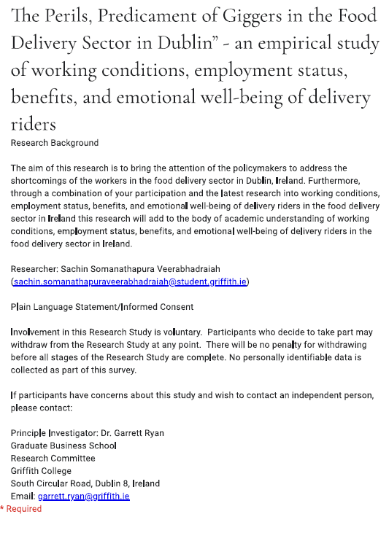






QR Code embedded with questionnaire used in Survey


APPENDIX D

Sample rider account rental advertisement from social media (Facebook Market Place)


Email Communication with the Central Statistics Office
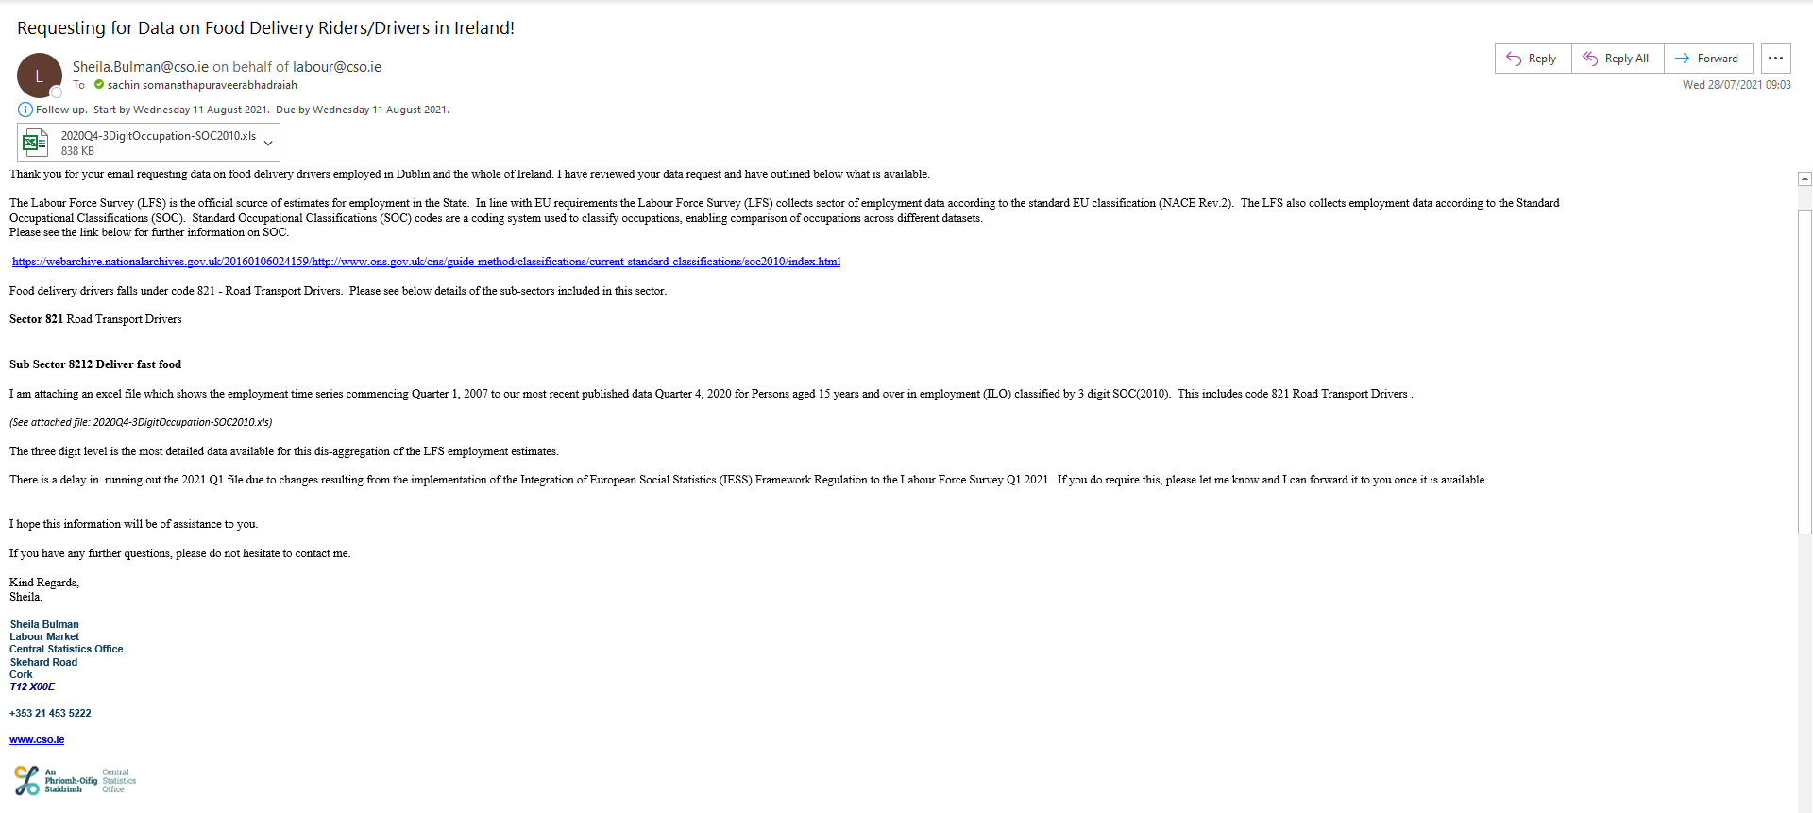

Email communication with the labour’s Union SIPTU
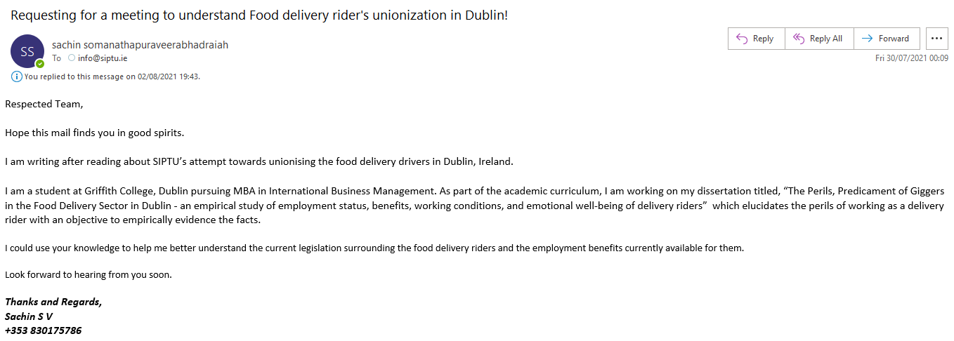

Email communication with one of the column writers in WIRED UK


Email communication with the leading platform providers (Deliveroo, JustEat, and UberEATS)

Deliveroo
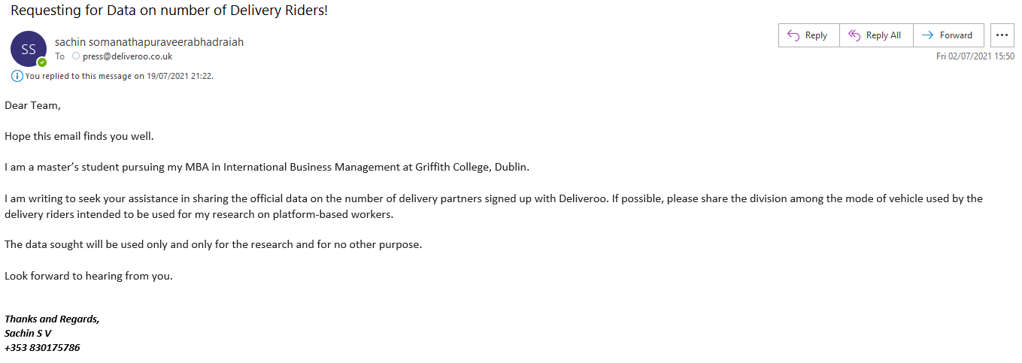
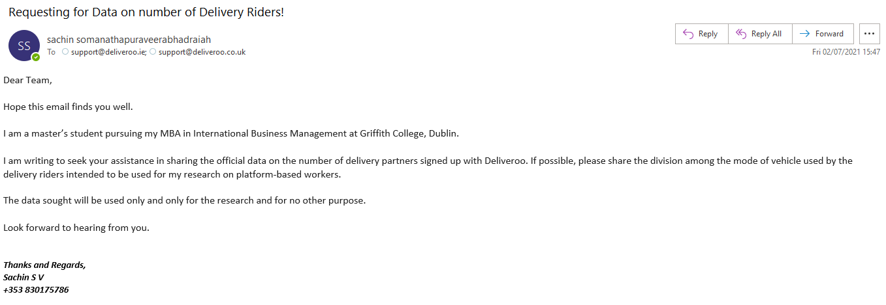
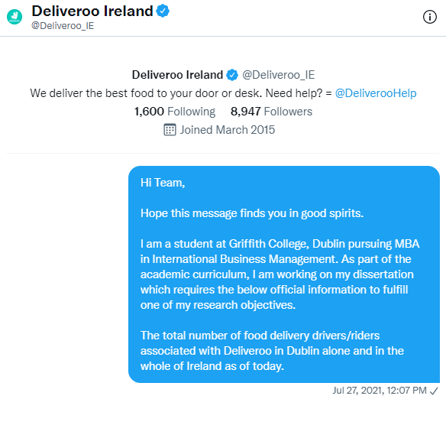

UberEATS
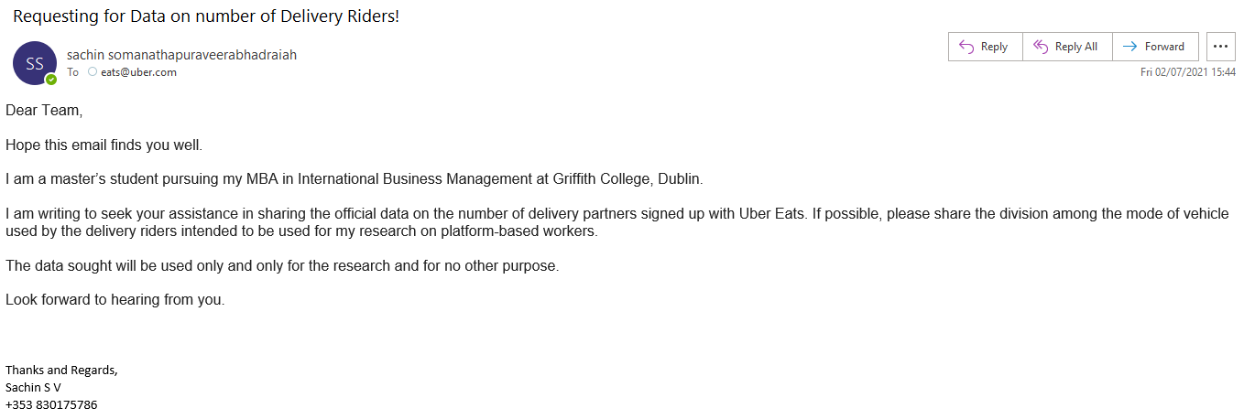
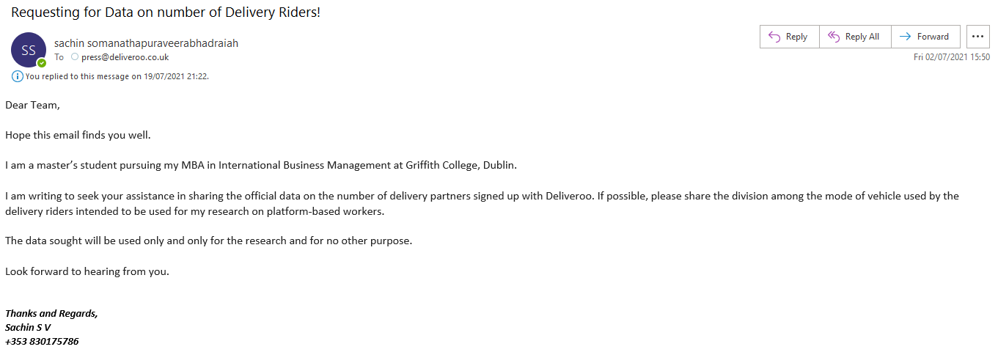
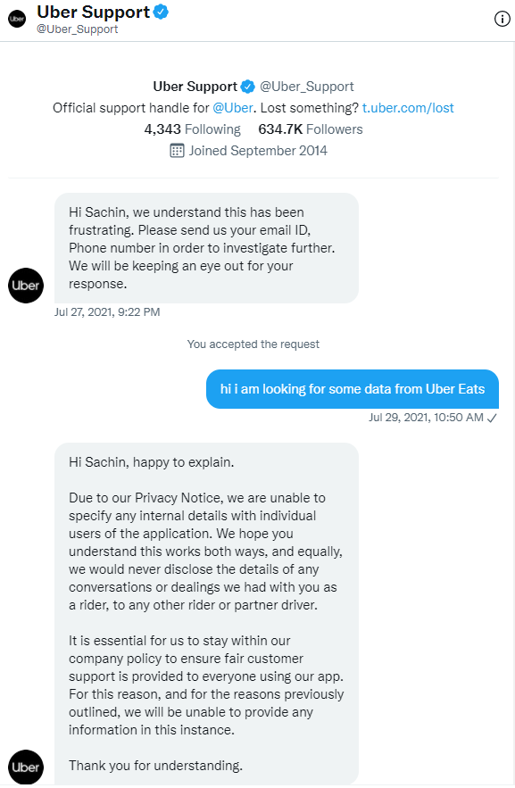

JustEat
