
Small investor- advise small investors on how to manage investment risk.
Msc in Accounting and Finance Management
Supervisor
Suzanne Burdis CPA, MATI, Dip IFRS (ACCA), PG Cert (TE) Senior lecturer in GBS.
Student ID:3069301

Table of Contents
Chapter 1 Introduction 4
Chapter 2 literature review
Introduction 7
Macroeconomic analysis (Momentary policy & economics cycles /Business) 7
Investment &Investment risk (What is investment? Why is it undertaken? Who undertakes investing activities/ investment risk) 13
Investor analysis(What is small investor &limitations /Investor behaviours) 15
Investment philosophy (The efficient-market hypothesis/ Warren Buffett's Investing Style/Asset allocation) 21
Conceptual framework 25
Conclusion 26
Chapter 3 Research Methodology
Introduction 27
Saunder’s research onion 28
Dissertation research methodology 33
Conclusion 38
Chapter 4 Findings &Analysis
Introduction 38
Demographic details 39
Investor analysis 43
Investment &Investment risk analysis 50
Investment Philosophy & Strategies analysis 53
Conclusion and Findings 58
Chapter 5 Conclusion
Introduction 60
Summary 61
Discuss the extent of the finding with literature reviews 63
Conclusion 65
References 68
Appendices
Questionnaire about Small Investor 74
Other comments for end of questionnaires 78

Abstract
High inflation is striking all over the world due to war, conflict, and pandemics. And deglobalization and the ageing population trend lead the world into turbulence stages. These situations make understanding investment become more important to preserve wealth. The research purpose is to advise small investors on how to manage investment risk. Identify the best investment strategy for small investors and make rational decisions without effect by fear and greed. Finding the right approach to manage the risk of investment. The primary data for this research was collected through semi-structured questionnaires and received 51 participants' questionnaires from 21 countries covering most regions of the world. The research methodology used epistemology research assumptions through interpretivism study with qualitative research methods.

The literature review covers all the key areas in investments. Explain investment and considered define what is small investors and examine the limitations facing small investors and Investor Behaviour. Analysis of all the aspects that affect investment making. Such as macroeconomics, risk management, and company evaluation. The importance to understand monetary policy, the position of the American dollar in world economics, and the Economics & Economic cycle. Other themes include identifying a great business investment and what is second-level thinking that it is important to know what others think and choose what everyone investing in the future as Keynes’s viewpoints. How to think differently and find the next popular investment opportunity is the key point to success in investment. The final part explores different investment philosophies & strategies for small investors. In the investment philosophy &strategy section, explore the efficient-market hypothesis, Warren Buffett's Investing Style and how Asset allocation works.

In primary data of questions and analysis, The questionnaire has 18 questions designed in response to literature structures. The sample was conducted in 21 countries with participating representatives to study global investor risk attitudes and behaviours. The demographic profile of the participants reflects a group primarily composed of younger adults with higher education and financial stability with roughly equal gender. The key findings of the research show the majority of participants have a relatively conservative attitude toward investment risk. Consider they are incapable investors in sample participants with 96.1% having undergraduate education and 77.4% can use more than two languages. Lack of financial knowledge is the other big finding, such as a low percentage of participants being aware of high fees and expenses. The finding indicates that investors need to enhance their financial knowledge such as taking various forms, including workshops, courses, and online resources. as well as seeking professional advice can help mitigate the risk of making investment choices. There is some recommendation for small investors to address these issues, The first is to use a margin of safety that leave enough safety space in investment. Other recommendations such as Asset allocation strategy combines diversification of investment in the portfolio theory, passive such as ETFs, and active investing advantages benefits. Therefore, investors should consider long-term investment strategies that align with their risk tolerance and financial goals. Overall, Improving individuals' financial knowledge can make more rational investment decisions, that can enhance investment performance and manage investment risk.

Acknowledgements

Throughout the writing of this dissertation, I have received a great deal of support and assistance. First, I thank all questionnaire participants for their wonderful collaboration.
I would particularly like to thank my supervisor Suzanne Burdis, whose expertise was invaluable in formulating the research questions and guide. Your insightful feedback pushed me to sharpen my thinking and brought my work to a higher level. And thank Dr Garrett Ryan for all aspects of dissertation support.

Small investor- advise small investors on how to manage investment risk.
Chapter 1 Introduction
2022 has been a challenging year for most people from the war in Ukraine to floods in Pakistan, heat waves in Europe, protests in Iran and China, the worldwide energy crisis, global economic turmoil and the ongoing influence from a global pandemic. People around the world are grappling with a rising cost of living crisis.

In the early 2000s, inflation in developed countries was already below 2%. However Malkiel (2019) argues that high inflation may strike suddenly at some point in the future. Inflation averaged nearly 4% per year from 1962 to 2014. What was the result? The price of newspapers has risen 49 times, and the price of chocolate bars has risen 20 times, so inflation looks mild, but in long-term compounding can be devastating. Therefore, investing makes sense for everyone, and if you are not prepared, wealth will be evaporated by inflation (Malkiel, 2019). The Consumer Price Index (CPI) is an important measurement of consumption power which indicate the average change in prices of the basket of goods and services. If CPI rises that means inflation is occurring and the currency purchase power decrease. A moderate level of inflation can stimulate economic growth. However, high inflation can destroy the whole economy and lead to severe social turmoil. Such as the hyperinflation in the Weimar Republic of German from 1921 to 1923, a pound of butter cost millions of German marks (Lehnen, 2023). Roselli (2021) believes from the monetization of Germany's massive debt and hyperinflation in 1923 to Adolf Hitler being appointed the Chancellor of Germany in 1933 in a decade, from the monetary perspective that inflation and massive debt arrangements have a decisive influence on the events. And it is questioned nowadays the risk of inflation led to unwanted political consequences - the results of a trend in nationalism (Roselli, 2021). The Consumer Price Index (CPI) for several years barely moved, and actually slightly backed up in the past decade. Because of the pandemic, it all changed. In October 2021, the consumer price index jumped to an annual rate of 5.1%, the highest level since the 2007 boom. In December 2021, the index rose further to 5.5% in Ireland (Shortt, 2022).

Post Covid annual inflation in the UK rose to its highest level since October 1981 (Trading economics, 2022). Faber (2015) observes that the power of purchases dropped 97% in 100 years, it is means $3 in 1922 equal to $100 nowadays. So, the purpose of investment is to beat inflation and preserve wealth.

To fight against inflation global central banks continued raising interest rates. Winters (2022) comments that while raising interest rates can slow inflation because of raising the cost of borrowing, the move further increases the cost of debt, and ordinary people struggle as the price of almost everything rises, including necessities such as food and rent. Rising interest rates have stunted economic growth, and may cause a recession, and many people may lose their jobs as a result (Winters, 2022). Inflation will not be temporary. The world’s biggest hedge fund Bridgewater Associates co–chiefs investment officer Greg Jensen warns of a bad future for investors, that global markets are entering a new era of volatility as the world adjusts to higher interest rates (Will, 2022) Another co-chief investment officer of Bridgewater Associates, Bob Prince, said that Central banks around the world will be powerless to stop inflation without damaging the economy (Anna, 2021). Investors need to prepare to face a stagflation environment (Prince, 2022).

Rani (2022) comments deglobalization is the process of reducing the degree of interconnectedness and interdependence of the global economic, cultural, and political systems (Rani, 2022). Although the central bank is against inflation, the deglobalization trend will still fuel inflation. The central bank can reduce the currency in the economic cycle but cannot control goods and services supply over time. Examples include the United Kingdom's Brexit and the trade tensions between the United States and China. There are many reasons that cause deglobalization, one of the reasons is protectionist economic policies that tariffs and trade barriers can limit the flow of goods, services, and capital across borders that will be fueling inflation. As economies increasingly diverge during deglobalization, deglobalization worsens inflation (Moyo, 2022). The economics of the deglobalization trend are characterized by high tariffs and geopolitical tensions (Moyo, 2022).

The other trend is an aging population. The rapid aging of the population means that there will be fewer and fewer working-age people in the future economy, resulting in a shortage of human capital and increasing labor costs for enterprises. According to the United Nations Department of Economic and Social Affairs, in 2019, there were 703 million people aged 65 and over in the world. The elderly population is projected to double to 1.5 billion by 2050 (United Nations et al., 2019). Borji (2019) comments countries with large elderly populations rely on a small number of people to pay for higher health care costs, pension benefits, and other public services causing rising health care costs, increasing dependency ratios, and changing economics.

The population structure is the most important factor and decisive variable in economic development. Goodhart (2020) also believes an ageing population will significantly boost the inflation level. Inflation or deflation comes from the dependency ratio and working population. (Goodhart and Pradhan, 2020) The dependency ratio decreases namely the expansion of the labour population has a deflationary effect because the working population will produce more products, provide the supply capacity, and reduce the inflation level. When the labour force decreases, the population of the products decreases, while the consumption population increases, which will produce an obvious inflation effect. Goodhart's viewpoint is similar to Economist William Baumol's proposed Baumol's Disease in the 1960s. The environment created by Bowmore disease is where different sectors of the economy exist with faster and slower productivity growth, and the service sector is a clear example of slower productivity growth. At the same time, with the development of the economy, people's demand will turn more to the service industry, and the efficiency of some service supply is difficult to be significantly improved through technology, and as a result, the service industry labour wages will rise significantly. The theory explains why costs are rising so fast in health care organizations. because of their low-productivity growth compared to other parts of the goods-producing economy. (Atanda et al., 2018)

This may not necessarily be the case in the manufacturing industry, the shortage of labour in manufacturing production can be replaced by machines, but this is very evident in the service industry. As the demand for labour in services increases, the population will shift from other industries to services, and overall wages will rise, creating a significant inflationary effect. According to the assumption of free labour mobility, an increase in wages in the service industry will also drive-up wages in other industries, resulting in an overall increase in economic inflation from a cost-driven perspective. As a common global phenomenon is that with the improvement of economic development level, the degree of population aging will gradually deepen.

Due to the visible deglobalization and aging population trend, the living cost for ordinary people will continue rising. Inflation is now a global phenomenon. How to have a better life in a turmoil financial environment and how to preserve wealth no matter if it comes from hard work salary or investment, dividend, rent even inheritance, is important for everyone. Especially as modern medical technology becomes more advanced and more people live longer than ever before. When getting older, the pension problem will become one serious challenge for everyone when social insurance becomes more and more of a burden.

Investing is an important way to preserve wealth. However, small investors have many issues in the modern complex financial world. The modern pension system is a pay-as-you-go system in most countries, young people pay money to give pensions to those who have retired. Aging and the low birth rate are very severe problems for future pensions. That is why understanding investment becomes more critical. Social insurance can only guarantee basic living needs. If want to have decent old-age life under unknown economic conditions such as high inflation, stagflation, or a deglobalization environment, people definitely need more successful investments to reduce the financial risk and uncertainty in the future.

The research purpose is to advise small investors and reduce risk in investment. Start at why understanding investment is important for small investors and the situation nowadays. Through literature review, explores existing investment theories and risk management for investors and how to improve investing performance. and brief overview of the research methodology and discuss the best suitable research methodology for dissertation research. Different investors have different investment purposes and risk tolerance, how to match various investment goals and existing theories, what is the main impact of investing, the biggest disadvantage and concerns, and how to improve it. After investigation research questionnaire collecting, analysis of primary data finding how to improve investment performance for small investors. Finally, the conclusion of the whole dissertation is an analysis of findings of which best practices for advice to small investors on how to reduce investment and manage risk.

Chapter 2 literature review
Introduction
This chapter will consider what an investment is and the purpose of investing. The literature will be considered in order to define what is a small investor and examine the limitations facing small investors in their investing activities. Analysis of investment risk and understanding investment risk involved in investor behaviour and how human nature such as fear and greed affects investing decision-making. Discusses the importance to understand monetary policy, the position of the American dollar in investment, and understanding the Economics & Economic cycle can improve investment decisions making. Identify a great business investment opportunity and company evaluation. The final part explores different investment philosophies & strategies for small investors. Such as the efficient-market hypothesis and irrational market practice in investing marketing, explain Warren Buffett's investing approaches and discourse the popular Asset allocation investment strategy of investing in a wide range and variety of assets with low or opposite correlation to reduce investment risk. The literature review will be the guide for dissertation research.

Through studying the giants in the investment field to understand the different investment philosophies &strategies and what is worth investing company and with specific investment methods. Summarize the wisdom of the predecessors. and exploration of new methods for the small investor in order to reduce the investment risk and increase successful chances.

Macro- economic analysis
Understanding Monetarist Theory is very important for understanding inflation and investment. Irving Fisher, was a famous American economist with his famous Fisher equation: MV = PQ, (M=Money supply, V= Money Spend, P= Price of merchandise, Q=Quantity of merchandise). That is, the quantity of money times the velocity of circulation = the price of goods and services times the quantity. The sample example is the American central bank. In the early days of the COVID-19 pandemic, the American central bank reduced its interest rate target to near zero in order to increase money supply. At the start of 2022 the Federal Reserve balance sheet was nearly $9 trillion, which is nearly double the size before the pandemic.

Surz (2019) argues according to Modern Monetary Theory, governments can solve economic problems by printing money until it causes inflation, at which point taxes need to be raised to control the currency. This is known as Quantitative Easing (QE) monetary policy. However, when the quantity of money increases, or the speed of circulation increases, since the quantity of goods will not increase rapidly, the price of goods and services will often rise sharply. Quantitative easing hasn't led to an increase in CPI yet, but the reality is that it does push up stock and bond prices, so there is inflation, but not the usual measure. So the CPI will rise. Inflation will actually be seen
(Surz, 2021). The QE policy does affect the stock market. Sean (2021) claims some evidence shows a positive relationship between quantitative easing (QE) and stock market gains. Some of the largest stock market gains in American history have occurred during quantitative easing (Ross, 2021). The worst influence of QE policy is to push high inflation, that will damage consumers. However understanding the QE effect will help investors seize the opportunity of the stock market rising. Therefore understanding the Monetarist Theory is very important.

Another famous theory “the visible hand” by English economist John Maynard Keynes published in 1936 also marks the emergence of modern western macroeconomics. He claims to use fiscal policy to intervene in the economy. Many elements effect the performance of stock markets. However, the stock market is the barometer of the economy and the monetary policy may be a visible hand for stock market. This huge effect must be brought to the attention of investors.

Opposite theory is “the invisible hand” from Wealth of Nations published by Adam Smith in 1776. He first proposed the concept and its famous quote about "the butcher, the brewer, and the baker". He believed that economic development does not come from the favour of anyone, but from the careful calculation of everyone's own interests. Free market is very important. As Depersio (2022) describes it is ‘allocation through price discovery and very importantly buyers and sellers compete with each other to agree on a price’ (Depersio, 2022).

In order to better understand modern economics, knowing the American dollar and how it plays the role in modern economics is crucial. And understanding the gold and the U.S. dollar relationship is key. Gold has historically been the medium of exchange. The gold standard is a monetary system in which the value of money is pegged to gold. However, in August 1971, Nixon cut off the dollar's direct convertibility into gold. As a result of this decision, the U.S. dollar became the main currency of the global financial system. But the gold dollar-denominated value has continued to rise since the U.S. left the gold standard. Lioudis (2022) comments the advantage of the gold standard system is that it prevents people from issuing unlimited amounts of money, and the actual amount of gold can be used as a limit to avoid inflation (Lioudis, 2022). The modern currency, such as the U.S. dollar, is a government-issued currency that is no longer backed by commodities such as gold. Currencies give central banks greater control over the economy because central banks can control the print amount of money. however, the problem is that governments can print too much which can lead to inflation. Pettinger (2022) said there is a close connection between the money supply and inflation, theoretically. If the money supply grows faster than actual output, then prices generally rise (Pettinger, 2022). That is why after quantitative easing in the pandemic, America and the rest of the world gets a higher rate of inflation. In order to control inflation the central bank's rise interest rate which decrease the amount of money in the economy, causing an economic recession. Especially the U.S. dollar is not only the American currency but also the world currency. American rise in interest rates will cause a strong U.S. dollar which is considered strong when it appreciates against other currencies in the foreign exchange market. Johns Hopkins University economics professor Jonathan Wright (2022) said the federal reserve is raising short-term interest rates sharply and faster than other central banks, making dollar-denominated assets more attractive (Estrada, 2022).

A strong dollar has advantages and disadvantages. As the dollar has strengthened over the past year, U.S. consumers have benefited from cheaper imports and cheaper foreign travel. But emerging market economies are negatively affected. Emerging market countries that need dollar reserves and pay debts will end up paying relatively more to get those dollars. Cohen (2022) claims that is only good for the American economy, a bad effect on the rest of the world, because the U.S. dollar is the international reserve currency. The U.S. central bank’s determination to curb domestic inflation by raising interest rates causes profound pain elsewhere — driving up prices, inflating debt payments, and increasing the risk of a deep recession (Cohen, 2022). Taylor (2022) comments "The dollar is our currency, but it's your problem", US Treasury Secretary John Connally told a roomful of European counterparts in 1971. The recording is actually over 50 years old but what was true then is still true today, for the rest of the world, a strong dollar increases the cost of imports and fuels domestic inflationary pressures (Taylor, 2022). However, as an investor, due to the international currency status of the US dollar, one needs to pay more attention to changes in the value of the US dollar when investing. This creates risks and opportunities for investors.

Economics & Economic cycle
Dagnino (2001) said from the profitability of businesses to the value of assets, small changes in economic growth rates can have important effects on overall economic performance (Dagnino, 2001). Therefore understanding economics and the economic life cycle is critical for investors. The economy is a sensitive and delicate mechanism and the stock market is a barometer of the economy and a leading indicator of the economy. Generally, the stock market will be 6-9 months ahead of the actual economy. However, there are many factors affecting the stock market. The stock market is not the economy. Giles (2021) argued that the reason is that the stock market does not represent everyone involved in the economy. It cannot represent all companies, some companies are not listed, and not everyone owns stocks. Finally, stock prices reflect investors' confidence in the future (Giles, 2021). The stock market may reflect changes in the economy, but it does not necessarily reflect the overall picture of the national economy. It is not representative of the global stock market. There are lots of stock markets in the world, however not all countries’ economies are the free market or to some degree free market. In history, some countries after political change even close the stock market or manipulate the market and these are all the risk factors for investors when investing abroad.

Investment is about the future. However, predicting the future is not an easy thing. All the successful predictions are based on data. A famous example to explain the prediction of the stock market is "Babson Break". On September 5, 1929, Brabson gave a speech at the National Business Conference predicting the Wall Street Crash. Roger Ward Babson warned investors that the stock market was about to crash. The stock market fell about 3% later that day. This is called "Babson's Break ". The Wall Street Crash of 1929 and the Great Depression followed. Published at a time when expectations of continued economic prosperity were high, he argued that more people were borrowing and speculating than ever before in history. The wise advice at the time was that investors should pay off their debts and put away their investments (Cohan, 2019).

The economy has cycles, and the prices of all assets follow the cycle that prices are dependent on different economic conditions, which directly reflect the expectations of investors, so the real situation in the world is not that important. What matters is what everyone thinks. Ray Dalio (2021) founder of Bridgewater Associates believes that there is a certain regularity to these things, as well as recurring patterns and causality behind them. Knowing what has changed in the past, consider the possibility that something similar might happen in the future (Dalio, 2021). Clement Juglar (1862) proposed the Juglar Cycle, a theory for a cyclical fluctuation of about ten years in a capitalist economy. When studying statistics such as population, marriages, births, and deaths, he began to notice regular fluctuations in economic affairs. He states the only cause of a depression is a boom. This tells us to dare to invest in a crisis, because this is the time with the least risk and the greatest return. Waiting for the recovery and prosperity of the economy is the time to make a fortune, and when investing in prosperity, waiting is recession (Juglar and Wolowski, 1862).

Analysis of the past cycles involves at least knowing what positions are in the economic cycles, and what holding will be best for the investor. The economic and business cycles guide investment that will increase win chances. From the investor perspective, the business cycle and finance cycle are critical. The business cycle is the expansion and contraction of the general regularity of the development of economic activities. And the finance cycle, the basic explanation is “the visible hand”; when the business cycle went into recession and the lack of confidence in the market, the central bank takes action to increase currency supply, cut interest rates to stimulate the economy and increase economic activity. Or the opposite direction action, that is the finance cycle, through the fiscal policy to smooth the economics. Analysing and understanding the economic cycle can also help investors identify potential market trends and adjust their investment strategies accordingly. As important as using a map, during periods of economic expansion, stock prices tend to rise, and corporate profits increase. On the other hand, during economic contractions, stock prices tend to fall, and corporate profits decline. An investor who believes that the economy is entering an expansion, should invest in stock and other riskier assets, as they have the potential to deliver higher returns. As a recession approaches, it should shift to more defensive assets.

The entire financial cycle should be like this. The economy recovers, commodity prices rise, real estate prices rise, then there's a boom. When there is a boom, interest rates increase, bonds fall, stock prices fall, then the economy begins to decline, and commodity prices fall. There is a crisis phase when house prices fall, interest rates are low, bond prices rise, and stock prices then turn from negative to positive (Tvede, 2009). From the essence of this circular investment, one should buy when the world economic order is in trouble, and sell it when everyone else feels the economy improves. Avoid investing when the economy is booming. Under the framework of cycle theory, at a certain stage, there are always assets in the market that are going up or down, so investment performance depends on holding the right assets at the right time. Thus, understanding the economic cycle can help investors make better-informed investment decisions and manage risk more effectively.

Business Investment
According to stock investment guru Peter Lynch, the key thing to remember when investing is that behind every stock there is a company and it is important to understand the company and how it works (Lynch, 2000). The most important factor affecting the intrinsic value of a company is its earnings.

“Intrinsic value is an all-important concept that offers the only logical approach to evaluating the relative attractiveness of investments and businesses. Intrinsic value can be defined simply: It is the discounted value of the cash that can be taken out of a business during its remaining life.”
---Warren Buffett’s owner’s manual(1999)

Listed companies must publish their annual and quarterly reports every year. Whether the investor is a large Wall Street investment bank or a small investor, they are very concerned about the latest financial report. The reasoning behind this is to analyse the future value of the company based on the expected earnings forecast. If a company performs better than expected, the stock price will rise. If a company's performance is worse than expected, the stock price will fall. Investors can use the discounted cash flow (DCF) method to determine how much to pay for a business, whether buying stock or buying an entire company.

How can investors identify a great business, and when investing in that business will maximize return? Morningstar is an American financial service and investment research firm, its research department has its own stock selection strategy called "Moat”. It first came from the investment legend Buffett (2008) who said that the ‘key to investing is to determine the competitive advantage of a given company and, most importantly, to determine the duration of this advantage’. A product or service protected by a wide, long-running moat can bring substantial returns to investors (Buffett and Ph.D, 2008). How much value a company can create for shareholders depends on two factors: one is the amount of value it creates in the present, and the other is its ability to continue to create value for a long time in the future. Current value investors can easily calculate based on basic financial statements, however it is difficult to determine the size and duration of future excess returns. Morningstar company believes the essence of a great business comes from 5 aspects; intangible assets, cost advantages, switching costs, network effects, efficient scale (Brilliant and Collins, 2014).

The first is intangible assets, such as brand, patents or government licenses. This likes a monopoly, there are barriers to market entry, and the ability to manipulate prices for high profits. In other words, only a few companies can do this business or special one, that is the first “moat”.

Secondly, cost advantage, the cost is lower than others. Cost advantage is one of the most powerful competitive advantages. If a company can manufacture a product or provide a service at a lower cost than its competitors, it has won the competition. A typical example is a large supermarket like Wal-Mart. Buffett has owned Walmart stock since 2005. Its low-cost advantage is difficult for competitors to imitate.

Third, switching cost, that is, how much it costs users to move away. When users are accustomed to using a certain product or service, if they want to switch to other competitors, it will cause a lot of inconveniences and bring switching costs. A typical example is the iPhone. Apple Computer uses its own system. When users get used to using Apple products, if they want to switch to Android phones, there will be various discomforts, and the switching cost is high.

Fourth, is the network effect. The more people use it, the greater the value of its service or product. When the number of users reaches a certain scale, the company's market share will be difficult to shake. Social media giant, Facebook is a typical example. The more people use Facebook, the greater the value that its social network can generate. Under the snowball effect, Facebook has become the market leader in social media.

Fifth, efficient scale. Also known as a natural monopoly. After the market competition and continuous integration, a monopoly company that dominates the market share emerges, and then it has reached an effective scale. It is said that new competitors are difficult to join. In the US automobile industry, the term Big Three is used for the country's three largest motor vehicle manufacturers that are Ford, GM, and Chrysler. However, in the early 1900s, there were approximately 3,000 automobile companies in the United States. However, until Tesla's success there were many decades where no new automobile company emerged in America.

From the perspective of corporate finance, companies with relatively deep moats are companies with relatively strong profitability: their return on asset (ROA), return on equity (ROE) and profit margin (Net Margin) are higher than those without a moat. However, these return rates based on financial data are calculated based on the company's past historical data and cannot represent the future.

When is the best time to invest in these great companies? Brilliant and Collins (2014) say that whenever such a company can be found, it should be bought, and as long as the company's competitive advantages remain intact, it’s stock should always be retained. However, why does such a good company stock cause investors to suffer losses? This goes back to the essence of "value investing": not only to find a good company, but also to find a good company at a low price, in order to make a profit on investment. Hayes argues only make more money when buying the company in lower prices (Hayes, 2022).

Investment
What is investment? Hayes (2023) said an investment is an asset or thing acquired for the purpose of generating income or appreciation. It involves putting money into assets that are expected to appreciate or provide income in the future (Hayes, 2023). Investing involves using capital today to increase its value over time. An investment requires an investment in the form of time, money, effort, etc., with the expectation of a greater return in the future than the initial investment. It can refer to any medium used to generate future income, including stocks, bonds, real estate, education etc. Investments generally involve risks and may not be rewarded. Hayes (2023)argues any action with the hope of increasing future income can also be considered an investment. For example, choosing to pursue additional education is to increase income in the future career (Hayes, 2023).

Why is it undertaken? Investing is made to achieve a variety of goals, such as increasing wealth for retirement, generating income, preserving capital, or just being interested. Different investment purposes may vary depending on the investor's goals, risk appetite, and investment horizon. How did Warren Buffett start investing? Financhill (2021) comments Warren Buffett saw poverty in his youth, while his father was a stockbroker and was exposed to stocks very early. He was 11 when he bought his first stock (Financhill, 2021). Later he earned a Bachelor of Science in business administration and a Master of Science in economics learning from Benjamin Graham widely known as the father of value investing. However, ordinary people not interested as professionals in the investment industry, still need investment, because it can help build wealth, protect against inflation which can help protect their wealth from being eroded by rising prices, diversify their assets and reduce unknown risks. The purpose of investment can vary depending on the investor's goals, risk appetite, and investment horizon.

Who undertakes investing activities? Investment is undertaken to achieve a variety of objectives. It is done by individuals, companies, and governments who usually have surplus funds and are looking to invest for the long term. Investing activities are undertaken by a variety of participants, such as individual investors including retail investors, small investors, institutional investors such as pension funds, mutual funds, hedge funds, private equity firms, and companies that invest in their own businesses.

Risk management investment strategies
Hayes (2023) believes that return on investment and risk should be positively correlated. Investors must weigh their risk appetite when making investment decisions (Hayes, 2023). Regarding investment risk as Mark (2011) said the essence of investment is to obtain the greatest possible return on investment with as little risk as possible. Understanding and identifying risks is the basis for effective risk control (Mark, 2011). Mongan (2022) says, before starting, it is very important to understand one’s own financial situation, the goal of investment and the attitude toward risk. There are no guarantees for any investment in which the value of company shares or the stock market can go up or down over time (Irish Life, 2022). Douglas said among trading-related issues, there is no such thing as accepting that risk has a huge impact on successful investors (Douglas, 2001).

The management of investment risk should be the main goal of your trading strategy. Investors should learn how to formulate flexible and reasonable risk control strategies, such as poker players deciding the size of bets according to the probability of winning, and adjusting the investment amount according to the possibility of investment profitability (Dagnino, 2001). Mongan (2022) says, there are two ways to manage risk, One is to invest spread across a range of assets, secondly is a long-term investment (Irish Life, 2022).

Allen said the author of Don Quixote coined the phrase "don't put all your eggs in one basket" in the early 1600s, and it has since become a valuable metaphor for explaining investment risk management (Allen, 2019). Diversified investment, also known as portfolio investment, refers to investing in different asset types or different securities at the same time. Buiter (2003) said the American Nobel Prize Winner in Economics in 1981, James Tobin, outlined "portfolio theory" and summarized it as "Don't put all your eggs in one basket ", that is, to use the risk differences of different assets to reduce the volatility of the asset portfolio, thereby reducing the overall investment risk (Buiter, 2003). Diversification of risk is a wise choice, asset allocation and asset selection are two important parts. Asset allocation, that is, the allocation of your wealth in large categories of assets, for example, how much to allocate in assets such as stocks and bonds. Asset selection refers to a specific choice in a certain type of asset, such as holding stocks, bonds or commodities, gold, etc. Investors, should not concentrate on a single asset, otherwise, no matter what kind of asset allocation it is, it means losing the opportunity for the asset portfolio to resist risks. The main principle of diversification is to use the risk-return characteristics of different products in the portfolio to smooth the return of the entire investment portfolio.

Many things in life are very certain in the short term and uncertain in the long term. However, investing in the stock market is more uncertain in the short-term, but more certain in the long-term (Hagstrom, 2000). If taking a long-term view, the stock market always moves upwards from American stock market records, the Standard and Poor's 500 (S&P 500) Index which is a market capitalization weighted index of the 500 major U.S. public companies. The average annualized return of 10% since its inception in 1928 has been very stable over time (S&P Dow Jones Indices, 2022). After adjusting for inflation, the historical average annual return is about 8.5% (Historical Returns for the US, 2022). The income of the stock comes from the profit of the company, and the profit of the company is based on the continuous development of the economy. Historical data from the United States shows that long-term holding of stock assets can maximize the benefits of economic growth.

Combine diversified and long-term, another more effective way to invest in funds regularly is using Exchange-Traded Fund (ETF) for "time diversification of investment". Passive investing ETF fund is a passive tracking index. Exchange-traded funds, also known as ETFs have many advantages for small investors. It allows investors to participate in the stock investment with relatively small funds, and the professional management of such products can save time and effort. Passive investing is a long-term strategy for building wealth by buying securities that mirror stock market indexes and then holding them long-term. Troy (2021) said for most individual investors, ETFs are the ideal asset class for building a diversified portfolio. ETFs tend to have much lower expense ratios and are more tax efficient than actively managed funds (Troy, 2021). However, the disadvantage obvious is unable to gain beyond the average return of the market. Compared with directly investing in the stock market, individual investors are limited by factors such as professional knowledge, capital size, time and energy, etc. ETF is a relatively better choice. And though a regular fixed investment method, agreed time and agreed investment amount, by adopting the method of buying in batches, overcomes the defect of only choosing one-time point for buying and selling and can balance the cost. Time is the best tool to smooth out fluctuations, slow and steady wins the race. A pioneer in the American fund industry who pioneered index investment, John Bogle (2017) has a very simple suggestion for individual investors: buy index funds with low cost, low turnover rate, and strict compliance with portfolio strategies. He also said the first issue that investors should consider is investment strategy. From the beginning, investing has been an act of faith and a willingness to defer immediate consumption for future gains. Long-term investment is the core task for investors to obtain optimal returns. In a more complex investment tool, simplicity is the foundation of a good investment strategy (Bogle, 2017).

Small investor
Generally speaking, a small investor has a relatively small amount of money compared to institutional investors who are known as retail or individual investors. Mike(2023) argues anyone who does not invest professionally is considered a retail investor (Mike, 2023). Arora (2022) said retail investors are defined as non-professional investors who use their funds to buy and sell securities. The institutional investor compares to the non-professional market’s participants who are more professional with an educated professional employee and efficient funding and technology and information advantages. However, the non-professional market participants are the majority in U.S. financial market according to SEC (2020). More than 58% of the U.S. stock market is held by U.S. households directly or indirectly through investments worth $29 trillion (SEC, 2021). It is very important in size and scope. In the 2019 Federal Reserve survey, about 53% of American households own stocks, and 70% of middle- and high-income families own stocks (Bhutta et al., 2020). Hayes (2021) comments these immature investors are susceptible to behavioural biases, and cause panic selling through emotional trading. It is a force that cannot be underestimated (Hayes, 2022). Arora (2022) said although they have always been a small but vital part of the investing industry, the powerful combination of social media and access to the stock market through digital trading apps has created a force to be reckoned with.

Mike (2023) believes that five advantages for the small investor are concentration, stock size, fluidity, flexibility, and circle of competence. Small investors can concentrate their investments. The more concentrated the higher the potential return. Also they can buy small stock-size companies who normally outperform the market and institutions cannot buy these stocks. Small investors do not need to consider market liquidity because of small capital and they have more flexibility, as a small investor, more investment options and fewer restrictions. The final circle of competence is both a pro and a con. A small investor may have certain capabilities in a specific industry. But it cannot understand all industries. However as the upside, Kilham (2022) believes it is still a great way to build financial security over time.

However, there are some potential downsides to being a small investor. Kilham (2022) comments small investors may have fewer resources and access to information with higher costs than institutional investors, and a lack of professional knowledge. It can make informed investment decisions even more challenging (Kilham, 2022). Mike (2023) also argues that fees, time and access the key information are a disadvantage for small investors.

Identifying individual and institutional investors is particularly important in financial market research. Understanding their investment behaviors, decision-making processes, and performance can help to improve understanding of how financial markets work and how they respond to different economic and financial conditions. However, Swensen (2009) realizes the key is not to differentiate the individual investor and institutional investors, it is about to ability to distinguish between capable, efficiently active investors and incapable investors. The evidence proves that only a few fund managers can have high returns beyond the market average return and even commit significant resources to active management. There are even fewer individual investors who can achieve excess market returns (Swensen, 2009). David Swensen is the former Head of Yale Endowment who diversified the portfolio to increase Yale Endowment from $1 Billion in 1985 to $31.2 Billion in 2020 (Yale’s Endowment, 2022). Capable investors are those who are able to achieve their investment goals through efficient and effective investment strategies and are also able to consistently generate positive returns and outperform the market over the long term. On the other hand, incapable investors are those who are unable to achieve their investment goals despite their efforts and may also be overly risk-averse or take on too much risk, resulting in negative returns or underperformance. Therefore, rather to compare the difference between small investors and institutional investors, the importance is to make more informed investment decisions, set realistic investment goals, and plan suitable investment strategy is suitable for small investors.

Limitations of being a small investor
Analyzing and applying relative knowledge is a good approach to reducing investment risk. However, due to investors having different education levels, knowledge, skills, and experiences, the limited information application is more obvious. At the same time, small investors are faced with an ever-increasing variety of information which also includes much worthless and noisy information. The rapid expansion of information volume makes it more difficult for small investors to understand and analyse valuable information in a short period of time.

Other issues are mainly cognitive biases. Small investors tend to be overconfident, believe too much in their own judgment, and think they grasp the market trend and overestimate their chances of success. On another hand, small investor also will have excessive fear. When stock prices fall sharply they often cannot make rational analysis and tend to sell off quickly, thus buy too expensive and sell too early. Most small investors have the psychology of conformity or superstition of authority, that is, they are easy to believe the opinions held by the majority or authorities, resulting in losses. The famous France psychologist Gustave Le Bon (1895) said once many individuals form a group, a unique collective psychology will be produced. This collective psychology will cause individuals to lose the ability to think rationally through mutual emotional infection (Le Bon, 1895). This is may be why small investors suffer losses in the financial market and are not always successful.

Finding the right investment approach is also vital to reduce the risk of investment. While it is easy to achieve average results in investing, it is far from easy to achieve superior return on investment. People wish they can find an easy way to achieve success and make fortune, but this will not happen unless they are very lucky. However, if continuing gambling and not investing they will lose in the long term. Clark (2017) states ‘…that there is no formula and no magic system for investment, it needs lots of knowledge about business, human nature and numbers’. Swensen (2009) also declares investors need a lot of knowledge to make correct investment decisions. Successful investment managers not only need to master financial knowledge, but also to understand the psychological characteristics of human beings, know the historical development and know the inside of the world (Swensen, 2009). Reading more business biography is better to read investment books to understand the different histories of business models. It will show when will encounter difficulties and how to survive different economic periods. Meanwhile, understand what makes the company great or leads to failure. Being aware of the lasting advantage of competitiveness of the company is crucial to investment. Not only need to know business knowledge, but also know accounting knowledge, which is the language of business areas, and also understand the role of central banking. Overall, small investors can be successful with their investments, but it requires a combination of knowledge, experience, discipline, and access to investment good opportunities. Hence, managing risk and successful investment require many conditions. The key to small investors' success is not only challenged by investment risk but also the need to be aware of human nature such as greed and fear.

Purpose of the small investor
The goal of investing for small investors is typically to increase wealth over time and achieve financial goals such as retirement, buying a home, or paying for education. It is important to consider factors such as risk tolerance, investment time horizon, and personal financial goals when making investment decisions. Hayes (2023) said the fundamental investment objectives are safety, income and growth. He also argues investment can take many forms and endless opportunities, including stocks, bonds/ fixed-income securities, index funds and mutual funds, real estate, commodities, cryptocurrency, collectibles and more (Hayes, 2023). However, it is a lot of challenges in the modern finance market. Not only the information and knowledge barrier but also human nature such as fear and greed will deeply affect decision-making, and finally, affect the investment results. However, through investment philosophy and discipline, investors can improve investment performance and reduce investment risk. Investing always involves risk, so it is important to research with careful planning and a long-term perspective and make informed decisions.

Education can decrease the investment risk level, such as understanding the company and stock market and how they are working, which is important for decision-making and increases the chances of achieving better investment performance. As Professor Siegel (2005) said ‘The long-term return of the stock market is almost constant, 10% without deducting inflation, and about 6.6% annualized after removing inflation, which is very stable’. After realising this, index investing is a very good strategy. As long as the investment keeps holding the index, it can get a 6.6% return in one year. In the long-term range, the timing of buying is no longer important.

Another example is that the return on investment of stocks does not depend on the growth of the company's profits, but only on whether the actual profit growth exceeds investors' expectations. Keynes (1936) argues financial investment is like a beauty pageant. Do not choose the beauty you think is the most beautiful to win the championship but choose which beauty everyone will choose as the champion (Keynes, 1936). Applying Keynesian beauty pageant thinking to the stock market, speculation is based on the psychology of the population. In terms of financial market investment, Keynes' beauty pageant theory is actually used to analyse the impact of people's psychological activities on investment decisions. Marks (2011) also states that facing the market needs patience to pursue long-term stable income not short-term profiteering. A market is a place competing with other people who also want to win. So beating the market means winning the 80% of investors who are one step ahead or have a higher education, the most important is sharp thinking that is the concept (Marks, 2011). In short, having good knowledge of investments is important for informed decision-making and reducing risk, but it is only through the actual investment practices that can improve return on investment.

Investor Behaviour
“If a man didn't make mistakes he'd own the world in a month.” ― Jesse Livermore, Reminiscences of a Stock Operator (2005)

Except for fiscal policy intervention, stock prices are affected by market forces. In fact, the stock price changes due to the relationship between supply and demand. If there are more people wanting the stock than there are supplies, the price will go up. The opposite instead, the price will fall. The Keynesian beauty contest is a concept developed by John Maynard Keynes. In beauty pageants, there is a need to be rewarded for choosing the most popular among all the judges, not the one they personally think is the most attractive. Keynes (1936) believed that similar behaviours worked in the stock. Choosing stocks not only needs to refer to the company's financial reports, but also needs to refer to other investors' views on the value of stocks. Not only need to be based on the understanding of the value of the company, but also need other investors' views on the value of the company. Therefore, Hagstrom (2000) comments that common sense in the stock market is the opposite of common sense in life. Consumption needs to refer to the opinions of the public, but investment requires independent thinking, because things that everyone is optimistic about must be expensive. For example, the stocks of Apple, Amazon and Tesla are good companies, everyone thinks this, and the stock is not cheap now. In the face of a crazy market, people always forget the ability of human independent thinking (Graham et al., 2006). Collective unconscious that is Le Bon (1895) expounded the characteristics of groups and group psychology, and pointed out that once people integrate into the group, their individuality will be submerged and they will lose their ability to think independently, and their influence is not limited to time and space. Therefore, in a state of frenzy or panic, buying or selling in a hurry. How is it useful for current investors? The basic idea is that the human mind has not changed in the past 100 years. Still reacting to the same emotions and prejudices as our ancestors. The same mistakes are repeated generation after generation.This would explain why most people do not succeed in their investment activities.

Besides, it is important to know what others think and choose what everyone investing in the future as Keynes’s viewpoints. How to think differently and finding the next popular investment opportunity is the key point for success in the investment. Howard Marks (2011) called second-level thinking the distinctive thinking necessary to outperform the market average. First-level thinkers have the same perspectives on the same events as each other and usually come to the same conclusions. Therefore, it is impossible to achieve excellent investment results. It is impossible for all investors to beat the market because all of them are the market (Marks, 2011). The influence of crowds has never been more relevant. Investors must protect their minds from the opinions and ideas of the crowd and the deluge of information. It is a blurry, almost imperceptible line that separates one's own opinion from that of the crowd. Unprepared investors ignore the influence of the crowd when making investment decisions and suffer losses. The psychological motivation of buying when stocks are high and selling when stocks are low. Thus, the investor needs to stay calm and think independently. One thing Gross and Buffett have in common is that neither of them lives on Wall Street, and instead lives far from the heart of the financial market. Avoiding the influence of Wall Street and keeping independent thinking may be the one secret of their success.

The assumption of rational people in mainstream economics has been considered an unquestionable one for a long time. It makes us believe that every decision people make is based on rational calculations and is in line with the purpose of maximizing personal interests. However behavioural economists, represented by Daniel Kahneman (2012), said people's decision-making and behaviours are often influenced by many invisible factors. For example, intuition often leads people to pursue the wrong things. People's perceptions and memory are not reliable, and people's perceptions and memory of their own mental states are especially unreliable (Kahneman, 2012). That is, what exactly is affecting our judgment. In investment, this problem is even more serious. the same stock is valued by different researchers, and the results may be quite different. After getting these conclusions, it is even more confusing. In a noisy system, errors do not cancel each other out, they just add up (Kahneman et al., 2021). The investment decision-making process is also affected by many aspects. The reason why erroneous investment decisions are repeated is not external, it is internal. Without understanding the human brain, emotional thinking replaces rational thinking, and in a very complex and volatile stock market, decisions made unconsciously and instinctively are often wrong.

Being human is always overconfident, which also is a problem for an investor who always thinks they are smarter than others, thinking that crowds have no influence on their minds, and they can earn more than the market average return, but the market always clearly indicates otherwise. Therefore, investment is not an easy or painless endeavour. As Mark (2001) said ‘understanding and deliberately recognizing the obstacles in your mind is an important part of creating long-term benefits’. To cultivate and maintain a mentality that can see market opportunities, but not be affected by fear and greed, requires energy and deliberate practice. The best traders have many different ways of thinking, and most importantly they have a mental structure that allows them to trade without fear while avoiding reckless trading. At the same time, check and control yourself against being adversely affected by euphoria or overconfidence (Douglas, 2001). Fear and greed are two powerful emotions that can drive human behaviour. Fear can cause individuals to act conservatively and avoid risk, while greed can drive individuals to pursue high-return investments and take on more risk. Understanding the role of fear and greed in financial markets is important for effective investment management and decision-making, as emotions can often cloud judgment and lead to poor investment outcomes.

However, Munger (2022) said that the world is motivated more by envy than greed (Charlie Munger Speaks at the Daily Journal Annual Meeting, 2022). Munger believes envy is the driver of investment for human nature. Billionaire investor Charlie Munger is a 98-year-old, who has amassed a fortune that Forbes estimates at $2.5 billion in 2022. (Forbes, 2023a) His motivation for accumulating wealth has always been to ensure independence, and the freedom to do what he wants in business and life. Envy is the feeling of resentment towards someone who has something that one desires. On the other hand, greed refers to an excessive desire for wealth, power, or material possessions. Both greed and envy can drive individuals and societies, ultimately, the motivations behind human behaviour are complex and influenced by a range of psychological, social, and cultural factors.

Investment philosophy & strategies
Numerous books and theories talk about investment, however, there is not permanent theory fit for the permanent volatile market, while risk and return are permanent topics. George (2001) asserts that it is the same philosophy doing business and investment. When a method is the most effective, it must be imitated, and then this method will not work (Dagnino, 2001). There is no omnipotent method, the conditions is uncontrollable and the human heart is uncontrollable, so the results often have huge deviations. There is even a huge paradox that when an investment method becomes popular, it is not far from failure. Thus, investment is a combination of art and science (Marks, 2011). The fields of science and art have their own characteristics. Science often needs availability and certainty, while art is accompanied by chance and uncertainty.

The reason why investment is an art is not only that it cannot use financial report analysis and a set of methodologies to create answers. The essential reason is that the laws of nature are often constant, but the market environment is changing all the time. Changes in factors such as policies, industry life cycles, and other investor behaviours will affect investment results, resulting in unavoidable volatility in the investment process. Therefore, the art of investment is more reflected in various dimensions of investment and needs to be developed in the long-term. Using business wisdom, experience, business understanding, risk evaluation, etc. to find a suitable investment type and the investing trend is vital. Investment is about qualitative rather than quantitative assessment. For example, the exact value of a company's brand cannot be calculated from a company's balance sheet, and what cannot be reflected in the report may have a huge impact on the company's brand value. Portfolio investment is through the structural allocation of industries and individual stocks, and it depends more on the accumulation of experience and analysis and judgment, which is close to art.

The efficient-market hypothesis
The discussion of whether markets are efficient or not is a controversial topic that has never ceased. The winner of the 2013 Nobel Prize in Economics, the famous American economist Professor Fama proposed the famous "Efficient Market Hypothesis"(EMH). Fama (1970) argues that markets are efficient if relevant information is not distorted and is fully reflected in stock prices (Fama, 1970). One of the most important inferences of the efficient market hypothesis is that any attempt to beat the market will fail because the stock price has fully reflected all possible information. Therefore, for investors, the best strategy is to buy and hold for a long time without doing anything. Ellis (2017) makes a statistic that more than half of the active funds underperform in the market every year, and professional fund managers cannot win the market. However, even if most fund managers cannot beat the market, there are still many outstanding ones, such as Buffett, Peter Lynch, John Neff, Templeton, etc. Investing gurus outperform consistently over a long period of time. The theory is based on the concept of the rational investor. Whereas humans are not still rational all the time. Human beings have emotions, greed and fear, and investors as a group will project their ideas into the market to fulfil their self-prophecy. Dalio (2017) said that if a market consensus view emerges, it means that the news is already reflected in the stock price. The stock market does not only reflect value, but also shows people's expectations. When actual results are better than expectations, stock prices rise. When actual results are worse than expectations, stock prices fall (Dalio, 2017). In extreme cases, the market will be dominated by emotions, and at this time it should be realised that the market has been invalidated.

Conversely, Yale University economist Robert Shiller (1981) argues that markets and stock prices are generally irrational and therefore can be beaten. He predicted a tech stock bubble in the late 1990s. The most common counter-argument is Warren Buffett and his 50 years of extraordinary success since the early 1960s. In an early 2010 interview, Eugene Fama comments that Buffett himself is not an investor but a businessman. He bought the whole business and will help run the business (Richards, 2012). Wasik (2014) said that Eugene Fama believes Buffett success is due to luck or skill. The market is usually efficient, it makes mistakes but not all the time, but it is ineffective sometimes. The reason for the inefficiency is that investors' emotions fluctuate in the market, which leads to people's madness and greed in the market. In extreme cases, mistakes occur and lead to serious mispricing. When investors' emotions stabilize and rationality returns, the price will naturally return to the market.

Warren Buffett's Investing Style
Warren Buffett is one of the most successful investors in the world, with a net worth of over $100 billion in 2022 (Forbes, 2023b). Mary Buffett (2008) wrote Warrant Buffett says his style was 85 percent influenced by Graham and 15 percent influenced by investor Fisher (Buffett and Ph.D, 2008). Benjamin Graham (1894-1976) is known as the Father of Value Investing. Value investors rely on fundamental analysis of a company's financial performance to identify stocks whose market price is lower than their intrinsic value, the present value of the company's future cash flows. The Father of Growth Stock Investing Strategies Philip Fisher (1907 – 2004) provided the investment philosophy to invest in high-speed growth companies, and the theory is to predict that the company's future profits can grow rapidly. Growth investors look for companies whose operating earnings will ensure a rapid increase in the company's intrinsic value. For example, the company's profit growth rate is above 50%, and the price-earnings ratio is also around 50 times. Because of the rapid growth of the company, the current price-earnings ratio is not high compared to the future price-earnings ratio. The disadvantage of value investing is that some assets have a high book value but a low actual value. Growth investing requires growth that must be sustainable, but the future cannot be predicted. Warren Buffett absorbed the views of both parties and developed his own investing style which is only investing in stocks that are truly understanding good business and holding for the long term.

Clark (2017) states Buffett and Munger regard the purchase of stocks as the ownership of company and judge the future value of enterprises through company’s competitive advantages. A rough estimate of the discounted company's future cash flows (DCF) (Clark, 2017) which means the secret of Buffett's success is who knows what he is buying. Understand the business of the company that can focus on the business itself and ignore the market fluctuation. Rational thinking to finding the right business, the right people, and the right price in Buffett's own standard and investing in a real understanding of business. Probabilistic thinking considers the company's discounted future cash flow and current market valuation.

Other Buffett strategy is buying stocks seen as acquiring and merging a company, controlling countless companies to continuously generate cash flow, and then continuing to acquire low-priced high-quality companies. The strategy of buying and holding for a long time without selling will make him succeed. In Common Stocks and Uncommon Profits, Fisher (1996) states that the best time to sell stocks is "almost never" (Fisher and Guidall, 1996). Buffett (2016) wrote in his letter to Berkshire Hathaway shareholders that his "favourite holding period is forever" (Buffett, 2016). Statistical research shows that the stock market must rise with the economy in the long term. However, the short-term volatility is huge, the shorter the holding time, the higher the risk, and the longer the holding time, the higher the certainty of income (Siegel, 2022).

In the stock market, there are only three kinds of rewards. The dividend comes from the company, company growth and the company valuation changes. Long-term holding will eliminate the effect of company valuation changes which is the risk of fluctuations in the price of the company's stock. Just focus on the intrinsic value of the company which integrates Graham's “lower price” and Fisher's “growth” concept to generate cash flow continuously and continue seeking for lower price and growth company. Therefore, that is why Professor Fama comments that he is not an investor, but a businessman as mentioned early.

Even though Buffett's company announces its holdings every quarter, everyone can see the Berkshire Hathaway public Annual & Interim Reports and it is still difficult to imitate for small investors and even professional fund managers. who cannot hold for such a long time, or cannot ignore the fluctuations in the stock market. The fund manager also still needs short-term better performance for the fund holder. Therefore, only by truly understanding the business model and intrinsic value of the company can investors ignore short-term market fluctuations and truly achieve long-term holding and obtain maximum benefits.

Asset allocation
Asset allocation is an important investment strategy to invest in a wide range and variety of assets with low or opposite correlation to reduce investment risk. Because the economy will continue to develop, asset allocation can diversify risks and reduce volatility, and the portfolio will continue to grow with the economy.

American economist and the Nobel Memorial Prize winner in Economic Sciences Harry Max Markowitz known for developing Modern Portfolio Theory (MPT), claims that markets are efficient. Markowitz (1952) believe asset allocation is the best strategy for investors, the performance of individual stocks does not perform as well as the performance of an entire portfolio (Markowitz, 1952). Major assets are basically divided into four categories; stocks, bonds, commodities and cash. Different assets perform differently in the market environment, use their irrelevance to hedge risks, and rely on strategies to earn income. In 1996, Bridgewater Fund established the all-weather principle of asset allocation, which is now known as the "risk parity" theory. Dalio (2017) said the All-Weather Allocation method increases the leverage of low-risk assets and reduces the leverage of high-risk assets. The risk reduction by better diversification is far greater than the risk increased by the use of leverage (Dalio, 2017).
The most important thing in investment is to build a matching rate of return based on the risk tolerance of different customers. For investors, the best result is to obtain the highest rate of return with the lowest risk. Swensen (2009) pointed out that investors often fail to follow the most basic investment principles. Instead of focusing on solving the primary problem of setting reasonable long-term asset allocation goals, they have shifted too much attention to the secondary problems of stock selection and timing of trading (Swensen, 2009). Asset allocation can reduce the dependence on stock and selection timing, follow market fluctuations, and earn long-term gains in assets. Reducing buying and selling and the impact of risk fluctuations on emotions and having more time to enjoy life may be the true meaning of investing.
Conceptual framework
The researched literature tries to identify and review some of the relevant literature on investment as well as investors, identifying key concepts, definitions, and outlining the relationships, with careful attention to detail and a clear understanding of the research question. Summarising and developing critical reviews, evaluating core concepts and theory with previous empirical research facilitates the development of a powerful and effective framework that helps guide the research project and inform the data collection and analytical review of findings.

What are the main issues affecting the performance of investors, and how to reduce the risk in investment? The research goal is to advise small investors on how to manage investment risk, and help small investors invest more wisely. There are many variables that influence investment. The literature review uses a top-down strategy which means first analysing the macro and microeconomic situation, and market trends, and investment business opportunities and then merging individual investment behavior analysis with an investment philosophy and strategy. To identify what is suitable investment philosophy and strategy which can reduce risk and improve the return for small investors.

- Macroeconomic analysis (Momentary policy & economics cycles /Business investment)
- Investment &Investment risk (What is investment? Why is it undertaken? Who undertakes investing activities/ investment risk)
- Investor analysis(What is small investor &limitations & why not successful /Investor behaviours)
- Investment philosophy (The efficient-market hypothesis/ Warren Buffett's Investing Style/Asset allocation)

Macroeconomic analysis can have a significant impact on investment decisions, and between both monetary policy and economic cycles. Such as central bank policy, when interest rates are low, the business is willing to borrow more and input produce activity that stimulates the economic cycle into a positive circle. Conversely, the rise in interest rates will cause low levels of borrowing and less business activity resulting in high unemployment and lower investment return. By understanding the impact of monetary policy, economic cycles, and accounting data, investors can better assess the risks and opportunities associated with different investment options.

Effective risk management is a key component of successful investing by minimizing losses and maximizing returns investors can reduce the risk of investment and protect capital. The investment market is participated by an investor, the investor's fear and greed drive the market into bull and bear markets. Analysis of investor behaviours and risk management can have a significant impact on investment decisions. To mitigate the impact of emotions on investment decisions by understanding how investors behave and make decisions, understanding investors also can provide valuable insights into market trends and potential investment opportunities.

Investment philosophy usually is principles or beliefs that guide investors. Understanding the difference between investment philosophies can help develop an informed investment strategy. That helps investor decision-making and management of risk. Finally, an investment philosophy can help investors achieve investment goals and maintain a long-term perspective. Overall, macroeconomic analysis can provide valuable insights into the broader economic and business environment. Investors also play a key role in shaping market trends and driving economic growth. The investment philosophy can help investors to successfully.

Conclusion
Investment masters such as Graham and Buffett have always advocated value investing, the core of which lies in the confidence in the correct valuation and pricing of stocks and the return of value; However, the economist Keynes believes that the so-called stock value is a "castle in the sky", and stock investment is a "game of stupidity", and his "beauty pageant theory" is the real effective investment method. How to understand and apply the wisdom of the predecessors. Or how to make perfect rational behaviours under uncertain conditions, as the economic theory says. How to find suitable investment strategies and products, challenges small investors, however investing in index funds on the long-term horizon and diversifying into different assets may be the easiest method for the small investor.

Investing in index funds in long-term horizon. Index funds aim to replicate a broad market index, offering diversification and reducing the risk of a single stock or sector performing poorly. Invest for the long-term, as markets tend to be less volatile over longer time periods. Eugene F. Fama economic sciences, is widely recognized as the “father of modern finance’. Under the current environment, what advice for investors? He said (2014) ‘I don't give investment advice. But generally speaking, decide how much risk you are willing to take, and then decide how much money to invest in stocks and bonds’. There's no point trying to beat the market by picking individual stocks. (Wasik, 2014) referring to his personal investments, Fama's reply is simple. It is recommended to buy index funds with a broad base, covering all areas of the global, stock, bond and real estate markets, and buy Treasury Inflation-Protected Securities (US) when you are older.

Diversify investments and spread your investments across multiple asset classes and markets to reduce the impact of any single investment. Modern Portfolio Theory (MPT) suggests that by diversifying investments across different asset classes, an investor can reduce the overall risk of the portfolio and potentially increase returns. Hagstrom (2000) asserts that after many years of investment, deeply realise that above-average returns are not only about stock selection issues but even more is building a portfolio. From the changes in the world, look for those deterministic regular patterns. By capturing these regular patterns, targeted asset allocation can be achieved (Dalio, 2021). However, the impact of diversification, product selection, and timing on a portfolio's performance can vary greatly and can be influenced by many factors such as market conditions, the specific assets in a portfolio, and an investor's individual risk tolerance and investment goals. It should be viewed with caution. Finding a professional investment fund manager and diversity in the long-term period may be a good method of investment.

There is no investment strategy that can completely eliminate risk, but following these methods and strategies can be taken to minimize investment risk. Investor’s well-thought-out approaches generally produce excellent average returns over the long run, although they may be far from perfect. The best they can hope for is that they make more right decisions than wrong ones and make more money from successful decisions than lose money from bad decisions. Therefore, the final conclusion is that there is only one absolute truth about investment. Investing is not easy – (Charlie Munger cited in Clark, 2017).

Chapter 3 Research Methodology
Introduction
This chapter will provide a comprehensive overview of research methodology, with a specific focus on Saunders' Research Onion framework and will be discussed in detail each layer of Saunders' research onions including philosophies, approaches, methodological choices, strategies, time horizon, and data collection with techniques& procedures. Furthermore, the chapter will explore how to apply the framework to dissertation research and the field of study. Through research design from the research question, research philosophy and approach, to the nature of data and research strategy. Finally, will also be given to data collection methods, sources of data, and analysis techniques. By the end of this chapter, will have a solid understanding of the structure and content of research methodology and how it can be applied in dissertation research, including potential outcomes, limitations, and ethical considerations.

Research methods have always been about using a systematic approach to solving problems and explaining phenomena. There is a variety of research methods to execute the master's research. An example of a distinction in the range of possibilities is to contrast open or unstructured forms of research with pre-coded or structured forms of research. Fisher (2010) states to use the metaphor of the era of geographical discovery, there are two images of discoverers: the explorer and the surveyor. Explorers travel into unknown territories and surveyors can predict the general shape of their findings (Fisher and Buglear, 2010). All these distinctions mean that in the open forms, the answers that participants might give to the researchers' questions were not anticipated. And in the unstructured forms, researchers have aware of a range of answers and pay more attention to the relative frequency of various options.

The nature and purpose of academic research are generally considered as Collis (2014) said to process of inquiry and investigation, apply systematic and methodical, and increase knowledge. This shows that researchers need to use appropriate methods to collect and analyze research data and apply them rigorously to achieve results. The nature of this outcome will depend on the type of research being conducted and the level of operation. Saunders' Research Onion is considered one of the best fits for research because it provides a comprehensive and flexible structure for conducting research.

Saunder’s research onion
Saunders' Research Onion views the research process as unfolding an onion layer by layer. This applies to research that has to take the right steps accordingly, completing one step before another, to achieve the goal. Saunders (2019) describes the different decisions that need to be made when selecting strategies and when developing research methods, depending on the data required for the study and the purpose of the study (Saunders et al., 2019). Thus, the benefit is that it creates a series of stages under which different data collection methods can be understood and demonstrates the steps by which methodological research can be described while also allowing for flexibility and adaptation to suit the needs of the research project.
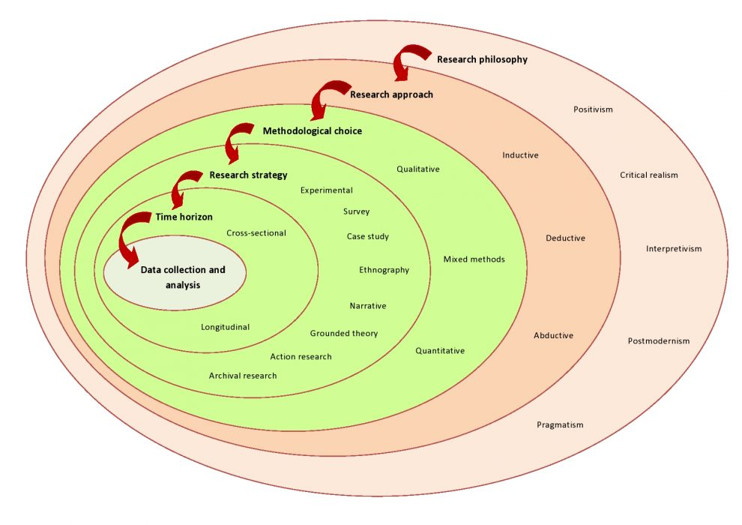
- Research Philosophy
The layers of the Saunders research onions include six layers. Research philosophy refers to the set of assumptions, beliefs, and values that guide the research process.
The outermost layer is the research philosophy, which lays the foundation for the research process and defines the methodology employed by the research approach. Saunders (2019) said the system of beliefs and assumptions about the development of knowledge is the philosophy of research. And also declares the need to understand and interpret the important outer layers of the onion and how to collect data at the heart of 'onion' research (Saunders et al., 2019).

Bryman (2011) explain the research philosophy refers to a set of beliefs about the nature of reality under study. (Bryman and Bell, 2011) and Tim (2011) believe the choice of research idea depends on the type of knowledge being investigated in the research project, these are not necessarily different. Research philosophies make three major types of assumption and define and distinguish ontology, epistemology and axiology, and explain the relevance for business research of philosophical positions that help explain the assumptions inherent in the research process and how these fit into the methodology used.

Ontology –The assumption of the nature of reality is Ontology, which is concerned with the study of being, existence, and reality. The ontological assumptions shape the way researchers view and study subjects. Therefore, choose what to study as a research project.

Epistemology – Assumptions about knowledge, what is acceptable, valid and legitimate knowledge is Epistemology and the study of knowledge, belief and justification. It focuses on the nature, sources, limitations and validity of knowledge and its acquisition. Saunders (2019) said from numerical data to textual and visual data, from facts to opinions, including narratives and stories – all can be considered legitimate. In other words, despite this diversity, different researchers employ different epistemological studies in their studies, it is the researcher’s epistemological assumptions that will dictate what the researcher deems appropriate for research (Saunders et al., 2019). Positivism, critical realism and interpretivism are under Epistemology philosophical positions. Bryman (2011) noted that positivism's use of testable research questions can help to find explanations using commonly accepted knowledge. Realism allows people to use new research methods. interpretivism helps you explain how people perceive their behavior and the behavior of others. It helps to understand people's culture and their participation in social life (Bryman and Bell, 2011).

Axiology is the research value, including ethics value, aesthetic value and other forms of value. Silverman (2021) states that it provides insight into the influence of people's opinions on the collection and analysis of research. Knowing your own value positions can also help you decide what is ethical and explain when questions are raised about the decisions made. It can help to understand the importance of people when conducting research and understand how valuables and perspectives influence the collection and analysis of the research.

The research main paradigm or philosophy including positivist, realism, interpretivism and pragmatism. Choosing a research philosophy is an important aspect of the research process, as it influences the research question, the methods used, and the interpretation of results. The philosophy simply provides a rationale for the research methodology. The method should be determined by the nature of the observed phenomena. Saunders (2019) argues there is no best research philosophy, each philosophy contributes to seeing the organizational world in a unique and valuable way (Saunders et al., 2019). Ultimately, the choice of research paradigm and philosophy will depend on the specific research question and the context in which it is being studied.

- Research Approach
The second layer of Saunders research onion identifies two research approaches; deductive and inductive approaches. With deduction, a theory and hypothesis (or hypotheses) are developed and a research strategy designed to test the hypothesis. With induction, data are collected and a theory developed as a result of the data analysis.

The deductive approach is often used in natural and social sciences, where researchers develop hypotheses or theories based on previous research or observations. Deductive method involves a research method that tests a specific hypothesis or theory by collecting and analyzing data. If the data does not support the hypothesis, the researcher may revise or refine the theory and test it again. Kothari (2004) said the characteristic of deductive method is from general to specific. Formulate one or more hypotheses based on existing theory, and then develop research methods to test one or more hypotheses. Snieder and Larner (2009) declaim that deductive methods can be considered particularly suitable for positivist research. It allows hypotheses to be formulated and statistical tests of expected outcomes to be performed to an acceptable level. The deductive approach is generally considered to be a more rigorous and objective approach to research. The validity of the deductive approach depends on the quality of the theory or hypothesis being tested, and the quality of the data collection and analysis methods used to test the theory.

Induction is a research method that involves collecting data, identifying patterns, and generating a theory or explanation based on observations. This approach is often used in qualitative research to explore complex phenomena which focus on understanding the perspectives and experiences of individuals, groups, or communities. Bryman and Bell (2011) pointed out that the features of the induction approach is from the specific to the general. Flick (2013) states that there is no framework for pre-data collection in this approach, and research directions can be summarized after data collection. The researcher collects information through various methods, such as interviews, questionnaires, or observations. It starts with specific observations and then works to develop broader generalizations and theories that can explain those observations. However, it can also be used in quantitative research and statistical analysis can be used to identify patterns in large data set. Overall, the inductive approach is useful for generating new insights, developing theories or explanations, and identifying areas for further research.

- Research strategies
How the researcher plans to execute the research is the research strategy. There are several approaches, for example, experimental study, surveys, case study, action research, grounded theory, ethnography, archival research etc.

Experimental research is to create a research process to establish a cause-and-effect relationship between the independent and dependent variables while controlling for the influence of extraneous variables that may affect the results used to investigate cause-and-effect relationships.

Interview research is a qualitative research method that is often used to gain a deeper understanding of a specific phenomenon, explore new ideas, or collect rich and detailed data. It is often used in the social sciences. That involves asking individuals questions to gather information about their experiences, opinions, attitudes, and beliefs. Through in-person, by phone or online. Interviews can be easily interpreted in an open or structured manner (Fisher and Buglear, 2010). An open interview works by accepting cues and topics from the interviewee. In contrast, pre-coded interviews are controlled by the researcher, and the interviewer usually reads the prepared script. Semi-structured interviews are somewhere in between.

Surveys typically produce quantitative data associated with deductive methods linked with the Saunders research onion (Saunders et al., 2019). Surveys are most commonly used in quantitative research projects. Investigation strategies are mainly used to observe contributing variables between different data. It allows the collection of large amounts of data for research analysis.

A questionnaire is a research method that involves collecting data from individuals through a standardized set of questions. This can be done in a variety of formats including on-site, online, and through interviews. Benefits quickly and cost-effectively collecting data from large populations. In a questionnaire, the questions can be pre-coded and open-ended, and the responses can be quantitative or qualitative. The difference between pre-coded and open-ended is that pre-coded questionnaires have checkboxes for respondents to choose from, while open-ended questionnaires have a few open questions and lots of blank space for people to answer (Fisher and Buglear, 2010). Questionnaires are a common research method in many fields, for various purposes, including measuring attitudes and beliefs, gathering information etc.

- Research Choice
The Saunders' Research Onion overview includes whether it is appropriate to use a combination of quantitative and qualitative methods or just one method. According to Saunders et al. (2019), there are three outlined options, including the Mono method, mixed methods, and multi-method.

Mono method. When using this method, only one type of information needs to be collected: using quantitative or qualitative methods.

Mixed approach. This approach allows the integration of quantitative and qualitative methods to collect data and create new data in research.

Multi-method. Similarly with mixed approach combines quantitative and qualitative methods. However, it is collecting quantitative and qualitative data separately and then analysing using quantitative or qualitative methods respectively and did not create a new set of data.

- Research time horizon
The time frame describes how long the project is expected to take to complete (Saunders et al., 2019). Two types of time horizons are as follows:

Cross-sectional. A cross-sectional time frame is an established time frame for which data must be collected. This method is used when the investigation is related to the study of a specific phenomenon at a specific time.

The longitudinal time frame of data collection and repeated collection of data over a longer period of time, and used in research to examine changes over time.

The chosen time frame is not tied to a particular research methodology. Additionally, it allows some control to be established over the variable being studied. Thus, it is suited for research studying change and development.

- Techniques and procedures
Data collection and data analysis. Bryman and Bell (2011) declare the methodological approach decides the data collection and data analysis. The data collected is divided into two types: Primary Data and Secondary Data. The data used in research interpret is important and explains data sources, study design, samples, sample size, sample ethics, sample limitations, research reliability and validity.

Primary data are data obtained from first-hand sources, by using various methods, such as questionnaires, oral or written interviews, etc.

Secondary data was derived from other researchers’ work or opinion.

Thus, the most valid distinction between the two types of data may be determined by the use in research rather than the inherent characteristics of the data themselves. There are several analytical procedures including discourse analysis, narrative analysis etc. such as narrative analysis using verbatim transcripts or complete set of notes produced, normally for phenomenological research. It is a powerful method for understanding the stories and experiences of individuals, groups, and communities. Researchers can gain valuable insights into meaning. The process used at this stage has a significant impact on the overall reliability and validity of the study (Saunders et al., 2019). The validity of measurement and authenticity of research material is significant for the research and improving the validity of research findings (Fisher and Buglear, 2010).

This dissertation research methodology
- Research Question
The research concentrates on individuals including small investors and aims to advise them on how to manage risk during investing.

Under epistemology research assumptions, through interpretivism study with qualitative research methods, the data will be collected from investors in different countries', with questions on individual investor opinions and behaviors regarding risk and investment; the theory will be compared with the inductive analytical data, using narrative analysis procedures and try to find the facts about investment activity of small investors and how to improve risk management during investing.

- Research Paradigm and Philosophy
The most appropriate research paradigm is interpretivism. Interpretivism is subjective perception or understanding which is a paradigm of understanding and explaining the laws of the social world and can reveal the inner relationship between the appearance of things.

Social phenomena cannot be studied using purely objective methods, but rather requires an appreciation of the interpretive processes that people use to create and make sense of their social reality, exploring the cultural, social, and psychological factors that shape investor decision-making. Both positivist and interpretivist approaches can be useful for studying investor behaviors. However, qualitative data differs from quantitative data, which is about opinion and experience, not fact. Interpretivism use of quantitative methods and the objective measurement of social phenomena. It is suitable for investor investigation. There are also other research such as exploratory research may involve the use of a battery of research methods – interviews, observation, documents and so on in open and semi-structured research.

Overall, interpretivism emphasizes the importance of understanding the subjective experiences and meanings that people attach to their social world, and the interpretive processes that shape these meanings. In order to gain a more comprehensive understanding of this complex and multifaceted phenomenon.

Open or unstructured forms questionnaires will be the best research strategy to collect primary data which tries to find how investor opinions and behaviours affects the investment risk and results and decision-making. The questionnaire collects data from the perspective of individual behaviours and the psychological factors that produce such behaviours. The research perspective seeks the decision-making behaviour characteristics of different market entities in different environments by analyzing the deviations in their market behaviours. Research will consider if issues such as age, education, region or expectations affects the bias of the investor etc.

- Research Approach
The purpose of the research approach is analytical on small investor risk and investment. How to invest wisely, there are many methods and philosophies to guide investors on how to distinguish and reduce investment risk. Through research identifies and finds deep meaning behind the data.

The research choice is the Mono method approach which is a qualitative method for research methodology. using a single method or data source to collect data for a particular research question. Qualitative research methods take many forms and quantities depending on the project and the number of tools available, including interviews, observations, or interactions with people.

These methods provide fundamentally different insight than quantitative research method measurements. Quantitative data is factual or numerical that can be measured using statistical methods to be analyzed. Qualitative data refers to opinions, thoughts, perspectives and attitudes which are normally transient and only understandable in context.

The approach of classification by the outcome is basic, to contribute to general knowledge and theoretical understanding. Many previous theories have been perfected and attempted to refine existing theoretical knowledge.

The logic of the approach is inductive research. In inductive research, the investigation is of investor risk assessment and investment behaviors use of open-ended research questions, flexible data collection methods, and iterative data analysis processes. This approach allows researchers to gain a deeper understanding of the experiences, perspectives, and behaviors of the small investors or groups being studied. Inductive research is particularly useful for generating new hypotheses and theories, as well as for exploring complex phenomena where little is known. Inductive reasoning involves moving from specific observations to broader generalizations or theories.

- Implications for Research Design
As with any research design, the choice approach should be carefully considered in relation to the research question and the goals of the study. it should also carefully evaluate the strengths and limitations of the approach.

- Nature of the Data
Qualitative data need to be collected from primary data. The data using a questionnaire will take the electronic form to collect. The quality of research data is essential to the success of a research, as it informs the validity and reliability of the study's findings.

- Research Strategy
Interpretivist is a subjectivist philosophy. Qualitative data collection process and sampling from the beneficial practical views which can use non-random sampling methods, such as snowball, judgmental or natural sampling however that is not suited for quantitative data collection.

The benefit of qualitative data is detectable because in an interpretivism study, collecting contextual data and understanding context will help the researcher to discover or identify the present existing data. Another benefit is the quality of qualitative is more valid the research results reflect the extent of the phenomenon under study.

There are several methods available for qualitative data collection. All come with benefits and costs in terms of time, effort, and validity. The questionnaire is the obviously most suitable one for dissertation data collection.

- Data Collection Methods
Questionnaires. The difference between pre-coded and open questionnaires is simple. The pre-coded ones have lots of checkboxes for respondents to fill in, whereas open questionnaires have a few open questions and lots of white space for people to make their responses in their own words. The questionnaires are generally considered a tool for quantitative research, where data is analyzed using statistical methods. However, in qualitative research, the goal is often to gain a deep understanding of a particular phenomenon or topic through open-ended questioning and exploration of participants' experiences, perspectives, and attitudes. And using open or half-unstructured questions is a sort of text communication in which the shape of survey questions, the order of questions, and the way and method of answers are not predefined. Open questions are vital when the researcher is interested in new ideas or novel points of view or cannot anticipate the likely answers, that can be used to gather meaningful information from investors. The questionnaire approach saves time, money, and manpower, which is why it is frequently utilized. Thus, The most appropriate survey method here is the open-ended questionnaire for researchers.

- Sources of Data
The main data collection population is the individual investor or potential investor. One of the important decisions to be made during the questionnaire design phase is to determine the reference population that is representative of the investor. The questionnaire plan is sent via messages or email and shared on social media, and respondents can answer it at their convenience. Firstly to ensure that can generate high-quality data will send it to different countries to participate in the questionnaires and then will share it on social media to reach broad participants.

- Data Analysis Methods
The narrative analysis will be adapted to analytical procedures. that involves examining stories or narratives to identify patterns and themes. The analysis process will summarize keynotes and maybe explorer new findings. The researcher intends categorizations of meanings and unitizing data, and structuring meanings using narrative. Categorizing meanings involves identifying themes or patterns in the data. Unitizing data involves breaking down the narratives into smaller units of meaning which allows for a more detailed analysis of the data. Structuring meanings using narrative involves creating a coherent story or narrative that captures the key themes and patterns in the data (Fisher and Buglear, 2010). Finally, it can gain a deeper understanding of the meanings and motivations that underlie investor behaviour. There is also other analysis procedure such as content analysis, discourse analysis, etc.

- Limitations
Any research methods are not perfect that have certain limitations. Such as the potential bias for response questionnaires. Subjective bias is likely to be introduced into a study by anyone, whether participants or a researcher.

Questionnaires may not cover all aspects and lack flexibility so limiting the deep findings. Participants may be unwilling to truly respond to the answer or critical of themselves. To mitigate these threats to reliability, ensure using anonymous or confidential to reduce participants' worries. From a researcher's point of view, that may be not asking the questions the same way or measuring consistently or giving inaccurate responses to distort the result of the study. Both error and bias can have serious implications for research, as they can lead to inaccurate or incomplete data that can affect the validity of the conclusions.

Therefore, questionnaire research should be carefully designed and validated to ensure the quality of the data collected. Such as solving the limiting of findings, and allowing comments on each question. And the researcher should have adequate research, use standardized procedures for data collection, and use multiple observers to check and verify observations to minimize errors and bias.

Other limitations, such as mixing causality and correlation occur when one assumes that a correlation between two variables implies that one variable causes the other. To avoid mixing up, it is important to carefully consider, should be clear about the limitations of their findings and avoid making causal claims based solely on correlational data.

- Potential outcome
Man is a rational animal who always loses his temper when he is called upon to act in accordance with the dictates of reason. (Oscar Wilde,1891,Intentions)
Overall, almost all theories take rational people as the premise and believe that people will make the most favourable decisions based on information. For example, the efficient market theory and investor irrationality debate. However, Humans cannot be perfectly rational in the real world and Investors are the main players in the market. Humans and Human Nature is the eternal theme.
After the research, through analysis investor generic questions that will reveal different factors that influence investor's preference, such as high education may result in better investment performances. Females may be more patient than males in investment. Drawing the investor portrait to find different groups of people with risk attitudes and reveal the investor decision process what main consideration during investment decision-making, such seek professional advice or diversification to different finance products to reduce the risk. And what is necessary knowledge for investors, do they need financial knowledge and what level of familiarity with investment opportunities in their countries and explore unknown opportunities. What is the investor's attitude towards risk is essential to understand. Some people are risk-averse, which means that they are more likely to choose investments that offer lower returns but are relatively safe. Other people are risk-neutral, which means that they are not particularly swayed by the potential risks or rewards of an investment. risk-seeking, which means that they are willing to take on higher levels of investment risk in exchange for potentially higher returns. It is crucial to find a balance between investment and risk tolerance. And what level of patience is an investment? By staying patient and focusing on a long-term investment strategy, investors can benefit from long-term returns and avoid short-term market fluctuations. Such as Warren Buffett insists on investing for the long term. So how investors can make decisions with maximum returns and minimum risks is a worthy research question.
Combine the investment theory and Philosophy to analyze investors' investment behaviour, risk preference, psychological expectations, etc., use these data to find more worthwhile investment opportunities, and design more effective investment strategies. The research may find a new way to advise small investors, on how not to be afraid in a bear market and not to follow blindly in a bull market in investment. Minimax the risk and maximin the investment performance.
- Ethical
In primary data collection, some recognized ethical issues and concerns are included. Such as informed consent, confidentiality, anonymity, and data security. While the participants will provide their informed consent to participate in the research, they will be informed about the research project purpose and how data will be used, as well as there will be anonymity which means their privacy will be protected. All participants' options remain anonymous, and the data collected cannot be traced. The researcher will comply with data protection regulations, such as GDPR when collecting and processing data from participants. Respect the dignity and rights of participants and ensure that none are harmed in any way during the research project.

Conclusion
This research concentrates on the small investor and hopes to advise small investors on how to manage investment risk, using epistemology research assumptions through interpretivism study with qualitative research methods. Interpretations believe that social reality is complex and multifaceted and that researchers should aim to understand and explain it from the perspective of the participants. Interpretavists often use qualitative methods. Exploring requires an open approach, an exploratory approach ought to adopt open, or at most semi-structured research tools. Fisher (2010) commented that not being open-minded can lead new discoveries astray, such as the naming of the West Indies when they were discovered by Europeans who thought they had found a new route to India and the East (Fisher and Buglear, 2010). Therefore good researchers need to be open-minded when try to treat new findings. Albert Einstein said ‘If we knew what we are doing it wouldn’t be called research’ (Einstein quoted in Arvinen-Barrow and Visek, 2021)

Chapter 4 Findings &Analysis
Introduction
The research approach was chosen for analyzing small investor risk and advice in investment. The research seeks to uncover the underlying meaning behind the data. The research choice is the Mono method approach which is a qualitative method for research methodology. It provides a framework for thorough analysis and interpretation of the data, ultimately leading to valuable insights and potential implications for the field of investment research.

The questionnaire is designed in five parts. Part 1 is about Demographic information. The rest of the questions belong to Macroeconomic analysis, Investor analysis, Investment &Investment risk, and Investment Philosophy in response to literature structures. The primary data collection by semi-structured open questionnaires as research tools concentrate on the global small investor. The data collection population is the individual investor or potential investor. The data using a questionnaire will take the electronic form to collect. The data collected duration between 18th April and 12th May is approximately 24 days.

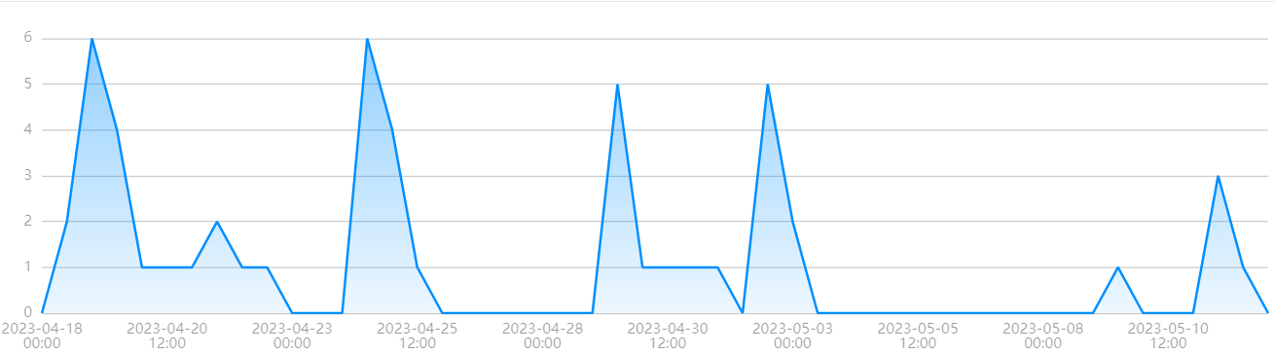
Timeline of data collected

The narrative analysis will be adapted to analytical procedures. intends categorizations of meanings and unitizing data, and structuring meanings using narrative. Combine the literature theory to analyze the investors' investment behaviours, risk preferences, psychological expectations, etc.

Demographic details
In the Questionnaire about Small Investors, the total amount recovered was 51 and by views 110 a recovery rate of 46% and an average completion time of 6 minutes 24 seconds.
1. What is your gender?
Fill rate 100.0% / fill 51 which 24 Male and 27 Female
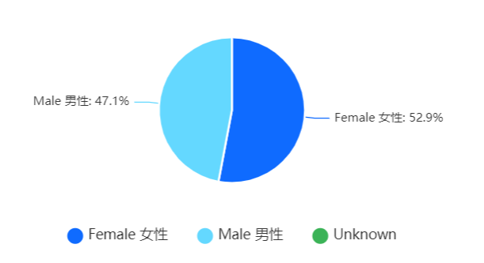
2. How old are you?
Fill rate 100.0% / fill 51.
The main participants are between 18-29 years old, accounting for 49%. And 98% of participants were under 50 years old.
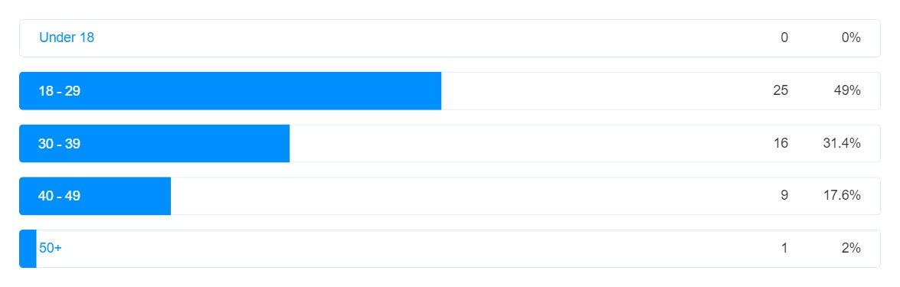
3. What is your current level of education?
Fill rate 100.0% / fill 51
The participants are well educated 96.1% have undergraduate education.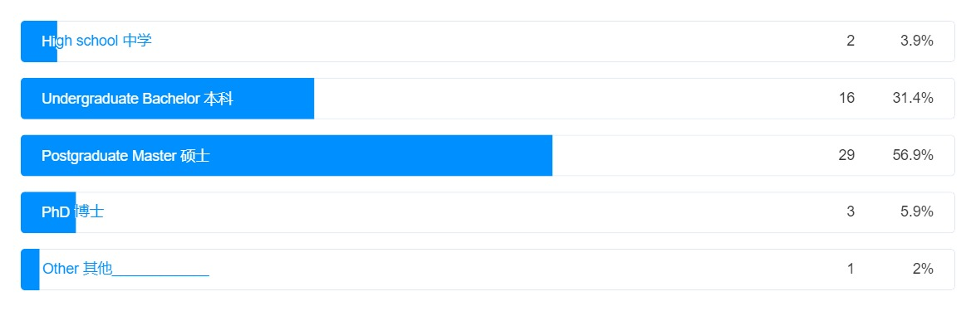
4. How many languages do you speak well?
Fill rate 100.0% / fill 51.
77.4% of the participants can use more than two languages.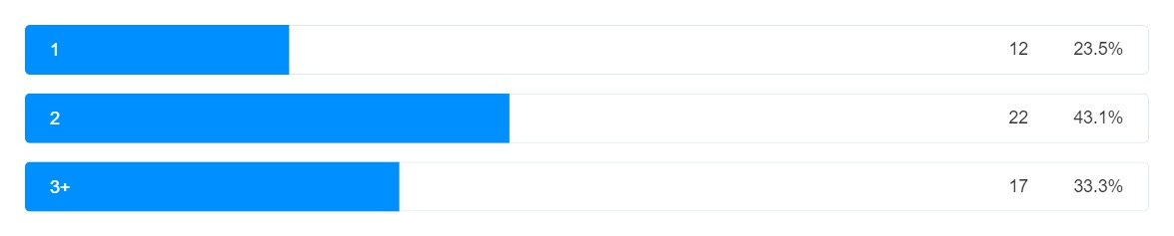
5. What is your nationality?
Fill rate 100.0% / fill 51
Participants were from 21 countries. The below bar chart shows 33.33% which 17 of people are from China, the largest number of participants. Followed by Indian and Brazilian. The Irish and South Korea 4th of the participants.
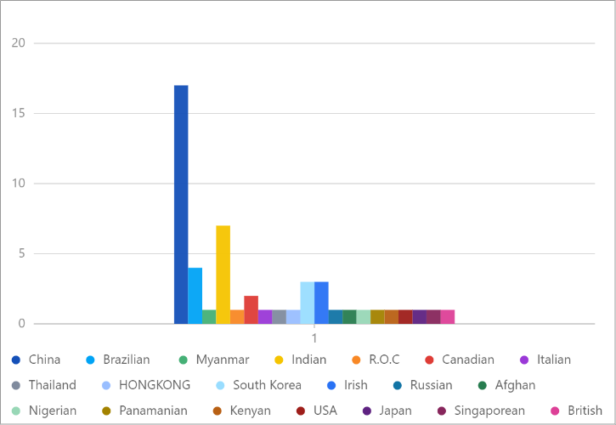

6. What is your current financial situation?
Fill rate 100.0% / fill 51
The majority of participants are debt free and financially stable 64.7%.
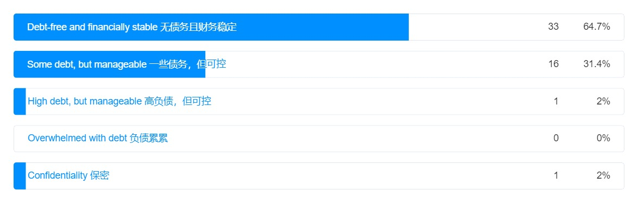
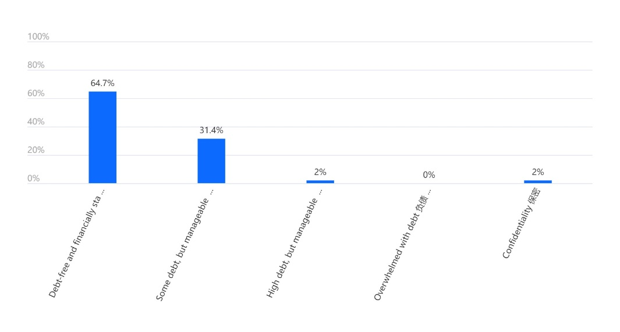
Demographic overview, the total number of respondents was 51, of which 24 were male and 27 were female, that roughly equal ratio of men to women. The age group is distributed within 49%, and 25 of them are under the age of 30. According to simple statistics, 80.4% are under the age of 40, which means that very young people, as young investors, can seek greater returns by taking greater risks. According to the theory, if the young investor loses money, they have time to make up for it by generating income.

The educational background of respondents is well educated 96.1% have undergraduate education or higher. 4 peoples have a Doctor degree and A Juris Doctor (JD) degree and 29 peoples have postgraduate 56.9% of responses as the majority. That evidence proves the sample are highly educated. The literature reviews show that education has important factors in shaping investor behaviour and risk attitude.

77.4% of the participants can use more than two languages. Language can have an impact on financial decision-making. For individuals with limited English proficiency, language barriers can be a significant challenge in accessing affordable financial services and products, creating a barrier to financial inclusion. Bilingual or multilingual finance professionals can help reduce the wealth gap and improve financial literacy and mobility for non-English speaking communities which can reduce investment risk and increase profitability.
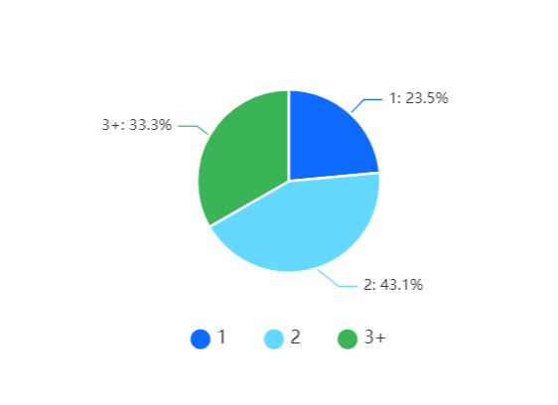

The geographical distribution profiles are all major regions of the world. 51 respondents from 21 countries. This is a large representative and an experiment was conducted to study global investor risk attitudes and behaviors. Investors should make investment decisions based on their unique investment objectives and financial situation. Regarding the financial situation of participants in the sample, 64.7% of participants are debt-free and financially stable. This may be causing the main participants under the age of 40 and at the peak of their careers to have stable incomes. However, 31.4% of participants had some debt, which was manageable. This shows that 96.1% of people are currently able to invest. The evidence shows that the sample is of high quality and can represent the risk preference and attitude of investors with investment capabilities.

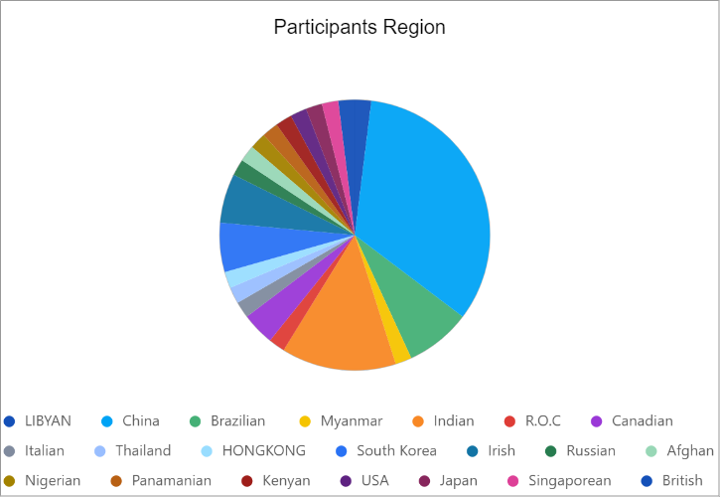

Macroeconomic analysis
Understanding monetarist theory is important for understanding inflation and investment. Surz (2019) based on Modern Monetary Theory believes that the government can solve economic problems by printing money until it causes inflation, at which point taxes need to be raised to control the currency. This is known as quantitative easing (QE) monetary policy. Understanding modern economics and knowing how the American dollar can play a crucial role in investment is important.

Question 8 is about testing participant's financial knowledge.
8. Do you think quantitative easing (QE) monetary policy is the main reason causing inflation?
Fill rate 100.0% / fill 51

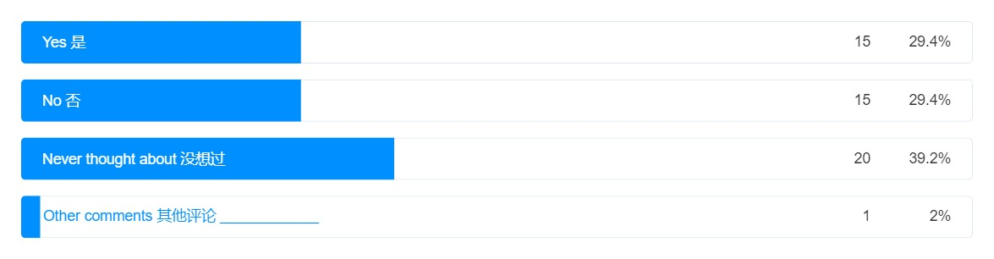39.2% of participants never thought about how monetary policy affects their life in this highly educated population. The answer thinking yes or no are equal to 29.4%. and only one person give a very critical answer that The failed philosophy of Capitalism and the unsustainable quest for ever increasing profits over all else is the main reason that is a very interesting answer and reflects deep thinking of situations in which inflation exists.

Based on the theory there is an increase in the general price level of goods and services over time. Central banks often use inflation targeting as a monetary policy tool to maintain price stability and promote economic growth. Quantitative easing (QE) is a monetary policy where central banks buy financial assets to increase the domestic money supply and encourage economic activity. It can lead to inflation in certain circumstances. When a central bank implements QE policies, if this leads to more spending and investment in the economy, it can cause inflation. The U.S. Federal Reserve has implemented QE policies, such as during the COVID-19 pandemic and after the 2007-2008 financial crisis.

When the amount of money increases, or the speed of circulation increases, but the number of goods will not increase rapidly, the price of goods and services will often rise sharply. Such as in Russia-Ukraine War the lack of crude oil leads to higher energy prices, especially in an island country like the UK where all products are transported by sea, and higher oil prices lead to higher prices for all commodities. The trade war with China, resulting in a lack of cheap goods from China, will also cause prices to rise, and there is no solution in the short term. Therefore, 96.1% of participants have undergraduate education and do not have a clear vision of the economic situation that will be a negative impact on investment activity. In the same way, if well-educated investors cannot understand the principles, those who are not educated do not have a better performance in the investment market. The stock market is a barometer of the economy, and monetary policy may be a visible hand of the stock market. This massive impact has to be on the minds of investors. For the same reason, understanding the business cycle can help investors make smarter investment decisions and manage risk more effectively by holding the right assets at the right time.

Investor analysis
Compared with individual investors and institutional investors, small investors have relatively less capital. Mike (2023) believes that anyone who does not invest professionally is regarded as a retail investor. Likewise, Swensen (2009) realizes that the key is not to distinguish individual investors from institutional investors but to distinguish competent effective active investors from incompetent investors. Therefore, rather than compare the difference between small investors and institutional investors, the importance is to make more informed investment decisions, set realistic investment goals, and plan suitable investment strategies, is suitable for small investors. Therefore, question 7 is designed to examine investor goals and investment awareness.

Question 7. Do you have an investment plan to deal with future inflation and retirement?
Fill rate 100.0% / fill 51
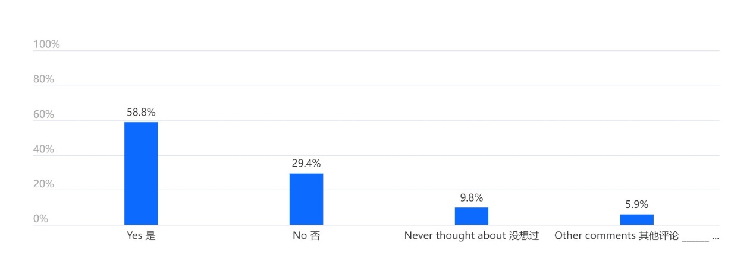
According to the data, 58.8% of participants have an investment plan. This is a positive signal, it indicates that a significant portion of the sample is taking steps to secure their financial future. However, it is important to note that having an investment plan does not guarantee financial success. Various factors can impact the performance of investments, such as economic conditions and market volatility which is why the emphasis is on understanding the macroeconomy. 29.4% have no plan, and 9.8% never thought about future inflation and retirement life. The trend of the world population is ageing, the rapid ageing of the population means that the working-age population in the future economy will be less and less, resulting in a shortage of human capital and increased labour costs for enterprises. Borji (2019) comments that countries with large older populations rely on fewer people to pay for higher healthcare costs, pension benefits, and other public services, leading to higher costs. All problems may be solved in the future, but without a clear investment plan, there will definitely be no good returns for investors. By having a clear investment plan, individuals can work towards generating good returns and potentially mitigate some of these challenges.

There are some other comments around the question one is I am figuring out some other financial plans before I tackle investment plans for retirement, other is figuring it out right now. If the questionnaire gives some clues to participants that will be a good thing to explore financial planning options. Overall, financial literature encourages individuals to develop investment plans for retirement and contribute to a more secure and stable financial future.

The big difference between individual investors and institutional investors is that institutional investors have more advanced information than individual investors, and can make more informed decisions which have more advantages to reduce risk. There are also some potential disadvantages of being a small investor. Kilham (2022) comments that small investors may have fewer resources and less access to information than institutional investors.

Question 9 is how do you stay informed about the markets?
Fill rate 100.0% / fill 51
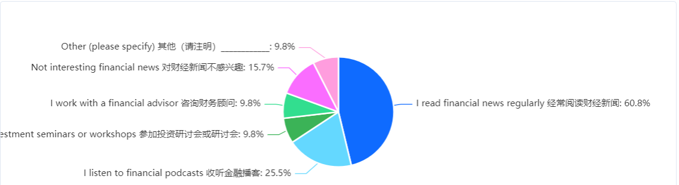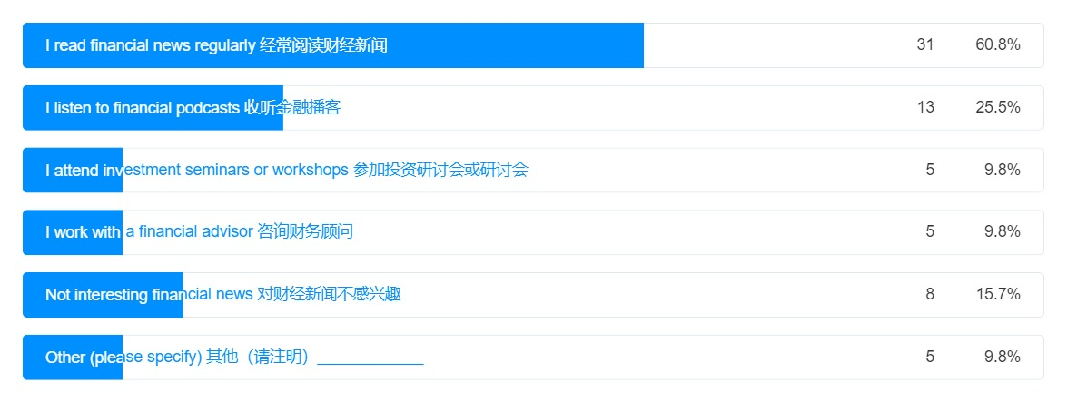

Based on the primary data provided, it is encouraging to see that 60.8% of participants are actively reading financial news regularly as their main source of information. Staying informed about financial news can help individuals make more informed decisions regarding their investments, retirement plans, and overall financial well-being.
Followed by listening to financial podcasts, 25.5% of participants use this other popular way to keep informed, which indicates that audio-based platforms are an effective way for individuals to stay updated on financial topics. 9.8% of participants chose financial advisors or attend seminars or workshops that highlight the value they place on professional advice and educational events. It's worth noting that 15.7% of participants expressed disinterest in financial news. This may indicate a lack of engagement or a preference for alternative sources of information.

There are other options in comments that were not included in the question options as follows:
………….colleagues
……….....I work in finance therefore I am constantly exposed to financial news.
………….follow the government policies and other regulatory bodies
………….read financial news but not too regular

Overall, the data suggests a diverse range of preferences in accessing financial information. Combining various sources, such as financial news, podcasts, professional advice, and industry colleagues, can provide a more comprehensive understanding of financial matters and facilitate better decision-making.

Question 10. What is your biggest concern about investing?
Fill rate 100.0% / fill 51
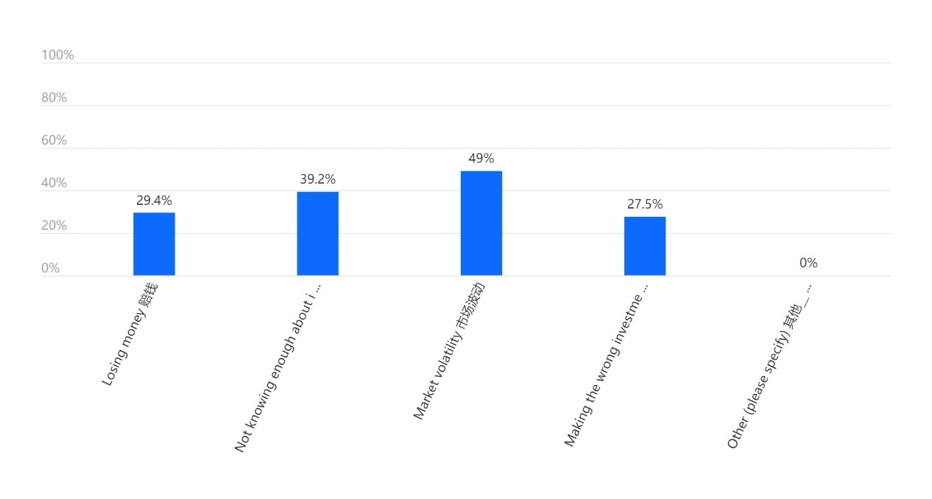
Asking individuals about their biggest concerns when investing, helps gather insights into the specific challenges and worries they may have when it comes to making investment decisions. Understanding these concerns allows for a better understanding of investors' needs and preferences.

It is clear that market volatility is a significant concern for investors, with 49% of participants selecting it as the top option. The second-highest concern, with 39.2% of participants selecting it, is not knowing enough about investment. This highlights the importance of financial education in empowering individuals to make informed investment decisions. The third concern, chosen by 29.4% of participants, is the fear of losing money. This fear is understandable, as investment inherently carries some level of risk, and there is always a possibility of experiencing losses. Risk tolerance and the ability to manage potential losses are crucial factors to consider when formulating an investment plan. Lastly, making wrong investment decisions was selected as the least prominent concern. While this may indicate a level of confidence or competence among the participants, it's important to recognize that making wrong investment decisions can have significant financial implications.

Siegel (2022) commented on the relationship between volatility and time. Short-term volatility is high, and holding for a short period increases the risk. However, the longer the duration of holding over, the higher the certainty of profitability. That is why Warrant Buffett's favourite holding period is forever when Mary Buffett (2016) was written. Because the long-term holding increases profit probability. Asset allocation is an important investment strategy, Buiter (2003) said worte don't put all your eggs in one basket the Portfolio theory using the risk differences of different assets to reduce the volatility of the asset portfolio can also reduce the overall investment risk. The second-highest concern is not knowing enough about investment. Do not understand the volatility and time relationship that will be difficult in investment, because how to manage risk depends on the investment time horizon. Normally, long-term holding increases profit probability. This also emphasizes the importance of investors’ financial education.

Question 17. What do you think are the main disadvantages of investment?
Fill rate 100.0% / fill 51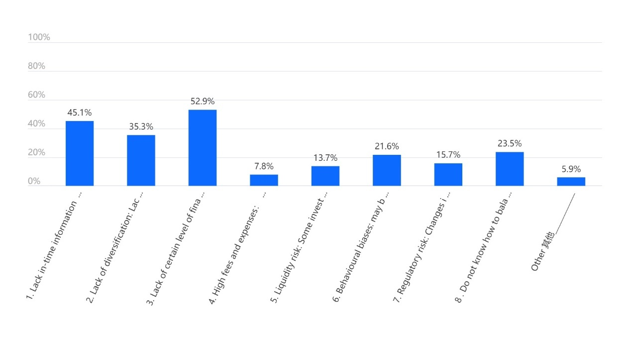
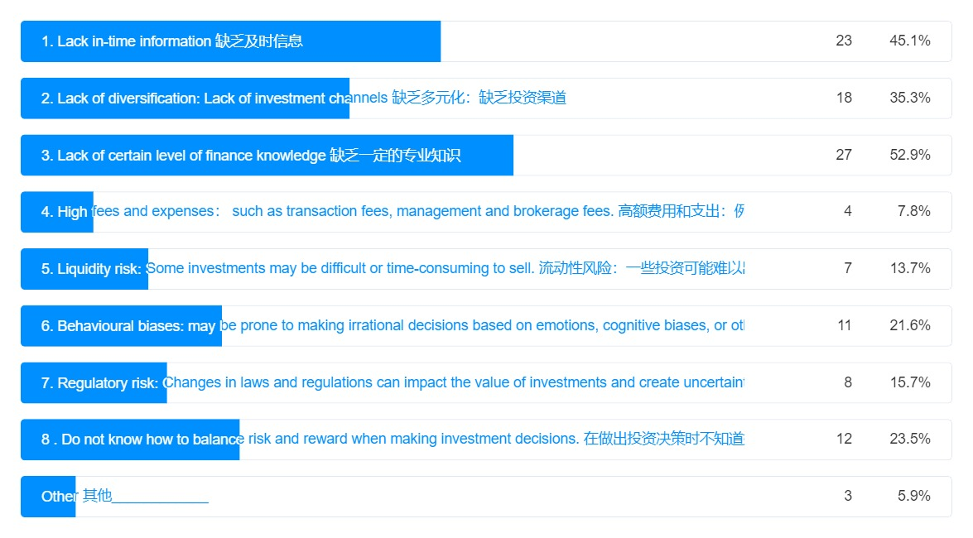

By asking this question about individuals’ perception of the main disadvantages of investment helps to gain insights into the potential drawbacks or challenges that they associate with investing.

The bar chart identifies a lack of financial knowledge with 52.5% of participants selecting this as the biggest disadvantage, it indicates that a significant portion of individuals believes that a lack of financial knowledge poses a challenge to successful investing. This emphasizes the importance of financial education.

Mike (2023) also believes that cost and access to key information are unfavourable for small investors. Small investors may have fewer resources and access to information with higher costs. In the investigation, 45.1% of participants chose ‘Lack of timely information’, the concern about not having access to timely information, that matches the Kilham comments. And also suggests that small investors are aware of and value up-to-date and relevant information to make investment choices. About 35.3% of participants consider the lack of diversification channels as a disadvantage. Approximately 23.5% of participants expressed uncertainty about how to balance risk and reward in investment. This indicates the importance of financial education, to understand more about different assets to reduce the impact of individual asset volatility and understand risk tolerance, and investment goals, and align them with appropriate investment strategies.

Le Bon (1895) described the characteristics of groups and group psychology and pointed out that once people integrate into groups, their personalities will be submerged, they will lose the ability to think independently, and their influence is not limited to time and space. This may be why small investors suffer losses in the financial market. While selected by 21.6% of participants, the awareness of behavioral bias is a positive sign. Behavioral bias refers to cognitive or emotional biases that can influence investment decision-making by group psychology or personal bias. As Mark (2001) said 'understanding and delineately recognizing the objects in your mind is an important part of creating long-term benefits'. Therefore, recognizing their existence suggests an understanding of the potential impact of emotions and biases on investment choices, which may lead to more rational decision-making.

Question 14. Do you agree or disagree that emotions affect investment decisions? 94.1% of participants chose agreement. By asking this question, it helps gauge the extent to which individuals recognize the impact of emotions on their investment choices. This high percentage underscores the recognition of the impact of emotions on investment choices. It suggests that participants are aware that emotions such as fear, greed, overconfidence, and herd mentality, can influence their decision-making process and potentially lead to biases and irrational investment decisions. Overall, the data indicates that while a smaller percentage of participants are specifically aware of behavioural biases, a much larger majority recognize the impact of emotions on investment decisions.
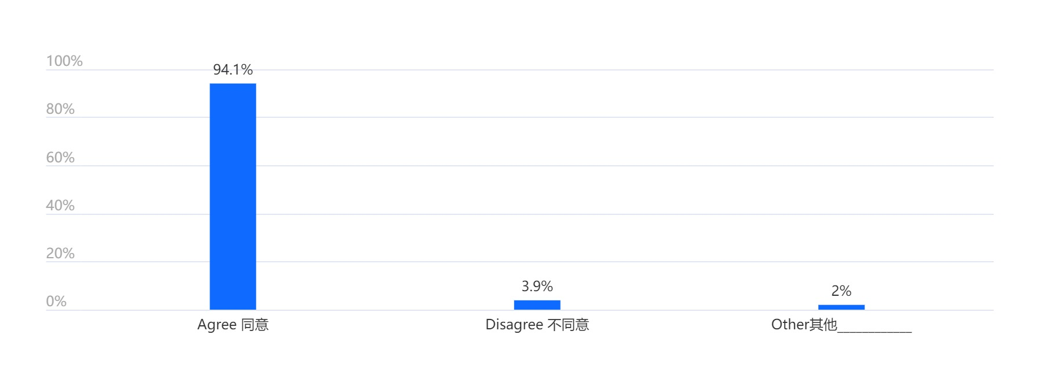

In addition, the question 17 data reveals that only 7.8% of participants are aware of the high fees and expenses associated with investments. Mike (2023) also argues that fees are a disadvantage for small investors. This low percentage is indeed a concerning signal, as it suggests a lack of awareness regarding the potential impact of fees and expenses on investment returns. High fees and expenses can significantly eat into investment gains over time, reducing the overall profitability of investment portfolios. Investors must understand the fees charged by investment vehicles, such as mutual funds, exchange-traded funds (ETFs), or financial advisors, as well as other expenses like transaction costs.

Investment &Investment risk analysis
Hayes (2023) believes that investment return and risk should be positively correlated. Investors must weigh their risk appetite when making investment decisions. Mark (2011) Understanding and identifying risks is the basis for effective risk control. Question 12 is about how you manage risk in your investments. Fill rate 100.0% / fill 51

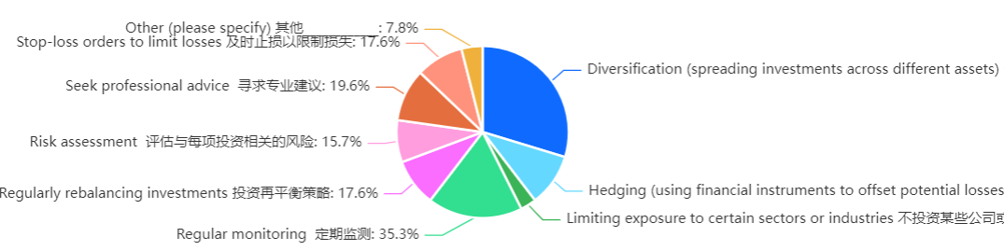

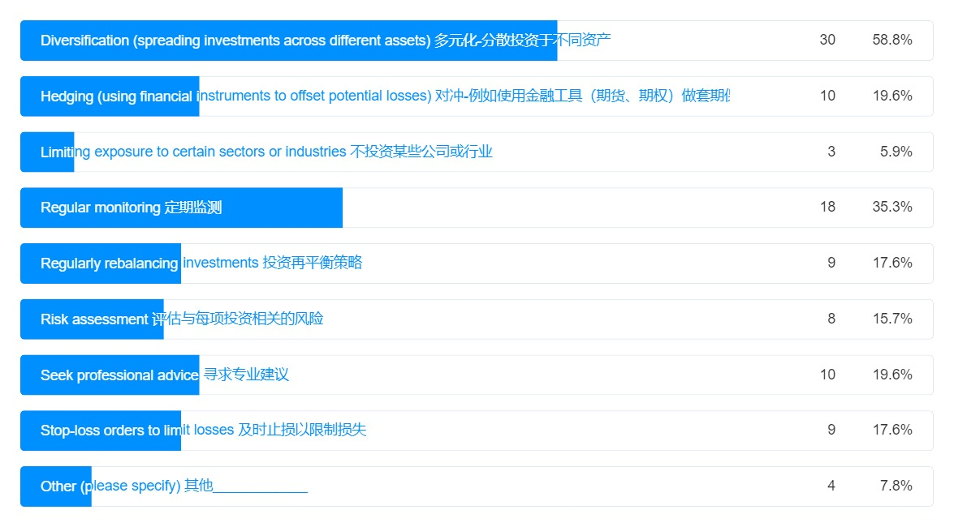

The majority chose ‘diversification’ (spreading investments across different assets) 58.8% of participants which is indeed a positive sign. Diversification is a fundamental principle of investing, aimed at reducing risk by spreading investments across different assets or asset classes. It indicates that participants recognize the importance of not putting all their eggs in one basket and are taking steps to protect their portfolios from the potential impact of a single investment's poor performance. The high percentage of participants choosing to regularly rebalance their investments also demonstrates a proactive approach to risk management. Regularly rebalancing ensures that the portfolio maintains the desired asset allocation, preventing any one asset or asset class from becoming overweighted and potentially exposing the portfolio to excessive risk.

The choice of hedging as a risk management strategy by 19.6% of participants is indeed noteworthy. Hedging involves using sophisticated financial instruments to offset potential losses, such as options, futures, or swaps. This suggests that a significant portion of participants has advanced financial knowledge and is comfortable employing more complex risk management techniques. It is a very positive indication that participants are aware of these tools and are willing to use them to mitigate risk in their investment portfolios. Furthermore, the selection of seeking professional advice by 19.6% of participants also highlights a recognition of the value of expert guidance in managing investment risks. Seeking professional advice can help investors make more informed decisions and navigate the complexities of the financial markets effectively.

Overall, the data indicate that participants have a diverse range of risk management strategies and demonstrate a solid understanding of these strategies. The use of techniques such as diversification, rebalancing, hedging, and seeking professional advice showcases a level of financial knowledge and education among the participants. While regularly rebalancing investments (17.6%) and stop-loss orders to limit losses (17.6%) were also the popular choices, the percentages for limiting exposure to certain sectors or industries, and risk assessment, indicate that a notable portion of participants actively consider these proactive approaches to manage risk in investment.

Small investors typically invest intending to increase wealth over time and meet financial goals such as retirement, buying a home, or paying for education. And it is important to consider risk tolerance when making investment decisions. Questions 11. What do you feel about 'Risk'? Fill rate 100.0% / fill 51
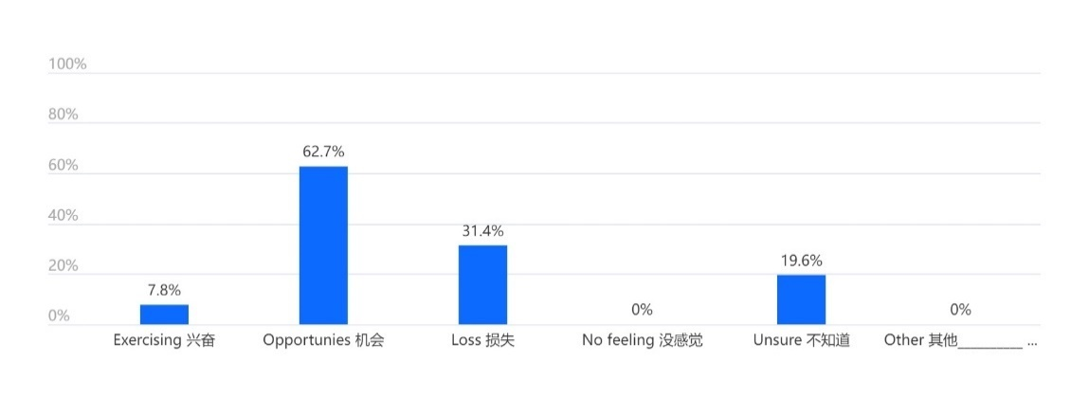
The data indicates that only 7.8% of participants feel excitement towards risk these people as considered positive investors can be associated with a higher tolerance for risk and a willingness to engage in more aggressive investment strategies. These individual investors may be motivated by the potential for significant gains and enjoy the adrenaline rush that comes with taking on riskier investment opportunities. These people also should consider the emotional effect on investment.

While the majority of participants view risk as opportunities (62.7%), the relatively low percentage of participants who feel excitement suggests that most individuals have a more balanced or cautious approach to risk mindset.

On the other hand, 31.4% of participants perceive risk as loss, indicating a higher degree of risk aversion. These individuals are more concerned about potential losses rather than focusing on the opportunities that risk can present. This suggests a more conservative approach to investing for these people, whose primary goal is to protect capital rather than pursue higher returns.

It is interesting to note that no participants chose the option of having no feeling towards risk. This implies that individuals generally have some level of awareness and emotional response to risk in the context of their investments. The absence of "no feeling" suggests that risk is an inherent aspect of investing that elicits some form of emotional or cognitive response from participants.

Furthermore, 19.6% of participants expressed uncertainty or being unsure about their feelings towards risk. This could indicate a lack of clarity or a neutral stance on risk, with participants potentially needing more information to form a clear opinion.

In conclusion, the data reflects a range of attitudes towards risk among the participants. While a small percentage (7.8%) feel excitement towards risk and are likely more willing to take on aggressive investment strategies, a significant portion (31.4%) of participants perceive risk as a loss and exhibit a higher degree of risk aversion. This indicates that the number of risk-averse individuals is approximately four times higher than those who view risk positively. And the majority (62.7%) view risk as opportunities and adopt a more balanced approach. understanding the emotional responses towards risk is valuable for investors. It underscores the importance of tailoring investment strategies and advice to individual risk profiles, ensuring that each person's comfort level and emotional response to risk are considered. And every investor should be aligning investment approaches with personal risk tolerance.

Investment Philosophy & Strategies analysis
Countless books and theories have been written about investing, and George (2001) asserts that when a method works best, there are countless imitators, and then the method fails. From the efficient market hypothesis and semi-strong efficient market to the debate on market inefficiency, everyone hopes to find out whether the market can be defeated and whether they can obtain excess returns that exceed the market. From Warren Buffett's investment success to asset allocation theories to explore investor knowledge, risk tolerance, and investment strategies through questions.

Question 15 investigates the types of investments participants have made or tried and provides insights into their investment experience and familiarity with different investment options. It helps to understand the diversity of investments participants have engaged in, ranging from traditional options like stocks and bonds to alternative investments such as real estate or cryptocurrencies.

Similarly, question 16 asking about the preferred stock investment methods allows for an understanding of participants' specific approaches to investing in stocks. Some investors may prefer fundamental analysis, focusing on company financials and performance, while others may lean towards technical analysis, using charts and patterns to make investment decisions. Question 13 about "patience" in investing allows us to gauge participants' understanding of the time horizon and long-term nature of successful investing.

Question 15 is about what types of investment types have participants made or tried. Fill rate 100.0% / fill 51.
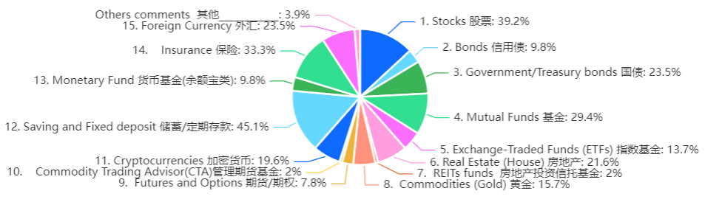

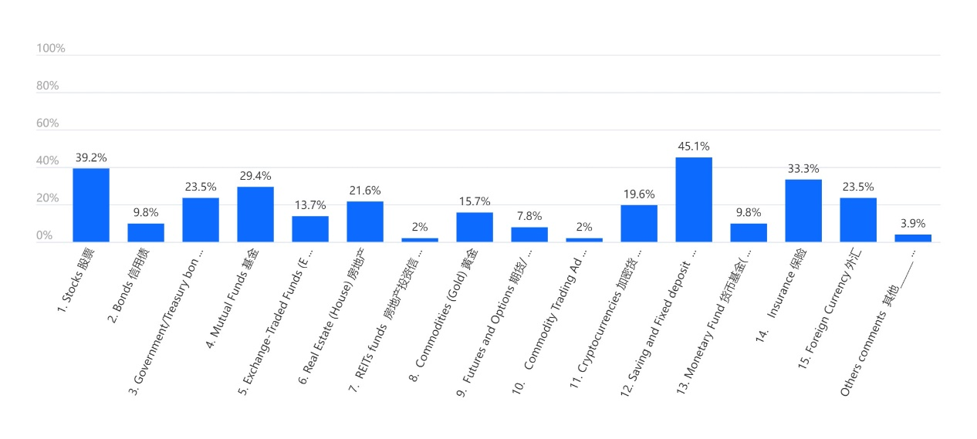
According to the data reveals, 45.1% of participants are saving or fixed deposit and the third most popular option is insurance (33.3%) which corresponds to risk tolerance assessment, the majority of participants are risk neutral and 31.4% of participants risk aversion. This suggests a conservative approach to investing, as savings and fixed deposits are generally considered low-risk options. The stocks and mutual funds rank as the second and fourth most chosen investment options, selected by 39.2% and 29.4% of participants, respectively. This highlights the enduring popularity of these investment vehicles, suggesting that they remain widely recognized and utilized by participants. It indicates a willingness to take on some level of risk and engage in market-based investments for potential returns.

Other than 20% of participants chose Government bonds (23.5%), foreign currency (23.5%) and real estate (21.6%). The government bonds as a choice for 23.5% of participants reflects a continued preference for relatively low-risk investment instruments. Government bonds are often seen as a safer investment option due to the backing of the government, offering stability and predictable returns to investors.

The selection of foreign currency as an investment option by 23.5% of participants is interesting, considering the risk of exchange rate fluctuations. Investing in foreign currencies can be volatile and unpredictable due to factors such as economic conditions, geopolitical events, and monetary policies. This suggests that a portion of participants may be willing to take on higher risks or may have specific knowledge or strategies related to currency trading.

The real estate as a chosen investment option by 21.6% of participants indicates an interest in property investments. Real estate can provide a tangible asset and potential long-term growth, although it also comes with certain risks such as property market fluctuations and maintenance costs. Participants who have chosen real estate as an investment option may value the potential for income generation through rental properties or anticipate long-term appreciation in property values.

Cryptocurrencies, such as Bitcoin, Ethereum, and others, have gained significant attention in recent years due to their potential for high returns and technological innovation. The worth north of cryptocurrencies as an investment option chosen by 19.6% of participants highlights the growing interest and adoption of digital assets in investment portfolios. maybe because the participants under 50 years old may be more inclined to adopt new technologies and explore innovative investment opportunities. It's important to note that investing in cryptocurrencies requires careful consideration and understanding of the risks involved. Overall, the inclusion of cryptocurrencies among the participants' investment choices reflects the evolving landscape of investment options and the increasing popularity of digital assets.

Overall, the data suggest that participants have a range of preferences when it comes to investment instruments, ranging from traditional options to more innovative choices. This diversity reflects the evolving investment landscape and the varying risk appetites and objectives of the participants. The varying degrees of risk tolerance and preferences and tailoring investment strategies to individual preferences and goals.

Question 16 about stock investment methods. Fill rate 100.0% / fill 51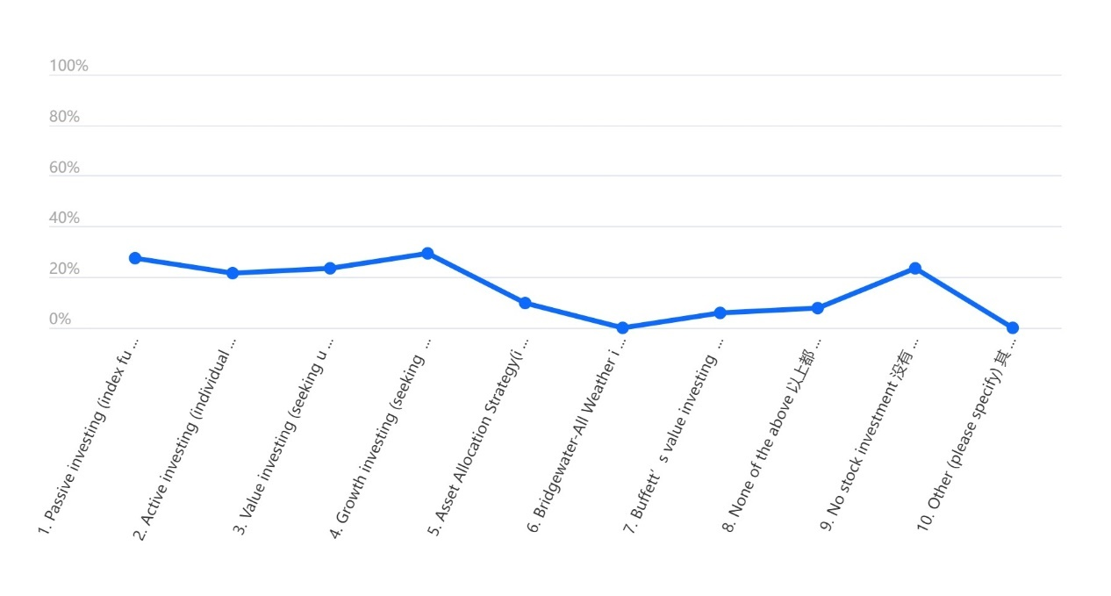
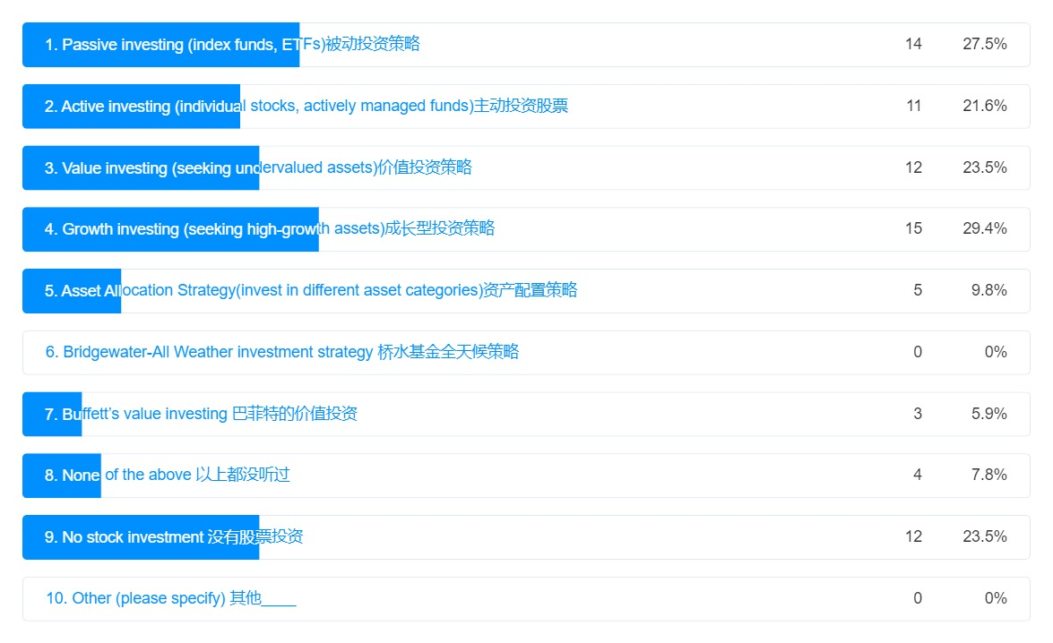

The line chart and data reveal a range of strategies and preferences among participants when investing in a stock. Growth investing emerges as the top choice, selected by 29.4% of participants. This strategy focuses on investing in companies that have the potential for significant growth in earnings and stock price. It indicates that these participants are seeking higher returns and are willing to take on more risk. Furthermore, 21.6% of participants chose active investing, indicating a higher tolerance for risk and a willingness to engage in more aggressive investment strategies. Active investing involves actively selecting and managing individual stocks

Passive investing, chosen by 27.5% of participants, involves using exchange-traded funds (ETFs) to track a specific market index or sector. This strategy aims to replicate the performance of the overall market rather than actively selecting individual stocks.
Value investing and no stock investments are tied in the ranking third, with 23.5% of participants selecting each. Value investing focuses on identifying undervalued stocks that have the potential for long-term growth which the famous success is Warrant Buffett. And the participants who chose no stock investments may prefer to allocate their funds to other asset classes, such as bonds or real estate, or they may have lower risk tolerance.

A very important figure in Buffett's investing style is long-term investing. He has consistently emphasized the importance of investing with a long-term perspective and holding investments for extended periods. Buffett's emphasis on long-term investing is rooted in the belief that short-term market fluctuations and noise can often distract investors from the true value of a company. He advocates for patience and a focus on the underlying business performance and competitive advantages. Question 13 is about participants' opinions about ‘patience’ in investing which allows us to gauge participants' understanding of the time horizon and long-term nature of successful investing. Fill rate 100.0% / fill 51.
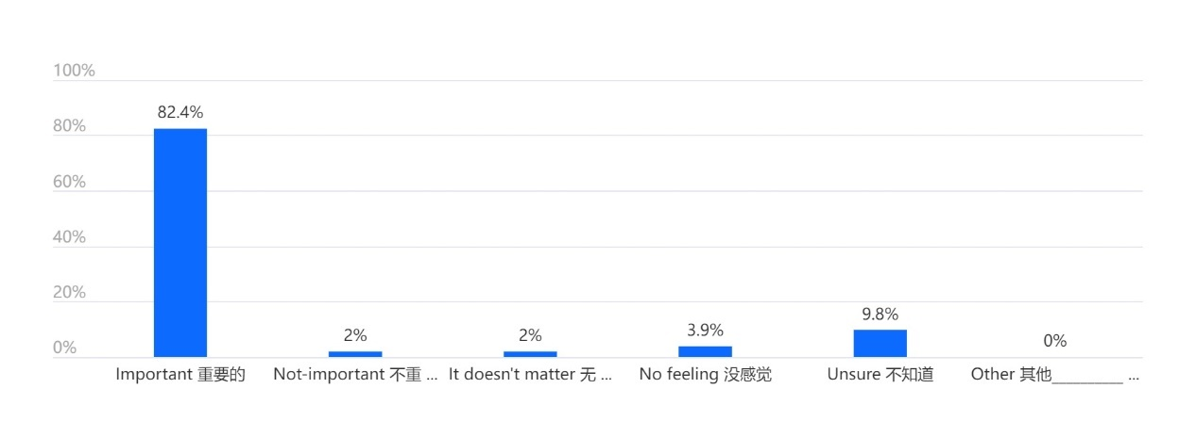
The fact that the majority 82.4% of participants consider patience important in investment reflects a common understanding among investors. Only 2% of participants indicated that patience is not important in investment. While individual preferences and investment styles may vary, the overwhelming majority recognizing the importance of patience suggests a widespread recognition of its role in successful investing.

Compounding occurs when investment returns are reinvested, leading to exponential growth over time. Patience allows investors to harness the power of compounding and maximize their long-term returns. While Buffett's long-term investment style has been proven successful over several decades, it's important to note that it requires discipline, thorough research, and a long-term perspective. It may not be suitable for all investors

In question 16, only 9.8% of participants chose asset allocation as their preferred strategy. The low percentage of participants selecting this strategy suggests that many may not be fully aware of its benefits or may not have considered it as a primary investment approach. Markowitz claiming that the market is efficient (1952) believes that asset allocation is the best strategy for investors, and the performance of individual stocks is not as good as that of the entire portfolio. Use different assets to perform differently in the market environment, use their irrelevance to hedge risks, and rely on strategies to earn income. Asset allocation strategy aims to achieve a balance between risk and return by spreading investing across various assets involving diversifying such as stocks, bonds, cash etc.

In conclusion, Patience is an essential attribute of success for investors because it reflects the ability to remain calm and committed to a chosen investment strategy, even during periods of market volatility or fluctuations. Buffett's long-term investment style needs decades and may not suit everyone. Active investing requires significant effort and expertise to select and analyze stocks, monitor investments regularly, and make informed decisions. It can be demanding in terms of time, energy, and research. Additionally, active investing outcomes are not guaranteed, and not all investors have the necessary skills or resources to consistently outperform the market. Therefore, it may not be the best choice for small investors who may face limitations in terms of time, resources, and access to comprehensive market information. Passive investing has low cost and saves time and energy, however, the results still depend on the exchange-traded funds (ETFs) that investors choose and the whole marketing performance. Asset allocation is combine ETFs and active investing advantages benefit such as long-term market returns and active selection assets, which save time and the investment performance does not lose to the market. This approach can be suitable for small investors as it offers a balanced and diversified portfolio which be the best option for the small investor. The fact that only 9.8% of participants chose asset allocation as their preferred investment method may indicate a lack of financial knowledge or a need for financial advisor assistance among the participants.

Conclusion and findings
The research questionnaires received a total of 51 copies. The participants are roughly evenly divided between men and women. The demographic profile of the participants reflects a group primarily composed of younger adults with higher education and financial stability. 98% of the participants were under the age of 50, of which 49% were between the ages of 18 and 29. 96.1% have a bachelor's degree or above. 77.4% of the participants could use two or more languages. Participants were from 21 countries, and most participants were financially debt-free and financially stable at 64.7%. These characteristics may have implications for the generalizability of the research findings and provide a context for understanding the perspectives and behaviours of the participants.

Macroeconomic theory understanding is important for investing. Through the analysis of the Fed's quantitative easing (QE) monetary policy inflation, 39.2% of the participants have never thought about how monetary policy will affect it, and 29.4% of the participants think it has an impact. Therefore, 96.1% of the participants have a bachelor's degree, and their understanding of the economic situation is not clear, which has a negative impact on investment activities. It also shows that even with a bachelor's degree, it is necessary to improve economic and financial awareness.

According to data from investor analysis, 58.8% of participants have investment plans. This is a positive sign that a large proportion of people have a sense of future inflation and retirement. How to understand market information. 60.8% of the participants will actively and regularly read financial news. Listening to financial podcasts is another popular method. Also, choose a financial advisor or attend a seminar or workshop. Indicates a variety of preferences in obtaining financial information. Market volatility was a key concern for investors, with 49% of participants choosing it as their top choice. In second place was not knowing enough about investing, which was chosen by 39.2% of participants. Questions about what investors perceive as the main disadvantages. 52.5% of the participants lacked financial knowledge, citing this as the biggest disadvantage. According to previous investors' understanding of macroeconomics, insufficient understanding of financial investment is the main problem faced by investors.

Investment risk questionnaires data reflect a range of attitudes towards risk among participants. It is generally believed that investment returns and risks should be positively correlated. In the question about risk attitude, most people see risks as opportunities suggests that most individuals have a more balanced or cautious approach to risk mindset and only 7.8% of participants feel excitement towards risk. The results match philosophy & strategies questions, the number of people who are risk averse is about four times that of people who view risk positively. Understanding investors' emotional responses to risk is valuable. On the question of how to manage investment risk, 58.8% of participants selected diversification which indicates participants recognize taking a more balanced approach to managing risk.

The data also showed that 19.6% of participants chose to hedge as a risk management strategy. This indicates that this part of the participants has advanced financial knowledge and is willing to adopt more sophisticated risk management techniques in line with the demographic profile of younger adults with higher education. That's a very positive sign.

In the investment philosophy & strategies questionnaire, 45.1% of the participants chose savings or time deposits, and 33.3% chose insurance. Savings and insurance are generally considered risk-free and low-risk. Approximately four times as many people who chose low-risk finance products compared to choosing other finance products, consider risk averse four times more than risk positive. The data reflected a range of attitudes toward risk among participants. Low returns usually correspond to low risks, but also avoid huge investment losses. 19.6% of participants chose cryptocurrency as an investment option, perhaps in line with the demographic profile of 98% of participants under the age of 50. More inclined to adopt new technologies. Overall, the data suggest that participants tend to be conservative in investing but receptive to new things.

Finally, it is revealed that 76.5% of the participants have investments in stocks and a series of stock investment strategy preferences. 21.6% of the participants chose to actively select and manage individual stocks, indicating that they have a higher tolerance for risks. 23.5% think it is value investing. One of the most important aspects of Buffett's investment style is that long-term investment requires patience. 82.4% of the respondents believe that investment patience is very important, reflecting the consensus of investors. But decades to invest may not be right for small investors. Few participants choose asset allocation as their preferred strategy. A combination of asset allocation based on literature may be best suited for small investors. This also shows that participants lack awareness of relevant investment products and strategies. Corresponding to the previous questionnaire about investor data concern about investing is not enough understanding of investment and the main disadvantage of investment is the lack of certain financial knowledge.

The final open question is asking the participants who think they are capable investors, such as making more informed investment decisions, setting realistic investment goals, planning suitable investment strategies and achieving investment goals. Fill rate 52.9% / fill 27. The majority of participants think they are incapable investors because no experience in finance or not well-read on this topic, or thinking of incompetent investing. This is a surprising finding in this high-education sample with 96.1% having undergraduate education and 77.4% of the participants can use more than two languages. Also shows the investment is professional works. Besides, It is worth noting that there were also a few participants who responded affirmatively, indicating that they have some level of experience or knowledge in investing. These individuals may have a better understanding of investment concepts and feel more confident in their abilities as investors. Thus, the research findings suggest a need for financial educational initiatives to empower individuals and improve their understanding of investing which can gain the necessary knowledge and skills to make informed investment decisions, thereby reducing the risks associated with investing.

Chapter 5
Introduction
The research aims to advise small investors and how to manage investment risk in investment. The research question has been updated with many versions, from the focus on the company evaluation to investors, however, the core never changes it is about risk. No matter how evaluating the company or investor's decision-making is all about managing risk in investment. Search for a highly profitable company with a low-price company or find the next ‘apple’ company that is trying to find low risk with high reward investment. And making rational decisions without effect by emotion is also to manage risk. After a nearly 10-month research study, therefore, the key to investment success is to manage the risk. In simple terms, buy low and sell high.

The research methodology uses a mono-method approach and epistemology research assumptions through interpretivism study with qualitative research methods. The logic of the approach is inductive research and narrative analysis will be adapted to analytical procedures. It received 51 participants' questionnaires from 21 countries covering most regions of the world. The dissertation frame has 5 chapters. Each chapter has a different content, the first chapter emphasises the background of the topic and research questions and layout of the dissertation. The second chapter is a literature review that focuses on summarizing all aspects of investors. Chapter three provides a comprehensive of the research methodology and introduces the dissertation using epistemology research assumptions through interpretivism study with qualitative research methods. Chapter four is the research findings and analysis of the research question data and attempts to uncover the underlying meaning behind the data. and the end of the chapter concludes the dissertation.

Summary
The first chapter starts with the rising cost of living prices in 2022, and ends with particular emphasis on why understanding investment is important. There is still much negative affection on Europe economics due to the war between Ukraine and Russia. Economic sanctions against Russia also hurt Europe economies. Energy shortages and rising prices affect everyone. Shortly, also facing the ageing population and retainment challenge globally. The conflict and economic deglobalization have negative effects that continue in the visible future. The ageing population and labour shortage will also cause inflation in the future when the current working population is retired and then will be a very different world. Therefore, understanding and successful investments are critical for everyone's happy retirement life meantime to reduce the risk of in uncertainty the future.

The second chapter is literature reviews taking the most effort and time. The literature review focuses on summarizing many aspects of investor needs and what are the main issues affecting the performance of investors, and how to reduce the risk in investment. Narrative in four themes which about Macroeconomic, investment risk, investor analysis, and end with an investment philosophy.

Begin with Standard economic theory, Monetarist Theory to Modern Portfolio Theory, following each famous investor giants such as American Warren Buffett to another giant Andre Kostolany in Europe. The analysis of investment strategy of the famous investment insulation such as Bridgewater Fund to Yale's Endowment. Research understanding all the accounting, finance, and economics definitions for example along with CPI to derivatives such as futures, options, and swaps. It is also important to understand business cycles and investor psychology. Bon, G.L. (1895) The Crowd: A Study of the Popular Mind. It is the best book definitely to describe the crowd. As the same as the described group of investors. Based on standard economic theory is the belief that individuals behave rationally, this assumption is called the effective market hypothesis in investment etc. There are still many theories in investment theory, and investment strategies need to be verified, however, the key to investment success is still risk management. Small investors have many disadvantages compared with intuitional investors, reducing and managing the risk is still vital to investment decision-making. For example, if investing in the American stock market the small investor taking the same risk as Warren Buffet but maybe expect high return than him, that limitation of knowledge may result in this kind of bias. The following recommendations section will discuss how small investors manage risk in investment.

Chapter three is about research methodology which provides a comprehensive overview of the research methods, with a particular focus on the Sanders research onion, and discusses how to apply this framework to the dissertation and research field. The dissertation uses epistemology research assumptions through interpretivism study with qualitative research methods. The research question is about individual investors such as investors with small amounts of money and aims to advise them on how to manage risk during investing and relay to individual investor opinions and behaviours in managing risk and investment. The research choice is the mono-method approach which is a qualitative method for research because qualitative data refers to opinions, thoughts, perspectives, and attitudes which are normally transient and only understandable in context. The logic of the approach is inductive research. The research using a questionnaire takes the electronic form to collect primary data from participants whom the individual investor. And the narrative analysis will be adapted to analytical procedures. The potential bias for response questionnaires is the main limitation including participants and researcher. In the end, discuss potential outcomes, and ethical considerations.

Chapter four is the research findings and analysis. It provides a framework for thorough analysis and interpretation of the data, ultimately leading to valuable insights and potential implications for the field of investment research. Seeking to uncover the underlying meaning behind the data. The primary data using a semi-structured open questionnaire will take an electronic form to collect roughly 24 days. The questionnaire is designed in response to literature structures. The 18 questions belong to Macroeconomic analysis, Investor analysis including demographic information, Investment &Investment risk, and Investment Philosophy.

Investor analysis including demographic information questions 1-7,9,10,14,17, the demographic data of the participants reflected, mainly composed of highly educated and economically stable young people. 49% of participants were between 18 and 29 years and 98% were under 50. 96.1% have a bachelor's degree. 77.4% of the participants could use two or more languages. 58.8% of participants have an investment plan, that indicates A large portion of the sample is taking steps to secure their financial future. A diverse range of preferences in accessing financial information. Combining various sources, such as financial news, podcasts, professional advice, and industry colleagues. 60. 8% of the participants regularly actively read financial news as their primary source of information. Market volatility is a significant concern for investors, with 49% of participants taking it as preferred. The second biggest concern, 39. 2% of participants chose to have enough understanding of the investment. Regarding personal opinions on the main disadvantages of investment, 52.5% of participants choose to lack financial knowledge. 94.1% of participants chose to agree on the impact of personal emotions on investment decisions. This indicates that participants are aware of the impact of emotions on investment decisions, which can affect their decision-making process and may lead to bias and irrational investment decisions.

In Macroeconomic analysis question 8. The understanding of macroeconomic theory through the analysis of the Federal Reserve's quantitative easing (QE) monetary policy inflation test. 39.2% of participants have never considered how monetary policy will affect it, A very astonishing result indicates a low understanding of the economy and finance in such level highly educated population.

Investment &Investment risk, questions 11, 12. Data on investment risk issues explains that participants have a relatively conservative attitude toward investment risk. About how to manage risk in your investments. The majority of participants 58.8% choose 'diversification' that to diversify their investments into different assets. Meanwhile, data indicates that participants have different risk management strategies, and regular rebalancing of investments (17.6%) and stop loss orders to limit losses (17.6%) is also indicating that a considerable number of participants are actively considering these proactive methods to manage investment risks.

Investment Philosophy & Strategies questions are 13, 15, and 16. About investment types of participants have used or tried. 45.1% of participants chose savings or term deposits, and 33.3% chose insurance. It reflects that the number of participants who are averse to risk is approximately four times higher than the number who view risk positively in investing in financial products. The selection of risk-free and low-risk products is in line with the assessment attitude of low-risk conservative risk tolerance. However, 19.6% of participants chose cryptocurrency as their investment choice, which is also consistent with their population structure. It indicates that participants tend to be conservative in their investments, but receptive to new technologies. Overall, participants have a range of preferences in investment tools, ranging from traditional choices to more innovative ones. Different levels of risk tolerance and preferences. It is noteworthy, only 9.8% of participants chose asset allocation as their preferred strategy. Regarding stock investment methods. Growth investment becomes the first choice, followed by passive investment and value investment, 23.5% of participants stated that they do not have stock investments. The consensus among participants is that patience is important for investment in questionnaires. Finally, most participants expressed that they cannot be competent investors, lack experience or little reading in investment, or do not understand investment matters. This indicates the need for further education and awareness raising in the field of investment. Marks (2011) points out that the market is a place to compete with others who also want to win. Therefore, beating the market means being a step ahead or being highly educated.

Discuss the extent of the finding with literature reviews.
The former head of the Yale Endowment Fund, Swensen (2009) realized that the key was not to distinguish between individual investors and institutional investors but to be able to distinguish between capable and incompetent investors. The key to comparing the differences between small investors and institutional investors is to make wiser investment decisions and set realistic investment goals. Mike (2023) believes that some advantages of small investors are concentration, size, liquidity, and flexibility, but cost, time, and obtaining key information are disadvantages for small investors. According the data shows different levels of risk tolerance and preferences. Investment types of participants have used or tried, except for the majority of chosen low-risk products. However, there are more options for small investors due to the flexibility and concentration, size, and liquidity. Easy to invest in a wider range of products ranging from traditional choices to more innovative ones. Such as 19.6% of participants chose cryptocurrency, stocks selected 39.2%, and mutual funds 29.4% of participants, etc. Therefore, investment success varies depending on the investor's goals, risk appetite, and investment horizon with an investment strategy that can improve investment results and reduce the risk in investment. Especially in the information age, the connection speed become faster and faster with the popularization of the network.

Hayes (2023)argues any action with the hope of increasing future income can also be considered an investment. For example, choosing to pursue additional education is to increase income in the future career. According to the data shows most participants unqualified investors, therefore, strongly agree with Hayes's argument. The finance world is very complicated, and investments need professionals to manage. Theory and practice are two sides of one coin. Only understanding theory is not enough, investment needs lots of practice both in the real market and physical. Investment is not easy cannot rely on one sentence from the investor giant. Mongan (2022) says, before starting, it is very important to understand own financial situation, the goal of investment and the attitude toward risk. Due to the fact that the number of participants who are risk averse is approximately four times higher than those who view risk positively. And nearly half of the participants chose risk-free and low-risk finance products. Dagnino (2001) stated that investors should learn how to develop flexible and reasonable risk control strategies That also indicates every investor should be aligning investment approaches with personal risk tolerance.

And Hayes (2021) commented that these immature investors are susceptible to behavioural biases and can cause panic through emotional trading. The data shows that nearly all of the participants choose to agree with the impact of personal emotions on investment decisions. This indicates that participants are aware of the impact of emotions on investment decisions, that consistent with Hayes' viewpoint. Bon (1895) mentioned the characteristics of groups and group psychology and pointed out that once people integrate into groups, their personalities will be submerged. Human nature and bias never changed, as same as in the past century, that have the same reaction as the same situation in the past. Therefore, it requires practice to cultivate and maintain a mindset that sees market opportunities while not being influenced by fear and greed. Greed and fear can influence our brains, forcing us to give up common sense and self-control, thereby triggering change, fear and greed can be powerful motivations. Therefor realize people’s limitation in emotion can significant reduce risk investment and decision making.

Hagstrom (2000) believes that investing in the stock market is more uncertain in the short term, but more certain in the long term. The question of investment 'patience' can measure participants' understanding of the time frame and long-term nature of successful investments. Marks (2011) also points out that the market needs patience to pursue long-term and stable income. The majority of participants consider patience important in investment and realize long-term strategy is more successful in investing. Buffett's long-term investment style has been proven successful for decades, as long-term investment and patience allow investors to leverage the power of compound interest and maximize their long-term returns.

Conclusions
Recommendations for small investors on how to manage the investment risk
Investment and competitive sports have some subtle similarities. The top fund manager in American Marks, H. (2011) The Most Important Thing, concludes that both investment and competitive sports are competitive, and winning and loss can be measured, both as a combination of luck and ability. In the sport competitive how to win the game if the competitor has the same level as you? The answer is to make fewer mistakes than a competitor, in other words, the decision winner does not use an active strategy and it minimizes mistakes. The small investor to minimize mistakes? Leave enough safety space in investment. in brief, have a margin of safety. The concept come from Benjamin Graham (1894-1976) who is known as the Father of Value Investing. It means the price below the value of an asset, The bigger the underestimation and the bigger the margin of safety. For example, the $100 value of an asset and sale is $90 and the price difference of $10 is the safety margin. High failure rate if invest in a lower safety margin or beyond the safety margin. Same as never invest in a business you cannot understand. Warren Buffett investing style always investing which means buying companies that show robust earnings and long-term growth potential for less than inside intrinsic value. This is a very useful concept for small investors and no matter whether passive investment strategies or active ones have enough safety margin is vital for risk management and investment success.

Although primarily composed of younger adults with higher education. However, lack of financial knowledge is the big finding as well as the participants selected as the biggest disadvantage, and market volatility is a significant concern for investors, the second concern is not knowing enough about investment. This also emphasizes the importance of financial education. A lack of financial knowledge can be a hindrance to making informed investment decisions, understanding financial products and concepts, and effectively managing an investment portfolio. Another issue is the low percentage of participants being aware of high fees and expenses is a concerning finding. Understanding the impact of fees and expenses can help investors develop realistic expectations about the potential returns they can achieve. And lower participants who choose asset allocation as their preferred investment method may indicate unfamiliarity with financial tools.

To address these concerns, investors can focus on enhancing their financial knowledge through education, staying updated on market trends, diversifying their investment portfolios, and considering long-term investment strategies that align with their risk tolerance and financial goals. Proper research, analysis, and seeking professional advice can help mitigate the risk of making poor investment choices. Moreover, financial education can take various forms, including workshops, courses, and online resources.
Thus, improving individuals' financial knowledge can enhance their understanding of investment strategies, risk management, asset allocation, and other key factors that contribute to successful investing.

There are other recommendations for small investors. For example, flexibly adjust the proportion and allocation of each product in their portfolio according to market changes and individual conditions. And also, should have a long-term investment perspective to avoid emotional trading due to short-term market fluctuations long-term holding can help investors reduce the risk of short-term market volatility and reduce transaction costs. The diversification of investment in the portfolio theory can effectively reduce the overall risk of the portfolio and improve the stability of returns and the ability to resist market volatility. Asset allocation strategy combines diversification of investment in the portfolio theory, passive such as ETFs, and active investing advantages benefits such as long-term market returns and active selection assets, which save time and the investment performance does not lose to the market. This approach can be suitable for small investors as it offers a balanced and diversified portfolio. As the Nobel Memorial Prize winner in Economic Sciences, Harry Max Markowitz (1952) believes that asset allocation is the best strategy for investors.

Critique/limitations of the study
The main limitation of this study is less critical analysis. due to the previous education which did not encourage thinking and emphasize memory. under this kind of education is good at memory but the downside is less thinking. The lack of analysis may lead to the confusion of various key theories, unable to clearly express the main arguments or ideas and the relationship between these parts. or can be explained not clearly. there is another main limitation is the non-native English level, Although the best may still not be able to express the full point. However, there may not be significant errors in the findings, because the finding is all about the participants despite these limitations, would not have much impact on the main conclusions.

Personal reflections
The last and vital reflection of the research study is to realize how important independent critical thinking is in investment activity. In the financial world, millions of news in every second. How to identify the difference between information and noise. And more important is how to make the right decisions compared to thousands of choices. All information is readily accessible in modern society, therefore analysis and identification became more vital in investing. Some countries will never have someone like Warren Buffett as an investor giant, for example, in North Korea, not only there is no stock market but also imprison people’s thinking. ‘One party, one leader and one thought’ policy will restrain people's minds and also social development. Hence, Independent critical thinking is more like a firewall to protect investors who have been not only defrauded by edited financial news and also making good investment decisions and life decisions based on that. Investors' mind has been critically thinking empowered. Through the right decision and right persistence as well as the right abandonment reduce risk in investment and improve investment performance. In simple terms, buy low and sell high.

In the end of interesting finding is that all investors giant have longer lifespans. Buffett is just one of many great investors born in the Depression in the 1930s who’ve lived long lives. Why do great investors live longer? And alcoholics and smokers have shorter lifespans. Great investors are usually emotionally stable and able to manage stress, while alcoholics and smokers often cope with stress through drinking and smoking, resulting in earlier death times. investment active may result in a lifetime to live longer or more about rational thinking, maintaining focus, and having more patience dose. Below are some of the evidence:
John Templeton: Died at aged 96
Phil Fisher: Died at aged 96
Andre Kostolany: Died at aged 93
Benjamin Graham: Died at aged 82
Jesse Livermore: Died at aged 63
…
Charlie Munger was born in 1924,
George Soros was born in 1930,
Peter Lynch was born in 1944,
Ray Dalio was born in 1949
Cathie Wood born in 1955
…

References
Allen, S. (2019) Why you shouldn’t put all your eggs in one basket. Available at: https://www.wealthify.com/blog/why-you-shouldn-t-put-all-your-eggs-in-one-basket (Accessed: 21 December 2022).
Anna, G. (2021) Bridgewater’s Inflation Warning: ‘It Starts to Look a Bit like the 70s and the Oil Shocks’ | Kitco News. Available at: https://www.kitco.com/news/2021-10-11/Bridgewater-inflation-warning-It-starts-to-look-a-bit-like-the-70s-and-the-oil-shocks.html (Accessed: 17 December 2022).
Arora, K. (2022) Council Post: The Rise Of The Retail Investor. Forbes. Available at: https://www.forbes.com/sites/forbesagencycouncil/2022/11/04/the-rise-of-the-retail-investor/ (Accessed: 31 March 2023).
Bhutta, N. et al. (2020) ‘Changes in U.S. Family Finances from 2016 to 2019: Evidence from the Survey of Consumer FinancesChanges in U.S. Family Finances from 2016 to 2019: Evidence from the Survey Consumer Finances’.
Bob, P. (2022) ‘Investors Need to Prepare for Stagflation’. Financial Times, 15 July.
Bogle, J.C. (2017) The Little Book of Common Sense Investing: The Only Way to Guarantee Your Fair Share of Stock Market Returns. 2nd edition. Hoboken, NJ: Wiley.
Bon, G.L. (1895) The Crowd: A Study of the Popular Mind. Courier Corporation.
Borji, H.S. (2021) 4 Global Economic Issues of an Aging Population. Investopedia. Available at: https://www.investopedia.com/articles/investing/011216/4-global-economic-issues-aging-population.asp (Accessed: 4 April 2023).
Brilliant, H. and Collins, E. (2014) Why Moats Matter: The Morningstar Approach to Stock Investing. Hoboken, New Jersey: Wiley.
Buffett, M. and Ph.D, A.P.S. of L.D.C. (2008) Warren Buffett and the Interpretation of Financial Statements: The Search for the Company with a Durable Competitive Advantage. 1st edition. New York: Scribner Book Company.
Buffett, W. (2016) Berkshire Hathaway Letters to Shareholders. 3rd edition. Olson, M. (ed.). Explorist Productions.
Buiter, W.H. (2003) ‘James Tobin: An Appreciation of His Contribution to Economics’. The Economic Journal, 113(491), pp. F585–F631.
Charlie Munger Speaks at the Daily Journal Annual Meeting (2022) Directed by Charlie Munger Speaks at the Daily Journal Annual Meeting. Available at: https://www.youtube.com/watch?v=8RxLj9OVqLo (Accessed: 22 December 2022).
Clark, D. (2017) Tao of Charlie Munger: A Compilation of Quotes from Berkshire Hathaway’s Vice Chairman on Life, Business, and the Pursuit of Wealth With Commentary by David Clark. New York: Scribner.
Cohan, P. (2019) 90 Years Ago Roger Babson Predicted The Market Crash. What Would He Say Today?. Forbes. Available at: https://www.forbes.com/sites/petercohan/2019/09/05/90-year-ago-roger-babson-predicted-the-market-crash-what-would-he-say-today/ (Accessed: 20 December 2022).
Cohen, P. (2022) ‘The Dollar Is Strong. That Is Good for the U.S. but Bad for the World.’ The New York Times, 26 September. Available at: https://www.nytimes.com/2022/09/26/business/economy/us-dollar-global-impact.html (Accessed: 18 December 2022).
Dagnino, G. (2001) Profiting In Bull or Bear Markets. 1st edition. McGraw Hill.
Dalio. (2021) Principles for Dealing with the Changing World Order: Why Nations Succeed or Fail. 1st edition. Simon & Schuster UK.
Dalio, R. (2017) Principles: Life and Work. New York: Simon & Schuster.
Depersio, G. (2022) What Are Some Examples of Free Market Economies?. Investopedia. Available at: https://www.investopedia.com/ask/answers/040915/what-are-some-examples-free-market-economies.asp (Accessed: 18 December 2022).
Douglas, M. (2001) Trading in the Zone: Master the Market with Confidence, Discipline, and a Winning Attitude. Prentice Hall Press.
Estrada, S. (2022) What are the pros and cons of a strong dollar? A Johns Hopkins economist explains. Yahoo Finance. Available at: https://finance.yahoo.com/news/pros-cons-strong-dollar-johns-102936484.html (Accessed: 4 April 2023).
Fama, E.F. (1970) ‘Efficient Capital Markets: A Review of Theory and Empirical Work’. The Journal of Finance, 25(2), pp. 383–417. DOI: 10.2307/2325486.
Financhill. (2021) How Did Warren Buffett Get Started. Financhill. Available at: https://financhill.com/blog/investing/how-did-warren-buffett-get-started (Accessed: 5 April 2023).
Fisher, P.A. and Guidall, G. (1996) Common Stocks and Uncommon Profits and Other Writings. new edition. New York: John Wiley & Sons, Inc.
Forbes. (2023a) Charles Munger. Forbes. Available at: https://www.forbes.com/profile/charles-munger/ (Accessed: 5 April 2023).
Forbes. (2023b) Warren Buffett. Forbes. Available at: https://www.forbes.com/profile/warren-buffett/ (Accessed: 5 April 2023).
Giles, M. (2021) Short Answer: Stock Market vs. Economy. Morningstar, Inc. Available at: https://www.morningstar.com/articles/1034789/short-answer-stock-market-vs-economy (Accessed: 20 December 2022).
Graham, B., Zweig, J. and Buffett, W.E. (2006) The Intelligent Investor Rev Ed.: The Definitive Book on Value Investing. revised ed. edition. New York: Harper Business.
Hagstrom, R.G. (2000) The Warren Buffett Portfolio: Mastering the Power of the Focus Investment Strategy. 1st edition. New York, NY: Wiley.
Hayes, A. (2023) Investment Basics Explained With Types to Invest In. Investopedia. Available at: https://www.investopedia.com/terms/i/investment.asp (Accessed: 5 April 2023).
Hayes, A. (2022) Value Investing Definition, How It Works, Strategies, Risks. Investopedia. Available at: https://www.investopedia.com/terms/v/valueinvesting.asp (Accessed: 21 December 2022).
Historical Returns for the US. (2022) Historical Returns on Stocks, Bonds and Bills: 1928-2021. Available at: https://pages.stern.nyu.edu/~adamodar/New_Home_Page/datafile/histretSP.html (Accessed: 22 December 2022).
Irish Life. (2022) Starting to Invest with Small Sums Is Easy and Accessible through Digital Platforms. The Irish Times. Available at: https://www.irishtimes.com/sponsored/2022/05/27/starting-to-invest-with-small-sums-is-easy-and-accessible-through-digital-platforms/ (Accessed: 2 July 2022).
Juglar, C. (1819-1905) A. du texte. and Wolowski, L. (1810-1876) A. du texte. (1862) Des crises commerciales et de leur retour périodique en France, en Angleterre et aux États-Unis / par le Dr Clément Juglar... Available at: https://gallica.bnf.fr/ark:/12148/bpt6k1060720 (Accessed: 5 March 2022).
Kahneman, D. (2012) Thinking, Fast and Slow: Daniel Kahneman. 1st edition. London: Penguin.
Kahneman, D., Sibony, O. and Sunstein, C.R. (2021) Noise: A Flaw in Human Judgment. New York: Little, Brown Spark.
Keynes, J.M. (1936) The General Theory of Employment, Interest, and Money. first edition. San Diego: Houghton Mifflin Harcourt.
Kilham, A. (2022) What Is a Retail Investor? Definition, Pros, and Cons. SoFi. Available at: https://www.sofi.com/learn/content/retail-investors/ (Accessed: 31 March 2023).
Lehnen, C. (2023) 1923: How Weimar combatted hyperinflation – DW – 01/01/2023. dw.com. Available at: https://www.dw.com/en/1923-how-weimar-combatted-hyperinflation/a-64184767 (Accessed: 2 April 2023).
Lioudis, N. (2022) What Is the Gold Standard? Advantages, Alternatives, and History. Investopedia. Available at: https://www.investopedia.com/ask/answers/09/gold-standard.asp (Accessed: 4 April 2023).
Lynch, P. (2000) One Up On Wall Street: How To Use What You Already Know To Make Money In The Market. 2nd revised edition. New York: Simon & Schuster.
Malkiel, B.G. (2019) A Random Walk Down Wall Street - The Time-Tested Strategy for Successful Investing. 12th ed. edition. New York: W. W. Norton & Company.
Markowitz, H. (1952) ‘Portfolio Selection’. The Journal of Finance, 7(1), pp. 77–91. DOI: 10.2307/2975974.
Marks, H. (2011) The Most Important Thing: Uncommon Sense for the Thoughtful Investor. illustrated edition. New York, NY: Columbia Business School Publishing.
Mike, P. (2023) What Is a Retail Investor?. The Motley Fool. Available at: https://www.fool.com/investing/how-to-invest/retail-investor/ (Accessed: 31 March 2023).
Moyo, D. (2022) Why Deglobalization Makes US Inflation Worse | by Dambisa Moyo. Project Syndicate. Available at: https://www.project-syndicate.org/commentary/why-deglobalization-makes-us-inflation-worse-by-dambisa-moyo-2022-10 (Accessed: 17 December 2022).
Pettinger, T. (2022) The Link between Money Supply and Inflation. Economics Help. Available at: https://www.economicshelp.org/blog/111/inflation/money-supply-inflation/ (Accessed: 4 April 2023).
Rani, M.J.A. (2022) Deglobalisation Has Multiple Impacts on Malaysia. The Edge Markets. Available at: http://www.theedgemarkets.com/article/deglobalisation-has-multiple-impacts-malaysia (Accessed: 2 April 2023).
Richards, D. (2012) The Father of Efficient Markets: Is Warren Buffett Smart or Lucky?. Available at: https://www.advisorperspectives.com/articles/2012/06/05/the-father-of-efficient-markets-is-warren-buffett-smart-or-lucky (Accessed: 23 December 2022).
Roselli, A. (2021) ‘Hyperinflation, Depression, and the Rise of Adolf Hitler’. Economic Affairs, 41(2), pp. 300–308. DOI: 10.1111/ecaf.12466.
Ross, S. (2021) How Quantitative Easing (QE) Affects the Stock Market. Investopedia. Available at: https://www.investopedia.com/ask/answers/021015/how-does-quantitative-easing-us-affect-stock-market.asp (Accessed: 18 December 2022).
SEC. (2021) SEC.Gov | What We Do. Available at: https://www.sec.gov/about/what-we-do (Accessed: 31 March 2023).
Shiller, R.J. (1981) ‘Do Stock Prices Move Too Much to Be Justified by Subsequent Changes in Dividends?’ The American Economic Review, 71(3), pp. 421–436.
Siegel, J. (2022) Stocks for the Long Run: The Definitive Guide to Financial Market Returns & Long-Term Investment Strategies, Sixth Edition. 6th edition. New York, NY: McGraw Hill.
S&P Dow Jones Indices. (2022) Icons: The S&P 500® and The Dow® | S&P Dow Jones Indices. Available at: https://www.spglobal.com/spdji/en/research-insights/index-literacy/the-sp-500-and-the-dow/ (Accessed: 22 December 2022).
Surz, C.R. (2021) Money Printing and Inflation: COVID, Cryptocurrencies and More. Available at: https://www.nasdaq.com/articles/money-printing-and-inflation%3A-covid-cryptocurrencies-and-more (Accessed: 18 December 2022).
Swensen, D.F. (2009) Pioneering Portfolio Management: An Unconventional Approach to Institutional Investment, Fully Revised and Updated. updated edition. New York: Free Press.
Taylor, H. (2022) US dollar: Their currency, your problem. Available at: https://www.investorschronicle.co.uk/news/2022/10/31/us-dollar-their-currency-your-problem/ (Accessed: 4 April 2023).
Trading economics. (2022) United Kingdom Inflation Rate - November 2022 Data - 1989-2021 Historical. Available at: https://tradingeconomics.com/united-kingdom/inflation-cpi (Accessed: 17 December 2022).
Troy, S. (2021) Enron Scandal: The Fall of a Wall Street Darling. Investopedia. Available at: https://www.investopedia.com/updates/enron-scandal-summary/ (Accessed: 18 November 2021).
Tvede, L. (2009) Business Cycles: History, Theory and Investment Reality. 3rd edition. Wiley.
United Nations., Department of Economic and Social Affairs, and Population Division (2019) ‘World Population Ageing 2019: Highlights’.
Wasik, J.F. (2014) A Nobel Prize Laureate’s Winning Investment Formula. Forbes. Available at: https://www.forbes.com/sites/johnwasik/2014/09/22/a-nobel-prize-laureates-winning-investment-formula/ (Accessed: 23 December 2022).
Will, D. (2022) The Chief Investment Officer at the World’s Biggest Hedge Fund Says We’re Headed for a Recession That’s ‘Double the Normal Length’—and It Has a Lot to Do with China. Fortune. Available at: https://fortune.com/2022/12/16/how-bad-recession-double-normal-length-china-bridgewater-associates-cio/ (Accessed: 17 December 2022).
Winters, M. (2022) The Fed announces 4th consecutive ‘jumbo’ interest rate hike of 75 basis points—here are 4 things that will be more expensive. CNBC. Available at: https://www.cnbc.com/2022/11/02/fed-raises-borrowing-costs-with-another-jumbo-interest-rate-hike.html (Accessed: 17 December 2022).
Yale’s Endowment. (2022) Overview of Yale’s Endowment. Yale University. Available at: https://www.yale.edu/funding-yale-home/overview-yales-endowment (Accessed: 6 April 2023).

Arvinen-Barrow, M. and Visek, A.J. (2021) ‘“If We Knew What We Were Doing, It Would Not Be Called Research, Would It?” (Albert Einstein): Paying Forward Publishing Pearls of Wisdom’. Journal for Advancing Sport Psychology in Research, 1(1), pp. 22–32. DOI: 10.55743/000003.
Bryman, A. and Bell, E. (2011) Business Research Methods 3e. OUP Oxford.
Fisher, C.M. and Buglear, J. (2010) Researching and Writing a Dissertation: An Essential Guide for Business Students. third edition. Harlow: Financial Times Prentice Hall.
Flick, U. (2013) Introducing Research Methodology: A Beginner’s Guide to Doing a Research Project. SAGE.
Kothari, C.R. (2004) Research Methodology: Methods and Techniques. New Age International.
Saunders, M.N.K., Lewis, P. and Thornhill, A. (2019) Research Methods for Business Students. eighth edition. [Electronic Resource]. Harlow: Pearson Available at: https://www.vlebooks.com/vleweb/product/openreader?id=Griffith&accId=9153605&isbn=9781292208794 (Accessed: 19 February 2023).
Silverman, D. (2021) Doing Qualitative Research. SAGE Publications, Limited.
Snieder, R. and Larner, K. (2009) The Art of Being a Scientist: A Guide for Graduate Students and Their Mentors. Cambridge University Press.
Tim, M. (2011) Social Research: Issues, Methods and Research. McGraw-Hill Education (UK).
Wilde, O. (1997) The Critic as Artist. Green Integer.

Buffett, W. (1999) Owner’s Manual. Available at: https://berkshirehathaway.com/owners.html (Accessed: 30 May 2023).
Lefèvre, E. (2005) Reminiscences of a Stock Operator: Illustrated Edition. illustrated ed. Hoboken, NJ: John Wiley.

Appendices- Questionnaire about Small Investor

- advise small investors on how to manage investment risk \
中小投资者调查问卷——如何管理投资风险

This is a study conducted by YangLi (email: yang.li2@student.griffith.ie), Msc in Accounting and Finance Management for his graduate dissertation in Griffith College Dublin, under Graduate Business School, with the supervision of a Senior lecturer in GBS, Suzanne Burdis CPA, MATI, Dip IFRS (ACCA), PG Cert (TE).\
This research concentrates on the small investor and advises small investors on how to manage investment risk. In recent years, many countries around the world have experienced higher levels of inflation than they have in the past. and the world is experiencing a rapidly ageing population. Inflation can erode the purchasing power of an investor's money over time. And according to the United Nations, the global population aged 65 and older is expected to more than double from 703 million in 2019 to 1.5 billion in 2050. Due to Insufficient pensions， many countries are increasing the retirement age to deal with these challenges. \
The research aims to help small-investor find a better way to cope with situations such as inflation, and insufficient pensions to reduce investment risk and for a future happy life. \
This project involves taking part in completing the questionnaire. The responses will seek to gather information on your investment experiences. It estimates taking almost 10 minutes to complete this questionnaire. \
Involvement in this Research study is voluntary. Participants may withdraw from any part of the study at any time. Every effort is made to ensure the confidentiality of the participant. Participant names will not be recorded, as all participants will be assigned a code. Confidentiality of information provided is subject to legal limitations. Survey data will be destroyed upon completing this master's degree in full compliance with GDPR regulations.\
Please read the Plain Language Statement and Informed Consent Form before commencing. Both agreements contain the same information mentioned here but in more detail.\
I have read and understood the information in this form. Therefore, I consent to take part in this research project. Thank you very much. If participants have concerns about this study and wish to contact an independent person, please contact: Suzanne Burdis \
Graduate Business School\
Griffith College Dublin - Main Campus \
Email: suzanne.burdis@griffith.ie\
\
中小投资者调查问卷——如何管理投资风险\
欢迎参加本次小调研！本次调研仅使用于毕业论文，目的为研究中小投资如何管理投资风险。您所有回答匿名保密仅用于调研分析分析使用，非常重视您的感受和宝贵意见，感谢您的支持！[段落说明]

What is your gender?[单选题](您的性别是？)
Female 女性
Male 男性
Unknown

How old are you?[单选题](您的年龄是？)
Under 18
18 - 29
30 - 39
40 - 49
50+

What is your current level of education?[单选题](你目前的教育水平是？)
High school 中学
Undergraduate Bachelor 本科
Postgraduate Master 硕士
PhD 博士
Other 其他____

How many languages do you speak well?[单选题](您能熟练使用几种语言？)
1
2
3+

What is your nationality?（Please enter)[单行文本题](你的国籍是？\(请输入\）)

What is your current financial situation?[多选题](您目前的财务状况如何？)
Debt-free and financially stable 无债务且财务稳定
Some debt, but manageable 一些债务，但可控
High debt, but manageable 高负债，但可控
Overwhelmed with debt 负债累累
Confidentiality 保密

Do you have an investment plan to deal with future inflation and retirement?[多选题](您是否有投资计划应对未来的通货膨胀和退休生活？)
Yes 是
No 否
Never thought about 没想过
Other comments 其他评论 ____

Do you think quantitative easing (QE) monetary policy is the main reason causing inflation?[多选题](您认为量化宽松\（QE\）货币政策是造成通胀的主要原因吗？)
Yes 是
No 否
Never thought about 没想过
Other comments 其他评论 ____

How do you stay informed about the markets?[多选题](您如何随时了解市场信息？)
I read financial news regularly 经常阅读财经新闻
I listen to financial podcasts 收听金融播客
I attend investment seminars or workshops 参加投资研讨会或研讨会
I work with a financial advisor 咨询财务顾问
Not interesting financial news 对财经新闻不感兴趣
Other (please specify) 其他（请注明）____

What is your biggest concern about investing?[多选题](您对投资最关心的是什么？)
Losing money 赔钱
Not knowing enough about investing 对投资了解不够
Market volatility 市场波动
Making the wrong investment decisions 做出错误的投资决定
Other (please specify) 其他____

What do you feel about 'Risk'？[多选题](你怎么看待“风险”？)
Exercising 兴奋
Opportunies 机会
Loss 损失
No feeling 没感觉
Unsure 不知道
Other 其他____

How do you manage risk in your investments?[多选题](您如何管理投资风险？)
Diversification (spreading investments across different assets) 多元化-分散投资于不同资产
Hedging (using financial instruments to offset potential losses) 对冲-例如使用金融工具（期货、期权）做套期保值
Limiting exposure to certain sectors or industries 不投资某些公司或行业
Regular monitoring 定期监测
Regularly rebalancing investments 投资再平衡策略
Risk assessment 评估与每项投资相关的风险
Seek professional advice 寻求专业建议
Stop-loss orders to limit losses 及时止损以限制损失
Other (please specify) 其他____

How do you think "patience" in investing?[多选题](您怎么看待“耐心”在投资中的作用？)
Important 重要的
Not-important 不重要的
It doesn't matter 无关紧要
No feeling 没感觉
Unsure 不知道
Other 其他____

Do you agree or disagree that emotions affect investment decisions?[多选题](您是否同意情绪会影响投资决策?)
Agree 同意
Disagree 不同意
Other其他____

What types of investment types have you made or or tried (multiple choices)[多选题](您做过或尝试过哪些投资类型\（多选\）)
1. Stocks 股票
2. Bonds 信用债
3. Government/Treasury bonds 国债
4. Mutual Funds 基金
5. Exchange-Traded Funds (ETFs) 指数基金
6. Real Estate (House) 房地产
7. REITs funds 房地产投资信托基金
8. Commodities (Gold) 黄金
9. Futures and Options 期货/期权
10. Commodity Trading Advisor(CTA)管理期货基金
11. Cryptocurrencies 加密货币
12. Saving and Fixed deposit 储蓄/定期存款
13. Monetary Fund 货币基金(余额宝类)
14. Insurance 保险
15. Foreign Currency 外汇
Others comments 其他____

Which stock investment methods (if any) do you prefer to use? and offer the choices...[多选题](关于股票市场投资，您更倾向使用哪种股票投资方法\（如果有\）？ 请选择...)
1. Passive investing (index funds, ETFs)被动投资策略
2. Active investing (individual stocks, actively managed funds)主动投资股票
3. Value investing (seeking undervalued assets)价值投资策略
4. Growth investing (seeking high-growth assets)成长型投资策略
5. Asset Allocation Strategy(invest in different asset categories)资产配置策略
6. Bridgewater-All Weather investment strategy 桥水基金全天候策略
7. Buffett’s value investing 巴菲特的价值投资
8. None of the above 以上都没听过
9. No stock investment 没有股票投资
10. Other (please specify) 其他____

What do you think are the main disadvantages of investment?[多选题](您认为投资中主要劣势是什么？)
1. Lack in-time information 缺乏及时信息
2. Lack of diversification: Lack of investment channels 缺乏多元化：缺乏投资渠道
3. Lack of certain level of finance knowledge 缺乏一定的专业知识
4. High fees and expenses： such as transaction fees, management and brokerage fees. 高额费用和支出：例如交易费、管理费和经纪费。
5. Liquidity risk: Some investments may be difficult or time-consuming to sell. 流动性风险：一些投资可能难以出售。
6. Behavioural biases: may be prone to making irrational decisions based on emotions, cognitive biases, or other factors. 行为偏见：可能容易根据情绪、认知偏见或其他做出不合理的决策。
7. Regulatory risk: Changes in laws and regulations can impact the value of investments and create uncertainty for investors.监管风险：法律法规的变化会影响投资价值并给投资者带来不确定性。
8 . Do not know how to balance risk and reward when making investment decisions. 在做出投资决策时不知道如何平衡风险和回报。
Other 其他____

Do think you are a capable investor? such as making more informed investment decisions, setting realistic investment goals, and planning suitable investment strategies and achieve investment goals. or other comments, thank you very much! （Please enter)[多行文本题](您认为您是有能力的投资者吗？ 例如做出更明智的投资决策，设定切合实际的投资目标，规划合适的投资策略并实现投资目标。 或者有其他评论，非常谢谢！)

Appendices- Other comments for end of questionnaires

Yes, I am a capable investor!
I know a bit and I would like to learn more.
Yes. I don't allow to inform my decision to other people/ investor
No, I usually talk about my investments with a consultant and after that I make a decision.
Yes I have a diverse portfolio with short term and long term goals, and do not make rash decisions based on emotions.
Before I invest in anything I need to research a lot more. There are people that know more than me and I won’t be able to beat them
I'm a semi qualified CA from ICAI of India, by profession equity analyst, day trader, technical analyst. I trade in NSE largest derivative Exchange of world in F&O segment.
Yes, I think so, but investing at the present time has become less profitable and more dangerous because taxes, transaction fees, and financial deductions have become very large.
I am unsure at the moment. I would like to think that my financial moment would help me take control of the decisions but I am aware that knowing risk and seeing it applied would be very different.
Unfortunately, I don’t think I am a capable investor. I think learning and analyzing are important factors for a capable investor, but I simply do not have enough time for them, because of my business. As a result, I have done a few investments advised by my main bank.

