A visual and linguistic approach to the representation of celebrity news on Instagram as observed on the accounts of E!News, Entertainment Tonight, and Page Six

By
Alessia Bonori

A thesis submitted in partial fulfilment of the requirements for the MA in TV and Radio Journalism (QQI)

Faculty of Journalism & Media Communications
Griffith College

August 2023

Declaration

I hereby certify that this material, which I now submit for assessment on the programme of study leading to the award of the MA in TV and Radio Journalism, is my own; based on my personal study and/or research, and that I have acknowledged all material and sources used in its preparation. I also certify that I have not copied in part or whole or otherwise plagiarised the work of anyone else, including other students.
Signed:
Dated: 02/08/2023

Abstract
This study investigates the visual and linguistic portrayal of celebrity cheating scandals on Instagram, exploring the interplay between news circulation on social media and the reporting techniques of entertainment journalism. As a result of the digitalisation of news production and circulation, celebrity journalism has adapted its business strategies and reporting techniques to the new platforms emerging in the media landscape. By conducting a mixed quantitative and qualitative content analysis of 23 celebrity news posts, the present paper determines the means through which cheating scandals are visually and linguistically depicted on the Instagram accounts of three entertainment news platforms: E!News, Entertainment Tonight, and Page Six. Employing academic research on images’ role in the news and on journalistic reporting styles as a springboard, this study identifies a range of visual and linguistic tools employed in the cheating scandal posts. Taking into account the sensational nature of celebrity journalism, as well as the business strategies and application-specific features of Instagram, this paper determines that the use of visual and linguistic tools in the posts contributes to the creation of sensationalism by functioning as attention-grabbing devices. This dissertation delves into a variety of interrelated aspects concerning the digitalisation of news circulation, the ad revenue system of social media platforms, and the sensational reporting style of entertainment journalism. The content analysis of celebrity cheating scandal posts on Instagram, has served as an important method to foreground some of the issues and lacunae in the contemporary news media, such as the lack of transparency and the unfair advertising revenue systems on social media. This dissertation highlights the importance of spreading more awareness among consumers with regard to news production and dissemination across the ever-expanding media landscape.

Table of contents
Declaration i
Abstract ii
Acknowledgments 1
1. Introduction 3
1.1. Research Context 3
1.2. Research Problem 5
1.3. Research Questions 6
1.4. Aims and Objectives 7
1.5. Significance 8
2. Literature Review 10
2.1. News circulation and consumption on social media 10
2.1.1. Big tech companies’ ad revenue system 13
2.1.2. Instagram as a news-sharing platform 15
2.1.3. Celebrity news publications on Instagram 17
2.2. Celebrity Culture 18
2.3. Celebrity Journalism 21
2.4. Sensationalism in the news 24
2.4.1. Sensationalism in the news: the visual component 25
2.4.2. Sensationalism in the news: the linguistic component 28
3. Methodology 33
3.1. Visual Component 34
3.1.1. Type of Image 34
3.1.2. Copyright Concerns 35
3.1.3. Semiotic Approach 36
3.2. Written Component 37
3.2.1. Pragmatic Strategies 38
3.2.2. Semantic Strategies 39
3.2.3. Headline-Writing Techniques 39
3.3. Contribution to Sensationalism 41
3.4. Data 42
3.4.1. Cheating scandal: Adam Levine and Behati Prinsloo 43
3.4.2. Cheating scandal: Gerard Piqué and Shakira 44
3.4.3. Limitations and Challenges 44
3.5. Ethical Considerations 45
4. Visual Analysis 46
4.1. Type of Image 46
4.2. Copyright Concerns 48
4.3. Semiotic Approach 49
4.4. Comparison among the publications 51
5. Linguistic Analysis 53
5.1. Pragmatic Tools 53
5.2. Semantic Tools 54
5.3. Headline-Writing Techniques 55
5.4. Word play and link in bio 56
5.5. Typos 57
6. Discussion 59
6.1. Research Question 1 59
6.2. Research Question 2 60
6.2.1. Implication of visual tools 60
6.2.2. Implication of linguistic tools 64
6.3. Research Question 3 67
6.4. Limitations 68
7. Conclusion 70
7.1. Research questions and aims achieved 71
7.2. Suggestions for future research 72
7.3. Final Observations 73
Bibliography 76
List of Appendices 85
Appendix A 85
E!News 85
Entertainment Tonight 92
PageSix 100
Appendix B 108
Appendix C 108

List of figures
Figure 1: Example of collage (see Appendix A) 47
Figure 2: Example of stand-alone photograph (see Appendix A) 47
Figure 3: Type of images 47
Figure 4: Copyright concerns 48
Figure 5: Range of vertical angles 50
Figure 6: Example of framing element (see Appendix A) 50
Figure 7: Example of framing element (see Appendix A) 50
Figure 8: Linguistic tools 54

Acknowledgments
As my academic career is coming toward a bittersweet end, I am looking back at the past 4 years of university and 13 years of school with joy and gratitude as I realise how lucky I am to be surrounded by so many emotionally generous, inspiring, and loving people.
Firstly and most importantly, I want to thank my parents because without their continuous love, support, and encouragement, I would not be where I am today. Thank you for allowing me to chase my dreams and for believing in me. To meine Mama, thank you for your unconditional love, your patience, your words of reassurance, and thank you for being my role model. To mio papá, thank you for your selflessness, for always putting our family first, and for never pushing me but always inspiring me to do better.
To my brother Fabio, thank you for the distractions while I was trying to study or write my thesis. In hindsight, I probably needed them. Thank you for making me laugh with your terrible jokes and for making our house feel like home whenever I come back.
To Letizia, Federica, and Giorgia my best friends since kindergarten, thank you for the love and support throughout the years no matter the distance between us. Thank you for being there when I needed a laugh, a shoulder to cry on, or when I simply needed someone to talk to. There is no one else I would have rather grown up with.
To Sara and Elisabetta, thank you for all the wonderful memories during our high school years, and thank you for simply being you: generous, kind, and loving.
To Virág, Laura, Lena, and Eva thank you for making Innsbruck feel like home. Thank you for making my bachelor’s the most wonderful three years of my life. Thank you for the love and support you continue to show me even after I moved away. Thank you for being wonderful friends at university and in life.
To Anna and Ann-Sophie, thank you for being the best flatmates I could have ever asked for and for being such wonderful friends. Thank you for your kindness, your love, and generosity. Thank you for welcoming me with open arms: into (y)our flat and into your lives.
To Sophia, Laura, and Anna thank you for making my master’s in Dublin so memorable. Thank you for the laughs, the day trips, the nights out, and the nights in. Sharing this chapter of my life with you is something I will cherish forever.
To Troy and Cindy thank you for the love and support you keep showing me even from the other side of the world. Thank you for the continuous words of encouragement and reassurance, thank for always putting a smile on my face whenever we facetime.
To my supervisor Ellie O’Byrne, thank you for your invaluable advice, continuous support, and patience during my master’s dissertation.
Lastly, and probably somehow selfishly I want to thank myself. I want to thank the Alessia studying till late at night, the Alessia spending more time at the library than at home the past two summers, the Alessia sleeping 4 hours a night and drinking 6 coffees a day. Most importantly, I want to thank the Alessia who realised that student life is not all about studying but about living.
If I could say one thing to that 19-year-old girl moving abroad for college, I would tell her not to worry because she is so so loved.

Introduction
In an era of social media dominance, the lens through which society consumes celebrity news has undergone a profound shift. The presence of celebrity journalism on Instagram is a recent and particularly noteworthy phenomenon. The circulation of entertainment news on Instagram is a manifestation of numerous social and cultural changes of the past decades: the advent of social media, the digitalisation of news production and dissemination, audience fragmentation, and the rising interest in celebrities and popular culture.
The spread of celebrity gossip across social media platforms is an essential aspect to consider in light of the changes undergone by the contemporary media landscape. The investigation of the means in which celebrity journalism is portrayed and delivered on a platform like Instagram is pivotal to comprehend the complex dynamics observed in the news media today.

Research Context
Entertainment news, despite its predominantly negative reputation as a trivial and sensationalistic journalism genre, plays a significant role in modern society and the media landscape. Interest in the public and private lives of famous people has persisted for centuries.
As a journalism genre, however, celebrity news is a relatively modern phenomenon emerging concomitantly with the advent of mass media. Entertainment news as it is known today, indeed, began in The New Yorker in 1957 when the magazine wrote a profile on actor Marlon Brando, and it has since then stretched beyond gossip columns and tabloid magazines (Gay, 2018). Celebrity news has moved onto a variety of different platforms ranging from television to radio, and subsequently to podcasts, the internet, and lastly to social media.
Celebrities, intended as famous individuals emerging from the entertainment industries and whose private and professional lives are continuously under the spotlight, are a uniquely modern phenomenon (Farrell, 2013). Famous people have always existed; nonetheless, “the nature of fame and the systems that create and maintain an individual’s fame have changed dramatically over time” (Farrell, 2013, p.368). These changes have thus led to the creation of the current celebrity culture. As Nayar stresses in his book Seeing Stars: Spectacle, Society and Celebrity Culture, “it would be no exaggeration to say that today you cannot avoid seeing a celebrity” (2009, p.2).
The rising interest and popularity of celebrity culture have quickly captivated the news industry. Entertainment news has inundated the media and considering the role played by social networks in the circulation of news, it is pivotal to explore these two phenomena side by side.
With the rise of social media and the demand for brief and compact information, countless news outlets have started creating content specifically for social media platforms, such as Facebook, Twitter, YouTube, TikTok, and Instagram. News outlets publish on social media for a plethora of reasons, e.g., to address a wider audience, to keep abreast with contemporary trends in news circulation and consumption, and as Guaglione emphasises, for brand building (2023).
Social media are not only appealing to news publications but also to consumers. Statista’s 2022 report on news consumption in the United States demonstrates that social media was the most popular news platform among 18 to 34-year-olds (Watson, 2023). Comparably, a report by Pew Research shows that as of 2022, half of US adults get news at least sometimes from social media (Liedke and Matsa, 2022).
Social media platforms offer innovative tools and features to both the producers and the receivers of information. Content can be pushed using hashtags or easily shared by users themselves to an even wider audience. News stories can be designed and delivered using text, images, videos, and audio, all aimed at generating captivating and engaging posts.
As a content-sharing medium, Instagram offers a variety of these tools to news publications. As of March 2023, Instagram counts 2 million monthly active users and more than 200 million businesses using Instagram to advertise, promote, or sell their products and services (Daniel, 2023). Because Instagram is a picture and video-sharing app, businesses aiming to reach a growing audience ought to create visually appealing content attached to brief and concise text.
Among the businesses using Instagram to sell their services are celebrity news publications. As a result of its application-specific features, Instagram functions as a practical medium for celebrity journalism; particularly, when taking into consideration the genre’s sensationalistic reporting style.
Entertainment news has indeed often been associated with sensationalism, comprising catchy headlines, emotionally charged content, and striking photographs. Sensationalism, as defined in the Cambridge Dictionary, is “the act by newspapers, television, etc. of presenting information in a way that is shocking or exciting”(Cambridge Dictionary, 2023b). As a picture-sharing platform, Instagram precisely offers these possibilities to news publications.

Research Problem
Although “celebrity coverage has become omnipresent and pervasive even to the extent that
it constitutes a new normality in the contemporary media world” (Dubied and Hanitzsch, 2014, p.137), it has received relatively limited attention in the academic field.
As Dubied and Hanitzsch argue, there is a justifiable place for celebrities in the news even though it seems counter-intuitive and controversial in many academic circles (2014). The extensive coverage of celebrities, the scholars explain, is journalism’s response to the challenges presented by shifts and changes in modern society (Dubied and Hanitzsch, 2014). Because of its social and cultural relevance, entertainment news is worth analysing in the context of scholarly research.
News is published daily on social media, as a growing number of publications have adapted their business strategies accordingly to address wider audiences. As news production and circulation have gradually become digitalised, media and communications studies have begun exploring this phenomenon from an academic perspective.
The 2023 Reuters Institute digital news report shows that in the United States, an increasing number of people have used social media as a news source going from 27% in 2013 to 48% in 2023 (Newman et al., 2023). While Facebook, Twitter, and YouTube are still the most popular platforms with regard to news consumption, Instagram is gradually ascending the hierarchy (Newman et al., 2023).
Notwithstanding the platform’s increasing popularity, news production and circulation on Instagram has been an overlooked phenomenon in academic research. As a growing news-sharing medium, Instagram is a key platform to consider in light of the digital transformation of journalism.

Research Questions
Social media offers numerous innovative strategies to news publications juxtaposing the written with the visual. In order to develop a deeper understanding of this duality, the present study will investigate the means in which celebrity news is sensationalised on Instagram, more specifically on the accounts of E!News, Entertainment Tonight, and Page Six, multibrand platforms reporting on entertainment and pop culture. By conducting a content analysis, I will answer the following research questions:
- What visual and linguistic tools are employed to portray celebrity cheating scandals on the Instagram accounts of E!News, Entertainment Tonight, and Page Six?
- How do the visual and linguistic tools employed in E!News, Entertainment Tonight, and Page Six’s Instagram posts contribute to the creation of sensationalism?
- Taking into consideration the number of likes and comments under the celebrity cheating scandal posts of E!News, Entertainment Tonight, and Page Six, how do the visual and linguistic tools relate to audience engagement?

Aims and Objectives
The research aims of this dissertation can be summarised as follows:
- Investigate the means in which celebrity cheating scandals are portrayed on Instagram in order to gain a better understanding of the dynamics between news production on social media and the reporting style of celebrity journalism.
- Assess how and to what extent the use of visual and linguistic tools contributes to the creation of sensationalism based on the observation of the Instagram posts from E!News, Entertainment Tonight, and Page Six’s accounts.
- Evaluate how the sensational portrayal of celebrity news relates to audience engagement under the Instagram posts from E!News, Entertainment Tonight, and Page Six.
- Contribute to academic research on social media’s role in news distribution and on the reporting techniques of celebrity journalism.
The research objectives of this dissertation can be summarised as follows:
- Conduct a comprehensive literature review on the digitalisation of news production and circulation, social networks and their role in the news media, celebrity culture, celebrity journalism, and on sensational reporting styles in order to establish a solid theoretical foundation for the research study.
- Identify and determine a dataset of visual and linguistic tools to use as a springboard for the analysis of Instagram reporting techniques in celebrity news posts.
- Collect and analyse a dataset of celebrity cheating scandal posts from the Instagram accounts of E!News, Entertainment Tonight, and Page Six.
- Examine the selected celebrity news posts based on the presence and frequency of the visual and linguistic devices.
- Assess the contribution of visual and linguistic tools to the creation of sensationalism and understand the motives that lie behind their occurrence.
- Investigate the ties between the news reporting techniques and audience engagement by evaluating the like and comment count under the selected cheating scandal posts.
- Provide recommendations for future academic research as well as for news publishers and consumers.
By addressing these aims and objectives, this dissertation intends to provide a comprehensive analysis of the portrayal of celebrity news on Instagram and its implications on the contemporary media landscape, celebrity culture, and society at large.

Significance
The visual and the written elements of an Instagram news post are interdependent, in that, for the successful delivery of a story, both must be present. Instead of only focusing on either the image or the text of a news story, this dissertation explores the two components conjointly and juxtaposes them to the features of Instagram as a photo-sharing app and to the sensational nature of celebrity journalism. From both a journalistic and academic perspective, the visual and linguistic analysis of Instagram news posts is an essential research to conduct, as it offers a novel and different perspective on the news production and circulation processes on social media.
From a media and communications perspective, it is particularly important to consider new platforms for news circulation such as social media, and to consider other genres of journalism differing from current affairs. Celebrity journalism, although considered trivial and of little importance to the larger news landscape, is an important genre to explore. Entertainment news mirrors the interests, preoccupations, and values of the societies in which it is published. By investigating how celebrity news, more specifically cheating scandals, are depicted on a novel platform for news circulation like Instagram, this dissertation intends to explore journalism from a different angle.

Literature Review
In order to analyse celebrity coverage on Instagram, it is crucial to gain a better understanding of the complex relationship between journalism, entertainment news, and social media. In doing so, this literature review will contribute to a deeper insight into the aforementioned interplay shedding light on a variety of interrelated aspects of celebrity news coverage.
Firstly, it is pivotal to look into news circulation on social media, as the presence of publications on social networks is a relatively modern phenomenon. Secondly, to analyse celebrity journalism’s presence in the news world, it is necessary to explore celebrity culture, its developments, and its role in society. Thirdly, the evolution and characteristics of celebrity journalism will be explored to understand its significance in popular culture. By differentiating between public interest journalism and journalism of public interest, it will be possible to understand why people enjoy consuming celebrity news.
Lastly, sensationalism as a reporting style will be explored in relation to its emergence and development across different types of news. Because the present study will also focus on the means in which the style and structure of Instagram posts contribute to the creation of sensationalism, visual and linguistic elements interrelated with the reporting style will be examined.

News circulation and consumption on social media
News circulation and consumption have changed significantly in the past century. Moving from newspapers to radio, then television, the internet, and ultimately social networks, the media landscape has evolved rapidly, and news outlets have adapted their business strategies accordingly. With the advent of social media, publishers have started using platforms like Facebook, Instagram, Twitter, and YouTube as an additional and essential medium on which to share news stories.
Before moving onto social media, however, news outlets were confronted with the emergence of the internet. As Newman asserts, “the seeds of today’s dramatic changes to news production and distribution were sown right at the start of the internet revolution” (2011, p.10).
The first online journalism website was launched in 1993, a couple of months after the launch of one of the first web browsers, Mosaic, by the University of Florida’s Journalism Department (Siapera and Veglis, 2012). Only a year later, in November 1994, the UK’s Daily Telegraph launched the Electronic Telegraph, a static page with articles one on top of the other (Siapera and Veglis, 2012).
The beginning of online journalism can thus be traced back to the 1990s when the advent of the internet changed the face of journalism forever (Siapera and Veglis, 2012). In consonance with the gradual evolution of the World Wide Web, journalism was compelled to reach beyond its conventional media to where the new audience was: in cyberspace (Stassen, 2010). In order to survive the gradual digitalisation of the media landscape, news organisations have embraced new technology by using “social media tools in ways that add value to what they do” (Ludke, 2009, p.4).
As social media platforms have become more firmly embedded in everyday communication, their importance and relevance to news organisations have grown (Bowd, 2016). Starting in 2004 with the launch of Facebook, social media has gradually become an important news-sharing channel for publications. Because of their convenient and easy-to-use tools for posting content, social media platforms simplify and facilitate news sharing for both media organisations and individuals (Kümpel et al., 2015).
In the United States, digital news has become an important part of Americans’ news media diets, and social media has played a crucial role in news consumption (Liedke and Matsa, 2022). A Pew Research survey shows that in 2022, 50% of US adults got news at least sometimes from social media (Liedke and Matsa, 2022). The report outlines that roughly a third of US adults regularly get news from Facebook, followed by YouTube (25%), Twitter (14%), and then Instagram (13%) (Liedke and Matsa, 2022). Similarly, a 2022 survey by Statista on daily news consumption in the United States reveals that 47% of 18 to 34-year-olds used social networks for news on a daily basis (Watson, 2023). Numbers were comparably high amongst 35 to 44-year-olds, where 45% of respondents turned to social media for news, while only 30% of 45 to 64-year-olds followed this trend (Watson, 2023).
Recent surveys depict a notable rise in news consumption on social media, and the trend “cuts across nearly every demographic group, not just young people” (Lee, 2016, p.106). People consume news on social media for two main reasons. Firstly, news on social media is brief and compact, as many platforms often only allow text to be written in a limited number of characters. Secondly, users already find themselves on social media platforms; thus, they can easily consume news by staying on the same medium without the need to search for information elsewhere.
Boczkowski et al.’s study on young users’ news consumption on social media found that the most common mode in which 18 to 29-year-olds obtain information on social networks can be described with the notion of ‘incidental news’ (2017). The scholars maintain that the majority of young social media users consume news on their mobile devices by scrolling through platforms like Facebook or Twitter (Boczkowski et al., 2017).
A more recent study shows that YouTube, Instagram, and TikTok are the most popular platforms among young users, and they are also their preferred channels for news consumption (Vázquez-Herrero et al., 2022). Vázquez-Herrero et al. assert that “exposure to news is more frequent on these platforms than via the voluntary monitoring of news media and journalists” (2022, p.3836).
Social media users do not specifically search for news stories, instead, they encounter the information somewhat accidentally. Consumers are presented with news items because their friends post about them, through social media’s algorithms, and because news companies push their content through hashtags and other techniques (Boczkowski et al., 2017).

Big tech companies’ ad revenue system
Journalism has been both positively and negatively affected by the rise of social media. On one hand, news publishers are reaching more people than ever before through platforms like Facebook, Twitter, or Instagram (de Cornière and Sarvary, 2022). Additionally, the current social media environment provides unique opportunities for journalism which would not have been available otherwise, such as collaborative news gathering and reporting, as well as real-time communication between journalists and consumers (Lee, 2016).
On the other hand, news outlets are not receiving any advertising revenues from publishing on social media platforms, which they would normally receive on traditional media, e.g., newspapers, radio, or television. The media economy has always been dependent on the advertising industry (Thussu, 2015), and the lack of ad revenue on social media is negatively affecting journalism.
The ad revenue system on social media platforms has been of concern to governments and users, but it has also been of significant concern for news outlets (de Cornière and Sarvary, 2022). Meta’s domination over the online advertising industry has drastically affected the traditional news business. While social media companies report enormous profits from the circulation of news on their platforms, traditional media outlets are suffering. The US news industry, for instance, has seen the destruction of 70 daily and over 2,000 weekly and nondaily news outlets since 2004 (Abernathy, 2020).
Big Tech companies’ power in the online news world has been a pressing issue, as traditional media is losing control of their audiences and advertising. “The novelty of digital modernity is the hegemony of a very few multinational companies as the operators of the key infrastructures of communication, media distribution, and information retrieval on a global scale,” argues Schrape (2016, p.14).
For news outlets, the central and most pressing issue resulting from the aforementioned hegemony is the advertising revenue they lose to Meta, the multinational technology conglomerate comprising Facebook, Instagram, and WhatsApp, as well as to Google, and Amazon. The annual advertising revenue of Instagram, for instance, was 17.4 billion US dollars in 2020, and the platform is projected to reach approximately 40 billion US dollars in annual ad sales in 2023 (Faria, 2023). News publications’ businesses, on the other hand, are hurt by social media’s unbalanced ad revenue system.
A report by NERA Economic Consulting, issued by Meta, however, asserts that the claims from news publishers that Facebook and other social media platforms benefit unfairly at their expense are incorrect (Eisenach, 2023). According to the report, “Facebook referrals drive between 10 and 15 percent of that traffic to publisher web sites” (Eisenach, 2023, p.35). The report thus claims that news organisations gain significant economic benefits by publishing content on Facebook because by sharing links to articles they drive traffic to their websites resulting in more subscribers and higher advertising revenues (Eisenach, 2023).
On the contrary, a Statista report on social media clickthrough rate shows that the global clickthrough rate in 2022 was 1.21% (Statista Research Department, 2023), in clear opposition to NERA’s claims. Because of low the click-through rate on social media, news outlets are struggling to drive traffic to their websites, on which they receive ad revenues.
Binns explains that although news organisations have to be present on social media in order to maintain visibility in the digital world, it is on platforms like Facebook and Instagram where they are deprived of advertising revenue (2021)
News organisations’ loss of ad revenues remains a pressing issue; nevertheless, publications are trying to benefit from social networks’ possibilities. Sharing news content on social media, for instance, can be used by news outlets as a means to direct users to their websites and as brand development. As Guaglione’s article on news companies’ usage of social media demonstrates, many publishers view Instagram as a natural brand builder and as a place to interact with a different type of audience (2023).

Instagram as a news-sharing platform
Because news publication and circulation on Instagram will be the focus of this analysis, it is pivotal to explore the medium further. Instagram was launched in 2010 and is one of the most successful social media platforms in the world (Dixon, 2023). As of January 2023, the photo and video-sharing app had over 2 billion monthly active users, with India and the United States being home to the world’s largest Instagram audiences (Dixon, 2023). In the USA alone, Instagram counts 143 million users (Dixon, 2023). According to a Pew Research survey, Instagram has gradually gained popularity as a social media platform among US citizens, as the share of adults who report using the site has grown from 9% in 2012 to 40% in 2021 (Schaeffer, 2021). The platform’s increasing popularity has rapidly caught the attention of news companies.
The social media platform is currently playing an essential role in spreading information, as many news companies that used to post their content solely on their websites have been making their way to Instagram (Khalisah and Anjarningsih, 2020). However, as Al-Rawi et al. suggest, unlike other social media platforms, such as Twitter and Facebook, there is little academic research analysing news on Instagram, as it is still primarily viewed as a venue for entertainment (2021).
Being a photo and video-sharing app, Instagram presents itself as an attractive medium for news publication. When considering Instagram news, “there seems to be emphasis by news organizations to carefully select, package, and post the most appealing stories that have some of these aesthetic features to further encourage audience engagement” (Al-Rawi et al., 2021, p.308). Because an Instagram post’s most evident feature is its visual component, news stories must comprise intriguing images or videos to catch a user’s attention and result in potential engagement, e.g., a like or comment.
According to Al-Rawi et al., the aesthetic nature of Instagram limits the number of published news items that are almost always accompanied by high-quality visual content (2021). The text accompanying news stories on Instagram is indeed relatively short, as the focus remains on the visual elements of the post. Although the limit for Instagram captions, i.e., the text attached to a photo or video, is 2200 characters, if the text is longer than 125 characters, everything after that amount will be hidden. In order to read the rest of the text, users are given the option to click more, and the full caption will appear. News publications are thus compelled to hook the reader in the first 125 characters or to simply limit their word count.
Although presenting itself as an appealing medium for publications, the inability to share links in posts has been of serious concern for news outlets as it limits website visits. Instagram does indeed not allow the sharing of weblinks in posts’ captions, an action that is possible on other social media such as Facebook or Twitter. The platform allows accounts to have one external link in their bio, hence called link in bio, making it the only means news publications have to drive traffic to their own websites. On Instagram, the bio refers to the description of an account which can be up to 150 characters long and is found at the very top of the profile page. The link in bio thus becomes a central feature for news publications.
Instagram’s distinct features make it an interesting medium to explore in relation to news circulation and consumption. Because of its expanding audience and its innovative content-sharing tools, the app has attracted numerous entertainment news publications, which have turned to Instagram to publish their stories.

Celebrity news publications on Instagram
Entertainment magazines as well as television programmes have created accounts on a variety of social media platforms to publish excerpts of news stories, links to their websites, or livestreams from red-carpet events and film premieres. Because this dissertation aims to investigate how celebrity news is depicted on the Instagram accounts of E!News, Entertainment Tonight, and Page Six, it is important to give further information on the three publications, their social media presence, as well as their business strategies.
E!News is the most followed US-based entertainment news account on Instagram counting 22.9 million followers as of June 2023 and is thus a leading publication in the field. E!News is a multiplatform brand reporting on entertainment, pop culture, and lifestyle topics (E! Online, 2023). Among the platforms on which E!News can be found are Snapchat, Facebook, Instagram, YouTube, TikTok, the E! Live 360 red-carpet app, and television. The E!News TV shows, for instance, air in more than 130 countries with a total global reach of 98.6 million viewers (E! Online, 2023). The brand’s target audience comprises “young, influential, trendsetting consumers” (E! Online, 2023).
Entertainment Tonight, stylised as ET, is a US-based multiplatform entertainment news brand. Although not displaying as many Instagram followers as E!News, with solely 4.2 million followers as of June 2023, ET is the longest-running entertainment newsmagazine on television and is thus an important brand in the field (Entertainment Tonight, 2023). Owned by Paramount Global, ET has nearly 4 million daily viewers and delivers more than 190 million video online views per month (Paramount Express, 2022). Entertainment Tonight defines itself as “the global leader in celebrity news bringing audiences exclusive interviews, breaking news, behind-the-scenes access, and more for over 40 years” (Entertainment Tonight, 2023).
Page Six is part of the New York Post network and was initially a gossip section in the very tabloid newspaper. As of today, Page Six is distributed as a print as well as an online magazine, while also being on a variety of social media platforms. Page Six’s digital magazine counts a total of 114 million page views, while the daily circulation of their print version amounts to 479,456 copies (The New York Post Network, 2022). As of June 2023, the gossip publication counts 812,000 Instagram followers. Their tagline epitomises the magazine’s gossip nature, “if you don’t want it on Page Six, don’t do it” (The New York Post Network, 2022).
E!News, Entertainment Tonight, and Page Six play a central role in the production and distribution of celebrity news in the United States as well as on a global scale. The three multi-platform brands cover very similar news stories and are active on a number of the same social networks. E!News, Entertainment Tonight, and Page Six are among the most popular US-based entertainment news publications on Instagram thus being important contributors to the circulation of celebrity culture on social media.

Celebrity Culture
Entertainment news is closely tied to celebrity culture. Boorstin describes celebrities as people who are known for their well-knownness (1992). Nayar, on a similar note, defines a celebrity as “one whose private life acquires as much public importance, and into which people want sights and insights, as her or his public one” (2009, p.5).
As Farrell observes, famous individuals have existed for a long time; in previous centuries, people from the nobility and the aristocracy, for instance, were considered well-known subjects. Nonetheless, celebrities as they have been described by Boorstin (1992) and Nayar (2009) are a modern phenomenon. Farrell maintains that the emergence of democracy and the expansion of consumer capitalism have been the two central aspects of contemporary Western society underpinning its culture and influencing the shift in the allocation of fame (2013). In pre-democratic societies, fame depended on fixed social hierarchies and thus reflected the status of elites (Farrell, 2013). In democratic societies, on the contrary, fame reflects the ability to represent and embody the masses (Farrell, 2013).
The creation of celebrity culture must also be considered in relation to the advent of photography. In the past, the appearance of one person becoming widely known was only possible with portraiture, which would be predominantly commissioned by members of the aristocracy or the elite. The gradual innovations in photography allowed for a simpler, cheaper, and wider circulation of celebrities’ pictures and consequently increased their visibility (Doussot, 2023).
Doussot (2023) explores the ties between the invention of photography in the nineteenth century and the emergence of celebrity culture. More specifically, the scholar focuses on photographs of literary celebrities, e.g. poets, playwrights, and authors. The invention of the daguerreotype in the late 1830s, made photography accessible to a non-scientific public, among others, writers (Doussot, 2023). Doussot asserts that “the advent of mass visual culture in the 19th century went together with the birth of celebrity culture” (2023, p.16). In the case of literary figures, photography became an inevitable connection between the public and writers, making it possible for people to recognise writers without reading their books (Doussot, 2023).
Although concerned with writers’ visibility, Doussot’s (2023) paper illustrates the pivotal role photography played in the emergence of celebrity culture. Without photography, celebrities, as they are defined today, would not exist. Not only is photography a crucial element of celebrity culture and entertainment news, but it is also at the core of Instagram being a photo-sharing platform. The site’s name is indeed an amalgam of the words instant camera and telegram.
The emergence of the celebrity figure led to the creation of a celebrity culture, which is now an inherent part of Western society. Nayar defines celebrity culture as being constituted by media production and the public consumption of celebrities (2009). Celebrity culture is based on the circulation of photographs and stories of famous individuals and on the consequent consumption and the response these invoke. In order to maintain their fame, celebrities require visibility and recognisability; thus, mass media coverage becomes a central element of their being.
Nayar maintains that celebrity culture is only possible in the age of mass media, as celebrities require the media to disseminate their images and talk about them (2009). The author argues that “celebrities are constructed through this process of talking, exchange of information, and public visibility” (Nayar, 2009, p.7). Fame indeed comes with the loss of one’s privacy. In the contemporary media landscape, celebrities are considered commodities and to a certain extent public properties. Yang and Zhang, for instance, argue that celebrities are manufactured, marketed, and traded as a form of infotainment (2020).
Celebrity culture exists because people are interested in the public and private lives of famous individuals. Simultaneously, people are invested in celebrities' lives because they continuously appear across a variety of media and are sold as a form of infotainment to the public. This interplay between the media, the public, and celebrities can lead to the creation of a parasocial relationship, i.e., the emotional connection with a celebrity or a fictional character from a film, book, or TV series.
Although today’s heightened interest in celebrities’ lives is principally tied to the emergence of mass media, Burnett asserts that parasocial relationships are not a new phenomenon, as humans have always admired high-status individuals from afar and formed imaginary relationships with them (2022). Nonetheless, in recent decades, obsessive adoration of celebrities has become more common because society “has made it increasingly easy to acquire information about likeable individuals without ever encountering them in person” (Burnett, 2022). The public’s desire to acquire more and new information about celebrities has resulted in the expansion of entertainment news.

Celebrity Journalism
Celebrity journalism, similarly to celebrity culture, is closely linked to the emergence of democracy and capitalism. In connection with the advent of mass media, celebrity gossip gradually became a widely tackled and popular topic in the news. At first, restricted to tabloids and magazines, celebrity coverage “has spread rapidly to all news media to become an essential structuring device of much of the contemporary information flow” (Conboy, 2014, p.174). O’Neill’s study exemplifies this steady increase as it examines the coverage of celebrity news by the British quality press over the course of 30 years (2012). By conducting a case study and comparing the coverage of two celebrity deaths, Elvis Presley and Michael Jackson, O’Neill found that the extensiveness of celebrity coverage has considerably increased and that entertainment has risen in the hierarchy of news (2012).
In stark contrast to public interest journalism, celebrity news constitutes the type of journalism in which the public is interested. Public interest journalism comprises the information the public has the right to know and is often equated with watchdog or investigative reporting (Carson, 2017). Celebrity journalism, on the other hand, comprises stories that are “simply ‘interesting to the public’- that is, entertaining, but with no civic value” (Carson, 2017). Carson maintains that these profit-oriented stories have filled certain tabloids and glossy magazines for years and are now employed as clickbait to attract readers in the digital space, and are similarly found under traditional media banners. (2017)
The tabloidization of traditional forms of journalism has become an increasingly discussed topic and concern in the past two decades, as more newspapers and current affairs programmes have started reporting on celebrity-related news.
Celebrity journalism is often condemned by the elite press for its trivial and unnewsworthy nature. Turner and Conboy both assert that the critique toward celebrity journalism and the tabloidization of traditional news is grounded in the hostility toward popular culture and the fear of its expansion into more aspects of the contemporary media world (1999; 2014). In discussions of celebrity news, one controversial issue has been whether it can be considered news. Turner argues that although different from more traditional versions of journalism, it can be considered as such, in that it satisfies many of the same cultural demands as other news forms, but serves different functions in informing citizens (2013).
The newsworthiness, or lack thereof, of celebrity journalism can be more thoroughly explored by considering Harcup and O’Neill’s seminal work on news values (2017).
News values “inform the mediated world that is presented to news audiences” (Harcup and O’Neill, 2017, p.1470) and represent the requirements stories must satisfy to become news. In Harcup and O’Neill’s revision of news values, the scholars examine the extent to which these have changed in relation to recent developments in the media landscape, e.g., the emergence of social media (2017).
In their analysis of lead stories published in newspapers and of most shared news-related posts on Facebook and Twitter, Harcup and O’Neill outline an updated set of contemporary news values (2017). By observing Harcup and O’Neill’s news values, it can be concluded that celebrity journalism satisfies a number of the requirements: conflict, surprise, entertainment, drama, follow-up, celebrity, good and bad news (2017). Furthermore, if celebrity stories on social media are taken into consideration, entertainment news also satisfies the following two values: audio-visuals and shareability (Harcup and O’Neill, 2017).
Although celebrity culture often dominates the news with rumours, scandals, and drama generating an obsession with individuals’ private lives, it is worthy of examination in the realm of journalistic scholarship. From a sociological perspective, argue Dubied and Hanitzsch, entertainment news is journalism’s reaction to central changes occurring in modern societies, such as individualisation, social value change, and mediatisation (2014).
Dubied and Hanitzsch explain that nowadays, individuals are confronted with weakening social institutions, eroding collective norms, and increasing multi-optionality (2014). These major shifts in society have led to a need for orientation, which has in turn been satisfied by the media (Dubied and Hanitzsch, 2014). Dubied and Hanitzsch argue that entertainment news fulfils the aforementioned need perfectly: because their private lives are publicly displayed, “celebrities may serve as carriers of identity markers, as exemplars for particular ways of life and expressing oneself, and as models whose stories are subject to public conversation” (2014, p.140). Celebrity news thus provides a set of lifestyles that individuals can either admire or condemn.
Conboy defines entertainment news by first looking at contemporary journalism and asserts that it “manifests social, technological, and cultural complexity in its performance” (2014, p.183). The scholar then observes that celebrity news is one area of this complexity portraying the world as a more emotionalised and personalised place, differing greatly from traditional journalistic views of the world (Conboy, 2014).
The content of celebrity news reports is a manifestation of the capitalist world in which it is produced and disseminated. By studying celebrity news, social as well as cultural trends of current societies can be investigated. Reports on the lives of the rich and famous are indicators of where the interests of society lie.

Sensationalism in the news
Sensationalism refers to the sensation experienced by the recipients of a message (Burgers and Graaf, 2013). As a result, sensationalistic news features are defined as “content features or formal features of messages that have the capability to provoke attention and arousal responses in viewers” (Kleemans and Hendriks Vettehen, 2009, p.229). A sensational news story must be both informational and entertaining, in that it has to arouse the curiosity of its audience.
In journalism, sensationalism is defined as “a type of editorial bias in mass media in which events and topics in news stories are over-hyped to increase viewership or readership figures” (Uzuegbunam and Udeze, 2013, p.71). It presents itself through the content and the form of the news message (Burgers and Graaf, 2013). With regards to content, news stories tackling topics such as sex, divorce, romance, crime, and corruption are often conveniently sensationalised because of their already melodramatic and lavish nature. As regards the form of the news message, the visual and textual elements that shape the story can also significantly contribute to its sensationalism.
Uzuegbunam and Udeze explain that sensationalism includes reports about trivial matters and events that do not influence overall society as well as biased presentations of newsworthy topics in a tabloid manner (2013). In other words, although soft news topics are more frequently sensationalised, reports on serious issues can also be portrayed sensationally in order to attract more readers (Uzuegbunam and Udeze, 2013).
Sensationalism, whether appearing in the context of soft or hard news, is created to attract readers, viewers, and listeners’ attention. Sensationalised news stories, for instance, are characterised by the usage of words like breaking or exclusive in their headlines, or by extensive use of emotionally charged adjectives and adverbs, as these traits have been widely and academically recognised to catch people’s attention (Schaffer, 1995).
Sensationalism, however, is not a new concept, and as Uzuegbunam and Udeze emphasise, it “has been around ever since early humans began telling stories, ones that invariably focused on sex and conflict” (2013, p.70). As daily newspapers began circulating more widely in the first half of the 19th century, sensationalism slowly started pervading journalism (Uzuegbunam and Udeze, 2013). By the end of the 19th century, the increasing availability of newspapers through lower production prices made it necessary to attract the attention of a larger readership, which in turn led to the development of yellow journalism (Uzuegbunam and Udeze, 2013). The main argument is that the fragmentation of the media market and the increasing competitive pressures led journalists to apply a sensationalist style in their stories (Skovsgaard, 2014)
Yellow journalism became a reporting practice when newspapers began running minor news stories with overly dramatic headlines and attention-grabbing pictures or drawings (Asemah, 2014). Uzuegbunam and Udeze point out that this reporting style brought news to a new audience, more specifically to lower classes, who, thanks to the increasing amount of illustrations, were able to understand newspapers (2013).

Sensationalism in the news: the visual component
In news reporting, the visual component of a story is often equally as important as the spoken or written text. Oparaugo discusses the importance of photography in newspaper journalism and asserts that the reason why pictures are so powerful is because they speak a universal language and can thus be understood by everyone and no matter the literacy level (2021). The picture-led texts of yellow journalism, for instance, made news available to lower classes for the first time (Uzuegbunam and Udeze, 2013).
Visuals, as Oparaugo points out, can have a dramatic effect on a reader’s involvement and feelings toward the represented news story (2021). In a news context, the presence and content of a photograph can have a powerful impact on readers’ attitude and their understanding, which oftentimes cannot be created by text alone (2021).
Photographs, videos, and graphs also contribute to the delivery of the news message by attracting and holding the audience’s attention. “Photographs are visual magnets and they arrest the attention of readers” (Buike, 2021, p.103). Oparaugo explains how this process unfolds: if a photo is interesting enough, the reader will stop scrolling, read the caption, and if that catches their attention, they will look at the article (2021).
Particularly on a photo and video-sharing medium like Instagram, images play a pivotal role in captivating users and can contribute to the sensationalism of a story. For instance, the use of a graphic image portraying wounded civilians in a war report will attract users’ attention more than a photograph of destroyed buildings. The use of visual elements to attract readers’ attention to a story can thus be considered an instance of sensationalism.
In order to understand why and how visual content is selected for publication, it is worth considering Caple and Bednarek’s study on the construction of news values in news photography (2016).
The newsworthiness of a story is constructed through language, layout, and photography (Caple and Bednarek, 2016); these elements work together to emphasise the importance of an event. In their study, Caple and Bednarek apply a discursive approach to news values, i.e., they focus on language, images, and layout, to demonstrate how an event is packaged and sold to audiences as news (2016). Caple and Bednarek propose two perspectives from which to analyse how news values are constructed through images: content and camera technique (2016). The former considers the image participants, their activities, and the circumstances, while the latter considers the image frame, the perspective, and the angle (Caple and Bednarek, 2016).
Taking into account that the analysis of the Instagram posts will focus on celebrity cheating scandals, it can already be established that one or more of the following news values will be represented in the images: negativity, eliteness, and novelty. Photographs foregrounding negativity, for instance, show negative events and their effects, people experiencing negative emotions, and they are captured from a high camera angle putting the viewer in a dominant position (Caple and Bednarek, 2016).
Photographs representing the news value of eliteness show known and easily recognisable key figures, self-reflexive elements like microphones/camera or media scrum, people being flanked by bodyguards, and they are characterised by a low camera angle indicating the high status of the subject (Caple and Bednarek, 2016).
Lastly, images emphasising novelty show new and/or unexpected events, people being surprised, and in relation to camera technique, individuals are singled out through foregrounding or backgrounding (Caple and Bednarek, 2016).
By employing photographs depicting one or more of the aforementioned news values, even trivial reports on celebrities’ lives can be presented as newsworthy to the public. Making these stories appear newsworthy can be considered a form sensationalism.
Specific types of celebrity photographs can then be employed to sensationalise a news story. ‘Candid’ snaps by paparazzi catching celebrities in bad moments, composite images depicting the same person with and without make-up, or images purposefully inviting criticism toward people’s bodies are frequently employed in entertainment news to captivate readers’ attention and sensationalise trivial and mundane events.

Sensationalism in the news: the linguistic component
Text, whether written or spoken, is a vital component of a news report. Not only does text create and shape a story, but it also communicates values and messages. The selection of words in a news report is never random, as each component of a sentence and the order in which it is placed carries meaning. Even on a photo-sharing medium like Instagram, text plays a central role in telling a story and attracting users’ attention.
Compared to other platforms, however, the news message must be delivered in an even briefer manner on Instagram. The limit for Instagram captions is 2,200 characters; nonetheless, if the text exceeds 125 characters, the remaining words will be hidden unless the user chooses to click on the more option. In other words, the text of an Instagram caption must be short and intriguing in order to attract users. Particularly in the context of celebrity news, known to dramatise and exaggerate their stories, a linguistic analysis can be useful to explore the tools employed in the creation of sensationalism.
Al-Hindawi and Mehdi’s study examines the language employed by entertainment and celebrity news reporters from a pragmatic perspective (2017). Pragmatics is a field of linguistics concerned with the study of language in use. It analyses an utterance, i.e., a continuous piece of speech beginning and ending with a clear pause, in its specific communicative context and its relation to the intentions of the speaker and the interpretations of the listener (Mair, 2012).
Al-Hindawi and Mehdi maintain that in celebrity news stories, reporters exploit certain pragmatic techniques to attract more readers (2017). In their study, Al-Hindawi and Mehdi examine the frequency of three pragmatic techniques: presupposition, allusion, and conversational implicature, in a selection of British and American entertainment news reports (2017).
Presupposition consists of making an implicit assumption about certain facts in an utterance, i.e., the addresser takes the addressee’s knowledge on the topic for granted (Al-Hindawi and Mehdi, 2017). Allusion can be described as a brief and indirect reference to a person, place, or idea (Al-Hindawi and Mehdi, 2017). Allusion depends on shared knowledge, background assumptions, and common-sense knowledge in order to be interpreted correctly by the receiver (Al-Hindawi and Mehdi, 2017). Conversational implicature refers to the unstated and implicit meaning of an utterance (Mair, 2012). Although conversational implicature relates to instances in spoken communication where the speaker means more than they say, it is also applicable to written text, as Al-Hindawi and Mehdi’s (2017) analysis of online news reports demonstrates.
Al-Hindawi and Mehdi found that both British and American celebrity news reports make extensive use of presupposition and allusion to raise the informativity and interestingness of the report, while conversational implicature occurs more sparingly (2017).
In their study, Khalisah and Anjarningsih use Al-Hindawi and Mehdi’s (2017) framework to analyse whether the same pragmatic techniques are employed in celebrity news reports on Instagram and whether these play a role in shaping the brand image of E! News’ account (2020). Khalisah and Anjarningsih found that presupposition and allusion were employed to shape the brand image of E! News as an up-to-date and modern publication, while conversational implicature was used to catch the audience's attention (2020).
Burgers and Graaf’s (2013) study explores the news features employed to attract an audience’s attention from a different linguistic perspective: semantics. Semantics is the subdiscipline of linguistics devoted to the systematic study of meaning, as opposed to the contextual study of meaning which is the focus of pragmatics. Burges and Graaf examine the usage of intensifiers in textual news reports and distinguish between semantic and lexical intensifiers (2013). Semantic intensifiers are words that can be replaced with a less extreme version, e.g., gigantic is an intensifier of large (Burgers and Graaf, 2013). Lexical intensifiers, on the other hand, are words that can be removed from the text, leading to a decrease in intensity, e.g., very intensifies the adjective large in the expression very large (Burgers and Graaf, 2013). Their study demonstrates that the use of intensifiers leads to an increase of perceived language intensity, and audiences associate this with an article’s newsworthiness (Burgers and Graaf, 2013). The usage of intensifiers, i.e., intense language characterised by extensive use of adjectives and adverbs, in news stories can be considered an indicator of sensationalism (Burgers and Graaf, 2013).
Other instances of sensationalism can be observed in Schaffer’s paper on tabloids’ liberal use of headlines to sensationalise their stories (1995). Schaffer’s analysis focuses on the linguistic devices employed in the headlines of four popular tabloids in the United States and on how these catch readers’ attention (1995).
Schaffer identifies the following linguistic devices: connotation-rich vocabulary, first-name-only use, pseudo quotes, and alliteration (1995). Connotation-rich vocabulary comprises words that grab the attention of the reader either through reference to sensational topics, e.g., romance, divorce, sex, scandal, or through the use of powerful and emotional connotations, e.g., weird, sizzling, stripped (Schaffer, 1995). The use of first-name-only to identify celebrities is an attempt to establish intimacy and familiarity between the subject at issue and the readers of the story (Schaffer, 1995). Another pivotal device used to promote readers’ feelings of closeness to the individuals featured in the articles are pseudo quotes (Schaffer, 1995). Pseudo quotes are statements that are treated as if they were direct quotes although not being such (Schaffer, 1995). Lastly, the final category of linguistic strategies employed in tabloid headlines involves literary devices such as alliteration, i.e., the use of the same sound, often consonants, at the beginning of a series of words close together (Schaffer, 1995).
Similarly, Lagerwerf and Govaert’s study investigates headline-writing techniques employed by editors to raise the clickworthiness of online news reports (2021). An important technique to take into consideration is forward referencing, “a linguistic category whereby a word or group of words refers to something that is explained later, typically in the article itself” (Lagerwerf and Govaert, 2021, p.99).
Forward referencing in headlines occurs in two forms: discourse deixis and cataphora (Blom and Hansen, 2015). Blom and Hansen define discourse deixis as “the reference to forthcoming parts of the discourse relative to the current location in the discourse” (2015, p.87). In other words, deixis refers to a word or phrase that shows the time, place, or situation in which a speaker is when talking. In the sentence: ‘this is the funniest joke you will ever hear,’ the demonstrative pronoun this is an exemplification of discourse deixis, as it refers to the time in which the speaker is telling the joke.
Cataphora refers to those linguistic elements that point forward to a word or a phrase explained later in the sentence or text (Blom and Hansen, 2015), e.g. ‘When he arrived at the crime scene, the policeman interviewed the victim's daughter,’ here the pronoun he refers to the policeman mentioned later in the sentence.
Forward referencing is a particularly important headline-writing technique considering the nature of celebrity news on Instagram where publications want users to read the rest of the story found at the link in bio.
The investigation of linguistic strategies employed in the portrayal of celebrity news stories on Instagram will be a central focus of the present study. The existing research on pragmatic and semantic news features as well as on headline-writing techniques will be employed as a springboard. Studies exploring news reports from a linguistic perspective have predominantly analysed newspapers, both print and online, yet little attention has been devoted to social media posts, where a catchy headline and caption are necessary to receive clicks and likes.

Methodology
The representation of celebrity cheating scandals on Instagram will be examined by conducting a content analysis of 23 news posts selected from the accounts of E!News, Entertainment Tonight, and Page Six. The analysis will focus on the visual and written elements of the posts.
The visual analysis will be concerned with the photographs and the layout of the posts. The written component of the Instagram posts will be evaluated from a linguistic perspective by employing a pragmatic and semantic approach to analyse the text in the caption, as well as by considering Schaffer (1995), Lagerwerf and Govaert’s (2021) tabloid headline-writing techniques. The content analysis of the Instagram posts reporting on cheating scandals will then allow for the identification of both the news reporting elements and medium-related features contributing to the sensationalism of the stories.
Content analysis being a media and communications-related form of research, suits both the topic and the purpose of this dissertation. As a research method, content analysis is adopted in order to determine patterns in recorded communication gathered from a selection of texts, which can be written, visual, or oral (Stemler, 2001). Because I will analyse Instagram posts, I will focus both on the written and visual components of the texts.
Content analysis can be either qualitative or quantitative (Bengtsson, 2016); nonetheless, many researchers argue that an analysis of both the latent and manifest content of a text can result in a better understanding of its meanings (Macnamara, 2005). While qualitative research focuses on words, images, and their meanings, quantitative research is concerned with figures and statistics. A combination of quantitative and qualitative content analysis will thus be employed in this dissertation to thoroughly examine how celebrity cheating scandals are both visually and linguistically portrayed on Instagram.

Visual Component
Instagram first emerged as a photo-sharing platform; therefore, it is essential to consider the visual component of the posts reporting on celebrity cheating scandals. By observing the latest Instagram posts on the accounts of E!News, Entertainment Tonight, and Page Six, it is clear that photographs and videos constitute a fundamental element of their reporting. As opposed to other news publications on the platform, there are very few posts composed of mere text or graphs on a monochrome background. On Instagram, posts are comprised of either photographs, videos, or reels, i.e., 15 to 90-second vertical videos, as written texts cannot stand alone.
Because research on the visual elements of celebrity news reporting is limited, I have developed my own framework for the analysis of the images employed in the Instagram posts. The images and the layout of the cheating scandal posts will be analysed based on the type of image, e.g., whether it is a stand-alone photograph or a collage, on copyright concerns, as well as from a semiotic perspective.

Type of Image
Based on the observation of E!News, Entertainment Tonight, and Page Six’s Instagram accounts, posts on celebrity cheating scandals are predominantly characterised by five types of images: stand-alone photographs, collages, red-carpet photos, Instagram photos, and ‘candid’ paparazzi snaps. A combination of two or more of these types of images is often used in posts depicting celebrity cheating scandals.
Stand-alone photographs are composed of a single shot of the celebrities discussed in the news post. Collages, on the other hand, comprise two or more photographs depicting the subjects of the news report. Both types of images can contain additional visual elements such as lightning or broken hearts symbolising divorce or break-up. The Instagram posts on the accounts of E!News, Entertainment Tonight, and Page Six will be examined based on whether they comprise a stand-alone photograph or a collage.
The images can also be divided into red-carpet photographs, i.e., stock images of the celebrities, ‘candid’ paparazzi snaps, and Instagram pictures shared by the celebrities themselves. Red-carpet photographs are predominantly employed to give a visual representation of the person discussed in the report. ‘Candid’ paparazzi snaps are employed as story evidence, particularly in the case of dating rumours, engagements, pregnancies, or cheating scandals. The usage of Instagram pictures published by celebrities themselves can fulfil both the aforementioned aims, as they are a visual representation of the person discussed in the report and can also function as evidence to the story. The choice behind these types of images will also be investigated with regard to copyright concerns.

Copyright Concerns
A pivotal aspect to consider when analysing the images constituting the Instagram posts is the source of the photograph and thus the related copyright concerns.
Celebrity pictures taken by photographers or paparazzi can only be used in articles if the copyright holder of the image licenses news publications to do so (Kellogg, 2019). Without license or permission of the copyright holder, news publications are bound to use stock images of celebrities, usually taken at red-carpet events, or hire their own photographers. Similar rules exist for resharing a person’s Instagram picture: without their permission, it is deemed copyright infringement (Buxton, 2018). When publications use a celebrity’s Instagram picture in their news post, they have permission to do so.
Therefore, images also ought to be examined in connection to their source which is always mentioned in the caption accompanying the photograph. The name of the source is normally preceded by a camera emoji and indicates the photographer and/or the supplier of the stock image, e.g., Getty Images.

Semiotic Approach
Semiotics is “the study of signs and symbols, what they mean, and how they are used” as defined in the Cambridge Dictionary (2023a). A subfield of linguistics, semiotics examines the ways in which signs, i.e., words, images, and gestures, convey information, depict concepts, and shape people’s understanding of the world. A social semiotic approach will be employed to analyse the visual elements and the respective meanings found in the celebrity cheating scandal posts. This approach, as explored by Van Leeuwen and Jewitt, focuses on the description of semiotic resources, i.e., on what images say and do (2001). “Semiotic resources are resources that we use to organise our understanding of the world and to make meaning in communication with others, or to make meaning for ourselves” (Danielsson and Selander, 2021, p.17). Examples of semiotic resources in visual communication are point of view, framing, and salience.
Point of view allows subjects to be depicted from above, below, at eye-level, and from the front, the side, or the back (Van Leeuwen and Jewitt, 2001). The angle of a photograph allows producers of the image and viewers to create meanings (Van Leeuwen and Jewitt, 2001). The range of vertical angles, i.e., the depiction of the subject from above, below, or at eye-level, can communicate symbolic power or equality to the viewers (Van Leeuwen and Jewitt, 2001). A photograph of a celebrity at eye level, for instance, may imply familiarity and immediacy to the viewer. The range of horizontal angles, i.e., the portrayal of the subject from the front, the side, or behind, allows for the creation of either a feeling of involvement or detachment (Van Leeuwen and Jewitt, 2001). Frontality, for example, allows for maximum involvement as the viewer is directly confronted with what is represented in the picture.
Framing refers to the elements of a composition and how these can be either represented as separate identities or as belonging together (Van Leeuwen and Jewitt, 2001). As a semiotic resource, framing disconnects or connects elements (Van Leeuwen and Jewitt, 2001). Disconnection is created through thick frame lines, empty spaces, and contrasts of colour or form, while connection is achieved in the exact opposite way through similarities and rhymes, vectors connecting elements, and the absence of frame lines (Van Leeuwen and Jewitt, 2001). In the context of this dissertation, framing refers to the layout of Instagram posts. Framing can thus be observed in collages, where two or more photographs are juxtaposed in the same post.
Lastly, salience indicates that some elements can be made more eye-catching than others through size, colour contrast, and anything which can make a given aspect stand out from its surroundings (Van Leeuwen and Jewitt, 2001). Salience will not only be explored with regard to colour and size of the subjects in the photographs, but also in connection to the embedded text often present in the Instagram posts of E!News, Entertainment Tonight, and Page Six. Instead of being written in the caption, the headline or pull quote of the news story can often be found within the image itself. The size and position of the text, as well as the colours employed to frame it, will also be analysed in the context of the visual elements composing the stories.
The images constituting celebrity news posts on the Instagram accounts of E!News, Entertainment Tonight, and Page Six will thus be analysed from a semiotic perspective. The point of view, framing, and salience of the photographs employed in the selected posts will be the focus of this semiotic analysis.

Written Component
Although the visual component plays a crucial role in the portrayal of a news story on Instagram, the written text is an equally important contributor to its delivery. In the Instagram posts of E!News, Entertainment Tonight, and Page Six, the written text is constituted by the caption accompanying the image and by the headline or pull quote sometimes situated within the photograph. All written constituents of the news stories will be analysed from a linguistic perspective. The frameworks developed by Al-Hindawi and Mehdi (2017) and Burgers and Graaf (2013), as described in the literature review, will be employed for the investigation of pragmatic and semantic strategies in the celebrity cheating scandals. Schaffer's (1995) and Lagerwerf and Govaert’s (2021) studies on headline-writing techniques will then be employed to analyse the linguistic devices employed in the news stories’ headings.

Pragmatic Strategies
Al-Hindawi and Mehdi’s study highlights the two most prevalent pragmatic aspects characterising celebrity news reports (2017). The headline and caption of each selected Instagram post will be analysed based on the usage of presupposition and allusion.
In entertainment news, the use of presupposition can be observed when very little information is given about a celebrity in a news report, i.e., reporters assume that the audience already knows certain facts about the event and/or the person. Allusion can be observed when indirect references to films, albums, or TV series are made in news reports; for example, when a singer is not called by their name but by the title of one of their songs. Al-Hindawi and Mehdi’s study found that these pragmatic strategies are employed in both British and American online entertainment news reports (2017); thus, the present analysis will reveal whether the same applies to US-based celebrity news publications on Instagram.
Pragmatics, which analyses the meaning of words in context, is a crucial branch of linguistics to explore in relation to celebrity news on Instagram. The portrayal of cheating scandals on Instagram comprises a context by itself; thus, the words employed in these news reports will carry a different meaning as compared to stories concerned with other journalism genres. Furthermore, investigating the meaning of the words in the Instagram posts is crucial to determine how these contribute to the creation of sensationalism.

Semantic Strategies
Burgers and Graaf’s study investigates the usage of language intensifiers in textual news reports (2013). Intensifiers are part of the exaggeration technique frequently employed in newspaper headlines (Lagerwerf and Govaert, 2021). The written text of each celebrity cheating scandal post will be analysed based on the occurrence of semantic and lexical intensifiers. Because Burgers and Graaf’s study (2013) explores the occurrence of language intensifiers in hard news reports, this analysis will determine whether they are also present in celebrity news.
Semantics, which is concerned with the study of meaning in language, is another central branch of linguistics worth investigating in the framework of celebrity news on social media. The literal meaning of words is as important as their meaning in context. Semantic strategies such as the use of intensifiers in news reports are an indication of the journalist or editor’s intention. When a news story on celebrity cheating scandals presents words such as tragic or awful instead of bad, for instance, the editor’s intention behind the choice of words may be that of exaggerating the event.

Headline-Writing Techniques
A crucial component of any news story is the headline, as it is the first element that catches the reader’s attention. Especially, in an online age where attention spans have been consumed by information overload (Luu, 2016), writing striking headlines has become a necessary condition for publications. On a platform like Instagram, where a text needs to be under 125 characters to be viewed without any omissions, headlines and the accompanying news report need to be particularly effective.
Headline-writing techniques are thus pivotal linguistic tools to consider in light of celebrity news reports on Instagram. Because celebrity cheating scandals are a type of tabloid news, Schaffer’s (1995) study on the language of tabloid headlines will be used as a framework for this analysis. E!News, Entertainment Tonight, and Page Six’s posts reporting on celebrity cheating scandals will thus be examined based on the occurrence of the following linguistic devices: connotation-rich vocabulary, first-name-only use, pseudo quotes, and alliteration. Connotation-rich vocabulary and alliteration are predominantly used to arouse curiosity or interest, while first-name-only use and pseudo quotes from celebrities are devices employed to engage readers and make “them feel ‘inside’ the story” (Schaffer, 1995, p.32).
Another study which will be employed as a springboard for this analysis is Lagerwerf and Govaert’s (2021) study on headline-writing techniques and how they are used to raise clickworthiness in online news. A unique aspect of news circulation on a platform like Instagram is that as opposed to print, online, radio, or TV, publications are not receiving any advertising revenues from publishing on them. Consequently, news outlets have to persuade users to click on the respective article link to drive traffic to their website. Clickworthiness is thus a crucial aspect of news sharing on Instagram.
Headlines need to be carefully crafted in order to attract Instagram users, and an important linguistic technique to achieve this is forward referencing. Forward referencing can be observed in the use of the pronoun this in the following sentence: ‘Kim Kardashian swears by this weight-loss drink’. By using demonstrative pronouns -this, that, these, those- in their headlines, journalists make a direct reference to a story detail that will only be revealed to the reader by clicking on the article. Forward-reference in headlines is predominantly expressed by demonstrative pronouns, personal pronouns, adverbs, and definite articles (Blom and Hansen, 2015).
The text of the Instagram posts will also be analysed based on the presence and frequency of the aforementioned linguistic tool. By adopting the technique of forward referencing in their Instagram posts, publications hint at additional story details that can only be discovered by clicking on the link in bio.
As opposed to print or online articles, the Instagram accounts of E!News, Entertainment Tonight, and Page Six never include the full news story in their posts. Further and additional details on the reported news story can be found by clicking on an external link. Because the Instagram posts only present a fraction of the information on the celebrity cheating scandals, the text of the caption will be equated to a headline for the scope of this dissertation. Thus, not only the embedded headers but also the caption accompanying the posts will be analysed based on the occurrence of the aforementioned headline-writing techniques.

Contribution to Sensationalism
After ascertaining which of the visual and linguistic strategies occur in celebrity cheating scandal posts on Instagram, the analysis will focus on the means in which these tools contribute to the creation of sensationalism.
Each image will be examined based on the occurrence of the following visual elements: type of image, copyright concerns, and semiotic resources. Similarly, each post’s written text, i.e. the caption and eventual headline or pull quote, will be thoroughly analysed based on the occurrence of the following linguistic elements: presupposition, allusion, semantic and lexical intensifiers, connotation-rich vocabulary, first-name-only use, pseudo quotes, and forward referencing. After identifying the presence of the aforementioned devices in each selected post from the Instagram accounts of E!News, Entertainment Tonight, and Page Six, their incidence will be counted.
The frequent use of these visual and linguistic tools in the portrayal of celebrity cheating scandals on the publications’ accounts will be considered in relation to the platform’s features and the journalistic genre of the reports.
Depending on how often each visual and linguistic device occurs in the posts, it will be possible to determine whether they contribute to the creation of sensationalism in celebrity cheating scandals on Instagram. A thorough investigation of the implications and motives behind the use of these reporting techniques will then allow to identify how they contribute to sensationalism.

Data
By conducting research on recent cheating scandals in the entertainment industry, two couples have been selected for analysis: Adam Levine and Behati Prinsloo, and Gerard Piqué and Shakira.
The two couples have recently been under the spotlight following cheating allegations against their husbands Adam Levine and Gerard Piqué (Mohammed, 2022; Shaw, 2023). These two cheating scandals have been selected, as they are concerned with well-known celebrities in the United States and were thus covered extensively by the three US-based publications E!News, Entertainment Tonight, and Page Six. Furthermore, because the cheating scandals occurred respectively in September 2022 and January 2023, the posts were easily retrievable on the Instagram accounts.
A total of 23 posts have been chosen for the analysis of the portrayal of celebrity cheating scandals on Instagram. The collected posts have been divided based on the couple involved in the scandal and the publication reporting on it. From the Instagram account of E!News four posts tackling Adam Levine and Behati Prinsloo’s cheating scandal and three posts concerned with Gerard Piqué and Shakira’s story have been selected. From the account of Entertainment Tonight, four posts addressing Adam Levine and Behati Prinsloo’s cheating scandal and four reporting on Gerard Piqué and Shakira’s story have been chosen. Lastly, five posts on Adam Levine and Behati Prinsloo’s and three posts on Gerard Piqué and Shakira’s respective cheating scandals have been selected from the account of Page Six.
The posts were collected between May and June 2023. I first researched when the cheating scandals took place on the websites of E!News, Entertainment Tonight, and Page Six. I then scrolled through the three Instagram accounts and saved all the posts tackling the scandals onto my personal Instagram folder. Subsequently, I took a screenshot of each post and pasted each caption into a separate Word document. Each post was then labelled and divided according to the couple involved in the scandal and the publication reporting on it.
The posts have been selected in chronological order of appearance on the three accounts starting from the breaking story of each scandal. The posts reporting on Adam Levine and Behati Prinsloo’s cheating scandal go from 20 September 2022, when the story first broke, to 29 September 2020. The time frame for the posts tackling Gerard Piqué and Shakira’s cheating scandal goes from 12 January 2023 to 15 February 2023.

Cheating scandal: Adam Levine and Behati Prinsloo
Rumours of Adam Levine’s alleged affair first surfaced on September 20, 2022, only days after his wife Behati Prinsloo had confirmed her third pregnancy. Adam Levine, the Maroon 5 frontman, has been married to former Victoria’s Secret angel Behati Prinsloo since 2014, and the couple has three children (Reslen, 2022).
In September 2022, Instagram model Sumner Stroh claimed that she had a physical affair with Adam Levine in 2021 (Reslen, 2022). Stroh published a TikTok video in which she showed direct Instagram messages Adam Levine had sent her (Reslen, 2022). Immediately after the rumours began to circulate on social media, the singer denied that he had had an extramarital affair with Stroh; nevertheless, he admitted to crossing a line during a regrettable time of his life (Chung, 2022).
Following Sumner’s path, several other women, including models, influencers, and the singer’s former yoga instructor, claimed that Levine had sent them several flirty Instagram messages (Zilio, 2023). Because it started publicly; more specifically on TikTok and Instagram, the cheating scandal dominated tabloid headlines across the United States. Nonetheless, the couple handled the issues privately and were seen together shortly after the cheating allegations (Chung, 2022). The couple did not separate and welcomed their third child in January 2023.

Cheating scandal: Gerard Piqué and Shakira
Rumours that FC Barcelona player Gerard Piqué had cheated on singer Shakira came shortly after the couple announced their separation in 2022 after 11 years together (Melendez, 2022).
However, when the allegation first surfaced in June 2022, they were neither confirmed nor denied by either party and were thus not followed up by tabloid publications. In January 2023, Shakira’s fans spotted her ex Piqué’s new girlfriend in a Zoom interview the football player did from their home back in 2021 when the couple was still together (Melendez, 2023). The cheating allegations were then implicitly discussed by Shakira in her two breakup songs BZRP Music Session #53 and Te Felicito (Bonner, 2023). In the weeks following news of the cheating scandal, Shakira mocked her ex-husband’s relationship through her lyrics and videos on social media (Melendez, 2023). Gerard Piqué has since then neither explicitly nor publicly commented on the allegations.

Limitations and Challenges
During the selection and collection of the data, a few limitations and challenges were faced. The limitations mainly concern the word count of this dissertation, while the challenges relate to the retrieval of posts.
Although Adam Levine and Gerard Piqué’s cheating scandals do not embody all reports on extramarital affairs on Instagram, they were chosen to represent this news story genre on the accounts of E!News, Entertainment Tonight, and Page Six. Furthermore, only two cheating scandals were taken into account to avoid exceeding the word count of this dissertation. With regard to the posts chosen for the analysis, the number thereof had to be reduced for similar reasons.
The main challenge faced in the collection of data concerned the availability of posts reporting on the cheating scandals. Initially, a different couple had been chosen: Emily Ratajkowski and Sebastian Mclard. However, the couple was replaced with Gerard Piqué and Shakira’s cheating scandal, as the number of posts reporting on the former was insufficient.

Ethical Considerations
The analysis of celebrity cheating scandal posts on the Instagram accounts of E!News, Entertainment Tonight, and Page Six does not lead to any ethical issues, as it is an examination of publicly-available content. Nevertheless, the posts reporting on celebrity cheating scandals present ethical implications. By extensively and sensationally reporting on celebrity cheating scandals, tabloid news publications portray marriages as fragile and partners, particularly men, as serial cheaters.
The issue of celebrity journalism and ethics is a complex one. Although many argue that visibility is the price that celebrities have to pay for having a public life, famous people have faced ongoing struggles to maintain some space between their public and private life often leading to legal battles (Sowerby, 2019). “A celebrity’s right to privacy has been a highly examined issue for years” (Sowerby, 2019), yet it is often still unclear when publications’ reporting can be deemed an invasion of privacy or an ethical dilemma.
In the case of celebrity cheating scandals, it is important to stress how an overly sensational portrayal thereof can affect real-world trust between couples and more broadly the sexes. Linguistic devices such as connotation-rich vocabulary, lexical and semantic intensifiers may contribute to an exaggerated and emotionally charged representation of these scandals impacting readers’ perceptions of celebrity relationships. Other linguistic devices such as presupposition, allusion, and forward referencing, on the other hand, may direct further and potentially unnecessary attention to cheating rumours.

Visual Analysis
The visual component of Instagram posts is a vital element to examine in light of celebrity news’ portrayal on the platform. Images play a pivotal role both in the context of celebrity journalism and Instagram being a photo-sharing app.
23 Instagram posts from the accounts of E!News, Entertainment Tonight, and Page Six reporting on Adam Levine and Gerard Piqué’s respective cheating scandals have been evaluated in consideration of the visual elements they comprise. The posts have been examined based on the type of image employed, i.e., stand-alone, collage, event photograph, ‘candid’ paparazzi snap, or Instagram photo, on copyright concerns, whether a stock photo, an original one, or an Instagram picture was employed, and lastly based on the following three semiotic resources: point of view, framing, and salience. Because a number of the selected posts are formed by either a collage or a slideshow of two or more photographs, a total of 35 images have been taken into consideration for some of the forenamed categories.
Appendix A contains a thorough and detailed analysis of the visual as well as written elements identified in E!News, Entertainment Tonight, and Page Six’s posts reporting on Adam Levine and Gerard Piqué’s cheating scandals.

Type of Image
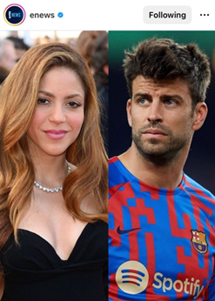
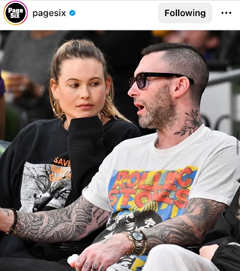
The first category to be analysed is the type of images employed in each post. As observed in Appendix B, which summarises the findings of the visual analysis, 13 posts (56.5%) comprise standalone photographs, while 10 (43.5%) are formed by collages (see Figures 1 and 2 for examples). Figure 3 shows that event photographs are the most popular type of images employed in the posts reporting on Levine and Piqué’s cheating scandals. 23 (65.7%) of the 35 pictures in the posts are event photographs. Instagram photographs taken from the celebrities’ personal accounts, on the other hand, were employed for 10 (28.6%) out of the 35 images, often in a collage together with an event picture. Lastly, only 2 (5.7%) ‘candid’ paparazzi snaps have been identified. These photographs are employed in Entertainment Tonight’s fourth post reporting on Adam Levine and Behati Prinsloo’s first public appearance following the cheating allegations (see Appendix A).
Figure 1: Example of collage (see Appendix A)
Figure 2: Example of stand-alone photograph (see Appendix A)
It can thus be concluded that photographs taken at red-carpet and other public events are the most frequently used types of images in E!News, Entertainment Tonight, and Page Six’s posts reporting on the aforementioned celebrity cheating scandals.
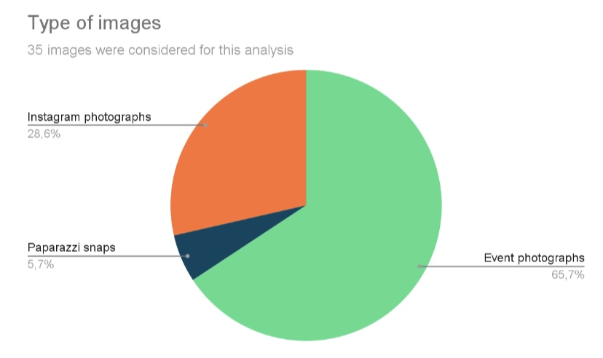
Figure 3: Type of images

Copyright Concerns
In connection to this, Figure 4 displays the findings related to copyright concerns in the celebrity cheating scandal posts. In each post, the source of the photographs is mentioned in the caption accompanying it. Original photographs were not present in any of the three publications’ posts. 71.4% of images are stock photographs, for which the publications needed the copyright holders’ permission, while 28.6% are Instagram photographs shared by celebrities on their personal accounts (see Figure 4). As Appendix B shows, the most popular source for stock photographs on all three accounts was Getty Images. The American supplier of stock images was mentioned as a source in 82.6% of the selected posts.
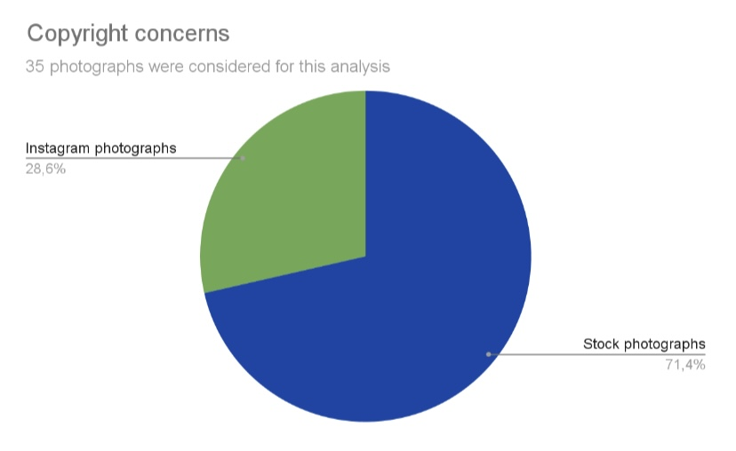
Figure 4: Copyright concerns
Copyright concerns have impacted the number of photographs publications have available for reports on both their social media accounts and their websites. It can indeed be observed that publications often employ either identical photographs or similar snaps from the same event for their Instagram posts. E!News, for instance, has employed two very similar photographs taken at the same red-carpet event for their first and fourth post reporting on Levine’s scandal (see Appendix A). Entertainment Tonight has used two pictures of Adam Levine from the same event in their second as well as in their third post reporting on the scandal (see Appendix A). Page Six has reused the same photographs of Sumner Stroh and Adam Levine for the collages in their second and third post discussing the cheating allegations by merely changing the order of the images (see Appendix A). Lastly, Page Six also selected the same Instagram photograph for the collages in their second and third post reporting on Piqué’s cheating scandal and his new girlfriend.

Semiotic Approach
The photographs have also been examined from a semiotic perspective by considering the angle of the pictures, the presence of any framing elements as well as the occurrence of any salient features.
The point of view in photographs allows subjects to be depicted from above, below, at eye-level, and from the front, the side, or the back (Van Leeuwen and Jewitt, 2001). 30 of the 35 pictures (86%) employed in the cheating scandal posts were taken from a frontal angle, as they were event photographs for which the celebrities posed (see Appendix B). The two ‘candid’ paparazzi snaps in the aforementioned Entertainment Tonight’s post, for instance, were taken from behind and the side since the subjects did not pose for the photographer.
Figure 5 shows the range of vertical angles in which the 35 photographs in the publications’ posts were taken. 40% of pictures were characterised by a low angle, the other 40% were taken at eye-level, while the remaining 20% were snapped from a slightly higher point of view.
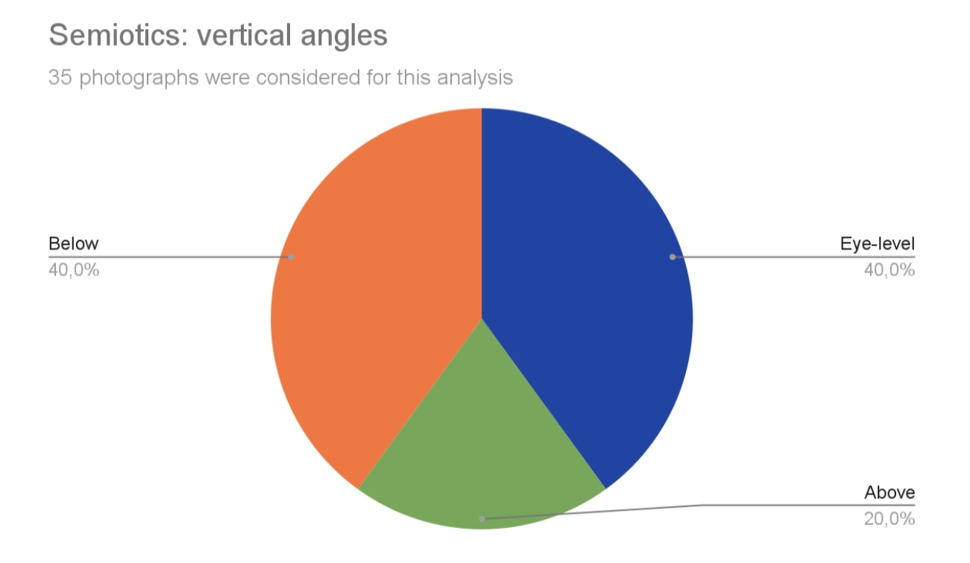
Figure 5: Range of vertical angles
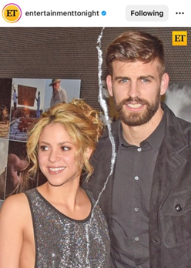
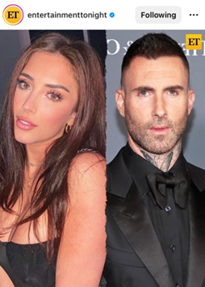
Framing elements were used sporadically in the posts, as only three presented noticeable features disconnecting two subjects of the same photograph or two separate pictures (see Appendix B). In a picture, framing elements refer to lines and other shapes which can represent the subjects of a composition either as separate identities or as belonging together (Van Leeuwen and Jewitt, 2001). Entertainment Tonight was the only publication using framing elements in their posts. In the publication’s second post reporting on Levine’s scandal, a wavy line is employed to divide the two photographs, while in their first and third post on Piqué’s scandal, a paper tear was added to separate the two subjects (see Figures 6 and 7).
Figure 6: Example of framing element (see Appendix A)
Figure 7: Example of framing element (see Appendix A)
Lastly, salience has been observed in 15 of the selected posts. Salience comprises those elements that make the content of an image more captivating than others through size, colour contrast, and any other feature making some aspects stand out from their surroundings (Van Leeuwen and Jewitt, 2001). Among the most frequently employed salience elements were large, embedded headlines or pull quotes as well as colour contrast. The headlines and pull quotes, however, were only present in the posts by E!News and Entertainment Tonight. Colour contrast was predominantly observed in photographs of Adam Levine and Behati Prinsloo, in which the singer is portrayed in darker colours, while the model is dressed in red or pink (see Appendix A).
The subjects’ facial expressions, similarly to colour contrast, are another striking feature of the selected photographs. Particularly in E!News’ posts, the photographs chosen to represent Levine and Piqué’s cheating scandals often depict the two men with a concerned and serious look on their faces (see Appendix A).

Comparison among the publications
A few differences and similarities were observed among the three publications’ choice and use of visual elements for their Instagram posts. E!News and Entertainment Tonight’s posts, for instance, present a very similar layout. Both publications make use of large, embedded headlines and pull-quotes in their posts. Page Six, on the other hand, does not embed any written text in their posts, but makes extensive use of collages. 75% of the selected Page Six’s posts are constituted by a composition of two photographs.
Taking into consideration the subjects of the selected photographs, it can also be observed that E!News’ posts do not present any images depicting the women involved in the reported affairs (see Appendix A). Entertainment Tonight and Page Six have included photographs of Sumner Stroh, the woman accusing Levine of cheating, and Clara Chia Marti, Gerard Piqué’s new girlfriend, in their posts discussing the scandals. E!News, on the other hand, solely makes use of pictures portraying the couple at issue.
The specific visual elements and features employed in each publication’s Instagram posts will be further explored in the discussion chapter of this dissertation, where the focus will be on the implications and meanings behind these choices.

Linguistic Analysis
The written text of the Instagram posts is another vital component to consider in light of celebrity news’ portrayal on the platform. Although Instagram is a photo-sharing medium, the written text remains an important factor contributing to the successful delivery of news messages. 23 Instagram posts from the accounts of E!News, Entertainment Tonight, and Page Six reporting on Adam Levine and Gerard Piqué’s cheating scandal have been evaluated in consideration of the linguistic tools they entail. Each post’s caption as well as the eventual headline or pull quote embedded in the accompanying image have been taken into consideration for this analysis.
The posts have been examined based on the occurrence of two pragmatic, two semantic, and five headline-writing techniques. The following linguistic techniques were explored: presupposition, allusion, semantic intensifiers, lexical intensifiers, connotation-rich vocabulary, first-name-only use, pseudo quotes, alliteration, and forward referencing.
While analysing the textual component of each post, two devices were added to the list since they occurred repeatedly: word play and the expression link in bio. Word play, for instance, has been frequently observed in expressions referencing Shakira’s songs in the posts reporting on her ex-husband Gerard Piqué’s cheating scandal. Furthermore, the phrase link in bio was also considered a linguistic element because it has been detected in every post’s caption.

Pragmatic Tools
Pragmatic tools constitute the first category to be analysed. As can be seen in Figure 8, presupposition occurs in 16 of the 23 posts (69.90%). It is, along with connotation-rich vocabulary, the second most prominent linguistic tool employed in the cheating scandal posts. Allusion, on the other hand, occurs with less frequency, as it was only identified in 5 posts (21.7%).
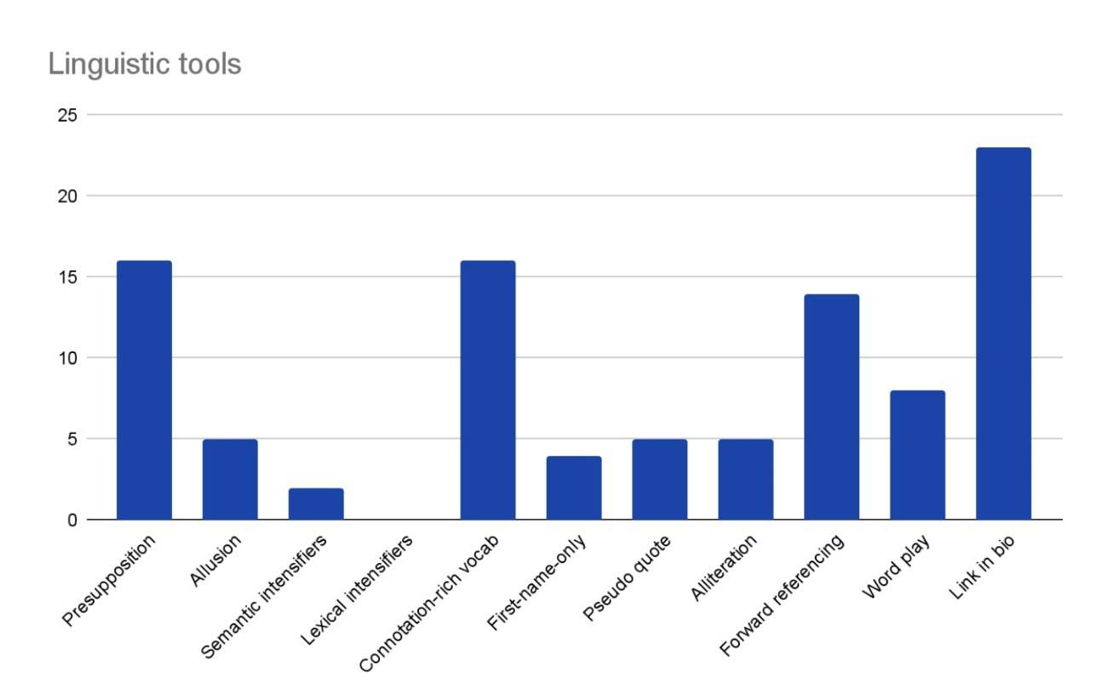
Figure 8: Linguistic tools
Presupposition was employed by all three publications. The editors of the posts continually assumed that readers were aware of the discussed celebrities’ relationship statuses and that they had seen previous posts concerning the scandals. For instance, in the posts reporting on Gerard Piqué’s cheating scandal, it was continuously presumed that readers knew about the footballer and Shakira’s marriage and their recent divorce, as these details were rarely mentioned.
Allusion, which can be observed in those instances where Adam Levine is referred to as the “Maroon 5 frontman” or “Maroon 5 singer”, is solely employed in the posts by Page Six (see Appendix C). Contrary to Al-Hindawi and Mehdi’s findings, allusion is not extensively employed in the celebrity news posts shared by E!News, Entertainment Tonight, and Page Six on their Instagram accounts.

Semantic Tools
Looking at semantics, Figure 8 shows that intensifiers have been employed sparingly in the selected posts. Semantic intensifiers have only been observed in 2 of the posts (8.7%), while lexical intensifiers were completely absent. Although the usage of intensifiers in news stories is considered an indicator of sensationalism, which is extensively present in celebrity journalism, these two semantic devices were not employed abundantly in the selected posts from the Instagram accounts of E!News, Entertainment Tonight, and Page Six.

Headline-Writing Techniques
With regard to headline-writing techniques, it can be observed that connotation-rich vocabulary and forward referencing are the most frequently used devices (see Figure 8). Connotation-rich vocabulary, consisting of the use of words that get the attention of the reader through reference to a particularly interesting topic (Schaffer 1995), occurs in 16 of the 23 posts (69.60%). The most common words in this category are affair, rumors, alleged affair, allegations, cheat, cheating allegations, and unfaithful (see Appendix A). Because these words immediately refer to the type of gossip being reported, they easily catch Instagram users’ attention.
Forward referencing, on the other hand, occurs in 14 posts (60.9%) (see Figure 8). This headline-writing technique frequently occurs in the last sentence of the posts, which lures users to click on the link in the account’s bio to read the full story, which is only hinted at in the caption. As a headline-writing technique, forward referencing is a linguistic category whereby a word, e.g., a pronoun or an adverb, refers to something that is explained later, oftentimes in the article itself (Lagerwerf and Govaert, 2021). In the selected posts, the definite article the preceding nouns such as full story, details, and situation, or pronouns like those and it function as a reference to something that is only revealed at the link in bio.
Occasionally employed headline-writing techniques are first-name-only use, pseudo quotes, and alliteration. The celebrities discussed in the posts were only referred to by their first name in 4 instances (17.4%). The concept behind only using celebrities’ first names is that readers feel as if they know these people personally; hence, they do not need their full names to identify them (Schaffer 1995). Nevertheless, in the selected posts, this has been better achieved by the use of presupposition. By employing this pragmatic technique, editors assume that readers are invested in celebrities’ lives thus not needing extensive details on previous stories.
Pseudo quotes only appear in 5 of the 23 posts (21.7%). Similarly to first-name-only use, pseudo quotes are another device used to promote readers' feeling of closeness to the individuals featured in tabloid articles (Schaffer 1995). These statements are treated as if they were direct quotes, but they are often introduced by ambiguous expressions such as an “insider tells People” (see Appendix A). The use of pseudo quotes gives readers a feeling of involvement in the story and a sense that the information is authentic.
Alliteration, which consists of the repetition of the same letter or sound at the beginning of a series of words in a sentence, occurs in 5 posts (21.7%) and concomitantly with word play (see Appendix C). Alliteration solely occurred in posts reporting on Piqué’s cheating scandal and, in four of the five instances, it consisted of the repetition of the letter s or the sound sh. Alliteration can be observed in the repetition of the sound sh in the following sentence, “Shakira did not shy away from a little shade” (see Appendix A). Furthermore, alliteration and word play are only employed in posts by Entertainment Tonight and E!News.

Word play and link in bio
Considering their frequent occurrence in E!News, Entertainment Tonight, and Page Six’s posts, two additional textual elements were considered for the analysis. The posts were examined based on the use of word play, and the presence of the expression link in bio. While word play occurred in 8 of the posts, the expression link in bio was employed in all 23 posts (see Figure 8).
Word play predominantly occurs in posts reporting on Gerard Piqué’s cheating scandal; indeed, in only one instance, a pun was detected in a report on Levine’s alleged affair (see Appendix C). The word play in Piqué’s cheating scandal posts, are usually references to Shakira’s songs and can thus only be understood by those familiar with her music. Her song “Hips Don’t Lie” was the most frequently referenced in connection to her ex-husband’s infidelity. An instance thereof can be observed in the expression “Her lyrics don’t lie”, employed in Entertainment Tonight’s second post on the scandal to discuss Shakira’s new song, in which she references her ex Gerard Piqué and his younger girlfriend (see Appendix A)
The use of word play, i.e. puns, in headlines shares much in common with the language employed in advertising (Alexander, 1986). Both advertisers and editors employ puns in their slogans and headlines to catch the audience’s attention (Alexander, 1986). The use of puns in article headlines has also been associated with tabloid journalism, where catching the reader’s eye is often more important than informing them.
The omnipresence of the expression link in bio is closely tied to Instagram’s ad revenue system. Social media’s unbalanced ad revenue has affected news publications sharing content on platforms like Instagram. Because they do not receive any ad revenues from the platform on which they publish content, news outlets are compelled to drive traffic to their websites. The link in bio becomes a central element for publications and is thus repeatedly mentioned in the Instagram captions accompanying a news story post.
E!News, Entertainment Tonight, and Page Six direct users to their link in bio in every post’s caption because they want to drive traffic to their own website, where they receive ad revenues as compared to Instagram, where, on the contrary, they lose it to Meta owning the platform.

Typos
A surprising element which was noted while analysing the textual component of the posts were the typos identified in some of the captions. In Entertainment Tonight’s fourth post discussing Adam Levine’s cheating scandal, Behati Prinsloo’s first name was spelled incorrectly (see Appendix A). In both E!News’ first and third post reporting on Gerard Piqué’s cheating scandal, the supplier of stock images Shutterstock was spelled incorrectly in the captions (see Appendix A).
A potential explanation behind these typos can be found in the restricted amount of time and attention that may be dedicated to the creation of social media content. Because publications do not receive any advertising revenues from sharing news stories on their Instagram accounts, the posts might not be subedited and checked for grammatical errors and typos. More attention, on the other hand, might be devoted to the articles on their websites.
This detailed analysis of the textual component of the selected Instagram posts has allowed for a more comprehensive understanding of how celebrity news stories are delivered to users on the platform. The breakdown of the posts’ text has also highlighted the most prominent linguistic tools employed by E!News, Entertainment Tonight, and Page Six to report on Gerard Piqué and Adam Levine’s cheating scandals. The meaning behind the use and frequency of the linguistic tools in the selected posts will be examined in more detail in the following section.

Discussion
The content analysis of celebrity cheating scandal posts on the Instagram accounts of E!News, Entertainment Tonight, and Page Six has served as a valuable method to explore the visual and linguistic modes of representation concerning this news genre. The selection of 23 Instagram posts portraying two different cheating scandals and taken from three distinct entertainment publications allows for a thorough investigation of the use and frequency of these reporting techniques. Additionally, the findings function as a springboard for a more comprehensive analysis relating to the implications and motives behind these modes of representation. Because of the variety of visual and linguistic tools explored in the posts of three different publications, this dissertation functions as a representative exemplification of the portrayal of celebrity news on Instagram.

Research Question 1
As the visual and linguistic analysis of E!News, Entertainment Tonight, and Page Six’s Instagram posts demonstrates, several graphic and linguistic tools are employed to represent celebrity cheating scandals on the forenamed publications’ accounts.
The use of stand-alone photographs, collages, event photographs, stock images, and salience elements are the key visual tools employed to portray Adam Levine’s and Gerard Piqué’s cheating scandals on the Instagram accounts of E!News, Entertainment Tonight, and Page Six.
Focusing on the written component then, link in bio, presupposition, connotation-rich vocabulary, forward referencing, and word play are the main linguistic tools employed to portray celebrity cheating scandals on the Instagram accounts of E!News, Entertainment Tonight, and Page Six.
Because the frequency of the aforementioned visual and linguistic tools is not accidental, the next section will explore their occurrence in relation to the features and regulations of Instagram, as well as the sensational nature of celebrity journalism in the 21st century.

Research Question 2
In order to comprehend how the visual and linguistic tools employed in E!News, Entertainment Tonight, and Page Six’s Instagram posts contribute to the creation of sensationalism, it is pivotal to look into the implications of their use.
By focusing on the meanings behind the visual and linguistic tools identified in the content analysis, it will be possible to understand how and to what extent they sensationalise the news stories in which they are employed. The motives behind the choice of the visual and linguistic reporting techniques will also be explored by taking into account more practical factors, e.g., relating to copyright concerns, workflow of the media, and application-specific features of Instagram.

Implication of visual tools
Instagram first emerged as a photo-sharing platform, its key purpose being entertainment. Images have thus always played a pivotal role in the medium; nonetheless, as advertisers, businesses, and news publications gradually moved onto the platform, the visual component of posts has been taken to a new level. Photographs, graphics, and drawings must not only fulfil an entertaining purpose, but they must also captivate users scrolling through the app.
For news publications that share content on Instagram, pictures become a pivotal tool to grab audiences’ attention. Most social media users encounter information somewhat accidentally on the platforms (Boczkowski et al., 2017); thus, news items have to be appealing for a person to stop scrolling, read the caption, and eventually clink on the link in bio.
As Buike asserts, photographs are visual magnets arresting readers’ attention (2021). Because the image is the first item that Instagram users notice while looking through posts, it is the first and sole possibility news publications have to catch their attention.
Analysing the motives and subsequent implications of the visual devices will provide an explanation for how Instagram posts captivate users’ attention and to what extent the techniques contribute to the creation of sensationalism.
As Appendix B shows, stand-alone photographs and collages occur with similar frequency. Stand-alone photographs are employed in those instances where solely the couple at issue is depicted. Collages, on the other hand, are employed to showcase more pictures simultaneously. Both representation types display the images available in a straightforward manner, in that users do not have to engage with the post any further to view its visual content.
Taking into consideration the types of images employed in the posts, event along with Instagram photographs comprise 94.3% of the pictures (see Appendix B). Both types usually comprise the images in which the subjects can be best recognised, as they are taken from a frontal perspective and have higher quality as opposed to ‘candid’ paparazzi snaps.
An essential feature of celebrity news stories is that the subjects at issue are recognisable to the audience. Not every reader will know the names of the celebrities involved in a tabloid story; however, a photograph of the subject can help audiences make the visual association in their brains. In other words, if an Instagram user is presented with a clear and high-quality picture of a celebrity, they are more likely to recognise the subject and be intrigued by the story.
Furthermore, the choice of using event or Instagram photographs is motivated by copyright concerns. News publications may not always receive permission from copyright holders and are thus compelled to use stock images, many of which are event photographs. Similarly, Instagram pictures shared on the platform by the celebrities themselves can only be employed by news publications in those instances in which they were able to get permission.
From a semiotic perspective, it is worth discussing the range of vertical angles from which the photographs were taken. According to Van Leeuwen and Jewitt, the choice to portray a subject from above, below, or at eye-level, can communicate symbolic power or equality to the viewers (2001). A photograph of a celebrity at eye level can imply familiarity and immediacy to the viewer, one from below hints at the subject’s superiority towards the reader; lastly, a picture taken from above may suggest detachment or disdain for the depicted subject. However, as Van Leeuwen and Jewitt also stress, power, detachment, and involvement are only possible meanings of these angles (2001); thus, they should not be considered definite interpretations thereof.
In the case of E!News, Entertainment Tonight, and Page Six, the images employed in their posts are predominantly stock photographs and not originals; therefore, the angles may not have been considered as attentively by the editors. Considering the limited access publications have to stock images, the angle of the photographs in their posts should not be decoded verbatim.
Another semiotic resource to explore is salience. Although contrast was a frequent salience element detected in the posts, it should again be acknowledged that most of the photographs are taken from suppliers of stock images and may not have been as meticulously examined by the editors before selecting them for publication. The salience elements added by the publications themselves, however, take on a more meaningful role.
The large headlines and pull quotes embedded in the photographs or the paper tear added to two Entertainment Tonight’s posts on Piqué’s scandal are pivotal salience elements to consider as they were purposely included (see Appendix A). The paper tear, for instance, adds a dramatic effect to the image giving a visual representation of Shakira and Piqué’s divorce. The embedded headlines and pull quotes function as attention-grabbing elements. The headlines summarise the content of the caption and because of their size, it is more likely that an Instagram user will stop scrolling to read them. The pull quotes, on the other hand, attract attention by offering a teaser to draw the reader into the story.
The photographs and the accompanying visual elements function as pivotal means to design appealing and intriguing Instagram posts on the accounts of E!News, Entertainment Tonight, and Page Six. The selection of the photographs in the publications’ posts is motivated by copyright concerns, access and availability of stock images, the sensational nature of tabloid news, as well as Instagram’s ad revenue system.
Celebrity news is inherently sensational. Sensational and attention-grabbing reporting techniques can be considered synonymous, in that sensationalism is defined as the over-hyped representation of trivial news stories to increase readership figures (Uzuegbunam and Udeze, 2013). In other words, by employing techniques that captivate readers, publications are creating sensational news content. Although attracting audiences has always been celebrity news publications’ key goal, its importance has increased on a platform like Instagram.
Because on social media, new outlets are not receiving any advertising revenues, which they would typically receive on traditional media, attracting users’ attention has become even more essential to publications.
To answer the first part of the second research question, it can be concluded that the visual tools employed in the celebrity cheating scandal posts by E!News, Entertainment Tonight, and Page Six are aimed at attracting users’ attention thus contributing to the creation of sensationalism.

Implication of linguistic tools
The written or spoken text is the most essential element of any news report, as it shapes a story, and through an attentive selection of linguistic devices, it conveys values and messages.
Even though Instagram is a photo-sharing platform, written text is pivotal to delivering news messages efficiently. The written component of Instagram posts can be found both embedded in the image in form of a headline or pull quote, and in the caption, where the text cannot exceed 125 characters to be viewed in its entirety by users.
The image constituting an Instagram news post is the first element users notice when scrolling through the platform. After the image captivates the audience, the eventual embedded headline or pull-quote followed by the caption must hold their attention to entice them to click on the link in bio. As a result, the news text ought to be presented in an intriguing and dramatic manner.
Analysing the motives and subsequent implications of the linguistic devices will allow for a greater understanding of how the Instagram posts are aimed at captivating users’ attention and to what extent these techniques contribute to the creation of sensationalism.
As Appendix C shows, presupposition was the most common pragmatic tool employed in the celebrity cheating scandal stories, and it was also one of the most popular linguistic devices. Presupposition, which is the omission of certain facts from a story, is only successful provided that the audience is already aware of the relationship statuses of the celebrities at issue for instance, or that users have read previous articles and/or posts concerning the topic.
The use of this pragmatic tool is rooted in the follow-up news value outlined by Harcup and O’Neill (2017) in their seminal work. Follow-up as a news value can indeed be observed in the continuous, implicit assumptions about Adam Levine and Behati Prinsloo’s, Gerard Piqué and Shakira’s relationships. It is assumed that people who read entertainment news follow these stories unfold and do not necessitate further details on the discussed celebrities.
Presupposition also creates a feeling of involvement and closeness between the celebrities portrayed in the posts and the readers. By assuming that the readers know the backstory of a gossip story, they are led to believe that they know the subject somewhat personally. Allusion, first-name-only use, and pseudo quotes, although used less frequently, fulfil a similar function, in that they create a sense of intimacy and involvement (Schaffer, 1995).
Semantic tools, on the other hand, occur sporadically. According to Burgers and Graaf’s research study semantic and lexical intensifiers are employed to increase an article’s newsworthiness and thus sensationalise its content. Nonetheless, the analysed celebrity cheating scandal posts do not follow this trend, as only two posts present sematic intensifiers (see Appendix C).
Instead of creating an appealing and newsworthy story through language intensity, the posts of E!News, Entertainment Tonight, and Page Six make extensive use of connotation-rich vocabulary. Connotation-rich vocabulary, which consists in the use of words that grab the attention of the reader through explicit reference to sensational topics (Schaffer, 1995), is an essential technique to captivate Instagram users, as it summarises the key points of the celebrity gossip at issue.
Forward referencing was among the most common linguistic tools employed in the analysed posts functioning as an essential technique to captivate the audience and lure them to click on the link in bio to obtain further details on the story. Particularly on Instagram, driving traffic to their websites is vital for publications sharing news content on the very platform. By using the technique of forward referencing, the editors of the posts suggest that there is more information to the story, which can only be discovered by reading the full article at the link.
Word play and the use of the expression link in bio are two techniques that were added to the list of linguistic tools because of their frequency in the analysed posts. Word play is extensively common in English-language advertising, where it fulfils the role of attracting and maintaining the audience’s attention (Díaz-Pérez, 2012). Similarly, in entertainment news, word play functions as an attention-grabbing device. Because of its unusual use of language, word play stands out and is thus more likely to be noticed by the reader. Furthermore, word play is entertaining because finding the meaning behind a pun can be compared to solving a riddle (Wylie, 2018).
The expression link in bio, identified in every analysed post, fulfils a similar function to forward referencing, in that it refers to the virtual space in which more information on the story at issue will be disclosed. Because of Instagram’s ad revenue system, news publications like E!News, Entertainment Tonight, and Page Six rely on grabbing users' attention and enticing them to click on the link leading to their websites.
While linguistic devices such as presupposition, allusion, first-name-only use, and pseudo quotes are aimed at creating a feeling of involvement and closeness between the subjects of the celebrity cheating scandals and the audience, other tools such as connotation-rich vocabulary, alliteration, forward referencing, word play, and link in bio are intended to attract users.
The explanation behind the frequent use of attention-grabbing linguistic elements lies behind the sensational nature of celebrity news, but most importantly behind the lack of ad revenue received by publications sharing news on Instagram. Deprived of ad revenues but pressured to maintain their presence in the digital world (Binns, 2021), news publications must craft intriguing and captivating posts through which they can then drive traffic to their websites.
To answer the second part of the second research question, it can be concluded that by involving users and attracting their attention, the linguistic tools employed in the celebrity cheating scandal posts on the accounts of E!News, Entertainment Tonight, and Page Six contribute to the creation of sensationalism.

Research Question 3
The present study has identified a considerable number of both visual and linguistic devices employed to attract users’ attention on a platform like Instagram where driving traffic to their websites is the only possibility publications have to receive ad revenues.
The means in which the visual and linguistic components of the news story relate to audience engagement, however, cannot be explored. The like and comment count of the posts is not visible on any of the three accounts since on Instagram, users, as well as businesses and publications, can hide their like and comment count from others.
The third research question, which comprised the investigation of the number of likes and comments under the celebrity cheating scandal posts of E!News, Entertainment Tonight, and Page Six, can thus not be answered. I have written an email to the social media managers of E!News, Entertainment Tonight, and Page Six enquiring about their choice, but I have not received any response.
Two possible explanations behind the publications’ decision to hide the like and comment count on their posts have been identified. One of the reasons behind their choice may lie in the competitive dynamics of online markets and, more specifically on digital platforms, an issue explored in the OECD Competition Committee discussion paper (OECD, 2021). Digitalisation has indeed increased competition among news publishers as a consequence of the broader reach of professional news content as well as the increasing number of non-professional sources available on the web and social media (OECD, 2021). As a result of the rising competition among news publishers on social media, it can be assumed that E!News, Entertainment Tonight, and Page Six have decided to hide their like and comment count in order to conceal these figures from other publications.
The second explanation behind the news outlets’ distinctive decision is the low and limited engagement the celebrity cheating scandal posts may have received, and the subsequent need to hide the number of likes and comments under the posts.
Nonetheless, without a concrete response from the publications’ social media managers, solely assumptions regarding the choice to keep the numbers of audience engagement private can be made.

Limitations
While the present research study has indeed provided new insights into news circulation on social media and into the reporting style of celebrity journalism on Instagram, the content analysis of the posts has also exposed its limitations.
The inability to answer the third research question relating to audience engagement under the celebrity cheating scandal posts can indeed be considered the main limitation of this dissertation.
Further limitations relate to the dataset employed in the analysis. Because both the word count and the amount of time available for this dissertation were important factors to consider, only two cheating scandals were explored. The findings resulting from the analysis of Adam Levine and Gerard Piqué’s cheating scandal posts have thus served as representative cases for the portrayal of celebrity news on Instagram. Although Levine’s and Piqué’s cheating scandals do not account for all gossip of this genre published on E!News, Entertainment Tonight, and Page Six’s Instagram, they offer an insight into celebrity journalism’s presence on the platform.
Another limitation can be observed in the sporadic occurrence or even absence of some of the visual and linguistic elements in the posts. Semantic and lexical intensifiers, for instance, although extensively discussed in the literature review, were practically absent in the posts. Similarly, original photographs were not employed in any of the analysed celebrity cheating posts. Both these techniques were expected to occur frequently in the posts based on previous academic research and personal observations made while consuming celebrity news on the platform. Nonetheless, the content analysis has contradicted these expectations.

Conclusion
With the advent of social media and their increasing importance as news-sharing platforms, celebrity journalism has adopted a variety of strategies and techniques to produce and disseminate content. In order to keep abreast with the digitalisation of the news landscape, publications have moved onto social media creating content specifically for these platforms. News sharing on social networks is an intriguing phenomenon to investigate, as these platforms function differently from more traditional forms of media.
Instagram in particular has gradually gained popularity as a social media platform among US citizens; indeed, as of 2021, 40% of adults reported using the site (Schaeffer, 2021). The application has also become an essential medium for news circulation, and numerous publications, which would previously only share stories on their websites, have proceeded to post content on the platform (Khalisah and Anjarningsih, 2020).
Instagram offers innovative tools to news publications for the creation of compelling and engaging news stories. Posts can be pushed using hashtags, shared by users to an even wider audience, and news stories can be published employing text, images, videos, and audio effects.
Among the many news outlets using Instagram to disseminate their stories are celebrity gossip publications. Because of Instagram’s peculiar features, the platform presents itself as an appealing news-sharing medium for this journalism genre. Instagram is principally a venue for entertainment and became a platform for news content only recently; therefore, it complements celebrity journalism’s duality: entertaining and informing audiences. Furthermore, taking into consideration the genre’s sensationalistic reporting style, Instagram’s emphasis on visual elements, as well as on short and compact text suits the purpose of entertainment news.
In order to comprehend the dynamics between celebrity journalism and Instagram’s role as a news-sharing platform, the present paper has investigated the portrayal of celebrity cheating scandals on the accounts of E!News, Entertainment Tonight, and Page Six.

Research questions and aims achieved
The evaluation of 23 Instagram posts reporting on Levine’s and Piqué’s respective cheating scandals and shared by E!News, Entertainment Tonight, and Page Six shows that both visual and linguistic tools are extensively employed by the publications to enhance their content. The mixed quantitative and qualitative content analysis of the cheating scandal posts allows me to address and answer the research questions of this dissertation.
- What visual and linguistic tools are employed to portray celebrity cheating scandals on the Instagram accounts of E!News, Entertainment Tonight, and Page Six?
The use of stand-alone photographs, collages, event photographs, stock images, and salience are prominent visual tools employed to portray the two cheating scandals on the publications’ accounts. Presupposition, connotation-rich vocabulary, forward referencing, wordplay, and the expression link in bio, on the other hand, are the most common linguistic tools employed to depict this genre of gossip.
- How do the visual and linguistic tools employed in E!News, Entertainment Tonight, and Page Six’s Instagram posts contribute to the creation of sensationalism?
Based on previous academic research on sensational reporting style, headline-writing techniques, and taking into consideration the medium-specific features as well as the ad revenue system of Instagram, the usage of these visual and linguistic tools contributes to the creation of sensationalism, in that they function as attention-grabbing devices. In other words, the juxtaposition of visual and linguistic tools aimed at captivating users’ attention and enticing them to click on the link in bio lead to the production of sensational news stories.
Users are persuaded to click on the link situated in the accounts’ bio, as it is the only possibility for publications to drive traffic to their websites and receive ad revenues. The inability to share multiple links on Instagram along with the platforms’ unfair ad revenue system are central factors to consider with regards to the frequent use of attention-grabbing elements in the posts.
- Taking into consideration the number of likes and comments under the celebrity cheating scandal posts of E!News, Entertainment Tonight, and Page Six, how do the visual and linguistic tools relate to audience engagement?
The investigation of audience engagement in relation to the visual and linguistic elements of E!News, Entertainment Tonight, and Page Six’s posts could not be conducted in this research study. The Instagram-specific feature to hide the like and comment count under an account’s post has hindered the examination of audience engagement.
By investigating the means through which celebrity cheating scandals are portrayed on Instagram, this dissertation has shed light on the dynamics between news production on Instagram and the reporting style of celebrity journalism on the very medium.
Through the analysis of the portrayal of celebrity cheating scandals on Instagram, this dissertation has contributed both to academic studies on social media’s role in the news landscape and to journalistic research on entertainment news.

Suggestions for future research
Future research on the topic could explore the portrayal of celebrity news on other social networks by conducting a comparative analysis. It would be interesting to investigate potential differences and similarities in the depiction of this news genre on two or more social media platforms. Because a number of the visual and linguistic devices identified in E!News, Entertainment Tonight, and Page Six’s posts are closely tied to Instagram’s features and its business model, an investigation of how celebrity journalism is represented on other platforms could lead to a deeper understanding of the current media landscape.
Moreover, further research could focus more specifically on audience engagement. Instead of relying on like and comment count, future studies could conduct interviews with people consuming celebrity news on social media in order to get a better understanding of how the visual and linguistic tools employed in posts attract the audience’s interest.
In order to examine the phenomenon from a different perspective, further studies could consider the producers of social media news posts instead of the consumers. Qualitative interviews with journalists working in the digital sphere of news production can be particularly useful to explore the pressures emerging from creating content in such a competitive environment. Through these interviews, the workflow and the dynamics of digital journalism, particularly in the context of social media, can be compared to those observed in more traditional media, e.g., print, television, or radio.
Interviewing journalists working in the field can also lead to a deeper understanding of the motives that lie behind the use of certain reporting techniques on social media. On a similar note, qualitative interviews may reveal further details on the ad revenue system of companies like Meta and exemplify the means in which journalists as well as publications make a profit in the contemporary media landscape.

Final Observations
As a researcher, a media and communications student, and a news consumer, investigating the portrayal of celebrity news on Instagram has allowed me to consider social media and the contemporary news landscape from a different perspective.
The classification of the main visual and linguistic tools used in the celebrity cheating scandal posts has not only shed light on the pressures faced by publications to captivate audiences’ attention in social media’s competitive environment but also on the continuously sinking attention span of users.
As a result of the digitalisation and the fragmentation of news, consumers are overwhelmed by the overflow of information. Society is confronted with a growing variety of platforms and media from which to choose. In this state of media pluralism, social media has established itself as a prominent channel for news consumption offering users brief and compact information, as well as the advantage of viewing stories on the same platform they use for entertainment purposes. Consequently, people have become familiar with this new mode of information delivery which, in turn, has negatively impacted their attention spans.
Furthermore, the analysis of the impact of Instagram’s business strategies on news publications sharing content on the platform highlights the importance of educating consumers. Many Instagram users are unaware of the unfair ad revenue system of social media, and they are oblivious to the fact that publications do not profit from sharing their news stories on these platforms.
I believe that particularly in schools more time should be devoted to clarifying how news is produced and how it is disseminated across the various media. Because younger generations present an important demographic with regard to social media use, middle and high school students should be taught how news circulation functions on platforms like Instagram and be made aware of the advantages and disadvantages thereof.
Not only younger generations but all news consumers should be informed of the systems underpinning the contemporary media landscape. I believe that more awareness on the issue should be spread by news publications, journalists, and governments. I also believe that social media platforms should and could operate with more transparency.

Bibliography
Abernathy, P.M. (2020) News Deserts and Ghost Newspapers: Will Local News Survive? Chapel Hill: University of North Carolina Press Available at: https://www.usnewsdeserts.com/reports/news-deserts-and-ghost-newspapers-will-local-news-survive/the-news-landscape-in-2020-transformed-and-diminished/vanishing-newspapers/ (Accessed: 3 June 2023).
Alexander, R.J. (1986) ‘Article Headlines in “the Economist”. An Analysis of Puns, Allusions and Metaphors’. AAA: Arbeiten Aus Anglistik Und Amerikanistik, 11(2), pp. 159–177.
Al-Hindawi, F.H. and Mehdi, M.K. (2017) ‘A Pragmatic Approach to British and American Entertainment and Celebrity News Reports’. British Journal of English Linguistics, 5(2), pp. 29–50. DOI: 10.1016/j.lingua.2016.11.004.
Al-Rawi, A., Al-Musalli, A. and Fakida, A. (2021) ‘News Values on Instagram: A Comparative Study of International News’. Journalism and Media, 2(2), pp. 305–320. DOI: 10.3390/journalmedia2020018.
Asemah, E.S. (2014) ‘Sensationalism as a Style for Drawing Reader’s Attention to Newspaper Pages’. In Ihejirika, W.C. and Ochonogor, C.I. (eds.) Style in Media Production: Essays in Honour of S.A Ekwelie. Port Harcourt: Unique Printing and Publishing Company.
Bengtsson, M. (2016) ‘How to Plan and Perform a Qualitative Study Using Content Analysis’. NursingPlus Open, 2, pp. 8–14. DOI: 10.1016/j.npls.2016.01.001.
Binns, A. (2021) ‘Journalism: Digital Giants Paying for Content Is Good News, but Will It Support Local Press?’ The Conversation, 1 March. Available at: http://theconversation.com/journalism-digital-giants-paying-for-content-is-good-news-but-will-it-support-local-press-156074 (Accessed: 4 July 2023).
Blom, J.N. and Hansen, K.R. (2015) ‘Click Bait: Forward-Reference as Lure in Online News Headlines’. Journal of Pragmatics, 76, pp. 87–100. DOI: 10.1016/j.pragma.2014.11.010.
Boczkowski, P., Mitchelstein, E. and Matassi, M. (2017) ‘Incidental News: How Young People Consume News on Social Media’. Proceedings of the 50th Hawaii International Conference on System Sciences, pp. 1785–1792.
Bonner, M. (2023) ‘Shakira Allegedly Realized Gerard Piqué Was Cheating on Her Thanks to Some Jam’. Cosmopolitan, 19 January. Available at: https://www.cosmopolitan.com/entertainment/celebs/a42565549/shakira-gerard-pique-cheating-jam/ (Accessed: 29 June 2023).
Boorstin, D.J. (1992) The Image: A Guide to Pseudo-Events in America. New York: Random House.
Bowd, K. (2016) ‘Social Media and News Media: Building New Publics or Fragmenting Audiences?’ In Griffiths, M. and Barbour, K. (eds.) Making Publics, Making Places. University of Adelaide Press, pp. 129–144. Available at: https://www.jstor.org/stable/10.20851/j.ctt1t304qd.13 (Accessed: 3 July 2023).
Buike, O. (2021) ‘Relevance of Photographs in Newspaper Journalism’. Central Asian Journal of Social Sciences and History, 2(10), pp. 97–107.
Burgers, C. and Graaf, A. de. (2013) ‘Language Intensity as a Sensationalistic News Feature: The Influence of Style on Sensationalism Perceptions and Effects’. Communications - The European Journal of Communication Research, 38(2), pp. 1–34. DOI: 10.1515/commun-2013-0010.
Burnett, D. (2022) ‘Parasocial Relationships: When Your Favourite Celebrities Feel like Friends’. BBC Science Focus Magazine, 28 June. Available at: https://www.sciencefocus.com/the-human-body/parasocial-relationships-when-your-favourite-celebrities-feel-like-friends/ (Accessed: 7 June 2023).
Buxton, M. (2018) You’ve Probably Broken Copyright Laws On Instagram, Without Even Realizing It. Refinery29. Available at: https://www.refinery29.com/en-us/2018/04/196864/instagram-copyright-dos-donts (Accessed: 6 July 2023).
Cambridge Dictionary (2023a) ‘Semiotics’. Available at: https://dictionary.cambridge.org/dictionary/english/semiotics.
Cambridge Dictionary (2023b) ‘Sensationalism’. Available at: https://dictionary.cambridge.org/dictionary/english/sensationalism (Accessed: 31 May 2023).
Caple, H. and Bednarek, M. (2016) ‘Rethinking News Values: What a Discursive Approach Can Tell Us about the Construction of News Discourse and News Photography’. Journalism, 17(4), pp. 435–455. DOI: 10.1177/1464884914568078.
Carson, A. (2017) ‘Explainer: What Is Public Interest Journalism?’ The Conversation, 14 June. Available at: http://theconversation.com/explainer-what-is-public-interest-journalism-78996 (Accessed: 20 May 2023).
Chung, G. (2022) Adam Levine and Behati Prinsloo Step Out Together Amid Cheating Allegations. E! Online. Available at: https://www.eonline.com/news/1347201/adam-levine-and-behati-prinsloo-step-out-together-amid-cheating-allegations (Accessed: 29 June 2023).
Conboy, M. (2014) ‘Celebrity Journalism – An Oxymoron? Forms and Functions of a Genre’. Journalism, 15(2), pp. 171–185. DOI: 10.1177/1464884913488722.
de Cornière, A. and Sarvary, M. (2022) ‘Social Media and News: Content Bundling and News Quality’. Management Science, 69(1), pp. 162–178. DOI: 10.1287/mnsc.2022.4341.
Daniel, C. (2023) Instagram Revenue and Growth Statistics (2023). SignHouse. Available at: https://www.usesignhouse.com/blog/instagram-stats (Accessed: 19 May 2023).
Danielsson, K. and Selander, S. (2021) ‘Semiotic Modes and Representations of Knowledge’. In Danielsson, K. and Selander, S. (eds.) Multimodal Texts in Disciplinary Education: A Comprehensive Framework. Cham: Springer International Publishing, pp. 17–23. DOI: 10.1007/978-3-030-63960-0_3.
Díaz-Pérez, F.J. (2012) ‘The Use of Wordplay in Advertisements Published in Men’s Magazines. A Comparative Study in the UK and Spain’. Estudios Ingleses de La Universidad Complutense, 20, pp. 11–36. DOI: 10.5209/rev_EIUC.2012.v20.39993.
Dixon, S. (2023) Instagram-Statistics & Facts. Statista. Available at: https://www.statista.com/topics/1882/instagram/ (Accessed: 19 May 2023).
Doussot, A. (2023) (97 Printemps) ‘The Author Inside: Celebrity Photography 1840‒1902’. Cahiers Victoriens et Édouardiens, (97 Printemps), pp. 1–22. DOI: 10.4000/cve.12955.
Dubied, A. and Hanitzsch, T. (2014) ‘Studying Celebrity News’. Journalism, 15(2), pp. 137–143. DOI: 10.1177/1464884913488717.
E! Online (2023) #BePopCultured With E!. Available at: https://www.eonline.com/about (Accessed: 6 June 2023).
Eisenach, J.A. (2023) Meta and the News: Assessing the Value of the Bargain. Washington DC: Nera Economic Consulting.
Entertainment Tonight (2023) About Entertainment Tonight. Available at: https://www.etonline.com/about (Accessed: 6 June 2023).
Faria, J. (2023) Annual Instagram Advertising Revenues in the United States from 2018 to 2023. Statista. Available at: https://www.statista.com/statistics/1104447/instagram-ad-revenues-usa/ (Accessed: 6 June 2023).
Farrell, N. (2013) ‘Celebrity Journalism: Navigating the Stars’. In Journalism: New Challenges. Poole, UK: Centre for Journalism & Communication Research, Bournemouth University, pp. 367–383.
Gay, C. (2018) ‘What Is Celebrity Journalism?’ Medium, 28 December. Available at: https://medium.com/@chloehgay/what-is-celebrity-journalism-ed2f819c5f88 (Accessed: 19 May 2023).
Guaglione, S. (2023) ‘Publishers Move Past Seeing Social Media Platforms as Traffic Drivers’. Digiday, 10 March. Available at: https://digiday.com/media/publishers-move-past-seeing-social-media-platforms-as-traffic-drivers/ (Accessed: 30 May 2023).
Harcup, T. and O’Neill, D. (2017) ‘What Is News?’ Journalism Studies, 18(12), pp. 1470–1488. DOI: 10.1080/1461670X.2016.1150193.
Kellogg, K. (2019) The Essential Guide to Using Images Legally Online. Search Engine Journal. Available at: https://www.searchenginejournal.com/using-images-legally-online-guide/319403/ (Accessed: 5 July 2023).
Khalisah, A. and Anjarningsih, H.Y. (2020) ‘“Taking It for Granted”: The Utilization of Pragmatic Aspects in Entertainment News Reporting on Instagram’. Indonesian Journal of Applied Linguistics, 9(3), pp. 508–516. DOI: 10.17509/ijal.v9i3.23200.
Kleemans, M. and Hendriks Vettehen, P. (2009) ‘Sensationalism in Television News : A Review’. In Konig, R.Nelissen, P.and Huysmans, F. (eds.) Meaningful Media: Communication Research on the Social Construction of Reality. Nijmegen: Tandem Felix, pp. 226–243.
Kümpel, A.S., Karnowski, V. and Keyling, T. (2015) ‘News Sharing in Social Media: A Review of Current Research on News Sharing Users, Content, and Networks’. Social Media + Society, 1(2), pp. 1–14. DOI: 10.1177/2056305115610141.
Lagerwerf, L. and Govaert, C.G. (2021) ‘Raising Clickworthiness: Effects of Foregrounding News Values in Online Newspaper Headlines’. In Temmerman, M. and Mast, J. (eds.) News Values from an Audience Perspective. Cham: Springer International Publishing, pp. 95–119. DOI: 10.1007/978-3-030-45046-5_6.
Lee, J. (2016) ‘Opportunity or Risk? How News Organizations Frame Social Media in Their Guidelines for Journalists’. The Communication Review, 19(2), pp. 106–127. DOI: 10.1080/10714421.2016.1161328.
Liedke, J. and Matsa, E.K. (2022) Social Media and News Fact Sheet. Pew Research Center’s Journalism Project. Available at: https://www.pewresearch.org/journalism/fact-sheet/social-media-and-news-fact-sheet/ (Accessed: 19 May 2023).
Ludke, M. (2009) Let’s Talk: Journalism and Social Media. The Nieman Foundation for Journalism at Harvard University.
Luu, C. (2016) ‘How Does the Language of Headlines Work? The Answer May Surprise You.’ JSTOR Daily, 24 August. Available at: https://daily.jstor.org/how-does-the-language-of-headlines-work-the-answer-may-surprise-you/ (Accessed: 29 June 2023).
Macnamara, J. (2005) ‘Media Content Analysis: Its Uses, Benefits and Best Practice Methodology’. Asia-Pacific Public Relations Journal, 6(1), pp. 1–34.
Mair, C. (2012) English Linguistics. 2nd Edition. Tübingen: Narr Verlag.
Melendez, M.A. (2022) Shakira and Longtime Boyfriend Soccer Star Gerard Piqué Are Separating | Entertainment Tonight. ETonline. Available at: https://www.etonline.com/shakira-and-longtime-boyfriend-soccer-star-gerard-pique-are-separating-185179 (Accessed: 3 July 2023).
Melendez, M.A. (2023) Shakira Seemingly Sends Message to Gerard Piqué’s New Girlfriend Clara Chia Martí | Entertainment Tonight. ETonline. Available at: https://www.etonline.com/shakira-seemingly-sends-message-to-gerard-piques-new-girlfriend-clara-chia-marti-199972 (Accessed: 29 June 2023).
Mohammed, L. (2022) ‘9 Celebrity Cheating Scandals From 2022 That Will Make You Lose All Faith In Men’. BuzzFeed News, 27 December. Available at: https://www.buzzfeednews.com/article/leylamohammed/messiest-2022-celebrity-cheating-scandals-lose-all-faith-men (Accessed: 29 May 2023).
Nayar, P. (2009) Seeing Stars: Spectacle, Society and Celebrity Culture. New Delhi: Sage Publications DOI: 10.4135/9788132108351.
Newman, N. (2011) Mainstream Media and the Distribution of News in the Age of Social Media. Reuters Institute for the Study of Journalism, Department of Politics and International Relations, University of Oxford. Available at: https://ora.ox.ac.uk/objects/uuid:94164da6-9150-4938-8996-badfdef6b507 (Accessed: 5 June 2023).
Newman, N. et al. (2023) Reuters Institute Digital News Report 2023. Reuters Institute for the Study of Journalism, Department of Politics and International Relations, University of Oxford.
OECD (2021) ‘Competition Issues Concerning News Media and Digital Platforms’. OECD Competition Committee Discussion Paper. Available at: https://www.oecd.org/daf/competition/competition-issues-in-news-media-and-digital-platforms.htm.
O’Neill, D. (2012) ‘No Cause for Celebration: The Rise of Celebrity News Values in the British Quality Press’. Journalism Education, 1(2), pp. 26–44.
Oparaugo, B. (2021) ‘Relevance of Photographs in Newspaper Journalism’. Central Asian Journal of Social Sciences and History, 2(10), pp. 97–107.
Paramount Express (2022) CBS Media Ventures | Entertainment Tonight. Available at: https://www.paramountpressexpress.com/location-not-allowed (Accessed: 6 June 2023).
Reslen, E. (2022) ‘Model Sumner Stroh Claims She Had Affair with Adam Levine’. Page Six, 20 September. Available at: https://pagesix.com/2022/09/20/model-sumner-stroh-claims-adam-levine-had-an-affair-with-her/ (Accessed: 29 June 2023).
Schaeffer, K. (2021) 7 Facts about Americans and Instagram. Pew Research Center. Available at: https://www.pewresearch.org/short-reads/2021/10/07/7-facts-about-americans-and-instagram/ (Accessed: 30 May 2023).
Schaffer, D. (1995) ‘SHOCKING SECRETS REVEALED! The Language of Tabloid Headlines’. ETC: A Review of General Semantics, 52(1), pp. 27–46.
Schrape, J.-F. (2016) ‘Social Media, Mass Media and the “Public Sphere”. Differentiation, Complementarity and Co-Existence’. Research Contributions to Organizational Sociology and Innovations Studies, pp. 5–19. DOI: 10.2139/ssrn.2858891.
Shaw, G. (2023) ‘25 Celebrities Who Have Been Accused in Cheating Scandals’. Insider, 25 March. Available at: https://www.insider.com/celebrity-cheat-scandals-2017-12 (Accessed: 5 July 2023).
Siapera, E. and Veglis, A. (2012) ‘Introduction: The Evolution of Online Journalism’. In The Handbook of Global Online Journalism. John Wiley & Sons, Ltd, pp. 1–17. DOI: 10.1002/9781118313978.ch1.
Skovsgaard, M. (2014) ‘A Tabloid Mind? Professional Values and Organizational Pressures as Explanations of Tabloid Journalism’. Media, Culture & Society, 36(2), pp. 200–218. DOI: 10.1177/0163443713515740.
Sowerby, M. (2019) ‘The Law and Ethics of Celebrity Journalism’. Medium, 22 January. Available at: https://medium.com/@SowerbyMicaela/the-law-and-ethics-of-celebrity-journalism-152dc19ff4d1 (Accessed: 3 July 2023).
Stassen, W. (2010) ‘Your News in 140 Characters : Exploring the Role of Social Media in Journalism’. Global Media Journal-African Edition, 4(1), pp. 116–131. DOI: https://doi.org/10.10520/EJC34933.
Statista Research Department (2023) Global Social Media Ads CTR 2022. Statista. Available at: https://www.statista.com/statistics/872099/social-media-advertising-ctr/ (Accessed: 4 July 2023).
Stemler, S. (2001) ‘An Overview of Content Analysis’. Practical Assessment, Research, and Evaluation, 7(1), pp. 1–6. DOI: https://doi.org/10.7275/z6fm-2e34.
The New York Post Network (2022) Page Six Media Kit. The New York Post Network. Available at: https://advertising.nypost.com/page-six/ (Accessed: 19 June 2023).
Thussu, D.K. (2015) ‘Infotainment’. In The International Encyclopedia of Political Communication. John Wiley & Sons, Ltd, pp. 1–9. DOI: 10.1002/9781118541555.wbiepc152.
Turner, G. (2013) ‘Is Celebrity News, News?’ Journalism, 15(2), pp. 144–152. DOI: 10.1177/1464884913488719.
Turner, G. (1999) ‘Tabloidization, Journalism and the Possibility of Critique’. International Journal of Cultural Studies, 2(1), pp. 59–76. DOI: 10.1177/136787799900200104.
Uzuegbunam, C. and Udeze, S. (2013) ‘Sensationalism in the Media: The Right to Sell or the Right to Tell?’ Journal of Communication and Media Research, 5(1), pp. 69–78.
Van Leeuwen, T. and Jewitt, C. (2001) The Handbook of Visual Analysis. London: SAGE.
Vázquez-Herrero, J., Negreira-Rey, M.-C. and Sixto-García, J. (2022) ‘Mind the Gap! Journalism on Social Media and News Consumption Among Young Audiences’. International Journal of Communication, 16, pp. 3822–3842.
Watson, A. (2023) Most Used News Platforms U.S. by Age 2022. Statista. Available at: https://www.statista.com/statistics/717651/most-popular-news-platforms/ (Accessed: 28 May 2023).
Wylie, A. (2018) The Science Behind Why Wordplay Is an Effective Communications Tool. PRsay. Available at: https://prsay.prsa.org/2018/12/04/the-science-behind-why-wordplay-is-an-effective-communications-tool/ (Accessed: 24 July 2023).
Yan, Y. and Zhang, W. (2020) ‘Gossip at One’s Fingertips: Predictors of Celebrity News on Twitter’. Journalism, 21(5), pp. 707–726. DOI: 10.1177/1464884918791349.
Zilio, B. (2023) ‘Adam Levine Shows Behati Prinsloo’s Butt in Birthday Post’. Page Six, 16 May. Available at: https://pagesix.com/2023/05/16/adam-levine-shows-behati-prinsloos-butt-in-birthday-post/ (Accessed: 3 July 2023).

List of Appendices

Appendix A

E!News

Adam Levine and Behati Prinsloo
- Post from 20/09/2022
Enews (2022) Days after Behati Prinsloo confirmed her pregnancy, husband Adam Levine is coming clean about rumors of an alleged affair. [Instagram] Available at: https://www.instagram.com/p/Ciu9f2EsezQ/?igshid=MTc4MmM1YmI2Ng== (Accessed: 30/05/2023)
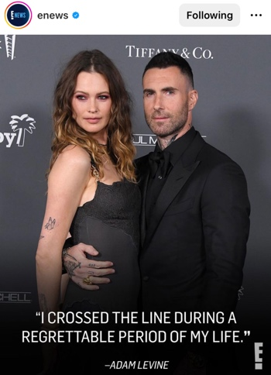
Image:
Visual analysis:
- Type of image: stand-alone + red-carpet photograph of the couple.
- Copyright concerns: stock photograph. The source of the photograph, which is cited in the caption, is Getty Images.
- Point of view: above + front.
- Salience: large, embedded pull quote.
Caption: Days after Behati Prinsloo confirmed her pregnancy, husband Adam Levine is coming clean about rumors of an alleged affair: Link in bio for his full statement detailing “the greatest mistake” he “could ever make.” (: Getty)
Embedded pull quote: “I CROSSED THE LINE DURING A REGRETTABLE PERIOD OF MY LIFE.” -ADAM LEVINE
Linguistic analysis:
- Connotation-rich vocabulary: coming clean, rumors, alleged affair.
- Forward referencing: in the sentence “Link in bio for his full statement detailing ‘the greatest mistake’ he ‘could ever make,’” the use of the definite article the is an instance of forward referencing.

- Post from 21/09/2022
Enews (2022) A source has now shared Behati Prinsloo’s reaction to the affair allegations. [Instagram] Available at: https://www.instagram.com/p/CiyMqe4hOte/?igshid=MzRlODBiNWFlZA== (Accessed: 30/05/2023)
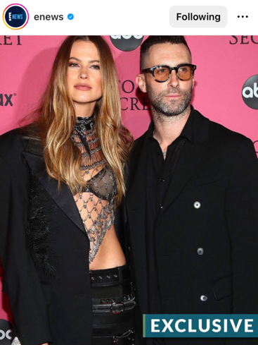
Image:

Visual analysis:
- Type of image: stand-alone + red-carpet photograph of the couple.
- Copyright concerns: stock photograph. The source of the photograph, which is cited in the caption, is Getty Images.
- Point of view: below + front.
- Salience: the bottom left text reading EXCLUSIVE in capital letters; the colour contrast between the couple dressed in black and the bright pink background.
Caption: A source has now shared Behati Prinsloo’s reaction to the affair allegations. Link in bio for where she stands with Adam Levine. (:Getty)
Linguistic analysis:
- Presupposition: assumption that the readers had seen the previous post and that they knew that Adam Levine and Behati Prinsloo are married and that cheating rumours had been circulating.
- Connotation-rich vocabulary: word EXCLUSIVE written in capital and bold letters and embedded in the image, as well as the words affair allegations in the caption.
- Forward referencing: in the sentence “Link in bio for where she stands with Adam Levine” Behati Prinsloo’s thoughts on the affair allegations against her husband Adam Levine are not explicitly mentioned in the post, but the use of the adverb where indicates that they will be further explored at the link in bio.

- Post from 21/09/2022
Enews (2022) After Adam Levine denied cheating on his wife Behati Prinsloo, an old interview resurfaced. [Instagram] Available at: https://www.instagram.com/p/Cix4DVHuhht/?igshid=MzRlODBiNWFlZA== (Accessed 30/05/2023)
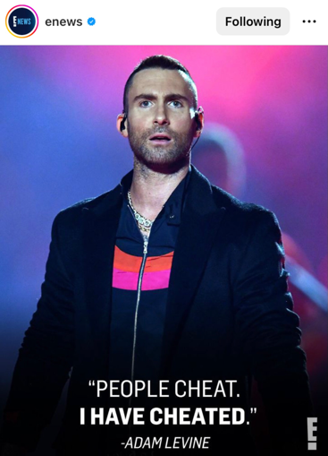
Image:

Visual analysis:
- Type of image: stand-alone + event photograph of Adam Levine.
- Copyright concerns: stock photograph. The source of the photograph, which is cited in the caption, is Getty Images.
- Point of view: below + front.
- Salience: large pull quote in capital letters; the facial expression of Adam Levine, who looks somewhat surprised and concerned.
Caption: After Adam Levine denied cheating on his wife Behati Prinsloo, an old interview resurfaced. Link in bio for his 〜candid〜 thoughts on monogamy as well as the rest of this saga. (: Getty)
Embedded pull quote: “PEOPLE CHEAT. I HAVE CHEATED.” -ADAM LEVINE
Linguistic analysis:
- Connotation-rich vocabulary: the word cheat occurs three times both in the quote and in the caption of the post.
- Pseudo quote: embedded in the image. By merely looking at the image, the reader is led to believe that the quote refers to a recent statement Adam Levine made concerning the cheating allegations against his wife. However, by attentively reading the caption, it becomes clear that the quote is merely used to attract users’ attention, as it indeed is allegedly taken from an old interview.

- Post from 29/09/2022
Enews (2022) A week after cheating allegations against Adam Levine resurfaced, he and Behati are maintaining a united front. [Instagram] Available at: https://www.instagram.com/p/CjEdocvogcF/?igshid=MzRlODBiNWFlZA== (Accessed: 30/05/2023)
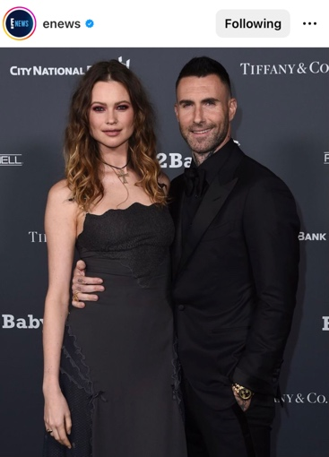
Image:

Visual analysis:
- Type of image: stand-alone + red-carpet photograph of the couple.
- Copyright concerns: stock photograph. The source of the photograph, which is cited in the caption, is Shutterstock.
- Point of view: eye-level + front.
Caption: A week after cheating allegations against Adam Levine resurfaced, he and Behati are maintaining a united front. See where they were headed at the link in bio. (: Sutterstock)
Linguistic analysis:
- Presupposition: assumption that people know that Adam Levine and Behati Prinsloo are married.
- Connotation-rich vocabulary: cheating allegations.
- Forward referencing: in the sentence “see where they were headed at the link in bio,” the adverb where and pronoun they refer to something that will be explained at the link in bio.

Gerard Piqué and Shakira
- Post from 12/01/2023
Enews (2023) Shakira can’t lie when it comes to her music. [Instagram] Available at: https://www.instagram.com/p/CnU3qO7ppkp/?igshid=MzRlODBiNWFlZA== (Accessed: 16/06/2023)
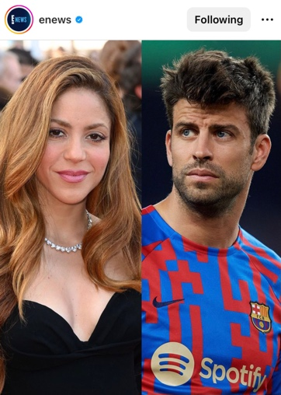
Image:
Visual analysis:
- Type of image: collage of the two exes. Both photographs are taken at public events.
- Copyright concerns: stock photographs. The sources of the photographs, which are cited in the caption, are Getty Images and Shutterstock.
- Point of view: left picture: eye-level + front; right picture: below + front.
- Salience: colour contrast between Shakira dressed in black and Piqué dressed in red and blue. The strong contrast in their facial expressions can also be considered a salient element of the post. Shakira is depicted smirking, while Piqué is portrayed with a concerned look.
Caption: Shakira can’t lie when it comes to her music… Link in bio to see her seemingly shade her ex, Gerard Piqué, and his gf in her new song. (: Getty/Shutterstock)
Linguistic analysis:
- Presupposition: it is assumed that the reader knows that Shakira and Piqué were married and got divorced.
- Alliteration: it can be observed in the repetition of the consonant s in the following sentence “Link in bio to see her seemingly shade her ex”.
- Wordplay: the expression “Shakira can’t lie” is a reference to one of Shakira songs “Hips Don’t Lie”

- Post from 26/01/2023
Enews (2023). The internet is going loca, loca, loca over Gerard Piqué’s Instagram. [Instagram] Available at: https://www.instagram.com/p/Cn4Ya2rsSDy/?igshid=MzRlODBiNWFlZA== (Accessed: 16/06/2023)
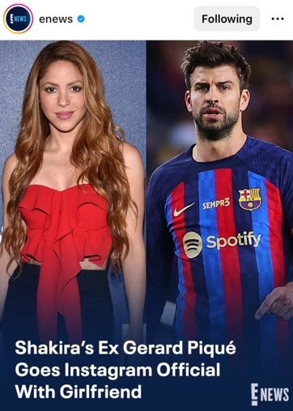
Image:

Visual analysis:
- Type of image: collage of Shakira and Gerard Piqué, both taken at public events.
- Copyright concerns: stock photographs. The sources of the photographs, which are cited in the caption, are Shutterstock and Getty Images.
- Point of view: left picture: eye-level + front; right picture: below + front.
- Salience: embedded headline. Similarly to the previous post, the difference in their facial expressions is an important feature to consider. Shakira looks content, while Piqué seems concerned.
Caption: The internet is going loca, loca, loca over Gerard Piqué’s Instagram. See the post at the link in bio. (: Sutterstock/Getty)
Embedded headline: Shakira’s Ex Gerard Piqué Goes Instagram Official With Girlfriend
Linguistic analysis:
- Presupposition: it is assumed that readers know that Piqué and Shakira were married and then got divorced.
- Alliteration: repetition of the letter l in the pun loca, loca, loca.
- Word play: loca, loca, loca is a reference to the lyrics in Shakira’s song Loca.
- Forward referencing: the definite article the in the expression “see the post”.

- Post from 15/02/2023
Enews (2023) Shakira did not shy away from a little shade. [Instagram] Available at: https://www.instagram.com/p/CosNCtNOfQ3/?igshid=MzRlODBiNWFlZA== (Accessed: 16/06/2023)
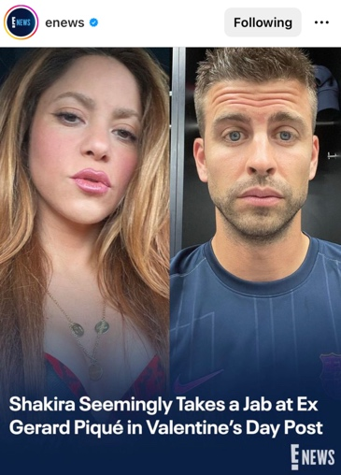
Image:

Visual analysis:
- Type of image: collage of Shakira and Gerard Piqué, both taken from the celebrities’ personal Instagram accounts.
- Copyright concerns: Instagram photos.
- Point of view: both selfies are taken from below and the front.
- Salience: embedded headline.
Caption: Shakira did not shy away from a little shade. Click the link in bio whenever, wherever for her subtle jab. (: Instagram)
Embedded headline: Shakira Seemingly Takes a Jab at Ex Gerard Piqué in Valentine’s Day Post
Linguistic analysis:
- Presupposition: it is assumed that users know that Piqué and Shakira were married and then got divorced.
- Alliteration: in the first sentence, “Shakira did not shy away from a little shade,” alliteration can be observed in the repetition of the sound sh. In the second sentence, on the other hand, it can be observed in the repetition of the sound wh in the expression whenever, wherever.
- Word play: whenever, wherever is a reference to Shakira’s song “Whenever, Wherever” .

Entertainment Tonight

Adam Levine and Behati Prinsloo
- Post from 20/09/2022
Entertainmenttonight (2022) Adam Levine is speaking out after an Instagram model claimed she was manipulated into having a year-long physical relationship with him. [Instagram] Available at: https://www.instagram.com/p/Ciu-SxorQ2v/?igshid=MzRlODBiNWFlZA== (Accessed: 30/05/2023)
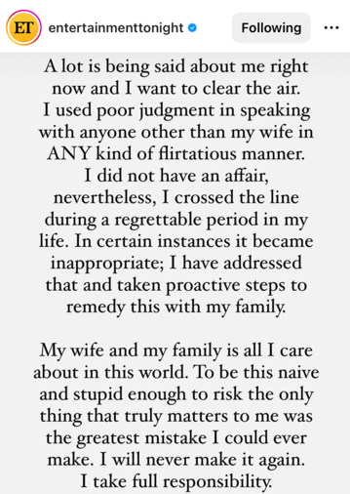
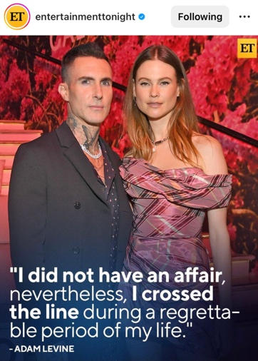
Image:

Visual analysis:
- Type of image: stand-alone + red-carpet photograph of the couple.
- Copyright concerns: stock photograph. The source of the photograph, which is cited in the caption, is Getty Images.
- Point of view: eye-level + front.
- Salience: The embedded pull quote and the colour contrast between Levine’s dark suit and Prinsloo’s pink dress in the photograph.
Additionally, Entertainment Tonight included a screenshot of Adam Levine Instagram story in which he admits to crossing a line but denies the cheating allegations.
Caption: Adam Levine is speaking out after an Instagram model claimed she was manipulated into having a year-long physical relationship with him. While he has been married to Behati Prinsloo since 2014 and recently announced they are expecting their third child, Adam admits on his Instagram story that he “crossed the line,” and stated he “did not have an affair.” All of the details at the link in bio. (: Getty Images)
Embedded pull quote: “I did not have an affair, nevertheless, I crossed the line during a regrettable period of my life.” -ADAM LEVINE
Linguistic analysis:
- Connotation-rich vocabulary: affair.
- First-name-only: Adam.
- Forward referencing: in the first sentence, the model, Sumner Stroh, who accused Adam Levine of cheating on his wife, is not mentioned, but she is only referred to through the use of the personal pronoun she. In the last sentence, the definite article the in the expression “all of the details” is also an example of forward referencing since it indicates something that will be explained at the link in bio.

- Post from 21/09/2022
Entertainmenttonight (2022) So… who exactly is Sumner Stroh? [Instagram] Available at: https://www.instagram.com/p/Civ7RfNtqJQ/?igshid=MzRlODBiNWFlZA== (Accessed: 30/05/2023)
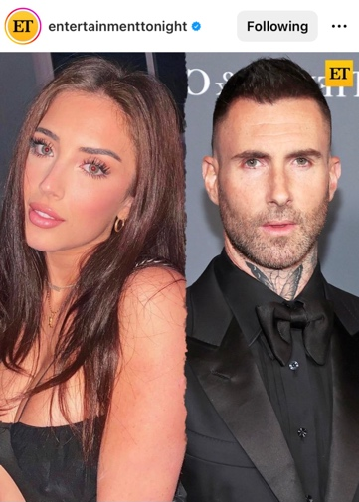
Image:

Visual analysis:
- Type of image: collage of Sumner Stroh, the woman accusing Levine of cheating on his wife, and the Maroon 5 singer. Sumner Stroh’s picture is an Instagram photo, while Levine’s is an event photo.
- Copyright concerns: Instagram photo + stock photograph. The sources of the photographs are Sumner’s personal Instagram account and Getty Images.
- Point of view: eye-level and from the front for both photographs.
- Framing: a disconnecting element is employed to frame, and more specifically separate, the two pictures. The line dividing the photographs is indeed wavy.
Caption: So… who exactly is Sumner Stroh? The Instagram model came forward with allegations that she had an affair with Maroon 5 frontman Adam Levine “for about a year” earlier this week and shook the entire internet. From her early life to response to backlash about her allegations, we’re untangling everything at the link in bio. (: Getty Images, sumnerstroh)
Linguistic analysis:
- Presupposition: assumption that readers of the post know that Adam Levine is married.
- Semantic intensifier: use of the word shook.
- Connotation-rich vocabulary: allegation.
- Pseudo quote: by Sumner Stroh in the second sentence of the text.
- Forward referencing: the pronoun everything in the expression “we’re untangling everything” refers to something that will be discussed at the link in bio.

- Post from 22/09/2022
Entertainmenttonight (2022) An old interview has resurfaced of Adam Levine claiming monogamy is “instinctively” wrong after he denied allegations of being unfaithful to his wife Behati Prinsloo. [Instagram] Available at: https://www.instagram.com/p/Ci0TqUcMm1X/?igshid=MzRlODBiNWFlZA== (Accessed: 30/05/2023)
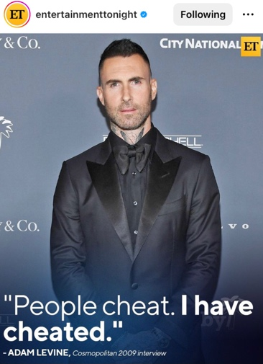
Image:

Visual analysis:
- Type of image: stand-alone + event photograph of Adam Levine.
- Copyright concerns: stock photograph. The source of the photograph, which is cited in the caption, is Getty Images.
- Point of view: eye-level + front.
- Salience: large pull quote at the bottom of the photograph.
Caption: An old interview has resurfaced of Adam Levine claiming monogamy is “instinctively” wrong after he denied allegations of being unfaithful to his wife Behati Prinsloo. Link in bio for his *honest* thoughts. (: Getty Images)
Embedded pull quote: “People cheat. I have cheated.” -ADAM LEVINE, Cosmopolitan 2009 interview
Linguistic analysis:
- Connotation-rich vocabulary: allegations and unfaithful.
- Pseudo quote: a quote by Adam Levine is embedded in the image, and it is allegedly taken from a 2009 Cosmopolitan interview. In the caption, a second quote by the singer can be observed in the use of the word instinctively written in quotation marks.

- Post from 22/09/2022
Entertainmenttonight (2022) Following the allegations of Adam Levine being unfaithful to his wife Behat Prinsloo, the pair were spotted out together this morning running errands. [Instagram] Available at: https://www.instagram.com/p/Ciye72ALMQg/?igshid=MzRlODBiNWFlZA== (Accessed: 30/05/2023)


Image:

Visual analysis:
- Type of images: two stand-alone photographs of Adam Levine and wife Behati Prinsloo. In contrast to previously analysed posts, here the two photographs are ‘candid’ paparazzi snaps.
- Copyright concerns: stock photographs. The sources of the photographs, which are cited in the caption, are Backgrid and Getty Images
- Point of view: because they are paparazzi snaps, the point of view differs greatly from other posts: the first was taken from above and behind, while the second one was taken from below and the side.
- Salience: low quality of the photographs which indicates that they are ‘candid’ snaps making them more intriguing to the audience.
Caption: Following the allegations of Adam Levine being unfaithful to his wife Behat Prinsloo, the pair were spotted out together this morning running errands. A source tells ET that he “is embarrassed and recognizes that his actions were inappropriate” and is trying to make things right with Behati and his family. More on his decision to address the situation at the link in bio. (: Backgrid, Splash)
Linguistic analysis:
- Connotation-rich vocabulary: allegations and unfaithful.
- First-name-only: Behati.
- Pseudo quote: can be observed in the following sentence “a source tells ET that he ‘is embarrassed and recognizes that his actions were inappropriate’”.
- Forward referencing: the use of the definite article the in “the situation” implies that the specific situation will be discussed at the link in bio.

Gerard Piqué and Shakira
- Post from 13/01/2023
Entertainmenttonight (2023) Shakira is letting her music do all the talking. [Instagram] Available at: https://www.instagram.com/p/CnV167TNgQM/?igshid=MzRlODBiNWFlZA== (Accessed: 16/06/2023)
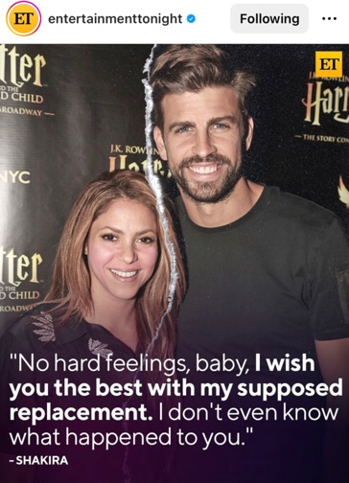
Image:

Visual analysis:
- Type of image: stand-alone photograph of the two exes at a red-carpet event.
- Copyright concerns: stock photograph. The source of the photograph, which is cited in the caption, is Getty Images.
- Point of view: above + front.
- Framing: the photograph is characterised by a disconnecting element separating Shakira and Piqué, a paper tear.
- Salience: large pull quote at the bottom of the photograph, and the paper tear separating the two subjects.
Caption: Shakira is letting her music do all the talking. Shakira is seemingly singing about her ex, former soccer pro Gerard Piqué, and his younger girlfriends in her new song. The hips don’t lie at the link in bio for more on how she also addresses her tax fraud case. (: Getty Images)
Embedded quote: “No hard feelings, baby, I wish you the best with my supposed replacement. I don’t even know what happened to you.” -SHAKIRA
Linguistic analysis:
- Presupposition: assumption that the reader knows that Shakira and Piqué were married and got divorced in 2022. The editors also assume that the readers are aware of the fact that Shakira was involved in a tax fraud case by mentioning that she addresses the issue in her new song.
- Alliteration: repetition of the consonant s in the sentence “Shakira is seemingly singing about her ex”.
- Word play: the expression “The hips don’t lie” is a reference to one of Shakira’s songs.

- Post from 14/01/2023
Entertainmenttonight (2023) Her lyrics don’t lie. [Instagram] Available at: https://www.instagram.com/p/CnaPmAmyy1S/?igshid=MzRlODBiNWFlZA== (Accessed: 16/06/2023)
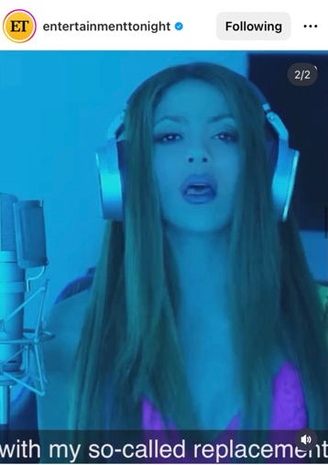
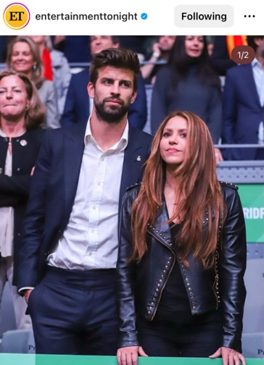
Image:

Visual analysis:
- Type of images: first picture: stand-alone + event picture of Shakira and Gerard Piqué; second picture: snippet from Shakira’s music video.
- Copyright concerns: stock photograph + Instagram picture. The sources of the photograph and the video, which are cited in the caption, are Getty Images and Bizarrap, the producer of Shakira’s song.
- Point of view: first picture: below + front; second picture: eye-level + front.
Caption: Her lyrics don’t lie. Shakira is leaving a lot up to interpretation when it comes to her new music. She seemingly references her ex, Gerard Piqué, and his much younger girlfriend in her new song, ‘Bzrp Music Session, Vol. 53.’ ➡️She also takes a jab at those tax fraud claims. Move your way to the link in our bio for a full breakdown of her new jam. (: Getty Images, Bizarrap)
Linguistic analysis:
- Presupposition: assumption that the readers know about Shakira and Piqué’s marriage as well as about their recent divorce. It is also assumed that the readers know about Shakira’s tax fraud case.
- Forward referencing: the pronoun her in the initial sentence “Her lyrics don’t lie” functions as a reference to Shakira who is mentioned later in the caption. The demonstrative pronoun those in the expression “those tax fraud” hints at something that will be discussed at the link in bio.
- Word play: “Her lyrics don’t lie” is a reference to one of Shakira’s songs.

- Post from 20/01/2023
Entertainmenttonight (2023) The jam jar don’t lie. [Instagram] Available at: https://www.instagram.com/p/CnnreNPuQKi/?igshid=MzRlODBiNWFlZA== (Accessed: 16/06/2023)
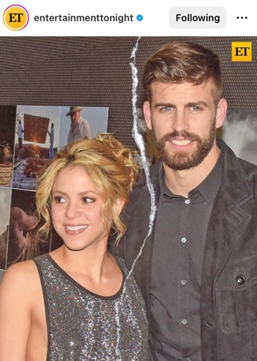
Image:

Visual analysis:
- Type of image: stand-alone photograph of the two exes at a red-carpet event.
- Copyright concerns: stock photograph. The source of the photograph, which is cited in the caption, is Getty Images.
- Point of view: above + front.
- Framing: the photograph is characterised by a disconnecting element dividing Shakira and Piqué, a paper tear.
- Salience: the paper tear in the middle of the picture.
Caption: The jam jar don’t lie. Shakira seemingly sang about her ex Gerard Piqué and his younger girlfriend in her new song, and new theories online are adding fuel to the fire as she reportedly first became suspicious that he was being unfaithful upon noticing that her jar of strawberry jam had been eaten while she was away. Oh, how the plot thickens at the link in bio. (: Getty Images)
Linguistic analysis:
- Presupposition: it is assumed that the readers know about Shakira and Piqué’s marriage as well as about their recent divorce.
- Alliteration: observed in the repetition of the letter s in the expression “Shakira seemingly sang”.
- Word play: “The jam jar don’t lie” is a reference to Shakira’s song “Hips Don’t Lie”. “How the plot thickens” can also be considered wordplay, as it is an idiom but can also be interpreted as a reference to the aforementioned jam, which can indeed be thick.

- Post from 26/01/2023
Entertainmenttonight (2023) Is Gerard Piqué firing back by posting a subtle, no-caption photo of him and his new girlfriend, Clara Chia Martì? [Instagram] Available at: https://www.instagram.com/p/Cn3IW81NVgy/?igshid=MzRlODBiNWFlZA== (Accessed: 16/06/2023)
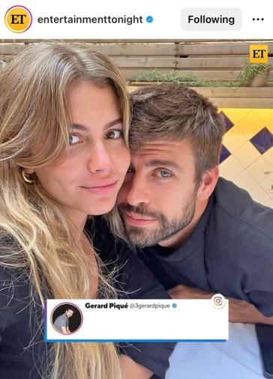
Image:

Visual analysis:
- Type of image: stand-alone Instagram picture of Gerard Piqué and his girlfriend Clara Chia Martì.
- Copyright concerns: because the photograph was taken from Gerard Piqué’s Instagram account the source is the footballer himself.
- Point of view: above + front.
- Salience: the blank caption that Piqué added to his original photo was also embedded in the post making it the most salient element thereof.
Caption: Is Gerard Piqué firing back by posting a subtle, no-caption photo of him and his new girlfriend, Clara Chia Martì? Just days after Shakira blasted him over their new relationship, alleging rumors of infidelity and more, we get the official hard-launch on IG. What does it mean? Find out at the link in our bio. (: Gerard Piqué)
Linguistic analysis:
- Presupposition: it is assumed that the readers know about Shakira and Piqué’s marriage and their recent divorce.
- Semantic intensifier: the use of the word blasted.
- Connotation-rich vocabulary: alleging rumors, infidelity.
- Forward referencing: the pronoun it in the question “What does it mean?” Refers to something that will be discussed at the link in bio.

PageSix

Adam Levine and Behati Prinsloo
- Post from 20/09/2022
Pagesix (2022) EXCLUSIVE DETAILS: Did #AdamLevine cheat on his wife #BehatiPrinsloo? [Instagram] Available at: https://www.instagram.com/p/CiusiYVMSWN/?igshid=MzRlODBiNWFlZA== (Accessed: 24/06/2023)
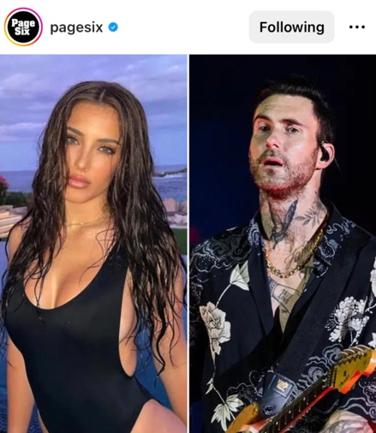
Image:

Visual analysis:
- Type of image: collage of Sumner Stroh and the Maroon 5 singer. Stroh’s photograph is taken from her personal Instagram account, while Levine’s is an event picture.
- Copyright concerns: left picture: Instagram photo; right picture: stock photograph from Getty Images.
- Point of view: left picture: eye-level + front; right picture: below + front.
Caption: EXCLUSIVE DETAILS: Did #AdamLevine cheat on his wife #BehatiPrinsloo? Instagram model #SumnerStroh is going viral on TikTok after accusing the #Maroon5 frontman of having an affair with her. Get the full story at the link in our bio. : Instagram; Getty
Linguistic analysis:
- Allusion: “Maroon5 frontman” refers to Adam Levine.
- Connotation-rich vocabulary: affair.
- Forward referencing: the definite article the in the expression “get the full story”.

- Post from 20/09/2022
Pagesix (2022) #AdamLevine has entered the chat. [Instagram] Available at: https://www.instagram.com/p/Ciu7qeIO00T/?igshid=MzRlODBiNWFlZA== (Accessed: 24/06/2023)
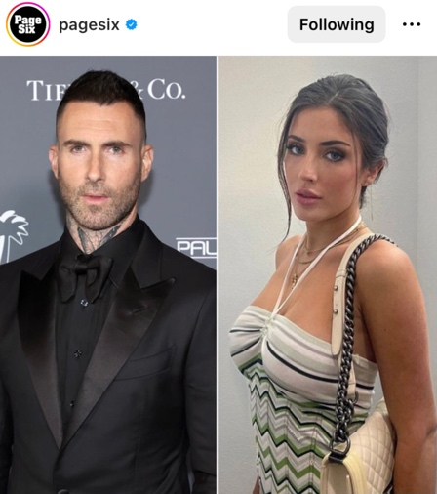
Image:

Visual analysis:
- Type of image: collage of Adam Levine and Sumner Stroh. Sumner Stroh’s picture is an Instagram photo, while Levine’s is an event photo.
- Copyright concerns: left picture: stock photograph from Getty Images; right picture: Instagram photo.
- Point of view: eye-level + front for both images.
- Salience: colour contrast between the two photographs: Adam Levine’s photo is dark, while Sumner Stroh’s is brighter.
Caption: #AdamLevine has entered the chat. The #Maroon5 singer just denied having an affair with model #SumnerStroh, but DID admit he “crossed a line.” His side of the story is at the link in bio. : Getty, Instagram
Linguistic analysis:
- Presupposition: assumption that readers have seen the previous post and know that Adam Levine is married, and that Sumner Stroh accused him of having had an affair with her in a TikTok video.
- Allusion: “Maroon5 singer” refers to Adam Levine.
- Connotation-rich vocabulary: affair.
- Forward referencing: the definite article the in the expression “his side of the story” refers to something that will be revealed to the reader at the link in bio.
- Word play: “Adam Levine has entered the chat” is a reference to the cheating allegations by Sumner Stroh, who revealed flirty messages between her and the singer.

- Post from 20/09/2022
Pagesix (2022) #SumnerStroh had a shady response to #AdamLevine’s denial over their alleged affairs. [Instagram] Available at: https://www.instagram.com/p/CivOFyRvCzN/?igshid=MzRlODBiNWFlZA== (Accessed: 24/06/2023)
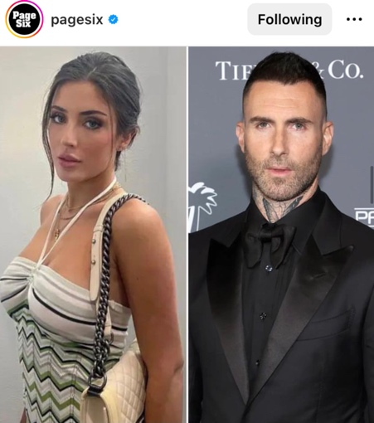
Image:

Visual analysis: This third post reporting on Adam Levine’s cheating scandal is almost identical to the previous one the only difference being the position of the two photographs: Sumner Stroh’s image is left, while Levine’s is on the right side.
Caption: #SumnerStroh had a shady response to #AdamLevine’s denial over their alleged affairs. The Instagram model cryptically posted on her Instagram stories only a few hours after the #Maroon5 frontman claimed he just “crossed the line.” See what she had to say at the link in our bio. : Instagram; Getty
Linguistic analysis:
- Presupposition: it is assumed that readers have seen the previous posts and know that Adam Levine is married and that Sumner Stroh accused him of cheating.
- Allusion: “Maroon5 frontman” refers to Adam Levine; “the Instagram model” refers to Sumner Stroh.
- Connotation-rich vocabulary: alleged affair.
- Forward referencing: the word what in the expression “see what she had to say” alludes to something that will be explored at the link in bio.

- Post from 21/09/2022
Pagesix (2022) #BehatiPrinsloo is reportedly “very upset” over the allegations that her husband, #AdamLevine, cheated on her, and an insider tells People that he’s “trying his best to make things better.” [Instagram] Available at: https://www.instagram.com/p/CiwFGBJNFs4/?igshid=MzRlODBiNWFlZA== (Accessed: 24/06/2023)
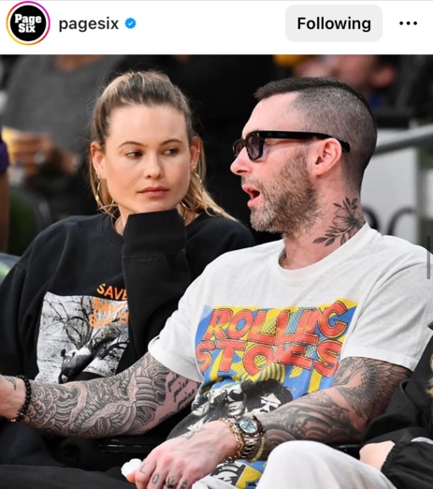
Image:

Visual analysis:
- Type of image: stand-alone + event photograph of the couple.
- Copyright concerns: stock photograph. The source of the photograph, which is cited in the caption, is Getty Images.
- Point of view: below + side.
Caption: #BehatiPrinsloo is reportedly “very upset” over the allegations that her husband, #AdamLevine, cheated on her, and an insider tells People that he’s “trying his best to make things better.” More details at the link in our bio. : Getty
Linguistic analysis:
- Connotation-rich vocabulary: allegations, cheating.
- Pseudo quote: “Behati Prinsloo is reportedly ‘very upset’”; “an insider tells People that he’s ‘trying his best to make things better’”.

- Post from 22/09/2022
Pagesix (2022) It’s all love between #AdamLevine and wife #BehatiPrinsloo – or is it? [Instagram] Available at: https://www.instagram.com/p/Ci0NdpyM7dK/?igshid=MzRlODBiNWFlZA== (Accessed: 24/06/2023)
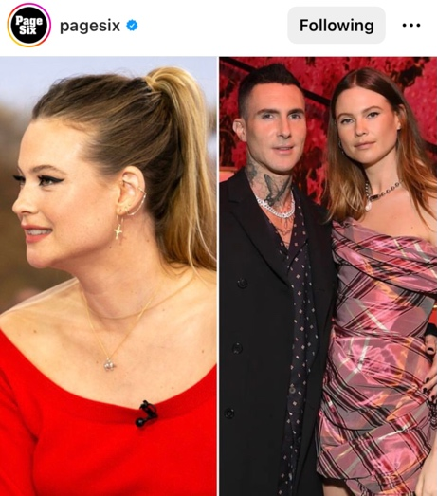
Image:
Visual analysis:
- Type of image: collage of an event picture of Behati Prinsloo on the left and a red-carpet photograph of the couple on the right.
- Copyright concerns: stock photographs. The source of both photographs, which is cited in the caption, is Getty Images.
- Point of view: left picture: below + side; right picture: eye-level + front.
- Salience: use of the colour red and its variations in both photographs.
Caption: It’s all love between #AdamLevine and wife #BehatiPrinsloo – or is it? The couple put on a united front Wednesday amid the #Maroon5 frontman’s flirty texting scandal – but Behati’s outfit says otherwise.🫖 The message the former #VSAngel just sent with her latest fit is at the link in bio. : Getty
Linguistic analysis:
- Presupposition: assumption that readers know that Adam Levine and Behati Prinsloo are married and that cheating allegations were circulating.
- Allusion: “Maroon5 frontman” refers to Adam Levine; “former VS Angel” refers to Behati Prinsloo.
- Connotation-rich vocabulary: scandal.
- First-name-only: Behati.
- Forward referencing: the define article the in the sentence “The message the former #VSAngel just sent with her latest fit is at the link in bio” hints at something that will be revealed later at the link in bio.

Gerard Piqué and Shakira
- Post from 19/01/2023
Pagesix (2023) Well, this isn’t a sweet treat. [Instagram] Available at: https://www.instagram.com/p/Cnk6Q8SOEbf/?igshid=MzRlODBiNWFlZA== (Accessed: 24/06/2023)
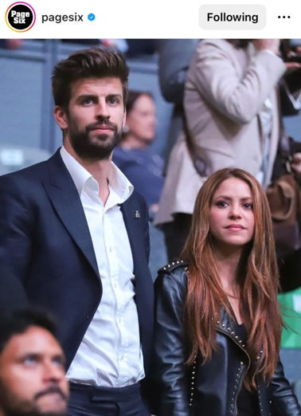
Image:

Visual analysis:
- Type of image: stand-alone photograph of the two exes at an event.
- Copyright concerns: stock photograph. The source of photograph is Getty Images.
- Point of view: below + side.
Caption: Well, this isn’t a sweet treat. #Shakira allegedly realized her longtime love #GerardPiqué was cheating on her… because of a jam jar. 🫙The full, wild story of how the drama started to unfold is at the link in bio.🫢: Getty
Linguistic analysis:
- Presupposition: assumption that the readers know that Shakira and Gerard Piqué got divorced.
- Connotation-rich vocabulary: cheating.
- Forward referencing: the definite articles the in the sentence “the full, wild story of how the drama started to unfold is at the link in bio” both refer to details of the story and the drama which will be only revealed by clicking on the link.
- Word play: “this isn’t a sweet treat” is both an idiom and a reference to the jam jar, which is the object through which Shakira found out that her ex-husband Gerard Piqué was cheating on her.

- Post from 26/01/2023
Pagesix (2023) #GerardPiqué went #Instagram-offcial with girlfriend #ClaraChiaMarti – just weeks after his ex #Shakira released a diss track about the former soccer star. [Instagram] Available at: https://www.instagram.com/p/Cn3BDvZtzg_/?igshid=MzRlODBiNWFlZA== (Accessed: 24/06/2023)
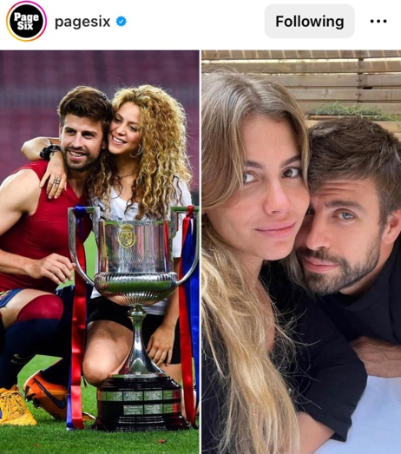
Image:

Visual analysis:
- Type of image: collage of two photographs: the first portraying exes Shakira and Gerard Piqué, the second depicting the footballer and his new girlfriend.
- Copyright concerns: left picture: stock photograph from Getty Images; right picture: Instagram photo.
- Point of view: left picture: below + front; right picture: above + front.
Caption: #GerardPiqué went #Instagram-offcial with girlfriend #ClaraChiaMarti – just weeks after his ex #Shakira released a diss track about the former soccer star. Although Piqué didn’t add a caption to the flick, fans were quick to write their own. Tap the link in our bio for more details. : Getty, Instagram
Linguistic analysis:
- Presupposition: it is assumed that readers know that Gerard Piqué and Shakira were married and got divorced.
- Allusion: “former soccer star” refers Gerard Piqué.
- First-name-only: Piqué (in this case he is only referred to by his last name).

- Post from 28/01/2023
Pagesix (2023) #Shakira just reacted to her allegedly unfaithful ex #GerardPiqué going public with his new girlfriend, Clara Chia Martì. [Instagram] Available at: https://www.instagram.com/p/Cn8Iy6FMW8h/?igshid=MzRlODBiNWFlZA== (Accessed: 24/06/2023)
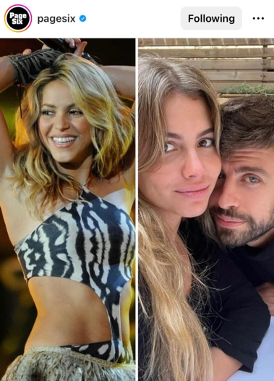
Image:

Visual analysis:
- Type of image: collage of two photographs. The first is an event picture of Shakira, and the second is an Instagram picture depicting the footballer and his new girlfriend.
- Copyright concerns: left picture: stock photograph from Getty Images; right picture: Instagram photo.
- Point of view: left picture: below + front; right picture: above + front.
Caption: #Shakira just reacted to her allegedly unfaithful ex #GerardPiqué going public with his new girlfriend, Clara Chia Martì. Link in bio. : Getty, Instagram
Linguistic analysis:
- Presupposition: assumption that readers know that Gerard Piqué and Shakira were married and got divorced.
- Connotation-rich vocabulary: allegedly unfaithful

Appendix B
Table of visual elements
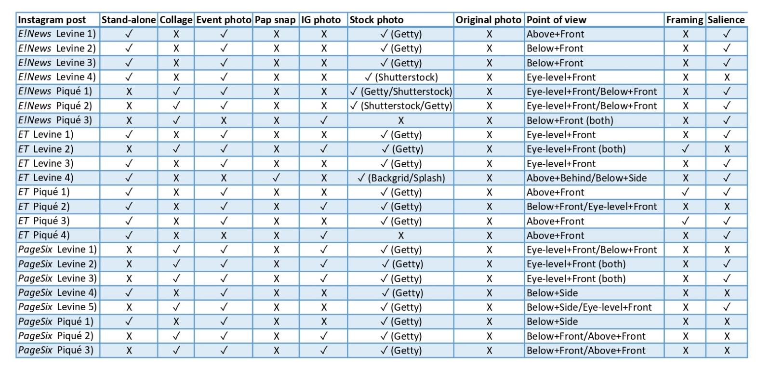

Appendix C
Table of linguistic elements
