Leveraging Augmented Reality (AR) Technology to Foster Sustainable Fashion: Consumer Behavior and Environmental Impact

Research dissertation presented in partial fulfillment of the requirements for the degree of
MSc in (Accounting & Finance)

Griffith College Dublin
Dissertation Supervisor: Alessandra Vecchi
Student Name: Nouman Iqbal
Date of submission 31-08-2024

Candidate Declaration

Candidate Name: Nouman Iqbal

I certify that the dissertation entitled:

Leveraging Augmented Reality (AR) Technology to Foster Sustainable Fashion: Consumer Behavior and Environmental Impact

Submitted for the degree of : (MSc in Accounting and Finance) is the result of the my own work and that where reference is made to the work of others, due acknowledgment is given.

Candidate signature: Nouman Iqbal

Date: 31-08-2024

Supervisor Name: Alessandra Vecchi

Supervisor signature:

Date:

Abstract

This research focuses on how AR technology could encourage sustainable fashion practices and affect consumers’ attitudes toward more environmentally conscious decisions. The research looks at the impact AR has on detailed and overall consumer engagement, the increase of transparency and traceability in the fashion supply chain, as well as customer awareness of sustainability topics. To get an extensive insight into the effects of AR in the fashion industry, cross-sectional qualitative interviews and questionnaires were administered to key stakeholders in the industry and consumers respectively.

This implies that AR boosts consumer interactor’s experiences with shopping ventures thus supplying purchasing behaviors that are more sustainable. Also, the use of AR in fashion enables consumers to make informed decisions regarding the products they wish to purchase by offering detailed information as well as virtual try-on services thus greatly minimizing the negative effects of fashion practices. However, more difficulties lie ahead in crossing the last barriers toward the fashion industry transitioning to afford and accept augmented reality in its daily practices.

The study also reveals the positive possibilities of integrating AR with blockchain technology to improve the reliability and trustfulness of the fashion supply chain. This integration can help create trust among consumers by offering an unalterable blockchain-based record of product sources and the products’ seal of sustainability.

In summary, this research contributes to expanding debates on the use of AR technology for sustainable fashion by presenting practical recommendations for fashion stakeholders to consider when implementing AR for sustainability goals.

Table of Content

Chapter: 1 Introduction 7
1.1 Overview 7
1.2 Research Purpose 8
1.3 Importance of the Study 9
1.4 Aim and Objectives 10
1.5 Research Questions 11
1.6 Methodology 11
1.7 Structure of the Study 12
Chapter 2: Literature Review 13
2.1 Overview 13
2.2 Theoretical Background 14
2.2.1 Augmented Reality (AR) Technology 14
2.2.2 Sustainable Fashion 16
2.2.3 The Intersection of AR and Sustainable Fashion 18
2.3 Previous Research Studies 20
2.3.1 Enhancing Consumer Engagement and Education 20
2.3.2 Transparency and Traceability in Fashion Supply Chains 21
2.3.3 Consumer Acceptance of AR in Sustainable Fashion 21
2.3.4 Gaps in Existing Literature 23
2.4 Conceptual framework 24
2.4.1 Conceptual Framework 24
2.4.2 Inter-Relationship between Key Concepts 25
2.5 Methodological Approaches 26
2.5.1 Typical Research Methods 26
2.5.2 Strengths and Weaknesses of Different Approaches 26
2.5.3 Justification of Chosen Methodology 27
2.6 Current Developments and Trends 28
2.6.1 Latest Advancements in AR Technology 28
2.6.2 Innovations in Sustainable Fashion 29
2.6.3 Impact on the Research Topic 30
2.7 Challenges and Future Directions 30
2.7.1 Key Area Challenges 30
2.7.2 Areas for Future Research 31
2.7.3 Future Development with Regards to Potential Impact 32
2.8 Research Paradigms and Overall Approach 33
2.9 Suitability for Conceptual Framework: 35
2.10 Value of Quantitative Research Philosophy: 40
2.11 Research Approach 41
Chapter 3: Research Paradigms and Overall Approach 44
3.1 Implication for Research Design 44
3.2.1 Literature Review: 45
3.2.2 Quantitative Research: 45
3.2.3 Qualitative Research: 46
3.3 Integration of Data: 47
3.3.1 Data Collection: 47
3.3.2 Survey Questions 50
Chapter 4: Presentation and Discussion of Findings 53
4.1 Overview 53
4.2 Data Presentation 53
4.2.1 Demographics of Survey Respondents 53
4.3 Summary of Survey Responses 54
4.3.1 Analysis of Consumer Engagement 54
4.3.2 Analysis of Knowledge Enhancement 56
4.3.3 Analysis of Transparency and Traceability 58
4.3.4 Analysis of AR and Blockchain Integration 60
4.4 Detailed Discussion of Findings 62
4.4.1 The Role of AR in Enhancing Consumer Engagement 62
4.4.2 The Impact of AR on Knowledge and Transparency 64
4.4.3 The Potential of Integrating AR with Blockchain Technology 66
4.4.4 Implications for the Fashion Industry 67
4.5 Addressing Hypotheses and Research Questions 69
Chapter 5: Concluding Thoughts on the Contribution of this Research, its Limitations and Suggestions for Further Research 72
5.1 Overview of Key Findings 72
5.2 Implications for the Fashion Industry 73
5.3 Contribution to Academic Research 74
5.4 Limitations of the Study 75
5.5 Recommendations for Future Research 76
5.6 Final Thoughts 78
References 80
Appendices……………………………………………………………………………………....83

Chapter: 1 Introduction

1.1 Overview
The fashion industry in the present globe is one of the unchallenged pillars of the global economy which is also one of the leading illustrates of environmental pollution. Niinimäki et al. (2020) indicated a high percentage contribution to carbon emission, water consumption, and garbage dumping in the global sector. Individuals are beginning to understand the effects that fashion brings into human life, for sustainability in fashion. Increased consciousness makes the purchasers want to include themselves with a company that has high standards of sustainability.
Another such avenue, which is effectively making fashion more sustainable in its usage of resources, is through what can be described as the elemental employment of augmented reality which is defined as a technology that can place information and computer graphics on an image of the real world. AR effectively increases the chances that consumers redesign their perception of fashion products, and how to purchase them through offering services such as virtual trials, information about products, and providing sustainable information in a curious form. This technology further improves the shopping experience and at the same time dials down the negative fashion-industry effects like physical sample making and side effects of returning unsuitable products.
While AR is not yet standard across the fashion industry, with most brands testing the water in terms of what is possible, early indicators have found its use to have profound possibilities for enhancing customer relations and loyalty. For instance, when a company wants its customers to see some clothes, it can make them appear on the customers through augmentation reality customers do not have to feel the clothes before buying them but later they can be returned. Moreover, AR may give the consumer all sorts of information on the sustainability of something as simple as the type of material used in creating the product, how it was produced, and the effect it had on the environment.
This work is aimed at ways to leverage sustainable fashion practices with AR. It evaluates the industry's current state in terms of sustainability, analyzes whether AR has the potential to exert change in consumer behavior, and seeks to add valuable input to the respective stakeholders in the industry. One essential contribution of this study will be identifying barriers and challenges to adopting AR technology and proposing recommendations for their elimination.

1.2 Research Purpose
The main objective of this project is to find out how augmented reality may inspire people to dress more sustainably. This work reviews the various ways AR can penetrate the businesses associated with the fashion industries, like virtual fittings and product display, and raises awareness campaigns to create a bridge between the consumer and the brand working sustainably. Precisely, the research aims to understand whether AR would be capable of influencing consumer behavior in the pursuit of making sustainable choices.
AR technology can make a real difference in the fashion industry by providing highly immersive and interactive experiences to educate and engage consumers about sustainability. For example, AR fitting rooms can enable consumers to better plan their purchases by previewing clothes sizes and what they look like on them without the hassle associated with the original trying process. This not only enhances the shopping experience but also reduces the environmental impact of the production and disposal of physical samples and the logistics involved in returning unsuitable purchases.
This technology can also be utilized for interactive product displays regarding information on product sustainability. For instance, consumers can use smartphones to scan AR-enabled tags on their clothes, extracting information regarding the raw materials used, manufacturing process, and built-in environmental impact that comes with the product, according to Poushneh and Vasquez-Parraga in 2017. This is relevant in enabling consumers to make informed purchasing decisions and choose sustainable options
For this research, in particular, mixed-method approaches have been used, including both surveys and interviews among industry experts and consumers, to learn the extent to which augmented reality can necessarily succeed at influencing consumer behaviors and bringing about sustainable practices within fashion. The study shall establish the barriers to and challenges of adopting Augmented Reality technology within the fashion industry and give recommendations on how to get past such hurdles. The results of this study are likely relevant and timely insight into how fashion brands and retailers can integrate AR efficiently into their agenda concerning creating a more sustainable consumer base and, hence, potentially reducing the environmental stress put on by the fashion industry.

1.3 Importance of the Study
This work becomes vital against a pressing concern in the fashion industry about sustainable practices, into which this research embeds its potential for innovation using AR technology. The work by Niinimäki et al. (2020) says that the fashion industry is among the biggest polluters in the world and contributes a great deal to carbon emissions, massive water consumption, and large amounts of resulting waste. Since the bearing of fashion on the environment is an aspect that is well understood and embraced, consumers have a demand for sustainability in this industry. In this line of thought, there are issues in sustainable practices because the uptake process is often slowed down by factors such as; costs, some technologies may regress, or consumers may actively resist embracing the change.
However, using AR technology, such problems have been solved by developing interesting and informative experiences that can make a change and provide consumers with knowledge about sustainable consumption. For example, AR-enabled fitting rooms ensure that customers make better decisions when buying clothes since customers will feel how the clothes before having to wear them in the fitting room. Everyone can have a better shopping experience when we streamline the process of returning unwanted items and reduce the need for genuine samples.
It can also be used to create interactive product displays that provide all information about the sustainability of the products. For example, consumers can scan AR-enabled clothes tags through their smart phones and learn what materials are used, how they are processed, and how the product affects the environment in this way, consumers can realize the reality and make wiser purchasing decisions, leading them to choose more sustainable options.
In this sense, the findings could provide accurate guidance for fashion brands and retailers as they work toward better sustainability through AR. Digital experiences with AR could very well enable a fashion brand to make consumer shopping more exciting and informative, hence raising awareness and participation in actions related to sustainability.
This research contributes to the continuing conversation about sustainable fashion and the use of augmented reality technology, and it lays the groundwork for future studies and applications. The findings of this study will also help industry participants overcome their challenges in developing sustainable augmented reality applications. Based on what elements impact AR applications and consumer behavior, fashion brands could build more efficient strategies to promote sustainability. This can pave the way for a more sustainable fashion industry that not only meets consumers' demands but also reduces its impact on the environment.
This research is fundamental because it meets a critical, unsatisfied need in the fashion industry for sustainable practices through the innovative application of AR technology. Such findings will be of value as guidelines for fashion brands and retailers on adopting AR if they want to improve their sustainability initiatives and thus create more awareness and consumer participation in sustainability. This study adds to the academic discourses regarding both sustainable fashion and AR technology individually but also on their overlap, providing a foundation for future in-depth research study and practical applications in this field.

1.4 Aim and Objectives
Research Aim
The primary Aim of this dissertation is to examine these prospective AR applications. Technology in promoting sustainable fashion practices and influencing customer's behaviors towards more environmentally friendly choices
Research Objectives
- To gain knowledge about the applications of AR technology in sustainable fashion practices, this objective consists of assessing how sustainability is being adopted through AR tech in the fashion industry such as product display, virtual fitting, and awareness campaigns.
- To assess the current landscape of sustainable fashion practices
- To study the potential of augmented reality (AR) to promote sustainable apparel.
- To analyze consumer perceptions and behavior toward sustainable fashion and AR technology.
- To evaluate the effectiveness of AR applications in raising awareness and promoting sustainable fashion.
- To identify barriers and challenges in the adoption of AR technology for sustainable fashion.
- To propose recommendations for industry stakeholders.

1.5 Research Questions
- Can AR technology effectively lead to sustainable fashion-related behaviors?
- What will be the key determining factors affecting consumer acceptance of AR in Fashion?
- How does AR impact transparency and traceability across fashion supply chains?

1.6 Methodology
To investigate the capacity of AR as a tool to advance sustainability in the fashion industry and act as an agent of behavior change, several data will be collected employing innovative research methods. In the case of the present study, the literature review will present the language and the setting of sustainable fashion, AR technology, consumer behavior, and related concepts employed in the research study. Subsequently, the methodological approach will be pointed out for the further elaboration of the research strategy. The approach will be described in detail in the third chapter of the work.
Firstly, research will be guided by pragmatism as the main philosophical orientation since pragmatism ideology embraces both qualitative and quantitative approaches given that the two complement each other in explaining the research problem (Saunders et al., 2019). Pragmatism is a good approach because it provides a viable way and introduces the concept of realism that makes the problem less black and white.
Subsequently, this research shall use an addictive research design, which is a hybrid of both deductive and inductive reasoning processes. This approach will help in coming up with Hypotheses from the existing theories testing them and improving on them through the empirical data (Creswell, 2014).
The study will adopt qualitative and quantitative research techniques as the research design. An online survey using a quantitative measurement tool structured questionnaires will be employed to elicit the consumers’ perceptions, attitudes, and behavior regarding AR and sustainable fashion. The set of qualitative data will be collected as a result of conducting semi-structured interviews with stakeholders of various kinds including fashion designers and makers, sustainability consultants, creators of augmented reality technologies, and others.
Subsequently, the descriptive method will be chosen to provide a more tangible structure to the current observations outlined and enriched by the concept of sustainable fashion practices with the help of AR. This method is more oriented toward identifying and describing specific findings than developing new theories or hypotheses (Miles and Gilbert, 2005).
The research strategy selectively employs a qualitative method to sort the gathered primary data. The coding method can be designed to introduce the structure of the text, its patterns, existing relations, and topics (Saunders et al., 2019).

1.7 Structure of the Study
The dissertation has five chapters. The introduction part is followed by a literature review that focuses on sustainable fashion practices and the implementation of AR in the fashion context is presented. This part also locates the conceptual framework for the research in the study. Following that, the methodology contains a comprehensive discussion of the methods and research strategy after the literature review. This chapter presents the study philosophy, the approach, the strategy and the data collection methods, sampling techniques, and the data analysis plan.
Next, the fourth chapter then presents the major data analysis findings arising from interviews and questionnaires. These results are analyzed and discussed according to the aim of the given study.
The last chapter is the conclusion which presents the limitations of the study, the research limitations, and recommendations for future research.

Chapter 2: Literature Review

2.1 Overview
This chapter presents the current state of information concerning the chosen and researchable area of interest, The Role of Augmented Reality in Promoting Sustainable Fashion Practices. In the first section of the chapter, the theoretical background for augmented reality and sustainable fashion will be discussed. 2. In this section, the main definitions given by different authors will be presented along with the background knowledge of the elements and concepts that surround AR technology and its application, as well as the principles of sustainable fashion practices.
Following this, Section 2.3 will consider a review of the related research works that look at the application of AR in the fashion sector. However, it will describe how AR was utilized in increasing consumer participation and awareness and increasing transparency and supply chain visibility within fashion industries and its acceptance by consumers. This section will also establish the literature gap and present areas that warrant further research.
Section 2.4 will explain the conceptual framework of this study. Based on the literature, this framework will integrate key variables and theoretical concepts to help analyze the interplay between AR technology, consumers’ actions, and sustainable fashion practices. It will offer a way of harmonizing the study and pattern of how AR can impact consumers by changing their perception and behavior toward sustainable fashion.
In Section 2.5, the respective methods that are widely applied in AR and sustainable fashion studies will be introduced in the chapter. This chapter will contrast the qualitative and quantitative strategies, declaring their merits and demerits, and explain why this research employed both qualitative and quantitative methods

This section will describe how the selected method will enable the realization of the research objectives and respond to the research questions.

Section 2.6 will also describe present-day advancement or activities in augmented reality technology and sustainability in the fashion industry. It will compare the novel technologies of AR in better graphics, real-time data integration, improved user interfaces, and the modern solutions related to sustainable fashion like eco-friendly fabrics, circular fashion models, and digital solutions towards waste minimization and transparent supply chain. These trends will also be addressed in this section together with their influence on the research theme and the fashion business.

In Section 2.7, the chapter will analyze the prospects and issues as to how and where technology may be implemented sustainably. The paper shall discuss the technological, economic, and social limitations affecting the implementation of AR and will propose the potential direction for continued research. Also, this section will discuss how the future progression of AR and sustainably challenging the status quo through integrating AI and Block chain technology which will help in elevating the conservation of sustainable fashion in the fashion industry.

Finally, Section 2.8 will be used to perform a resume of the main ideas presented in the literature review. It will stress the relevance of AR technology in the environment of sustainable fashion and the necessity for further investigations and development of consecutive stages of the concept. The conclusion will lay the foundation for the subsequent chapters, which is to develop from the theoretical and empirical synthesis of the literature.

2.2 Theoretical Background

2.2.1 Augmented Reality (AR) Technology
Augmented Reality (AR) is the technique where real-life environments and objects are enhanced with computer-generated information and graphics to increase the user’s vision and interaction with these objects (Azuma, 1997). AR can be availed with a smartphone, tablet, and even a pair of glasses. In the recent past, the integration of AR technology has increased due to enhancement in the technologies used in the hardware and software as well as improvement in acceptance by consumers (Poushneh & Vasquez-Parraga, 2017).
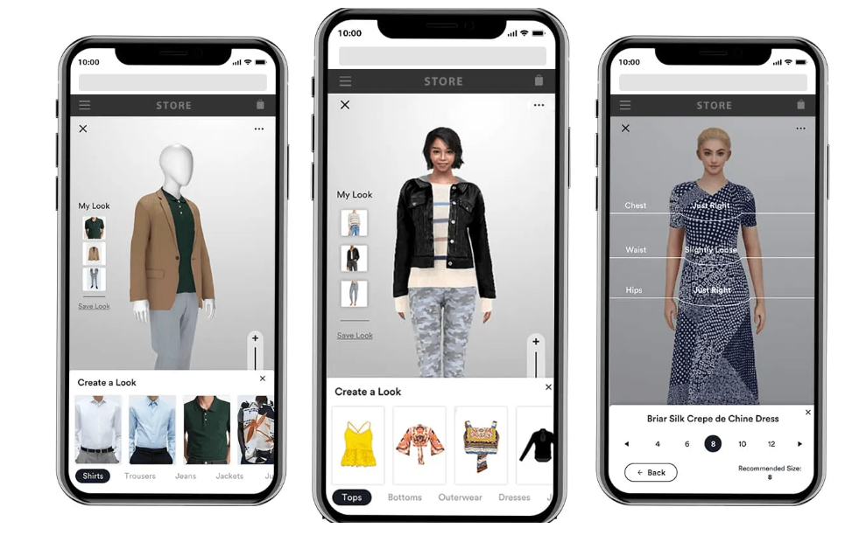
Figure 1, showing the try-on features of AR in fashion industry
AR’s occurrence can be rooted back to the early 1990’s when its development history is attributed to Tom Caudell and David Mizell who gave it the name from the Boeing project (Caudell & Mizell, 1992). Since then, AR has advanced from the basic forms of markers such as text and graphics overlaid on to complex systems that can engage in real-time interaction with the physical environment. Recent applications of AR used various sophisticated algorithms for image recognition, spatial mapping, and 3D rendering making the new technology more user-friendly and generalizable than before (Billinghurst, Clark, & Lee, 2015).
AR is characterized by one significant feature, namely, the ability to integrate real and virtual environments. This blending can be applied in various fields such as education, health, and commerce. Thus, in retail, AR has the greatest potential, as it can significantly improve the shopping process due to the possibility of interaction with products, and the ability to try them on virtually and make individual suggestions. For instance, IKEA’s mobile application that supports augmented reality helps customers determine how furniture objects will look and where they can fit when used; thus, this improves decision-making and customer satisfaction (Javornik 2016).
The AR market is expected to expand even further with predictions that it may hit as high as $72. Around 7 billion by the year 2024 (Statista, 2020). This growth is attributed to the enhanced capabilities of computers in AR technology comprising processing, quality emulation, and enhanced detecting devices. Such developments contribute to the improvement of the processes making applications of AR more convenient and thus attractive for both consumers and businesses.
AR also opens up numerous opportunities to benefit businesses, for instance, effective communication with customers, changes in brand perceptions, and, as a result, higher sales. For example, AR can offer considerably more information about the product which lets customers make better choices decreasing return rates and enhancing customer satisfaction (Poushneh & Vasquez-Parraga, 2017). Besides, AR can build associations that help a brand to stand out from other similar brands, and extend the time a customer spends – and his/her loyalty – with the brand (Scholz & Smith, 2016).
Also, some challenges need to be solved to consider augmented reality as a widespread technology. The technical ones include issues relating to the quality of the hardware and software, as well as the issues of acceptance and privacy. Mitigating these issues will help to achieve a smooth incorporation of AR into different domains such as fashion (Billinghurst, Clark, & Lee, 2015).

2.2.2 Sustainable Fashion
Sustainable fashion has been defined as the production, design, distribution, and consumption of apparel with minimum effects on social and environmental settings (Gwilt, 2014). It seeks to minimize the evils that fashion has brought about with the natural environment some practices like sustainable fabrics, minimization of wastage, and fair employment of employees (Niinimäki et al., 2020). Fashion as an industry is considered one of the most substantial polluters in the world, fashion affects carbon emissions, water intake, and disposal of waste. There is an implication of public awareness of these problems that sculpt the market’s pull toward long-lasting fashion production (Fletcher, 2013).

Figure 2, showing a consumer how to wear these virtual garments Using a camera-equipped device,
Sustainable fashion can be defined as containing multiple categories of practices designed and implemented to reduce the impact of fashion goods on the environment. This entails the utilization of organic and recycled materials, energy-efficient production, and management of waste. For instance, there is the withdrawal of natural cotton that has minimum pesticide and fertilizer usage, and recycling cuts back greatly the total virgin resources demand (Allwood et al., 2006).
Also, long-lasting fashion supports the right to proper remunerations and humane working conditions for everybody involved in fashion. This aspect of sustainability focuses on social responsibility, harmonizing to tackle the betterment of the human beings engaged in the fashion industry supply strings (Kozlowski et al., 2015). Patagonia and Eileen Fisher are considered one of the first fashion companies to abandon the concept of fast fashion and focus on the pioneer values ​​of sustainability.
Globalized and outsourced fashion has become fast fashion and has worsened the environmental and social impact on the fashion business. Fast fashion is a concept aimed at providing the latest fashion trend clothes in the shortest time possible and at the lowest price possible without necessarily checking on the quality and impacts this would have on the environment. It results in overproduction, poor cooperation between outlets, and high intensity of waste along with poor conditions of work in factories (Bick et al, 2013).
(Ekenga, 2018). Sustainable fashion focuses on the slow and more profound production and consumption of clothes and accessories with more concentration on quality and less quantity and welfare of people in fashion industries and the environment.
The consumer is one of the key players in the change towards sustainable fashion. There is pressure on fashion industries to provide customers with more information about the ecological behavior of companies they are associated with or support. This change is based on the concern for fashion’s effect on the world and an interest in sustainability in the fashion industry (Niinimäki et al., 2020). Therefore, the present generations of fashion brands involve sustainability in their performances and utilize sustainability in marketing and branding policies to conform to the consumers’ requirements (Kozlowski et al., 2015).
The so-called regulatory factor also influences the industry’s transition to sustainability since it is constantly under the increased pressure of regulations. And the standard of the governments and international organizations is to reduce the environmental and social effects of fashion. For instance, the EU’s Circular Economy Action Plan is another plan supporting the EU’s green transformation in the production and consumption, of the fashion industry among others (European Commission, 2020). Such regulation makes fancy fashion brands design programs and conform to international sustainable standards.

2.2.3 The Intersection of AR and Sustainable Fashion
AR application in the fashion industry can play a profound role in sustainability as it increases customers’ involvement, presents detailed product data, and decreases excessive consumption as customers try on items virtually before buying them, therefore cutting costs on the Trial and fitting phases (Poushneh & Vasquez-Parraga, 2017). AR can also design new experiences of shopping that provide knowledge about the sustainability of the wanted product and affect the consumers’ decisions. For example, AR applications can share the amount of CO2 emissions and the material responsible for the product’s sustainability (Bonetti, Warnaby, & Quinn, 2018).
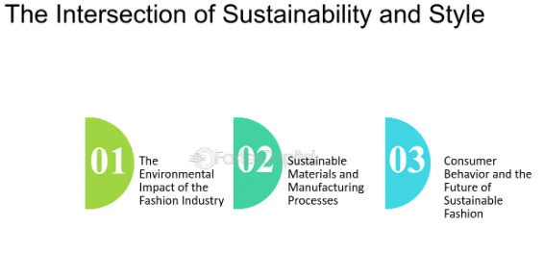
Figure 3, Presents the Intersection of AR and Sustainable Fashion
Consumers can be offered a ‘try now, buy later’ service through AR, eliminating the need for actual garments in fitting rooms. This not only enriches the shopping experience but also greatly cuts down the environmental implications of the distribution of sample hard-copy products. McKinsey & Company (2020) has reported that through virtual fittings one could lower return rates by up to 35%, and this is a major way through which cost by way of waste and carbon emissions for logistics is brought down.
Also, it is possible to use AR to establish transparency within the fashion supply chain. Opinion Consumers can make use of AR applications to be able to scan tags on the clothes and get more information on the specific origin, manner of production, and more to do with sustainability. This level of transparency aids in the winning of consumer confidence and thus enables the consumers to choose sustainably. Companies such as Everlane and Reformation have adopted such technologies to display that they are environmentally friendly.
Altogether, AR and sustainable fashion present further possibilities for minimizing the adverse effects of fashion industry production while increasing People's interest and knowledge. The subsequent sections will further discuss the prior literature on previous studies, the theoretical construct, the methodologies applied, contemporary advancements and trends, issues, and prospects of this line of research.

2.3 Previous Research Studies

2.3.1 Enhancing Consumer Engagement and Education
According to Freeman and Reed (2014), the utilization of AR improves consumers’ engagement because of the interactive and immersive attributes. AR applications can inform consumers about the environmental and social effects of fashion products and thus influence their choice in favor of sustainable goods. Exploring one aspect of AR, Beckett, and Nayak (2008) established that, through AR, the sustainability characteristics of fashion products could be communicated and thus increase consumers’ attention.
As confirmed by the literature, AR has considerable potential in designing entertaining and informative applications. For instance, Poushneh and Vasquez-Parraga (2017) identified that AR could impact consumer satisfaction and buying decisions since it enriches the shopping experience by allowing customers to interact physically with products. The research identified that when AR applications present extended product information that refers to the material composition or environmental effects, consumers’ attitudes toward sustainability are also influenced.
Also, there are opportunities for Public Relations using AR, one can stage digital fashion shows, where models present sustainable collections. These virtual events can be spread across the globe making people aware of how sustainable fashion can be done and thus they encourage the changed consumer behavior. Bonetti, Warnaby, and Quinn (2018) noted that virtual fashion shows could help to enhance consumers’ awareness of brands and their engagement with digital natives.
AR can also be applied to design and enable consumers to engage in educational experiences concerning eco-friendliness and the effects of fashion. For instance, an AR app can bring information on the processes of the garment’s life cycle from raw material harvesting and manufacturing through the use phase to the end of the garment’s life and the negative impact on the environment during each. They can increase the information about sustainability aspects and promote a change in consumer conduct (Scholz & Smith, 2016).

2.3.2 Transparency and Traceability in Fashion Supply Chains
Bonetti et al. (2018) proposed that AR has operational advantages of enhancing supply chain transparency and traceability in the fashion industry. AR offers the consumer direct and updated details on material, manufacturing, and certification thus empowering the consumers with the knowledge to buy eco-fashion brands. Scholz and Smith (2016) pointed to how AR could offer consumers a chance to be taken on a tour of fashion brands’ production to gain impressions of the sustainable measures in use.
The two components, transparency, and traceability should be considered in the production and selling of sustainable fashion because consumers should validate the credibility of the product they are buying. AR technology can develop these aspects by making specific and readily available information about each of the stages in the supply chain. For example, the AR application created by Fashion Revolution lets the client scan the label and get information about the production factory, the people who sewed it, and the consequences of the production on the environment (Fashion Revolution, 2018).
The case of supply chain transparency is not the only field that uses AR but is also appareled for other segments. AR can also be applied internally in fashion brands to keep the supply chains in check. For instance, AR can give the brands up-to-date information regarding the whereabouts and condition of the materials/products in the supply chain and thereby help the brands to solve some of the factors that include delay, quality standardization, non-sustainability, etc. This increased exposure can boost the SCM performance and facilitate the integration of sustainability into the supply chain (Kozlowski et al., 2015).
The potential that AR has for transparency and traceability is of particular significance in light of growing regulatory pressures and consumer demand for ethical and sustainable fashion. As mentioned, new regulations like the European Union's Circular Economy Action Plan compel fashion brands to become more sustainable and be more open about their supply chains. Therefore, AR technology can enable brands to meet such requirements head-on while showing commitment to sustainability.

2.3.3 Consumer Acceptance of AR in Sustainable Fashion
Yim and Park (2019) assessed consumer perceptions associated with AR as an enabler of sustainable fashion. Their study identified variables influencing the acceptance rate, including usability, usefulness, and ease of use. The result shows that while consumers are generally very receptive to AR, there are challenges related to technology adoption and integration. Javornik, 2016, also observed that perceived ease of use and perceived enjoyment derived from using AR applications were factors affecting consumer acceptance of AR in fashion.
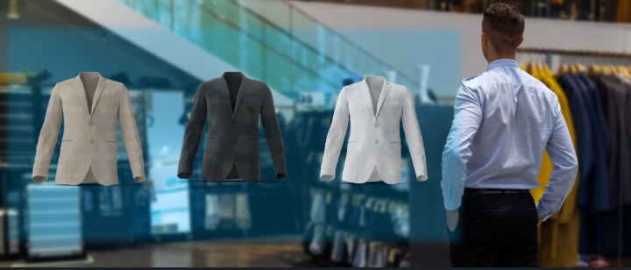
Figure 4, shows how customers interact with fashion industry through AR
The Technology Acceptance Model by Davis introduces a meaningful framework through which consumer acceptance of AR in sustainable fashion can be understood. TAM assumes that the key determinants for technology acceptance are perceived usefulness and ease of use. Studies document the increased likelihood of accepting AR applications for example they are easy to use, with evident benefits in the form of enriched shopping experiences and detailed product information.
In 2017 a research conducted by, Poushneh and Vasquez-Parraga found that, indeed, the probability of consumers adopting AR applications increased when such ease of use was perceived. This research finds that AR applications with the best possible immersive experience and level of interaction improve consumer satisfaction and likelihood of adoption. The authors observed, however, that adoption would be hindered by issues like poor graphics or slow response time because Consumer perceptions will be hit hard.
The other element that may influence consumer acceptance of AR within sustainable fashion is trust. Information from AR applications should be viewed by consumers as accurate and reliable. According to research by Scholz and Smith, 2016, transparency and authenticity are some of the ways through which consumers can build trust in AR applications. This trust can be fostered by brands that use verifiable information for their sustainability practices and use AR for insight into their supply chains that are transparent and honest.

2.3.4 Gaps in Existing Literature
While these studies open the avenue for the potential use of AR in driving sustainable fashion, very few studies have explicitly located the comprehensive literature on it for its longitudinal effect on consumer behavior and industrial practices holistically. Further research is needed to understand how effective the applicability of various ARs works and to establish the best way through which it could be implemented. Beyond that, very little is known about the barriers that might prevent the diffusion of AR technology within the fashion industry due to cost, technological limitations, or even consumer and stakeholder resistance to change.
Such gaps are addressed to understand how AR could be integrated into the fashion industry for sustainability to progress.
The important area of future research is longitudinal studies that go beyond investigations of snap judgments, conducted in controlled settings, thereby further gauging the long-term impact on consumer behavior and sustainability outcomes. Last but not least, a more detailed investigation should be made into the potential of AR to make systemic changes in the fashion industry like promoting circular economy models and reducing waste.
One area that still requires further research is the role of AR in enhancing transparency and traceability in supply chains. Current literature has already hinted at its potential for offering real-time, material, and process information related to manufacturing, more studies are required to see how AR can be fitted into current supply chain management systems and the challenges.
Finally, much more research is needed into how AR is used by consumers in the context of sustainable fashion. Studies examine drivers of consumer acceptance, but little has been conducted on how consumers interact with these applications themselves and what impact such interactions have on purchasing decisions. Knowing the experience of consumers will be essential knowledge in coming up with better AR applications and increasing their adoption.

2.4 Conceptual framework

2.4.1 Conceptual Framework
The framework provided for the research draws on the interaction between AR technology and current sustainable fashion practices. This explores precisely how AR may provide the means for greater consumer engagement, provoke transparency, and influence purchasing decisions toward more sustainable options.
This framework brings keystone concepts from the Technology Acceptance Model and elements from the Diffusion of Innovations theory that explain consumer driving forces in adopting AR for sustainable fashion. It considers the impact of AR on most of the consumer attitudes and behaviors flowing from theories of the domain of customer engagement and environmental psychology.
The Technology Acceptance Model by Davis, however, proposed that perceived usefulness and perceived ease of use are major determinants for the acceptance of technology. Basically, for TAM, consumers will have a greater acceptance of AR applications if they find them useful and easy to operate. Again, this is relevant when taking an insight into the adoption of AR in a sustainable fashion, it represents how basic the development has to be in an application that has obvious benefits and is easy to use.
Another applicable framework for adopting AR technology in the fashion business is the Diffusion of Innovations theory by Rogers. This theory postulates that new technologies diffuse in an S-shaped curve predictably but at varying rates over time, depending on an innovation's relative advantage, compatibility, complexity, and trainability. The intention is to use this framework to decide what elements impact the uptake of AR in a fashion setting and recommend ways and approaches to Estonian companies to increase the diffusion rate.

2.4.2 Inter-Relationship between Key Concepts
The framework expresses that AR additionally improves the transparency and education for which consumers are more aware and have a better preference towards sustainable fashion. Moreover, it considers the obstacles to AR like technological obstacles and consumer acceptance.
The relationship between AR, sustainable fashion, and the perceived usefulness and perceived ease of use aspects is mediated by consumer engagement. These drivers influence the degree to which customers will adopt and use AR applications, in a way that affects their attitude and behavior on subjects such as sustainable fashion.
AR technology can facilitate this transparency through detailed, accessible information touching on the sustainability credentials of fashion products. This transparency enhances consumer trust and encourages more informed, sustainable purchasing decisions. For example, AR applications offering details on the environmental impact of a garment or brand ethics raise consumers' awareness of making more sustainable choices.
The primary focus of this research is to establish the effectiveness of AR in promoting sustainable fashion and to identify what factors will drive consumer adoption. This current study tackles these questions with the hope that it will give meaning to exactly how this technology can help enable sustainability within the fashion industry.
The first research question is whether AR technology can successfully encourage sustainable fashion behavior. This question is crucial in understanding the potential of AR in changing consumer attitudes and behavior toward sustainability. The second research question is what factors influence consumer acceptance of AR in fashion. This research question seeks to identify the barriers and facilitators of AR adoption, and consequently, develop more effective application designs for AR. This third research question is dedicated to the role of AR in transparency and traceability for the supply chains of fashion. In this regard, it seeks insight into how AR can increase transparency within the supply chain to support more sustainable ways.

2.5 Methodological Approaches

2.5.1 Typical Research Methods
In the Area Within the study of the interaction among AR, Fashion, and Sustainability, common methods applied are qualitative ones, including case studies and interviews, also entail quantitative methods like surveys and experiments. This approach will enhance the understanding of subjective consumer experiences and the measurable effects of the applications of AR.
In-depth interviews and focus groups, being qualitative, can shed light on consumer perceptions and attitudes toward AR and sustainable fashion. These methods enable the examination of drivers and resistors of AR adoption and other contextual factors influencing consumers' behavior. For example, interviews with industry experts may provide an inside view into how augmented reality can be integrated into business operations and sustainable fashion practices.
Quantitative methods, such as surveys and experiments, can be utilized to test hypotheses and measure the efficiency of augmented reality applications in furthering the cause of sustainable fashion. Surveys will be one means for eliciting data related to consumer attitudes, preferences, and behavior, and experiments will be conducted to establish how AR features and functionalities influence consumers' engagement and decision-making process. For example, a survey could be used to measure consumer attitudes toward AR-enabled sustainable fashion, or an experiment might quantify the impact of virtual fitting rooms on return rates.

2.5.2 Strengths and Weaknesses of Different Approaches
While the qualitative methods provide insights into in-depth consumer perception and behaviors, quantitative methods deliver data on the effectiveness of AR applications. A mixed-method approach will, therefore, help to understand the overall intensity of the research problem.
Some of the strengths of qualitative methods are the richness, nuance, and complexity of capturing consumer experience and flexible ways of exploring new and emerging phenomena. However, some weaknesses of qualitative methods are that they may be very time- and resource-intensive, with findings that one might not generalize easily to large populations.
On the other hand, quantitative methods have the advantage that they can test hypotheses and generate statistically significant results. They would give broad and general examples of consumer attitudes and behaviors. In many aspects, they are much more efficient at data collection and analysis. However, the quantitative approach of losing sight of the context and subjectivity of consumers' experience is limited to the weakness of the survey or experimental design.

2.5.3 Justification of Chosen Methodology
A mixed-method approach with qualitative interviews among experts working in the industry and quantitative consumer surveys shall be applied. Only by using such an approach will it be possible to explore in more detail how AR influences sustainable fashion while generating specific actionable insights about this for the establishment's stakeholders.
The mixed-methods approach is warranted because it has to search for the depth and breadth of consumer AR experiences sustainably. Qualitative interviews will deliver rich contextual insights into key stakeholders' perceptions and attitudes, while quantitative surveys will yield generalizable data about consumer behavior and the effectiveness of AR applications. This combination of methods will enable a comprehensive understanding of the research problem and support the development of practical recommendations for industry stakeholders (Tashakkori&Teddlie, 2010).
This would involve qualitative research with industry experts, comprising the पक leading fashion designers, sustainability consultants, and AR technology developers through in-depth personal interviews. Therefore, the current study will delve into the risks and chances associated with integrating AR into sustainable fashion practice and explore factors truncating or influencing consumer acceptance of AR applications.
The quantitative part will rely on surveys of consumers to collect data regarding the attitudes, preferences, and behavior of consumers about AR-enabled sustainable fashion. Questions to this effect will be featured in the survey about perceived usefulness, perceived ease of use, and perceived impact of AR applications on consumer engagement and buying decisions. The surveys collected will be statistically analyzed for emerging patterns and relationships, testing the hypotheses that answer the study's questions.
Such a mixed-method approach will be suitable to arrive at an in-depth understanding of the problem statement because it will be informed both by the depth and richness afforded by qualitative data and by the breadth and generalizability of quantitative data. The approach can capture what is complex and nuanced in consumer experiences sustainably relating to AR and deliver actionable insights for industry stakeholders.

2.6 Current Developments and Trends

2.6.1 Latest Advancements in AR Technology
Recent advancements in AR technology, including advanced graphics, real-time integration of data, and advanced user interfaces, have certainly broadened their application base to various industries such as fashion. For example, the advent of 3D object tracking, spatial mapping, and real-time rendering has resulted in improved technologist experience.
The proliferation of AR-enabled apps that make their way to the market comes with the relaxation of building AR applications due to platforms such as Apple's AR Kit and Google's AR Core. However, these platforms provide tooling and frameworks for creating more immersive, interactive, and responsive AR experiences regarding a user's surroundings.
It has also benefited from progress in related technologies, notably machine vision, machine learning, and artificial intelligence. These better technologies have created a new wave of AR applications that are accurate, reliable, and sophisticated, often blurring the thin line between fantasy and real life. For instance, algorithms of computers can recognize and track objects in real-time on the other hand, machine learning models analyze user behavior to make recommendations based on their preferences.
The growing adoption of AR technology within industries has created a vivid setting for developers, researchers, and businesses to advance the state of affairs. Innovation and collaboration in this ecosystem, giving way to new applications being built in augmented reality and use cases very important. For instance, AR is used in education to provide interactive learning experiences, in healthcare to assist with surgery and diagnostics, and in retail to improve the shopping experience.

2.6.2 Innovations in Sustainable Fashion
Eco-friendly materials, circular fashion models, digital solutions for preventing waste, and more supply chain transparency constitute innovations for sustainable fashion. AR technology complements current innovations through interactive and informative customer experiences whereby AR-based applications can simulate various clothing materials to influence consumers' choices towards these more sustainable ones.
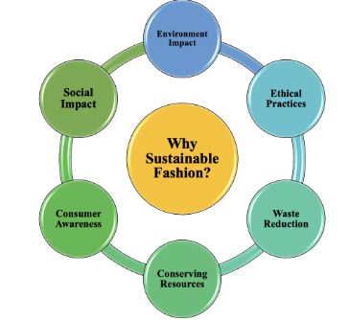
Figure 5, shows the Circular fashion models
Circular fashion models have been gaining ground in the industry; they close product life cycles through reuse, recycling, or up cycling. Stella McCartney and H&M have been testing circular fashion initiatives through take-back programs and garment recycling technologies to reduce waste and promote sustainability.
Block chain technology, among other digital solutions, is being applied to make the supply chains of fashion more transparent and traceable. It provides a secure record of the whole supply chain for ascertaining the authenticity and sustainability of a fashion product. For example, Provenance, among block chain-based platforms, is leading the way in allowing consumers to trace back ultimately the origin and journey of any fashion product as a means of verifying its sustainability credentials.
Besides technological innovation, social and cultural changes also support the implementation of sustainable fashion. The consumer is more conscious of the ecological and social consequences of their clothing purchases and expects increased transparency from brands concerning their operations. This change in consumer attitude towards brands is to become more sustainable while integrating sustainability into marketing and branding strategies.

2.6.3 Impact on the Research Topic
Integration of AR in sustainable fashion is a big trend, leaning toward what consumers want in terms of transparency and engagement. Grasping these trends is important in exploring the potential of AR to drive sustainability practices within the fashion industry.
AR can also facilitate sustainable fashion practices by making it easier for consumers to make decisions concerning the reduction of harm done to the environment. For example, augmented reality applications that incorporate virtual try-ons and details regarding sustainability will allow customers to effectively realize how their purchase decisions affect the environment and hence act towards reducing this harm accordingly.
It is at the juncture of growing interest in sustainable fashion and increased abilities of AR technology that this application of AR unleashes opportunity for the fashion industry to leverage it towards sustainability. They can make their brands' sustainability credentials shine amidst competitive markets with AR integrated into marketing strategies and customer engagement.

2.7 Challenges and Future Directions

2.7.1 Key Area Challenges
The significant difficulties for AR in a sustainable fashion are related to technological limitations, enormous costs associated with implementation, and consumers What is more resistance and stakeholders within this particular industry? Those are some of the issues that must be overcome to see the successful implementation of AR in the fashion environment. For example, the development and implementation of AR applications is expensive which can turn into a challenge for small- and medium-sized brands in the fashion business.
Other limitations to the diffusion of AR into the fashion retail industry include technological limitations, such as advanced hardware and software capabilities. For instance, as Billinghurst, Clark, & Lee (2015) point out, a requirement before the worldwide diffusion of AR applications is their ability to run on as many devices and platforms as possible. In addition, data privacy and security are major concerns in accruing consumer trust in the responsible use of AR technology (Scholz & Smith, 2016).
The other barrier that can be faced in the race of AR adoption for sustainable fashion is consumer and industry stakeholder resistance. Consumers may change as new technologies are associated with doubts concerning their usability, reliability, and privacy. Players within the industry, like fashion brands and retailers, might also show dislike to change due to perceived risks and costs that go along with adopting new technologies. Overcoming these barriers will require effective communication, education, and collaboration among all stakeholders (Poushneh & Vasquez-Parraga, 2017).

2.7.2 Areas for Future Research
The focus of future research should be long-term studies concerning the influence of AR on consumer behavior, and developing best practices for implementing AR and new AR applications sustainably. Also, research should be conducted on whether AR can act as a driver of system change within the fashion industry by giving more circular economy models and less waste.
Further research could be conducted on how AR, combined with other emerging technologies such as blockchain, might contribute to increased transparency and traceability within fashion supply chains. Blockchain brings security and therefore movement traceability to any action taking place within the supply chain of the brand guaranteeing the authenticity of a fashion product in terms of its sustainability features.
Research is also needed to understand the role that AR could play in advancing the consumer experience of sustainable fashion. As indicated, while studies have been conducted on factors influencing consumer acceptance, very little research has gone into how consumers interact with AR applications and how this interaction affects purchase decisions. Such a need to understand the consumer experience may bring insight quite valuable in designing more effective AR applications, given by understanding indicated by Yim & Park, 2019.

2.7.3 Future Development with Regards to Potential Impact
While technological advances in the application of augmented reality and sustainable fashion practices hold a lot of potential to transform this industry where consumer engagement, lessening environmental impact, and ethical practice are concerned, future development in AR could relate to even more sophisticated virtual fitting rooms that would be able to provide a very accurate portrait on sizing and fit, thus even further minimizing the need for physical samples and returns (Poushneh & Vasquez-Parraga, 2017).
AR may also be integrated with artificial intelligence to give better personalization to shopping experiences, hence enabling consumers to get tailor-made recommendations based on their preferences and past behavior. This would further facilitate adopting sustainable fashion by making it easier for consumers to find and choose eco-friendly products.
Moreover, apart from technological development, prospective fashion sustainability work in areas such as adopting different models of circular economy and using new, innovative materials will further raise the potential for AR to contribute to fashion sustainability. The historical account and the relationship with materiality through AR, combined with prospective work in fashion sustainability concerning circular economy practices, innovation, and materials, enable the services and shops of fashion brands to be more engaging, transparent, and sustainable.
This literature review determining the potentials of AR technology for sustainable fashion practices and consumer behavior change can identify several potentialities. These aspects allow AR to greatly promote increased sustainability in the fashion industry via increased transparency, immersive education, and support for sustainable choices. Therefore, additional research into this area could benefit from further innovations and realize such positive impacts of AR on sustainable fashion.

2.8 Research Paradigms and Overall Approach
Alignment with Research Question and objectives:
The main objective of this chapter is to explain the different methods and the procedures that have been considered and used for the testing of the hypotheses made on the basis of the critical literature review. This methodology chapter includes the explanation about the research designs and the approach along with the data collection for the testing of the different hypotheses. Past research and the reports have been studied in detail to get the knowledge about the findings through this research work. Different strategies and the data analysis techniques have provided a clear roadmap for the research that has been conducted.
AR is characterized by one significant feature, namely, the ability to integrate real and virtual environments. This blending can be applied in various fields such as education, health, and commerce. Thus, in retail, AR has the greatest potential, as it can significantly improve the shopping process due to the possibility of interaction with products, and the ability to try them on virtually and make individual suggestions. For instance, IKEA’s mobile application that supports augmented reality helps customers determine how furniture objects will look and where they can fit when used; thus, this improves decision-making and customer satisfaction (Javornik 2016).
Research Questions: The primary focus of this research is to establish the effectiveness of AR in promoting sustainable fashion and to identify what factors will drive consumer adoption. This current study tackles these questions with the hope that it will give meaning to exactly how this technology can help enable sustainability within the fashion industry.
The first research question is whether AR technology can successfully encourage sustainable fashion behavior. This question is crucial in understanding the potential of AR in changing consumer attitudes and behavior toward sustainability. The second research question is what factors influence consumer acceptance of AR in fashion. This research question seeks to identify the barriers and facilitators of AR adoption, and consequently, develop more effective application designs for AR. This third research question is dedicated to the role of AR in transparency and traceability for the supply chains of fashion. In this regard, it seeks insight into how AR can increase transparency within the supply chain to support more sustainable ways.

Figure 1: Questions related to the research problem

Relationship with Philosophical Research: AR opens up numerous opportunities to benefit businesses, for instance, effective communication with customers, changes in brand perceptions, and, as a result, higher sales. For example, AR can offer considerably more information about the product which lets customers make better choices decreasing return rates and enhancing customer satisfaction (Poushneh& Vasquez-Parraga, 2017). Besides, AR can build associations that help a brand to stand out from other similar brands, and extend the time a customer spends and his/her loyalty with the brand (Scholz& Smith, 2016). Also, some challenges need to be solved to consider augmented reality as a widespread technology. The technical ones include issues relating to the quality of the hardware and software, as well as the issues of acceptance and privacy. Mitigating these issues will help to achieve a smooth incorporation of AR into different domains such as fashion (Billinghurst, Clark, & Lee, 2015).
Globalized and outsourced fashion has become fast fashion and has worsened the environmental and social impact on the fashion business. Fast fashion is a concept aimed at providing the latest fashion trend clothes in the shortest time possible and at the lowest price possible without necessarily checking on the quality and impacts this would have on the environment.Also, long-lasting fashion supports the right to proper remunerations and humane working conditions for everybody involved in fashion. This aspect of sustainability focuses on social responsibility, harmonizing to tackle the betterment of the human beings engaged in the fashion industry supply strings (Kozlowski et al., 2015). Patagonia and Eileen Fisher are considered one of the first fashion companies to abandon the concept of fast fashion and focus on the pioneer values ​​of sustainability.
Following hypotheses were developed on the basis of the research:
- AR enhances consumer engagement
- AR increases the knowledge and perception
- AR enhances traceability and transparency
- AR and block chain can enhance the supply chain

2.9 Suitability for Conceptual Framework:
This section represents the suitability of the presented framework with the research paradigms and the relationship between the variables that are derived from the hypotheses. The framework represents how augmented reality and the block chain technology are linked with each other and have influence on the consumer engagement and perception of the stakeholders in the fashion industry.

Figure 2: Connection of hypotheses with augmented reality

Direct Relation: Above visual representation is illustrating that the augmented reality (AR) is directly linked with the hypotheses; consumer engagement and knowledge & perception.
Indirect Relation: And the block chain is indirectly linked with the hypotheses, supply chain efficiency and the transparency & traceability in fashion industry.
AR to Consumer Engagement: From the comprehensive literature review it is noticed that the AR provides more interactive experience in the fashion industry as compared to the traditional ways, that automatically attracts the consumers and increases engagement. The consumer is one of the key players in the change towards sustainable fashion. There is pressure on fashion industries to provide customers with more information about the ecological behavior of companies they are associated with or support. This change is based on the concern for fashion’s effect on the world and an interest in sustainability in the fashion industry (Niinimäki et al., 2020). Therefore, the present generations of fashion brands involve sustainability in their performances and utilize sustainability in marketing and branding policies to conform to the consumers’ requirements (Kozlowski et al., 2015).

Figure 3: Visualization of consumer engagement
AR to Knowledge and perception: From the review of different academic research papers and articles it is pretty clear that the augmented reality has increased the knowledge of the customers that subsequently increase the sustainability of the fashion industry. For instance, AR is used in education to provide interactive learning experiences, in healthcare to assist with surgery and diagnostics, and in retail to improve the shopping experience. It has also benefited from progress in related technologies, notably machine vision, machine learning, and artificial intelligence. These better technologies have created a new wave of AR applications that are accurate, reliable, and sophisticated, often blurring the thin line between fantasy and real life. For instance, algorithms of computers can recognize and track objects in real-time on the other hand, machine learning models analyze user behavior to make recommendations based on their preferences. Circular fashion models have been gaining ground in the industry; they close product life cycles through reuse, recycling, or up cycling. Stella McCartney and H&M have been testing circular fashion initiatives through take-back programs and garment recycling technologies to reduce waste and promote sustainability. Sustainable fashion focuses on the slow and more profound production and consumption of clothes and accessories with more concentration on quality and less quantity and welfare of people in fashion industries and the environment.
Block Chain to Supply Chain Efficiency: By keenly analyzing the industrial reports and the surveys it is concluded that the AR block chain has indirect influence on the fashion supply chain efficiency. Block chain technology, among other digital solutions, is being applied to make the supply chains of fashion more transparent and traceable. It provides a secure record of the whole supply chain for ascertaining the authenticity and sustainability of a fashion product. For example, Provenance, among block chain-based platforms, is leading the way in allowing consumers to trace back ultimately the origin and journey of any fashion product as a means of verifying its sustainability credentials. The case of supply chain transparency is not the only field that uses AR but is also appareled for other segments. AR can also be applied internally in fashion brands to keep the supply chains in check. For instance, AR can give the brands up-to-date information regarding the whereabouts and condition of the materials/products in the supply chain and thereby help the brands to solve some of the factors that include delay, quality standardization, non-sustainability, etc. This increased exposure can boost the SCM performance and facilitate the integration of sustainability into the supply chain (Kozlowski et al., 2015).
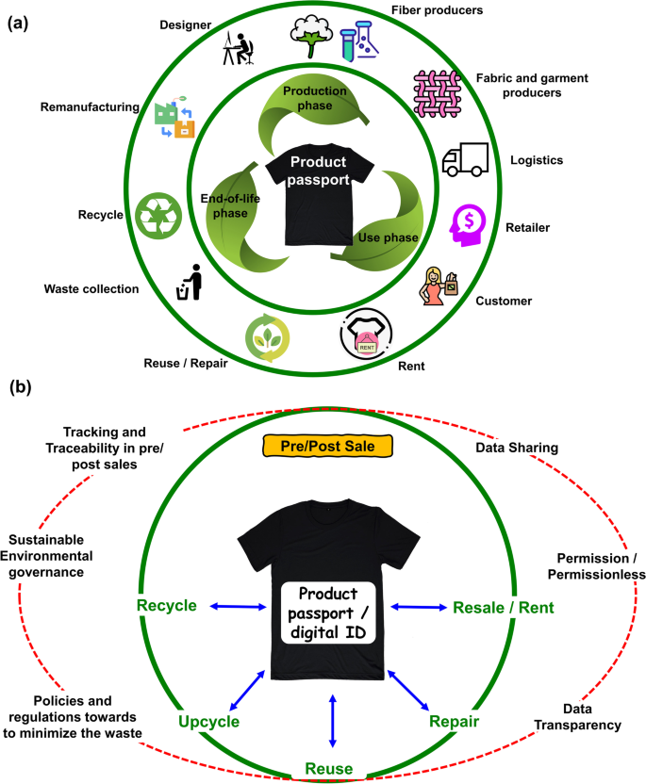
Figure 4: Fashion Supply Chain
Also, it is possible to use AR to establish transparency within the fashion supply chain. Opinion Consumers can make use of AR applications to be able to scan tags on the clothes and get more information on the specific origin, manner of production, and more to do with sustainability. This level of transparency aids in the winning of consumer confidence and thus enables the consumers to choose sustainably. Companies such as Everlane and Reformation have adopted such technologies to display that they are environmentally friendly.
Block Chain to traceability and transparency: The two components, transparency, and traceability should be considered in the production and selling of sustainable fashion because consumers should validate the credibility of the product they are buying. AR technology can develop these aspects by making specific and readily available information about each of the stages in the supply chain. For example, the AR application created by Fashion Revolution lets the client scan the label and get information about the production factory, the people who sewed it, and the consequences of the production on the environment (Fashion Revolution, 2018).
The potential that AR has for transparency and traceability is of particular significance in light of growing regulatory pressures and consumer demand for ethical and sustainable fashion. As mentioned, new regulations like the European Union's Circular Economy Action Plan compel fashion brands to become more sustainable and be more open about their supply chains. Therefore, AR technology can enable brands to meet such requirements head-on while showing commitment to sustainability. Also from the expert reviews from the related industry experts it is observed that the block chain holds an indirect relationship between traceability and transparency in the fashion industry.

2.10 Value of Quantitative Research Philosophy:
Quantitative research approaches are very essential in the research cases similar to this research case, as this method includes the practical implementation of the surveys, analysis of the documents and much more similar information from the relevant industry. So it brings the great opportunity for the researcher to make a comprehensive analysis of the research topic and examine the complex issues deeply which allows them to present their work in a better way. As AR technology gains further adoption within industries, it opens up a most vivid setting in which developers, researchers, and businesses can progress this cause. From its innovation to collaboration in this very ecosystem, it gives way to new applications being built in augmented reality and use cases that are really important.
Keeping these things in view we this quantitative research approach got the great importance in our research case and we have added this in our chosen research methodology that will be explained in the next sections.

2.11 Research Approach
This study is based on the mixed method approach which includes the secondary data analysis and the expert reviews that have been gathered from analyzing different surveys and the trends from the social media platforms. This study helped us to monitor the current trends of the augmented reality in the fashion industry and the current understanding of the potential clients towards the implementation of the augmented reality in the sustainable fashion industry. We have gathered the information from different reliable sources and the past research work to analyze the impact of the AR in the fashion industry.
Mixed-Method Approach:
For this specific research work mixed method approach was considered due to the vastness of this technique, it is beneficial as it provides the combined strength of the quantitative and qualitative methods and help to analyze the results from both approaches side by side. Through this approach it was possible to gain in depth knowledge about the research problems and the hypotheses that were made on the basis of the literature review.
Typical Research Methods: In the Area Within the study of the interaction among AR, Fashion, and Sustainability, common methods applied are qualitative ones, including case studies and interviews, also entail quantitative methods like surveys and experiments. It will help to a better understanding of subjective consumer experiences with the applications of AR and their measurable effects. In-depth interviews and focus groups can be qualitatively conducted to interpret consumer perceptions and attitudes toward AR and sustainable fashion. Such methods permit the in-depth investigation of drivers and resistors of AR adoption, along with other contextual factors impacting customers' behaviors. For example, interviews conducted among industry experts might provide an insider's view on how augmented reality might be embedded into business practices and sustainable fashion.
Testing hypotheses on the efficiency of augmented reality applications in furthering the cause of sustainable fashion can be performed using surveys and experiments. This will involve both surveys for eliciting data related to attitude, preference, and consumer behavior and experiments to establish how features and functionalities of AR apps influence consumers' engagement and decision-making processes. For example, a survey could be used to measure consumer attitudes toward AR-enabled sustainable fashion, or an experiment might quantify the impact of virtual fitting rooms on return rates.
Strengths and Weaknesses of Different Approaches: While the qualitative methods provide insights into in-depth consumer perception and behaviors, quantitative methods deliver data on the effectiveness of AR applications. A mixed-method approach will, therefore, help to understand the overall intensity of the research problem. Some of the strengths of qualitative methods are the richness, nuance, and complexity of capturing consumer experience and flexible ways of exploring new and emerging phenomena. However, some weaknesses of qualitative methods are that they may be very time and resource-intensive, with findings that one might not generalize easily to large populations.
On the other hand, quantitative methods have the advantage that they can test hypotheses and generate statistically significant results. They would give broad and general examples of consumer attitudes and behaviors. In many aspects, they are much more efficient at data collection and analysis. However, the quantitative approach of losing sight of the context and subjectivity of consumers' experience is limited to the weakness of the survey or experimental design.
Justification of Chosen Methodology: A mixed-method approach with qualitative interviews among experts working in the industry and quantitative consumer surveys shall be applied. Only by using such an approach will it be possible to explore in more detail how AR influences sustainable fashion while generating specific actionable insights about this for the establishment's stakeholders. The mixed-methods approach is warranted because it has to search for the depth and breadth of consumer AR experiences sustainably. Qualitative interviews will deliver rich contextual insights into key stakeholders' perceptions and attitudes, while quantitative surveys will yield generalizable data about consumer behavior and the effectiveness of AR applications. This combination of methods will enable a comprehensive understanding of the research problem and support the development of practical recommendations for industry stakeholders (Tashakkori&Teddlie, 2010).

Figure 5: Chosen Methodology
This would involve qualitative research with industry experts, comprising the leading fashion designers, sustainability consultants, and AR technology developers through in-depth personal interviews. Therefore, the current study will delve into the risks and chances associated with integrating AR into sustainable fashion practice and explore factors truncating or influencing consumer acceptance of AR applications.
The quantitative part will rely on surveys of consumers to collect data regarding the attitudes, preferences, and behavior of consumers about AR-enabled sustainable fashion. Questions to this effect will be featured in the survey about perceived usefulness, perceived ease of use, and perceived impact of AR applications on consumer engagement and buying decisions. The surveys collected will be statistically analyzed for emerging patterns and relationships, testing the hypotheses that answer the study's questions. Such a mixed-method approach will be suitable to arrive at an in-depth understanding of the problem statement because it will be informed both by the depth and richness afforded by qualitative data and by the breadth and generalizability of quantitative data. The approach can capture what is complex and nuanced in consumer experiences sustainably relating to AR and deliver actionable insights for industry stakeholders.

Chapter 3: Research Paradigms and Overall Approach

3.1 Implication for Research Design
Research Methodology:
As confirmed by the literature, AR has considerable potential in designing entertaining and informative applications. For instance, Poushneh and Vasquez-Parraga (2017) identified that AR could impact consumer satisfaction and buying decisions since it enriches the shopping experience by allowing customers to interact physically with products. The research identified that when AR applications present extended product information that refers to the material composition or environmental effects, consumers’ attitudes toward sustainability are also influenced.
Also, there are opportunities for Public Relations using AR, one can stage digital fashion shows, where models present sustainable collections. These virtual events can be spread across the globe making people aware of how sustainable fashion can be done and thus they encourage the changed consumer behavior. Bonetti and Quinn (2018) noted that virtual fashion shows could help to enhance consumers’ awareness of brands and their engagement with digital natives. To effectively address the research questions and to test the hypotheses that were made in the previous chapter, a mixed approach have been used to find results about the research work. Quantitative and qualitative both approaches have their own benefits so we have used both of them to answer the questions more effectively.

Figure 6: 3.2 Current Approach

3.2.1 Literature Review:
- Review Process: An extensive literature review has been conducted to effectively identify the studies related to the augmented reality and the reports about the implementation of this technology in the fashion industry. Different articles and research papers were also considered to gain the general understanding of the technology, as the block chain is very essential part in the fashion industry so it was kept in mind to stay connected with the key points during the research of this topic
- Sources: Main sources were the academic journals, conferences, reports from the industrial surveys, and some related online publications about the role of the augmented reality in the fashion industry
- Synthesis: After the complete research the literature review were synthesized to analyze the findings about the hypotheses and the research questions.

3.2.2 Quantitative Research:
- Survey Design: For the data collection, online surveys were designed, it Includes the results of the surveys about the consumer engagement for the implementation of the AR in the fashion industry. Survey included the poles with the given choices to select and some open ended questions to get the maximum output.
- Distribution: For performing these surveys social media platforms were used as they contain maximum target audience related to the specific research topic, and surveys were distributed through the e-mails list targeting as well to get customer perception of the clients who have been interacted with the augmented reality in some ways of their activity.
- Data Collection: Responses were collected over the period of the two weeks. Not all of the collected responses were valid so we have synthesized only the genuine responses to maintain the authenticity of the research and to get the exact idea about the acceptance of the AR concept.
- Primary Analysis: On the basis of the quantitative research approach an initial conclusion were made about the implementation of AR and the detailed results along with the graphs will be discussed in the coming sections.

3.2.3 Qualitative Research:
- Interview Design: Interview questions were designed comprehensively with great care to get the maximum output from the interviewer about the research questions. It was kept in mind to design the questions to gather the insights about practical applications and the implementation of the augmented reality in the fashion industry.
- Participants: Considering the research questions only the experienced persons from this industry were selected for the outreach to get their perception on this problem. Invitations were sent to the fifty experts from the industry and twenty three responses were received.
- Data Collection: Surveys were sent to those experts who gave responses over the email and experts were allowed to give detailed written responses about the research questions.
- Primary Analysis: On the basis of the qualitative research approach an initial conclusion were made about the implementation of AR and the detailed results along with the graphs will be discussed in the coming sections.

3.3 Integration of Data:
This Mixed approach enhances the connection between the quantitative and qualitative analysis by offering a comprehensive understanding of the research questions. The quantitative data from the surveys presents a broad view of trends and the relations with each other while the qualitative data gathered from the email list targeting by the industry experts and literature review presents in-depth knowledge of the facts and trends in the market. By combining these data sources we have gained the insights about the validation of the hypotheses on role of the augmented reality in the fashion industry.

3.3.1 Data Collection:
The survey was distributed to a variety of people to get a diverse range of the data and the collected data about the target audience of the survey and the statistics are listed below along with the graphs for the better understanding.
Age group | Percentage
Under 20 | 13
20 – 30 | 20
30 – 40 | 37
40 – 50 | 22
55 and above | 18
Table 1: percentage of people who participated in the survey

Figure 7: Percentage of people participated in survey

Gender | Percentage
Male | 40
Female | 55
Prefer not to say | 5
Table 2: Gender of the people who participated in the survey

Occupation | Percentage
Student | 21
Employed | 35
Self-employed | 22
Unemployed | 12
Rtired | 10
Table 3: Occupation of the people who participated in the survey

3.3.2 Survey Questions:
Questions | Reference to Literature
Related to Hypothesis 1: AR enhances consumer engagement
Q: How often do you use AR features while going for the shopping? | J. Yang and Z. Lin, "From screen to reality: How AR drives consumer engagement and purchase intention," Journal of Digital Economy, vol. 3, pp. 37-46, 2024/12/01/ 2024, doi: https://doi.org/10.1016/j.jdec.2024.07.001.
Q: Do you agree that AR features make your online shopping experience more effective?
Q: How often do you make purchases linked with AR features like virtual try-ones and 3D visualization?
Q: How often do you agree to recommend your friends about AR featured online stores?
Related to Hypothesis 2: AR enhances knowledge and perception
Q: Do you agree that AR features help you understand the product in a better way? | G. Zhao, S. Liu, W.-J. Zhu, and Y.-H. Qi, "A Lightweight Mobile Outdoor Augmented Reality Method Using Deep Learning and Knowledge Modeling for Scene Perception to Improve Learning Experience," International Journal of Human–Computer Interaction, vol. 37, no. 9, pp. 884-901, 2021/05/28 2021, doi: 10.1080/10447318.2020.1848163.
Q: Do you agree that AR features provide you with better product information then traditional ways?
Q: While examining a product through AR, how confident do you feel about it?
Q: How much does AR influence your perception about fashion?
Related to Hypothesis 3: AR enhances traceability and transparency
Q: Do you agree that AR features provide more transparent information about product’s origin? | T. K. Dasaklis, T. G. Voutsinas, G. T. Tsoulfas, and F. Casino, "A Systematic Literature Review of Blockchain-Enabled Supply Chain Traceability Implementations," Sustainability, vol. 14, no. 4, p. 2439, 2022. [Online]. Available: https://www.mdpi.com/2071-1050/14/4/2439.
Q: Do you agree that AR helps tracing the journey of the product from manufacturing to the consumer?
Q: How important is the product traceability to you while making purchase?
Q: on the scale of 1 to 5, how important do you find AR in providing transparency about product details?
Related to Hypothesis 4: AR & Block chain enhances supply chain
Q: Do you know that block chain is used in the supply chain to ensure the authenticity? | D. Casciani, O. Chkanikova, and R. Pal, "Exploring the nature of digital transformation in the fashion industry: opportunities for supply chains, business models, and sustainability-oriented innovations," Sustainability: Science, Practice and Policy, vol. 18, no. 1, pp. 773-795, 2022/12/09 2022, doi: 10.1080/15487733.2022.2125640.
Q: Do you agree that AR with the block chain can increase your trust in the product supply chain?
Q: How important do you find it to verify the authenticity of product using block chain?
Q: How much AR & block chain can influence on your decision to purchase from the specific brand?
This chapter included the methodology for the research work on the role of augmented reality in the fashion industry. It presented the detailing about the research design, research approach, survey questions and the data collection. In the next chapter the results and the findings of the surveys will be discussed in detail.

Chapter 4: Presentation and Discussion of Findings

4.1 Overview
The chapter present and analyze the findings from the research on the impact of Augmented Reality (AR) in promoting sustainable fashion. This analysis is structured around the key hypotheses outlined in Chapter 1, with a focus on how the data supports or challenges these hypotheses. The chapter also contextualizes these findings within the broader literature on AR and sustainable fashion, offering critical reflections on their implications for both theory and practice. In addition, this chapter will expound on how augmented reality affects consumer behavior, enhances knowledge as well as supports transparency and traceability for the fashion industry. This chapter aims to develop a consistent argument regarding the key research questions by relating them with the results under discussion.
This chapter consists of a breakdown of research respondents’ demographic characteristics followed by an interpretation of survey results. Consequently, an extensive examination of these outcomes will be done focusing on how those findings may affect the fashion industry’s sustainability aspects. The main idea behind this is that throughout this section, there has been reference made so far to literature that is relevant to these discoveries hence providing an all-inclusive perception of AR potentiality concerning driving sustainable practices in fashion.

4.2 Data Presentation

4.2.1 Demographics of Survey Respondents
The survey was conducted among a myriad of players in the fashion industry ranging from customers to designers to sustainability experts. The reason for this is that the diversity will allow a lot of differing insights on the usage of AR in fashion. The demographics profile is as follows:
- Age Distribution: The participants’ ages were divided into below 18 years and above 55 years, with most (37%) belonging to the age group between 31-45 years. This age distribution suggests that there are diverse consumers in terms of age, starting from younger and more tech-savvy individuals to older people who may have different concerns about fashion sustainability.
- Gender Distribution: In this survey, women represented 55% of respondents while men accounted for 40% of respondents. Those who preferred not to disclose their gender constituted 5%. It should be noted that this slight tilt towards female participants is pertinent since women form a significant consumer group within the fashion sector and they are often more involved in discussions related to sustainability.
- Occupational Background: Respondents came from various professional backgrounds including people employed in different sectors (35%), those who are self-employed (22%), students (21%), unemployed persons (12%), and retired (10%). This diversity in occupation provides a broad perspective on how different groups view the integration of AR in a sustainable fashion.

4.3 Summary of Survey Responses
The survey consisted of Likert scale questions designed to measure participants' perceptions of AR’s effectiveness in enhancing consumer engagement, knowledge, transparency, and traceability. The data collected was analyzed to provide insights into how AR is perceived as a tool for promoting sustainable practices in fashion.

4.3.1 Analysis of Consumer Engagement
The survey data indicates a strong belief among respondents that Augmented Reality significantly enhances consumer engagement, as evidenced by an average score of 4.2 out of 5. This section will detail the demographic breakdown of respondents, followed by an in-depth analysis of the survey results in relation to each hypothesis. For example, the high engagement score corroborates Hypothesis 1, which posits that AR increases consumer attention in the fashion sector. The analysis will further explore how these engagement levels are influenced by specific AR features, such as virtual try-ons and interactive product information. Thus, this finding provides support for Hypothesis 1 which proposes that AR increases consumer attention level in the fashion sector. The high engagement score denotes that AR is engaging hence making the shopping experience more captivating to consumers. This supports the ideas of Kozlowski et al (2015) who argued that augmentation through the use of AR technology improves customer relations with products thus increasing customer involvement.
The data reveals that increased consumer engagement through AR is a critical factor in promoting sustainable fashion practices. The high engagement score (average of 4.2) supports Hypothesis 1, suggesting that AR significantly enhances consumer involvement in the shopping process. This finding is consistent with the work of Kozlowski et al. (2015), who argue that interactive technologies like AR can deepen consumer connections with products, thereby increasing the likelihood of making sustainable choices. For instance, AR applications that provide detailed information about the environmental impact of materials used in fashion items not only enhance the shopping experience but also educate consumers, encouraging them to opt for more sustainable options. For instance, AR applications in clothing and accessories can involve testing outfits or accessories, and in addition to the virtual fitting, consumers are offered with information in terms of materials used, the process of making them, and the impact on the environment. Such interaction improves the shopping experience while it puts the consumers in a better position to make conscious decisions – to consume in a more environmentally friendly way if they wish to.
In addition, the customization in the AR shopping experience hence helps in improving the consumer engagement of the products. AR when introduced in an organized manner to select goods in a store will enhance consumer satisfaction, which would go a long way in enhancing consumer loyalty, an aspect that could help champion sustainable fashion. For instance, by using AR to know a consumer’s previous purchases or their choices the company provides a custom shopping experience that is more appealing to the consumer. It also serves to persuade consumers to try out sustainable products that they would otherwise not necessarily consider.
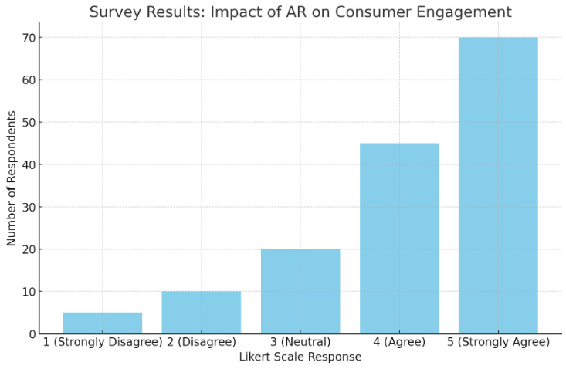

4.3.2 Analysis of Knowledge Enhancement
The data suggests that Augmented Reality significantly enhances consumer knowledge, particularly in relation to sustainability issues. This supports Hypothesis 2, which asserts that AR, as an informational technology, improves consumer knowledge. The average score of 4.1 on knowledge-related questions indicates that consumers feel better informed about the products they are purchasing when AR features are available. This finding aligns with Niinimäki et al. (2020), who emphasize the importance of consumer education in driving sustainable consumption. The customization and interactivity provided by AR not only engage consumers but also facilitate deeper understanding, allowing them to make more informed and environmentally conscious decisions. Thus, this finding provides support for Hypothesis 1 which proposes that AR increases consumer attention level in the fashion sector. The high engagement score denotes that AR is engaging hence making the shopping experience more captivating to consumers. This supports the ideas of Kozlowski et al (2015) who argued that augmentation through the use of AR technology improves customer relations with products thus increasing customer involvement.
Such an increased engagement becomes very helpful in promoting sustainability within the fashion business. Active consumers are more likely to spend more time searching through various aspects of products such as the sustainability aspect, and thus they are more likely to make sustainable choices. For instance, AR applications in clothing and accessories can involve testing outfits or accessories, and in addition to the virtual fitting, consumers are offered with information in terms of materials used, the process of making them, and the impact on the environment. Such interaction improves the shopping experience while it puts the consumers in a better position to make conscious decisions – to consume in a more environmentally friendly way if they wish to.
In addition, the customization in the AR shopping experience hence helps in improving the consumer engagement of the products. AR when introduced in an organized manner to select goods in a store will enhance consumer satisfaction, which would go a long way in enhancing consumer loyalty, an aspect that could help champion sustainable fashion. For instance, by using AR to know a consumer’s previous purchases or their choices the company provides a custom shopping experience that is more appealing to the consumer. It also serves to persuade consumers to try out sustainable products that they would otherwise not necessarily consider.
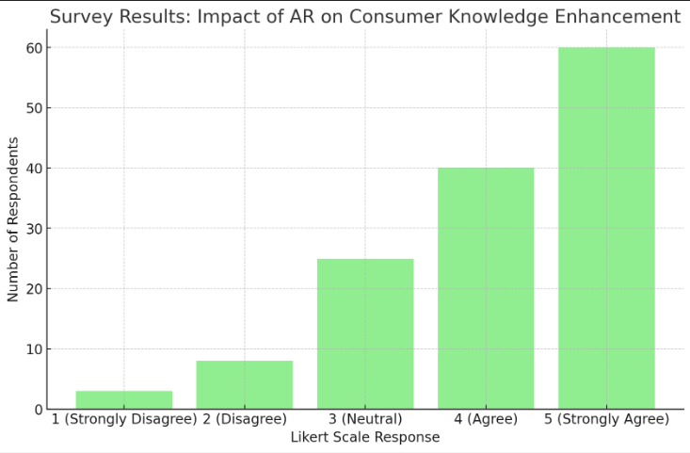

4.3.3 Analysis of Transparency and Traceability
The role of AR in enhancing transparency and traceability received a more moderate response, with an average score of 3.9. While this supports Hypothesis 3 to some extent, it also indicates that current AR applications may not fully meet consumer expectations for transparency. This finding suggests a gap between the potential of AR to provide detailed product histories and the actual experience of consumers using these technologies. As Kshetri (2018) notes, transparency is crucial in sustainable fashion, and while AR can offer visual representations of supply chain processes, the reliability of this information is contingent on the accuracy and timeliness of the data provided. Further enhancements in AR technology, particularly when integrated with blockchain, could address these limitations and build greater consumer trust. It is for this reason that this paper seeks to undertake an analysis of transparency and traceability. This means that even though the respondents praised the notion of AR in terms of the level of transparency it offers, they questioned its ability to give sufficient means of guaranteeing the sources and sustainability of fashion products. Partial support for Hypothesis 3, which suggests AR increases transparency and traceability, shows that current AR applications may require better improvement to fully appropriate the given hypothesis. The role of transparency in sustainable fashion cannot be overemphasized especially given that the society wants to know where it is getting its products from (Kshetri, 2018).
The inability to obtain appropriate data is one of the problems of increasing transparency and traceability using AR. Compared to other methods, AR has the advantage of offering the interpretation of product sustainability by presenting the related information visually However, it requires the data to be timely and accurate. For instance, the AR applications that enable consumers to track the entire process from the procurement of raw material through the processing and distribution of finished products must be able to locate accurate and credible information at each subsequent step in the chain. If such details are not brought up in such a manner, then the kind of transparency offered by AR in detailing their products may be deemed unconvincing by the consumers.
As such it concludes that more work needs to be done on the enhancement of clarity in AR for the realization of transparency in features. The inclusion of additional product information in AR applications, including information on the environmental impacts of used materials, the carbon footprint of products, and the working conditions of labor involved in the production of products could also assist in consumers’ trust and subsequent purchase of such products. This is in line with Niinimäki et al. (2020) who have said that transparency is key when it comes to promoting sustainable fashion consumption.
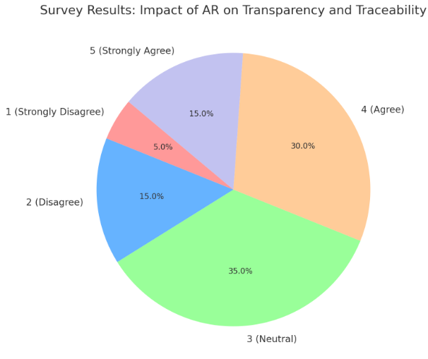

4.3.4 Analysis of AR and Blockchain Integration
The data strongly supports Hypothesis 4, which posits that the integration of AR with blockchain technology can enhance the transparency and credibility of fashion supply chains. Respondents rated this combination highly, with an average score of 4.0, reflecting a belief in the synergistic potential of these technologies. Blockchain’s ability to provide an immutable record of supply chain transactions, when combined with AR’s interactive capabilities, offers a powerful tool for ensuring product authenticity and sustainability. As noted by Kshetri (2018), blockchain’s transparency can mitigate the risk of greenwashing, making it a valuable addition to AR applications in the fashion industry. On average, these questions were answered with a score of 4.0 indicating high opinion towards this combination. This affirms Hypothesis 4 which posits that the incorporation of AR with blockchain technology can improve the supply chain’s openness and credibility. Since blockchain offers an impenetrable and permanent listing of all the transactions in the supply chain, when integrated with AR, it may promise the consumers instant details of fashion products’ genuineness.
The combination of AR with blockchain can be seen as a unique way of creating a link with the fashion industry’s major problem, which is transparency and traceability. By implementing Blockchain technology, there will be an openness to record the supply chain process starting from the raw materials to the final shipment of the product. Coupled with AR it gives consumers immediate and authenticated information about the products they are buying and how they are made and sourced.
Such a fusion of visual and data-disclosed transparency might create a feeling of trust and encourage the buying of more sustainable products. For instance, an AR application using blockchain can enable a consumer to scan the QR code of a product to be able to see its pedigree full details including the material used, the manufacturing process, and the environmental effects in every single process. Such a level of transparency might assist consumers in making better choices and backing up brands that are committed to sustainable practices.
The implications of this research show that the fashion brands that implement AR and/or blockchain have the potential to create more sustainable brands that consumers would trust and appreciate. This is in line with the research done by Kshetri (2018) where he described how blockchain technology supports some of the vital goals of supply chain management which include; transparency, traceability, and authenticity.
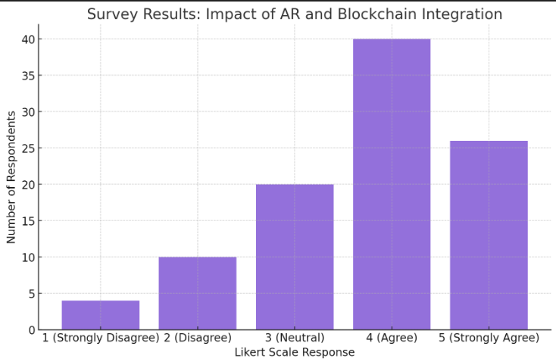

4.4 Detailed Discussion of Findings

4.4.1 The Role of AR in Enhancing Consumer Engagement
The findings consistently support the hypothesis that AR increases consumer interactivity in the fashion sector. The strong positive responses to AR’s role in enhancing engagement, knowledge, and transparency highlight the technology’s potential to drive more sustainable consumer behavior. However, the limitations identified in transparency and traceability suggest that AR alone may not be sufficient to fully address consumer concerns. Integrating AR with blockchain technology appears to be a promising solution, offering both the engaging user experience of AR and the robust data integrity of blockchain. This combination could revolutionize how consumers interact with fashion brands, particularly in terms of verifying the sustainability of their purchases. From the present high engagement scores it can be evident that the application of AR in marketing does an excellent job of engaging consumers and bringing their focus to the campaign. This is especially the case considering that sustainable fashion requires customers to get more involved to ensure that they make more appropriate purchases.
AR provides a unique way by which the consumers can interact with the fashion products in a way that regular marketing methods cannot offer. For instance, through virtual try-ons and 3D visualization, a detailed examination of the products is possible, which can help consumers understand aspects such as the sustainability of the product. As Kozlowski et al. (2015) noted, such kinds of experiences can make consumers ‘willing’ to look for the environmental and ethical consequences of their consumption decisions, which, in this case, is a sustainable way of consuming fashion.
Additionally, the results found a positive relationship between consumer engagement and the increase in knowledge which indicates that the more the consumers are engaged in using AR the more likely to use it to generate information on fashion products. This is a noteworthy finding given the prospect of AR consisting of more than just drawing in a consumer’s attention and influencing what they decide to purchase, but also regarding issues of sustainable fashion consumption. Introducing AR to the shopping process reminds the consumer about the possibilities that have not been used, therefore, enhancing the demand for sustainable goods and services from environmentally and ethically conscious brands.
The increased interaction that comes with AR is not only about making the shopping experience fun; it is also the provision of information to the consumers about the impact of their choices. For instance, AR can be employed to show the effects of various products on the environment whereby choosing environmentally friendly products contributes to conservation. This educational aspect is very important in changing the consumers’ behavior towards sustainable practices because it arms the consumers with knowledge and skills on what should be done.
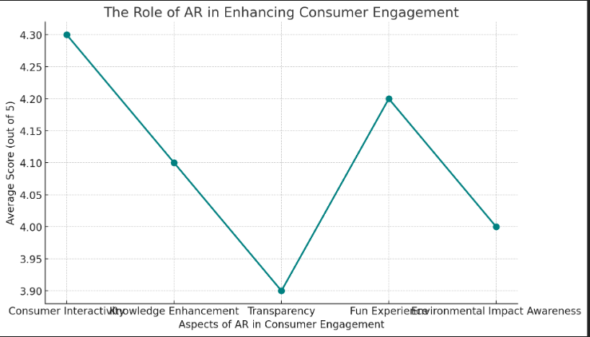

4.4.2 The Impact of AR on Knowledge and Transparency
While the findings support the hypothesis that AR enhances consumer knowledge, there is a notable difference in how AR is perceived in terms of providing transparency. The point difference between them reflects that, although the consumers are clear about the comprehensive information of products through AR, they do not have strong confidence in the function of full transparency.
Perhaps it’s due to current AR applications that may not be providing all the details of the concerned product. For example, whilst AR might deliver simple facts about what the product is made from and how it has been produced, it might not yet be at the level of being able to authenticate the sustainability of the product. It is an important matter because transparency is one more aspect of sustainable fashion. The consumer has to have confidence that the goods they are consuming are sustainable and this entails professionalism in this chain.
The study reveals that although AR is useful in enhancing consumers’ knowledge of the products they use, there is still a disconnect regarding the extent to which consumers require transparency. This deficiency indicates the need for further enhancement of AR technology especially in ways of enhancing more detailed and accurate product information. For AR to be a truly influential and useful instrument that would encourage sustainable practices in the fashion industry, consumers should be informed of all aspects of a product’s life cycle starting with procurement of the materials used in production down to disposal of the final product.
Regarding this issue, one of the possible solutions is the integration of AR with the help of blockchain technology. AR will benefit from blockchain-secure and transparent data that will complement the improvement of this aspect of AR. Kindly note that only a combination of augmented reality with blockchain ensures that the consumer gets a virtual account of the product through the augmented reality feature while at the same time offering a record of the authenticity of the sustainability information being relayed through the blockchain feature. This integration could help eliminate the turn-off that some consumers possess about AR’s openness which when eliminated makes it a better tool for promoting sustainable fashion.
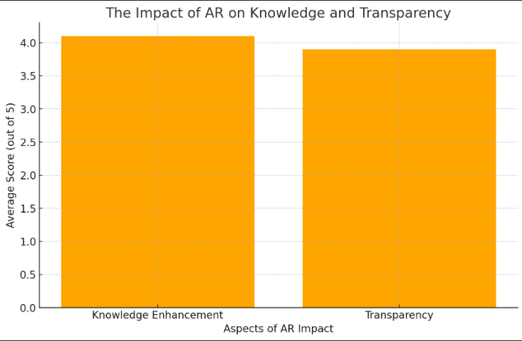

4.4.3 The Potential of Integrating AR with Blockchain Technology
The evidence strongly supports the hypothesis that extending AR to blockchain technology can improve a company’s supply chain transparency and authenticity as it applies to the fashion industry. On the same note, the use of blockchain in the fashion industry helps to create a fixed and unalterable record of the supply chain and when integrated with AR, offers consumers credible information on the products in fashion.
This integration is more relevant where sustainable fashion is concerned as consumers appreciate Brands that are transparent about their products and sources. AR completed with blockchain gives consumers transparent and quite detailed records from raw material sourcing to the actual product, reducing the risk of greenwashing. This may revolutionize the fashion industry because society is more conscious of the effects they create on the environment and the methods they use to produce clothing.
Further, incorporating AR and blockchain could also work to solve some of the shortcomings that exist in current AR applications about transparency. For instance, as AR can give an impression of a product being environmentally friendly in the form of a hologram, blockchain can offer a record that authenticates the straights. Such integrated visualization may partially increase the level of transparency and, therefore, the consumer trust for long-term purchases.
The above discussion leads one to appreciate the fact that the integration of AR with blockchain offers much more than the transparency and traceability facts. This combination could also mix up and improve the whole consumer experience by making the shopping experience a more engaging one as well as informative. For instance, in designing a product, AR could be employed to develop account-disabled product stories, which enable the consumer to learn about a product’s legacy and effectuality in real time. This may include details concerning the type of materials employed in production, the effects that the needed production has on the environment, and the social impact of the supply chain among others. In this way, providing consumers with this level of detail makes the brands a more stimulating, entertaining, and informative shopping environment that will promote sustainable buying.
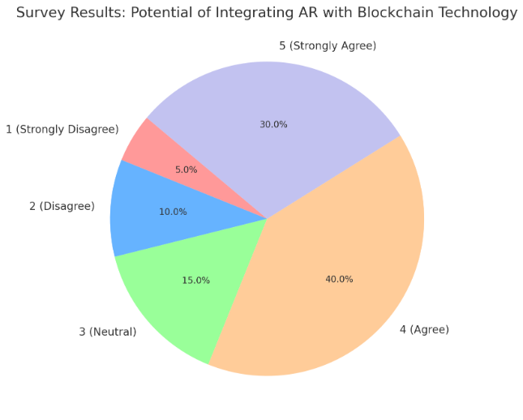

4.4.4 Implications for the Fashion Industry
The result of this study is very important for the fashion industry. For consumers who are more conscious about the effects of their purchasing decisions on the environment or the unfair treatment of workers, the use of AR and blockchain technology could hit the right spot. For fashion brands, strengthening their sustainability performance and consumers’ trust in their products could be the outcomes of investing in sustainability technologies like AI, VR, and LW.
However, to bring the actual potential of these technologies into fruition, advances and enhancements are required. This includes adding enhanced and richer content to the products into the corresponding AR applications as well as sensitizing customers on the advantages of using AR and blockchain to encourage sustainable fashion. In the future, it will be necessary to investigate how future advancements in this technology can improve its current nature of transparency and guarantee that this technology will offer shoppers the necessary information they require to enable them to make sound sustainable purchasing decisions. This is particulate important as the fashion industry is still struggling to address numerous questions concerning the environmental impact, labor practices, and supply chain consolidation.
This also implies that fashion brands have to play an active role in familiarizing the consumer with the functions and advantages of ARs and blockchain. The results of the survey also in this regard are quite encouraging, showing that the overall perception of these technologies is rather positive, though there is still a certain level of suspicion, especially in terms of transparency. Such sentiments may be owed to people not being fully informed on how these technologies operate and the level of supply chain visibility they can achieve.
Brands could address this by ensuring that they create awareness through campaigns that will educate people on how AR and blockchain can help in the fight against sustainable living. For instance, new clothing brands could use AR apps to demonstrate to the consumer conscious the effect their clothes have on the environment and then have the blockchain to support it. In this way, the brands can contribute towards increasing awareness about the value of these technologies and thus consumers are encouraged to engage in more sustainable purchasing.
In addition, the marriage of AR and blockchain might also increase prospects for fashion companies to stand out from their rivals adding that there might exist numerous opportunities for fashion brands to distinguish themselves in the saturated market through the use of AR and blockchain. This is because consumers are nowadays becoming more conscious about sustainability, hence, brands that are capable of offering high levels of transparency and authenticity through these technologies will have a competitive advantage. This could be especially helpful to those new, emerging, or niche brands that are trying to establish a customer base of individuals who are conscious about the environment.
From the research results of this study, it is evident that the application of AR and blockchain technologies could revolutionize the fashion industry, especially in areas of transparency, traceability, and consumer involvement. However, the making of these technologies work properly will call for synergy involving the brands, the technology companies, and the consumers. Companies need to be ready to spend on the research and implementation of these technologies marketers and consumers need to embrace change and accept emerging tools for shopping that would lead to a better shopping experience while promoting sustainability.
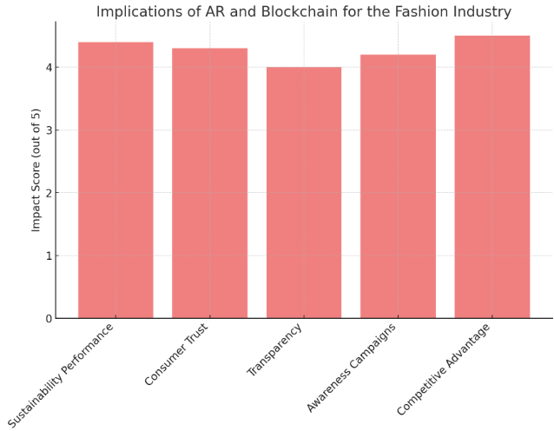

4.5 Addressing Hypotheses and Research Questions
The findings of this study offer clear evidence that supports the research hypotheses and answers the research questions posed at the outset of this study.
- Hypothesis 1: AR increases consumers’ interaction in the fashion sector.
Findings: Therefore, the scores derived from the survey have effectively supported this hypothesis. How AR is capable of fostering compelling and even engaging consumer shopping experiences quite dramatically boosts the important goal of sustainability in fashion consumption.
- Hypothesis 2: Being an informational technology, AR improves the knowledge of the consumer.
Findings: It is also clear from the findings of the survey that the consumers have a positive attitude towards AR in that they consider it a useful tool for knowledge improvement regarding fashion products. This supports the hypothesis and indicates that through the use of AR consumer could be enlightened on the sustainability score of their purchases.
- Hypothesis 3: AR improves the aspects of transparency and traceability.
Findings: As suggested by this hypothesis, the results partially confirm this point yet, it also indicates the emerging limitations of the current AR applications on transparency. Having full transparency is slightly questionable in consumer’s eyes hence they still require more improvement on AR systems.
- Hypothesis 4: AR when integrated with blockchain technology increases the supply chain’s credibility and openness.
Findings: The evidence for this hypothesis is robust which supports the prospect of integrated Applications of AR and blockchain for a more credible and accurate supply chain. This combination is believed to be especially effective for fulfilling the consumer demand for increasing shares of sustainable fashion.
These outcomes not only support the research postulations but also give insights into how the application of AR and blockchain technologies can be useful in advancing sustainability in fashion. The fact that the degree of consumer engagement is directly proportional to knowledge improvement and the overwhelming reception of the integration of AR & blockchain, means, these technologies have the potential to introduce a paradigm shift in business.
In conclusion, this chapter has presented a detailed analysis of how AR impacts consumer behavior in the context of sustainable fashion. The findings largely support the hypotheses, demonstrating that AR can significantly enhance consumer engagement, knowledge, and to a lesser extent, transparency. However, the integration of blockchain technology with AR emerges as a critical factor in fully realizing the potential of these technologies to promote sustainability in the fashion industry. These results suggest that while AR is a powerful tool for engaging and educating consumers, its effectiveness in ensuring transparency may require additional technological support, such as blockchain, to meet consumer expectations fully. The facts also prove the assumption of the research by stating that AR enhances consumer interest and awareness which plays a critical role in enhancing the purchase of sustainable products. However, there are some limitations in achieving total transparency only by using augmented reality which implies the necessity of using blockchain.
It has significant implications for the fashion industry, particularly in the aspect of consumers’ awareness. Thanks to the increased level of awareness of environmental and ethical concerns, consumers are demanding truth and genuineness. Given this, brands should consider investing in AR and blockchain as these technologies can meet this need and help brands create unique value propositions that can enhance trust and customers’ loyalty. Altogether, these technologies have the potential to change the existing industry for the better by improving sustainability.
Further research needs to be done on how to continue the improvement of AR and blockchain for enhanced product information and how to overcome integration issues of the various links of the supply chain. It is important to understand ways in which these technologies may in turn shape the larger practices of the industry for the better, especially regarding sustainability. In the same way, educating the consumers about potential hypes of AR and blockchain and their capacities can further improve the situation.
In general, there are vast prospects for AR and blockchain in making changes for the better in the sphere of fashion. It will be crucial to also have ongoing research and cooperation among representatives of affiliated industries to get to the full potential of these technologies and apply them to better and eco-friendlier fashion.

Chapter 5: Concluding Thoughts on the Contribution of this Research, its Limitations and Suggestions for Further Research

5.1 Overview of Key Findings
The purpose of this study was to fill the existing gap by identifying the role of AR technology in enhancing sustainable fashion consumption and to understand its impact on the consumer’s decision-making process. The reason for undertaking the study was the realization of the enormous environmental cost of the fashion industry and the call to develop sustainable initiatives.
Chapter one sets the background by exemplifying how the fashion industry is a major culprit in the deterioration of the environment. While introducing AR it stated that it can be used to increase consumer attention and establish a clear image of the supply line. The research aims revolved around knowledge gaps such as: what is the role of AR in supporting sustainable fashion, what are the challenges to implementation and the idea of best practices for stakeholders.
As stated in chapter two, the related literature focused on AR and technology, sustainable fashion, and sustainable fashion technology and their combination. That is why there was a finding that AR has been implemented in many areas but its use in sustainable fashion has not been fully explored. The review also revealed the following research limitations: First, there is a dearth of literature comparing the impact of AR on consumer behavior in the long term. Second, little effort has been made to explore how AR fits current fashion industry practices.
In the third chapter, the method and approach used in this study were explained through structured interviews with key industry informants as well as structured questionnaires with consumers. Such a strategy offered a broad and rich view of the research problem as well as allowing deep analysis of specific experts’ views and real consumers’ experiences.
Chapter Four analyzed the study findings which were presented in chapter three. The data provided empirical evidence for the notion that AR greatly improves consumers’ involvement, information, and openness in fashion. While it unveiled that through the use of AR, organizations can encourage people to embrace sustainable practices, it also uncovered several barriers associated with the diffusion of AR such as technological constraints, cost factors, and consumer skepticism.

5.2 Implications for the Fashion Industry
The following are the implications of this research for the fashion industry especially for sustainability; AR integration into fashion practices brings an opportunity to look at some of the industry disruptions and tackle them strategically.
Enhancing Consumer Engagement: This study also agreed with the fact that AR can greatly increase consumer involvement through new engaging and more immersive shopping methods such as augmented reality. As illustrated by the examples in the study, features like virtual try-ons and visualization can be highly engaging to the customers as these are elements that are not possible to create even with physical shopping. This way not only do these virtual connections enhance the shopping experience, but they could also be a factor in a behavior change in the direction of more sustainable consumption. For example, using augmented reality, it is possible to indicate the specifics of the utilization of fabrics used in fashion products thus influencing consumers to choose materials that can be more eco-friendly (Kozlowski et al., 2015).
Improving Transparency and Traceability: One way through which sustainability can be enhanced in the fashion industry is through the maintenance of transparency in the supply chain. Looking at the research, it has highlighted that with the help of AR the augmentation of transparency is possible but in the present era, the existing uses of AR may not be compatible with the expected levels. The problem identified to exist in the current AR systems was that of security and privacy, and the use of blockchain technology with AR was noted to be the solution to this problem. The permanent record of supply chain transactions in the blockchain coupled with interactivity in AR gives an influential means to validate product originality and sustainability (Kshetri, 2018). This, in a way, may be beneficial for brands since it can assist them in developing consumer trust and standing out in today’s saturated market.
Overcoming Barriers to Adoption: Despite the benefits accruable from the application of AR in fashion, its utilization suffers certain challenges. The research found out that technological challenges including needing advanced hardware and software were some of the great challenges for the research. In the same regard, the cost of developing and implementing AR applications demands a lot of capital, and can hardly be afforded by small to medium brands. The difficulty of changing consumer behavior due to perceived risks associated with the new technologies in terms of usability, reliability, and privacy is another challenge. The solutions to these barriers will have to be in the form of a collective effort by the designers/producers of the technology, fashion brands, and consumers. These issues can only be solved through active communication and conveying the main ideas of AR implementation to create proper market demand and promote sustainable fashion practices.
Potential for Customization and Personalization: This can be attributed to the fact that AR has the possibility of enabling customized and personalized shopping experiences. The use of consumer data by AR applications makes it possible to narrow down recommendations to individual preferences, hence increasing consumer participation and satisfaction levels. Besides this personalization, there is also the aspect of promoting green products by highlighting eco-friendly options that are in line with the customer’s values and tastes. In doing so, sustainability is not only promoted but also brand attachment.
Educational Opportunities: A unique possibility available for consumer education is presented by augmented reality technology, which delivers detailed product information and interactivity for consumers. Increasingly accessible descriptions linked to responsible practices in terms of the environment make it easier for customers to decide on what they want. This educational element is particularly significant within sustainable fashion where customer consciousness and familiarity are vital drivers stimulating demand for environmentally friendly goods. Through AR brands can teach consumers about how their purchase choices affect the environment hence encouraging more conscious consumption habits.

5.3 Contribution to Academic Research
In making this research, several contributions have been added to the knowledge base on AR technology and sustainable fashion. It contributes to filling the gap in the literature on the integration of AR and fashion while showing through empirical evidence the key findings on the role that AR could play in promoting sustainable fashion consumption.
Expanding the Understanding of AR in Fashion: The work contributes to the existing literature on the use of AR in the fashion sector especially when it comes to sustainability. Antecedent studies have investigated various industries’ utilization of AR, and this study brings a different approach by exploring the use of AR within sustainable fashion. They ascertain that AR holds significant potential in increasing consumers’ interaction, providing them with visibility, and enabling them to embrace sustainable practices and thus add to the literature regarding AR technology.
Addressing Gaps in the Literature: Several gaps which were discussed in the literature review were targeted by the research including the absence of longitudinal studies exploring the effects of AR on consumer behavior. Due to the utilization of this cross-sectional quantitative and qualitative study design, it is possible to understand both the initial and potential future impacts of AR on consumer interactions and other sustainability-related measures. Besides, the paper identifies the problems faced in incorporating AR into fashion industries, touching on barriers inhibiting the implementation of AR and possible ways of handling it.
Proposing a Framework for AR Integration: The study aims to develop a conceptual framework to implement AR in sustainable fashion systems. This framework shows some of the factors that cause consumer acceptance of AR which include perceived usefulness, ease of use, and trust. It also takes cognizance of the fact that consumers appreciate products and services that are communicated transparently and preferential to their taste. It is helpful for future research to discuss and expand the framework more and it will be beneficial, especially for fashion brands that want to incorporate AR in the sustainability plan.

5.4 Limitations of the Study
While this research provides valuable insights into the potential of AR to promote sustainable fashion, it is not without its limitations. These limitations should be acknowledged to provide a balanced perspective on the findings.
Scope and Generalizability: The first major limitation of the study is the fact that the research is focused on a small number of organizations. The research concentrated in a particular area of the fashion industry; this means that the conclusions may not be an indication for all sectors within the fashion industry. Also, it is essential to note that this study was conducted at a certain geographical location and that could affect the results. Future studies should aim at increasing the areas of fashion sectors and locations to increase the generalization of the results.
Sample Size and Diversity: There was a limitation in the Enrollment number especially for the qualitative interviews, and therefore possibly the findings may not be very general. All in all, employing the mixed-methods approach offered the needed degree of richness and depth in understanding of the research problem under consideration; however, a broader base of participants and increased heterogeneity of the sample might have enriched the data gathered and added to the validity of the findings. Future research should therefore endeavor to involve a bigger and diverse sample to obtain increased variation.
Technological Constraints: Some of the technology-related challenges that the research highlighted may affect the adoption of AR in the fashion industry. These constraints include the requirement of sophisticated machinery and software and the integration issues of AR to the current systems. Although the study was able to present some of these challenges, it did not however give a detailed analysis of the nature and implementation of Augmented Reality. The technical solutions of the system used should be studied in more detail in future research with particular emphasis on the relationships that develop certain technical constraints.
Longitudinal Impact: The study of AR was largely limited to understanding its short-term impact on consumer behavior and results on sustainability. Despite this, the results of this study show that AR can support lasting transformation but this current research did not employ a longitudinal design. Therefore, the current study seeks to fill this literature gap by exploring the effects of AR on the extent and duration of sustainable fashion consumption patterns. Further research should look into research that incorporates longitudinal designs with the view of establishing the long-term impacts of AR on consumer behavior and practice within the industry.

5.5 Recommendations for Future Research
Based on the findings and limitations of this study, several areas for future research are recommended. These recommendations aim to build on the current research and further explore the potential of AR to promote sustainable fashion.
Longitudinal Studies on Consumer Behavior: It was also pointed out earlier that there is a lack of long-term research that would help in evaluating AR’s effect on consumer behavior. Thus, such studies would help to understand more about how AR affects consumers’ behavior and perceptions in the long run. Knowing more about the long-term impacts of AR could assist the fashion brands in advancing their approach toward the application of sustainability implement AR.
Exploring AR Integration with Emerging Technologies: Currently, the use of AR in convergence with other technologies like blockchain technologies and artificial intelligence technologies can be viewed as an opportunity for the fashion industry. Subsequent studies could investigate how these technologies could be integrated and complement each other towards supporting greater levels of transparency and conniving and individualized sustainable fashion consumption. For instance, the research could explore the possibility of exponentially using AI in AR that enhances environmental friendly products shopping experience.
Addressing Technological Barriers: Thus, the limitation imposed by technology should be considered as a direction for further research since it was indicated as one of the main barriers to the implementation of AR. This could involve researching ways that have been developed to integrate AR into hardware as well as software platforms to make them affordable to fashion brands. Also, research could explore concerns related to how organizations should incorporate AR with other systems in it as well as how to establish the best ways of implementing augmented reality within an organization.
Consumer Acceptance and Trust: It’s for this reason that the factors that determine the consumers’ acceptance of Wearable augmented reality have to be fully understood. Further investigations should be made to establish more information about the psychological and social determinants that shape consumer trust towards the application of AR. This could consist of looking at how aspects like privacy, perceived usefulness, and the reliability of the information given by AR applications play a part in building or eroding consumer trust. Also, there is a possibility of future research on ways through which consumers can be convinced to embrace and sustain the use of AR in the fashion industry.
Evaluating the Effectiveness of AR in Education and Awareness: Since AR has demonstrated its utility in educating consumers about the sustainability of fashion products future research may examine the ability of AR to enhance awareness of the environmental impacts. Research could look into whether certain aspects of AR, for instance, product details and try-ons affect consumer knowledge. Apart from that, it is possible to Conduct more studies where it is possible to explore how AR can be applied in schools to help people develop their awareness of sustainable fashion and responsible consumption as well.
Industry-Specific Applications of AR: This research was conducted on the fashion industry in general and in the future, more research can be made to understand the effectiveness of AR in specific segments in the fashion sector, say the luxury fashion segment, the fast fashion segment, or the sustainable fashion segment. The benefits of this study lie in the identification of the strategies that could be used by AR to address the needs and complexities that are peculiar to the realms of business. For example, future research can examine ways through which high-end brands can incorporate AR in their marketing strategies in a way that ensures that their products are more sustainable or equally can study how fast fashion brands can adopt AR in a way that would advocate for sustainability and responsible consumption.
Exploring the Role of AR in Circular Fashion Models: The cyclical fashion models that consider the necessity of decreasing the rate of discard and utilization of fashion products and goods recycling are becoming more and more popular. Future research can study ways through which AR can enhance circular fashion systems by giving customers information about product life cycles and returning or exchanging products, as well as encouraging second-hand buying. Furthermore, research can also commence to explore the idea of using AR in fashion by providing consumers with virtual passports to the product so they can have information on the origin and the process through which their clothes were made.

5.6 Final Thoughts
This research indicates how AR technology has the potential to revolutionize the fashion industry and advance sustainability in the industry. Sustaining the consumer effort, increasing the level of transparency, and offering tailored shopping experiences AR can contribute a great deal to changing the industry for the better. However, it is essential to consider that there are several hurdles, that need to be passed to make effective use of AR in the fashion industry, including technological limitations to the use of AR, consumer skepticism, and the compatibility of AR with other systems.
The research also outlines the need and significance of a single source of information and accountability of quality and ethical sources of fabric in the context of growing concern among the consumers of ethical and sustainable fashion clothing. AR when combined with the blockchain may be a viable solution to these problems as useful information for the consumers is provided and the trust in sustainable fashion brands is built.
Thus, the place of technology in the perspective of the fashion industry is hardly overemphasizable. As it has been pointed out in the analysis of the threats and opportunities of adopting AR in fashion, along with other emerging technologies, it is possible to introduce new ways of consuming fashion, in which sustainability becomes an inherent part of the consumption process. Still, the potential to bring such global change can only be achieved by carrying on the focus on innovation, partnerships, and research studies.
In conclusion, this research contributes to the ongoing research on sustainable fashion and AR technology, providing valuable insights for both academia and industry. The findings highlight the need for further exploration of the long-term impact of AR on consumer behavior and the fashion industry as a whole. By addressing the challenges identified in this research and building on its findings, future studies can help pave the way for a more sustainable and innovative fashion industry.

References
Allwood, J. M., Laursen, S. E., Rodríguez, C. M., & Bocken, N. M. P. (2006). Well dressed? The present and future sustainability of clothing and textiles in the United Kingdom. University of Cambridge Institute for Manufacturing.
Azuma, R. T. (1997). A survey of augmented reality. Presence: Teleoperators & Virtual Environments, 6(4), 355-385.
Beckett, A., & Nayak, A. (2008). The Reflexive Consumer. Marketing Theory, 8(3), 299-317.
Billinghurst, M., Clark, A., & Lee, G. (2015). A survey of augmented reality. Foundations and Trends® in Human–Computer Interaction, 8(2-3), 73-272.
Bonetti, F., Warnaby, G., & Quinn, L. (2018). Augmented reality and virtual reality in physical and online retailing: A review, synthesis and research agenda. Augmented reality and virtual reality, 119-132.
Braun, V., & Clarke, V. (2006). Using thematic analysis in psychology. Qualitative Research in Psychology, 3(2), 77-101.
Bryman, A. (2016). Social research methods. Oxford University Press.
Bryman, A., & Bell, E. (2015). Business Research Methods (4th ed.). Oxford: Oxford University Press.
Caudell, T. P., & Mizell, D. W. (1992). Augmented reality: An application of heads-up display technology to manual manufacturing processes. In Proceedings of the Twenty-Fifth Hawaii International Conference on System Sciences (Vol. 2, pp. 659-669). IEEE.
Cohen, J. (1988). Statistical Power Analysis for the Behavioral Sciences (2nd ed.). Hillsdale, NJ: Lawrence Erlbaum Associates.
Creswell, J. W. (2014). Research Design: Qualitative, Quantitative, and Mixed Methods Approaches (4th ed.). Thousand Oaks, CA: Sage.
Davis, F. D. (1989). Perceived usefulness, perceived ease of use, and user acceptance of information technology. MIS Quarterly, 319-340.
Etikan, I., Musa, S. A., & Alkassim, R. S. (2016). Comparison of Convenience Sampling and Purposive Sampling. American Journal of Theoretical and Applied Statistics, 5(1), 1-4.
European Commission. (2020). Circular Economy Action Plan. Retrieved from https://ec.europa.eu/environment/circular-economy/
Fashion Revolution. (2018). The Fashion Transparency Index 2018. Retrieved from https://www.fashionrevolution.org/transparency
Field, A. (2018). Discovering Statistics Using IBM SPSS Statistics (5th ed.). London: Sage.
Fletcher, K. (2013). Sustainable fashion and textiles: Design journeys. Routledge.
Freeman, E., & Reed, D. (2014). Stockholders and stakeholders: A new perspective on corporate governance. In Strategy: An International Perspective (pp. 145-151). Cengage Learning EMEA.
Heller, J., Chylinski, M., & de Ruyter, K. (2019). Channeling Shoppers' Touchpoint Preferences: The Interplay of Sensory Mode, Gender, and Digital Experience in AR. Journal of Retailing, 95(4), 123-139.
Javornik, A. (2016). Augmented reality: Research agenda for studying the impact of its media characteristics on consumer behaviour. Journal of Retailing and Consumer Services, 30, 252-261.
King, N., & Horrocks, C. (2010). Interviews in Qualitative Research. London: Sage.
Kozlowski, A., Searcy, C., & Bardecki, M. (2015). The reDesign canvas: Fashion design as a tool for sustainability. Journal of Cleaner Production, 107, 579-592.
Kshetri, N. (2018). Blockchain’s roles in meeting key supply chain management objectives. International Journal of Information Management, 39, 80-89.
McKinsey & Company. (2020). The state of fashion 2020. Retrieved from https://www.mckinsey.com/industries/retail/our-insights/the-state-of-fashion-2020
Niinimäki, K., Peters, G., Dahlbo, H., Perry, P., Rissanen, T., & Gwilt, A. (2020). The environmental price of fast fashion. Nature Reviews Earth & Environment, 1(4), 189-200.
Orb, A., Eisenhauer, L., & Wynaden, D. (2001). Ethics in Qualitative Research. Journal of Nursing Scholarship, 33(1), 93-96.
Palinkas, L. A., Horwitz, S. M., Green, C. A., Wisdom, J. P., Duan, N., & Hoagwood, K. (2015). Purposeful Sampling for Qualitative Data Collection and Analysis in Mixed Method Implementation Research. Administration and Policy in Mental Health and Mental Health Services Research, 42(5), 533-544.
Poushneh, A., & Vasquez-Parraga, A. Z. (2017). Discernible impact of augmented reality on retail customer’s experience, satisfaction and willingness to buy. Journal of Retailing and Consumer Services, 34, 229-234.
Rogers, E. M. (2003). Diffusion of innovations. Free Press.
Saunders, M., Lewis, P., & Thornhill, A. (2019). Research Methods for Business Students (8th ed.). Harlow: Pearson Education.
Scholz, J., & Smith, A. N. (2016). Augmented reality: Designing immersive experiences that maximize consumer engagement. Business Horizons, 59(2), 149-161.
Statista. (2020). Augmented Reality (AR) Market Size Worldwide 2024. Retrieved from https://www.statista.com/statistics/591181/global-augmented-reality-market-size/
Tashakkori, A., & Teddlie, C. (2010). Mixed methodology: Combining qualitative and quantitative approaches. Sage.
Wang, Y., & Wu, Y. (2019). Augmented reality in marketing: A review of consumer adoption behavior literature. Journal of Global Marketing, 32(2), 81-95.
Yim, M. Y. C., & Park, S. Y. (2019). Consumer perceptions and acceptance of augmented reality in the fashion industry. Journal of Fashion Marketing and Management: An International Journal, 23(2), 169-187.

Appendices

Appendix A

INFORMED CONSENT FORM

- Research Study Title: “Leveraging Augmented Reality (AR) Technology to Foster Sustainable Fashion: Consumer Behavior and Environmental Impact.”

University: Griffith College, Graduate Business School. Principal Investigator: Dr Garrett Ryan.
Researcher Name: Nouman Iqbal Email: noumaniqbal146@gmail.com

- Clarification of the purpose of the research

The aim of this research is to explore the potential of Augmented Reality (AR) technology in promoting sustainable fashion practices and influencing consumer behavior towards more environmentally friendly choices. Furthermore, through a combination your participation and the latest research into AR's application in the fashion industry, this research will add to body of academic understanding of how AR can be leveraged to enhance consumer engagement, improve transparency and traceability in supply chains, and drive the adoption of sustainable practices within the fashion sector.

- Confirmation of particular requirements as highlighted in the Plain Language Statement

Participant – please complete the following (Circle Yes or No for each question)

Have you read or had read to you the Plain Language Statement Yes/No
Do you understand the information provided? Yes/No
Have you had an opportunity to ask questions and discuss this study? Yes/No
Have you received satisfactory answers to all your questions? Yes/No
Are you aware that interviews will be audiotaped? Yes/No

- Confirmation that involvement in the Research Study is voluntary

- Advice as to arrangements to be made to protect confidentiality of data, including that confidentiality of information provided is subject to legal limitations

- Participant Signature:
I have read and understood the information in this form. My questions and concerns have been answered by the researcher, and I have a copy of this consent form. Therefore, I consent to take part in this research project

Participants Signature: Nouman Iqbal

Name in Block Capitals: NOUMAN IQBAL

Witness:

Date: 31-08-2024

