Business Transformation
in the Age of Digitization:
An Analysis of Digital Culture in Germany as a
Determinant Factor

Dissertation

Master of Sciences in International Business Management
Griffith College Dublin
Graduate Business School

Submitted by: Supervisor:
Anh Tuan Le Klaus Walter
Student ID: 3047597

Address: South Circular Road, Dublin 8, Ireland
Telephone: +49 157 58748888
E-mail: anhtuan.le@student.griffith.ie
Date: September 3rd, 2021
Preface
You might think you have heard everything there is to say about change management. By now, we know that only companies that have learned to change their business models, structures and processes systematically and sustainably can react to unexpected market opportunities and deal with internal and external problems of all kinds.
Digital transformation is fundamentally changing the world of work and profession-al life. Despite automation, there will not be less work in the future, but it will be a different way of working. Job descriptions and qualification profiles are changing, new occupations are emerging. This change can be shaped and yet there is one topic that only a few consistently dare to tackle, although it is regularly mentioned as one of the main hurdles for successful digital transformation, the own corporate culture.
But what exactly constitutes a digital culture? Where exactly do companies stand in the digital culture change and why is culture such a decisive strategic factor? And how does the transformation to a digital corporate culture succeed? This master thesis will deal with the answers to these questions.

Abstract
This master's thesis aims to explore the fundamental importance of corporate culture in change. The following research question will be asked: “What are the demands that digital transformation brings upon to the corporate culture?”
To be able to answer this question in a well-founded way, six interviews with experts from different companies and industries were conducted and evaluated in a qualitative content analysis according to Philipp Mayring.
The evaluation of the interviews shows that the implementation of a digital corporate culture is the elementary building block of a digital transformation and that without the creation of a culture in which people are at the center of attention, no change is permanent.
The creation of a suitable culture is the most challenging task in the entire transformation process and is of such relevance that it must be the first step before a company starts to think about going digital.

Table of Contents

Table of Contents IV
List of Illustrations VI
1 Introduction 7
1.1 Topic Description 7
1.2 Aims and Objectives 9
1.3 Structure 10
2 Literature Review 11
2.1 Digital Culture 11
2.2 Digital Transformation 18
3 Conceptual Framework 21
4 Methodology 22
4.1 Research Paradigm and Overall Approach 22
4.2 Research Design 23
4.2.1 Strategy 23
4.2.2 Methods and Additional Sources of Data 23
4.2.3 Nature of Data 25
4.2.4 Access and Research Ethical Issues 25
5 Results 26
6 Interpretation 30
7 Discussion 38
7.1 Building a Digital Corporate Culture 38
7.2 Hypotheses 42
7.3 Research Question 48
7.3.1 Capgemini's Eight Dimensions of Digital Culture 49
7.3.2 Guideline for Employee Involvement in the Digital
Transformation 55
8 Conclusion 60
8.1 Summary 60
8.2 Outlook 62

List of References 65
List of Appendices 70
Appendix 71
Affidavit 83

List of Illustrations

Figure 1: Forecast of connected devices worldwide by 2030 7
Figure 2: Kurt Lewin Three-Phase Model 13
Figure 3: Kotter’s 8-Steps Change Model 14
Figure 4: Analog Culture versus Digital Culture 15
Figure 5: Culture as the Number One Hurdle 16
Figure 6: Coding a Digital DNA 17
Figure 7: Journey of Culture Transformation 18
Figure 8: Digital Transformation Model (Veuve, 2016) 20
Figure 9: Conceptual Framework 21
Figure 10: Process Model for Content Structuring 24
Figure 11: Extract of Question 5 29
Figure 12: Degree of Digitization 30
Figure 13: Connection between Digital Transformation & Corporate Culture 31
Figure 14: Six Levers to change a Culture 32
Figure 15: Digital Maturity Level 35
Figure 16: Guideline for Employee Involvement in the Digital Transformation 55

- Introduction
1.1 Topic Description
Digital transformation is fundamentally changing the world of work and professional life. Despite automation, there will not be less work in the future, but it will be a different way of working (Schmidt et al., 2016). Job descriptions and qualification profiles are changing and new occupations are emerging. This change can be shaped and yet there is one topic that only a few consistently dare to tackle - the own corporate culture. Although it is regularly mentioned as one of the main hurdles for successful digital transformation, it appears that many organizations cannot accomplish this shift on their own (Schwertner, 2017).
Traditional business models are being called into question and new business models are increasingly emerging. In addition, new markets are developing with the result that the former winners suddenly become losers and newcomers pose a threat to established industries and companies (Ziyadin et al., 2020). Those who open up new markets early and soon set their own standards will ultimately be successful.
Digital change has developed rapidly in recent years. A major reason for this is the rapidly increasing networking of devices, machines and people via the internet.
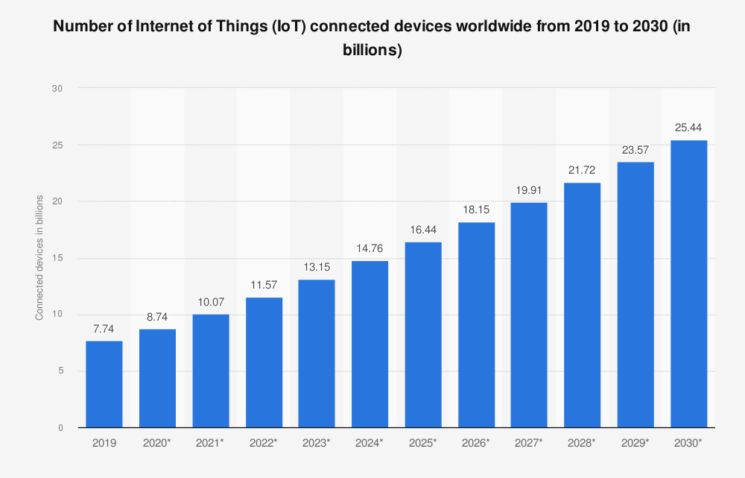
Fig. 1: Forecast of connected devices worldwide by 2030 (Statista, 2021)
In 2020, around 9 billion devices and machines were connected via the Internet. Statista estimates that this number will increase to almost 26 billion by 2030 which is almost triple the amount of 2020. The statistics shown above forecast the number of all devices connected worldwide from 2019 to 2030 (Statista, 2021).
Digitalization will thus fundamentally change the entire everyday life of society and companies in the future. For this reason, the debate on this topic is of the utmost relevance. But what does it mean for a company to be “digital”? Digital is not so much a state as a way of acting that affects different areas of the company. To be digital means to be able to make better decisions with the help of data, to shorten decision paths and to define iterative, fast business processes. This cannot be limited to just a few functions (McKinsey, 2015).
Digital transformation is not a project that can be delegated to a project group. It affects the entire company and changes the way we work together. Departmental structures are broken up and replaced by cross-functional cooperation, hierarchies become flatter and an environment is created that favors the development of new ideas. In order to identify opportunities and assess new risks, they should reflect on previous entrepreneurial activities and observe new market developments. Digitalization has enormous consequences for companies, as the transformation dynamics create present new challenges and call into question the previous organizational self-image of corporate culture (Behrend, 2019).
Nowadays, simply having a website is no longer enough to position a company for the digital present. The mere introduction of digital processes is not enough to bring about a cultural change, it only changes the process. The change to a digital corporate culture describes the greatest challenge on the way to survival in the digital economy (Frost et al., 2020). Managers and company owners, in particular, reach the limits of what is feasible when they introduce changes but do not want to adapt to a changing corporate culture, which ultimately also means equipping their employees with more skills and some of them losing their influence over themselves (Cherian et al., 2021).
The extent to which digitalization has an influence on corporate culture and how organizations will have to reorganize and align themselves in the future depends on the size of the company, the individual speed of transformation and the degree of digital maturity (Klein and Zirnig, 2019). For the systematic handling of these changes, a guideline will be created in this research based on the collected and analyzed primary data from expert interviews to support and accompany companies in their digital transformation process.
It is not about which technical prerequisites have to be created and how much has to be invested for their acquisition, but about what has to be brought everything on the way so that this process is also carried out by employees (Cetindamar Kozanoglu and Abedin, 2020). In this thesis, the cultural and not the technically necessary change process is considered, which digital transformation cannot avoid.
Since many companies fail in this process and thus need assistance, this master thesis deals with the importance of implementing a digital culture in the company from the very beginning as the entire transformation process must be supported by all employees, who are at the center of attention in this work, to ensure permanent and successful change.

1.2 Aims and Objectives
Digitalization has set the foundation of new business models and delivers plenty of new opportunities for businesses to generate revenues in multiple and innovative ways (Ignat, 2017). At the same time, this global trend and radical change in the economy entails numerous challenges. During the transition to a digital business many organizations, no matter which size or industry sector, underestimate this undertaking and solely focus on the technological aspect of digitization rather than motivating, educating and training, basically preparing, their workforce for this decisive shift (Tabrizi et al., 2019). This superficial and unfortunately widely adopted approach raises plenty of questions which is why it is therefore of monumental significance to do some extensive research on that specific issue. In addition to that, the unprecedented outbreak of COVID-19 has also contributed to a general rethinking of traditional business and accelerated digital transformation tremendously (Savić, 2020). For example, remote working and e-commerce have become an essential part of many businesses now (Soto-Acosta, 2020). For that reason, it is even more important to establish a digital culture to remain competitive and relevant in this time and age.
This master thesis aims to explore the fundamental importance of corporate culture in change, specifically during the era of digitization. In this context, qualitative expert interviews will be conducted to determine the influence of digitalization on companies and their corporate culture. The following research question will be answered in the proposed dissertation: “What requirements does digital transformation place upon the corporate culture of an organization?” Ultimately, a guideline for the systematic handling of digital changes will be developed. It aims to aid companies in the necessary digital transformation process by analytical considerations and solution impulses.

The research topic is placed in the business disciplines of digital management, human resource management and strategy with a primary focus given to change management. The following theories and frameworks derive from these areas and serve as empirical material and database for this academic research.

1.3 Structure
This dissertation comprises a total of eight chapters and a list with figures and tables used. The individual chapters are explained in more detail below. The first chapter, which also includes this subchapter, explains the research question and the goal of this work, whereby the initial situation and the problem are dealt with first.
In the second chapter, the theoretical basics and the state of research on the topic of digital corporate culture and digital transformation are presented. Relevant terms are defined, the drivers and influencing factors are determined and the challenges resulting from the digital transformation are described. Furthermore, it is explained how a corporate culture is created.
The third chapter contains the conceptual framework of this study which is based on the literature review and connects with the following chapters of this thesis.
Afterward, the methodology chapter begins which gives information about the process of data collection and the techniques used for data analysis. Here, the research strategy is explained and supported by a qualitative expert interview and analyzed in seven steps according to Philipp Mayring's evaluation procedure. The catalog of questions is presented, and the answers are evaluated by a descriptive analysis.
Subsequently, the results of the research are presented and interpreted profoundly.
After that, the transfer performance is discussed by comparing the applications of the literature that is critically reviewed in chapter 2 with the results of the expert interviews evaluated in chapter 5. The hypotheses are explained and then confirmed or refuted with the evaluated results of the expert interviews from Chapter 6.
In the final chapter, the summary follows, and trends are identified and a view into the future is given.

- Literature Review
Based on the theoretical foundations of corporate culture and digital transformation, the current state of research will be used to examine which approaches are suitable for creating a digital corporate culture.

2.1 Digital Culture
This section deals with the development from an analog corporate culture to a digital one. Furthermore, various suitable models that are available for companies regarding change management are examined in more detail.
To indicate the strategic relevance of corporate culture during the digital transformation process of existing companies, it is useful to get familiar with core terminologies in this area. Various definitions exist in the specialist literature for corporate culture, also known as organizational culture. The literature on corporate culture makes a distinction that is not easily understood by those who are not yet familiar with the subject. For this reason, it is necessary to synchronize all definitions and to identify aspects where the authors agree with each other. To obtain an overview of the diversity of definitions, definitions by different authors are listed below without further explanation, to subsequently discover commonalities and derive a simultaneous definition. According to Sackmann (2002), corporate culture is generally understood as a process of thinking, feeling and acting together as well as the norms, values and symbols within a company that conveys them. This basic population of common values, norms and attitudes shapes the decisions, actions and behavior of all members of the organization. In contrast to that, Edgar H. Schein (2016, p.12) describes corporate culture as follows: “A pattern of shared basic assumptions that the group learned as it solved its problems of external adaptation and internal integration, that has worked well enough to be considered valid and, therefore, to be taught to new members as the correct way to perceive, think, and feel in relation to those problems.” Although the authors seem to have slightly different views on the culture of a group of people, they all intend to convey the same message. Organizational cultures must be built on basic core values. However, something new is also tried out or existing rules, values or norms are further developed (Denison, 1990). Besides, the influence of group dynamics is evident. A group can have a completely different impact than a single person.
To figure out where existing companies are currently standing in terms of digital culture change, it is necessary to name the status quo of digital culture (Kotter, 2008). Compared to the classical term of corporate culture, digital culture is the spirit of leadership and cooperation between managers and employees that is aspired to or has already been developed by companies that have successfully implemented digital transformation (Gere, 2009). Its main characteristics are customer orientation, digital technologies, digitized processes, entrepreneurship, agility, autonomous working conditions, digital leadership, collaboration, learning and innovation (Deuze, 2006). Sufficient conditions are openness, willingness to learn, willingness to change and diversity (Lavender, 2010). Those companies that have a more pronounced digital culture are demonstrably not only financially more successful than other companies, but they also have more satisfied employees on board (Miller, 2020). Digital strategy and digital culture must therefore be thought and implemented together (Ryan, 2003).

Famous frameworks of change management supply a reasonably solid foundation and also serve as a good point of reference to generate a guideline for companies to succeed in the necessary changes throughout the entire digital transformation process. There are interdependent factors that significantly determine the success or failure of the desired change. The core message of change management is: The decisive factor in all change projects is the individual (Bernerth, 2004). Companies with a digital culture have greater economic success and more satisfied employees. To be highly effective, digitization must be integrated into a corporate culture that fits. The more firmly the digital culture is anchored in the company, the more successful digitization will be (Merzlikina and Kozhanova, 2020).
Kurt Lewin's research with his three-phase model (Figure 1) can be used as the basis for change management and as the first leading explanation of how change processes can be structured and managed which includes the following three steps: 1) Unfreezing, 2) Moving and 3) Freezing (Cummings et al., 2016).

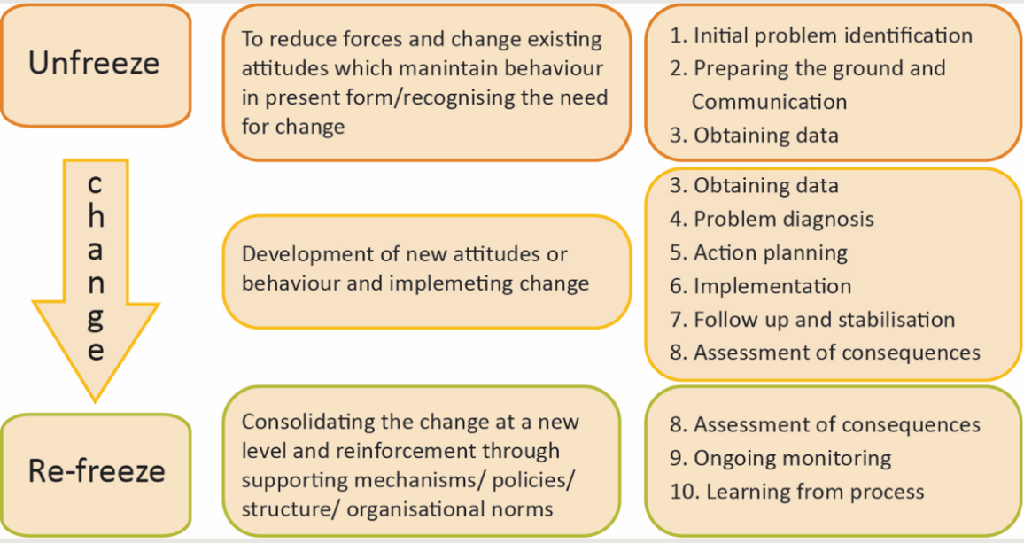
Figure 2: Kurt Lewin Three-Phase Model ((Burnes, 2020)

Another concept that will be taken into consideration in the development of a guideline for a clear and precise transition to a more digital business is John P. Kotter’s 8-Steps Change Model (Figure 2). This framework is based on Lewin’s three-phase model and Kotter was able to identify repetitive errors that led to failure or delays in change projects across multiple organizations. The eight steps complement Lewin’s scheme in detail and provide companies and executives with a flow chart. The sequence of the eight steps is essential for the success of the change project. Also, none of these stages must be skipped, as this can lead from discards to the failure of the entire project later on. For the introduced change to be successful in the long term, it is essential to include the employees’ feelings and emotions. Ultimately, the employees are decisively involved in the success or failure, if not ultimately the trigger for it (Hussain et al., 2018).
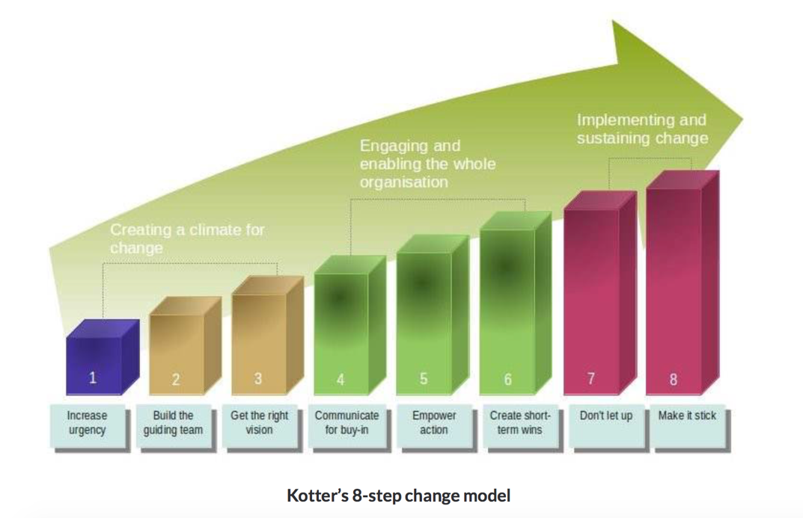
Figure 3: Kotter’s 8-Steps Change Model (Kotter, 2012)

After having a greater understanding of both models, the essential knowledge will be filtered and contribute to the generation of a new strategy facilitating the change for companies across various industries and sizes into a more digitalized culture. These models provide a general sense and insight into the topic of change management. In this regard, further research will be carried out to be able to create a more refined and robust guideline.

Before implementing a digital transformation process, it is also useful to have a look at fundamental differences between an analog and digital culture (Figure 3). This comparison will help to clarify potential obstacles and to address certain aspects to build a corporate culture digitally step by step (Wokurka et al., 2017). A key finding of this juxtaposition is that the market is changing faster than the organization can develop and it is certainly one of the biggest challenges of digital change. The organization's cultural ability to anticipate new developments quickly thus becomes a key success factor. While many analog enterprises follow the learned behavior of error avoidance, concept optimization and risk avoidance, successful digital enterprises have established a culture of constant testing and learning (Gupta, 2011). They take calculated risks and make more mistakes but find out more quickly which approaches are successful.

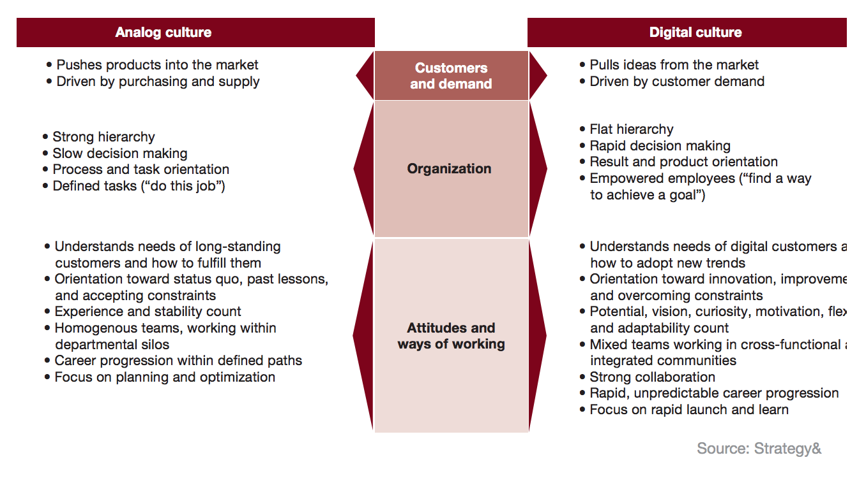
Figure 4: Analog Culture versus Digital Culture (Wokurka et al., 2017)

At this point, it makes sense to introduce some literature that specifically gives information on how companies can successfully transform from an analog culture to a digital culture to adapt to the new market conditions which are constantly at change. According to the multinational firm PwC (PricewaterhouseCoopers), three formal and three informal levers should help to manifest a digital culture (Meier, 2019). The formal levers are leadership policies, role definitions and people processes (Meier, 2019). In contrast to that, the three informal levers include key behaviors, role models and networks (Meier, 2019). The formal levers serve to facilitate the introduction of new digital channels into traditional processes and to structure processes within a company (Kande et al., 2020). They form the basis for the informal levers that deal with people's daily work and are intended to help them in their daily work (Kande et al., 2020). Therefore, employing formal levers can change processes and adapt organizational structures as well as roles and responsibilities (Young, 2000). They can use informal levers to encourage people to change their ways of thinking, feeling and behaving, to embed the digital nature of doing business in their daily work (Hand, 2016). The literature in this section suggests that the digital transformation process can only be successful if both formal and informal levers are considered. If management only considers the formal aspects and develops structures without targeting critical behaviors, likely, the transformation will not succeed in the long run (Freyermuth, 2015). By involving only role models, the urge to positively influence employee behavior will have limited success (Rowles and Brown, 2017).
To underpin the special position and importance of corporate culture in the process of change, it is also wise to examine how companies have viewed and experienced digital culture transformation in the past thus far. In the following, two studies by the management consultancy Capgemini are illuminated.
The study "The Digital Culture Challenge: Closing the Employee-Leadership Gap of 2017" deals with the gap between management and employees that needs to be closed to generate a culture of togetherness in the process of digital transformation.

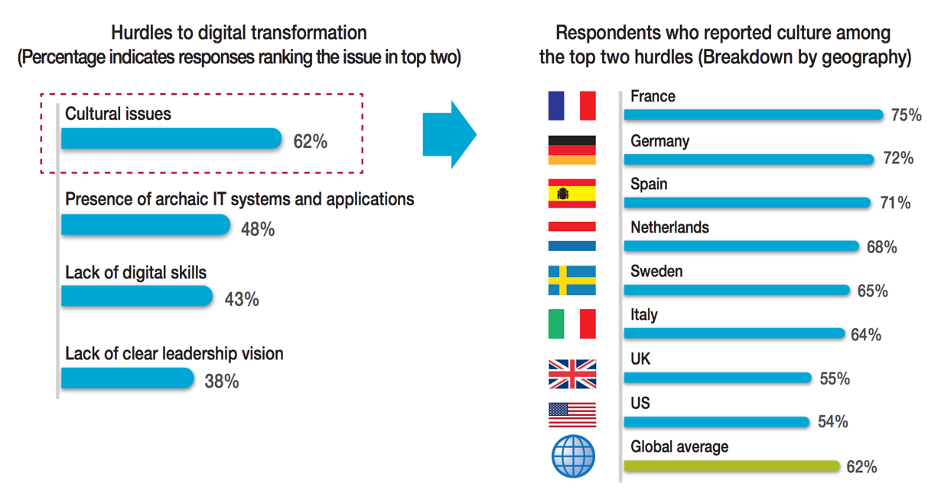
Figure 5: Culture as the Number One Hurdle (Singh, 2019)

This chart above (Figure 4) clearly shows, measured against the global average, that in almost all European countries corporate culture is seen as the most important problem. Thus, the creation of a digital culture is a real challenge. It takes several years, requires patience, persistence and constant control to establish a new culture in the company (Guinan et al., 2019). Employees must be inspired to actively shape the cultural change, including the right mix of top-down and bottom-up concepts (Buvat et al., 2017). This long-term project must include several key elements, which Capgemini presents as follows:
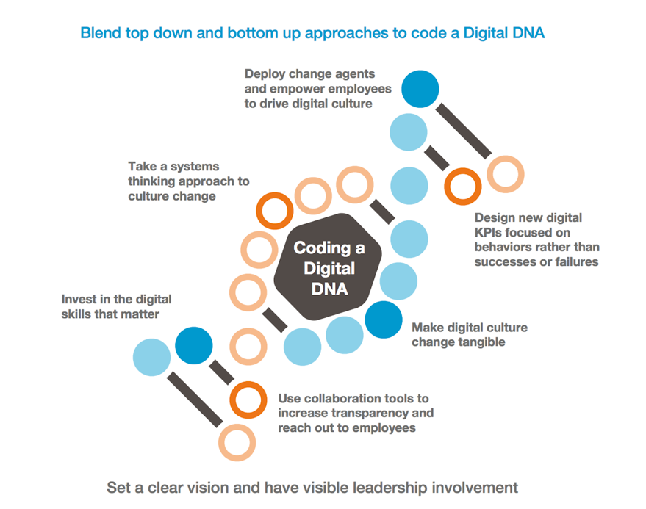
Figure 6: Coding a Digital DNA (Capgemini Global, 2021)

The findings from this study highlight the crucial role that corporate culture plays in the implementation of an effective and sustainable digital culture. Clearly formulated visions that bring recognizable benefits for all people involved are the key to success. New Key Performance Indicators, which measure employees by behavior rather than success or failure, and the use of change agents, which bring employees closer to expected behaviors and tools for employee training to gain digital skills, need to be installed. The goal should be to create an ecosystem that promotes learning, experimentation and growth and enables companies to gain a significant competitive advantage through their cultural identity (Henfridsson et al., 2014).

The second study "Culture First! - Learning from the pioneers of the digital revolution Change Management Study 2017" stresses the fact that digital transformation is a cyclically repeating process (Schaefer et al., 2017). Since technology is constantly evolving, the corporate culture must also be consistently adapted to the new circumstances (Shaughnessy, 2018). In the results of its study, Capgemini shows that change management must always reinvent itself to keep pace with change (Figure 6).
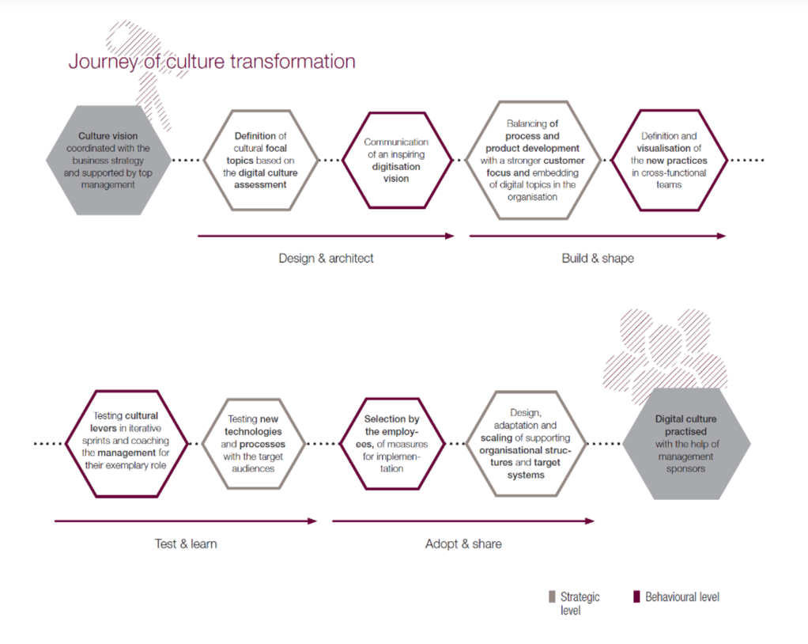
Figure 7: Journey of Culture Transformation (Capgemini Global, 2021)

This research also presents inspirational solution approaches that will aid to design a guideline for effective employee involvement in the digital transformation process.

2.2 Digital Transformation
In this chapter, the difference between the digitization of a company and the digital transformation will be explained. Relationships between technological and social change as well as the challenge that a corporate culture poses to digital transformation will be analyzed here as well.
The term digitization is not so easy to define because it depends heavily on the context in which it is used. On the one hand, digitization describes the process of digitizing analog media, i.e. converting analog data, for example scanning old photos and converting them into image files. Also, the conversion of analog data and information into digital file formats pursues the goal of digitally securing them and thus being able to distribute and process them faster and more flexibly (Ritter and Pedersen, 2020). On the other hand, it refers to all change processes that are driven by the continuous development of innovative information and communication technologies and their increasing adaptation by society, economy, education, culture and politics. They are primarily connected via the Internet, as well as powerful computers, mobile devices such as smartphones and tablets and the associated software tools and applications (Terras, 2011). Understanding digitization as one of the main drivers that lead the way of digital culture change is of enormous importance. Digitization is the most demanding entrepreneurial challenge today. It only develops its full potential if, in addition to technology and processes, cultural aspects are also taken into account (Gobble, 2018).
Digital transformation, however, is defined by Dorean (2019) as follows: “Digital transformation is based on digitalization but goes one step further. This is no longer about replacing existing processes or products with binary-based technologies. It is about the development of completely new business opportunities, which have only become possible through digitization (Berman, 2012). Two transformations can be distinguished: The transformation of companies and the transformation of markets.” (Schallmo and Williams, 2018)
Digital transformation cannot thrive without digitization because it is a necessary prerequisite. While digitalization means switching products and workflows to binary code-based technology, digital transformation means developing unprecedented opportunities and business models that are revolutionizing entire markets (Warner and Wäger, 2019). Digitization takes place within existing business models and corporate structures and has a mainly innovative character. In radical contrast, digital transformation is breaking new ground (Ziyadin et al., 2020). Everything is questioned and adapted to new needs. Companies gain flexibility and independence. Free competition will sooner or later lead to an increased digital transformation of companies and markets in the future.
To get a better understanding of the relationship between technological and social change, Alain Veuve’s (2016) “Digital Transformation Model” (Figure 7) will be investigated in more detail in this dissertation. It applies to all technologies. The speed at which digital technology has made its way into our society can be measured, especially in digital technology. Most companies were and are surprised by this and fall behind, which they now have to overcome in a special effort.
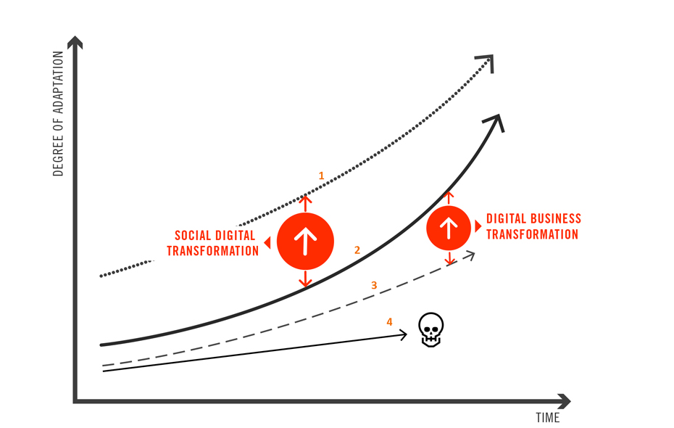
Figure 8: Digital Transformation Model (Veuve, 2016)

In general, this concept underlines the urgency for companies to make the transition to a more digitally-oriented business model. Primarily, companies have to focus on the changing needs of their customers and not solely prioritizing the latest technologies to stay ahead of the market. Those who do not adapt to the market environment will have to leave the market sooner or later (Mugge et al., 2020). In this regard, it is mandatory for companies nowadays to pursue a digital strategy that builds strongly on a stable digital culture.
Considering the argument that corporate culture poses a daunting challenge to digital transformation can possibly explain why business organizations are facing difficulties to make this decisive move towards a digital direction (Jacobi and Brenner, 2018). The following gained knowledge will also help during the collection of primary data to get more clarification on the extent how companies have been digitalized so far. The explanations in the previous literature have shown that corporate culture makes a significant contribution to digital transformation and thus exerts a decisive influence on the digital transformation process. Jane McConnell (2015), Stoianova et al. (2020), (Singh and Hess, 2017) and (Vey et al., 2017) examine the cultural factors of digital change. If companies have worked out an opportunity to implement factors such as decision-making, participation, openness, departure from silo thinking and knowledge monopolies in their corporate culture, then according to the authors, companies will initially have to overcome five major challenges which are illustrated below:
- Lengthy decision-making processes
- Finding solutions to deal with people who resist digital transformation
- Prioritizing technology over employees’ views and ability to adapt to digital change
- Facing unforeseen risks & possible problems that occur during the implementation phase
- Management fears a potential loss of control and is concerned that the workforce’s performance will be negatively affected (e.g. distraction by social media platforms)

- Conceptual Framework
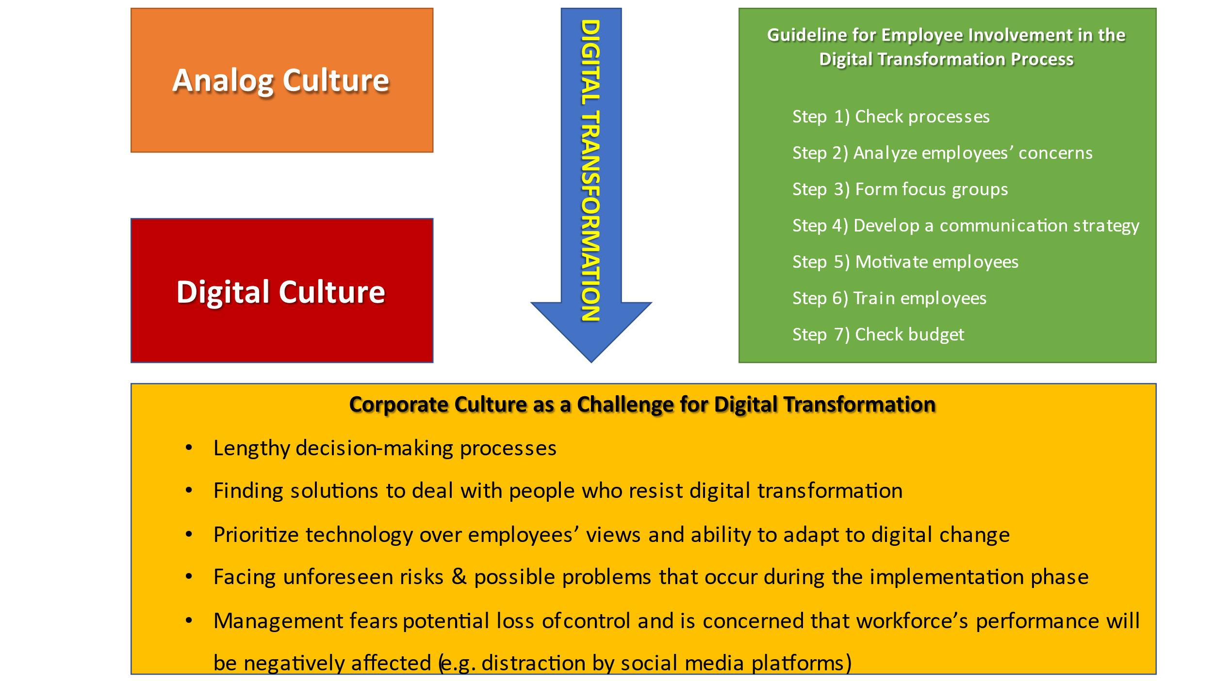
Figure 9: Conceptual Framework

Figure 8 represents the conceptual framework of the research based on the literature review. Also, the essential aspects of the envisaged guideline for employee involvement in the digital transformation process are depicted in the above illustration which is created based on references in this dissertation. It is also the result of all the findings from the qualitative expert interviews which have been properly analyzed. The acquired knowledge from the literature review supplied the key basis for the generation of the question catalog for the collection of primary data. At this point, several hypotheses can be formed that will be either confirmed or refuted in the course of the research. This includes the following:
- There is a close connection between digital transformation and corporate culture.
- The digital corporate culture requires agility.
- It is the CEO's responsibility to drive the digital transformation process.
- Setting up a digital department is necessary.
- The digital transformation will only succeed if it is carried out across all departments.
- The digital corporate culture is a continuous development process.

- Methodology
4.1 Research Paradigm and Overall Approach
One of the main objectives of doing this research is to come up with a strategy or guideline that serves as an orientation to start the transformation from an analog to a digital culture. Companies that have already initiated or are in the middle of a digital culture change can also adopt this model for further improvement. For that reason, it makes sense to implement a qualitative research method. To be more specific, the research will be based on the phenomenological philosophy because this investigation aims to collect data from various experts representing different business branches and company sizes who will share their subjective experiences and views on the research topic which is a powerful method for inquires. Furthermore, the proposed research is also influenced by the interpretivism philosophy as an insight into the distinctive perspectives of interview partners will be given. This way, it is possible to interpret social reality with the help of the individual attitudes of the embedded participants where the reality is located. Additionally, the obtained information will help to create a universal approach. In this context, an inductive rather than a deductive method will be selected as specific observations from the conducted interviews will be summarized to get broader generalizations.
The purpose of this research is a combination of an exploratory and descriptive study. On the one hand, this research topic is very up-to-date and does not provide a great amount of academic literature (exploratory). On the other hand, this research intends to determine the current stage of companies in terms of digital culture change (descriptive).
On the whole, choosing the qualitative research method will ensure to encapsulate changing viewpoints of the participants, allow a certain degree of speculations about the examined research area and offers flexibility as questions can be easily adapted to improve responses.

4.2 Research Design
4.2.1 Strategy
In general, an exploratory and descriptive case study was applied as the overall strategy for this research. As limited academic literature is available for this research topic, which is also a contemporary issue, an inductive approach is considered as a plausible choice.
In this empirical social research, the qualitative content analysis method for primary data by Philipp Mayring was utilized. This form of evaluation provides a structure for organizing, categorizing and structuring the contents of an interview or group discussion. It is primarily used in the disciplines in which text and image material is evaluated. The selected research method ensures that the experts' answers to the questionnaire will be first compressed so a high density of information will be guaranteed and then subjected to an evaluation. These condensed results can be finally interpreted.

4.2.2 Methods and Additional Sources of Data
In empirical social researches, qualitative content analysis is an evaluation method for data. This form of evaluation provides a structure for organizing, categorizing and structuring the contents of an interview or group discussion. It is primarily used in the disciplines in which text and image material is evaluated. The selected research method ensured that the experts' answers to the questionnaire were first compressed so that there was a high density of information and then subjected to an evaluation. These condensed results are finally interpreted.
The methodology of qualitative content analysis by the German psychologist Philipp Mayring was used for the expert interviews. For more than 20 years, Mayring has continued to expand the approach and has thus succeeded in gaining international and interdisciplinary recognition for his approach.
The seven-step model according to Mayring shown below (Figure 9) was employed to analyze the structured expert interviews. The individual steps are explained successively below (Figure 9). They will contribute step by step to answering the following research question: “What requirements does digital transformation place upon the corporate culture of an organization?” This question was deliberately chosen because its answer can be used to develop a guideline that can be used by companies that deal with the transformation process or have already taken their first steps. It is decisively influenced by the interview questions and their results as well as the hypotheses.
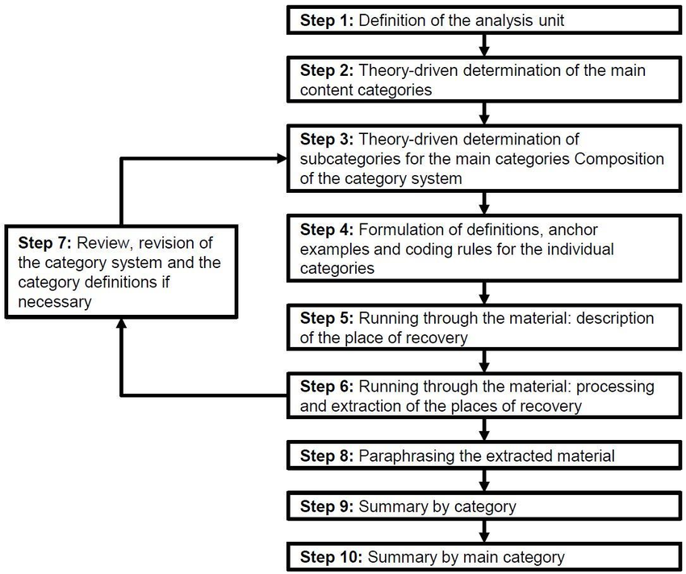
Figure 10: Process Model for Content Structuring (Mayring, 2015)

The qualitative content analysis according to Mayring (2015) offers two different approaches. A distinction is made between inductive and deductive category development. The inductive category development will be used here because it can be adapted more individually and meets the requirements of this research as mentioned earlier.
The selection of ideally ten experts for the interviews will be made in such a way that the broadest possible spectrum of different industries and company sizes can be covered so that the guideline to be developed can be adapted by companies of all sizes and across all industries. This ensures that a universal concept can be created for corporations to transform their organizational culture digitally in an effective way. Hence, primary data will be used for this research.

4.2.3 Nature of Data
In the following, a questionnaire, with a total of ten questions, is presented which was used in the interviews. A distinction is made between closed and open questions which are formulated as follows:
- Is your company completely or partly digitally structured?
- Is there a strong connection between digital transformation and corporate culture?
- Do you have projects dealing with the digitalization of corporate culture?
- Have you ever heard of PwC's "Six Levers to Change a Culture" model?
Questions one to four are closed questions. They facilitate the introduction to the interview and provide statistical data that can be easily visualized for later analysis.
- What do you think a digital corporate culture should look like?
- Who is responsible for driving and implementing the digital transformation?
- How important do you think it is to set up an own department within the company that deals exclusively with the digitization process?
- On a scale of 1 to 10, 1 is low and 10 is high, how would you rate the implementation of your company's digital transformation?
- How important is digital transformation from the company's perspective?
- What do you think your company will be like in three years concerning the digital corporate culture?
Questions five to ten are open questions. Their answers are much more comprehensive than the closed questions above. Furthermore, important details, as well as similarities or inequalities, are to be shown, both between the companies and to the theoretical bases taken from the literature. The questionnaire draft is designed to interpret the differentiated aspects of the research question based on the evaluation. The focus of the listed questions is chosen in such a way that the focus is always on the importance of people in terms of the corporate culture. Besides, insights into already implemented diverse options in companies and answers about exploitable potential will be provided.

4.2.4 Access and Research Ethical Issues
On principle, the expert opinions were obtained orally in the form of interviews. To respect the dignity and privacy of all participants, interviewees can request to stay anonymous if they want their names or the company they work for to be treated with confidentiality. Each expert has received a set of sample questions in advance of the actual interview to allow time for preparation. All of them were also informed about the duration of the interview and the research topic of the dissertation. The entire process of collecting primary data in form of a qualitative content analysis complies with the regulations stipulated by Griffith College Dublin.

- Results
First of all, all experts involved in this study will be introduced. Each of the interviewed experts received and answered the same questions in identical chronological order. This ensures that the same starting conditions were created for each interviewee. In the following, the experts and the companies they work for are briefly described in order to get a better overview. The sequence is based on when the interviews took place and begin with:
Florian Kölsch, he is an independent keynote speaker, digital consultant and chief executive officer (CEO) of his own company KölschMedia, plus he is also the business manager for the Düsseldorf Startplatz’s start-up Dnetwo UG, making the entrance possible for medium-size enterprises into the digitization with maximum scalability and quality. Mr. Kölsch has been active in the digital environment for over 20 years and has made a name for himself in the digital transformation scene through numerous projects. His primary goal is to accompany medium-sized companies in the digital transformation and to support their implementation.
The Raiffeisen Landesbank Oberösterreich AG based in Linz is the second expert to answer questions. It stands on stable pillars and comprises investments in banks and financial institutions, strong subsidiaries that represent an important complement to the core business of the financial institution. As Austria's leading regional bank, Raiffeisen Landesbank Oberösterreich AG is both regionally anchored and globally networked. Mr. Haunschmied is a junior corporate client consultant and is responsible for supporting senior customer advisors, supporting companies and their financing projects, supporting customer acquisition, research and preparation activities as well as coordination activities.
With the industry giant Capgemini as the third interview partner, one of the leading international providers of IT consulting and digital services, it has annual sales of EUR 13.2 billion in 2018 and around 200,000 employees in over 40 countries. As Engagement Director, Mr. Schmidt is responsible for Application Development & Maintenance Services (AMS), which is responsible for the operation and further development of customer applications according to SLAs (Service Level Agreements). Further areas of responsibility are further qualifications and internal training in the area of Engagement Management.
The fourth expert, Mr. Wagner, is an automotive engineer Dipl. Ing., a specialization in general mechanical engineering, in a Cologne-based company specializing in digital construction. He obtained his diploma in automotive engineering at the Technical University of Cologne and holds a doctorate in physics from the RWTH University in Aachen. The small company, which currently consists of four people and has a very flat hierarchy, has no interest in expansion, although the possibilities would certainly exist. It relies on healthy economic figures and satisfaction in the company in general rather than on a rampant expansion, which could result in strong fluctuations in orders. Mainly, Mr. Wagner designs 3D volume models on his laptop using the CATIA V5 design program and is in direct contact with the company's customers.
The Düsseldorf-based company Vodafone Deutschland GmbH provides the fifth expert. It supplies Internet, mobile communications, fixed-lined network and television from one provider. As a digitization partner of the German economy, Vodafone’s customers include start-ups, medium-sized companies as well as DAX corporations. With around 49.6 million mobile phone cards, almost eleven million broadband, 14 million television customers and numerous digital solutions, Vodafone Deutschland and its 16,000 employees generate service revenues of almost 13 billion euros. As a digital consultant and quality management specialist, Mr. Q is responsible for cross-departmental quality checks in sales, order entry, order processing, measures for planning, controlling and optimizing processes, as well as carrying out internal and external audits, planning, implementing and further developing the quality management system.
Finally, the electronics retail giant Saturn provides its know-how. Saturn turns technology into an experience for its customers and shows how modern technology products can enrich people’s lives. Since it was founded in 1961, the company has been presenting the latest technology trends and tailoring its products to the wishes of its customers. Today, Saturn pursues a multichannel concept encompassing several distribution channels. It is managed as an independent sales brand under the umbrella of the Media Markt Saturn Retail Group and is represented in Germany with around 150 stores. There are currently around 168 Saturn stores in Germany, Austria and Luxembourg. As regional manager, Mr. Fischer is responsible for the support of all Saturn stores in the Ruhr/West and Ruhr East alliances, as a direct link between the corporate management and the GmbH managing directors, he is additionally responsible for compliance with the required key figures such as sales targets, trade margins, inventory ratios, etc., and supports the managing partners in their implementation.
The selection of experts for the interviews was made in such a way that the broadest possible spectrum of different industries and company sizes could be covered, so that the guidelines to be developed could be adapted by companies of all sizes and across all industries. Four of the six expert opinions were obtained orally in the form of an interview, while two preferred to answer the interview questions in written form. To respect privacy, some names of companies or experts were not mentioned.
This chapter illustrates how the results were determined, which will be evaluated in the following chapter. The procedure is based on the qualitative content analysis according to Mayring, which provides two possibilities for category development. Instead of the deductive category development, in which the categories are given from the outside, the inductive category development is applied, which means that the categories into which the text modules or other content elements were placed were spontaneously formed from the available material. A text element must be read or viewed first. (Mayring 2015, p. 69)
The interview material presented here consists of four oral interviews and two are available in written form. The following companies were interviewed. The first interview partner was Mr. Kölsch from Dnetwo UG in Düsseldorf, followed by Raiffeisen Landesbank Oberösterreich AG represented by Mr. Haunschmied, Capgemini SE represented by Mr. Schmidt, a digital construction office represent-ed by Mr. Wagner, Vodafone GmbH represented by Mr. Q. and Saturn Deutsch-land GmbH represented by Mr. Fischer. The list is based on the order in which the interviews took place.
The answers of each interview partner were paraphrased in the first step, whereby care was taken to leave out only filling terms in order to retain the meaning. This step was repeated for each interview question asked and for each interviewee so that a total of 60 paraphrases were created in the first step. (Mayring 2015, p. 71)
In the next step, these paraphrases were generalized. The paraphrases were basically paraphrased again in order to shorten the texts further and retain the core message. Afterward, these 60 generalizations were first categorized; repeating statements within an interview were deleted and then categories were created in which generalizations could be summarized. (Mayring 2015, p. 71)

The procedure is illustrated by the following example:
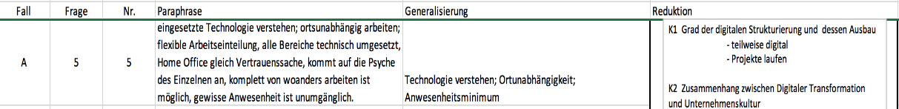
Figure 11: Extract of Question 5

In case A, question number five, the statement of the interview is paraphrased, therefore abbreviated, while the core of the statement remains. In the following generalization, filler words fall out in order to categorize them in the reduction.
At this point, it is decided whether the same category applies again, or whether a new category must be created to assign this element to a category. This step is repeated until all generalizations are assigned to the categories. If too many categories have been created, it is possible to combine individual categories later if they are too similar. The step sequence was applied to each interview partner. The facts described can be found on pages 81 to 86 in the list of appendices.
At the end of the next step, the reduction, there are eight categories for each inter-viewed expert, in total 48 categories (K1 - K48) for further processing. In the following, the categories including entries were first compared with the source mate-rial and checked for meaningfulness before the 48 categories were further processed. (Mayring 2015, p. 72)
In the following, the eight categories assigned to the respective interview partners were compared chronologically, e.g. 1 with 9, 17, 25, 33 and 41. For example, interview questions one and three were summarized in category one, and questions five and ten in category four. All other questions were assigned to a category. This process was repeated six times for each of the interviewees. So, 60 interview questions became 48 categories. (Mayring 2015, p. 72)
It was generalized again and statements with the same meaning or content were deleted in order not to have double statements later. The statements that now remained in the 48 categories were summarized in categories K´1 to K´8 in order to be compared one last time with the source material. This can be seen in the list of appendices on pages 76 to 78. These eight categories form the basis of the material that is used to evaluate the interview questions. (Mayring 2015, p. 83)
The resulting findings are used to answer the research question in chapter 3.3 and are compared with the unanimous findings from the literature. From the categories with closed questions as well as from questions that had to be answered numerically, diagrams Appendix A Round 1 Summary Case A to Appendix L Round 2 Summary Case F were also prepared in order to visualize the results more clearly and to be able to extract all important information at a glance, these are shown on pages 71 to 82.
In the following chapter 6, the self-generated charts and Excel tables are explained in more detail, and their statements are analyzed and interpreted.

- Interpretation
The evaluation of the last eight remaining categories takes place in chronological order. This can be found in the list of appendices. Starting with the category K’1, which is composed of the interview questions number one “Is your company completely or partly digitally structured?” and number three: “Do you have projects dealing with the digitization of the corporate culture?”. Since the questions build on each other, they were summarized in this category.
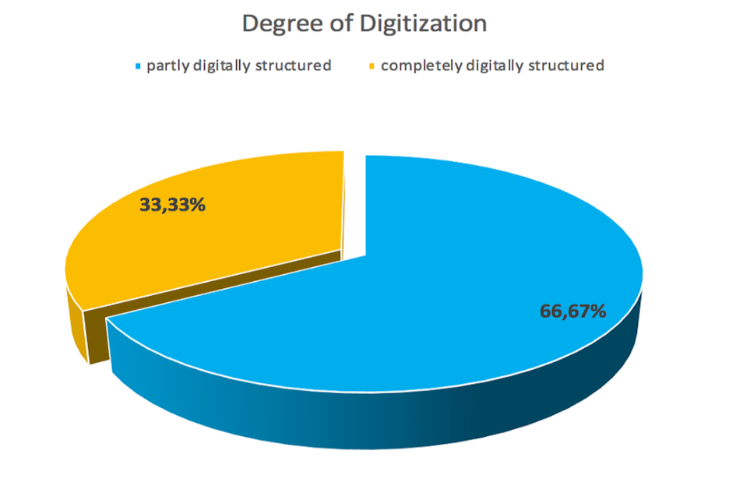
Figure 12: Degree of Digitization

In the first part of this category, two-thirds of the respondents (Dnetwo UG, Raiffeisen Landesbank Oberösterreich AG, Vodafone GmbH & Saturn Deutschland GmbH) answered that they were partly digitally structured, even if already quite advanced, but in different ways. The remaining one-third (Capgemini SE & digital construction office) stated that their companies were completely digitally structured.
In five of the companies surveyed, projects are currently underway that are directly concerned with the digitization of corporate culture, only Vodafone GmbH does not currently have such a program. The company is more concentrating on expanding digital technology in order not to lose ground in the fiercely contested competition. (Q, pers. comm. 29 July 2021, see audio Question 2) As far as the other companies are concerned, there are various projects that deal with cultural change. To name just a few examples, while Raiffeisen Landesbank Oberösterreich AG is concerned with implementing new digital work processes (T. Haunschmied, pers. comm. 22 July 2021, see audio 3:20 min), Saturn Deutschland GmbH focuses more on improving internal communication with employees and between departments. (Fischer, pers. comm. 02 August 2021, see audio Question 8)
The K’2 category reflects all answers to the second interview question: "Is there a strong connection between digital transformation and corporate culture?”
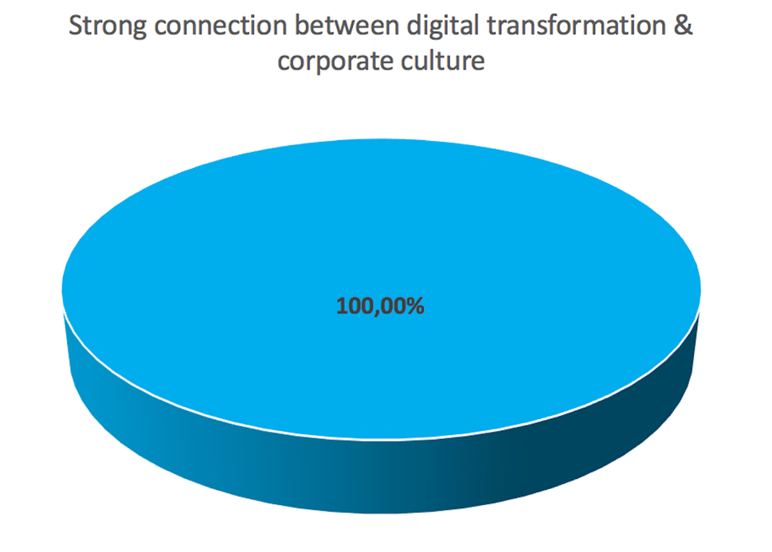

Figure 13: Connection between Digital Transformation & Corporate Culture

In answering this question, all respondents agreed that there is a strong correlation between digital transformation and corporate culture. For all respondents, it was clear that without a culture that wants to drive this transformation from the top of the company down to the lower levels of the hierarchy, it cannot succeed. That an attitude of refusal towards the new would slow down the change and in principle, every employee has to be taken along. It is not enough to try to convince the employees by courageous action, the employees must become aware of the benefits they will gain from it at their workplace. There must be an open communication right from the start so that no fears of losing their jobs arise, as this would paralyze rather than drive the process. The introduction of new digital technology and other digital innovations is far from being enough to put a company in the fast lane if the corporate culture is not adapted to the new circumstances in advance.
Category K’3 deals with interview question four: "Have you ever heard of the PwC model "Six Levers to change a Culture"?

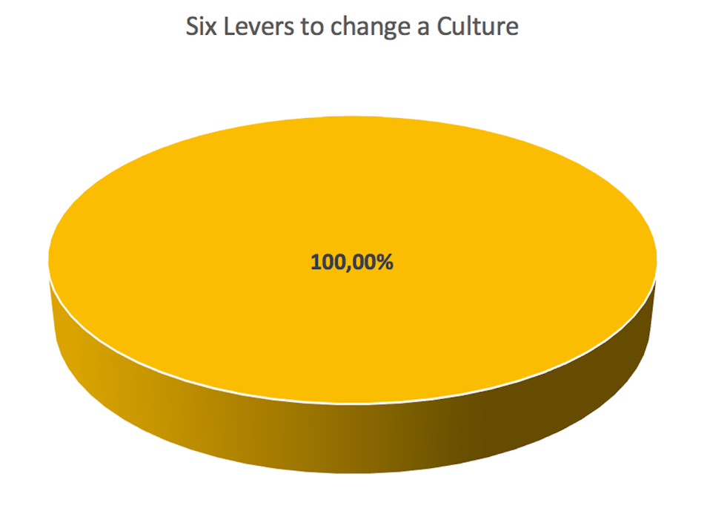
Figure. 14: Six Levers to change a Culture

There was also 100% agreement in answering this question. Although all interviewees had already dealt with the digital transformation in detail, none of them was familiar with PwC's "Six Levers to change a Culture" model. This suggests that either other models were used for implementation or that the model is already being used in practice, but few will be aware of its origins. It is often a combination of different models that ultimately leads to the desired result. Not every model is suitable for every industry. This model has already been explained in detail in chapter 2.
Category K'4 summarizes the answers to the interview questions five "What do you think a digital corporate culture should look like?" and question ten "What do you think your company will be like in 3 years with regard to the digital corporate culture?” The summary provides an outlook into the near future of the interviewed companies.
Aiming first at the first question of the category, it should be said that the most important statements are as follows and that there were multiple mentions, which underlines the importance. On the one hand, the interviewees are concerned with the fact that technology has to be understood, it is not enough to acquire it, the employees have to be trained in order to be able to use the constantly evolving technology in an economically sensible manner. But that alone is far from enough. A culture has to grow and should be open to digital disruption (T. Haunschmied, pers. comm. 22 July 2021, see audio 6:20 min) in order to survive in the rapidly changing market. Only a grown culture that is flexible and allows creativity can quickly adapt to new market requirements and thus prevent losing touch. The cultural change has to be accepted and lived by the employees; they have to recognize the benefits of what they do every day. This only works if the process is promoted and exemplified by the management and through all levels of the hierarchy. The workforce should be actively involved in the rethinking process and see itself as part of the big picture. Employees need to be made aware of how other departments work and have an understanding of which processes are taking place around them. In this way, cross-departmental work is encouraged, and silo thinking is systematically reduced and the “we-feeling” is strengthened.
In order to accelerate processes and work speeds, hierarchies are kept flatter, the employees are given more autonomy and skills so that decisions can be made faster and easier. However, implementing a new digital culture in the company also means that many unknown things must first be tried out in order to then find out the optimal way of working. In this way, mistakes will happen that will start a learning process. It is important to create a culture of mistakes in which mistakes can be made and are not punished. Errors help to improve processes. A too strict interpretation only unnecessarily slows down the creativity of the employees and eventually leads to a refusal attitude.
For some companies, one goal is to achieve a degree of independence of location, both for employees and experts who can be called upon when external knowledge and expertise are needed. Terms like home office are on everyone's lips these days, not only do they increase flexibility and motivation, they also reduce costs. For small companies it is also conceivable to do without their own premises completely. These can be rented as required, for example to hold meetings once or twice a month. (F. Kölsch, pers. comm. 19 July 2021, see audio 10:53 min) This makes companies extremely flexible. Of course, this does not apply to companies that are dependent on customer proximity and stationary business. Despite all flexibility, a certain attendance minimum cannot be waived at present. (F. Kölsch, pers. comm. 19 July 2021, see audio 2:56 min)
When asked where the interviewees see their company in three years, the unanimous tenor was that everyone will continue to develop in order to adapt to the constantly changing market situations and not to lose touch with the competition. The digital transformation does not allow for a standstill, it is a process that has to be constantly adapted to new circumstances.

Concerning the still pending category K’7, four out of six respondents (Raiffeisen Landesbank Oberösterreich AG, Capgemini SE, Vodafone GmbH & Saturn Deutschland GmbH) stated that they will continue to push development forward because there is still enough potential for improvement. Two of the respondents (Dnetwo UG & digital construction office) who already perceive themselves to be at a very high level do not see any further potential for improvement. Dnetwo UG would like to further promote location independence but does not consider a digital maturity level of 100% to be realistic. (F. Kölsch, pers. comm. 19 July 2021, see audio 17:10 min) The interviewed 3D construction office even deliberately took a step back due to security concerns, and now only sends order and customer documents on data carriers, as the Internet and cloud solutions are too insecure for them. (Wagner, pers. comm. 29 July 2021, see audio 8:08 min) Four of the interviewed participants saw their company in three years at a maturity level of 90%, one between 80 and 90% and one over 90% whereby a 100% implementation was classified as unrealistic. All in all, a positive prognosis for the future.
The K’5 category deals with the question: "Who is responsible for driving and implementing the digital transformation?” This question is also clearly answered. All respondents see the top management or the CEO to be responsible. The management must fundamentally drive the issue forward. Of course, tasks can be delegated, and experts can be consulted, but responsibility cannot be passed on. Here, the role model function is particularly important, because one simply cannot demand that employees live something to which they do not seem to attach great importance.
Category K’6 deals with the question: “How important do you think it is to set up an own department within the company that deals exclusively with the digitization process?” The answer to this question depends on the size of the company and the industry. The larger a company is, the more important it is to release specially trained and suitable personnel to accompany the digitization process and to support employees and managers in implementing it. These employees or departments should only deal with the issues of digitization so that the remaining workforce can continue to concentrate on the core business. (T. Haunschmied, pers. comm. 22 July 2021, see audio 10:53 min) Furthermore, they should train employees so that they can develop new skills to implement new work processes. They should support and not patronize, actively relieve employees, because they usually have to struggle with enough news in the restructuring phase. Employees are integrated into the new processes and the benefits that digitization brings with it should be made clear to every employee because only then will this concept be shared by everyone.

“Eine Abteilung innerhalb eines Unternehmens, die sich ausschließlich mit dem Digitalisierungsprozess beschäftigt ist wichtig. Zum Beispiel bei Vodafone, wurden die Ressort „Strategie“ & „Digitales“ zusammengeführt – denn die Digitalisierung ist Kern unserer Unternehmensstrategie“, says Mr. Q. from Vodafone GmbH. (Q, pers. comm. 29 July 2021, see audio Question 7)
Category K‘7 provides answers to question eight: "On a scale of 1 to 10, 1 is low and 10 is high, how would you rate the implementation of your company’s digital transformation?”
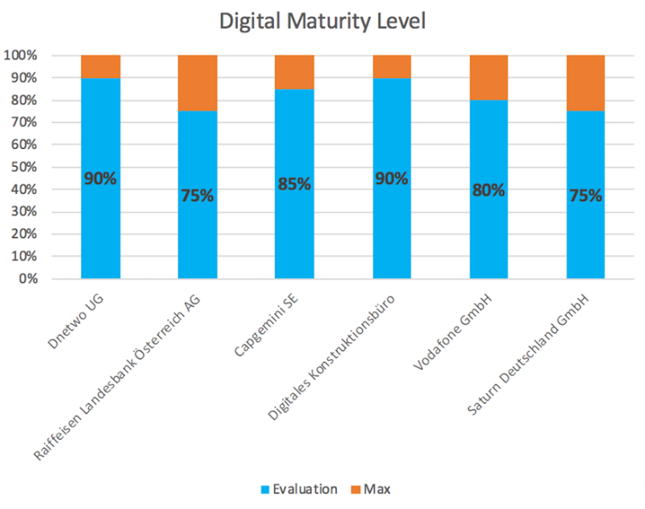
Figure 15: Digital Maturity Level

The justifications given for why the level of digitization is not already higher for some companies are as varied as the industries from which they come. Often, many restructuring measures still need to be managed. In banking, there are still gaps in IT and payment transactions that need to be digitally closed, but which are often delayed by legal regulations. (T. Haunschmied, pers. comm. 22 July 2021, see audio 16:28 min)
Service providers and banks are in the process of constantly expanding the range of services offered to integrate processes that are as customer-friendly as possible. Some companies quite deliberately do not go to the limit because they simply lack trust when it comes to security aspects. Mr. Wagner from the 3D construction office in Cologne confirms that since the NSA scandal, customer order data and the finished plans are no longer sent cloud-based, but instead, as in the past, simple data carriers such as CD, DVD or USB stick are used, some of which are handed over personally to the customers. This personal limitation costs time and money but increases security. (Wagner, pers. comm. 29 July 2021, see audio 6:59 min)
Companies like Capgemini SE represented by Mr. Schmidt have already reached a very high level of digital maturity. Because the company operates multi-nationally in over 50 countries and is organized decentrally, a high degree of networking and digitization is inevitable. (D. Schmidt, pers. comm. 25 July 2021, see audio 9:57 min) Finally, as one of the industry leaders in digital transformation consulting, the company needs to set a good example.
Many of the companies still have potential in cross-divisional or cross-departmental processes that need to be optimized. Mr. Fischer from Saturn Deutschland GmbH criticizes the often still inadequate communication between managers and employees on the sales floor and between the individual departments. This could be better coordinated, which would free up resources that could relax the often tense situation in terms of personnel. He sees further potential in the wealth of ideas of his own employees. “Ebenso was den Ideenreichtum unse-rer Mitarbeiter angeht, kann noch sehr viel getan werden. Diese fühlen sich oft zurecht nicht wirklich ernst genommen. Daher haben wir extra ein Portal geschaf-fen, wo Mitarbeiter ihre Ideen direkt mit der Konzernleitung teilen können, darüber hinaus werden die besten Ideen mit attraktiven Prämien vergütet, um einen zusätzlichen Anreiz zu schaffen. Der Erfahrungsschatz unserer Mitarbeiter ist unser größtes Kapital.“ (Fischer, pers. comm. 02 August 2021, see audio Question 8)
The last category K'8 deals with question nine: "How important is the digital transformation from the company’s perspective?”. This question cannot be answered simply with the word "important". The interviews clearly showed that digital transformation is very important to everyone, but it also became clear that there will be no digital transformation unless the process is preceded by the creation of a digital corporate culture.
At Dnetwo UG in Düsseldorf, digitization has progressed so far that their representative, Mr. Kölsch, believes that the DNA in the company is already digitally anchored. (F. Kölsch, pers. comm. 19 July 2021, see audio 13:04 min)
Mr. Haunschmied from Raiffeisen Landesbank Oberösterreich AG reaffirms the importance as well as the further advance. It is important to further expand integrated online portals, as well as to set up banking and investment apps and digital access for customers. (T. Haunschmied, pers. comm. 22 July 2021, see audio 14:19 min) In order not to lose the connection to the competitor, processes must be constantly rethought and newly developed. Of course, this strongly depends on the industry as well as the expectations of the customers.
For Vodafone, the optimization of internal processes along the value chain and its employees, as well as the expansion of further developments with strategic partners, is at the top of the agenda. (Q, pers. comm. 29 July 2021, see audio Question 9)
Mr. Fischer from Saturn Deutschland GmbH formulates it as follows: “Es ist unum-gänglich, kein Unternehmen, welches im Multichannel Bereich tätig ist, kommt daran vorbei, ohne den Anschluss zu verlieren. Nur wenn dieses Unterfangen mit größter Professionalität und Hingabe umgesetzt wird, kann man seinen Kunden das Einkaufserlebnis bieten, welches erwartet wird und gegebenenfalls darüber hinaus. Neue Unternehmen am Markt sind gleich digital aufgestellt, der Prozess der Umstellung nimmt hingegen viel Zeit in Anspruch und erfordert einen hohen Kostenaufwand. Es erfordert viel Überzeugungsarbeit vor Ort in den Märkten, weil die Mitarbeiter es erst dann mittragen, wenn sie den Nutzen dieses Aufwands erkennen.“ (Fischer, pers. comm. 02 August 2021, see audio Question 9)
In summary, thanks to the qualitative content analysis according to Mayring, the evaluation of the rather comprehensive interview answers filters out the core statements according to categories in order to be able to transfer them to the subsequent chapter. The insights gained here are juxtaposed with the theoretical background from the literature reviewed.

- Discussion
In this chapter, the basic principles and statements developed in the second chapter, which were taken from the literature and published studies, are compared with the material compiled in chapter four from the evaluation of the six expert interviews according to Mayring's qualitative content analysis.

7.1 Building a Digital Corporate Culture
Both the literature and the opinions of the experts surveyed indicate that digital transformation cannot be achieved without the creation of a suitable digital corporate culture. A rethinking process is therefore essential if a company wants to continue to exist in the market. In the long term, no company will be able to avoid digital transformation; the sooner this step is taken, the better it will be able to position itself in the market.
But how does a company manage to implement a new idea that is accepted by both employees and external stakeholders? The answer is: through well-thought-out and solidly planned change management. The 8-steps model by John P. Kotter already presented in chapter 2 can serve as an instrument for a step-by-step and structured change. It would be obvious to assume that adapting to the latest technology makes change management so complicated. However, it is the human being who is the greatest obstacle to change. This insight from his research prompted Kotter to develop the 8-steps model in 1996. It enables managers to successfully implement change. The model focuses on internal corporate communication.
Mr. Fischer from Saturn Deutschland GmbH confirms with this statement that this is not yet fully developed in many organizations: “Es muss halt noch viel getan werden, um die Kommunikation im Unternehmen zu verbessern. Es versickern noch zu viele wichtige Informationen im Unternehmen, die nicht beim Mitarbeiter auf der Verkaufsfläche ankommen. Hier sind vor allem die Führungskräfte in den Märkten gefordert, an einem deutlich besseren Informationsfluss zu arbeiten.“ (Fischer, pers. comm. 02 August 2021, see audio Question 10)
The first step of successful change management should be to find the right strategy for the digitalization of the company. Digital technology serves merely as a tool for implementation. This strategy should include where the company currently stands and what goals are to be pursued with digitization. The design of the future business model must be defined in order to meet the needs of the customers. At the same time, it must be determined which organizational changes are necessary and which competencies must be built up or brought into the company. A necessary change in the management culture should also be addressed.
A suitable way of doing this is to compare the analog and digital corporate culture of Strategy&, a part of PwC, which was described in chapter 2. This illustration clearly lists the differences between an analog and digital culture. The digital part of the organization, which describes flat hierarchies and quick and short decision-making processes, is confirmed as follows in an interview with Mr Schmidt, from Gapgemini SE: “… flache Hierarchien im Unternehmen, um halt wirklich dann auch Entscheidungen schnell hervorbringen zu können, durchdringen zu können.“ (D. Schmidt, pers. comm. 25 July 2021, see audio 5:10 min)

Furthermore, the model also describes the differences between analog and digital working methods, such as understanding the needs of the digital customer. Mr. Haunschmied from Raiffeisen Landesbank Oberösterreich AG says about this: “Man hat sich ja auch das Ziel gesetzt, ein “Home of Financial Intelligence“ zu sein und das eben umfasst diese starke Kundenorientierung. Kundenorientierung erreicht man einerseits mit Online Banking. Auch die Arbeitsprozesse hier digital umzustellen, differenzierte Leistungsangebote und Betreuungskonzepte für den Kunden zu ermöglichen. Persönliche Beratung mit den digitalen Service zu kombinieren.“ (T. Haunschmied, pers. comm. 22 July 2021, see audio 3:29 min)
However, the use of digital technology alone does not immediately make companies innovative, efficient and agile. These attributes first have to be anchored in the corporate culture, then in the corporate structure and finally in the corporate organization. They can be found in business models and processes. It is not enough to install a few tools, especially since they often cannot communicate with each other, it is much more important to make the change. Processes and organizational models need to be questioned. For companies, this means that they have to deal with reorientation and optimization.
According to Alain Veuve, whose model was discussed in the second chapter, the reorientation of a company should in no way be tied to the status quo of technology. The danger of missing the market is too great. At the heart of the matter is that customers orient themselves according to the latest available technology and decide whether or not to accept it. It is advisable for companies to orient themselves to the needs of their customers. New technologies are usually used hesitantly in the beginning, only when a critical mass of users has been reached, does a technology usually spread quickly. The approximation of the technology adaptation curve of the users to the provided technology can be described as a social, digital transformation, on which companies should orientate themselves.
The digitalization of a company does not only concern the introduction of modern software solutions and collaboration tools, but has much more fundamental effects on the structure, business models and the way an organization works together. Only if the digital transformation is advanced and exemplified by a company's qualified management personnel and all components are taken into account, can a holistic change be initiated.
Digitization must always be considered in its entirety. It must therefore not be the sole responsibility of the managing director, because it can also have consequences for the strategic orientation of a company. This statement is also shared by the expert of the Raiffeisen Landesbank: “Wie schon gesagt, dass muss einfach… das ist, glaube ich nicht sowas, was von einer Person direkt ausgehen muss. Das müssen mehrere Player einfach gemeinsam vorantreiben. Es fängt beim CEO an und hört bei den einzelnen Abteilungen einfach auf.“ (T. Haunschmied, pers. comm. 22 July 2021, see audio 9:46 min)
It requires quick reactions and an agile ability to adapt to changes in customer behavior, the competitive environment and technical developments. The market potential of applicants has also changed. It is one of the central tasks of an HR department to attract young digital talent to the company and at the same time to develop or expand the digital skills of existing employees and managers. Today, digital competence is one of the core competencies that every single employee should have, because it does not only require specialist knowledge in areas such as web controlling, omnichannel management and big data management.
Modern, dynamic forms of collaboration require the use of collaboration tools, digi-tal communication technology and other solutions for digital exchange. But these also have disadvantages. As Mr. Wagner, an engineer in a 3D design office, men-tioned in his interview, it is often the lack of security that curbs a holistic digitization process. You do not have 100 percent control over the security of transactions in cloud-based data transfers, “da der Diebstahl von den digitalen Daten halt natürlich immer ein Thema ist. Von daher haben wir jetzt… sind wir sogar den Weg gegangen, dass wir entweder teilweise wirklich Boten mit USB-Sticks losschicken oder es entsprechend, wenn wir ein Produkt oder Konstruktion vorstellen, es dann persönlich machen und die Sachen persönlich auf dem Stick transportieren.“ (Wagner, pers. comm. 29 July 2021, see audio 8:04 min) But this ensures full data security. So it depends on the priorities that have to be set beforehand from case to case.
The fact that the application of new programs and tools is necessary for everyday work and that they help to solve problems faster and to cope with increasing complexity must be manifested in the awareness of the employees. They need to be trained in these technologies and the most important functions need to be familiar to the employees. Attention must be paid to a sustainable and result-oriented use and the resulting benefits should always be in the foreground. Often it is a lack of communication skills that makes everyday work more difficult.
Mr. Kölsch and his colleagues already know this problem from their past personal experiences: “Ich kann ein Tool einführen. Ich kann irgendwie eine mobile App, mobile Outlook einführen oder kann von mir aus eine Cloudlösung einführen für irgendetwas. Das ist das eine. Die Frage ist aber… man muss das auch nutzen. Ich habe es bei uns gesehen, dass wir sehr lange noch… mit Excel gearbeitet haben, wenn es um Kontakte ging… Dann haben wir ein Tool eingeführt, was lange nicht genutzt wurde, weil es umständlicher als Excel war… man musste erstmal den Mehrwert herbeiführen.“ (F.Kölsch, pers. comm. 19 July 2021, see audio 5:35 min)
However, human resource managers in companies must also make digital skills their own. On the one hand, in order to understand which organizational changes are necessary in the company and which infrastructure must be made available to the employees, and on the other hand, to make their own work more efficient. How can HR processes be digitally mapped and accelerated? For them, too, it is important to adopt a new way of thinking.
At this point, the importance of corporate culture for all digitization projects and initiatives in the company becomes clearly visible. A digital mindset, an open and curious attitude towards modern technologies and a basic understanding of the influence that digitized processes can have on work and communication can only be achieved if the corporate culture makes this possible.
Far-reaching changes such as digitization bring uncertainty, especially with regard to corporate cultures in traditional companies. Employees are afraid for their own jobs or fear that they will not be able to cope with the new technology. That is why it is so important to involve the employees. Because that is what corporate culture is all about. It sensitizes employees to changes - and in such a way that they internalize the principle of "turning those affected into participants". Those responsible teach how to use the collaboration tools and communicate the added value. They obtain feedback from employees and take it into account. In this way they become co-creators of change.
This has already been successfully implemented at Capgemini, for example “Wir haben auch bei uns im Unternehmen eine sehr gelebte und proaktive Feedback-kultur. Das heißt, das gibt es positiv, aber auch negativ. Das heißt, dass halt auch wirklich die Kollegen auch schnell lernen oder das Feedback bekommen, was war gut und was war vielleicht jetzt nicht so gut, was kann verbessert werden und da wird auch offen darüber geredet.“ (D. Schmidt, pers. comm. 25 July 2021, see audio 14:17 min)
Capgemini's Culture Transformation Model describes the evolution of transformation from the vision to the implemented process, in which constant adjustments are needed to adapt to changing circumstances. It also points out the importance of integrating employees into the development process from the very beginning.

Furthermore, the corporate culture contains the values, norms and guidelines actually lived by a company. It defines the way in which people work together and is a decisive factor in determining which digital talents choose a company as an employer. Therefore, even before implementing the digitization strategy, it is important to clarify to what extent the existing culture supports the digital transformation in the company and what measures need to be taken to promote openness among employees and managers and to enable digital and agile forms of collaboration. The corporate culture determines which companies successfully master the digital transformation.
Digitalization demands a great deal from companies of all sizes. It not only affects the use of software, but also collaboration, customer contacts and the entire organizational structure. Many aspects of digitization require a new way of thinking. This openness to modern technologies, forms of work and communication must be supported by a digital-friendly corporate culture.

7.2 Hypotheses
The following six hypotheses are based on the interview questions, the answers to which are intended to confirm or refute them. They have been drawn up on the basis of the most important interview questions, the answers to which should provide all the information necessary to answer the actual research question in a targeted and well-founded manner.
1) There is a close connection between digital transformation and corporate culture.
Each of the six experts surveyed was able to confirm a strong connection between digital transformation and corporate culture, as well as the demands that its creation places on a company.
As Mr. Fischer from Saturn Deutschland GmbH aptly stated: “Ja, und es ist eigentlich auch die anspruchsvollste Aufgabe, eine geeignete Firmenkultur als Grundlage für die digitale Umwandlung des Unternehmens zu erschaffen. “
(Fischer, pers. comm. 02 August 2021, see audio Question 2)
The corporate culture is directly reflected in the way we work and in the culture of cooperation, especially in companies that are already well advanced in this process. It goes beyond the use of digital technology, it is necessary to convince employees of the vision of digital transformation and to make the resulting benefits visible to all employees. “Eine digitale Transformation, ein Teil der Unternehmenskultur sein und auch bleiben.“ (Wagner, pers. comm. 29 July 2021, see audio 2:13 min)
“Die digitale Transformation bedeutet Kulturwandel. Eine Transformation kann man nur erschaffen, wenn sich die Denkweise im jeweiligen Unternehmen verändert. Die Unternehmenskultur nimmt Einfluss auf jede Ebene im Unternehmen,“ confirms Mr. Q. from Vodafone GmbH. (Q, pers. comm. 29 July 2021, see audio Question 2)
Thus, the experts have confirmed the hypothesis with their well-founded statements and assigned it a high priority across all sectors.
2) The digital corporate culture requires agility.
Companies that recognize new situations abruptly, act quickly and react are called agile. Thanks to their dynamism and willingness to change, they are easily identifiable from the outside. In their internal structures, they are characterized by the fact that standard processes have a lower priority than people themselves and their interactions, which reflect the culture they live in. What counts is the quality of co-operation between employees, customers or suppliers rather than the stubborn adherence to contracts. Results are given more importance than their achievement and the willingness to change is valued far more than the execution of processes. A prerequisite for greater agility is the flattening of hierarchies and the provision of employees with the necessary autonomy to shorten decision-making paths and accelerate processes.
“Offene und ehrliche Kommunikation durch alle Hierarchieebenen ist wichtig, wo-bei die Struktur wesentlich flacher geworden ist, was Entscheidungsfindungen einfacher und vor allem schneller macht. Man sollte seinen Mitarbeitern Vertrauen entgegenbringen und ihnen die Kompetenzen zugestehen, die sie für ihre tägliche Arbeit brauchen. Wir leben das vor allem auf der Verkaufsfläche, weil auch unsere Kunden davon profitieren.“ says Mr. Fischer. (Fischer, pers. comm. 02 August 2021, see audio Question 5)
The expert from the management consultancy Capgemini SE also comes to the same consensus. “Autonomie, die man den einzelnen Mitarbeitern ein Stück weit zu gute hält. Nicht komplette Kontrolle, im Unternehmen, dass sich so sowas halt in der Kultur niederschlägt.“ (D. Schmidt, pers. comm. 25 July 2021, see audio 5:57 min)
In the eyes of the respondents, agility is an immensely important factor in a digital corporate culture in order to keep pace with competitors, which confirms the hypothesis.

3) It is the CEO's responsibility to drive the digital transformation.
Basically, all the experts surveyed are of the same opinion that the drive for digital transformation should come from the top of the company and that the transformation process is the responsibility of the respective CEO, managing director or top management.
Mr. Wagner says that the responsibility lies with the CEO, but each employee has a certain degree of participation and their own ideas can influence a significant part of the overall decision. (Wagner, pers. comm. 29 July 2021, see audio 5:28 min)
The situation with Saturn is as follows: “Es ist bei uns grundsätzlich Chefsache, da wir ein dezentral aufgestelltes Unternehmen sind, sind hier hauptsächlich die GmbH Geschäftsführer in der Pflicht, dass für ihren Verantwortungsbereich umzusetzen. Unser CEO legt größten Wert darauf, dieses Thema unaufhörlich voranzutreiben.“ (Fischer, pers. comm. 02 August 2021, see audio Question 6)
In a digital culture, the top management of a company conveys a clearly defined vision that must be implemented by management. This means that responsibility in sub-areas is passed on from top to bottom in the hierarchy. It is distributed to several parties, right down to the managers in the individual departments. The current course and the adherence to this vision will continue to be subject to the top management of the company. In small companies and businesses, on the other hand, it can be assumed that the owner solely bears the responsibility.
The willingness to take on this responsibility should be seen as a cultural anchor-age in the company policy, this is how it is seen at Raiffeisen Landesbank Oberösterreich AG (T. Haunschmied, pers. comm. 22 July 2021, see audio 18:07 min)
Since all experts see the management of a company as responsible for driving the digital transformation, this hypothesis can also be clearly affirmed.
4) Setting up a digital department is necessary.
Here the experts' statements differ somewhat, but this is mainly due to the size of the companies. In the case of the 3D construction office, the company with a permanent staff of four people is simply too small to install its own digital unit. Since their activities and products are purely digital, it is quite sufficient for the employees to share the concerns of digitalization among themselves. For cost reasons, too, it would make little sense to occupy a CDO. (Wagner, pers. comm. 29 July 2021, see audio 6:06 min)

Whereas at Capgemini SE and Saturn Deutschland GmbH, this position has already been occupied by a separate division. Capgemini has created positions that deal specifically with the issue of digital transformation. For example, new positions such as Digital Transformation Manager and Chief Data Officer were created that bring the importance and sustainability of the topic closer to the employee and integrate it into the existing processes. (D. Schmidt, pers. comm. 25 July 2021, see audio 7:33 min)
Quote from Mr. Fischer: “Sehr wichtig, zumindest für ein Unternehmen unserer Größe. In kleinen Betrieben würde ich das nicht so sehen. Aber die Media Saturn Holding mit ihren 1022 Märkten in 14 Ländern braucht eine eigene Organisation im Unternehmen, die sich ausschließlich um diese Belange kümmert, und das inter-national. Nach dieser Prämisse wurde auch dieses Team zusammengestellt, um länderübergreifend die gleichen Ergebnisse zu erzielen.“ (Fischer, pers. comm. 02 August 2021, see audio Question 7)
It is also important for Vodafone GmbH to integrate a department within a company that deals exclusively with the digitization process. The departments “Strategy” and “Digital” were merged together for this occasion. (Q, pers. comm. 29 July 2021, see audio Question 6)
Digital units should not act like a lighthouse that outshines everything because digitization is not an end in itself. Digitization must be applied and subordinate to a specific goal. It should always be the focus. The digital unit should support the employees in the implementation and not patronize them. (F.Kölsch, pers. comm. 19 July 2021, see audio 9:10 min)
The department for digitization is supposed to keep the resource employees free for the core business but is also responsible to support and inform the employees in the digital processes. (T. Haunschmied, pers. comm. 22 July 2021, see audio 10:55 min)
The basic consensus is a majority yes to the installation of a self-sufficient digital unit in the company, which means that this hypothesis must also be regarded as confirmed.
5) The digital transformation will only succeed if it is carried out across all departments.
A fundamental element of the digital culture is the interdepartmental and interdisciplinary exchange of employees among each other and with customers. It has greatly simplified the gathering, sharing and structuring of information. In critical situations, this essential privilege can be eliminated by an inappropriate corporate culture; in a culture adapted to digitalization, the benefits will increase. One of the strongest levers to take digitization forward is collaboration. It is also in the interest of the customers if employees are able to give information.
In this context, Mr. Fischer says: “Es soll eine offene Kultur sein, in der die Mitarbeiter gerne mal über den Tellerrand hinausschauen und sich aktiv in den Entwicklungsprozess einbringen. Es sollte jeder ein abteilungsübergreifendes Verständnis besitzen und die Abläufe der anderen Abteilungen kennen und verstehen. Zumindest mit den Abteilungen, mit denen er zu tun hat.“ (Fischer, pers. comm. 02 August 2021, see audio Question 5)
Mr. Haunschmied states that one should have a certain openness and curiosity about digital disruption so that it is valued at all levels. (T. Haunschmied, pers. comm. 22 July 2021, see audio 6:20 min)
This hypothesis is also confirmed by the subjects of the interviews, even if Capgemini has no personal statement, their numerous studies, as one of the leading consulting firms for digital transformation, show that this topic has a strong influence on digital culture. In the case of the two small companies surveyed, there are no departmental structures, since they consist of only a handful of employees, between whom rapid and continuous communication is guaranteed.
6) The digital corporate culture is a continuous development process.
The way of running a business or interacting with customers has changed fundamentally in recent years. The corporate world is becoming faster and more diverse, the customers more self-determined and demanding. Entrepreneurs must therefore adapt to the new environmental situations and continually develop and reinvent themselves. The digital transformation is therefore a necessary process for many companies in order to exploit their full potential. Of course, changes in the corporate process are always very risky and are subject to constant further development in order not to feel any losses in the highly competitive markets. Therefore, rethinking and development processes will be repeated cyclically.
The digital transformation is a constant process of development. Due to the consulting of large companies, some of which belong to the DAX30, there is a constant rethinking process for new ideas, which can also be used in the own company. (D. Schmidt, pers. comm. 25 July 2021, see audio 1:00 min)
Digital topics are constantly changing. You always have to stay up to date and you don't have to isolate yourself to stay competitive, especially when it comes to internal processes according to Mr. Wagner. (Wagner, pers. comm. 29 July 2021, see audio 1:08 min)

Many of the companies surveyed emphasize the importance of a living error culture. In an ongoing development process, many processes have to be rethought and new paths taken. On these paths, errors are inevitable. They must simply be accepted by the management.
This is also how Mr. Fischer sees it: “Ebenso die sogenannte Fehlerkultur, wenn man neue Wege geht, muss man auch neu denken, und wenn man nicht aus Er-fahrungen schöpfen kann, muss man halt neue Dinge ausprobieren. Da ist es normal, dass Fehler geschehen oder der Weg nicht zum Ziel führt. Man muss sich zusammensetzen, um gemeinsam Lösungen zu finden, um Fehler nicht zu wie-derholen. Fehler sind wichtig, weil sie einen Lernprozess in Gang setzen. Solche Fehler darf man nicht ahnden, weil das der Kreativität und Ideenfindung einfach schaden würde.“ (Fischer, pers. comm. 02 August 2021, see audio Question 5)
Mr. Schmidt also agrees with this statement and says that the culture of error must be lived. Employees should be encouraged to make their own decisions and to make mistakes. (D. Schmidt, pers. comm. 25 July 2021, see audio 6:34 min)
At Dnetwo UG, one will be reminded not only to talk about a culture of mistakes but also to live it. In theory, that is great, but if you talk about mistakes honestly, some people feel hurt very quickly. The introduction of changes leads to an increased error rate, which must be accepted by the company. Digitalization is a trial and error. Errors are not a bad thing but help to improve processes. Therefore, an error culture must be in place. (F. Kölsch, pers. comm. 19 July 2021, see audio 15:23 min)
From a banking perspective, this is viewed somewhat more critically. As Mr. Haunschmied notes, the error culture in the banking industry is a somewhat highly sensitive process, as the clientele requires a certain level of professionalism. (T. Haunschmied, pers. comm. 22 July 2021, see audio 16:25 min)
All participants surveyed agreed that the development process of a digital corporate culture is not a process that is completed at some point. Managers and employees can learn a lot from mistakes and unwanted events about how they can improve their work in the future. By analyzing these errors, conclusions can be drawn about their causes and protective measures can be taken.

A well-established process of error reporting and processing as well as subsequent decision making enables rapid action to be taken - even in an emergency. When employees experience that mistakes or events are dealt with constructively in the company, this also increases the probability that they will be more open about even small mistakes and deviations in everyday life and not conceal them. A culture in which managers and employees can admit mistakes without fear also has a positive effect on the working atmosphere. It is a constant learning process, which also confirms the last hypothesis.

7.3 Research Question
The research question "What are the demands the digital transformation brings upon to the corporate culture?” was selected on the basis of its fundamental importance for change. People are the most important factor in every company, therefore a transformation towards a digital company cannot succeed without prior adaptation of the corporate culture. The necessary prerequisites for this must be identified, examined and then implemented. This master thesis is intended to be a step-by-step guide to the implementation of a digital corporate culture, for all companies of any size and industry.
The result of the research question of this master thesis is illuminated from two perspectives. On the one hand, it is based on Capgemini's eight-dimensional catalog of digital culture and on the other hand, with a self-compiled model called “Guideline for Employee Involvement in the Digital Transformation”. Subsequently, a summarizing comparison of both approaches is made.

  - .1 Capgemini's Eight Dimensions of Digital Culture
Capgemini's eight Dimensions of Digital Culture, published in the study "Culture First" in 2017, was developed through qualitative interviews with 20 selected people from companies such as Google, SAP and IBM who answered the same questions: "What characteristics distinguish the culture of companies which have already come a long way in the digital transformation? Which ways of thinking and behavioral patterns, which values and standards, and what type of management characterize this digital culture?” In cooperation with the University of Innsbruck, these eight aspects for the creation of a digital corporate culture, which are described in more detail below, were identified. (Schaefer et al. 2017, p. 8)
The eight dimensions are composed as follows: Customer focus, digital technologies and digitized processes, entrepreneurship, agility, autonomous working conditions, digital leadership, collaboration and finally innovation and learning. These points are also explained in more detail in this order and backed up with examples. (Schaefer et al. 2017, pp. 24-25)
- Customer Focus
The lived customer focus has always been one of the most important foundations in a corporate culture. Only those who know their customers' needs can align their company to meet their customers’ wishes and thus strive for lasting corporate success. Digitalization has made it much more convenient for customers, markets that were previously unmanageable are now growing together to form a marketplace. The lack of transparency in the past has become a thing of the past, thanks to a wide range of comparison possibilities with just a few clicks. Consumers are feeling the benefits of the digital revolution in all areas of life, and their sovereignty has taken on astonishing proportions. Convenient consumption from home, around the clock, has become part of everyday life.
This offers companies new opportunities to study customer behavior and draw conclusions for future trends; every step can be analyzed and evaluated. Comments and evaluations of customers in the social media serve as a barometer of mood. If these channels are used carefully, both negative and positive changes can be perceived promptly and counteracted accordingly. The customer is always at the center of the company's thinking and trading process and thus also deter-mines its future direction. Customer interaction can be promoted immensely through digital technology, which ensures a close exchange with customers. Their needs can then be analyzed with the help of digital data and tools, thus helping to bring tailor-made offers to the market. (Schaefer et al. 2017, p. 30)
In addition, considerable costs can be saved in this way. If customer wishes are implemented into suitable offers, new business opportunities are tangible. It is helpful to look at your own company from the customer's point of view, which should apply to all employees who want and should act in a customer-oriented manner.
If you know the needs of your customers and include them in the planning and conception, you not only act customer-oriented, but also show your customers a special appreciation, which might be helpful to bind them to your company in the long run. The enterprise IKEA offers its customers the possibilities of planning furnishing concepts freely online or in the branches with the help of coworkers, for example for the living, sleep or kitchen range, beyond that the customer is informed at any time about the current prices and can see in such a way whether it fits to their budget. In addition, suggestions and requests from customers are delivered free of charge. So, it is in one’s own interest to summarize as much data as possible for analysis purposes. Striving for comprehensive customer knowledge is a matter of course in digital companies.
- Digital technologies and digitized processes
Only when both management and employees are open-minded to the new technologies, the benefits of digitization can unfold. It means weighing opportunities and risks and including the human factor in all considerations, because their working environment should henceforth be subject to new structures and processes. (Schaefer et al. 2017, p. 31)
This is especially true for the further development of internal and external processes using digital tools, because digitization will affect the habits of all employees in the company, which many initially perceive as a disruption and reduction in the value of their own experience. If this perception is also confirmed by managers, the willingness to open up to new things will decrease even further. The employees should be involved in the new processes right from the start in order to become aware of the advantages as quickly as possible. They should also be able to express their thoughts and concerns, so that their experiences are recognized and valued. (Schaefer et al. 2017, p. 31)
By using digital tools, both internal and external processes are developed further, enabling data-based decisions to be made and eliminating sensitivities. Gut feelings or misjudgments are significantly minimized when decisions are based on sound facts. Digital technologies are used for planning, execution and analysis of processes and results across departments in the company.
To ensure that employee satisfaction remains at a consistently high level, the example of the French wine producer Pernod Ricard is a good example. By using the intranet and internal social networks, the more than 19,000 employees are able to exchange information in real-time dialogue and across all channels. In 2013, a survey of employees revealed a satisfaction rate of an impressive 94 percent. More than four out of five employees worldwide use Pernod Ricard's online social platform, a quarter of them daily. (Schaefer et al. 2017, p. 31)
- Entrepreneurship
With good corporate governance, employees have more freedom to implement their own thoughts and ideas. They should be seen as an important and valued component in the decision-making process within the company. Their wealth of experience is of crucial importance in this respect. In order to be able to follow the constant changes in the market, the current business model must be constantly scrutinized in order to be able to adapt quickly to new trends or market changes if necessary, because even an excellent business model needs to be kept in line with the market by making adjustments. Those who rest on their laurels will soon be overtaken. The willingness to constantly change and not to be satisfied with the status quo should be anchored in the company DNA. (Schaefer et al. 2017, p. 32)
Occasional failures and setbacks have to be accepted if one is constantly looking for better solutions out of one's own drive. It is not to be assumed that the majority of employees will think in this way. But even those employees who reject change can be guided and developed in a certain direction. (Schaefer et al. 2017, p. 32)
Even large companies can learn something from the small ones. According to the power plant constructor Areva based in Bavaria, which is pursuing an approach to anchor a creative start-up mentality in their workforce. The task was to send seven employees to find new products and concepts. For one year they worked passionately on new innovations under the constant supervision of experienced start-up consultants. As with real start-ups, they were released for six weeks for their actual activities in the Munich Technology Center. All employees were kept up to date on their progress via the intranet. The message: “We need you. Get involved." (Schaefer et al. 2017, p. 32)
- Agility
Companies that recognize, act and react quickly are called agile, recognizable by their dynamics and willingness to change. The ability to adapt to new circumstances under modified conditions is an important factor. New circumstances are promptly recognized, evaluated and implemented. (Schaefer et al. 2017, p. 33)
Streaming service Spotify has proven to be an agile company with 60 million users globally and more than 1,200 employees. The company has succeeded with small teams called "squads", which are fully autonomous cross-functional and self-organized units. Each of these units is responsible for everything they do from start to finish - from the first sketch to the deployment. All teams face a common challenge, and each team is looking for the best solution. They have long-term goals that affect the company as a whole, as well as project goals. This enables the company to continue to grow without being hampered by dependencies and coordination problems. (Schaefer et al. 2017, p. 33)
The example given above makes clear what a groundbreaking mindset lies behind the concept of entrepreneurial agility. Agility challenges every single employee and is therefore one of the keys to entrepreneurial success. Both human curiosity and intelligence are valued and placed above standards and routines. It promotes the natural desire to work together. (Schaefer et al. 2017, p. 33)
- Autonomous Working Conditions
It is in the nature of man to act as autonomously as possible and to make free decisions. This striving is opposed by the loss of control that the leadership would suffer if it were to give in to this striving. (Schaefer et al. 2017, p. 34)
However, well-positioned digital companies take advantage of this urge by expecting a certain amount of performance and in return release certain degrees of autonomy for their employees. But this also creates a high pressure to perform, which employees then have to face. (Schaefer et al. 2017, p. 34)
Companies have to get rid of the old way of thinking that employees acting independently would not act in their interest. The provided autonomy can be manifold, from the possibility to arrange the working day as freely as possible, to the adjustment of working hours or the place of work, such as working in one's own home office. It is always connected with the goal of awakening as much initiative as possible without the employees feeling exposed to too much pressure. In a self-created environment, there is usually a pleasant and productive working atmosphere. (Schaefer et al. 2017, p. 34)
A prime example is the former DVD mail order company Netflix, which has become one of the largest streaming providers in the film and entertainment segment. The company treats its employees with respect and gives them every possible freedom that even a start-up would give them. Honest dealings with each other are a basic requirement, because in this case neither working hours, places of work nor holidays are formally regulated. (Schaefer et al. 2017, p. 34)
- Digital Leadership
The task of a leadership is clearly defined, it should convey a clear vision and strategy, which should then be implemented with the help of the management and their employees. In a digital corporate culture, managers often see themselves as coaches for their employees, whose talents and skills need to be recognized, and then trained and matured. This type of relaxed cooperation creates a working atmosphere in which everyone feels equally comfortable and everyone has their own freedom. Due to the increasing trust, the close cooperation creates a closer bond with their own employees. Digital tools can make management more comfortable, but this involves the willingness and ability of the management to use such digital tools and act as a role model. (Schaefer et al. 2017, p. 35) A team-internal WhatsApp group, for example, could be such a tool. But it also requires a certain amount of discipline from all members.
- Collaboration
When there is a lively exchange between employees, customers, and competitors, it is called collaboration. Through the power of collaboration, hierarchical structures are overcome, and silo thinking is broken down; the collaborating parties support each other. The team spirit is strengthened by this open attitude, col-leagues among each other become more helpful and the "we feeling" is strengthened. The use of digital platforms such as Slack or Microsoft Cloud promotes online collaborations. (Schaefer et al. 2017, p. 35)
In 2012, Google presented a group of scientists with a real challenge, because they had to figure out how to put together a perfect team. The core task was to put together a team of the best professionals who would work together peacefully and deliver the best results. The project lasted for three years and the experts explained that the expertise of the individual team members did not affect the quality of the collaboration. It was only when the principles of the digital corporate culture were taken on board that there were positive effects on the results. Topics such as trust, mutual respect, empathy, listening to each other, the knowledge of making mistakes, all had a positive effect on the results. Knowing how relevant the sensitivities and inner convictions of the employees are to the results, one has to talk about them. Google went one step further and said that collaboration needs to be re-learned and re-practiced little by little in order to really work. (Schaefer et al. 2017, p. 35)
- Innovation and Learning
The consistent readiness to innovate and learning orientation is considered a prerequisite in a digital culture. People can become creative in an environment where experiments, making mistakes and bringing creative ideas are seen as the foundation for future business success. Established processes and habits are constantly being put to the test and critically questioned. Processes are not cemented but can be flexibly adapted to needs. The “trial and error” approach is expressly desired, new ways are taken to check whether or not they might be a shortcut. Failures in the development process must be accepted by the company and will not be sanctioned because this could bring progress to a standstill. No employee will take risks if this would have consequences. Old structures would continue to be retained. An openly communicated and creative environment is needed in which employees can share their ideas. This is the only way to manage the ongoing process of adaptation in a fast-moving environment. (Schaefer et al. 2017, p. 36)
The Berlin-based innovation incubator “The Dark Horse” goes one step further, where mistakes are even a living cult. There is an annual Fail-Award for the Hammer of the Year, for which only those responsible can nominate themselves, after which all employees can vote on who has produced the biggest fail. It is not at all about punishing the nominated person, it is rather about initiating a discussion about what can be done better in the future. There will even be a bonus, which is a sign that failure becomes a common cause. Even in large companies, there are trials and experiments, usually by their own teams, which take on special problems and work on a solution. The new methods are then implemented and tested on a small scale. If something fails on a small scale, the risk remains manageable, but if it works, the new processes can be implemented step by step throughout the company. (Schaefer et al. 2017, p. 36)

7.3.2 Guideline for Employee Involvement in the Digital Transformation
This is a self-designed seven-step model that can be used in the digitization strategy and is suitable for all sizes of companies. The person or team responsible is given an overview of what is to be planned step by step in the short, medium and long term. The focus is on the human resource because a successful digital transformation can only be achieved with open-minded and enlightened employees.
In the following diagram, the time expenditure is shown in the form of a Gantt chart, taking into account the involvement of the employees.
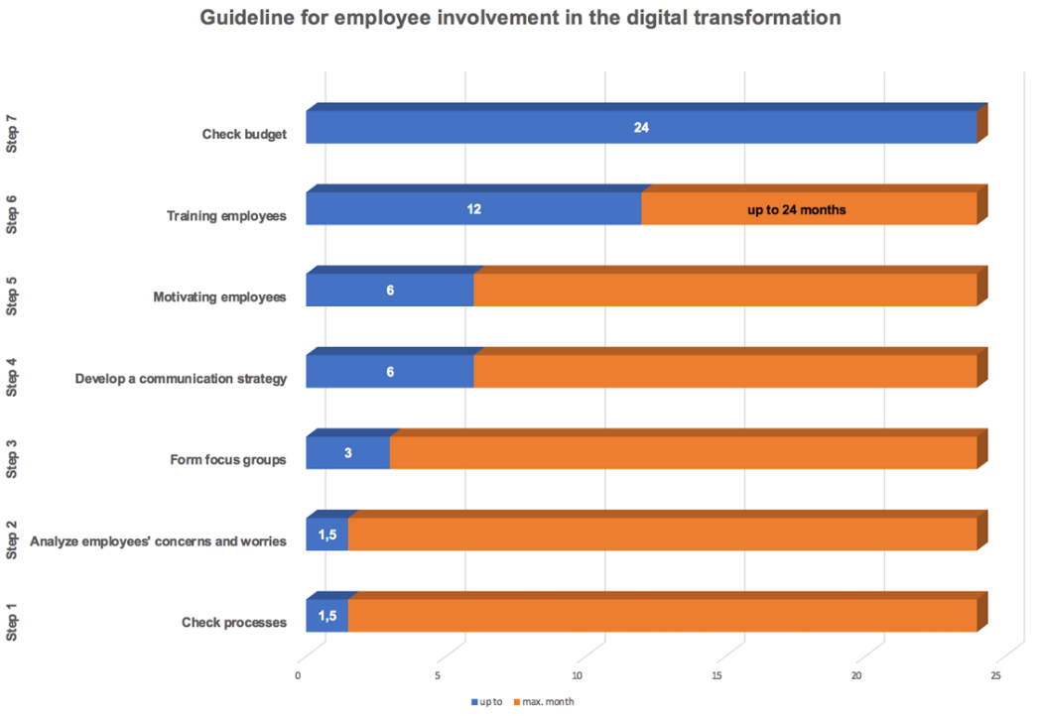
Figure 16: Guideline for Employee Involvement in the Digital Transformation

The X-axis illustrates the approximate duration of the individual tasks and the Y-axis shows the individual steps of the guide in ascending order. It should illustrate the time frame of the short, medium and long-term measures. The data basis is based on a medium-sized company. The terms given here are estimates and may vary depending on the size of the company and the sector.
Step 1: Check processes
If a company has to realign itself in the market in order to meet the demands of the market, not only must all previous processes and habits be put to the test, but a strategy must also be developed, a vision of how the company can operate successfully in the market in the future and in the long term. It has to be examined which areas have to be adapted, where do new interfaces belong and what has to change and can the tried and tested be kept.
The adaptation and new development of a business model go far beyond technological changes; it also requires equally profound strategic, organizational and, above all, cultural changes within the company. Processes and structures must be adapted to the new orientation and needs. Human resources and competencies may have to be adapted or expanded. In order to implement better communication, structures must be created that promote cross-departmental understanding and work and eliminate silo thinking. This is a short-term measure that can take three to six weeks, depending on the size of the company.
Step 2: Analyze employees’ concerns and worries
The desired changes have a profound impact on the people working in the companies. New differentiated requirements lead to a modified need for competence. The new environment requires new approaches to leadership, communication and interaction. People must be involved and supported in the change processes. The biggest obstacle on the way to digitalization in the company is the human being itself. Such innovations usually do not meet with open ears and are greeted with a negative attitude. It is not possible to create a new mindset among employees with just a few words. They must be convinced of the benefits of their new or changed job.
Most of them are simply afraid of not being able to cope with the new situation and fear for their jobs, financial losses or loss of competence. Therefore, open communication with employees is exorbitantly important. They should be involved in the process of change as early as possible. Their concerns must be taken seriously, only then will it be possible to dispel them later. Here it makes sense to involve the managers based in the departments. However, depending on the type and volume, the employees should also be directly interviewed. Managers or confidants must be named as contact persons to whom the employees can communicate their concerns, wishes and suggestions. Four to six weeks should be invested for this short-term measure, but in large companies this can take longer.
Step 3: Form focus groups
Digitization must be seen as a holistic process, so solo runs are undesirable. This process affects the entire company, so if one or more departments lose touch, the entire flow would be slowed down. The pre-defined strategy derived from the overall business objectives must be followed. All areas of a company are included in the digitization strategy.
In focus groups, employees can be involved in the implementation process in advance. They must be confident that they will receive the necessary training, receive the necessary support throughout the process and recognize the benefits both for the company and for their future work processes.
It is important for future digitization initiatives or focus groups that result in organizational changes to get to know and address their concerns. For the implementation to be planned, it is possible to draw on the know-how and skills of existing employees. This should also help to determine whether external expertise is still needed to make digitization a success. Employees who are open to digitization can be used as ambassadors for the project. This process is to be planned for the medium term with a duration of approximately three months.
Step 4: Develop a communication strategy
Being digital is becoming increasingly important for companies. Changing media behavior, flexible media use, mobile messengers, social media platforms and apps etc. are now a must for most companies in every modern communication strategy. Digital communication requires a basic understanding of digital interaction in addition to a higher level of detail. The demands on the communication management of companies are constantly increasing in all areas such as corporate and financial communication and marketing. Whoever wants to convince here must develop the strategy with tools. But this also applies to internal communication, which is often still lacking.
Internal departmental or cross-departmental WhatsApp groups, for example, would be an effective means of internal communication. Timely and targeted exchange of information is important to ensure that agility in companies is not negatively affected. Own groups or company-wide platforms in social networks are also a suitable means of communication. Employees can be informed about the status quo at any time and also be informed about upcoming events. This communication should always work in both directions. Problems and concerns should be able to be communicated at any time so that countermeasures can be taken quickly if necessary. These medium-term measures can take about three to six months.
Step 5: Motivating employees
Fear is not a good motivator. Often employees, especially those with many years of experience, are afraid of a certain loss of competence, because of their way of thinking, with digitalization many things become automated and their experience is no longer needed.
Early discussions are therefore necessary to take away this fear, as the experience of employees is one of the most valuable assets of a company. Employees should be involved in the planning processes right from the start, they will be much more committed than when everything is presented to them readily. Additionally, fears can be reduced. Every employee should see himself as a valued part of the big picture. Whoever feels needed, whose competence is needed, has a much higher motivation to perform.
A major motivation factor is a higher degree of autonomy for the employees. This can be manifold but should be performance-based, with more freedom for more performance. Whether in the form of free working hours or temporary independence of location in a home office must be determined if necessary. It requires mutual trust to operate this model. Time planning for this medium-term measure is three to six months.
Step 6: Training employees
Everyone is talking about digital transformation. Digitalization affects every company and every industry. It changes all business models, some slower, some faster and sometimes even radically. Across Germany, restraint still dominates. This is reflected in the rather slow pace of workplace modernization. Investing in your own employees should be the motto. It is important to identify suitable candidates in the company for further training and to exploit their full potential. However, training should affect the entire staff, because change will affect everyone.
The development and expansion of digital skills among permanent staff is an important prerequisite for smooth digital change. In the future, HR professionals will have to deal with how to make work more needs-oriented, efficient and agile. Learning opportunities as an integral part of work processes should be tailored and adapted to the needs of companies and employees.
The lack of qualified personnel with the necessary expertise for successful digitization is often a problem. Training should therefore be started in good time. However, managers also need support with regard to the requirements and design options of digitization. They must learn to create working time flexibility and offer home office facilities and also lead virtual teams at a distance. A good relationship should be established with internal communication and the human resources department. The possibilities of how these departments can accompany and sustainably support the human component of digital transformation with communication and employee training should be examined. Training projects should be designed for the long term. Depending on the industry, more training may be required. One to two years should be planned here.
Step 7: Check budget
Budgeting is a time-consuming process because the budget is mostly oriented towards the figures from the previous year. Increasingly, aspects of the company's success and sometimes enormous sums of money are at stake.
The following approaches should help to adapt budgeting to digitization. If cut-backs have to be made in various areas, the person responsible must emphatically point out the effects on the business processes of these affected areas. In this way, it can be avoided that the department can be held responsible for possible consequences.
Personnel costs are a major cost factor in every company. The budget plan should therefore include not only the acquisition and maintenance costs of the IT systems, but also the implementation of the measures by the specialist personnel and their further training, and in particular training for end-users. In order to effectively ensure the acceptance of the employees within the framework of a digitization project, support should be sought in justifying additional funds. A well-thought-out budget planning allows potentials and weaknesses to be identified and avoids unexpected cost burdens in the course of the year. Instead of a conventional financing plan, it should be seen as a tool for prioritizing HR initiatives. Since the budget is adjusted in most cases and reassessed at least annually, planning ac-companies the entire process of digital change. Depending on the company, no fixed duration can be predicted for this long-term measure, as it depends on the duration of the process.
In overall terms, the research question can be answered that the human being is the most important factor in both the digital and the cultural transformation process. From this, it can be deduced that the involvement and permanent dialogue with all employees to convince people of the necessity of change is fundamental.
The eight dimensions of digital culture studied by Capgemini, present the main characteristics that a digital corporate culture should have nowadays. While the model Guideline for Employee Involvement in the Digital Transformation explains the employee's career path in the digital transformation step by step. Both approaches combined help companies of all sizes and industries to address digitalization and put the employee at the center of the change process.
This study was limited by the lack of voluntarily participating interview partners. As the minimum number of 10 experts was not reached within the given time, the scope of the results obtained is only of limited informational value. The main reasons for non-participation were concerns about giving away in-house information as well as the ongoing pandemic of COVID-19 which made it difficult for companies to schedule an interview appointment as many companies are currently struggling to survive in these difficult and unprecedented times. It would be recommendable to undertake a similar research after the global situation has relatively stabilized to get a more robust and significant study.

- Conclusion
In the concluding chapter, the basics and findings of the master's thesis are presented cumulatively. The status quo is discussed and a look into the near future is ventured. What companies, entrepreneurs and employees have to and should prepare for in the future, and what new additional opportunities will open up for them, is illustrated in a final outlook.

8.1 Summary
Chapter 1 of this master's thesis deals with the corporate culture from today's perspective, which is exposed to constant change as the markets change faster and faster and the process of digital transformation does not allow stagnation in development.
The following problem was examined in more detail. In order to digitalize an organization, it is by far not sufficient to use digital technology. Since companies have to question everything right down to the innermost structures during this step, it is of monumental relevance to involve the workforce from the very beginning. As digital companies are driven by other factors than analog ones, all structures, workflows and ways of thinking must be revised. Employees have to be taken along and prepared for change.
A guideline was created by using structured and qualitative interviews with experts to determine which requirements digital transformation places on corporate culture. Through an analytical approach and solution impulses, it should help companies to master the necessary changes through the digital transformation process.
Chapter 2 first describes the current state of research on the topics of corporate culture and digital transformation in more detail. By defining corporate culture as opposed to digital culture and digital transformation, a basic understanding was first provided.
The serious differences between an analog and digital corporate culture were highlighted utilizing a diagram of the management consultancy firm PwC. This is intended to show organizations where they currently stand and what changes need to be made to become digital. Using other models from PwC and Capgemini, it was made clear that it is not only a question of technological change but in particular of cultural change. The cultural background in the process of digital transformation is dealt with in the models Six Levers to change a Culture, Coding a digital DNA and Culture Transformation Journey in particular.
After a critical review of relevant and crucial literature, a conceptual framework has been developed based on that which serves as a transition or bridge between the following components of this dissertation.
Using the research method of qualitative content analysis according to Philipp Mayring, the statements of the interviewed experts (chapter 5) are subjected to a detailed and differentiated analysis in Chapter 6. Six experts from divergent positions, industries and company sizes answered the ten questions, which consisted of both closed and open questions to confirm or refute the hypotheses presented. Care was taken to be able to cover the broadest possible spectrum. From the start-up to management consultancy, banking, service provider and the retail group, information was obtained in order to determine matches. Their evaluation will later help companies of all sizes. All companies are still considering themselves in the process of digital transformation but are quite advanced in different forms. Potentials were primarily identified above all in dealing with errors, as well as the expansion of possibilities through improved digital communication behavior. The best concept cannot be successful if it is not exemplified by the top of an organization, which results in another commonality.
The insights gained are of great relevance for chapter 7, as they are put into relation with the current theoretical knowledge of the state of the research in order to take a stand on the hypotheses and the research question.
Chapter 7 deals with the development of a guide on how to gradually build a digital culture in a company, using the insights gained from the theory and evaluation of the qualitative expert interviews.
The six hypotheses put forward for this master's thesis were largely confirmed. Deviations mostly resulted from the size of the interviewed companies or were dependent on the industry. It became clear that the larger the companies are, the more effort is required.
To answer the research question, Capgemini's eight dimensions of digital culture were used. A second perspective is provided by the self-compiled model Guideline for Employee Involvement in the Digital Transformation. A direct comparison of both perspectives and the challenges of digitally transforming an organization can only lead to one conclusion. The human being is at the center of the processes in all matters relating to transformation and requires special attention in order to successfully complete the transformation.
If one imagines all this on a time axis that extends far into the future, the concluding chapter 8.2 should provide an outlook on possible future prospects and upcoming trends.

8.2 Outlook
The digital future has already begun. It is not a phenomenon that lies too far away. Companies are currently in a time in which their environment is changing very quickly. They should be aware that this speed of transformation must be accompanied by accelerated change. Corporate cultures have the problem that they cannot change at the same pace as technological progress does. They have no choice but to constantly evolve in order not to lose touch with their competitors. This process will continue and never end in the future, and it will experience increasing acceleration. This makes it even more difficult for companies to keep up. Furthermore, it increases the risks as well as the financial effort that companies will have to face in the future. As a result, digital strategies often meet with internal resistance. This makes it all the more important for companies to implement a digital corporate culture to eliminate this resistance.
Culture is the driver of digital transformation in companies. Creating a digital culture takes time and patience and the sooner an organization begins to do so, the sooner it can assert itself in the current short-lived, digitalized environment. Technologies, infrastructures and processes can be adapted, but without including the human factor, there will be no change in the long run.
The sum of the abilities of a company and its employees reflects the degree of innovation. Unfortunately, few cultures are willing to take risks when it is the fastest way to innovate. The culture of a company is the operating system of the organization, which needs to be constantly updated.
As digital transformation has changed the way we think, the focus must be on flexibility, efficiency, and willingness to create open innovation methods. To implement innovative thinking in the organization, an innovation culture must be developed to facilitate automation and robustness of organizational processes. Achieving greater transparency for the teams that manage innovation and digital transformation in organizations must be a top priority. So for managers, the approach that applies is that those who best adapt to value creation in a collective environment, as well as to information exchange and new business models, are better positioned from a long-term perspective than those who adhere to hierarchical and traditionally closed structures.
It can be assumed that in ten years, the digital transformation will already be an integral part of many companies and the digital corporate culture will be a fixed component of business strategy. The digital culture must not fail to keep pace with technological progress. Every day new technologies come onto the market that companies have to deal with. Due to the greatly shortened product life cycles, e.g. in software, companies are constantly forced to train their staff. Frequent new investments in hardware are also indispensable, which leads to a further increase in costs. In the future, this will tempt more and more companies to enter into global alliances. On the one hand, this will lead to a reduction in costs and on the other hand to a certain degree of interdependence. Here, it is particularly important to harmonize corporate cultures. It would make sense to involve project teams in joint ventures with the other company to ensure a dialogue for joint development work.
Since more and more work processes will be digitalized in the future, a certain independence of location will be created. In principle, skilled workers can intervene in what is happening from anywhere. This results in more flexible working time models, which require a certain amount of mutual trust and thus lead to an improved work-life balance for employees. However, these freedoms can lead to increased pressure to perform.
From an industrial point of view, the increased use of artificial intelligence and robotics leads to a reduction in the workload of the workforce and generally to more efficiency. However, this does not mean that manpower becomes superfluous, but that the focus shifts. This means that more time is available for the more important tasks, when technologies can perform monotonous administrative tasks automatically, for example.
Based on the above examples, it can be concluded that adaptation processes will take place in ever-faster cycles, both in terms of management and employees. The corporate culture will have to adapt more and more quickly to external influences. Work in its current form will look completely different in just a few years. Employees will be faced with a constant need for further qualifications to be able to assert themselves on the job market. Companies are therefore advised to invest in the further training of their staff now to avoid a shortage of skilled workers later on. In a well-integrated and functioning corporate culture, this should be a self-evident fact, as human capital is one of the most important pillars on which a company can build.

List of References
Behrend, F. (2019) Dr. Frank Behrend – Business Transformation Management. Dr. Frank Behrend. Available at: https://transformation.work/ (Accessed: 3 July 2021).
Berman, S.J. (2012) ‘Digital Transformation: Opportunities to Create New Business Models’. Strategy & Leadership, 40(2), pp. 16–24. DOI: 10.1108/10878571211209314.
Bernerth, J. (2004) ‘Expanding Our Understanding of the Change Message’. Human Resource Development Review, 3(1), pp. 36–52. DOI: 10.1177/1534484303261230.
Burnes, B. (2020) ‘The Origins of Lewin’s Three-Step Model of Change’. The Journal of Applied Behavioral Science, 56(1), pp. 32–59. DOI: 10.1177/0021886319892685.
Buvat, J. et al. (2017) The Digital Culture Challenge: Closing the Employee-Leadership Gap. capgemini.com. Available at: https://www.capgemini.com/consulting/wp-content/uploads/sites/30/2017/07/dti_digitalculture_report.pdf (Accessed: 2 February 2021).
Capgemini Global. (2021) Company Profile & Figures. capgemini.com. Available at: https://www.capgemini.com/gb-en/company-profile-key-figures/. (Accessed: 6 February 2021).
Cetindamar Kozanoglu, D. and Abedin, B. (2020) ‘Understanding the Role of Employees in Digital Transformation: Conceptualization of Digital Literacy of Employees as a Multi-Dimensional Organizational Affordance’. Journal of Enterprise Information Management, ahead-of-print(ahead-of-print). DOI: 10.1108/JEIM-01-2020-0010.
Cherian, J. et al. (2021) (1) ‘Corporate Culture and Its Impact on Employees’ Attitude, Performance, Productivity, and Behavior: An Investigative Analysis from Selected Organizations of the United Arab Emirates (UAE)’. Journal of Open Innovation: Technology, Market, and Complexity, 7(1), p. 45. DOI: 10.3390/joitmc7010045.
Cummings, S., Bridgman, T. and Brown, K.G. (2016) ‘Unfreezing Change as Three Steps: Rethinking Kurt Lewin’s Legacy for Change Management’. Human Relations, 69(1), pp. 33–60. DOI: 10.1177/0018726715577707.
Denison, D.R. (1990) Corporate Culture and Organizational Effectiveness. Oxford, England: John Wiley & Sons.
Deuze, M. (2006) ‘Participation, Remediation, Bricolage: Considering Principal Components of a Digital Culture’. The Information Society, 22(2), pp. 63–75. DOI: 10.1080/01972240600567170.
Dorean. (2019) Digitalisierung vs. Digitale Transformation. Dorean. Available at: https://www.dorean.ch/2019/01/14/digitalisierung-vs-digitale-transformation/ (Accessed: 16 February 2021).
Freyermuth, G.S. (2015) ‘From Analog to Digital Image Space: Toward a Historical Theory of Immersion’. Studies in Intermediality, 9, pp. 165–204.
Frost, M., Jeske, T. and Ottersböck, N. (2020) ‘Leadership and Corporate Culture as Key Factors for Thriving Digital Change’. In Nunes, I.L. (ed.) Advances in Human Factors and Systems Interaction. Advances in Intelligent Systems and Computing. Cham: Springer International Publishing, pp. 55–61. DOI: 10.1007/978-3-030-51369-6_8.
Gere, C. (2009) Digital Culture. London: Reaktion Books Ltd.
Gobble, M.M. (2018) ‘Digitalization, Digitization, and Innovation’. Research-Technology Management, 61(4), pp. 56–59. DOI: 10.1080/08956308.2018.1471280.
Guinan, P.J., Parise, S. and Langowitz, N. (2019) ‘Creating an Innovative Digital Project Team: Levers to Enable Digital Transformation’. Business Horizons, 62(6), pp. 717–727. DOI: 10.1016/j.bushor.2019.07.005.
Gupta, P. (2011) ‘Leading Innovation Change - The Kotter Way’. International Journal of Innovation Science, 3(3), pp. 141–150. DOI: 10.1260/1757-2223.3.3.141.
Hand, M. (2016) Making Digital Cultures: Access, Interactivity, and Authenticity. New York: Routledge.
Henfridsson, O., Mathiassen, L. and Svahn, F. (2014) ‘Managing Technological Change in the Digital Age: The Role of Architectural Frames’. Journal of Information Technology, 29(1), pp. 27–43. DOI: 10.1057/jit.2013.30.
Hussain, S.T. et al. (2018) ‘Kurt Lewin’s Change Model: A Critical Review of the Role of Leadership and Employee Involvement in Organizational Change’. Journal of Innovation & Knowledge, 3(3), pp. 123–127. DOI: 10.1016/j.jik.2016.07.002.
Ignat, V. (2017) ‘Digitalization and the Global Technology Trends’. IOP Conference Series: Materials Science and Engineering, 227, p. 012062. DOI: 10.1088/1757-899X/227/1/012062.
Jacobi, R. and Brenner, E. (2018) ‘How Large Corporations Survive Digitalization’. In Linnhoff-Popien, C.Schneider, R.and Zaddach, M. (eds.) Digital Marketplaces Unleashed. Berlin, Heidelberg: Springer, pp. 83–97. DOI: 10.1007/978-3-662-49275-8_11.
Kande, M., Jackson-Moore, W. and Swanston, H. (2020) How to Succeed in Uncertain Times. strategy+business. Available at: https://www.strategy-business.com/article/How-to-succeed-in-uncertain-times?gko=d5465 (Accessed: 12 February 2021).
Klein, B. and Zirnig, C. (2019) (3) ‘Corporate Culture 4.0’. Ökologisches Wirtschaften - Fachzeitschrift, (3), pp. 30–34. DOI: 10.14512/OEW340330.
Kotter, J.P. (2008) Corporate Culture and Performance. New York: Simon and Schuster.
Kotter, J.P. (2012) Leading Change. Boston, Massachusetts: Harvard Business Press.
Lavender, A. (2010) ‘Digital Culture’. In Lavender, A. et al. (eds.) Mapping Intermediality in Performance. Amsterdam: Amsterdam University Press, pp. 125–134. Available at: https://www.jstor.org/stable/j.ctt46mwjd.23 (Accessed: 19 February 2021).
Mayring, P.A.E. (2015) Qualitative Inhaltsanalyse – Grundlagen Und Techniken. 12th Edition. Weinheim Und Basel: Beltz.
McConnell, J. (2015) The Company Cultures That Help (or Hinder) Digital Transformation. Harvard Business Review. Available at: https://hbr.org/2015/08/the-company-cultures-that-help-or-hinder-digital-transformation (Accessed: 25 February 2021).
McKinsey. (2015) Government 4.0 – the Public Sector in the Digital Age | McKinsey. Available at: https://www.mckinsey.de/publikationen/leading-in-a-disruptive-world/government-40-the-public-sector-in-the-digital-age (Accessed: 3 July 2021).
Meier, J.D. (2019) How To Create and Cultivate a Digital Culture. How to Create and Cultivate a Digital Culture. Available at: https://jdmeier.com/how-to-create-a-digital-culture-in-your-organization/ (Accessed: 13 February 2021).
Merzlikina, G.S. and Kozhanova, T.E. (2020) ‘Stategic Change Management of the Industrial Enterprise in the Conditions of Digitalization’. In III International Scientific and Practical Conference ‘Digital Economy and Finances’ (ISPC-DEF 2020). Atlantis Press, pp. 99–103. DOI: 10.2991/aebmr.k.200423.021.
Miller, V. (2020) Understanding Digital Culture. 2nd Edition. London: SAGE Publications Ltd.
Mugge, P. et al. (2020) ‘Patterns of Digitization: A Practical Guide to Digital Transformation’. Research Technology Management, 63(2), pp. 27–35. DOI: 10.1080/08956308.2020.1707003.
Ritter, T. and Pedersen, C.L. (2020) ‘Digitization Capability and the Digitalization of Business Models in Business-to-Business Firms: Past, Present, and Future’. Industrial Marketing Management, 86, pp. 180–190. DOI: 10.1016/j.indmarman.2019.11.019.
Rowles, D. and Brown, T. (2017) Building Digital Culture: A Practical Guide to Successful Digital Transformation. London: Kogan Page Publishers.
Ryan, M. (2003) ‘Review: Digital Culture’. Media International Australia, 108(1), pp. 181–182. DOI: 10.1177/1329878X0310800126.
Sackmann, S. (2002) Unternehmenskultur: Erkennen -- Entwickeln -- Verändern : erfolgreich durch kulturbewusstes Management. 2nd Edition. Wiesbaden: Springer Gabler Available at: https://search.ebscohost.com/login.aspx?direct=true&scope=site&db=nlebk&db=nlabk&AN=1579399 (Accessed: 25 February 2021).
Savić, D. (2020) ‘COVID-19 and Work from Home: Digital Transformation of the Workforce’. Grey Journal, 16, pp. 101–104.
Schaefer, D., Bohn, U. and Cummernerl, C. (2017) Culture First! - Learning from the Pioneers of the Digital Revolution Change Management Study 2017. capgemini.com. Available at: https://www.capgemini.com/consulting-de/wp-content/uploads/sites/32/2018/01/pdf_changestudie2017_rz_en.pdf (Accessed: 8 February 2021).
Schallmo, D.R.A. and Williams, C.A. (2018) Digital Transformation Now!: Guiding the Successful Digitalization of Your Business Model. New York: Springer International Publishing Available at: https://doi.org/10.1007/978-3-319-72844-5 (Accessed: 18 February 2021).
Schein, E.H. (2016) Organization Culture and Leadership: A Dynamic View. 5th Edition. Hoboken, New Jersey: John Wiley & Sons Available at: http://public.ebookcentral.proquest.com/choice/publicfullrecord.aspx?p=4766585 (Accessed: 22 February 2021).
Schmidt, R. et al. (2016) ‘Digitization – Perspectives for Conceptualization’. In Celesti, A. and Leitner, P. (eds.) Advances in Service-Oriented and Cloud Computing. Communications in Computer and Information Science. Cham: Springer International Publishing, pp. 263–275. DOI: 10.1007/978-3-319-33313-7_20.
Schwertner, K. (2017) ‘Digital Transformation of Business’. Trakia Journal of Science, 15(Suppl.1), pp. 388–393. DOI: 10.15547/tjs.2017.s.01.065.
Shaughnessy, H. (2018) ‘Creating Digital Transformation: Strategies and Steps’. Strategy & Leadership, 46(2), pp. 19–25. DOI: 10.1108/SL-12-2017-0126.
Singh, A. and Hess, T. (2017) ‘How Chief Digital Officers Promote the Digital Transformation of Their Companies’. MIS Quarterly Executive, 16(1), pp. 1–17.
Singh, Y. (2019) Figure 1: Culture Is the Number 1 Hurdle in Digital Transformation. ResearchGate. Available at: https://www.researchgate.net/figure/Culture-is-the-number-1-hurdle-in-digital-transformation_fig1_330764339 (Accessed: 25 February 2021).
Soto-Acosta, P. (2020) ‘COVID-19 Pandemic: Shifting Digital Transformation to a High-Speed Gear’. Information Systems Management, 37(4), pp. 260–266. DOI: 10.1080/10580530.2020.1814461.
Statista. (2021) IoT Connected Devices Worldwide 2019-2030. Statista. Available at: https://www.statista.com/statistics/1183457/iot-connected-devices-worldwide/ (Accessed: 3 July 2021).
Stoianova, O., Lezina, T. and Ivanova, V. (2020) ‘Corporate Culture: Impact on Companies’ Readiness for Digital Transformation’. In Bach Tobji, M.A. et al. (eds.) Digital Economy. Emerging Technologies and Business Innovation. Lecture Notes in Business Information Processing. Cham: Springer International Publishing, pp. 13–26. DOI: 10.1007/978-3-030-64642-4_2.
Tabrizi, B. et al. (2019) ‘Digital Transformation Is Not About Technology’. Harvard Business Review, 13 March. Available at: https://hbr.org/2019/03/digital-transformation-is-not-about-technology (Accessed: 21 February 2021).
Terras, M.M. (2011) The Rise of Digitization: An Overview. London: Brill Sense Available at: https://brill.com/view/book/9789460912993/BP000002.xml (Accessed: 25 February 2021).
Veuve, A. (2016) The ‘Digital Transformation Model’ – Revisited | AOE. AOE. Available at: https://www.aoe.com/en/home/insights-2/the-digital-transformation-model-revisited-000206.html (Accessed: 14 February 2021).
Vey, K. et al. (2017) ‘Learning & Development in Times of Digital Transformation: Facilitating a Culture of Change and Innovation’. International Journal of Advanced Corporate Learning (IJAC), 10(1), p. 22. DOI: 10.3991/ijac.v10i1.6334.
Warner, K.S.R. and Wäger, M. (2019) ‘Building Dynamic Capabilities for Digital Transformation: An Ongoing Process of Strategic Renewal’. Long Range Planning, 52(3), pp. 326–349. DOI: 10.1016/j.lrp.2018.12.001.
Wokurka, G. et al. (2017) ‘Digital Culture: Why Strategy and Culture Should Eat Breakfast Together’. In Oswald, G. and Kleinemeier, M. (eds.) Shaping the Digital Enterprise: Trends and Use Cases in Digital Innovation and Transformation. Cham: Springer International Publishing, pp. 109–120. DOI: 10.1007/978-3-319-40967-2_5.
Young, D. (2000) ‘The Six Levers for Managing Organizational Culture’. Business Horizons, 43, pp. 19–28. DOI: 10.1016/S0007-6813(00)80005-1.
Ziyadin, S., Suieubayeva, S. and Utegenova, A. (2020) ‘Digital Transformation in Business’. In Ashmarina, S.I.Vochozka, M.and Mantulenko, V.V. (eds.) Digital Age: Chances, Challenges and Future. Lecture Notes in Networks and Systems. Cham: Springer International Publishing, pp. 408–415. DOI: 10.1007/978-3-030-27015-5_49.

List of Appendices

Appendix A Round 1 Summary Case A 71
Appendix B Round 1 Summary Case B 72
Appendix C Round 1 Summary Case C 73
Appendix D Round 1 Summary Case D 74
Appendix E Round 1 Summary Case E 75
Appendix F Round 1 Summary Case F 76
Appendix G Round 2 Summary Case A 77
Appendix H Round 2 Summary Case B 78
Appendix I Round 2 Summary Case C 79
Appendix J Round 2 Summary Case D 80
Appendix K Round 2 Summary Case E 81
Appendix L Round 2 Summary Case F 82

Appendix

Appendix A Round 1 Summary Case A
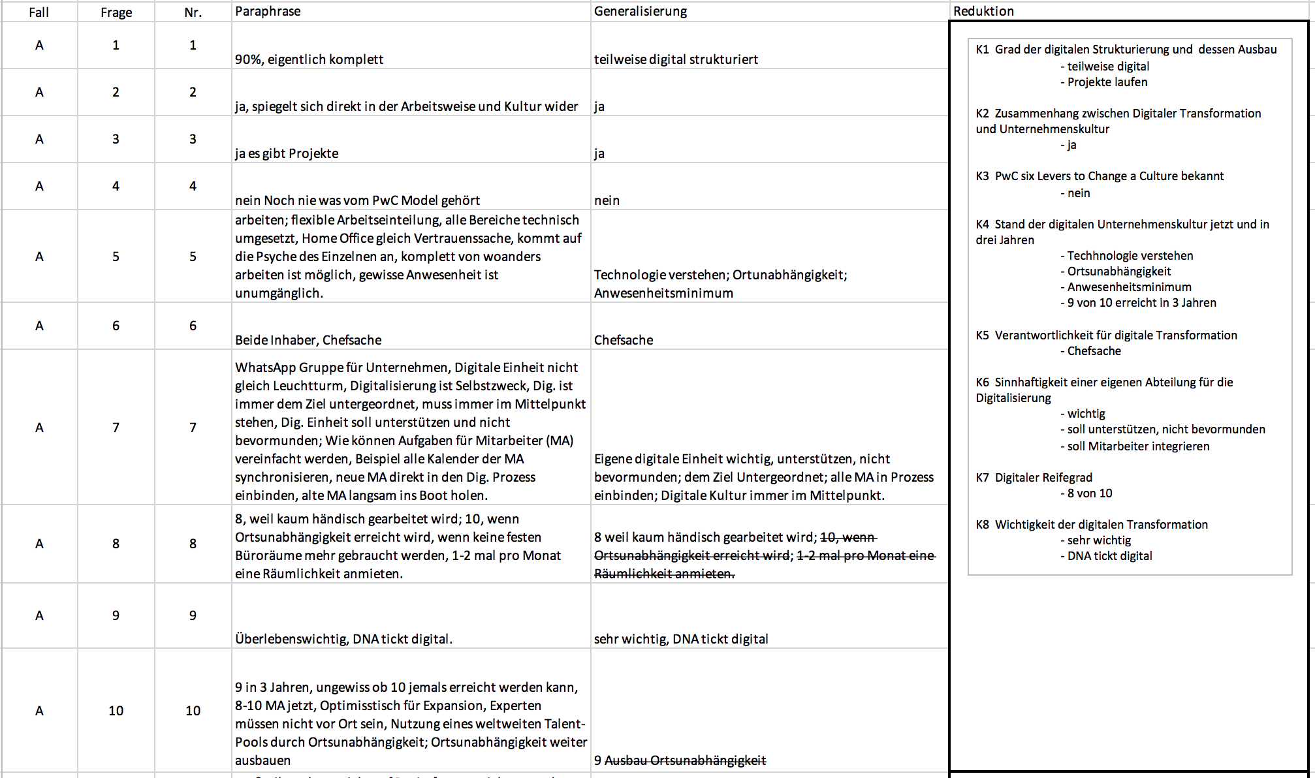
Appendix B Round 1 Summary Case B
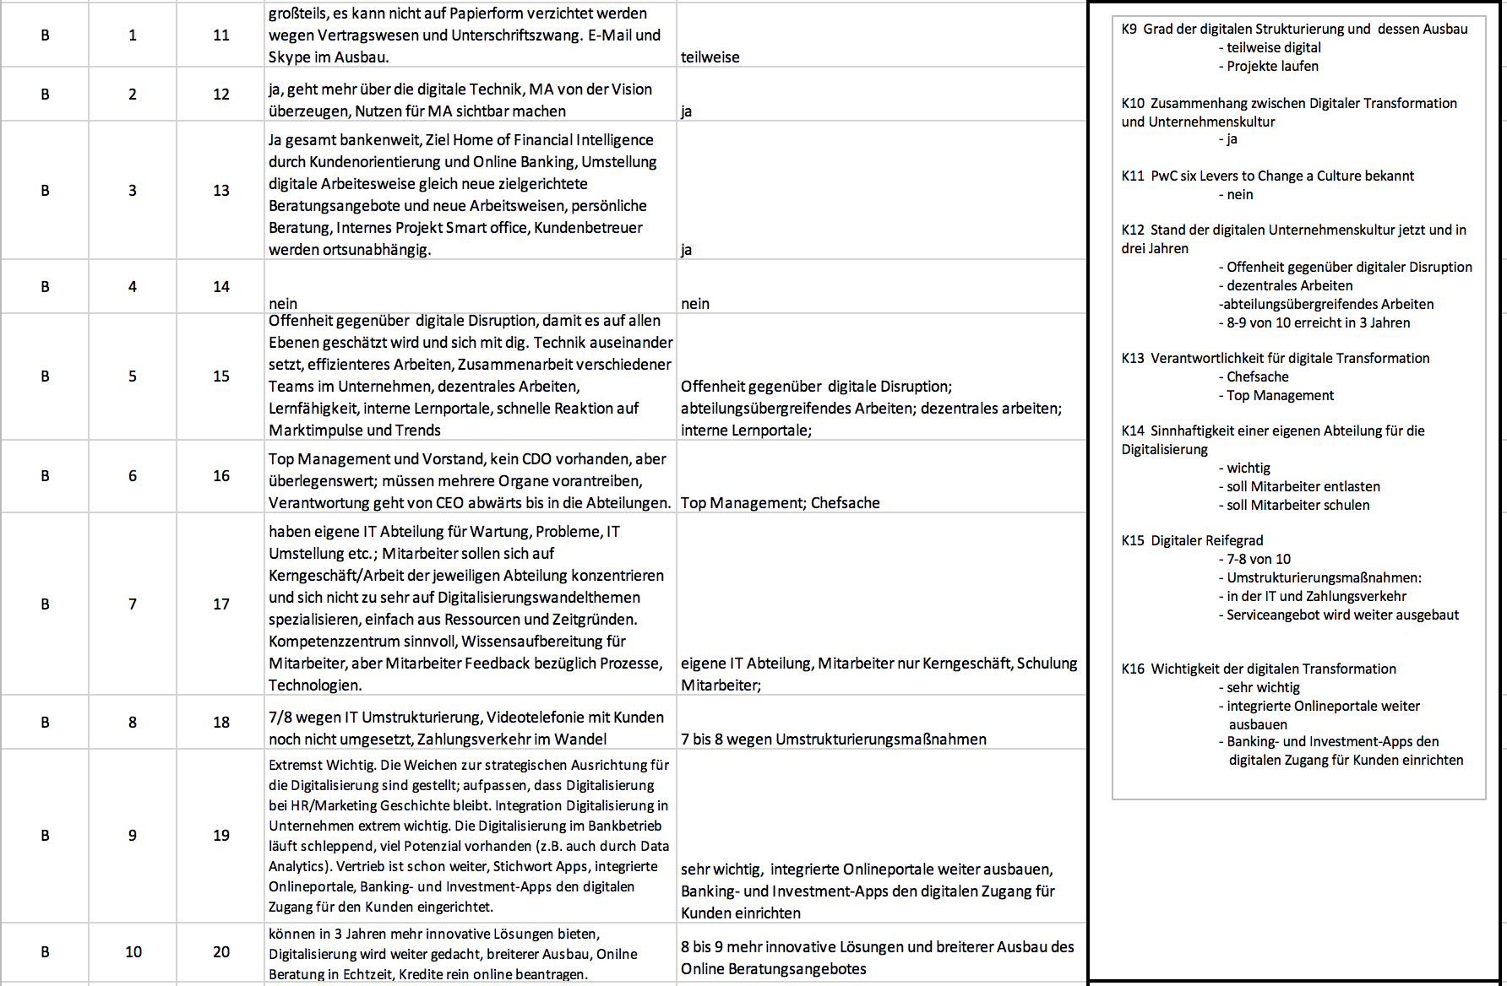

Appendix C Round 1 Summary Case C
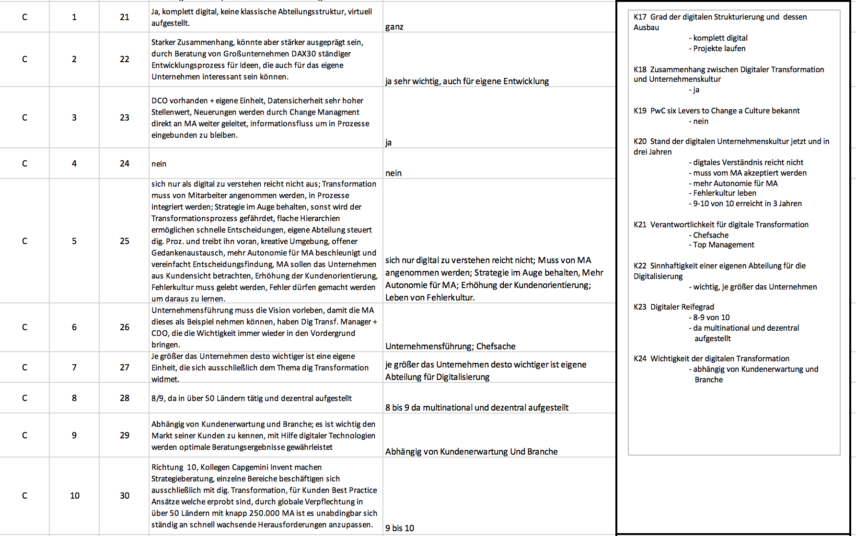
Appendix D Round 1 Summary Case D
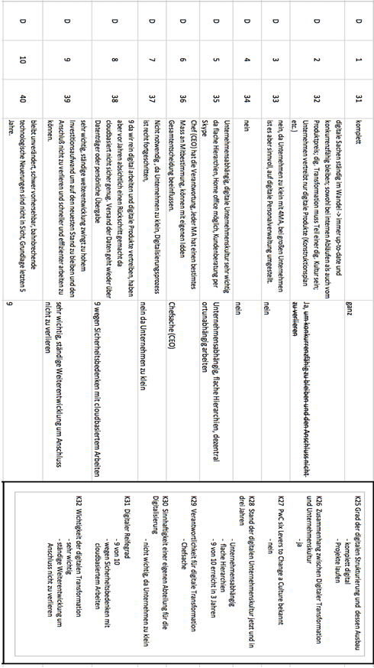
Appendix E Round 1 Summary Case E
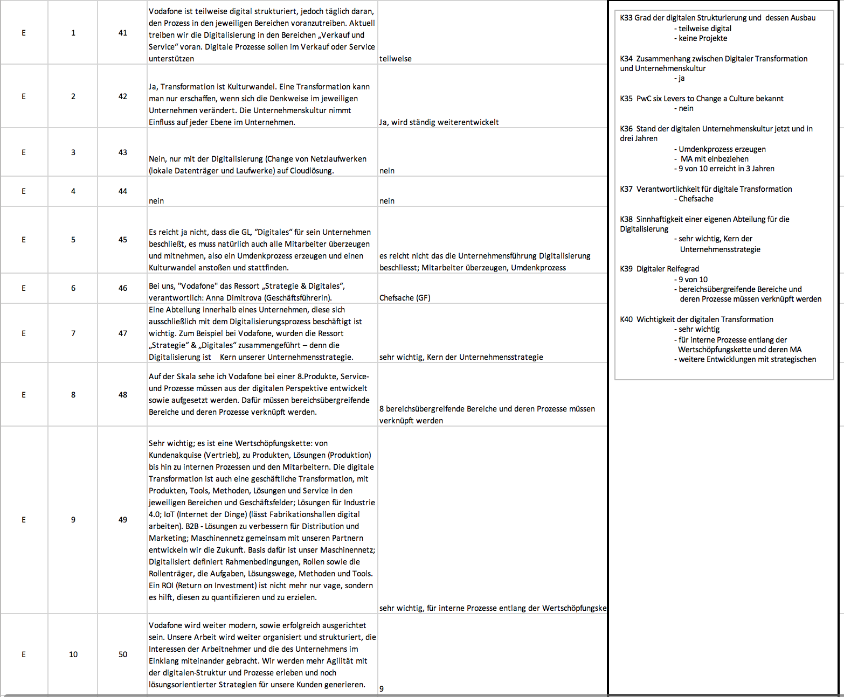
Appendix F Round 1 Summary Case F
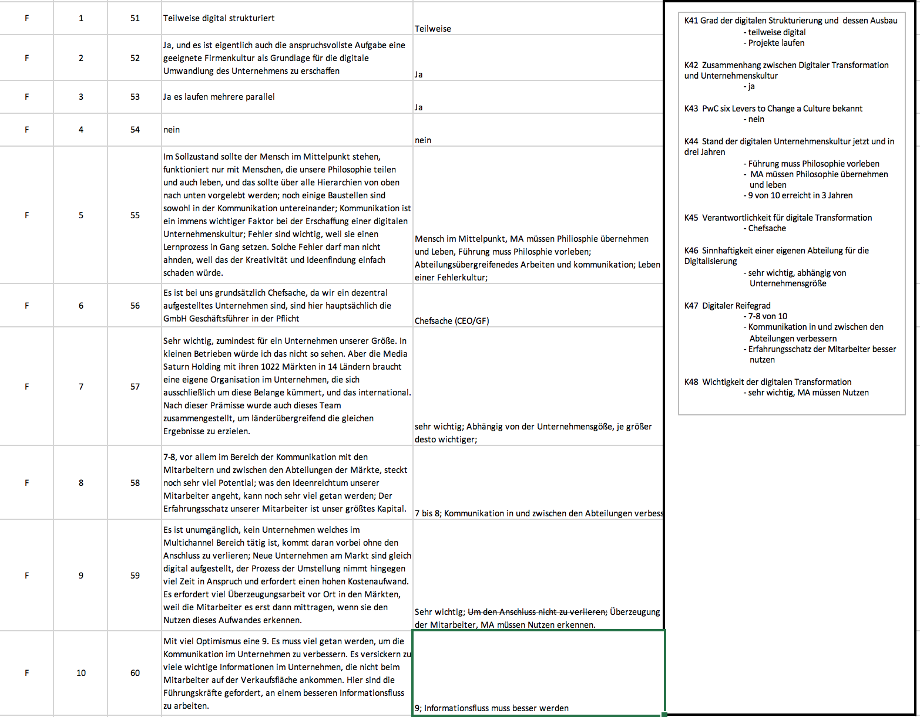
Appendix G Round 2 Summary Case A
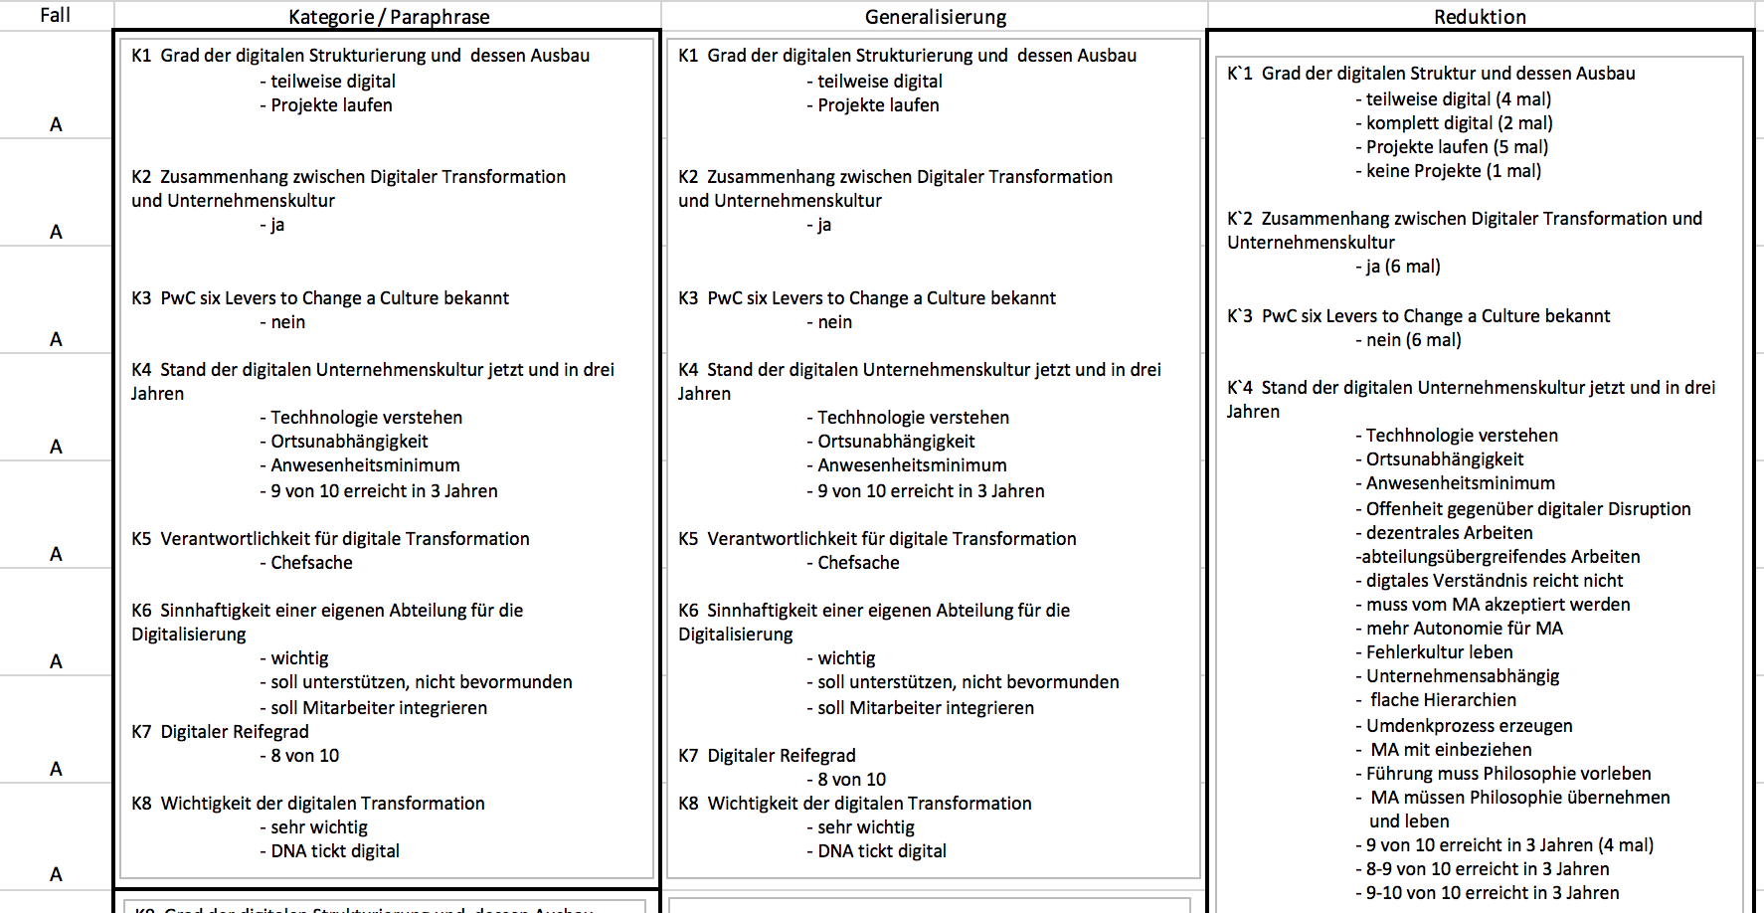
Appendix H Round 2 Summary Case B
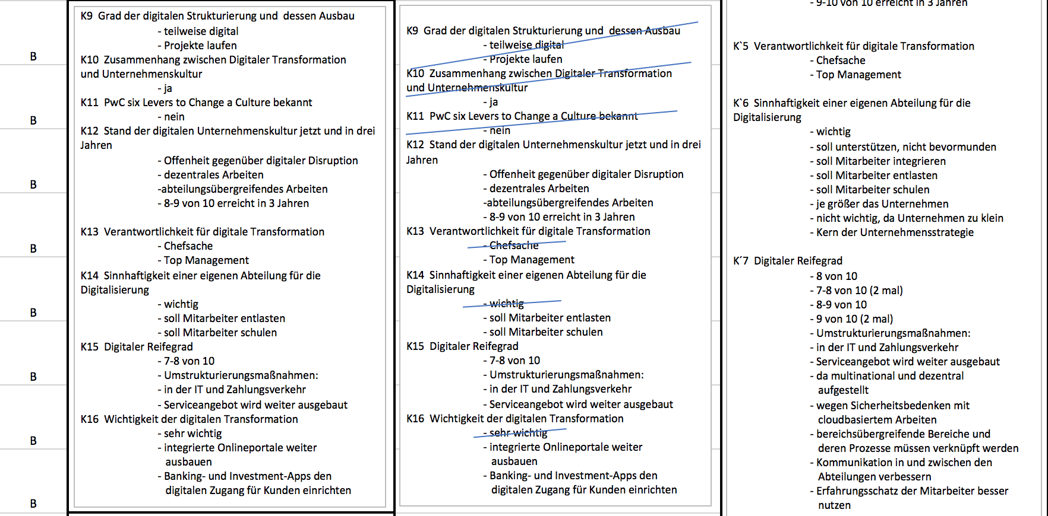
Appendix I Round 2 Summary Case C
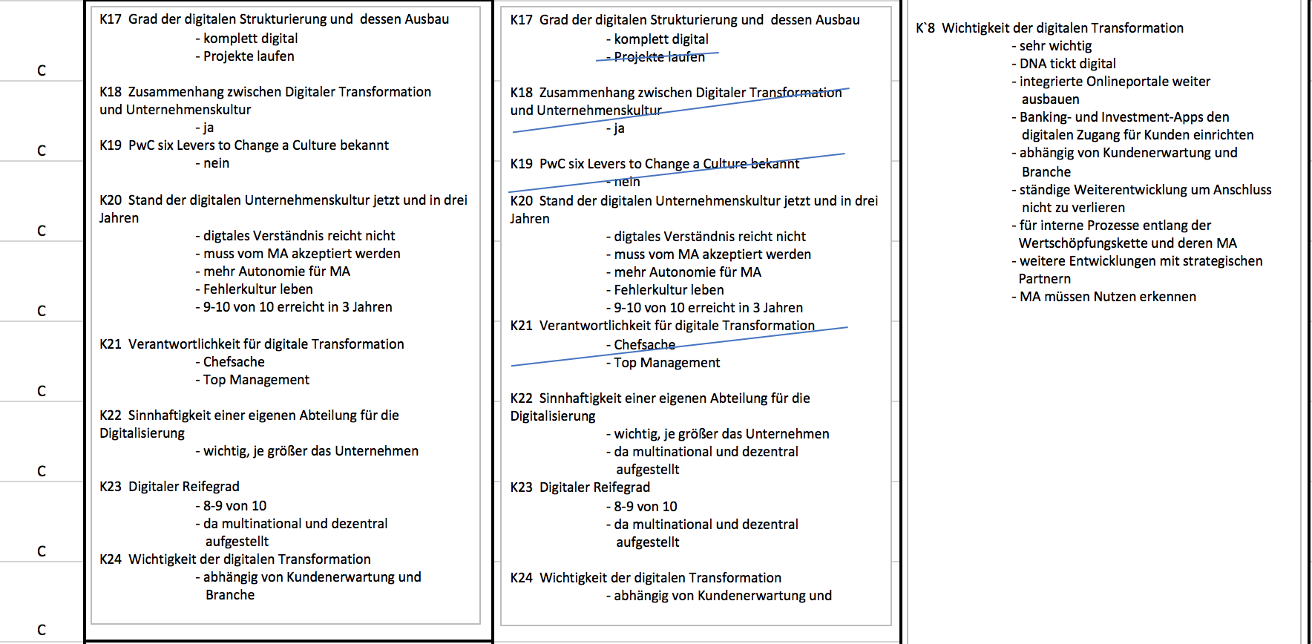
Appendix J Round 2 Summary Case D
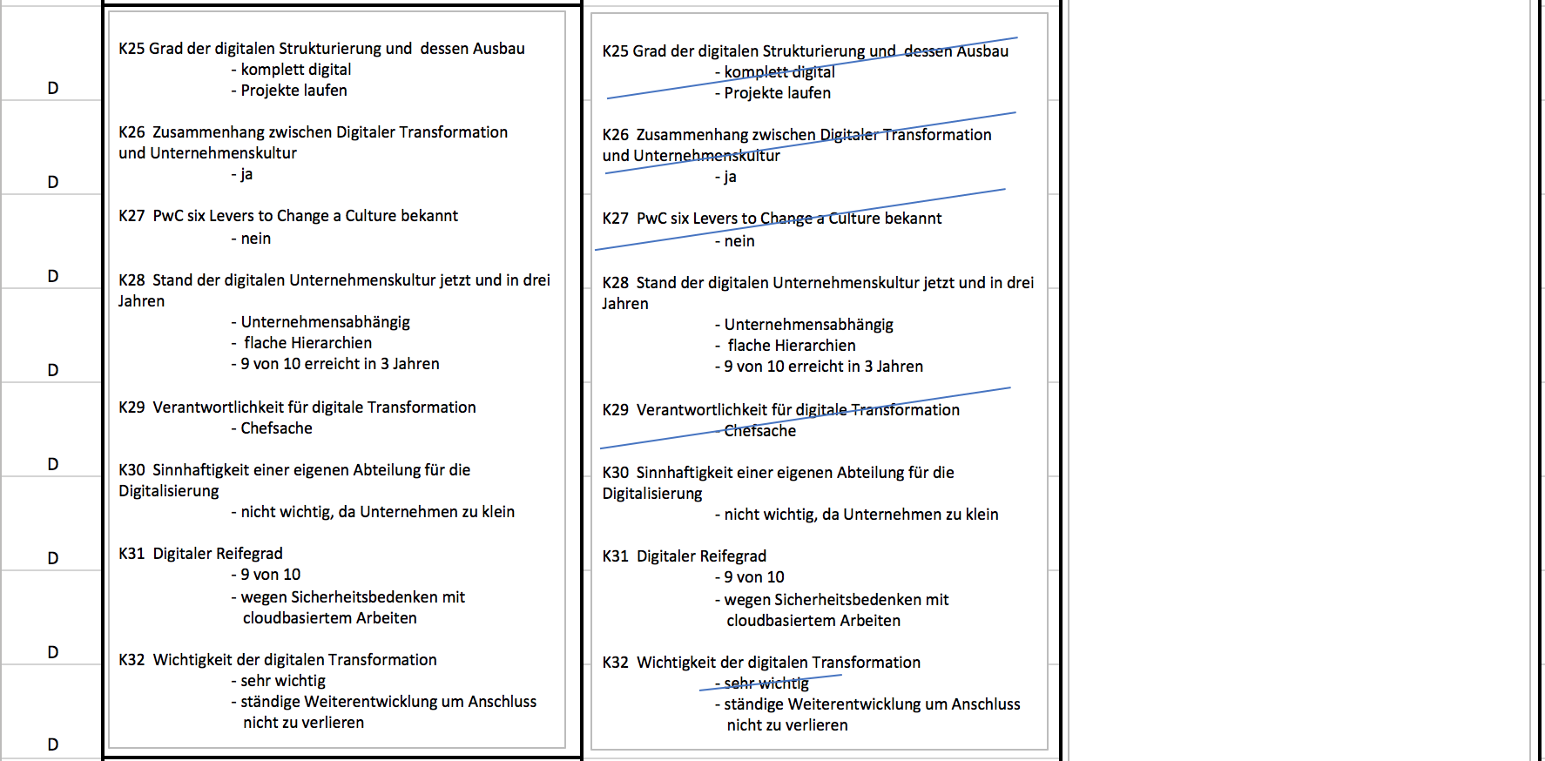
Appendix K Round 2 Summary Case E
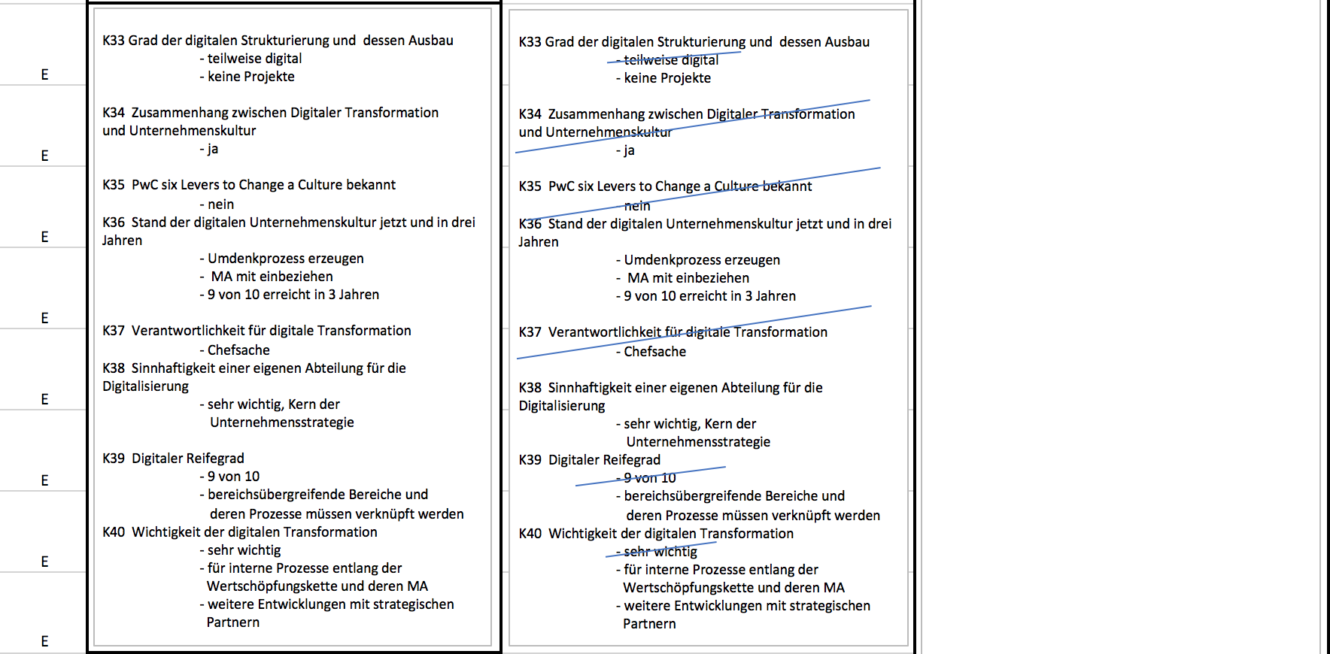
Appendix L Round 2 Summary Case F
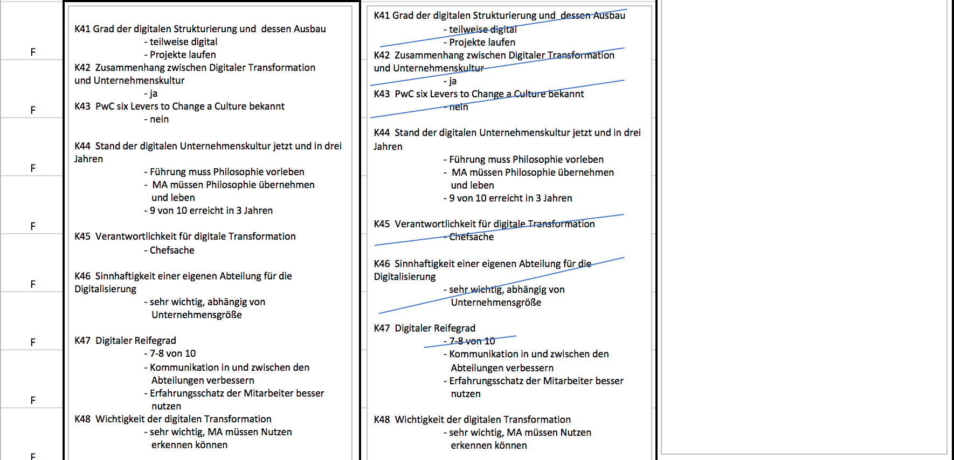
Affidavit
I hereby declare that I have written this paper by myself by referring only to the sources mentioned. All parts that have been cited directly or indirectly from public and private sources have been marked as such.

The work has not been submitted in an identical or a similar form to any other examination authority.

Anh Tuan Le
September 3rd 2021, Dublin

