TITLE OF DISSERTATION

THE EFFECT OF INTERNAL CONTROL SYSTEM IN THE ORGANIZATIONAL PERFORMANCE OF PUBLIC ORGANIZATIONS
“A CASE STUDY OF FEDERAL INLAND REVENUE SERVICE (FIRS), NIGERIA.

Research dissertation presented in partial fulfilment of the requirement for the degree of
MSc in Accounting and Finance Management Griffith College, Dublin
Dissertation Supervisor: Godwin Agbo
Student Name: Nnamdi Emmanuel Osondu
3rd September 2021

Candidate Declaration

I hereby certify that the dissertation titled:

THE EFFECT OF INTERNAL CONTROL SYSTEM IN THE ORGANIZATIONAL PERFORMANCE OF PUBLIC ORGANIZATIONS
“A CASE STUDY OF FEDERAL INLAND REVENUE SERVICE (FIRS), NIGERIA

submitted for the degree of MSc in Accounting and Finance Management is the result of my work and that where reference is made to the work of others, due acknowledgement is given.
Candidate Signature: Nnamdi Emmanuel Osondu
Date: 3rd September 2021
Supervisor Signature:

Dedication

I dedicate this research to the Lord Almighty for his unmerited love and grace over my life and for giving me the strength needed to complete my research. I am very grateful, and I give him the total honor and glory in my research. I also dedicate this research to my parents Barr and Barr. Mrs. Okoro. They were a huge source of inspiration all throughout my research journey.

Acknowledgements
First and foremost, I would like to appreciate my parents Barr and Barr Mrs. Okoro for their unending love and support throughout my journey in Griffith College Dublin. I would have to admit it was not easy sponsoring my masters especially during the pandemic and I must say, I feel really loved by their kind gestures. I am so grateful mum and dad, thank you so much for giving me the platform to achieve my dreams.
Also, I would like to acknowledge my ever supportive and caring siblings who at every stage of my journey always encouraged me. I am blessed to have you all as my siblings and thank you for trusting in my abilities.
Furthermore, I would like to acknowledge my supervisor Godwin Agbo for being very supportive throughout my dissertation journey. I must say, you are truly the best. Thank you so much for the support.
In addition, I would also like to acknowledge all my friends and colleagues, Kunle, Uju, Kalu, Kelvin, Ada, Ozone, Esther white, Esther B, Caramel and Tobi, for their unending support and love towards me. Thank you for always checking my progress in my dissertation. Without mincing words, you all rock. Finally, I would like to appreciate my family and friends, not to mention a few that has constantly supported me in every area of my life. May God bless you all.

Abstract
Internal control mechanism in organizations cannot be overemphasized. This is a result of the fact that it had indeed helped specific organizations in different capacities, especially, in line with ensuring organizations achieve set missions and visions. Public sector in Nigeria is characterized by ineptness and frauds, as often revealed in news. There are five components of internal control and this study focused on one of them, referred to as control activities. This research examined one of the components of internal control (control activities) and the performance of FIRS Nigeria as an organization. Well-structured questionnaire was used to elicit data for this study. The retrieved data was analyzed descriptively and presented in tables and charts. The data revealed that there is a functional internal control mechanism in FIRS; the internal control has been able to help deter fraudulent individuals from exhibiting their tendencies. Conclusively, it was established that internal control has aid organizational performance, premised on the fact that there is ethical disposition of staff members towards their work and increased revenue generation.
Keywords: Internal control, Control activities and organizational performance.

Table of Content pg.

Candidate Declaration II
Dedication III
Acknowledgements IV
Abstract V
List of figures IX
1 Introduction 1
1.1 Overview 1
1.1 Research Purpose 1
1.2 Significance of the study 3
1.3 Research objectives 4
1.4 Research questions 4
1.5 Structure of the Study 4
2. Literature Review 6
2.1 Internal Control System 6
2.2 Component of Internal Control System 8
2.2.1 Control Environment 9
2.2.2 Risk Assessment 10
2.2.3 Control Activities 11
2.2.4 Information and Communication 12
2.2.5 Monitoring 13
2.3 Organizational Performance 14
2.4 Empirical review 17
2.5 Conceptual Framework 19
2.6 Conclusion 22
3 Methodology and Research Design 23
3.1 Overview 23
3.2 Research Philosophy and Approach 23
3.3 Research Strategy 24
3.4 Primary Data Collection 25
3.4.1 Sources 27
3.4.2 Access and Ethical Issues 27
3.5 Approach to Data Analysis 28
3.6 Conclusion 28
4 Presentation and Discussion of the Findings 29
4.1 Overview 29
4.2 Findings 29
4.3 Discussion 48
5 Concluding Thoughts on the Contribution of this research, its limitation and suggestions for further research 54
5 Concluding thoughts on the contribution of this study 54
5.1 Implication of findings for the research 55
5.2 Limitation of the research 56
5.3 Recommendations for future research 56
References 56
Appendices A
Questionnaire 68

LIST OF TABLES AND FIGURES pg.
Figure 4.1 Age of respondents 29
Figure 4.2 Educational qualification of respondents 30
Table 4.1 Functionality of the internal control systems in FIRS 31
Table 4.2 Security measures to ensure staff members comply with internal control 32
Table 4.3 If FIRS do staff performance review 32
Figure 4.4 Staff members activities being duly supervised by FIRS management 33
Figure 4.5 Staff members being happy about FIRS internal control process 34
Table 4.4 Internal control not well funded 34
Table 4.5 Management does not give due attention to internal control 35
Table 4.6 The result is never upheld 36
Table 4.7 Brazen favoritism of some staff members during internal control 37
Table 4.8 Internal control leading to the arrest of fraudulent staff members 38
Table 4.9 successful deterrence to many staff members with fraudulent tendencies 38
Table 4.10 It is easier for organizational management to follow or track organizational progress
39
Table 4.11 It has made it easier to achieve organizational targets 40
Table 4.12 It has compelled several members to stick with organizational ethics 40
Table 4.13 If members abscond from duties during internal control review 41
Figure 4.7 Management staff and other staff members presenting themselves during internal
control review 42
Table 4.14 Access to financial registers of FIRS during internal control review is always
very easy 43
Figure 4.8 Staff members arrive at work in time during internal control review 44
Table 4.15 Revenue generation of FIRS have been consistent for the past years 44
Table 4.16 Service delivery of FIRS to clients have been seamless and impressive 45
Table 4.17 FIRS have world class tax collecting facilities 46
Table 4.18 FIRS have functional feedback mechanism in place that addresses the complaints
and concerns of clients 47
Figure 4.9 Staff members are happy with the welfare package of FIRS 48
Chapter 1
1.0 Introduction
1.1 Overview
The importance of internal control systems in organizations cannot be overstressed. This is premised on the fact that it can ensure smooth running of the organization. The effectiveness of this control measure in public organizations in a third world Country, like Nigeria may sometimes be questionable. This spurs the need for this research. Thus, the study area for this research is Federal Inland Revenue Service here in after referred to as FIRS. The reason being that FIRS is a public organization in Nigeria which happens to be a third world country. A quantitative approach was adopted, as relevant data were collated with the use of questionnaire. The collated were coded and fed into a statistical software for appropriate analysis.
1.2 Research Purpose
Internal control may essentially be described as the lifeline of any business entity that is profit oriented. This is because the chances of any business enterprise either in making profit or being plunged into losses is left to how internal control can be effectively operationalized. Zelie (2021) opined that the template and establishment of efficient internal control system could be referred to as the major criteria that determines that the organization will either fail or succeed. It is established to drive the human resources in an organization to act in such a way that organizational success will be achieved in good and real time. While driving the human resources in the organization, it averts risks as much as possible. It ensures that the staff members of the organizations are conscious of the fact that an intentional system is set in place to check their excesses, especially, in line with financial misappropriation. Tuan (2020) opined that the obvious reduction of organizational risk, fraudulent prevention, enhancement of organizational performance, improvement of efficient and effective organization and adherence to rules and policies established by organizational management are all consequences of internal control. It does a lot in abating risks, before such risks are translated to substantive harm. Control set in place by the personnel in the managerial positions of organizations usually spurs the organization via its environment in the direction of attaining present and future targets (Otley and Soin 2014).
Internal control is established intentionally to ensure organizations activities are checkmated. This is created and operated by the staff members that occupies the managerial and executive positions in an organization. Thus, it is a system that is intentionally replete with pros and cons that would ensure sustenance of productivity in an organization. Mire and Mukhongo (2016) opined that internal control system is packed with policy and activities set aside by the individuals at the managerial department of an organization in supporting management aims, sticking with organizational policy, preserving asset’s integrity, the prevention and unraveling of criminal activities and errors, precision, and completion of account records with timely presentation of economic data with reliability. It is notable that all internal control systems are adopted to drive management’s goals and aims to fruition. On the premise that it blocks financial leakages, it is certain that financial records will be prepared in record time without unnecessary ambiguity and delay.
Henk (2020) opined those persistent scandalous situations and failures evident in a lot of business entities in the World (for instance, Enron, WorldCom, Volkswagen) have revealed that risks and the means of ameliorating it via internal control procedure is not absolutely fixed. It is not doubtable that many organizations have internal control mechanisms that are capable of checking various excesses in the organization, hence, there are various literatures in such regard already, but it is notable that there is paucity of literatures that focuses on the effectiveness of control activities as a component of internal control and performance of public organizations, precisely studying FIRS as a study area. Hence, the purpose of this study is along the path of filling the literature gap that exists in terms of studies on control activities as a component of internal control and organizational performance. Similarly, the purpose of the research is further expatiated on the premise of the research objectives examined for this study. This is because this research objectives are a compilation of the variables for this study.
1.3 Significance of the Study
This research revealed the relationship between internal control and organization performance. Thus, pertinent information was made available in tandem with the degree to which FIRS staff members comply with internal control, the potency of internal control in FIRS and the indicators for organizational performance in FIRS. It is worthy of note that the pitfalls associated with internal control in FIRS was also lucidly outlined. All these information will be needful in helping Government and the management of FIRS make pertinent decisions that will further enhance the productivity of the organization.
1.4 Research Objective
General objective for this study was to examine the internal control and organizational performance of public sector in Nigeria, adopting FIRS as case study.
The precise objectives considered for this study are to.
1) Identify the pitfalls attributable with control system in public sectors of developing countries.
2) Evaluate the potency of the internal control systems put in place by FIRS.
3) Analyze the extent to which FIRS staff members complies to the internal systems that have been put in place.
4) Examine the indicators for organizational performance attributable to FIRS.
1.5 Research Questions
There are four (4) questions that drove this research and they are as follows:
- What are the pitfalls attributable with control system in public sectors of developing countries?
- What is the potency of the internal control system put in place by FIRS?
- What is the extent to which FIRS staff members comply to the internal control system put in place by the organization?
- What are the indicators for organizational performance in FIRS?
1.6 Structure of the study
This thesis has five main sections. The sections are also known as chapters. There is a synergy between each of the sections, hence, no section stands alone. There is synergy between all the sections to ensure that the target of the study is attained without dilly dallying.
The structure of this study is outlined below
Chapter 1 is inclusive of the various subthemes: introduction to the study, the aim and objective of the study, structure of the study. In this first section, a general overview of the study was established.
Chapter 2 is inclusive of the following subthemes: conceptual framework and empirical review. The literature gap that spurred this study was evident from this section.
Chapter 3 is inclusive of the following subthemes: research philosophy and approach, research strategy, collection of primary data and approach to data analysis. The modus operandi of retrieving data from the data and the plans for analyzing such data was captured in this section.
Chapter 4 is inclusive of the following subthemes: Analysis and interpretation and the discussion of the findings. Data will be presented in charts and tables in this section.
Chapter 5 is inclusive of the following subthemes: concluding thoughts on the contribution of this research and recommendations.

Chapter Two
2.0 Literature Review
This chapter consist of profound review of literatures that are only relevant to this study. The subthemes examined for this chapter are essentially the variables drawn from the research title. All in-text citations were adequately referenced.
2.1 Internal Control System
For all organizations, internal control is a mechanism that is very important. It is important such that it is supposed to be factored in and established before the operationalization of organizational activities. If it is set in place before an organization sets out, then it will help prevent a lot of financial crises. Organizational employees will be intimated with the fact that a system is in place to check and monitor their professional activities in the organization. Internal control management is indeed important for effective organizational sequences; hence, it needs the template and establishment of an internal control system (Lakis and Giriunas, 2012). The fact that organizational employees are aware of this system, there is the likelihood they will conduct themselves ethically and appropriately. Similarly, there is a high chance that the employees will exhibit proclivity to be more ethical at work. Thus, there may be concerted efforts from these employees in aiding the organization to achieve set targets. Deshmukh (2004) opined that internal controls essentially ensure balances and checks, also it drives the business entity to move in line with the trajectories of the business entrepreneurs and protection of the business assets. Once, employees are alive to their duties and ethical about it, there should be growth in the organization and a consequent protection of the organizational facilities. Protected organizational facility is inclusive of the ethical conducts expected of employees in an organization. This is because aside ethical conducts, internal control also measures the functionality and existence of organizational assets.
Internal control is not a new concept for organizations. According to Younas and Kassim (2019), internal control is linked with time immemorial till the beginning of the 20th century in the United States of America when there was epoch of auditing receipts and documents. Thereafter, internal control got more attention in various Global geographical spread premised on the fact that it is germane for business entities in the World. Internal control can basically be explained as the system created by business entities, such that on a periodic basis financial receipts and invoices are assessed, likewise, it ensures employees are reminded to purport and conduct themselves in line with the ethical expectation of such organization. It could be defined as being a system of procedure, assignments, duties, likewise, persons that are intentionally fused or consciously dismembered so as to ensure that the aim of the organization is achieved (Lawson, Muriel and Sanders, 2017).
It gives room for pertinent evaluation in the section of the organization that has to do with finances. Thus, it has the capacity to check unnecessary tendencies of person(s) to basically manage the financial dealings of a business entity for a considerable time. If the main right to manage the finances of a business enterprise is in the capacity of a person(s) for a long time, there is a tendency that such person(s) may display his or her fraudulent nature. It is notable that internal control system compels such person(s) to pertinent assessment periodically. Applying internal control measure to organizations is germane so as to ensure appropriate accountability and good usage of existing financial resources. Akinleye and Kolawole (2020) noted that a solid form of internal controls is hence necessary in effectively managing existing funds in higher citadel of learning. On the basis that employees are assessed on a periodic basis, it is implied that there is substantive percentage that a lot of employees purport themselves in a respectable manner, run away from fraud, likewise, aid business entities in achieving their goal and target. It is, therefore, notable that when staff members portray themselves ethically and in good light, investors investments in an organization will be in safe hands, thus, earning such organization better integrity and name. Effectiveness in terms of internal control systems guarantees that stakeholder’s investments are safe (Mahmood et al., 2020).
In a bid to corroborate the above, a few definitions of internal control follows; Internal control is a sequence set in place by an organization’s management, board and sundry experts, just to make available logical validation with respect to the attainment of organizational goal that connects with operative reports and compliance (Dănescu and Dogar, 2012). Onuorah and Appah, (2012) in the report of the Nigerian Institute of Certified Public Accountants issued defined internal controls as activities which results into maximal outcome for business enterprises. Lawson, Muriel, and Sanders, (2017) opined that internal control is a compound of process, function, activities, mini-systems, and individuals that are consciously brought together or individualized. International Federation of Accountants (IFA) (2012) noted that internal control can be defined as an important phase of an organization’s mode of governance and capacity in managing risk, and essential to support the success of a business entity’s targets and creation, enhancement, and protection of shareholders worth. Considering the various definitions, it is obvious that they align, vis-à-vis guaranteeing that business enterprises funds will be judiciously utilized to ascertain value for money.
2.2 Components of Internal Control.
Based on the previous literatures that have been reviewed, it is evident that there are five (5) components attributable with internal control. These five components are control environment, risk assessment, control activities, information and communication and monitoring activities. Alslihat et al., (2018) opined that internal control structure premised on COSO model are Control Environment, Risk Assessment, Control activities, Information and Communication Information and Monitoring (Alslihat et al., 2018).
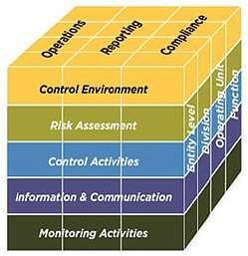
Source: www.coso.org
2.2.1 Control Environment
Environmental condition offers sustainability to business enterprises. Hostility in relations to an environment implies that there are possibilities that it may stifle the business entity. Control environment could simply be defined in terms of a compound that either houses or accommodates the remaining components of internal control. Control environment is essentially the umbrella that captures other components of internal control (Alslihat et al., 2018). It is notable that Tsay and Turpen (2011) opine that ab initio is necessary to establish a strong control environment, however, it is a herculean duty because it requires variation of official modus operandi that exists in the business, from the section of operations to the executive cadres, in a bid to ensure that managers and staff members have the similar character. Meanwhile, the environment in this situation is essentially established by the organizational management. Thus, it is managed and maintained by the management. Deshmukh (2004) opined that control environment implies characters of the organizational management in terms of control. Therefore, it is the organizational management that creates control environment, and they are capable of either making it hostile or very accommodating to work in.
2.2.2 Risk Assessment
It basically focuses on identifying, managing, reducing, or deleting risks. Risks are associated with all business enterprises; hence, it is better it is quickly identified and nipped in the bud. Fourie and Ackermann (2013) opined that the individuals in the managerial section of a business enterprise must evaluate all risks, intrinsic and extrinsic which can further imply that targets of the business enterprise may not be attained. The risks to be evaluated must be holistic. There are specific steps that are connected with risk assessment and analysis. Deshmukh (2004) noted the steps that are connected to analysis of risks are as follow:
- Threat identification phases of finances, operations, and strategy
- Estimation of risks associated with each of the threat
- Worth of loss as a result of the risk, which implies higher chances of risk occurrence multiplied by possible loss
- Risk management through the design of necessary controls
- It must be ensured that all controls are subjected to cost/benefit analysis
The above steps will guide the organization in itemizing risks and managing the risks in such a way that it will have nil effect on the organization.
2.2.3 Control Activities
Control activities precisely are operationalized to check risks associated with organizations. It helps to control these risks in such that they are substantively ameliorated and expunged as much as possible. According to Janvrin et al., (2012) procedures connected with control activities are stated below.
(i) Business enterprises should create and select control procedures that could contribute to the amelioration of risk and foster substantive achievement of organizational target. Organizational aim can be achieved via allocation of duties, evaluation of the degree of exploration of activities and so on.
(ii) Business enterprise should select and grow general control activities instead of advancement of technology that could support achievement of organizational targets. This can be realized as a result of the initiation of germane know-how in terms of technology, development, and managing of procedures of control activities, initiation of germane template for technology and so on.
(iii) Distribution of control procedures which are obvious in the regulation, likewise, further establish procedures that will affect created laws. The achievement can be ascertained through the revalidation of laws and methods, corrective modes and so on.
All aspect of a business enterprise should adopt control activities, so that it will be certain that frauds are abated, and employees of the organization are always ethically conscious. Control activities ensures that other components of internal control are set in motion to achieve organizational goal. Deshmukh (2004) opined that control activities are policies and process which gives assurance that the organizational management’s instructions are executed. Eke (2018) opined that control activities are continual activities that are being engaged by staff members in a bid to ensure correct operational execution, likewise, precisely designed in supporting accurate, whole, and dependable financial transaction processing. They are activities that make the daily management of the organization seamless. They also that ensure that staff members portray themselves ethically and represent the organization in good conduct both in the organizational environment and outside of the organizational environment.
2.2.4 Information and Communication
It must be ensured that there must not be any form of communication gap in the organization. Information is vital for the development of an organization and must not be hindered at any time. Channels hindering information flow must be blocked as much as possible. There is a distinct unit of internal control that facilitates the retrieval of parallel and vertical data, and obtained data are shared amongst employee of the organization (Umar and Dikko, 2018). This component ensures that germane information for the advancement of the organization is well shared and distributed amongst staff members of the organization. Eke (2018) opined that Information and communication system is that unit of internal control that avails the organization the opportunity to get important information and pass it on to individuals of interest. Similarly, it ensures that important information is being passed on from the organization to the organizational clients and business partners in record time without any ado. Al-Sady et al., (2021) opined that employee exchange pertinent data to most senior colleagues and ensure that transparent communications with outside organized units. This component of information system makes sure that information is being appropriately passed along the direction that the organization deem fit at a particular point in time. There is no haphazard distribution of information in this regard. With good information channel in the organization, the chances that the organization proceeds in the right direction is high. The prospect that information system of the organization’s management and subsection is better integrated is high (Hayali et. al., 2013).
2.2.5 Monitoring
There is no point creating a mechanism that is devoid of significant monitoring which may obviously show whether the mechanism functions adequately or the other way round. The Main target of the monitoring section of internal control is to assess and evaluate the efficiency of the mechanism over a specific duration continually qualitatively. Al-Sady et al., (2021) noted that this component connects to how organization evaluates or assesses efficiency of internal control in achieving the expected degree of internal control that will also decipher the chances of changing it in tandem with whatever variation occurs. So as to keep the competitive energy in a rapidly growing environment of an organization, a solid monitoring system for the business entity and management were engaged (Kang et al., 2011). Eke (2018) noted that monitoring is essentially process-driven such that internal control’s quality and effectiveness are being measured. This component makes it easy to quickly decipher if anything is wrong with the internal control system or not. The organization will be able to decipher if the internal control mechanism has so far achieved its set targets or otherwise. An article by American Institute of Certified Public Accountants (AICPA) (2014) revealed that monitoring activities for internal control should entail the following.
- Does the control exist in the appropriate condition and is it operational? There is no point creating policies and procedures if there is no proper implementation.
- Is internal control mechanism functioning in line with the established plan? Irrespective of the extent of the importance of formal system, it is not certain that the policies and procedures will be really adopted. Staff members of the organization might take advantage of pertinent sequence while working on their various tasks as soon as possible, or in plain terms may be oblivious of the existence of these procedures.
- Is there prompt response in regard to proffering solution to pointed out problems? Monitoring can only be assumed to attain effectiveness when its outcome is passed down to the necessary quarters and pertinent steps are taken
- Is there periodic review of controls? Organizational employees’ turnover, plan mergers and various changes requires that controls is oftentimes subjected to review so as to be assured of continual effectiveness.
When monitoring component of internal control is executed in line with the above, then there is high prospect that the monitoring activities will achieve set goals and in the same vein it will facilitate the internal control to be effective as much as possible.
It is in tandem with the afore-explained background that it is germane to ensure the components of internal control keeps functioning, so as to ensure organizational sustainability. Meanwhile, for this research control activities will be examined vis-à-vis performance of organizations.
2.3 Organizational Performance
Organizational performance shows the clear direction at which an organization is headed. This is because an organization may be headed towards the target of increased production and enhanced income, similarly an organization may maintain its direction towards the trajectory of failure. Eke (2018) noted that performance may be examined vis-à-vis a compound trajectory of the extent at which a business entity achieves it aims. It is largely a predictor to measure the extent to which the organizational goals are achieved. Thus, there are various yardsticks that are used to determine the concept of organizational performance. The capacity of a business entity to attain set targets and aim is referred to as organizational performance (Callahan and Soileau, 2017). The aim involved for an organization to explore its facilities appropriately in such a way that set targets are achieved can be referred to as organizational performance. For an organization to be sustainable the performance of such organization must be well factored. It is an essential predictor for evaluating successes attained in a business entity. Tamunomiebi and Chika-Anyanwu (2020) noted “performance of a business entity over a period has been considered with different trajectories that corroborates the success of such business entity”. Performance of a business entity is a product of the methods and procedures engaged in the business enterprise. This can be referred to because of the ability of a business entity in having a deep reflection, to use efficient standard methods in establishing attained targets (Randeree and Al Youha, 2009). The set modus operandi aids the business entity in attaining set targets. Janepuengporn and Ussahawanitchakit, (2011) opined that the concept of organizational performance is premised on the degree to which organizations achieve their planned targets.
It is worthy of note that business enterprises are established to spawn income alongside meeting customers’ demands. On this basis, the main parameter to evaluate organization’s performance is premised on the spawned profit by the precise business entity, likewise, the efficiency of such business entity with prompt service delivery. Apparently, there may be other predictors in evaluating the performance of business entity, meanwhile, it is a fact that they all focus on driving the organization to generate more revenue. Organizational performance is usually operationalized through financial indicators (e.g., profits) or non-financial indicators (e.g., satisfying customers and standardized product) (Tamunomiebi and Chika-Anyanwu, 2020).
Conțu (2020) noted that attaining organizational performance is premised on three conditions, that are stated below:
- Efficient economy: All business enterprises plan to attain their targets using minimum inputs.
- Clients’ satisfaction: Achievement of greater outcome using minimal input, through a means that surpasses client’s anticipation.
- Staff members satisfaction: Efficiency attributable to management of the organization is dependent upon the management’s capacity in driving the staff members appropriately and meeting the needs of the staff members.
In the light of the above considered factors, a business enterprise achieving a lot with little input is an indicator for organizational performance. In the same vein, various feedbacks from clients, denoting that they are satisfied from the service rendered to them by the organization, significantly determines organizational performance. Similarly, the welfare provision of the organization meeting the daily needs of the staff members denotes performance. This is because, there is chances that the staff members perform better on their jobs, once they are sure that the welfare package of the organization is capable of paying their bills and meeting their needs. Thus, it is predictable that the staff members will be happy. The capacity to make staff members generally happy resides with the leadership cum management of the organization. Performance of a business enterprise is dependent majorly on the expertise exhibited by the management of such enterprises in relations to the implementation of plan of action (Almatrooshi, Singh and Farouk, 2016). When the staff members are not availed with good welfare package that could make them happy and channel good energy to their jobs, then those employees may not operationalize other resources adequately to endear the sustenance of the organization. Armie and Orosanye (2020) opined that essentially, staff members engage sundry resources like technological facilities, money, data, and sundry paraphernalia to attain business entities targets and aim.
With respect to organizational performance Folan (2007) outlines three conditions that determine organizational performance:
- Analysis of performance should be based on separate individuals premised on the environment where the business is being operationalized. An instance is when a business entity’s performance must be broken down on the basis of the markets where they domicile.
- Organizational performance is usually connected with a singular or various goals established by the individual that performance is operationalized for. Hence, the business entity’s performance is evaluated in line with the intrinsically created goals instead of the extrinsic created goals.
- There is significant reduction of performance to the pertinent and acceptable standard.
From the above, it could be deduced that in measuring performance of an organization, it’s better to assess each staff member and evaluate their performance, then a summation of all their performances is capable of giving an insight into the overall performance of the organization.
2.4 Empirical Review
This section assesses the existing empirical studies on internal control. Internal control certainly exhibits a germane responsibility in assisting management and audit committee members through the quarterly reports and provision of experts advise regulatory issues such as timely tax filing to avoid penalty payments. It is the internal control system that gives reasonable assurance to the elected assembly members that management of the assembly are complying with relevant laws and standards.
Lu et al., (2020) mentioned that internal control operations are “social structured, context inclined condition, that exhibit capability of filling variant responsibilities”. This was further supported by Flint (Abiola and Oyewole, 2013) who declares: The function has evolved in response to a perceived need of individuals or groups in society who seek information or reassurance”. Indeed, internal control plays variety of roles which end up benefiting society at large. For instance, it is mandatory for FIRS to use not less than 20% of their Internally Generated Funds (IGF) for physical projects such as schools, hospitals/ community clinics to encourage the citizens to pay their property tax with ease. Public sector internal control system, in appraising the performance of their respective FIRS are to check for such projects, verify their physical existence and report on them. If all internal control system in the FIRS is able to conduct this audit annually and report accurately to the appropriate authorities, many of the basic amenities would have been provided by these assemblies. Alawaqleh (2021) examined the effect of internal control on employee performance of Small and Medium-Sized Enterprises in Jordan: the role of accounting information system. Questionnaires were used to elicit data for this study. Two hundred and three questionnaires were used for the analysis of this study. The retrieved data were analyzed with the aid of AMOS and SPSS. The study revealed that internal control exuded a significant positive relationship with staff members performance and a relationship with AIS. Henk (2020) examined internal control via the perspective of institutional work using a systematic literature review. The study is basically qualitative as only literatures were reviewed, and inferences were made from the reviewed literatures. The study revealed that the perception of internal control is presently categorized into a section of the literature reveals precedence for internal control over reports of finances and the second category considers internal control from a globally and strategically placed perspective. Fourie and Ackerman (2013) examined the impact of COSO control components on internal control effectiveness: an internal audit perspective. Data was retrieved with the aid of questionnaire. The study revealed that internal auditors opined that control components as outlined in the COSO framework for ‘risk assessment’, ‘information and communication’, ‘control activities and ‘monitoring’ components of internal control, do contribute to an effective internal control system.
It, therefore, means that doing things right is paramount in the performance of the value addition roles of internal control system. This is because internal control units would be a journey of futility if internal control renders services efficiently and or economically but are ineffective. For instance, if internal control activities can be carried out in the FIRS neatly and at the barest minimum cost but without and significant recommendations to Audit Committee (AC) for onward implementation that can improve on the service delivery goals of the Assembly, then such activity is in futility. Internal control system can be able to provide assurance services well if they are able to harness and improve upon their IT potential knowing very well that businesses are being driven by advance information technology.

2.5 Conceptual Framework
The reiteration that internal control is germane to the success of a business entity. On the premise of the fact that control activities are one of the components of internal control, the conceptual frame for this research hovers around two variables and they are internal control activities and business entity’s performance. Control activities helps to depict the current phase of an organization, with respect to frauds and thus, either abate such fraud or inhibit it in the future. The importance of internal control comparatively ensures the proper value of the present condition vis-à-vis a widely acknowledge foundation for comparison that might include responsibilities, regulations, or guides (Dimitrijevic et al., 2015). The Crux of the matter is that when measured, internal control must be effective as much as possible. Ramdany et al., (2017) opined that it is notable that effectiveness in terms of internal control essentially result into rational assurance vis-à-vis efficient and effective operations, dependable report of finances, adherence to obtainable rules. In a bid to ensure that internal control measure in an organization is a success, there are specific activities that must be engaged. Such activities are better understood and operationalized by the experts into internal control in an organization. Control activities are established in a bid to decipher risk tendencies that may push the business entities in financial mishaps. In specific situations control factors are systems for prevention of various misappropriation to ensure that the business entity do not fall into fraudulent traps of unscrupulous employees. Dimitrijevic et al., (2015) further opined that it is apparent that impacts are higher when a functional internal control system and management activities are created in reducing chances of financial misconduct. As soon as these control activities either prevents business entities from being a victim of scandalous frauds or the detection of fraudulent activities and dealt with without delay, then, the prospect of increased efficiency and success of the business entity is high.
Organizational performance is usually dependent on the profit accrued by the organization and the extent at which an organization can meet the expectations of clients. The primary goals of organizations are to make profit, save the non-profit oriented organizations. There are various indices that are capable of ultimately propelling an organization to perform well. Amongst these indices are control activities. Hence, in a typical organization there should be a relationship between internal control, precisely control activities and the performance of such organization. This forms the conceptual bedrock for this study, as evident in figure 1 below, especially considering the fact that internal control and organizational performances are both variables for this study. The result from the analysis for this study will help in drawing better inference vis-à-vis chemistry that exists between these control activities as a variable and the performance of business entities as another variable.

Figure 1: Conceptual Framework
The fact that a functional and effective internal control eventually contributes significantly to the growth and success of an organization is indeed pertinent to consider. Henk (2020) opined that there is a general knowledge about the prospective consequence of an efficiently managed internal control. This has further established a lucid synergy between control activities as a variable and the performance of organization as another pertinent variable.
Meanwhile, the supposed relationship between the above-named variables can only be deciphered by first examining the likely indicators for each of these variables, as evident in figure 2 below. Set control activities in an organization must exhibit functionality to a very good extent before it could aid in achieving organizational set goals and targets. Similarly, the indicators for organizational performance are in line with revenue generation in FIRS, FIRS ability deliver services promptly as much as possible, impressive infrastructures, and staff members happiness.

Revenue generation, service delivery, operational facilities, staff happiness and so on
Potency cum functionality of control activities

Figure 2: Conceptual Framework with method of data retrieval.
2.6 Conclusion
It is evident from this chapter that sundry reviewed literatures have brought the gap in literature to the fore, thereby, further establishing the purpose cum necessity for this research. The literatures reveal gross importance of internal control mechanism in organism. It also reveals how some of the components of internal control system have been operationalized, but it never revealed how control activities as a component of internal control have been precisely operationalized against organizational performance in FIRS.
3. Methodology and Research Design
3.1 Overview
This chapter reveals the philosophical background to this study. In the same vein the means of collating relevant information and the modus operandi of analyzing such information appropriately is captured in this chapter.
3.2 Research Philosophy and Approach
For this phase, strategic philosophy that this research anchors on were investigated into. It is common knowledge that philosophy is the mother of other academic areas. Therefore, it is gain saying when the philosophical trajectory of the study is mentioned. Philosophy gives room for germane research-based questions capable of profoundly establishing academic narratives. The hypothetical questions are basically consequences of profound reflections. Profound reflections are constructively thought because of depth of scholar(s). The scholarly profoundness of an individual ensures that research from such scholars relates to constructs of philosophy. It is notable that in research there are various assumptions, and the assumptions usually escalate into research problems that drive research. Research philosophy is explained as the growth of assumptions, depth, and practice in research (Sanders, Lewis, and Thornhill, 2007).
Basically, there exists two broad trajectories to philosophy, and they are ontology and epistemology. The science of knowledge is referred to as epistemology. Worthy of note, is it that depth in knowledge is needed for internal control systems and standard efficiency of the business entity. Hence, epistemology is engaged for this research, because of academic depth solely leading to pertinent questions which can aid the attainment of set targets for this study.
Outside of the purview of epistemology and ontology, there exists four research philosophies, as evident from different literatures reviewed. Žukauskas, Vveinhardt and Andriukaitienėthe (2018) opined that there are four research philosophies, and they are positivist research philosophy, interpretivist research philosophy, pragmatist research philosophy, and realistic research philosophy. Each of these research philosophies have their importance. Positivist research philosophy engage research based on objectivity. Interpretivist philosophies engage research based on subjectivity. Pragmatist research philosophy engage research from a practical perspective. Realist research philosophy engages research based on the fusion between positivist and interpretivist trajectory. A lot of past studies by different authors have adopted pragmatist approach usually on the premise that it gives room for flexibility, vis-à-vis the researcher’s choice of appropriate research method to adopt. Žukauskas, Vveinhardt and Andriukaitienėthe (2018) opine that the researchers have freedom in selecting the modus operandi, tools and means that is most appropriate in achieving the set research target. It is, however, worthy of note that this pragmatist philosophy does not really morph into pragmatism in the field of philosophy. Alghamdi and Li (2013) opined that pragmatism philosophy never fits into any philosophical make-up and actuality. However, this study adopts positivist paradigm on the premise that it focuses on just a type of research method (quantitative). Kivunja and Kuyini (2017) opined that research captured in this philosophical basis is dependent on deductive logic, construction and test of hypothesis, functional defining concepts and statistical models and statements that could help achieve the aim of the study.

3.3 Research Strategy
Research can be broadly categorized on qualitative and quantitative basis. Qualitative research adopts qualitative means of eliciting and analyzing data. In the same vein quantitative research adopts quantitative means of eliciting and analyzing data. Chege and Otieno (2020) opined that quantitative strategy are usually engaged to analyze response, in a bid to evaluate substantive outcome for the study. Quantitative technique of research gives room for measuring variables and checking the relationship between them. Meanwhile, the mode of eliciting data for quantitative research especially considering the survey research design revolves around the usage of questionnaires and the data retrieved with questionnaires are analyzed statistically. It is notable that for this study quantitative research method was adopted. Questionnaire was used in eliciting appropriate data. Thus, this research instrument (questionnaire) was distributed to staff members of FIRS that availed the researcher with appropriate information.
3.4 Collection of data
For quantitative studies, the main mode of data collection revolves around the usage of questionnaire. Questionnaires capture each objective of the study. Questionnaires drafted out of the scope of research questions cum research objectives will not elicit data necessary to achieve the aim of the study. This mode of data collection is preferable for this study because it will help in eliciting data that could be measured descriptively. Thus, it will make it easy to deduce the number of occurrences of each indicator. Likewise, it makes it easy for respondents to quickly attend to the research instruments sent to them at their latest convenience. Thus, it is a flexible data collection approach that avails the researcher the opportunity to send out research instruments at his/her convenience and avail the respondents to work with his/her time. This is indeed very important especially considering the fact that the pandemic has reduced physical contacts between people.
3.4.1 Sources
The data for this study were collected directly from the field with the use of the appropriate research instrument. Since, the basic study area for this research was FIRS, the data were collected from members of staff in FIRS. It was ensured that members of staff that are educated enough to understand the nub of the research and that can avail the researcher with germane information were administered the research instrument unto.
3.4.2 Access and ethical issues
The ethical guidelines followed in conducting the research are outlined below:
- The research was conducted in adherence with all the necessary regulations of the University’s ethical requirements concerning research work.
- Also, the data was obtained from the respondents(employees) willingly; that is, respondents were given the opportunity to agree to participate or not participate.
- The respondents were also informed that they could withdraw anytime during the interview or even before the interview. They were also informed that they could refuse to answer certain questions if they did not want to.
- Respondents were duly updated about aim of the research and that the study is purely academic exercise.
In the light of the above, all the set guidelines were strictly adhered to. All respondents consciously and intentionally filled out the questionnaire. Hence, none of the respondents was at any point in time coerced or unnecessarily induced to fill the questionnaire against his or her will.
3.5 Approach to data analysis
This research is basically quantitative in nature. In tandem with survey research type, usually questionnaire is used to elicit quantitative primary data from the field. Quantitative approach helps to quantify responses of respondents by ascribing numerical values to these responses. These numerical values can be used to either rate or rank the responses. Essentially, the research objectives set for this study can only be justified through this research approach. Hence, it is certain that necessary answers to the research questions shall be made available consequent upon this research approach. In the same vein, this approach meets the ethical standard of Griffith College. It makes it easy to obtain consent of the respondents. Likewise, it is also really easy to guarantee anonymity of the respondents and protect their information as much as possible.
Thus, it is worthy of note that questionnaires were used to collect data from the field for this study. Just as earlier mentioned, the questionnaires were carefully administered, so as to ensure that only individuals that could provide relevant and appropriate responses were sent the questionnaire. The target respondents are the employees of FIRS. There are FIRS offices scattered throughout the various States of the Nation. However, there will be precise focus on the FIRS offices in Lagos. Lagos is precisely selected because Lagos is indeed an urbanized State with the three modes of transportation that connects it with other Nations of the World. It is notable that precisely four FIRS offices are purposively selected in Lagos. The selected FIRS offices are the offices located at Agege, Ikorodu, Island and Ikeja. In each of these offices fifty respondents were selected to result into a total of two hundred (200) respondents.
As a result of the exigency of the present pandemic situation in the World, the questionnaires were administered through the internet. The filled questionnaires were automatically collated in an online Google repository. The data were then retrieved from the repository and analyzed appropriately. Most of the data were displayed in a chart form in the Google repository. However, they were not properly displayed in such a way that will make it easy to understand. Hence, the data were then further entered into a Microsoft Excel spreadsheet. From the Microsoft Excel spread sheet, good and clear charts were drawn. The charts were copied and entered the Microsoft word document. In a bid to ensure flexibility some of the charts where also converted to frequency and percentage tables. It is worthy of note that the data represented by both charts and tables are captured under the descriptive form of data analysis. The fact that the retrieved data was done through Google documents will make it almost impossible to transpose the data into the SPSS which stands for Statistical Package for Social Sciences. Considering the data could not be transposed into SPSS means that inferential statistics will be impossible. However, the descriptive mode of analysis covers frequency and percentage distribution. This suffices in making appropriate deductions and predictions about the retrieved data. Thus, the retrieved data were essentially descriptively analyzed. Beneath of the frequency and percentage distribution tables and charts are appropriate interpretations for each of the tables and charts. Since, it is basically descriptive analysis, the interpretation is simple enough, without ambiguity, as the interpretation was done at face value of both the charts and the tables.
3.6 Conclusion
This section of the study has significantly revealed the means of collating data, the modus operandi for analyzing the collated data and the means of both interpreting and presenting the analyzed data. This will guide the structure of the following section for this study appropriately.
4. Presentation and Discussion of the findings
4.1 Overview
In this chapter is a collection of the analyzed data, interpretation, and the discussion of the findings. The data for the analysis was retrieved from the Google form that was used to disseminate the questionnaire to the respondents. A total of two hundred questionnaires were distributed. A total of one hundred and eighty-seven (187) responses were received from the respondents who are employees of the Federal Inland Revenue Services (FIRS) in Nigeria. Thus, the one hundred and eighty-seven responses were analyzed and interpreted accordingly. The first section of the analysis captures the demographic (educational background and age) characteristics of the respondents, while other sections of the of the analysis captures all the research questions of the study. This was followed by robust discussion of the findings that was appropriately corroborated by existing literatures.
Demography of the respondents
Figure 4.1: Age of the respondents

The figure above reveals that thirty nine percent (39%) of the respondents are between 25-40 years old, forty-eight-point one percent (48.1%) of the respondents are between 41-55 years old, while, twelve point eight percent (12.8%) of the respondents are fifty six years and above.

Figure 4.2: Educational Qualification of the respondents
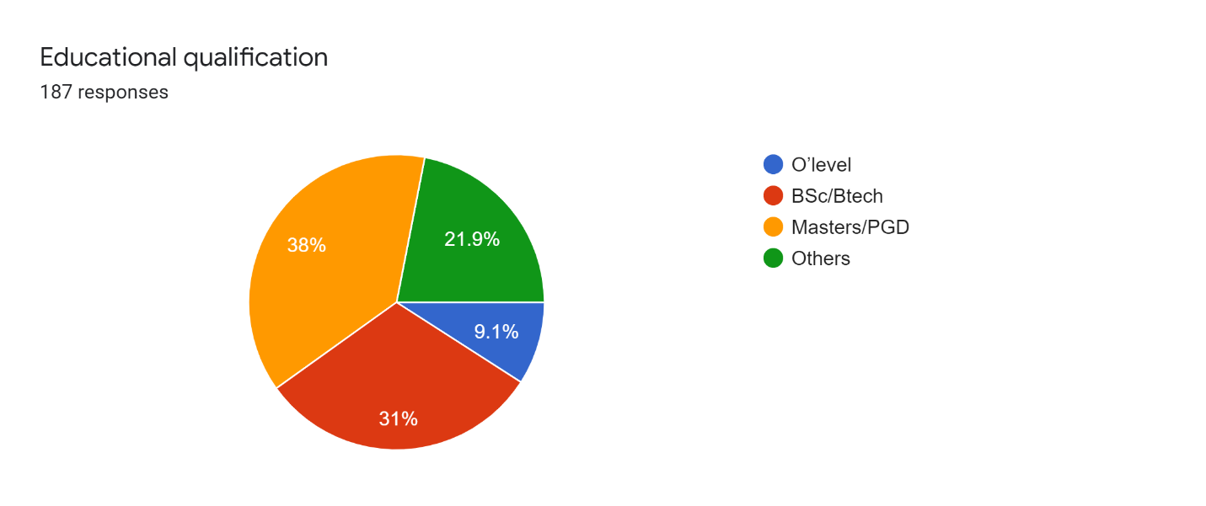

It is evident from the figure above that nine-point one percent (9.1%) of the respondents have Ordinary level certificates, thirty one percent (31%) of the respondents have bachelor’s degree (BSc/Btech), thirty eight percent (38%) of the respondents have Masters/postgraduate Diploma degrees, while twenty-one point nine (21.9%) of the respondents have other categories of degrees.

Control Activities
Table 4.1: How functional are the internal control systems in FIRS
 | Frequency | Percentage
Functional | 112 | 65.2
Very functional | 60 | 32.1
Not functional | 5 | 2.7
Total | 187 | 100

The table above reveals that sixty-five-point two percent (65.2%) of the respondents opined that the internal control systems in FIRS is functional, thirty-two-point one percent (32.1%) of the respondents noted that it is very functional while, two point seven percent (2.7%) of the respondents noted that the internal control systems in FIRS is not functional.
Figure 4.3: Internal control being the only system that could be used to check financial misappropriation in FIRS
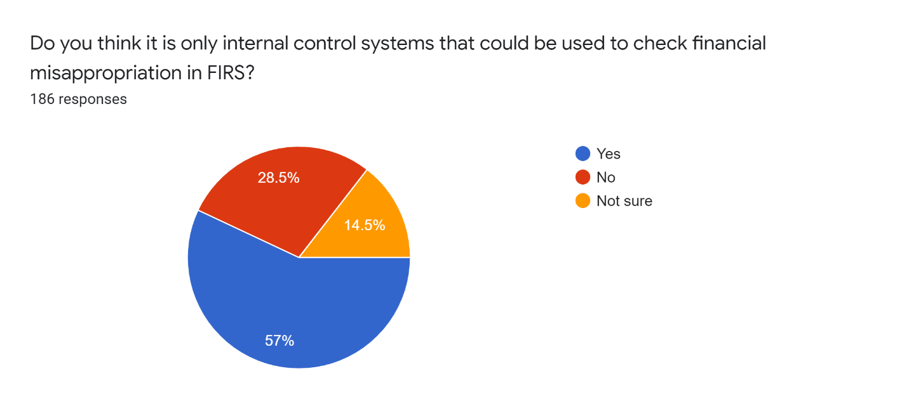
The chart above shows that fifty seven percent (57%) of the respondents noted that internal control is the only system that could be used to check financial misappropriation in FIRS, twenty-eight-point five percent (28.5%) noted otherwise, while fourteen-point five percent (14.5%) of the respondents noted that they are not sure.
Table 4.2: Security measures to ensure staff members comply with internal control systems
 | Frequency | Percentage
Yes | 143 | 76.5
No | 2 | 1.1
Not sure | 42 | 22.5%
Total | 187 | 100

From the above table it is clear that seventy-six point five (76.5%) of the respondents agreed that there are security measures in place to ensure staff members comply with internal control systems, just two respondents noted ‘no’, while twenty-two-point five percent of the respondents noted that they are not sure.
Table 4.3: If FIRS do staff performance review
 | Frequency | Percentage
Yes | 169 | 90.4
No | 6 | 3.2
Not Sure | 12 | 6.4
Total | 187 | 100

It is clear from table 4.3 that ninety-point four percent (90.4%) of the respondents noted that FIRS do staff performance review, three-point two percent (3.2%) of the respondents stated otherwise, while six point four (6.4%) of the respondents noted that they are not sure.
Figure 4.4: Staff members activities being duly supervised by FIRS management

From the figure above it is clear that eighty-six-point six percent (86.6%) of the respondents noted that staff members activities are being duly supervised by FIRS management, three-point two percent of the respondents noted that staff members activities are not duly supervised by FIRS management while, ten-point two percent of the respondents opined that they are not sure.

Figure 4.5: Staff members being happy about FIRS internal control processes
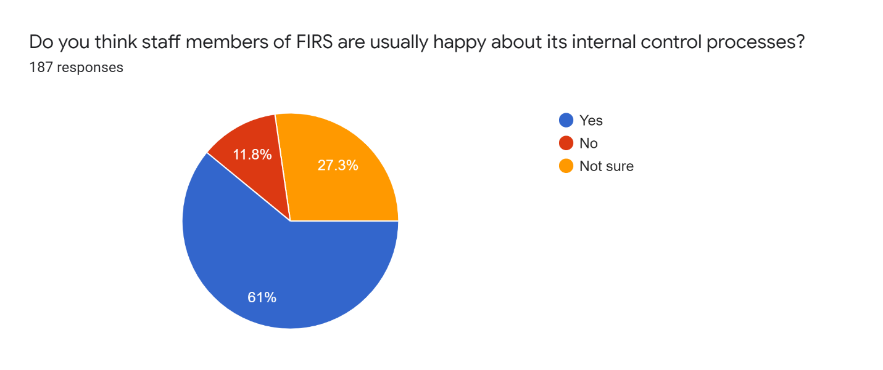
Figure 4.5 revealed that sixty one percent (61%) of the respondents noted that staff members are happy about FIRS internal control processes, eleven-point eight percent (11.8%) noted that staff members are not happy about FIRS internal control processes, while, twenty-seven-point three percent (27.3%) of the respondents noted that they are not sure.

PITFALLS ATTACHED TO INTERNAL CONTROL SYSTEMS
Table 4.4: Internal control not well funded
 | Frequency | Percentage
True | 19 | 10.2
False | 117 | 62.6
Don’t know | 51 | 27.3
Total | 187 | 100

Table 4.4 shows that ten-point two percent (10.2%) of the respondents noted that internal control in FIRS is usually not well funded, sixty-two point six (62.6%) of the respondents noted that internal control in FIRS is well funded while twenty seven point three percent (27.3%) noted that they don’t know.
Table 4.5: Management does not give due attention to internal control
 | Frequency | Percentage
True | 25 | 13.4
False | 133 | 71.1%
Don’t know | 29 | 15.5
Total | 187 | 100

It is evident from the table above that thirteen-point four percent (13.4%) of the respondents opined that FIRS management does not give due attention to interna control system, seventy-one-point one percent (71.7%) of the respondents noted that the management of FIRS give due attention to the internal control process in FIRS while fifteen-point five percent (15.5%) noted that they don’t know.

Table 4.6: The result is never upheld
 | Frequency | Percentage
True | 21 | 11.2
False | 117 | 62.6
Don’t know | 49 | 26.2
Total | 187 | 100

The table above reveals that eleven-point two percent (11.2%) of the respondents noted that the result of the internal control done in FIRS is never upheld, sixty-two point six (62.6%) of the respondents opined that the result of the internal control process in FIRS has always been upheld while twenty-six point two noted that they don’t know.
Figure 4.6: result of Internal Control been upheld when junior staff is caught in financial scandal alone
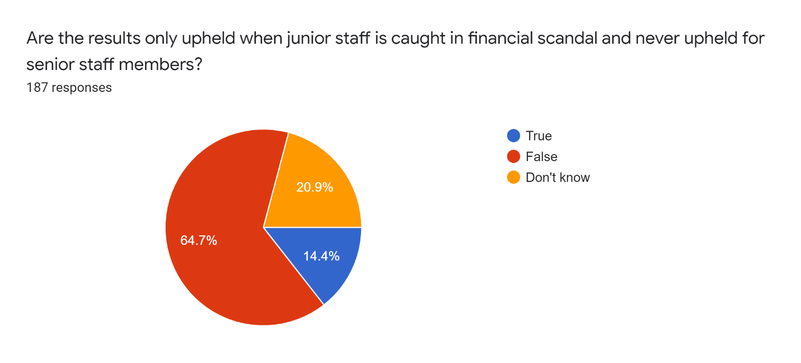

The figure above shows that fourteen-point four percent (14.4%) of the respondents noted that the result of internal control has always been upheld when junior staff is caught in financial scandal and never for when senior staff members are caught in financial scandals, sixty-four-point seven percent (64.7%) of the respondents noted that such assertion is false while, twenty point nine percent (20.9%) of the respondents noted that they do not know.
Table 4.7: Brazen favoritism of some staff members during internal control
 | Frequency | Percentage
True | 39 | 21
False | 106 | 57
Don’t know | 41 | 22
Missing system | 1 | -
Total | 187 | 100

The table above reveals that twenty-one percent (21%) of the respondents noted that brazen favoritism of some staff members is displayed during internal control processes in FIRS, fifty seven percent (57%) of the respondents noted that no brazen favoritism of some staff members is displayed during internal control process in FIRS while twenty two percent (22%) noted that they don’t know, and one respondent didn’t choose any option for this question.

Potency of the internal control system put in place by FIRS
Table 4.8: Internal control leading to the arrest of fraudulent staff members
 | Frequency | Percentage
True | 150 | 80.2
False | 9 | 4.8
Don’t know | 28 | 15
Total | 187 | 100

It can be deduced from the above table that eighty-point two percent (80.2%) of the respondents noted that internal control system in FIRS has led to the arrest of several fraudulent individuals that are members of the organization, four-point eight percent (4.8%) of the respondents noted otherwise while fifteen percent (15%) noted that they don’t know.
Table 4.9: Successful deterrence to many staff members with fraudulent tendencies
 | Frequency | Percentage
True | 160 | 85.6
False | 12 | 6.4
Don’t know | 15 | 8
Total | 187 | 100

It can be deduced from the table above that eighty-five-point six percent (85.6%) of the respondents noted that internal control measures have successfully deterred many staff members with fraudulent tendencies from exhibiting their tendencies, six-point four percent (6.4%) of the respondents noted that internal control have not been able to successfully deter many staff members with fraudulent tendencies from exhibiting their fraudulent natures while eight (8%) noted that they do not know.
Table 4.10: It is easier for organizational management to follow or track organizational progress
 | Frequency | Percentage
True | 164 | 87.7
False | 20 | 10.7
Don’t know | 3 | 1.6
Total | 187 | 100

It is evident from the table above that eighty-seven point seven (87.7%) of the respondents noted that internal control has made it easier for the management of FIRS to track organizational progress, ten-point seven percent (10.7%) of the respondents noted that it is false that internal control has made the management of FIRS to easily tack organizational progress, while one point six percent (1.6%) of the respondents noted that they do not know.

Table 4.11: It has made it easier to achieve organizational targets
 | Frequency | Percentage
True | 162 | 86.6
False | 5 | 2.7
Don’t know | 20 | 10.7
Total | 187 | 100

It is evident from the table above that eighty-six point six percent (86.6%) of the respondents noted that internal control has made it easier to achieve organizational targets in FIRS, two-point seven percent (2.7%) noted that it is false that internal control has made it easier to achieve organizational targets in FIRS while ten point seven percent of the respondents noted that they don’t know.
Table 4.12: It has compelled several staff members to stick with organizational ethics
 | Frequency | Percentage
True | 162 | 87.1
False | 10 | 5.4
Don’t know | 14 | 7.5
Missing system | 1 | -
Total | 187 | 100

The table above shows that eighty-seven-point one percent (87.1%) of the respondents noted that internal control has compelled several members to stick with organizational ethics, five-point four percent (5.4%) of the respondents noted that it is false that internal control has compelled several staff members to stick with organizational ethics. It is notable that one of the respondents did not fill any option for this question, hence, the missing system in the above table.
Extent of compliance of FIRS staff members to internal control processes
Table 4.13: If Staff members abscond from duties during internal control review
 | Frequency | Percentage
True | 10 | 5.4
False | 124 | 66.7
Don’t know | 52 | 28
Missing system | 1 | -
Total | 187 | 100

The table above shows that five-point four percent (5.4%) of the respondents noted that it is true that staff members abscond from duties during internal control review, sixty-six-point seven percent (66.7%) of the respondents noted that it is false that staff members abscond from duties during internal control review and twenty eighty percent (28%) noted that they do not know. It is notable that one of the respondents did not fill any option for this question, hence, the missing system in the above table.
Figure 4.7: Management staff and other staff members presenting themselves during internal control review.
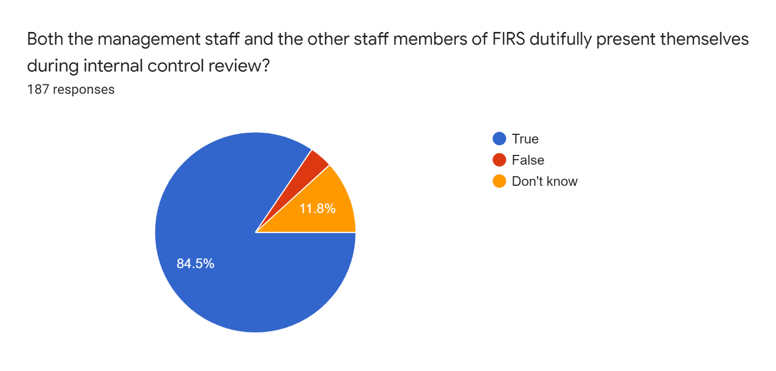

It is evident from the table above that eighty four point five percent (84.5%) of the respondents noted that both the management staff and other staff members of FIRS dutifully make themselves available during internal control review, three point seven percent (3.7%) of the respondents noted that it is false that the management staff and other staff members dutifully make themselves available during internal control review and eleven point eight percent (11.8%) of the respondents noted that they do not know.

Table 4.14: Access to financial registers of FIRS during internal control review is always very easy
 | Frequency | Percentage
True | 152 | 81.7
False | 3 | 1.6
Don’t know | 31 | 16.7
Missing system | 1 | -
Total | 187 | 100

The table above shows that eighty-one-point seven percent (81.7%) of the respondents noted that it is true that access to financial registers of FIRS during internal control review is always very easy, one point six percent (1.6%) noted that its false that access to financial registers of FIRS during internal control review is always very easy, while sixteen-point seven percent noted that they don’t know. It is notable that one of the respondents did not fill any option for this question, hence, the missing system in the above table.

Figure 4.8: Staff members arrive at work on time during internal control review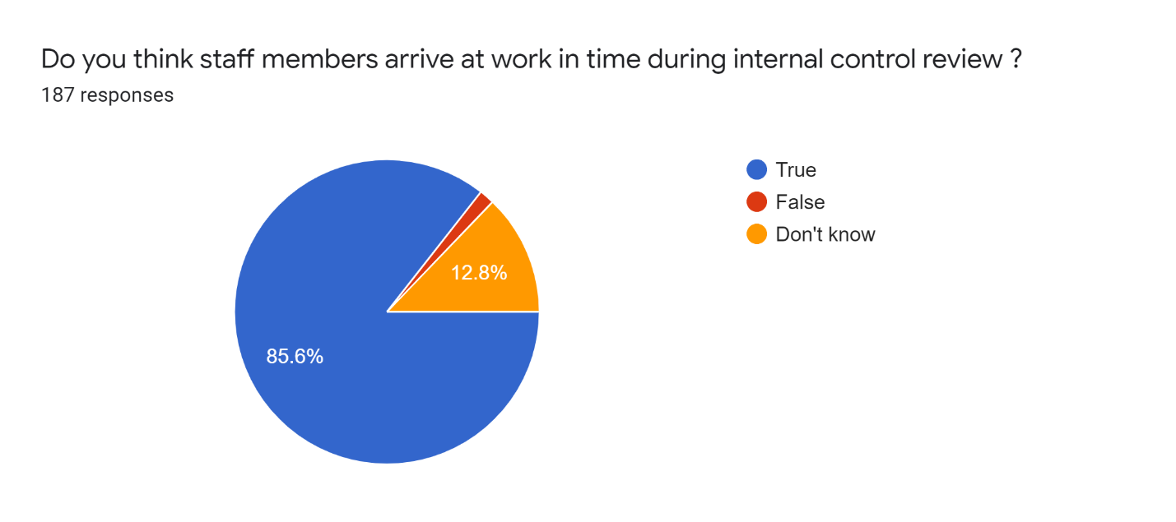

The figure above reveals that eighty-five-point six percent (85.6%) of the respondents noted that it is true that staff members arrive at work on time during internal control review, one point six percent (1.6%) of the respondents noted that it is false that staff members arrive on time during internal control review, while, twelve-point eight percent (12.8%) of the respondents noted that they don’t know.

Indicators for organizational performance
Table 4.15: Revenue generation of FIRS have been consistent for the past years
 | Frequency | Percentage
True | 49 | 26.2
False | 120 | 64.2
Don’t know | 18 | 9.6
Total | 187 | 100

The table above shows that twenty-six-point two percent (26.2%) of the respondents noted that the revenue generation of FIRS have been consistent for the past years, sixty-four-point two percent (64.2%) of the respondents noted that it is false that the revenue generation of FIRS have been consistent for the past years.
Table 4.16: Service delivery of FIRS to clients have been seamless and impressive
 | Frequency | Percentage
True | 152 | 81.7
False | 14 | 7.5
Don’t know | 20 | 10.8
Missing system | 1 | -
Total | 187 | 100

It is evident in the table above that eighty-one-point seven percent (81.7%) of the respondents noted that it is true that access to financial registers of FIRS during internal control review is always very easy, one point six percent (1.6%) noted that its false that access to financial registers of FIRS during internal control review is always very easy, while sixteen-point seven percent noted that they don’t know. It is notable that one of the respondents did not fill any option for this question, hence, the missing system in the above table.
Table 4.17: FIRS have world class tax collecting facilities
 | Frequency | Percentage
True | 148 | 79.6
False | 18 | 9.7
Don’t know | 20 | 10.8
Missing system | 1 | -
Total | 187 | 100

It is evident in the table above that seventy-nine-point six percent (79.6%) of the respondents noted that it is true that FIRS have world class tax collecting facilities, nine-point seven percent (9.7%) noted that its false that FIRS have world class tax collecting facilities, while ten point eight percent (10.8%) noted that they don’t know. It is notable that one of the respondents did not fill any option for this question, hence, the missing system in the above table.

Table 4.18: FIRS have functional feedback mechanism in place that addresses the complaint and concerns of their clients
 | Frequency | Percentage
True | 161 | 86.6
False | 8 | 4.3
Don’t know | 17 | 9.1
Missing system | 1 | -
Total | 187 | 100

It is evident in the table above that eighty six point six percent (86.6%) of the respondents noted that it is true that FIRS have functional feedback mechanism in place that addresses complaints and concerns of their clients, four point three percent (4.3%) of the respondents noted that it is false that FIRS have functional feedback mechanism that addresses the complaints and concerns of their clients, while nine point one percent (9.1%) of the respondents noted that they don’t know. It is notable that one of the respondents did not fill any option for this question, hence, the missing system in the above table.

Figure 4.9: Staff members are happy with the welfare package of FIRS
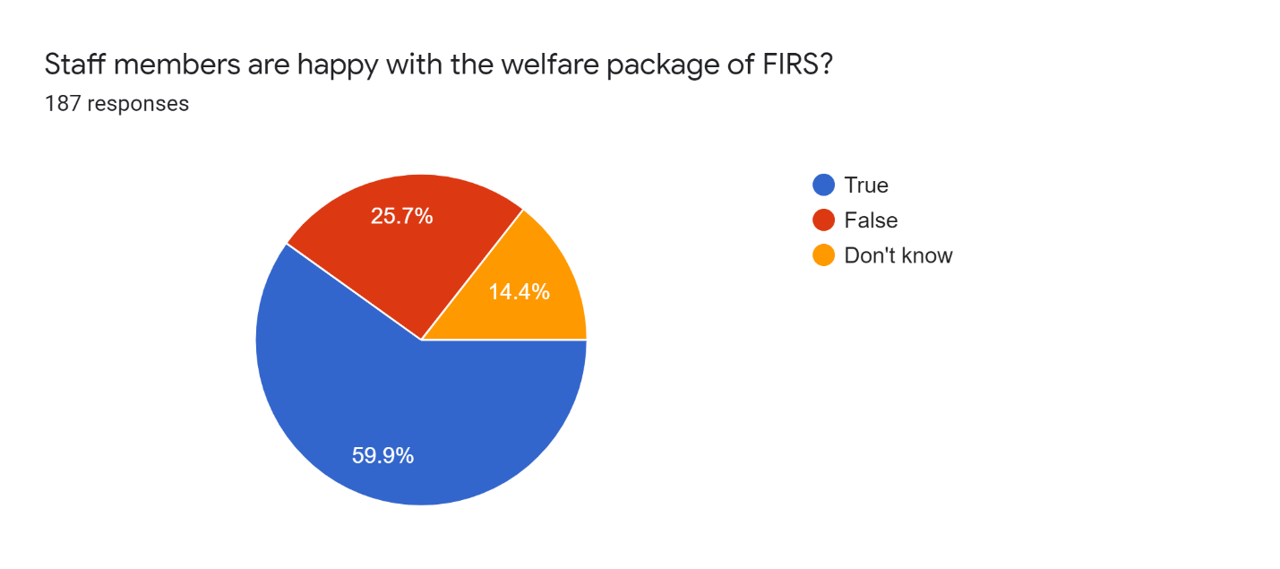
The figure above reveals that fifty-nine-point nine percent (59.9%) of the respondents noted that staff members of FIRS are happy with the welfare package of FIRS, twenty-five-point seven percent (25.7%) of the respondents noted that it is false that staff members of FIRS are happy about the welfare package of FIRS and fourteen-point four percent (14.4%) of the respondents noted that they do not know.
Discussion of the findings
The demographic characteristics of this research captured the age and the educational qualification of the respondents. It was revealed that 39% of the respondents are between 25-40 years old, 48.1% of the respondents are between 41-55 years old. This simply depicts that most of the respondents are between 25 years and 55 years old. This is clarity of thought and decisiveness that accompanies this age group, hence, to a large extent their submission is valid. It was also revealed that 9.1% of the respondents have Ordinary level certificates, 31% of the respondents have Bachelor’s Degree (BSc/Btech), 38% of the respondents have Masters/postgraduate Diploma degrees, while 21.9% of the respondents have other categories of degrees. The import of this is that most of the respondents are educated hence understanding the content of the research instrument should not pose a problem.
For FIRS the result of this study revealed that there is a functional internal control system that is being engaged. This is premised on the fact that 65.2% of the respondents opined that the internal control systems in FIRS is functional. Internal control may not be the only gateway mechanism that organizations use to check financial misappropriation. Meanwhile, for FIRS most of the employees (57%) are of the opinion that internal control is the only gateway system that is used to check financial misappropriation in their organization. In ensuring employees of organizations adhere to internal control mechanism, a security apparatus to drive control activities are usually set in place. FIRS has also adopted the same principle, as 76.5% of the respondents agreed that there are security measures in place to ensure staff members comply with internal control systems in FIRS. Staff performance review makes it easy to substantiate staff contribution to the development of organizations. 90.4% of the respondents noted that FIRS do staff performance review. Likewise, the management of FIRS duly supervise other staff members of the organization, as asserted by 86.6% of the respondents. It is evident from the analysis that most of the staff members are happy about FIRS internal control process because 61% of the respondents noted that staff members are happy about FIRS internal control processes.
Pitfalls are naturally part of any functional process, which is also inclusive of FIRS. Masanja (2018) noted that with regards to implementing internal control systems, a couple of pitfalls escalated to feeble control measures. However, it is evident that funds do not substantively serve as a pitfall for the internal control process in FIRS. This is consequent upon the fact that 62.6% of the respondents noted that internal control in FIRS is well funded while 27.3% noted that they don’t know. It can be asserted that the management of FIRS give due attention to internal control system, as premised on the fact that 71.7% of the respondents noted that the management of FIRS give due attention to the internal control process in FIRS. Likewise, it could be asserted that the result of the internal control process is usually upheld rather than being discarded. This is as a result of the fact that 62.6% of the respondents opined that the result of the internal control process in FIRS has always been upheld. In the same vein there is usually not double standards when it comes to upholding the result of the internal control process in the organization. This is as a result of the fact that 64.7% of the respondents noted that it is false that the result of internal control has always been upheld when junior staff is caught in financial scandal and never for when senior staff members are caught in financial scandals. The cases of frauds might be ameliorated when evaluated staff members performances and reward systems are essentially fair while adopting pertinent transformation in producing improved staff members outcome as a result of enhancing organization justice perception (OJP) in the business enterprise (Kirsty and Nava, 2008). Fairness and transparency in internal control by the management will further strengthen the faith of FIRS employees across different cadres in the organization and its internal control process.
The potency of internal control system depicts its capacity to be effective in whatever situation that it is engaged. It has always been effective in apprehending different fraudulent individuals that have participated in frauds in the organization. It is a consequent of the analysis that 80.2% of the respondents noted that internal control system in FIRS has led to the arrest of several fraudulent individuals that are members of the organization. In the same vein, the internal control has effectively served as a deterrence to individuals that intends exhibiting fraudulent characteristics. 85.6% of the respondents noted that internal control measures have successfully deterred many staff members with fraudulent tendencies from exhibiting their tendencies. Agwor and Akani (2017) noted that it is obvious that if internal control mechanism emphasizes on the provision of being accountable, then an efficient internal control mechanism is necessary in deterring fraud and unscrupulous character hence the provision of accountability to the people. Largely, the fear of the knowledge that there is a mechanism in place that will ensure an individual would be caught easily when engaged in fraud, is enough to deter such individual from engaging in fraud. In the same vein it is established that internal control mechanism makes it relatively easy to follow up the progress and achievements achieved by the organization. 87.7% of the respondents noted that internal control has made it easier for the management of FIRS to track organizational progress. Going forward, once it is easy to track organizational progress then it should be quite easy to achieve organizational targets, as necessary decisions will be made after progress has been tracked. 86.6% of the respondents noted that internal control has made it easier to achieve organizational targets in FIRS. Integrity bulletin (2016) revealed that Internal control system is a process established by organizational management in aiding such business entity to be effective and efficient in operation so as to be able to attain set goals. The awareness of staff members that internal control measures exists in the organization is sufficient enough to compel staff members to behave ethically at all times. 87.1% of the respondents noted that internal control has compelled several members to stick with organizational ethics.
Compliance level of employees to internal control mechanism determines to a large extent the chances that such mechanism will either fail or success both in the immediate circumstance or in the long run. It is notable that from the analysis of the study largely the staff members of FIRS are available during internal control procedures. 66.7% of the respondents noted that it is false that staff members abscond from duties during internal control review. Kirsty and Nava (2008) noted that being careless, lazy and disobedient usually are factored as tenable reason for not giving due attention to internal control. Similarly, it was realized that being present during internal control procedure is not limited to staff members alone but both management staff and staff members make themselves available. 84.5% of the respondents noted that both the management staff and other staff members of FIRS dutifully make themselves available during internal control review. Hence, an internal control mechanism does error prevention and fraud prevention via being monitored and enhanced organizational cum finance reportage, likewise, assurance of complying with necessary policies and rules (Kirsty and Nava, 2008).
Aside staff members making themselves available during internal control, they also make available pertinent documents especially financial documents of the organization. 81.7% of the respondents noted that it is true that access to financial registers of FIRS during internal control review is always very easy. Perhaps, the fact that the staff members aware of the existence of a functional internal control is the reason they make financial registers available and up to date. This is in line with John et al., (2020) opinion that the internal control ensures regulations of the managerial persons is stuck with, facilities are protected and registers of the organization are precise and up to date. There is also a huge sense of timely arrival at work by the FIRS staff during internal control. 85.6% of the respondents noted that it is true that staff members arrive at work in time during internal control review.
There are specific parameters that are used to measure the performance of organization. These parameters will clearly spell it out if the organization is performing well or otherwise. It is notable that a large percentage (64.2%) of the respondents noted that the revenue generation of FIRS has been consistent in the recent past. There has been sharp increase in the revenue generation of FIRS in recent time. FIRS have world class tax collecting facilities. Perhaps, the reason there has been steady increase in the taxes generated in recent time. The analysis revealed that 79.6% of the respondents noted that it is true that FIRS have world class tax collecting facilities. Similarly, FIRS have functional feedback mechanism that ensures that it is easy to attend to the complaints and concerns of their clients. The analysis revealed that 86.6% of the respondents noted that it is true that FIRS have functional feedback mechanism in place that addresses complaints and concerns of their clients. Lastly a good number of the staff 59.9% opined that the staff members are happy with the welfare package of FIRS while 25.7% of the respondents noted that it is false that staff members of FIRS are happy about the welfare package of FIRS. Perhaps, this is a consequence of the fact that some individuals may not be entirely pleased with the remuneration and other ancillary benefits they get from FIRS.
In the light of the above it is pertinent to note that there is a functional control activity in FIRS which has ensured individual staff members exhibit ethical character and thus ameliorating the chances of frauds in the organization. Control activities in an organization, for instance, separation of responsibilities, giving authority and approval might deal with the chances of embezzling and colluding with individual or organizations on the outside (Le and Tran, 2018). It is also notable that ethical behavior, compliance, and happiness with organizational welfare of FIRS staff members contradicts. Masanja (2018) assertion that the main pitfall of internal control was unethical character of staff members, inadequate pay, and freedom from punishment for unruly character with local government Authority in Arumeru District.

Chapter 5
Conclusion and Recommendations
5.1 Concluding thoughts on the contribution of this study
There are five components attributable to internal control mechanism. All of these components ate germane to drive internal control processes, however, control activities as one of the components of internal control was focused on for this study. Thus, the parameters to measure control activities were examined for the FIRS. It is evident from the analysis that FIRS have functional control activities, such that it even deters individuals with fraudulent tendencies from exhibiting such tendencies and also helps to apprehend those individuals that are already engaged in fraud in the organization. It is notable that there is significant compliance of staff members and management staff of FIRS to internal control procedures. Such that they are punctual in offices and it is easy to access various registers especially financial registers to be subjected to internal control procedures. There is evidence that the internal control adopted by FIRS is indeed potent. This is because it has led to the arrest of the fraudulent individuals, and it does not indulge in double standards vis-à-vis exposing all and sundry that participates in fraudulent activities in the organization. Lastly, the parameters for measuring organizational productivity were examined and it was revealed that to a substantive extent FIRS is indeed productive, as a result of the increased tax revenue collected by FIRS in recent past, the fact that FIRS have world standard facilities for their operations and the fact that majority of the staff members of FIRS are happy about the welfare package of FIRS. It could be deduced that the potency of the control activities has significantly resulted into the obvious organizational performance. The fact that most of the staff members are ethical about their activities in FIRS might spur enhanced organizational performance, consequent upon the fact that such staff members will always work toward ensuring FIRS achieve set goals. Meanwhile, the analysis has revealed that quite a number of the respondents noted that they are not happy about the welfare package of FIRS. Conclusively, this could be inferred from this study that internal control that exists in FIRS is fair to a large extent, it is well upheld, and it has aided organizational performance.
5.2 Implications of Findings for the Research
This study has lucidly shown that internal control is germane for organizations especially public organizations. It has shown that a functional internal control system that helps check various activities exists in FIRS. Considering the fact that FIRS is a government parastatal, this research has shown that most of the staff members of this parastatal understands what internal control system is and they actively participate in the process as when due. Gramling (2000) noted that the essence of internal controls should not be underrated, precisely for a big, integrated business entity such as the federal government: thus, weak internal controls exude substantive risks to the government—losses in millions, or billions, of dollars can and do occur. This active participation of staff members has significantly ensured that financial risks, especially, in line with financial misappropriation has been dealt with. Thus once, the financial risk is ameliorated then it is certain that to a good extent loss will be avoided while profit will be assured. It is notable that in the first-place control activities ensures reduction of risk, thus, it can be inferred that control activities in organization are capable of translating such organization into enhanced performance. Internal control exhibits a substantive of organizational performance; hence, organizational performance is a consequence of internal control system created by the business entity (Masanja 2018). On this basis that the implication of the findings of this study for research is justified sufficiently.

5.3 Limitations of the Research
The fact that the research instrument was administered through Google form is in the equation of it being pretty expensive. It cost money to send out the research instruments to the respondents. In the same vein, it cost time and money to get in contact with some of these respondents. In most case, the questionnaire was sent out in a kind of snowball pattern, because some staff members of FIRS had to help locate other staff members and send the questionnaires to them. The fact that physical contact was not done didn’t avail the researcher the opportunity to explore interview aspect of research which could have helped the researcher check the body language and physical disposition of the researcher to some of the questions asked. Likewise, the researcher would have been able to easily deduce the staff members that do not have adequate information about the research or are not ready to avail the researcher the correct information at their disposals. However, it is the new normal and it is no brainer that as much as possible social distancing must be kept and utmost care must be taken.
5.3 Recommendations
The following recommendations was drawn from this topic;
- There should be more transparency in line with the conducts of the internal control processes in FIRS
- The staff members should be better informed about the result of the internal control process. Also, those that have been apprehended in fraudulent activities irrespective of level in the organization should serve the punishment given to them, this is premised on the fact that some percentage of the respondents noted that the result of internal control can only be upheld for junior staff members and not management staff
- The control activities of FIRS should be further strengthened so that there will be more deterrence vis-à-vis the exhibition of criminal tendencies of the staff members
- Periodically, a colloquium should be called for or a circular should be sent to all staff members to make them familiar with the importance of internal control, in regards with the ethical conducts of internal control and what the organization seek to lose if internal control is not done by such organization.
- The Government should do better with the welfare of package of the staff members of public offices in Nigeria, as a number of the staff members noted that they are not happy about the welfare package of FIRS. An impressive welfare package will naturally deter a lot of individuals with fraudulent tendencies from exhibiting their harmful nature.

Reference
Agwor T. and Akani F. (2017) Internal Control System and Fraud Prevention in Public Service of Bayelsa State, Nigeria. International Journal of Novel Research in Marketing Management and Economics. 4(3), 170-178. https://www.noveltyjournals.com/upload/paper/Internal%20Control%20System-1236.pdf
Akinleye G. and Kolawole A. (2020) Internal Controls and Performance of Selected Tertiary Institutions in Ekiti State: A Committee of Sponsoring Organisations (COSO) Framework Approach. International Journal of Financial Research. 11(1) 405-416. https://pdfs.semanticscholar.org/95a6/712baf32449354e0cc37ac978d2e769ed8f5.pdf
Alawaqleh Q. (2021) The Effect of Internal Control on Employee Performance of Small and Medium-Sized Enterprises in Jordan: The Role of Accounting Information System. Journal of Asian Finance, Economics and Business 8(3) 0855–0863. https://www.koreascience.or.kr/article/JAKO202106438543581.pdf
Alghamdi A., and Li L. (2013) Adapting design-based research as a research methodology in educational settings. International Journal of Education and Research 1(10), 1-12.
Almatrooshi B., Singh S. and Farouk S. (2016) Determinants of organizational performance: a proposed framework. International Journal of Productivity and Performance Management, 65 (6) 844 – 859. file:///C:/Users/DELL/Downloads/IJPPM-02-2016-0038.pdf
Al-Sady D., Dabaghia M. and Alhorani A. (2021) Role of Internal Control Components in the Development of External Auditor Performance in Accordance with COSO Decisions: A Field Study on Audit Offices/Bureaus in Gaza Strip. Academy of Accounting and Financial Studies Journal 25(2) 1-18. https://www.abacademies.org/articles/role-of-internal-control-components-in-the-development-of-external-auditor-performance-in-accordance-with-coso-decisions.pdf
Alslihat, Matarneh A., Moneim U., Alali H. and Al-Rawashdeh N. (2018) The Impact of Internal Control System Components of the COSO Model in Reducing the Risk of Cloud Computing: The Case of Public Shareholding Companies. Ciência e Técnica Vitivinícola 33(4) 188-202.
American Institute of Certified Public Accountants (AICPA) (2014) Monitoring your controls is critical. The importance of internal control in financial reporting and safeguarding plan assets. 1-40. https://www.aicpa.org/content/dam/aicpa/interestareas/employeebenefitplanauditquality/resources/planadvisories/downloadabledocuments/plan-advisoryinternalcontrol-hires.pdf
Armie J. and Orosanye A. (2020) Assessing Employee Relations and Organizational Performance: A Literature Review. International Journal of Applied Research in Business and Management. 1(1) 1-17. https://www.ijarbm.org/wp-content/uploads/2020/11/IJARBM-1.1_pp01-17-Arimie-Organizational-Performance.pdf
Callahan C., and Soileau J. (2017) Does enterprise risk management enhance operating performance? Advances in Accounting, 37, 122-139. Available at: https://doi.org/10.1016/j.adiac.2017.01.001.
Chege K. and Otieno O. (2020) Research Philosophy Design and Methodologies: A Systematic Review of Research Paradigms in Information Technology. Global Scientific Journals. 8(5), 33-38. https://www.globalscientificjournal.com/researchpaper/Research_Philosophy_Design_and_Methodologies_A_Systematic_Review_of_Research_Paradigms_in_Information_Technology_.pdf
Conțu E. (2020) Organizational performance – theoretical and practical approaches; study on students’ perceptions. Proceedings of the 14th International Conference on Business Excellence. 298-406.
file:///C:/Users/DELL/Downloads/Organizational_performance_theoretical_and_pract.pdf
Dănescu, T. and Dogar, C., 2012. COSO Principles and European Social Fund Funded Projects in Romania. Procedia - Social and Behavioral Sciences, 62, pp.901–905. https://doi.org/10.1016/j.sbspro.2012.09.152.
Deshmukh A. (2004) A Conceptual Framework for Online Internal Controls. Journal of Information Technology Management. 15(3-4) 23-32. http://jitm.ubalt.edu/XV3-4/article3.pdf
Dimitrijevic D., Milovanovic V., and Stancic V. (2015) The role of a company's internal control system in fraud prevention, e-Finanse: Financial Internet. University of Information Technology and Management, Rzeszów, 11(3) 34-44, http://dx.doi.org/10.14636/1734-039X_11_3_003
Eke G. (2018) Internal Control and Financial Performance of Hospitality Organisations in Rivers
State. European Journal of Accounting, Auditing and Finance Research 6(3), 32-52.
Fourie H. and Ackerman C. (2013) The Impact of COSO Control Components On Internal Control Effectiveness: An Internal Audit Perspective. Journal of Economic and Financial Sciences 6(2), 495-518. file:///C:/Users/DELL/Downloads/The_impact_of_COSO_control_components_on_internal_.pdf
Gramling R. (2000) Internal Control Essential for Safeguarding Assets, Compliance With Laws and Regulations, and Reliable Financial Reporting. United States General Accounting Office. GAO/T-AIMD-98-125. https://www.govinfo.gov/content/pkg/GAOREPORTS-T-AIMD-98-125/pdf/GAOREPORTS-T-AIMD-98-125.pdf
Hayali A, Dinc Y, Sarılı S, Dizman S, Gundogdu A. (2013) Importance of Internal Control System in Banking Sector : Evidence From Turkey. Turkey: Marmara University. Retrieved from https://www.researchgate.net/publication/258258914
Henk O. (2020) Internal control through the lens of institutional work: a systematic literature review. Journal of Management Control 31, 239–273. https://doi.org/10.1007/s00187-020-00301-4
International Federation of Accountants (IFA) (2012) Evaluating and Improving Internal Control
in Organizations. Final Procurement. 1-18.
https://www.ifac.org/system/files/publications/files/Evaluating%20and%20Improving%20Intern
al%20Control%20in%20Organizations%20-%20updated%207.23.12.pdf
Integrity bulletin (2016) Implementing the Five Key Internal Controls. U.S. Department of Housing and Urban Development. https://www.hudoig.gov/sites/default/files/2019-04/Internal%20Controls%20Integrity%20Bulletin%20CPD.pdf
Janepuengporn K., and Ussahawanitchakit P. (2011) The impacts of knowledge management
strategy on organizational performance: An empirical study of clothing manufacturing
businesses in Thailand. International Journal of Business Strategy, 11(1), 92-109. Retrieved from http://connection.ebscohost.com
John A., Philip B., Geofrey M. and Abraham A. (2020) The Calibre of Personnel Influence of
Management’s Compliance to Internal Control Systems in Organizations and Institutions.
International Journal of Scientific and Research Publications, 10(7), 669-678.
file:///C:/Users/DELL/Downloads/The_Calibre_of_Personnel_Influence_of_Managements.pdf

Kang B., Jung Y., Wook Cho N., and Kang H. (2011). Real-time business process monitoring
using formal concept analysis. Industrial Management & Data Systems, 111(5), 652-674.
http://dx.doi.org/10.1108/02635571111137241

Kivunja C. and Kuyini B. (2017) Understanding and Applying Research Paradigms in Educational Contexts. International Journal of Higher Education 6 (5) 26-41. https://files.eric.ed.gov/fulltext/EJ1154775.pdf
Kirsty R. and Nava S. (2008) Quality of internal control procedures. Managerial Auditing Journal 23(2), 104 - 124 Permanent link to this document: http://dx.doi.org/10.1108/02686900810839820
Lakis V. and Giriūnas L. (2012) The concept of internal control system: Theoretical aspect. Ekonomika, 91(2), 142-152.
Lawson, B.P., Muriel, L. and Sanders, P.R., 2017. A survey on firms’ implementation of COSO’s 2013 Internal Control–Integrated Framework. Research in Accounting Regulation, 29(1), pp.30–43. https://doi.org/10.1016/j.racreg.2017.04.004.
Le, T. H., and Tran, M. D. (2018) The effect of internal control on asset misappropriation: the case of Vietnam. Business and Economic Horizons, 14(4) 941-953. http://dx.doi.org/10.15208/beh.2018.64
Lu, X., Wang, H., Liu, X., Song, Z., Jiang, N., Xie, F., Zheng, Q. and Lin, D., 2020. Functional separators prepared via in-situ growth of hollow CoSO4 hydrate arrays on pristine polypropylene membrane for high performance lithium-Sulfur batteries. Journal of Alloys and Compounds, 838, p.155618. https://doi.org/10.1016/j.jallcom.2020.155618.
Mahmood M., Hamawandy N., Abdullah A., kareem F. and Ali R. (2020) Perceived Effect of Internal Control on the Financial Performance of Manufacturing Firms in Kurdistan Regional Governmient of Iraq. Journal of Critical Reviews 7(15) 4599-4614. file:///C:/Users/DELL/Downloads/mohammadnawzad.pdf
Masanja N. (2018) The Impact of Internal Control Challenges on Organizational Financial Performance for Selected Local Government Authorities in Arumeru District, Arusha Tanzania. International Journal of Research and Innovation in Social Science 2(11) 206-211.
Mire and Mukhongo (2016) Effects of Internal Control System on the Organizatoinal Performance of Remittance Companies in Modadishu-Somalia. Journal of Business Management, 2(9) 153-167.
Onuorah, A.C. and Appah, E., 2012. Accountability and public sector financial management in Nigeria. Arabian Journal of Business and Management Review, 1(6).
Otley D., and Soin K. (2014) Management Control and Uncertainty. In D. Otley and K. Soin (Eds.), Management control and uncertainty 1, 1–13. Houndmills: Palgrave Macmillan
Janvrin J., Payne A., Byrnes P., Schneider P. and Curtis B. (2012) The Updated COSO Internal
Control—Integrated Framework: Recommendations and Opportunities for Future Research.
Journal of Information Systems; 26(2): 189–213. https://doi.org/10.2308/isys-50255.
Ramdany, Yadiati W., Suharman H. and Poppy K. (2017) Effectiveness of Internal Control, Good Governance, and Accounting Information Quality on Budgetary Discipline. International Journal of Business, Economics and Law, 12(1) 62-70. https://www.ijbel.com/wp-content/uploads/2017/06/ACC-348.pdf
Randeree K. and Al Youha H. (2009) Strategic management of performance: an examination of public sector organizations in the United Arab Emirates. International Journal of Knowledge, Culture and Change Management 9(4), 123-134.
Saunders M, Lewis P, Thornhill A. (2007) Research Methods for Business Students. 4th ed. London: Financial Times Prentice Hall.
Tamunomiebi D. and Chika-Anyanwu H. (2020) Empowerment Practices and Organizational Performance: A Review of Literature. International Journal of Research and Innovation in Social Science 6(8) 585-599. https://www.rsisinternational.org/journals/ijriss/Digital-Library/volume-4-issue-8/585-599.pdf
Tsay Y., and Turpen A. (2011) The Control Environment in Not-for-Profit Organizations. The CPA Journal, 81(1), 64.
Tuan, T. T. (2020). The effect of internal control on the performance of Vietnamese construction enterprises. Accounting, 6(2020), 781–786
Umar, H., and Dikko, M. U. (2018). The effect of internal control on performance of Commercial banks in Nigeria.International Journal of Management Research & Review, 8(6), 13-32.
Younas M. and Kassim D. (2019) Essentiality of internal control in Audit process. International Journal of Business and Applied Social Science 5(11), 1-6. DOI:10.33642/ijbass.v5n11p1
Zelie E. (2021) The Effect of Internal Control Components on Mitigating The Impact of Covid-19 Risks in Healthcare Organizations in Ethiopia. Journal of Economics, Business, and Accountancy Ventura 23(3), 402 – 413. file:///C:/Users/DELL/Downloads/The_Effect_of_Internal_Control_Components_on_Mitig.pdf
Žukauskas P., Vveinhardt J. and Andriukaitienėthe R. (2018) Philosophy and Paradigm of Scientific Research. Management Culture and Corporate Social Responsibility. 121-139 http://dx.doi.org/10.5772/intechopen.70628.

Appendix: Research Questionnaire
I am a postgraduate student of Griffith University. I seek information about internal control and organizational performance. Kindly note that the information sought from you will only be used for academic purpose. Your anonymous identity shall be protected.
Age: a) 25-40 years () b) 31-56 ( ) c) 56 and above ( )
Educational qualification: a) O’ level () b) BSc/Btech () c) Masters/PGD ( ) d) Others ( )
How functional is the internal control in FIRS? A) Very functional () b) Functional () c) Not functional ().
Do you think it is only internal control that could be used to check financial misappropriation in FIRS? A) Yes () b) N0 ( ) c) Not sure ( )
Are there security measures to ensure staff members comply with internal control? A) Yes ( ) b) No ( ) c) Not sure ( )
Does FIRS do staff performance review? A) Yes ( ) b) No ( ) c) Not sure ( )
Are staff members activities duly supervised by the management of FIRS? A) Yes ( ) b) No ( ) c) Not sure ( )
Do you think staff members of FIRS are usually happy about its internal control processes? A) True [ ] b) False [ ] c) don’t know [ ]
Pitfalls attached to internal control
It is usually not well funded? A) True [ ] b) False [ ] c) don’t know [ ]
The management does not give due attention to it? A) True [ ] b) False [ ] c) don’t know [ ]
Its result is never upheld? A) True [ ] b) False [ ] c) don’t know [ ]
Its result is only upheld once junior staff is caught in financial scandal and never upheld for senior staff members? A) True [ ] b) False [ ] c) don’t know [ ]
There is brazen favoritism of some staff members during the exercise? A) True [ ] b) False [ ] c) don’t know [ ]
Potency of the internal control systems put in place by FIRS
It has successful led to the arrest of a lot of fraudulent staff members? A) True [ ] b) False [ ] c) don’t know [ ]
It has successfully deterred many staff members with fraudulent tendencies from exhibiting their fraudulent natures? A) True [ ] b) False [ ] c) don’t know [ ]
It has made it easier for organizational management to follow organizational progress? A) True [ ] b) False [ ] c) don’t know [ ]
It has made it easy to achieve organizational targets? A) True [ ] b) False [ ] c) don’t know [ ]
It has compelled several staff members to stick with organizational ethics? A) True [ ] b) False [ ] c) don’t know [ ]
Extent to which FIRS complies to the internal systems that have been put in place.
Do you think some FIRS staff members abscond from duties during internal control? A) True [ ] b) False [ ] c) don’t know [ ]
Both the management staff and the other staff members of FIRS dutifully present themselves during internal control? A) True [ ] b) False [ ] c) don’t know [ ]
Access to financial registers of FIRS during internal control exercise by the internal control expert is always very easy? A) True [ ] b) False [ ] c) don’t know [ ]
Do you think staff members arrive at work in time during internal control exercise? A) True [ ] b) False [ ] c) don’t know [ ]
indicators for organizational performance attributable to FIRS.
The revenue generation of FIRS has been consistent for the past years? A) True [ ] b) False [ ] c) don’t know [ ]
Service delivery of FIRS to clients have been seamless and impressive? A) True [ ] b) False [ ] c) don’t know [ ]
FIRS have World class tax collecting facilities? A) True [ ] b) False [ ] c) don’t know [ ]
FIRS have functional feedback mechanism in place that addresses the compliant and concerns of their clients? A) True [ ] b) False [ ] c) don’t know [ ]
Staff members are happy with the welfare package of FIRS? A) True [ ] b) False [ ] c) don’t know [ ]

